Marketing plan written for
Tara! Pop-up Kitchen
Student Name: Mark Jeffrey Pascual
Student ID number: 2229176
Marketing Essentials BMGM 5001
Lecturer: Ruth Taylor-Davies
Spring 2024

Introduction
Tara! Pop-up Kitchen is a new restaurant concept that aims to introduce and celebrate Filipino-Asian cuisine while incorporating locally sourced Welsh produce. The name "Tara" reflects the Filipino expression for inviting someone to come or join, creating a sense of warmth, hospitality, and inclusivity whilst the Welsh "Ta ra" embraces the sentiment of bidding farewell with warmth and affection, embodying a sense of fondness and camaraderie. It reflects a welcoming and inclusive atmosphere, inviting patrons to depart with a smile and a promise of future encounters.

A concise strategic marketing plan outlines market trends, target segments, value propositions, competitive advantage strategies, prioritised objectives, and financial implications, ensuring clarity and simplicity in communicating the roadmap for achieving superior value in the marketplace (Chernev, 2020). Spear (2018) suggests that the implementation of a strategic plan is instrumental in generating revenue for businesses. He argued that marketing transcends mere brand visibility, as evidenced by his research indicating that most customers discover his business through word-of-mouth referrals.

Tara! Pop up Kitchen utilising the SOSTAC framework for comprehensive marketing planning, incorporating Situation Analysis, Objectives, Strategy, Tactics, Action, and Control and 4Ps, aims to strategically position as the premier destination for authentic and innovative dining experiences in Swansea.

Situation Analysis (5’C’s)
1.Company
One of the most crucial tools for gaining insight into organisational decisions is the SWOT analysis. By examining an organisation's resources and environment, it aids in better understanding and strategic positioning for the business (Phadermrod, 2019).

SWOT analysis for Tara! Pop up Kitchen
Strengths | Weaknesses
1. Unique Concept: Tara! offers a distinctive fusion of Filipino-Asian cuisine with locally sourced Welsh produce, providing a unique culinary experience not readily available in the market. | 1. Limited Visibility: As a new pop-up restaurant, Tara! may struggle with establishing brand awareness and attracting a steady stream of customers, especially in competitive dining markets.
2. Authenticity: The restaurant prides itself on authenticity, offering genuine flavours and dishes that resonate with both Filipino and Asian cuisine enthusiasts. | 2. Operational Challenges: Managing logistics, such as securing suitable pop-up locations, coordinating with suppliers, and maintaining consistent quality, may pose challenges for Tara! in its initial stages.
3. Creative Menu: Tara! Pop-up Kitchen's menu showcases innovative dishes that highlight the richness of both Filipino and Welsh culinary traditions, attracting adventurous foodies. | 3. Seasonal Availability: Depending on the availability of Welsh produce, Tara! may face limitations in menu offerings and consistency, particularly during off-seasons for certain ingredients.
4. Flexibility: As a pop-up kitchen, Tara! has the flexibility to experiment with its menu and location, allowing for agile responses to customer preferences and market trends.
5. Engaging Branding: The name "Tara!" and its association with warmth, hospitality, and inclusivity resonates well with customers, creating a memorable brand identity.
Opportunities | Threats
1. Culinary Events: Participating in food festivals, markets, and cultural events can provide Tara! with opportunities to showcase its unique offerings, attract new customers, and build brand recognition. | 1. Competition: Tara! faces competition from established restaurants offering similar cuisines or unique dining experiences, posing a challenge in capturing market share and attracting loyal customers.
2. Collaborations: Forming partnerships with local businesses, chefs, and food influencers can expand Tara!'s reach and introduce its cuisine to new audiences. | 2. Economic Factors: Fluctuations in the economy, changes in consumer spending habits, and unforeseen events such as global pandemics can impact the restaurant industry's overall stability and profitability.
3. Digital Marketing: Leveraging social media platforms, online reviews, and food blogs can help Tara! increase its visibility, engage with customers, and generate buzz around its pop-up events and menu innovations. | 3. Supply Chain Disruptions: Disruptions in the supply chain, such as shortages of key ingredients or increases in prices, can affect Tara!'s ability to maintain menu consistency and manage operational costs.
4. Expansion: If successful, Tara! can explore the possibility of expanding its pop-up locations or transitioning into a permanent restaurant, capitalizing on its established brand and customer base. | 4. Regulatory Challenges: Adhering to health and safety regulations, obtaining necessary permits, and complying with food handling guidelines can pose regulatory challenges for Tara! Pop-up Kitchen.

2. Customers
Organisations pursue segmentation for several reasons (Doyle, 1994), such as catering to consumer needs more precisely, enhancing profitability, achieving segment leadership, and fostering customer retention.

Organisational marketing objectives involve choosing products or services for specific markets, making market selection crucial in strategy. The segmentation process, comprising segmentation, targeting, and positioning, is vital, as it determines how to approach and position offerings within chosen markets for effective strategy formulation (Drummond, 2005).

Segmentation | Targeting | Customer Profiles
- Demographic Segmentation:  - Age: Adults aged 18-45.  - Income: Middle to upper-middle-income individuals.  - Occupation: Students, young professionals, and individuals in creative fields.  - Psychographic Segmentation:  - Lifestyle: Urban dwellers and food enthusiasts seeking unique dining experiences.  - Values: Individuals who value convenience, affordability, and authenticity in their dining choices.  - Behavior: Those who enjoy exploring different cuisines and are active on social media platforms for food-related content. | Based on the segmentation analysis, Tara! Pop-up Kitchen will primarily target:  Young Urban Dwellers:  - Demographics: Age 18-30, urban residents.  - Psychographics: Value experiences, enjoy  socialising and trying new foods.  - Behavior: Actively seek out trendy and unique dining experiences, often share their experiences on social media.  Food Enthusiasts:  - Demographics: Age 25-45, diverse backgrounds.  - Psychographics: Passionate about food, appreciate authenticity and creativity in cuisine.  - Behavior: Regularly seek out new restaurants and culinary experiences, willing to pay for quality and innovation. | Creative Millennials:  - Demographics: Age 22-30, young professionals.  - Psychographics: Value creativity and authenticity, seek out unique experiences.  - Behavior: Enjoy exploring different cuisines, often share food experiences on social media platforms like Instagram, value convenience and affordability.  Social Foodies:  - Demographics: Age 25-35, diverse backgrounds.  - Psychographics: Highly social, enjoy dining out with friends and trying new foods.  - Behavior: Actively follow food influencers and bloggers, often seek out new and trendy dining spots, prioritize ambiance and experience.

According to StatsWales, the population estimates for individuals aged between 18 to 45 years old, as of the mid-year of 2022, were 61,661 for Neath Port Talbot and 107,986 for Swansea. The Office for National Statistics reported that in the population ranking of local authority areas in Wales based on the 2011 and 2021 Censuses, Swansea held the second position, with Cardiff securing the first. Nearby areas such as Port Talbot were ranked ninth. Additionally, as of 2024, Swansea's population is estimated to be 318,188 by World Population Review.

Tara! will benefit from segmentation by targeting specific customer groups more effectively, enhancing satisfaction and maximising profitability.

3.Competitors

Brand positioning based on TripAdvisor. Restaurant reviews entails leveraging customer feedback and ratings to establish a favourable perception and reputation within the market.

After evaluating Tara! Pop-up Kitchen's marketing strategy, particularly regarding its pricing and the quality of its offerings, it appears poised to position itself as one of the top establishments in the area.

Best restaurants in Swansea Marina by Squaremeal 2024.

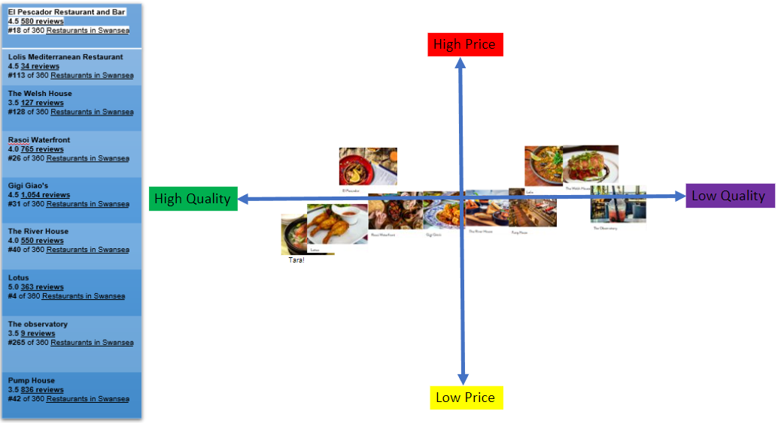
4.Collaborators
Collaborators of Tara! Pop-up Kitchen plays a crucial role in enhancing its reach, offerings, and overall business success. Collaborations with event organisers and community groups provide Tara! with valuable exposure to diverse audiences through food festivals and cultural events, fostering community engagement and brand recognition. Tara! further extends its reach by partnering with universities and colleges, offering internship opportunities, engaging in research projects, and hosting culinary events to nurture budding talent and promote learning within the hospitality industry. Additionally, by exploring franchise opportunities, Tara! aims to expand its footprint and share its unique culinary concept with new markets, offering entrepreneurs the chance to leverage its brand and operational support while fostering entrepreneurship.
These collaborative efforts underscore Tara!'s dedication to innovation, sustainability, and community engagement, positioning it as a dynamic and influential presence in the culinary industry.

5.Climate
Named for the initials of its six macroeconomic categories (Political, Economic, Socio-cultural, Technological, Legal, and Environmental), the PESTLE analysis enables managers to pinpoint key factors affecting business development. By assessing both opportunities and potential risks amid uncertainty, the model facilitates scenario conceptualization to enhance future predictions and informed decision-making for long-term success (Marmol, 2015).

PESTLE Analysis for Tara! Pop up Kitchen
Political | Economic | Social
- Government regulations and policies regarding food safety and hygiene.  - Taxation policies affecting food businesses.  - Brexit (supply chain) | - Economic conditions impacting consumer spending on dining out.  - Inflation rates affecting ingredient prices.  - Business rates | - Cultural acceptance and appreciation of diverse cuisines.  - Changing consumer preferences towards locally sourced and sustainable ingredients.
Technological | Legal | Environmental
- Advancements in online ordering and delivery platforms.  - Use of technology in food preparation and kitchen operations. | - Compliance with health and safety regulations in food handling.  - Licensing and permits required for operating a food establishment. | - Sustainable sourcing of ingredients and waste management practices.  - Impact of climate change on ingredient availability and farming practices.  - Carbon emissions  - Recycling at work Wales

Objectives
Characterised by its five essential components, a SMART target ensures comprehensive target setting, facilitating a structured approach towards achieving success. Without addressing all aspects, one may engage in target setting but may not effectively devise a plan for success (Leonard and Watts, 2022).
A SMART target serves as a framework for effective target setting, encompassing Specific, Measurable, Achievable, Relevant, and Time-bound criteria. This approach ensures targets are well-defined, quantifiable, attainable, relevant, and bound by a clear timeline, enhancing the likelihood of successful target attainment (CFI team, n.d).
The SMART target for Tara! Pop-up Kitchen's marketing plan is to achieve a 20% increase in monthly revenue within 12 months through targeted marketing efforts, menu optimisation, and operational improvements, aligning with the overarching goal of establishing the brand as a culinary leader in the community while ensuring sustainable business growth.

Strategy

To effectively communicate its value proposition, Tara! utilises various channels such as digital marketing, in-person experiences, and word-of-mouth recommendations. By targeting specific customer segments such as young urban food enthusiasts, locally conscious consumers, and social foodies, Tara! positions itself as the go-to destination for authentic yet innovative dining experiences.

Leveraging Ansoff's Matrix, Tara! explores growth strategies including market penetration, development, and diversification, further solidifying its market position, and expanding its reach.

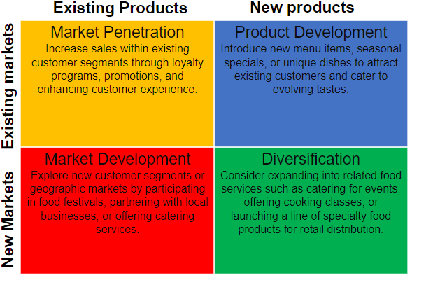

This tool is a strategic management and planning aid utilised by marketing management teams to devise strategies for future business expansion. Named after the Russian-American applied mathematician Igor Ansoff, it offers four growth alternatives for organisational development and risk mitigation (Clarissia, 2020).

Tactics and Marketing mix
McCarthy (1964) introduced the "marketing mix," commonly known as the "4Ps," to operationalise marketing planning (Bennett, 1997). It's a conceptual framework guiding managers in configuring offerings to meet consumer needs (Pandey,2016).

Product: Tara! offers a unique fusion of Filipino-Asian cuisine using locally sourced Welsh produce, providing an innovative culinary experience. Its menu showcases a diverse range of dishes crafted with authentic flavors and creativity, appealing to food enthusiasts seeking unique dining experiences.

Price: Tara! strategically prices its menu items to reflect the quality of its offerings while remaining competitive in the local market. Pricing is designed to ensure affordability for customers while also reflecting the value of the ingredients and culinary expertise involved in preparing each dish.

Place: Tara! selects prime locations within the Swansea area to establish its pop-up kitchen, maximising visibility, and accessibility to its target audience. These strategic locations may include areas with high foot traffic or proximity to popular attractions, ensuring convenience for customers seeking culinary delights.

Promotion: Tara! employs a comprehensive promotional strategy to build brand awareness and attract customers. This includes digital marketing efforts such as social media campaigns and email newsletters, as well as traditional methods like print advertising and participation in local events. Special promotions, loyalty programs, and engaging content are utilised to encourage customer engagement and foster a loyal customer base. 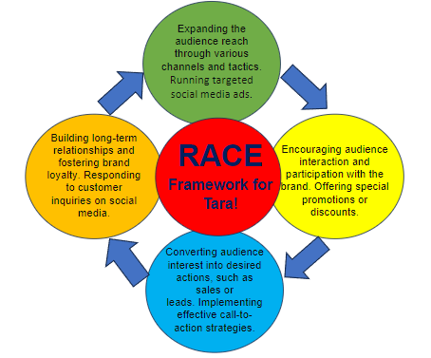

RACE comprises four steps aimed at facilitating brands in connecting with their customers. These steps mirror the stages in the customer journey, beginning from Awareness, progressing to Conversion, and extending to post-purchase Engagement (Oxford College of Marketing, 2023).

Action and Control

Gantt's chart is a crucial management tool aiding in resource conservation, cost reduction, material efficiency, and timesaving in manufacturing processes. Its effectiveness hinges on meticulous planning and execution, making it indispensable for organizational management and growth in the modern era (Ramachandran, 2019).

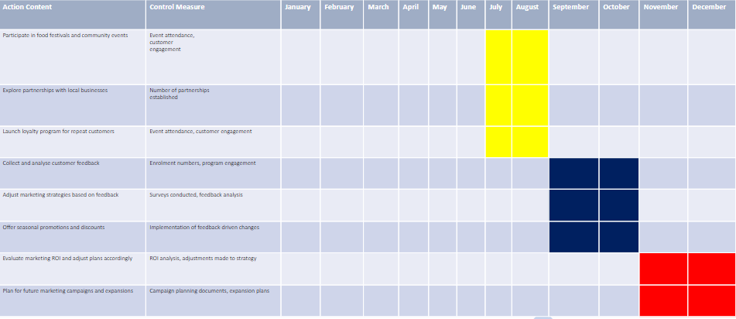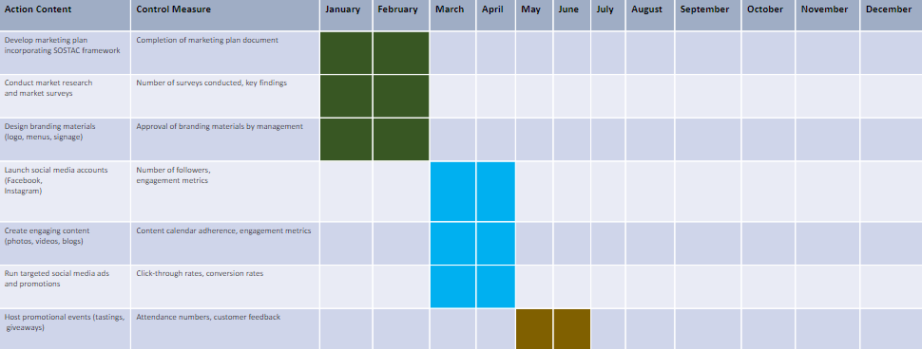The provided Gantt chart meticulously outlines Tara! Pop-up Kitchen's marketing activities for 12 months, accompanied by corresponding actions and control measures to ensure their effective execution and evaluation. The decision-making process behind this marketing plan was driven by a comprehensive understanding of the organisation's objectives, target audience, and competitive landscape.
Every action was strategically chosen to adhere to the SOSTAC framework, guaranteeing a structured approach to marketing planning. To gauge success, key performance indicators (KPIs) such as survey participation, social media engagement, event attendance, and loyalty program enrollment will be closely monitored.
Success will be assessed through various metrics including the acquisition of new customers, enhancement of brand perception, and increased profitability, as indicated by ROI analysis. Additionally, the effectiveness of partnerships with local businesses, promotional events, and incorporation of customer feedback will be evaluated.
Through meticulous tracking of these metrics, Tara! Pop-up Kitchen aims to achieve its marketing objectives and solidify its position as a culinary leader in the community while driving sustainable business growth and profitability.

Conclusion
Tara! Pop-up Kitchen’s marketing plan is a testament to its commitment to excellence, innovation, and community engagement. Through meticulous planning and strategic execution, Tara! has crafted a comprehensive strategy to elevate its brand presence, drive customer engagement, and foster sustainable growth. By leveraging partnerships with local suppliers, event organizers, universities, and potential franchisees, Tara! not only ensures the authenticity and quality of its offerings but also fosters meaningful connections within the community. Through targeted social media campaigns, promotional events, and loyalty programs, Tara! aims to expand its reach, attract new customers, and retain existing ones. Additionally, by embracing feedback-driven adjustments and continuous evaluation of key performance indicators, Tara! remains agile and responsive to the evolving needs and preferences of its audience. With a clear focus on customer satisfaction, brand integrity, and long-term success, Tara! is poised to thrive in the competitive culinary landscape, leaving an impression on patrons and stakeholders alike. As it embarks on this journey, Tara! remains committed to its vision of delivering exceptional dining experiences and celebrating cultural diversity through food.

References:
Bennett, A.R., 1997. The five Vs‐a buyer’s perspective of the marketing mix. Marketing intelligence & planning, 15(3), pp.151-156.
Chernev, A., 2020. The marketing plan handbook. Cerebellum Press.
Clarissia, S.M.S., 2020. A study on Ansoff Matrix Technique: As a growth strategy and an adaptive learning technique adopted in the leading brand of products. BIMS Journal of Management, 18.
Corporate Finance Institute [CFI], (n.d). SMART Goals. Available at: https://corporatefinanceinstitute.com/resources/management/smart-goal/ ( Accessed: 22 February 2024)
Doyle, P. and Stern, P., 2006. Marketing management and strategy. Pearson Education.

Drummond, G. (2005). Introduction to marketing concepts. Butterworth-Heinemann.

Leonard K and Watts R., (2022). The Ultimate Guide to S.M.A.R.T. Goals. Available at: https://www.forbes.com/advisor/business/smart-goals/ (Accessed: 22 February2024)
Marmol, T. del and Feys, B. (2015) PESTLE analysis. Translated by C. Probert. Namur: Lemaitre Publishing.
Office for National Statistics, (2022). How the population changed ing Swansea: Census 2021. Available at: https://www.ons.gov.uk/visualisations/censuspopulationchange/W06000011/ (Accessed: 21 February 2024)
Oxford College of Marketing, (n.d). Using The RACE Framework for Practical Planning. Available at: https://blog.oxfordcollegeofmarketing.com/2018/08/06/using-the-race-framework/#:~:text=RACE%20consists%20of%20four%20steps%20designed,Marketing%20can%20really%20drive%20personalised%20success%29.&text=RACE%20consists%20of%20four,really%20drive%20personalised%20success%29.&text=of%20four%20steps%20designed,Marketing%20can%20really%20drive ( Accessed: 22 February 2024)
Pandey, S.N, 2016. MARKETING MIX: 4PS OR MORE?.
Phadermrod, B., Crowder, R.M. and Wills, G.B. (2019) “Importance-Performance Analysis based SWOT analysis,” International journal of information management, 44, pp. 194–203. Available at: https://doi.org/10.1016/j.ijinfomgt.2016.03.009. (Accessed: 20 February 2024)
Ramachandran, K.K. and Karthick, K.K., 2019. Gantt chart: An important tool of management. Int. J. Innov. Technol. Explor. Eng, 8(7).
Spear, C. H. (2018). Why it’s important to have a marketing plan. In Optometry times (Vol. 10, Issue 4, pp. 1–26). MultiMedia Healthcare Inc.
Stat Wales, (2023). Population estimates by local authority and age. Available at: https://statswales.gov.wales/Catalogue/Population-and-Migration/Population/Estimates/Local-Authority/PopulationEstimates-by-LocalAuthority-Age. ( Accessed: 21 February 2024)

SquareMeal, (2024). Best Restaurants in Swansea Marina. Available at: https://www.squaremeal.co.uk/restaurants/best/best-restaurants-swansea-marina_475 ( Accessed: 21 February 2024)
TripAdvisor, (n.d). Swansea Marina Restaurants. Available at: https://www.tripadvisor.co.uk/Search?&q=Swansea%20Marina%20%20Restaurants&topIds=215434&searchSessionId=00179fb55ed02e52.ssid&sid=414856F6EB494021B200AE5F937710E31709073751162&blockRedirect=true&ssrc=a&isSingleSearch=true&geo=1 (Accessed: 21 February 2024)

World Population Review, (2024). Swansea Population 2024. Available at: https://worldpopulationreview.com/world-cities/swansea-population (Accessed: 21 February 2024)

Appendices:
Appendix 1: Presentation slides




