Katy Grummett (2209790)
University of Wales Trinity Saint David
Research Proposal
Independent Project BMBM6020

Contents
Title 2
Introduction 2
Aims and Objectives 2
Background 3
Purpose and Significance 3
Literature Review 4
Work-life Balance when working remotely, and its impact on productivity 4
Impact of remote working on collaboration 5
Methodology 5
Research Approach 6
Research Limitations 7
Conclusion 7
Reference List 9

Title
The indicative title for this research project is “The Impact of Remote Working post-COVID-19 on the Productivity of Employees in Financial Roles based in South Wales”.

Introduction
This research project will examine the impact of remote working on productivity for employees in finance roles across various sectors post-COVID-19. This study will investigate key factors that affect productivity levels for finance professionals working remotely. This project acknowledges that there are many factors that can affect productivity (Rüdinger, 2024), but due to the time constraint and word limit of this research project, the only factors that will be investigated are collaboration and work-life balance.

Aims and Objectives
This research project aims to assess the impact that remote working has on the productivity of employees working in a finance role. The objectives of this study are to research and measure changes in productivity following the introduction of remote working in finance roles, identify factors that either challenge or enhance the productivity of financial workers in a remote environment and provide recommendations for improving the productivity of individuals in financial roles while working remotely. The research will offer findings that could assist organisations in developing work systems which allow employees to work from home while maintaining high productivity levels.
The research will focus on two primary questions: “How has remote working affected productivity for employees in finance roles post-COVID-19?” and “What productivity challenges and opportunities do employees in finance roles encounter while working remotely?” The first question explores the overall impact of remote work on productivity, examining both numerical measures, such as employee output levels, and subjective aspects, for example, employee perceptions. The second question investigates specific challenges and opportunities faced by finance professionals, including collaboration difficulties, increased flexibility, and improved work-life balance. By analysing these factors, the research aims to provide insights into productivity dynamics in remote financial roles, ultimately assisting organisations in optimising their remote work strategies.

Background
The COVID-19 pandemic rapidly accelerated the implementation of remote working across many industries (Boileau, 2022: Melian, 2024) and affected several different finance positions such as bookkeepers, auditors, financial advisors and many more. Before the pandemic, remote work was mostly seen as an option for a small selection of roles or as part of flexible work arrangements (Al Mohamed, Al Mohamed and Alebrahem, 2024). However, the global crisis left companies with no choice but to switch to remote work to keep their operations running. By April 2020, the percentage of employees who were working remotely increased from 4.7% to 46.6% (Office for National Statistics, 2020: Hooson, 2024) showing just how significantly the pandemic forced businesses to adapt to the new working conditions.
Financial roles are highly analytical and data-driven (Vipond, 2020), and therefore traditionally rely on collaborative in-office settings where quick access to resources and communication channels is readily available. The transition to remote work has introduced new dynamics and potential productivity challenges that are critical for organisations to understand as they consider the future of work arrangements and whether remote working or hybrid working is a viable long-term option for employees in financial positions.
The passion to complete this research project came from an interest in the differences between working in an office and working from home as both have been experienced by the author. In-office work allows for faster collaboration and immediate access to resources, while remote work has introduced flexibility and potentially unique challenges in maintaining focus and efficiency while working. These dynamics highlight the importance of understanding how remote work impacts productivity for finance professionals on a larger scale.

Purpose and Significance
The purpose of this study is to investigate the impact of remote working on the productivity of employees in financial roles, examining both positive and negative influences on collaboration and work-life balance. This project acknowledges that there are many other factors that can affect productivity, however, this research will solely focus on collaboration and work-life balance. Finance-related tasks often demand intense focus, attention to detail, and rapid access to confidential data, all of which may be affected by the limitations and benefits of remote work. Considering the widespread nature of finance functions across sectors and the growing adoption of remote work, understanding these influences on productivity has become increasingly important. The significance of this research lies in its potential to provide organisations with insights that can guide the development of effective remote work policies, aimed at either improving or maintaining productivity while enabling employees to continue working remotely. Additionally, by identifying factors that maximize productivity, this study could contribute to enhancing employee well-being within remote and hybrid work arrangements.

Literature Review

Work-life Balance when working remotely, and its impact on productivity
Research by Subari and Sawitri (2022) found that working from home has a positive and significant impact on employees' work-life balance. They explain that this improvement arises from the flexibility that remote work offers, allowing employees to fulfil family and personal needs more easily. Without the time demands of commuting, employees gain more free time, which can reduce stress and enhance overall well-being, thereby supporting a healthier balance between work and personal life. Their study also shows that the reduced stress from the increased flexibility of remote work helps employees feel less pressure in their roles, which fosters greater creativity, leading to higher productivity levels.
This theory is supported by research conducted by Ivasciuc et al. (2022), who found that employees experienced greater flexibility when working remotely. This flexibility allowed for a better balance between professional and personal life, leading to increased commitment to work and higher productivity levels. Similarly, research by Yogiaman (2023) found that the improved work-life balance from remote work positively affected employees' overall happiness, which further boosted productivity.
On the other hand, research by Tsipursky (2022) has shown that remote working negatively impacts employees’ work-life balance due to their difficulty distinguishing between work and personal time, resulting in challenges with disconnecting from work at the end of the day. For finance employees with high-stakes deadlines, this inability to fully disengage from work can lead to burnout over time, which ultimately reduces productivity as they struggle to maintain focus and energy.

Impact of remote working on collaboration
According to Beau and Jerman (2024), remote working has had a negative impact on social bonding, specifically for those working in an auditing role. They explain that auditors often need strong bonds with their management to establish a high level of trust, however, a lack of social bonding can lead to reduced trust and increased suspicion from management, which, in turn, lowers the employee's productivity as they feel less trusted to perform their job effectively.
A study conducted by The Access Group (2024) also showed that working remotely has negatively impacted the ability to collaborate with other employees. Their research found that although there was an increase in individual productivity, there was a significant decline in team productivity, showing that working from home can create barriers to effective communication and teamwork. The lack of face-to-face interaction may lead to misunderstandings, reduced engagement, and weaker relationships among team members, ultimately hindering collective performance and diminishing the overall effectiveness of the team (Tsipursky, 2023).
These findings indicate that while remote work can benefit individual productivity, it poses challenges to team dynamics and trust-building, particularly in roles like auditing that rely on close collaboration and mutual trust.

Methodology
For this research, the most appropriate approach will be a pragmatic approach. A pragmatic approach starts with identifying a problem and aims to improve and shape future methods and strategies by creating practical solutions (Saunders, Lewis and Thornhill, 2019). This approach will take on a mixture of positivism and interpretivism. According to Ryan (2018), positivism is a philosophical approach associated with quantitative research and experiments, viewing knowledge as objective and free from researcher bias, and emphasising that valid knowledge is confirmed only through scientific observation. Interpretivism is quite the opposite of positivism as it is a social science approach that emphasises the importance of understanding individuals' beliefs, motivations, and reasoning in a social context to interpret the meaning of the data collected about a phenomenon (Nickerson, 2024).
The positivist approach will be applicable because this study aims to measure productivity quantitatively based on responses from financial employees, and this approach allows for objective analysis of productivity factors in remote work settings. However, the interpretivism approach will also be applicable in some areas, as understanding personal perceptions and experiences around remote work might reveal details in productivity that pure numbers may not capture. This is why a pragmatic approach is ideal for this research project, as it combines raw numerical data with human perceptions to achieve the most detailed results.

Research Approach
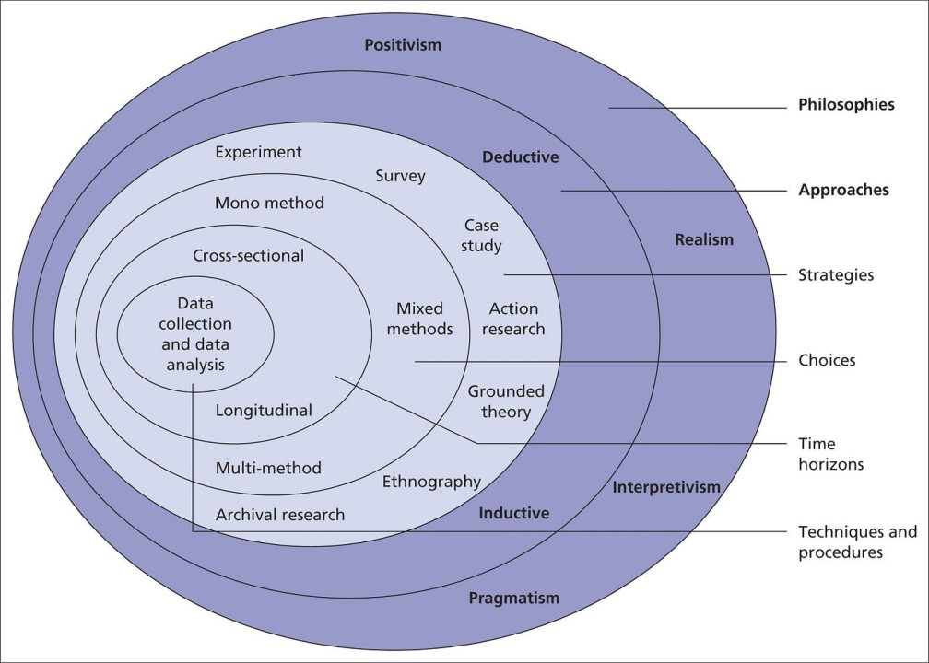
Figure 1- Research Onion
With reference to the research onion (Figure 1) (Saunders, Lewis, and Thornhill, 2019), this research project will be cross-sectional due to time constraints, making a longitudinal study unfeasible. Therefore, this project will look at the current impact of remote working on productivity rather than looking for changes in productivity over a long period of time (Wang and Cheng, 2020).
The research will adopt an inductive approach rather than a deductive approach. Deductive research is an approach where the research starts with an established theory, and the predictions shape the evidence that the researcher seeks to collect (Grix, 2019), whereas an inductive approach is a method where researchers create a theory by examining and interpreting data that has been collected beforehand (Saunders and Lewis, 2018). By focusing on the data collected, the research aims to reveal patterns and connections that will help better understand how remote working affects productivity for employees in finance roles.
For data collection, this project could use either a mono-method or mixed-method approach. A mono-method approach focuses exclusively on one type of data, either quantitative or qualitative, while a mixed-method approach incorporates both types of data (Melnikovas, 2018). For this study, a mono-method approach has been selected, as it allows for a focused quantitative analysis using a questionnaire. This quantitative approach has been chosen because it provides clear and measurable insights into the impact of remote working on the productivity of individuals in finance positions. The questionnaire is an efficient means of gathering data from a large sample of respondents, enabling the collection of standardised information that can be easily analysed (Saunders and Lewis, 2018).

Research Limitations
This research project acknowledges that there are limitations that may impact the study's findings. Firstly, time constraints and word limits pose significant limitations, as the research must be completed by a set deadline in the coming year and can be no longer than 10,000 words in total. The limited timeframe and word limit may restrict the depth of data collection and analysis, potentially affecting the completeness of the research outcomes.
Second, the number of participants in the study is another important limitation. Although the research plans to gather data through a questionnaire from approximately 100 participants, the researcher cannot control how many people choose to take part. If fewer individuals respond, it may reduce the diversity and representativeness of the data, which could affect the reliability of the findings.

Conclusion
In conclusion, this research proposal outlines a study on the impact of remote work on productivity in finance roles, focusing on work-life balance and collaboration. The literature review suggests that while remote work can improve individual productivity by enhancing flexibility and work-life balance, it can also reduce teamwork and hinder collaboration, especially in roles such as auditing. Additionally, the blurred line between work and personal time may lead to burnout, ultimately affecting productivity.
Despite limitations such as a tight timeline, word limits and uncertain participant response rates, this study is valuable. By examining both the benefits and challenges of remote work for finance professionals, it aims to provide insights that will help organisations develop remote work policies that maintain high productivity and support employee well-being in a post-COVID-19 environment.

Reference List
Al Mohamed, A., Al Mohamed, S. and Alebrahem, M. (2024) ‘The remote revolution: assessing the impact of working from home on finance professionals’, Future Business Journal, 10(1). doi:https://doi.org/10.1186/s43093-024-00345-1.
Beau, P. and Jerman, L. (2024) ‘Working apart: Remote working and social bonding in the Big Four audit firms’, Critical perspectives on accounting, 99, pp.102727–102727. doi:https://doi.org/10.1016/j.cpa.2024.102727.
Boileau, B. (2022) Working from home and the COVID-19 pandemic. Available at: https://ifs.org.uk/articles/working-home-and-covid-19-pandemic (Accessed 18 Oct. 2024).
Grix, J. (2019) The Foundations of Research. 3rd ed. London: Macmillan International Higher Education, Red Globe Press.
Hooson, M. (2024) UK Remote And Hybrid Working Statistics. Available at: https://www.forbes.com/uk/advisor/business/remote-work-statistics/ (Accessed 18 Oct. 2024).
Ivasciuc, I.S., Epuran, G., Vuță, D.R. and Tescașiu, B. (2022) ‘Telework Implications on Work-Life Balance, Productivity, and Health of Different Generations of Romanian Employees’, Sustainability, 14(23), p.16108. doi:https://doi.org/10.3390/su142316108.
Melian, V. (2024) How Covid-19 contributes to a long-term boost in remote working. Available at: https://www2.deloitte.com/ch/en/pages/human-capital/articles/how-covid-19-contributes-to-a-long-term-boost-in-remote-working.html (Accessed 18 Oct. 2024).
Melnikovas, A. (2018) ‘Towards an Explicit Research Methodology: Adapting Research Onion Model for Futures Studies’, Journal of Futures Studies, 23(2), pp.29–44.
Nickerson, C. (2024) Interpretivism Paradigm & Research Philosophy. Available at: https://www.simplypsychology.org/interpretivism-paradigm.html (Accessed 31 Oct. 2024).
Office for National Statistics (2020) Coronavirus and Homeworking in the UK: April 2020. Available at: https://www.ons.gov.uk/employmentandlabourmarket/peopleinwork/employmentandemployeetypes/bulletins/coronavirusandhomeworkingintheuk/april2020 (Accessed 18 Oct. 2024).
Rüdinger, J. (2024) Factors Influencing Productivity When Working From Home.
Ryan, G. (2018) ‘Introduction to positivist, interpretivism & critical theory’, Nurse Researcher, 25(4), pp.41–49. doi:https://doi.org/10.7748/nr.2018.e1466.
Saunders, M. and Lewis, P. (2018) Doing research in business and management an essential guide to planning your project. 2nd ed. Harlow: Pearson.
Saunders, M., Lewis, P. and Thornhill, A. (2019) Research Methods for Business Students. 8th ed. United Kingdom: Pearson.
Subari, R.V.Y. and Sawitri, H.S.R. (2022) ‘The effect of work from home toward work-life balance and productivity with work stress as a mediating variable: Study on employees of Financial Services Authority (OJK RI)’, Asian Management and Business Review, 2(2), pp.176–192. doi:https://doi.org/10.20885/ambr.vol2.iss2.art6.
The Access Group (2024) Remote work in finance: How to stay connected in 2024. Available at: https://www.theaccessgroup.com/en-au/blog/fms-remote-work-in-finance/ (Accessed 3 Nov. 2024).
Tsipursky, D.G. (2023) Remote Communications Training Is Key To Hybrid Work. Available at: https://www.forbes.com/sites/glebtsipursky/2023/05/24/remote-communications-training-is-key-to-hybrid-work/ (Accessed 2 Nov. 2024).
Tsipursky, G. (2022) Does Remote Work Hurt Wellbeing and Work-Life Balance? Available at: https://www.forbes.com/sites/glebtsipursky/2022/11/01/does-remote-work-hurt-wellbeing-and-work-life-balance/ (Accessed 2 Nov. 2024).
Vipond, T. (2020) Finance Definition. Available at: https://corporatefinanceinstitute.com/resources/wealth-management/what-is-finance-definition/ (Accessed 27 Oct. 2024).
Wang, X. and Cheng, Z. (2020) ‘Cross-Sectional Studies: Strengths, Weaknesses, and Recommendations’, An Overview of Study Design and Statistical Considerations, 158(1), pp.65–71. doi:https://doi.org/10.1016/j.chest.2020.03.012.
Yogiaman, R. (2023) 11 Surprising Statistics on Remote Work in 2022. Available at: https://www.strongdm.com/blog/remote-work-statistics (Accessed 18 Oct. 2024).

