Assignment 2: Practical & Professional Development
Changemakers: Creativity and Value Creation – ACCA5033
29/04/26

2317483@student.uwtsd.ac.uk
Daniel Leone (2317483)

Table of Contents
Table of Figures 2
2. Task 1: Practical Prototype Development / Implementation 3
2.1 Initial Data Collection & Feedback 3
2.1.1 Data Collection Method 3
2.1.2 Summary of initial Feedback 4
2.1.3 Implementation of Feedback 5
2.2 Implementation and Practical Work 5
2.2.1 Tools and Technologies Used 5
2.2.2 Development Process and Key features 7
2.2.3 Troubleshooting and Challenges 11
3. Task 2: Enterprise 15
3.1 Tech Start-up Proposal 15
3.1.1 Company Overview 15
3.1.2 Business concept 16
3.1.3 Business Strategy and Funding 16
3.2 PEST Analysis 16
3.2.1 Political 16
3.2.2 Economic 16
3.2.3 Social 16
3.2.4 Technological 17
4. Task 3: Project Feedback & Reflection 17
4.1 Practical Feedback 17
4.1.1 Student Perspective 17
4.1.2 Educator Perspective 17
4.1.3 Game Designer Perspective 17
4.1.4 Summary of feedback 17
4.2 Project Progress Diary Reflection 18
4.3 Skills Development 18
4.4 Positive Social Impact 19
5. Conclusion 19
6. References 20

7. Appendices 22
7.1 Finished project: prototype/demo link 22
7.1 Progress sheets 23
7.1.1 Week 1 progress form 23
7.1.2 Week 2 progress form 24
7.1.3 Week 3 progress form 25
7.1.4 Week 4 progress form 25
7.1.5 Week 5 progress form 26
7.1.6 Week 6 progress form 26
7.1.7 Week 7 progress form 27
7.2 Survey results 28
7.3 Testing on native hardware 30
7.3.1 Summary of Experimental Testing 30
7.3.2 Testing outcome 31
7.4 Continuing Professional Development 34

Table of Figures
Figure 1, Gathering feedback with Microsoft Forms 4
Figure 2, Key feedback gained through MSforms 5
Figure 3, Using Aseprite to design assets: doorway & USB drive 6
Figure 4, Using Tiled to create scenes 6
Figure 5, scenes overview 7
Figure 6, Save data handling example 8
Figure 7, Scene 1 programming example (1) 9
Figure 8, Scene 1 programming example (2) 9
Figure 9, Scene 5 programming example 10
Figure 10, Validation: Preventing users from skipping scenario 11
Figure 11, Validation: Preventing users from accessing restricted area 12
Figure 12, Layering & Transparency issue 13
Figure 13, Layering & Transparency resolved 13
Figure 14, Solution found on Tiled Forums [10] 14
Figure 15, Bitwise Games Ltd. Company Logo [11] 15
Figure 16, Finished prototype deployed on web 22
Figure 17, Survey Results 28
Figure 18, Survey Results 29
Figure 19, Survey Results 29
Figure 20, Survey Results 30
Figure 21, Testing on native hardware 31
Figure 22, Testing on native hardware 32
Figure 23, Testing on native hardware 33
Figure 24, CPD: Linkedin Learning course 34
Figure 25, CPD: Linkedin Learning course 34
Figure 26, CPD: Linkedin Learning course 35
1. Introduction
This report documents the continued development of ‘The Human Firewall’, an educational cybersecurity themed game. Building on the ideation phase completed in previous coursework, the project has progressed from an initial concept to a functional prototype. Through an iterative development process, the project has evolved by incorporating user feedback, refining design, and improving functionality to create an engaging and intuitive learning tool.

The author of this report will reflect on the development process, challenges encountered, and solutions applied, while also exploring the commercial potential of the project through the development of a startup concept and business analysis. Additionally, the author will reflect on academic and personal development, highlighting the transferable skills gained throughout the project such as technical skills, and understanding of project management.

2. Task 1: Practical Prototype Development / Implementation

2.1 Initial Data Collection & Feedback

2.1.1 Data Collection Method
To gather initial feedback on the project, a questionnaire was created using Microsoft Forms. Three participants were selected, all of whom were students.

The questionnaire aimed to gain both quantitative and qualitive data. Consisting of a combination of closed questions, such as rating the overall project idea, alongside open ended questions designed to collect more detailed feedback [1] [2]. These questions focused on areas including likes, dislikes, and suggestions for improvement.

Participants were asked to play the earliest prototype, which demonstrated the core gameplay concept, before completing the questionnaire. This ensured feedback was grounded in real user experience, making it useful for guiding further development.

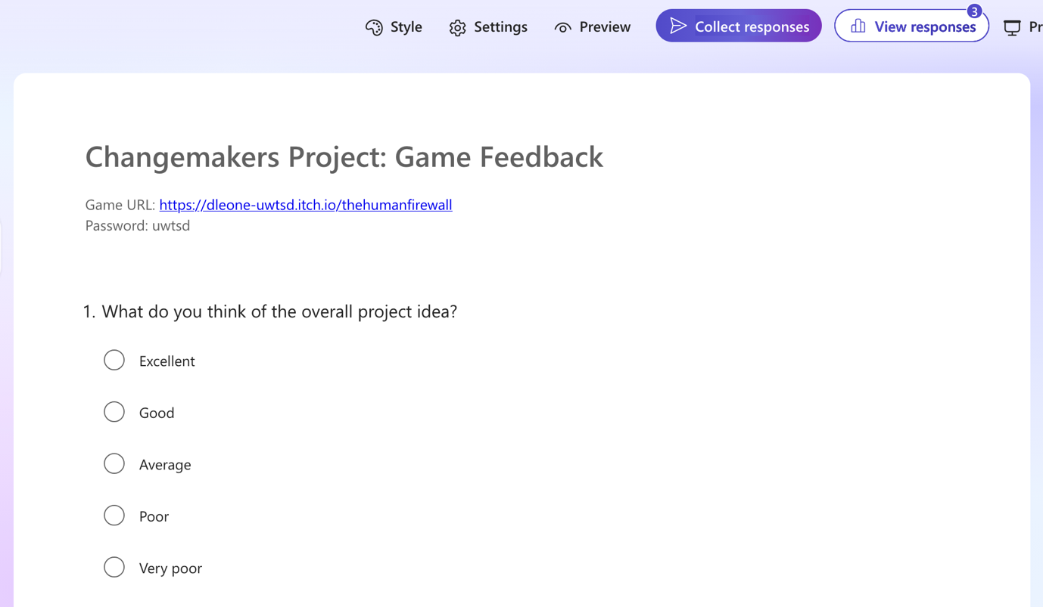
Figure 1, Gathering feedback with Microsoft Forms

2.1.2 Summary of initial Feedback
The feedback collected from the participants was generally positive, with all respondents rating the overall project idea as either good or excellent. Most participants found the concept engaging and interactive, with the majority agreeing that the gameplay could achieve its educational purpose. The realism of the initial social engineering scenario was also viewed positively. However, some areas for improvement were identified. One participant noted that the purpose of the game was not clearly communicated within the gameplay, suggesting that more explicit educational messaging may be beneficial. A selection of feedback can be seen in figure 2, below.
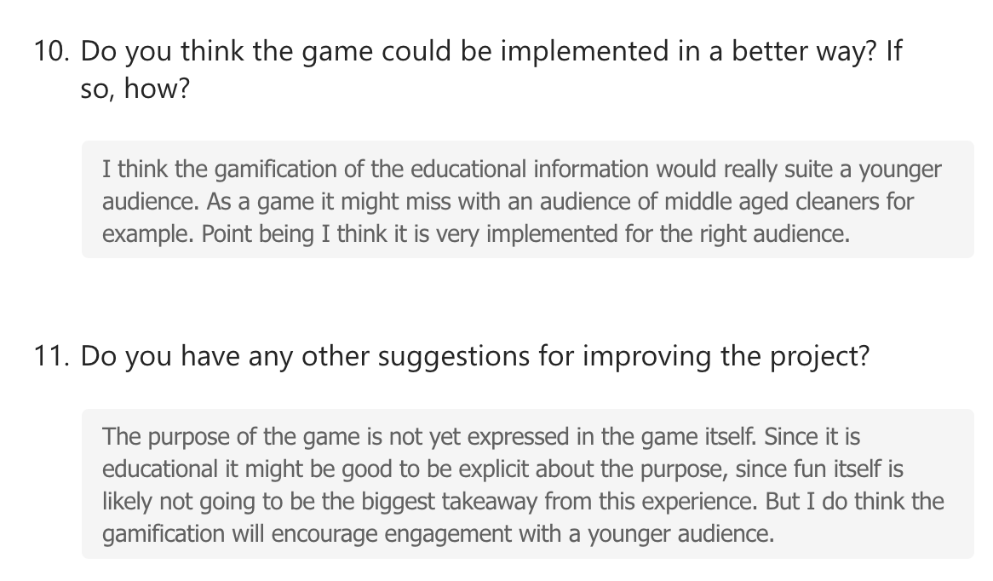
Figure 2, Key feedback gained through MSforms

2.1.3 Implementation of Feedback
Given that the initial feedback was based on a rudimental prototype, no major changes would have been necessary at this stage. Instead, the feedback was used to influence the priorities of ongoing development. In particular, the responses emphasised the need for the games objectives to retain a clear educational focus and be easy to understand. As a result, development continued with attention to keeping interactions straightforward, and considerations for how text-based instructions and feedback support user understanding.

2.2 Implementation and Practical Work

2.2.1 Tools and Technologies Used
The game was primarily developed using ‘GB Studio’ [3], with ‘Tiled’ [4] used to design scenes. An external asset pack, “Game Boy Interior Master Pack” by Royal Graphics Resources [5], was used to support scene creation and ensure visual consistency across the game.

‘Aseprite’ [6] was used in an initial attempt to design custom assets. However, achieving an appealing visual style proved challenging and time consuming. Fortunately, this challenge was anticipated during the planning stage in previous coursework, with an asset pack already identified as a contingency. A small number of custom sprites were still used, including the doorway used across all scenes and a USB drive featured in the final scene. The decision to rely on the asset pack allowed greater freedom to focus on the technical design of the game rather than artistic details [7, pp. 6-8].

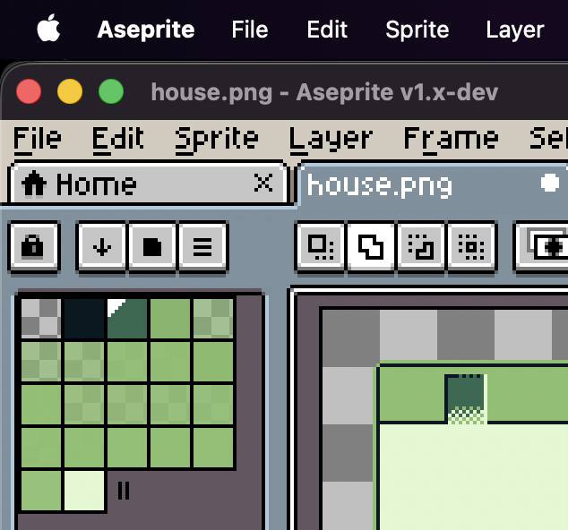
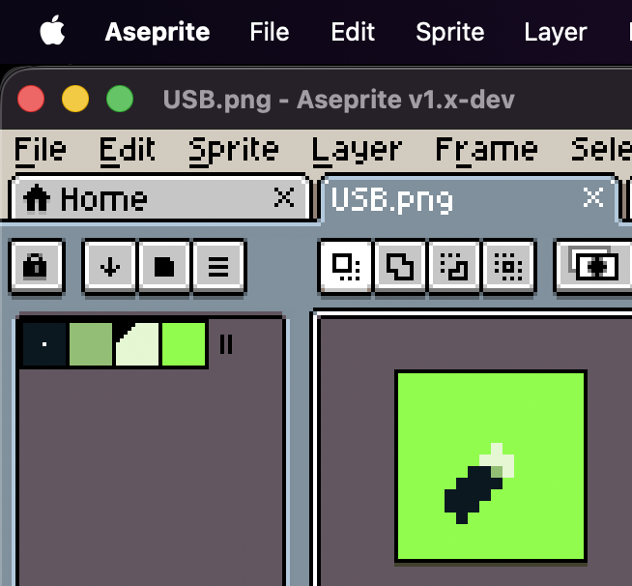
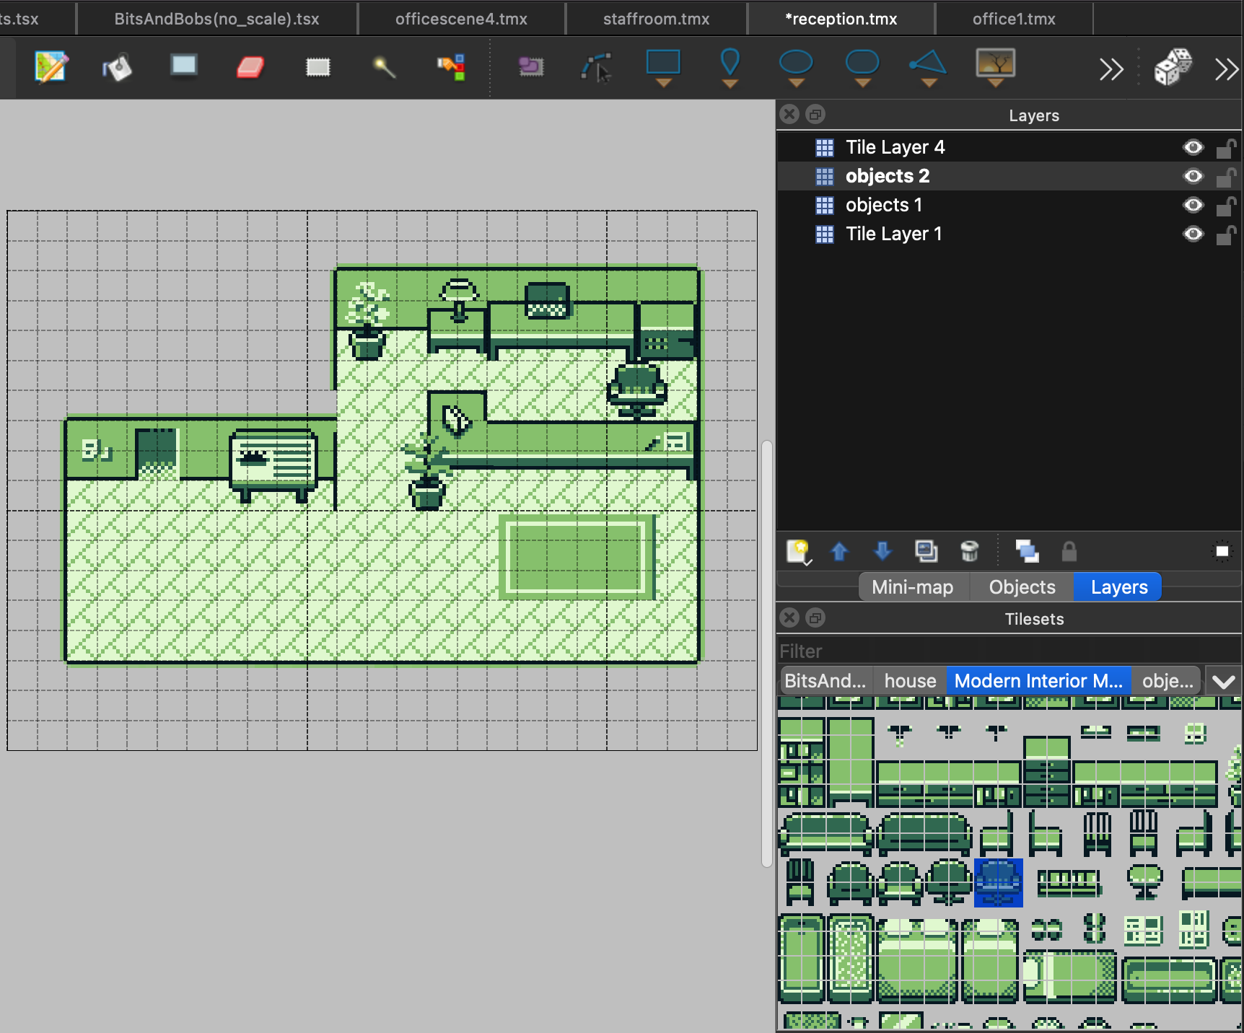
Figure 3, Using Aseprite to design assets: doorway & USB drive
Figure 4, Using Tiled to create scenes

2.2.2 Development Process and Key features
The finished prototype consists of five scenes, as well as a title screen. The title screen provides options to start a new game or continue from a saved state. Crucially, selecting “new game” resets all variables to their default values, ensuring that progress from previous sessions does not carry over to the new session, allowing for functional re-playability.
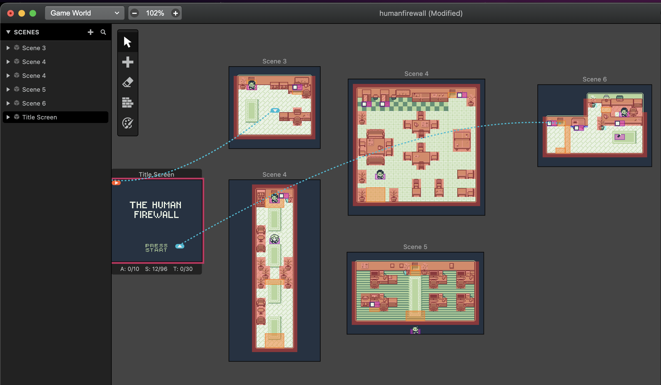
Figure 5, scenes overview

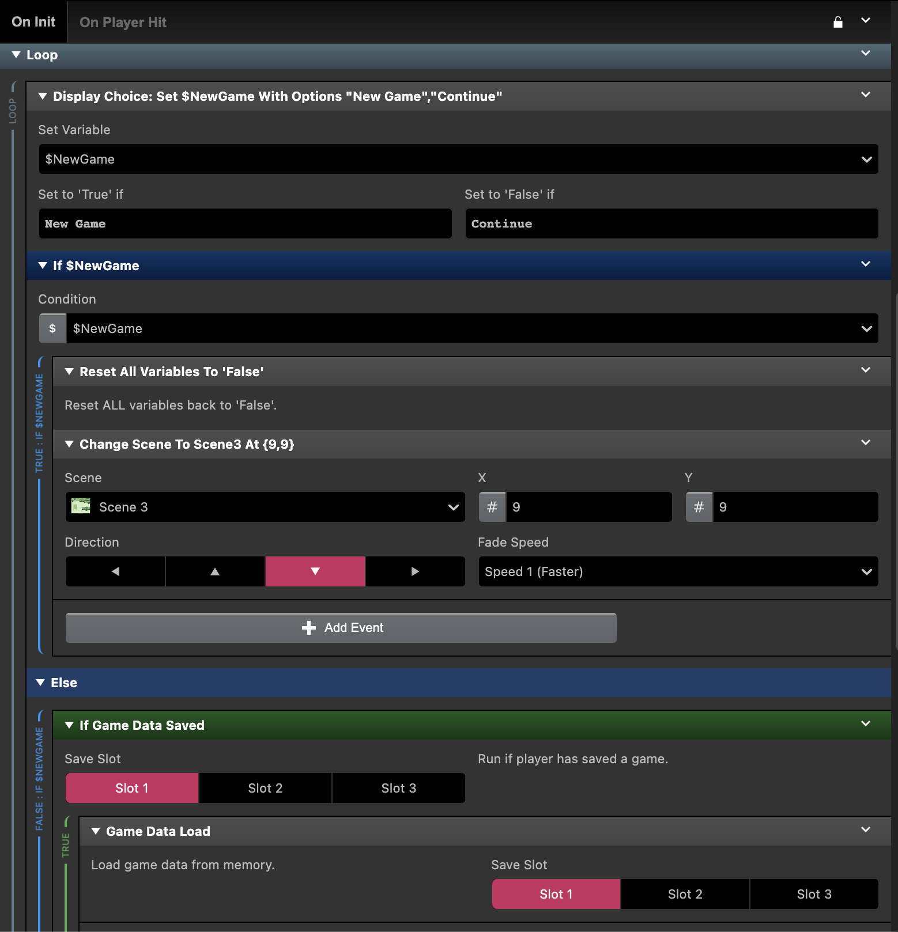
Figure 6, Save data handling example

Each playable scene required unique structured logic and event handling to achieve the desired outcomes, including managing player interactions, conditional events, and scenario progression. Due to the scale of implementation, only a limited selection of screenshots has been provided below to illustrate representative elements of the development.
Figure 7, Scene 1 programming example (1)
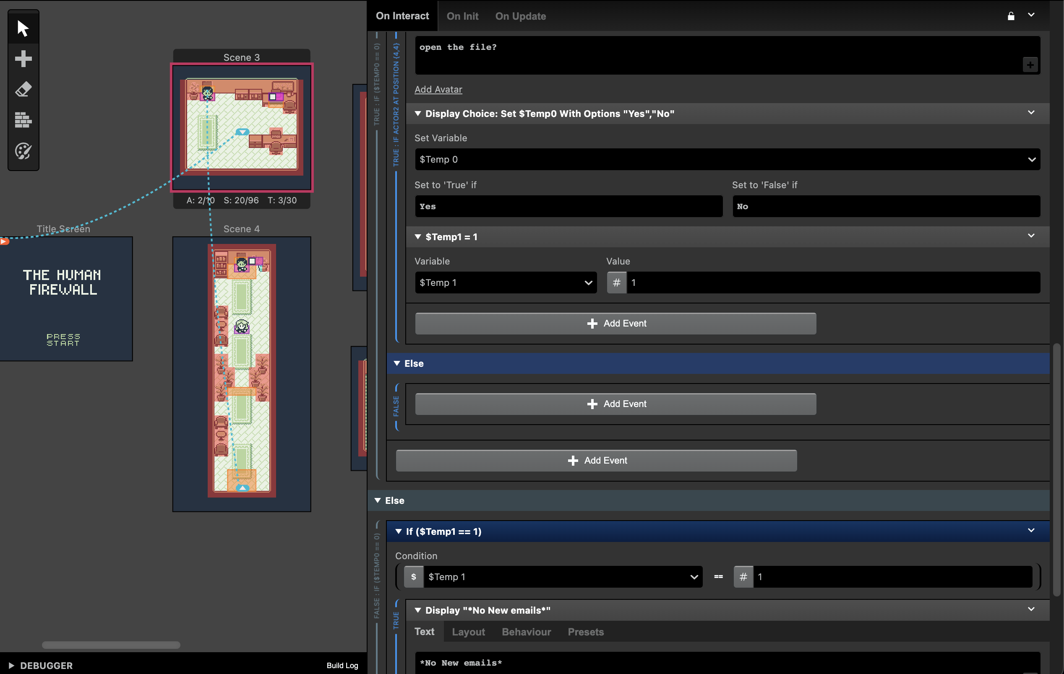
Figure 8, Scene 1 programming example (2)
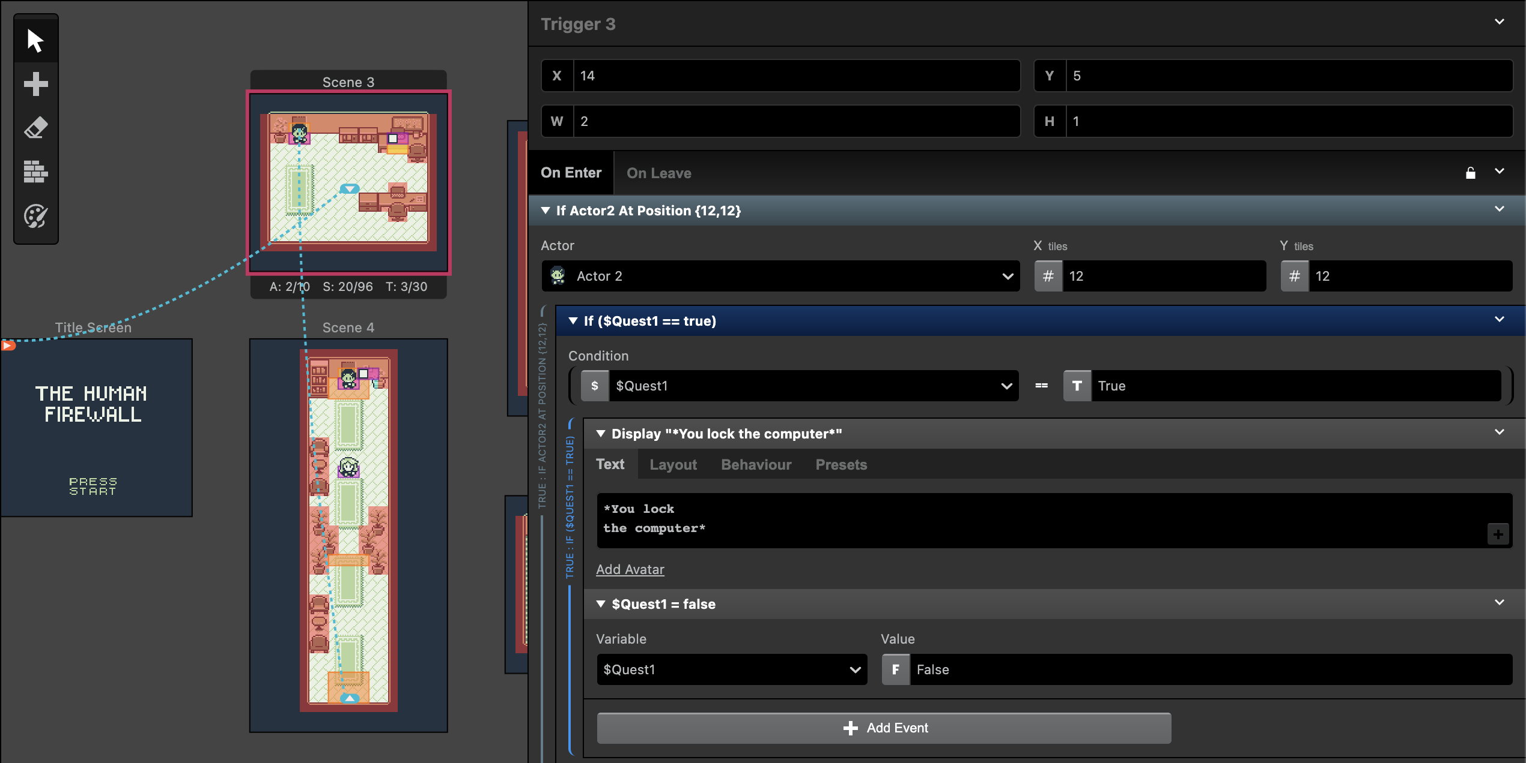

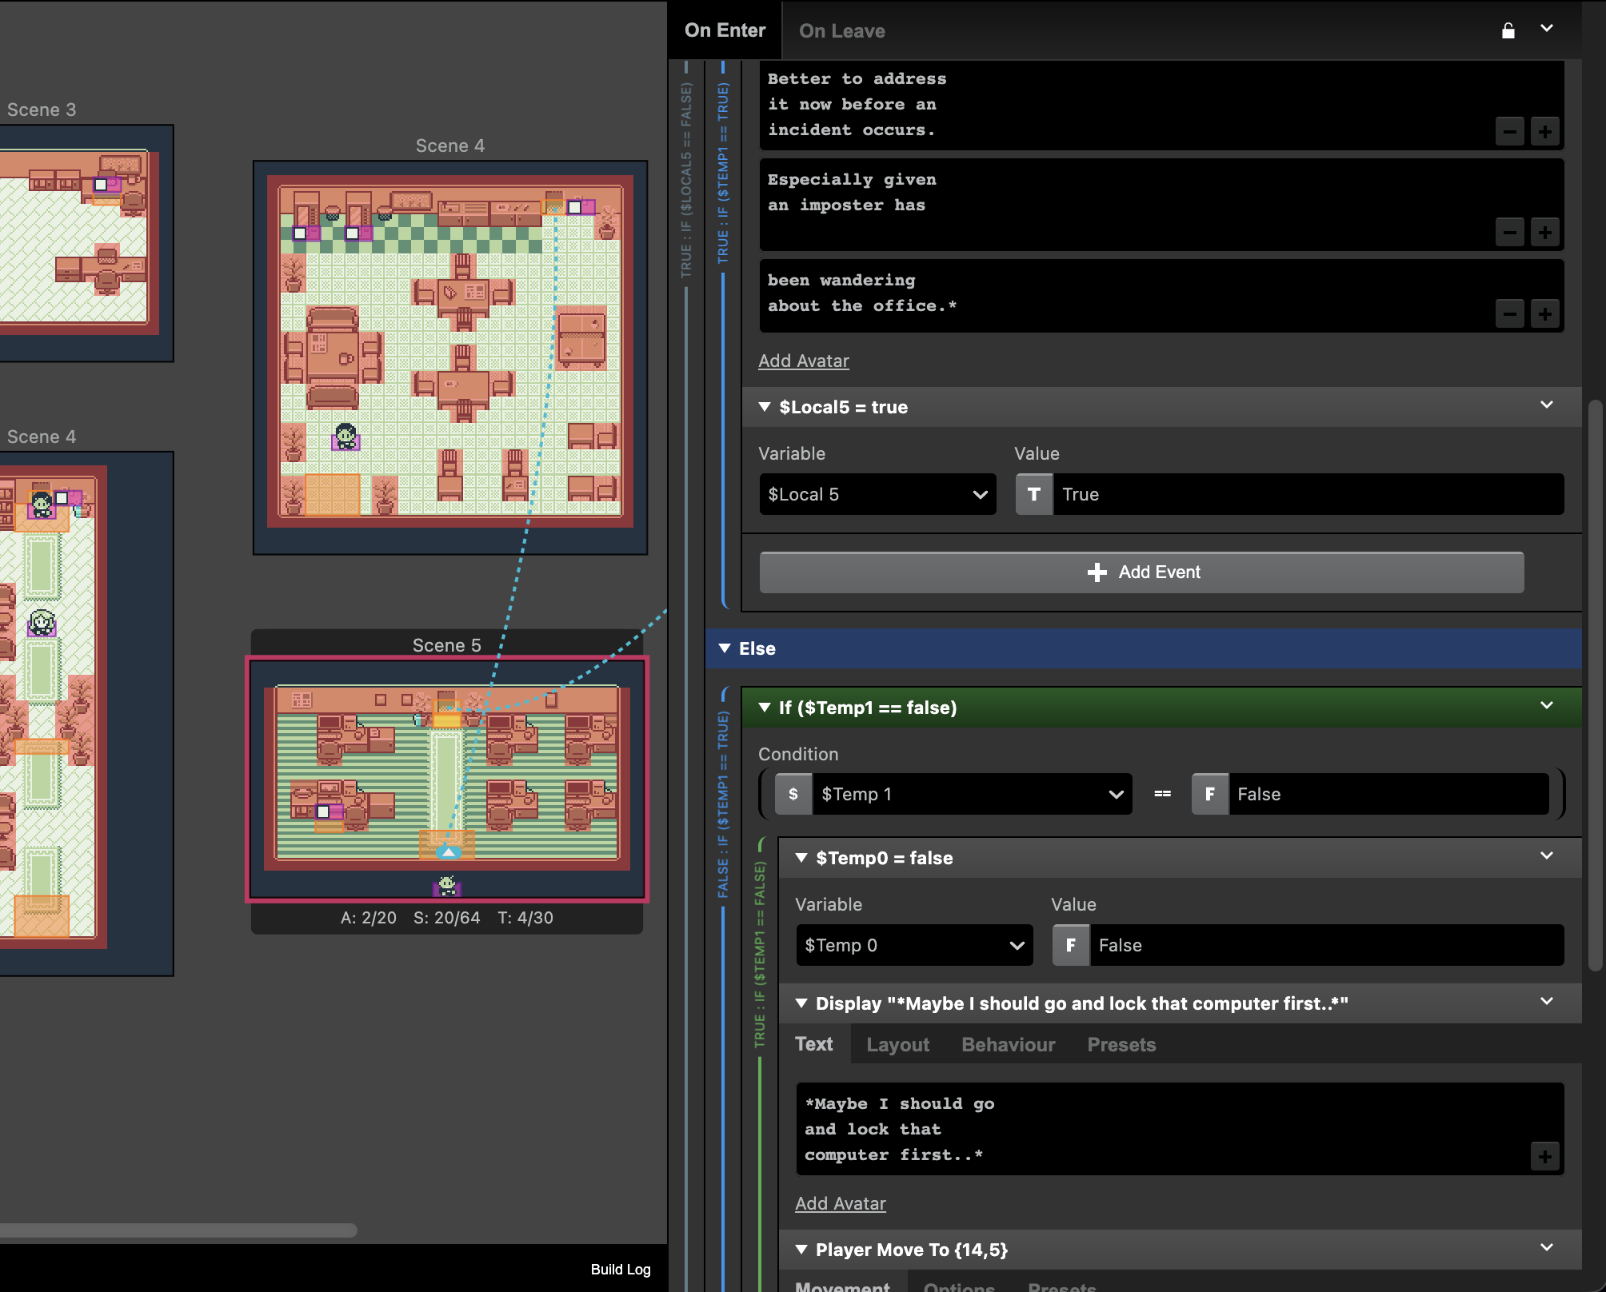
Figure 9, Scene 5 programming example

2.2.3 Troubleshooting and Challenges
A key challenge during development was managing the flow of logic, and ensuring variables were in the correct state, at the correct time to produce the intended outcome. This required careful planning of the order of operations, alongside extensive validation to account for alternative user actions. It was necessary to consider not only the intended path through each scenario, but also how the game should respond if the user played in unintended ways, such as trying to go through a door before fully completing a scenario. As a result, additional safeguards were implemented to prevent the game from breaking and to maintain a consistent experience [8] [9, pp. 11-16].
Figure 10, Validation: Preventing users from skipping scenario
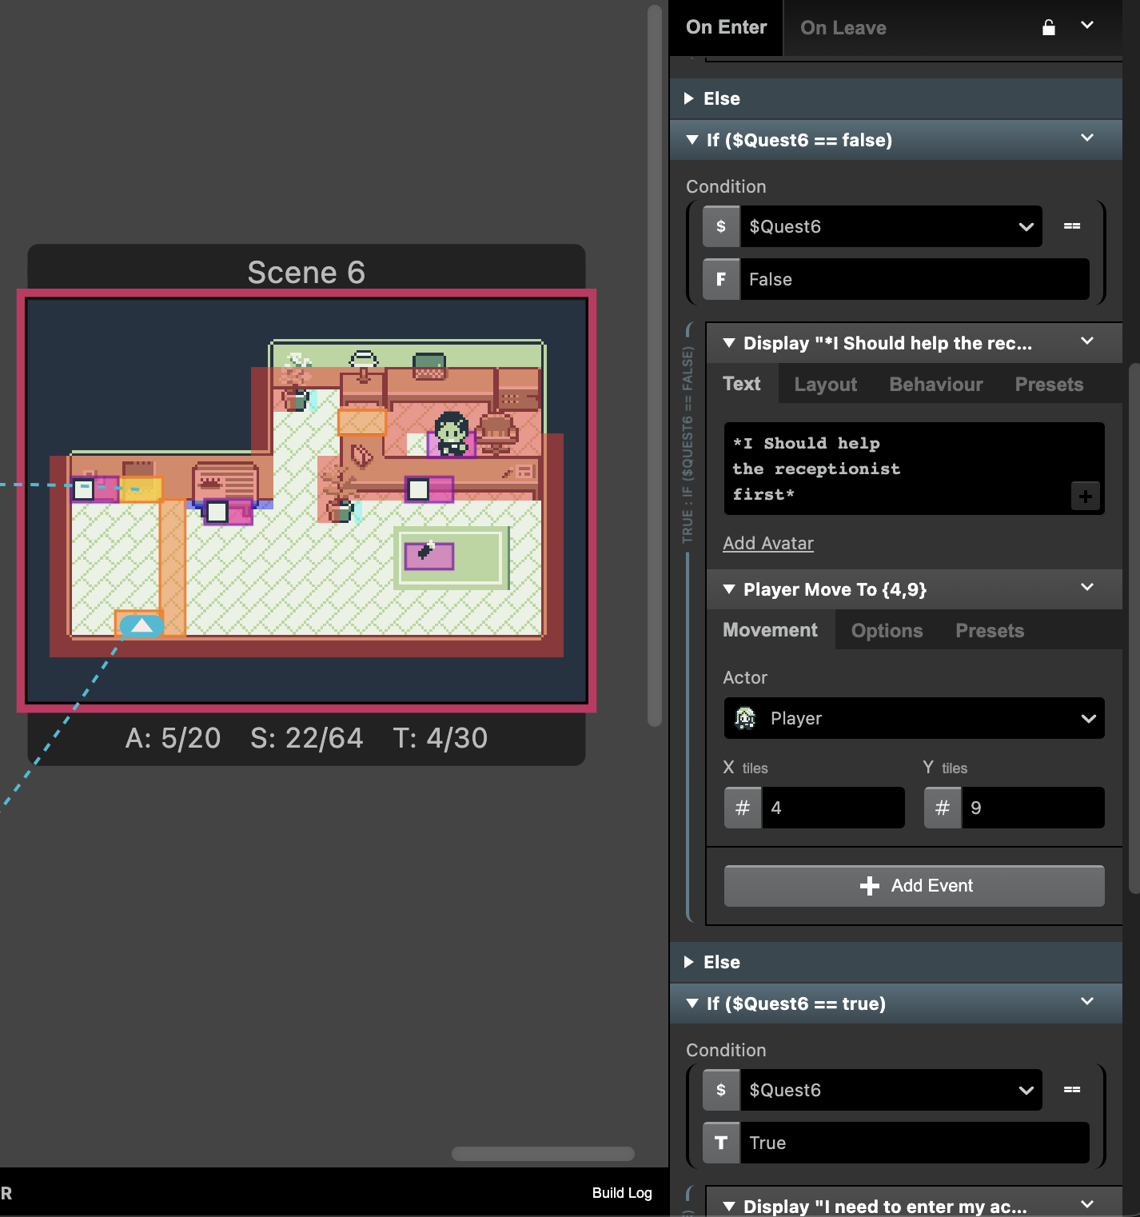

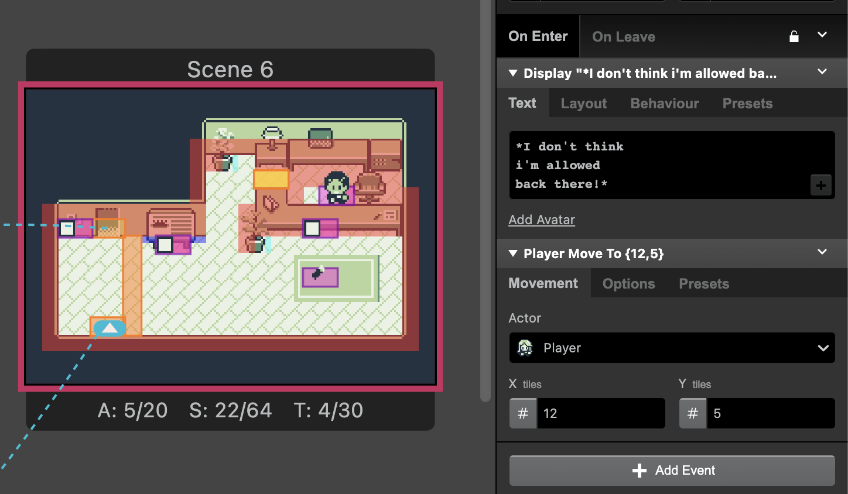
Figure 11, Validation: Preventing users from accessing restricted area

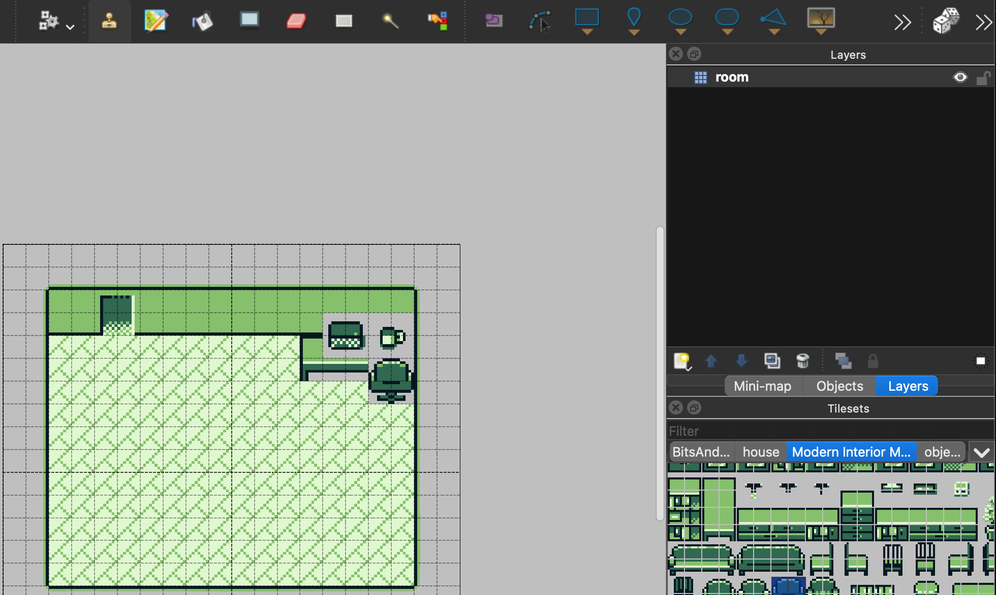
An earlier challenge arose whilst learning to use Tiled to design scenes. Initially, overlaying assets in a scene caused visual issues, where underlying floor and wall elements would disappear due to incorrect application of transparency. A post from 2016 on the Tiled forums [10] provided the solution. This issue could be resolved by introducing additional tile layers, allowing assets with transparency to be overlaid correctly. Although the solution was simple, identifying the issue was not intrinsically obvious as a total novice.
Figure 12, Layering & Transparency issue
Figure 13, Layering & Transparency resolved
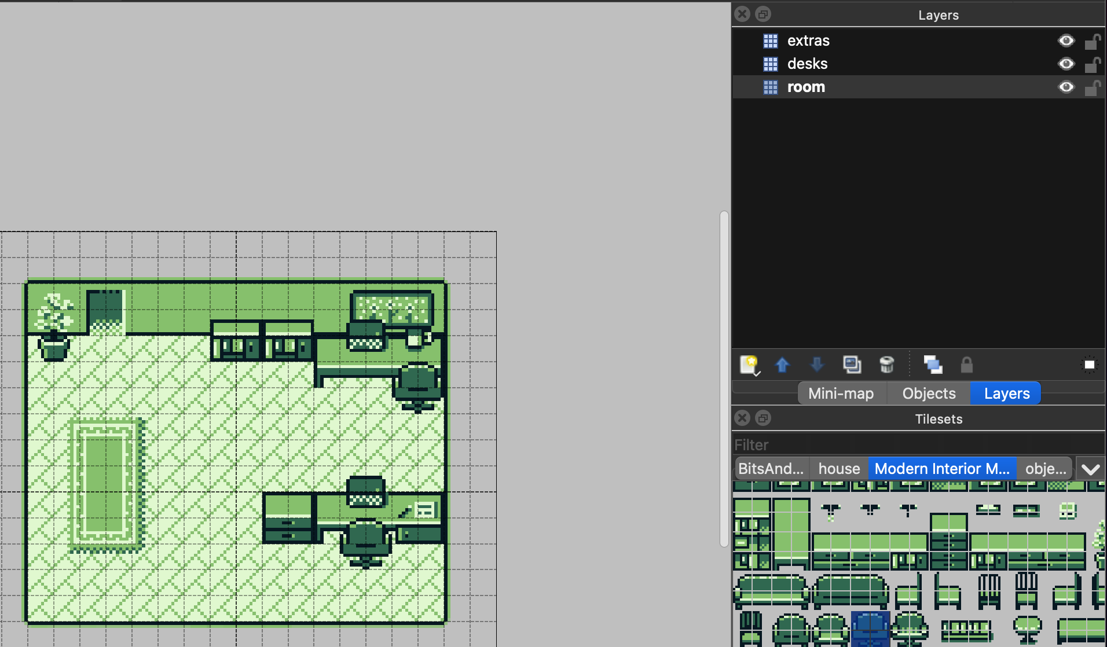
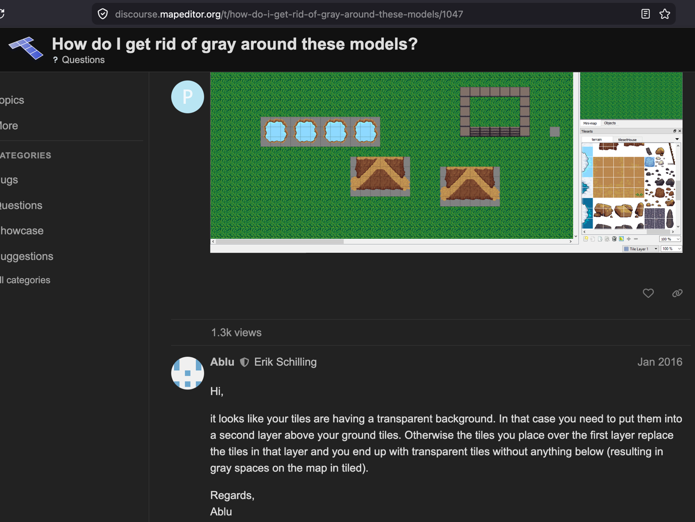
Figure 14, Solution found on Tiled Forums [10]

3. Task 2: Enterprise

3.1 Tech Start-up Proposal

3.1.1 Company Overview
To grow the project beyond a single product, the creation of a game development studio was identified as a logical progression. This would allow the concept to be expanded into a scalable business capable of producing multiple educational titles.

Company Name: Bitwise Games Ltd.
Business Type: Private Limited Company
Mission statement: ‘Transforming education through games. Play, Learn, Be a bit wiser.’
Values:
- P – Playful: Making education engaging through interactive gameplay
- I – Inclusivity: Designing accessible experiences for a wide range of users
- X – eXperience First: Prioritising intuitive, user focused design
- E – Educational Impact: Ensuring meaningful learning outcomes
- L – Learning Relevance: Reflecting real-world scenarios and applications

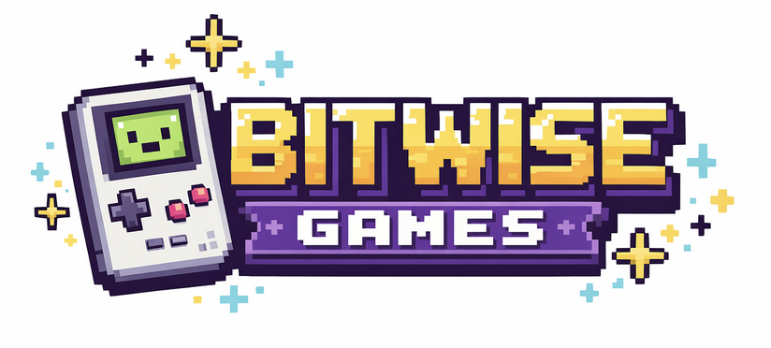
Figure 15, Bitwise Games Ltd. Company Logo [11]
The logo for Bitwise Games Ltd. was created using ChatGPT’s [11] image generation tool, using targeted prompts to achieve a fun aesthetic with a pixelated design that reflects the company’s identity.

3.1.2 Business concept
The aim of the company is to develop a portfolio of educational games that improve awareness and decision making in real-world scenarios. ‘The Human Firewall’ would be the company’s first product, focused on educating users about cybersecurity. However, the underlying concept is adaptable, allowing expansion into broader areas of educational requirements. For example, gamified training could be developed to support a wide range of organisational requirements, such as health & safety or food hygiene.

3.1.3 Business Strategy and Funding
The company would adopt a business-to-business model. A primary offer would provide access to a catalogue of existing educational games through subscription, producing a scalable source of recurring income. A secondary avenue focuses on commissioned work, where bespoke games would be developed in close collaboration with clients. These games would be uniquely tailored to meet specific organisational needs, including elements reflective of internal policies and branding, creating a more personalised learning experience. While the subscription model provides financial stability, it also serves a strategic role in building rapport with clients, creating opportunities for future commissioned work [12].

Early funding could be bolstered through initiatives such as Creative Wales, which offers grants through the Games Development Fund [13]. Securing this type of funding would support the development of an initial catalogue of games, placing the company in a strong position to attract its first clients, However, eligibility is uncertain, as the scheme appears geared toward entertainment projects, which this project may not fully align with.

3.2 PEST Analysis

3.2.1 Political
Organisations are often required to provide staff training across regulated areas, driven by legislation [14] which creates consistent demand for training solutions. This presents both an opportunity to meet a training need, but also a significant challenge as content must remain accurate and up to date with continually evolving requirements.

3.2.2 Economic
Training is often treated as a necessary expense rather than a priority, even in high-risk areas such as cybersecurity [15]. Although costly cyber incidents highlight the need for thorough training, organisations may limit spending unless clear value is recognised. A subscription model lowers the barrier of entry, however commissioned work would be inherently costly and could be viewed as an unnecessary expense.

3.2.3 Social
There would be a high expectation that training translates into real-world behaviour. This increases pressure to demonstrate effectiveness, where evidence such as reductions in security incidents would support credibility. However, outcomes may be misinterpreted, as correlations between training and incident rates do not necessarily imply causation. Trends could be attributed to the training even where other factors are responsible [16].

3.2.4 Technological
While individual browser-based games can support accessible learning, they may not meet wider organisational requirements. Larger organisations may expect integration with existing systems rather than standalone games, requiring evaluation functionality [17] [18] [19] such as tracking, analytics, and reporting. This introduces technological challenges. A completion marker and separate assessment could be implemented; however, deeper analytics, such as user progress within the game itself, are unlikely to be achievable given the limitations of the platform.

[11]

4. Task 3: Project Feedback & Reflection

4.1 Practical Feedback
The second round of feedback involved participants testing a near complete prototype of the game alongside an updated questionnaire. Participants included one returning student, an educator with experience in higher education teaching and currently leads an educational project within a large organisation. The final participant was an individual with industry experience in game design. It was particularly valuable to receive feedback from these varied and relevant perspectives.

4.1.1 Student Perspective
The returning participant found the game engaging and noted improvements from the initial version, particularly in environmental detail and interaction. However, it was highlighted that the game lacked a defined ending, resulting in an unclear sense of completion.

4.1.2 Educator Perspective
The educator recognised the potential of the approach as a more engaging alternative to traditional training, particularly compared to passive methods. It was noted that the game encourages deeper thinking, though the likely need for some form of assessment or tracking was identified for real world application.

4.1.3 Game Designer Perspective
From the game designer’s perspective, the concept and retro aesthetic were positively received, with feedback highlighting the engaging nature of learning through gameplay. Suggestions included exploring more immersive themes, storytelling and additional features.

4.1.4 Summary of feedback
The feedback raised key considerations for future development, particularly the need to incorporate assessment and tracking to support real world application, as well as further refinement of immersion, progression mechanics and including a defined ending. These observations are consistent with the current state of the project as a prototype but provide direction for how the concept could be expanded further.

4.2 Project Progress Diary Reflection
The project required ongoing planning and organisation to achieve development goals. Weekly progress sheets were used to track tasks and monitor progress, helping to keep the project on track. Through these progress sheets, it became clear that initial planning did not fully account for how the flow of the game would evolve over time. Development was not purely linear but instead often involved revisiting earlier work.

For example, when introducing a scenario involving an unattended computer, it was recognised that the player had not been required to secure their own device in the opening stage. This required revisiting the first stage design and introducing new triggers, and dialogue that had not been planned during storyboarding. This adjustment was necessary to maintain consistency and reinforce the intended learning outcome for the user.

In future, more time would be spent producing a comprehensive storyboard during the planning phase. While A basic storyboard was created to reflect an example scenario and the core gameplay loop, it did not account for how scenarios and desired learning outcomes would connect across the entire game. A more thorough approach would help ensure consistency from the beginning and reduce the need to revisit earlier stage design.

4.3 Skills Development
This project represented the author’s first experience of game development, an area that had previously seemed inaccessible. With prior experience in Python, it provided an opportunity to apply similar programming logic within a new environment. Although GB Studio uses a block-based system, it still relies on core concepts such as variables, conditional branching, and order of operations. This enabled the author to apply existing knowledge while developing a broader understanding of its application within game development.

Academically, the project contributed to the development of both technical and soft skills. Confidence increased through independent learning and creative problem solving, enabling the author to explore ideas beyond their initial comfort zone. Additionally, the project proved that game development can be more accessible than initially believed and provided a foundation of practical experience to support further exploration in this area.

4.4 Positive Social Impact
Current feedback suggests there is strong potential to positively impact cybersecurity awareness by offering a more engaging option compared to traditional training methods. Many organisations’ training approaches rely on passive learning through videos, or static content such as presentations or written materials, which produces limited engagement.
In contrast, this project uses gamification and decision making to actively involve the user in the learning process. A core design goal was for the learning outcomes to remain consistent regardless of choices made. The game intentionally allows players to select the ‘wrong’ option and to explore how each scenario unfolds. Learners are provided a safe environment to experiment, reflect and develop critical thinking skills [20] [21] [22].

5. Conclusion
This project provided an opportunity to explore game development for the first time, applying existing programming knowledge within a new context. Through this process, practical skills were developed alongside increased confidence in tackling technical and creative challenges independently.

A key outcome was recognising how an initial idea can rapidly evolve beyond its original scope into a broader concept, with potential for expansion into a commercial product, and additionally bring meaningful societal impact.

Furthermore, the project also highlighted that independent work does not necessarily mean working in isolation, as external feedback provided valuable insight that challenged assumptions and helped refine the project.

Finally, the importance of effective project management, supported through planning and progress tracking became evident. Development also required flexibility, as review would lead to ongoing refinement of earlier work, demonstrating that project development is not always linear and that adaptability is essential for meeting objectives.

6. References

[1] | BBC Bitesize, “Marketing: Market Research: Quantitative vs qualitative data - CCEA,” [Online]. Available: https://www.bbc.co.uk/bitesize/articles/z6wb239#zwv23qt. [Accessed 10 April 2026].
[2] | . L. Besishahar, “Qualitative Versus Quantitative Research,” Marsyangdi Journal, vol. 1, no. 1, 2020.
[3] | “GB Studio,” [Online]. Available: https://www.gbstudio.dev/. [Accessed 10 April 2026].
[4] | “Tiled,” [Online]. Available: https://www.mapeditor.org/. [Accessed 10 April 2026].
[5] | “Game Boy Interior Masterpack,” [Online]. Available: https://royalgraphicsresources.itch.io/game-boy-interior-master-pack. [Accessed 13 March 2026].
[6] | “Aseprite,” [Online]. Available: https://www.aseprite.org/. [Accessed 10 April 2026].
[7] | M. Hackett, How to Make a Video Game All by Yourself: 10 Steps, Just You and a Computer, Valadria, 2022.
[8] | F. Petrillo, C. Politowski and Y.-G. Guéhéneuc, “A Survey of Video Game Testing,” in IEEE/ACM International Conference on Automation of Software Test (AST), Madrid, Spain, 2021.
[9] | E. Ruuska, “QUALITY ASSURANCE TESTING IN VIDEO GAMES The importance and impact of a misunderstood industry,” 2015.
[10] | P. and E. Schilling, “How do I get rid of gray around these models?,” Tiled Forum Post, January 2016. [Online]. Available: https://discourse.mapeditor.org/t/how-do-i-get-rid-of-gray-around-these-models/1047. [Accessed 14 March 2026].
[11] | “ChatGPT - Generative AI, Private Communication,” [Online]. Available: https://chatgpt.com. [Accessed 23 March 2026].
[12] | S. Survase, “A Deeper Dive into B2B (Business-to-Business) Understanding the Dynamics of the Model,” 26 November 2024. [Online]. Available: https://www.linkedin.com/pulse/deeper-dive-b2b-business-to-business-understanding-dynamics-survase-1nhnf. [Accessed 11 April 2026].
[13] | “Games Scale Up Fund for Wales,” [Online]. Available: https://creativewales.ukgamesfund.com/. [Accessed 11 April 2026].
[14] | “Regulatory Compliance/Required Employee Training,” Journal of the California Dental Association,, vol. 49, no. 4, pp. 271-272, 2023.
[15] | A. Asen, W. Bohmayr, S. Deustchher, M. González and D. Mkrtchain, “ARE YOU SPENDING ENOUGH ON CYBERSECURITY?,” BCG, 2019.
[16] | D. Estevez, “The Correlation Fallacy: Unraveling the Illusion of Causation,” Linkedin, 21 March 2024. [Online]. Available: https://www.linkedin.com/pulse/correlation-fallacy-unraveling-illusion-causation-david-estevez-snpke. [Accessed 11 April 2026].
[17] | M. Ozturan and B. Kutlua, “Employee satisfaction of corporate e-training programs,” Procedia - Social and Behavioral Sciences, vol. 2, no. 2, p. 5561 5565, 2010.
[18] | A. M. Altwijri and T. I. A. I. Aldosemani, “Employee Perceptions of the Effectiveness of E- training to Meet Performance Evaluation Requirements,” Journal of Learning, Teaching and Educational Research, vol. 21, no. 2, pp. 49-71, 2022.
[19] | Indeed Editorial Team, “A guide to the process of evaluating training programmes,” 27 November 2025. [Online]. Available: https://uk.indeed.com/career-advice/career-development/evaluating-training-program. [Accessed 11 April 2026].
[20] | S. S. Paul, “Active and Passive Learning: A Comparison,” GRD Journals- Global Research and Development Journal for Engineering , vol. 2, no. 9, 2017.
[21] | M. A. Mahmood, M. Tariq and S. Javed, “STRATEGIES FOR ACTIVE LEARNING: AN ALTERNATIVE TO PASSIVE LEARNING,” Academic Research International, vol. 1, no. 3, 2011.
[22] | M. B. Armstrong and R. N. Landers, “Gamification of employee training and development,” International Journal of Training and Development, vol. 22, no. 2, pp. 162-169, 2018.
[23] | U. Javaid, “How Curiosity Fuels Innovation And The Path To Discovery,” 28 October 2024. [Online]. Available: https://www.forbes.com/councils/forbestechcouncil/2024/10/28/how-curiosity-fuels-innovation-and-the-path-to-discovery/. [Accessed 11 April 2026].

7. Appendices

7.1 Finished project: prototype/demo link

URL: https://dleone-uwtsd.itch.io/thehumanfirewall
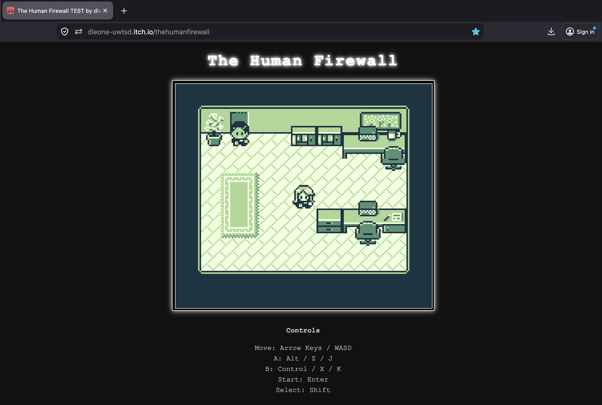
Password: uwtsd
Figure 16, Finished prototype deployed on web

7.1 Progress sheets

7.1.1 Week 1 progress form

Date: 11/03/2026

Progress:
- Rudimentary proof of concept prototype developed and deployed, includes core gameplay loop including one decision making option and branched outcomes.
- Initial tests and survey undertaken.

Actions:
- Review feedback from test participants
- Attempt to produce custom assets, or source asset pack if required as contingency
- Refine first stage design, populate level with assets like desks etc. Include Collisions.
- Will need to experiment with Collison, how the player and NPC movement deals with obstacles.

Next review date: 18/03/2026.

7.1.2 Week 2 progress form

Date: 18/03/2026

Progress:
Initial feedback was reviewed to form a better understanding of general direction of the project. Work began on refining the first stage through the addition of assets and collision. Custom asset creation was explored, however it was decided to acquire a pre-made asset pack instead. Player and NPC movement and interaction with obstacles were also tested within the newly populated environment.

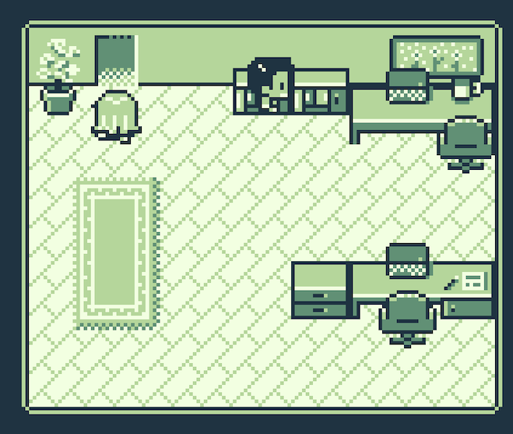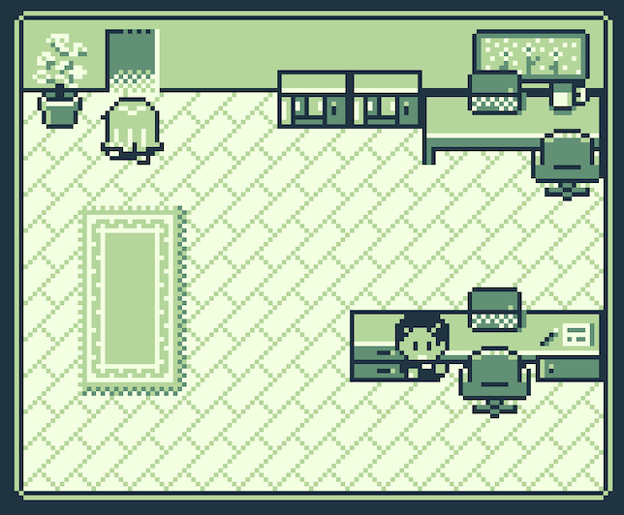

Actions:
- Resolve issues with NPC movement and collision behaviour
(NPC taking incorrect route and collision is not working for NPC as it does with player character - Turning on collision for NPC halts movement entirely so may just need to break movement into separate blocks to force correct order. E.g. block to move down first, and then second block to move to the right.
- Begin design and development of the next stage
- Implement the next scene into GB Studio, including initial event logic and interactions.

Next review date: 25/03/2026.

7.1.3 Week 3 progress form

Date: 25/03/2026

Progress:
NPC movement and collision issues were resolved, didn’t need to implement previously discussed workaround Afterall. The next scene has been designed, and work began on implementing it within GB Studio, including initial event logic and character interactions.

Actions:
- Continue developing the second stage mechanics
- Refine dialogue and feedback to improve clarity of desired learning outcome
- Test overall gameplay flow between the two stages

Next review date: 01/04/2026.

7.1.4 Week 4 progress form

Date: 01/04/2026

Progress:
The second stage was completed. Testing across the first two stages confirmed that progression worked as desired, with scenarios flowing logically between stages.

Actions:
- Design third scene, this will likely be the largest area. Explore what’s possible with larger scenes and more assets to create an immersive environment.
- Begin implementation of the third stage in GB studio (must include branch dialogue with NPC, dependent on outcome of previous stage)
- Explore adding some interactive objects like vending machines, these will be unrelated to the main game objective.
- Begin design of fourth scene

Next review date: 08/04/2026.

7.1.5 Week 5 progress form

Date: 08/04/2026

Progress:
The third stage was designed and implemented, including branching dialogue linked to previous player decision in scene 2. Additional interactive elements were introduced to enhance environmental detail and make the scene feel more immersive. Fourth scene designed and implemented including programming logic.
It was recognised during testing that learning outcomes between stages had not remained consistent. Scene 4 contradicted players (in)action in scene 1.

Actions:
- Revisit stage 1 to incorporate conditions and triggers which prevent player from progressing until they lock their own computer.
- Test flow of game, refine interactions if necessary
- Begin design of scene 5.

Next review date: 15/04/2026.

7.1.6 Week 6 progress form

Date: 15/04/2026

Progress:
- Corrected educational inconsistency between stages 1 and 4. Designed scene 5 and began implementing in GB studio. Created and tested a sprite for an object (USB drive). Testing how player can interact with it in a meaningful way, such as picking it up and how this can successfully be incorporated into the scenario gameplay.

Actions:
- Finalise development of scene 5
- Gather feedback for the near complete prototype by contacting identified participants. Desired individuals include a student, an educator, and an individual with game design experience in industry.
- Upload newest build to itch.io, ready for external testers
- Produce refined questionnaire to accompany testing

Next review date: 22/04/2026.

7.1.7 Week 7 progress form

Date: 22/04/2026

Progress:
- Completed development of scene 5.
- Corrected a couple minor consistency issues, including a missing event trigger to automatically move player away from door in scene 3 (Where it asks for door code, but player remained within the doorway). Not game breaking but wasn’t consistent with behaviour implemented to locked door in scene 5).
- Implemented solution to allow functional continuation of game saves and new game sessions through title scene.
- Implemented automated game save triggers in all five scenes
- Gathered feedback through updated survey and participants
- Personally conducted thorough QA testing, exploring all possible decision paths to identify potential issues, no bugs were identified.

Actions:
At this stage, the prototype is considered complete, and focus will shift towards project reflection, evaluation of feedback, considerations for further development, and reflection on personal learning outcomes.

7.2 Survey results
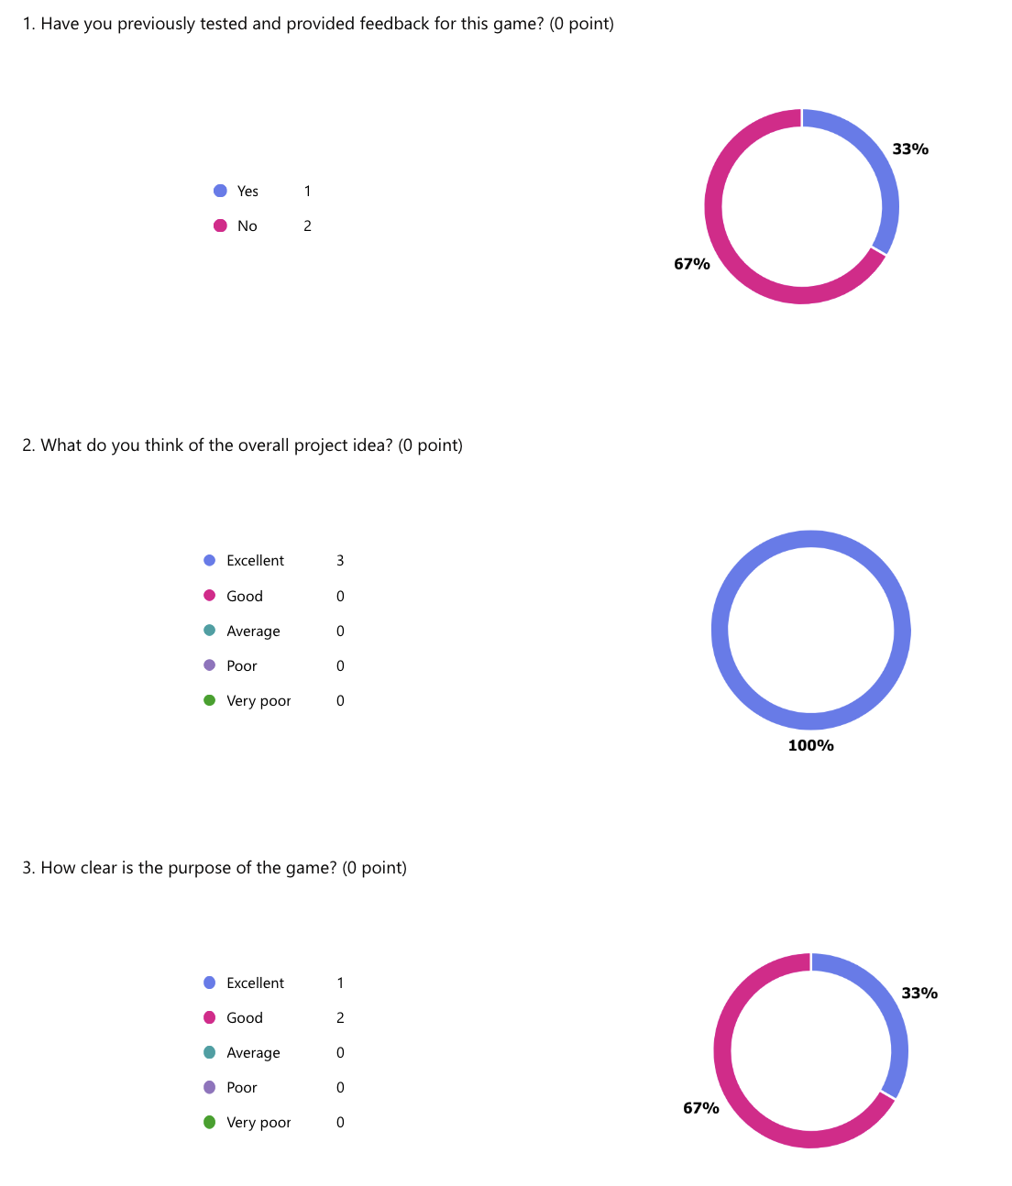
The following screenshots detail a selection of survey results from the final phase of testing.
Figure 17, Survey Results

Figure 18, Survey Results
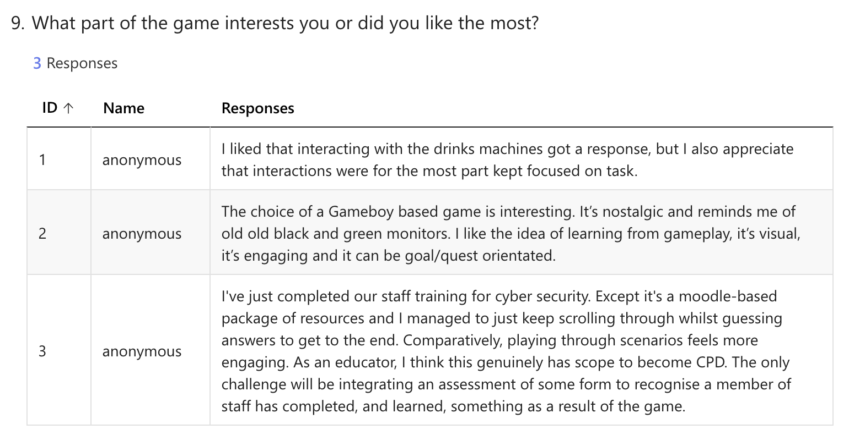

Figure 19, Survey Results
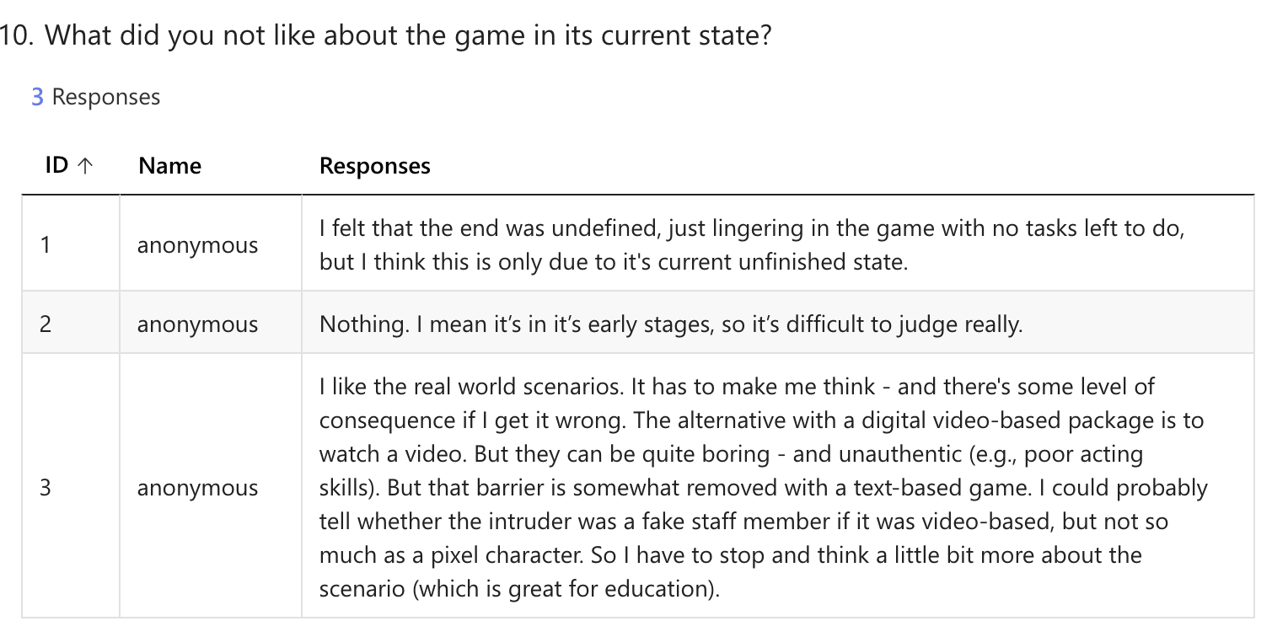

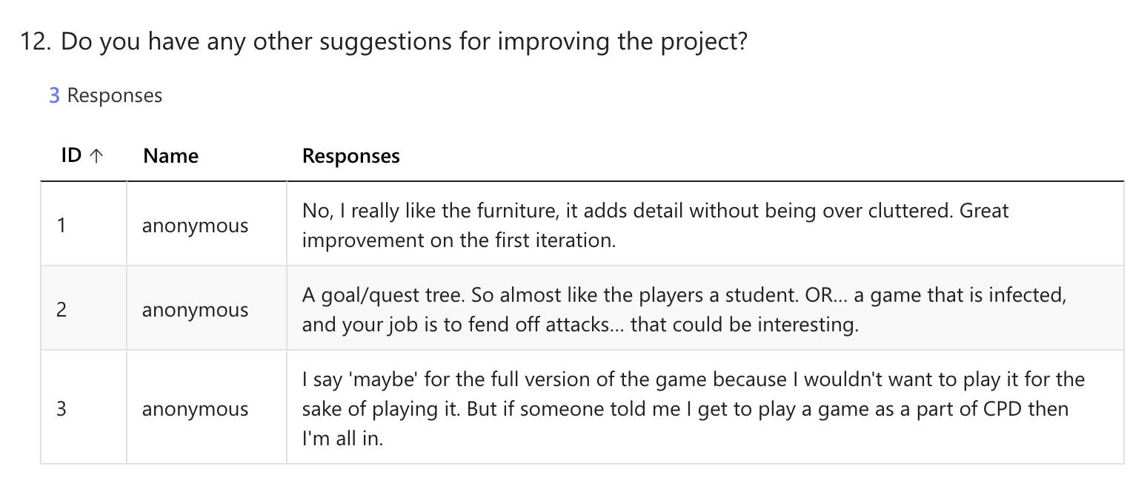
Figure 20, Survey Results

7.3 Testing on native hardware

7.3.1 Summary of Experimental Testing
Although the project was designed with accessible deployment as a core requirement, the author also explored running the game on its’ native hardware platform.

This test provides little value toward the wider objectives of the project but was undertaken out of curiosity to compare how the game would perform on original hardware versus the browser-based emulator solution.

This form of experimentation reflects the role of curiosity in fuelling innovation [23], where ideas can be extended beyond their planned scope simply to explore them further. Despite not being driven by a specific goal, this type of experimentation could lead to new insights and ideas.

7.3.2 Testing outcome

YouTube video link:
https://www.youtube.com/watch?v=aQ-jf1p_itQ

Screenshots from video:

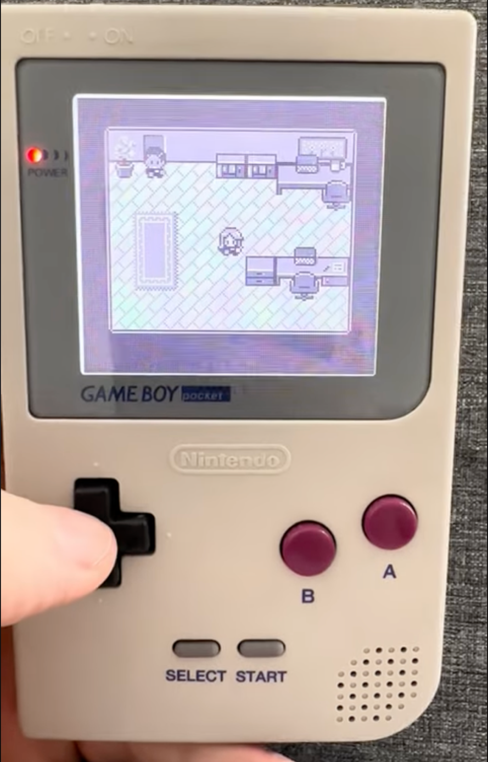

Figure 21, Testing on native hardware

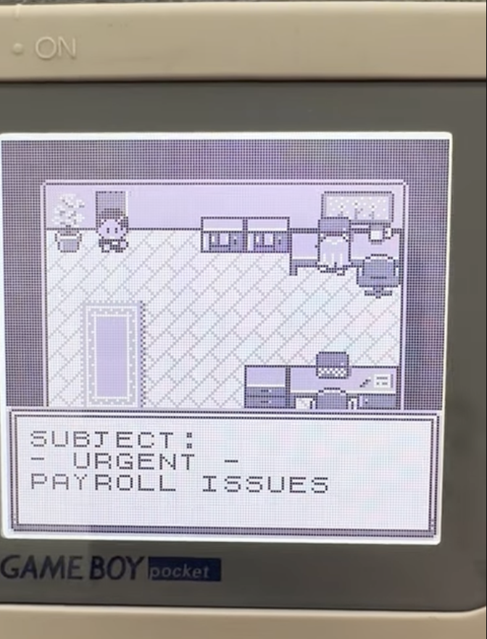
Figure 22, Testing on native hardware

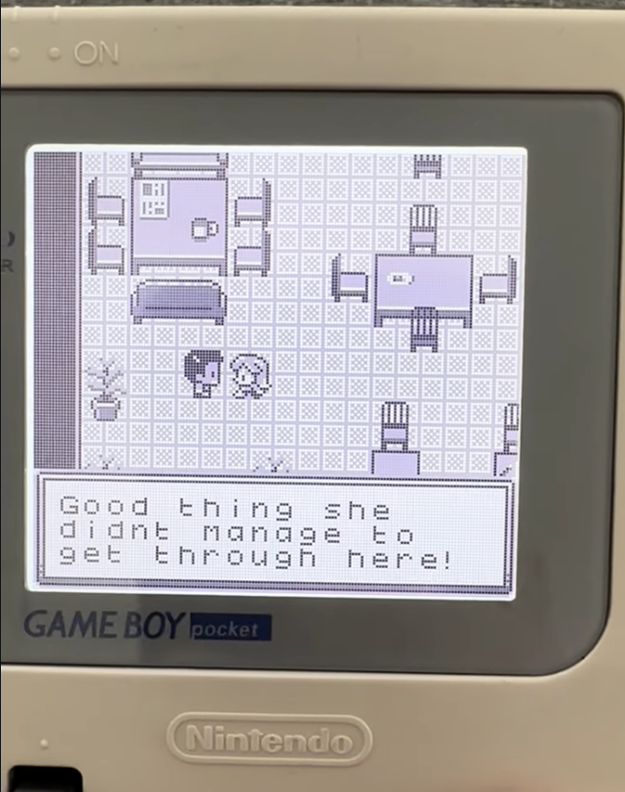
Figure 23, Testing on native hardware

7.4 Continuing Professional Development

Figure 24, CPD: Linkedin Learning course
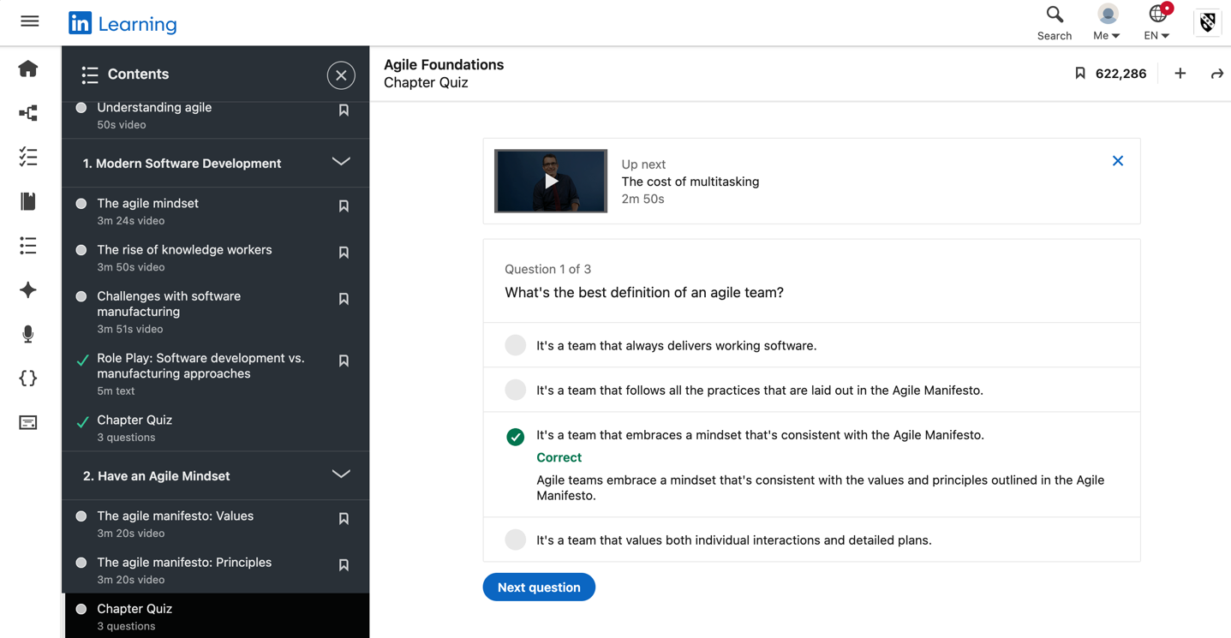
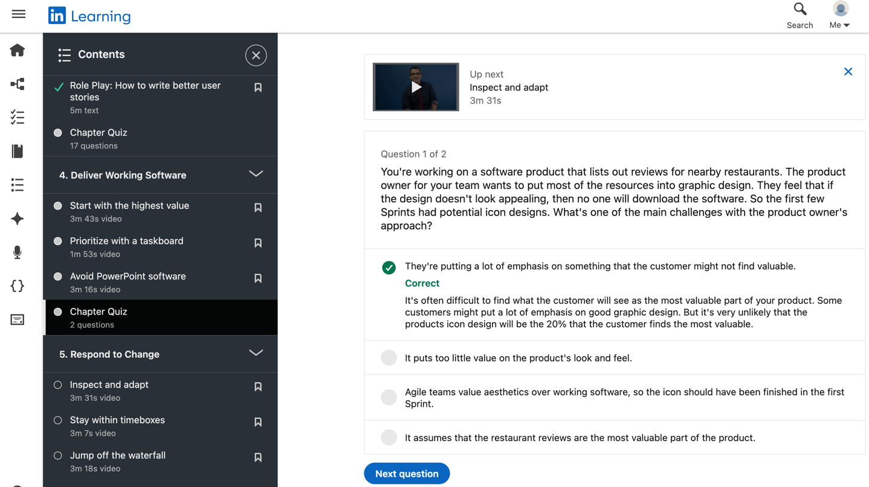
Figure 25, CPD: Linkedin Learning course

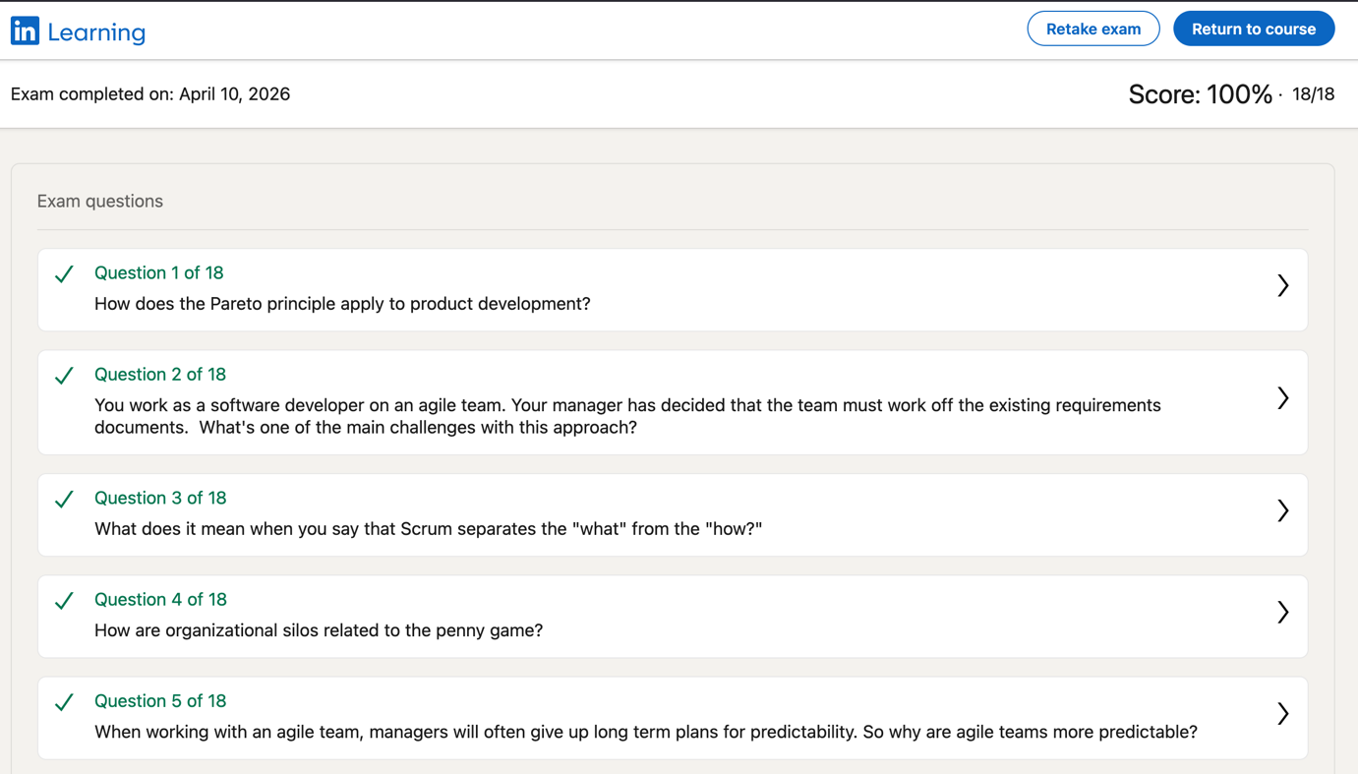
Figure 26, CPD: Linkedin Learning course

