Data Handling and Business Intelligence
LCBB5000

Mihaela Boicu
Student ID: 2223393
Table of Contents
Section 1 3
Introduction 3
Descriptive statistics 3
Presenting data by using pivot charts 7
Correlation analysis 9
Scatter Plot 12
Conclusion of the analysis 14
Section 2 15
a) Advantages and Disadvantages of Using SPSS, Excel, and Tableau 15
SPSS 15
Advantages 15
Disadvantages 15
Microsoft Excel 16
Advantages 16
Disadvantages 16
Tableau 17
Advantages 17
Disadvantages 17
b) Understanding and Role of Data Mining Cycle 17
Problem Definition 18
Data Preparation 18
Data Exploration 18
Modelling 18
Evaluation 18
Deployment 19
Monitoring and Maintenance 19
Importance of the Data Mining Cycle 19
Informed Decision-Making 19
Efficiency and Productivity 19
Competitive Advantage 19
Cost Savings 20
Innovation and Growth 20
References 21

Section 1

Introduction
The data set applied in this particular analysis was derived from the study on student performance, whereby scores in reading, writing and mathematics were compiled for a sample of 1000 students. The analysis of this case will seek to identify and display numerous descriptive measures like the mean, median, mode, standard deviation, and variance based on the observations of the given scores. These statistical measures will assist in giving a quick and direct representation of the data through means, medians, mode and range, allowable variability, and overall student performance.
Besides descriptive statistics, the research study will apply Microsoft Excel to create pivot tables and charts to easily identify the scores and compare various groups. Thus, applying pivot charts will help make the data analysis clear and comprehensible and reveal patterns in the dataset.
In addition, a correlation test between reading and writing scores will be conducted using the statistical testing tool SPSS. This direction and strength amount will assist in defining the relation between these two variables. The companion scatter plot will also be created to better understand this relationship and get an immediate vision of how the scores are connected.
In other words, the overall aim of this study is to give a descriptive analysis of the district student achievement and, for this purpose, shall be using built-in analysis tools of Excel and SPSS to get the statistics out of the data being used. This will help get ideas regarding faculties and literature regarding a particular student's strengths and weaknesses, which in turn may help in framing educational strategies to improve the student's results. The results are then presented and explained, providing cardinal observations and suggestions from the analysis.

Descriptive statistics
 | Math score | Reading score | Writing score
Valid | 1000 | 1000 | 1000
Missing | 0 | 0 | 0
Mean | 66.0890 | 69.1690 | 68.0540
Median | 66.0000 | 70.0000 | 69.0000
Mode | 65.00 | 72.00 | 74.00
Std. Deviation | 15.16308 | 14.60019 | 15.19566
Variance | 229.919 | 213.166 | 230.908
- What is the mean value for the reading score?
The mean value for the reading score is 69.1690. It means that if sum up all the values of reading scores and divided by the number of scores (1000), it will provide approximately 69.169 mean value.
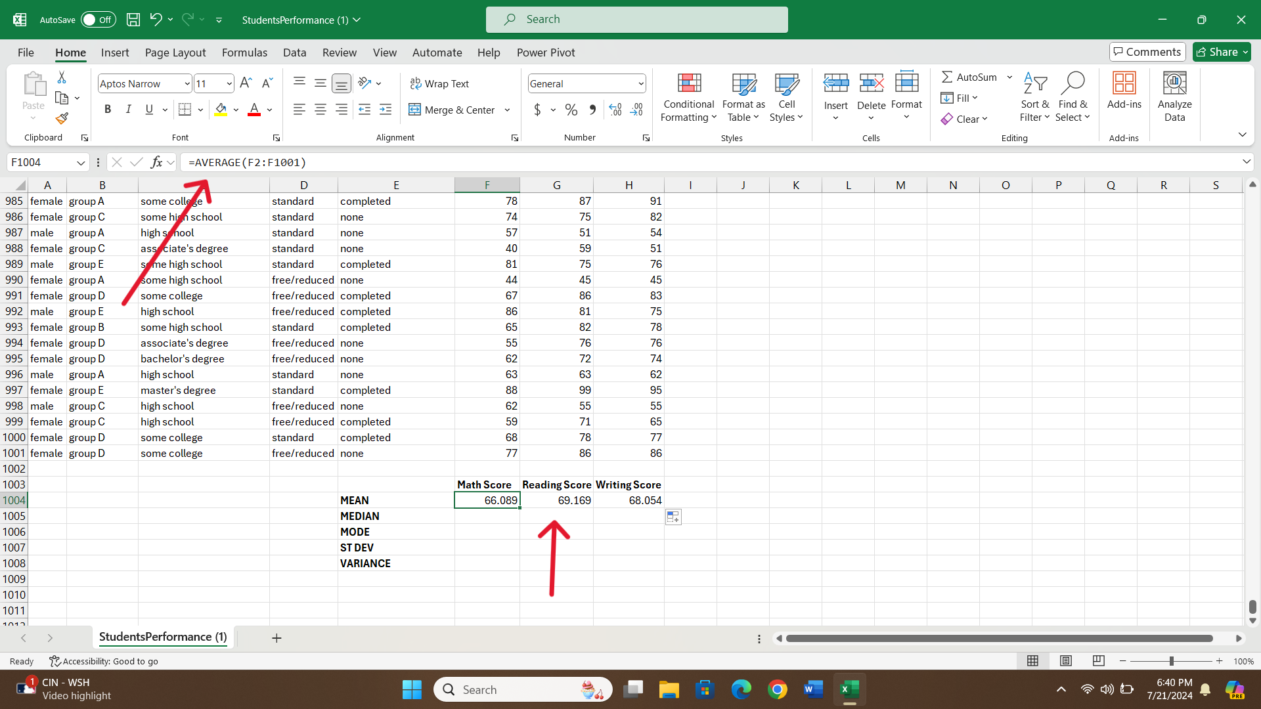
- What is the median value for reading scores?
The median value is the middle value when the reading scores are arranged in ascending order. The median value for reading scores is 70. This suggests that half of the students score above 70 and half of the students score below 70.
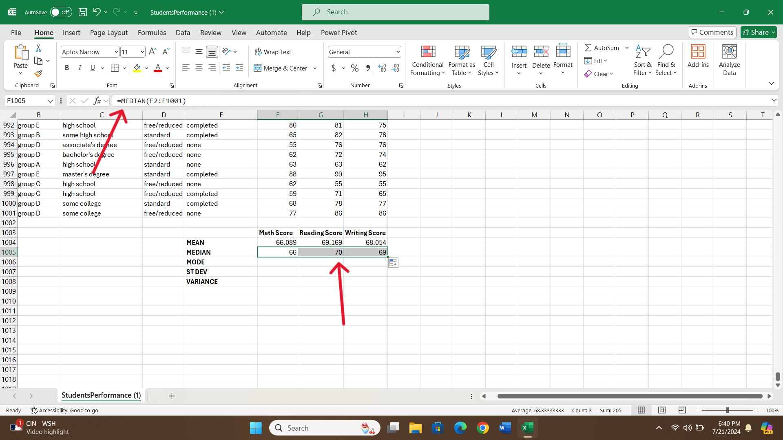
- What is the mode of the reading score?
The mode is the most frequently used number in the dataset. In case of reading score, the mode is 72, which indicates that it appears most in the dataset.
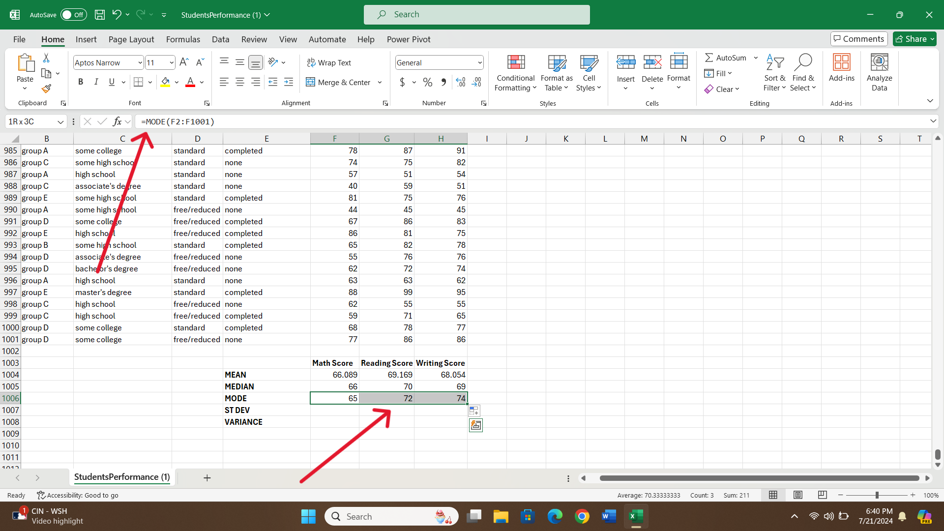
- What is the standard deviation for writing scores?
A standard deviation is a measure of how dispersed the data is about the mean. A higher SD indicates that the writing scores are most dispersed from the mean. The standard deviation for writing scores is 15.195, which indicates that on average, writing scores vary by 15.195 points from the mean value (68.054).
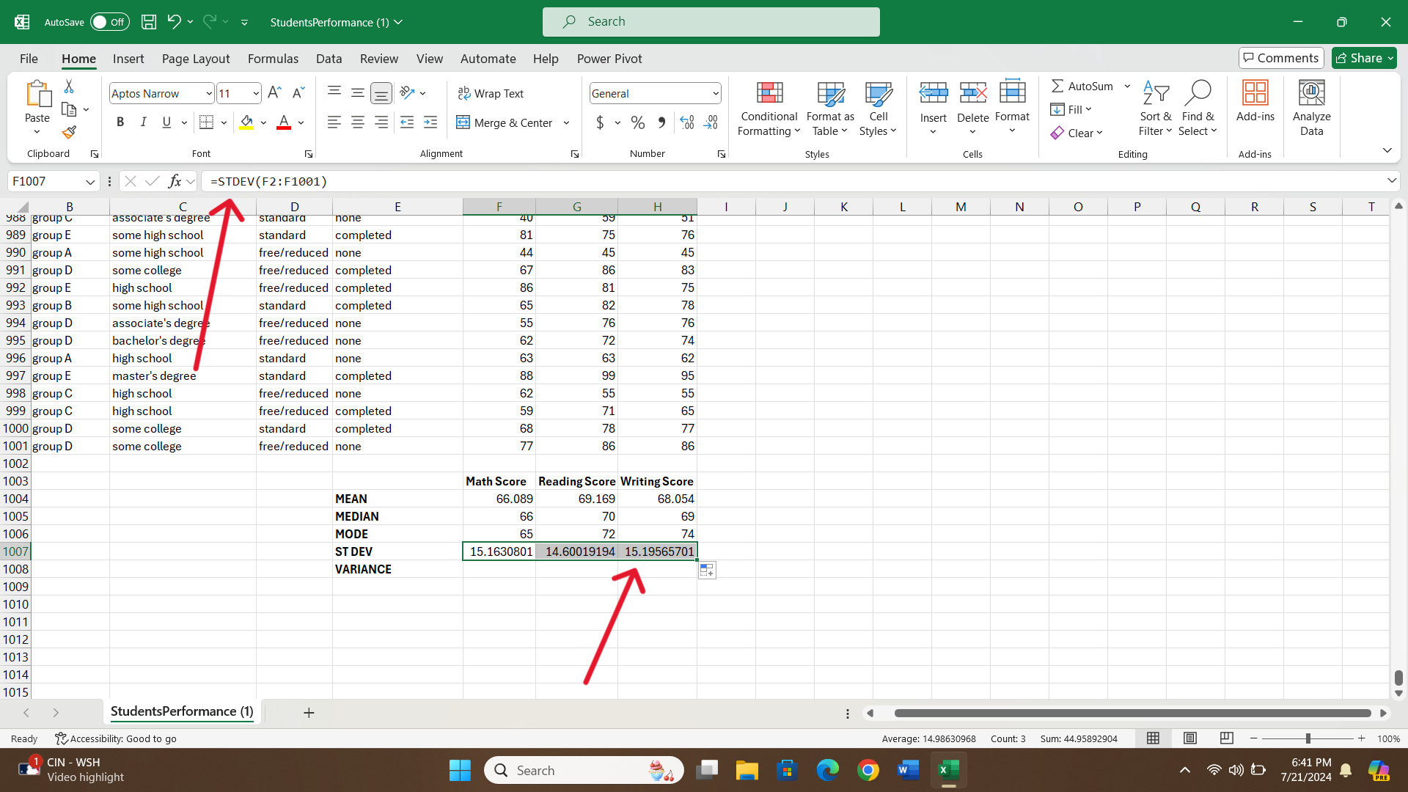
- Which one of the variables has a larger variance?
Variance is also a measure of dispersion. The results indicate that writing scores have the largest variance of 230.908. which indicates that writing score has the most variability among the three sets of scores.
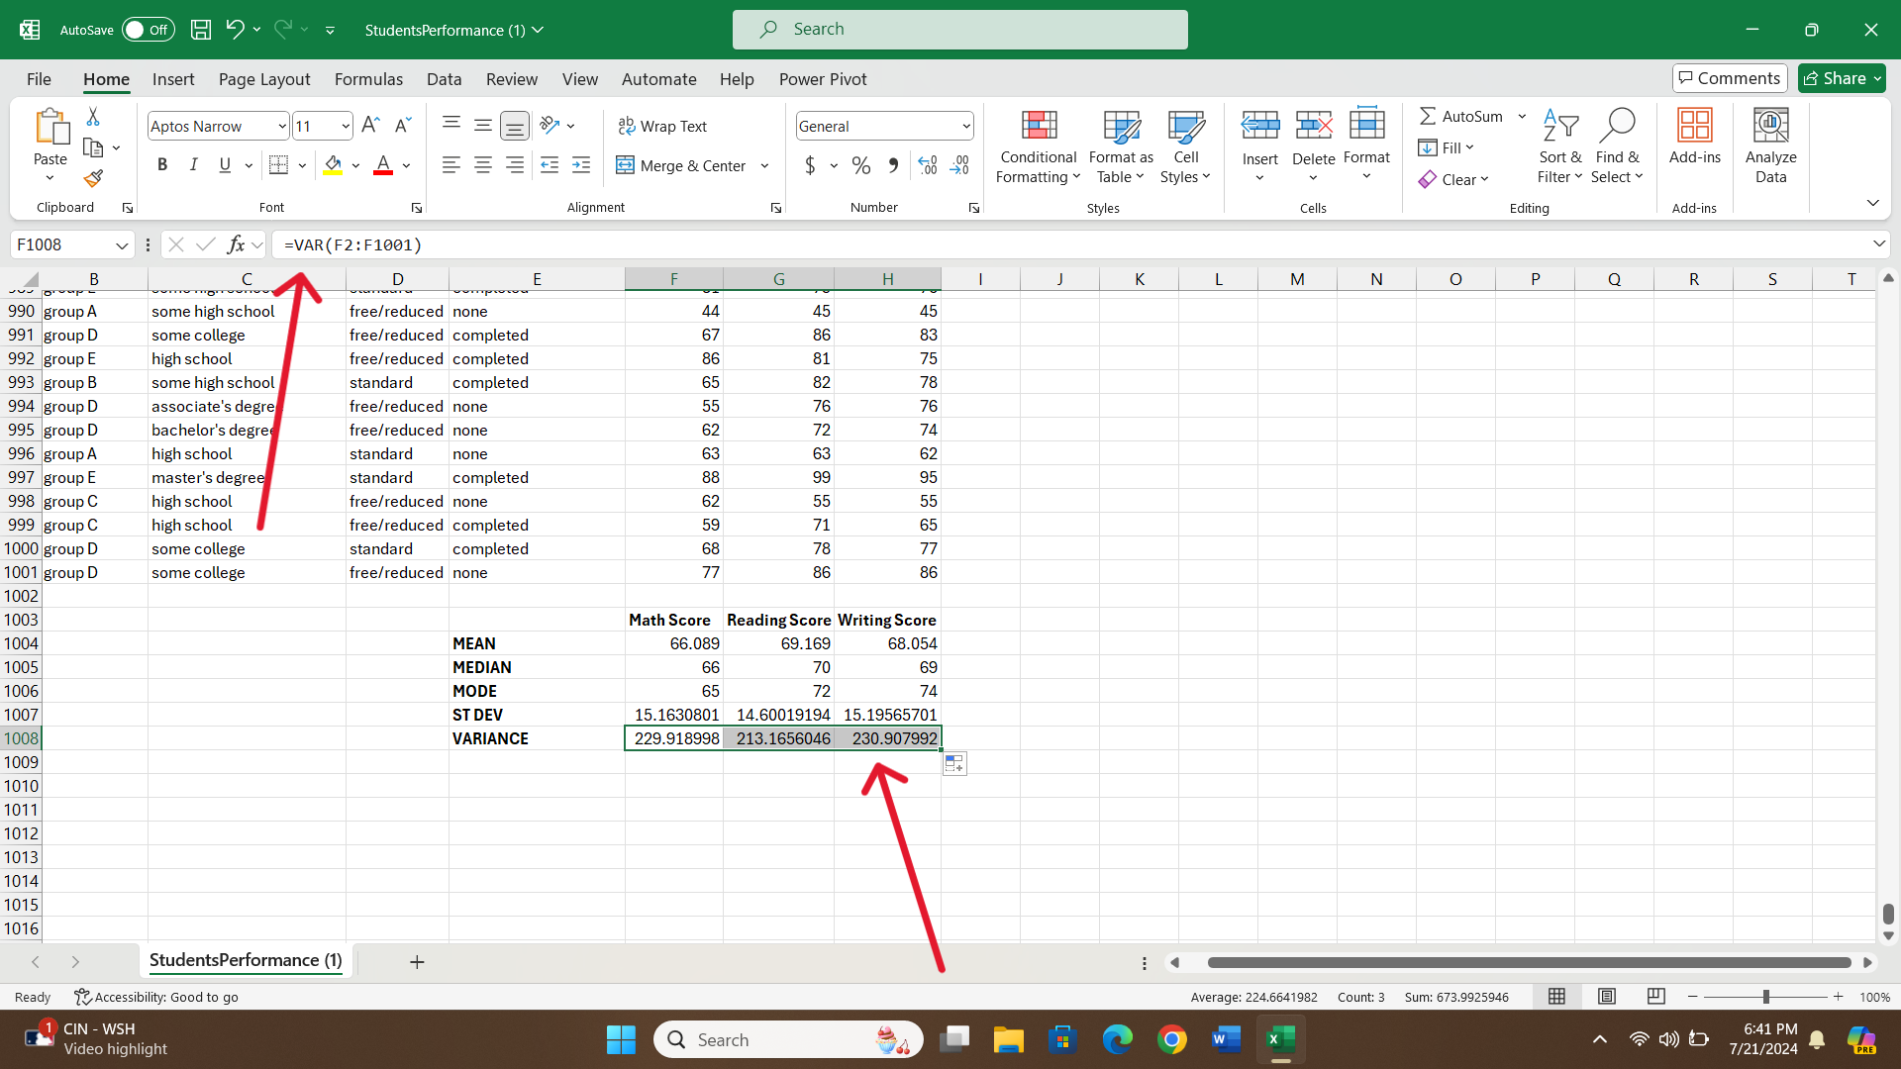
- Which one of the variables has a larger standard deviation?
The writing score has the largest standard deviation of 15.195 which means the highest spread in scores compared to reading score and math score.
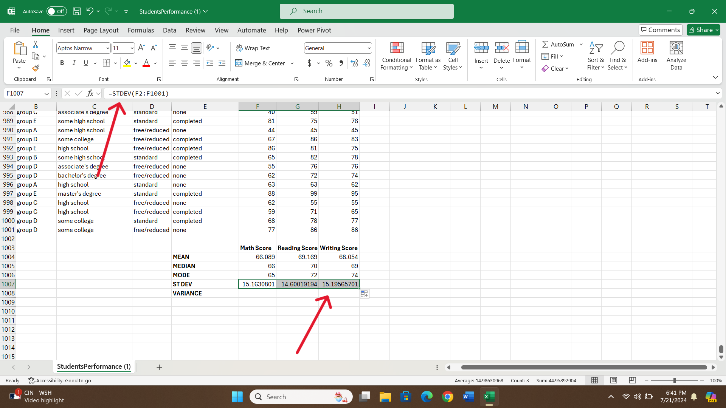
- Can you interpret the last three outcomes?
Writing scores have the highest variance (230.908) and standard deviation (15.195), which indicates that the writing scores are more spread out than the other variables around the mean of (68.054). This suggests more diverse writing abilities among different students.
Math score has a variance of 229.919 with a standard deviation of 15.163. While the writing score has a variance of 230.90 with a standard deviation of 15.195 which is higher than the math scores. This means that the spread is somewhat lower, yet still significant, around the mean of 66.089 in math scores.
The reading score has the lowest value of variance (213.166) followed by a standard deviation of 14.600, which describes that the reading scores are less dispersed around the mean of 69.169. This means that the students have lesser variation in their reading abilities.

Presenting data by using pivot charts

The chart represents the sum of scores for different race/ethnic groups. The aim of using pivot charts is to understand the performance across these groups. The chart shows that Group C has the highest performance while Group A has the lowest performance among all groups. It is obvious that Group C performs well in all manners, followed by Group D which is second best performing among all groups. Group A has the lowest performance which needs some improvements. The chart shows significant variations in performance around different ethnic groups.
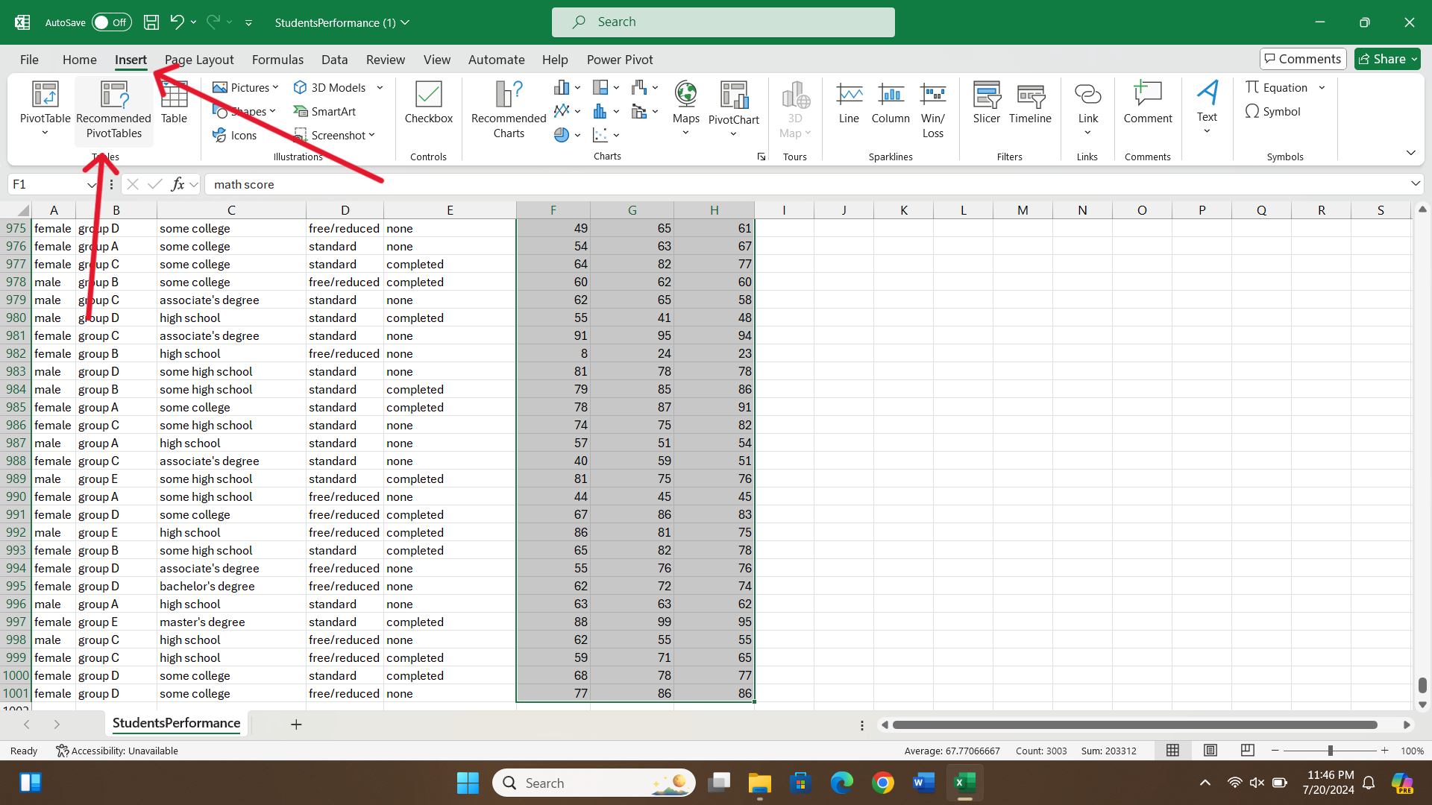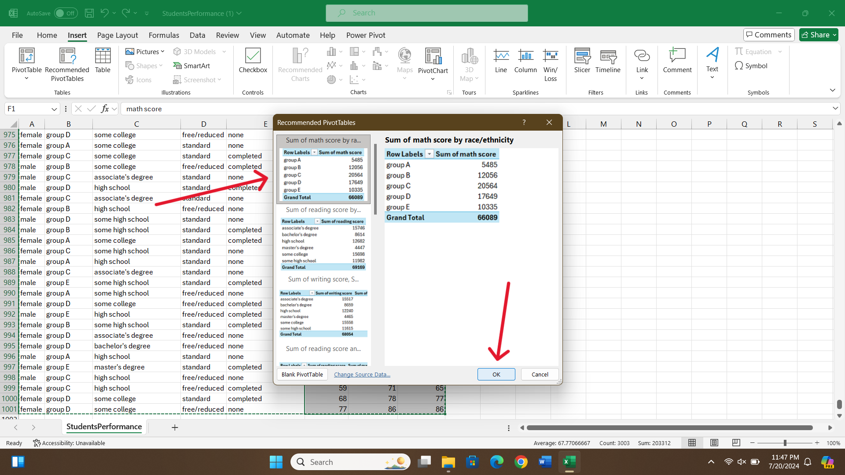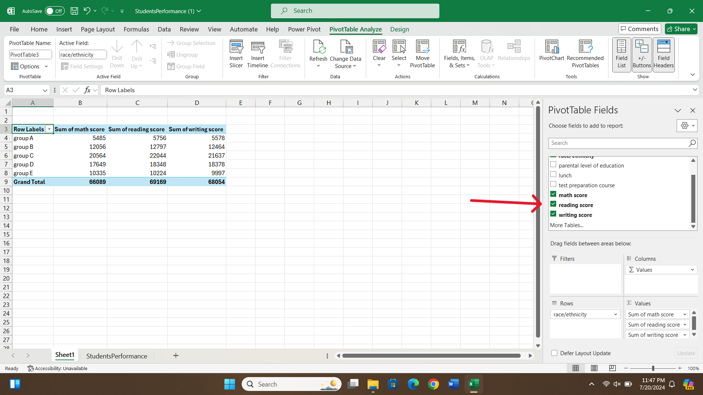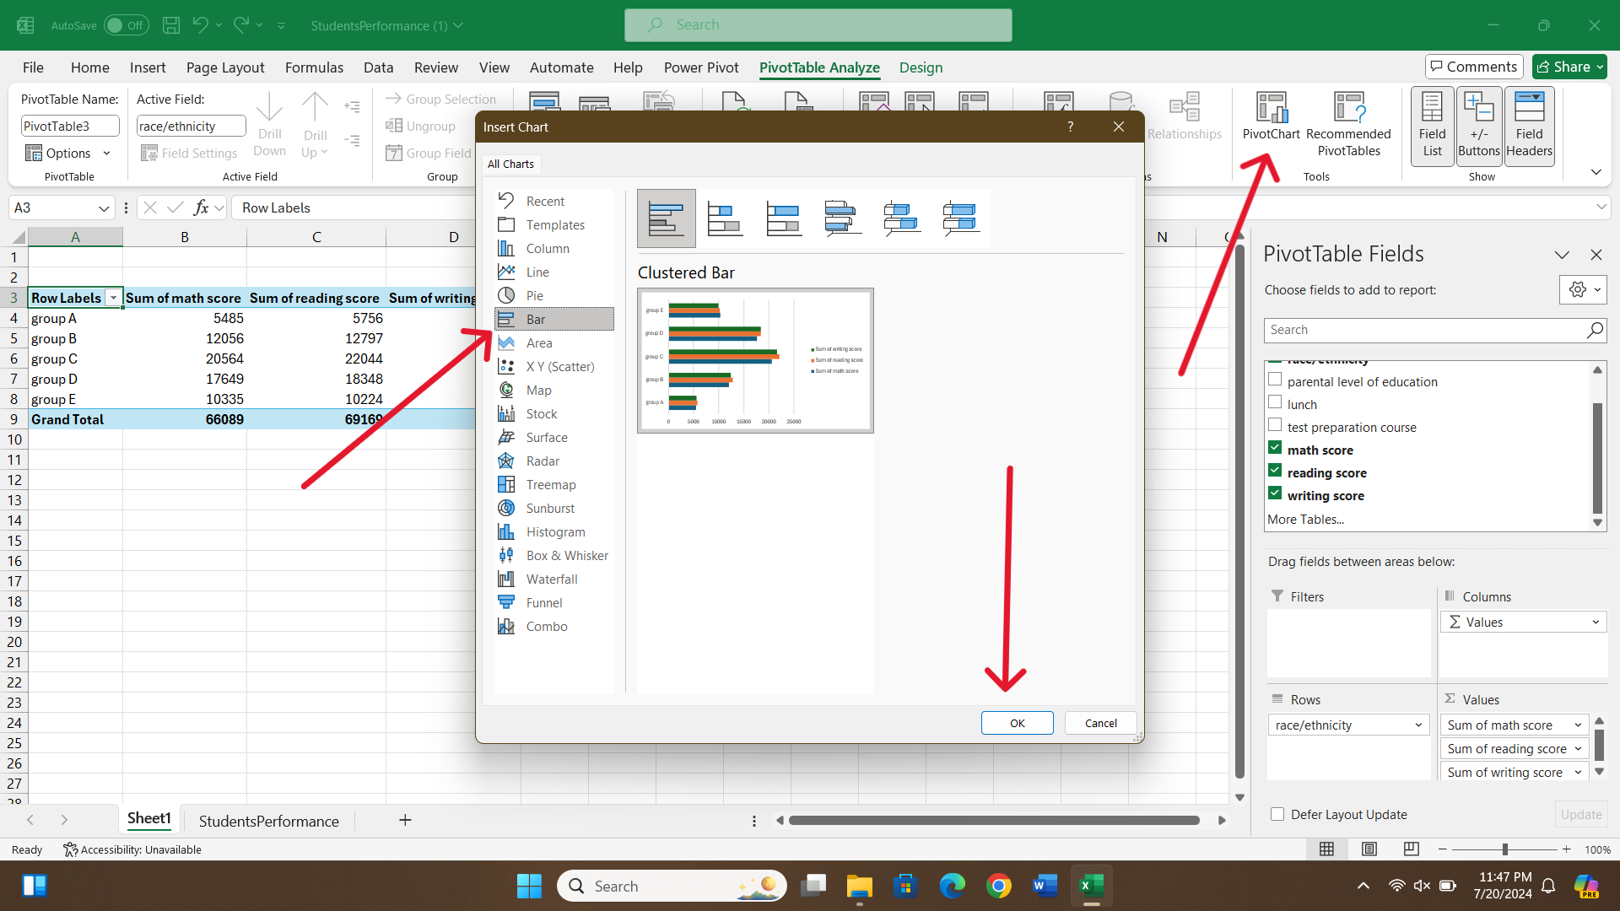

Correlation analysis
Correlations
 |  | Reading score | Writing score
Reading score | Pearson Correlation | 1 | .955**
 | Sig. (2-tailed) |  | 0.000
Writing score | Pearson Correlation | .955** | 1
 | Sig. (2-tailed) | 0.000
**. Correlation is significant at the 0.01 level (2-tailed).
Correlation analysis is used to find the significant differences among different variables. A correlation coefficient is a number between -1 and 1 that indicates the strength and direction of a relationship between variables. The table shows the Pearson correlation between reading scores and writing scores. The correlation coefficient between reading score and writing score is 0.955 which is very close to 1. This indicates a highly positive correlation between reading score and writing score, suggesting that if reading score tends to increase then writing score also tends to increase and vice versa. The significant value is 0.000 which is less than 0.01 indicating a highly significant correlation between variables. This suggests that there is a less than 1% probability of the observed correlation to be attributed to random variations, meaning that a strong correlation between the two pairs of scores as well as their relationship with the reading and writing scores is quite reliable.
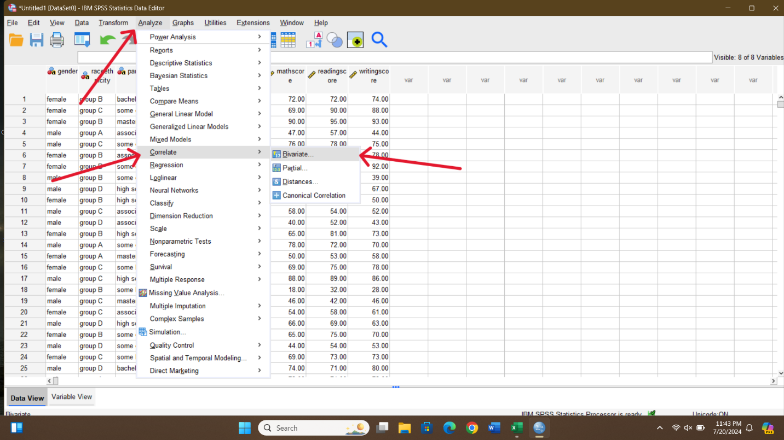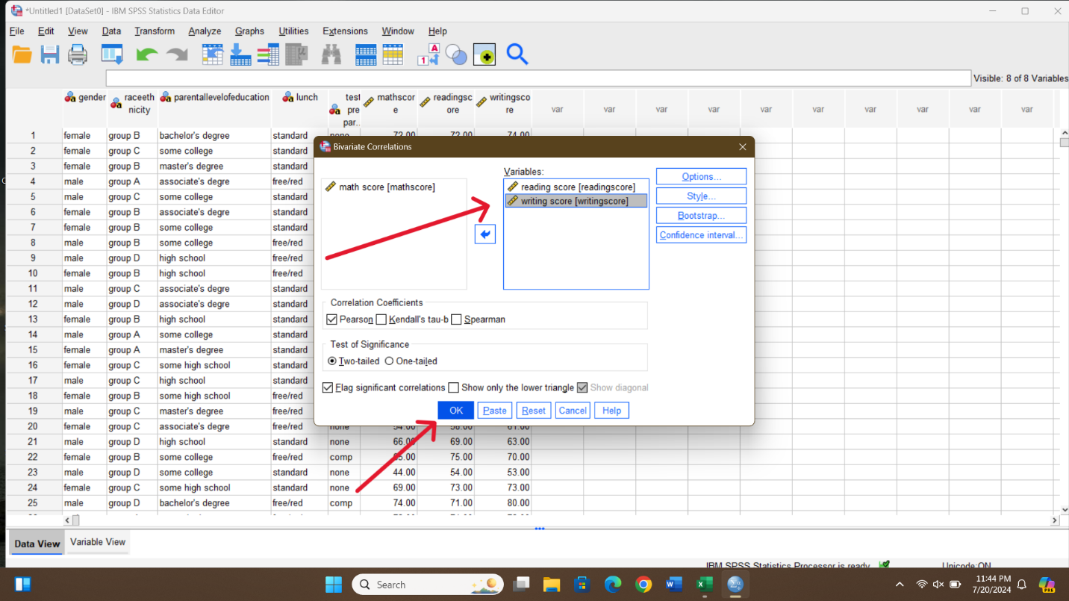

Scatter Plot
The scatter plot shows the relationship between both reading scores and writing scores. It shows a strong positive correlation between both scores, which indicates that if one increases the other score also increases with the same ratio. Overall, the scatter plot shows a strong linear relationship between writing score and reading score. It suggests that students who perform well in reading also tend to perform well in writing.
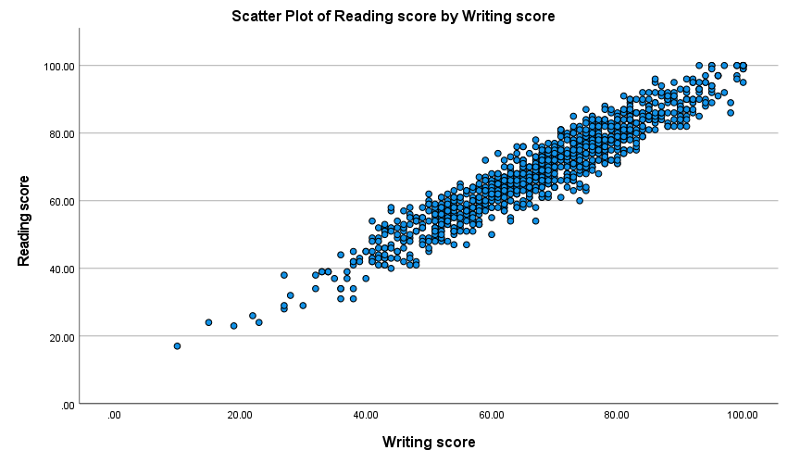
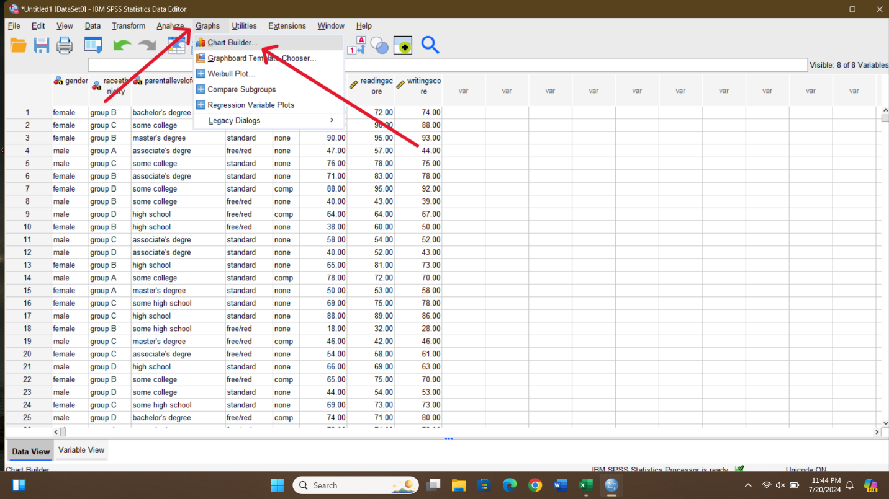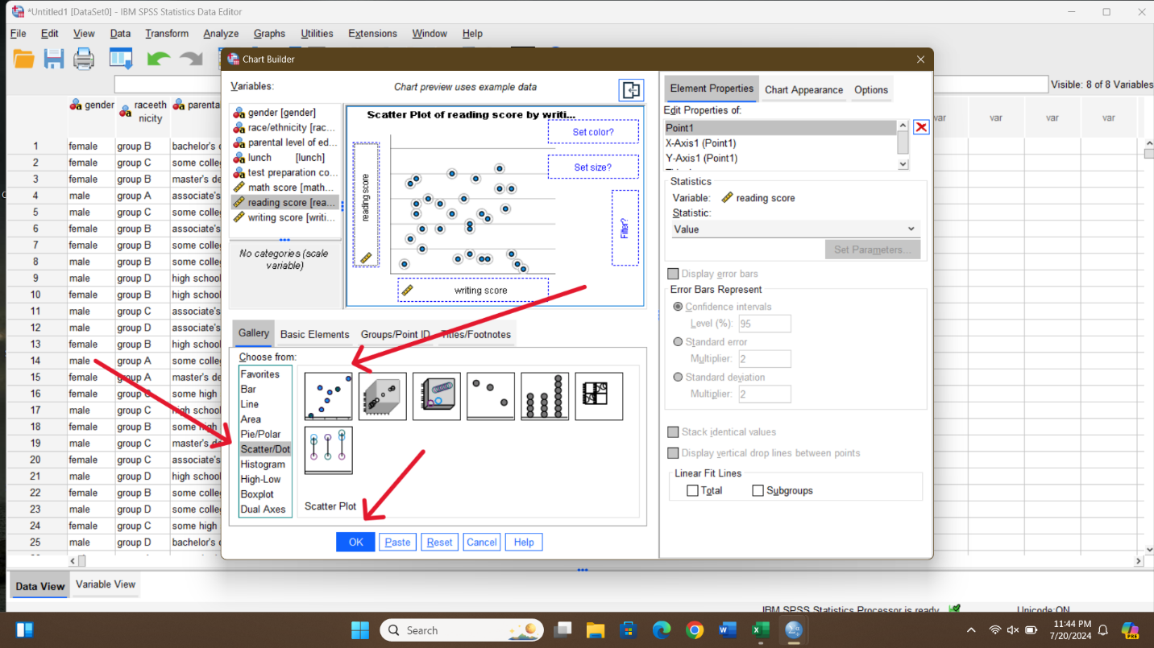

Conclusion of the analysis
The overall analysis provides a comprehensive analysis of student performance focused on math score, reading score, and writing score in different conditions. The descriptive statistics shows the measure of central tendencies and measure of dispersion. The measure of central tendencies shows the mean, mode and median of math score, writing score, and reading score. This shows that the mean values for math score, reading score, and writing score are 66.089, 69.169, and 68.054 respectively. The median for these scores is 66, 70, and 69 respectively which suggests that half of the students score above these values and half of the students score below these values. Similarly, the mode value for these scores is 65, 72, and 74 respectively. The measure of dispersion includes variance and standard deviation. The analysis shows that the writing score has the largest variance or 230.90 with the highest standard deviation of 15.195. This suggests that the writing score is more dispersed than the reading score and writing score. This type of variability indicates that there are significant differences in the writing abilities of students.
The pivot chart/bar chart represents the group performance among different scores. The chart shows that Group C has the highest value among all, and Group A is the least performing among all groups. This suggests that Group A needs some improvements to perform well. Similarly, correlation analysis shows a very strong positive correlation reading and writing scores of the students. The correlation coefficient is 0.955 which is very close to 1 and indicates a very strong association between both variables. The value of probability that is computed is less than 0.01 which supports the fact that the two variables are positively related and confirming a statistically significant positive correlation between them. This is confirmed by the scatter plot, as shown below, which can be interpreted to show a very positive correlation between the two variables.
These outcomes present a comprehensive picture of student achievements in various groups that may be used when developing various approaches to educational enhancement and assisting students in boosting the student’s performance in all groups.

Section 2

a) Advantages and Disadvantages of Using SPSS, Excel, and Tableau

SPSS

Advantages
Advanced Statistical Analysis: SPSS incorporates many statistical tests and procedures and is famous for its generally acceptable statistical power. For instance, it can run tests such as ANOVA, regression analysis, or factor analysis that are less of a hassle for extensive analysis.
User-Friendly Interface: All statistical software has a graphical user interface (GUI), which makes working on SPSS quite easy, even for people who have no programming experience (Kulas et al., 2021).
Integration with Other Software: Export and import features also allow work with other materials, like MS Excel and other bases. Information integration increases efficiency in working on a case and in managing data, information, and knowledge.

Disadvantages
Cost: The only disadvantage of using SPSS is that it is relatively expensive compared to tools that can barely afford to source the software. It may also be rather costly to license, but that also prevents some people from using it.
Learning Curve: While it has a reachable graphical user interface, it is difficult for people who are not familiar with statistical software like SPSS (Kulas et al., 2021).
Resource Intensive: The application of SPSS may also be problematic as it demands higher power and memory for computer software. This may prove disadvantageous for users with old graphic cards or computers with confined physical and processing space.

Microsoft Excel

Advantages
Wide Availability: Excel is easily accessible and is normally included in the operating system of computers, making it easy to analyse data. This makes it easily available to clients and is one of this program's key selling points.
Ease of Use: Excel is relatively easy to use, and there exist simple and many more complex functions and formulas for simple statistical analysis in MS Excel. Facilities such as pivot tables allow for the slicing and dicing of data, and charts provide analysed data graphs (McFedries, 2022).
Versatility: One of Excel's strengths is that users can accomplish many functions in a company, including budgeting, forecasting, data handling, and statistical analysis.

Disadvantages
Limited Advanced Statistical Functions: As a result, the statistical analyses that can be performed using Excel’s functions are not as diverse as in a specialised program, such as SPSS or R, and complex analyses may need add-ins or other tools.
Error Prone: Using Excel can be time-consuming and repetitive, as it involves entering the data by hand and creating the formulas. Hence, mistakes may be made. These types of errors are rather hard to address and outline.
Scalability Issues: Calculating large sets of data in Excel might cause problems that slow down its performance. There is no optimisation for big data, which can be a drawback in large data set applications (McFedries, 2022).

Tableau

Advantages
Data Visualisation: Tableau is strong in data visualisation, with ample charts, graphs, and dashboards that are easy to build and analyse.
Real-Time Data Analysis: Tableau's virtues include the fact that it works with live data, where the user can establish a connection to the data and update the visualisations at any given moment (Batt et al., 2022).
Integration and Connectivity: Tableau also supports many types of data formats and connections, such as databases, cloud services, and spreadsheets. Thus, connectivity helps integrate and process all available information and demonstrate it.

Disadvantages
Cost: Like SPSS, Tableau can also be costly, with costly licenses when purchasing single and/or multiple licenses, which can be expensive for small firms or individuals.
Learning Curve: While Tableau might be very intuitive for straightforward data analysis tasks, working with all its options and features certainly takes a while.
Limited Statistical Analysis: Despite the advantages, it is crucial to recognise that Tableau is not for statistical analysis but can be used for data visualisation. Some users want to do achievable calculations with another tool and then transport their results to Tableau to create an illustration (Mittal and Raheja, 2022).

b) Understanding and Role of Data Mining Cycle
Data mining is, again, a sequential procedure that discovers the hidden relationships between variables. It comprises several important steps, for which you must do a lot, which are very important to achieve the ultimate goal of turning raw data into useful information (Durugkar et al., 2022). The cycle typically includes the following steps:

Problem Definition
The first process herein explains that one needs to identify the business problem/research question to be solved. This is mostly important because the problem definition forms the basis of the data mining process. For instance, a retail firm may wish to identify the customers' buying propensity to enhance its marketing proposals.

Data Preparation
In this stage, consultation and data acquisition occur, which means gathering and pre-processing data for analysis. It was ascertained that proper data preparation is important to avoid affecting the quality of research or analysis that is to be conducted.

Data Exploration
In this phase, exploratory data analysis techniques are employed to describe the nature of the data and how the variables are related. Specific data visualisation tools ands selected measures of central tendency and variability, enable one to define patterns, trends and outliers. For instance, the first approach is to have scatter plots for graphical representation as a method of analysing the relation between sales and advertising expenditure (Sunhare et al., 2022).

Modelling
The modeling stage involves spelling out various data mining methods and applying them to the prepared data. The most well-known methods are classification, regression, clustering, and association rule mining. The problem under study and the kind of data at the disposal determines the selection of techniqueosal. For example, decision trees are other algorithms used in classification to predict customer churn (Pan and Zhang, 2021).

Evaluation
Assessment is carried out to determine the effectiveness of the different models created in the previous stage. Some measures used include accuracy, precision, recall, and F1 score for the models used. The validation of the models, such as cross-validation, guarantees that the model is good in other new data sets.

Deployment
Deployment is incorporating the model into the current organisational structure so that decisions can be made in real-time. For instance, a forecast model of customer classification can be included in a CRM system to address marketing campaigns (Rotondo and Quiligan, 2020).

Monitoring and Maintenance
Performance tests of the model are conducted after it has been deployed to ascertain whether or not its performance has changed. It is vital to receive updates and perform maintenance due to constant changes in the patterns and needs of the business. This stage helps maintain the long-term efficacy of data mining solutions in the long run.

Importance of the Data Mining Cycle

Informed Decision-Making
The Data Mining Cycle represents a methodology for channelising knowledge discovery in databases, resulting in better and more informed decisions for the organisation. For example, banking organisations utilise date data mining fraudulent transactions and reduce their risks (Tang and Liao, 2021).

Efficiency and Productivity
When implemented, the data mining cycle increases the efficiency and productivity of data analysis procedures. This positive development means that businesses can easily determine opportunities and threats, which enables the right action to be taken to help reduce impacts and promote business development.

Competitive Advantage
Businesses that incorporate data mining into their strategy have an advantage because of the knowledge it provides on enhancing products and services and customer satisfaction. For instance, e-commerce companies apply data mining to recommend the right products to clients, hence increasing the chances of sales (Durugkar et al., 2022).

Cost Savings
Data mining is used to discover areas of inefficiency and make recommendations on how best to make changes to achieve more efficiency, which reduces overheads. For example, original equipment manufacturers use data mining for future failure diagnosis and maintenance scheduling to avoid excessive failure costs and time.

Innovation and Growth
Data mining is a key that unlocks data, opens it to analysis, and leverages it to incite innovation and business growth. It also helps firms understand changes in the market environment and consumers’ preferences and hence facilitates the identification of new opportunities for venturing into new markets and new products (Durugkar et al., 2022).
In conclusion, the data mining cycle might be said to be a crucial process providing access to useful information from big data. These phases ensure that the mined data results are valid, useful, and efficient in achieving organisational objectives. Therefore, it is possible to state that by following this kind of logical course of analysis, one can easily control the results and attain additional advancements in organisations.

References
Batt, S., Grealis, T., Harmon, O., and Tomolonis, P. (2020) Learning Tableau: A data visualization tool. The Journal of Economic Education, 51(3-4), 317-328.
Durugkar, S. R., Raja, R., Nagwanshi, K. K., and Kumar, S. (2022) Introduction to data mining. Data Mining and Machine Learning Applications, 1-19.
Kulas, J. T., Roji, R. G. P. P., and Smith, A. M. (2021). IBM SPSS essentials: managing and analyzing social sciences data. John Wiley and Sons.
McFedries, P. (2022). Excel data analysis for dummies. John Wiley and Sons.
Mittal, M., and Raheja, N. G. (2024). Data Visualization and Storytelling with Tableau. CRC Press.
Pan, Y., and Zhang, L. (2021) A BIM-data mining integrated digital twin framework for advanced project management. Automation in Construction, 124, 103564.
Rotondo, A., and Quilligan, F. (2020) Evolution paths for knowledge discovery and data mining process models. SN Computer Science, 1(2), 109.
Sunhare, P., Chowdhary, R. R., and Chattopadhyay, M. K. (2022) Internet of things and data mining: An application oriented survey. Journal of King Saud University-Computer and Information Sciences, 34(6), 3569-3590.
Tang, M., and Liao, H. (2021) Multi-attribute large-scale group decision making with data mining and subgroup leaders: An application to the development of the circular economy. Technological Forecasting and Social Change, 167, 120719.

