Dr. Gareth morgan | Introduction to Health Research BMNS4005
The Health Risks of Asbestos
Samantha Walters
2109469

Table of Contents
Introduction 2
What is Asbestos? 2
What are the health risks of Asbestos? 3
Who is affected? 5
The Process of Research 7
Latest Mesothelioma Research 9
Conclusion 11
Reference List 12

Introduction

Lung Cancer is one of the most common and serious types of cancer, according to the NHS, nearly 47,000 people are diagnosed in the United Kingdom (UK) every year, 2,700 of those are diagnosed with mesothelioma. There are three main causes of lung cancer:

- Smoking,
- Radon Gas
- Asbestos
(NHS, 2022)

In this report, Asbestos, the effects it has on the public’s health, and the research that is underway to treat and cure those who are diagnosed with asbestos related lung cancer, Mesothelioma, will be considered.

What is Asbestos?

Asbestos was imported into the UK from countries such as Canada and south Africa, in the 1800’s it started to be widely used in the Industrial Revolution. Asbestos is a naturally occurring fibre, there are three different types of asbestos fibres that were used most commonly in the UK, generally used in construction and other industries until it was banned in 1999, these fibres are blue (crocidolite), brown (amosite) and white (chrysotile) (British Lung Foundation, 2022). Asbestos was used for insulation, flooring, roofing and was sprayed on ceilings and walls in buildings, some buildings that were built before the year 2000 may still have asbestos in them, whilst asbestos should be handled with care, it is not usually a problem if it is undisturbed and undamaged.

What are the health risks of Asbestos?

In 1906 the first death was documented in relation to asbestos; however, it wasn’t until the 1950’s that the first report linking asbestos and lung cancer was produced (Mesothelioma UK, 2022).
Exposure to asbestos is responsible for up to 9 out of 10 mesothelioma cases, mesothelioma is a cancer of the mesothelium, a thin lining that covers some of the body’s internal organs. In most cases mesothelioma affects the lining of the lungs, this is called Pleural Mesothelioma, this causes the pleura to thicken, if this occurs it may cause pressure onto the lungs or cause the pleura to attach itself to the inside of the chest wall, this results in the expansion of the lungs to become progressively restricted by the tumour.
As there are very low levels of asbestos in the air, it is likely that most people will inhale fibres at some point in their life, however when a large amount of dust and fibres are inhaled, these fibres can lodge in the lungs and affect the membranes lining, the inside of the chest wall and the surface of the lung.
Mesothelioma cancer is, unfortunately rarely curable, however through recent research, treatment is being made available to help control symptoms and give patients a more comfortable life after diagnosis, (NHS, 2022).
Mesothelioma may not develop until15 to 60 years after a person has been exposed to asbestos, this is why there has been an increased in cases in recent years, Cancer research UK suggests that the number of people dying from mesothelioma each year was expected to peak around 2020 and then start to decline (Cancer Research UK, 2021, a).

The diagrams below show healthy lungs, and then the effect mesothelioma has on the body.
Healthy Lung

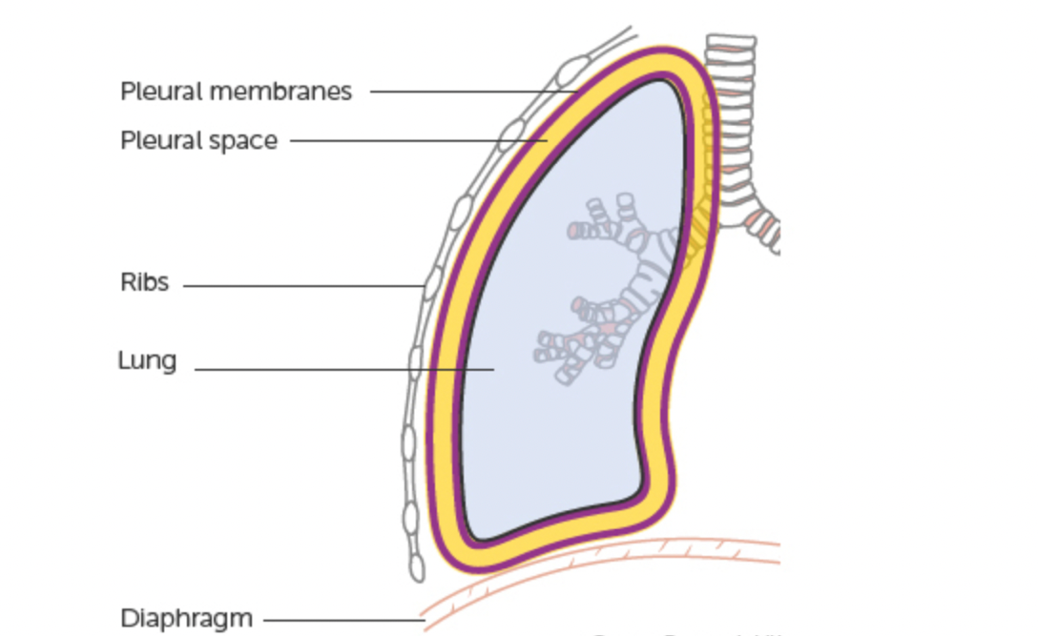

Lung affected by Mesothelioma

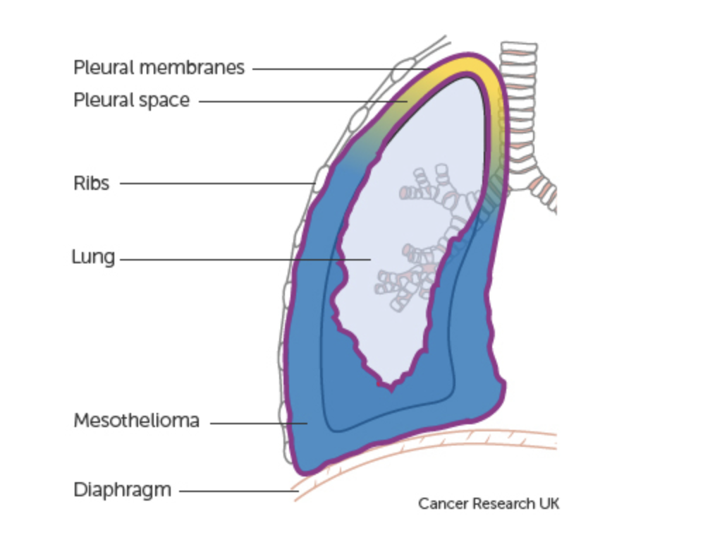

(Cancer Research UK, 2022)

Who is affected?

Mesothelioma is most common in those who have been exposed at work, such as manufacturing using asbestos, or used asbestos products in construction or engineering, a range of jobs including:
- Plumbers
- Carpenters
- Mechanics
- Metal plate workers
All would have been exposed to asbestos products in the 1960’s, however plumbers were the most at risk as they would have been inside the walls resulting in the closest contact with asbestos. An audit was conducted by the Royal College of physicians and Mesothelioma UK between 2014-2016, out of 7192 individual patients diagnosed, 6932 cases were pleural mesothelioma, 260 cases were peritoneal mesothelioma, 84% of pleural mesothelioma patients were male and 75.7 years was the average age at the time of diagnosis (Mesothelioma UK, 2022).

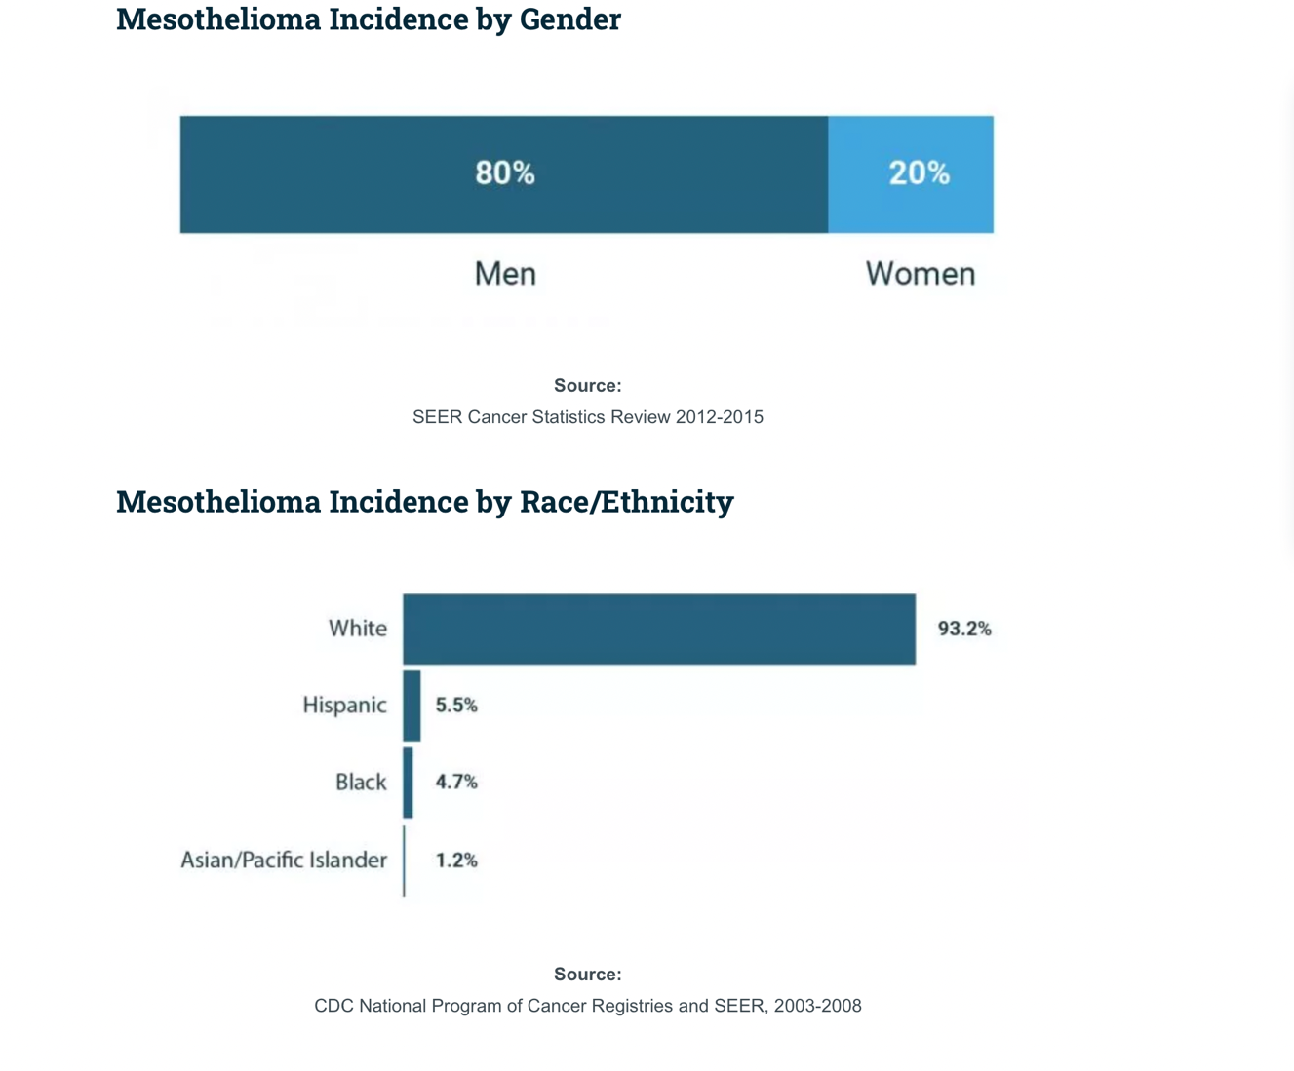.

(Asbestos.com, 2022)

The information available on the Cancer Research UK website champions the data shown above as it suggests that exposure to asbestos causes more than 9 out of 10 cases of mesothelioma in men (more than 90%) (Cancer Research UK, 2021, b).

This figure below shows a large increase in mesothelioma mortality rates at the beginning of the 2000’s, the incidence and mortality are provided as a standardised rate (per 100,000) for the whole of England and Wales each year, this reflects on the change in the disease coding on death certificates, prior to 2001, the office of National Statistics (ONS) used the International Classification of Disease (ICD) version 9 which had no specific mesothelioma code. This means most mesothelioma deaths were missed, when ICD version 10 was introduced in 2001, a specific code for mesothelioma was created, which led to the large apparent increase in mortality rates.

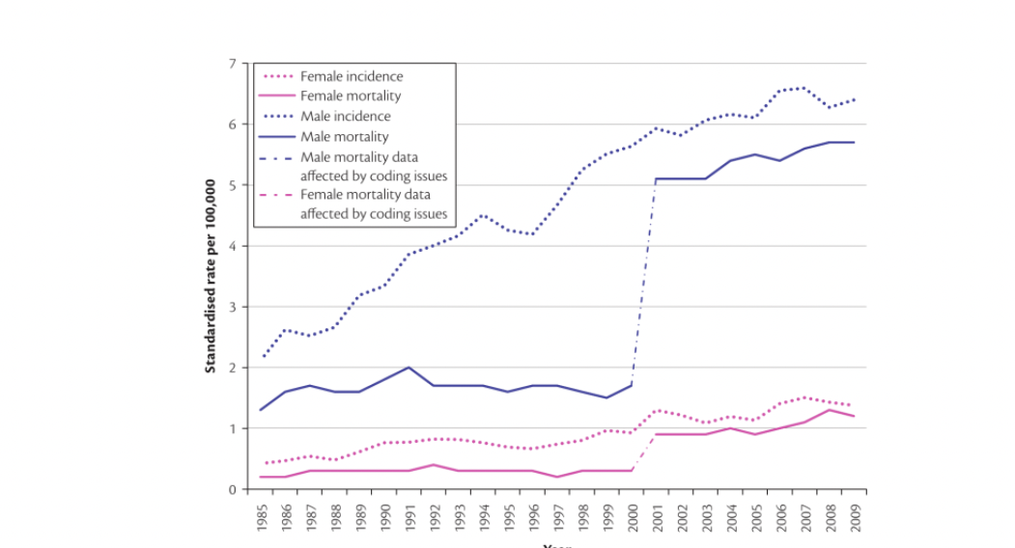
(Hansell et al, 2014)

The Process of Research

The process of seeking to improve care for people with cancer, and making new cancer treatments available to patients, can take many years, as there is a long development and approval process that needs to be followed. Researchers are always seeking new treatments that can offer patients hope, the Randomised Control Trail (RCT) is the gold standard. Some ways how cancer drugs are discovered are: through accidental discovery, plants, fungi and animals, studying the biology of cancer cells and computer simulation, Research studies are then conducted, after the drugs are created, researchers test them on human cancer cells in the laboratory, to see if the drugs stop the growth of the cells, if this is successful they then test the drug in animals, this helps them learn how the body uses the drug, or what side effects may occur. The next stage for development is clinical trials, there are four phases altogether,

- Phase 1, usually around 15-30 patients are given the drug to try and establish the most effective and safe dose.
- Phase 2, once the safe dosage has been established, a larger group of patients will be given the drug and be compared to those patients of phase 1, this helps further assess the safety as well as if the drug works.
- Phase 3, compare a new drug to the standard – of – care drug, these assess the side effects of each new drug, and which one works better, 100 or more patients are enrolled into this phase.
- Phase 4, trials test new approved drugs, researchers are able to better their knowledge on the short-lived and long-lasting side effects and safety by testing the drug in several hundreds or thousands of patients.

If the drug has a positive outcome after the trials have finished, the next stages of the process are licensing and approval, the manufacturer must prove that the drug is safe to use, any side effects it may have, are outweighed by its benefits and it is effective for it to be licensed. The Medicines and Healthcare Agency (MHRA), oversees this process, and is the sole regulator for new medicines in England, Scotland and Wales.
The final stage is for the drug to be approved for its use in the NHS, once it has its license, this is done by the National Institute of Health and Care Excellence (NICE). NICE’s decisions are also followed in Wales and Northern Ireland. NICE asses the clinical effectiveness and cost of new treatment and drugs, cost effectiveness balances cost against the expected health benefits, decisions can be based on evidence supplied by health professionals, patients and carers.
In England NICE will choose one of three outcomes:

- Approval – if approved doctors are able to prescribe the new drug to eligible patients.
- Not approved – the new drug has not been approved for use in the NHS.
- Recommended for the Cancer Drugs Fund – this can help patients access promising new treatments.

The Cancer Drug Fund (CDF) can enable earlier access for patients to drugs that have promising trial results, but don’t have enough evidence for NICE to tell if they are cost effective, drugs made available on the CDF are available for up to two years to allow more time for evidence to be gathered, after those two years NICE will then reconsider if the drug should be used or not. The CDF is only applicable in England however Wales has now introduced the New Treatment Fund, which offers access to those drugs approved for use on the CDF (Mesothelioma UK, 2022).

Latest Mesothelioma Research

Over £10,000,000 has been spent in funding mesothelioma research, the British Lung Foundation aims to tackle the disease from many different angles, some of these are:
- Understanding what mutations and genetic changes that drive the disease
- Enhancing the effectiveness of existing treatments
- Pioneering new and better treatments
- Providing better care for people living with the disease
(Asthma + Lung UK,2022).

A survey was created for the experience of patients and caregivers with malignant pleural mesothelioma, as discussed earlier pleural mesothelioma is a rare cancer with poor prognosis, there is little information available on the lived experience. Surveys were developed from previous interviews with patients, caregivers and health professionals, about treatments and decision-making, participants were recruited from two support groups, government compensation body and hospitals. The results show that survey responses were received from 78 patients and 106 caregivers from January to September 2014, 85% of patients were male, with an average age of 69 years and an average of 15 months since diagnosis. Caregivers had an average age of 68, 91% were female, 90% were spouses of the patients and 95% were bereaved. The results showed that:

- Most participants felt informed about treatment but only 69% thought all treatment options were discussed.
- 92-95% had chemotherapy discussed most frequently.
- 80% had sufficient information for decision making.
- 24% of patients decided chemotherapy as an option considering the doctors opinion.
- 18% doctor and patient decided equally on chemotherapy.
- 17% doctors decided on chemotherapy.
- 81% of patients strongly agreed that they had made the right decision about chemotherapy.
- 60% of caregivers strongly agreed on the decision about chemotherapy.
- 5% of patients and 16% of caregivers respectively regretted the decision.
- 71% of participants received sufficient support.
- A quarter of patients reported seeing a cancer nurse specialist.
- 31% patients had palliative care referral.
- 85% of caregivers had palliative care referral.
- 41% of caregivers felt they would have liked more time alone with someone.
- 30% of caregivers wanted more time with doctors.
- 29% of caregivers wanted more psychological support.
- 31% of caregivers wanted clearer information.
- 39% of bereaved caregivers requested grief counselling.
- 23-25% bereaved caregivers requested a post-death consultation with specialists.

The conclusion to this survey is that there was a high satisfaction rate of treatment, however improvement on communication and the quality of information, discussion about all treatments, end-of-life assistance, and caregiver support after the patient’s death was needed (Warby, Dhillon, and Vardy, 2019).

According to Cancer Research UK, there are no UK-wide statistics available for mesothelioma survival by stage, however there are 1 year survival statistics available for each stage of mesothelioma in England, the figures shown below are for men and women diagnosed between 2013 and 2017:

- Stage 1- Around 60 out of 100 people (60%) will survive their cancer for 1 yea or more after they are diagnosed.
- Stage 2- Almost 60 out of 100 people (60%) will survive their cancer for 1 year or more after diagnosis.
- Stage 3- Around 50 out of 100 people (50%) will survive their cancer for 1 year or more after they are diagnosed.
- Stage 4- 30 out of 100 people (30%) will survive their cancer for 1 year or more after they are diagnosed.

Overall, for people with mesothelioma in England:
- 45 out of 100 people (45%) survive their mesothelioma for 1 year or more after diagnosis.
- More than 5 out of 100 people (5%) survive their mesothelioma for 5 years or more after diagnosis, (Cancer Research UK, 2021).

Conclusion

To conclude there has been millions of pounds spent towards the research on the hopeful cure to cancer. As stated earlier there is unfortunately, no cure to mesothelioma at this current time. Patients palliative care has been tailored as best it can, to ensure a more comfortable end of life, however due to the tumours associated with Mesothelioma, patients find it extremely hard to breathe or eat. Many patients have stated that they are well informed by their doctors regarding, the disease, possible treatment and counselling for themselves and their caregivers. Thankfully due to the ban of Asbestos in 1999 there should be a significant decrease in the number of Mesothelioma cases in coming years.

Reference List

Asbestos.com, (2022). Mesothelioma: Statistics & Facts. Available at: https://www.asbestos.com/mesothelioma/statistics/ (Accessed on 23rd February 2022).

Asthma + Lung UK, (2022). Our mesothelioma research. Available at: https://ww.blf.org.uk/research/ (Accessed on 28th February 2022).

British Lung Foundation, (2022). What is asbestos? Available at: https://www.blf.org.uk/support-for-you/asbestos-related-conditions/what-is-asbestos (Accessed on 23rd February 2022).

Cancer Research UK, (2021). Mesothelioma: Mesothelioma survival. Available at: https://www.cancerresearchuk.org/about-cancer/mesothelioma/survival (Accessed on: 4th March 2022).

Cancer Research UK, (2021). Mesothelioma: Risks and causes. Available at: ,https://www.cancerresearchuk.org/about-cancer/mesothelioma/risks-causes (Accessed on: 4th March 2022).

Cancer Research UK, (2021). What is mesothelioma?: The lungs and pleura. Available at: https://www.cancerresearchuk.org/about-cancer/mesothelioma/about (Accessed on: 4th March 2022).

Hansell, A., Ghosh, R., Fortunato, L., and Fecht, D. (2014). The Environment and Health Atlas for England and Wales. Oxford University Press: London.

Mesothelioma UK, (2022). History of Asbestos. Available at: https://www.mesothelioma.uk.com/what-is-asbestos/ (Accessed on 23rd February 2022).

Mesothelioma UK, (2022). How new drugs are made available in the NHS. Available at: https://www.mesothelioma.uk.com/wp-content/uploads/dlm_uploads/2021/12/How_new_cancer_drugs_are_made_available_in_the_NHS_web.pdf. (Accessed on 28th February 2022).

Mesothelioma UK, (2022). Pleural Mesothelioma: What is it? Available at: https://www.mesothelioma.uk.com/pleural-mesothelioma/ (Accessed on 23rd February 2022).

NHS, (2022). Mesothelioma, Available at: https://www.nhs.uk/conditions/mesothelioma/ (Accessed on: 28th February 2022).

NHS, (2022). Overview: Lung Cancer. Available at: https://www.nhs.uk/conditions/lung-cancer/ (Accessed on 23rd February 2022).

Warby, A., Dhillon, H., and Vardy, J. (2019), ‘A survey of patient and caregiver experience with malignant pleural mesothelioma’, Supportive Care in Cancer, 27, pp. 4675-4686.

