OS Install and Setup

L4: Introduction to Computer Systems – Computing
Module Code: ACCA4021
BSC4F Computing
(Games Development)

Contents
Part One – Operating System Installation 3
A. Windows Installation 3
B. Splitting the Memory Drive 7
Part Two – Report on Drivers & Office 11
1. Sound Card Driver Setup 11
2. Network Card Driver Setup 12
3. Installing Apache OpenOffice 13
References 16

Part One – Operating System Installation

A. Windows Installation
To begin this installation, I first opened Oracle VirtualBox and started a new project, with ‘Windows7’ as the title. I then loaded the saved ISO for windows 7 from my directory, as well as defining a folder directory to save this virtual machine to. I chose to save it to my Onedrive folder, for ease of access on different machines.
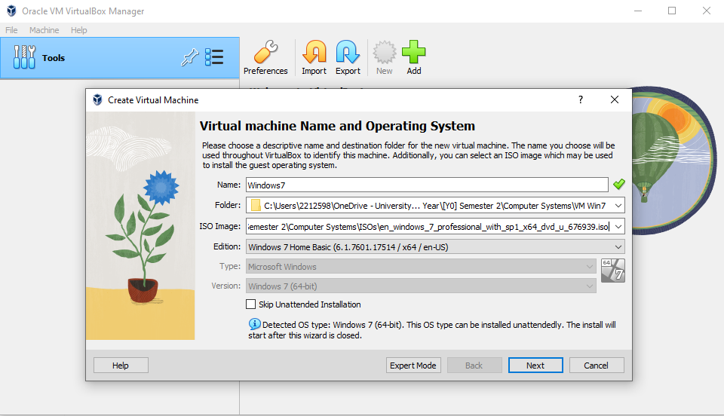
Figure 1 - Starting new VM project.

Next, I defined a username and password for the machine to use. For ease of use and remembering, I set these to ‘testuser’ and ‘password’ respectively, and continued to the next stage.
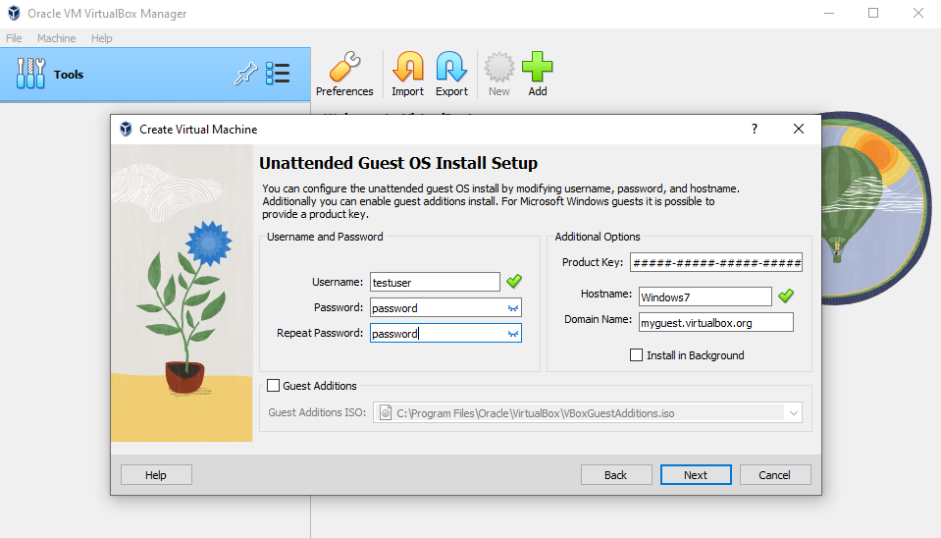
Figure 2 - Username & password
When defining the hardware parameters this machine would use, I opted to give it 2 Gigabytes of RAM, and 1 CPU core. These specs were chosen due to the machine hosting this VM being relatively low spec, so I didn’t want to run a virtual machine that was too taxing or heavy for the system to cope with.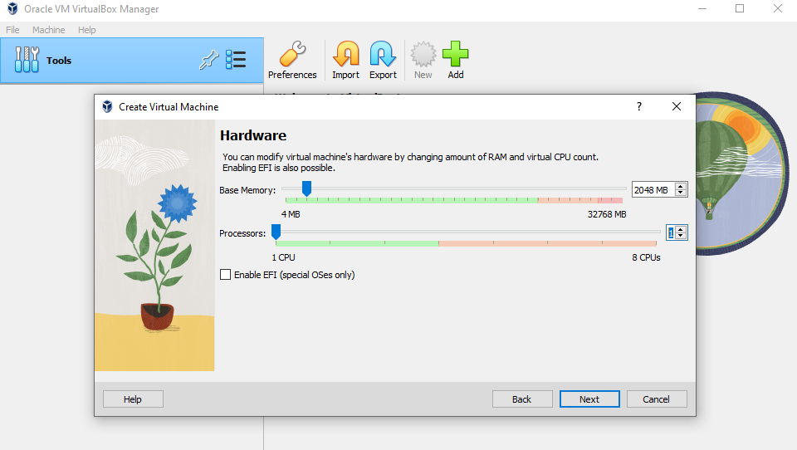
Figure 3 = Hardware specs

Despite the host machine having a low RAM and CPU count, it had enough storage space to allocate the default 32 Gigabytes of memory for this virtual machine to use.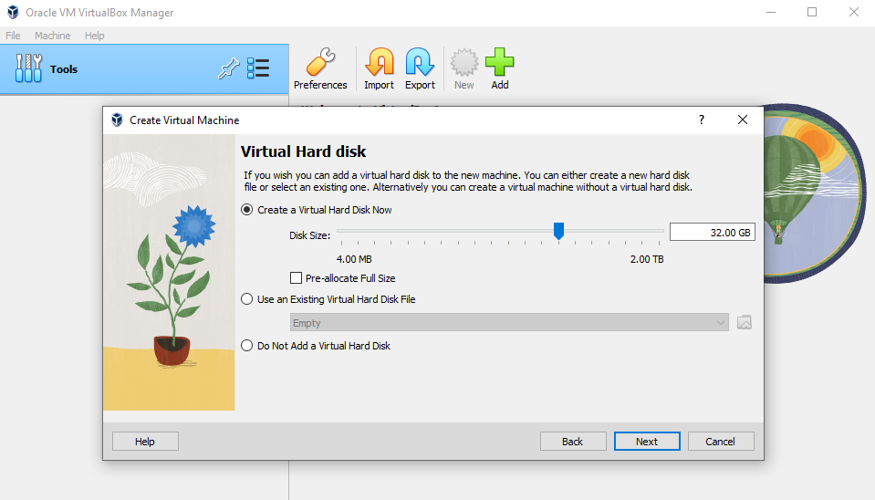
Figure 4 - VM Memory
Reviewing the summary page, all specifications looked correct and ready to continue to the actual installation of the VM.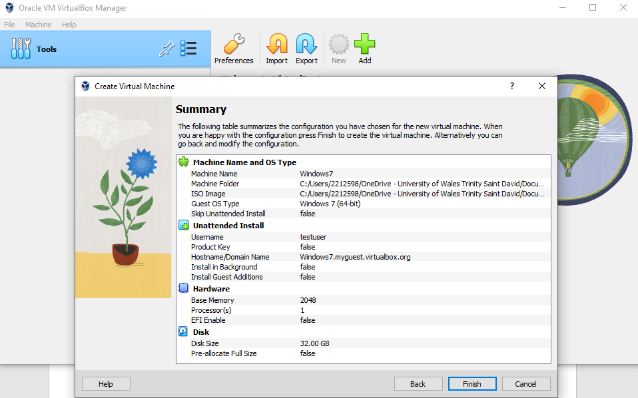
Figure 5 - Install summary

The virtual machine successfully began initialising, adding itself to the VM list in Oracle and beginning the process of installing the windows operating system.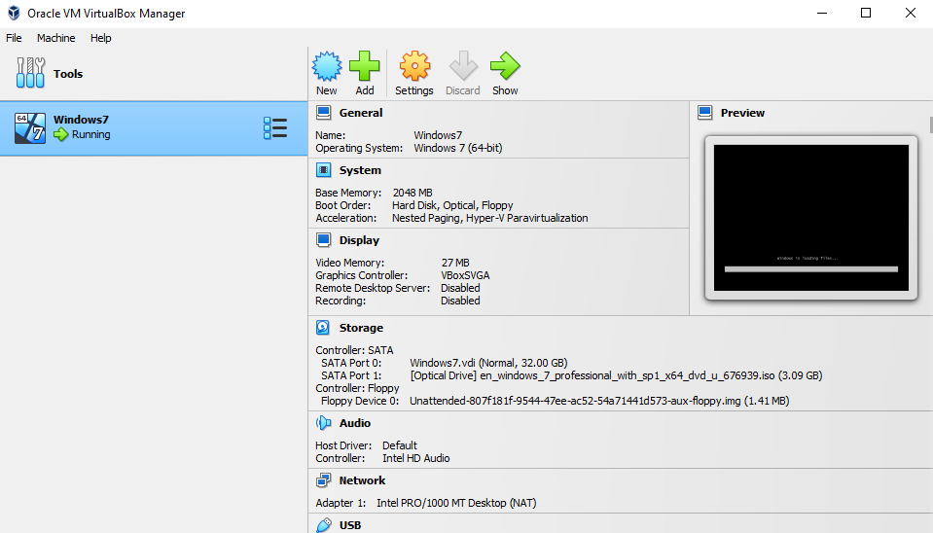
Figure 6 - VM in Oracle
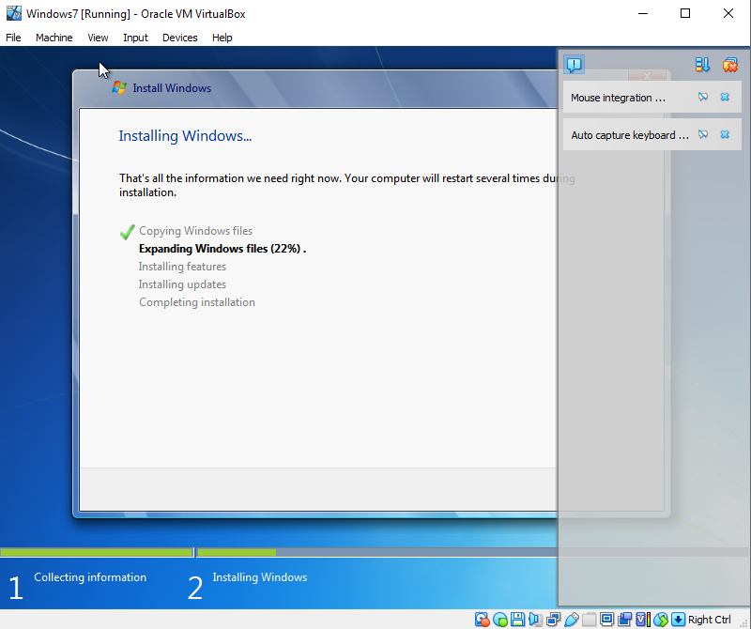
Figure 7 - Windows installing

After a few minutes, windows had successfully installed and was running in the virtual machine.
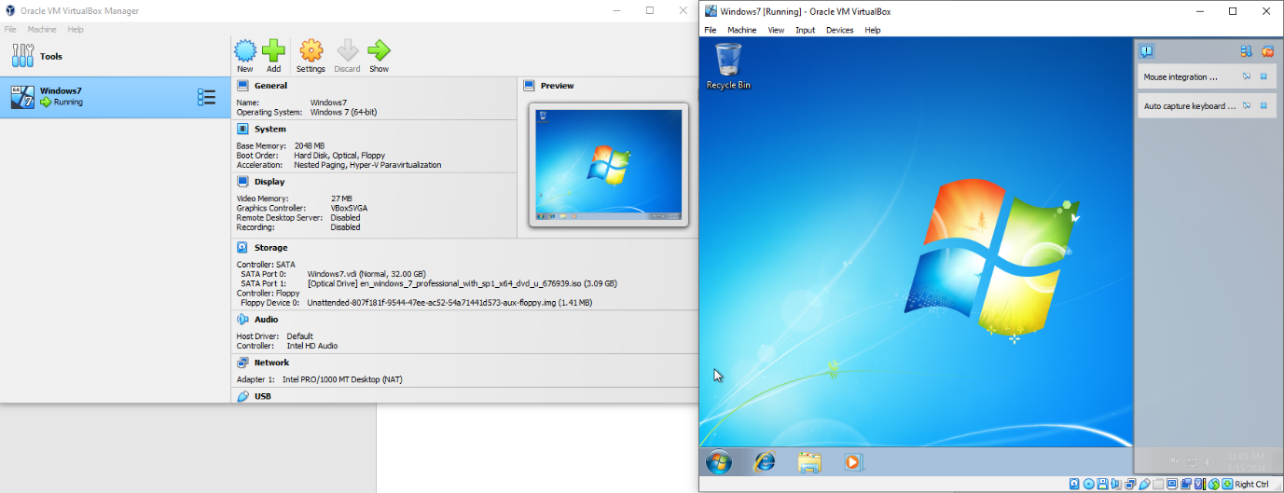
Figure 8 - Finished Successful Installation

B. Splitting the Memory Drive
To split the memory into two partitions, I navigated to the Control Panel, then to All Control Panel Items, and then Administrative Tools. From here, I selected Computer Management from the options available.
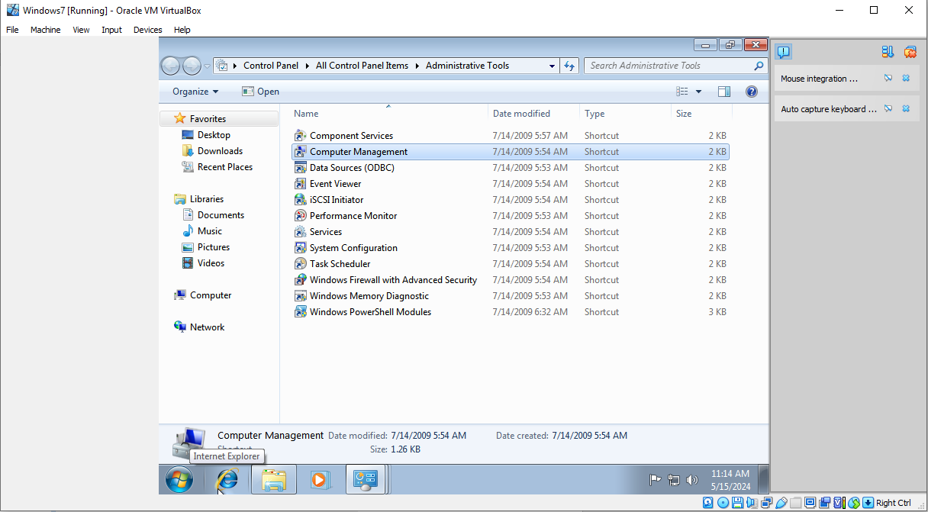
Figure 9 - Control Panel

Here I could view the C: drive that the VM was running with, which was 32 Gigabytes as defined during setup. To begin splitting this into two, I right clicked and selected ‘shrink volume’ and waited for the system to check for available space.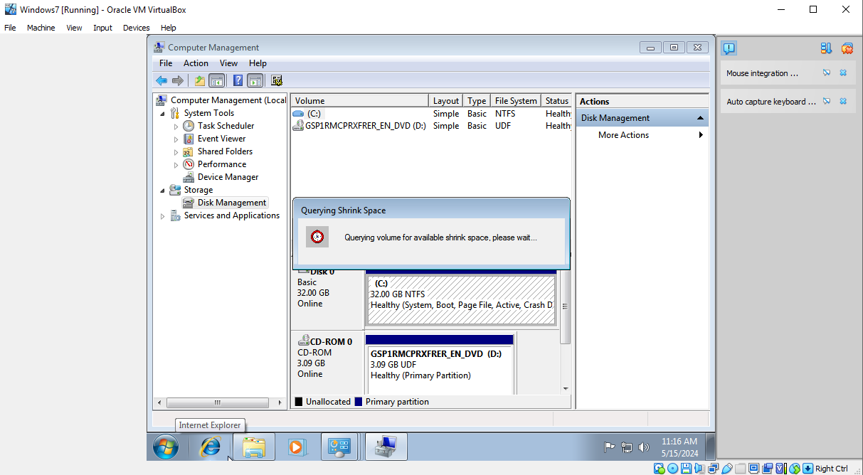
Figure 10 - Shrink Volume

Once this was complete, a screen was displayed showing the amount of available memory and allowing me to input the amount I wanted to partition. I opted to select 16000 to split the memory by roughly half its original size.
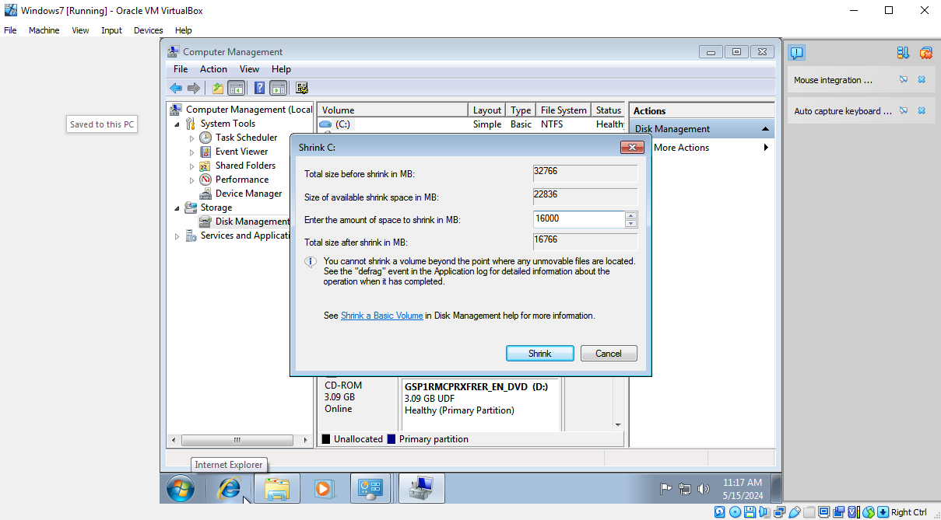
Figure 11 - 16 GB Memory Split
Once this process finished, the display next to ‘Disk 0’ showed the previous memory size of 32GB had successfully been split into 2 partitions of roughly 16GB each.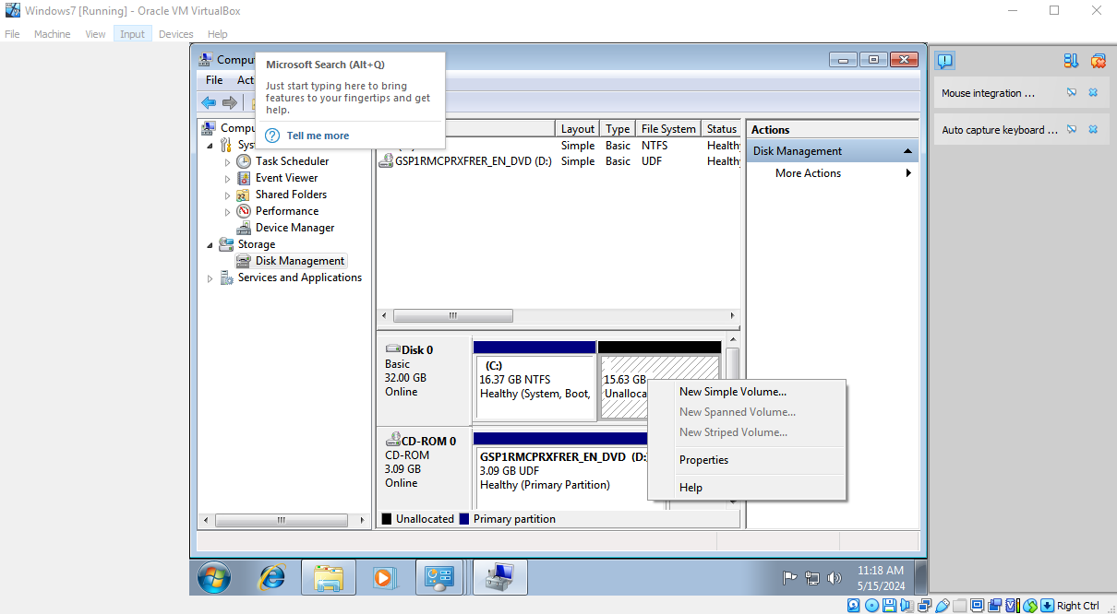
Figure 12 - Two Memory Drives

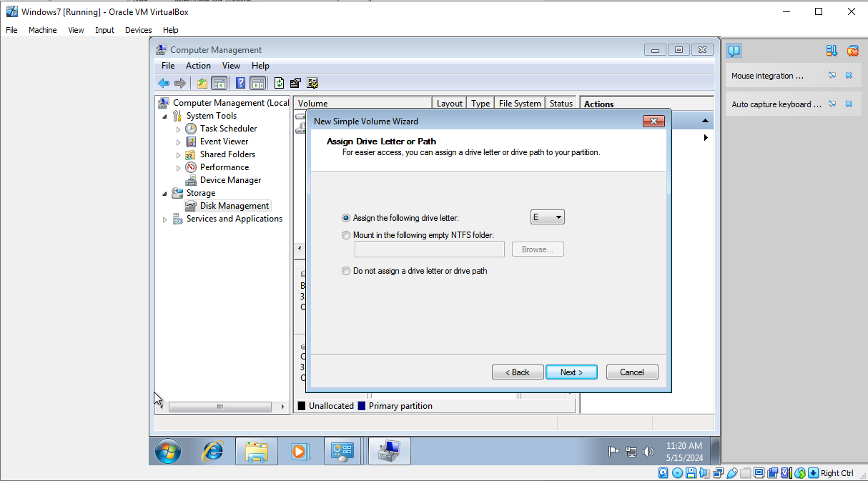
To format this new drive, I right clicked the unallocated memory and clicked the ‘New Simple Volume’ option. This allowed me to assign the drive the letter ‘E’, label it ‘DriveE’, and choose the file system. I chose NTFS, which provides some benefits over systems like FAT32, such as enhanced security and automatic file repairs [1].
Figure 13 - Drive Letter
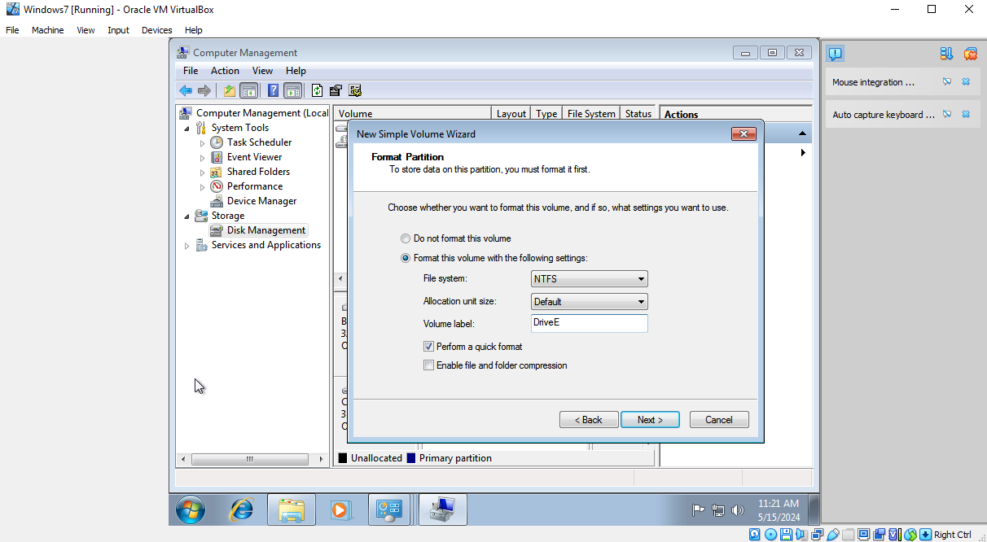
Figure 14 - Drive Label & File System

Once the drive was formatted, it successfully appeared under the VM’s available drives, showing the 32GB C: drive memory had successfully been split into two 16GB drives; C: drive, and E: drive.
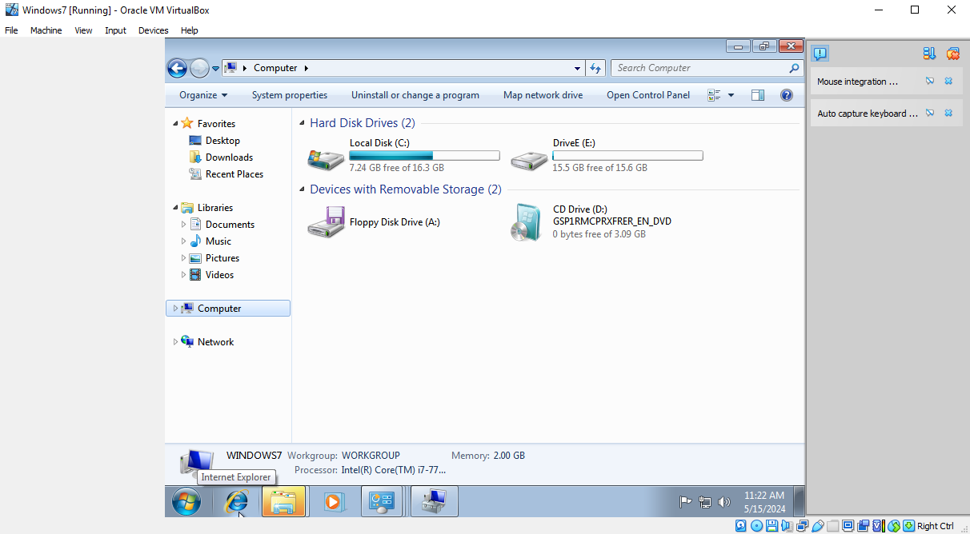
Figure 15 - Final Successfully Split Drives

Part Two – Report on Drivers & Office

1. Sound Card Driver Setup
Upon navigating to the device manager, I was able to retrieve the properties for the default sound card drivers installed on the system, shown below. 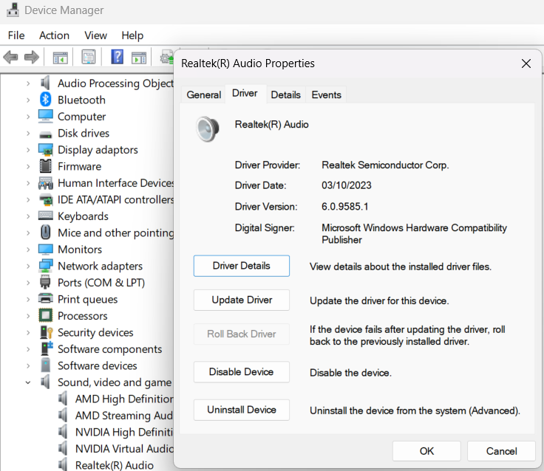
Figure 16 - Sound Card Drivers
The sound card and drivers are provided by Realtek Semiconductor Corp, a popular and widespread provider of computer hardware established in 1987 and based in Taiwan [2]. The driver date is the 3rd of October 2023, and when scanning for updates Windows confirms this to be the most up-to-date build available.

2. Network Card Driver Setup
Similarly, the VirtualBox virtual machine’s ethernet adapter was shown to be up to date, the driver date recording being 2nd of May 2024.
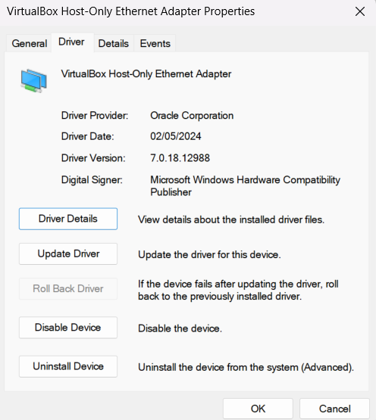
Figure 17 - Network Card Drivers
This driver was provided by Oracle itself, and allows the Virtual Machine to utilise the host machine’s ethernet cable connection to connect itself to the internet.

3. Installing Apache OpenOffice
To install OpenOffice on the VM, I first updated the system’s search engine to Google Chrome, as Internet Explorer was quite slow and outdated.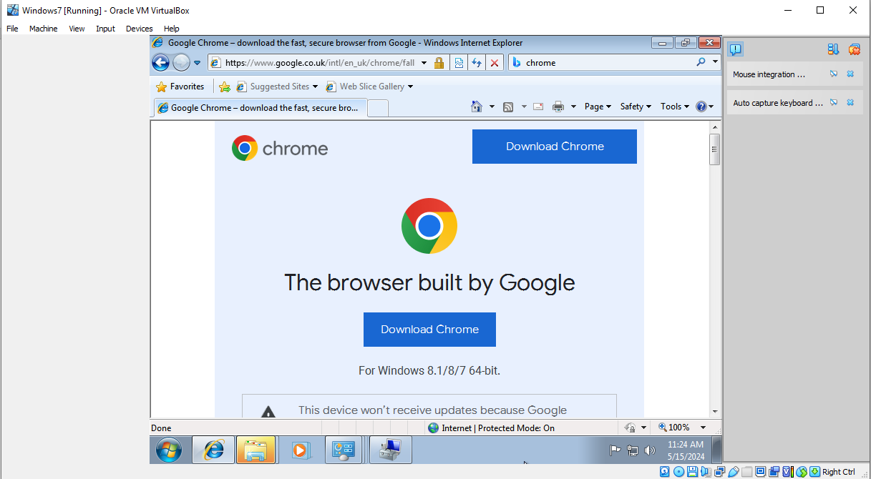
Figure 18 - Downloading Chrome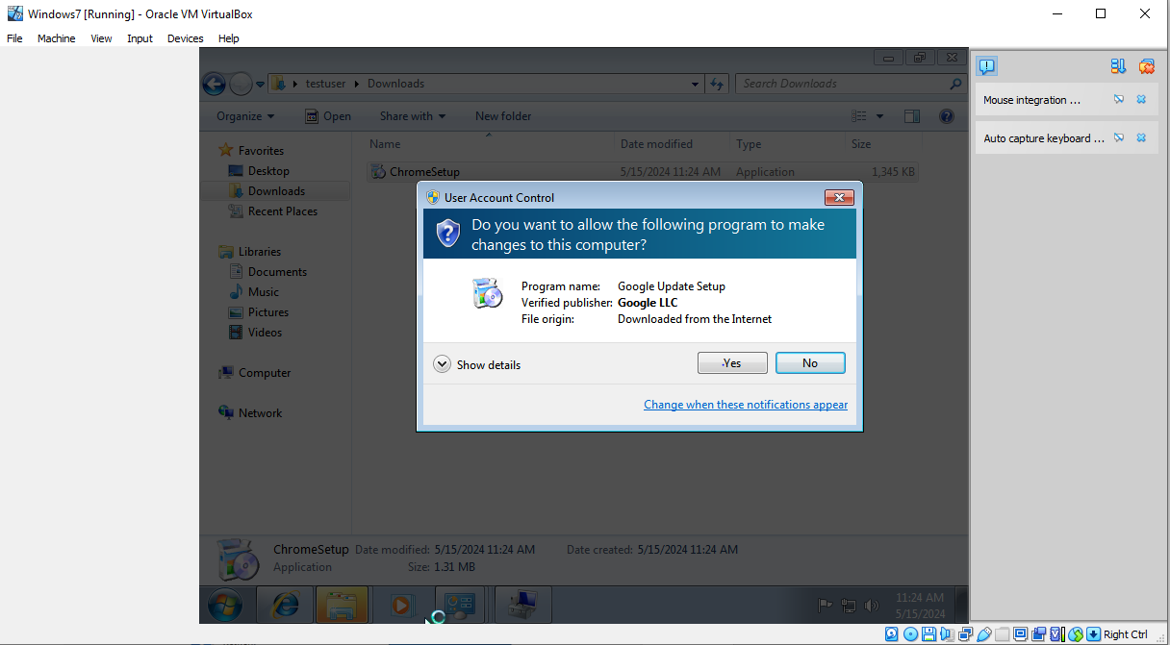
Figure 19 - Installing Chrome

With Chrome installed to its default directory under Default Apps, the next step was to navigate to OpenOffice’s website and download the installer, which would be much quicker on the Chrome browser.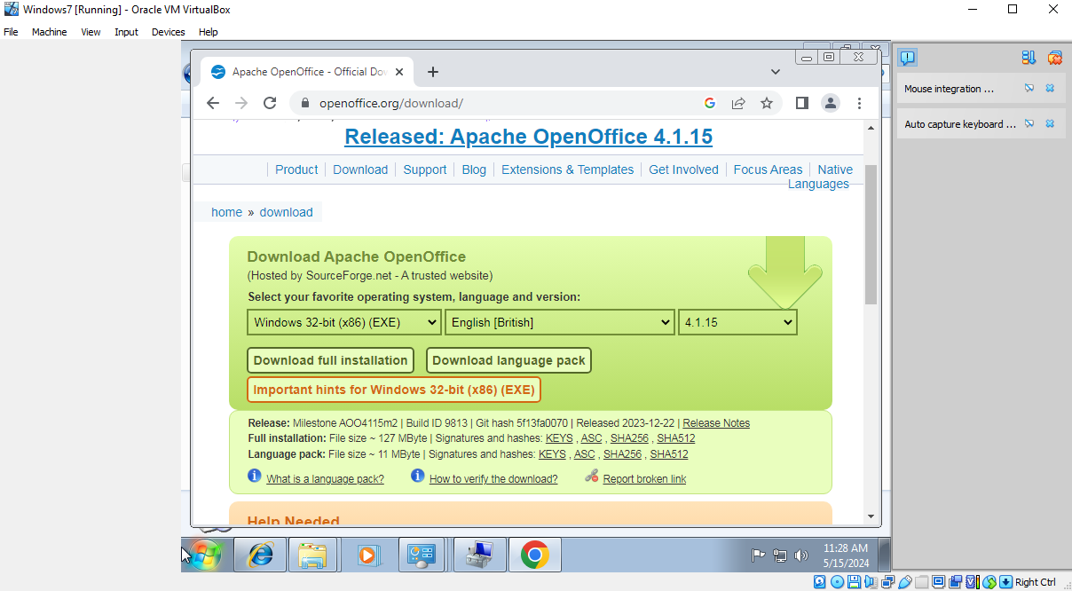
Figure 20 - Apache OpenOffice Download
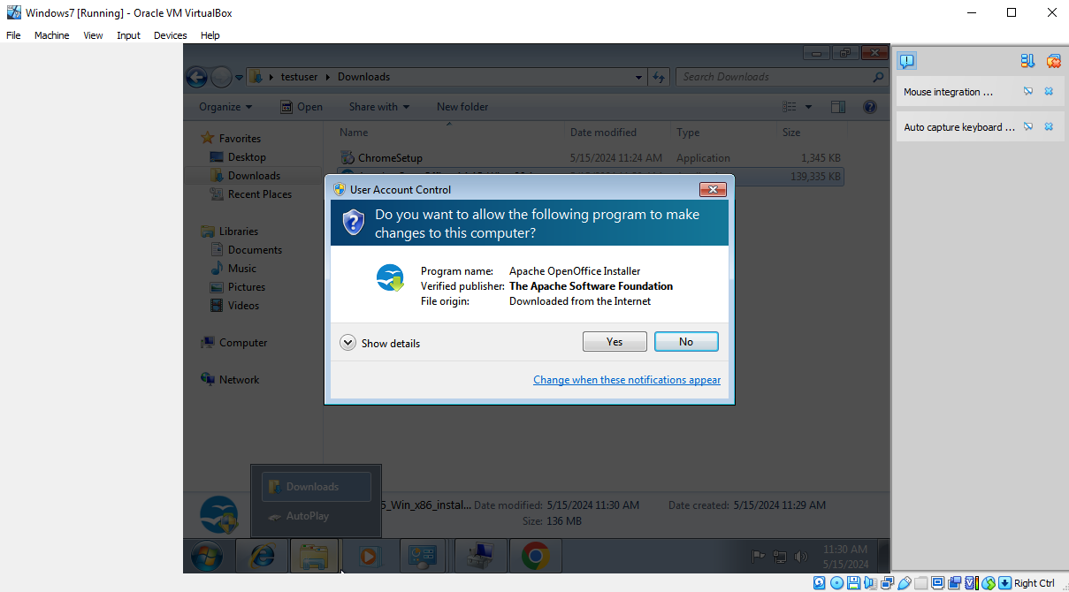
Figure 21 - Apache OpenOffice Installation

Apache OpenOffice began its installation Wizard, and prompted to input the user’s name and permission settings. For the ease of use on the VM, I left the name as the default ‘Windows User’ and allowed access for anyone using the machine. I also opted to use the typical/standard installation option, to avoid overcomplicating the process.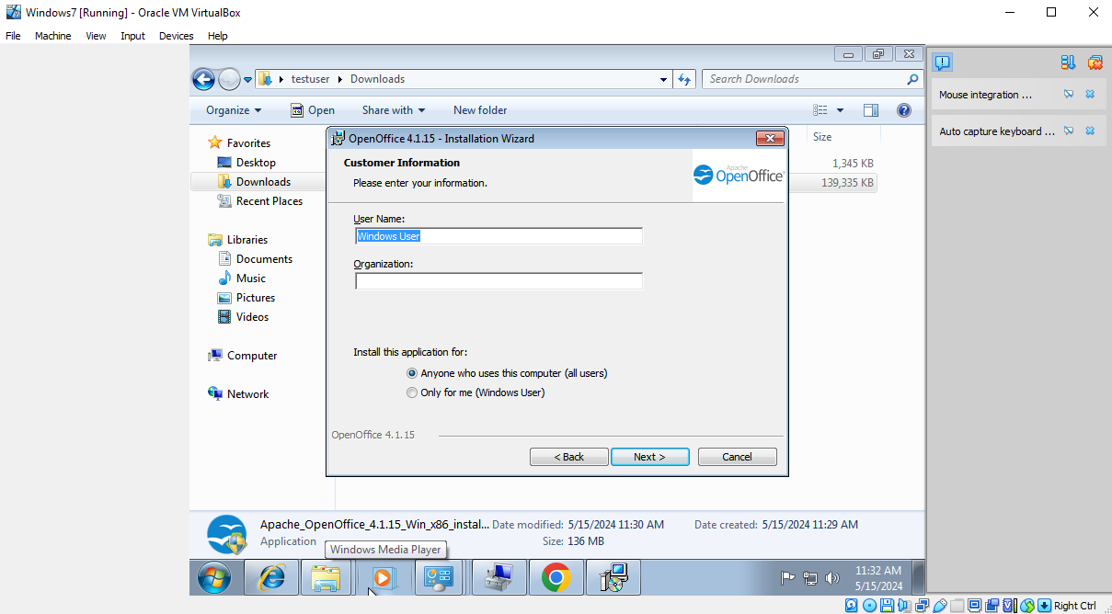
Figure 22 - OpenOffice Settings
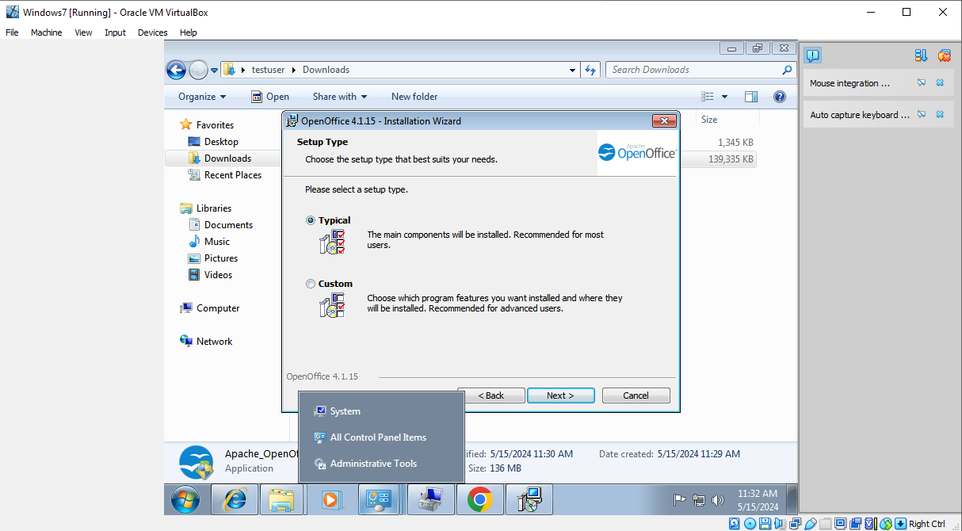
Figure 23 - OpenOffice Setup Type

Once these parameters were completed, OpenOffice successfully began to install, its files defaulting to the Program Files directory for ‘testuser’ as it finalised installation. Once complete, it was possible to create and open various kinds of office-based file formats on the VM, such as spreadsheets and presentations, just as described on OpenOffice’s website. [3]

References

[1] | T. G. Mesevage, “NTFS vs FAT32: Which Is Better?,” Datto, 10 May 2022. [Online]. Available: https://www.datto.com/blog/fat-vs-ntfs-which-is-better/. [Accessed 9 May 2024].
[2] | “Office Location,” Realtek, [Online]. Available: https://www.realtek.com/Article/Index?menu_id=416&lang=en-GB. [Accessed 9 May 2024].
[3] | “Why Apache OpenOffice,” Apache OpenOffice, [Online]. Available: https://www.openoffice.org/why/index.html. [Accessed 13 May 2024].

Figure 1 - Starting new VM project. 3
Figure 2 - Username & password 3
Figure 3 = Hardware specs 4
Figure 4 - VM Memory 4
Figure 5 - Install summary 5
Figure 6 - VM in Oracle 5
Figure 7 - Windows installing 6
Figure 8 - Finished Successful Installation 6
Figure 9 - Control Panel 7
Figure 10 - Shrink Volume 8
Figure 11 - 16 GB Memory Split 8
Figure 12 - Two Memory Drives 9
Figure 13 - Drive Letter 9
Figure 14 - Drive Label & File System 10
Figure 15 - Final Successfully Split Drives 10
Figure 16 - Sound Card Drivers 11
Figure 17 - Network Card Drivers 12
Figure 18 - Downloading Chrome 13
Figure 19 - Installing Chrome 13
Figure 20 - Apache OpenOffice Download 14
Figure 21 - Apache OpenOffice Installation 14
Figure 22 - OpenOffice Settings 15
Figure 23 - OpenOffice Setup Type 15

