Driver comparison through data analysis
Race Engineering (M6X02207)

Liam Paul Standing
P150310

University of Wales Trinity Saint David
School of Engineering
Automotive Engineering BSc

6 December 2019

Contents

Contents 2
1. Introduction 5
2. Literature Review 6
3. Planning & Outcome 7
3.1 Session 1 Plan 7
3.2 Session 1 Outcome and planning session 2 7
3.4 Session 2 Outcome 8
4. Results 8
5. Analysis 9
5.1 Session 1 9
5.2 Session 2 10
5.3 Comparing Sessions 1 and 2 11
6. Conclusion 12
7. References 13
8. Appendices 14

Figure 1, Brands Hatch Track Map, Sourced MoTeC data, 2019. 6
Figure 2, Data breakdown and referred naming 7
Figure 3, Session 1 testing plan, Standing 2019 13
Figure 4, session plan 2 14
Figure 5, Session 2 discussion and minutes. 15
Figure 6, Tim session 1 warm up tyres effect, Standing 2019 16
Figure 7, Davis session 1 lap variance, Standing 2019 17
Figure 8, Mike Session 1 lap variance, Standing 2019 17
Figure 9, Tim Session 1 lap variance, Standing 2019 18
Figure 10, Davis session 2 Stint variance, Standing 2019 18
Figure 11, Mike session 2 Stint variance, Standing 2019 19
Figure 12, Tim session 2 Stint variance, Standing 2019 19
Figure 13, Davis comparing fastest session 1 and 2, Standing 2019 20
Figure 14, Mike comparing fastest session 1 and 2, Standing 2019 20
Figure 15, Tim comparing fastest session 1 and 2, Standing 2019 21
Figure 16, Session 1Davis compared to Tim turn 4 to 5, Standing 2019 21
Figure 17, Session 1 Davis (Red) compared to Tim (Black) turn 2, Standing 2019 22
Figure 18, Session 1 Davis compared to Tim turn 3, Standing 2019 22
Figure 19, Session 1 Davis compared to Tim whole lap, Standing 2019 23
Figure 20, Session 1 Mike compared to Tim turn 4 in to 5, Standing 2019 23
Figure 21, Session 1 mike compared to Tim turn 1, Standing 2019 24
Figure 22, Session 1 Mike compared to Tim whole lap, Standing 2019 24
Figure 23, Session 1 Tim compared to Davis (Blue) and Mike (Green), Standing 2019 25
Figure 24, S1D1-8 improving turn 1, Standing 2019 25
Figure 25, S1T1-7 improving turn 1, Standing 2019 26
Figure 26, S1D1 fastest lap against Session 2 fastest lap of each stint, Standing 2019 26
Figure 27, S1M1 fastest lap against Session 2 fastest lap of each stint, Standing 2019 27
Figure 28, S1T1 fastest lap against session 2 fastest lap of each stint, Standing 2019. 27
Figure 29, Tyre temperature S1T1-OUT compared to S1T1-1, Standing 2019 28
Figure 30, Tyre temperature S1M1-OUT compared to S1M1-1, Standing 2019 28
Figure 31, Understeer to tyre temp and G force laterally, Standing 2019 29

Table 1: Abbreviations 4

Abbreviation | Meaning
Str 1-2 | Straight 1-2 (straight from turn 1 to turn 2)
Table 1: Abbreviation

Introduction

In this report 3 drivers perform in a time trial session at Brands Hatch Indy circuit using a driver in the loop simulator. Data from this first session was analyzed prior to a second time trial session. During the second session drivers had to implement individual assigned objectives to attempt to improve lap times. These objectives were developed from all the drivers first session from analysis using MoTeC i2 Pro software and development of math channels. The effect the implementations have on the lap times and of the vehicle has been reviewed.

Planning & Outcome
This section of the report will cover the plan for testing. Prior to having session 1 of data collection the group organized a test session to decide the drivers taking part. Drivers Davis and Mike were decided upon as both were consistent drivers during testing with steady improvement during a short test session. The third driver decided was Tim down to vast experience in the Sim. For the following sessions Tim was used as a benchmark to improve both other drivers, as well as seeing what the others drivers did differently to improve Tim’s lap times. Others drivers of the group not driving in the sessions were less consistent in achieving clean laps during the test session. These group members not driving were in charge of separate team jobs such as data labeling and collection, live data advice and note taking, driver line notes and incidents.
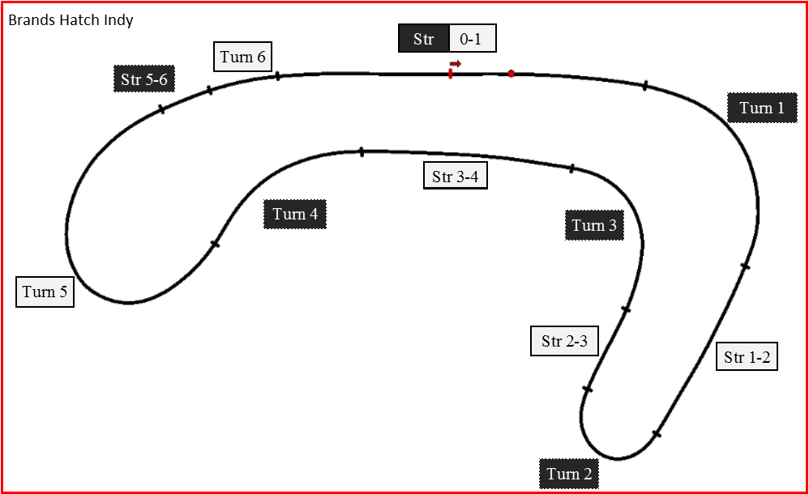
Figure 1, Brands Hatch Track Map, Sourced MoTeC data, 2019.
Figure 1 shows Brands Hatch Indy Circuit selected for the Simulator sessions. This figure shows the labeling of turns and straights used throughout this report. This track was selected for its combination of fast and slow corners and very short distance to increase number of laps recorded in a short space of time.

3.1 Session 1 Plan
The plan for Session 1 can be seen in figure 3 (see appendices). The reason for this particular plan was to allow the slowest drivers to go first, to prevent drivers getting too competitive and risk-taking to achieve the same lap time as faster drivers and potentially risk crashing. This plan was put in place to allow the Davies and Mike to hone in on their individual driving line and pace on the track and gain familiarity. Then using all the collected lap data from Tim stint an analysis could be completed compared to the other driver’s laps to see any potential improvements for the next session.

3.2 Session 1 Outcome and planning session 2
The outcome from session 1 was data that we could analyze for all drivers and give advice for session 2. However the 13 lap stint in the car only benefited Davis and Mike, as Tim was able to perform his fastest lap at lap 2. This was achieved as he warmed up his tyres on his outlap, something the group hadn’t considered before. This was seen as he slalomed around the track to increase tyre temperature and therefore grip (reference) (See GG Diagram of cold and warm lap figure in appendices). Hence the implementation of outlap tyre warm up and 4 lap stints for session 2 plan (figure 4). The 4 lap stints were introduced to allow quick changes in the simulator after warming up the tyres to achieve the implementations given. The individual driver analysis of implementation can be seen in section 5.1 and the decided implementation can be seen in the Session 2 plan (figure 4) in the appendices. A hand out was also given at the start of session 2 giving a clear indication to the tyre temperature warm-up achieved by Tim in session 1 compared to the other drivers, this can be seen as figure 6 in appendices.

3.4 Session 2 Outcome
The outcome of session 2 was again more data that we could use to compare laps, drivers and implementations of advice. This data is analyzed in the section 5.2 onwards. Recorded minutes of session 2 can also be seen in the appendices (figure 5).

Results
The resulting driver data was collected at the time of both sessions. The software MoTeC i2 Pro was used to analyze the data in the following Analysis section (section 5). The data from each driver stint is labeled below (Figure 2) and will be referred to by the referred name in the sections for here onwards.
Figure 2, Data breakdown and referred naming
When refereeing to a lap from one of the sessions the referred name from the above figure 2 will be used, for example “S2M1-3” would refer to session 2, Mike’s first stint and looking at lap 3.
The number of laps in figure 2 does not include the Out-lap or In-lap and these will be labeled as “S1T1-OUT” referring to the out-lap of Tim’s session 1 or “S1T1-IN”for his In-lap.

Analysis
This section analyses and compares the driver’s laps over each stint and session to the other drivers and the implementation of advice that was given and further implications on the times or vehicle.

5.1 Session 1
This session will look at the different laps produced by the drivers in session 1 and give insight to reasoning for implementations for the session 2 plan (Figure 4)
Davis lap time variance session 1 (Figure 7)
The fastest lap was S1D1-12 in session 1. As seen in figure 7 there are possible improvements when the variance gradient is negative, therefore reducing time.
Possible improvements include;
- Carry more speed in to Straight 0-1. (Figure 7)
- S1D1-8 show variance decrease for turn 1. Figure 24 shows this due to carrying more speed in to the corner via braking less then gradual throttle application however the application of the throttle is too late.
- Turn 2 follow S1T1-2 (Figure 17). Where Tim comes off throttle and applies brakes later in to turn 2.
- Turn 3 follow S1T1-2 (Figure 18) and S1D1-10 (Figure 7). When the braking and turn in is achieved earlier leaving a late and carrying more speed.
- Lift off throttle half-way turn 4 and accelerate hard for turn 5 as seen in figure 16.

Mike lap time variance session 1 (Figure 8)
S1M1-6 is the fastest lap.
Possible improvements include;
- Turn 1 till turn 3 follow S1M1-8. (Figure 8)
- Turn 3 till turn 4 follow S1M1-3. (Figure 8)
- Leave in 4th gear for turn 4. (Figure 20)
- Set pedals before stint, as throttle does not reach 100% in whole lap. (Figure 22)
- Manage bump as seen by S1T1-2 in to turn 1 (Figure 21)

Tim lap time variance session 1 (Figure 9)
S1T1-2 was the fastest lap for Tim.
Possible improvements include;
- Carry more speed through turn 3 (Figure 9) as seen by S1T1-13
- Carry more speed through turn 1 (Figure 25)

From session 1 all the possible improvements outlined was considered and was ultimately formulated in to the session 2 driver improvements seen in figure 4.

5.2 Session 2
In this section the data from section 2 was analyzed to determine if the improvements were put in to effect and the affect this had on the vehicle and the sector/ overall lap time.

Davis Session 2 fastest laps each stint (Figure 10)
Comparing S1D1-12 (Red) to the fastest laps of each stint (S2D1-3=green, S2D2-4=blue, S2D3-2=dark blue) in figure 26 (combination of session 1 and session 2). Compared to the first session more speed is carried into the straight 0-1. This only benefits stints 2 and 3 as the stint 1 loses time in turn 1by braking too early. Turn 4 Davis implements the change requested as going to half throttle as seen in stint 2 and 3 on throttle position, however this change ultimately slows up the last causing this change to lose time. Braking later does not take place at turn 2 hence no analysis can be given other than the variance doesn’t change. Turn 3 shows all three stints of session 2 showing greater brake application. This is followed by earlier throttle application as compared to previous session. This would show a late apex approach (Segers , 2014) which over the whole section improves the lap time.

Mike Session 2 fastest laps each stint (Figure 11)
Figure 27 compares Mike’s session 1 fastest lap to his session 2 laps as expressed akin to Davis above. Management of the bump into turn 1 is managed. He also made a vast improvement of up to -0.3s by the end of turn 1 however by turn 3 and 4 lost this gained time as seen in figure 27 and 11. The throttle percentage reaches 100% in the all straights unlike in session 1.
From figure 11; all laps start at the same pace, S2M2-3 takes a good corner from Turn 1 but loses pace to Turn 2 end whereas S2M1-4 gains on the pace. S2M3-1 is fastest through straight 3-4 and takes turn 4 and 5 best of all data, however S2M2-3 takes time off as a whole from turn 4 to end of lap.

Tim Session 2 fastest laps each stint (Figure 12)
Figure 28 shows likeness to figures 27 and 26 above with data representative of Tim’s first and second session. Tim’s fastest lap (S2T3-1) was a mixture of a well-executed turn 1 and a blend of the previous implementations. Advice to apply throttle earlier in turn 2 exit actually negates performance as seen as turn 2 for all laps get positive variance compared to the session 1 lap.
From figure 12; All laps are slower than S2T3-1 in to turn 1 however S2T1-4 manages to gain time up to the breaking point of turn 2. All other laps than S2T3-1 are braking sooner in to turn 2 and quicker in the exit. Laps S2T1-4 and S2T2-4go slower for the rest of the lap. S2T3-4 carries more speed through turn 3 and manages to gain time and again in turn 4 however loses time in turn 5 ultimately causing the lap to be slower than S2T3-1 overall.

5.3 Comparing Sessions 1 and 2

Davis comparing fastest session 1 to session 2 (Figure 13)
To his first session Davis made improvements from turn 1 till turn 2. Turn 3 and 5 he loses time in the midpoint of the corner but gains the time back on each turn to ultimately make no improvement between sessions. (Figure 13)

Mike comparing fastest session 1 to session 2 (Figure 14)
Between sessions Mike makes major improvements in turn 1 and 2 however loses time in turn 3 and 4. This leads to a potentially much improved lap time however a combination of the session 2 turns 1 and 2 and session 1 turns 3 and 4 doesn’t occur in either session.

Tim comparing fastest session 1 to session 2 (Figure 15)
Session 2 is a vast improvement to session 1 for Tim. He gains the majority of his time from turn 1 and loses most of the time in the straight that follows but each section of the track be overall makes improvements to his lap time with the exception of the end of straight where he loses a small amount of the time gained.

5.4 Outlap Warm-up
As discussed previously during session 1 Tim used the Out-lap to warm up the tyres to increase the available grip therefore carry more speed through the corner (this is also help by downforce from aerodynamics at high speed in corners however is not looked at here). Seen in figure 29 is a Rainbow track maps made in MoTeC to demonstrate the increase of temperature from S1T1-OUT (red car marker) to S1T1-1 (black car marker). Compared this to figure 30, where even though the coloring of the tracks temperature is similar the key showing the tyre temperature demonstrates S1M1 tyres are actually colder.
Figure 31 shows the correlation of understeer and tyre temperature. As seen in the GG diagram S1T1-1 (red) experiences less lateral force than S1T1-2 (black). However at this same point S1T1-1 has large understeer while S1T1-2 has minimal understeer.

Conclusion

To conclude each of the drivers were able to make improvements specified by the group and improve their time in a section or through the whole lap as a result of this. The most improved in the sessions was Tim by blending together all improvements in the last stint of session 2 to improve his overall lap time by -0.34s compared to his first session (figure 15). Davis made improvements especially in turn 3, however was unable to tie together the a complete improvement lap and therefore only improved by -0.004s which can be put down to gain experience and advise given by the group (figure 13). Mike was unable to make an improvement to his entire lap time but managed to gain -0.12s by the end of turn 2 however through turn 3 and 4 lost this gained time.

References

1. Segers J, 2014. “Analysis Techniques for Racecar Data Acquisition”, SAE International, ISBN 978-0-7680- 1659-9
2. Templeman G, 2008. “The Competition Car Data Logging Manual”, Veloce publishing, Dorchester, ISBN 978-1- 84584-162-1
3. Larminie, J. R. J., Martin, J. K., 2007. “Data Acquisition Systems,” A DLC, Motorsport knowledge exchange publications, Oxford Brookes, ISBN 978 1 87364045 6.

Word count = 3000

Appendices
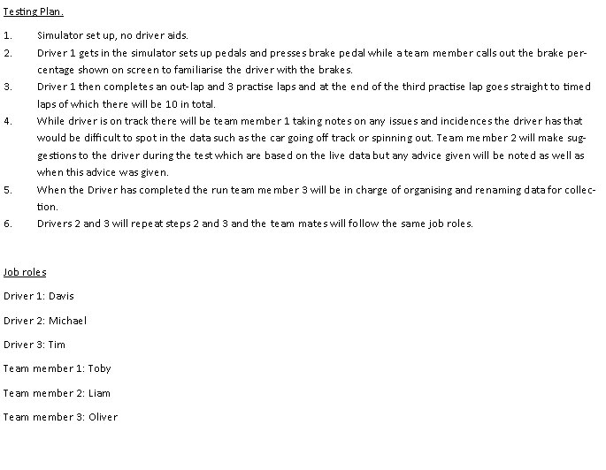
Figure 3, Session 1 testing plan, Standing 2019


Figure 4, session plan 2

Figure 5, Session 2 discussion and minutes.

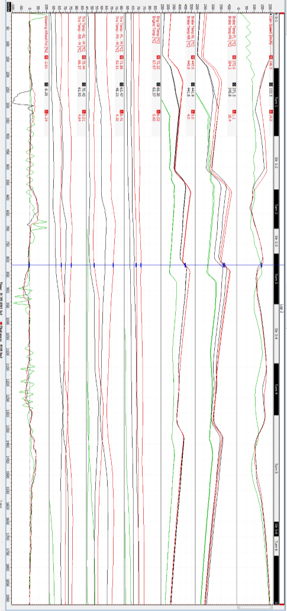
Figure 6, Tim session 1 warm up tyres effect, Standing 2019

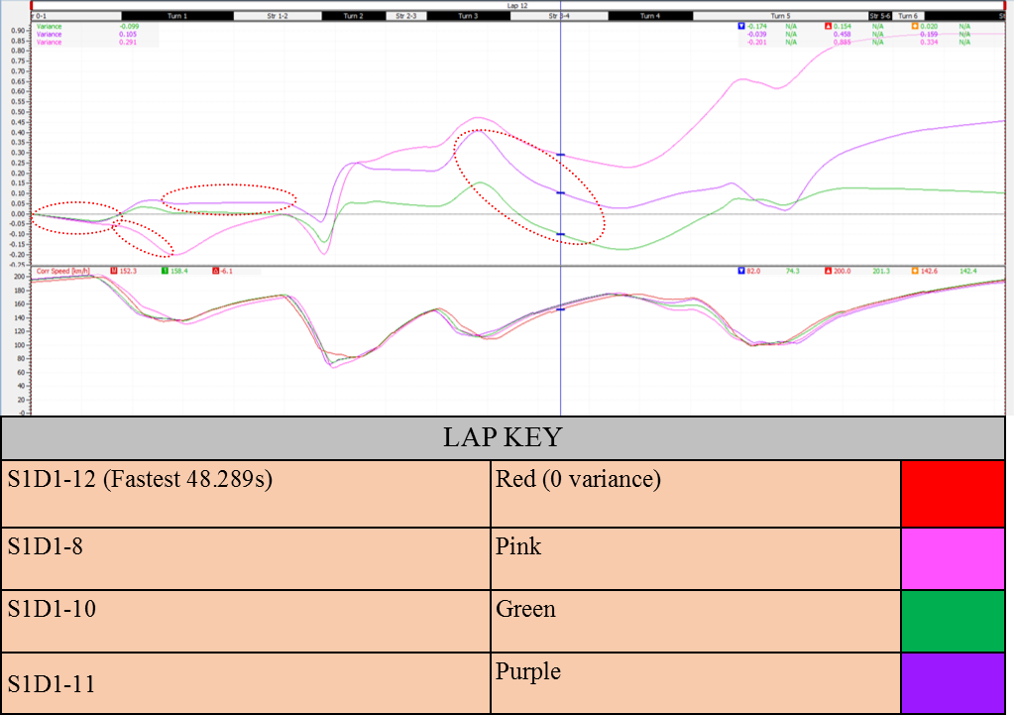
Figure 7, Davis session 1 lap variance, Standing 2019

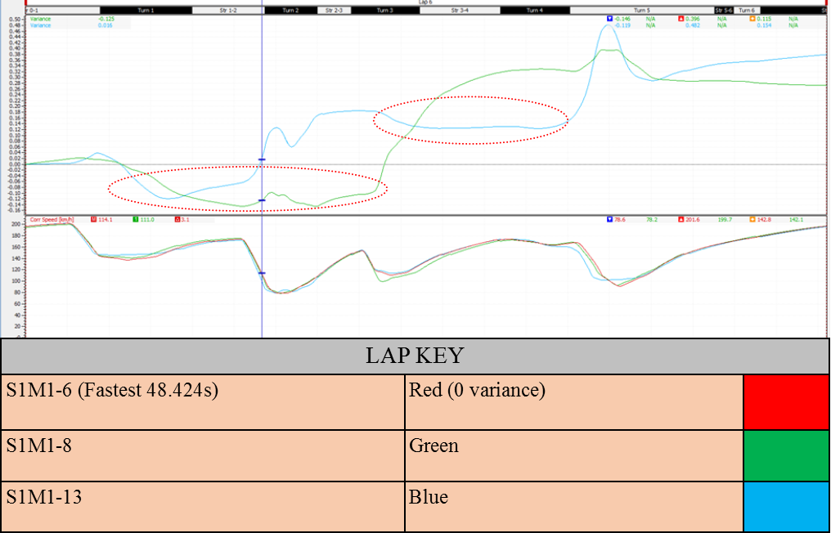
Figure 8, Mike Session 1 lap variance, Standing 2019
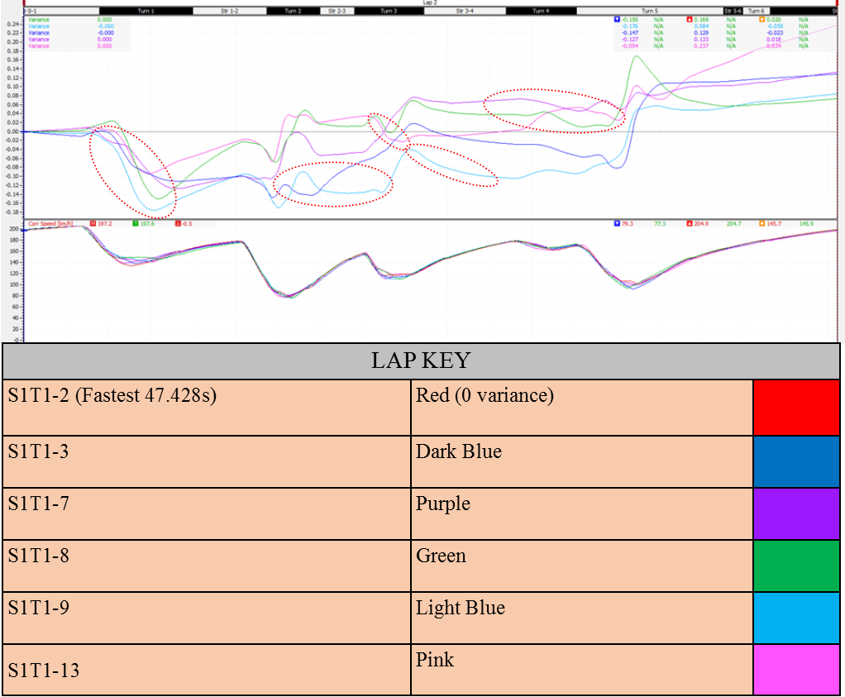
Figure 9, Tim Session 1 lap variance, Standing 2019
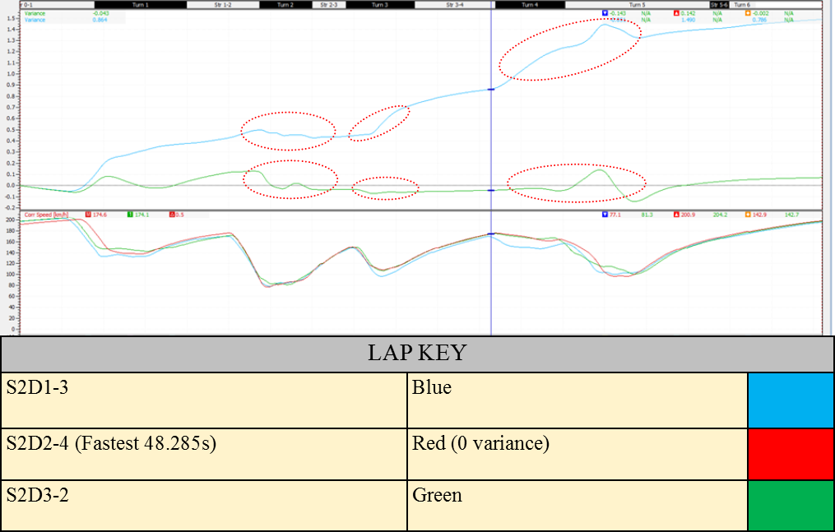
Figure 10, Davis session 2 Stint variance, Standing 2019
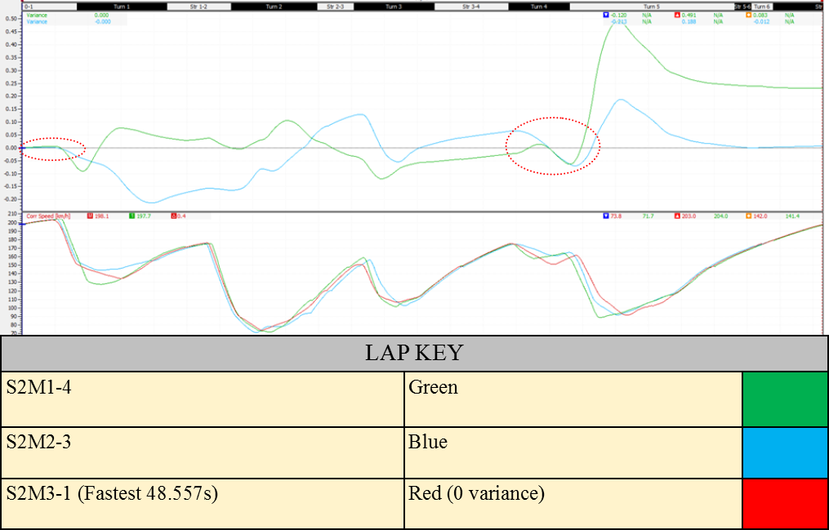
Figure 11, Mike session 2 Stint variance, Standing 2019

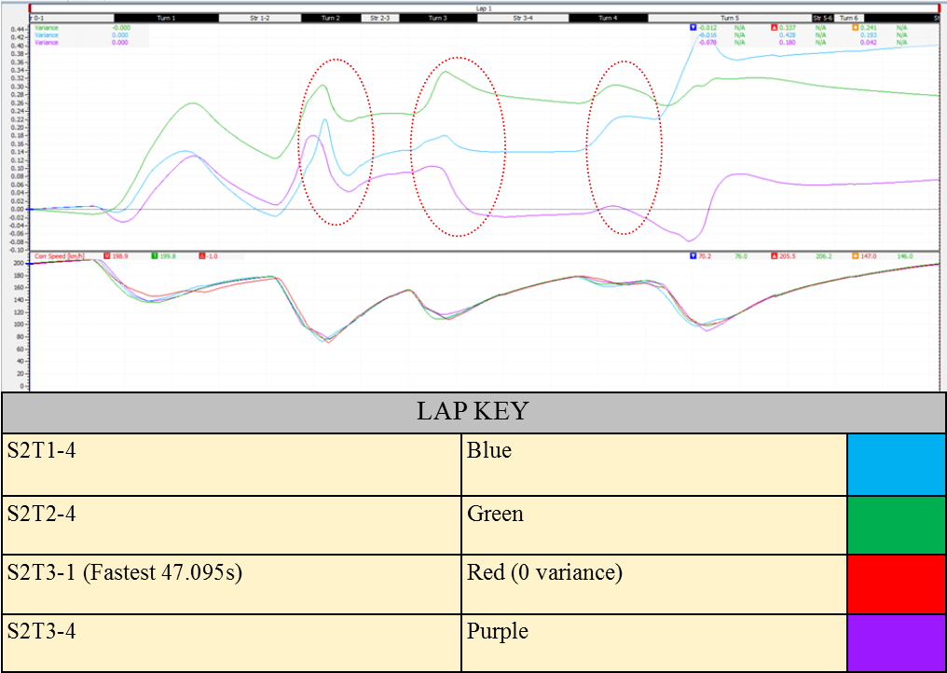
Figure 12, Tim session 2 Stint variance, Standing 2019
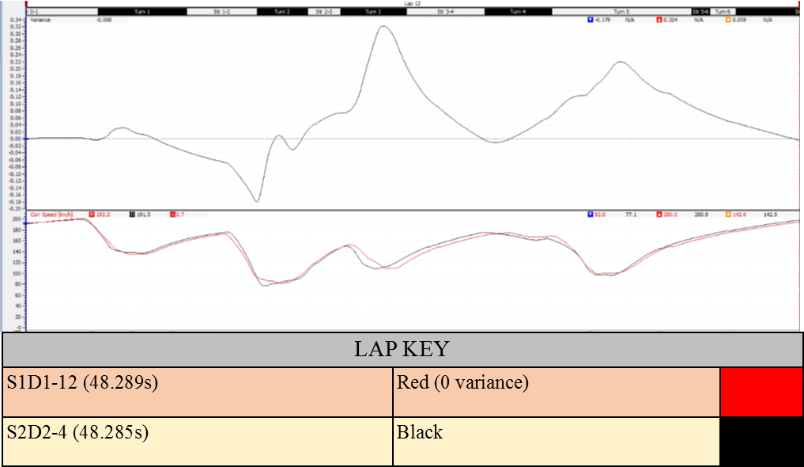
Figure 13, Davis comparing fastest session 1 and 2, Standing 2019

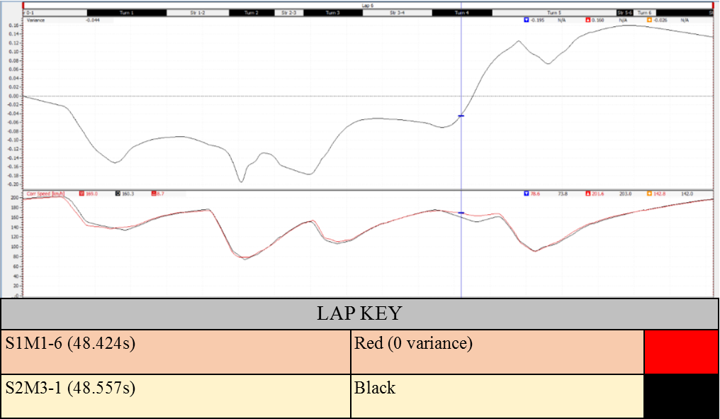
Figure 14, Mike comparing fastest session 1 and 2, Standing 2019

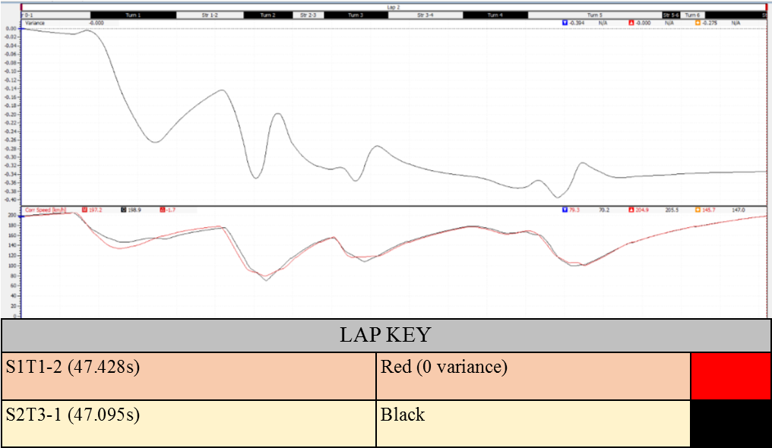
Figure 15, Tim comparing fastest session 1 and 2, Standing 2019

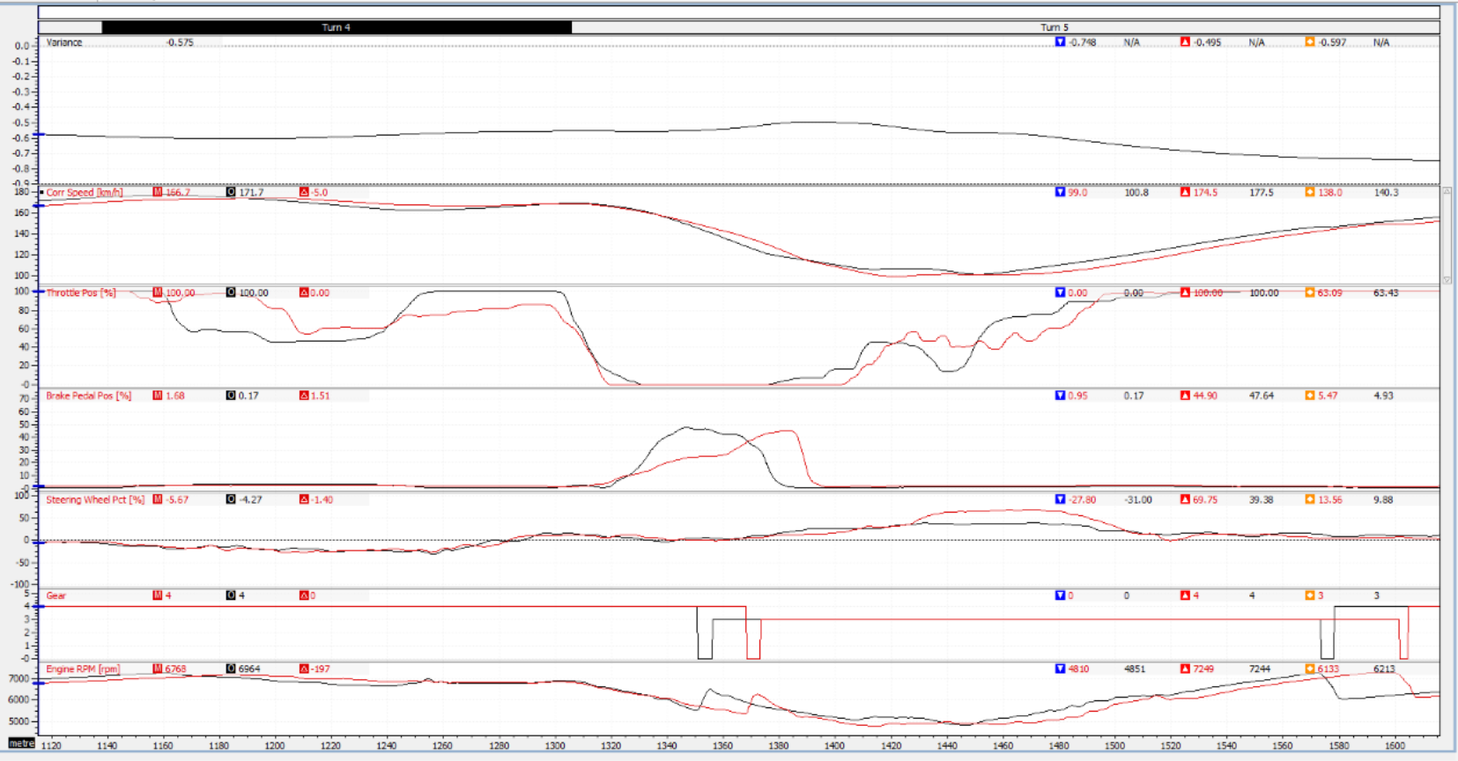
Figure 16, Session 1Davis compared to Tim turn 4 to 5, Standing 2019

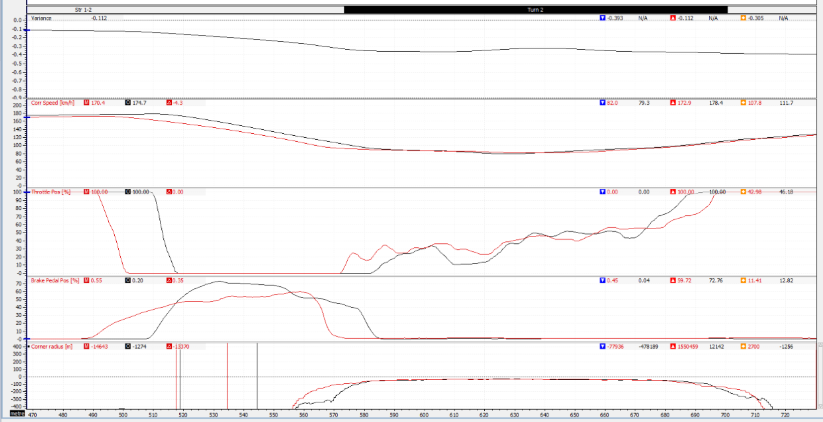
Figure 17, Session 1 Davis (Red) compared to Tim (Black) turn 2, Standing 2019

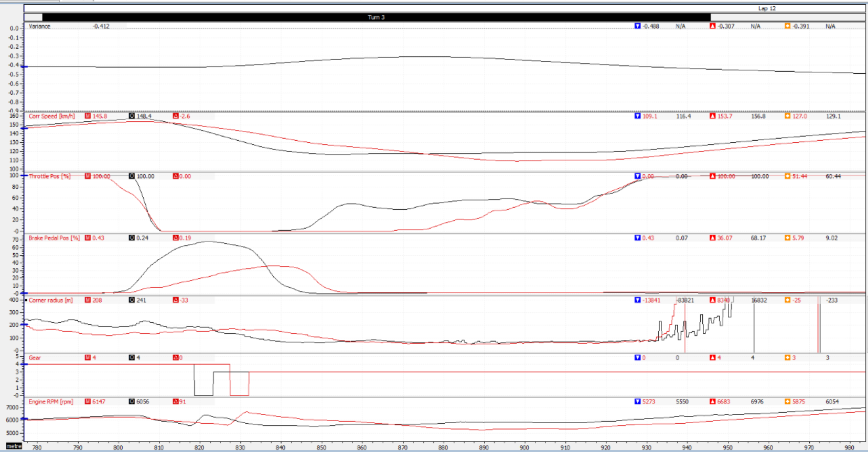
Figure 18, Session 1 Davis compared to Tim turn 3, Standing 2019

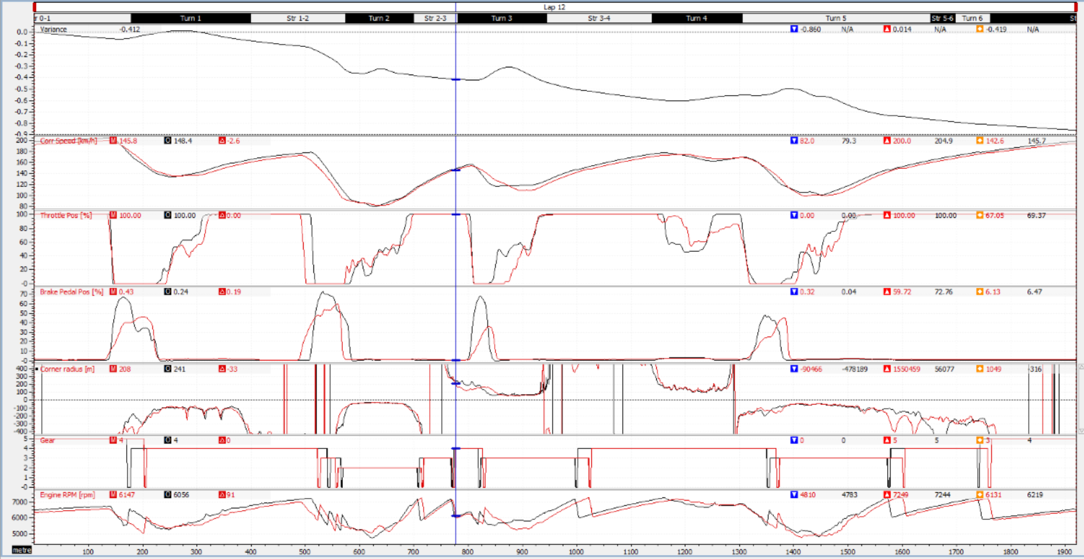
Figure 19, Session 1 Davis compared to Tim whole lap, Standing 2019

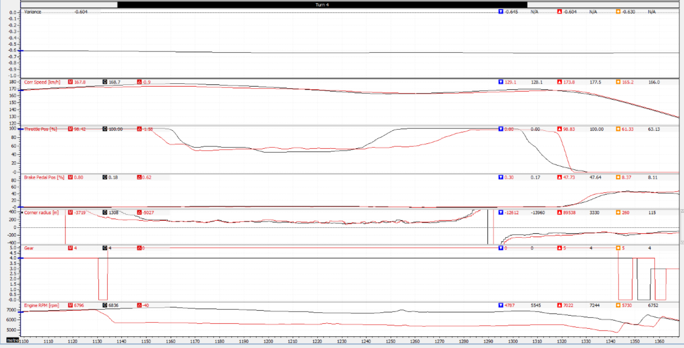
Figure 20, Session 1 Mike compared to Tim turn 4 in to 5, Standing 2019

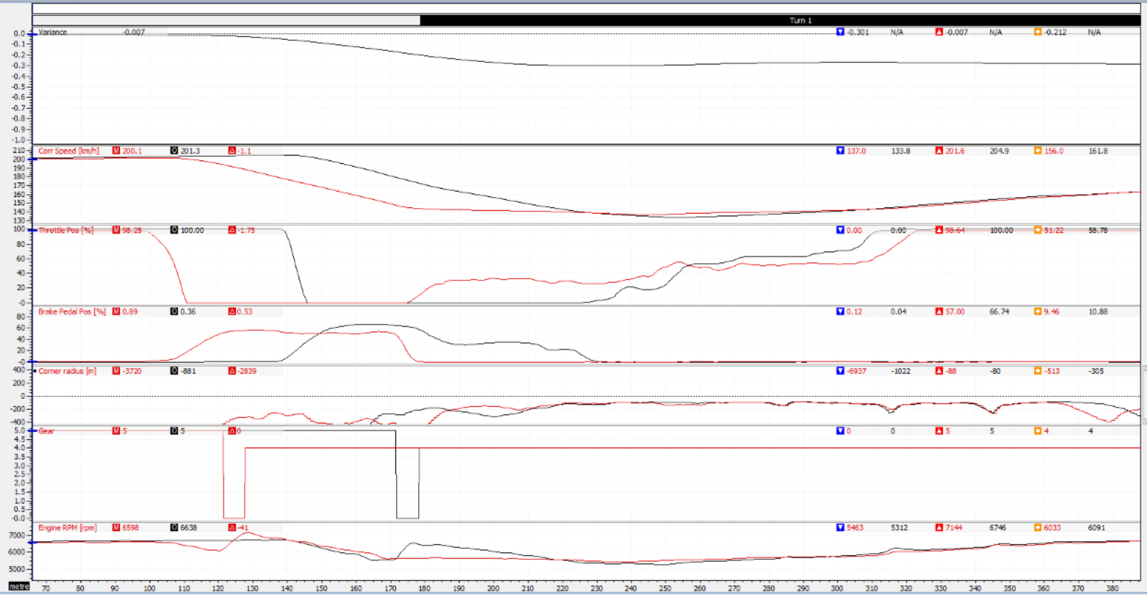
Figure 21, Session 1 mike compared to Tim turn 1, Standing 2019

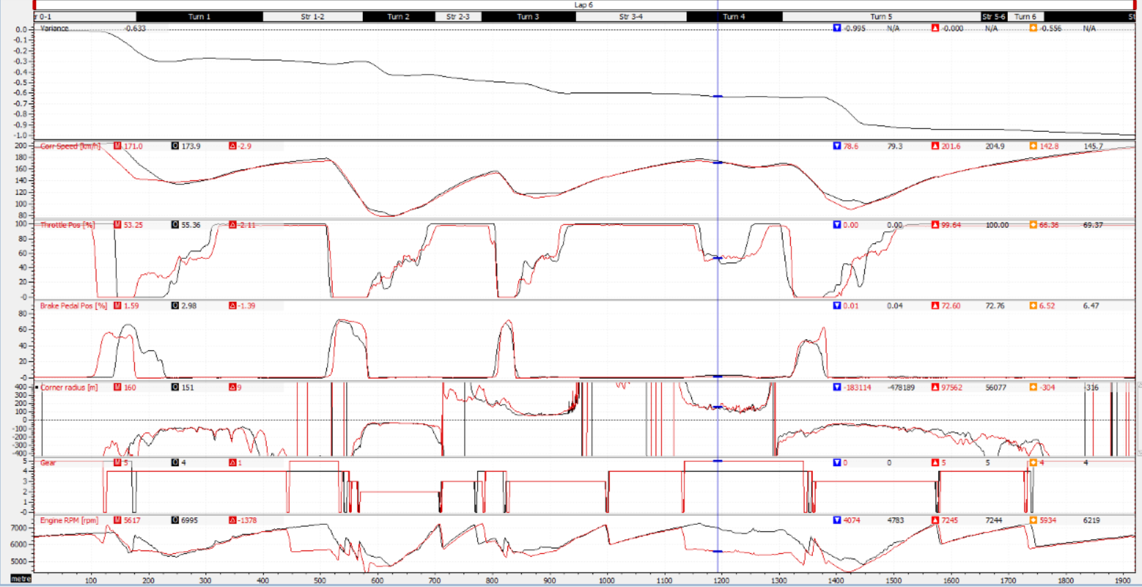
Figure 22, Session 1 Mike compared to Tim whole lap, Standing 2019

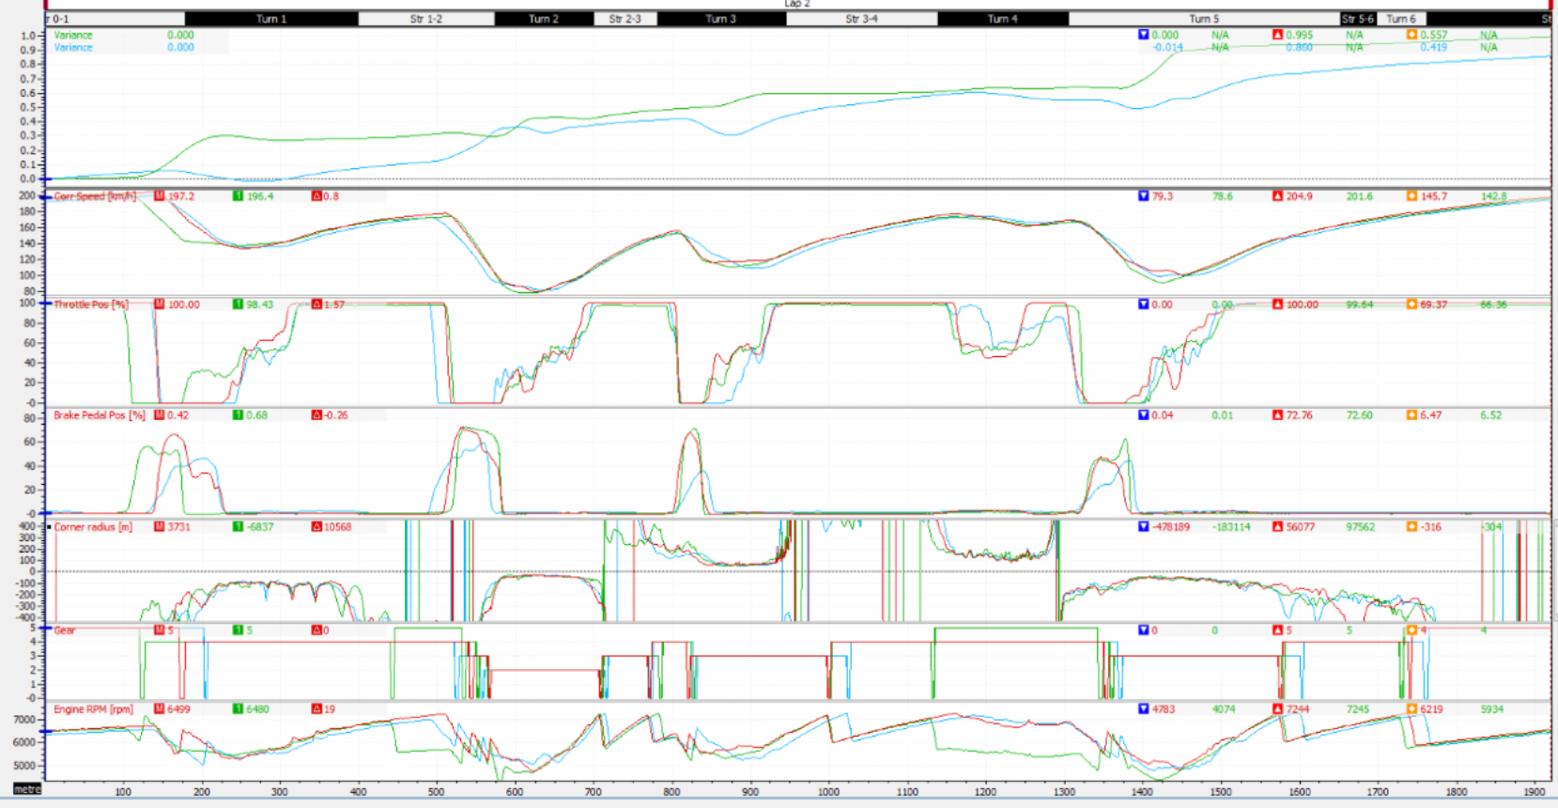
Figure 23, Session 1 Tim compared to Davis (Blue) and Mike (Green), Standing 2019

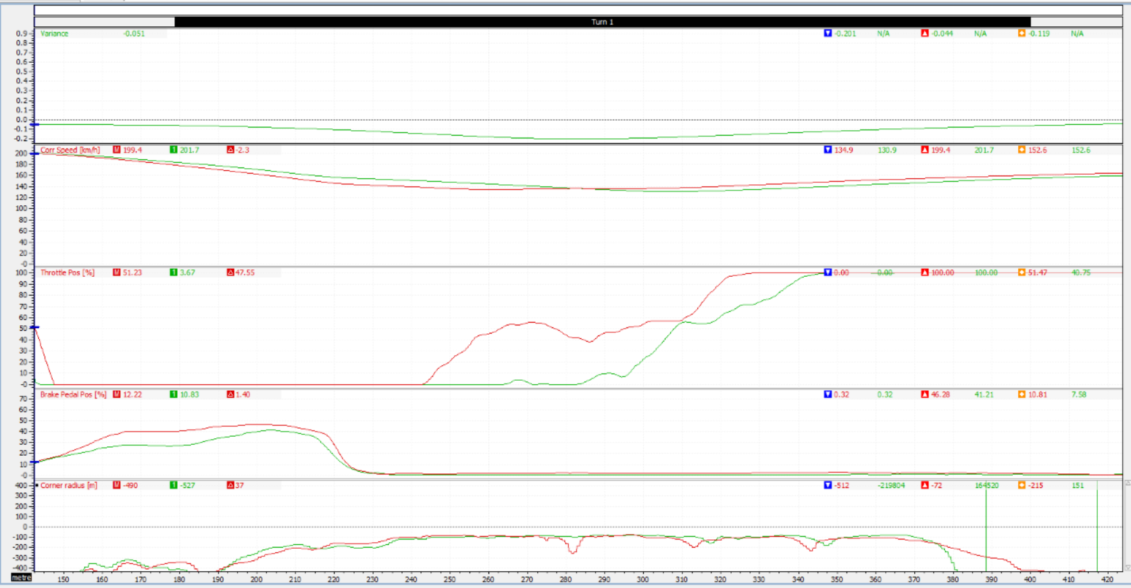
Figure 24, S1D1-8 improving turn 1, Standing 2019

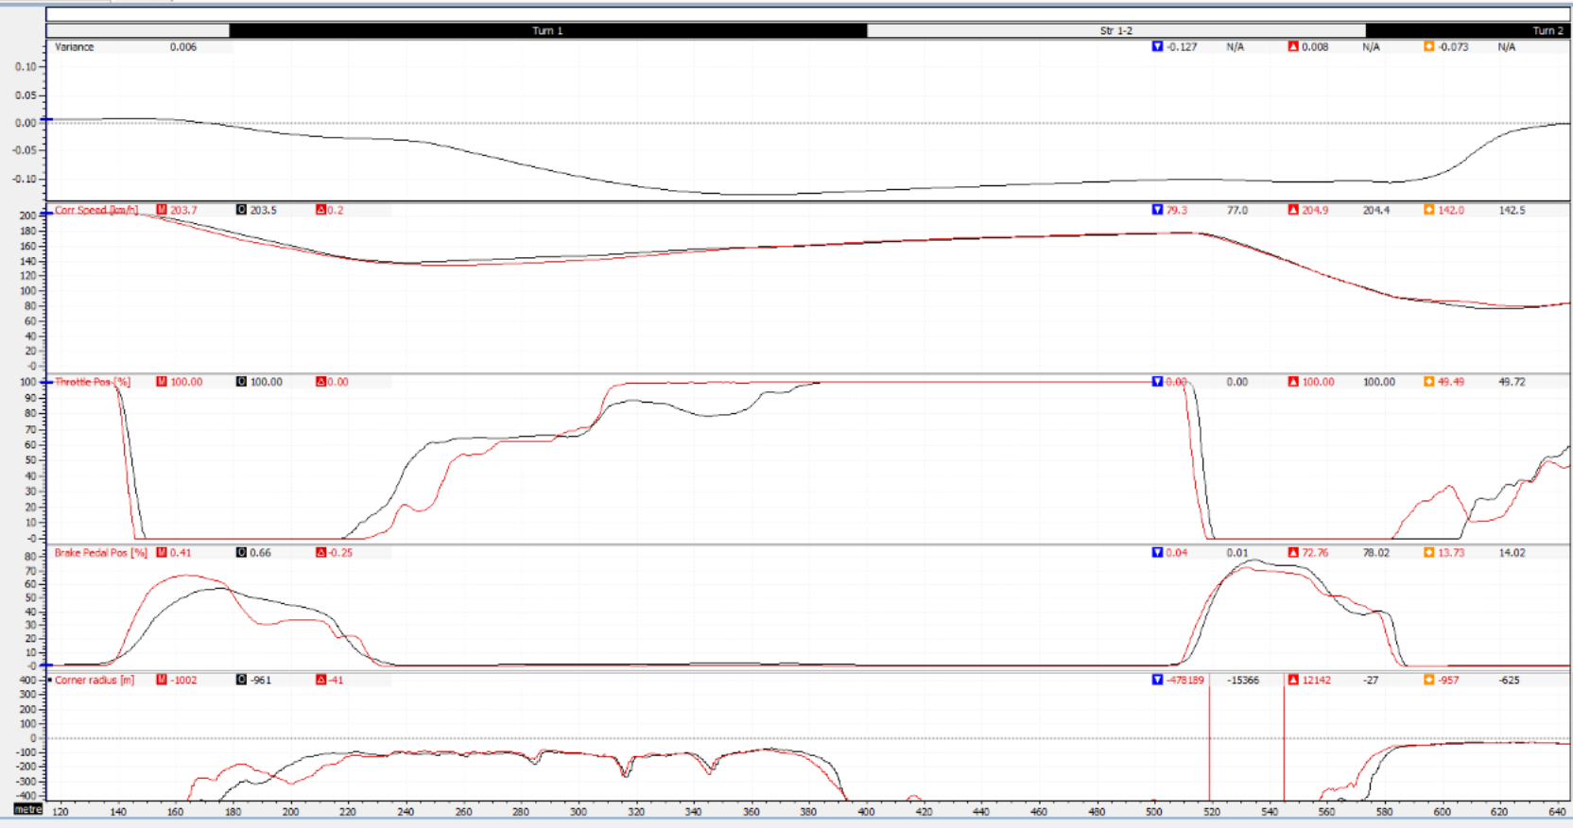
Figure 25, S1T1-7 improving turn 1, Standing 2019

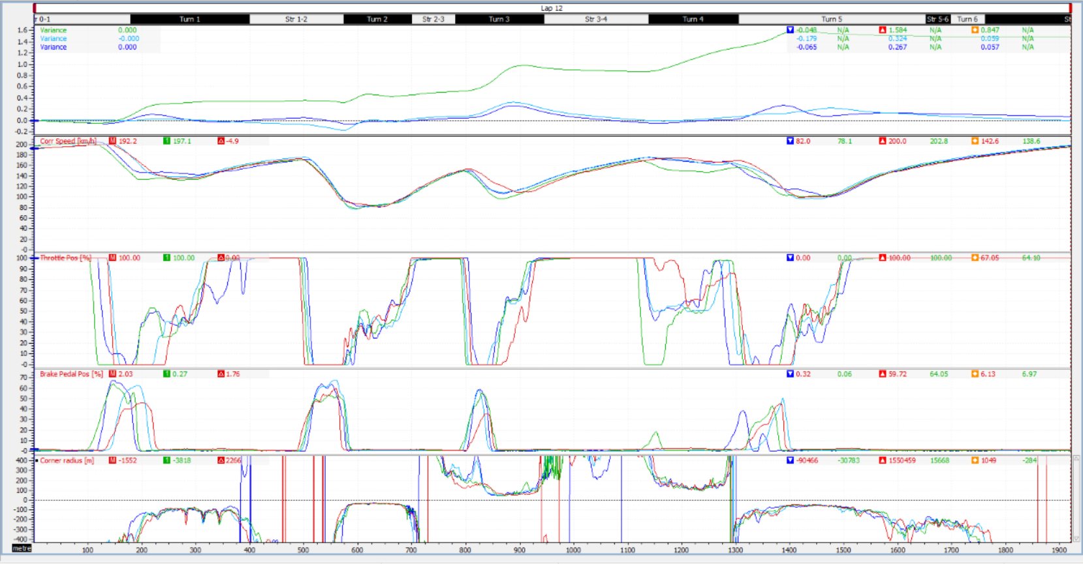
Figure 26, S1D1 fastest lap against Session 2 fastest lap of each stint, Standing 2019

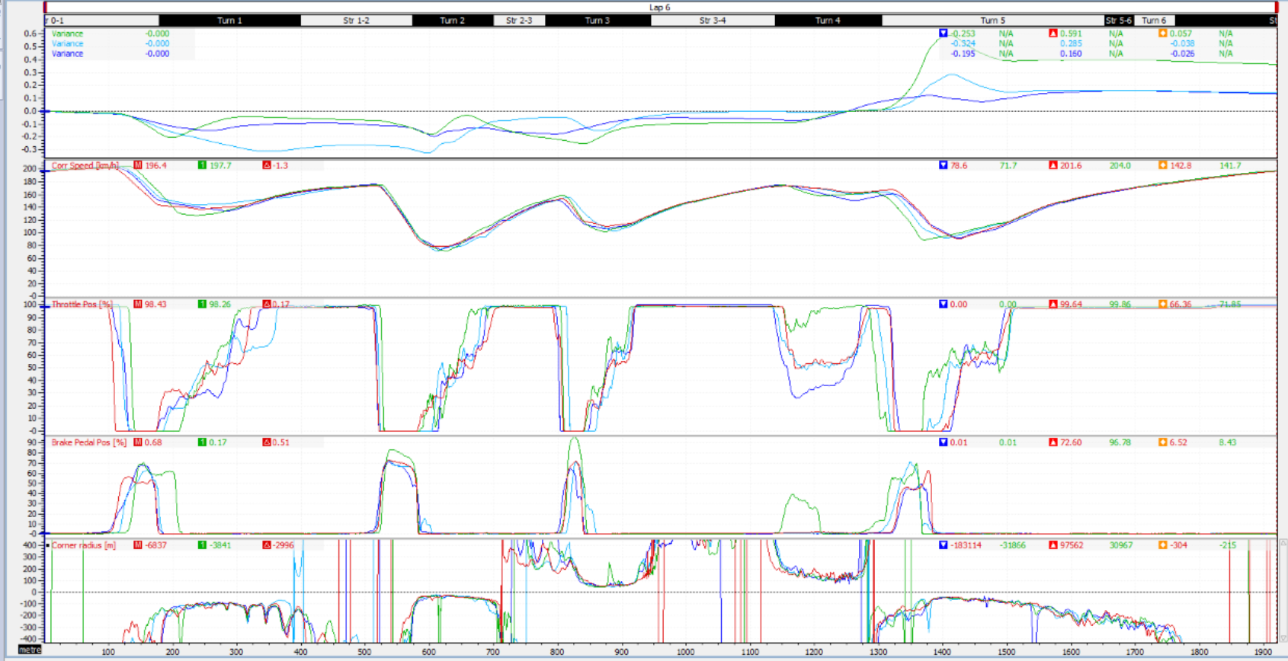
Figure 27, S1M1 fastest lap against Session 2 fastest lap of each stint, Standing 2019

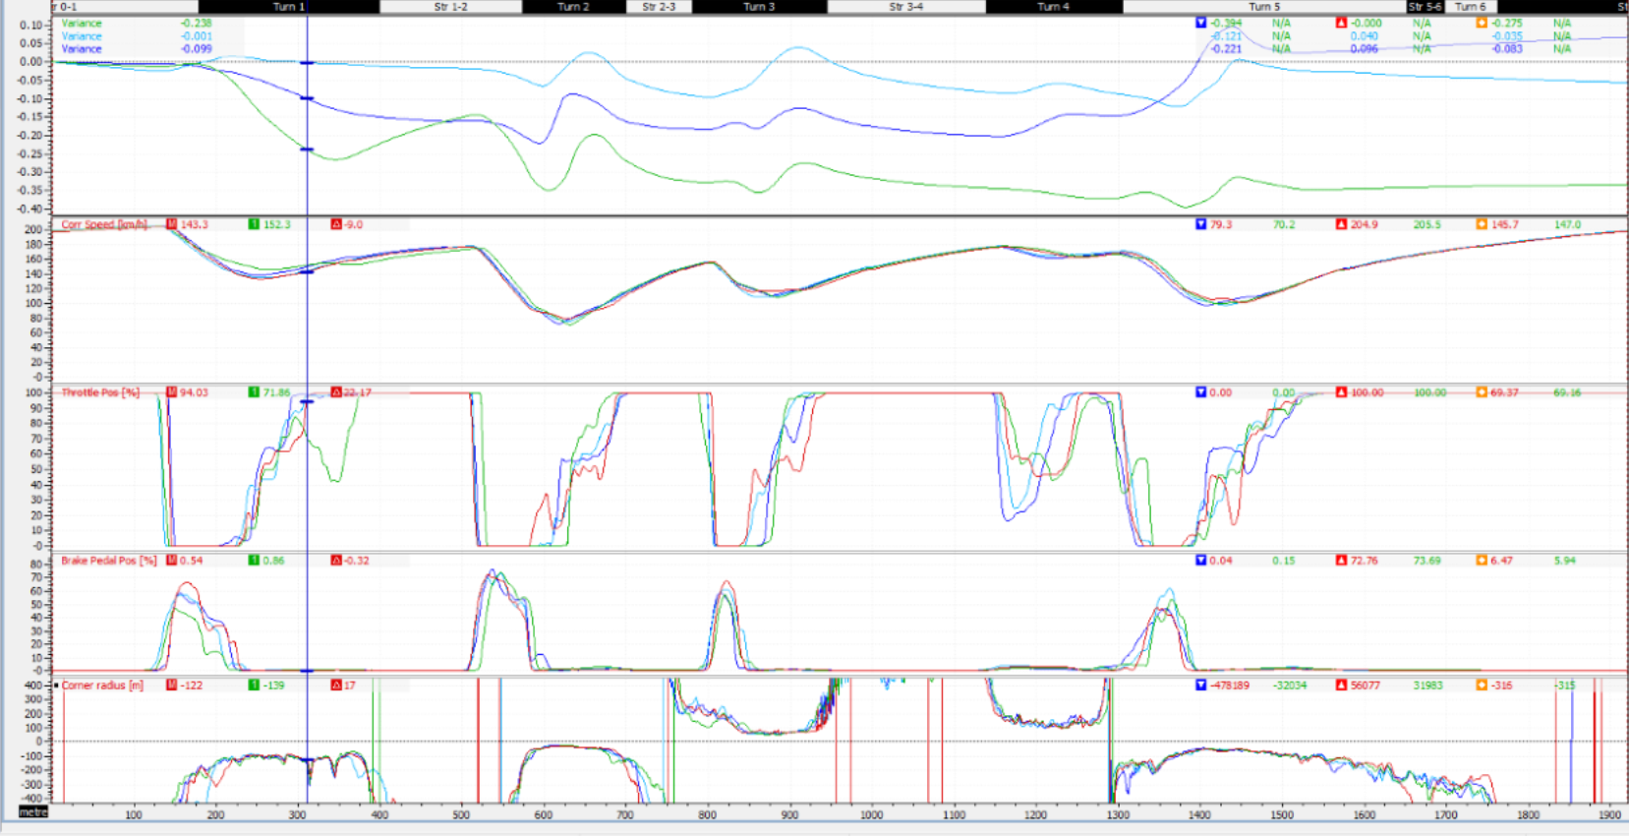
Figure 28, S1T1 fastest lap against session 2 fastest lap of each stint, Standing 2019.
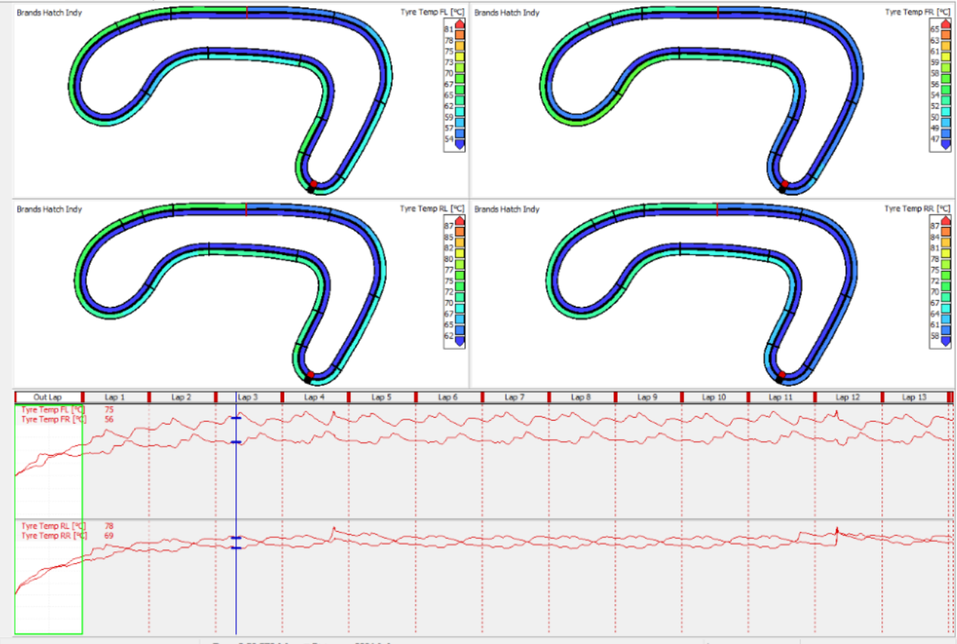
Figure 29, Tyre temperature S1T1-OUT compared to S1T1-1, Standing 2019

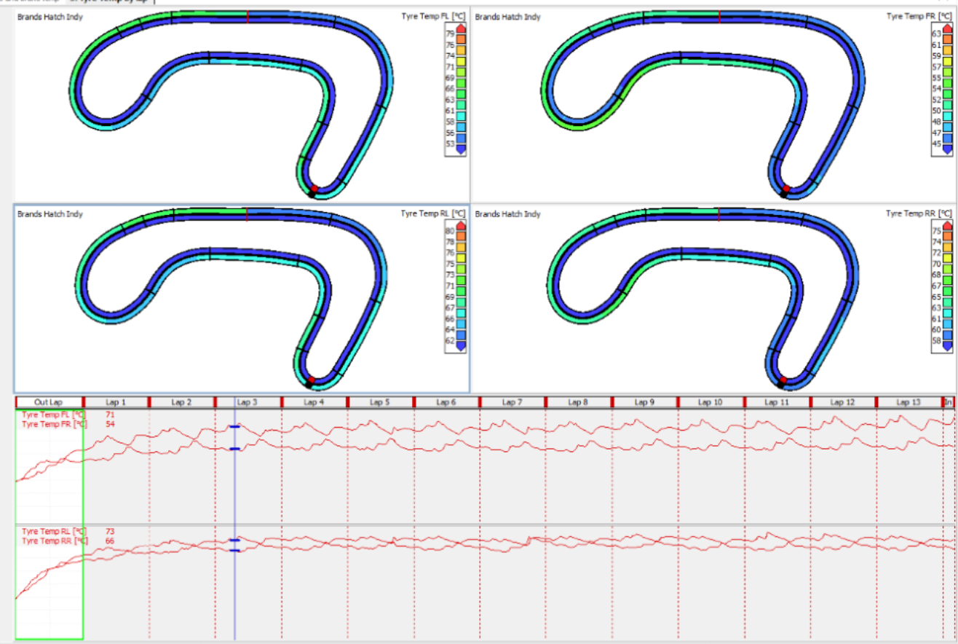
Figure 30, Tyre temperature S1M1-OUT compared to S1M1-1, Standing 2019
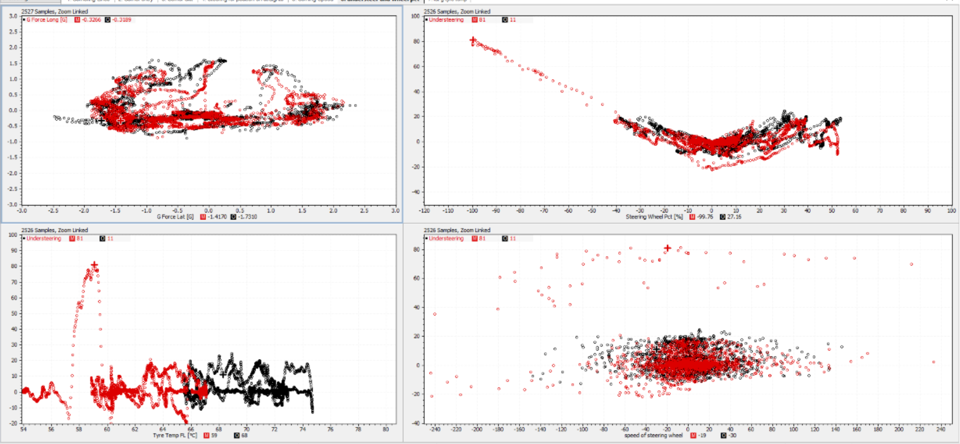
Figure 31, Understeer to tyre temp and G force laterally, Standing 2019

