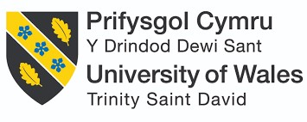

Student Name: Meetkumar Sureshbhai Vaghasiya
Student ID: 2432237
Module Name: International Marketing: Principles and Practices
Module Code: LCMB7026
Title: Starbucks (US and UK)
Lecturer’s Name: Tushara Balendran

Term: June 2025
Course: MBA
Submission Deadline: 19th December 2025

Table of Contents
1. Introduction 2
2. Brand Overview 4
3. Socio-Cultural and Macroenvironmental Contexts 6
3.1 Political Factors 7
3.2 Economic Factors 9
3.3 Social Factors 11
3.4 Technological Factors 14
3.5 Legal Factors 14
3.6 Environmental Factors 15
3.7 Similarities and Differences 16
3.8 Value Chain Analysis 16
3.9 Similarities and Differences 17
4. Segmentation, Targeting, and Positioning Strategies 18
4.1 STP 18
4.1.1 Market Segmentation 18
4.1.2 Target Audience 20
4.1.3 Positioning 22
4.2 Similarities and Differences 24
5. Marketing Mix Strategies 24
5.1 Product 24
5.2 Price 26
5.3 Place 27
5.4 Promotion 28
5.5 People 31
5.6 Process 32
5.7 Physical Evidence 33
6. Performance of Marketing Strategies 37
6.1 Market Share, Revenue, and Growth 38
6.2 Brand Equity and Customer Loyalty 39
6.3 Performance Indicators and Digital Engagement 40
6.4 Sustainability Achievements 40
7. Performance of Marketing Ethics Practices 42
8. Recommendations and Conclusion 44
8.1 Recommendations 44
8.2 Conclusion 45
References 46

1. Introduction
This report examines the marketing strategies of Starbucks Corporation in the United States and Starbucks Coffee Company (UK) Limited in the United Kingdom to understand how the organisation adapts its global brand to different competitive, cultural, and economic environments. Using analytical frameworks such as PESTLE analysis, Segmentation Targeting Positioning (STP), and the Marketing Mix (7Ps), the report analyses Starbucks’ strategic approaches in both countries and evaluates the effectiveness and ethical implications of its global marketing practices.
Since its founding in Seattle in 1971, Starbucks has expanded to become the world's largest chain of coffee shops, with over 40,000 locations worldwide as of 2024. Starbucks went global after the North American market became saturated, and today it has about 22,000 locations outside of the continent (Statista, 2025a).
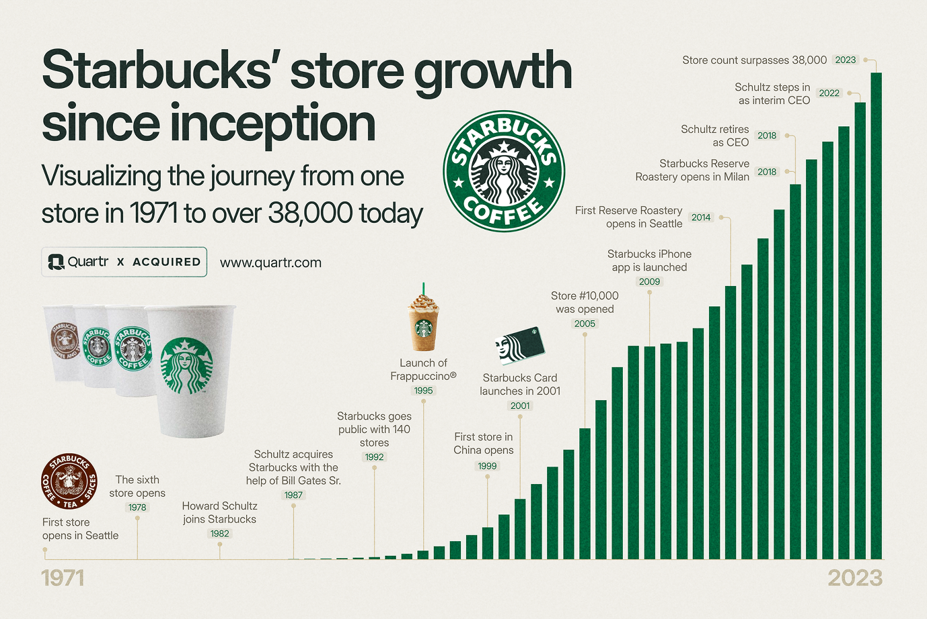
Source: https://quartr.com/insights/edge/the-starbucks-story-from-beans-to-billions
The company's ability to modify its products to suit regional preferences while preserving a recognizable worldwide brand identity is a major factor in its success. For example, it serves traditional morning fare like the sausage sandwich and English breakfast tea in the UK, as well as matcha-based drinks in Japan (Statista, 2025a; Starbucks, 2020). Starbucks made over 36 billion dollars in 2024 and was the second most valuable restaurant brand in the world in 2025.

2. Brand Overview
Starbucks started off as a single coffee bean shop in the Pike Place Market in Seattle in 1971. When Jerry Baldwin, Zev Siegl, and Gordon Bowker founded the business, their primary goal was to sell premium coffee beans and supplies. Howard Schultz joined the company in 1982 and later bought it in 1987, which marked the beginning of its transition into a worldwide coffeehouse brand (Westberg, 2025).
Since its humble origins, Starbucks has grown to become one of the most well-known companies in the world, with more than 38,000 locations in 80 countries (Westberg, 2025). Both creativity and consistency have served as guiding principles for the company's expansion strategy. The debut of espresso-based drinks, the 1995 rise in popularity of the Frappuccino, and the development of Starbucks Rewards and stored-value cards, which turned consumer interactions into enduring loyalty programs, were examples of early milestones.
Starbucks’ mission is to be the premier provider of high-quality coffee while inspiring and nurturing the human spirit, one person, one cup, and one neighbourhood at a time. Its vision is to establish a friendly third location that encourages interpersonal relationships outside of the home and workplace (Starbucks, 2025). Starbucks' fundamental values, which guide ethical behaviour, innovation, inclusion, and consistent performance across worldwide operations, place a strong focus on craftsmanship, courage, results, belonging, and joy.
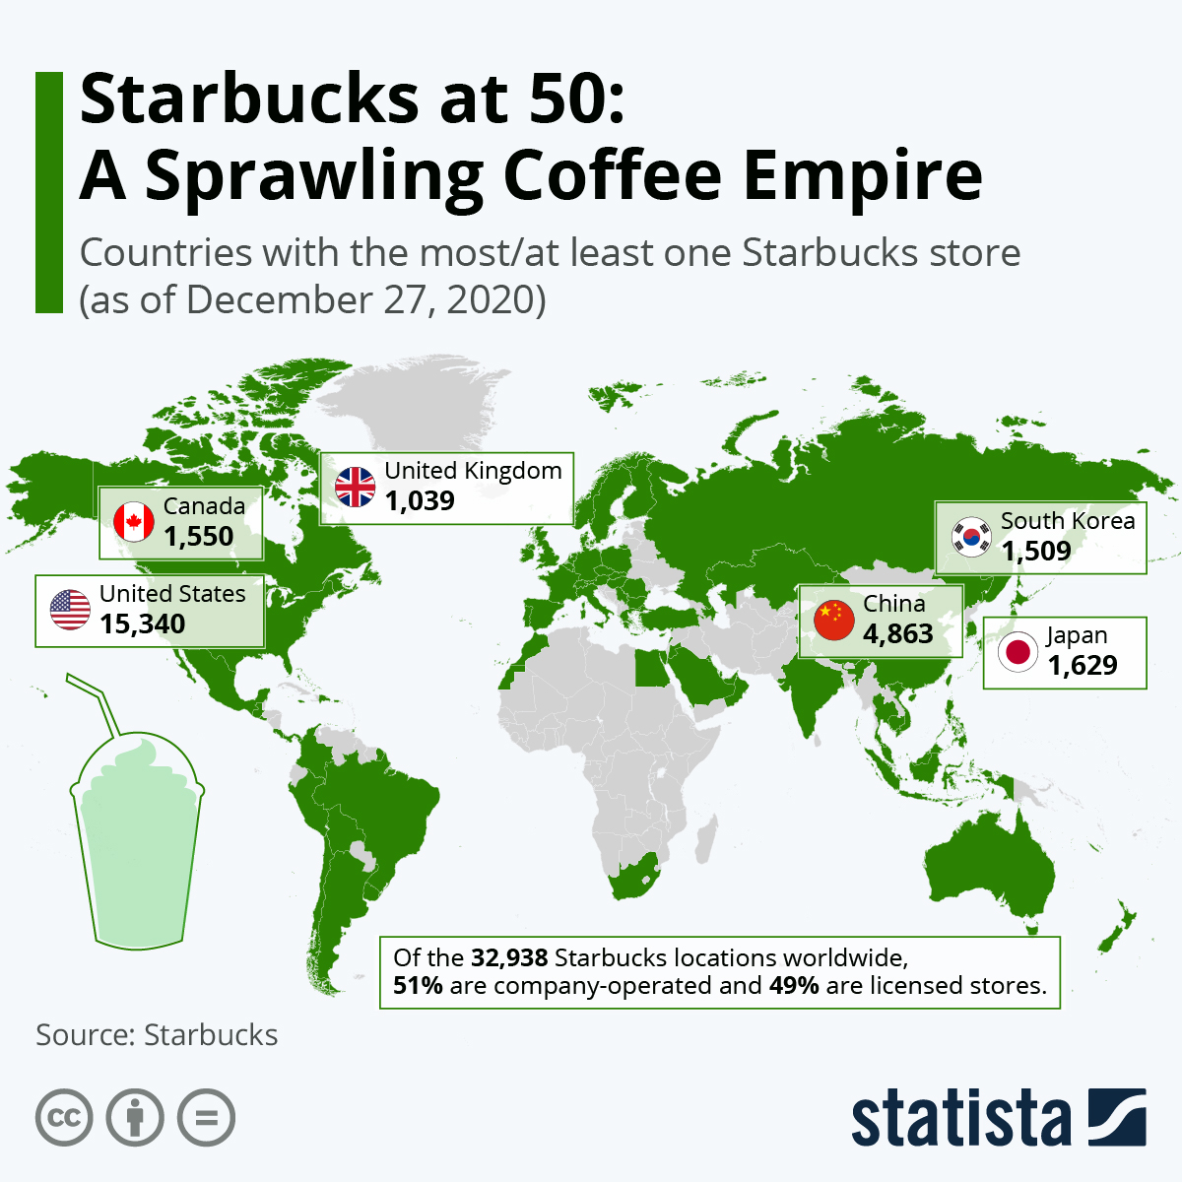
Source: https://www.statista.com/chart/24546/starbucks-stores-worldwide/?srsltid=AfmBOor3cr6Oxu-jQGxzbh6HVYrjs9G-JVypbFRM9bjYxthE3tNvJib0
Inclusion, sustainability, and ethical sourcing are highlighted in the company's values. Initiatives like the Bean Stock program, which gives employees, referred to as partners, stock ownership to encourage dedication and shared success, and the Coffee and Farmer Equity (C.A.F.E.) Practices program, which guarantees fair wages and environmentally responsible sourcing, are examples of how these values are reflected (Westberg, 2025). These tactics support Starbucks' unique brand identity, which is based on moral leadership and personal connection.
The "Starbucks Experience" is just as much a part of the Starbucks brand as its merchandise. Each store is made to be a friendly place with a consistent atmosphere and attentive service (Westberg, 2025). Localized store designs, menu modifications, and interactions between baristas and customers all reflect the company's emphasis on community.
Starbucks has been able to reflect local cultures while retaining a global character. For example, whereas Japanese supermarkets sell matcha-based beverages, UK retailers sell things like English breakfast tea and banger sandwiches (Statista, 2025a; Starbucks, 2020). Starbucks' ongoing appeal is largely due to this combination of local customisation and global consistency.
Starbucks has more than 16,000 locations and is a market leader in the US (Statista, 2025b). The company has successfully tapped into the nation's fast-paced, convenience-focused coffee culture (Westberg, 2025). Its position has been further reinforced by its digital ecosystem, which incorporates delivery partnerships, loyalty benefits, and mobile ordering. Starbucks has established a reputation for providing high-quality coffee that appeals to both urban and suburban customers by providing an aspirational yet approachable experience.

3. Socio-Cultural and Macroenvironmental Contexts
We will use the PESTLE framework to examine the socio-cultural and broader macroenvironmental contexts influencing Starbucks in the US and UK.
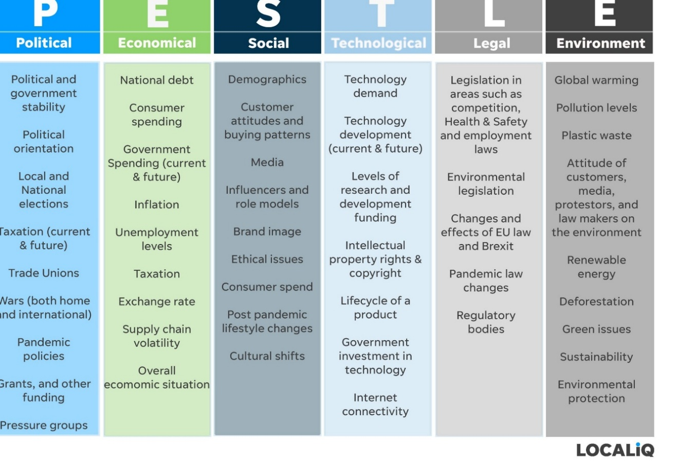
Source: https://localiq.co.uk/blog/a-complete-guide-to-using-swot-pestle-for-marketing
Through this analysis, we identify the key external factors that create opportunities and challenges across both markets.

3.1 Political Factors
United States
- Favourable: Federal and state sustainability and labour regulations help reinforce Starbucks’ ethical positioning as a responsible employer (Burt, 2024).
- Unfavourable: The surge in labour activism, over 500 unionised stores since 2021, and governance conflicts, including lawsuits involving Starbucks Workers United, increase political pressure and operational risk (Durbin, 2023). Rising minimum wage disputes also elevate costs.
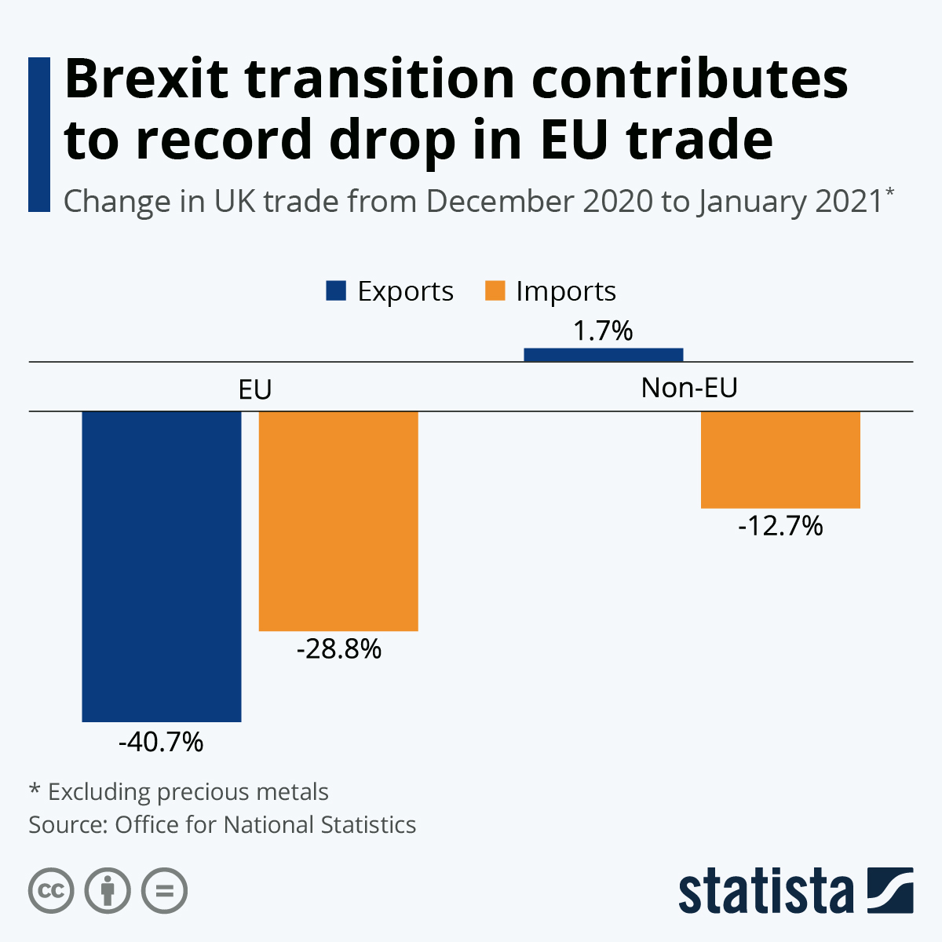
Source: https://www.statista.com/chart/24402/change-in-uk-trade-eu-non-eu/?srsltid=AfmBOoprkxxkJbv9c0U5IjiPYgVsC5AilQE6OwqauasU0gH_vSG74OcO
United Kingdom
- Favourable: Policies such as the National Living Wage, Modern Slavery Act, and plastic packaging regulations strengthen Starbucks’ ethical and compliant image (BBC News, 2017).
- Unfavourable: Post-Brexit trade barriers raise customs taxes on imported dairy and coffee beans, increasing operational costs (BBC News, 2017).
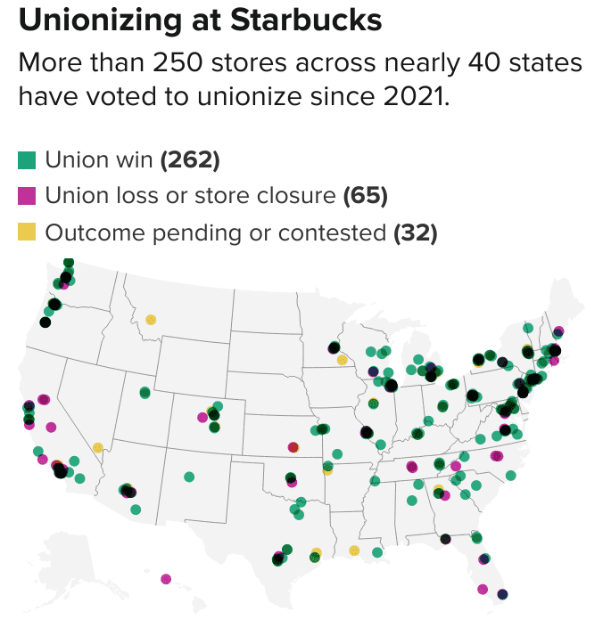
Source: https://www.cnbc.com/2022/12/09/map-of-starbucks-stores-that-voted-to-unionize.html

3.2 Economic Factors
United States
- Favourable: A strong $68 billion café market in 2024, with Starbucks controlling ~45% and generating nearly $30 billion, supports growth. High digital-ordering activity (60%+ transactions) helps offset inflation (NCDT, 2025).
- Unfavourable: Inflation, rising labour expenses, and boycott-related demand fluctuations continue to challenge margins despite resilience.
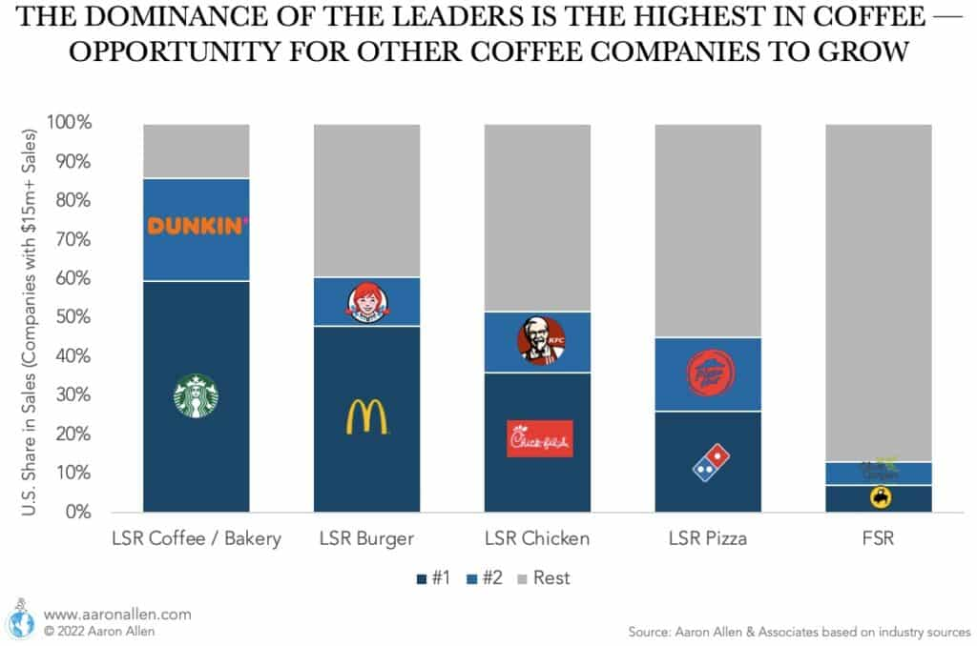
Source: https://aaronallen.com/blog/coffee-shop-industry
United Kingdom
- Favourable: The sector contributes £9.1 billion to GDP and over 210,000 jobs, with gradual recovery toward £6.1 billion market value by 2024 (CEBR, 2018).
- Unfavourable: High energy costs, rent increases, and reduced consumer spending pressure profitability in a competitive market dominated by Costa, Greggs, and Pret (CEBR, 2018).
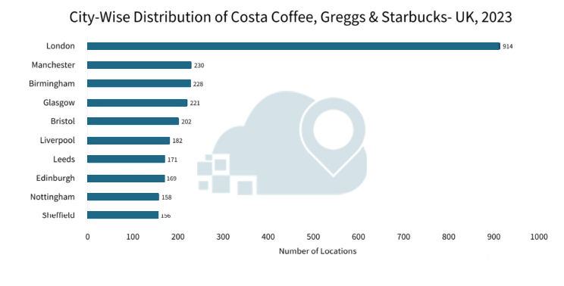
Source: https://www.locationscloud.com/research-report/analysis-of-leading-coffee-shop-chains-uk/?srsltid=AfmBOoqBxVeGjpTaBbal0WqPNVb-4c3ElMrjXA7fU0oAWqbLgev9ab3t

3.3 Social Factors
United States
- Favourable: Strong coffee culture, 40% of consumers visiting cafés weekly, along with Gen Z preferences for plant-based and cold beverages drive innovation and loyalty (NCDT, 2025).
- Unfavourable: Social backlash tied to union disputes and perceptions of corporate activism has harmed Starbucks’ employer reputation in some demographic groups.
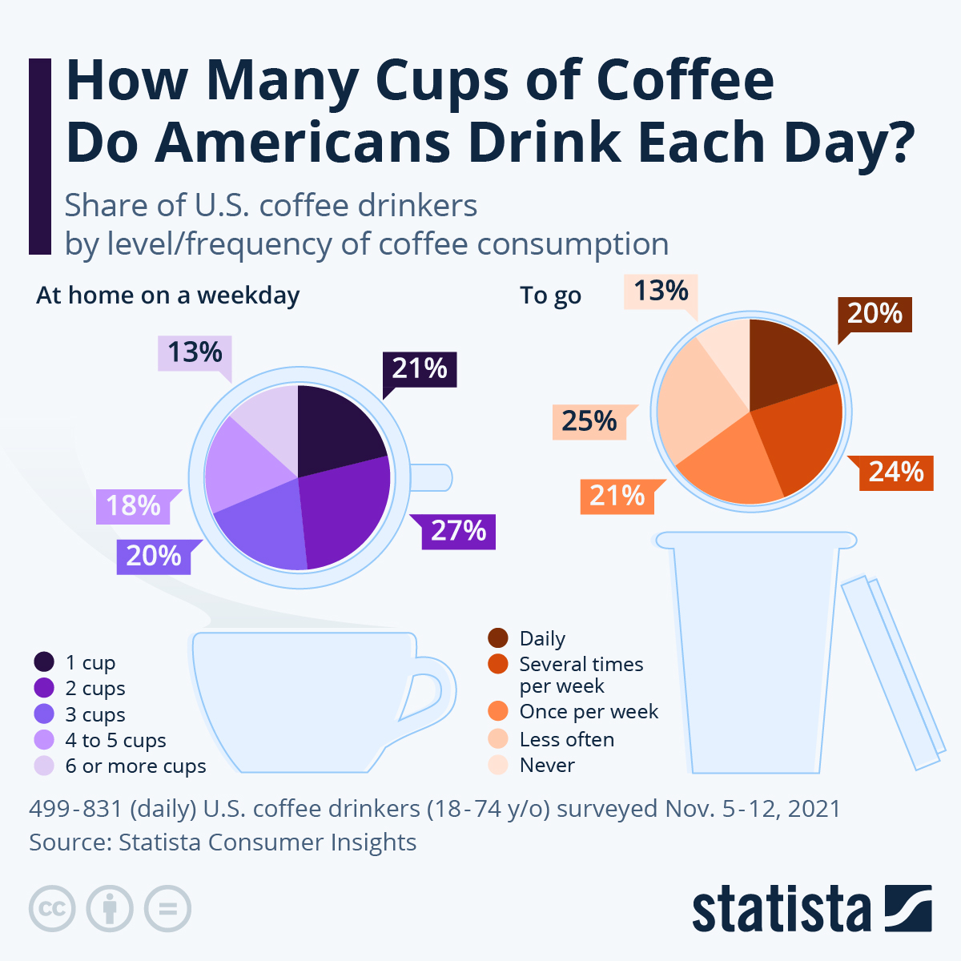
Source: https://www.statista.com/chart/19524/cups-of-coffee-drunk-by-americans-per-day/?srsltid=AfmBOoq00xeG0Yopfp3ukG7hlkFWa_OHFcxOcNbE09veTlv5qWm4LSIf
United Kingdom
- Favourable: Shifting from tea culture toward coffee, with 75% of young adults visiting coffee shops bi-weekly. Demand for organic, fair-trade, and health-conscious products aligns with Starbucks’ offerings (CEBR, 2018).
- Unfavourable: Heightened societal expectations for sustainability increase reputational risks if Starbucks fails to meet ethical standards.
Hofstedes’s Cultural Dimensions
Hofstede's cultural factors offer a helpful perspective for comprehending how national values influence consumer behaviour and organisational expectations, especially for international firms like Starbucks (Culture Factor, 2025). Although the US and the UK are both individualistic, market-driven nations, there are significant cultural variations that affect Starbucks' product positioning, employee management, and customer interactions.
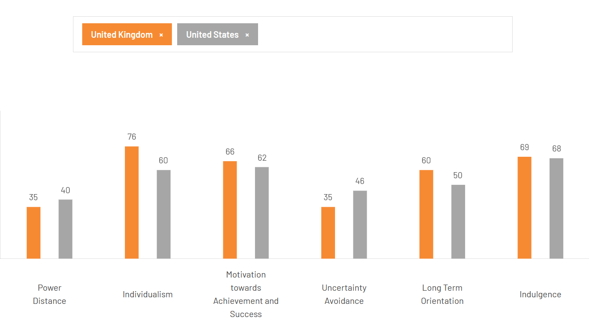
Source: https://www.theculturefactor.com/country-comparison-tool?countries=united+kingdom%2Cunited+states
The US has a high individualism score, which reflects a culture that prioritises convenience, personal preference, and customisation (Culture Factor, 2025). This fits in nicely with Starbucks' focus on customised drinks, mobile ordering, and the "third place" idea that encourages social flexibility and individual productivity.
Both countries have comparatively low Power Distance scores, which favour employee empowerment and flatter hierarchies (Culture Factor, 2025). Nonetheless, workplace relationships are typically more formal in the UK.
Starbucks' emphasis on innovation, quick service, and loyalty-based reward systems is supported by the US's higher levels of masculinity, which emphasise success and competition (Culture Factor, 2025).
Lastly, the UK has a lower Uncertainty Avoidance score, indicating that British customers place a high priority on accuracy and dependability (Culture Factor, 2025).
Similarities and Differences
Starbucks' worldwide consistency is supported by Hofstede's model, which highlights a number of cultural parallels between the US and the UK. Starbucks' customizable goods and individualized service are in line with the high individualism scores of both nations, which show a strong emphasis on personal choice, self-expression, and independence.
Despite these parallels, Starbucks' local adaption techniques are influenced by cultural variances. The United States has a higher masculinity score due to a greater emphasis on performance, success, and competition, which encourages aggressive loyalty programs, speed, and creativity.

3.4 Technological Factors
United States
- Favourable: Starbucks leads digital retail with 34M+ app users, AI-driven inventory systems, and a Rewards program generating a $1.6B stored-value float (Statista, 2025a; CNN, 2025).
- Unfavourable: Heavy reliance on digital data increases vulnerability to privacy and compliance challenges.
United Kingdom
- Favourable: Strong fintech infrastructure enables widespread mobile and contactless payments. Partnerships with Uber Eats and Just Eat improve digital reach (Starbucks, 2019).
- Unfavourable: Competitors’ subscription-based loyalty schemes (Costa, Pret) threaten Starbucks’ technological advantage, while strict UK data protection laws increase compliance demands (FCSI, 2023).

3.5 Legal Factors
United States
- Favourable: Regulatory clarity around digital privacy (e.g., CCPA) helps define boundaries for customer data handling (State of California, 2025).
- Unfavourable: Ongoing NLRB cases and accusations of anti-union behaviour expose Starbucks to financial and reputational legal risk (Bloomberg, 2025).

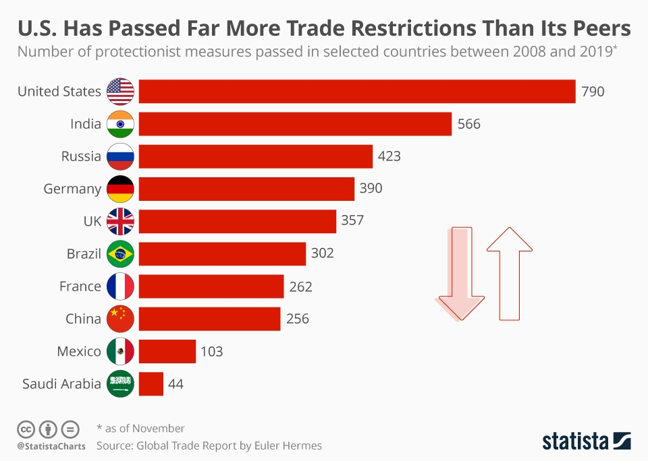
Source: https://www.statista.com/chart/20139/number-of-trade-restrictions-selected-countries/?srsltid=AfmBOorySL4AIYUFQTfDDdm6oCuNYnO90U0ap6oH752rVLJ9UjwE6kd-
United Kingdom
- Favourable: Consumer-protection frameworks, Plastic Packaging Tax, calorie labelling, ensure standardised, transparent compliance (CMS, 2024).
- Unfavourable: GDPR rules impose strict, costly data-handling obligations, tightening operational flexibility.

3.6 Environmental Factors
United States
- Favourable: Starbucks’ 2030 goals to reduce water use, waste, and carbon emissions, and its “Greener Stores” initiative (10,000 planned) strengthen sustainability credentials (Starbucks, 2023).
- Unfavourable: Industry-wide progress on emissions reduction remains limited, reducing measurable environmental impact (CEBR, 2018).
United Kingdom
- Favourable: Strong national environmental expectations, EPR, recycling mandates, encourage sustainable product offerings such as reusable cup incentives and plant-based menu items (UK Government, 2025).
- Unfavourable: Compliance with strict environmental rules raises operational costs, particularly around waste and emissions reporting.

3.7 Similarities and Differences
In both the US and the UK, Starbucks operates in macroenvironmental conditions that are mostly identical. Legally and politically, both markets uphold strict labour, consumer protection, and environmental laws that encourage moral company conduct but raise the cost of compliance.
However, important differences influence Starbucks’ strategic focus in each country. Due to unionization, labour activism, and continuous regulatory scrutiny, the United States poses greater political and legal risk, but the United Kingdom is more impacted by post-Brexit trade obstacles and rising import input costs.

3.8 Value Chain Analysis
In 2024, a sizable, multi-layered supply structure will support Starbucks' value chain. Strategic inventory buffering is crucial to inbound logistics since it keeps inventory in anticipation of seasonal demands to avoid interruptions (Starbucks, 2025).
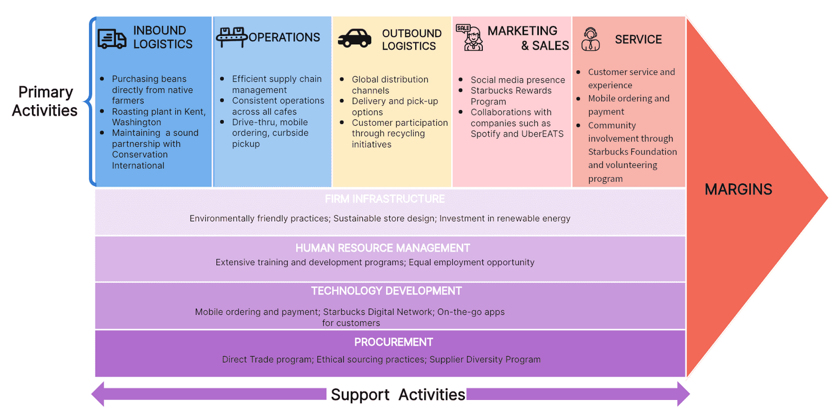
Source: https://boardmix.com/analysis/starbucks-value-chain/
However, supply chain delays can adversely impact store operations and cause equipment shipments to be delayed. The footprint of company-managed stores is significant: 78% of all revenues, or $28.5 billion, came from 16,466 company-operated outlets, illustrating the size of inbound procurement needed to sustain beverage-driven sales (Starbucks, 2025).
Starbucks' biggest activity that adds value is operations. Revenues from licensed stores added $8.1 billion (22%) to company-operated revenues, which totalled $28.5 billion, or 78% of total net revenues (Starbucks, 2025). There are 38,587 outlets in the worldwide retail network, with the largest strategic concentration coming from China and the United States.
With $23.4 billion in revenue, the U.S. segment alone accounted for 65% of total revenues and had a high operating density (Starbucks, 2025). Starbucks' internal operational program, Lodestar, led to specific gains in equipment dependability, inventory optimisation, and labour efficiency.

3.9 Similarities and Differences
There are two distinct yet developed macroenvironments in which Starbucks operates. Although the US has financial strength, scale, and digital dominance, it also faces increased labour tension and public scrutiny. Smaller but more morally conscious, the UK calls for increased localization, sustainability, and transparency. The United Kingdom is more controlled politically and legally, while the United States is more profitable economically.
The United Kingdom promotes sustainability while the United States focuses convenience, the United Kingdom leads in the adoption of technology, and the United Kingdom enforces stricter environmental regulations. In order to maintain its position as a worldwide leader, Starbucks' dual-market strategy must integrate technology innovation and operational efficiency in the United States with ethical branding and regulatory alignment in the United Kingdom.

4. Segmentation, Targeting, and Positioning Strategies

4.1 STP

4.1.1 Market Segmentation
According to VALS framework, in the US, Starbucks primarily targets Achievers and Experiencers, who are younger, urban, career oriented, and lifestyle driven. 55% of Americans expressly drink specialty coffee, up six percentage points since 2020, and 73% of Americans drink coffee on a weekly basis (NCDT, 2025). Customers between the ages of 25 and 39 make up the core sector, accounting for 64% of specialty coffee drinkers, followed by those between the ages of 40 and 59 (59%).
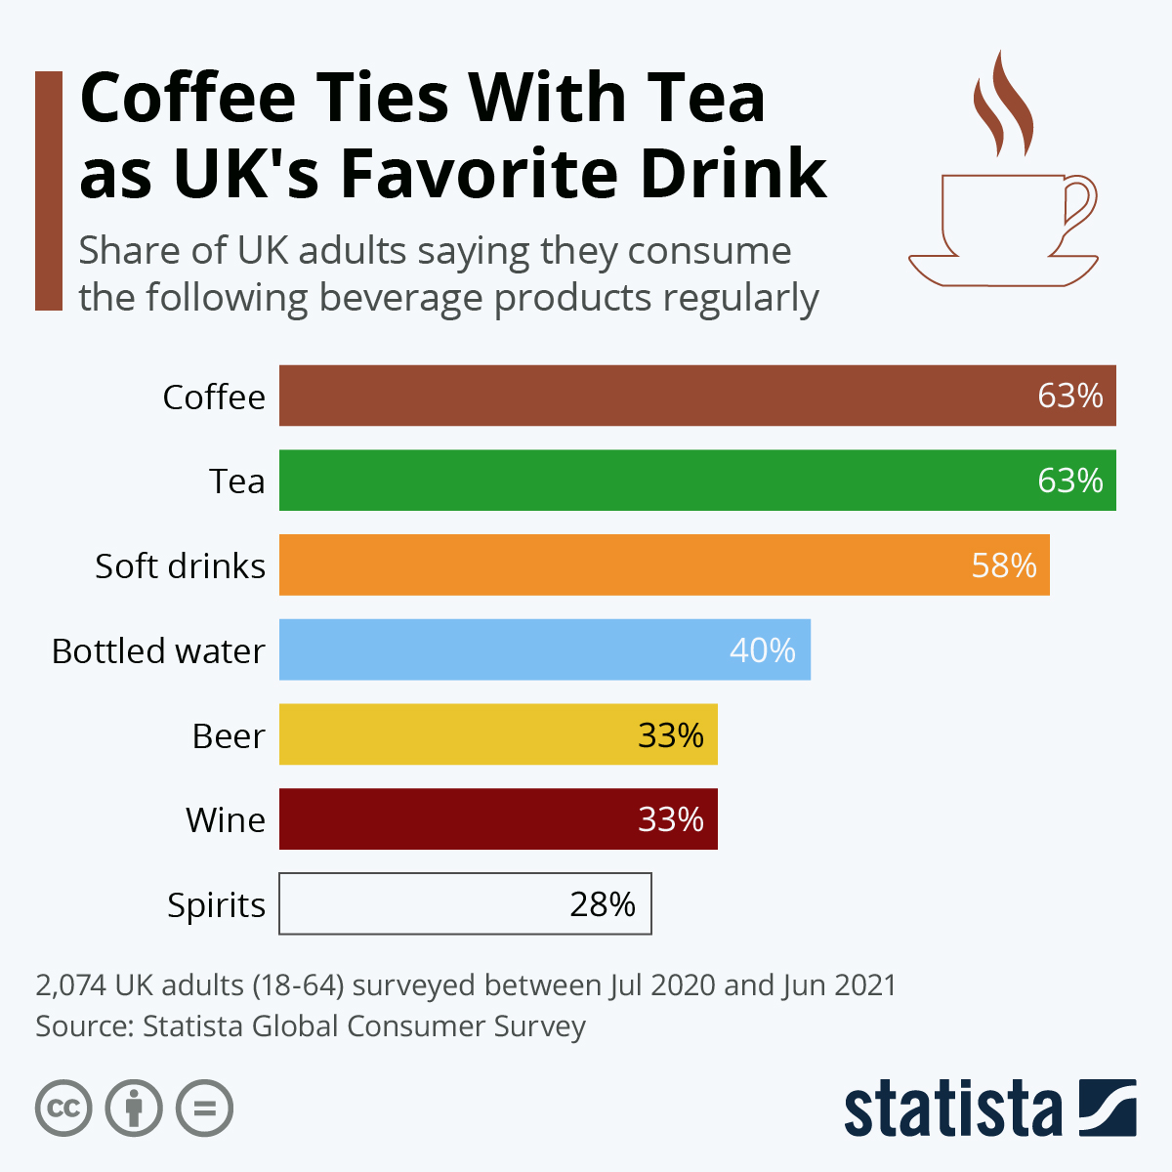
Source: https://www.statista.com/chart/23081/most-consumed-drink-types-uk/?srsltid=AfmBOorhGPq7LYNfYngZd55kxhN6Q1e64bgAOymOHsYIYlf9bsN3HBoY
Cold and blended beverages are especially popular among younger folks (18–24 years old), with 16% preferring cold brew and 21% preferring frozen coffee. A psychographic split is demonstrated by this data: Gen Z and millennial consumers view coffee more as a means of personal expression, convenience, and lifestyle than as a regular source of caffeine (NCDT, 2025).
The segmentation patterns in the UK are a little different. Here, Starbucks’ VALS based segmentation places greater emphasis on Achievers and Thinkers, who value quality, reliability, and ethical consumption. The average daily consumption is 95 million cups, or two cups per person (CEBR, 2018). Nonetheless, the UK still has a sizable instant coffee market, which in 2017 accounted for 54% of retail sales (£810 million).
However, fresh ground and pod-based coffee had the most growth, going from £74 million in 2012 to £305 million in 2017, which reflected consumers' growing desire for "barista-quality" experiences (CEBR, 2018). Starbucks takes advantage of this by growing its presence in high-end retail locations and urban areas.
An "out-of-home" trend fuelled by experiential consumption is seen in behavioural segmentation in both nations. 35% of specialty coffee drinkers in the United States had their coffee made outside the home in 2025. 33% of all coffee sales in the UK come from out-of-home sales, which brought in £3.2 billion in revenue in 2017 (CEBR, 2018).
Demographically, Starbucks targets young to middle-aged adults in both markets, with US consumers aged 25–39 forming the core segment and accounting for 64% of specialty-coffee drinkers (NCDT, 2025). Younger adults aged 18–24 further drive demand for cold and blended beverages, reflecting evolving consumption patterns. In the UK, growth in fresh ground and pod-based coffee, from £74 million in 2012 to £305 million in 2017, indicates rising interest among higher-income, urban consumers seeking premium café experiences (CEBR, 2018).
Psychographically, Starbucks appeals to consumers who value convenience, premium quality, and alignment with lifestyle identity. In the US, Gen Z and millennials increasingly view coffee as a personalised and expressive experience rather than a simple caffeine source, reinforcing demand for customisable beverages and digital ordering (NCDT, 2025). In the UK, ethically minded and quality-focused consumers respond strongly to Starbucks’ sustainability initiatives and café ambiance (CEBR, 2018).

4.1.2 Target Audience
In the United States, Starbucks employs a differentiated strategy, focusing on multiple segments. Specialty coffee consumers earn a higher mean household income of $67,100 compared to $59,200 for standard coffee drinkers (NCDT, 2025).The mean household income of speciality coffee users in the United States is $67,100, which is substantially higher than the average of $59,200 for standard coffee consumers. Along with a 50% female and 50% male distribution, the demographic composition also shows a high percentage of Hispanic-American (22%) and Caucasian-American (68%) customers.
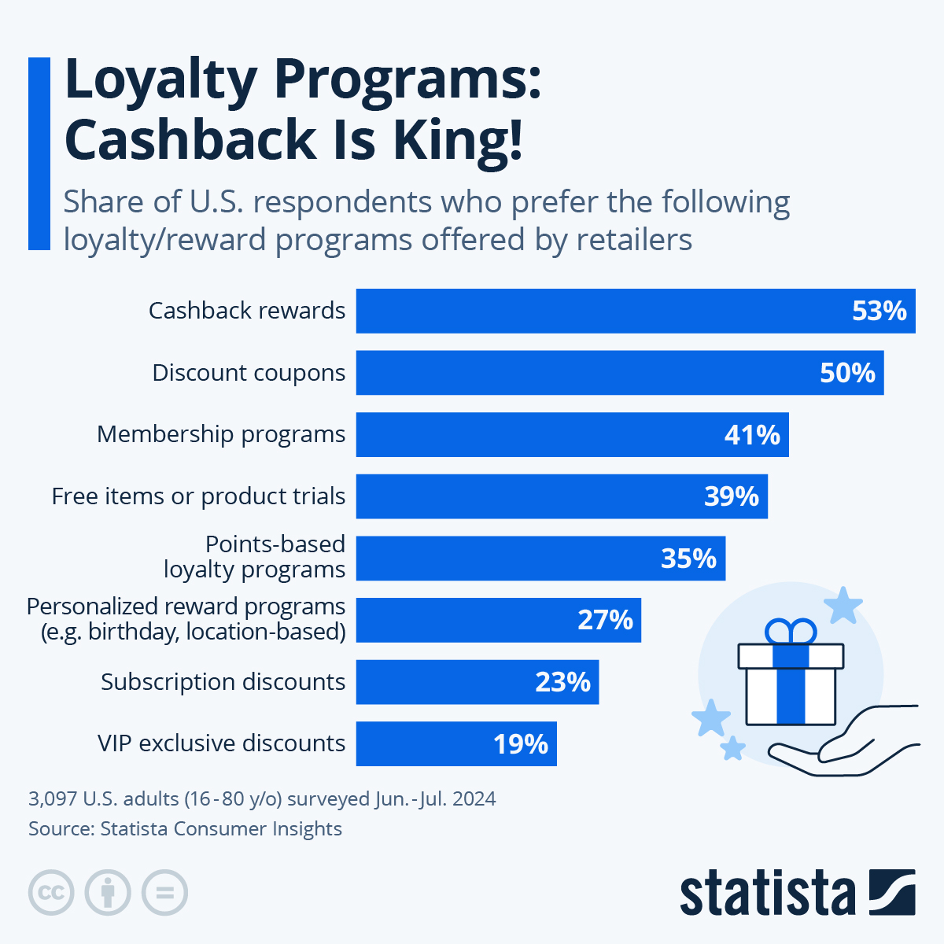
Source: https://www.statista.com/chart/33517/loyalty-programs-preferred-by-us-consumers/?srsltid=AfmBOopC1NFfJ-C5ktTWEvRWmRpU643-6ZTa9T_Wux_V2b8em0RbEe-H
In terms of psychology, people view coffee as a type of "cheap luxury," which is consistent with Starbucks' brand promise. Starbucks' focus on digitally native, convenience-driven customers is further supported by its emphasis on customisation through the Starbucks Rewards app, where mobile ordering and digital payments make up over 25% of U.S. sales (Soper, 2021).
Starbucks targets a slightly older and more cosmopolitan demographic in the UK. Urban areas with the highest levels of disposable income and café density, like London, Manchester, and Edinburgh, have the strongest coffee cultures (CEBR, 2018). Starbucks appeals to young families and professionals who see coffee shops as multipurpose places to work and socialize.
However, in the United Kingdom, Starbucks adopts a concentrated strategy. The British consumer is still more morally and financially sensitive, and Fairtrade certification and sustainability claims have a big impact on what people buy (CEBR, 2018). In response to this desire, Starbucks has introduced paper straws, reusable cups and recyclable packaging, bringing the company into line with environmentally minded ideals.

4.1.3 Positioning
Starbucks places a strong emphasis on innovation and customization in the US. Supported by digital interaction, it markets itself as a "third location" between home and work. The Starbucks Rewards loyalty program, which promotes emotional attachment and regular consumption, is directly related to the brand's success (Soper, 2021).
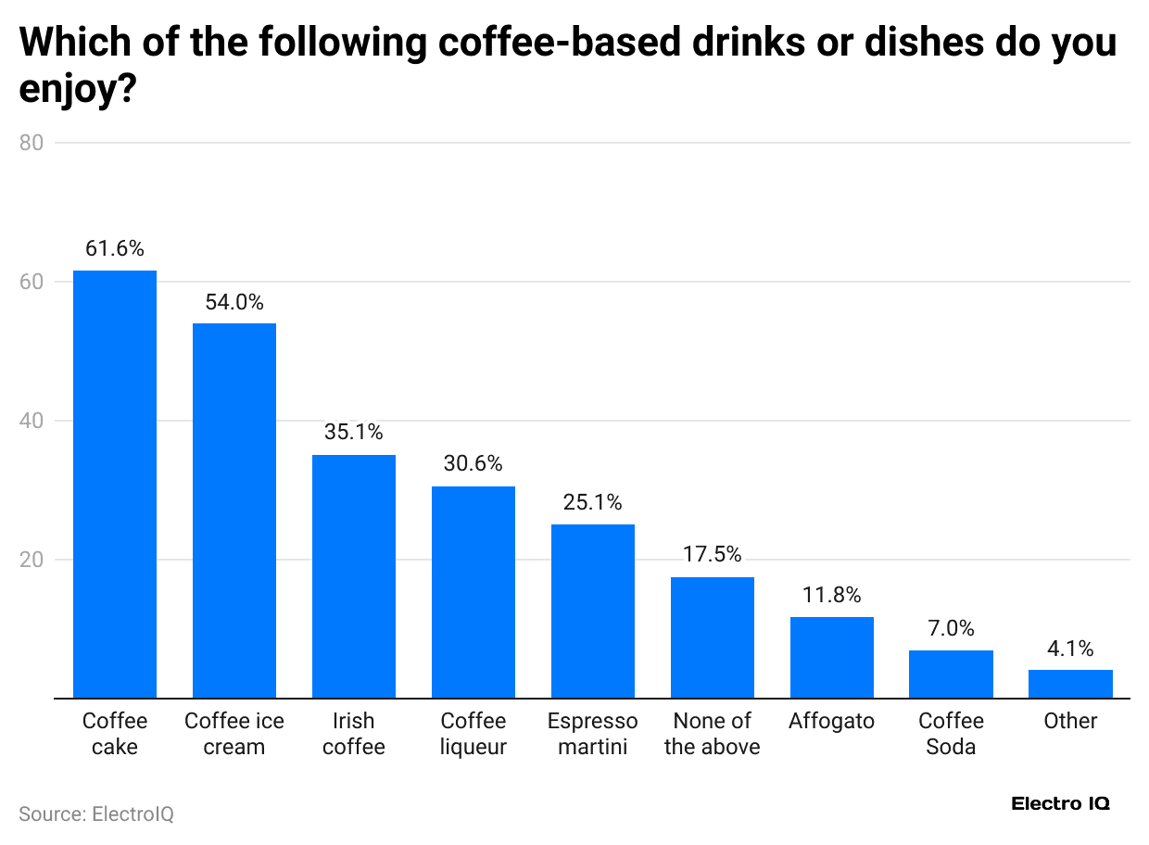
Source: https://electroiq.com/stats/how-many-people-drink-coffee-statistics/
43% of Americans consume espresso-based drinks on a weekly basis, including lattes (17%), cappuccinos (17%), and Americanos (11%). Starbucks' positioning as a quality-driven yet approachable brand is supported by its emphasis on premium, experiential offerings (NCDT, 2025).
Starbucks upholds the same aspirational image in the UK, but it places a more emphasis on community storylines and ethical sourcing. Substantial localization and supply-chain integration are evident in the fact that 76% of the value of an average cup of coffee in the UK is produced domestically (CEBR, 2018).
Perceptual Map
The following diagram illustrates the perceptual map for Starbucks compared to its competitors. Starbucks occupies the high-price, high-quality quadrant, reflecting its premium coffee offerings and strong brand reputation. Pret a Manger is placed in the high-price, lower-quality segment, emphasising natural and organic options at a premium. Costa Coffee represents low-price, high-quality, appealing to value-conscious consumers seeking quality coffee. McCafé occupies the low-price, low-quality quadrant, targeting budget-focused customers with basic coffee products.
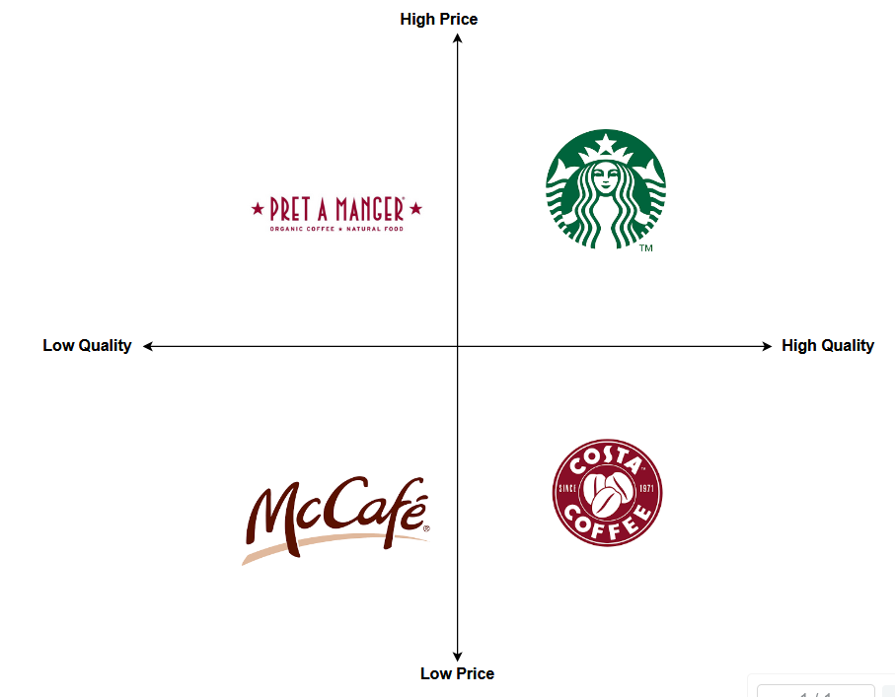
Source: Author’s Creation

4.2 Similarities and Differences
In terms of demographics, specialty drinkers in the United States are more diverse and consume more frequently, averaging three cups daily (NCDT, 2025). In comparison, only 12% of UK consumers have increased their coffee consumption in recent years, averaging two cups per day (CEBR, 2018). This suggests that the UK market is more developed but expanding more slowly, therefore Starbucks needs to concentrate on customer retention and distinctiveness through ethical branding.
In terms of behaviour, Americans display strong technologically driven loyalty tendencies. One of the most popular restaurant loyalty applications in the US is Starbucks' app, which acts as a behavioural segmentation tool to record buying habits and encourage regularity (Soper, 2021).
In the meantime, UK customers are more inclined to look for social interaction and in-store experiences. 33% of the UK market is made up of coffee consumed outside the home, with a focus on communal rather than individual consumption (CEBR, 2018). Starbucks takes advantage of this by creating roomy cafés that serve as social and co-working spaces, setting itself apart from rivals like Costa and Pret a Manger.

5. Marketing Mix Strategies

5.1 Product
Starbucks prioritizes worldwide consistency, quality, and customisation in their product strategy while preserving regional uniqueness. Food makes about 23% of revenue in company-operated outlets, while beverages make up roughly 74% (Starbucks, 2025). While Starbucks' U.S. and U.K. markets both prioritize beverages as the cornerstone of their product offerings, local tastes and cultural consumption patterns influence innovation in different ways.
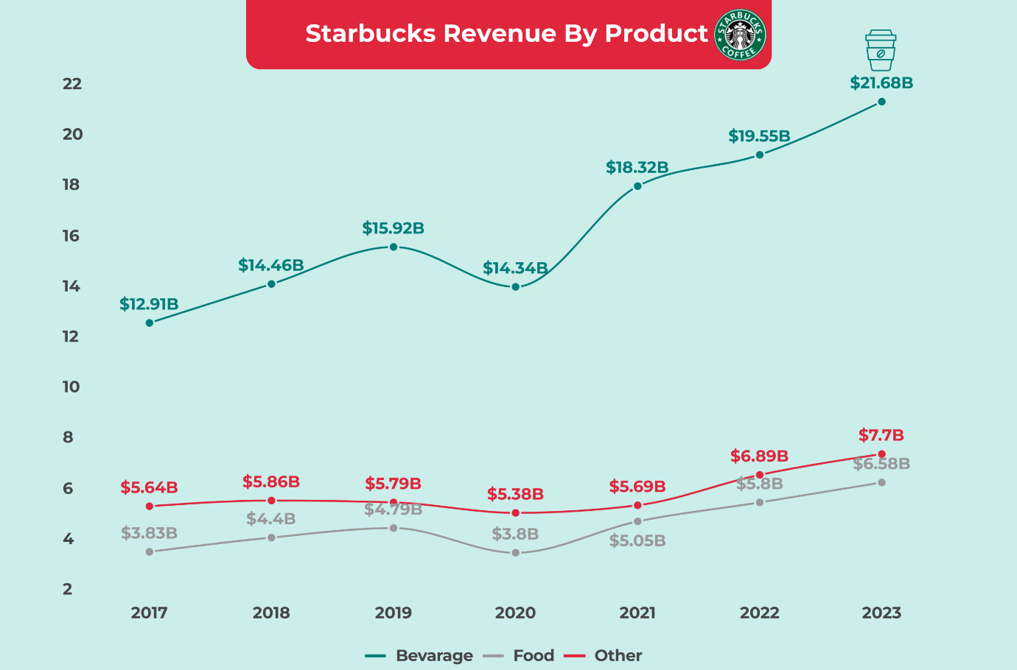
Source: https://fourweekmba.com/starbucks-revenue-by-product/
Starbucks highlights beverage personalization and menu innovation as important differentiators in the US. Due to the growing popularity of cold brews, iced espresso, and personalized cold foam drinks, the company has continuously increased the variety of cold beverages it offers. In 2024, cold drinks account for almost 75% of beverage sales in the United States (NCDT, 2025).
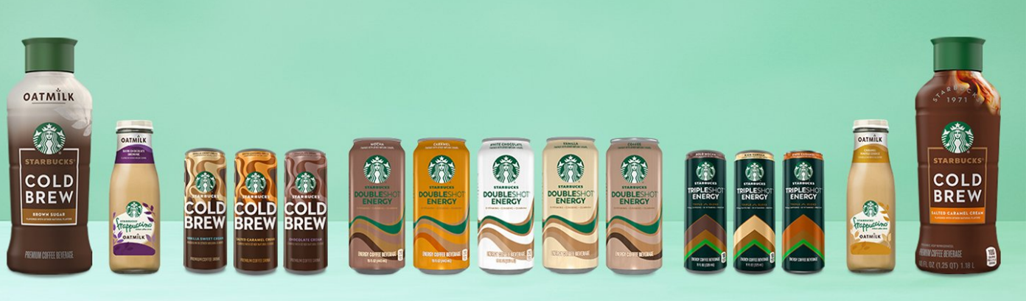
Source: https://about.starbucks.com/press/2024/starbucks-introduces-new-ready-to-drink-coffee-line-up-including-refreshed-fan-favorites/
Starbucks uses emotional connection and habit building to encourage repeat business, as evidenced by the launch of plant-based milk choices and seasonal favourites like the Pumpkin Spice Latte. This quick innovation methodology is in line with the convenience and variety preferences of American consumers. 43% of Americans drink espresso-based beverages on a weekly basis, while 55% of Americans consume specialty coffee, indicating an increasing need for premium, personalized coffee experiences (NCDT, 2025).
Starbucks UK
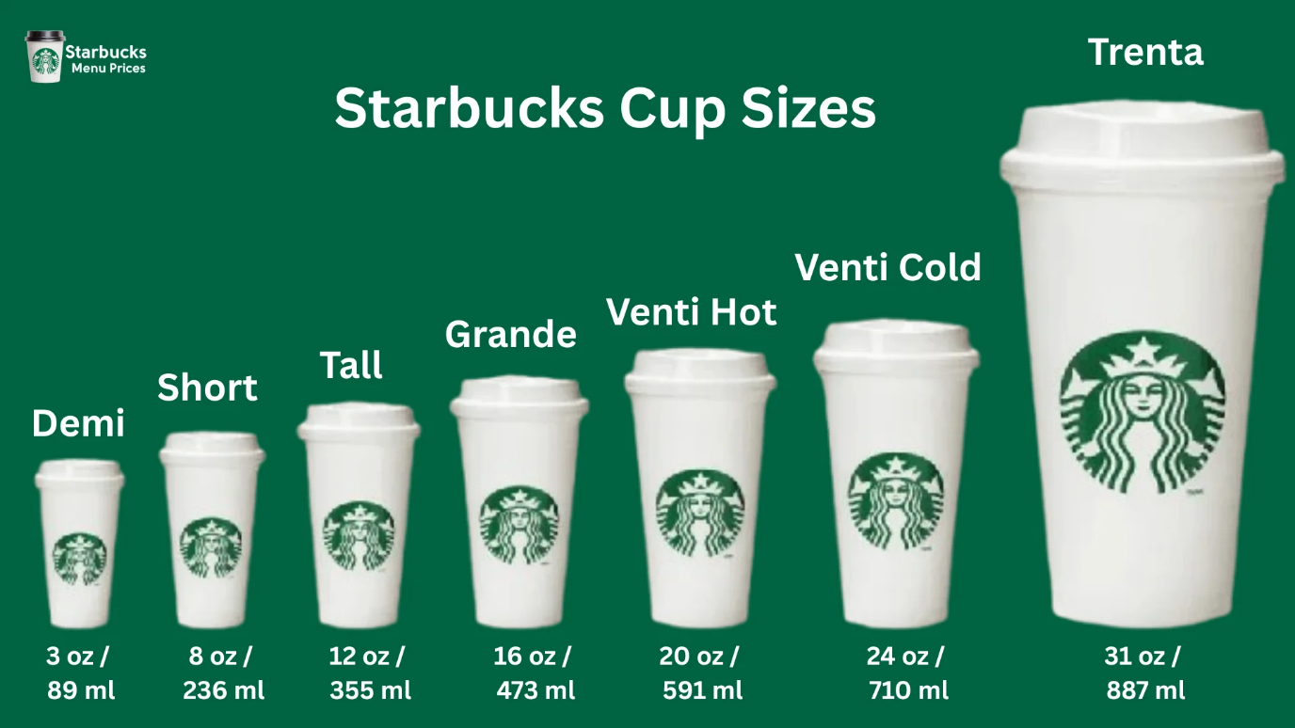
Source: https://starbuckmenu.uk/starbucks-cup-sizes/
There is more localization in the product portfolio in the UK. Since tea has long been a popular beverage among British consumers, Starbucks saw early on the necessity to include tea-based products like English Breakfast Tea and Chai Tea Lattes on its menu (Starbucks, 2025). Starbucks introduced vegan, low-sugar, and dairy-free alternatives earlier in its U.K. locations due to the higher social drivers of sustainability and health consciousness in the U.K. than in the U.S.

5.2 Price
Starbucks maintains a premium pricing strategy in the US that capitalizes on perceived quality and brand equity (Starbucks, 2025). The business maintains its aspirational appeal while reinforcing accessibility through psychological pricing, which usually ends prices with ".95" or ".99." Despite a little drop in transaction volume, Starbucks was able to boost average ticket size by 2%, as reported in the 2024 Annual Report.
On the other hand, premium positioning and competitive adaptability are balanced in the UK pricing strategy. Starbucks has been obliged to make strategic price adjustments as a result of post-Brexit inflation, high operating costs, and a 20% VAT on food and drink.
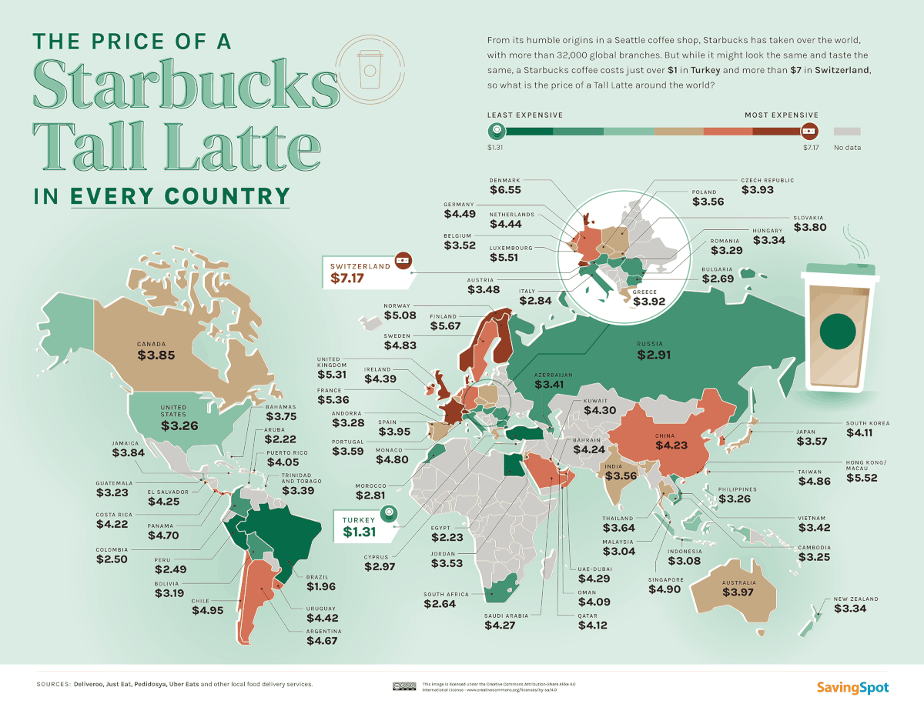
Source: https://www.visualcapitalist.com/cp/mapped-the-price-of-starbucks-in-every-country/
In a market that is defined by price sensitivity and value-oriented consumption, Costa Coffee and Greggs are the major competitors (CEBR, 2018). The value of the UK's branded coffee shop industry was £6.1 billion as of early 2025, demonstrating a rebound from pandemic lows but continued rivalry on price and convenience. Starbucks uses its U.K. mobile app to give loyalty discounts, bundle offers, and recurring value promotions to lessen this strain.

5.3 Place
In the United States, most of the 16,900 stores are company-owned, providing direct control over quality, service, and brand experience. Drive-thru and pickup-only stores, along with mobile orders and delivery via DoorDash and Uber Eats, strengthen direct engagement with customers (Starbucks, 2025; NCDT, 2025). Tighter control over quality, brand experience, and innovation rollout is made possible by this ownership approach. Drive-thru and pickup-only stores, which made up more than 40% of new openings in 2024 and catered to suburban growth and mobile consumers, are now given priority in the company's global expansion plan.
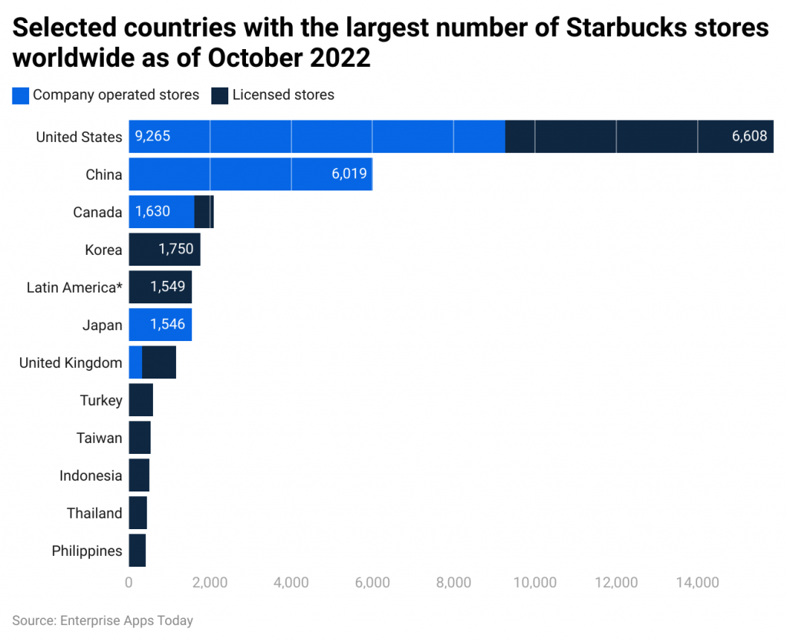
Source: https://www.enterpriseappstoday.com/stats/starbucks-statistics.html
Starbucks uses a license-dominant business strategy in the UK. Starbucks relies primarily on indirect channels through licensed stores, strategically located in commercial districts and transport hubs. Partnerships with Just Eat, Deliveroo, and Uber Eats further expand accessibility while reducing operational costs (Starbucks, 2019; Starbucks, 2025).

5.4 Promotion
Starbucks use integrated marketing communication to target local markets with campaigns that convey a consistent brand message. In the US, IMC emphasizes social media interaction, digital loyalty programs, and emotionally charged advertising that emphasizes inclusivity, comfort, and individual empowerment (Starbucks, 2025). IMC places a strong emphasis on sustainability, ethical sourcing, and community involvement in the UK.
U.S. marketing revolves around campaigns like "Starbucks Rewards," "Pumpkin Spice Season," and holiday Red Cup promos. Heightened promotional activity and rising marketing expenses caused a 1% small decline in operating profit (Starbucks, 2025).
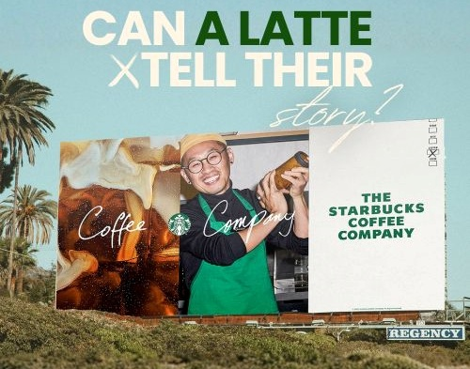
Source: https://bmoutdoor.com/info/Starbucks-Baristas-Campaign
Starbucks uses influencer partnerships and TikTok-driven beverage trends to draw in Gen Z customers, demonstrating the importance of social media participation (Zhu, 2024). Comfort, inclusion, and personal empowerment, three important emotional factors in American culture, are emphasized in U.S. messaging.
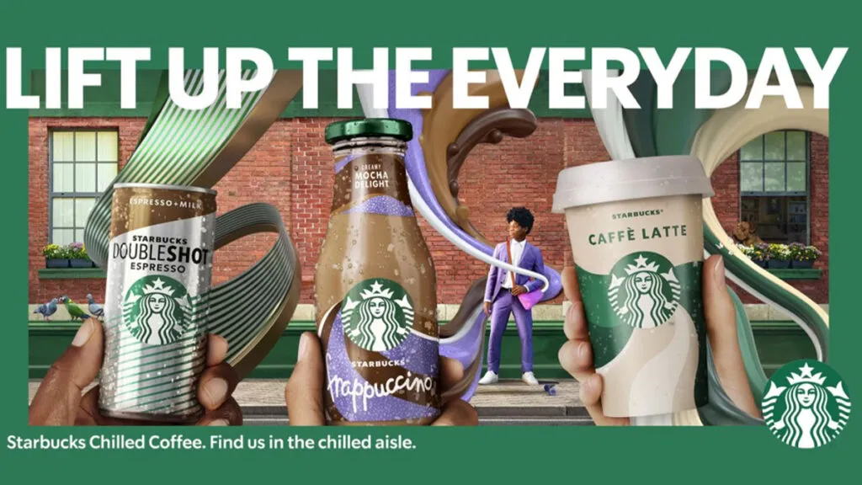
Source: www.adweek.com/brand-marketing/the-most-effective-campaigns-of-2022-came-from-kfc-cadbury-and-starbucks/
In the United Kingdom, Starbucks’ promotional efforts prioritize sustainability, inclusivity, and ethical sourcing. Campaigns and "Greener Stores" highlight the company's social responsibilities and environmental leadership (WARC, 2025).
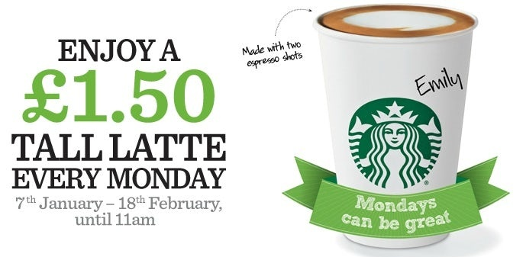
Source: https://www.marketingweek.com/starbucks-eyes-reputation-recovery-with-monday-promotion/
Starbucks leverages this information to promote itself as an ethical leader in the UK market, where 41% of customers choose brands that demonstrate environmental commitment (CEBR, 2018). Promotions from the UK also emphasize community involvement, including collaborations with British nonprofits and awareness of gender inclusion.

5.5 People
With a focus on benefits, diversity, and empowerment, Starbucks employs about 240,000 people throughout the US. Employees (referred to as "partners") are granted equity interests through the Bean Stock program, and retention is aided by the Employee Stock Purchase Plan and health insurance (Starbucks, 2025).
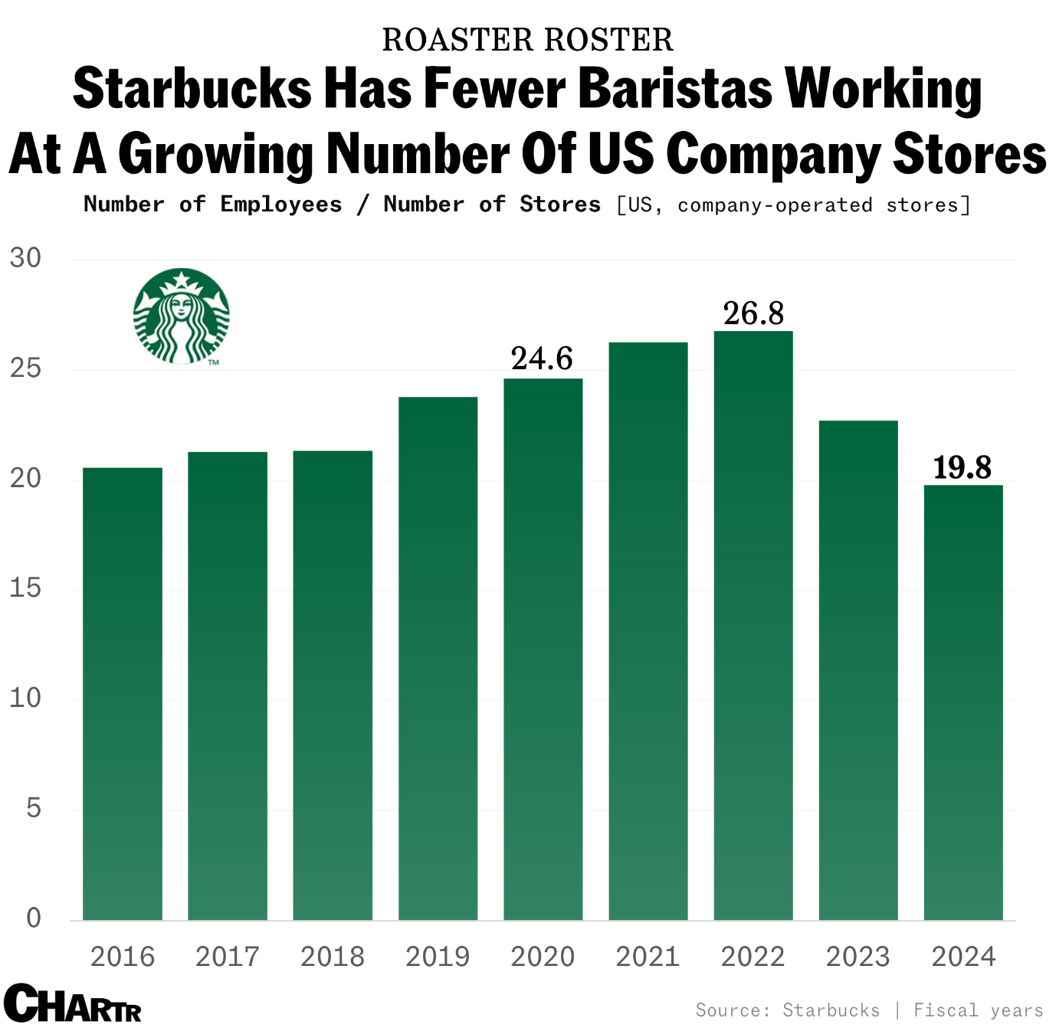
Source: https://sherwood.news/business/starbucks-goes-all-in-on-human-baristas-after-years-of-slashing-the-size-of/
51.9% of workers identify as racially diverse, while 70.9% of workers are female. By 2025, Starbucks will have more than 500 unionized locations in the US, indicating labour problems (Starbucks, 2025). The trade-off between workforce activism and empowerment culture is highlighted by these interactions.
Starbucks has a smaller, more dispersed staff in the United Kingdom (Starbucks, 2025). Direct employment is restricted by licensing, although all franchisees must adhere to the company's stringent training requirements. In keeping with European hospitality standards, U.K. operations place a strong emphasis on customer experience, diversity, and barista craftsmanship.

5.6 Process
Starbucks has the most sophisticated digital environment in the world in the United States. The Deep Brew AI platform improves staffing, inventory, and personalization decision-making. In addition to making ordering easier, the mobile app gathers useful client information for focused advertising Kingdom (Starbucks, 2025).
In 2024, over 25% of all U.S. revenue came from digital sales, and the corporation is still investing in optimizing drive-thrus and pick-up locations (Soper, 2021). Customer complaints are handled through multiple channels, including in-app feedback, customer service hotlines, and social media, with AI-assisted responses ensuring timely resolution and personalized follow-up.
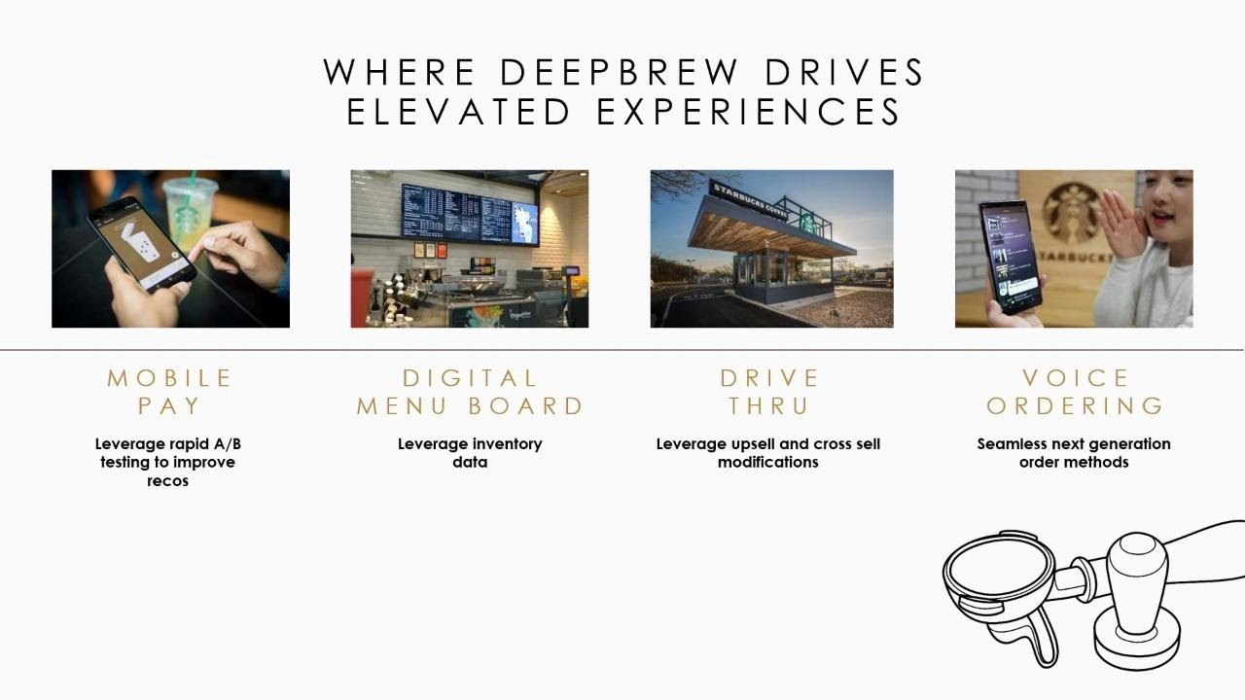
Source: https://www.youtube.com/watch?v=XxK1PyaF1bw
In the UK, sustainability and standardization are key components of process efficiency. More than 90% of transactions now involve contactless payments, demonstrating Britain's sophisticated fintech embrace (CEBR, 2018). To comply with regulatory sustainability requirements, Starbucks has introduced process improvements like waste tracking systems and incentives for reusable cups.
However, when licensed partners are used, process consistency may differ slightly from store to store. Customer complaints are addressed via in-store feedback, email, and social media channels, with licensed partners adhering to corporate guidelines to ensure consistent service, though minor variations between stores may occur Kingdom (Starbucks, 2025).

5.7 Physical Evidence
Starbucks locations in the US are a symbol of friendliness and community. Flagship locations that highlight Starbucks' "experiential luxury" approach include the 35,000-square-foot Chicago Reserve Roastery. In order to support its "third place" concept, typical stores include open layouts, ambient lighting, and carefully chosen music.
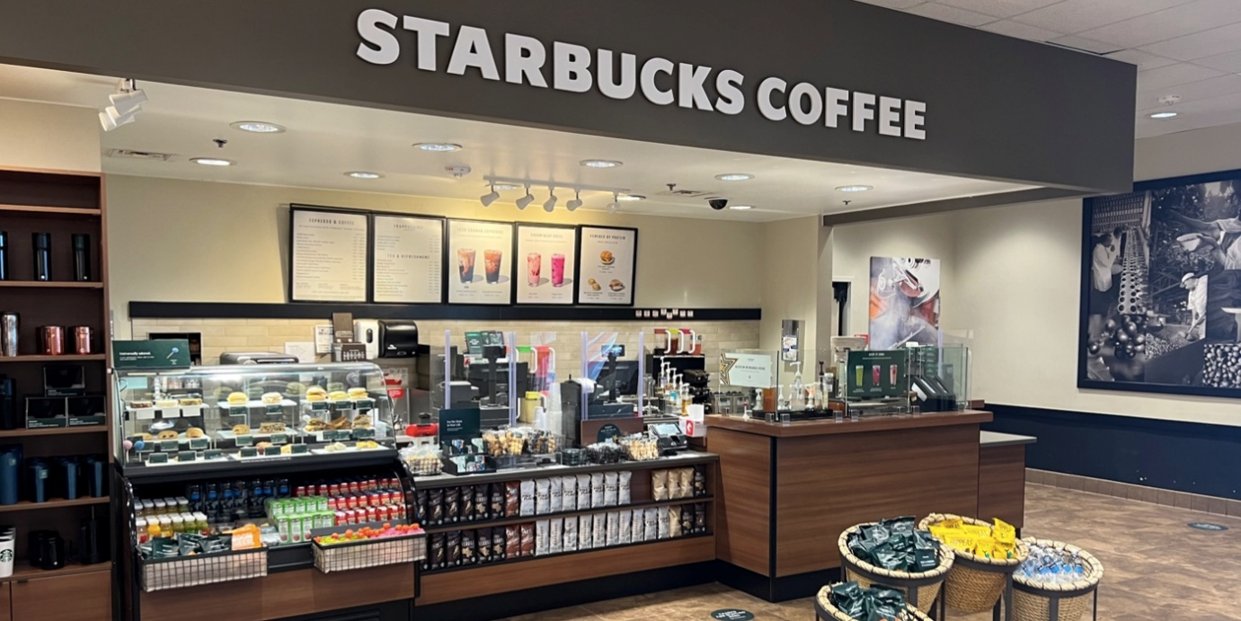
Source: https://www.shortform.com/blog/starbucks-store-design/
As part of its 2030 carbon objectives, the company emphasized redesign with a sustainability focus, such as using recyclable packaging and energy-efficient equipment (Starbucks, 2025).
US Website
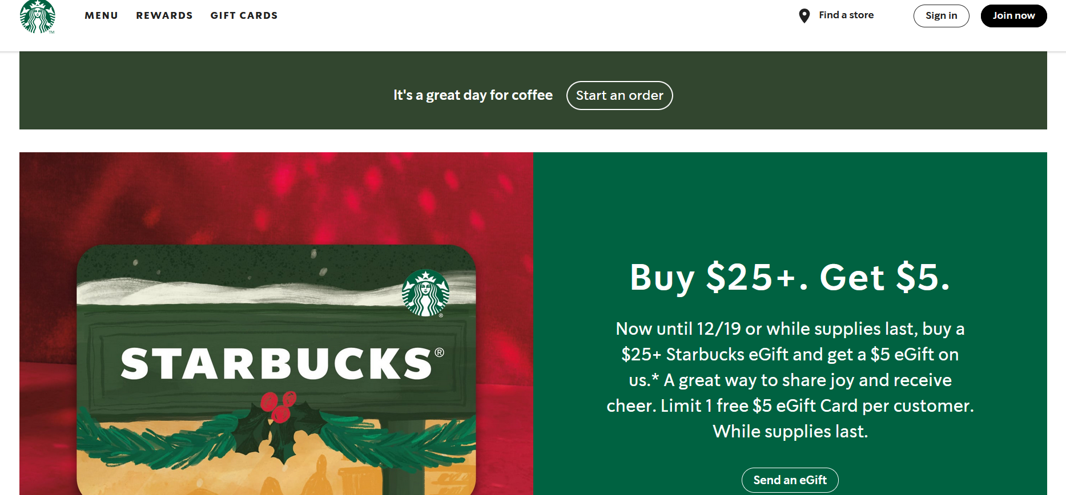
Source: https://www.starbucks.com/
US Uniform
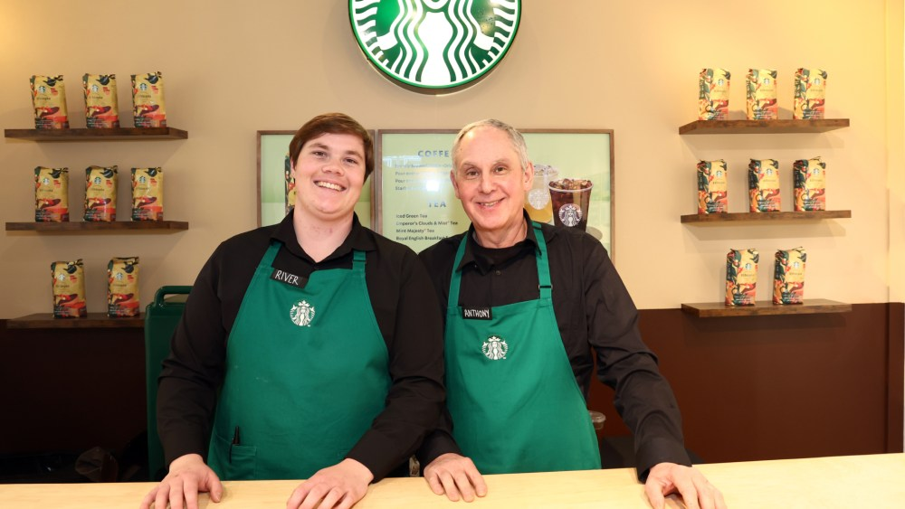
Source: https://wwd.com/fashion-news/fashion-scoops/starbucks-strike-new-uniform-policy-1237732702/

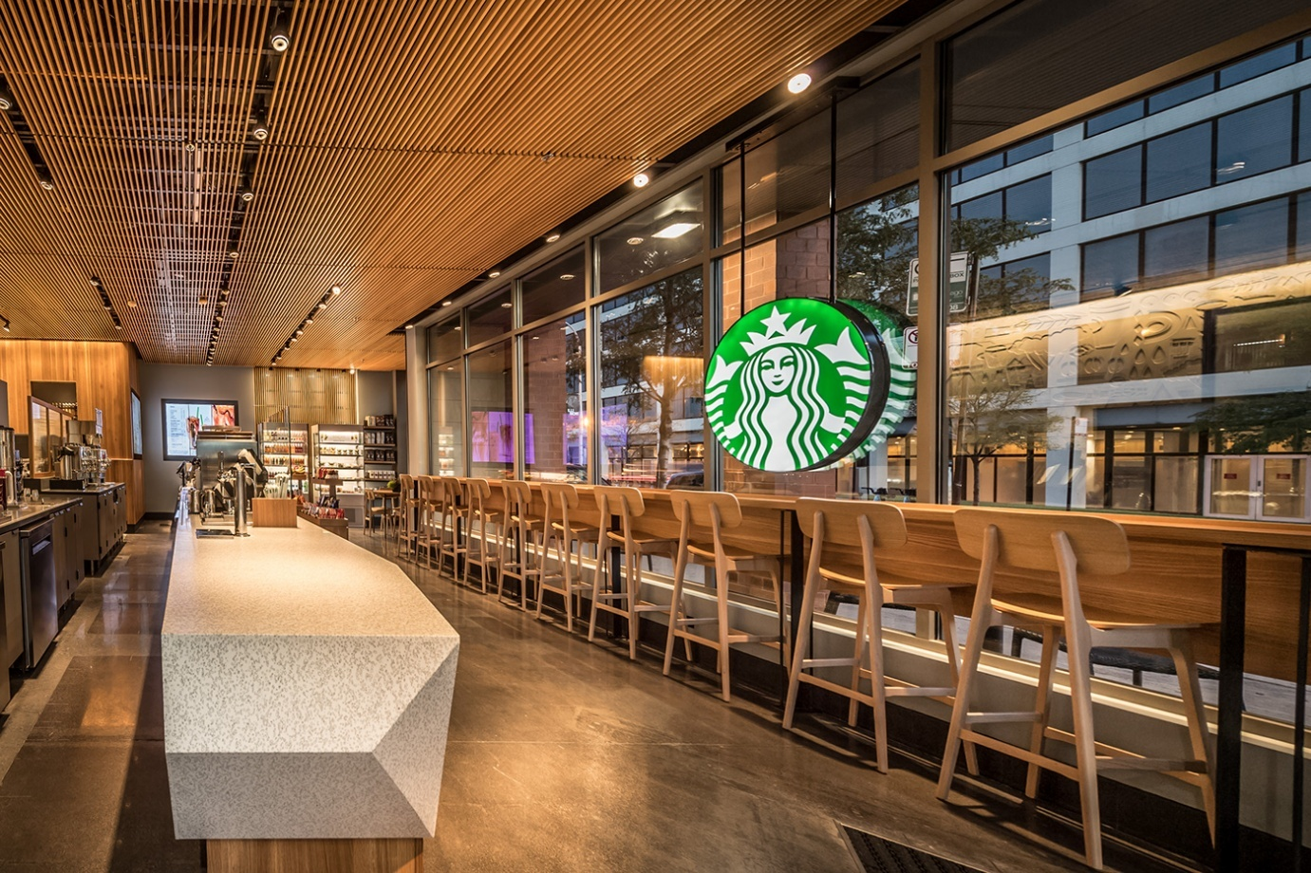
Source: https://www.behance.net/gallery/66413765/Starbucks-Coffee-Store-DesignRetail-Fixtures/modules/388608671
Comfort and minimalism are balanced in UK store design, which frequently uses repurposed materials, subdued colours, and regional artwork. at the UK, Starbucks' "Greener Stores" campaign has proven very effective, cutting waste by 30% and energy use by 20% at test sites (Starbucks, 2025). While design changes, such as smaller store footprints in metropolitan areas, reflect local behaviour patterns, the classic green siren logo is still used to assure global uniformity.
UK Website
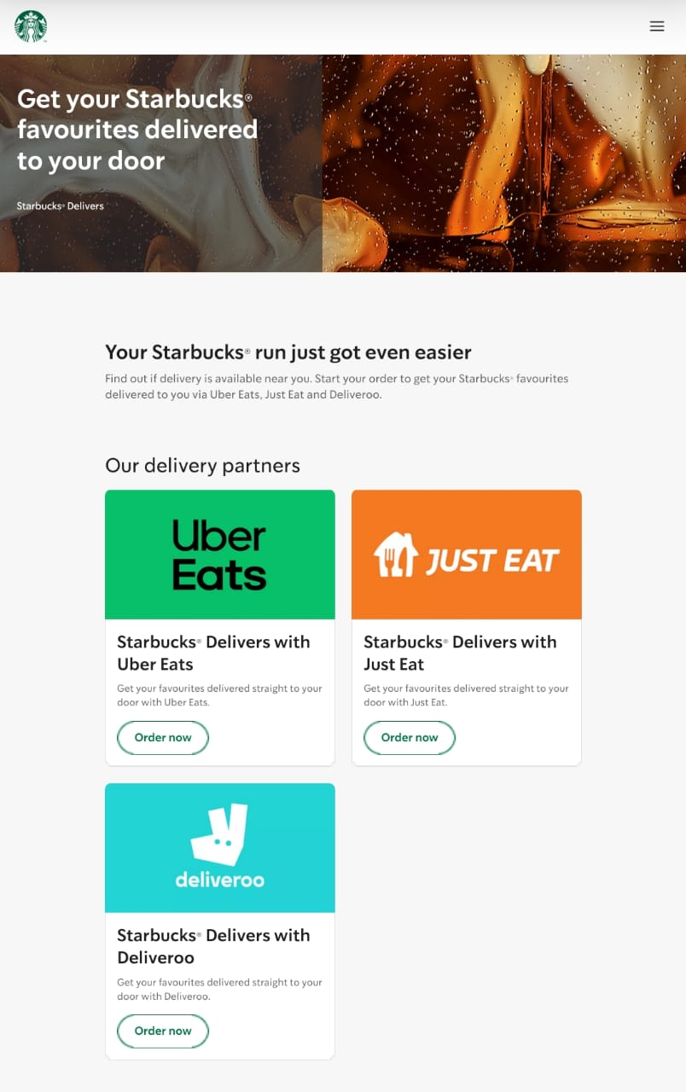
Source: https://www.starbucks.co.uk/delivers
UK Uniform
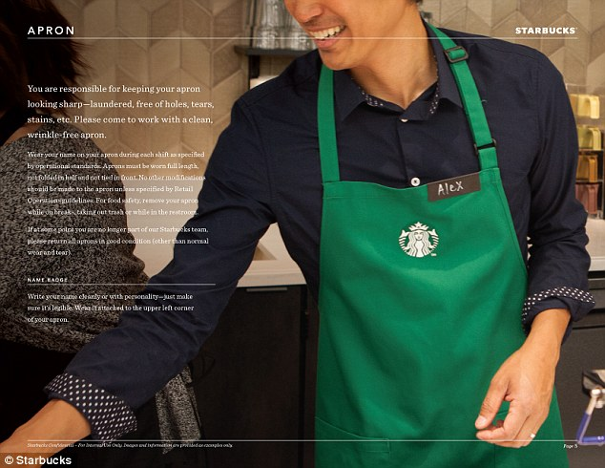
Source: https://www.dailymail.co.uk/lifestyle/article-3712885/Starbucks-releases-new-dress-code-urging-staff-open-closets-fun-sticking-meticulous-rules-colors-skirt-lengths-SOCK-PATTERNS.html

6. Performance of Marketing Strategies
US Performance
In 2025, Starbucks U.S. revenue reached approximately $9.6 billion. Operating profit slightly declined due to marketing and restructuring costs. The company has 34.6 million Starbucks Rewards members, boosting loyalty. Social media campaigns and TikTok trends drive engagement and attract younger customers (Starbucks, 2025). Customer reviews highlight convenience, personalization, and store experience. Starbucks focuses on improving digital ordering, drive-thrus, and mobile app features.
UK Performance
Starbucks UK generated around £525 million in sales but reported a pre-tax loss of about £35 million. High costs and competition affected profitability. Social media engagement is moderate, with customer reviews praising sustainability initiatives and store service (Starbucks, 2025). Starbucks focuses on ethical sourcing, community programs, and inclusive campaigns. Contactless payments and environmental initiatives appeal to UK consumers. The brand aims to improve customer loyalty while maintaining operational standards and enhancing store-level consistency.

6.1 Market Share, Revenue, and Growth
533 net new locations and a 4% increase in average ticket price helped Starbucks' U.S. revenues grow 2% year over year, offsetting a 5% drop in transactions. Approximately $27.1 billion, or 75% of total revenues, came from the North American division, which also generated $5.4 billion in operating income and a 19.8% margin (Starbucks, 2025).
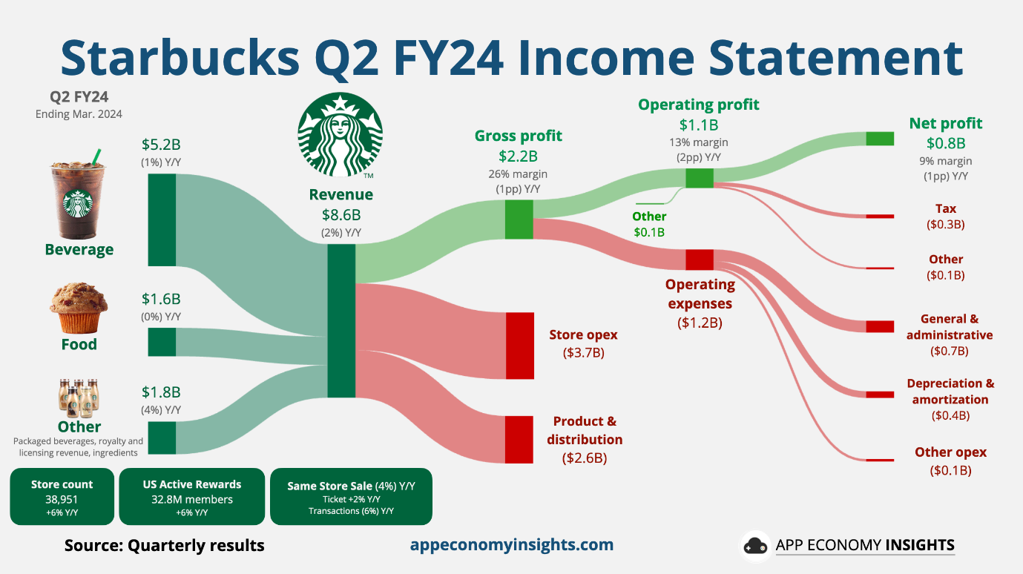
Source: https://www.appeconomyinsights.com/p/starbucks-a-brewing-crisis
International revenues, on the other hand, dropped 2% to $7.3 billion, mostly as a result of poor currency translation (-$252 million) and a 4% decline in comparable store sales, with average ticket prices falling 4% (Starbucks, 2025). Due to high operating expenses and price sensitivity, the U.K. saw moderate expansion (net +88 outlets) but lesser profitability, with 378 company-operated and 976 licensed locations.
In 2024, Starbucks had 40,199 locations worldwide, 21,018 company-operated and 19,181 licensed, a 7% net growth from the previous year. About 10,158 company-operated and 6,777 licensed stores were located in the United States, demonstrating the company's continued dominance in its home market (Starbucks, 2025).

6.2 Brand Equity and Customer Loyalty
One of Starbucks' most important strategic advantages is still the strength of its brand. With deferred revenues from stored-value cards and loyalty points rising from $1.57 billion to $1.72 billion in 2024, a 9.6% increase, the company's Starbucks Rewards program broadened its global reach and demonstrated consistent loyalty engagement (Starbucks, 2025).
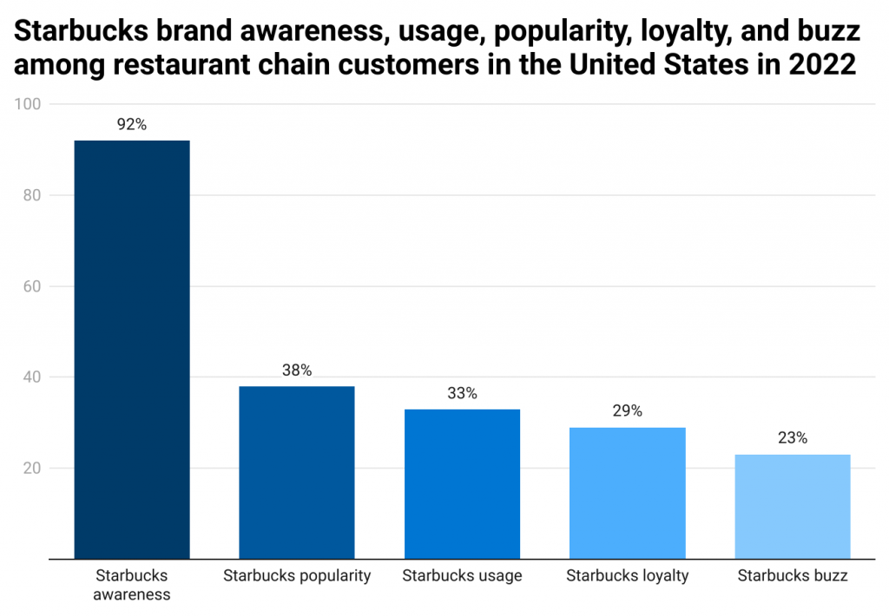
Source: https://www.enterpriseappstoday.com/stats/starbucks-statistics.html
The mobile app's interaction with the program reinforces switching obstacles and encourages recurring purchases. More than 25% of all transactions in the US were made possible by the app, demonstrating the brand's digital maturity and compatibility with convenience-driven consumer behaviour (Soper, 2021).
Although its stock underperformed larger indices, Starbucks' equity performance shows investor confidence. Between 2019 and 2024, total shareholder returns rose 22%, compared to 110% for the S&P 500 and 77% for the consumer discretionary index, confirming the brand's durability in the face of market difficulties (Starbucks, 2025).

6.3 Performance Indicators and Digital Engagement
The business continues to make significant investments in operations and technology. Drive-thru and pickup-only formats accounted for 40% of new U.S. openings, while the Deep Brew AI platform optimized inventory management and store staffing (Starbucks, 2025). Strategic reinvestment in store remodelling and sustainability resulted in a 22% increase in capital expenditures to $2.8 billion in 2024.

6.4 Sustainability Achievements
Starbucks kept moving closer to its 2030 targets of a 50% reduction in waste, water, and carbon emissions. The Greener Stores effort, involving more than 3,500 global sites, delivered 30% waste reduction and 20% energy efficiency gains, particularly in the U.K. market (Starbucks, 2025).
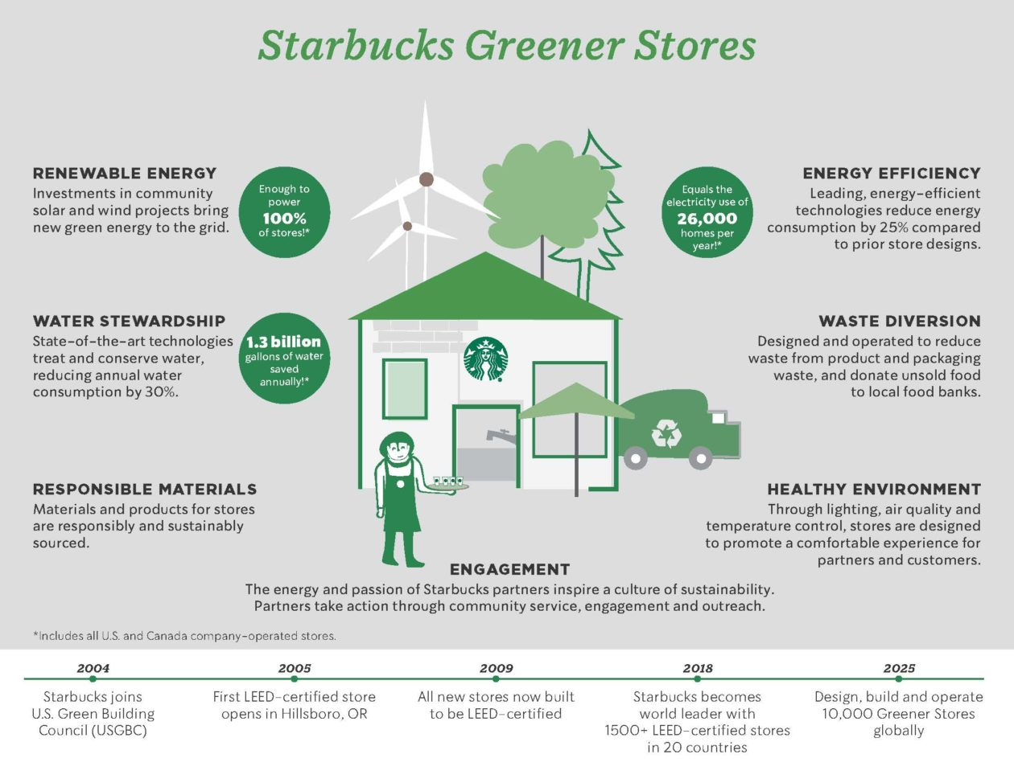
Source: https://www.geekwire.com/2018/starbucks-announces-plans-go-greener-10000-stores-worldwide-2025/
In morally sensitive markets, localization tactics like the introduction of oat milk, menu items tailored to a particular location, and British community efforts improved consumer sentiment by enhancing brand authenticity and cultural alignment.
Similarities and Differences
Starbucks prioritizes brand consistency, loyalty programs, and the consumer experience in both the US and the UK. Social media and mobile applications are examples of digital platforms that are essential to engagement and tailored marketing. Innovative beverages, store design, and high-quality service are prioritized in both markets. Both nations support ethical sourcing and sustainability, although UK programs are more prominent.
However, the operational priorities and strategic focus of the two markets are different. Campaigns in the US emphasize fast-moving product trends, emotional connection, and digital loyalty to appeal to younger, tech-savvy consumers. Despite increased marketing expenses, profitability is still high. In the UK, local consumer values are reflected in the focus on sustainability, ethical sourcing, and community involvement. While contactless payments and fintech usage are more common, high prices and competition pose a challenge to profitability. While campaigns in the UK place more emphasis on diversity and moral leadership, social media involvement is higher in the US.

7. Performance of Marketing Ethics Practices
As cornerstones of its brand identity, fair trade sourcing, labour justice, and environmental sustainability are all incorporated into Starbucks' marketing ethics strategy. Through its Coffee and Farmer Equity (C.A.F.E.) Practices, which are audited by third-party verifiers for fair compensation, environmental stewardship, and community welfare, 98% of Starbucks' coffee was confirmed to be ethically sourced by 2024 (Starbucks, 2025).
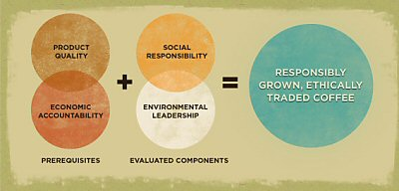
Source: https://www.coffeehabitat.com/2010/09/starbucks-cafe-practices/
Through agronomy training and climate adaptation initiatives, the company's ten global Farmer Support Centres, which are located in China, Rwanda, and Costa Rica, directly support more than 400,000 coffee growers, increasing yields by as much as 20% yearly (Starbucks, 2025). Furthermore, the Global Coffee Alliance with Nestlé increased access to Rainforest Alliance and Fairtrade-certified goods in 87 markets, strengthening ethical consumer positioning and supply-chain transparency.
Labor ethics remain another prominent concern. In 2024, Starbucks had 361,000 employees worldwide, 211,000 in the United States and 150,000 abroad, and upheld racial and gender wage parity in all U.S. areas where it operates (Starbucks, 2025). However, disagreements over unionization at more than 400 U.S. stores heightened ethical scrutiny, exposing a conflict between its "partner-first" philosophy and labour advocacy.
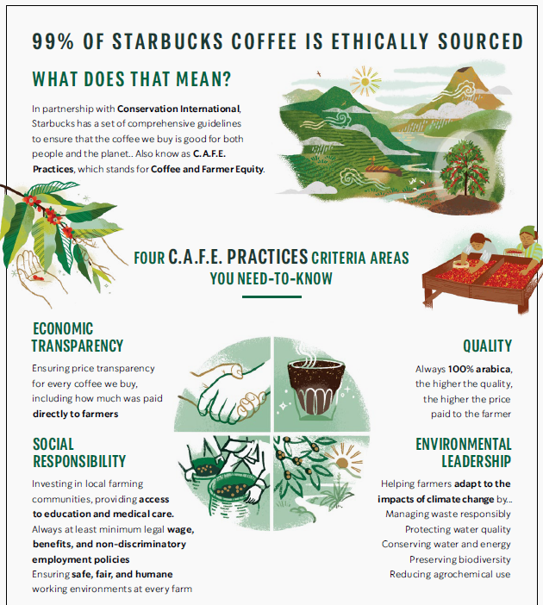
Source: https://stories.starbucks.com/emea/stories/2020/coffee-and-farmer-equity-practices-emea-explainer-video-internal/
In spite of this, the business kept up its generous benefits package, which supported its human-centric marketing message by offering 20 free mental health therapy sessions a year and 100% tuition reimbursement for qualified partners (Starbucks, 2025). In the U.K., Starbucks faced increased criticism over corporate tax avoidance, having paid negligible corporation tax during 2012–2020 despite strong earnings.
In line with its ethical branding objectives, Starbucks invested more than £2.5 million in U.K. community grants and increased transparency through local reporting to repair reputational harm. Starbucks' CSR efforts, particularly the 2030 resource-positive commitment and the Greener Stores framework (which aims to reduce waste and energy use in stores by 30% and 20%, respectively), reinforce its moral leadership (Starbucks, 2025).
Overall Ethical Judgement
Through fair trade sourcing, environmental sustainability, and labour justice, Starbucks exhibits a strong commitment to ethical practices. Over 400,000 growers receive assistance from its Farmer Support Centres, and its C.A.F.E. Practices guarantee that 98% of coffee is obtained ethically. Its human-centric brand is supported by wage equity and employee perks.
However, ethical issues are brought to light by unionization struggles in the United States and previous corporate tax criticism in the United Kingdom. Starbucks has a generally good reputation for ethics, which is bolstered by CSR programs like Greener Stores and community contributions.

8. Recommendations and Conclusion

8.1 Recommendations
United States
- Strengthen Labor and Partner Engagement – Address rising internal dissatisfaction and unionization concerns by establishing a Partner Advisory Council. Involving employees in decisions on compensation, scheduling, and workplace conditions will reinforce the "partner-first" philosophy, enhance customer satisfaction, and reduce staff turnover.
- Enhance Digital and Loyalty Initiatives – Expand mobile ordering, personalized promotions, and digital engagement through apps and social media to boost customer retention and sales, building on the success of Starbucks Rewards and drive-thru optimization.
United Kingdom
- Increase International Profitability – Streamline supply chains, expand licensed operations, and implement cost-saving measures to offset high VAT, inflation, and operating expenses, improving margins while maintaining quality.
- Strengthen Sustainability Leadership – Highlight Greener Stores achievements, promote C.A.F.E.-verified ethical coffee, and develop carbon-neutral supply chains. Marketing these initiatives will strengthen brand trust, particularly among environmentally conscious consumers.

8.2 Conclusion
Starbucks’ performance indicates that its marketing success hinges on brand equity, ethical sourcing, digital innovation, and sustainability integration. With 75% of total revenue, the U.S. market still drives profitability, but in order to maintain growth, the U.K. and other overseas markets need more precise localization and digital adaption.
Brand trust is increased by ethical programs like C.A.F.E. Practices, Greener Stores, and inclusive labour practices, but they must change to meet the expectations of stakeholders. Starbucks can improve its position in the global market and maintain long-term, morally sound profitability by enhancing employee interactions, boosting environmental leadership, and maximizing digital ecosystems.

References
BBC News (2017) Starbucks says Brexit vote hit UK profits. https://www.bbc.com/news/business-39586848.
Bloomberg (2025) 'Starbucks, NLRB to Clash Again in Court With No End in Sight,' Bloomberg Law, 11 November. https://news.bloomberglaw.com/daily-labor-report/starbucks-nlrb-to-clash-again-in-court-with-no-end-in-sight.
Burt, K. (2024) 500 Starbucks locations have voted to unionize as labor talks continue. https://www.cnbc.com/2024/10/01/500-starbucks-locations-have-voted-to-unionize.html.
CEBR (2018) The UK coffee market and its impact on the economy, The British Coffee Association. https://britishcoffeeassociation.org/uk-coffee-market-analysis-report/.
CMS (2024) Plastics and packaging laws in the United Kingdom. https://cms.law/en/int/expert-guides/plastics-and-packaging-laws/united-kingdom (Accessed: November 11, 2025).
CNN (2025) Starbucks is changing one of the most generous perks of its loyalty program. https://edition.cnn.com/2025/05/29/food/starbucks-rewards-reusable-cup-stars-changes (Accessed: November 11, 2025).
Culture Factor (2025) Country comparison tool. https://www.theculturefactor.com/country-comparison-tool?countries=united+kingdom%2Cunited+states (Accessed: November 25, 2025).
Deepak (2025) Starbucks Sustainability. https://thesustainableinnovation.com/starbucks/ (Accessed: November 11, 2025).
Durbin, D.-A. (2023) Starbucks, Workers United union sue each other in standoff over pro-Palestinian social media post. https://apnews.com/article/starbucks-workers-united-union-lawsuit-israel-palestinian-f212a994fef67f122854a4df7e5d13f5 (Accessed: November 11, 2025).
FCSI (2023) 'Subscriptions to Encourage Customer Loyalty,' FCSI, 29 March. https://fcsi.eu/subscriptions-to-encourage-customer-loyalty/.
NCDT (2025) The 2025 NCDT Specialty Coffee Report. https://www.ncausa.org/market-research/specialty-coffee-report.
Soper, T. (2021) More than a quarter of all Starbucks orders in the U.S. are now paid for with a smartphone. https://www.geekwire.com/2021/quarter-starbucks-orders-u-s-now-paid-smartphone/ (Accessed: November 11, 2025).
Starbucks (2019) Starbucks Delivers expands across the UK, powered by Uber Eats. https://stories.starbucks.com/emea/stories/2019/starbucks-delivers-expands-across-the-uk-powered-by-uber-eats/ (Accessed: November 11, 2025).
Starbucks (2020) Roastery-inspired tea innovation arrives at Starbucks in Tokyo. https://stories.starbucks.com/asia/stories/2020/roastery-inspired-tea-innovation-arrives-at-starbucks-in-tokyo/ (Accessed: November 11, 2025).
Starbucks (2023) Starbucks Commits Over $50 Million to Sustainable Waste and Water Funds Toward a Resource-Positive Future. https://about.starbucks.com/press/2023/starbucks-commits-over-50-million-to-sustainable-waste-and-water-funds-toward-a-resource-positive-future/ (Accessed: November 11, 2025).
Starbucks (2025) Starbucks Fiscal 2024 Annual Report. https://investor.starbucks.com/financials/annual-reports/default.aspx.
State of California (2025) California Consumer Privacy Act (CCPA). https://oag.ca.gov/privacy/ccpa (Accessed: November 11, 2025).
Statista (2025a) Starbucks. https://www.statista.com/topics/1246/starbucks/?srsltid=AfmBOooLooKBlNy20LCxWr76kHaVqGKNyrrWiVu1zop5Wl_3RRXlBRM8#topicOverview (Accessed: November 11, 2025).
Statista (2025b) Coffee shops and cafes in the U.S. https://www.statista.com/topics/1670/coffeehouse-chain-market/?srsltid=AfmBOoqK8Z-f_LANEm4xOLAqQQDKRMLY7s3zOeCtmaN2zLa_g6rm8ye_ (Accessed: November 11, 2025).
Statista (2025c) Cafes and coffee shops in the United Kingdom. https://www.statista.com/topics/3650/cafes-and-coffee-shops-in-the-united-kingdom-uk/?srsltid=AfmBOorUb4G4ucS6d1VaoRu9117obJo_f2wJXXmDLhUU_y0J0FRI1reg (Accessed: November 11, 2025).
UK Government (2025) Extended producer responsibility for packaging: who is affected and what to do. https://www.gov.uk/guidance/extended-producer-responsibility-for-packaging-who-is-affected-and-what-to-do (Accessed: November 11, 2025).
WARC (2025) Starbucks: How the modern influence of paid media helped Starbucks move from a convenient business to a loved brand. https://www.warc.com/content/paywall/article/ipa/starbucks-how-the-modern-influence-of-paid-media-helped-starbucks-move-from-a-convenient-business-to-a-loved-brand/en-gb/156839? (Accessed: November 11, 2025).
Westberg, P. (2025) The Starbucks story: From beans to billions. https://quartr.com/insights/edge/the-starbucks-story-from-beans-to-billions.
Zhu, Y. (2024) 'Leveraging social media Marketing: A case study of Starbucks Digital success,' Advances in Economics Management and Political Sciences, 102(1), pp. 185–190. https://doi.org/10.54254/2754-1169/102/2024ed0108.

