

Module Name: Digital Skills for Personal and Professional Growth
Module Code: (BMSW4008)
Assignment Name: Task 1 and 2: Word questionnaire analysis and website design and Excel Financial Projection & Analysis
Student Name: Ionela- Catalina Simion
Student Number: 2227035
Lecturer: Philippa Fitzgerald
Deadline: 20th June 2025

AI Acknowledgement
Examples of statements If you have not used AI
I confirm that I have not presented any AI generated materials as my own work.
I confirm that I have copies of my drafts, notes, and other resources I used, which I may be asked to provide in evidence.

Contents
Task 1 3
Introduction 3
Key Findings & Data Analysis 4
Audience Segmentation 6
Website Design & SEO Strategy 7
Marketing Materials 9
Conclusion 12
References 13
Task 2 15
Introduction 15
Financial Planning and Budgeting 16
Decision-Making Through Data Analysis 17
Efficiency and Automation 18
Digital Literacy and Employability 19
Conclusion 20
Website Link: Happy Toes Online 21
Appendix: Screenshot Evidence 22
References 24

Task 1

Introduction

This study describes the creation of Happy Toes, a prospective indoor playground business. To confirm that the service matches local demand, 11 respondents filled out a Google Forms questionnaire. The data insights were used to create a website and marketing materials that reflect customer preferences. The paper focusses on major survey results, their impact on brand strategy, and how audience feedback influenced the design, style, and content of the website and promotional materials.

Key Findings & Data Analysis

The questionnaire (Google Forms, n.d.) generated key insights from the target audience:
Respondents' Ages: The majority of respondents were between the ages of 25 and 54, with four in the 25-34 range and three in the 35-44 range. This complements the company's focus on parents with small children.
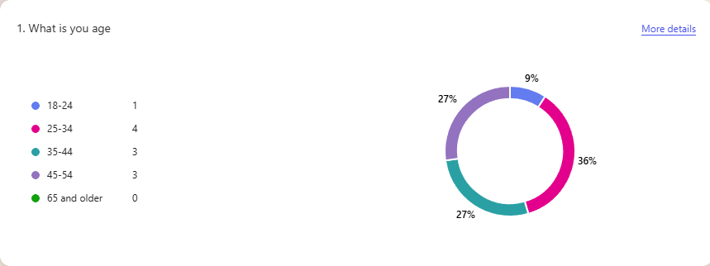
Indoor Playground Experience: Nine of the eleven respondents had previously visited indoor playgrounds. This demonstrates a high market interest in such services and justifies the business concept.
Playground Preferences: Respondents ranked cleanliness (9), safety (8), nice staff (4), and pricing (4). These findings influenced the website's messaging and design decisions.
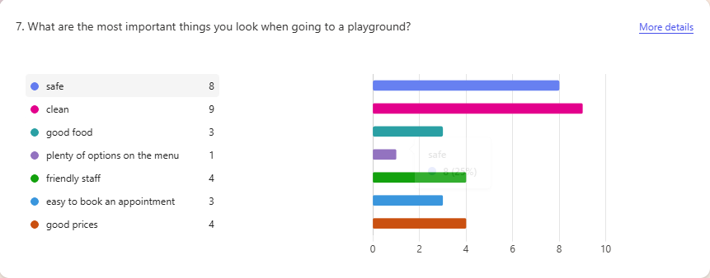
Dietary Needs: Seven people requested vegetarian or dietary menu alternatives. This was addressed on the website's pricing page and emphasized in marketing materials.

These findings provide actionable insights that helped guide the creation of digital platforms and ensured they met client expectations.

Audience Segmentation

The poll results indicate a major audience segment: parents aged 25 to 44, mostly women. These individuals make decisions about family activities and place a high emphasis on safety, cleanliness, and convenience. The data also shows that the majority of respondents have never hired a playground for a birthday, highlighting an opportunity to simplify and market this service.
Audience segmentation enabled the brand to target a specific group of people with specific demands, which influenced the tone, layout, and structure of both the website and marketing collateral. (ROSPA, 2023)

Website Design & SEO Strategy

The Happy Toes website, built using Google Sites (Google Sites, n.d.), has two primary pages: Home and Parties & Pricing. The design is simple and modern, with an emphasis on ease of use. Headings contain SEO-friendly (Moz, 2023) keywords like "indoor playground " and "birthday party soft play."
The visual hierarchy and layout follow survey findings. Cleanliness and safety are highlighted through imagery and language. The Home page has a welcoming banner, while the Pricing page has detailed package breakdowns and a booking button.
The website also features mobile optimization and accessible layout. SEO tactics include the use of alt text, internal links, and keyword-rich titles. This assures discoverability and is consistent with digital marketing best practices.
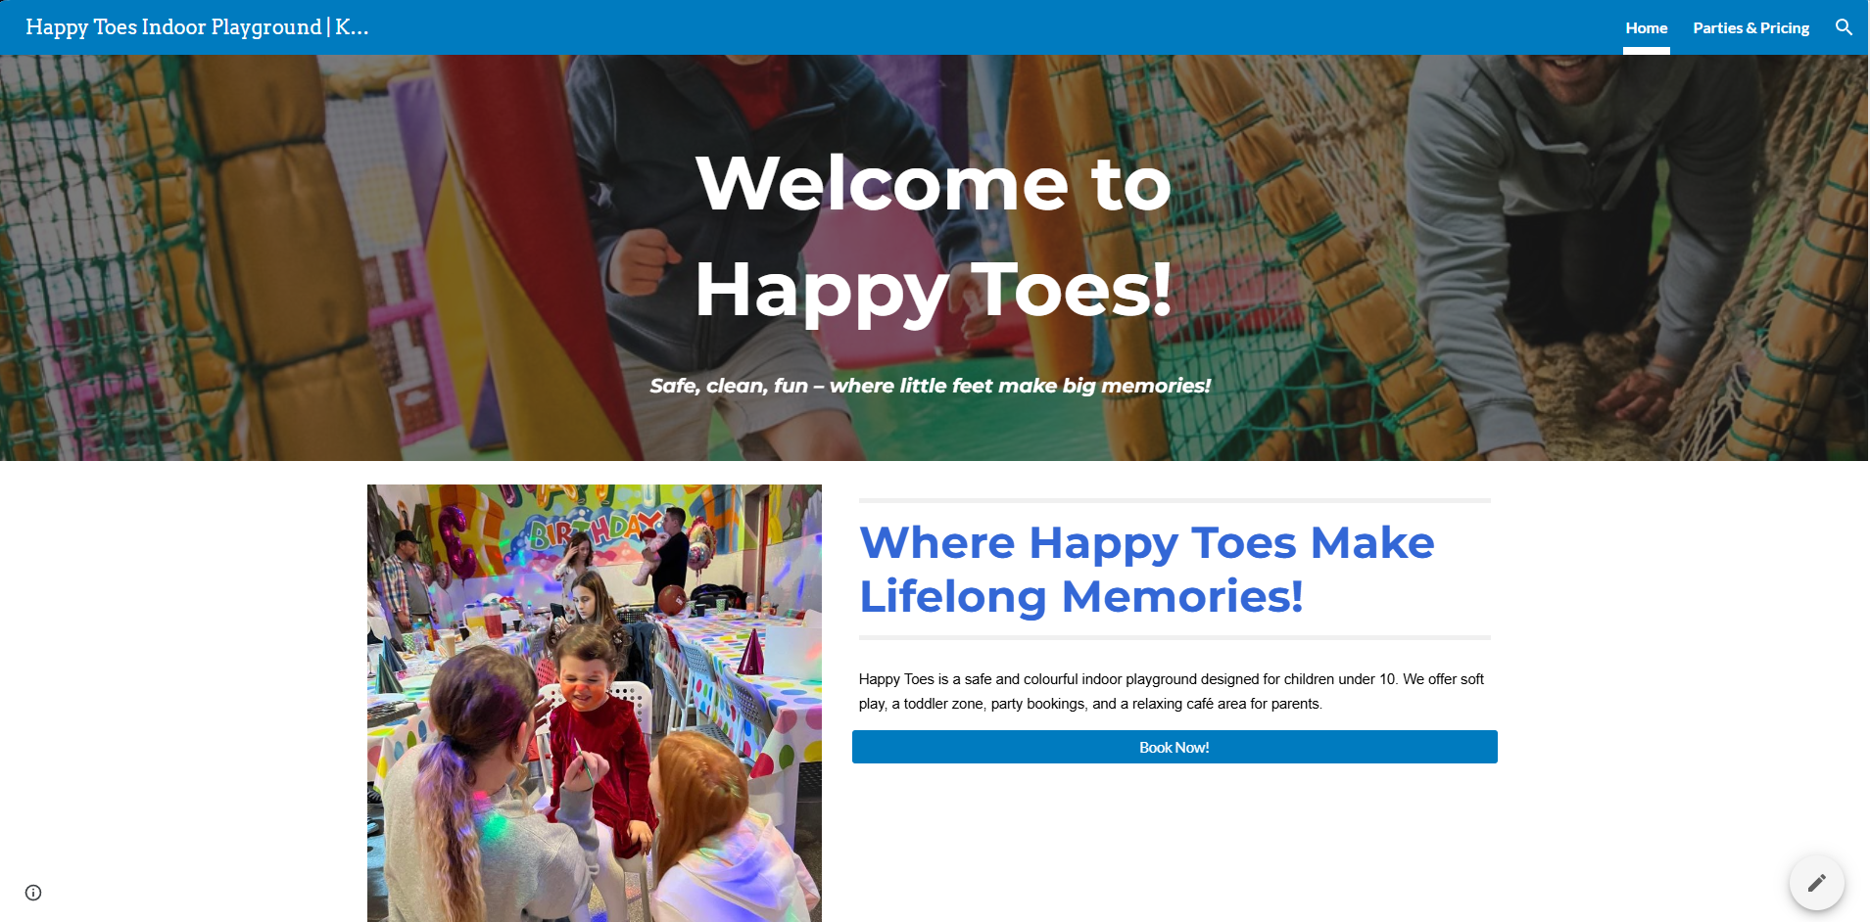
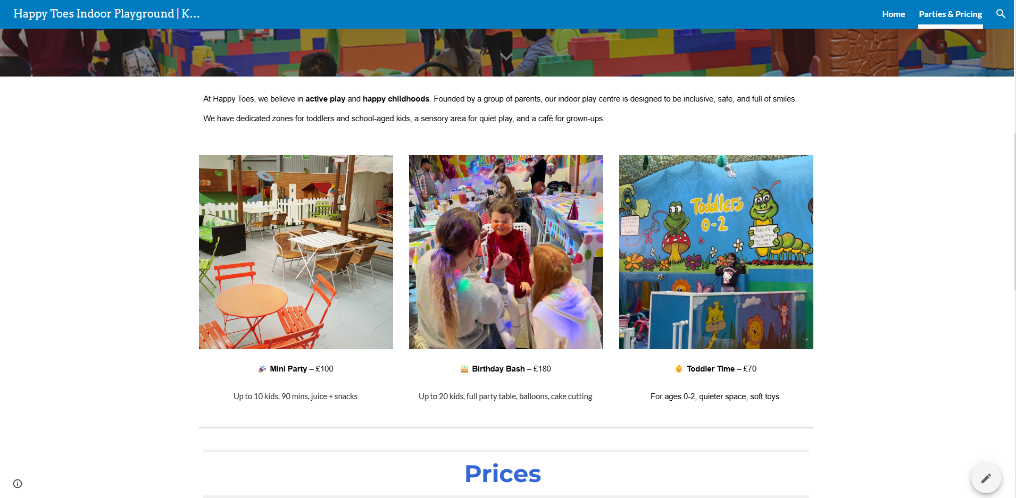

Marketing Materials

Canva (Canva, n.d.) was used to generate marketing materials, with the major audience preferences found in the questionnaire serving as guides. To appeal to families, the color scheme includes soothing pastels. Flyers and social media posts highlight safety, cleanliness, party booking convenience, and menu flexibility.
Typography was chosen to ensure readability and a welcoming tone. To aid visual communication, safety icons, dietary-friendly menus, and booking buttons were provided. These materials are aligned with the website and assist to reinforce the brand's ideals.
All designs are targeted to the requirements and ideals of the 25-44 parent demographic, with a focus on emotional reassurance and simple decision-making.
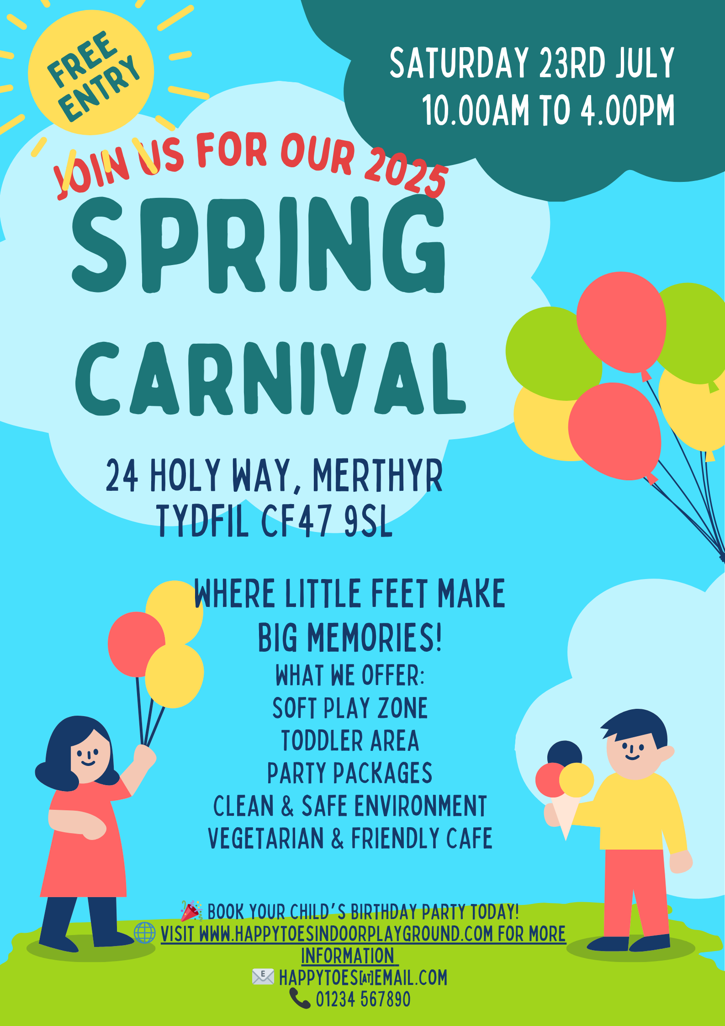



Conclusion

This project demonstrates how meaningful data can shape a business strategy from concept to execution. Survey responses highlighted core customer values such as safety, cleanliness, and dietary accommodation. These insights influenced website design, content structure, marketing messaging, and overall brand strategy.
By combining user data with tools like Google Sites and Canva, Happy Toes delivers a targeted, accessible, and research-driven service concept. The final outputs reflect a professional approach to business development in the digital age.

References

British Nutrition Foundation (2024). Special diets: Vegetarian and vegan. [online] Available at: https://www.nutrition.org.uk [Accessed 18 Jun. 2025].
Canva (2024). Designing websites for kids: Trends and best practices. [online] Available at: https://www.canva.com/learn/kids-websites/ [Accessed 18 Jun. 2025].
Chaffey, D. and Ellis-Chadwick, F. (2019). Digital Marketing. 7th ed. Harlow: Pearson Education.
ROSPA (2023). Legal aspects of safety on children's play areas. [online] Available at: https://www.rospa.com/play-safety/advice-and-information/legal-aspects [Accessed 18 Jun. 2025].
Kotler, P. and Keller, K.L. (2016). Marketing Management. 15th ed. Harlow: Pearson Education.
Moz (2023). The Beginner's Guide to SEO. [online] Available at: https://moz.com/beginners-guide-to-seo [Accessed 18 Jun. 2025].
CreativePlayUK. Playgrounds & The Hospitality Sector | Revealed - Success Statistics. [online] Available at: https://creativeplayuk.com/playgrounds-and-hospitality-revealed-success-statistics/ [Accessed 18 Jun. 2025].
Google Forms https://docs.google.com/forms/ [Accessed 18 Jun. 2025]
Google Sites https://sites.google.com [Accessed 18 Jun. 2025]

Task 2

Introduction

In today's digital economy, Microsoft Excel is still an essential tool for organizations of all kinds (Group, 2024). From budgeting to data analysis, Excel enables entrepreneurs to clearly visualize, manage, and forecast their operations. Excel helps small businesses like Happy Toes, an indoor playground, track finances, make informed decisions, and plan for long-term growth. This essay examines Excel's complex role in business and emphasizes its usefulness in workplace digital literacy.

Financial Planning and Budgeting

Excel is extensively used for budgeting because of its ability to organize numerical data in a straightforward and flexible manner. Understanding monthly revenue, fixed expenses (such as rent and salary), and variable costs is critical for small firms operating on tight margins. In the case of Happy Toes, Excel enables the management to enter monthly predictions, alter seasonal income assumptions, and monitor profit patterns over time. (Investopedia, 2023)
The usage of formulas like =SUM, =IF, and =AVERAGE simplifies calculations that would otherwise require manual labor or sophisticated accounting software. Small firms benefit from visualizing financial data in bar charts and line graphs, which assist them avoid overspending or underinvestment.

Decision-Making Through Data Analysis

Excel also helps small firms make better decisions by analyzing past data. For example, Happy Toes may monitor which months generate the most bookings and how weather affects visitor numbers. Excel's pivot tables can categorize performance by service (for example, general admission versus party bookings), and conditional formatting can highlight critical patterns or red flags. (Support, n.d.)
Excel's ability to filter and sort data makes it simple to answer key queries like, "Should we hire extra staff during the summer?" Is the café stock being managed efficiently? These judgements become data-driven rather than guesswork, resulting in better business outcomes.

Efficiency and Automation

Automation is one of Excel's most powerful features. Business owners can create reusable templates for monthly reports, invoicing, timesheets, and order forms. Non-technical people can save hours of tedious work by employing simple macros or pre-built templates.
Happy Toes, for example, can use a spreadsheet to manage weekly cleaning supplies orders, updating totals automatically and highlighting low stock levels. Excel also connects seamlessly with online services such as Google Sheets, enabling real-time communication with team members or accountants.
Such automation is vital for small teams with limited time. Excel increases efficiency while decreasing the risk of human error, which is critical for sustaining consumer trust and financial stability.

Digital Literacy and Employability

Excel proficiency is also an important digital skill for personal development and job opportunities. Employers across industries want employees to be comfortable with spreadsheets for administration, reporting, and analytics. Excel training provides students in a Level 4 Employability course with core knowledge that may be used to employment in finance, marketing, human resources, and other fields.
In today's data-driven world, Excel is more than a tool; it's a language. Knowing how to "speak" that language provides people and businesses a competitive advantage.

Conclusion

Excel is more than simply a spreadsheet; it's a flexible tool for planning, analysis, and success (GlobalEduLink, n.d.). It is critical to Happy Toes' financial health, operational efficiency, and long-term growth. Excel is still an important tool for making informed business decisions in the digital age.

Website Link: Happy Toes Online

https://sites.google.com/view/happytoesindoorplayground/home
As part of Task 1, this website was created using Google Sites (Google Sites, n.d.) and directs visitors to the financial data and business model presented in Task 2. It contains explicit pricing, party packages, and a booking area that corresponds to the monthly estimates shown in the attached spreadsheet. (TechRadar, (2022).)

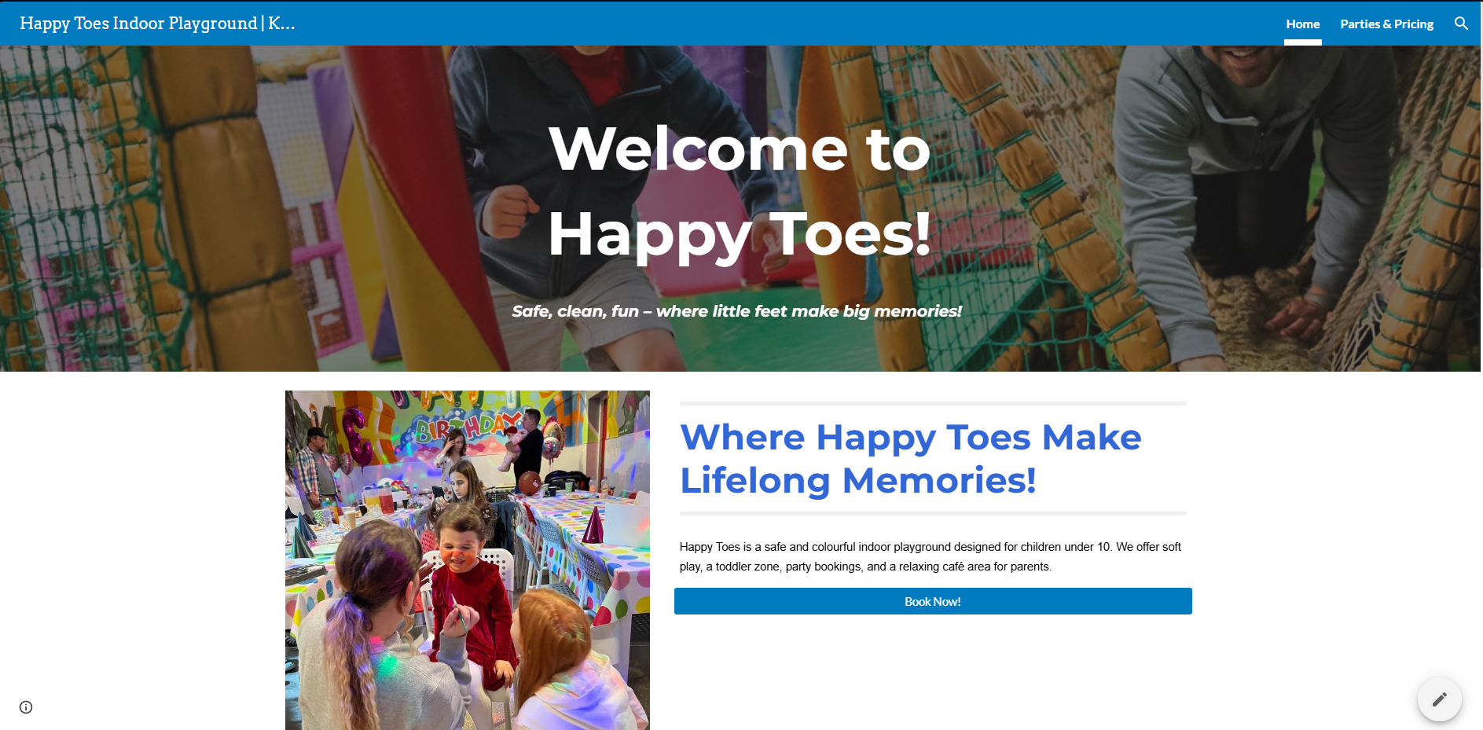
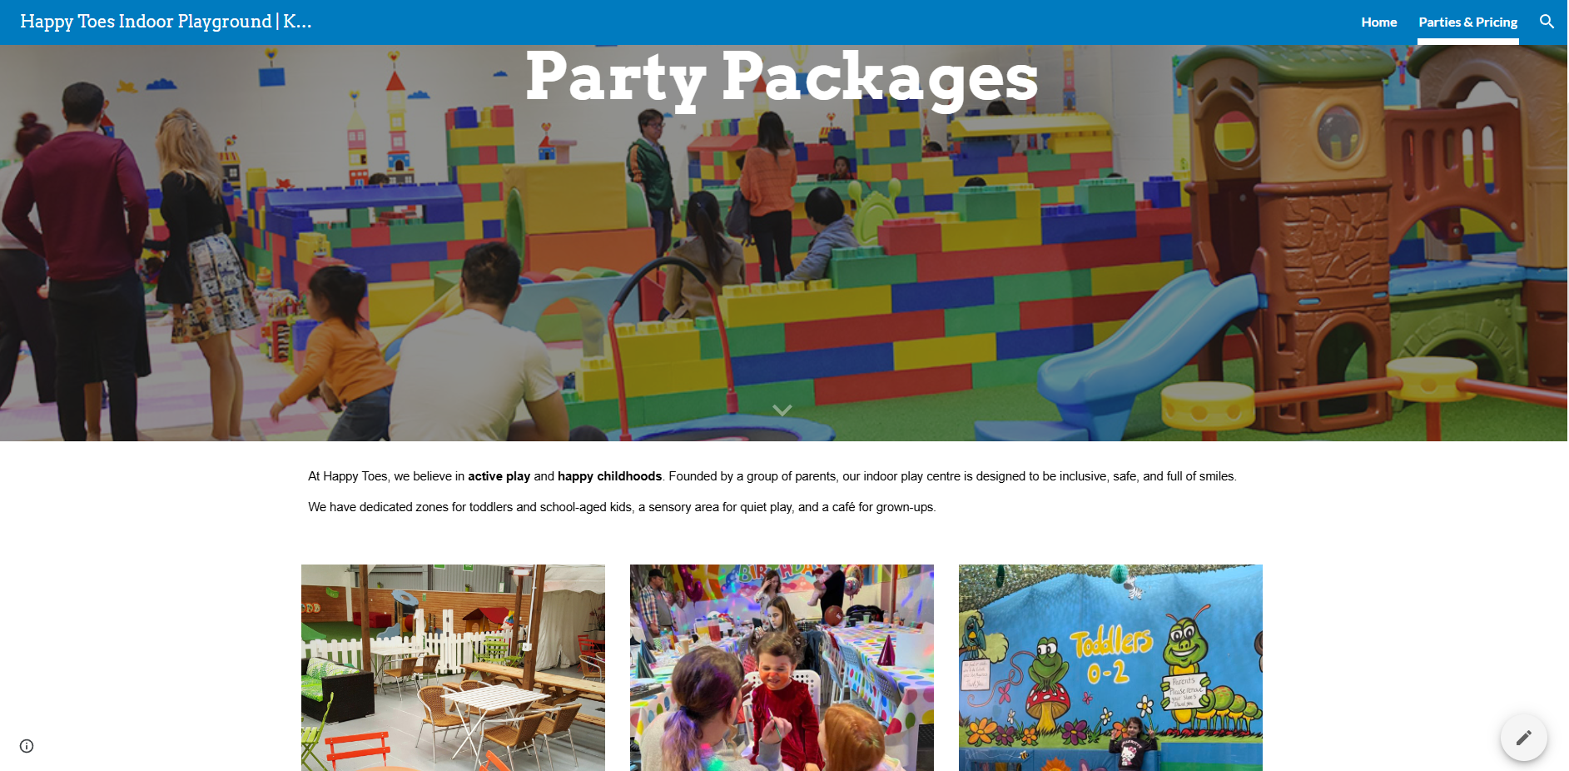

Appendix: Screenshot Evidence

Figure 1 – Happy Toes 12-Month Financial Projection


Figure 2 – Monthly Revenue vs Costs
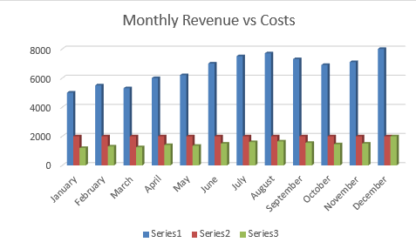

Figure 3 – Monthly Profit Line Graph
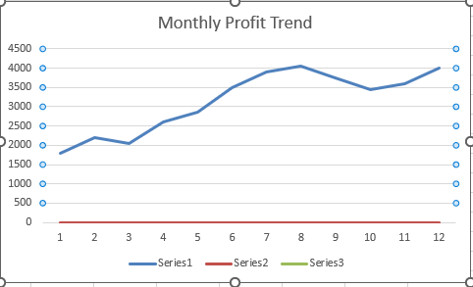

References

FDM Group (2024). 13 advanced Excel skills for business. [online] Available at: https://www.fdmgroup.com/news-insights/advanced-excel-skills/ [Accessed 18 Jun. 2025].
High speed training (2022). What is the Importance of Digital Skills in the Workplace? [online] Available at: https://www.highspeedtraining.co.uk/hub/digital-skills-for-the-workplace/ [Accessed 18 Jun. 2025].
Investopedia (2023). The Importance of Excel in Business. [online] Available at: https://www.investopedia.com/articles/personal-finance/032415/importance-excel-business.asp [Accessed 18 Jun. 2025].
Microsoft Support (n.d.). What is Excel?. [online] Available at: https://support.microsoft.com/en-us/office/what-is-excel-94b00f50-5896-479c-b0c5-ff74603b35a3 [Accessed 18 Jun. 2025].
TechRadar (2022). 10 Things You Need to Know to Build a Small Business Website. [online] Available at: https://www.techradar.com/news/10-things-you-need-to-know-to-build-a-small-business-website [Accessed 17 Jun. 2025].
GlobalEduLink Importance of MS Excel in our daily & Business Lives. [online] Available at: https://www.globaledulink.co.uk/importance-of-ms-excel-in-our-daily-business-lives/ [Accessed 17 Jun. 2025].
Google Sites https://sites.google.com [Accessed 17 Jun.2025]

