Oliver Allen
2516731 |
Fundamentals of Construction Technology (ACBA4022)
Case Study: Rhyd-y-car Terrace, St Fagans

Table of Contents
List of Figures 0
1 Introduction 1
2 Windows 2
3 Doors 3
4 Wall Construction 4
5 Foundations 7
6 Wall Coverings 7
7 Roofs & Roof Coverings 8
8 Floors 10
9 Conclusion 11
10 References 12
11 Appendices 14
11.1 Appendix A – Pre 1919 Sketch 14
11.2 Appendix B – 1920’s sketch 15
11.3 Appendix C – Post 2000’s Sketch 16

List of Figures
Figure 1 The houses of Rhyd-y-car terrace in St Fagan’s, Cardiff (Photo Credit: Oliver Allen, 2025) 1
Figure 2: The door of the 1985 house (Photo Credit: Google Arts & Culture, 2019) 4
Figure 3: Brick arches used to create openings (Photo Credit: Google Art & Culture, 2019) 6
Figure 4: The layout of a modern truss used in a roof (Photo Credit: Riley ,2018) 9
Figure 5: Make-up of a modern ground floor (Photo Credit: Riley, 2018) 10

Introduction
This report will provide an analysis of how the methods of construction for residential houses has evolved over time, comparing the traditional & modern methods of construction, using the houses of Rhyd-y-car Terrace in St Fagans, Cardiff as a point of reference. The report will comment on some of the differences between each house, looking at how the elements have changed, the reasons for why they have changed & whether the changes were seen as positive or negative. The report will be supported by a few digital sketches displaying the typical construction types between three periods: pre-1919, 1920’s and post 2000.
Cadw (2019) describes pre-traditional buildings as “…those constructed before 1919 using solid wall construction methods and materials including wood and stone.”
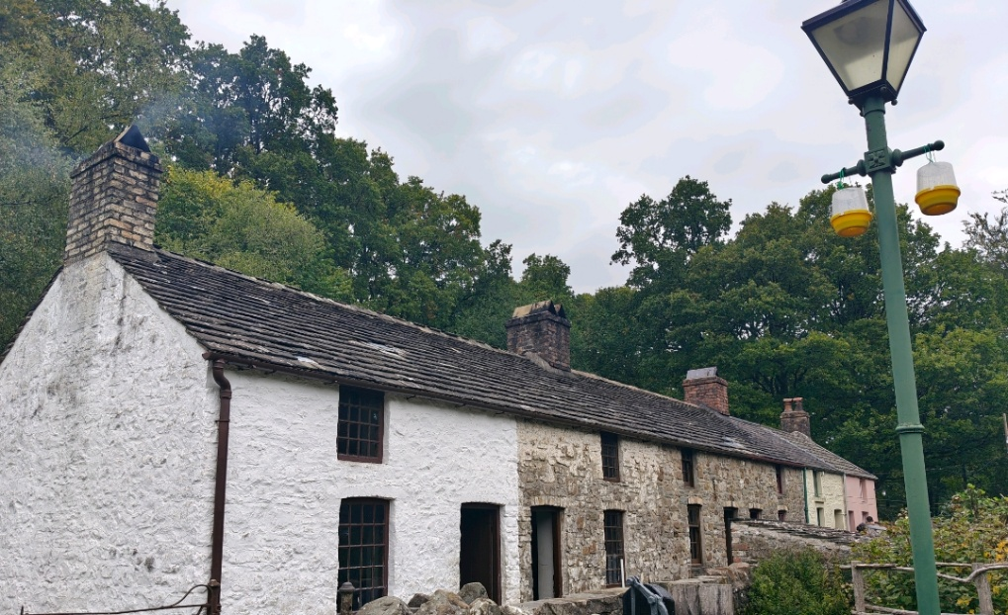

Figure 1 The houses of Rhyd-y-car terrace in St Fagan’s, Cardiff (Photo Credit: Oliver Allen, 2025)

Windows
It can be argued that the window has undergone the largest and most significant changes over time.
The 1805 and 1855 houses show how windows were introduced, with a typical window in this era comprising of small panes of glass held together in a hardwood frame with putty externally. The glass panes were small due to the poor manufacturing techniques of the time. The type of glass used was crown glass, which was hand spun, and is often recognised by the raised point in the centre of the pane, colloquially referred to as a bullseye.
The 1895 house features a sliding box sash window, which consists of one fixed pane of glass and one moveable pane of glass, creating an opening to provide ventilation into the house. This was viewed as a positive improvement as previously windows could not be opened, therefore providing no air circulation or ventilation. The type of glass also evolved to plate or float glass, as these materials tend to have a smoother and more uniform surface.
The 1955 house displays a more modern uPVC casement window with two openable panes either side of a fixed pane, complete with a small openable pane along the top. The move to using uPVC instead of timber is a material improvement, with Riley (2018) describing the benefits of uPVC as being able to “… offer high levels of performance and good control of air permeability.” The 1985 house shows another configuration of this type of window, opting for one large openable pane, one medium fixed pane and a small openable pane.
The variation in the size of the panes reflects the manufacturing technology of the times, as noted by Moores (2022) “The changes in the manufacturing process are such that glass can now be produced on much grander scales, and while smaller objects are still made, the float glass method allows huge sections of glass to be built.”. However, this improvement came at a financial cost.

Doors
Where windows have undergone several notable changes over their existence, doors can be seen as remaining similar over the years. All the houses in Rhyd-y-car Terrace feature hardwood external doors, with Chudley and Greeno (2014 p. 174) noting “External doors tend to be more robust, heavier and thicker than internal doors...”. Most of these doors are Ledge & Brace doors, made up of of several wooden planks fixed to horizontal and diagonal beams along the back of the planks.
The 1955 house is where the first change occurs, introducing a framed door with a clear rectangular panel at head height, affording the house with natural light. The 1985 house features a four panelled door with a more decorative light, in the form of panes in an arched design. This detail follows the principle of bringing in more natural lighting as seen with the 1955 house’s door but increases the level of privacy for the house.
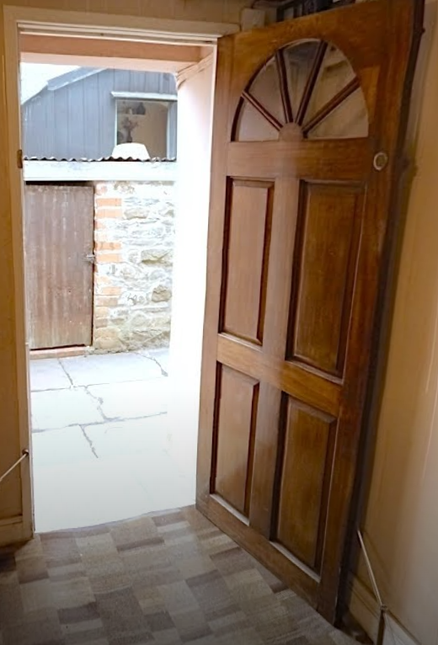
Figure 2: The door of the 1985 house (Photo Credit: Google Arts & Culture, 2019)

Wall Construction
Traditionally, external walls were made from stone, brick, or a mixture of the two materials. In many cases, stone was preferred for its durability and strength. The various sizes of stone had their respective strengths and weaknesses, with smaller stones being more lightweight and easier to transport but providing little to no strength or rigidity. One of the biggest downsides when using stone in the construction of an external wall was the irregularity of the material.
Bricks were seen by many as a better material because of the material’s standard sizing, resulting in more reliable walls, which were quicker to construct, both seen as large improvements to the construction process. These benefits are strengthened by Kercher (2024) who states bricks are “…fairly easy to install as they are lightweight to carry, uniform in shape and size…”. The use of brick also removed the need to taper walls. However, one of the challenges to using bricks was the availability of clay in the local area at the time of construction.
Modern walls continue to use bricks, however the process of building the wall has changed. Traditional walls would consist of a single layer of bricks, known as a skin. However, modern walls (built in 1920 and beyond) are comprised of an outer skin of brick, an air gap (referred to as a cavity) and an inner skin of concrete blocks. The two skins are held together with metal wall ties.
Riley (2018, p. 167) notes the importance of the cavity as it will “… create a break in the capillary path of the moisture.”, preventing moisture reaching the internal skin and creating damp. Cavities can also help to retain some heat as air can be a good insulator, however the cavity’s ability to retain heat was improved with the introduction of manufactured insulation, comprising of solid materials with air gaps.
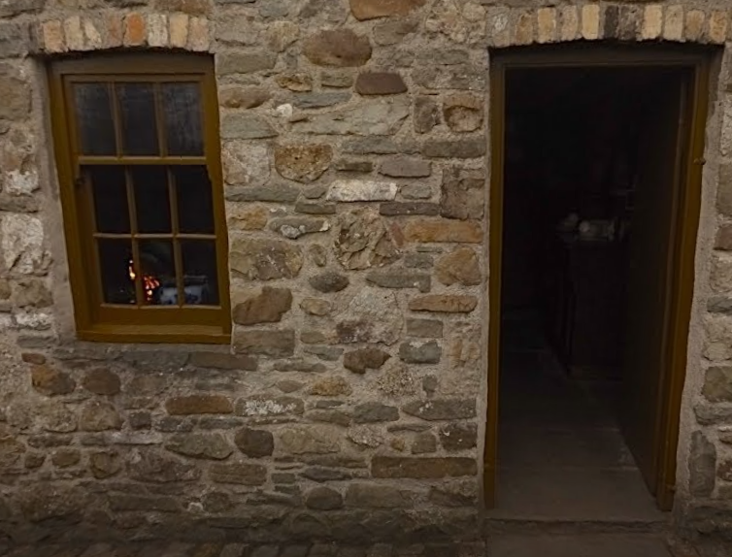
Traditionally, the openings for the doors and windows in these walls are created by introducing a brick arch, as this is a shape that can bare large amounts of load, however it was incredibly difficult to build arches on a larger scale in the 19th and 20th century, so these openings were kept to a minimal size. In the modern construction process, these brick arches have been replaced by lintels, which Cambridge Dictionary (2025) defines as “a long piece of stone or wood at the top of a door or window frame that supports the wall above”, which transfers the load around the opening and into the external wall material.
Figure 3: Brick arches used to create openings (Photo Credit: Google Art & Culture, 2019)

Internally, walls were constructed in one of a few different methods, such as solid brick walls with plaster finish, which creates a strong partition but at a high cost, or timber stud walls, which were either finished with lath and plaster or filled with lightweight brick and covered with plaster. In more modern houses, the most common internal walls consist of plasterboard sheets fixed to timber frame walls.

Foundations
The earlier houses of Rhyd-y-Car Terrace are unlikely to have any foundations, with the stone or brick typically being sat on the bare ground. The drawbacks to this are the walls having a greater exposure to damp, as the water can be drawn up through the material, as well as reduced loading capabilities as the material has nowhere to transfer this pressure. Over time, foundations were introduced in the forms of stones, extra courses of bricks, or more commonly in modern construction, concrete slabs. To help prevent the occurrence of damp, materials were added into the wall to stop the travel of moisture. Traditionally, this would be achieved by adding a layer of slate into the wall, with Skyes (2023) noting “Slate is a durable and long-lasting material that is resistant to water, making it an effective choice for a damp proof course”, however in modern construction a plastic sheeting known as Damp Proof Course (D.P.C) is used.

Wall Coverings
Wall coverings can be categorised as external or internal. Externally, the 1805 house features a limewash exterior. Cowland (2023) lists one of the benefits of a limewash finish as being a “…breathable finish, which means it allows the underlying surface to “breathe” by letting moisture evaporate.” The 1855, 1895 and 1925 houses do not feature any external coverings, opting for a natural finish to show off the materials of the wall, which held the burden of repelling moisture. This was also seen as a cheap, labour free finish. The 1955 and 1985 houses use a sand and cement render. Whilst this finish can provide an aesthetically pleasing product, Hlobil (2023) presents a drawback in that a “…sand and cement render can trap moisture within the structure, potentially leading to damp issues over time.”
The earlier houses (1805,1855 and 1895) all featured the same internal finish: a white, lime plaster. The first change comes in 1925 with the introduction of wallpaper, briefly replaced in 1955 with paint, before returning in 1985, alongside a kitchen featuring paint and tiles. Entwisle (1961) provides the benefits of wallpaper being cost effective and flexible in design.

Roofs & Roof Coverings
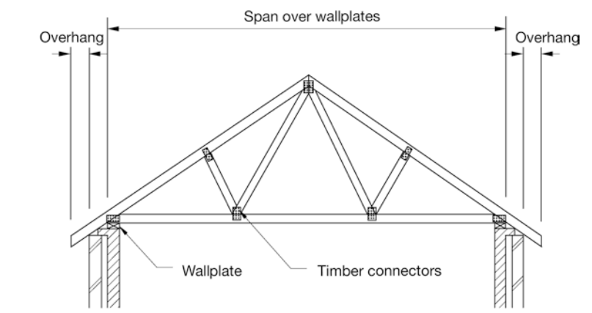
Roofs can be very easily split into two types: the more traditional hand cut roof and the modern trussed roof. A traditional roof is made up of angled timbers, known as rafters, connecting to a wall plate at the bottom and a ridge board at the top. Joists would be built into the walls and span the length of the room. Trussed roofs, the modern equivalent, were seen as an improvement over the traditional counterpart as they provided the same level of strength whilst using less material. Riley (2018) highlights some of the benefits of a trussed roof as being quicker to install and of higher quality due to their prefabrication.
Figure 4: The layout of a modern truss used in a roof (Photo Credit: Riley ,2018)
The roof covering for the 1855,1895 and 1925 houses are rough, stone tiles known as flags, fixed at angles to allow rainwater to run away from the house. Any gaps between the flags were often filled using moss. The downside to using this material was the extra load it placed on the top of the building. The choice of material does change for the 1955 house, which has a slate tile roof, utilising a material that would have been easily obtainable in South Wales at this time. Most modern houses, including the 1985 house, utilise concrete roof tiles, complete with channels to better aid in dispersing rainwater. Whilst concrete tiles are not as durable or aesthetic as slate, they are seen as a cheaper and more easily available option.

Floors
Watts and Tesh (2014) describes the make-up of a traditional ground floor as “stones, tiles, bricks and mosaics… laid directly onto the earth flooring or bedded on sand”. The construction of the floor was improved with the introduction of suspended floors, where the joists were built into the walls to slightly raise the floor, providing ventilation, and increasing the lifespan of the joists by preventing wet rot. A traditional floor would either be finished with large stone tiles, known as quarry tiles, or tongue and groove floorboards.
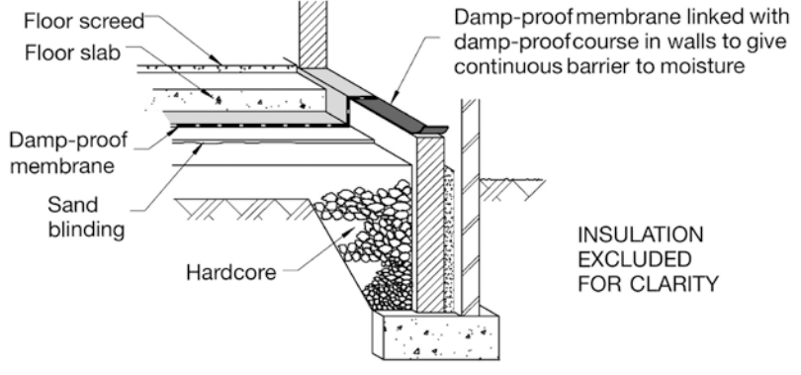
A modern floor features significantly more components, such as a hardcore base and insulation which retains the temperature within the house. Modern floors can also be built in a suspended fashion, with the floor joists being supported by metal hangers at the end and resting on small brick walls known as sleeper walls. The floors can be finished with a range of materials, from tongue and grove floorboards to lino flooring or tiles, due to the ease of materials and the ability to make larger sized components.
Figure 5: Make-up of a modern ground floor (Photo Credit: Riley, 2018)

Conclusion
The methods and materials used in the construction of a house has evolved significantly between traditional and modern houses, and this can be seen across the five houses of Rhyd Y Char terrace in St Fagans.
The more traditional and dated houses utilise a small number of materials, as the selection would depend on what materials were available in the local area, with more materials introduced as the houses become more modern due to the ease of availability of materials. The sizes of certain components like glass panes or floorboards have been able to grow as manufacturing techniques have improved.

References
Cadw (2019) Understanding Traditional (pre-1919) and Historic Buildings for Construction and Built Environment Courses | Cadw. Available at: https://cadw.gov.wales/learn/education/teaching-resources/understanding-traditional-pre-1919-and-historic-buildings (Accessed: 31 December 2025).
Cambridge Dictionary (2025) lintel. Available at: https://dictionary.cambridge.org/dictionary/english/lintel (Accessed: 31 December 2025).
Chudley, R. and Greeno, R. (2014) Building Construction Handbook. Abingdon, Oxon, UNITED KINGDOM: Taylor & Francis Group. Available at: http://ebookcentral.proquest.com/lib/trinity/detail.action?docID=1682274 (Accessed: 31 December 2025).
Cowland, A. (2023) ‘The Benefits Of Using A Lime Wash’, Old House Store, 3 July. Available at: https://oldhousestore.co.uk/product/traditional-lime-wash/ (Accessed: 31 December 2025).
Entwisle, E.A. (1961) ‘Wallpaper and Its History’, Journal of the Royal Society of Arts, 109(5058), pp. 450–467.
Google Arts & Culture (2019) Rhyd-y-car: Miner’s Homes Through Time, Google Arts & Culture. Available at: https://artsandculture.google.com/story/rhyd-y-car-miner’s-homes-through-time/GwWhwQqgrbN8mA (Accessed: 6 January 2026).
Hlobil, A. (2023) ‘Lime Render vs Sand and Cement Render’, EWI Pro, 22 November. Available at: https://ewipro.com/2023/11/22/lime-render-vs-sand-and-cement-render/ (Accessed: 31 December 2025).
Kercher, E. (2024) Brick vs Stone vs Concrete Masonry in Self Build Homes, THISTLE ARCHITECTURE. Available at: https://www.thistlearchitecture.co.uk/brick-vs-stone-vs-concrete-masonry-in-self-build-homes (Accessed: 31 December 2025).
Moores (2022) ‘A History of Glass Manufacturing | Moore’s Glassworks’, Moores Glass, 10 October. Available at: https://moores-glass.co.uk/the-evolution-of-glass-moulding-a-history-of-manufacturing-glass/ (Accessed: 31 December 2025).
Riley, M. (2018) Construction Technology 1. 4th ed. London: Macmillan Education UK.
Skyes, M. (2023) ‘The Various Types of Damp Proof Course – Rochester Building & Damp’, 22 January. Available at: https://www.rochesterbuildinganddamp.co.uk/2023/01/22/the-various-types-of-dpc/ (Accessed: 31 December 2025).
Watts, P. and Tesh, G. (2014) Traditional Solid Ground Floors. Available at: https://www.buildingconservation.com/articles/solid-ground-floors/solid-ground-floors.htm (Accessed: 31 December 2025).

Appendices

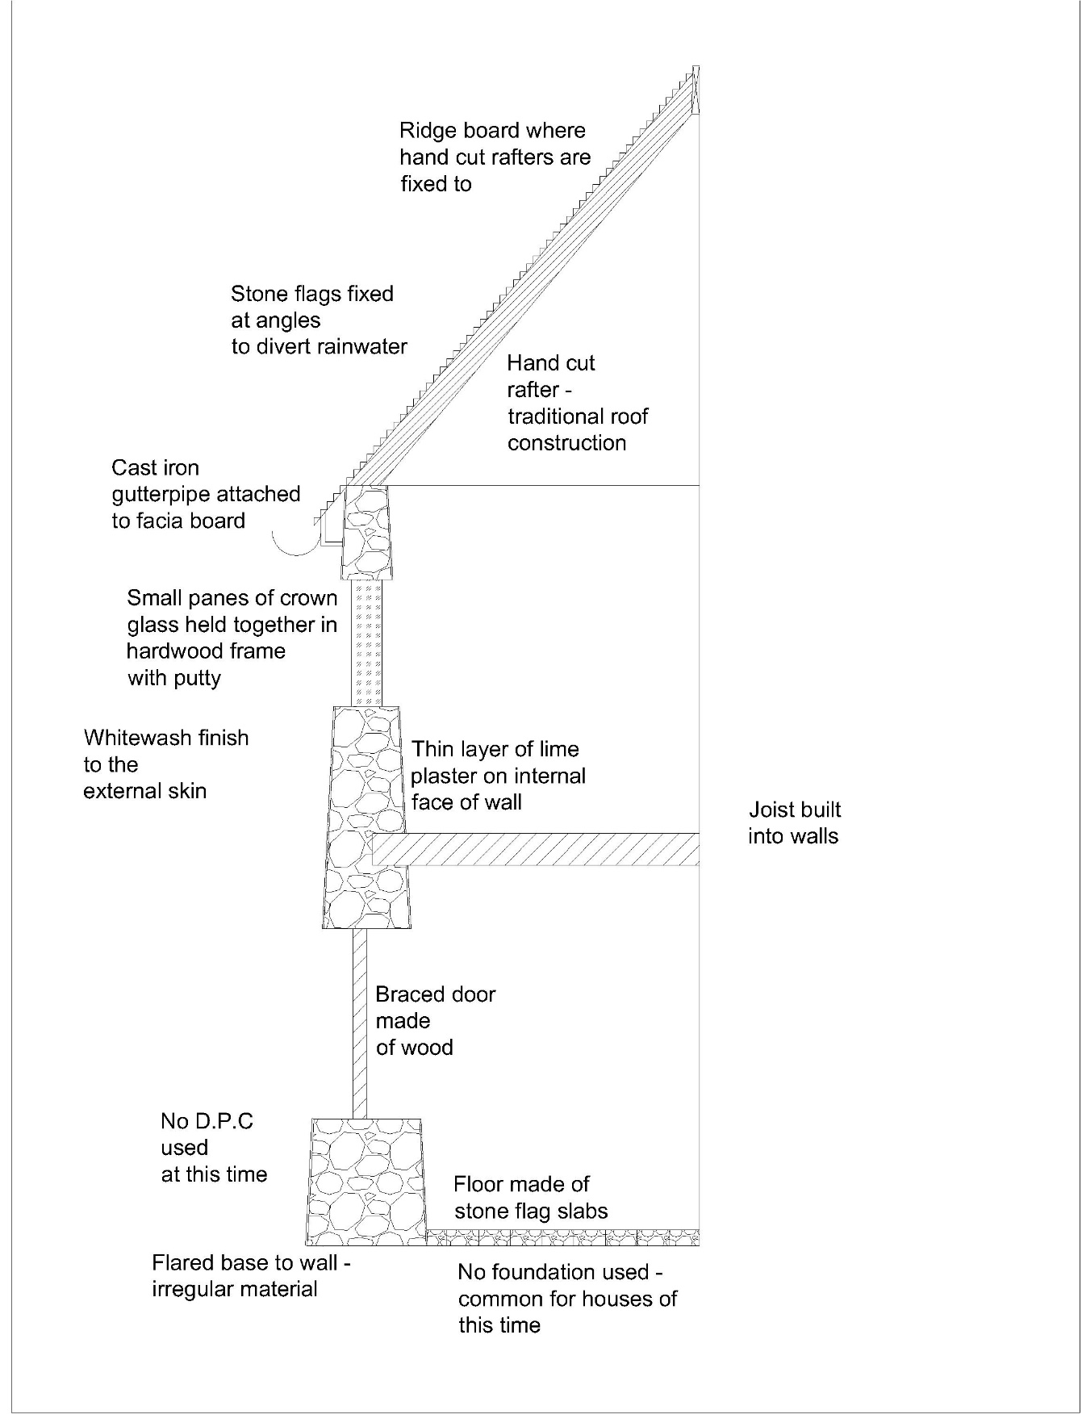
Appendix A – Pre 1919 Sketch

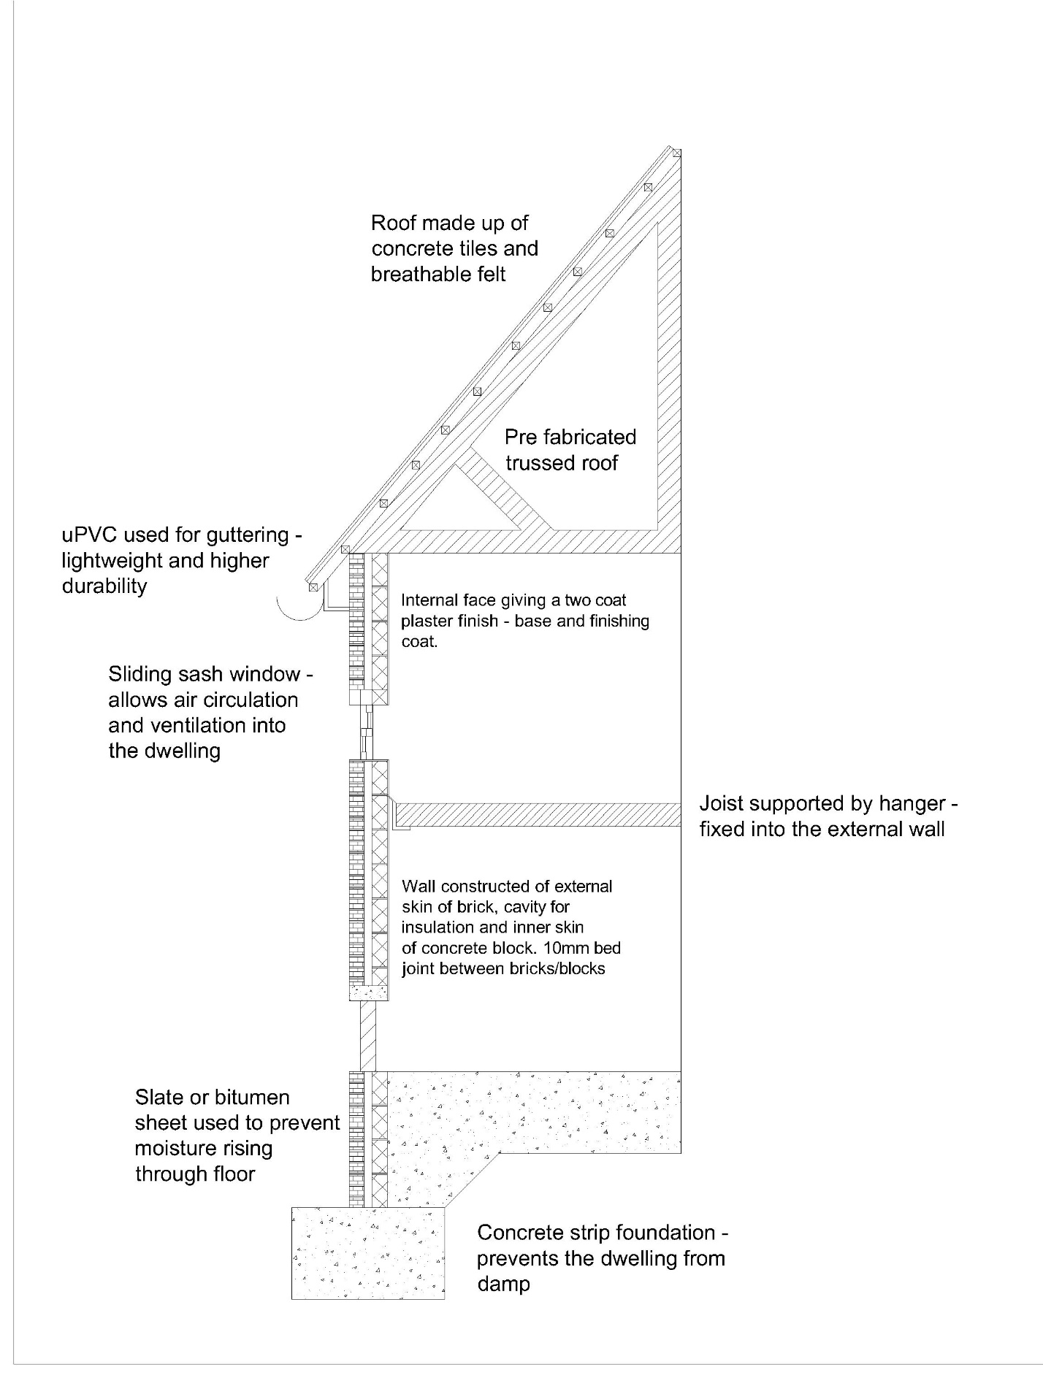
Appendix B – 1920’s sketch

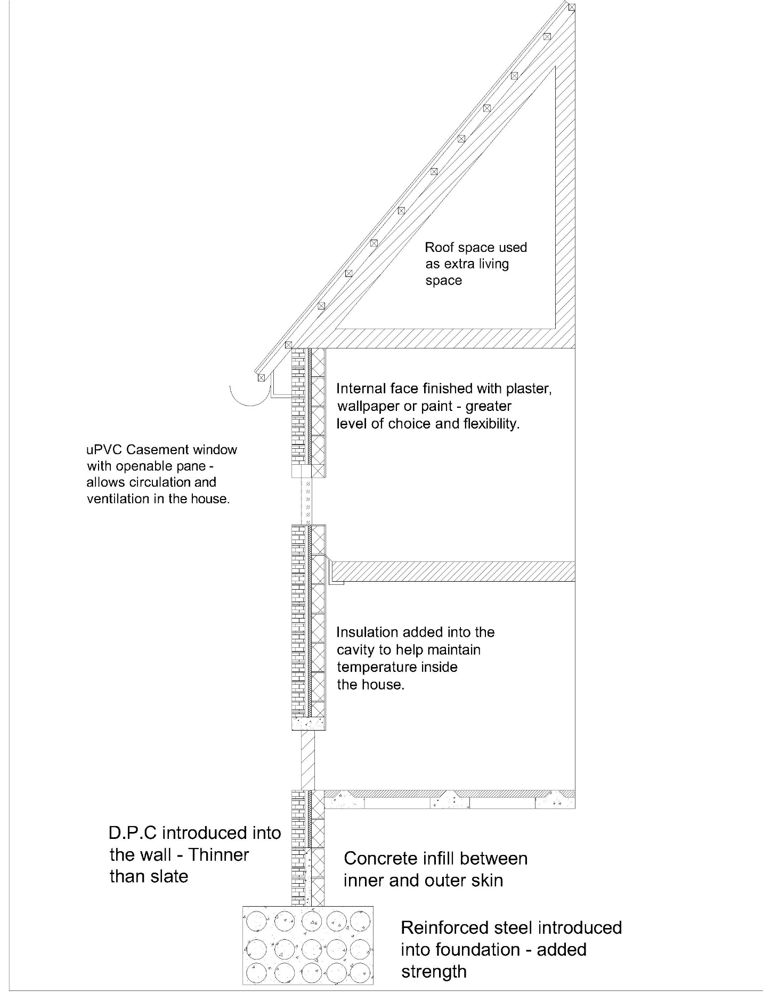
Appendix C – Post 2000’s Sketch

