CREATIVITY AND INNOVATION

NHS ENGLAND (REPORT)

Luciana Florea 2126969



TABLE OF CONTENTS
INTRODUCTION 3
Importance of Creativity and Innovation in health sector 3
Challenges facing health and care in NHS England 4
Diffusion of Innovation theory (DOI) 8
The familiar Linear Innovation Model 8
NHS Leadership 9
Why is creative problem solving (CPS) important for healthcare? 10
Componential Theory of Creativity 10
Intelligence threshold Theory 10
Wallas’ Four-Stage Model of the Creative Process 10
CONCLUSION 14
REFERENCES 14

INTRODUCTION
In this report I will refer to my current position as care assistant at NHS England in the infectious diseases sector. Creativity and innovation appeared when the organization faced problems, this organization had to evolve professionally and technologically. I will analyze the operations of the organization and how I do my job, but also the results from creativity and innovation. I will also present theories, concepts, techniques and models that have been put into practice to solve problems. The importance of creativity and innovation in an organization would be a very important role, which is why in this report I will present the concepts for the NHS organization. I will identify the barriers and risks we face, but also the leadership style.

Importance of Creativity and Innovation in health sector
Creativity thinking and acting means developing ideas, methods, and objects that are original and transcend traditional ways of thinking and acting. When you ask people to define creativity, they are stumped because they seem to have an inherent understanding of it. Innovation products and services are developed and marketed for adoption by customers in a systematic manner. It is not only about technological advancements but also about innovating business models, processes, organizational practices, and ways of solving problems. Taking calculated risks to achieve breakthrough results and drive progress is at the core of innovation. There are several factors that drive innovation, including curiosity, creativity, and a desire to improve. Since technology has advanced and we can find solutions to ease our work, it is very important that we come up with innovations and creativity in the health field.
Founded by the National Health Service (NHS) Act of 1946 and subsequent legislation, the National Health Service is a comprehensive public health service administered by the government in Great Britain. There are few minor charges for health care, and virtually all the population is covered. Individuals are provided with comprehensive healthcare services through the NHS based on their clinical need, not their ability to pay for health care. The NHS provides urgent and planned care in England through 209 providers. Essentially, there are three types of health care: primary, secondary, and tertiary. Healthcare professionals such as GPs, dentists, and pharmacists often provide primary care to people in need. There are various types of secondary care, including planned (elective) care such as cataract surgery, and urgent and emergency care such as fracture treatment. Neurosurgery, transplants, and secure mental health services are regarded as tertiary care.

Challenges facing health and care in NHS England
Changing health policy, funding constraints, and a shortage of healthcare workers make the NHS a complex and continually evolving system. As patients today are being treated holistically with a holistic understanding of their needs, innovation and creativity are becoming more important than ever. The best results for patients can be achieved by implementing innovative approaches throughout the product cycle. Innovation in research and development depends on challenging traditional thinking and structures. This mindset is being adopted by the industry, but further collaboration is needed to reduce the time it takes for a new drug to reach the market. It is our mission to deliver innovative products to patients more efficiently, since we are in possession of products that can make a difference. Health systems and NHS organizations must be able to innovate to remain competitive in the future, especially as resources are limited. The culture of highly innovative organizations can be distinguished by seven key dimensions. They can be used by leaders to assess and improve their organization's innovation culture. It is possible to greatly impact the culture of innovation with relatively simple changes in behavior and leadership processes. Cultures of organizations and systems are disproportionately influenced by leaders. Innovation is either hampered or aided by the behaviors of leaders.
Despite the fact that 59% of NHS organizations deemed innovation a priority, two-thirds of NHS staff said they weren't adequately supported to carry out innovation activities. In addition, one-third of respondents said they faced difficulties developing and implementing a culture of improvement. Our entire workforce needs to build and utilize their confidence, skills, wisdom, and experience to get the job done. Costs of public services tend to rise faster than those of other sectors when innovation is not present. As long as innovation is not implemented, cost containment pressures will only increase by forcing already overworked staff to work harder. Mulgan G. & Albury D. (2003). Arts, sports, and other leisure activities have long been an integral part of the quality of life in the communities we serve. Creative approaches are an integral part of our health care services as an NHS organization. Creative Minds is the name we have given to this work. Over the last few years, our Trust has recognized the importance of using creative approaches to improve health outcomes. Our service to individuals can be improved by using creative approaches. For people who use health services, creativity can lead to high quality outcomes. Staff-user relationships can be leveled by breaking down barriers between them and fostering engagement and involvement. We are committed to delivering our services with a creative approach, demonstrated by our creativity strategy, Creative Minds. Our good practice can be built upon, and we'll be able to encourage more collaboration with those who use our services and with our partners. Our communities and individuals possess a tremendous amount of creative potential, but it is largely untapped. We can restore a sense of community spirit through this work through the development, building, and use of social capital.
Many innovations have been implemented for the NHS over time. In this industry it is good to know as an assistant how I can help and support the idea of creativity and innovation. This report will identify an example of implementation that was brought by the organization and had maximum impact, but also my innovative solution that will benefit patients and the hospital. My experience as an assistant has encountered problems such as insufficient equipment. For example, for the infectious diseases sector, I met people with pressure sores (ulcers). For this problem, my innovative solution in terms of equipment that would greatly help patients and should not be missing from the hospital are pressure sores (ulcer) pillows.
The NHS system faced a number of technological challenges and they offer very good innovation. In order to help people more efficiently and quickly, an online platform was created. Health and care are being transformed by technology. As technology helps solve pressing health concerns around the world, it is helping to prevent illness, improve diagnostics, and provide better, kinder treatments. We're using technology to improve communication between health professionals and provide people with quick and easy access to care when they need it. In order to provide better care, we're working smarter to make it easier to get the health care and advice you need, from smart websites to apps that make it easy to get care anywhere, to connected computers that provide patients with test results, history, and evidence that they need to make better decisions.
Innovations applied by NHS
NHS APP
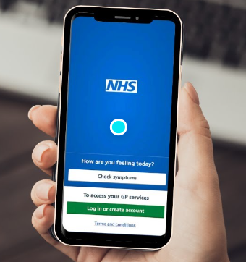

NHS App strategy: creating an ecosystem of digital services. In the NHS App strategy, we outline ways in which we can benefit others from the digital infrastructure on which the NHS App is built. It is an important part of our strategy to provide others with access to the digital infrastructure that supports the NHS App.
Rubber ball pillow innovation for pressure sores (ulcer)
During a pressure ulcer, the skin and underlying tissue are damaged. A pressure point on the skin causes them. Depending on the severity of the pressure ulcer, patches of discolored skin may appear, or open wounds may expose underlying bones and muscles. It is possible to develop pressure ulcers and sores from sitting for long periods of time. You can solve this problem with pressure pillows. Pressure care aids, such as these excellent products, are designed to distribute your body weight evenly so that all your weight is distributed equally. It is important not to put pressure on certain pressure points. Pillows are usually placed on existing chairs for use. Depending on your risk of developing pressure ulcers, you will need a different pressure pillow. Oftentimes, problems associated with pressure ulcers lead to serious complications and negatively affect the well-being of bedridden patients. One way to minimize pressure sore suffering is to use a rubber ball pillow, which protects pressure sores and improves patients' well-being. On the basis of Orem Theory and Jiraphaet's 13 steps of nursing innovation development, the conceptual framework of this study was developed. Health care delivery is associated with a number of potentially avoidable harms, including pressure ulcers. Over 24,674 patients1 developed pressure ulcers in the NHS in England between April 2015 and March 2016, with each day's treatment costing over £3.8 million. Hence, policy makers, managers, and practitioners must find ways to prevent pressure damage
The type of innovation identified is the radical type, and the way I identified was researching my organization that did not implement this innovation. For this innovation I applied habits. Why would this innovation be a solution? First of all, because it is a non-invasive method, which is why it should be implemented in the hospital. In my workplace, measures are taken against pressure ulcers and we have equipment, but some are painful and long-term. Which makes this pillow an easy method of recovery both at home and in the hospital without specialized intervention of the doctor. For example, during Covid-19 when there were not enough places in the hospital, these pillows should not be missing and come to the aid of people as help offered by the hospital. When I was offering help to people with pressure ulcers, I noticed that there are patients who are afraid of needles, doctors or nurses. They have a phobia of hospitals. Then I noticed that this innovation would be a solution especially for this type of patients. A member of my family suffered from pressure ulcers and that's when I searched the internet for ways to help him and saw this pillow. I experienced it and the results were very good with a very fast recovery. That's why we have seen that after experimenting with this fruit patients can make their lives easier. I shared this idea of a pressure ulcer pillow in an online meeting on the Zoom app with the executives and staff of the NHS hospital where I work, and they thought about the implementation process in the NHS hospital in the infectious diseases ward.
A VUCA situation represents a set of challenges faced by individuals, teams, managers, and organizations in affected industries. The challenges they present individually are significant, but when they are combined, they can be even more difficult. Volatile, uncertain, complex, and uncertain is what the acronym "VUCA" stands for. The VUCA world in which I live is that of volatility, uncertainty, complexity, and ambiguity, whether it is extremism and terrorism, or the ambiguity of social and political events such as #Brexit. It seems that NHS employees have been trying to operate within the wake of a sociopolitical hurricane for the past five years. Another VUCA world appears to have taken hold of people, often without their knowledge.

Diffusion of Innovation theory (DOI)
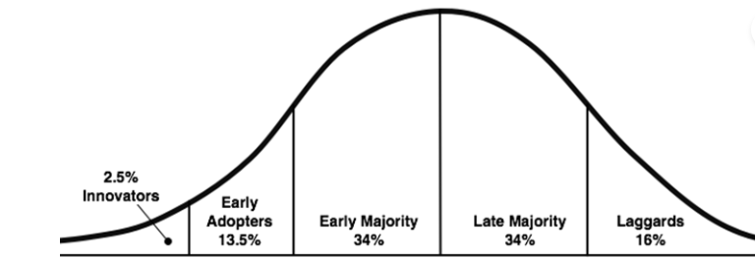

Rogers' Everett (1995) Diffusion of Innovation Theory explains user's adoption of new technology using a model developed by Rogers. It is defined by Rogers Everett (1995) that diffusion refers to the process of communicating innovations through particular channels among members of a society over time. A new idea or object is an innovation (Rogers Everett, 1995). Observability, trial-ability, complexity, and compatibility are all factors that affect the diffusion rate. Innovations are considered to be superior to their predecessors when they have a relative advantage. An innovation's compatibility can be assessed by how well it aligns with values, beliefs and needs of prospective adopters (Rogers Everett, 1995).

The familiar Linear Innovation Model
In a paper by Benoit Godin (Godin, 2005), the linear innovation model is presented in a historical perspective. However, he offers an early reference from 1945 as an initial indication of the source. Following are the steps that summarize the model: A research project is divided into five phases: basic research, applied research, development, and diffusion. He also suggests how this model has evolved over time using a time-based taxonomy. As a result of its emphasis on scientific advancement over contributions from later players, The Linear model is subject to a number of criticisms. Its simplicity is partly responsible for its continued use, despite much opposition. In addition, the lack of statistics for other innovation framework options may delay changes to other models based on the linear model.
For the model and theory in the above context we applied a new innovation (idea) and the process of communication through certain channels in between members. This linear innovation was applied by researching the problem and offering solutions.

NHS Leadership
Leadership is the role of all healthcare professionals.
All healthcare professionals within a healthcare organization have a role to play in leadership, not just those in formal senior positions. Leaders are now recognized as part of a team and leadership is more interactive than traditional hierarchical processes. Healthcare organizations and their engagement in innovation and entrepreneurship are significantly affected by leadership style and practices. The NHS has developed several models of leadership as a result of its wide acceptance of leadership's importance and value. A brief description of each element follows:
• Framework for Clinical Leadership Competencies
• Healthcare Leadership Model of the NHS Leadership Academy.
According to Dyer, Gregersen, and Christensen (2011), virtually everyone is capable of creative thinking. It is imperative that workers in the healthcare industry use their creativity to come up with new ways to deliver quality services and simultaneously reduce the enormous waste that occurs in the healthcare system. In order to figure out what is going wrong, the leader needs to listen to followers and customers, and then figure out how to fix the problems together.
In situations where conventional thinking has failed, creative problem solving (CPS) can be used to solve problems or identify opportunities. In order to overcome obstacles and reach your goals, you are encouraged to find fresh perspectives and come up with innovative solutions.

Why is creative problem solving (CPS) important for healthcare?
There are many challenges facing the healthcare industry, including rising costs, changing demands, limited resources, and ethical dilemmas. Health care professionals need creative thinking and problem-solving skills in order to deal with these challenges. By providing a flexible and structured framework that is adaptive to different contexts and scenarios, CPS can help them accomplish this. Different stakeholders may have different perspectives and needs, so CPS can encourage collaboration and communication among all of them.

Componential Theory of Creativity
Creative work can only be produced by individuals who have the social and psychological components that make up the componential theory of creativity. According to the theory, creativity means producing both novel and appropriate ideas or outcomes.

Intelligence threshold Theory
From the study of individual traits, Torrance (1962) concludes that intelligence is necessary but not sufficient for creativity. It is believed that creativity emerges at a certain level of intelligence. It has been found, however, that IQ do not correlate positively above a certain level, usually 120.

Wallas’ Four-Stage Model of the Creative Process
Despite holding sway as a conceptual anchor for many creativity researchers, Graham Wallas' four-stage creative process model (Preparation, Incubation, Illumination, Verification) does not accurately reflect Wallas' full account of creative processes, according to a detailed read of Art of Thought (1926).
In the NHS organization where I work as a care assistant, I used the above theories and model to apply creative work. I applied creative work in a team together with my colleagues, bringing new ideas in difficult moments. The creativity process applied to identify possible solutions are as follows: creating a survey for patients to discover the need to implement these ball pillows for pressure ulcers and the second process of creativity applied was raising funds to offer these pillows free of charge to needy people who are in difficulty and have medical care at home. The last creative process was analyzing interviews with 150 hospital team members involved in the collaboration, focusing on work processes or outcomes that participants identified as creative or promoting creativity. We sought to identify recurring patterns in all cases of creativity in problem solving. The survey created was for all NHS patients. These forms were sent to patients via home letter, email or text message. The survey was a simple one based on six simple questions to discover the need and implementation of pillows for pressure ulcers. For the fundraising process we created several groups of volunteers who were present in large stores (e.g. Tesco), shopping centers, large offices, and in city centers where there is a large population. My goal is to raise a significant amount to create a stock of pillows that will save patients' lives.
Implementation of pillows for pressure ulcers survey

- Gender
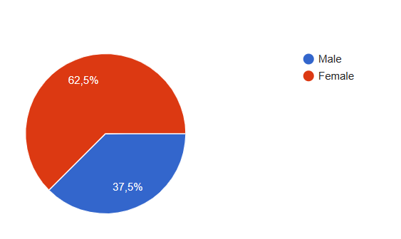

- Age
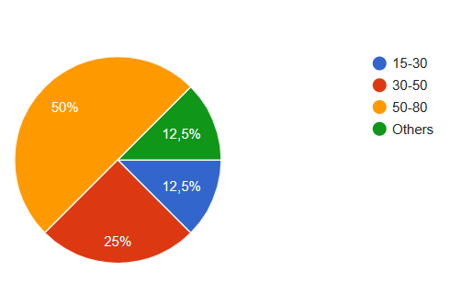
- Did you have pressure ulcers?
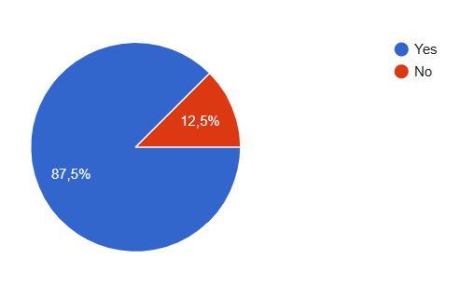
- What do you think is the cause of pressure ulcers?
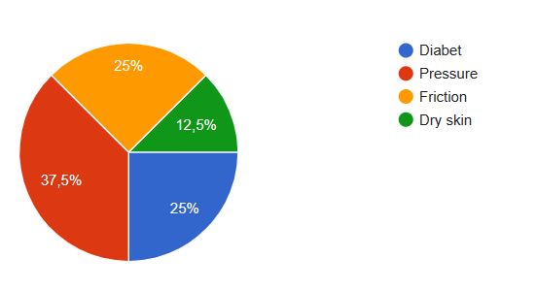
- If you had this disease, what were you treated with?
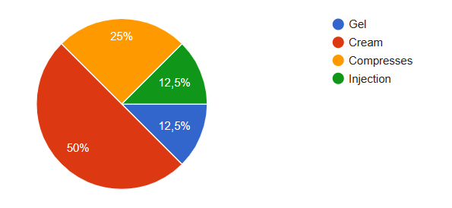
- Do you think implementing ball pillows in NHS hospitals would help patients?

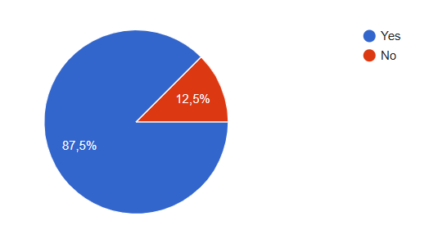

The survey found that 37.5% of women aged 50-80 had pressure ulcers and 87.5% had used wound healing creams and 87.5% believe that implementing pillows will be a solution for NHS patients. My job offers a lot of involvement and devotion to patients. Any job requires creativity and innovation and the NHS hospital is ready to find new solutions and ideas to help our patients.
Although creativity plays a critical role in solving problems, a relatively small number of studies have looked at how workers apply creativity to problem-solving in health care and other areas. In the past, most creative problem-solving research has been theoretical with some empirical research coming from industries such as new product development where novelty is an explicit goal. Also, such research emphasizes creative outcomes without taking into account how creativity is incorporated as part of organizational culture. An NHS hospital's problem-solving creativity typically resulted from gathering new and diverse information.
All face multiple barriers affecting their access to healthcare such as poor living and working conditions lack of a permanent address, language difficulties, isolation, uncertain immigration status, exploitation, hunger and poverty and. The difficulty of accessing health and wellness services, as well as the lack of time, were also reported as barriers to employee engagement. As a result of financial incentives, a supportive organizational structure, and a culture that prioritizes staff health and wellbeing, initiation of services was facilitated. An effective communication and advertisement approach, creativity and innovation with resources, as well as conducting needs analyses and evaluations before, during and after implementing health and wellbeing services are factors that facilitate the implementation of health and wellbeing services.

CONCLUSION
In conclusion, throughout my experience in the NHS team, I can say that barriers are not overcome. My passion for this profession made me discover the innovation and creativity presented in the report. To implement the idea of a pressure ulcer pillow, I used the six-question questionnaire for NHS staff that will certainly benefit people with this disease. Creativity and creative people are found in every organization. Creative thinking is a way of discovering weaknesses or gaps in current knowledge by using one's imagination. A creative individual has the ability to think beyond what people usually connect with. It is essential that healthcare providers engage in innovative processes and display creativity in the delivery system. Innovating is about envisioning a new idea and implementing it. Individuals in the organization usually work together to achieve this. Creative ideas can originate anywhere within an organization, which is the starting point for innovation. An improved product or service is typically the result of innovation. Pressure sores can be reduced for bedridden patients by using the rubber ball pillow innovation. The best way to prevent pressure ulcers is to use this innovation in conjunction with the traditional method of turning the patient every 2 hours to give the best benefits. Numerous barriers prevent health and wellbeing services being successfully introduced and implemented in the NHS, ranging from operational challenges to strategic or financial constraints at the highest levels.

REFERENCES

Brewster, A.L., Lee, Y.S.H., Linnander, E.L. and Curry, L.A. (2021). Creativity in problem solving to improve complex health outcomes: Insights from hospitals seeking to improve cardiovascular care. Learning Health Systems, 6(2). doi:https://doi.org/10.1002/lrh2.10283.
Britannica (2013). National Health Service | British agency. In: Encyclopædia Britannica. [online] Available at: https://www.britannica.com/topic/National-Health-Service.
Doctors of the world UK (2015). ACCESS TO HEALTHCARE IN THE UK. [online] Available at: https://mdmeuroblog.files.wordpress.com/2016/02/leaflet_access-to-healthcare_mdmuk_bd_pages.pdf.
ElgarBlog from Edward Elgar Publishing. (2022). Transforming Healthcare Through Innovation and Entrepreneurship. [online] Available at: https://elgar.blog/2022/01/18/transforming-healthcare-through-innovation-and-entrepreneurship/.
Healthcare Pro. (n.d.). Pressure Relief Cushion | Cushion For Chairs - NRS Healthcare Pro. [online] Available at: https://www.healthcarepro.co.uk/bedroom-seating-aids/pressure-relief-care/pressure-cushions.
Jain, N. (2023). What is Innovation? Definition, Types, Examples and Process. [online] IdeaScale. Available at: https://ideascale.com/blog/what-is-innovation/.
LaMorte, W. (2022). Diffusion of Innovation Theory. [online] Boston University School of Public Health. Available at: https://sphweb.bumc.bu.edu/otlt/MPH-Modules/SB/BehavioralChangeTheories/BehavioralChangeTheories4.html.
Luque, A.M.A. (2021). Theories of creativity and classic explanatory models. [online] Neuroscience of creativity and innovation. Available at: https://anamariaaguilera.com/creativity-theories/.
Maher, L., Plsek, P. and Price, J. (2010). Culture for Innovation A Practical Guide for Leaders Mark Mugglestone. [online] Available at: https://www.england.nhs.uk/improvement-hub/wp-content/uploads/sites/44/2017/11/Creating-the-Culture-for-Innovation-Practical-Guide-for-Leaders.pdf.
McKinsey (2022). What is innovation? | McKinsey. [online] www.mckinsey.com. Available at: https://www.mckinsey.com/featured-insights/mckinsey-explainers/what-is-innovation.
Mind Tools Content Team (2023). MindTools | Home. [online] www.mindtools.com. Available at: https://www.mindtools.com/a2j08rt/creative-problem-solving.
Morr, K. (2018). What is creativity? The ultimate guide to understanding today’s most important ability. [online] 99designs. Available at: https://99designs.com/blog/creative-thinking/what-is-creativity/.
Muntanavadee Maytapattana, Napissara Dhiranathara, Piyanun Phoythong, Niracha Kumwarat, Jinjuta Chobtodklang, Thunchanock Kongmark, Wasinee Ritthidet and Sorrawich Kongcharoen (2022). Journal of Nursing Science and Health, [online] 45(1), pp.61–74. Available at: https://he01.tci-thaijo.org/index.php/nah/article/view/250594 [Accessed 12 Mar. 2024].
NHS Providers (2015). The NHS provider sector. [online] NHS Providers. Available at: https://nhsproviders.org/topics/delivery-and-performance/the-nhs-provider-sector.
NHS England (2018). Leadership Development. [online] NHS England, p.5. Available at: https://www.england.nhs.uk/wp-content/uploads/2018/03/leadership-development.pdf.
NHS Improvement (2018). Pressure Ulcers: Revised Definition and Measurement Summary and Recommendations. [online] NHS England. Available at: https://www.england.nhs.uk/wp-content/uploads/2021/09/NSTPP-summary-recommendations.pdf.
NHS England (2019). Digital transformation. [online] England.nhs.uk. Available at: https://www.england.nhs.uk/digitaltechnology/.
NHS (2021). About the NHS App. [online] nhs.uk. Available at: https://www.nhs.uk/nhs-app/about-the-nhs-app/.
Noone, C. (2023). Why creativity, innovation, and disruption can improve healthcare outcomes. [online] COUCH Health. Available at: https://couchhealth.agency/why-creativity-innovation-and-disruption-can-improve-healthcare-outcomes/ [Accessed 12 Mar. 2024].
Optima-life (2018). NHS Staff - Who’s caring for you? Working in the VUCA world of the 21st Century. [online] Optima-life. Available at: https://optima-life.com/nhs-staff-whos-caring-for-you-working-in-the-vuca-world-of-the-21st-century/ [Accessed 12 Mar. 2024].
Plan, N.L.T. (2019). Research and innovation to drive future outcomes improvement. [online] NHS Long Term Plan. Available at: https://www.longtermplan.nhs.uk/online-version/chapter-3-further-progress-on-care-quality-and-outcomes/better-care-for-major-health-conditions/research-and-innovation-to-drive-future-outcomes-improvement/.
Quirk, H., Crank, H., Carter, A., Leahy, H. and Copeland, R.J. (2018). Barriers and facilitators to implementing workplace health and wellbeing services in the NHS from the perspective of senior leaders and wellbeing practitioners: a qualitative study. BMC Public Health, [online] 18(1). doi:https://doi.org/10.1186/s12889-018-6283-y.
Sciencedirect.com. (2015). Innovation Theory - an overview | ScienceDirect Topics. [online] Available at: https://www.sciencedirect.com/topics/computer-science/innovation-theory.
TALMAGE-ROSTRON, MARK. “Importance of Creativity & Innovation in Entrepreneurship 2024.” Www.nexford.edu, 12 Mar. 2024, www.nexford.edu/insights/creativity-innovation-in-entrepreneurship. Accessed 12 Mar. 2024.
The Medic Portal (2019). Challenges Facing The NHS - The Medic Portal. [online] The Medic Portal. Available at: https://www.themedicportal.com/application-guide/the-nhs/challenges-facing-the-nhs/.
www.nhsinform.scot. (2023). Pressure ulcers symptoms and treatments. [online] Available at: https://www.nhsinform.scot/illnesses-and-conditions/skin-hair-and-nails/pressure-ulcers/.
www.decision-making-solutions.com. (n.d.). Innovation Model. [online] Available at: https://www.decision-making-solutions.com/innovation-model.html.
www.linkedin.com. (n.d.). How can Creative Problem Solving improve healthcare? [online] Available at: https://www.linkedin.com/advice/3/how-can-creative-problem-solving-improve.
Yorkshire Partenership, South West . Creative Minds. Oct. 2011, www.southwestyorkshire.nhs.uk/wp-content/uploads/2018/03/Creative-Minds-magazine-issue-one-2011.pdf. Accessed 12 Mar. 2024.

