Title: Innovative Solutions to Operational Challenges at BP: A Critical Analysis and Proposal

Student name: Sandra Gorolova
Date: 11.03.2025

Table of Contents
Executive Summary 3
1. Introduction 4
1.1 Overview of BP 4
1.2 Description of Your Role within BP 4
1.3 Context and Purpose 5
2. Critical Analysis of the Importance of Creativity and Innovation to BP 5
2.1 Creativity vs. Innovation 5
2.2 Importance to the Sector 6
2.3 Examples from BP 6
2.4 Industry trends 7
3. The 4 P’s of Innovation and BP’s Proposed Idea 8
3.1 The 4 P’s of Innovation 8
3.2 Identify Your Idea: BP’s Innovative Approach 9
3.3 Rationale: Why the Idea Fits into the Selected Categories 10
4. The Creativity Process Applied to Develop the Idea 10
4.1 Creative Thinking Framework: SCAMPER Technique 10
4.2 Application to BP 12
4.3 Innovative Ideas Generation 12
5.2 Balance of Forces 15
6. Critical Discussion on BP’s Climate for Innovation 15
6.1 Organisational Climate for Innovation 15
6.2 Management’s Likelihood of Implementation 15
6.3 Barriers to Innovation at BP 16
6.4 Strategic Alignment 16
7. Main Findings 16
7.1 Key Insights from the Report 16
7.2 Innovation Model Application 17
7.3 Idea Viability 17
8. Conclusion 17
8.1 Summary of Key Points 17
8.2 Final Evaluation 17
8.3 Strategic Recommendation 17
9. References 18

Executive Summary
British Petroleum (BP) is a thriving global energy provider known for its environmentally friendly power. Customers throughout the globe receive oil, gas, and renewable energy services from this organisation. BP has a hard time incorporating creative innovation into its goals of operational excellence and long-term sustainability. The company has these challenges. We are committed to improving operating efficiency, being environmentally conscious, and staying up to date with the ever-changing energy market. Inefficient logistics management is BP's biggest problem. Because of this inefficiency, the company's worldwide supply chain has a harder time coordinating the delivery of raw materials and processed products. The inefficiency of resource allocation, the absence of real-time tracking, and the failure to integrate technology improvements all hinder BP's capacity to optimise its operations. This leads to higher costs and lost opportunities.
An AI-powered logistics optimisation tool is suggested as a solution to this problem in this study. Utilising machine learning, real-time data, and predictive analytics, this system maximises operational transparency, delivery delays, and effective allocation of resources. This approach is in line with BP's objective of enhancing operational efficiency and sustainability. The report's key conclusions include the significance of innovation models such as the four P's, the creative process involved in devising the solution, and the use of Lewin's Force Field Analysis to evaluate the feasibility of BP's organisational structure for executing this proposal.

1. Introduction

1.1 Overview of BP
Oil behemoth British Petroleum (BP) operates on a worldwide scale. Oil and gas, green power, and carbon-neutral products are all part of its varied inventory. Since its founding in 1908, BP has expanded to more than 70 countries, becoming a significant participant in the global energy market. Beyond the exploration, production, processing, and sale of oil and natural gas, the firm also develops wind, solar, and biofuels. The business has a wide range of activities. Sustainable energy technologies and net-zero emissions will be the focal points of BP's energy industry diversification efforts (Smit and Powell, 2023). With the global shift towards greener, more sustainable energy, we are making this commitment.
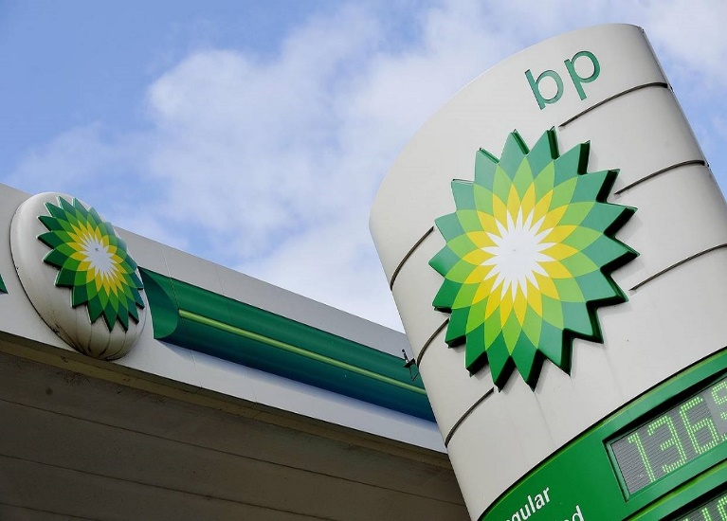
Figure 1: British Petroleum (BP)

1.2 Description of Your Role within BP
While I was an Operations Manager at BP, I was in charge of the supply chain, making sure resources were distributed evenly, and making sure logistics projects were a success. Resource allocation was also under my purview in this position. To improve General Electric's logistical performance and incorporate innovative ideas, your position required you to cooperate with the procurement, distribution, and technology divisions. I worked with senior management to assess BP's processes and find ways to improve them. In this role, I assisted the company in achieving its goals for operational and environmental efficiency.

1.3 Context and Purpose
Several of BP's operational issues stem from inefficient logistical management. Because of this inefficiency, it is difficult to coordinate the transportation of raw materials and completed commodities throughout its worldwide network. When it comes to allocating resources, making decisions, and measuring progress in real time, BP isn't up to speed. This impacts on the operational efficiency and cost-effectiveness of the company. To tackle these difficulties, this article suggests innovative alternatives such as logistics systems powered by AI. BP is banking on this study to help it find innovative ways to achieve its sustainability and growth targets in the long run.

2. Critical Analysis of the Importance of Creativity and Innovation to BP

2.1 Creativity vs. Innovation
We frequently use creativity and innovation interchangeably, yet they are different principles that help companies like BP succeed. Creativity is the invention of new methods or solutions. It is the capacity to think creatively, explore new options, and conceive alternate solutions (Sternberg, 2021). However, innovation is turning creative ideas into actual results. Creative ideas are the basis for innovation, but innovation is turning them into real-world goods, processes, or systems. BP needs creativity and innovation to grow. BP's inventiveness helps it foresee issues and find improvements in the fast-changing energy business. Innovation helps BP compete by translating ideas into profitable products and operations.
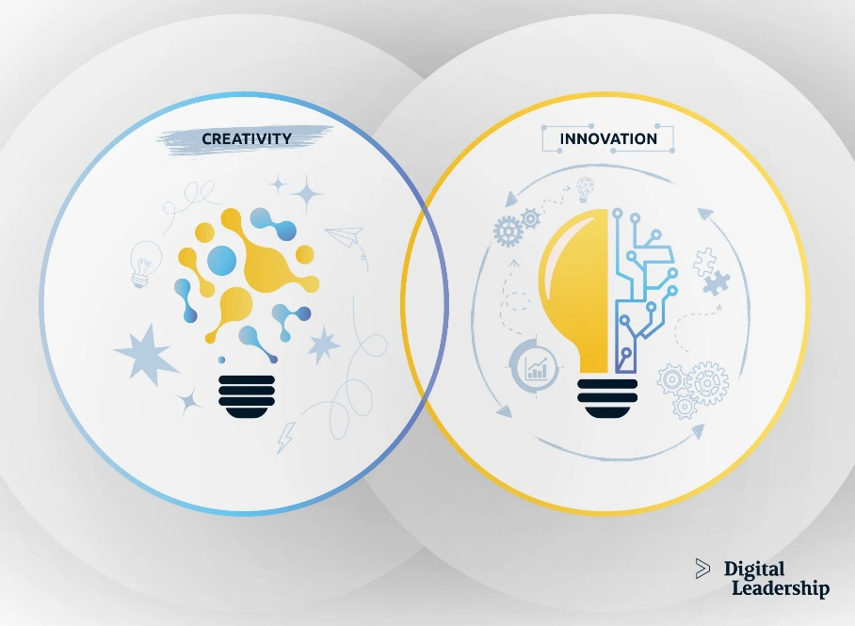
Figure 2: Relationship b/w Creativity and Innovation
BP must encourage employee creativity and innovation in its processes, products, and business models to sustain its energy sector leadership. Henry Chesbrough's Open Innovation Theory helps explain BP's creative and inventive initiatives. The framework advises organisations to use partnerships, collaborations, and new technology to innovate. To incorporate external developments, BP works with technology firms, universities, and other industry participants. BP can speed up innovation and respond to industry changes by integrating external knowledge and internal ingenuity (Eltweri et al., 2024).

2.2 Importance to the Sector
Complex, resource-intensive operations and expanding sustainability expectations in BP's industry require creativity and innovation to optimise operations. Oil and gas companies are under pressure to enhance efficiency and reduce environmental impact. BP uses creativity and innovation to rethink existing methods and apply more efficient, sustainable practices (Onukwulu et al., 2023). Modern technologies like AI, machine learning, and automation have improved BP's production, supply chain management, and cost reduction. In an industry that prioritises environmental sustainability, innovative resource management and process optimisation are essential. BP stays competitive by adopting new methods that boost operational efficiency and support global environmental goals. BP needs creativity and innovation to fulfil rising energy demand sustainably and meet its environmental stewardship goals.

2.3 Examples from BP
BP has shown how innovation can keep it competitive and grow. Key examples are the company's switch to renewable energy and low-carbon technology. BP declared its 2050 net-zero carbon goal in 2020. In "BP's Net Zero Strategy," the company invests in wind, solar, and biofuels to reduce its carbon footprint. BP used creativity and innovation to meet industrial demands for a cleaner energy mix with this transition towards a more sustainable energy future. For instance, BP uses digital technology to boost operational efficiency (Li et al., 2023).
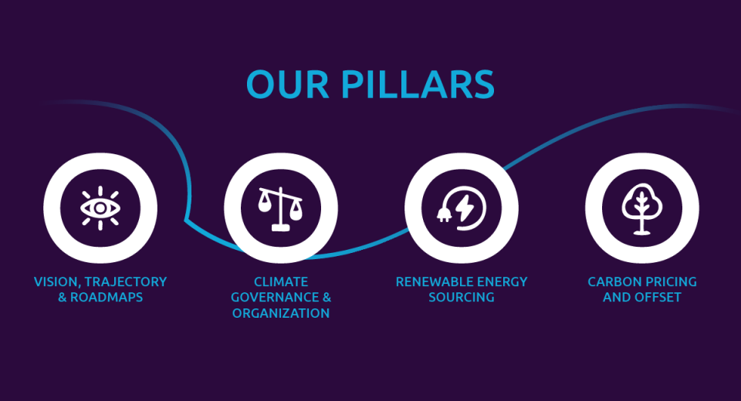
Figure 3: Solutions to Reach Net-Zero Strategy
BP aggressively invests in AI and data analytics to optimise exploration and production. AI-monitored predictive maintenance systems reduce downtime and improve operational efficiency by monitoring equipment health and predicting faults. This mix of creative problem-solving and cutting-edge technology has helped BP decrease costs and boost production, showing how creativity and innovation can enhance operations.

2.4 Industry trends
Technological and social changes are transforming the energy sector. This shift is driven by sustainability and digital transformation. As governments and consumers reduce carbon emissions, green energy demand is rising quickly (Kabeyi and Olanrewaju, 2022). BP may invest in and develop new renewable technologies like offshore wind and solar to meet its environmental goals. Another important development is energy sector digitisation. IoT, big data, and blockchain are transforming supply chain management, data collecting, and decision-making at BP, which operates in a digital-first environment. BP can respond faster to market developments, enhance operational efficiency, and build more resilient, real-time systems by using these technologies creatively. The energy transformation requires BP to innovate its exploration, extraction, and production technologies (Li et al., 2022). As oil and gas resources grow harder to acquire and environmental concerns mount, BP must find new ways to extract and manage them. This requires rethinking drilling and waste management, emphasising creativity and innovation.

3. The 4 P’s of Innovation and BP’s Proposed Idea

3.1 The 4 P’s of Innovation
Tidd and Bessant's (2018) 4 P's of Innovation approach includes Product, Process, Position, and Paradigm. These four topics show how organisations might innovate to compete and meet market expectations. Each of the 4 Ps is briefly explained:
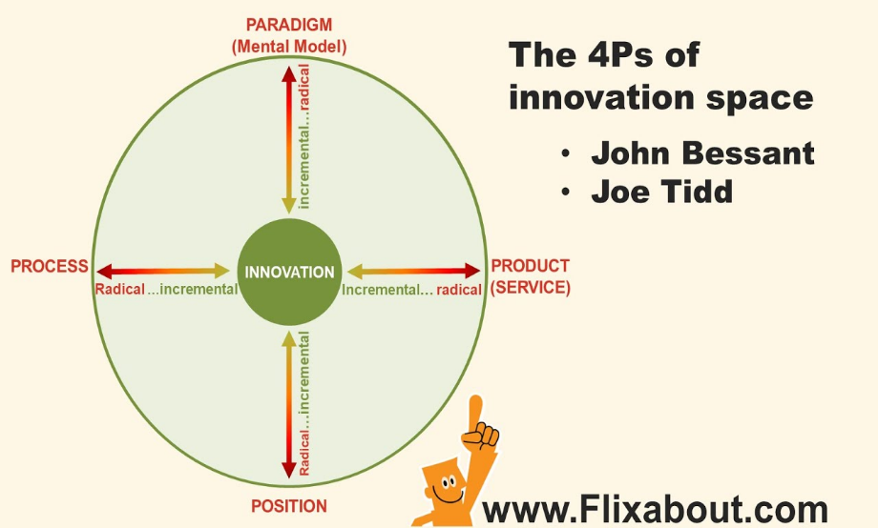
Figure 4: The 4P's of Innovation Space

Product Innovation refers to the introduction of new or significantly improved goods or services. This may involve creating new products or improving current ones to meet customer needs (Suherlan and Okombo, 2023).
Process Innovation simplifies internal procedures to boost efficiency, cost, and quality. Innovation that improves processes is common.
Position Innovation changes a company's market or industry position. Examples: targeting new customer segments, repositioning items, or entering new markets.
Paradigm Innovation may alter a company's strategy, business model, or values. How a company performs or provides value to customers might affect industry norms or markets (Wang et al., 2022).

3.2 Identify Your Idea: BP’s Innovative Approach
Use the 4Ps to understand this BP innovation. By developing offshore wind farms and solar energy, BP hopes to become a net-zero carbon company by 2050. BP hopes to lead the sustainable energy revolution by reducing its fossil fuel consumption and carbon footprint. The BP innovation strategy promotes global sustainability and energy transition. The innovation concept can be classified primarily under Product Innovation and Paradigm Innovation, though there are elements of Process and Position Innovation as well (Houtgraaf et al., 2023).
- Product Innovation: New Renewable Energy Solutions
BP substantially funds offshore wind, solar, and biofuel technologies. Renewable energy products are Product Innovations since they are new to BP's oil and gas strategy. The company is creating new energy solutions to meet global clean energy and sustainability goals (Jaiswal et al., 2022). BP will diversify its income streams and reduce its vulnerability to fossil fuel market volatility by scaling renewable energy products. Renewable energy like offshore wind farms can revolutionise BP's products. These novel technologies address global climate change and meet customer demand for cleaner energy.
- Process Innovation: Enhancing Operational Efficiency
BP must innovate to produce and manage renewable energy. Designing and building offshore wind farms, integrating AI for predictive maintenance, and improving energy storage systems require process improvements (Masoumi, 2023). AI can improve energy distribution and renewable energy supply chain efficiency for BP. BP requires these process improvements to boost renewable energy services without compromising efficiency or profit. BP's operational strategy demands process improvement to compete, minimise costs, and boost renewable energy.
- Position Innovation: Redefining Market Position
BP uses Position Innovation to focus on renewables. Oil and gas giant BP are leading the global energy transition. The company may now sell renewable energy to governments, sustainability-focused businesses, and environmentally conscious consumers (Arslan et al., 2021). The new market positioning portrays BP as a forward-thinking, environmentally responsible energy provider. By going low-carbon, BP is separating itself from fossil fuel companies. This strategic repositioning lets BP penetrate burgeoning renewable energy markets, especially those investing substantially in clean energy infrastructure.
- Paradigm Innovation: Shifting Business Model and Strategy
Paradigm Innovation is crucial to BP's strategy. BP is becoming a sustainable, renewable energy-focused integrated energy firm. BP must rethink its values and structure to make this change (Tang and Huang, 2024). This paradigm shift reimagines BP's value to customers, shareholders, and society. BP must also reframe its role in the global energy transition and set ambitious carbon reduction and sustainable growth goals. BP's sustainable strategy meets market demand and drives the energy sector.

3.3 Rationale: Why the Idea Fits into the Selected Categories
Innovation produces new energy solutions and modifies BP's business strategy, therefore it suits Product and Paradigm Innovation. The company's offshore wind and solar investments demonstrate energy diversity. Changes to BP's operations and customer value have resulted from its net-zero carbon target. BP's innovation strategy follows industry developments and positions it as an energy leader. Meeting global environmental goals and economic demand for renewable energy is a bold, strategic move.
Relevant Model
BP's innovation may be analysed using Business Model Canvas. BP is revamping its business model to incorporate sustainable energy goods and services by focusing on value proposition, client segmentation, and income sources. As BP restructures its business strategy and incorporates sustainability, Paradigm Innovation supports this approach. BP innovates new energy products and restructures its business model to meet environmental goals, aligning with Product and Paradigm Innovation (Alkaraan et al., 2024). These solutions help BP confront the energy shift and become a forward-thinking energy leader.

4. The Creativity Process Applied to Develop the Idea

4.1 Creative Thinking Framework: SCAMPER Technique
I utilised the SCAMPER creative thinking framework, which prompts questions in seven categories: replace, combine, adapt, modify, put to another use, remove, and reverse. This helped me solve BP's operational dilemma of switching to renewable energy while staying profitable. BP was able to analyse its operational model and find innovation opportunities in its green energy transition using this strategy (Halttunen et al., 2023).
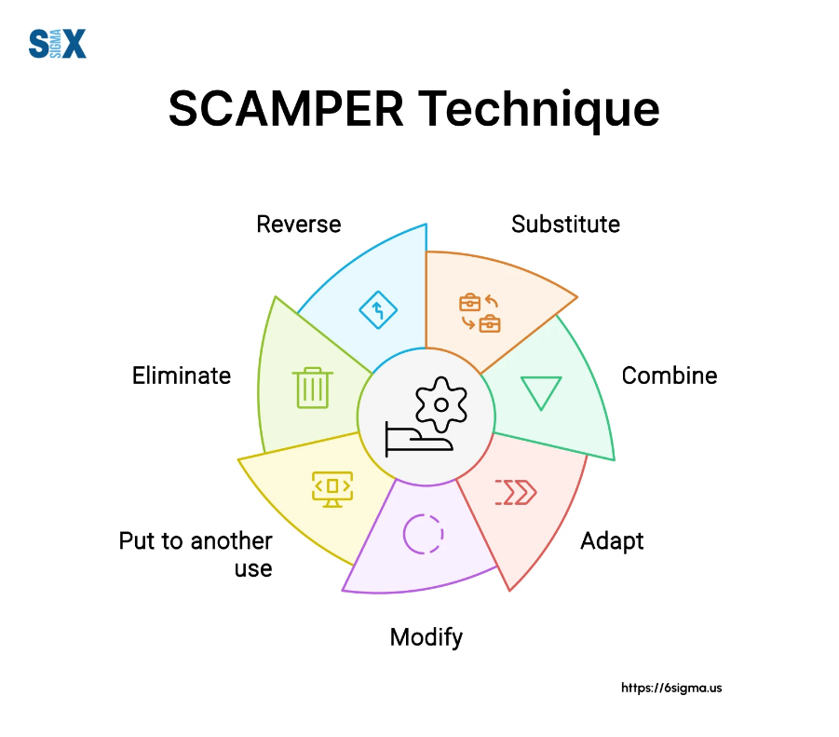
Figure 5: SCAMPER Technique
Substitute: The first step was to examine whether parts of BP's operations may be replaced. BP prioritises the oil and gas business, but I have considered replacing fossil fuels with wind, solar, and bioenergy. The market wants greener energy, and this alternative would reduce BP's dependence on volatile oil markets (Hartmann et al., 2021).
Combine: Next, I investigated how BP might incorporate renewable energy sources into its infrastructure. Due to its expertise in offshore drilling and energy generation, BP's offshore wind farms were a natural extension. BP's technology and digital skills combined with renewable energy systems might boost efficiency.
Adapt: BP's vow to reduce its carbon footprint can be amended by employing energy transition models that use similar strategies as other industries or businesses. To help BP develop its renewable portfolio, I researched renewable energy leaders' best practices and assessed how BP might apply them.
Modify: I also considered changing BP's products and services. BP might use biogas to clean up its natural gas products as a temporary measure. This would serve as a stopgap until the corporation expands its renewable energy activities.
Put to another use: BP may deliver renewable energy using its enormous energy distribution network, which is usually used for fossil fuels. Pipelines and other infrastructure may need to be adapted to transmit electricity from wind or solar farms to end customers.
Eliminate: BP's operations revealed places where fossil fuel initiatives may be replaced by renewable energy projects. For instance, oil reserve exploration investments have ceased.
Reverse: Finally, I considered inverting BP's business strategy. BP may change its focus from oil extraction and consumption to energy creation and sustainable resource use. This transition would change BP's client contacts from selling petrol to providing renewable energy options.

4.2 Application to BP
The SCAMPER framework allowed me to refine the focus of the innovation to BP’s need for a cleaner, sustainable future while addressing its operational challenges. BP's dependency on oil and gas and its efforts to become a renewable energy powerhouse without compromising its market position and profitability were identified as operational challenges. BP can reduce its environmental impact and diversify its energy portfolio by replacing fossil fuels with renewable energy, combining existing technology with creative energy solutions, and adopting strategies from other successful energy corporations (Oshilalu et al., 2021). This led to the idea of using BP's offshore expertise to build offshore wind farms. These wind farms would complement the company's present efforts and accelerate the global shift to renewable energy. To implement this goal, BP must change its business model to emphasise a low-carbon future and use AI for predictive maintenance and energy efficiency. It also needs to reassess BP's market position and perceive the business as a leader in sustainable energy rather than merely an oil giant.

4.3 Innovative Ideas Generation
Thinking creatively and analysing BP's operational needs led to a unique proposal. As part of BP's renewable energy efforts, offshore wind farms were proposed since BP's offshore oil platform infrastructure could be used for wind energy generation. This method would reduce BP's dependence on fossil fuels, leverage existing infrastructure, and fit with the global movement for sustainable energy. This, together with BP's other digital technologies like artificial intelligence for predictive maintenance and smart energy distribution systems, gives it an efficiency edge over its competitors (Aghahadi et al., 2024). If it added renewable energy to its core services and changed its business processes, BP might meet rising energy demand and meet environmental goals. Using the SCAMPER framework, I found a progressive and realistic solution. BP is having problems, but this approach prepares them for the future of energy.
5. Critical Evaluation of Your Idea’s Viability Using Lewin’s Force Field Analysis
5.1 Lewin’s Force Field Analysis
To assess the factors that might motivate a change, one change management approach is Lewin's Force Field Analysis. It will determine what is causing the change and what is holding it back. Positive change, according to Lewin, happens when the forces pushing for the change outweigh the forces holding it back, or when the variables limiting the change are diminished to make it feasible. Using this model, we can examine the viability and sustainability of BP's initial proposal to integrate offshore wind farms into our operations as part of our shift to renewable energy.
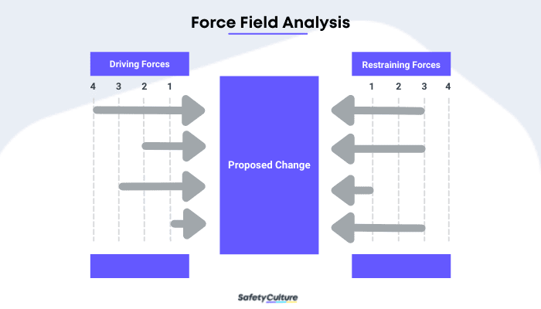
Figure 6: Force Field Analysis

- Driving Forces
There are several reasons why BP's transition to renewable energy sources is in line with both its internal and external objectives.
Market Demand for Renewable Energy: Renewable energy demand is driven by the worldwide need for environmentally friendly and long-term power. A growing number of countries' regulations aimed at reducing carbon emissions are compelling major corporations like BP to put money into renewable energy (Lu et al., 2023). The desire for green energy from customers is a driving factor in this.
BP’s Sustainability Goals: Being a carbon emitter with zero net emissions by the year 2050 is one of BP's environmental goals. The need to transition to more environmentally friendly energy sources is driven internally by these environmental aims (Derkenbaeva et al., 2022). In the long run, offshore wind turbines help BP achieve its sustainability objectives.
Technological Advancements: This shift is now more likely and less expensive thanks to new renewable energy technology, especially offshore wind power (Santhakumar et al., 2022). BP can make offshore wind projects a reality thanks to its expertise in offshore drilling.
- Restraining Forces
There are powerful motivating factors, but there are also some constraining factors that can prevent the suggestion from being put into action.
Financial Constraints: Major expenditures in infrastructure, technology, and expertise are necessary to make the transition to renewable energy. Thus, this change is subject to financial constraints. There could be financial difficulties for BP as it moves resources away from fossil fuels and towards renewable energy. Whenever the price of fossil fuels is unpredictable, this is particularly the case.
Company Culture and Resistance to Change: BP's long-standing reputation as a petroleum and gas behemoth may cause it to be averse to alternative energy sources. There is a chance that stakeholders and employees used to the old energy business model would fight against the reforms that are necessary to make the shift (Bhuiyan et al., 2025).
Regulatory and Policy Challenges: Difficulties with policy and regulations Offshore wind farm laws could be difficult to navigate, even though renewable energy is popular. Possible stumbling blocks include requests for worldwide permits and environmental impact assessments. For BP's wind energy projects to be profitable, the company must adhere to market circumstances, government subsidies, and laws.

5.2 Balance of Forces
Increasing demand for clean energy and BP's environmental objectives are the driving forces behind the company's transition to renewable energy, according to the balance of forces analysis. BP's offshore infrastructure and its goal of reaching net-zero emissions by 2050 provide a compelling case for the incorporation of offshore wind farms into BP's operations. Nevertheless, obstacles related to culture and finances persist. To tackle these challenges, BP may use a phased approach, beginning with experimental programs to gauge market potential while reducing financial commitment (Alkandi et al., 2024). By harmonising worker interests and concentrating on the long-term advantages of the move, BP may lessen cultural opposition and simplify the transition. Among these advantages include economic growth in developing nations and the creation of renewable energy jobs. Finally, BP's plan to integrate offshore wind farms is doable due to the driving factors, even though there are restrictions.

6. Critical Discussion on BP’s Climate for Innovation

6.1 Organisational Climate for Innovation
The organisational atmosphere for innovation at BP is changing, although it is not yet widely seen as encouraging new ideas. BP has led oil and gas technology in offshore drilling and energy management. The corporation has typically focused on oil and gas, which has hindered its ability to innovate in renewable energy and other alternative energy sources (Ekechukwu and Simpa, 2024). BP has improved its innovation and flexibility in recent years. After Bernard Looney took over, BP pledged to reach net-zero carbon emissions by 2050. This change shows BP's willingness to try new energy technology and commercial strategies. The organisation still struggles to create an innovation-driven culture across all areas, especially legacy operations that may not prioritise sustainability.
6.2 Management’s Likelihood of Implementation
Since BP is committed to sustainability, its management is likely to endorse and execute the creative notion of incorporating offshore wind farms into its operations. BP's large renewable energy expenditures indicate its management's commitment to diversify its energy portfolio. This includes BP's acquisition of a large share in offshore wind projects like Equinor's 50/50 U.S. joint venture. The leadership team is also cognisant of government, investor, and public demands to switch to renewable energy. Since BP wants to lead the energy transition, management may embrace this notion provided it coincides with their long-term aims and generates financial and environmental advantages.

6.3 Barriers to Innovation at BP
BP may face various obstacles to implementing creative ideas notwithstanding its strategic purpose. Since the corporation has established oil and gas procedures, organisational inertia is a major issue. Employees used to the old energy model may resist change, which may slow adoption. Given the significant legal, technological, and financial risks of large-scale renewable energy investments, revolutionary projects may be slow to execute (Doh et al., 2021).

6.4 Strategic Alignment
The idea to incorporate offshore wind farms supports BP's long-term sustainability and digitalisation aims. Clean, renewable offshore wind energy aids BP's goal to minimise carbon emissions and shift away from fossil fuels. The notion fits into BP's ambition to diversify its portfolio by investing in renewable energy and using digital solutions to optimise energy output. Offshore wind projects also support BP's goal and industry trends to improve energy security and combat climate change (Kołakowski and Rutkowski, 2022).

7. Main Findings

7.1 Key Insights from the Report
The paper stresses BP's dedication to innovation, especially as the company moves towards renewable energy and sustainability. BP is seeing a shift in its organisational climate, where there is an increasing willingness to consider innovative ideas and an acknowledgement of the necessity for significant reforms. A review of BP's policies and practices shows that top executives support the company's long-term objectives of achieving carbon neutrality and digital transformation through the exploration of novel energy solutions and the diversification of the energy portfolio. Nevertheless, there are still substantial obstacles to overcome, such as organisational inertia and opposition to change from established sectors within the corporation.

7.2 Innovation Model Application
To determine the idea's feasibility and strategic fit, the research made use of frameworks like Lewin's Force Field research and the 4 P's of innovation. The offshore wind farm initiative's execution might be impacted by both driving and restraining forces, which Lewin's model helped to uncover. Since the concept was differentiating itself in the market and making a strategic change towards sustainability, the 4 P's framework offered a systematic lens through which to classify it, placing it in the Position and Paradigm categories.

7.3 Idea Viability
It seems like a reasonable and achievable approach that fits in with BP's sustainability goals to include offshore wind turbines into the company's operations. Despite certain obstacles, such as internal resistance and budgetary restraints, this invention might have a significant positive effect on the environment and generate profits for BP in the long run.

8. Conclusion

8.1 Summary of Key Points
BP must reconcile its oil and gas activities with the rising need for renewable energy. BP's novel solution—integrating offshore wind farms into its portfolio—aims to diversify its energy sources and further its environmental goals. The organisational environment, creativity processes, and innovation models were examined to determine BP's readiness for this shift. Lewin's Force Field Analysis and the 4 Ps of innovation assessed the idea's driving and restraining forces and strategic fit.

8.2 Final Evaluation
The research shows that offshore wind farms are practical and strategically aligned with BP's sustainability and carbon neutrality aims. Financial restrictions and internal opposition are outweighed by market demand for renewable energy and BP's environmental strategy. BP may benefit from this innovation's environmental and economic benefits, despite organisational slowness.

8.3 Strategic Recommendation
BP should overcome internal resistance with strong leadership and clear explanation of the long-term advantages of this invention to move forward. Financial and regulatory hurdles can be reduced by investing in digitalisation and innovative technology. Beginning with experimental initiatives in critical locations, BP may gather data to develop its strategy and acquire stakeholder buy-in. By adopting this invention, BP may dominate the green energy business while being profitable.

9. References
Aghahadi, M., Bosisio, A., Merlo, M., Berizzi, A., Pegoiani, A. and Forciniti, S. (2024). Digitalization processes in distribution grids: a comprehensive review of strategies and challenges. Applied Sciences, 14(11), p.4528. https://doi.org/10.3390/app14114528
Alkandi, I., Alhajri, N. and Alnajim, A. (2024). Green Supply Chain Management, Business Performance, and Future Challenges: Evidence from Emerging Industrial Sector. Sustainability, 17(1), p.29. https://doi.org/10.3390/su17010029
Alkaraan, F., Elmarzouky, M., Hussainey, K., Venkatesh, V.G., Shi, Y. and Gulko, N. (2024). Reinforcing green business strategies with Industry 4.0 and governance towards sustainability: Natural‐resource‐based view and dynamic capability. Business Strategy and the Environment, 33(4), pp.3588-3606. https://doi.org/10.1002/bse.3665
Arslan, A., Haapanen, L., Hurmelinna-Laukkanen, P., Tarba, S.Y. and Alon, I. (2021). Climate change, consumer lifestyles and legitimation strategies of sustainability-oriented firms. European Management Journal, 39(6), pp.720-730. https://doi.org/10.1016/j.emj.2021.03.005
Bessant, J. and Tidd, J., 2013. Managing innovation: integrating technological, market and organizational change. Wiley.
Bhuiyan, F., Adu, D.A., Ullah, H. and Islam, N. (2025). Employee Organisational Commitment and Corporate Environmental Sustainability Practices: Mediating Role of Organisation Innovation Culture. Business Strategy and the Environment. https://doi.org/10.1002/bse.4200
Derkenbaeva, E., Vega, S.H., Hofstede, G.J. and Van Leeuwen, E. (2022). Positive energy districts: Mainstreaming energy transition in urban areas. Renewable and Sustainable Energy Reviews, 153, p.111782. https://doi.org/10.1016/j.rser.2021.111782
Doh, J., Budhwar, P. and Wood, G. (2021). Long-term energy transitions and international business: Concepts, theory, methods, and a research agenda. Journal of International Business Studies, 52(5), p.951. https://doi.org/10.1057/s41267-021-00405-6
Ekechukwu, D.E. and Simpa, P. (2024). Trends, insights, and future prospects of renewable energy integration within the oil and gas sector operations. World Journal of Advanced Engineering Technology and Sciences, 12(1), pp.152-167. https://doi.org/10.30574/wjaets.2024.12.1.0207
Eltweri, A., Al-karaki, W.E., Zhai, Y., Abdullah, K. and Faccia, A. (2024). UK Hydrogen Roadmap: Financial and Strategic Insights into Oil and Gas Industry’s Transition. Sustainability, 17(1), p.113. https://doi.org/10.3390/su17010113
Halttunen, K., Slade, R. and Staffell, I. (2023). Diversify or die: Strategy options for oil majors in the sustainable energy transition. Energy Research & Social Science, 104, p.103253. https://doi.org/10.1016/j.erss.2023.103253
Hartmann, J., Inkpen, A.C. and Ramaswamy, K. (2021). Different shades of green: Global oil and gas companies and renewable energy. Journal of International Business Studies, 52, pp.879-903. https://doi.org/10.1057/s41267-020-00326-w
Houtgraaf, G., Kruyen, P.M. and Van Thiel, S. (2023). Public sector creativity as the origin of public sector innovation: A taxonomy and future research agenda. Public Administration, 101(2), pp.539-556. https://doi.org/10.1111/padm.12778
Jaiswal, K.K., Chowdhury, C.R., Yadav, D., Verma, R., Dutta, S., Jaiswal, K.S. and Karuppasamy, K.S.K. (2022). Renewable and sustainable clean energy development and impact on social, economic, and environmental health. Energy nexus, 7, p.100118. https://doi.org/10.1016/j.nexus.2022.100118\
Kabeyi, M.J.B. and Olanrewaju, O.A. (2022). Sustainable energy transition for renewable and low carbon grid electricity generation and supply. Frontiers in Energy research, 9, p.743114. https://doi.org/10.3389/fenrg.2021.743114
Kołakowski, P. and Rutkowski, G. (2022). The analysis of offshore industry transition-acceleration from oil & gas to wind. TransNav, International Journal on Marine Navigation and Safety of Sea Transportation, 16(2), pp.375-384.
Li, M., Trencher, G. and Asuka, J. (2022). The clean energy claims of BP, Chevron, ExxonMobil and Shell: A mismatch between discourse, actions and investments. PloS one, 17(2), p.e0263596. https://doi.org/10.1371/journal.pone.0263596
Li, N., Dilanchiev, A. and Mustafa, G. (2023). From oil and mineral extraction to renewable energy: Analyzing the efficiency of green technology innovation in the transformation of the oil and gas sector in the extractive industry. Resources Policy, 86, p.104080. https://doi.org/10.1016/j.resourpol.2023.104080
Lu, L., Liu, Z., Mohsin, M. and Zhang, C. (2023). Renewable energy, industrial upgradation, and import-export quality: Green finance and CO2 emission reduction nexus. Environmental Science and Pollution Research, 30(5), pp.13327-13341. https://doi.org/10.1007/s11356-022-22629-1
Masoumi, M. (2023). Machine learning solutions for offshore wind farms: A review of applications and impacts. Journal of Marine Science and Engineering, 11(10), p.1855. https://doi.org/10.3390/jmse11101855
Onukwulu, E.C., Agho, M.O. and Eyo-Udo, N.L. (2023). Sustainable supply chain practices to reduce carbon footprint in oil and gas. Global Journal of Research in Multidisciplinary Studies, 1(2), pp.24-43. https://doi.org/10.58175/gjrms.2023.1.2.0044
Oshilalu, A.Z., Ajiboye, A.R. and Oshilalu, F.O. (2021). Performance Evaluation of Major Oil and Gas Companies Diversifying into Renewable Energy Resources. In AIAA Propulsion and Energy 2021 Forum (p. 3370). https://doi.org/10.2514/6.2021-3370
Santhakumar, S., Smart, G., Noonan, M., Meerman, H. and Faaij, A. (2022). Technological progress observed for fixed-bottom offshore wind in the EU and UK. Technological Forecasting and Social Change, 182, p.121856. https://doi.org/10.1016/j.techfore.2022.121856
Smit, D.J. and Powell, J.B. (2023). Role of international oil companies in the net-zero emission energy transition. Annual Review of Chemical and Biomolecular Engineering, 14(1), pp.301-322. https://doi.org/10.1146/annurev-chembioeng-092220-030446
Sternberg, R.J. (2021). Transformational creativity: The link between creativity, wisdom, and the solution of global problems. Philosophies, 6(3), p.75. https://doi.org/10.3390/philosophies6030075
Suherlan, S. and Okombo, M.O. (2023). Technological innovation in marketing and its effect on consumer behaviour. Technology and Society Perspectives (TACIT), 1(2), pp.94-103. https://doi.org/10.61100/tacit.v1i2.57
Tang, J. and Huang, K. (2024). Eco-cities of tomorrow: how green finance fuels urban energy efficiency—insights from prefecture-level cities in China. Energy Informatics, 7(1), p.148. https://doi.org/10.1186/s42162-024-00455-8
Wang, L., Qu, G. and Chen, J. (2022). Towards a meaningful innovation paradigm: conceptual framework and practice of leading world-class enterprise. Chinese Management Studies, 16(4), pp.942-964. https://doi.org/10.1108/CMS-12-2020-0536

