Discuss ways in which TWO Mexican films may be seen to challenge, or be in dialogue with, the dominant forms of Hollywood.
N/B Two films sited in week 11. World Cinema Case Study: Mexico (13th Dec 2017)
Amores Perros, Pan’s Labyrinth … (The latter being in fact made in Spain and first released there, then in Mexico 9 days later and Britain some-time after).
___________________________________________________________________________
As sentient beings with a common origin, uncertain of our destiny, we perch, in evolutionary terms, not far from the nest. Still unsure of our ability to fly, yet driven to try.

Then, like spotty teenagers who, free to imagine they know it all; do as they please. Immune for a while to imperatives, we make, or fail to make, choices. To languish, seek stimulation, or learn; in the hope of better understanding the nature of ourselves and the world we inhabit? We could of course just settle for entertainment.
___________________________________________________________________________



As well as considering, for the sake of comparison, the ‘dominant forms’ of Hollywood, it may also be worth considering the domination of Hollywood with regards to World Cinema. Without intending to be facetious; the overriding feature of Hollywood is Americanism; domineering by nature, self-obsessed, self-aggrandising and dollar driven. The Industry, founded as it was on making films with patriotic, morale-boosting themes and messages about the "American way of life" in alliance with Washington from 1916. After W War 1 Hollywood would dominate for another 40 years. Market shifts and consumer demand eventually leading to ‘blockbuster’ movies with profit still as the main priority.
That said; it would also be true to say that the roots of Hollywood film making are in theatre and that the pioneer directors were formally theatre directors. Even so the companies interest in box office takings meant that form and content were controlled and dispensed ‘from above’. The dominant forms associated with Hollywood movies up until the 1950s were dictated and governed by the boards of the ‘Big Five Studios’; who sanctioned little directorial freedom or license. It depended on a ‘star’ system created to reflect their image and agenda: “All American Hero”- Westerns, War Heroes, Gangsters, Success, Flamboyance, Male dominance over often powerful yet ultimately submissive women, comic eccentricity or slapstick, glamour, musical, cartoon and biographical picture. All mostly fiction or fictionalized, only rarely containing aspects of weakness or fallibility in leading roles. Hollywood cinematic time is generally linear and continuous towards a conclusive, often satisfactory, ending. Perhaps the most compelling form in many classic films of the “Golden Age” is to inspire empathy with the hero figure or heroine. Some strong-willed directors did, however, succeed in achieving their distinct artistic visions; Welles, Hawks, Hitchcock and Capra, among them.

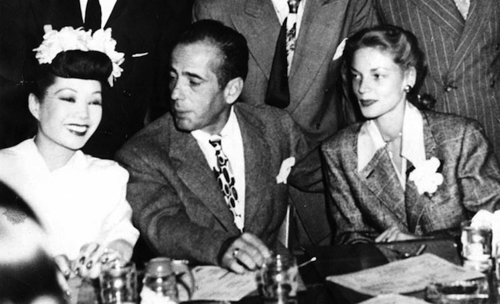

“Classical narration progresses always through psychological motivation, i.e. by the will of a human character and its struggle with obstacles towards a defined goal. This narrative element is commonly composed of a primary narrative (often a romance) intertwined with a secondary narrative, such as a business or a crime. This narrative is structured with an unmistakable beginning, middle and end, and generally there is a distinct resolution. Utilizing actors, events, causal effects, main points, and secondary points are basic characteristics of this type of narrative. The characters in Classical Hollywood Cinema have clearly definable traits, are active, and very goal oriented. They are causal agents motivated by psychological rather than social concerns. The narrative is a chain of cause and effect with the characters being the causal agents — in classical style, events do not occur randomly. [Goldburg, Michael. ‘Classic Hollywood Cinema’ (retrieved 2000 Internet Archive).

In contrast to Hollywood productions, the two examples of world cinema; Amores Perros (2000) and Pan’s Labyrinth (2006); very different films in their own right, demonstrate an independence of approach on many levels, although some parallels may be observed. Both are auteur films of distinctly original character. Both would be difficult to categorize in terms of genre beyond the generic heading of drama. One big difference is that neither tell a single story.
Pan’s Labyrinth, (a misleading translation from the Spanish title: El laberinto del faun, lit. The Labyrinth of the Faun’) at least, has a group of consistent characters that we follow chronologically from beginning to end. There is an identifiable central figure; a child; Ofelia, who relates to an older confidant, protector and ally; Mercedes, who is a spy for the rebels that are being hunted in the woods. Ofilia’s mother is presented as almost a captive ‘wife’ to her brutal husband Captain Vidal. The elements of threat and danger are apparent in the first scenes, we soon understand the dynamic of the environment the female characters are subject to. Male dominance played out as anti-hero; Vidal is a Falangist/Fascist after all. So far this could, in some ways, resemble elements of, if not Hollywood, European classic war film. Interestingly the second male hero; Mercedes’ brother Pedro is almost peripheral to the story; we do not see him at his camp or in conversation with his comrades. He is symbolic nonetheless of a fragile connection to a friendlier-caring, if not safer, world, where there is hope of a happy outcome. That is how Hollywood might play it.

This though, is not Hollywood. A mystical element, that has been introduced in the establishing sequence in the woods (and also in the title), begins to unfold in almost incongruous juxtaposition to the realistic portrayal of mounting tensions in the Nazi camp, that just happens to be set up near a labyrinthine entrance to the underworld. Two quite independent stories are being played out; a (generic) wartime drama and a ‘fairy’ story cum pagan myth. The two threads seem to hardly interrelate, except in the character of Ofilia who bridges both worlds. She procures magical roots intended to help her mother but which ultimately serve to heighten the sense of jeopardy when the Mandrake is discovered. What also unites the two threads, that could be compared to classic Hollywood themes, are the desired outcomes; we want the ill-treated wife to achieve liberation and some kind of retribution. And we want the child to succeed in the trials set by ‘Pan’ that will restore her to her true identity. In this film, only one of those satisfactory conclusions is fulfilled but the heroine has effectively to die in order to take her place as Queen of the underworld. This film is the last of a trilogy by del Toro referred to as The Trilogy of Darkness which included ‘Cronos’ (1992) and 'The Devil's Backbone' (2001).

Pan (of Greek mythology), is associated with the archaic ‘Horned God’ of the underworld, is an enigmatic figure, at once, frightening and yet revered as an entity with powerful and deep ‘Natural’ wisdom. He has though been demonized over the past 2000 years and wrongly associated with the devil in the Christian creed, partly as a device to subjugate previously pagan-rustic peoples. Pan though, in original folk tail and myth, is not an evil entity, he is symbolic of masculine fertility and Earth ‘magic’. Writer and Director Guillermo del Toro insists though, that the Faun is not Pan, according to Spelling, I. (2006)
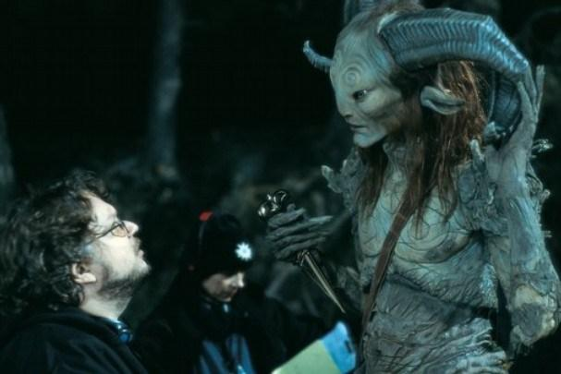
Pan’s Labyrinth, is consistently about the misappropriation of identities. Everyone is in the wrong place; Nazis in the woods, good women with bad men, a child, not only with a wrong father but also in exile from her underworld ‘true place’. In fact, according to the faun; she no longer knows who she is. I’m not sure how successfully the film works to make clear these connections but the symbology is there. While it is a remarkable attempt to transcend one dimensional narrative, in some way, it fails to convey the depth of meaning it aspires to. Instead it is burdened by the need for dramatic effect, almost Disneyesque portrayal of the mythical characters, shock factor and grotesque violence. The film was co-produced and distributed by Esperanto Filmoj and Warner Bros; one must wonder how much influence the Hollywood company had over the content of the production. In any case I don’t think Hollywood would have made a better job of it, without Del Toro.
Some obvious parallels could also be made with the shallower British production LABYRINTH; another unhappy mix of traditional portrayal of a ‘magical’ quest (also featuring a child), presented with real actors, silly soft-toy like puppets, and CGI. The underworld character played by David Bowie, being perhaps that film’s only saving grace (though even that is arguable).

Amores Perros, (Love of Dogs) is an altogether different production. It would be difficult to draw obvious parallels with Hollywood, especially in the choice of subject matter and narrative form. There are at least three main characters, whose stories play out independently and yet concurrently. One uniting factor is the car crash shown in the establishing sequence. The film is an example of non-conventional narrative (where ‘convention’ is likely based on the Hollywood approach to storytelling). In Amores Perros, events are not necessarily linear and we do not find out until much later in the script that all the main characters are in some way involved with the car crash. Another link is of course the dogs; important secondary characters that tie the complex plot together. Love, passion and desire are also important factors in the separate scenarios and all three protagonists are encumbered by difficult circumstances beyond their control. The film is also about loyalty and disloyalty in all three threads. It is about unconsidered and unintended consequences that result from human folly and irrational desire and plain circumstance, regardless of social status. In this sense, the film achieves far greater depth and psychological context than do most Hollywood productions.
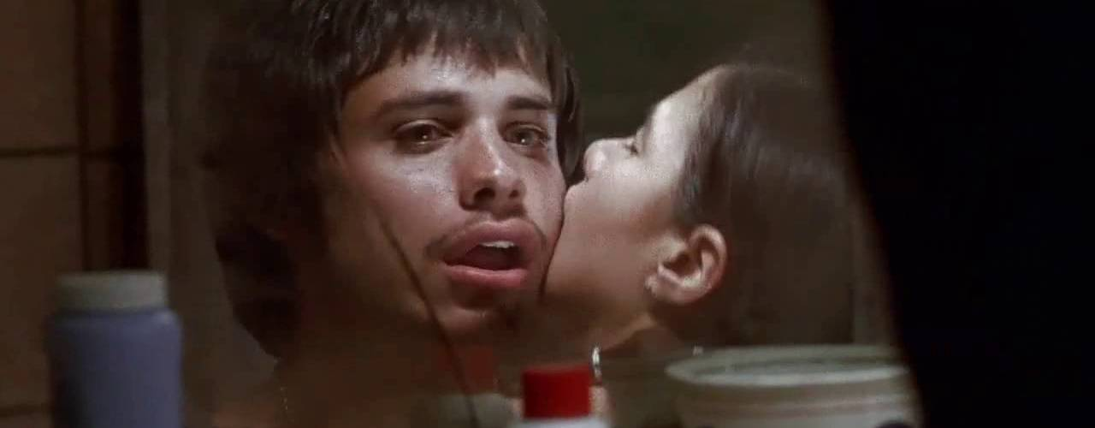

Director González Iñárritu came under heavy criticism for the inclusion in the film of dog fighting but he has said in response, that although it is horrible, dogfighting is one of the harsh realities of Mexico City; as paraphrased by Romney, J. (22. August 2000) The Guardian. The use of animals in films is synonymous with several Hollywood productions; where they are often used to show human affection and attachment, they usually add an unpredictable and mostly amusing element. While some of the cinematic style of Amores Perros could be compared to, and is possibly inspired by, typical later Hollywood productions; camera angles, fast editing during dramatic sequences. car chase etc. the subject matter is of another order, as is the treatment which is ‘realistic’ and not obviously affected by contrivance or artifice. The mis-en-scene is generally claustrophobic throughout which implies that all the characters are in some way trapped by their circumstances; poverty, oppressive domestic environments, hostile neighborhoods, the past, and, in the case of the model/mistress, by self-image. The advertising poster on a wall facing her window defines her identity, until she is broken; her dog defines her loyalties until it is lost beneath the polished floorboards which, when they are lifted, reveal a darker, rat infested world.
Apart from the none-conventional narrative of Amores Perros, the script and acting is also of a different order to, and challenges, Hollywood convention. Similar to productions such as La Hain or the films of Jim Jaramusch, Mike Leigh and other contemporary-independent directors. At the same time as applying great skill and method, possibly inspired by and gleaned from the mainstream industry, these directors begin with an idea of how they wish to portray ‘realities’ and improvise towards capturing human nature in an unembellished manor. This gives their films gravitas, authority and authenticity. By comparison, a film like Die Hard (1988) is pure pulp; True Grit (1969) a comic-book adventure… ‘Grittiness’ is not invented, it is observed, understood, played out and presented. A ‘man’s world’ is shown in a different light; unlike the comedy ‘affairs’ of Hollywood where we love both the rascals. Rascals who inhabit a carefree world, immune to grit, poverty or disaster. And, unlike Hitchcock’s freak psychopaths who titillate our desire for tension, these are common men in a world, not of social isolation but of dystopian pressure, born in to low life. The unfaithful businessman might measure his success in comparison with them but he inhabits an equally claustrophobic and pressurized, if polished, ‘world’…
Given the impact, critical acclaim and subsequent awards both these independent films achieved, the juxtaposition between the Hollywood film industry and the autonomous film makers approach, particularly, to storytelling, and narrative form, must surely have created a more equal dialogue between the Giant Companies and little indomitable sling-shot ‘Davids’. But the imperatives and aspirations of the film makers are poles apart; in general terms. Hollywood as symbol of “the American way”, has always been concerned with profit, and commercial domination. The big studios have perfected the art, based on a long history of feel good entertainment (again I generalize). They are the Tesco of international distribution ‘”just look at the selection folks - something for everyone – every little helps (us)”’. They own a lot of interests, and any ambitious director might be willing to adapt to the agenda in order to secure patronage. The same can be said of the music industry… But the upstart, ‘on the ground’ artists have stories to tell, are not bound in their visions and authenticity has mileage. The concern is that, just like Tesco and the corner shop, the small will in some way be absorbed into the large. This could possibly lead to ever more freedom being afforded to independent directors working with Hollywood which is no bad thing. However, the true artists will continue to innovate while Hollywood is preoccupied with keeping pace with demand from an increasingly discerning, if not fickle viewer. Only America thinks it can dominate the world for ever. Other people, have other ideas, other motivations.
Reference List
Spelling Ian (25th December 2006)
Brownlow, K. (1968). The Parade's Gone By.... University of California Press. p. 78. ISBN 0-520-03068-0.
Bordwell, D. Staiger, J. Thompson, K. (1988) The Classical Hollywood Cinema: Film Style and Mode of Production to 1960
Goldburg, M. "Classical Hollywood Cinema". Retrieved 2012-04-22.

https://web.archive.org/web/20080609075453/http://www.scifi.com/sfw/interviews/sfw14471.html
https://ipfs.io/ipfs/QmXoypizjW3WknFiJnKLwHCnL72vedxjQkDDP1mXWo6uco/wiki/Classical_Hollywood_cinema.html

