
University of Wales Trinity Saint David, London
Master of Business Administration (MBA)
Module Title: International Marketing: Principles and Practices
Module Code: LCMB7026

INTERNATIONAL MARKETING MIX ANALYSIS OF ZARA: A COMPARATIVE STUDY OF THE UNITED KINGDOM AND PAKISTAN

Student Name: Kamran Akhtar
Student ID: 2433466
Lecturer: Tushara Balendran & Dian Mayasari
Word Count: 5154
Submission Deadline: 24th April 2026
TABLE OF CONTENTS
1. INTRODUCTION 1
SECTION 1 1
2. COMPANY OVERVIEW (ZARA / INDITEX) 1
3. Comparative Market Analysis: PESTEL (UK vs Pakistan) 2
3.1 Political and Legal Factors 2
3.2 Economic Factors 3
3.3 Social and Cultural Factors 3
3.4 Technological Factors 3
3.5 Environmental Factors 3
4. Segmentation, Targeting and Positioning (STP) Analysis 4
4.1 Segmentation 4
4.2 Targeting 4
4.3 Positioning 5
5. International Marketing Mix (7Ps) Analysis 6
5.1 Product Strategy 6
5.2 Pricing Strategy 6
5.3 Place (Distribution) Strategy 7
5.4 Promotion Strategy 8
5.5 People 8
5.6 Process 8
5.7 Physical Evidence 9
6. Directional Development Strategy (Focus on Pakistan) 9
7. Ethical Issues in Zara’s International Marketing 10
7.1 Labour and Supply Chain Ethics 10
7.2 Environmental Sustainability 10
7.3 Ethical Marketing and Consumer Responsibility 11
8. Recommendations for Zara’s International Marketing Strategy 11
8.1 Pricing Adaptation 11
8.2 Product Localisation 11
8.3 Omnichannel Expansion 11
8.4 Ethical and CSR Consistency 11
SECTION 2: REFLECTIVE ACCOUNT 12
10. Reflective Account on the Research and Analysis Process 12
10.1 Description 13
10.2 Feelings 13
10.3 Evaluation 13
10.4 Analysis 13
10.5 Conclusion 14
10.6 Action Plan 14
REFERENCES 15

LIST OF FIGURES
Figure 1: Zara Business Model (Integrated Fast Fashion System) (Author, 2026) 2
Figure 2: A diagram of a perceptual map based of UK (Author, 2026) 5
Figure 3: The 7Ps Marketing Mix Model 6
Figure 4: Zara Store in United Kingdom (Bargh, 2020) 7
Figure 5: Zara Store – Pakistan (Franchising Key, 2019) 8
Figure 6: Zara Supply Chain Model (Adopted from Inditex, 2022; Author, 2026) 9
Figure 7: Gibbs’ Reflective Cycle (1988; cited in McLeod, 2025) 12

LIST OF TABLES
Table 1: PESTEL Comparison – UK vs Pakistan 2
Table 2: STP Comparison – UK vs Pakistan 5
Table 3: Marketing Mix (7Ps) Comparison – UK vs Pakistan 6
Table 4: Ansoff Matrix Application – Zara in Pakistan 8
Table 5: Ethical Issues Comparison – UK vs Pakistan 9
Table 6: Strategic Recommendations for Zara 10

1. INTRODUCTION
Zara, a flagship brand of the Inditex Group, has established itself as a leading global fast fashion retailer through a business model defined by speed, flexibility, and vertical integration. In contrast to the conventional fashion companies, Zara has a demand-based-system that is integrated so that design, production, and distribution are combined and respond quickly to changes in consumer preferences (Inditex, 2021; Inditex, 2022). This model has led to good financial results, as Inditex reported net sales of 35,947million in 2023, and gross profit margins of around 57-58 meaning that it is very efficient in its operations (Inditex, 2023; Inditex, 2022). Nevertheless, the efficiency of this globally standardised model is becoming a controversial topic, especially in a variety of global situations when economic and cultural factors differ dramatically (Doyle, 2016; Kotler and Keller, 2016; Hollensen, 2020).
This report critically evaluates the international marketing strategy of Zara by comparing its operations in United Kingdom (UK) and the international marketing operations in Pakistan. UK is a high-consumer-awareness, technologically advanced and mature market, whereas Pakistan is a developing economy with price sensitivity and cultural diversity (OECD, 2022; World Bank, 2023). Using the framework of PESTEL, STP, and marketing mix, the analysis is used to analyse the strategic differences, which are presented in Tables 13. Overall, the report states that the efficiency-based model adopted by Zara needs to be more localised to be efficient in the new markets.

SECTION 1

2. COMPANY OVERVIEW (ZARA / INDITEX)
Zara was started in 1975 in Spain by Amancio Ortega and was the pioneer of what would later become the flagship brand of the Inditex Group. Zara is a part of the strategic business model of Inditex, which has a global footprint of success due to its vertically integrated and highly responsive fast fashion business model (Christopher et al., 2004). As compared to the traditional apparel retailers, which rely on long forecasting processes and offshore manufacturing, Zara applies demand-driven approach where real-time sales information directly influences product design and replenishment (Inditex, 2023). This allows the market intelligence to be part of the operations to enable shorter lead times and reactiveness to evolve consumer tastes (Inditex, 2022; Martin and Blythe, 2023). The model used by Zara as shown in Figure 1 is a linked network in which design, production, distribution, and retail are constantly synchronised through feedback loops, which supports the speed and flexibility.
The model used by Zara is based on centralised control, which means that the company is able to turn over its inventory quickly and innovate continuously due to integrated logistics and IT systems (Inditex, 2023). Its efficiency is indicated by strong financial performance, such as the sales of €35,947 million and consistent margins (Inditex, 2023; Inditex, 2022). Nonetheless, this uniformity hinders localisation especially in markets such as Pakistan. Importantly, the model is universally scalable, but it might not be universal, especially in the emerging markets where infrastructure, and consumer behaviour are different (Cavusgil et al., 2014; Armstrong and Kotler, 2019).

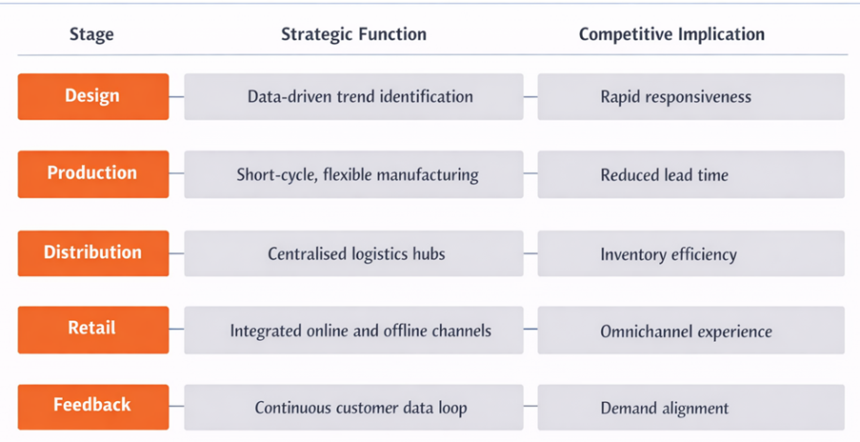
Figure 1: Zara Business Model (Integrated Fast Fashion System) (Author, 2026)

3. Comparative Market Analysis: PESTEL (UK vs Pakistan)
The macro-environmental conditions in developed markets and emerging markets differ significantly and they influence the performance of Zara in the international markets. Comparative PESTEL analysis of the United Kingdom (UK) and Pakistan indicates structural differences that have a direct impact on the strategic decisions of Zara especially in the context of pricing, adaptation of its products and development of its channels. These differences as summarised in Table 1 underscore the shortcomings of a standardised global strategy.
Table 1: PESTEL Comparison – UK vs Pakistan
Factor | United Kingdom (UK) | Pakistan | Strategic Implication for Zara
Political | Stable governance, predictable policy | Regulatory uncertainty, bureaucratic delays | Higher operational risk in Pakistan
Economic | High disposable income, mature retail market | Low–middle income, high price sensitivity | Need for pricing adaptation
Social | Sustainability awareness, fast fashion criticism | Cultural conservatism, hybrid fashion preferences | Product localisation required
Technological | Advanced e-commerce, omnichannel maturity | Growing mobile commerce, weak logistics | Channel adaptation needed
Legal | Strict labour & environmental laws | Weak enforcement mechanisms | Ethical and compliance risks
Environmental | Strong sustainability pressure | Emerging environmental awareness | CSR expectations differ

3.1 Political and Legal Factors
In the UK, Zara has a good political and legal environment because it has good governance and institutions, as well as clear legal frameworks that can enable predictable operations and long-term planning. Nevertheless, the disadvantages of stringent labour and environmental laws are in part undesirable because they raise the expenses of compliance even though they enhance brand credibility (Inditex, 2023; World Bank, 2023). Conversely, Pakistan is a very poor prospect, with a high level of regulatory instability, inconsistency, and laxity of policies. The reduced enforcement can decrease the compliance pressure in the short term, yet it is not a good practice long-term because of the reputational risks and unethical inconsistency (Fletcher, 2013; UNEP, 2019; Inditex, 2023).

3.2 Economic Factors
UK has a favourable economy to Zara based on high disposable income and robust consumer expenditure which helps it in sustaining its mid-range pricing strategy and sales expansion. This is in line with the global efficiency model and economies of scale of Zara (Porter, 2008; Inditex, 2022; Inditex, 2023). Conversely, Pakistan is a very unfavourable economic environment, where income levels are low and price sensitivity is high. The relatively high cost of Zara is due to its standardised pricing, which is determined by the importation duties and logistics. This provides a discrepancy between the value proposition and purchasing power, restricting accessibility and market penetration even with good global financial performance (Inditex, 2022; Inditex, 2023).

3.3 Social and Cultural Factors
The UK has a mixed yet mostly positive social environment that can favour Zara because of strong fashion awareness that favours its fast fashion model, but pressure on sustainability poses a challenge, thus requiring ethical behaviours (Inditex, 2023; Jackson and Shaw, 2017). Conversely, Pakistan has a somewhat poor social landscape, where cultural values include modesty and consumer tastes, which demand more adaptation of products. Using Hofstede’s dimensions, Pakistan’s higher collectivism and conservatism compared to the UK highlight the need for localisation. The main limitation to this flexibility is the centralised approach to design, which minimises market relevance in Zara. Thus, even though the demand of the Western fashion is there, growth is limited due to poor adaptation (Inditex, 2023).

3.4 Technological Factors
The technological infrastructure determines to a larger extent whether Zara will be able to execute its omnichannel strategy. UK has the advantage of well-developed digital ecosystems, such as high rates of internet penetration, well-developed logistics systems, and complexes of e-commerce (OECD, 2022). This reinforces the integrated retailing concept of Zara that involves a combination of brick-and-mortar shops with online platforms to facilitate customer experience (Inditex, 2024).
Pakistan is going through a fast and digital evolution, but it is limited by inefficient logistics and asymmetrical technological advancement. E-commerce is highly mobile, and scalability is constrained by issues with last-mile delivery and the payment system. Since the operations of Zara are dependent on real-time data and integrated IT systems (Inditex, 2023), these infrastructure constraints can lessen operational efficiencies and customer satisfaction in Pakistan.

3.5 Environmental Factors
For instance, in case of Zara, environmental factor is most favourable in UK with strong regulatory pressure and high consumer awareness for sustainable back-to-the shelf practices. Growing activism as well as tighter environment regulations pushes firms to operate responsibly, thereby enhancing brand trust and long-term sustainability (Inditex, 2023). Inditex has sought to use sustainability, a regulatory compliance and control surface, as a strategic lever: through investment in circular fashion models, resource efficiency, and emissions reduction initiatives.
On the other hand, Pakistan offers a somewhat unfriendly environment with limitations in consumer awareness and lack of strict regulatory mechanisms. This alleviates some immediate pressure on Zara to take sustainability measures and creates a strategic risk. Lack of strong environmental expectations may impede innovation and delay adoption of sustainable practice. In addition, the variation in sustainability standards between markets can negatively impact brand reputation due to expectations for global stakeholders to act consistently ethical (Fletcher, 2013; UNEP, 2019; Inditex, 2023).
In contrast, Pakistan showcases structural challenges of implementing a consistent global sustainability strategy even in production contexts that have to adopt such initiatives because the UK environment is conducive for the Zara transition towards sustainable fashion. This is further testimony to the contradiction inherent in Zara's standardised model and that stricter localisation is needed in order to mitigate

4. Segmentation, Targeting and Positioning (STP) Analysis
The STP strategy of Zara is an indication of a hybrid strategy that is international standardisation with less localisation. Although the brand has a consistent global brand, it has different performance levels in developed and emerging markets (Solomon, 2020). Comparative analysis of UK and Pakistan reveals that segmentation and targeting is partially adapted, but positioning is highly standardised. This causes strategic inconsistencies as summarised in Table 2 especially in markets that have varying socio-economic and cultural characteristics.

4.1 Segmentation
Zara in the UK uses a psychographic segmentation approach, which targets the consumer segment that is very sensitive to fashion trends and brand image. Such consumers focus more on style, immediate and diversity than on long-lasting product quality, which is very much aligned with the fast fashion model by Zara. Moreover, the rising sustainability awareness has led to the emergence of a cohort that is fashionable and socially responsible, which puts Zara under pressure to incorporate sustainability into its products (Inditex, 2023).
Conversely, Pakistan has a big income-based segmentation as a result of economic limitation. Zara is also limited in accessing a rather limited market, targeting mostly people with middle and high income and urban consumers in the first place. This organisational weakness demonstrates the low prices of Zara products in the Pakistani market which makes its products unaffordable to the Pakistani market hence limiting its market potential as compared to the UK.

4.2 Targeting
In the UK, Zara has a wide targeting strategy, which attracts a large population of fashionable consumers. This can be attributed to high purchasing power and mature retail environment, which allows the company to sustain high sales volumes. The regular updating of the products also increases the customer interaction and loyalty (Inditex, 2022).
On the other hand, in Pakistan, Zara is more discriminating in its targeting, with most of its customers being affluent in the major urban centres like Lahore, Karachi and Islamabad. This strategy is not strategical but mainly motivated by financial constraints. Such discriminating targeting as shown in Table 2 inhibits market growth and growth opportunities.
Table 2: STP Comparison – UK vs Pakistan
Element | United Kingdom (UK) | Pakistan | Strategic Implication
Segmentation | Psychographic (trend-driven, eco-conscious consumers) | Demographic + income-based (urban middle/upper class) | Narrower segment in Pakistan
Targeting | Broad mid-market | Selective affluent urban consumers | Limited market reach
Positioning | Affordable, trendy fast fashion | Aspirational, premium global brand | Positioning inconsistency

4.3 Positioning
Zara’s global positioning is centred on “affordable luxury,” offering high-fashion products at relatively accessible prices. This positioning is favourable in the UK, where high purchasing power and consumer expectations align with the brand’s value proposition, strengthening its competitive advantage (Figure 2) (Kapferer, 2015). In contrast, in Pakistan, this positioning becomes unfavourable, as higher relative prices shift the brand’s perception from affordable to premium or aspirational. This creates a clear mismatch between Zara’s intended global image and local market perception.
Zara, on the other hand, have proved far less effective - although their positioning is consistent to both markets. Wherein lies the common brand identity but wherein also arises consumer interpretation. In the UK, the positioning helps make both accessibility and volume sales easier whereas in Pakistan it limits market potential because the brand is only appealing to high-end consumers.
In summary, Zara’s approach to STP is unbalanced, moving between consistent global and relevant local markets. The dependence on a centralised, data-led model (Inditex, 2022; Inditex, 2023) both constrains responses to local market conditions. Merely positioning works in developed markets but needs a tweak to be competitive in emerging economies.
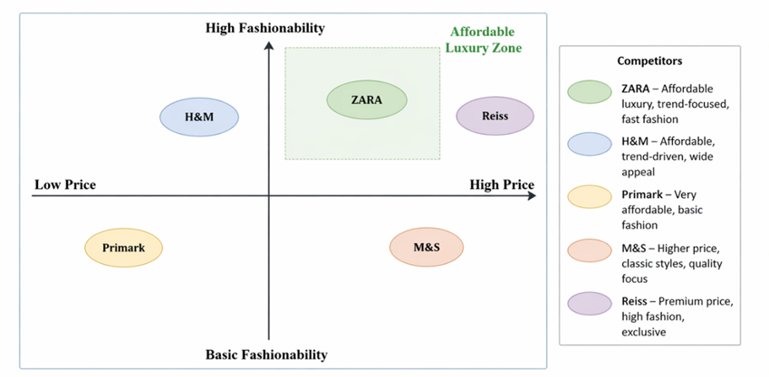
Figure 2: A diagram of a perceptual map based of UK (Author, 2026)

5. International Marketing Mix (7Ps) Analysis
The global marketing mix of Zara is outlined with a standardised approach which is aimed at optimising efficiency in operations and ensuring consistency of the global brand. Nevertheless, comparing the markets, like the UK and Pakistan, one can see that there are evident differences in the effectiveness of this strategy. Although the systems of the Zara are still globally interconnected, as seen in Table 3, their performance is highly differentiated because of the economic and cultural and infrastructural disparities.

5.1 Product Strategy
The marketing mix refers to the set of controllable tools (7Ps: product, price, place, promotion, people, process, and physical evidence; Figure 3) used to deliver value and influence consumer behaviour (Kotler and Keller, 2016; Armstrong and Kotler, 2019). Zara applies a largely standardised marketing mix to maintain global efficiency and brand consistency (Inditex, 2023). However, its effectiveness varies across markets. In the UK, the strategy is effective due to strong purchasing power and infrastructure, whereas in Pakistan it is less effective due to price sensitivity and cultural differences. As shown in Table 3, this highlights the limitation of standardisation and the need for localisation.
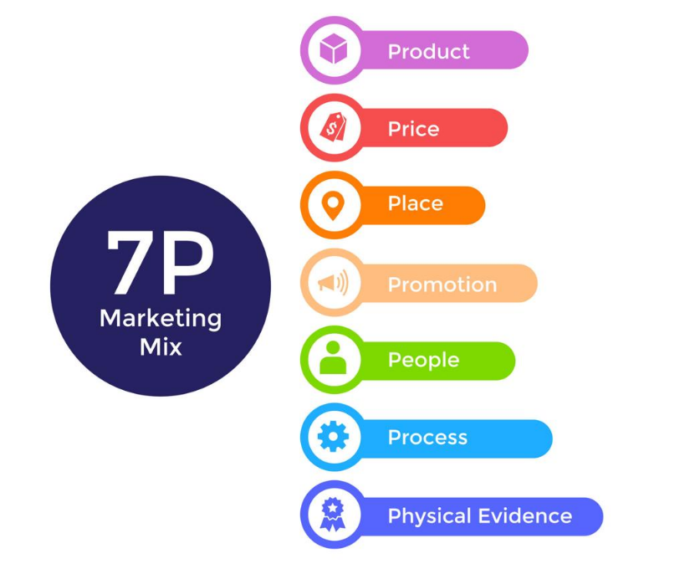
Figure 3: The 7Ps Marketing Mix Model
Source: Author (2026), adapted from Kotler and Keller (2016); Armstrong and Kotler (2019)

5.2 Pricing Strategy
Zara adopts a market-based pricing strategy in the UK, positioning itself within a mid-range segment supported by strong purchasing power and brand perception. his suggests a value-based pricing strategy where the price is commensurate with apparent fashionability and quality, making high sales volume possible. Furthermore, Zara also enjoys cost-effective economies from its scale of operation (Inditex, 2022; Inditex, 2023).
On the other hand, Zara in Pakistan uses a standardised global pricing strategy which backfires with imports duty costs because of high logistics and economic fluctuations. As a result, positioning them as premium products compared to local income levels that create a mismatch in intended product positioning and consumer affordability. Due to solid global margins (Inditex, 2022; Inditex, 2023), it confines market penetration as demonstrated in Table 3.
Table 3: Marketing Mix (7Ps) Comparison – UK vs Pakistan
Element | United Kingdom (UK) | Pakistan | Strategic Implication
Product | Full range, trend-driven collections | Limited cultural adaptation | Reduced relevance in Pakistan
Price | Competitive mid-range pricing | Premium due to import costs | Affordability constraints
Place | Advanced omnichannel (online + stores) | Limited physical presence, weaker e-commerce | Accessibility issues
Promotion | Minimal advertising, strong brand equity | Greater reliance on aspirational branding | Awareness gap
People | Skilled retail workforce | Developing service standards | Experience inconsistency
Process | Highly efficient, tech-driven operations | Same system but constrained by infrastructure | Operational inefficiencies
Physical Evidence | Premium store design, consistent branding | Selective store presence | Limited brand experience

5.3 Place (Distribution) Strategy
Zara’s distribution strategy is based on a centralised logistics system that enables fast global product movement and efficient inventory control. In the UK, this approach is favourable, supporting an advanced omnichannel model that integrates online and offline retail, improving accessibility and customer experience, as illustrated in Figure 4 (Inditex, 2024). In contrast, in Pakistan, distribution is partly unfavourable due to infrastructural limitations and restricted store presence in major cities. Additionally, logistical inefficiencies, particularly in last-mile delivery, reduce e-commerce effectiveness, as shown in Figure 5, thereby limiting overall market accessibility (Inditex, 2024).
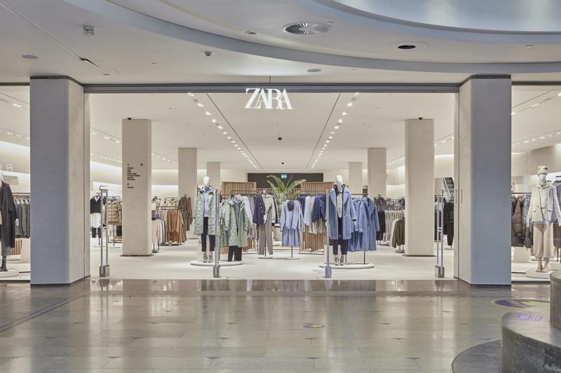
Figure 4: Zara Store in United Kingdom (Bargh, 2020)

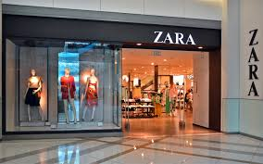
Figure 5: Zara Store – Pakistan (Franchising Key, 2019)

5.4 Promotion Strategy
The advertising effort by Zara is not the standard case as it does not make use of much of conventional advertising. Rather, the brand uses location, design, and product turnover of the store to stimulate consumer interest. The UK is a good market with excellent brand recognition and market maturity. This is not effective in Pakistan, where brand awareness is still in its infancy. Increased use of online marketing and promotions might be needed to increase visibility and consumer interaction. This introduces a gap in the level of awareness in the two markets as shown in Table 3.

5.5 People
Human resource is also crucial in the provision of the customer experience of Zara. In the UK, skilled personnel in the retail setting have helped in effective service and customer satisfaction that supports brand value. Pakistan In Pakistan, the training and service standards also might differ, and this might result in irregularities in customer experience. Although Zara follows global standards, the capacities of local workforce affect the delivery of services as expressed in Table 3.

5.6 Process
IT systems used by Zara to control inventory, sales, and supply chain operations drive processes within the company (Inditex, 2023). Efficiency and quick decision making are made possible by these systems. But they are effective and rely on supporting infrastructure. In the UK, operations run smoothly, further improving performance (Kotler and Keller, 2016). In Pakistan, there are infrastructural limitations that decrease efficiency, which may result in possible delays. This constraint is also demonstrated by the supply chain model of Zara depicted in Figure 6 that is very much dependent on speed and integration. This model throws light on how Zara can incorporate the customer feedback into its operations. Nevertheless, its dependence on speed and coordination of technology restricts flexibility in new markets.
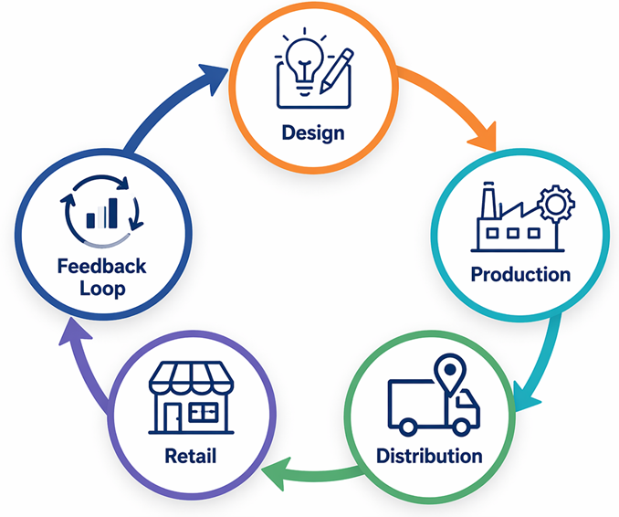
Figure 6: Zara Supply Chain Model (Adopted from Inditex, 2022; Author, 2026)

5.7 Physical Evidence
The physical evidence aspect in Zara is represented in how its stores are designed so that the brand identity can be reinforced through a consistent and high-quality shopping experience. This is good in the UK as well, where carefully designed stores have a role to play increasing customer engagement and supporting brand positioning (Inditex, 2024) amidst competitive retailing. The physical evidence part is not so great for Pakistan partly because of low number of stores where people can see the brand and interact. While the global store standards are kept, overall brand experiences under the influence of geographical limitations are also reduced (Table 3.)
Furthermore, Zara’s reliance on an internally driven marketing mix, rather than external adaptation, highlights a broader limitation of standardisation. While this approach improves efficiency, it reduces flexibility in responding to local market conditions. Consequently, the effectiveness of physical evidence varies across markets, requiring greater localisation for sustained competitiveness (Inditex, 2023; Inditex, 2024).

6. Directional Development Strategy (Focus on Pakistan)
The Ansoff Matrix can be applied to understand the expansion of Zara in Pakistan as a type of market development, in which the existing products are implemented in a new geographical market. This strategy capitalises on the international brand strength and capabilities of Zara. Market development is the main strategy that Zara uses in Pakistan as indicated in Table 4 whereas other strategic alternatives like product development are minimal as far as Zara is concerned.
Table 4: Ansoff Matrix Application – Zara in Pakistan
Strategy Type | Application to Zara | Critical Insight
Market Penetration | Limited due to high pricing | Constrained growth
Market Development | Entry into Pakistan | Primary strategy
Product Development | Minimal localisation | Weak adaptation
Diversification | Not applicable | High risk
Zara joining Pakistan is in line with the global expansion strategy of Inditex, which focuses on emerging markets that have high potential (Inditex, 2023). Though Pakistan has potential as urbanised and increased middle income, it cannot afford to solely rely on the geographic expansion. Table 3 demonstrates that access in this price-sensitive market is limited because of limited adaptation in pricing and product, which limits penetration. Additionally, reliance on centralised supply chains can result in inefficiencies because of infrastructural limitations (Inditex, 2023). All in all, the low-adaptation strategy used by Zara puts more emphasis on consistency than responsiveness, which restricts its growth opportunities unless it becomes more localised.

7. Ethical Issues in Zara’s International Marketing
The global fashion industry is becoming more focused on ethical considerations, especially in the framework of fast fashion models, where speed and high product turnover are prioritised. Zara is an affiliate of the Inditex, and it functions in such a system, which has been financially successful, but concerns the labour practices, environmental sustainability, and supply chain transparency. These problems differ in the UK and Pakistan markets since they are regulated and expected in different ways as it is presented in Table 5.
Table 5: Ethical Issues Comparison – UK vs Pakistan
Issue | United Kingdom (UK) | Pakistan | Strategic Implication
Labour Standards | Strict enforcement | Weak enforcement | Risk of inconsistency
Sustainability Pressure | High consumer awareness | Limited awareness | Uneven CSR expectations
Supply Chain Transparency | Strong scrutiny | Lower visibility | Reputational risk
Environmental Impact | Regulated and monitored | Less regulated | Potential ethical gaps

7.1 Labour and Supply Chain Ethics
An important ethical issue in the field of fast fashion is labour conditions. Inditex emphasises its efforts to keep track of suppliers and adherence to labour standards (Turker and Altuntas, 2014; Inditex, 2023). In the UK, there are higher standards through stringent regulation and publicity.
Conversely, Pakistan offers less enforcement and regulatory checks. Though this is not directly the production of Zara, the supply chain in the region is likely to pose a threat of inconstancy in labour practices. Such inconsistencies pose reputational risks, as revealed in Table 5 and especially at a time when global consumers insist on transparency.

7.2 Environmental Sustainability
High consumption and short product life cycle are some of the environmental issues that Zara contributes to due to its fast fashion model. Inditex has also launched sustainability projects, such as a circular economy and reducing emissions (Inditex, 2023). Sustainability is critical in the UK where there is a high level of regulatory pressure and consumer awareness. In Pakistan however, there is less awareness and a weaker regulation thereby minimising immediate pressure. This poses a strategic risk because unequal sustainability practices in markets can create the impression of having two sets of standards, which casts doubt on the credibility of global brands.

7.3 Ethical Marketing and Consumer Responsibility
The marketing strategy of Zara also brings about ethical issues since fast fashion fosters quick buying and discarding. Although this is revenue generating, it is contradictory to the objectives of sustainability. Despite Inditex advocating responsible business (Inditex, 2022; Inditex, 2023), there is still a disconnect between corporate promises and the actualities of its business model, notably in advanced markets where expectations are elevated. Zara is not facing operational but structural ethical issues. Although there is an improvement, discrepancies in markets (as indicated by Table 5) undermine credibility of CSR. International response to these problems involves, on the one hand, increased compliance, and on the other, increased alignment of global strategy and ethical demands.

8. Recommendations for Zara’s International Marketing Strategy
The analysis demonstrates that although Zara has an internationally integrated model that guarantees efficiency, it has considerable constraints in the emerging market like Pakistan. The subsequent suggestions seek to improve localisation, accessibility and ethical consistency summarised in Table 6.
Table 6: Strategic Recommendations for Zara
Issue Identified | Recommendation | Strategic Justification
High pricing in Pakistan | Introduce market-sensitive pricing or sub-lines | Increase accessibility and market penetration
Limited product adaptation | Develop culturally aligned collections | Improve relevance and demand
Weak market reach | Expand digital and physical presence | Capture wider consumer base
Ethical inconsistency | Standardise global CSR practices | Protect brand reputation
Sustainability pressure | Strengthen circular economy initiatives | Align with global expectations

8.1 Pricing Adaptation
The existing pricing model by Zara makes the brand high-end in Pakistan restricting its availability. To deal with this, the firm ought to use market-receptive prices or launch area-sensitive product lines. Even though Inditex enjoys economies of scale (Inditex, 2022), the rigid standardisation will hamper price-sensitive markets.

8.2 Product Localisation
Poor cultural adaptation decreases product relevancy in Pakistan. Zara ought to create local collections especially with taste of small fashion. This would enhance the fit with the consumer needs without affecting operational efficiency.

8.3 Omnichannel Expansion
The omnichannel model used by Zara in the UK is highly developed, and in Pakistan, it is underdeveloped. Mobile-based e-commerce would enhance accessibility and customer experience through investment and collaboration with local logistics providers (Inditex, 2024).

8.4 Ethical and CSR Consistency
Different ethical practices in different markets pose reputational risks. Zara ought to adopt a globalised CSR policy with uniformity, which would create transparency and increase trust in the stakeholders (Inditex, 2023). Overall, Zara should begin to change its approach to a more flexible one, which will be less standardised. Selective localisation, especially in pricing and product strategy is a necessary requirement as shown in Table 6 to enhance market penetration. In the absence of these adjustments, Zara will have the risk of not taking advantage of new markets such as Pakistan.
9. CONCLUSION
The analysis of Zara’s international marketing strategy across the United Kingdom and Pakistan highlights a clear tension between global standardisation and local adaptation. The vertically integrated model supported by fast supply chain and evidence-based decision-making ensures Zara a good competitive edge in mature markets, like the UK. In this case, the purchasing power, well-developed infrastructure, and style-focused customers will be in line with the fast fashion strategy of Zara, which will allow it to be efficient and maintain its performance in the market. Nonetheless, the results indicate that the model is not as effective in the new markets like Pakistan. Economic, cultural and infrastructural factors diminish the applicability of the standardised strategy of Zara. More specifically, market penetration is limited by high pricing, inadequate product adaptation, and by distribution channels that are restricted, positioning the brand as high-end, not affordable. Overall, the strategy of Zara provides operational efficiency but cannot be flexible in different markets. To become a sustainable global business, the company should be more balanced involving its strengths and more localised especially in the pricing, product development, and accessibility of the market.

SECTION 2: REFLECTIVE ACCOUNT

10. Reflective Account on the Research and Analysis Process
This reflection paper is a review of the procedure followed when researching, analysing, and developing the international marketing report on Zara through the Reflective Cycle as a systematic approach to Gibbs (Figure 7). The reflection evaluates critically the effectiveness of research approach, development of analytical and personal learning outcomes and the areas of improvement.
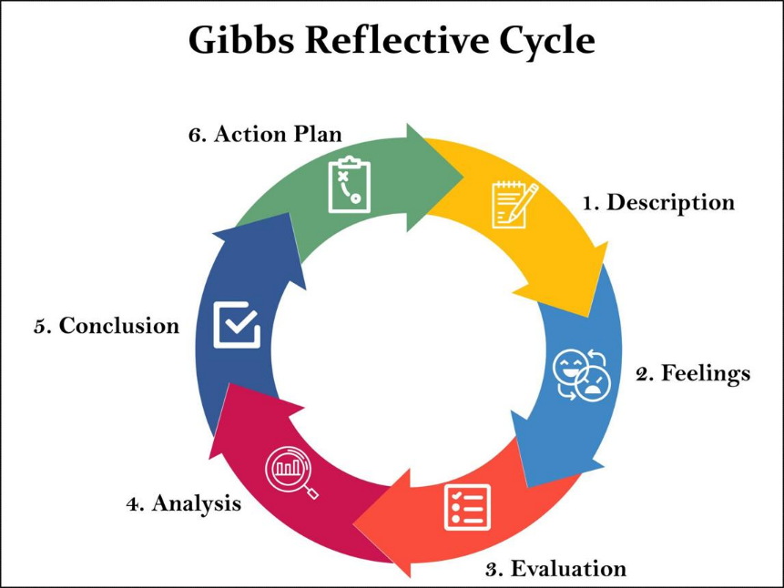
Figure 7: Gibbs’ Reflective Cycle (1988; cited in McLeod, 2025)

10.1 Description
The report entailed a comparative study of the international marketing strategy of Zara in two different markets: the United Kingdom and Pakistan. It started with the identification and screening of the important sources, especially with the annual reports of Inditex (20212024) that presented the primary data about the financial performance, operational model, and sustainability programs of the company. Academic theories like PESTEL, STP, and marketing mix framework were added to these reports.
The research stage entailed a synthesis of theoretical ideas as well as actual corporate facts to build a critical analysis. Tables and figures were introduced such as Table 1 (PESTEL) or Table 3 (Marketing Mix) to allow the organisation of the comparison and improve its clarity. This report was further systematised into sections according to the assignment requirements and there was a logical flow of macro-environmental analysis to strategic recommendations.

10.2 Feelings
At first, the task seemed to be easy because of being familiar with the marketing structures. But Level 7 demanded critical analysis that posed a great challenge. It was necessary to think in a different way as to go beyond descriptive writing to evaluative and analytical thinking. It was also a bit problematic to incorporate corporate data in annual reports to a theoretical analysis. Although the reports were very informative, to find the relevant knowledge and connect it to the marketing concepts, one needed to interpret the information carefully. With time, there was increasing confidence as patterns and interrelations between theory and practice became increasingly evident.

10.3 Evaluation
The credibility of the sources and the use of credible and current sources was one of the main strengths of the process, as it contributed to the reliability of the analysis, especially Inditex annual reports. These sources were integrated into the discussion, which made it possible to rely more on evidence-based approach in supporting arguments based on actual organisational data. Also, the comparative tables were used to enhance the clarity and organisation of the analysis. To take an example, Table 2 (STP Analysis) and Table 5 (Ethical Issues) allowed making a clear-cut between the UK and Pakistan, which supports the comparative character of the report. A general weakness, however, was the original inclination to descriptive writing. The initial drafts concentrated more on how to explain the concepts as opposed to how to critically analyse them. This necessitated a change so that it would answer questions of why and how, not just what.

10.4 Analysis
The process outlined the value of critical thinking when doing postgraduate work. The use of models like PESTEL and STP could not be simply implemented by theoretical knowledge; it needed to be able to process real-life information that is complex and make relevant conclusions. Among the learning outcomes was the fact that the global business models cannot be universal. Though it seems that the strategy employed by Zara is very productive on an international scale, the analysis has indicated that there are considerable weaknesses in the emerging economies like the one in Pakistan. This cemented the significance of contextual analysis in international marketing.
Moreover, the concept of sustainability and ethical integration implied the dynamism of marketing strategy. Corporate social responsibility is no longer a peripheral role but the focus of brand positioning and consumer perception. It was also a learning experience on how to research especially in determining the credibility of the sources and combining information using more than one reference. Annual report use was a cautious reading and interpretation since the information is usually held in a corporate view and should be critically evaluated.

10.5 Conclusion
In general, both analytical and research skills improved due to the process of writing the report. The shift in the writing style to the critical one is an important step, as the Level 7 study requires. The report was able to show the capability to apply theoretical frameworks in real-life situations, as well as how these frameworks have limitations. It also illustrated the significance of the balance between the global strategy and the local adaptation, which is also a crucial notion in international marketing. Nevertheless, the areas that can be further enhanced are the development of critical arguments and the work with a broader scope of academic literature.

10.6 Action Plan
To improve future academic work, several actions will be undertaken:
- Enhancing Critical Writing Skills: Greater focus will be placed on evaluating arguments rather than describing concepts. This will involve consistently addressing “why” and “so what” in analysis.
- Expanding Literature Use: Future work will incorporate a broader range of academic journal articles to strengthen theoretical grounding and critical depth.
- Improving Data Interpretation: Additional practice will be undertaken in analysing corporate reports and extracting relevant insights more efficiently.
- Time Management: Earlier planning and drafting will allow more time for revision and refinement, improving the overall quality of work.
- Strengthening Reflection: Future reflective writing will aim to provide deeper personal insight, linking experiences more explicitly to skill development.

REFERENCES
Armstrong, G. and Kotler, P. (2019) Marketing: an introduction. 14th edn. Harlow: Pearson.
Bargh, B. (2020) ‘Inside Zara’s new 37,000sqft UK flagship’, Cosmetics Business, 4 December. Available at: https://cosmeticsbusiness.com/news/article_page/Inside_Zaras_new_37000sqft_UK_flagship/172461 (Accessed: 21 April 2026).
Cavusgil, S.T., Knight, G., Riesenberger, J.R., Rammal, H.G. and Rose, E.L. (2014) International business. Melbourne: Pearson Australia.
Christopher, M., Lowson, R. and Peck, H. (2004) ‘Creating agile supply chains in the fashion industry’, International Journal of Retail & Distribution Management, 32(8), pp. 367–376.
Doyle, P. (2016) Marketing management and strategy. 5th edn. Harlow: Pearson.
Fletcher, K. (2013) Sustainable fashion and textiles: design journeys. London: Routledge.
Franchising Key (2019) ‘Zara’s Indian partner Tata is building its own apparel empire at half price’, Franchising Key, 6 August. Available at: https://www.franchisingkey.com/zara-franchise-for-sale-pakistan/ (Accessed: 21 April 2026).
Hollensen, S. (2020) Global marketing. 8th edn. Harlow: Pearson.
Inditex (2021) Annual report 2021. Available at: https://www.inditex.com/itxcomweb/api/media/5d3b3aec-3d72-41a0-9abd-275f2ac4a14c/2021%20Inditex%20Consolidated%20Annual%20Accounts.pdf (Accessed: 21 April 2026).
Inditex (2022) Annual report 2022. Available at: https://static.inditex.com/annual_report_2022/pdf/Inditex-group-annual-report-2022.pdf (Accessed: 21 April 2026).
Inditex (2023) Annual report 2023. Available at: https://static.inditex.com/annual_report_2023/en/Inditex_Group_Annual_Accounts_2023.pdf (Accessed: 21 April 2026).
Inditex (2024) Annual report 2024. Available at: https://www.inditex.com/itxcomweb/api/media/604197b9-50de-4f4f-ab84-c1e379cb3fd0/Inditex_Group_Annual_Report_2024.pdf (Accessed: 21 April 2026).
Jackson, T. and Shaw, D. (2017) Mastering fashion marketing. London: Palgrave.
Kapferer, J.-N. (2015) Kapferer on luxury. London: Kogan Page.
Kotler, P. and Keller, K.L. (2016) Marketing management. 15th edn. Harlow: Pearson.
Martin, J. and Blythe, J. (2023) Essentials of marketing. Available at: https://library.uniq.edu.iq/storage/books/file/Essentials_of_Marketing__3rd_Ed_Jim/1666785745Essentials_of_Marketing__3rd_Ed_Jim.pdf (Accessed: 21 April 2026).
McLeod, S. (2025) Gibbs reflective cycle. Simply Psychology. Available at: https://www.simplypsychology.org/gibbs-reflective-cycle.html (Accessed: 21 April 2026).
OECD (2022) Economic surveys: United Kingdom 2022. Available at: https://www.oecd.org/en/publications/oecd-economic-surveys-united-kingdom-2022_7c0f1268-en.html (Accessed: 21 April 2026).
Porter, M.E. (2008) ‘The five competitive forces that shape strategy’, Harvard Business Review, 86(1), pp. 78–93.
Solomon, M. (2020) Consumer behaviour: buying, having and being. 13th edn. Harlow: Pearson.
Turker, D. and Altuntas, C. (2014) ‘Sustainable supply chain management in the fast fashion industry: an analysis of corporate reports’, European Management Journal, 32(5), pp. 837–849. Available at: https://doi.org/10.1016/j.emj.2014.02.001 (Accessed: 21 April 2026).
UNEP (2019) Sustainability and circularity in the textile value chain. Available at: https://www.unep.org/resources/publication/sustainability-and-circularity-textile-value-chain-global-roadmap (Accessed: 21 April 2026).
World Bank (2023) Pakistan development update: recent economic development, outlook, and risks. Available at: https://thedocs.worldbank.org/en/doc/5ee854aff2b120cb30ef910f4e7421f9-0310012023/original/Pakistan-Development-Update-Report-April-2023.pdf (Accessed: 21 April 2026).

