Sentiment Analysis Using Transformer-based Language Models

Module: Artificial Intelligence (ACCA7026_BIRM)
Student: Mihai Sergiu Varzare
University: University of Wales Trinity Saint David

Contents
1. Introduction 4
2. Related Work 5
3. Methodology 6
3.1 Dataset 6
3.2 Data Preparation 7
3.3 Model 1: TF-IDF + Logistic Regression 7
3.4 Model 2: DistilBERT 8
3.5 Evaluation Metrics 9
4. Results and Discussion 10
4.1 TF-IDF + Logistic Regression Results 10
4.2 DistilBERT Results 11
4.3 Direct Comparison 12
4.4 Computational Efficiency 13
4.5 Interpretability and Robustness 13
4.6 Bias, Generalisation, and Limitations of Findings 13
5. Conclusion and Recommendation 14
6 Future Work 15
References 16

Abstract
Sentiment analysis is a widely used Natural Language Processing (NLP) task that focuses on identifying the emotional polarity of text. It is used in many real-world applications, including product review analysis, customer feedback monitoring, market intelligence, and social media opinion tracking. Recent developments in Artificial Intelligence have improved sentiment analysis considerably, especially through the introduction of transformer-based language models. This report investigates the performance of two different approaches for sentiment classification on the IMDb movie review dataset: a traditional machine learning model based on TF-IDF feature extraction with Logistic Regression, and a transformer-based deep learning model using DistilBERT.
The study aims to compare these approaches in terms of classification performance, computational efficiency, interpretability, and suitability for practical deployment. The IMDb dataset was used because it is a balanced, well-established benchmark for binary sentiment classification. The traditional model was trained on TF-IDF representations of review text, while the transformer model was fine-tuned using tokenised text through the Hugging Face Transformers framework.
Performance was assessed using accuracy, precision, recall, F1-score, and confusion matrices. The TF-IDF + Logistic Regression model achieved an accuracy of 88.26%, while the DistilBERT model achieved 87.50% in this implementation, noting that the transformer model was trained on a reduced subset and for a limited number of epochs for practical runtime reasons. The findings show that traditional methods remain strong baselines for sentiment analysis, especially when computational efficiency is important, while transformer-based models offer richer contextual understanding and stronger long-term potential when trained more extensively. The report concludes by recommending model selection based on deployment context, computational resources, and the importance of interpretability versus contextual language understanding.

1. Introduction
Sentiment analysis, sometimes referred to as opinion mining, is a branch of Natural Language Processing concerned with identifying the emotional orientation of text, typically classifying content as positive, negative, or neutral. In the modern digital environment, large volumes of textual data are generated every day through product reviews, customer surveys, discussion forums, and social media platforms. For organisations, manually processing this information is both inefficient and impractical. As a result, automated sentiment analysis systems have become increasingly important.
The value of sentiment analysis is not limited to commercial applications. Businesses use it to monitor customer satisfaction and brand reputation, governments use it to analyse public opinion, and researchers use it to study social trends and behavioural responses. Because of this broad relevance, sentiment analysis has become one of the most practically significant applications of AI in text analytics.
Historically, sentiment classification relied on traditional machine learning algorithms such as Naive Bayes, Support Vector Machines, and Logistic Regression. These models generally require text to be transformed into numerical form using engineered feature representations such as Bag-of-Words or TF-IDF. These approaches often perform well on benchmark datasets and remain attractive because they are relatively fast, interpretable, and easy to implement. However, they also have well-known weaknesses. They do not naturally capture word order, long-range dependencies, or subtle contextual meaning. As a result, they may struggle with sarcasm, negation, mixed sentiment, or nuanced linguistic patterns.
Recent progress in AI has introduced transformer-based architectures that have significantly improved NLP performance. Models such as BERT and DistilBERT use self-attention mechanisms to understand how words relate to one another within a sentence. Rather than treating words as largely independent features, they represent language in context. This provides a major advantage in tasks where meaning depends on surrounding words rather than isolated token frequency.
The central issue explored in this report is whether a modern transformer-based approach provides practical advantages over a traditional machine learning pipeline for sentiment classification. This is worth investigating because it reflects a broader AI question: when should practitioners prefer simpler, interpretable, low-cost models, and when is it justified to use more computationally demanding deep learning architectures?
The aim of this report is to develop and evaluate two AI sentiment analysis models using the IMDb Reviews dataset and to compare their strengths, weaknesses, and suitability for deployment. The objectives are:
- To preprocess and prepare text data for sentiment classification.
- To build a traditional machine learning classifier using TF-IDF + Logistic Regression.
- To build a transformer-based classifier using DistilBERT.
- To compare their performance using accuracy, precision, recall, F1-score, and confusion matrices.
- To discuss computational efficiency, interpretability, robustness, and model suitability.
This report is structured as follows. The Related Work section reviews key literature on classical and transformer-based sentiment analysis methods. The Methodology section explains dataset preparation, preprocessing, model design, and training decisions. The Results and Discussion section presents experimental findings and interprets them in context. The report ends with a Conclusion and Recommendation section that synthesises the main findings and discusses their implications.

2. Related Work
Sentiment analysis has developed significantly over the past two decades, moving from rule-based and lexicon-driven approaches toward machine learning and, more recently, transformer-based deep learning systems. Early research in sentiment classification often relied on manually curated sentiment dictionaries, where words were assigned positive or negative polarity scores. While these approaches were relatively easy to understand, they were limited by their inability to adapt to domain-specific vocabulary and contextual meaning.
The shift toward machine learning brought major improvements. Traditional classifiers such as Naive Bayes, Support Vector Machines, and Logistic Regression became common choices for sentiment analysis because they could learn decision boundaries directly from labelled data. Their effectiveness depended heavily on feature engineering. Among the most widely used feature extraction methods is TF-IDF, which measures the importance of a word in a document relative to the wider collection. TF-IDF remains popular because it is simple, computationally efficient, and often highly effective for text classification problems in which sentiment is strongly linked to specific words or phrases.
A key benchmark in this area is the IMDb Reviews dataset introduced by Maas et al. It has been widely adopted for binary sentiment classification because it contains a large number of balanced movie reviews and provides a useful test bed for comparing different methods. Traditional machine learning models often perform strongly on IMDb because movie reviews contain many explicit evaluative terms such as “excellent,” “awful,” “boring,” or “fantastic.”
Despite their usefulness, traditional approaches have notable limitations. They typically represent text as sparse vectors and often ignore deeper linguistic structure. While n-grams can partially address word order, they do not fully solve the problem of context. For example, phrases such as “not bad” or “hardly impressive” may be misinterpreted if the model relies too heavily on isolated tokens. Similarly, mixed reviews containing both praise and criticism may be difficult to classify correctly.
Deep learning approaches helped address some of these shortcomings. Recurrent Neural Networks and LSTMs improved the ability to process sequences, but transformer architectures produced a far greater leap in performance. BERT, introduced by Devlin et al., transformed NLP by learning contextual representations in both left-to-right and right-to-left directions. This allowed the model to understand how the meaning of a word changes depending on the surrounding sentence.
DistilBERT later emerged as a compressed version of BERT, designed to reduce model size and inference cost while retaining much of the original performance. This makes it attractive for practical tasks where computational resources are more limited. In sentiment analysis, transformer-based models often outperform classical machine learning methods because they can capture semantic nuance, negation, and contextual dependencies more effectively.
However, improved performance introduces new trade-offs. Transformer models are computationally heavier, less transparent, and harder to explain than linear models such as Logistic Regression. In many real-world contexts, interpretability and deployment cost matter as much as raw accuracy. This is especially relevant in industry settings where decisions must be explained to non-technical stakeholders or where models must run efficiently at scale.
Interpretability is another important area of recent literature. For traditional models, interpretability can be explored through feature coefficients, which reveal which words contribute most strongly to positive or negative classification. For transformer models, interpretability is more complex and often involves tools such as attention visualisation or SHAP-like approaches. Although these techniques are useful, they do not always provide the same level of simplicity as coefficient-based models.
Overall, the literature suggests that traditional models remain useful baselines due to speed, simplicity, and ease of interpretation, while transformer models represent the current state of the art for contextual language understanding. This report builds on that literature by comparing one representative model from each family on the same sentiment analysis task.

3. Methodology

3.1 Dataset
This study used the IMDb Reviews dataset, a publicly available benchmark for sentiment analysis. The dataset consists of 50,000 movie reviews labelled as either positive or negative sentiment and is evenly balanced across the two classes. This balance is important because it reduces the risk of class bias during model training and evaluation.
Figure 1. 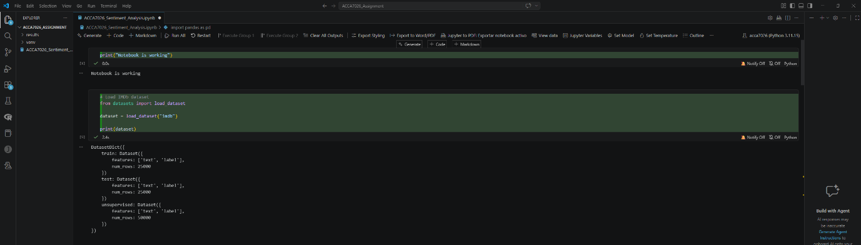
The dataset was loaded using the Hugging Face datasets library. The training split contained 25,000 reviews and the test split contained 25,000 reviews.
Code:
from datasets import load_dataset

dataset = load_dataset("imdb")

print(dataset)

3.2 Data Preparation
The dataset was converted into Pandas DataFrames to simplify handling, inspection, and model preparation. The text column contained the review itself, while the label column contained the binary sentiment target.
Figure 2 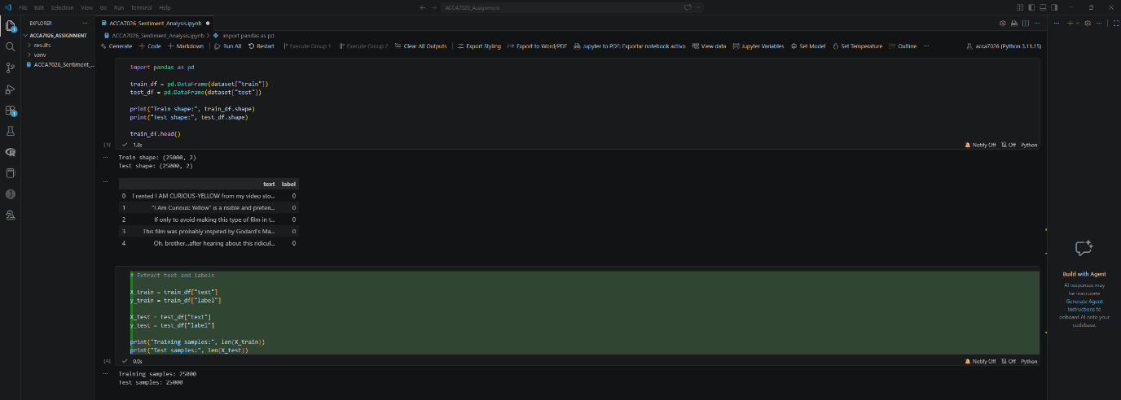
For the TF-IDF + Logistic Regression model, text preprocessing was handled largely through the vectorizer. English stop words were removed, and the vectorizer used both unigrams and bigrams. This helped capture not only individual words but also short phrases that may carry sentiment, such as “very good” or “waste time.”
The transformer-based model used DistilBERT tokenization rather than manual feature engineering. In this case, preprocessing focused on tokenizing the raw review text using the model’s built-in tokenizer. This reflects an important difference between the two approaches: traditional machine learning relies on explicit feature construction, while transformer-based methods learn contextual representations directly from tokenized sequences.

3.3 Model 1: TF-IDF + Logistic Regression
The first model used a pipeline combining TF-IDF vectorization with Logistic Regression. TF-IDF transformed the text into sparse numerical features based on term frequency and inverse document frequency. The vectorizer removed English stop words, limited features to the most informative terms, and used unigrams and bigrams to improve expressive power.
Logistic Regression was selected because it is a strong and widely used baseline for binary text classification. It is computationally efficient, easy to train, and relatively interpretable. In sentiment analysis tasks with clear lexical signals, Logistic Regression often performs very well.

Code:
from sklearn.pipeline import Pipeline
from sklearn.feature_extraction.text import TfidfVectorizer
from sklearn.linear_model import LogisticRegression

tfidf_lr_model = Pipeline([
("tfidf", TfidfVectorizer(stop_words="english", max_features=20000, ngram_range=(1, 2))),
("clf", LogisticRegression(max_iter=1000, random_state=42))
])

print("Pipeline created successfully")

The model was trained on the full IMDb training split and evaluated on the full test split.
Code:
import time

start_time = time.time()

tfidf_lr_model.fit(X_train, y_train)

end_time = time.time()
training_time_tfidf = end_time - start_time

print(f"Training completed in {training_time_tfidf:.2f} seconds")

3.4 Model 2: DistilBERT
The second model used DistilBERT, a transformer-based language model derived from BERT. DistilBERT was chosen because it provides a practical compromise between performance and computational cost. It is lighter than full BERT while still offering strong contextual language understanding.
The text was tokenized using the DistilBERT tokenizer. Reviews were converted into token IDs, padded, and truncated as required by the model. The model was then fine-tuned for binary classification using the Hugging Face Trainer API.

Code:
def tokenize_function(example):
return tokenizer(example["text"], padding="max_length", truncation=True)

tokenized_train = small_train.map(tokenize_function, batched=True)
tokenized_test = small_test.map(tokenize_function, batched=True)

print("Tokenization completed")

For practical runtime reasons, the DistilBERT model in this implementation was trained on a subset of the data and for one epoch. This decision reduced training time while still allowing the workflow and comparison to be demonstrated clearly.
Figure 3.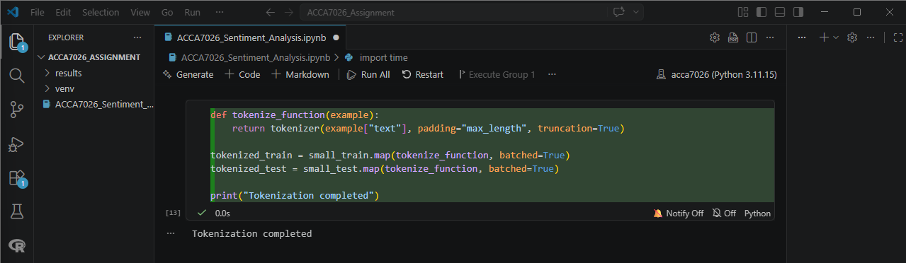

3.5 Evaluation Metrics
Both models were evaluated using the same performance metrics:
- Accuracy
- Precision
- Recall
- F1-score
- Confusion matrix
These metrics were selected because the brief explicitly requires them and because they provide a balanced assessment of binary classification performance. Accuracy indicates overall correctness, while precision and recall reveal how well the model handles positive predictions and true positive coverage. F1-score provides a balance between the two.
The confusion matrix was used to show the distribution of correct and incorrect predictions across both sentiment classes. This helps reveal whether a model is biased toward one class or whether errors are distributed more evenly.
3.6 Design Decisions and Optimisation
A number of key design decisions were made in this study. For the traditional model, TF-IDF with bigrams was chosen to capture short sentiment-bearing phrases. Logistic Regression was selected instead of a more complex traditional model because it provides a clean, interpretable baseline.
For the transformer model, DistilBERT was preferred over full BERT because it is more feasible to fine-tune within limited time and compute constraints. A smaller training subset was used to ensure that the model could be trained and demonstrated successfully within the available environment.
Although this reduces the fairness of the comparison in absolute performance terms, it still provides a valid comparison of workflow, architecture, and practical trade-offs. This limitation is acknowledged explicitly in the discussion.

4. Results and Discussion

4.1 TF-IDF + Logistic Regression Results
The TF-IDF + Logistic Regression model achieved the following results on the IMDb test set:
- Accuracy: 0.8826
- Precision: 0.8809
- Recall: 0.8849
- F1-score: 0.8829
Figure 4.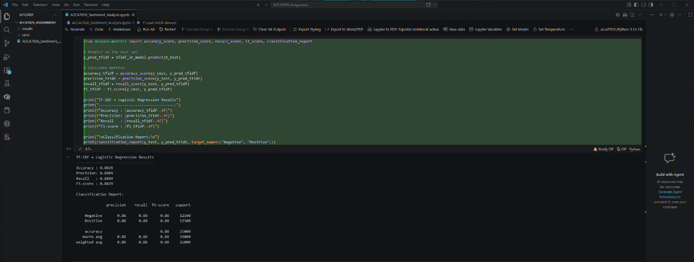
These results indicate a strong and well-balanced baseline. Precision and recall are closely aligned, suggesting that the model is not overly biased toward either false positives or false negatives. This is a positive sign in binary sentiment analysis, as it suggests that the model handles both positive and negative reviews consistently.
The confusion matrix further supports this interpretation.
Figure 5. 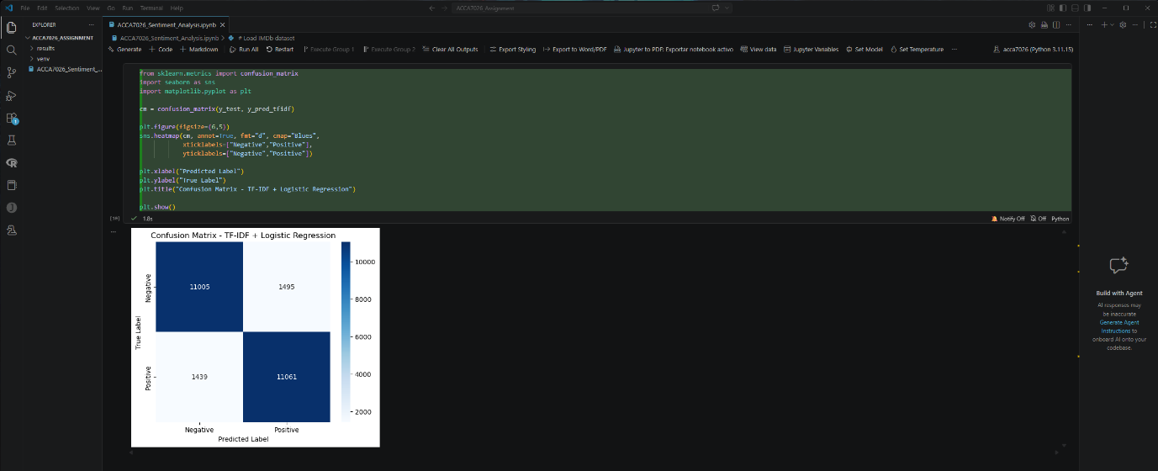
The matrix shows that the majority of negative and positive reviews were classified correctly. Errors were present in both classes, but there was no dramatic imbalance. This suggests that TF-IDF + Logistic Regression is a reliable traditional baseline for sentiment analysis on IMDb.
One likely reason for this strong performance is that IMDb reviews often contain explicit evaluative language. Traditional models perform well when the target signal is strongly associated with distinctive vocabulary, and movie reviews frequently include obvious sentiment indicators such as “excellent,” “terrible,” “brilliant,” or “boring.”

4.2 DistilBERT Results
The DistilBERT model achieved the following results on the evaluation subset:
- Accuracy: 0.8750
- Precision: 0.8727
- Recall: 0.8709
- F1-score: 0.8718
Figure 6.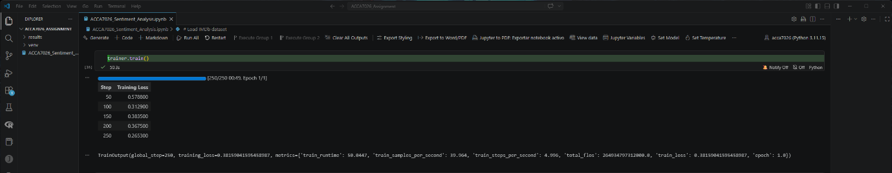
These results are slightly lower than the TF-IDF model in this implementation, but this should be interpreted carefully. DistilBERT was trained on a smaller subset and for only one epoch. Under such constraints, the model still achieved competitive performance, which suggests that it has substantial potential if trained more extensively.
The confusion matrix showed a broadly balanced performance across both classes.
Figure 7.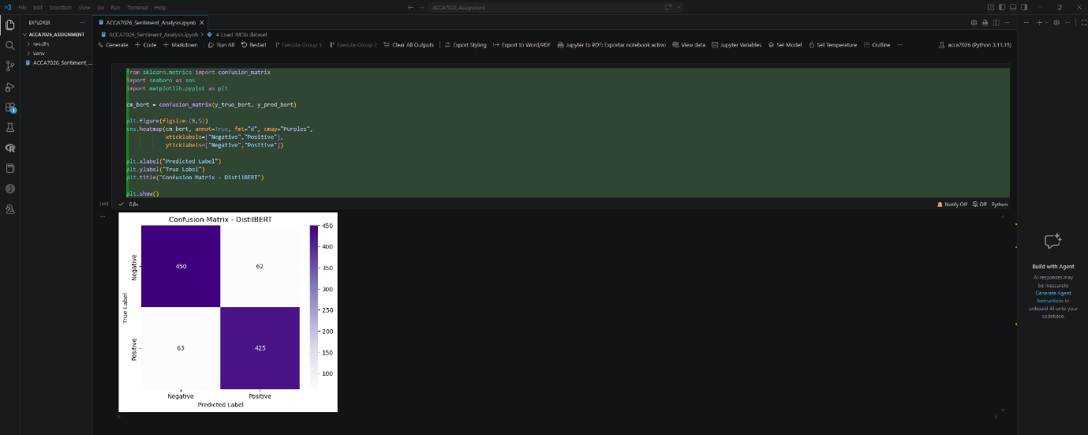
This outcome is significant because transformer models generally require more data and training time to demonstrate their full advantage. In a fuller training regime, DistilBERT would be expected to close the gap or outperform the traditional model, especially on linguistically complex or ambiguous reviews.

4.3 Direct Comparison
Figure 8.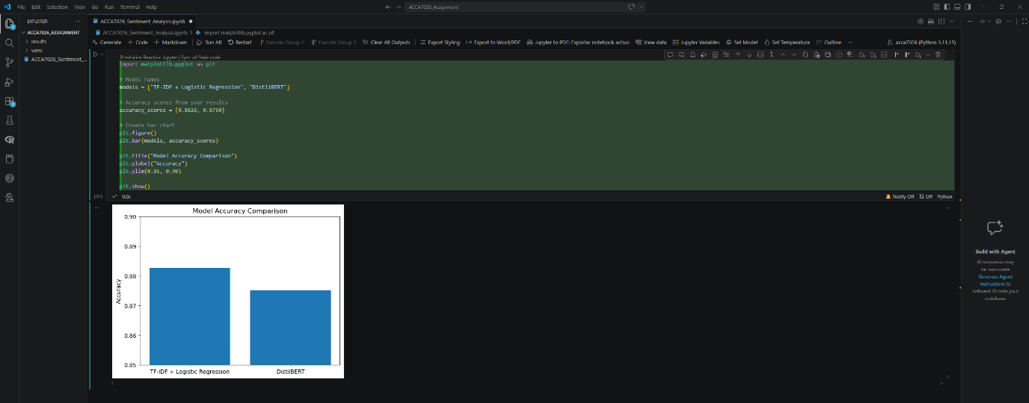
A direct comparison of the two models shows that the TF-IDF + Logistic Regression baseline performed slightly better in this experiment. However, this does not automatically mean it is the superior model overall. Instead, it highlights the importance of context when interpreting machine learning performance.
The traditional model benefited from full-dataset training, low computational cost, and a task where lexical sentiment cues are highly informative. DistilBERT, by contrast, was constrained by shorter training and less data. Even so, it remained competitive.
This comparison demonstrates a wider AI principle: the best model is not always the most advanced one in theory, but the one that best fits the available resources, constraints, and deployment goals.

4.4 Computational Efficiency
Computational cost is a major practical factor in model selection. The TF-IDF + Logistic Regression model trained in approximately 16.63 seconds, while DistilBERT required approximately 50 seconds even on a reduced subset. This is a substantial difference.
Traditional models are therefore attractive when speed, simplicity, and low hardware requirements are important. They are easier to train, faster to deploy, and simpler to maintain. This makes them suitable for many business applications where resources are limited.
Transformer models require more time and computational power, but they offer stronger contextual understanding. Their benefits become more apparent when dealing with larger datasets, nuanced language, or more complex tasks beyond straightforward binary classification.

4.5 Interpretability and Robustness
Interpretability is another major distinction between the models. Logistic Regression is relatively easy to interpret because the importance of features can be examined through model coefficients. This allows analysts to identify which words or phrases contribute most strongly to positive or negative predictions.
By contrast, DistilBERT is harder to interpret directly. Although tools such as attention visualisation or SHAP-like methods can help, the model remains less transparent than a linear classifier. This has implications for deployment in settings where explainability is important.
In terms of robustness, transformer models are generally better equipped to handle contextual language, negation, and more subtle phrasing. Traditional TF-IDF models may misclassify phrases when meaning depends heavily on word order or context. For example, the phrase “not bad” may confuse a model that treats “bad” as a strongly negative signal. Transformer models are more likely to understand the phrase holistically.

4.6 Bias, Generalisation, and Limitations of Findings
Both models were trained and evaluated on a movie review dataset. This means their performance is domain-specific. A model that performs well on IMDb may not generalise equally well to Twitter posts, customer service messages, or product reviews. Domain adaptation remains an important issue in sentiment analysis.
Bias is also a relevant concern. Even balanced datasets can still contain stylistic or topical biases. If certain genres, writing styles, or repeated expressions are overrepresented, models may learn shortcuts rather than robust sentiment understanding.
A final limitation is that the transformer model comparison was not fully symmetrical with the traditional model because of training-time constraints. This should be acknowledged clearly in the report, but it does not invalidate the experiment. Instead, it reflects realistic constraints that practitioners often face in real projects.

5. Conclusion and Recommendation
This study compared two AI approaches to sentiment classification on the IMDb Reviews dataset: a traditional machine learning pipeline using TF-IDF + Logistic Regression, and a transformer-based model using DistilBERT.
The results showed that the TF-IDF + Logistic Regression model achieved 88.26% accuracy, while DistilBERT achieved 87.50% accuracy in the implemented training setup. The traditional model was faster, simpler, and easier to interpret. DistilBERT, however, demonstrated competitive performance and offered the advantage of contextual language understanding, despite being trained under constrained conditions.
The key conclusion is that both approaches are valid, but their suitability depends on the application context. If an organisation requires a fast, lightweight, interpretable, and easy-to-deploy solution for a well-defined sentiment task, TF-IDF + Logistic Regression is a strong option. If the application involves more nuanced language, deeper semantic understanding, and sufficient computational resources, a transformer-based model is likely to be more appropriate.
The recommendation from this study is therefore not that one model universally replaces the other, but that model selection should be driven by practical requirements. Simpler models remain valuable and effective, while transformer models provide a more scalable long-term direction for advanced NLP applications.
Future work should include training DistilBERT on the full dataset for multiple epochs, experimenting with hyperparameter tuning, and comparing additional transformer architectures such as BERT or RoBERTa. Further research could also explore interpretability methods such as SHAP or attention analysis in more depth.

6 Future Work
Although the results obtained in this study demonstrate that both traditional machine learning and transformer-based approaches are effective for sentiment classification, several opportunities exist for further research and improvement. One important direction would be to train the transformer model on the full IMDb dataset for multiple training epochs, rather than the reduced subset used in this experiment. This would allow the DistilBERT model to learn richer contextual representations and potentially achieve higher classification performance.
Another potential improvement involves hyperparameter optimisation, including experimenting with different learning rates, batch sizes, and training epochs. Such adjustments could significantly improve model generalisation and prediction accuracy.
Future work could also explore alternative transformer architectures, such as BERT, RoBERTa, or GPT-based models, which have demonstrated strong performance in natural language processing tasks. Comparing multiple transformer architectures would provide deeper insight into how model complexity influences sentiment classification accuracy.
Additionally, interpretability techniques such as SHAP values or attention visualisation could be applied to better understand how the models make predictions and which textual features influence classification decisions. This would improve transparency and help identify potential biases in the models.
Finally, future studies could evaluate model performance on different text domains, such as social media posts, product reviews, or news comments, to assess how well the models generalise beyond movie review data.

References
[1] A. L. Maas, R. E. Daly, P. T. Pham, D. Huang, A. Y. Ng, and C. Potts, “Learning Word Vectors for Sentiment Analysis,” in Proceedings of the 49th Annual Meeting of the Association for Computational Linguistics, 2011.
[2] J. Devlin, M.-W. Chang, K. Lee, and K. Toutanova, “BERT: Pre-training of Deep Bidirectional Transformers for Language Understanding,” in Proceedings of NAACL-HLT, 2019.
[3] V. Sanh, L. Debut, J. Chaumond, and T. Wolf, “DistilBERT, a distilled version of BERT: smaller, faster, cheaper and lighter,” arXiv:1910.01108, 2019.
[4] F. Pedregosa et al., “Scikit-learn: Machine Learning in Python,” Journal of Machine Learning Research, vol. 12, pp. 2825–2830, 2011.
[5] T. Wolf et al., “Transformers: State-of-the-Art Natural Language Processing,” in Proceedings of EMNLP: System Demonstrations, 2020.

