Executive Summary
Data mining combines statistics, machine learning, artificial intelligence, data base and data warehousing. Businesses have used data mining for years to transform data into predictions and usable insights. Managers are then able to turn those insights found in the data into actions to market campaigns, increase sales, detect fraud. To these organisations data mining is their greatest assets of staying ahead of the competition. Specially to assist in the development of customized marketing programs. Using data mining techniques on software like Weka and RapidMiner

Introduction
We will define data mining, give real life applications and look at the different data mining software and compare these to contrasting types of software available on the market such as WEKA.
Referring to the main data mining approaches of prediction, association and clustering. This report aims to justify the use of data mining software in marketing and business professionals.

What Is Data Mining
Data mining combines statistics, machine learning, artificial intelligence, data base and data warehousing.
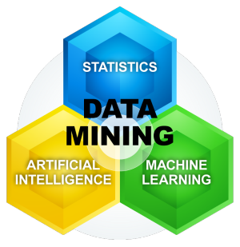
Abeer Badr El Din Ahmed tells us Data mining refers to extracting or "mining" knowledge from large amounts of data. Data mining techniques are used to operate on large volumes of data to discover hidden patterns and relationships helpful in decision making

Data mining allows you to:
- Sift through all the chaotic and repetitive noise in your data.
- Understand what is relevant and then make good use of that information to assess likely outcomes.
- Accelerate the pace of making informed decisions.

We are creating data every time we purchase, subscribe, use our cards at the shop , online or even at the petrol pump. Business over the years have stored huge amounts of data and a way to extract actionable information from this data is by the process of using computer program to find patterns or relationships in data than then can then be used. This is essentially is data mining. For example, if you are marketing manager for a major store such as Tesco you may want to know what products are frequently bought together with the goal to create more sales, profits through marketing campaigns.
Market Basket Example (association rule mining “ARM”)
Fig 1 mike parker of superioranalytics.org

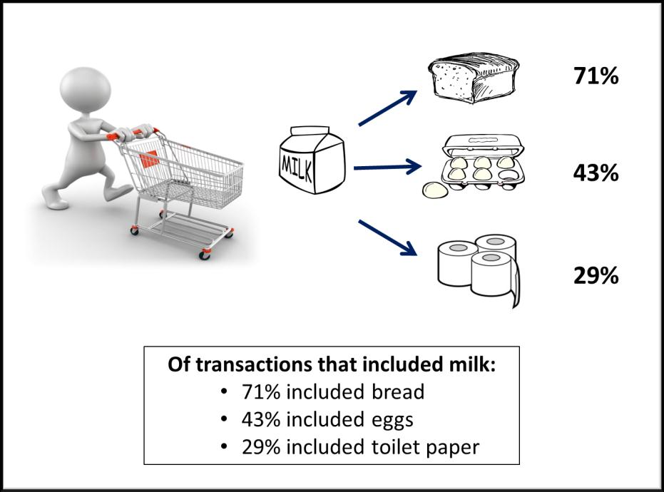

Data mining has many potential uses in marketing, including customer acquisition, customer retention, customer abandonment and market basket analysis Parker 1998

Data Techniques
Businesses have used data mining for years to transform data into predictions and usable insights. Managers are then able to turn those insights found in the data into actions to market campaigns, increase sales, detect fraud. To these organisations data mining is their greatest assets of staying ahead of the competition. For example marketing campaigns, based on traditional approaches could often result in poor response rate and increased cost. Most organizations have built up massive databases about their customers and their purchase transactions. Marketing with the useful information found in this data using data mining tools has transformed marketing. Gartner (sited Laney & Jain, 2017) predicts that 30% of new revenue growth from industry-specific solutions will include AI technology by 2021).
Predictive modelling is the process where analysis predicts a outcome. Used in business for predicting what their customer is likely to do. For example, will their customers want to pay for a specific product or are the likely to respond to a campaign. This can be useful for guiding decisions by eliminating some of the risk and marketing trends can be used for evaluating marketing programs or to forecast future sales
Zeng (2018) These prediction models become the basis for most business decisions by utilizing the data mining techniques of extracting usable information from vast resources of data. It will transform the way business is conducted as human decision making is increasingly replaced by algorithmic output.

Association rule is a data mining algorithm that discovers conditions that occur frequently together in a given set of data. Popular in retail to help predict customers behaviours, such as the example given earlier ( fig 1 the market basket ) on which items get frequently bought together or even at what time of the day are they likely to be bought together (eg if someone bought bacon in the morning they are likely to buy bread). This information can then be used to priorities marketing strategies such as product promotions or pricing as well as strategically placing these items close together on the shelf.
Abeer Badr El Din Ahmed tells us Clustering is analysing data and finding groups or clusters of such that the objects in one group will be similar to one another and different from the objects in another group. Clustering method is to automatically segment customers by behaviour, demographics or attitudes – to better understand needs of specific groups and serve them in a more targeted way SAS (2016) this translates over to marketing where Parker 1998 tells us Its purpose is to assist in the development of customized marketing programs that can be targeted to cluster members in hopes that they will buy more or become more loyal. For example, demographic characteristics, lifestyle descriptors, and actual product purchases might be used to segment mail-order

Fig 2: 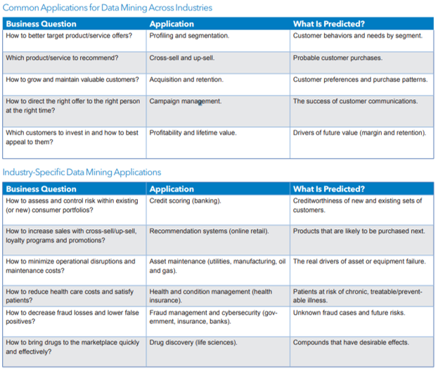

Software comparison
The WEKA (Waikato Environment for Knowledge Analysis) is a Data Mining tool, it is free to download. WEKA is an open source software supplying algorithm for data mining task.. WEKA is Java based software and can also run in different platforms with the Java based version,
Fig.3 PARAMETRIC COMPARISON OF DATA MINING TOOLS Neha Chauhan, Nisha Gautam
Advantages
- Easy to manipulate the data.
- Provide access to SQL databases. •
- It provides two options for the user to interact through Explorer and Command line
- Specially used for data mining
- It provides various machine learning algorithms for data mining tasks
- It supports various standard Data mining tasks that include: Data preprocessing, Clustering and Classification, Regression, Visualization and Feature selection
Disadvantages
- Memory is limited and has lesser performance
- Data visualization and data survey is limited
- Not better suitable option for the large datasets as they roughly handled
- Lacking in the representation to the result of processing
- Limited ability to partition dataset to training and test set
- It doesn’t accept data in every format (data format constraints)
- Not good in interfacing with other software

RapidMiner is also an open source java based system for data mining mainly used for business application.
Fig3.1 Fig.3 PARAMETRIC COMPARISON OF DATA MINING TOOLS Neha Chauhan, Nisha Gautam
Advantages
- It has enormous flexibility
- It provides the integration of maximum algorithm of such tools
- Easy to debug the errors.
Disadvantage
- Limited partitioning abilities for dataset to training and testing sets.
Weka and RapidMiner are very similar both are open source java based for data mining, both are pretty easy to use if you have some knowledge. Rapid miner is more flexible, has better visualization. provides an integrated environment for machine learning, data mining, text mining, predictive analysis and business analytic.

Conclusion
Business over the years have stored huge amounts of data. Data mining allows you to Sift through all the chaotic and repetitive noise in your data to find patterns or relationships in data than then can then be used. Managers are then able to turn those insights found in the data into actions to market campaigns, increase sales, detect fraud. Data mining has become an essential tool to stay ahead off the competition. Organisations now have proven the model works. Software like RapidMiner has made this tool affordable and excess able for any size organisation

Data Mining Report
The Justification of Data Mining in Business

Leon Rees

Reference page

Abeer Badr El Din Ahmed , Ibrahim Sayed Elaraby . "Data Mining: A prediction for Student's Performance Using Classification Method." World Journal of Computer Application and Technology 2.2 (2014) 43 - 47. doi: 10.13189/wjcat.2014.020203

investopedia. (2019). datamining. Available: https://www.investopedia.com/terms/d/datamining.asp. Last accessed 01/12/2019.

PEACOCK, P.R., 1998. Data mining in marketing: Part 1. Marketing Management, 6(4), pp. 8-18.

Superioranalytics. (2018). how to apply a market basket. Available: http://www.superioranalytics.org/. Last accessed 01/12/2019

Data Mining From A to Z: How to Discover Insights and Drive Better Opportunitie
Sas 2016
https://www.sas.com/content/dam/SAS/en_us/doc/whitepaper1/data-mining-from-a-z-104937.pdf

