

Joseph Nelhams

Understanding the importance of critical diameter and critical density in the detonation process

School of Applied Computing
ACDA4019 Principles of OME

Academic Year: 2025 - 2026

Lecturer: Gareth Collett

December 2025

Table of Contents
List of Figures 3
List of Tables 4
1 Introduction 5
1.1 Assignment Breakdown 5
1.2 Definitions 5
1.2.1 Critical Diameter and Critical Density 5
1.2.2 Critical Diameter and Critical Thickness 6
1.2.3 Confinement 6
2 Primary Explosive 7
2.1 Lead Styphnate 7
2.2 Properties of LS 8
2.2.1 Oxygen Balance calculation for LS 8
2.3 Confinement of LS 9
3 Secondary Explosive 10
3.1 RDX 10
3.2 Properties of RDX 11
3.2.1 Oxygen Balance calculations for RDX 11
3.3 Confinement of RDX 11
4 Explosive Train 13
4.1 Outline of an Explosive Train containing LS and RDX 13
References 16
Appendices 17
Appendix A Abbreviations 17

List of Figures
Figure 1 - Molecular structure of LS [7] 7
Figure 2 - Molecular Structure of RDX [8] 10
Figure 3 - Explosive train containing LS, RDX and a source of ignition under confinement 14

List of Tables
Table 1 - The effects of confinement on the critical diameter of Comp-B3, as shown in the “LLNL Explosives Handbook” [3]. 6
Table 2 - Table of properties of LS collated from multiple sources [4,5,6] 8
Table 3 - Quantities of CHNO atoms within one molecule of LS 8
Table 4 – Table of properties of unconfined RDX taken from the “LLNL Explosives Handbook [3]” 11
Table 5 - Quantities of CHNO atoms in one molecule of RDX 11
Table 6 – Minimum densities and diameters required for successful detonation of the explosive train 14

Introduction

Assignment Breakdown
This report aims to explain the importance of critical diameter and critical density to achieve successful detonation. One primary explosive and one secondary explosive are reviewed, with their explosive properties, including critical diameter and density, gathered from published literature. These explosives will then be analysed as part of a full explosive assembly, also known as an explosive train.

Definitions

Critical Diameter and Critical Density
Critical diameter and critical density are two parameters that outline whether an explosive or explosive train will successfully detonate. [1] The critical diameter is defined as the minimum diameter of an explosive charge required for the detonation front to propagate throughout the material. If an explosive charge has a diameter less than its critical diameter, then the reaction will not be able to sustain throughout the explosive. Instead, the explosive may partially detonate, deflagrate, or even fail entirely.
The critical density is the minimum density an explosive must have for a detonation front to successfully propagate throughout an explosive material. Below this density, a shock wave cannot be sustained, and detonation will fail.
[2] Some explosives, particularly primary explosives, can be too dense to sustain a detonation front; this is known as dead pressing. The reasoning behind this behaviour is due to how explosives might detonate in the first place. When a shock is applied to an explosive, small voids, cracks, or grain boundaries within the material will compress. As this happens, the pressure ramps up significantly, thus causing the temperature in that area to increase; these are known as hot spots. The hot spots get extremely hot, imparting enough energy into the explosive to reach the activation energy required for the explosive material to start chemically reacting. If the material is dead pressed, then these voids are either too small or non-existent; without these hotspots, the explosive will fail to detonate.

Critical Diameter and Critical Thickness
Critical diameter and critical thickness are essentially the same principle. The critical diameter is for cylindrical explosives, and the critical thickness is for non-cylindrical explosives such as sheet explosives. The critical diameter is roughly twice the size of the critical thickness in most explosives.

Confinement
Confinement affects the shock sensitivity of an explosive. When the explosive material begins to react, it releases heat and gas; when unconfined, these products vent into the surrounding atmosphere. When confined, these products contribute to the reaction by increasing the temperature and pressure. Confinement reduces the critical diameter and critical density; this is due to the surrounding material reflecting shock waves back into the explosive, driving the explosive reaction onwards. Table 1 shows the effects of confinement on the secondary explosive Comp B-3, as well as how different materials can affect the critical diameter.
Table 1 - The effects of confinement on the critical diameter of Comp-B3, as shown in the “LLNL Explosives Handbook” [3].
 | Unconfined | Encased in a Plexiglass tube | Confined in a steel tube
Critical Diameter (mm) | 3.73 – 4.24 | 3.18 | 2.54

Primary Explosive

Lead Styphnate
Lead Styphnate (lead 2,4,6-trinitroesorcinate, C₆HN₃O₈Pb) is a primary explosive that has been used internationally for several decades. It is a very sensitive explosive with an FOI of 12, which is lower than other common primary explosives, such as lead azide, which has an FOI of 20. Due to its low sensitivity, it can be initiated through mechanical impact, such as a firing pin in a firearm, or with heat through a flame or spark.
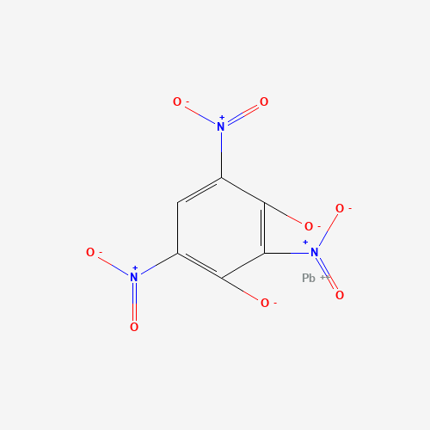
Figure 1 - Molecular structure of LS [7]

Properties of LS
Table 2 - Table of properties of LS collated from multiple sources [4,5,6]
Critical Diameter | Critical Density | Theoretical Maximum Density | VoD | Temperature of Ignition
< 1mm | 1.55 g/cc | 3.0 – 3.2 g/cc | 5200 – 5400 m/s | 330°C
The Theoretical Maximum density refers to the highest density LS can be pressed to for it to still function.

Oxygen Balance calculation for LS
The molar mass for LS is 473 g/mol. Using the following equation, the oxygen balance can be calculated.
$$OB(\%)=\frac{\left(d-2a-\frac{b}{2}\right)}{MW}×15.99 ×100\%$$
Equation 1
Table 3 - Quantities of CHNO atoms within one molecule of LS
A (Carbon) | B (Hydrogen) | C (Nitrogen) | D (Oxygen)
6 | 1 | 2 | 8
Using equation 1 and the quantities from Table 3, the oxygen balance of LS can be calculated.
$$OB(\%)=\frac{\left(8-2(6)-\frac{1}{2}\right)}{473}×15.99 ×100\%≈ -15.2\%$$
Equation 2
The oxygen balance for LS shows that the explosive is quite oxygen-deficient, making it an inefficient explosive to use. This is quite typical of most primary explosives, as they are used for their sensitivity to ignition. The explosive would be used in very small quantities of <1g to impart a shock into a much larger charge, with a higher oxygen balance.

Confinement of LS
It was difficult to find a reliable source that would provide a comparison of LS under confinement. However, as the critical diameter of LS is so small, it is likely that confinement would only have a small impact on the critical diameter and critical density.
The bulk density of LS in a powdered form states that it is 1.55 g/cc. Safety sheets recommend that it is handled as a wet powder due to its sensitivity; therefore, it is reasonable to assume that under confinement, LS would initiate with a critical density of around 1.55g/cc. The critical diameter of LS is very small, less than 1mm. For this reason, it can be assumed that under confinement, the critical diameter is only reduced slightly.

Secondary Explosive

RDX
RDX (1,3,5-trinitro-1,3,5-triazine, C₃H₆N₆O₆), also known as Cyclonite, is a secondary explosive that was widely used during World War 2, and is the basis of many explosive formulations used today, such as Semtex. It has an FOI of 80 and is now used as the reference point for all explosives; it used to be TNT, which has an FOI of 100.
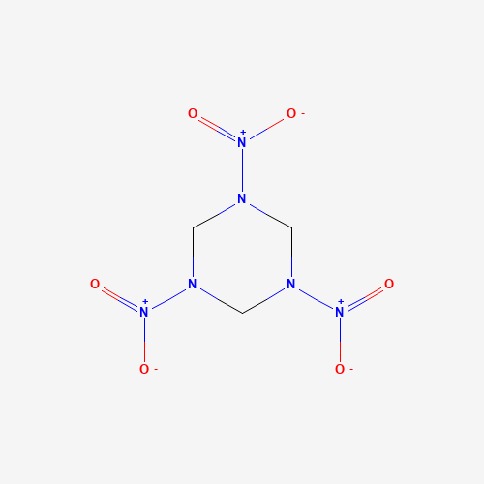
Figure 2 - Molecular Structure of RDX [8]

Properties of RDX
Table 4 – Table of properties of unconfined RDX taken from the “LLNL Explosives Handbook [3]”
Critical Density | Critical Diameter | VoD
0.9 g/cc | 5.2 mm | 8750 m/s

Oxygen Balance calculations for RDX
The molar mass of RDX is 222.12 g/mol. Using equation 1 and the CHNO quantities listed in Table 5, the oxygen balance for RDX can be calculated.
Table 5 - Quantities of CHNO atoms in one molecule of RDX
A (Carbon) | B (Hydrogen) | C (Nitrogen) | D (Oxygen)
3 | 6 | 6 | 6

$$OB(\%)=\frac{\left(6-2(3)-\frac{6}{2}\right)}{222.12}×15.99 ×100\%≈ -21.6\%$$
Equation 3
The oxygen balance calculated in equation 3 shows that RDX is also quite oxygen deficient, more so than LS.

Confinement of RDX
Within the “LLNL Explosives Handbook [3]”, the critical diameter of RDX and WAX (95/5) is given as between 4.0 mm and 5.0 mm. Whilst this is not the same composition as pure RDX due to the addition of wax, it does provide a good indicator of how much confinement could affect the critical diameter. Under confinement, the critical diameter of RDX can be reduced by approximately 1 mm. The critical densities provided show a slight increase in critical density. I expect this to be due to the addition of wax as opposed to an effect of confinement.
The “LASL Explosive Property Data” handbook states that Octol (75/25), an explosive composed of RDX and TNT, when confined, has a failure thickness of 1.43mm [9]. This would mean that the approximate critical diameter of Octol under confinement is 2.86mm, which is drastically smaller than when unconfined, where the critical diameter is 6.4mm, which is a ratio of 3.5:8.
As Octol is a similar composition to RDX, it could be estimated that the effect of confinement is similar for pure RDX. Using the ratio for Octol, the critical diameter of pure RDX in confinement can be estimated to be 2.275 mm. For the explosive train outlined in section 4, a critical diameter of 4.0mm will be used, as this is the lowest given for the composition of RDX/Wax (95/5), which is the closest to the chosen explosive.

Explosive Train
An explosive train is an assembly of multiple explosives and an ignition source. They are designed to make them safer to use and to transport. If you remove one of the elements of the explosive train, then the package either cannot detonate or the explosive output is drastically reduced. The typical elements of an explosive train include: a source of initiation such as a spigot designed to puncture the primary explosive or a wire that produces a spark; a primary explosive in very small quantities, as this is the most sensitive part of the explosive train; and a secondary explosive which makes up the majority of the explosive weight of the package, due to its higher FOI. Explosive trains may also use a booster; this is used for explosive trains that contain secondary explosives with very high FOIs, such as TATB (1,3,5-Triamino-2,4,6-trinitrobenzene), as a primary explosive may not impart enough energy to initiate the TATB.

Outline of an Explosive Train containing LS and RDX
The explosive train, shown in Figure 3, is based on an explosive characterisation test known as a cylinder test [10]. A secondary explosive is confined within a copper tube, an exploding bridge wire detonator is inserted slightly into the explosive cylinders, and the surrounding copper tube and exposed face have analytical instruments attached to, and or aimed at the experimental setup. These tests are designed to acquire JWL parameters for the EOS of explosives, which are the expansion parameters of the explosives; these figures would then be input into explosive models.
For this explosive train, the detonator will contain a bridge wire which will rapidly heat up and explode when 1kV of current is sent through it. This, in turn, will initiate the LS, which will send a shock through to the explosive fill, in this case a composition made of RDX and wax. The LS and bridge wire are both contained within an aluminium case; this provides an element of confinement to the LS, which will improve its performance and increase the likelihood of the secondary explosive picking up the shock.
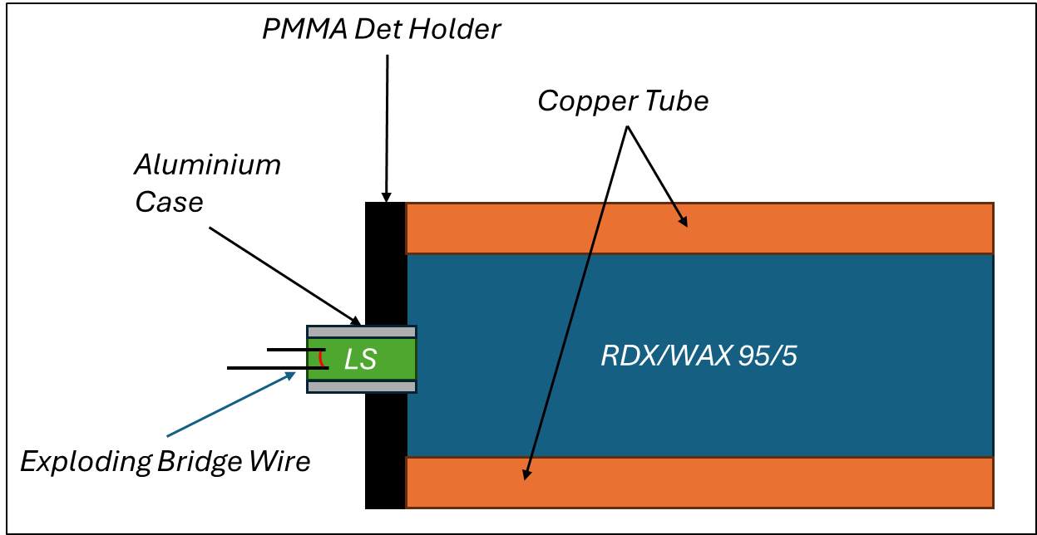
Figure 3 - Explosive train containing LS, RDX and a source of ignition under confinement
The minimum densities and diameters of the explosives required to achieve a successful detonation are listed in Table 6.
Table 6 – Minimum densities and diameters required for successful detonation of the explosive train
 | Minimum Diameter (mm) | Minimum Density (g/cc)
LS | 1.0 | 1.55
RDX/Wax (95/5) | 4.0 | 0.9
If the explosives were both pressed to their highest densities, then the VoD of the explosive train would reach 8750 m/s. For the VoD of the explosive to reach a steady state velocity of approximately 8750 m/s for RDX, the length of the cylinder should be at least 20 mm in length. Steady state velocity is defined as the moment at which the shock wave stops accelerating through the material.
If the explosives were both at the critical density, then it is likely the VoD would fall in the range of 8100-8300 m/s. Given that the cylinders were at a sufficient length to reach steady state velocity, then the diameter of the cylinders will not affect the VoD, provided they are above the critical diameter.

References
- Jaffe and D. Price, “Determination of the critical diameter of explosive materials,” ARS Journal, vol. 32, no. 7, pp. 1060–1065, Jul. 1962, doi: 10.2514/8.6205.
- C. M. Tarver, S. K. Chidester, and A. L. Nichols, “Critical conditions for Impact- and Shock-Induced hot spots in solid explosives,” The Journal of Physical Chemistry, vol. 100, no. 14, pp. 5794–5799, Jan. 1996, doi: 10.1021/jp953123s.
- B. Dobratz, “LLNL explosives handbook: properties of chemical explosives and explosives and explosive simulants,” Mar. 1981. doi: 10.2172/6530310.
- B. T. Fedoroff, Encyclopedia of explosives and related items. 1960. [Online]. Available: http://ci.nii.ac.jp/ncid/BA65880581
- Explosives, Sixth, Completely Revised. 2007. [Online]. Available: http://servidor.demec.ufpr.br/foguete/bibliografia/Meyer_et_al_2007_Explosives.pdf
- J. P. Agrawal, High energy materials: propellants, explosives and pyrotechnics. 2010. [Online]. Available: http://deposit.dnb.de/cgi-bin/dokserv?id=3294534&prov=M&dok_var=1&dok_ext=htm
- PubChem, “Lead styphnate,” PubChem. https://pubchem.ncbi.nlm.nih.gov/compound/Lead-styphnate#section=2D-Structure
- PubChem, “Cyclonite,” PubChem. https://pubchem.ncbi.nlm.nih.gov/compound/Cyclonite#section=2D-Structure
- T. R. Gibbs and A. Popolato, LASL Explosive Property data. Univ of California Press, 2023.
- E. C. Horton, L. Hill, J. H. Nelhams, B. D. Sutton, S. G. Finnegan, and J. W. Ferguson, “Improvements to build techniques for cylinder tests,” AIP Conference Proceedings, vol. 3066, p. 450003, Jan. 2024, doi: 10.1063/12.0028751.

Appendices

Abbreviations

ANFO Ammonium Nitrate Fuel Oil
EOS Equation of State
FOI Figure of Insensitiveness
HE High Explosive
JWL Jones-Wilkens-Lee
LLNL Lawrence Livermore National Laboratory
LS Lead Styphnate
RDX Research Department Explosive
TNT Trinitrotoluene
VoD Velocity of Detonation

