I can confirm that I have not used any AI tools in the research and creation of this assignment. I can confirm that I have not presented any AI generated materials as my own work. I can confirm that I have copies of my drafts, notes and other resources I used, which I may be asked to provide in evidence.

A Qualitative report using thematic analysis on teaching assistants’ experiences working with children with ADHD.

Abstract
With Attention Deficit Hyperactivity Disorder (ADHD) rates rising, Teaching Assistants (TAs) are progressively accountable in supporting learners with ADHD. As of November 2024, 29,250 support staff are working in the local authority-maintained schools in Wales. This represents a significant portion of the educational workforce. On average 14,167 individuals are employed exclusively as TAs, with an additional 3,370 staff dedicated to ALN (Additional Learning Needs) support. Despite their vital role in inclusion, their experiences and training needs supporting neurodiverse learners remains under-researched. This qualitative study interviewed 6 primary school TAs to answer two questions regarding their feelings about their role and the facilitators and hinderances to their work with ADHD children. Using thematic analysis six themes were identified including one-to-one relationships, social disapproval attached to ADHD, disadvantages to the job, proactivity and thinking, uninformed about ADHD and collaborative care. This study demonstrates the commitment TAs have to their job and building positive relationships, it also emphasises a need for enhanced training and improved pedagogical approaches, alongside insufficient support for Teaching Assistants and the negativity surrounding ADHD. Recommendations and implications of the study are reviewed.
Introduction.
According to data from the LMP Group (2025), within the UK 2.6 million people have ADHD, within that number 700,000 are children, with a rise still occurring. Attention Deficit Hyperactivity Disorder (ADHD) is characterised by a persistent pattern of hyperactivity-impulsivity and/or inattention, having a negative influence on academic, social functioning or occupational. These levels are often outside of the normal range expected for the age and level of intellectual functioning (APA, 2013). It is also a neurodevelopmental condition which may interfere with daily functioning (ADHD, 2024) and affects 3% to 9% of children present in schools in the UK, according to the National Institute for Health and Care Excellence (NICE, 2018). Although historically it has been seen as a condition occurring within childhood, evidence has shown that ADHD continues to occur within adulthood (Faraone et al.,2006 & Sibley et al., 2022). A higher demand for ADHD assessments has been prevalent since 2020, by teachers, clinicians and charities, stretching educational support systems and healthcare (Korducki, 2022; Parker, 2023; Searles, 2024 & Watts, 2024). However, the increased demands for ADHD assessment may reflect identification of previous unidentified cases, highlighting a change in societal understanding of neurodiversity (Banaschewski et al., 2023) rather than an increase in prevalence. Individuals with an ADHD diagnosis often have experiences with stigma, scepticism, and misdiagnosis (Adamis et al., 2019; Carr-Fanning & McGuckin, 2018). With symptoms such as hyperactivity occurring, inclusive of difficulty sitting still, fidgeting and excessive talking or learners being easily distracted due to inattention, making it difficult to follow instructions or complete tasks and learners struggling to wait their turn as they often interrupt others due to impulsivity (Mohr-Jensen et al., 2019). It has been reported by teachers that the most challenging classroom behaviours are those linked with ADHD (Barkley, 2018, Nguyen & Hinshaw, 2020). Furthermore, acceptance and understanding of ADHD varies for each individual. (McNicholas, 2018).
In order to support teachers and improve their workload, the number of staff in classrooms has been increased to support learners with special educational needs in England and Wales (Skipp & Hopwood, 2019). Teaching Assistants (TAs) have an increasing uncertainty over their future (Benstead, 2021). Although their role within settings has evolved drastically and is consistently changing (Benstead, 2021; Clarke & Visser, 2019). Typically, TAs work alongside learners who need the most support, supporting learners with their learning (Blatchford et al., 2009). TAs undertake varying roles such as pastoral, pedagogical and administrative within a school (Benstead, 2021) enabling teachers to focus on the rest of the class. However, within school’s TAs are often used in different ways dependant on the time of year (Wren, 2017) despite the guidance for schools. There is a shortage of research focusing on a TAs role when working with children with ADHD, focusing on their role and impact (Clarke, 2019; Roffey-Barensten & Watt, 2014). However, earlier research has stated that TAs feel isolated, exhausted and lonely due to the lack of acknowledgement to their work (Cockroft & Atkinson, 2015). Therefore, this report aims to extend the literature by exploring TAs experiences of working with children with ADHD.
In Wales it is expected that within a mainstream setting professionals need to have provisions in place such as Individual Development Plans (IDP’s) for learners who have additional learning needs (ALN). This change has occurred within special educational needs in Wales, as the employment of the Additional Learning Needs Tribunal (Wales) Act 2018 (ALNET) is now inclusive of new terminology and processes, meaning that children with special educational needs are now identified as children having ALN. According to ALNET (2018), these changes have still not allowed for ADHD to be a ‘standalone’ feature, however it is still integrated within the IDPs within multiple components, designed to support neurodivergence. According to GOV. WALES (2025) 43,885 pupils have additional learning needs in maintained schools, equating to around 9.5% of all pupils. Although a specific number of children with ADHD is difficult to obtain, due to some individuals remaining undiagnosed in their formative years. It is believed that on average 5% of children have an actual ADHD diagnosis in the UK, meaning that the level in Wales is around 1.8% to 2.2%. (Wales Online, 2026).
Research conducted by Moore et al., (2017) discussed that the response to ADHD within a classroom by teachers and TAs is vital to help children succeed academically. By ensuring that they got to know the children, practitioners found that individualised strategies were easier to implement as their interests could be included, thus leading to increased self-esteem. On the contrary, it was also noted that negative experiences could also occur, usually due to labelling children as ‘ADHD’, within Moore’s’ study practitioners discussed that children would use their diagnosis to avoid completing tasks. Likewise, labelling alongside an absence of understanding of ADHD leads to discrimination and stigmatisation, thus acting as a barrier to a successful relationship (Gwernan-Jones et al., 2016)
In light of this, it is evident that working in partnership holds high significance, effective collaboration between teachers and TAs is developed when each party shares information about students and teaching strategies (Devecchi & Rouse, 2010). Equally, relationships between professionals and parents are fundamental to encourage positive parental involvement (Knopf & Swick, 2007). Hence, providing caregivers with the confidence to know that their child is obtaining the best care and education.
With the commonness of TAs in Welsh classrooms, it is evident that there is an importance to investigate how TA’ s feel about their role of working alongside children with ADHD. Understanding the barriers and facilitators in which TAs face whilst fulfilling their job role responsibilities and could further support settings whilst ensuring the correct support for TA's and pupils with ADHD is provided. The outcomes could also assist decisions based on continued professional development and influence, likewise policymakers would be enabled to foster statutory standards for effective practice. Therefore, this report intends to conduct a qualitative investigation to scrutinise the following research questions:
- How do TAs feel about their role working with children with ADHD?
- What do TAs believe facilitates or hinders their work with children with ADHD?
Method
Participants and procedure.
The six interviews used within this report have been taken from a larger data set from the module’s tutor. The six participants were female Teaching Assistants aged 22 to 48 years (M = 35.33, SD = 9.83), with their experience as a TA ranging from 1 to 14 years (M = 8.67, SD = 4.80). Each TA was supporting 2 to 8 children simultaneously (M = 4, SD = 2.10) and their experience of working with ADHD children varied from 8.5 months to 10 years (M = 5.07, SD = 3.66).
Emails clarifying the nature of the study were sent to the headteachers of primary schools in West Wales. The headteachers were requested to distribute to all TAs in their schools. The original researchers (Greenway, C. W & Edwards, A. R., 2021) originally received nine responses via email, however they contacted the six TAs who agreed to be interviewed after snowballing had taken place (Bhattacherjee, 2012).
Materials.
The interviews were semi-structured and entailed seven questions (see appendix 1) with further probing and prompting questions based on current literature on ADHD to obtain TAs' experiences working one-to-one with children with ADHD. The justification for directing semi-structured interviews is to allow the researcher to delve into a specific topic, whilst ensuring the interviewee has an opportunity to provide interpretative answers and converse issues and experiences (Choak, 2012). Interviews were taped with a Dictaphone. Permission for recording was gained, and TAs were reassured that their answers were anonymous. Interviews lasted between 20 and 40 minutes, (the interview schedule is available within the appendices section, appendix D). Each TA was allocated an ID number to protect their identity.
Ethical Considerations
The University ethics panel granted ethics approval. Participants were informed on the information sheet that participation in the study was voluntary and that they could retract at any time. The information that had been taken at the beginning of the interview (age, years of service, etc.) was necessary demographic information to ensure anonymity and confidentiality.
Data Analysis
The data was collected using purposive sampling procedure, the selected participants was intentionally chosen to ensure that each interviewee was a TA and that their answers would be relevant to the research questions, focusing on gaining appropriate and useful information (Kelly, 2010; 317). The idea being that given the aims and objectives of the study, TAs specifically may have different views and opinions regarding the questions (Mason, 2002; Robinson, 2014; Trost,1986).
The data was analysed using thematic analysis, a qualitative research method, focusing on identifying themes and patterns which provides a comprehensive account of data (Fereday & Muir-Cochrane, 2006). Following the steps outlined by Braun and Clarke (2006), the data was read numerous times. On the final read-through, highlighting pens were used to identify general impressions about each interview transcript before producing codes. Finally, surfacing codes within the data was completed by using labels on the right-hand side of each transcript.
Coding was conceded self-sufficiently using Creswell’s (2014) idea of analysing and categorising specific statements which are significant to the area of interest. Following on from this it was then proceeded to group codes creating an initial table of fourteen subthemes and a narrative of each them noted extracts from the transcripts highlighted. The final step included the grouping of the fourteen subthemes into six main themes across the two research questions.
Legitimacy plus reliability were determined by different perspectives (Tracy, 2010). Multivocality was used as it encourages researchers to provide multiple diverse voices and opinions of those interviewed those opinions are obtainable through explanations and direct quotations provided in the next three sections which present the six main themes of the findings. In addition, Table 1 outlines the themes and sub-themes of each of the two research questions.

Table 1
Thematic analysis of TAs’ responses for each research question.
Research Question | Main Theme | Sub-theme
How do TA’s feel about their role working with children with ADHD?  What facilitates or hinders their work with children with ADHD? | Proactive and forward thinking.  Disadvantages to the job.  Social disapproval attached to ADHD.  Uninformed about ADHD  One-to-one relationship  Collaborative Care.  - | Advocate for learners.  Conduct research at home.  Passion for the job.  Physical and psychological consequences.  Misunderstanding and dismissal of ADHD symptoms  Unsympathetic approach from teachers.  Uneducated in ADHD.  Treating ADHD as a character flaw.  Limited exposure to ADHD  Understanding the needs of the child.  Child is the priority.  Supportive parents  Supportive headteachers

Research question 1: How do TA’s feel about their role working with children?
Proactive and forward thinking.
Whilst reading the transcripts it was evident that the TAs were all proactive and forward thinking when it came to their own professional development and supporting their learners with ADHD. They each expressed wanting what was best for the child and expressed the importance of the learner’s future development.
“So, he benefitted well both academically and socially.” (TA2. Line 10).
All TAs discussed that they had a passion for their job in particular they spoke about the satisfaction and pride in seeing the children's progress.
“I get so much satisfaction from seeing children develop.” (TA1. Line 1)
In addition, TAs discussed how they advocated for the children with ADHD noting that they had often challenged classroom practice to support the child.
“It’s like he gets punished he has kicked off but I can usually calm him down quickly but sometimes I don’t, they won't let me calm him down.” (TA 4. Line 21)
They also highlighted that they conducted their own research at home to be able to support their learner with ADHD.
“I did a lot of work, reading online to see what I could find out I brought a couple of books on the strategies for ADHD these were fab they helped me”(TA5. Line 50)
Disadvantages to the job.
Each of the TA's discussed the physical and psychological effects of their job they voiced feeling exhausted and drained throughout the day, they explained feeling isolated and alone within their job role because they spent most of their time with the child with ADHD.
“I can leave work absolutely exhausted. I can get upset when a child gets upset.” (TA6. Line 12).
“This is what emotionally drains me, and my brain is working all the time” (TA 3. Line 109)
Research question 2: What do TAs believe facilitates or hinders their work with children with ADHD?
Social disapproval attached to ADHD
Within the interviews the TA's discussed the social disapproval that is attached to ADHD whether this was misunderstanding, the stigma surrounding ADHD or unfair judgment. Few of the TAs discussed that some teachers believe that the individual child had ‘bad behaviour’ rather than a genuine disorder, it was also extended as they discussed how the individual's peers responded to them which often led to social exclusion as other children would become frustrated and do not have an understanding of ADHD.
“This can lead to frustration for the children and classroom teacher. Unfortunately, this frustration can then lead to animosity and sometimes exclusion.” (TA 6. Line 19).
Misunderstanding and dismissal of ADHD symptoms
In relation to ADHD misunderstanding and dismissal of their symptoms of ADHD is common, often resulting in both adults and children being labeled as naughty or unmotivated rather than receiving the correct support as ADHD is a neurodevelopmental condition these dismissals can lead to severe internalized shame and in some cases it can progress into the development of co-occurring conditions like anxiety or depression. Mislabeling behavior within school settings is extremely common due to individuals with ADHD showing signs of impulsive behaviour or emotional dysregulation each of these are often seen as difficult or disrespectful rather than a symptom. By having a misunderstanding of ADHD this can lead to delays in the diagnosis and treatment therefore limiting access to helpful therapies to support our learners.
Unsympathetic approach from teachers.
Within some of the interviews the TA's had discussed that the teachers had an unsympathetic approach and would often leave TAs feeling unsupported in their job role. Throughout the transcripts it was evident to see that many of the TA's felt lonely and isolated as they were often alone with the child diagnosed with ADHD, receiving minimal support and guidance from the class teacher as the class teacher often had tunnel vision on the whole class.
“They kind of say well that’s your job you deal with him, and they get cross if my child disrupts the class. Even when they can see I'm trying to calm him down, they make it clear that they are not happy.” (TA 1. Line 23).
Uninformed about ADHD
Teachers are often uneducated about ADHD and therefore they may hold negative attitudes towards students with this diagnosis however the teacher expectations for students performance may also be lower for children who have a diagnosis of ADHD. Due to being uninformed by ADHD individuals are more likely to perceive negative opinions about their peers who have a diagnosis particularly with regards to the anti-social behaviour.
Uneducated in ADHD.
The TAs each spoke about the lack of training that they had in regard to ADHD and how if they'd had ADHD training this would have benefited both themselves within their job role and the learners in which they were working with to ensure that the best possible care was provided.
“It would have been a good thing to have some training. So that I could have that foundation before, because I was blind going into this. (TA 2. Line 22).
Treating ADHD as a character flaw.
The TAs all discussed how ADHD is treated as a character flaw whether this was through labelling symptoms or other misconceptions.
“I didn't think it was real. I thought it wasn't a disorder. I thought it was just naughty children, and that it was a label too, you know, get them money to help schools. It wasn't until I worked with them did I realise that they have really complex needs and that they all show similar behaviours.” (TA 5, Line 4).
Limited exposure to ADHD
Many of the TA's discussed that they were in a small setting, in particular these small settings have very few learners with ADHD therefore their school system isn't necessarily set up to support these learners as they have minimal SEN children. Exposure to ADHD is critical to help our learners has teachers will then be able to find the right management to support children which can often be life changing by improving their focus their motivation and their communication.
“They tend to leave it up to the LSA's. We don't get much support. There's no money for extras, no training, nothing we are left to get on with it. Which really isn't good is it.” (TA 5. Line 28).
One to one relationship
Each Of the TA's describe the significance of the one-to-one relationship with the learner with ADHD they discussed needing good communication, having a caring attitude and needing trust to enable them to build a positive relationship with the children in their care. The characteristic of understanding the needs of the child was brought up multiple times, for instance they discussed about not thinking that every child is the same and pointed out that children with ADHD have diverse ways of learning and different needs. It was noted by some TAs that the implementation or adaption of strategies to suit the individual or to help children remain in the classroom for extending periods is needed and occurs by ensuring that they had an awareness of the needs of each child, this allowed them to differentiate strategies and interventions.
“I get so much satisfaction from seeing children develop. I have learned so much from working with children with ADHD, you know, they are wonderful children, all they need is your time and help.” (TA1. Line 1).
Understanding the needs of the child.
Many of the TA's discussed that understanding the needs of the child is imperative to help them learn and develop a diagnosis of ADHD has many symptoms that may occur however by ensuring that understanding is being developed allows an opportunity for growth.
“It was more about getting to know the child and knowing his traits and personality.” (TA 2. Line 64).
Child is the priority.
Within the transcripts it was noticed that the TAs prioritised the learners themselves making them a priority within everything that they plan and do. Consistently looking for ways to help the learner develop and to ensure that they are able to stay within a mainstream setting.
“If it's just a small escalation that you can stop and deescalate the situation then I think it's better to try and keep it in the classroom.... Integrating rather than segregating” (TA 3. Line 19).
Collaborative care
Collaborative care is imperative for learners with the diagnosis of ADHD as this allows partnership between teacher’s health care providers and parents to create a consistent data-driven support across the home and classroom settings whether this is by using daily report cards, behavioral interventions or making classroom adjustments to improve their social and academic functioning. By ensuring a collaborative approach is used we are able to ensure that there is a better manager of ADHD symptoms therefore academic performance will adjust by having consistent support for our learners this can reduce any confusion caused by the different expectations of home and school life. Collaborative care often involves establishing trust which takes time, but sharing common goals that focus on the student's strengths and their needs.
Supportive parents
Most TAs found that the parents were supportive and wanted best by their own children, they would often converse with the TA's and teachers to look at new strategies that they could implement at home and to help support them within their education.
“They are so supportive and I have a very good relationship with them.” (TA 1. Line 30).
Supportive headteachers
Some of the TA's discussed that the head teachers were great pillar of support within their job role. Offering guidance and support when needed and being a listening ear when things didn't quite go to plan some head teachers were also offering support when it came to having discussions with the parents about their child's learning.
“Brilliant, supportive, always. Always asking do I need anything, do I need to get parents in or whatever... And other schools the TA's probably don't have as much input with parents as we do because we're such a small school, he lets me, if I need to raise something with somebody I can. You do need to have a supportive class and head teacher. (TA 1. Line 82).
Results
Discussion
Whereby this data had been taken from a larger data set, there is still minimal research in which examines TA’s experiences of working with learners with ADHD. It is crucial for schools and policy makers to be able to support and provide the best education for learners and staff, however in order to do this the facilitators and barriers faced daily by TAs plays a huge role in enabling opportunities for support and appropriate education.
This report explored and discussed 6 emergent themes, originated from the lived experiences of TAs working with children with ADHD. It is clear to see through reading the transcript interviews, the love and dedication that the TAs have for their job role, whilst also expressing the importance for continued one-to-one support for learners with ADHD. Inclusive education is a global priority with an emphasis that all learners regardless of their ability should have access to equitable and quality learning opportunities (UNESCO 2024). Through inclusive practice teachers and school settings are able to create a supportive environment that nurtures empathy, respect and resilience amongst all learners (UNICEF, 2023). Previous research conducted by Moore et al. (2017) discussed teachers experiences of managing students with ADHD and a variety of foundations that nurtured effectiveness or hindered effectiveness. Throughout the research it was noted that students with ADHD accessed the classroom at the same time as their peers without ADHD (Moore et al., 2017). It was also identified that labelling hindered managing these students and led to poor relationships with students, for example labelling could lead to stigma or changes in their behaviour but it could also be helpful as practitioners are able to provide new strategies and interventions to support the learner’s problematic behaviour. This is evident and the trusting relationships between TAs and learners and how the TAs speak about the learners. Although having very little engagement with anybody else and spending all day together meant that both the children and the TAs feel excluded from teachers and their peers. On the contrary, having a close relationship may also benefit the learners, receiving one to one attention could also be a hurdle to developing self-esteem, social inclusion and independence. By feeling excluded, unsupported and underappreciated TAs were often feeling lonely, exhausted and isolated. The inadequate support and the deficiency of praise or acknowledgement confirm the findings that were outlined by Cockroft and Atkinson in 2015 and the importance of addressing the negative feelings. Thus, the importance that schools may wish to encourage TAs and teachers to discuss their practices and concerns enabling them to have additional interaction, positive well-being and inclusive practice throughout.
Overall, this report found that TA's often felt unsupported by teachers and did not feel a part of the teaching community, this aligns with previous literature (MacKenzie, 2011; Sharples et al., 2015). Many of the TA's spoke of minimal interactions and feeling demoralised by other teachers which steered towards tension within the classroom and with the teachers and children with ADHD. Tensions and ineffective support results in less chances to develop the positive and constructive relationships which are important for well-being and learning (Reyes et al., 2012). Thus, improvements and support need to be amplified through teacher and TA collaboration, joint training and planning time (Radford et al., 2015), and the enhancement of peer networks should be a priority so that all TAs feel a part of the wider teaching team (Webster et al., 2015).
Notwithstanding, the six TAs within this report acknowledged that there is a need for further training for themselves and teachers, they also discussed their improved knowledge due to completing research at home alongside acquiring knowledge from the learners themselves. The TAs believe that their independent research had aided their work which had shaped academic progress and behavioural changes. Furthermore, these differences had led to enhanced support and attitudes from the teachers and the learner's parents, which in turn led to increased interactions and acceptance from the child's peers, these improvements support earlier literature (Alfageer et al., 2018; Moore et al., 2017) and highlights the importance of independent research combined with the TA's readiness to adjust to strategies each of these are important for TA's as it enables them to succeed in their role and should be encouraged by all school settings (Burgess & Mayes, 2007). Consequently, any future research may deem it necessary to scrutinise the impacts that developed knowledge, attitudes and support have on a TAs classroom practice and the behavioural outcomes and educational outcomes of those with ADHD.
The main barriers for the TA's were limited understanding, lacking in knowledge and negative views maintained by teachers. TAs within this report highlighted these above along with other reasons due to the inadequate support, the peer rejection and exclusion of those with ADHD and the stigma surrounding ADHD. Due to the limited supply of training opportunities and the negative impression that ADHD often receives, having insufficient knowledge and understanding is prone to produce a cycle of negativity when teachers observe negative behaviours that disrupt the whole classroom. This calls for an immediate need for all school settings to undergo ADHD specific training as this will enable these misconceptions to be minimised. However, refining knowledge may not be enough to decrease the stigma surrounding ADHD, additionally for some children their behaviour can be response to the stigma and the labelling. Therefore, potential research needs to examine the learner's needs, their motivations and their experiences in the classrooms to fully comprehend the impact that labelling and stigma have on those with ADHD (Gwernan-Jones et al., 2016). Barkley (2018) expressed that if exclusion appeared alongside rejection, it could cause a significant impact to the erratic behaviours and disruptive nature of ADHD. As long-term effects of exclusion can be detrimental to learners’, schools could benefit from using child funding resources on education alongside children with ADHD as this would help to contest the negativity, the peer rejection and the disruptions to the class.
This report focused on 6 female primary TAs because of this the findings may not represent the experiences of all TAs Working with children with ADHD. Due to the generalisability of its findings through its selected sample with shared experiences of working with children ADHD. As previously mentioned, all the TAs were female, therefore there was also gender bias playing within this report as the six participants were only female it would have been ideal to have had male participants within this study so that a comparison of experiences of working with children with ADHD could have been conducted. Additionally, this report focused heavily on self-reported data gathered through interviews, whilst this allows for rich and in-depth insights it could be subject to recall bias. Also, retrospect plays a huge role in this study as some individuals used to work with ADHD learners however they do not now, knowledge and understanding of ADHD is much broader now than what it was 10 years ago, therefore it is crucial when undertaking research that participants are discussing the now, and how ADHD is seen today within settings. Additionally, there is a constricted focus on the facilitators and hinderances which provides a scope for further research examining how they impact on children with ADHD and their peers and the general classroom management. Finally, this report focused on TA's who did not have specialised training in ADHD this could generate different coping strategies and experiences in comparison to an individual who has had training with ADHD. These limitations propose that the results should be taken as an in-depth but context specific account rather than a general description of all TAs experiences of working with individuals with ADHD.

Conclusion
As a result, school settings and policy makers have been provided with an opportunity to utilise the experience of those with personal and direct knowledge of ADHD. The findings highlight the need for future research that delves deeper into the perspective of children with ADHD and TAs working with them. Therefore, addressing the lack of knowledge and negative attitudes discussed earlier individuals who are responsible in providing the initial teacher -training curriculum should provide ADHD specific content and experience with children with ADHD, to help minimise this element. Likewise, in-service training should be provided for teachers and an opportunity for staff to converse concerns and experiences surrounded by challenges associated with ADHD as this will assist all staff to feel heard. There is a dire necessity for mandatory and statutory guidelines to be created, those in which define the TAs role to execute robust pedological strategies. Despite the difficulties mentioned above the TAs within this study showed passion for their job, alongside their willingness to research from home and how deeply they wished for other professionals alongside them to learn should be admired. Finally, it is evident there is a need for funding and time in the professional development of all those concerned in the education and care of children with ADHD to receive appropriate training.

References

Adamis, D., Kasianenko, D., Usman, M., Saleem, F., Wrigley, M., Gavin, B., & McNicholas, F. (2023). Prevalence of Personality Disorders in Adults With Attention Deficit Hyperactivity Disorder (ADHD). Journal of Attention Disorders, 108705472311615. https://doi.org/10.1177/10870547231161531

Adamis, D., Tatlow-Golden, M., Gavin, B., & McNicholas, F. (2019). General practitioners’ (GP) attitudes and knowledge about attention deficit hyperactivity disorder (ADHD) in Ireland. Irish Journal of Medical Science (1971 -), 188(1), 231–239. https://doi.org/10.1007/s11845-018-1804-3

ADHD UK. (2024). About ADHD. ADHD UK. https://adhduk.co.uk/about-adhd/

APA (American Psychological Association) (2013) Publication Manual of the American Psychological Association (6th edn). Washington, DC: APA.

Banaschewski, T., Häge, A., Hohmann, S., & Mechler, K. (2023). Perspectives on ADHD in children and adolescents as a social construct amidst rising prevalence of diagnosis and medication use. Frontiers in Psychiatry, 14. https://doi.org/10.3389/fpsyt.2023.1289157

Barkley, R. A. (2018) Attention-Deficit Hyperactivity Disorder: a handbook for diagnosis and treatment (4th edn). New York: Guilford.

Benstead, H. (2021). Primary Initial Teacher trainees’ Perceptions of and Perspectives on the Role of the Teaching Assistant in English Primary Contexts. Support for Learning, 36(4). https://doi.org/10.1111/1467-9604.12384

Bhattacherjee, A. (2012). Scholar Commons Social Science Research: Principles, Methods, and Practices. https://repository.out.ac.tz/504/1/Social_Science_Research-_Principles_Methods_and_Practices.pdf

Blatchford, P., Bassett, P., Brown, P., Koutsoubou, M., Martin, C., Russell, A., Webster, R., & Rubie-Davies, C. (2009). Deployment and Impact of Support Staff in Schools The Impact of Support Staff in Schools (Results from Strand 2, Wave 2). https://dera.ioe.ac.uk/id/eprint/10818/1/DCSF-RR148.pdf

Bourgeault, I., Dingwall, R., & De Vries, R. (2010). The SAGE Handbook of Qualitative Methods in Health Research. Sage Publications.

Braun, V., & Clarke, V. (2006). Using Thematic Analysis in Psychology. Qualitative Research in Psychology, 3(2), 77–101. https://doi.org/10.1191/1478088706qp063oa

Burgess, H., & Mayes, A. S. (2007). Supporting the professional development of teaching assistants: classroom teachers’ perspectives on their mentoring role. The Curriculum Journal, 18(3), 389–407. https://doi.org/10.1080/09585170701590056

Carr-Fanning, K., & Mc Guckin, C. (2018). The powerless or the empowered? Stakeholders’ experiences of diagnosis and treatment for attention-deficit hyperactivity disorder in Ireland. Irish Journal of Psychological Medicine, 35(3), 203–212. https://doi.org/10.1017/ipm.2018.13
Choak, C. (2012) ‘ Asking questions: interviews and evaluations’, in S. Bradford and F. Cullen (eds), Research and Research Methods for Youth Practitioners. London: Routledge.

Clarke, E. (2019). Paint pot washers or pedagogues? Is gender an issue for teaching assistants? Educational Review, 1–16. https://doi.org/10.1080/00131911.2018.1559800

Clarke, E., & Visser, J. (2019). How do teaching assistants view their role in managing behaviour and cultivate their learning and understanding in relation to managing behaviour? Teacher Education Advancement Network Journal, 9(1), 66–79. https://ojs.cumbria.ac.uk/index.php/TEAN/article/view/369

Cockroft, C., & Atkinson, C. (2015). Using the Wider Pedagogical Role model to establish learning support assistants’ views about facilitators and barriers to effective practice. Support for Learning, 30(2), 88–104. https://doi.org/10.1111/1467-9604.12081

Creswell, J. W. (2014) A Concise Introduction to Mixed Methods Research. Thousand Oaks, CA: Sage.

DEVECCHI, C., & ROUSE, M. (2010). An exploration of the features of effective collaboration between teachers and teaching assistants in secondary schools. Support for Learning, 25(2), 91–99. https://doi.org/10.1111/j.1467-9604.2010.01445.x

Faraone, S. V., Biederman, J., & Mick, E. (2006). The age-dependent decline of attention deficit hyperactivity disorder: A meta-analysis of follow-up studies. Psychological Medicine, 36(2), 159–165. https://doi.org/10.1017/s003329170500471x
Fereday, J., & Muir-Cochrane, E. (2006). Demonstrating Rigor Using Thematic Analysis: a Hybrid Approach of Inductive and Deductive Coding and Theme Development. International Journal of Qualitative Methods, 5(1), 80–92. https://doi.org/10.1177/160940690600500107

Gavin, B., & McNicholas, F. (2018). ADHD: science, stigma and service implications. Irish Journal of Psychological Medicine, 35(3), 169–172. https://doi.org/10.1017/ipm.2018.20

Gov.Wales. (2025, July 23). Schools’ census results: January 2025 [HTML] | GOV.WALES. GOV.WALES. https://www.gov.wales/schools-census-results-january-2025-html

Greenway, C. W., & Rees Edwards, A. (2021). Teaching assistants’ facilitators and barriers to effective practice working with children with ADHD: a qualitative study. British Journal of Special Education, 48(3). https://doi.org/10.1111/1467-8578.12377

Gwernan-Jones, R., Moore, D. A., Cooper, P., Russell, A. E., Richardson, M., Rogers, M., Thompson-Coon, J., Stein, K., Ford, T. J., & Garside, R. (2016). A systematic review and synthesis of qualitative research: the influence of school context on symptoms of attention deficit hyperactivity disorder. Emotional and Behavioural Difficulties, 21(1), 83–100. https://doi.org/10.1080/13632752.2015.1120055

https://www.facebook.com/peoplemag. (2022). Rise in ADHD Diagnoses May Be Due to “Poor Mental Health”, New Study Finds. People.com. https://people.com/adhd-diagnoses-increase-poor-mental-health-8653776

Knopf, H. T., & Swick, K. J. (2007). How Parents Feel About Their Child’s Teacher/School: Implications for Early Childhood Professionals. Early Childhood Education Journal, 34(4), 291–296. https://doi.org/10.1007/s10643-006-0119-6
Korducki, K. M. (2022, June 2). TikTok trends or the pandemic? What’s behind the rise in ADHD diagnoses. The Guardian. https://www.theguardian.com/society/2022/jun/02/tiktok-trends-or-the-pandemic-whats-behind-the-rise-in-adhd-diagnoses

Kovacs, Y. (2025, March 31). ADHD - The rise that’s affecting your classroom - LMP. LMP. https://lmp-group.co.uk/news/adhd-the-rise-thats-affecting-your-classroom/

MACKENZIE, S. (2011). “Yes, but . . .”: rhetoric, reality and resistance in teaching assistants’ experiences of inclusive education. Support for Learning, 26(2), 64–71. https://doi.org/10.1111/j.1467-9604.2011.01479.x

Mason, J. (2002). Qualitative Research. http://www.sxf.uevora.pt/wp-content/uploads/2013/03/Mason_2002.pdf

McCarthy, L. (2026, March 27). “Our family was in crisis. We were told we’d have to wait years for help.” Wales Online. https://www.walesonline.co.uk/news/wales-news/our-family-crisis-were-told-33675154?utm_medium=Social&utm_source=Facebook#Ecobox=1774729081

Mohr-Jensen, C., Steen-Jensen, T., Bang-Schnack, M., & Thingvad, H. (2019). What Do Primary and Secondary School Teachers Know About ADHD in Children? Findings From a Systematic Review and a Representative, Nationwide Sample of Danish Teachers. Journal of Attention Disorders, 23(3), 206–219. https://doi.org/10.1177/1087054715599206

Moore, D. A., Russell, A. E., Arnell, S., & Ford, T. J. (2017). Educators’ experiences of managing students with ADHD: a qualitative study. Child: Care, Health and Development, 43(4), 489–498. https://doi.org/10.1111/cch.12448
Nguyen, P. T., & Hinshaw, S. P. (2020). Understanding the Stigma Associated with ADHD: Hope for the Future? The ADHD Report, 28(5), 1–10, 12. https://doi.org/10.1521/adhd.2020.28.5.1

NICE. (2018). Attention Deficit Hyperactivity disorder: Diagnosis and Management | Guidance | NICE. Nice.org.uk; NICE. https://www.nice.org.uk/guidance/ng87

Parker, K. (2023, March 15). ADHD: Is ADHD really on the rise in schools? | Tes. Www.tes.com. https://www.tes.com/magazine/teaching-learning/general/send-how-can-schools-cope-rise-adhd

Qureshi, S., Alfageer, H., Aldawodi, M., Al Queflie, S., Masud, N., Al Harthy, N., Alogayyel, N., & Alrabah, M. (2018). Knowledge and attitude of male primary school teachers about attention deficit and hyperactivity disorder in Riyadh, Saudi Arabia. Journal of Natural Science, Biology and Medicine, 9(2), 257. https://doi.org/10.4103/jnsbm.jnsbm_232_17

Radford, J., Bosanquet, P., Webster, R., & Blatchford, P. (2015). Scaffolding learning for independence: Clarifying teacher and teaching assistant roles for children with special educational needs. Learning and Instruction, 36(36), 1–10.

Reyes, M. R., Brackett, M. A., Rivers, S. E., White, M. & Salovey, P. (2012) ‘Classroom emotional climate, student engagement, and academic achievement’, Journal of educational psychology, 104, 700.

Robinson, O. C. (2014). Sampling in interview-based qualitative research: A theoretical and practical guide. Qualitative Research in Psychology, 11(1), 25–41. https://doi.org/10.1080/14780887.2013.801543

Roffey-Barentsen, J. (2014). The Voices of Teaching Assistants (Are We Value for Money?). Research in Education, 92(1), 18–31. https://doi.org/10.7227/rie.0002
Searles, M. (2024, April 4). ADHD and autism referrals up fivefold since pandemic amid “diagnostic creep” fears. The Telegraph. https://www.telegraph.co.uk/news/2024/04/04/adhd-and-autism-referrals-up-fivefold-since-pandemic/

Sharples, J., Webster, R., & Blatchford, P. (2015). Making Best Use of Teaching Assistants Guidance Report Education Endowment Foundation. https://dera.ioe.ac.uk/id/eprint/29360/1/TA_Guidance_Report_MakingBestUseOfTeachingAssisstants-Printable.pdf

Sibley, M. H., Arnold, L. E., Swanson, J. M., Hechtman, L. T., Kennedy, T. M., Owens, E., Molina, B. S. G., Jensen, P. S., Hinshaw, S. P., Roy, A., Chronis-Tuscano, A., Newcorn, J. H., & Rohde, L. A. (2022). Variable patterns of remission from ADHD in the multimodal treatment study of ADHD. American Journal of Psychiatry, 179(2), 142–151. https://doi.org/10.1176/appi.ajp.2021.21010032

Skipp, A., & Hopwood, V. (2019). Deployment of Teaching Assistants in schools Research Report. Department for Education. https://assets.publishing.service.gov.uk/government/uploads/system/uploads/attachment_data/file/812507/Deployment_of_teaching_assistants_report.pdf

Trost, J. E. (1986). Statistically nonrepresentative stratified sampling: A sampling technique for qualitative studies. Qualitative Sociology, 9(1), 54–57. https://doi.org/10.1007/bf00988249

UNESCO. (2024). Inclusion in education. Www.unesco.org; UNESCO. https://www.unesco.org/en/inclusion-education

UNICEF. (2023). Transforming education and building resilience by embracing life skills. Unicef.org. https://www.unicef.org/mena/blog/transforming-education-and-building-resilience-embracing-life-skills

Webster, R., Russell, A. & Blatchford, P. (2015) Maximising the Impact of Teaching Assistants: guidance for school leaders and teachers. London: Routledge.
Welsh Government. (2018). Additional Learning Needs and Education Tribunal (Wales) Act 2018. Legislation.gov.uk. https://www.legislation.gov.uk/anaw/2018/2/contents

Welsh Government. (2023, November 27). Additional Learning Needs and Education Tribunal (Wales) Act 2018 | Law Wales. Law.gov.wales. https://law.gov.wales/additional-learning-needs-and-education-tribunal-wales-act-2018
Wren, A. (2017). Understanding the role of the Teaching Assistant: comparing the views of pupils with SEN and TAs within mainstream primary schools. Support for Learning, 32(1), 4–19. https://doi.org/10.1111/1467-9604.12151

Appendices
Appendix A

Codes accros

Below are initial descriptive codes (short, concise labels that capture meaning):
Transcript | Initial Codes
1 | Enjoyment in job  Rewarding job  ADHD is educational  Patience benefits for all  Accepting and inclusivity is needed  Exhausting  Defensive of learner.  Misconceptions  Lack of funding  Lack of support  Job pressure  Ignorance towards ADHD  Frustrating  Argumentative parents  Undervalued  Unappreciated  Supportive parents  Lack of resources  High expectations  Stressful
2 | Considering others’ emotions  Lack of training  Stereotype  Misconceptions  Judgement from others  Lack of acknowledgement to job role  Negative views  Peers accustomed to behaviour  Peer exclusion  Accommodating school  Positive attitudes  Focus on child  Building trust  Inclusivity  Parental complaints  Complex needs  Broader knowledge  Better communication supportive school and staff  Emotionally challenging  Lack of control  Rewarding  Inspirational  Drive for change  Satisfaction  Lack of knowledge  A gap in research  Negative labels from parents  Positive challenge  Patience  Understanding of logical responses  Academic improvement  Lack of control from teacher  Better behaviour from learner  Happier parents  Stressful  Difficult  Lack of understanding  Frustration  Lack of training  No knowledge  Training needed  Supportive school  Ignorance from other teachers  Advice provided  Negativity  Difficulty building relationships.  Peer acceptance  Peer exclusion  Emotional dysregulation  Enhanced positivity  Improved behaviour  Anxious / intimidated  Misconceptions  Support network  Happy, supportive parents  Male peers frustrated  Female peers inclusive  Exhaustion  Rewarding  Satisfaction  Seeing individual as a person not a diagnosis  Drive for change  Need for training
3 | Supporting others understanding  No labels needed  Defensive of learner  Misconceptions  Stressful  Peer exclusion  Challenging behaviours  Tired  Research  Lack of understanding  Need for more inclusivity and positivity  Lack of support  No diagnosis  Lack of training/ knowledge.  Guess work  Impacts others  More training needed  Support for all  Teacher has tunnel vision  Occasional support provided  Tick boxes  Training needed for all  Issues with parents  Focus is on child  Parents in denial
4 | Need more than one adult sometimes  Some improvements overtime  Support changed for the better  Lack of funding  Research at home  Lack of structure  Disruptive and impulsive behaviour  Challenging  Try new things constantly  Lack of research  Draining  Emotionally challenging  Benefits for learner  One-to-one – more attentive and improved focus  Routine and structure  Mainstream learning experiences needed  Patience-more tolerant  Help others understand  Difficult  Frustrating  Peer exclusion.  Class removal from teachers  Classroom barriers- undermined.  Lack of understanding  Small school  Lack of funding  Lack of support  Professional barriers  Lack of understanding/empathy  Lonely job  Supportive parents  Research at home  Negative attitudes  Misconceptions  Love for the job  Challenging  Emotionally draining  Exhaustion  Trying best by learner.  Positivity towards achievements
5 | Challenging  Misconceptions  Labelling  Hyperactive children  Positive outcomes  Secluded  Teacher misconceptions  Isolated from other staff  No break from learner  Lonely  Lack of empathy from others  Small school  Lack of support, funding and training.
6 | No support for family  Lack of Interest from families  No training  Same expectations for all learners  Guess work to support learner  Research at home  Stressful  Exhaustion  Learning from pupil  Teaching other teachers  Change in attitudes.  Hard job  Always learning  Confidence gained  Rewarding  Satisfaction from job  Satisfying results  Guess work  Learn from pupil  Misconceptions  Ard work  E exhausting  Aggressive behaviour from pupil  Frustrating  Misconceptions  Negativity towards learners with ADHD  Lack of parental support  Lack of training  Research at home  Changing mindset  No training.  More training needed  Peer frustration  High expectations  Supportive staff  Knowledgeable staff  Unsupportive staff.  Happier staff when staff support one another  Positive progress  More tolerance and understanding towards ADHD  Comments and misconceptions from other parents. - negative influence on other children.

Appendix B
Codes organised into initial themes
Proactive and forward thinking
Focus to stay in mainstream
Emotionally rewarding
Inspirational
Satisfaction
Drive for change
Positive challenge
Patience
Understanding of logical responses
Academic improvement
Benefits to learner
Positive outcomes
Enhanced positivity
Rewarding
Attentive 24/7
Guess work (interventions)
Research at home
Tools and strategies in place
Helping others understand
Love the job / challenge
Trying best by learner
Always learning
Saw individual as a person not diagnosis
Defensive of learner
Disadvantages to job
Tiring
Exhaustion
Job pressure
Undervalued
Underappreciated
Lack of / no authority
Stressful
Demanding
Undermined
Emotionally challenging
Lack of control
Frustration
Intimidate
Anxious/nervous
Draining
Feeling stuck
Lack of support
Loneliness
Professional barriers
Secluded
Hard job
Unsupportive staff
Social disapproval attached to ADHD
Misconceptions “it’s made up”
Annoyance towards ADHD
Ignorance
Negative views
Misunderstanding
Labelled negatively
Teacher – lack of control
Tick boxes
Removal by teacher- further issues
Negative attitudes
Less social interaction with others

Same expectations
Uninformed about ADHD
Misconception “it’s made up”
Lack of support
Lack of funding
Ignorance towards ADHD
Lack of acknowledgement
Higher expectations
Argumentative parents
Stereotype
Lack of training
Exclusion from peers
Accustomed to behaviour
A gap in research negative labels from parents
Lack of understanding
Boy. Peers- frustration/ annoyance
A need for inclusivity and positivity
Tunnel vision on whole class
Parents – denial, needing attention
Secluded
Lack of empathy
Small school
No support for family
Changing mindset
Misconceptions/ comments from other parents- negative influence on other children
One-to-one relationship
Accepting and inclusive
Patience
Defensive
Focus to stay in mainstream
Drive for change
Rewarding
Academic improvement
Improved behaviour
Saw as an individual not a diagnosis
Defensive
Attentive 24/7
Trying best by learner
Positivity towards achievements
Satisfying results
Learnt from pupil
Positive progress
Collaborative care
School accommodating
Supportive parents
Parents- positive attitudes
Focus on child
Supportive staff
Supportive school
Advice provided
Empathetic
Parents- want best by child
Tools and strategies in place
Knowledgeable staff.

Appendix C

Revision and Final themes and sub-themes

- Proactive in their own development
- Completing own research at home.

- Thinking about next steps.

- Difficulty within their job
- Physical and psychological consequences.

- Social disapproval attached to ADHD
- Misunderstanding of ADHD symptoms

- Uniformed about ADHD
- Uneducated/ lack of training.

- One-to-one relationship.

Final themes and sub-themes

- Proactive and forward thinking
- Advocate for learners
- Conduct research at home
- Passion for the job.

- Disadvantages to the job.
- Physical and psychological consequences

- Social disapproval attached to ADHD
- Misunderstanding and dismissal of ADHD symptoms
- Unsympathetic approach from teachers.

- Uninformed about ADHD
- Uneducated in ADHD
- Treating ADHD as a character flaw
- Limited exposure to ADHD

- One-to-one relationship
- Understanding the needs of the child
- Child is the priority

- Collaborative care
- Supportive parents
- Supportive headteachers

Appendix D
Interview Questions
- You have experience with ADHD in the classroom- do you see any benefits of. Working with ADHD children? Please give examples.
- Do you see any disadvantages of working with ADHD children? Please give examples.
- Thinking of your experiences do you see any barriers to working with ADHD children?
- Prompts: support- school, knowledge, training, parents, peers.
- Have your experiences relating to the barriers you discussed changed overtime?
- Thinking of your experiences- do you see any facilitators that help you to work with ADHD children?
- Prompts: support- school, knowledge, training, parents, peers
- Have your experiences relating to the facilitators you discussed changed overtime?
- What impact does working with ADHD children have on you?
  - Prompts: positive, negative (emotional, physical)
Anything else you would like to add?

Appendix E

Transcript Excerpts

Transcript 1


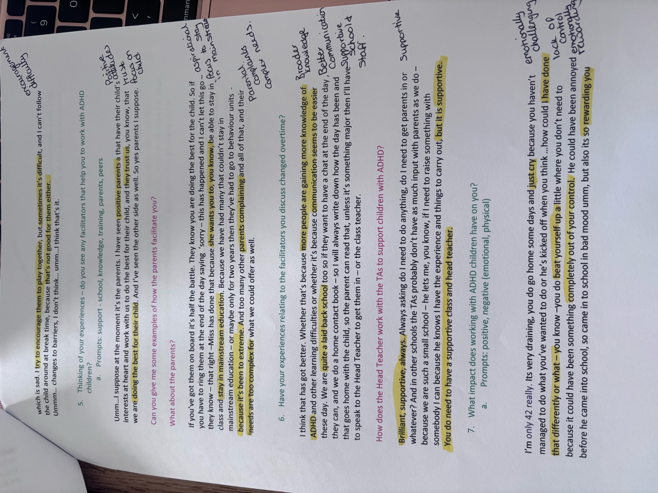

Transcript 2
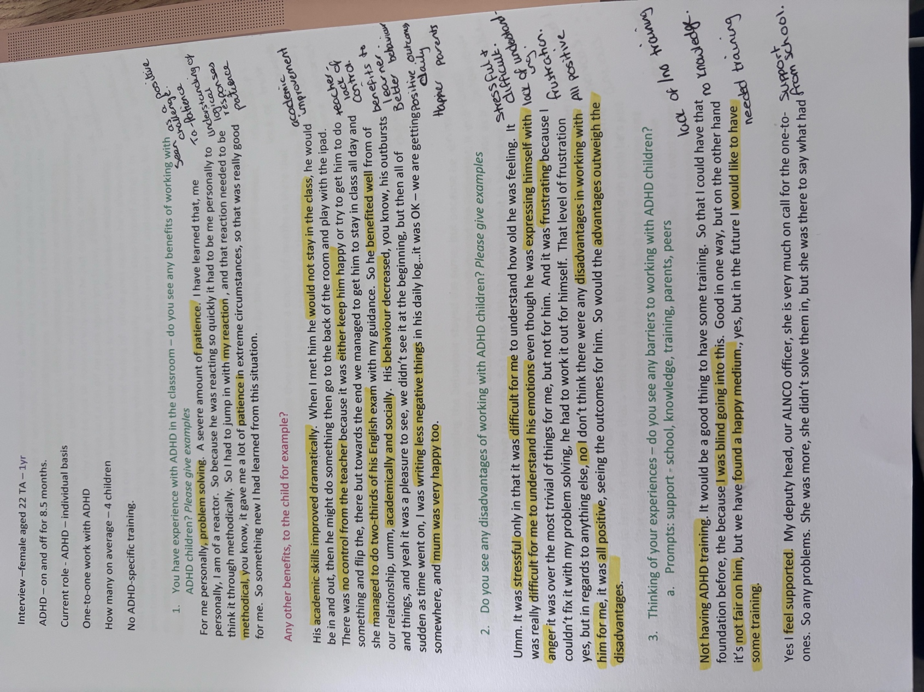
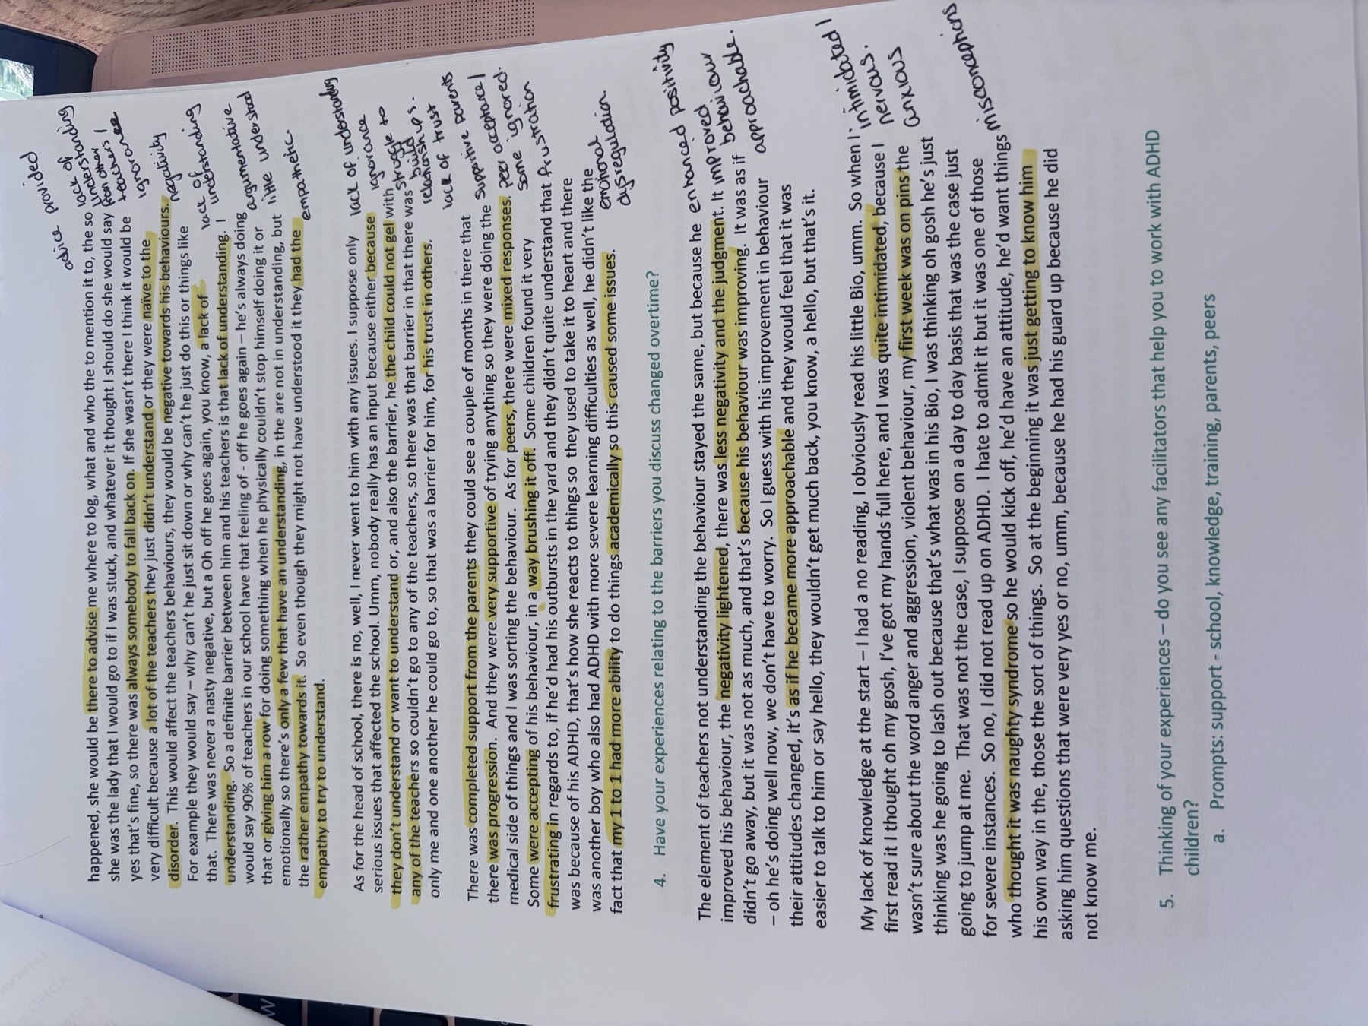
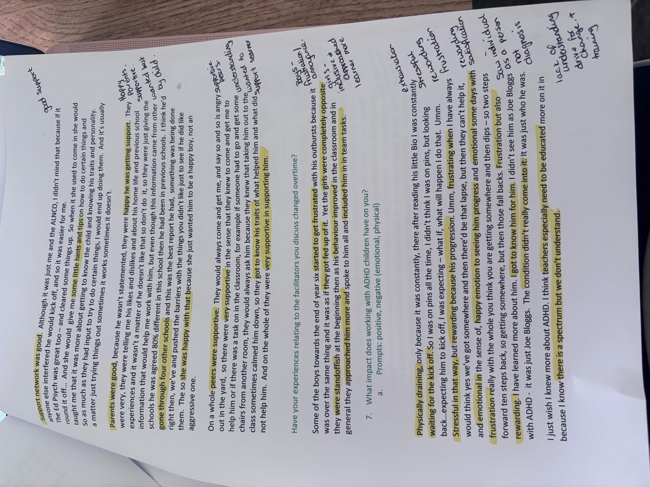
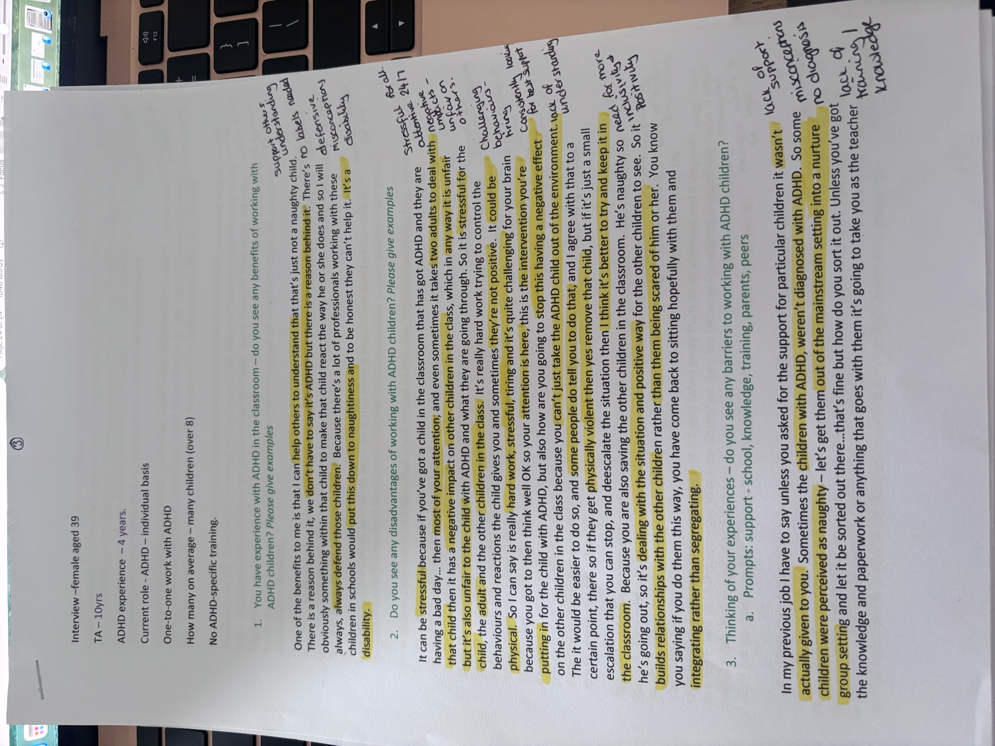
Transcript 3



Transcript 4

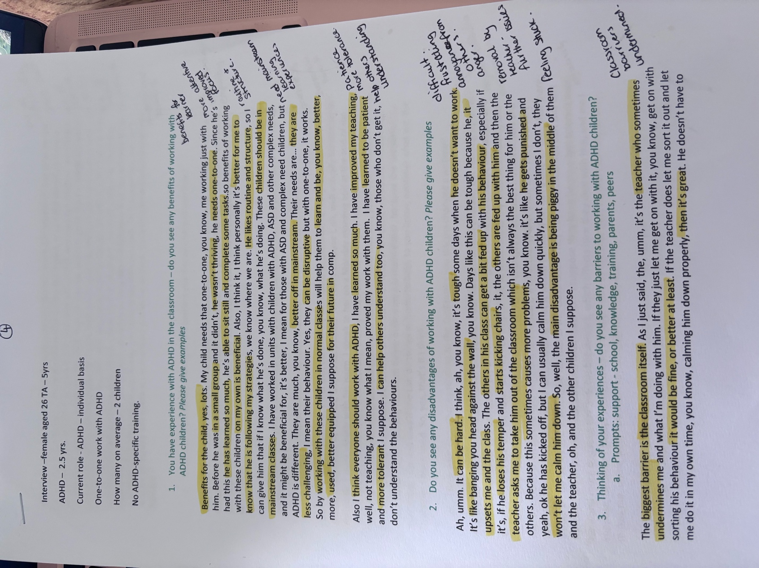
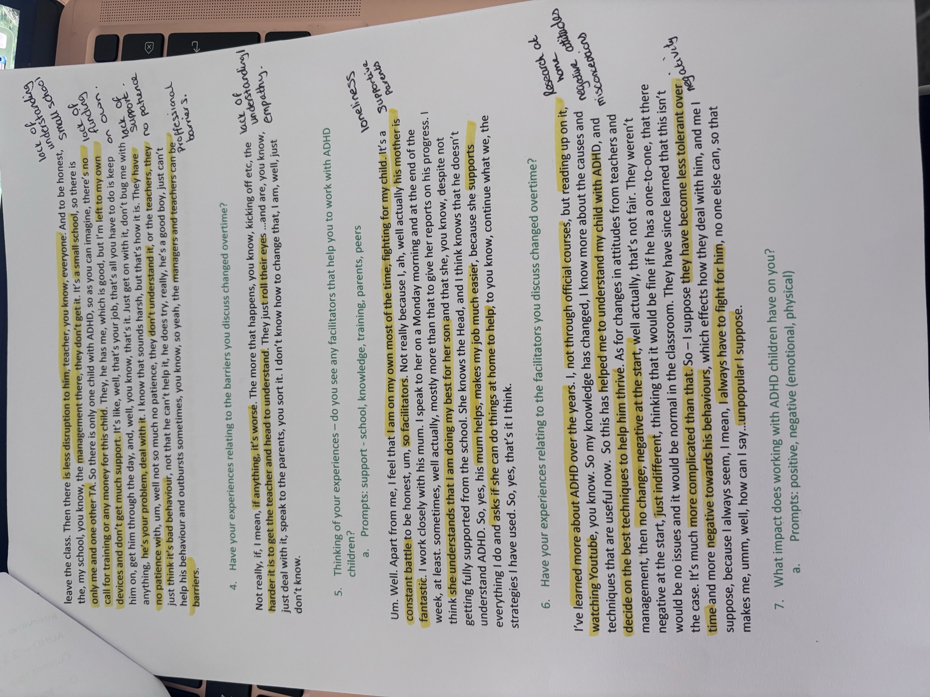

Transcript 5

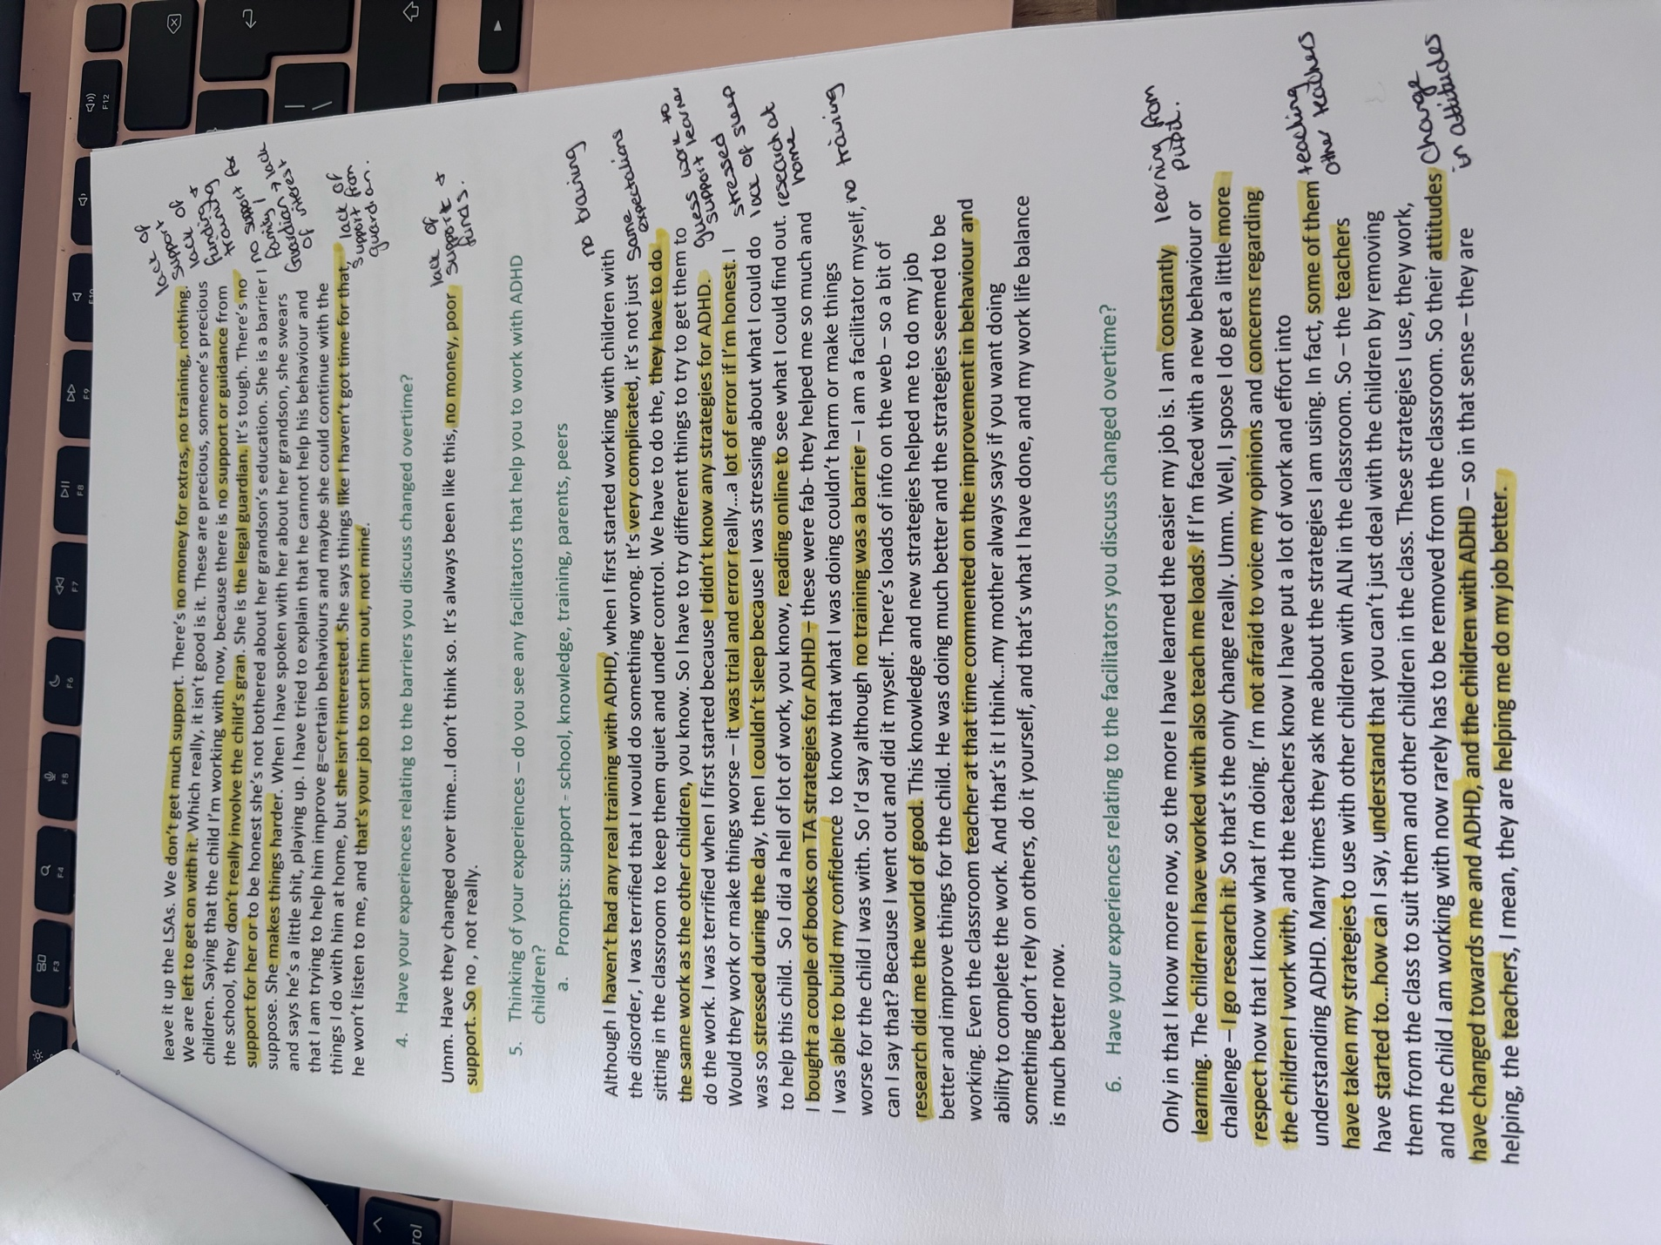


Transcript 6




