Student Name: Nancy Leather
Student Number: 2404204
Program Study: Design Craft
Module: ADDA4022

Tasks in Order I Received them:
Manifesto: 514 Words.
Observational Writing: 480 words.
Julia: I have some question’s!!!!!!
- When I site and I got the information from an organisation, and theres no author or date published, how do I site that???
- Im also confused on my bibliography, it says I have not reference 2 books (art and fear and keeping and eye open) when they are in there. Did I reference them wrong. Or do I have to reference every time I have used it because I used them more than once.

Manifesto:
Successful Art is Driven by the Conflict Between Opposing Ideas. The Unity of Opposites.

Manifesto Points:
1) The luscious yet grotesque conflict within a human body.
2) To be successful is to be Unsuccessful
3) Between Dog and Wolf, is Art Our Friend or Foe
4) Dialectic of Opposites
5) To Make is to Not Create
6) The Death of something Old Brings the Life of Something New.
7) Speaking but with no Words
8) Realism vs Surrealism

2) To be successful is to be Unsuccessful.
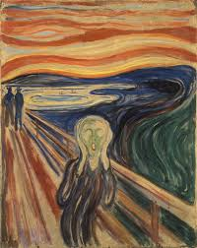
Figure 1, The Scream, Edvard Munch, 1893

Expression of negative emotion is what makes artists so profoundly successful in their ability to provide a connection between the viewer and artist. “…(Could only have been painted by a madman!)” is said to be scratched into the red strip across the sky in Edvard Munch’s, The Scream (“Modern Art,” 2006, p.17). “…(Munch screams because the pain suffered is spiritual and projects its insanity outward into a physical expression.)” (Heller, 1973, p.87). Without Munch’s unsuccess, known as Munch’s insanity, or had it not been painted by a ‘madman,’ would ‘The Scream’ be as commercially successful? Emotions drive the intensity of art, pouring emotion and experience that comes with the unlucky hand that has been dealt into visual stimulations. Munch has been compared to modernism in the realms of literature as, similarly, Munch wants to work through memories, thoughts, emotions (usually of melancholy attributes) that are felt by himself and seen through art, rather than working from already existing visuals that are solely for aesthetic pleasure (“National Gallery”, 1993, p.38).
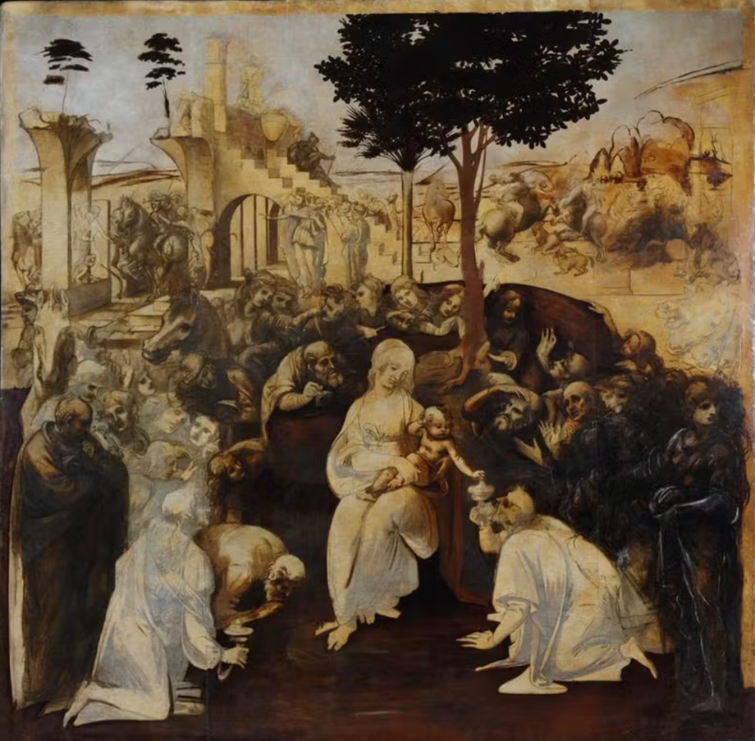
5) To Make is to Not Create.
Figure 2, adoration of the magi, Leonardo Da Vinci, 1481

“MAKING ART IS DIFFICULT. We leave drawings unfinished and stories unwritten.” (Art & Fear, 2001, p.1). Mastering the visuals often means having to master the psyche, which we will never fully understand, to perfectly put into context of what we want to create and what we actually create. To make but not create. The artist or creator or academic, consider themselves as an ordinary people, then put into consideration that other artists and creators are ordinary people having to overcome the universal experience of creative struggles (Art & Fear, 2001, p.4). Often perfection is an artist biggest enemy, not creating can often be the step needed to overcome expectations. Creating a finished product may be the most valuable external reason for creating art, but internally for the artist it is the journey, experiences, and technique that shape the work (Art & Fear, 2001, p.5). Leonardo Da Vinci, who left many of his pieces, that are also considered his most famous pieces, unfinished (Adoration of the magi) said “Art is never finished, only abandoned.” (Boland, B, 2021) Who decides there is any point n which art is finished; can more details not be indefinitely added? Is there any artwork that has been completely created?

6) The Death of something Old Brings the Life of Something New.
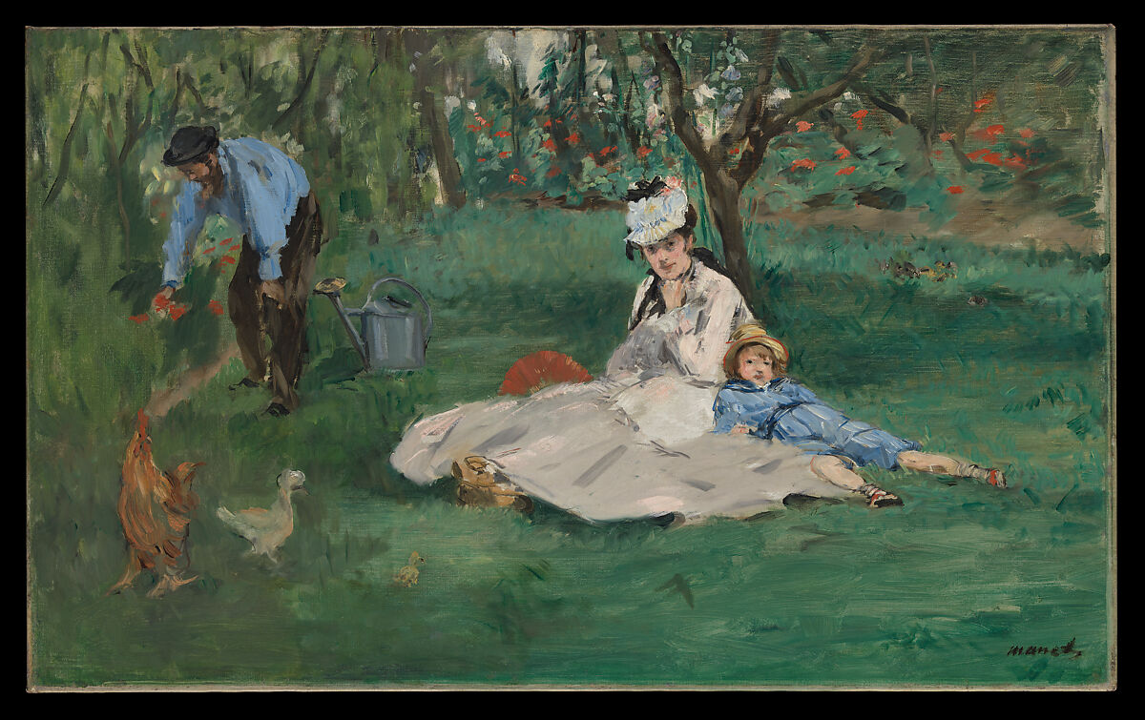
Figure Three, The Monet Family in Their Garden at Argenteuil, Edouard Manet, 1874

Modernism is the point at which historic and conservative values died within art and brought in life of individualism, experimentation, absurdity into the arts (Tate,). Manet is considered the founder or farther of the modernist period, who had a major impact and influence on impressionism, an early modernist art style (Artsper, 2022). While bringing life to painting and the french palette with opaque painting and Matt painting Manet simultaneously killed the obsession of oil paintings and the tradition values of art (keeping an eye open, 2015, p.72). “Even those who were on Manet’s side knew you cannot have the arrival of something old.” (Keeping and eye open, 2015, p.72). Though people appreciate and respect the place for traditional art mediums and ideologies nothing can live for eternity even an inanimate concept, life cannot exist without death.

Bibliography.
Barnes, J. (2015) ‘Manet: Black and White’, in Keeping an Eye Open: Essays on Art. London: Jonathan Cape, pp. 70-89.
Barrelli, A. (2023) The unity of opposites explained, Your Screenplay Guy. Available at: https://yourscreenplayguy.com/blogs/screenwriting-advice/the-unity-of-opposites-explained#:~:text=In%20screenwriting%2C%20the%20unity%20of,and%20drives%20the%20story%20forward. (Accessed: 25 October 2024).
Bayles, D. and Orland T. (2001) ‘The Nature of the Problem’, in Art & Fear: Observation on the perils (and rewards) of Artmaking. Santa Cruz, CA: The Image Continuum, pp. 1-7.
Boland, B. (2021) Art is never finished, only abandoned, ArtsHub Australia. Available at: https://www.artshub.com.au/news/features/art-is-never-finished-only-abandoned-262096-2370305/#:~:text=There's%20a%20popular%20quote%20you,writers%2C%20and%20creatives%20would%20recognise. (Accessed: 28 October 2024).
Heller, R. (2006)’” Could Only Have Been Painted by a Madman”- Or Could It?’, in. Edvard Munch: The Modern Life of the Soul. New York, London: Museum of Modern Art: Thames & Hudson, distributor, pp. 17-34.
Heller, R. (1973) ‘The Scream of Despair’, In Munch: The Scream London: Allen Lane Penguin Press, pp. 87-101.
Lathe, C. (1993) ‘Munch and Modernism in Berlin 1892-1903’, in Edvard Munch: The Frieze of Life. London: National Gallery Publications, pp. 38-44.
Mentler (2019) Nonfinito- the art of unfinished, The Society of Figurative Arts. Available at: https://tsofa.com/infinito/ (Accessed: 28 October 2024).
(No date) Rufino Tamayo- Arts of the Americans. Available at: https://www.oas.org/artsoftheamericas/rufino-tamayo#:~:text=RUFINO%20TAMAYO%20b.,1991%20Mexico&text=Hombre%20contemplando%20a%20la%20luna,as%20a%20dialectic%20of%20opposites. (Accessed: 25 October 2024)
ate (no date) Modernism, Tate. Available at: https://www.tate.org.uk/art/art-terms/m/modernism (Accessed: 3 October 2024)
Witek, D. (2022) How Manet changed art history, Artsper Magazine. Available at: https://blog.artsper.com/en/a-closer-look/how-manet-changed-art-history/ (Accessed: 31 October 2024)

List of Figures
Da Vinci, L. (1481) adoration of the magi. [Oil on Wood] Available at: https://www.uffizi.it/en/artworks/leonardo-adoration-of-the-magi (Accessed: 28 October 2024)
Manet, E. (1874) The Monet Family in Their Garden at Argenteuil. [ Oil on Canvas] The Metropolitan Museum of Art, New York. Available at: https://www.metmuseum.org/art/collection/search/436965 (Accessed: 31 October)
Munch, E. (1893) The Scream. [Oil, Tempera, Pastel on Cardboard] Munch Museum, Oslo. Available at: https://www.edvardmunch.org/the-scream.jsp (Accessed: 25 October 2024)

Observational Writing:
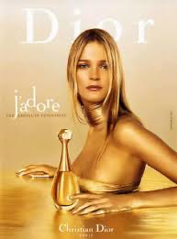
Simply, the concept of semiology using Saussure’s philosophy of signs having a signifier and signified. Signified is the subject and signifier is the associations of the subject (Media Studies, 2022). Denotation and connotation of the sign was developed from Saussure’s theory by Roland Barthes. Bringing the arbitrary nature of semiotics to the surface when connoting a denoted (Barthes, 1964, p.91). Using Christians Diors advertisement of J’Adore perfume I am going to put into context how semiotics is used.
Figure 1: J’Adore, Christian Dior (1999)
“We never look at just one thing; we are always looking at the relation between things and ourselves.” (Berger, 1972, p.9) Psychoanalysis is centred around the human subjective meaning that the way in which spectators respond to the advertisement is in relation to their characteristics that are arbitrary (Gillian, 2001, p.100). Using Gillian Roses paradigm on psychoanalysis “Psychoanalysis concepts are used to interpret aspect of visual images, and particularly their effects on spectators.” (2001, p.101) Christian Dior has used symbolic signs strategically to guide the decoding of spectators. Denoting the colour gold (the primary colour used in the advertisement) its simply just a colour. Gold is polysemic, connotations to wealth, success, luxury, power the human subjective notices these and the subjective is led to be in favour of the advertisement. Using the Weston connotations and Roland Barthes semiotic theory of myth’s, “The way we see things is affected by what we know or what we believe”(Berger, 1972,p.8), gold is used to affirm the Myth that with this perfume (J’Adore, Christina Dior) comes everything that has ever been wanted, money, success’s, power. A woman being represented through the iconic sign of Marilyn Monroe, blonde hair, a low cut dress that alludes to sexuality, but the body language seems at first to be submissive with the front of the body turned away but still slightly in view. Marlyn Monroe was a highly sexualised women within society who often had childlike, playful, and innocent tendencies and was often portrayed using Freuds theory of of scopophilia (the pleasure in looking) “…the pleasure in using another person as an object of sexual simulations through sight” in relation to the male gaze (Edwards, N/A). Reaffirming the myth of the gains and successes that come with J’Adore perfume. Marilyn Monroe is a strong signifier of it all, the fame, money, success. With being one of the most influential people, even still today, she arguably Is one of the most powerful and influential, loved and visually appealing iconic sign. Christian Dior wants the Spector to believe they can be too with J’Adore. J’Adore translates to “I love,” but only in relation to an object, not loving a being. Encoding to the idea that with J’Adore the only thing that is too be loved by you is the perfume. Whilst the advertisement is aiming for women there is still profound dependency of the male gaze.

Bibliography.
Media Studies (2022) Ferdinand de Saussure’s sign theory: Examples and analysis. Available at: https://media-studies.com/saussure/. (Accessed: 20th November 202).
Barth, R. (1964) Elements of Semiology. First addition. New York, United States: Hill and Wang.
Gillian, R. (2001) Visual Metrologies. London, New Deli: SAGE publications.
Berger, J. (1972) Ways of Seeing. London: Penguin Group.
Edwards, K. (N/A) Laura Mulvey’s Appropriation of the Gaze into Feminist Film Theory. Available at: https://www.vanderbilt.edu/AnS/english/Clayton/engl337a/edwards/337a-template-term-mulveyandgaze98.htm#:~:text=In%20her%20seminal%20article%20%EF%BF%BD,through%20sight%2C”%20and%20narcissism— . (Accessed: 21st November 2024)

List of Figures.
Dior, C. (1999) J’Adore. Available at: https://research-methodology.net/role-of-women-in-media-advertising-a-brief-literature-review/ (Accessed: 20th November 2024).

