GDAC CW2 write up

The general idea for our game was to create a shoot ‘em up game. The game that we created is called The Mammoths revenge. Our game is about a mammoth that finds out he is the last of his kind and vows to take revenge and breaks out of the zoo where he is being kept and gets on a flying train with a massive gun on it to enact his revenge. Unknown to him at the time he released an age-old virus that turned everything into zombies, but this won’t stop him from destroying everting in his path until he has revenge.
The desired target audience for our game was a younger target audience as we felt that the idea that we came up with appealed to a younger audience between the ages of 8-15. We decided that this would be the best age group to target as the content of our game wouldn’t appeal as much to older age groups and the cartoony theme that we were going for would also appeal more to this age group than any other.
The main design choices that I oversaw was mainly the building out of the game world as my main role within this project was working within the engine. I was also in charge of the design choices for the powerups that are in the game.
For building out the game world we decided as a group that the main areas in the game were going to be a zoo and a city. I then received the textured models, and it was left to me to build out the game world the first area that I worked on was the zoo area at the start of the game. I wanted to convey that this was the starting area of the game and somewhere that the player was escaping from.
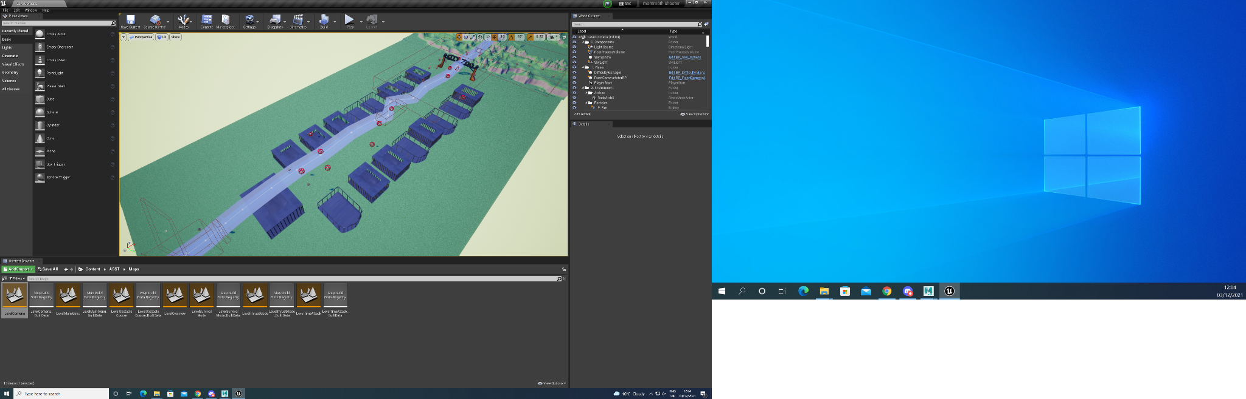
The second main area that I oversaw building in the game was the main city area of the game. I wanted to convey the idea that the player was entering a city that they could destroy. I believe that I have achieved this by having some of the buildings already be destroyed when the player enters this area. I also wanted to show that this was a busy city, so I added the models of cars and trucks to the streets to help show that this area was a busy city.
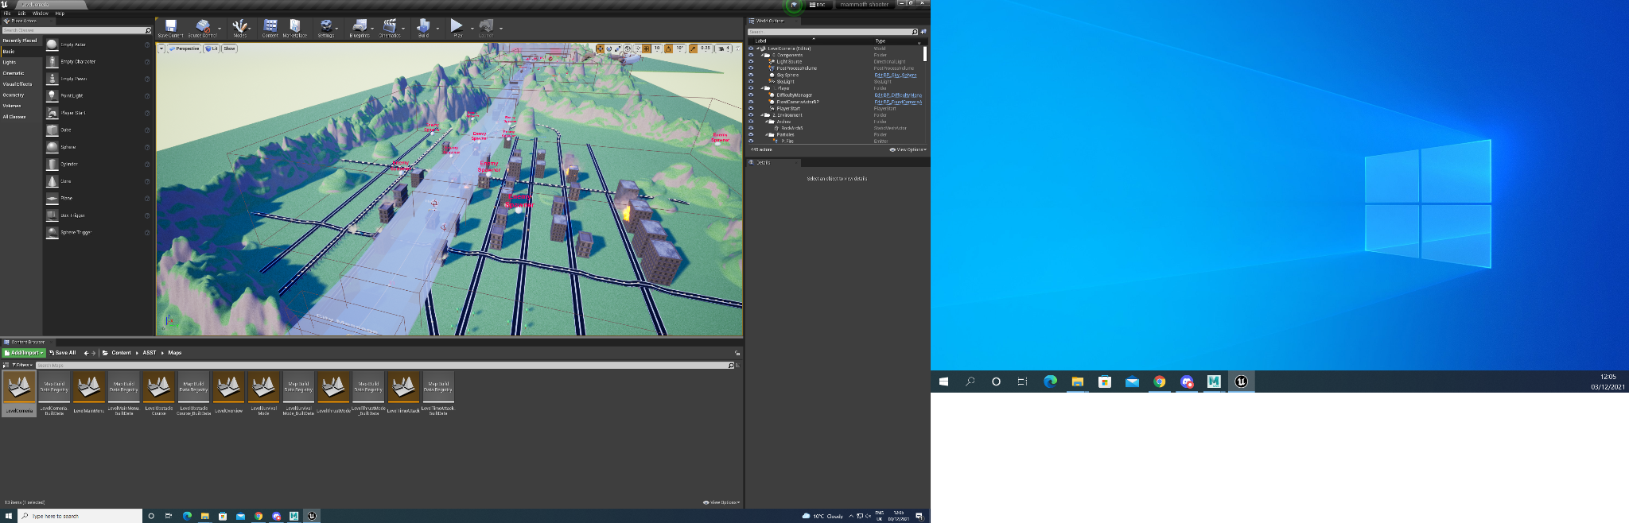
The last area that I oversaw building out was the town street I wanted to use this area as an area in which the player would be lower to the ground and would have to avoid the obstacles of the buildings that were placed in the way. I wanted the player to have multiple ways to avoid these obstacles with these being flying around the buildings to avoid causing debris that can damage the player. I also wanted a riskier way for the player to avoid these obstacles with this way being shooting through them by destroying the destructible mesh. I also wanted there to be more of an incentive for the player to destroy the buildings to achieve this I placed power ups that the player would only be able to collect if they destroyed the buildings.
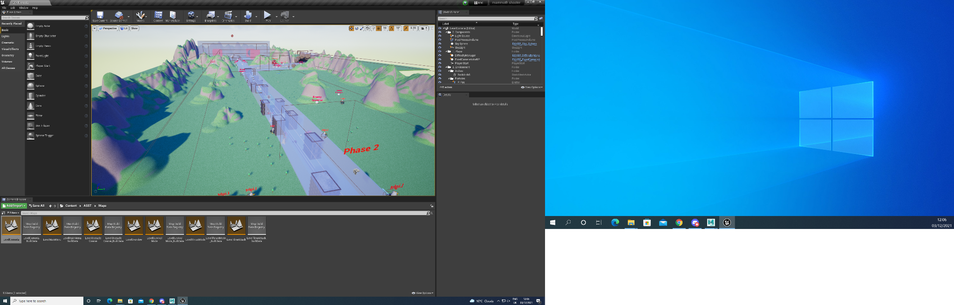
I was also in charge of the design for the power ups that were used in the game. My main design choices for the power ups were to make them stand out from the rest of the environment to convey to the player that these were something that you wanted to collect I believe that I achieved this by making the materials that they were made from brighter colours to make them stand out more.
For the power ups I also wanted them to convey what each of them did for the player without the player having to look up what each of the powers did. I believe that I have achieved this as the models and textures that I created for each of the power ups explained what they each did. For example, the health power, up is a green plus inside of a green and white ring I believe this conveys that this power up regains your health as a green plus is a commonly used symbol for health in video games. 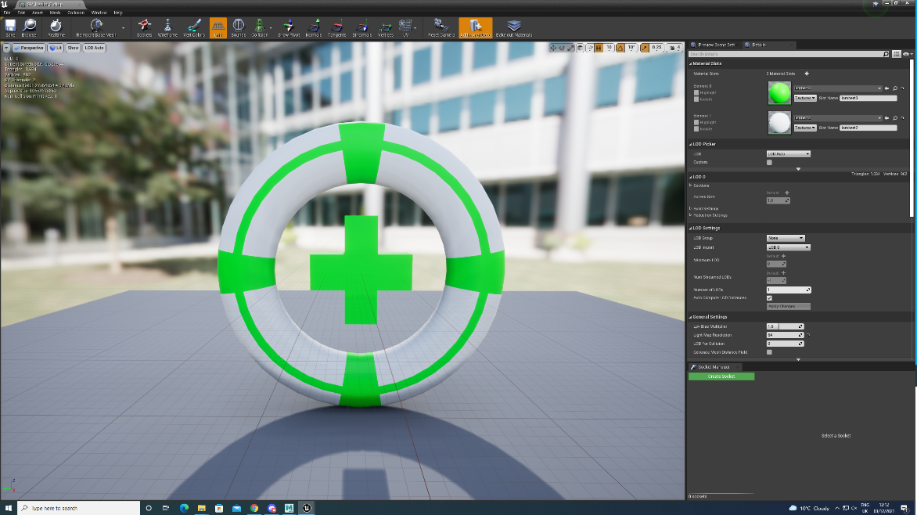
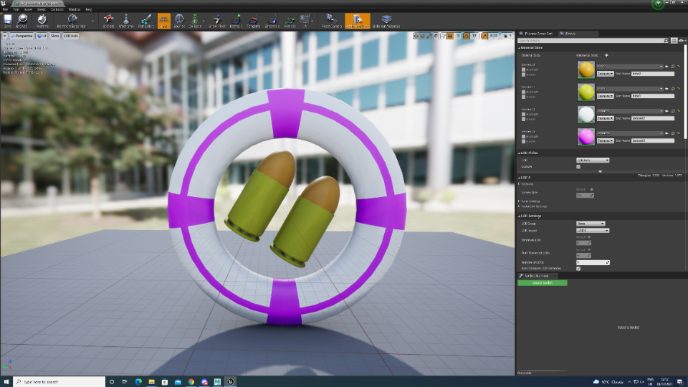
I also believe that some of the less recognisable powers still convey what they do from the models that they have. For example, the double weapon power, up conveys what it does by having two bullets as its model conveys that this power up will double the amount of damage that a player’s weapon will do.
I also believe that I achieved this for the missile power up as the model for it is a missile and I believe that the player would be able to recognise that this is an extra weapon that they can collect by flying through the rings.
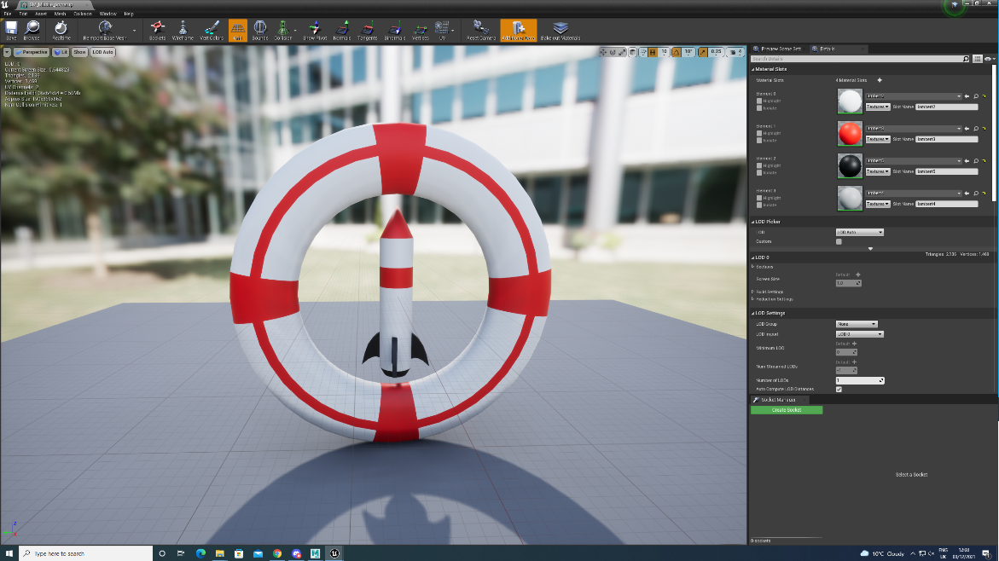

I conducted a lot of self-directed learning during this project. This research was mainly about the unreal engine and how to properly use it as I haven’t used the unreal engine in this capacity for something like this before, so I was fairly new to the software. The first thing that I researched was how to properly import assets into the engine (Importing Static Meshes, 2021) the main way that I researched this was using the internet to look at the unreal forums and see if anyone was asking the same questions that I was asking about when importing assets into the engine. Another way that I researched this area was to look at some YouTube tutorials. During this portion of my research, I found that I couldn’t rely on older videos and forum questions as the unreal engine can change its menu system and implement new features and remove older features that some older posts may have been suggesting to use. This made me rethink the way I went about doing my research for this project as I had to make sure that the information that I found was correct and up to date for the version of the engine that I was using. The way that I overcame this challenge with my research was to use Boolean searches. By using AND in my searches, I made sure that the information that I was finding was relevant to the version of the engine that I was using. After overcoming this challenge with my research, I was able to find a relevant YouTube tutorial that told me how to properly import assets into the engine to use in my game.
Another part of self-directed learning that I undertook during this project was learning to create destructible mesh in the unreal engine. To learn about how to create destructible mesh in the engine I deployed the same research technique that I used when I wanted to learn more about how to import assets into the engine. I looked at a lot of the online (Creating a destructible object in Unreal Engine 4 & Blender – Kids With Sticks, 2021) to help me and looked at some YouTube tutorials (Destructible Mesh (Any Mesh) - Unreal Engine 4 Tutorial, 2020) (Unreal engine, 2015) to learn the basics about how to create destructible mesh. I then wanted to learn more about how it works and the settings that I could change to make it better before I used in for the assets in my game. I decided that the best way to learn about this was to make a simple model and create a destructible mesh out of to use a prototype for my game so that I could play around with it and test it out. During this part of my learning, I discovered that I could make the fragmented parts of the mesh cause damage to the player. This gave me the idea of using the destructible meshes as hazards as it will allow the player to destroy buildings but also gives them a consequence to doing so. I then tested this setting to make sure that the fragmented mesh wasn’t doing too much damage to the player so that they would still have an incentive to destroy the buildings. After I had finished conducting my research and learning about destructible meshes, I then implemented them into the game using the assets that other members of my team had created.
Another part of research that I did for my role is research for editing the blueprints that the shoot ‘em up template provides. As these blueprints are unique to the template that we used the research method that I had previously used wouldn’t help me with this part of the project as I wouldn’t be able to find any information online about how to use them. For this part of my research, I tested the blueprints out in the engine to make sure that I knew what each of the blueprints did. I also changed the settings on the ones that I knew I was going to use such as the enemies and the track as I wanted to make sure that the blueprints worked after I had edited them. This part of the research for editing the blueprints was made easier as the template that we were working on had boxes of text explain what each part of the blueprints did. This helped me as I didn’t have to guess what part of the blueprints did what which made it easier to edit them the way I wanted to. It also provided less risk of me making the blueprints not working by editing parts of it I wasn’t meant to.
I believe that that the research that I conducted helped me with the effectiveness of the practical work that I completed during this project. The main part of my research that helped me with the practical side of the assessment would be the research that I did into destructible mesh as this was a part of the practical work that I really struggled with and the research that I did into this subject really helped me when I encountered any problems. For example, I encountered a problem with the mesh not fracturing after it had been hit. After looking through my research again I found out the problem was that I hadn’t set up the fracture setting properly.
I believe that the research that I did into destructible mesh really complemented the practical work that I have done for this project as it helped me to overcome some of the issues that I had at the beginning of the project. I also believe that all my other research for this project complemented well with the work that I completed with the practical side of the project. The main reason that I believe this is because my research helped me a lot with understanding the engine at the start of the project as it is not something that I had properly used before especially not in this capacity before. I also believe that the research that I conducted helped me solve any problems that I encountered during the practical work of this project.
I believe that the research methods that I used during this project helped benefit the design process of this assignment as all the external research that I conducted with this being articles and YouTube videos were up to date because of the research methods that I used for this project. This helped benefit the design process of the assignment as it helped me find all the features that I wanted to use, and I knew exactly where they were in the engine because I made sure that the research that I was conducting was relevant to the version of the engine that I was using for this project. If I was to do the research for this project again, I would look at more articles and YouTube videos regarding editing blueprints in the unreal and do some research in to how to properly create them as this would allow me to have more freedom in what I can do with the engine and improve the project that I was working on.

Bibliography
Research
Docs.unrealengine.com. 2021. Importing Static Meshes. [online] Available at: <https://docs.unrealengine.com/4.27/enUS/WorkingWithContent/Types/StaticMeshes/HowTo/Importing/> [Accessed 10 December 2021].
2020. Destructible Mesh (Any Mesh) - Unreal Engine 4 Tutorial. [video] Available at: <https://www.youtube.com/watch?v=4MaIhIBZq_A> [Accessed 10 December 2021].
Kidswithsticks.com. 2021. Creating a destructible object in Unreal Engine 4 & Blender – Kids With Sticks. [online] Available at: <https://kidswithsticks.com/creating-a-destructible-object-in-unreal-engine-4-blender/> [Accessed 10 December 2021].
Unreal engine, 2015. Making a Destructible Mesh | Live Training | Unreal Engine. [video] Available at: <https://www.youtube.com/watch?v=-gGiEmYj4oE> [Accessed 10 December 2021].

