Joseph Harris
Assignment one

Context
Addressing Table 3
3
Pinging PC01 3
Pinging PC02 4
Pinging PC03 4
Pinging PC04 4
Pinging Laptop 5
Pinging Server 5
Physical Topology 6
Logical Topology 7

Addressing Table
Device Name | Interface | IP Address | Subnet Mask | Default Gateway
IQ205 Server | NIC | 192.168.1.7 | 255.255.255.0 | 192.168.1.1
IQ205 Router | NIC | N/A | N/A | N/A
IQ205 Wireless Router | NIC | N/A | N/A | N/A
IQ205 Central Switch | NIC | N/A | N/A | N/A
PC01 | NIC | 192.168.1.3 | 255.255.255.0 | 192.168.1.1
PC02 | NIC | 192.168.1.4 | 255.255.255.0 | 192.168.1.1
PC03 | NIC | 192.168.1.5 | 255.255.255.0 | 192.168.1.1
PC04 | NIC | 192.168.1.6 | 255.255.255.0 | 192.168.1.1
Laptop01 | NIC | 192.168.0.4 | 255.255.255.0 | 192.168.0.2

Above I have listed all the devices used with my network.

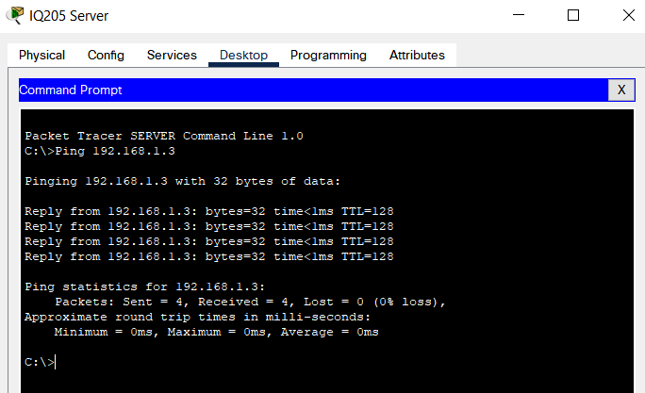
Pinging PC01

Pinging PC02

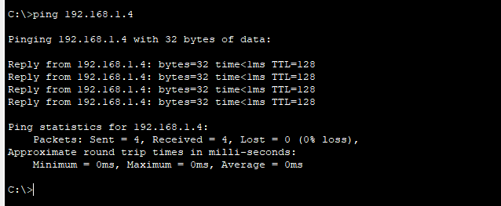

Pinging PC03
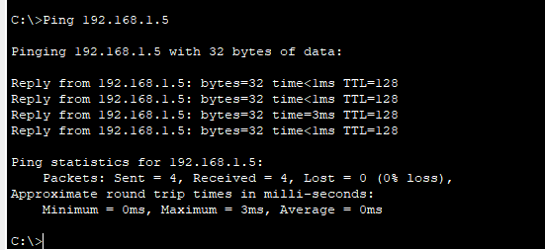

Pinging PC04

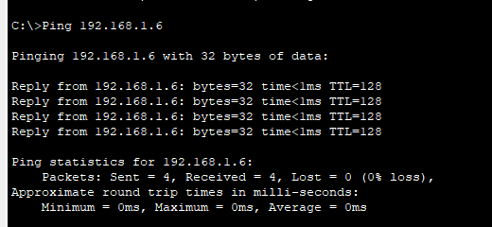

Pinging Laptop

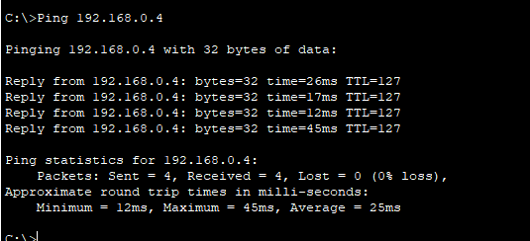

Pinging Server
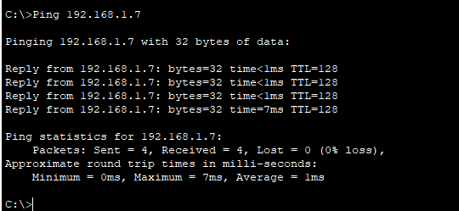

DEVICE NAME | DEVICE IP | PING SUCCESFULL
PC01 | 192.168.1.3 | YES
PC02 | 192.168.1.4 | YES
PC03 | 192.168.1.5 | YES
PC04 | 192.168.1.6 | YES
LAPTOP01 | 192.168.0.4 | YES
IQ205 SERVER | 192.168.1.7 | YES

Physical Topology

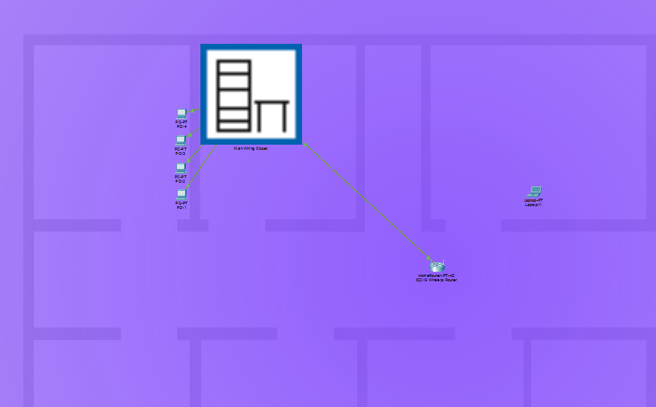

Above is my physical topology

Logical Topology
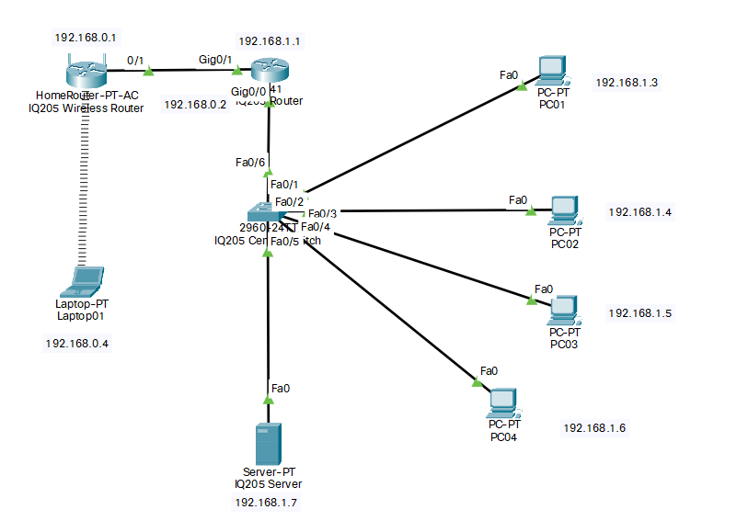
Above is my logical topology

