UNDERSTANDING AND ENGAGING IN THE CUSTOMER EXPERIENCE

MODUL CODE: BMSW 5103
LECTURER: NADEEM MIRZA
AUTOR: MARIANA GOLEMANOVA
STUDENT NUMBER: 2030688

Executive Summary
The IDIC model helps build one-to-one customer relationships through identification, differentiation, interaction, and customization. The report began with the introduction and it delved deep into the two tasks. In the first task, IKEA’s company CRM issues have been discussed with evidence, and the external and internal business environment of IKEA has also been discussed to understand the issues and their impact on the company. Task 2 has showcased the theories and the models, where the QCI model focused on customer management through the acquiring and detention of new customers with the help of technology. Theories and models have been used to analyse the issues and mitigate the problems in task 2. The potential challenges and benefits in addressing CRM along with an evaluation of the benefits and challenges in implementing Payne’s five forces model have been critically discussed in the second task. In the recommendations, the SMART chart has been proposed for the CRM models where some of the ways have been analysed for the company so that the company improves the consumer experience. Lastly, a conclusion has been added to summarise the whole report briefly.

Table of Contents
1. Introduction 4
TASK 1 4
2. Discussion 4
2.1 Company Context 4
2.1.1 Company Description 4
2.1.2 CRM issues with evidence 5
2.1.3 Benefits of addressing the CRM issue 6
2.1.4 Internal and External analysis 6
2.2 Models Review 10
2.2.1 IDIC model 10
2.2.2 QCI model 11
2.2.3 Payne’s Five Process Model 12
2.2.4 CRM Value Chain Model 14
TASK 2 15
2.3 Model Selection and Application 15
2.3.1 Analysing and justifying a selected model 15
2.3.2 Relevancy of selected model in the chosen company 15
2.3.3 Potential benefits and challenges to addressing CRM problem 16
2.3.4 Evaluation of the benefits and challenges of the application 17
2.3.5 Different customer approaches to build customer relations in IKEA company 18
3. Recommendations 20
4. Conclusion 24
References 24
Appendices 28
Appendix 1: IKEA customer-service reviews 28
Appendix 2: Customer Service Scoreboard of IKEA 29

1. Introduction
Customer Relationship Management or CRM can be understood as a technology for managing and controlling all the company’s interactions and relationships with potential customers. The primary goal of CRM is to enhance business relationships with promising clients and customers. It can be implied that a CRM system aids a company in staying in touch with the “customers”, “streamlining processes”, and “improving profitability”. Companies need to apply TQM which can allow the organisations to build long-term success by focusing on product quality and others, delivering better customer satisfaction. It is important to build and maintain a strong relationship with customers to retain their sales and profitability, however, maintaining relationships is not an easy task as it requires customer handling skills and expertise to retain customers. However, this report will identify the CRM issues that are bothering the Ikea company, a leading furniture company operating in the UK. Both the internal and external factors would be analysed to understand the way those factors have given rise to the CRM issues.

TASK 1

2. Discussion

2.1 Company Context

2.1.1 Company description
Ikea was founded in 1943 by “Ingvar Kamprad” and came into existence “as a mail order catalogue business” in the town of “Almhult, Sweden” (IKEA, 2022a). It is a leading “home furnishings retailer” that has grown rapidly and it is the world’s largest furniture company today. IKEA has been ranked as the eighth most valued retailer globally and it is valued at “21 billion US dollars” (Statista, 2022a). The company has “458 stores along with 50 e-commerce” where “775 million customers” have been observed to have visited the stores in 2021 (Statista, 2022a). Hence, it can be analysed that the company holds a good position.

2.1.2 CRM issues with evidence
IKEA is considered to be the world’s largest furniture company, however, it has a range of CRM issues and this can be understood with the evidence that 73% of the customers have marked the company’s customer service as bad. The communication mix theory is one such marketing theory that contains all the required tools such as advertising, sales promotion, public relations, direct marketing, and personal selling that are needed to be able to interact with the customers. A mix of dialogue and deficit activities can be found in most engagement activities (Metcalfe, 2019). As the customer feedback is fairly low for IKEA, they can make use of this model to promote customer interaction and improve their services. In the evidence, it is evident that a customer has faced delivery issues at his delivery has been delayed and this ruined the plans of the customer. Hence, it can be stated that not only one but there numerous customers like this who think that the company is less bothered for their customers. In appendix 2, one piece of evidence has been attached where the company has scored “27.39 out of 200” which goes to say that most of the customer's reviews have shifted toward negative and the review outcome is “terrible”. It has scored an overall score of only “3.4 out of 10 for friendliness” (IKEA, 2022b). Hence, it also means that the company executives are not friendly with their customers, which has given rise to more issues.
The 7P’s of marketing is another marketing theory that involves various sub-factors such as product, promotion, price, packaging, positioning, and people. The implementation of this model in the operations of IKEA will allow them to promote their products and services to gather further attention from the customers with respect to its product quality, pricing strategy, and other factors of marketing. Ikea has also been suffering from supply chain issues which are additionally giving rise to disappointing customers (Bloomberg, 2021). Delayed delivery of products made the customers impatient and it is more difficult to calm customers with an increasing rise in the demands and this supply chain has risen due to driver shortage (BBC, 2021). Hence, these issues need to be addressed at the earliest. [Refer to the Appendices]

2.1.3 Benefits of addressing the CRM issue
IKEA needs to address the CRM issues as soon as possible as it might affect heavily its sales. However, addressing these CRM issues can also help the company realise where they went wrong along with their weaknesses and threats. Once the company can know the actual issue and problem, it will enable the business to improve its services, build good customer relationships, and enhance business efficiency by automating its business leading to higher profitability.

2.1.4 Internal and External analysis
PESTLE Analysis
Factors | Impact | Level of Impact
Political | - Brexit has created uncertainty issues regarding employment (lack of skilled employees) and the economy (Bloom et al. 2019)  - Hence, IKEA cannot recruit skilled employees leading to minimal customer support and services to the customers  - Russia-Ukraine war might bring supply difficulties to the company where late deliveries can disappoint the customers  - Gradual increase in the UK corruption rate by 78 in 2021 is an issue (Statista, 2022b)  - Hence, raising the corruption rate in the company might bring dissatisfaction among the customers | High
Economic | - UK inflation rate has been increasing and has reached 9.1% and it will soon reach 11% (BBC, 2022)  - This might affect customers buying due to a higher rate of furniture. | High
Social | - COVID-19 has created issues in purchasing due to its social distancing scenarios  - This can affect customer’s buying and the company’s inability to provide necessary items can dissatisfy the customers | Moderate
Technological | - The UK Government has invested “2.5 million British Pounds in technology (BBC, 2018)  - Company’s inability to bring digital transformation or automation can lower the production quality leading to customer dissatisfaction | Moderate
Legal | - Consumer’s Right Act needs to be maintained by the company  - This act gives consumers the freedom to know and query about any products (GOV, 2022a) | High
Environmental | - “The Environment Act of the UK” states that companies need to follow the policies of “sustainable packaging” to attenuate environmental risks (GOV, 2022b)  - Failure to take such measures can dissatisfy the consumers | Moderate
Table 1: PESTLE Analysis
(Source: Self-developed)
SWOT Analysis
Strengths | Weaknesses
- Ikea has a brand image and identity  - IKEA has tied up with the lowest price suppliers (Wu, 2020)  - It has strict control over the manufacturing  - It has the label of a unique brand and has a higher reputation (Wu, 2020)  - It has 458 stores globally (Statista, 2022)  - It has both a physical and an e-commerce store  - It not only operates in Europe but also in China, and others  - Expertise in market entry strategies (Wu, 2020) | - It has a low customer satisfaction level [Refer to appendix 1&2]  - Weak in price advantage due to supply chain (Wu, 2020)  - Frequent supply chain issues due to shortage of drivers
Opportunities | Threats
- Increase CRM activities and system to gain good customer feedback  - Bringing automation into the business to retain customers  - Engaging in schemes and more offers to increase customer engagement | - Stiff competition from “Wayfair, Tesco, Amazon, Home Depot, and American WoodMark”  - Growing negative customer reviews
Table 1: SWOT Analysis
(Source: Self-developed)
Analysis of Pestle and Swot
From both the Pestle and the Swot analysis, it is quite clear that numerous factors have led to customer-related issues in the Ikea company. Having discussed its strengths and weaknesses, it can be evaluated that the company is less bothered by the customer’s demands as they have faced supply chain issues due to driver shortage and this has been difficult for the company to manage high customer demands regarding furniture which has severely led to lower customer satisfaction. It can also be analysed that the Ikea company might develop a tendency of corruption as the UK has an increased corruption rate. Hence, this can be a factor that can lead to more customer dissatisfaction. However, the strengths of the company can be understood by its unique brand and higher reputation and this comes as a complete contrary to the poor customer service of the company. Overall, it can be recommended that the company needs to maintain its relationship with the customers to increase its profitability.

2.2 Models Review

2.2.1 IDIC model
Peppers and Rogers developed the “IDIC (Identity, differentiate, interact, customise)” model in 1995. It is the most common model related to CRM which allows any company to function in customer service in a good manner. The key concept of the IDIC model is that a company has to take four actions as mentioned above to build one-to-one relationships with its customer as shown in figure 1.
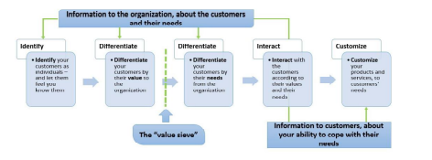
Figure 1: IDIC model
(Source: Ndhlela and Sibanda, 2020)
With this CRM model, the company has to identify its potential customer and develop a close understanding of its customer. Then its customer has to be differentiated based on their values. The differentiation enables the formulation and executes strategies for the specific customer group. The interaction with the customer ensures that the expectation of the customer has been understood. This process allows evaluating the interaction of the customer with another company.
Strength of the IDIC model
With the IDIC model, IKEA can access customer expectations and can develop values for its business (Ndhlela and Sibanda, 2020). This model provides effective customer interaction which leads to a better understanding of the customer.
Weakness of the IDIC model
According to Khashabet al. (2020), the IDIC model only focused on the value and need of the customer to meet customer expectation, but how to measure the customer needs and value are not discussed. Other different influential factors such as CRM strategies, analysis of the Current Situation of CRM, and others are also not considered in this model.
Evidence of successful application
As drawn from the evidence of Top Management Consulting, the company can be seen successfully applying the IDIC model for its CRM to be more customer-centric (Fernández-Cejas et al. 2022).

2.2.2 QCI model
The Quality Competitive Index (QCI)” is a customer management model, this, model states that the company is required to take certain actions to acquire new customers and retain old customers. This model is different from other CRM models as it is focused on customer management instead of customer relationships. This model focus on the management of impulsive buyers (Miremadi and Ghanadiof, 2021). Model, there are eight elements in this model as shown in figure 2. The core component of this model is consumer management activities that are comprised of “acquisition, retention, and penetration.” the supporting component of it are organized and people which are affected by the external environment and experience of the customer.
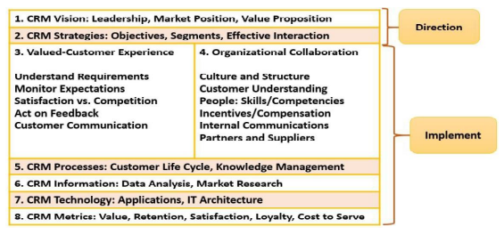
Figure 2: QCI model
(Source: Ndhlela and Sibanda, 2020)

Strength of the QCI model
Technologies have been used in this model to help the customer management activities. This model puts customer management at the centre of it with the organisation and customer as the intermediate process. This model eliminates the use of relationships as a part of the CRM. This model states that the strength varies between individual customer ad service products.
Weakness of the QCI model
This model focused on customer management, mainly the acquisition and retention of new customers but is not focused on old customer retention, this model is highly dependent on technology more specifically data analysis, which may give biased results (Efendi et al. 2021).
Application of the QCI model
Miremadi and Ghanadiof (2021) have shown that the QCI model has been applied to the financial institution for their CRM for customer retention.

2.2.3 Payne’s Five Process Model
Strengths
The strengths of “Payne’s Five Process Model” lies in the fact that it identifies the five core processes in customer relationship management and helps companies create a way to build value for the customers and gain customer appreciation. As stated by Tikku and CBSA (2020), this five-process model is focused on the fact since it is completely based on enhancing the retention and acquisition of customers by integrating and maintaining a relationship with valuable and loyal customers. These five processes are divided into the following:
- “Strategy development process”
- “Value creation process”
- “Multichannel integration process”
- “Performance assessment process”
- “Information management or analytical process”
According to Srivastava et al. (2018), a good customer relationship impacts positively on the business performance of a company. Hence, this company’s customer service and relationships can be enhanced by the implementation of this model.
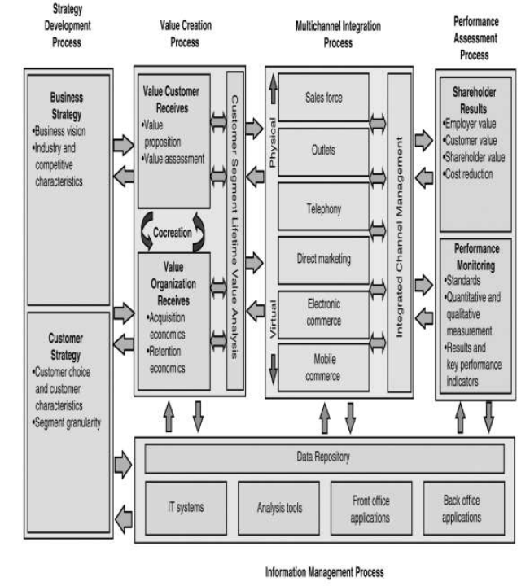
Figure 3:Payne’s Five Process Model
(Source: Tahir et al. 2018)
Weaknesses
This particular model is quite complex and difficult to understand, hence, it is also very difficult to apply or implement in an organisation (Tahir et al. 2018). The weaknesses of this model can be understood by the inability of this model to yield any desired result since the technology has been given the responsibility of analysing and interpreting the information.
Application evidence
Fernández-Cejaset al. (2022), has opined that the application of this model has resulted in the successful integration of customer relationships which has strengthened the CRM systems of companies as well.

2.2.4 CRM Value Chain Model
Strengths
According to Fernández-Cejaset al. (2022), the CRM field is a highly efficient tool and technique to support the application and development. The strengths of this particular model lie in the fact that it helps in setting the strategies that an organisation needs to follow while developing its CRM strategies. The strength can also be understood by its ability to deliver value to the customers and it also helps in managing the business with its customers in an effective way.
Weaknesses
The weaknesses of this model can be understood by its implementation issues since poor communication and a lack of leadership can affect the proper application of this model. Hence, to implement this particular model, proper leadership monitoring and support are required in applying this model. Another weakness can be understood with the model’s long process and time-consuming aspects which delay the application and thereby, its outcomes (Tikku and CBSA, 2020). However, this is an effective model which strengthens customer relationships effectively.
Application evidence
It has been found that the application of this particular model in companies has helped them in strengthening their relationship with customers and it can be analysed that this model helps in conveying the values to the customers which eventually aids and improves a better and a stronger customer relationship (Tikku and CBSA, 2020). It can be understood that the application of this model can be positive in building a robust and long-term relationship with the customers making them feel inclusive and safe while purchasing from the company.

TASK 2

2.3 Model Selection and Application

2.3.1 Analysing and justifying a selected model
The “Payne's Five process Model” can be considered by the IKEA company to integrate and create value for the organisation and develop a robust CRM system based on the strengths and weaknesses of the company. It can be understood that this particular model can aid IKEA in creating a way to build value for the customers and gain customer appreciation, leading to higher profitability. According to Fernández-Cejaset al. (2022), Payne's five process model is an effective model that deals with building customer relationships by undergoing a strategic development process. Since IKEA has a problem in the supply chain which causes late deliveries of products, adopting a strategic development of the supply chain can attenuate this problem to some extent. Hence, this can be an ideal process that might help the IKEA company not only to build a stable relationship with the customers but also to undergo the five effective steps to realise their issues and take measures to solve them.

2.3.2 Relevancy of selected model in the chosen company
Payne’s Five process Model apprehends “collecting, organising, and utilising information” that is associated with the customers and helps them with insights into the customer behaviour. This particular model helps an organisation to create an effective marketing response and fosters value propositions for the consumers. It can be understood that the application of this model would be beneficial to address and mitigate the CRM issues in the IKEA company as this model is based on the five long and effective processes which can help the company create value for the customers and meet their demands based on the needs and requirements of the customers. As stated by Tikku and CBSA (2020), it can be analysed that this model is quite long and time-consuming yet it is quite effective in the organisation. However, it is complex yet its five-long processes can help the organisation to complete each step with transparency and help the organisation in yielding a better outcome.
Payne’s Five Process model is a very relevant model that allows a customer-based value proposition. Organisation managers and retailers of IKEA can use this model for building CRM strategy by engaging its existing and new customers along with offering value propositions such as loyalty privileges, discounts, and faster delivery. Offering so much to the customers will help the company mitigate its issues and develop a robust customer relationship.

2.3.3 Potential benefits and challenges to addressing CRM problem
CRM also known as Customer Relation Management is a platform used by organisations to boost their sales after thoroughly studying the trends or behaviours among the customers. CRM is a dynamic approach and plays a critical role in the circular economy and the overall performance of the organisation (Delport, 2021). Most CRM projects fail to see success due to low customer adoption rates as they are not able to inform their customers of the proper prospects for making correct business decisions. Addressing the problem of the low adoption rate requires the users to get involved in the CRM process sooner. This allows an organisation to be a part of the user experience and gain an understanding of the perspective of the customers. As reported by Joseph et al. (2018), the consideration of various customer adoption factors can act as a medium for improving customer adoption and awareness. In many cases, the managers of the organisation select their CRM as per today’s needs without considering the future aspects.
It doesn't provide any room for the CRM to grow and evolve from its existing state, as such the organisation might be stagnant for a while in its operations. To fix this problem, the planning should be done with consideration of the evolution of CRM in the future and the integration of CRM in the various platforms used in the future. The implementation of Payne’s Five Process Model in the organisation will allow the evaluation of its strength and weaknesses to develop a robust CRM system and will integrate the newly created values into its operational process. As stated by Soni (2020), a disaster recovery planning system is essential for appropriate risk management, no matter the skills of the team.
One other potential problem is the security of the CRM system, from the perspective of an organisation its data is one of the most valuable assets it can have. This can be fixed by taking into account various security measures such as keeping the software used in the organisation updated and installing firewalls to fend off potential threats to the organisation. The rise in the digital ecosystem has made organisations aware of the importance of security and the implementation of security measures in ensuring privacy and the best digital ethical approaches (Susanto et al. 2021). The poor implementation of CRM strategy very often prevents an organization from achieving success in their business as the strategies implemented by them do not provide customer outcomes that align with their business strategy. A proper CRM strategy acts as a backbone for the organisation and allows them to determine the most optimal route needed to take to attain the objectives.
This can be prevented by weighing down the strengths and weaknesses and building a strategy around the strengths of the organisations to capitalise on them in the operations. Tawse and Tabesh (2021), reflect on the importance of an effective strategy in the success of an organisation and a potential source in providing an advantage over the competitors. The lack of improvement in the CRM process negatively influences the organisation as they cannot retain their customers. CRM value chain model’s implementation in the organisation will support the development and improvement of the CRM process as it provides value to the customers and helps in building a stronger customer relationship. Thus, the benefits and challenges of addressing the potential CRM problems can be seen in an organisation’s operations.

2.3.4 Evaluation of the benefits and challenges of the application
Payne's five forces model has been used in the application of various models as this model is one of the most important models used by IKEA. This model creates a QUBE forcefield that directs the field (Allen et al., 2019). It creates three aspects of value creation which create lots of value for the companies and consumers. It also helps the companies to maximise the segments which helps the company to exchange its values. It also converts multiple processes which help the company’s multiple value-aiding activities. It helps the businesses on making multiple decisions which helps IKEA to integrate all the channels so that the consumer experience remains positive.
The company also receives some positive feedback from this procedure which helps the company to evaluate the strategy and various propositions of values. It helps the company to implement a better CRM and acts as a success factor for the organisation. The companies need to come up with a strategy that supports the long-term competitiveness capacity mainly in unstable or disordered environments (Weissenberger-Eibl et al. 2019). The application of Payne’s five forces model will allow IKEA to devise a proper strategic development process that will provide them with a range of critical benefits such as the improvement in their service quality as well as the products, increase their revenue margins and attract new potential customers that supports the organisation in the long-run. In the implementation process of this model, IKEA might face resistance from its employers and management teams as adapting to a new environment is not preferred by everyone. This can lead to workflow disruption within the organisation as the colleagues and employees engage in arguments over the required change.
For the creation of value and emotional intellect with the customers, the marketers need to re-think their strategy concerning the engagement of the employees (Chan, 2019). Creating values within the organisation is essential as employees or workers need to feel valued in the organisation to increase their engagement and interaction among others. It also identifies the value a customer provides to a business and vice-versa. Interacting with each other allows them to understand others' perspectives in any given scenario which indirectly boosts the CRM rate within any organisation.
As Payne’s five forces model utilises the collected information, it can be an essential asset for IKEA to know the trends and behaviour of the customers that interact with them to target them specifically next time as per the recorded data.
IKEA might face potential challenges in the application of a value creation process in their organisation as team collaboration is necessary for this step to ensure that everyone is doing the relevant work as per the implied strategy of the business. According to Shavelson (2019), the performance assessment is done through a comprised set of tasks and questions that is mainly aimed at measuring the capabilities of an institution or an individual on specific skills such as critical thinking etc.
The assessment of performance allows IKEA to evaluate their whole business process and find any gaps that it may need to fill in its operations. It provides IKEA with a wide range of benefits such as the creation of career opportunities for the employees, improves the overall performance of the company etc. Payne’s five forces model may provide customer value, cost reduction, shareholder value and employer value etc through the performance assessment process. The unjust and illogical performance assessment lets the employees feel that they are being treated unfairly (Wei et al. 2019). The personal bias within IKEA may prevent them from assessing the performance fairly ultimately reducing the productivity of the organisation. Hence the various benefits Payne’s five process model provides to an organisation and the challenges in implementing those changes can be seen.

2.3.5 Different customer approaches to building customer relations in the IKEA company
The different approaches to building a strong customer relationship with the customers of IKEA, the following approaches can be considered.
Improving communication with the customers
Communication is the most important aspect and is a primary method to build a strong relationship with customers. According to Siregar (2021), communication has a primary aim to influence customers through the messages that are conveyed by others. In an organisation, communication is a key to achieving success and it also can strengthen the relationships with the customers based on an efficient and effective exchange of information. Therefore, the customer relationship management of IKEA needs to build a strong relationship with the customers through effective communication.
Gathering regular feedback
Feedback can be understood as personalised information that is based on direct observation and is delivered to the people for delivering the best potential (Jug et al. 2019). Therefore, it can be stated that the CRM of IKEA needs to continuously take feedback from the customers regarding the products and services. This will further help the company to assess the issues that are bothering the customers and deliver the best possible services to strengthen customer relationships.
Rewarding loyal customers
Rewarding loyal customers can be understood as the best way to retain old customers. According to Dalakas et al. (2022), a loyalty-based program can help in fostering the consumption behaviour of the customers over time. Hence, it can be analysed that the CRM of IKEA needs to reward loyal customers by giving them exclusive and unique offers and rewards. If this is practised by the CRM of IKEA, then it can help them in boosting customer relationships.

Creating a sense of community with the customers
Creating a sense of community with the customers can help in retaining and increasing customer satisfaction levels. Involving loyal and potential customers in providing insights and generating new ideas can help build a sense of community (Ind et al. 2020). Hence, it can be analysed that increasing the closeness and creating a sense of community with the customers can help in driving customer relationships with the CRM of IKEA company.

3. Recommendations
Recommended Models | Specific | Measurable | Accessible | Relevant | Time-bound
IDIC Model | The Company can find the main consumers who have a good understanding of the company. This strategy can get aligned with the main consumer needs (Khashab et al., 2020) The main aim of the company is to increase the level of consumer service. With this specific goal, the company can reach every consumer so that the needs and purchasing behaviour gets improved for a company like IKEA. | With good consumer service, the company can express some positive statements. These statements can help a company like IKEA to get the expected result for their service. It helps the company to become mature and powerful and meet the customer experience the company is expecting in the future (Nicolescu, 2022). The company can create some surveys or tests so that the company can measure the changes needed to implement the program. The company expects the desired result will come in the coming weeks and the measurement objective will get fulfilled for the company. | Accessible means to figure out the main ways that can help the company to achieve the goal and determine some ways so that the process can work towards the favour of a company like IKEA. Resources are the main factor for this kind of goal. The resource of the company is not a problem but the company can also make some more ways to generate resources by giving discounts or highlighting their products to make more sales and so on. It can help the company to get a better grasp of the model so that the company can determine how these strategies would be perfect for them (Pandey et al., 2022). Lots of other players in this industry have done it before, so IKEA is hopeful that they will pull this off and successfully implement it in their business operations in the future. | The company and their consumer-oriented strategy attract lots of consumers. Therefore, the main relevant goal for the company now is to determine the needed time and required resources. The company can check the objectives of their employees and it can help the company to determine the relevant goal for the company. Their employees know the work briefs and it can help the company to set some relevant goals in the future. IKEA can create a good framework that can help the company to focus on its relevant goal by following the main objectives and purposes of the company and its employees (Fernández-Cejas et al., 2022). It also helps the company to perform various roles and departments in the value chain department. | Time-oriented means the expected time of the expected result the company is trying to achieve in the coming 3 to 4 months. The company is aiming to make the consumer experience better so IKEA is aiming to make this process in the coming months. The company can also set some deadlines for that as well to motivate their workers and as a result of that, the company can achieve the main goal earlier than expected.
QCI Model | The main aim of this model is consumer management. Therefore, the company can spend more time with its consumers. The company can create some unique strategies in advertisements to spend more time with consumers (Öcal, 2020). Thus it can create a specific goal for the company in terms of this model. | The company can make some surveys to determine whether the aim is achieved or not. The company can also aim to make consumer management better. | The company can use some social media platforms like Instagram to make this campaign. It can help the company to get aligned with the target audiences to make consumer management better (Van Itallie et al., 2018). IKEA can also create marketing funnels to improve this section. | The company have enough time and resources for this better consumer management. The company can reach the main aim if it maintains some good procedures like good advertisements or good campaigning and so on (Bala and Verma, 2018). It can help the company to achieve the relevant goal. | 3 to 5 months is the time, the company can achieve this target. The company can set some tough deadlines to achieve it further ahead.
AI efficiencies | IKEA can improve AI efficiencies by expanding its operations by automating processes. It enables the identification of various insights to make the efficiencies better (Lin et al., 2021 ). The company can also increase AI efficiencies by using the right technology to provide more accurate results. | The company can respond to the consumers within hours so that the process gets easier for the company to get implemented | The company can hire some skilled professionals to work in this process so that the goal gets completed as early as possible. | Improving AI efficiencies can help the company to improve consumer experiences. It contributes the good governance as it can help the company to succeed in future (Mökander and Floridi, 2021). It can be worthwhile but it is a unique feature that can attract more consumers to the company. | 7 to 8 months is the time for the company to achieve this target. The company can also schedule each process on the calendar to achieve it earlier than expected.

Table 3: SMART Recommendations
(Source: Self-created)

4. Conclusion
From the above study, it can be concluded that the study focused on quality systems and consumer relationship management of IKEA. The study focused on the main importance of the quality processes like TQM or SERVQUAL and some CRMS and their benefits to the company. Then, the description of the company was given and some CRM problems with evidence were also stated. After that, some common CRM models such as; IDIC or QCI or Paynes and CRM value chain and their strengths and weaknesses and their application have been described. The study also highlighted some of the applications of these models in the organisation with proper pieces of evidence. Lastly, a recommendations table had been designed where a SMART goal had been set for some of the mentioned models for the company IKEA. Thus, the company can improve its value chain system and re-correct the consumer experience.

References
Allen, A.E., Robertson, M.J., Payne, M.C. and Cole, D.J., 2019. Development and validation of the quantum mechanical bespoke protein force field. ACS omega, 4(11), pp.14537-14550.
Bala, M. and Verma, D., 2018. A critical review of digital marketing. M. Bala, D. Verma (2018). A Critical Review of Digital Marketing. International Journal of Management, IT & Engineering, 8(10), pp.321-339.
BBC, 2018. UK attracts £2.3bn in tech investments and 1,600 new jobs, [online] Available at: <https://www.bbc.com/news/business-44452444> [Accessed on 16 July 2022].
BBC, 2021. “Ikea struggles with supply problems due to driver shortage”. Available at: https://www.bbc.com/news/business-58443653 [Accessed on 19th July 2022]
BBC, 2022. What is the UK's inflation rate and why is the cost of living going up? [online] BBC News. Available at: <https://www.bbc.com/news/business-12196322> [Accessed 15th July 2022].
Bloom, N., Bunn, P., Chen, S., Mizen, P., Smietanka, P. and Thwaites, G., 2019. The impact of Brexit on UK firms (No. w26218). National Bureau of Economic Research. Pp. 78-80.
Bloomberg, 2021. “Ikea Forecasts More Difficult Year on Supply-Chain Issues”. Available at: https://www.bloomberg.com/news/articles/2021-11-03/ikea-forecasts-more-difficult-year-on-supply-chain-issues [Accessed on 19th July 2022]
Chan, E.K., 2019. The role of personal relevance in the value creation process of edutainment consumption. Journal of consumer behaviour, 18(3), pp.190-204.
Dalakas, V., Tseng, M. and Melancon, J., 2022. Encouraging and rewarding customer loyalty: key considerations for sports teams. Atlantic Marketing Journal, 11(1), p.2.
Delport, R.G., 2021. Quantifying the influence of a customer relations management (CRM) approach on performance in a sales and distribution organisation (Doctoral dissertation, North-West University (South Africa)), pp.4-140.
Fernández-Cejas, M., Pérez-González, C.J., Roda-García, J.L. and Colebrook, M., 2022. CURIE: Towards an Ontology and Enterprise Architecture of a CRM Conceptual Model. Business & Information Systems Engineering, pp.1-29.
GOV, 2022a. “Consumer’s Right”. Available at: https://www.gov.uk/consumer-protection-rights [Accessed on 19th July 2022]
GOV, 2022b. World-leading Environment Act becomes law, [online] Available at: https://www.gov.uk/government/news/world-leading-environment-act-becomes-law [Accessed on 15th July 2022].
IKEA, 2022a. “About us”. Available at: https://www.ikea.com/gb/en/ [Accessed on 19th July 2022]
IKEA, 2022b. “User Reviews, Ratings and Comments”. Available at: https://www.customerservicescoreboard.com/Ikea [Accessed on 19th July 2022]
Ind, N., Coates, N. and Lerman, K., 2020. The gift of co-creation: what motivates customers to participate. Journal of Brand Management, 27(2), pp.181-194.
Joseph, J., Sriram, K.V., Rodrigues, L.L., Mathew, A.O. and Gana, K.C., 2018. An empirical study on customer adoption of mobile payment applications in India. International Journal of Enterprise Network Management, 9(3-4), pp.363-375.
Jug, R., Jiang, X.S. and Bean, S.M., 2019. Giving and receiving effective feedback: A review article and how-to guide. Archives of pathology & laboratory medicine, 143(2), pp.244-250.
Khashab, B., Gulliver, S.R. and Ayoubi, R.M., 2020. A framework for customer relationship management strategy orientation support in higher education institutions. Journal of Strategic Marketing, 28(3), pp.246-265.
Lin, Y.T., Hung, T.W. and Huang, L.T.L., 2021. Engineering equity: How AI can help reduce the harm of implicit bias. Philosophy & Technology, 34(1), pp.65-90.
Metcalfe, J., 2019. Comparing science communication theory with practice: an assessment and critique using Australian data. Public Understanding of Science, 28(4), pp.382-400.
Miremadi, A. and Ghanadiof, O., 2021. CRM Competitive Strategy in Financial Institutions. European Journal of Business and Management Research, 6(3), pp.111-117.
Mökander, J. and Floridi, L., 2021. Ethics-based auditing to develop trustworthy AI. Minds and Machines, 31(2), pp.323-327.
Ndhlela, M. and Sibanda, V., Reporting a Case Study on Customer Relationship Management as a Customer Retention Tool: OK Zimbabwe Limited.
Nicolescu, C., 2022. The approach of Customer Relationship Management as a Managerial Synapse. In Stakeholder Management and Social Responsibility (pp. 203-235). Routledge.
Öcal, D., 2020. Consumed Consumer Within the Framework of New Communication Technologies. In Handbook of Research on the Political Economy of Communications and Media (pp. 275-286). IGI Global.
Pandey, K.K., Bhatia, M. and Varshney, M.N., 2022. CUSTOMER RELATIONSHIP MANAGEMENT FOR RURAL RETAILING:“A FOCUS ON BUILDING COOPERATIVE AND COLLABORATIVE RELATIONSHIPS BETWEEN THE FIRM AND ITS CUSTOMERS”. JOURNAL OF HARBIN INSTITUTE OF TECHNOLOGY, 54(4), p.2022.
Shavelson, R.J., Zlatkin-Troitschanskaia, O., Beck, K., Schmidt, S. and Marino, J.P., 2019. Assessment of university students’ critical thinking: Next generation performance assessment. International Journal of Testing, 19(4), pp.337-362.
Siregar, B.A., 2021. Communication Strategy in Improving Satisfaction E-Commerce Customers. Almana: Jurnal Manajemen dan Bisnis, 5(2), pp.148-155.
Soni, V.D., 2020. Importance and Strategic Planning of Team Management. International Journal of Innovative Research in Technology, 7(2), pp.47-50.
Srivastava, S.K., Chandra, B. and Sinha, A.P., 2018. Effectiveness of knowledge management on customer relationship management in hotel business performance. Journal of Environmental Management & Tourism, 9(6 (30)), pp.1277-1288.
Statista, 2022a. “IKEA - Statistics & Facts”. Available at: https://www.statista.com/topics/1961/ikea/#:~:text=IKEA%20worldwide,visited%20IKEA%20stores%20in%202021. [Accessed on 19th July 2022]
Statista, 2022b. Corruption perception index UK 2021 | Statista. [online] Statista. Available at: <https://www.statista.com/statistics/868971/corruption-perception-index-in-the-uk/> [Accessed 13th July 2022].
Susanto, H., Yie, L.F., Setiana, D., Asih, Y., Yoganingrum, A., Riyanto, S. and Saputra, F.A., 2021. Digital ecosystem security issues for organizations and governments: Digital ethics and privacy. In Web 2.0 and cloud technologies for implementing connected government (pp. 204-228). IGI Global.
Tahir, D., Arshad, M. and Khan, M.M., 2018. Customer Relationship Management Model From Strategic Approach: A knowledge Management Perspective. Pp. 121-140.
Tawse, A. and Tabesh, P., 2021. Strategy implementation: A review and an introductory framework. European Management Journal, 39(1), pp.22-33.
Tikku, P. and CBSA, C., 2020. CRM and its Significance in Today’s Business Environment. Pp. 135-145.
Trustpilot, 2022. “IKEA”. Available at: https://www.trustpilot.com/review/www.ikea.com [Accessed on 19th July 2022]
Van Itallie, A., Corry, K., Vandelanotte, C. and Duncan, M., 2018. Effectiveness of a social media marketing campaign to increase awareness and membership of a physical activity website. Journal of science and medicine in sport, 21, p.S87.
Wei, Z., Siyal, A.W. and Bhand, S., 2019. Impact of personal bias on performance of employees in public sector banks. Journal of Public Affairs, 19(2), p.e1924.
Weissenberger-Eibl, M.A., Almeida, A. and Seus, F., 2019. A systems thinking approach to corporate strategy development. Systems, 7(1), p.16.
Wu, Y., 2020, February. The Marketing Strategies of IKEA in China Using Tools of PESTEL, Five Forces Model and SWOT Analysis. In International Academic Conference on Frontiers in Social Sciences and Management Innovation (IAFSM 2019) (pp. 348-355). Atlantis Press.

Appendices

Appendix 1: IKEA customer-service reviews
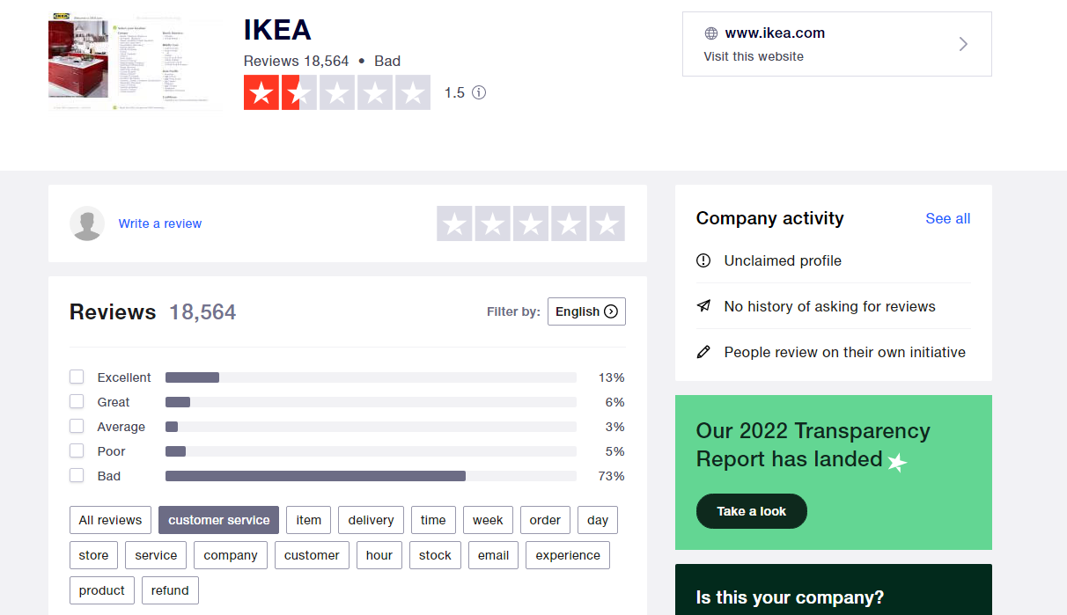
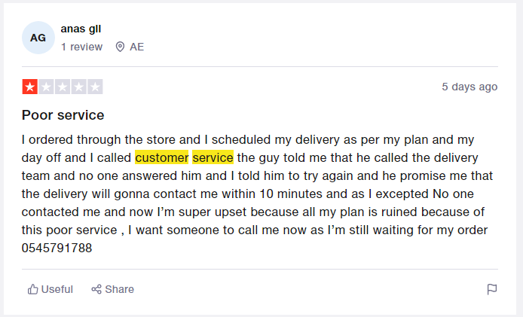
(Source: Trustpilot, 2022)

Appendix 2: Customer Service Scoreboard of IKEA
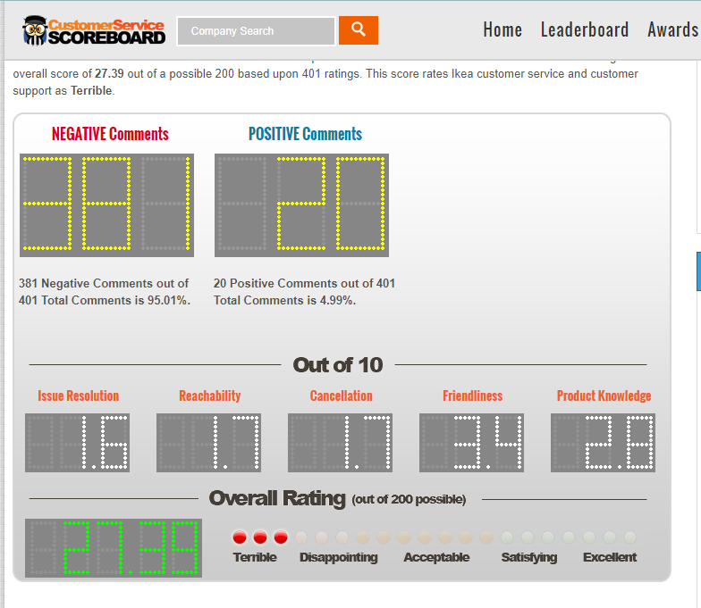
(Source: IKEA, 2022b)

