Configure, And Manage Virtualised Network
Network Operating Systems and Services | ACCA5023
jonathan wilcox - 2206641
2025
Table of Contents
Introduction 2
Time management 2
1. Swansea Network 3
2. Cardiff Network 15
3 Test the network for Connectivity. 21
4 Sharing Disk Drive: 23
5. Configure IIS Server 25
6. Remote Desktop Services: 29
Appendix 30

Introduction

This coursework is a continuation of Coursework 1, focusing on the practical implementation of network management and resource maintenance. Screenshots are included throughout to demonstrate the network functions.

Time management
The Gannt chart below was produced to help keep the project to track.
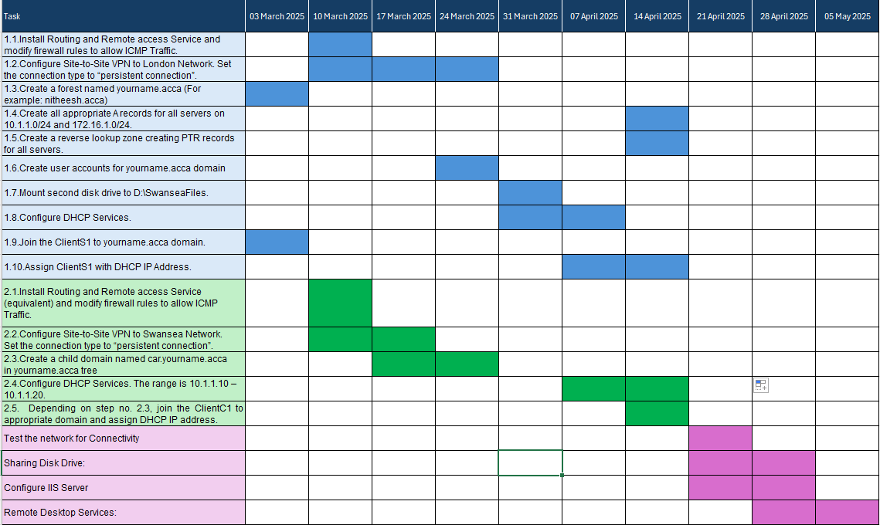

1. Swansea Network
  - Install Routing and Remote access Service and modify firewall rules to allow ICMP Traffic.
Setting up Routing and Remote access Service
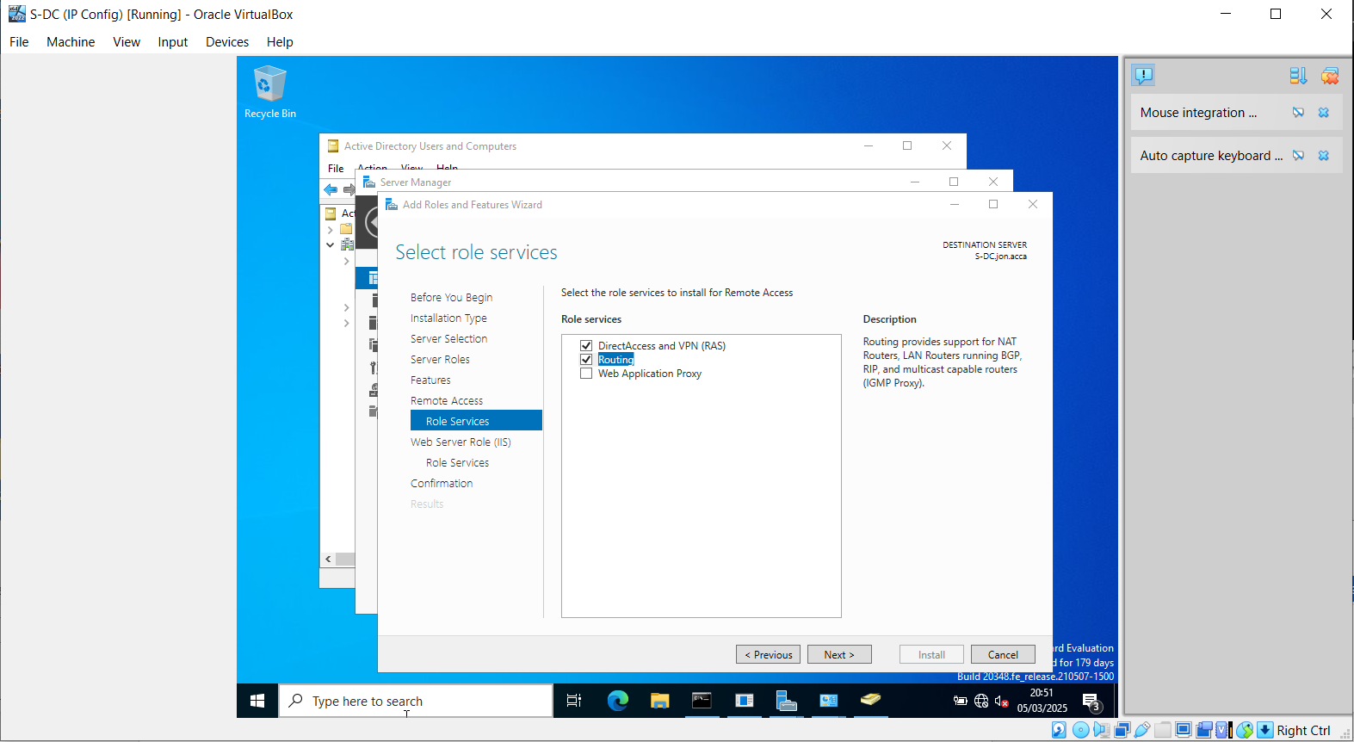
Modify Firewall Rules on S-DC server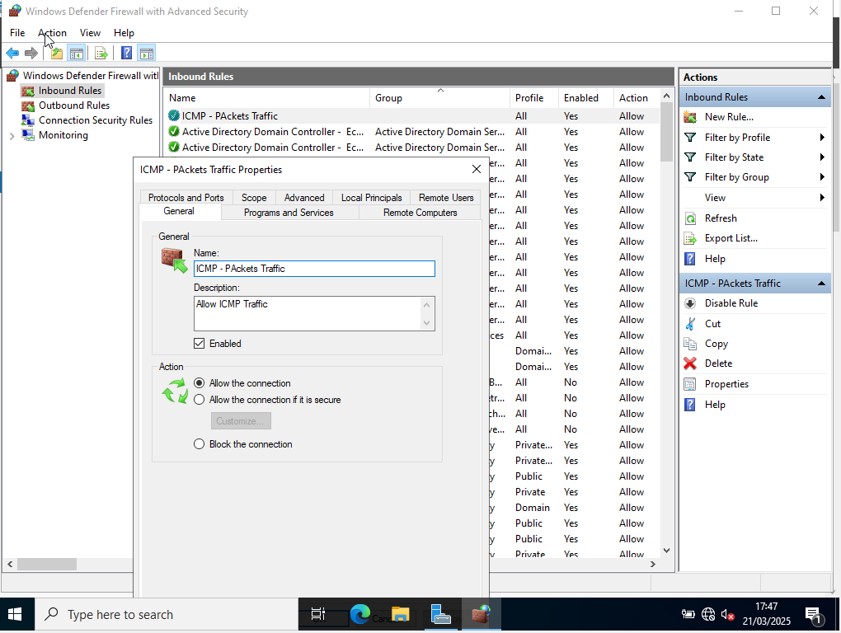

Modify Firewall Rules on Cilents1
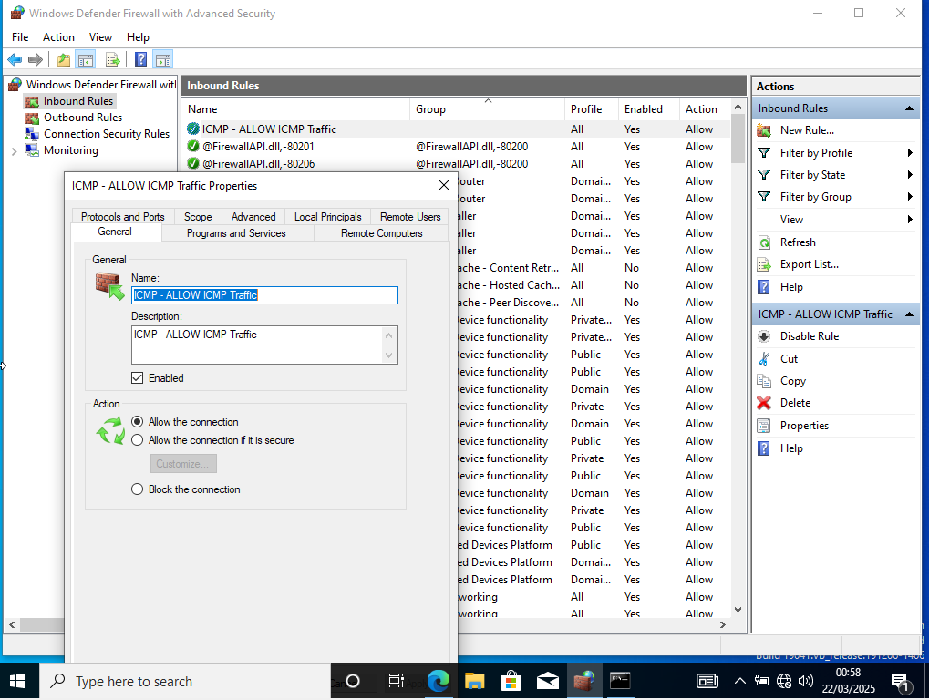
Successful pings between machines
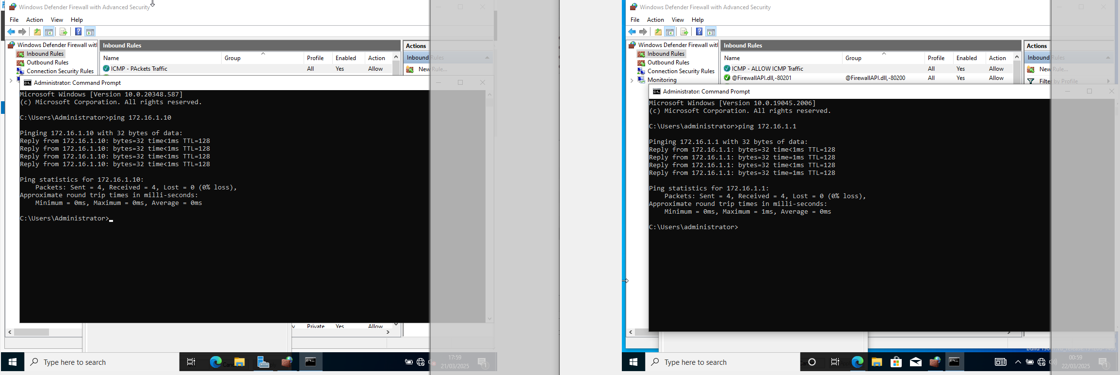

  - Configure Site-to-Site VPN to London Network. Set the connection type to “persistent connection”.

Successful ping site to site VPN
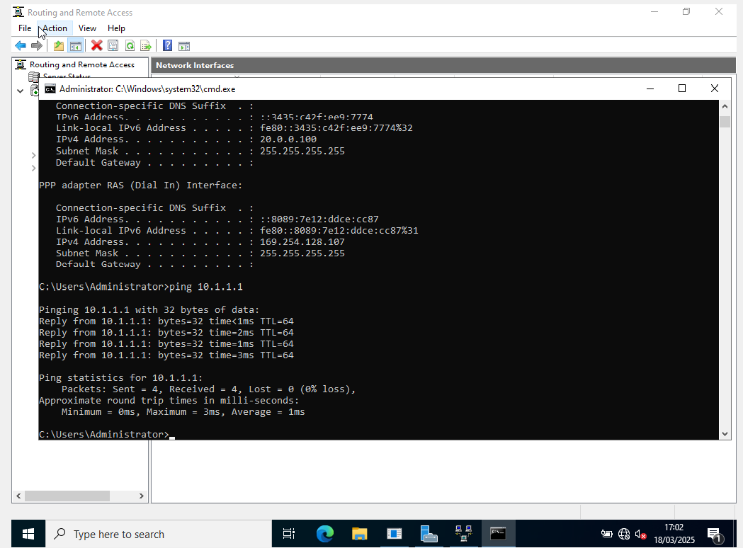
Successful VPN Connection
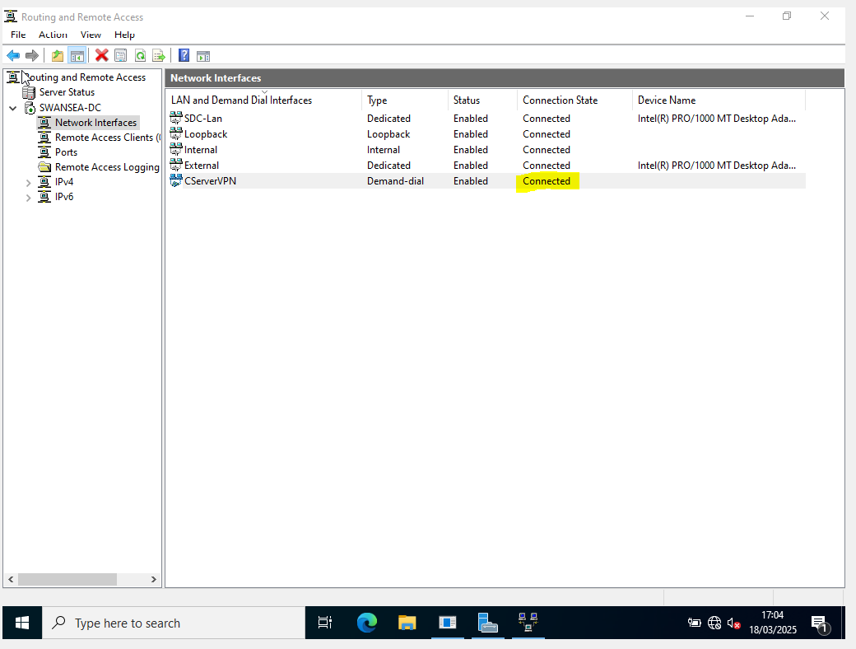
1.3 Create a forest named yourname.acca (For example: nitheesh.acca)
The screenshot below shows new forest creation with root name labelled jon.acca.

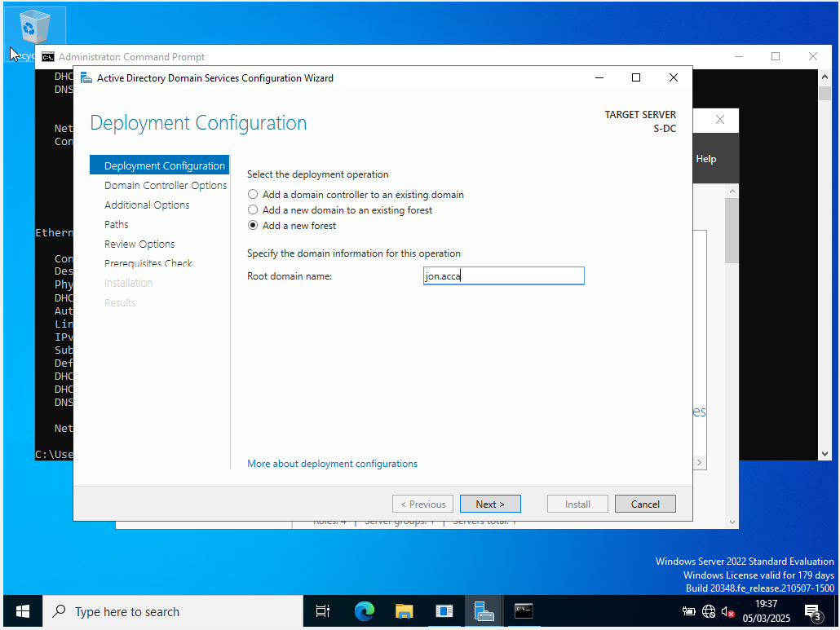

Figure 1. Creation of forest Jon.acca

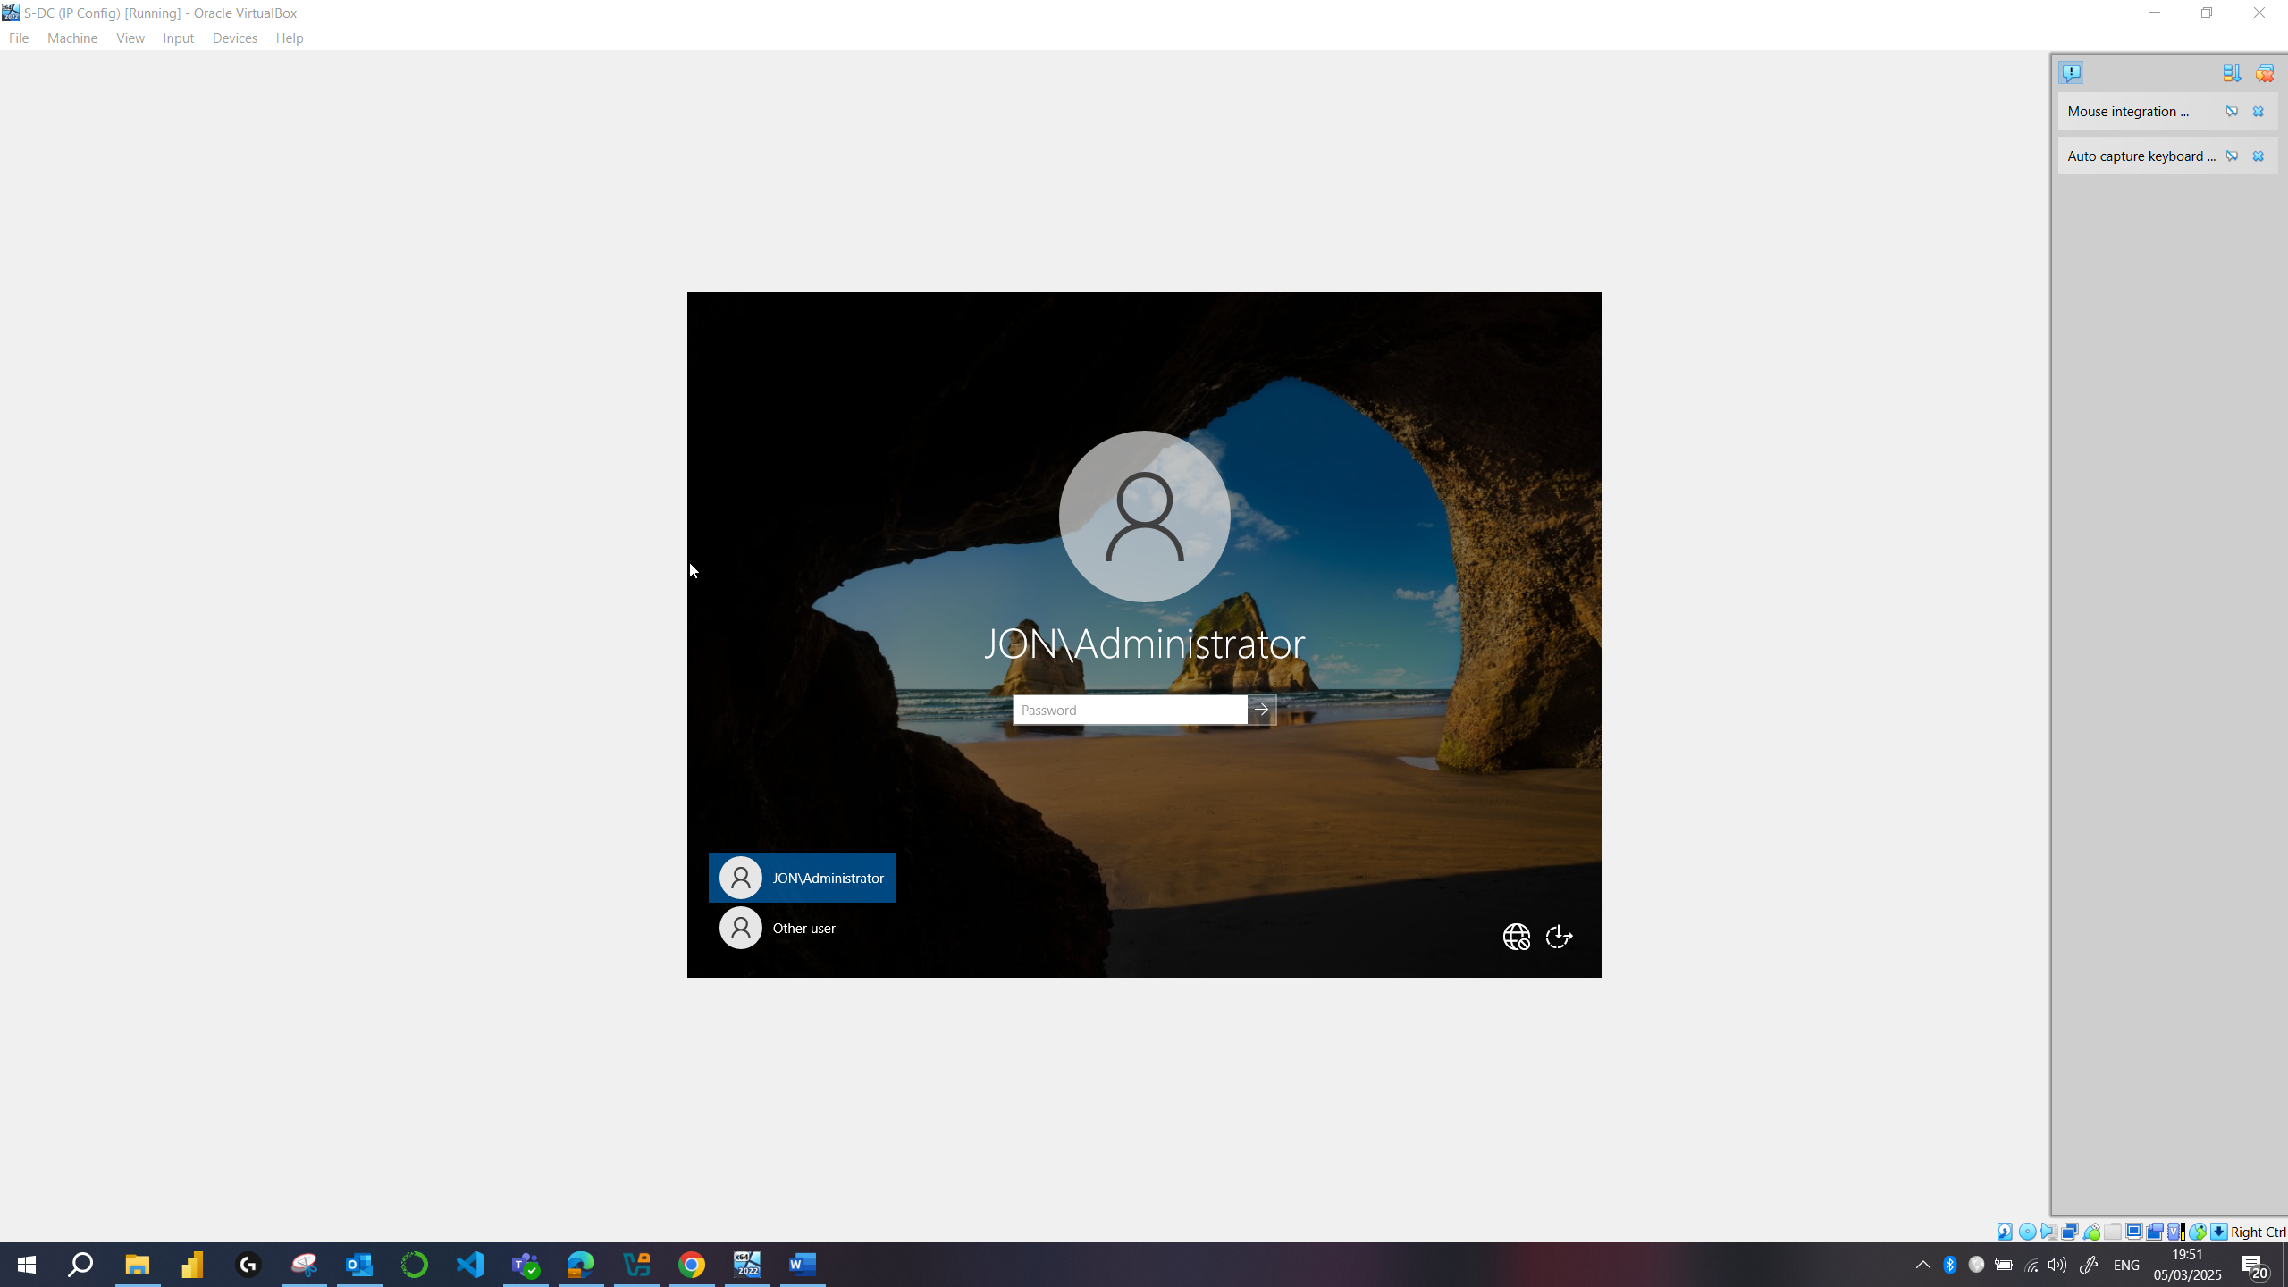
  - Create all appropriate A records for all servers on 10.1.1.0/24 and 172.16.1.0/24.
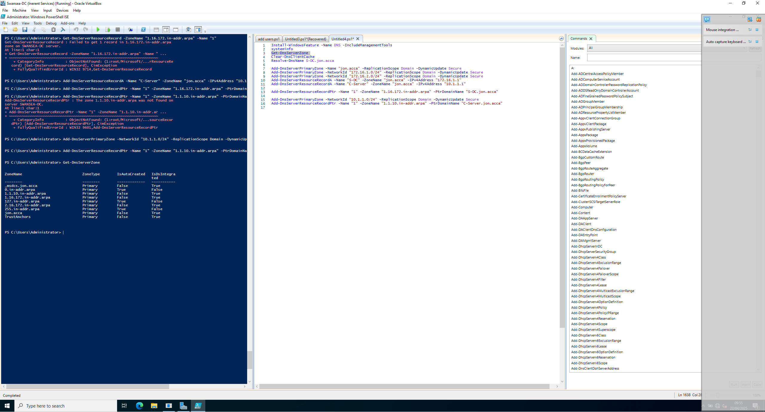
Powershell Script
Install-WindowsFeature -Name DNS -IncludeManagementTools
systeminfo
Get-DnsServerZone
Clear-DnsClientCache
Resolve-DnsName S-DC.jon.acca

Add-DnsServerPrimaryZone -Name "jon.acca" -ReplicationScope Domain -DynamicUpdate Secure
Add-DnsServerPrimaryZone -NetworkId "172.16.1.0/24" -ReplicationScope Domain -DynamicUpdate Secure
Add-DnsServerPrimaryZone -NetworkId "172.16.2.0/24" -ReplicationScope Domain -DynamicUpdate Secure
Add-DnsServerResourceRecordA -Name "S-DC" -ZoneName "jon.acca" -IPv4Address "172.16.1.1"
Add-DnsServerResourceRecordA -Name "C-Server" -ZoneName "jon.acca" -IPv4Address "10.1.1.1"

Add-DnsServerResourceRecordPtr -Name "1" -ZoneName "1.16.172.in-addr.arpa" -PtrDomainName "S-DC.jon.acca"

Add-DnsServerPrimaryZone -NetworkId "10.1.1.0/24" -ReplicationScope Domain -DynamicUpdate Secure
Add-DnsServerResourceRecordPtr -Name "1" -ZoneName "1.1.10.in-addr.arpa" -PtrDomainName "C-Server.jon.acca"
  - Create a reverse lookup zone creating PTR records for all servers.
Powershell Script
Install-WindowsFeature -Name DNS -IncludeManagementTools
systeminfo
Get-DnsServerZone
Clear-DnsClientCache
Resolve-DnsName S-DC.jon.acca

Add-DnsServerPrimaryZone -Name "jon.acca" -ReplicationScope Domain -DynamicUpdate Secure
Add-DnsServerPrimaryZone -NetworkId "172.16.1.0/24" -ReplicationScope Domain -DynamicUpdate Secure
Add-DnsServerPrimaryZone -NetworkId "172.16.2.0/24" -ReplicationScope Domain -DynamicUpdate Secure
Add-DnsServerResourceRecordA -Name "S-DC" -ZoneName "jon.acca" -IPv4Address "172.16.1.1"
Add-DnsServerResourceRecordA -Name "C-Server" -ZoneName "jon.acca" -IPv4Address "10.1.1.1"

Add-DnsServerResourceRecordPtr -Name "1" -ZoneName "1.16.172.in-addr.arpa" -PtrDomainName "S-DC.jon.acca"

Add-DnsServerPrimaryZone -NetworkId "10.1.1.0/24" -ReplicationScope Domain -DynamicUpdate Secure
Add-DnsServerResourceRecordPtr -Name "1" -ZoneName "1.1.10.in-addr.arpa" -PtrDomainName "C-Server.jon.acca"

  - Create user accounts for yourname.acca domain with all the parameters defined in the users_list_updated.xlsx document. This document will be shared by your lecturer. You must use first letter from first name with a dot and last name as SAM Account Name. Eg: First Name: Nitheesh Last Name: Kaliyamurthy. n.kaliyamurthy.

The figure below shows a user account added to domain.

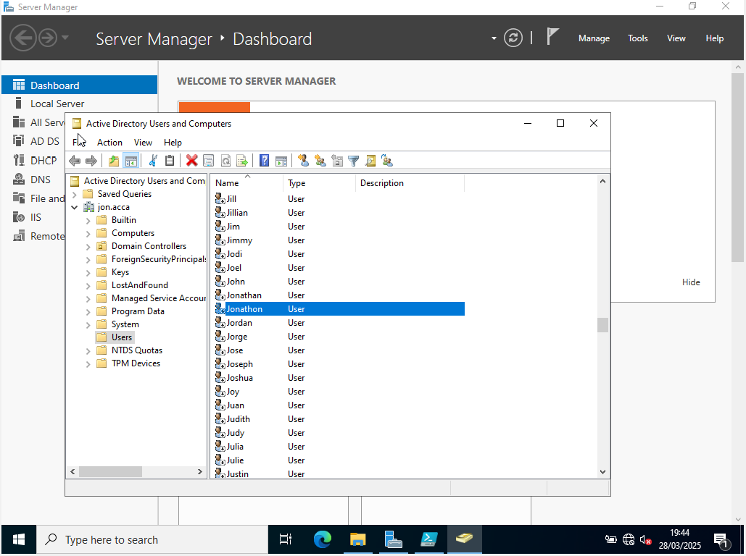

Script used to add user accounts

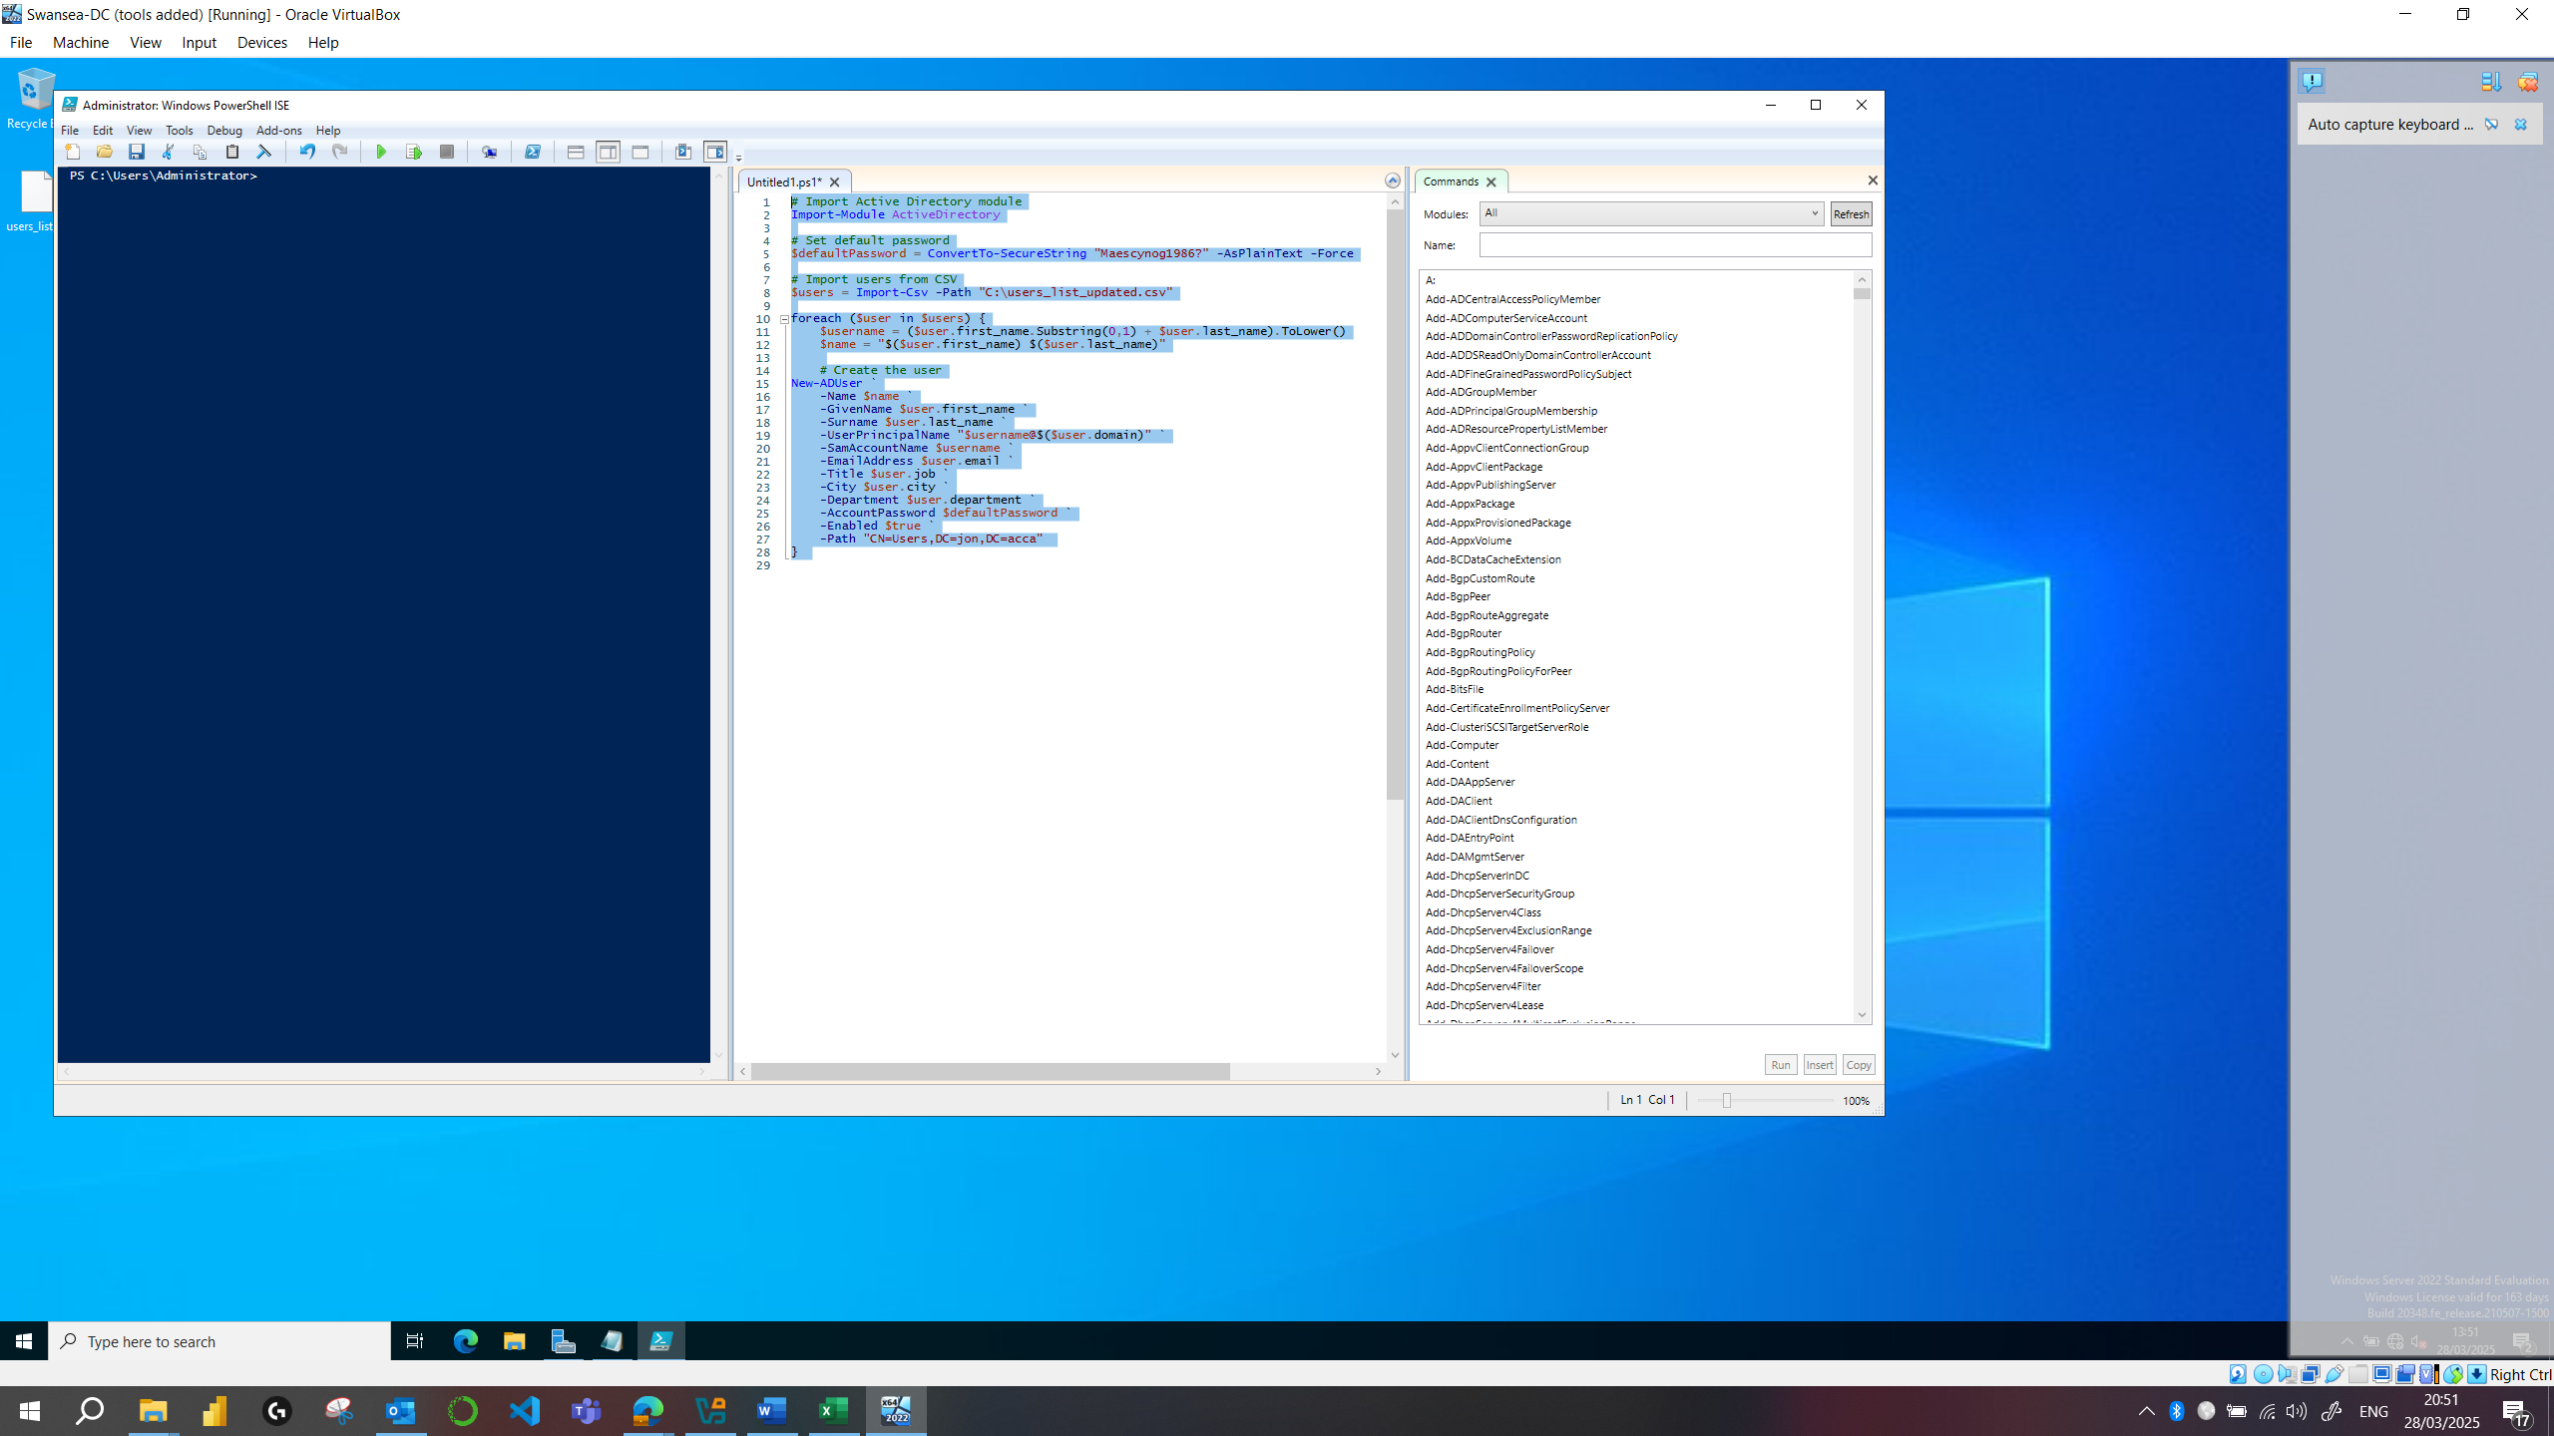

  - Mount second disk drive to D:\SwanseaFiles.

Mounted to E drive as D drive was reserved for system recovery

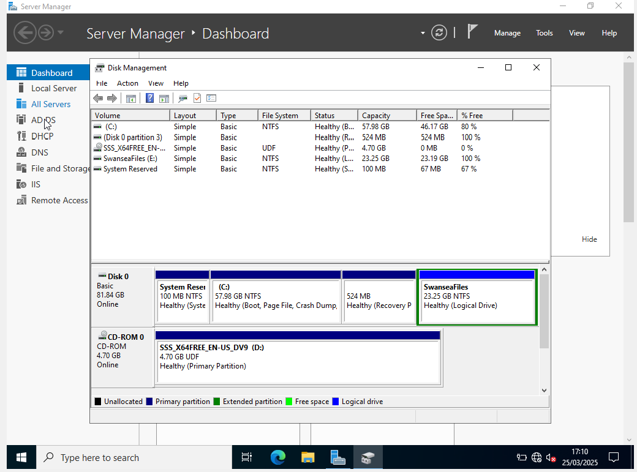

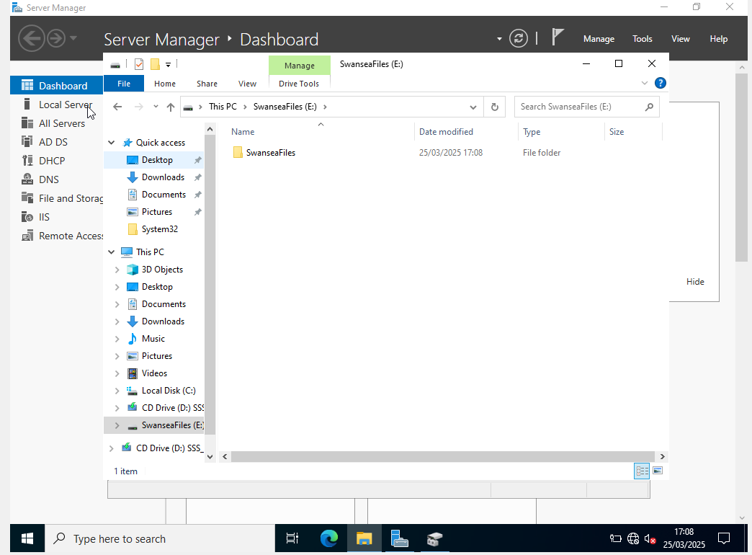

  - Configure DHCP Services. The range is 172.16.1.10 – 172.16.1.20. Determine other DHCP options as per the infrastructure.

Set up DHCP Services for windows client
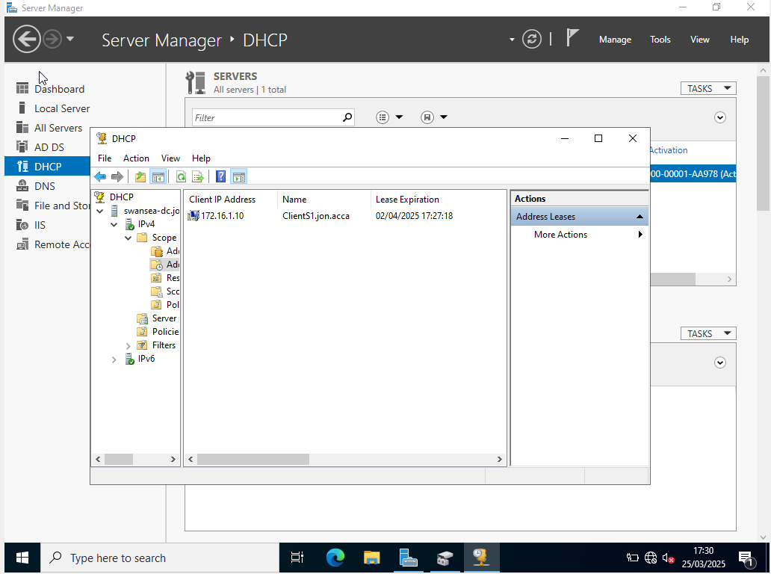

  - Join the ClientS1 to yourname.acca domain.

The figure below shows ClientS1 joined to the domain Jon.acca
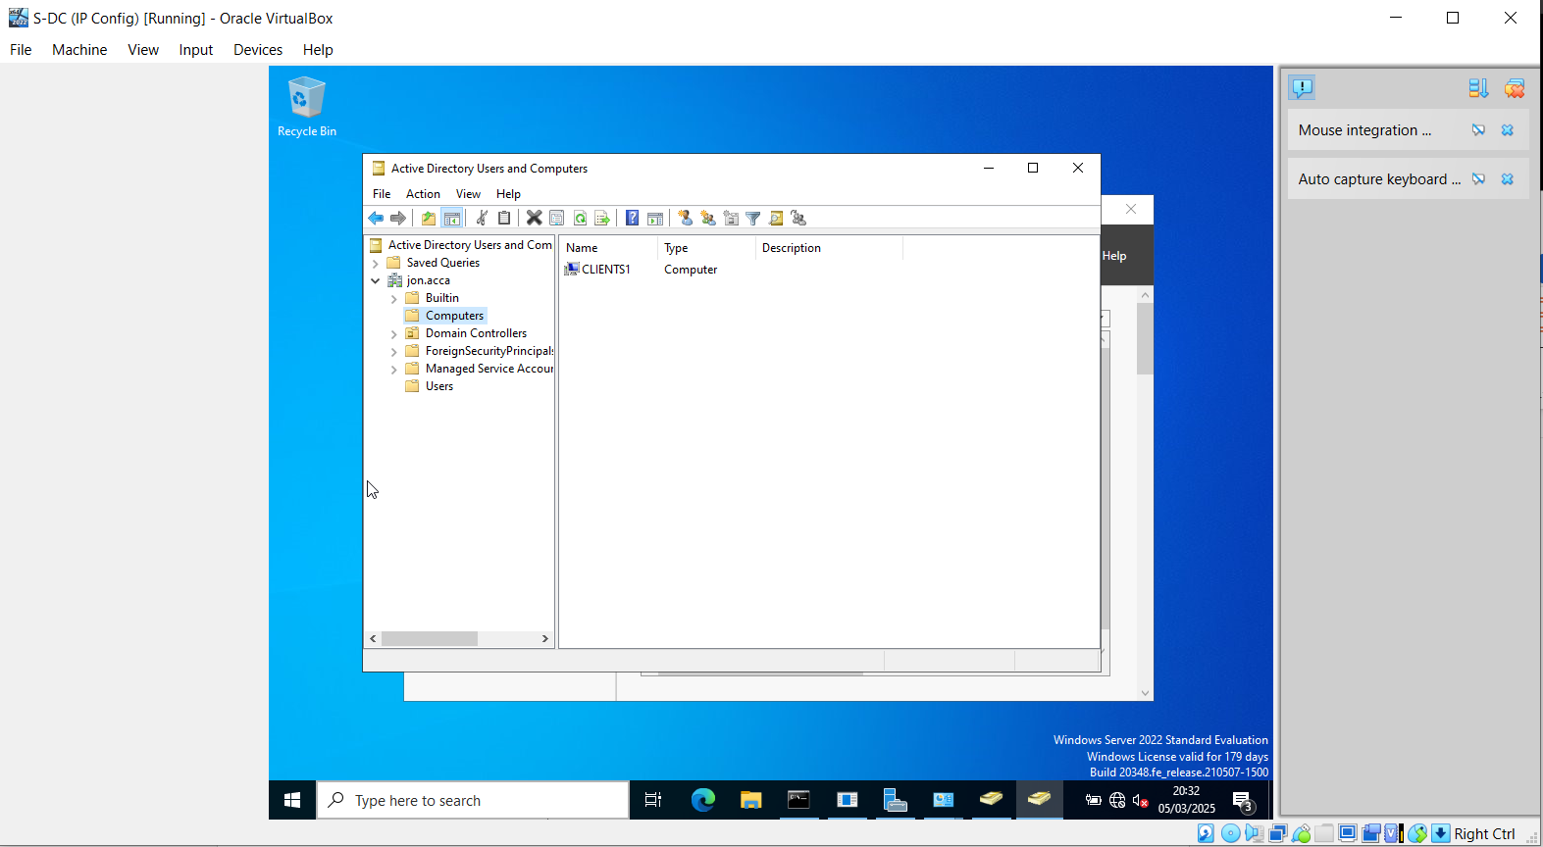

  - 10Assign ClientS1 with DHCP IP Address.
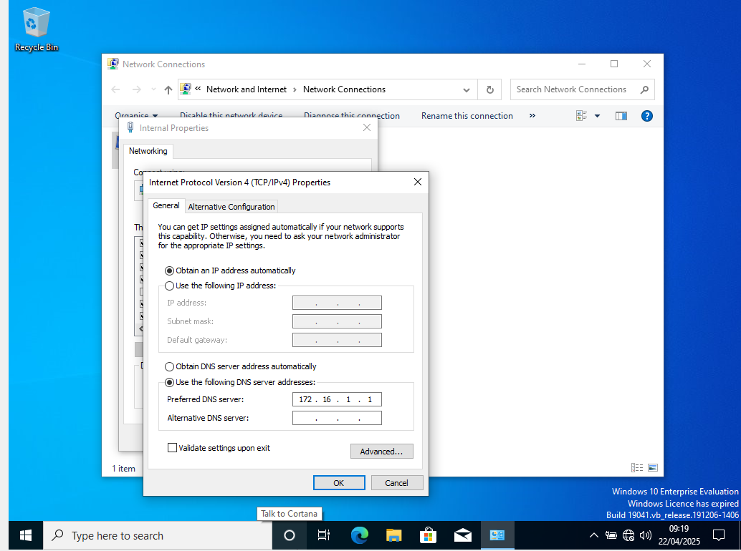

Cardiff Network
  - Install Routing and Remote access Service (equivalent) and modify firewall rules to allow ICMP Traffic.
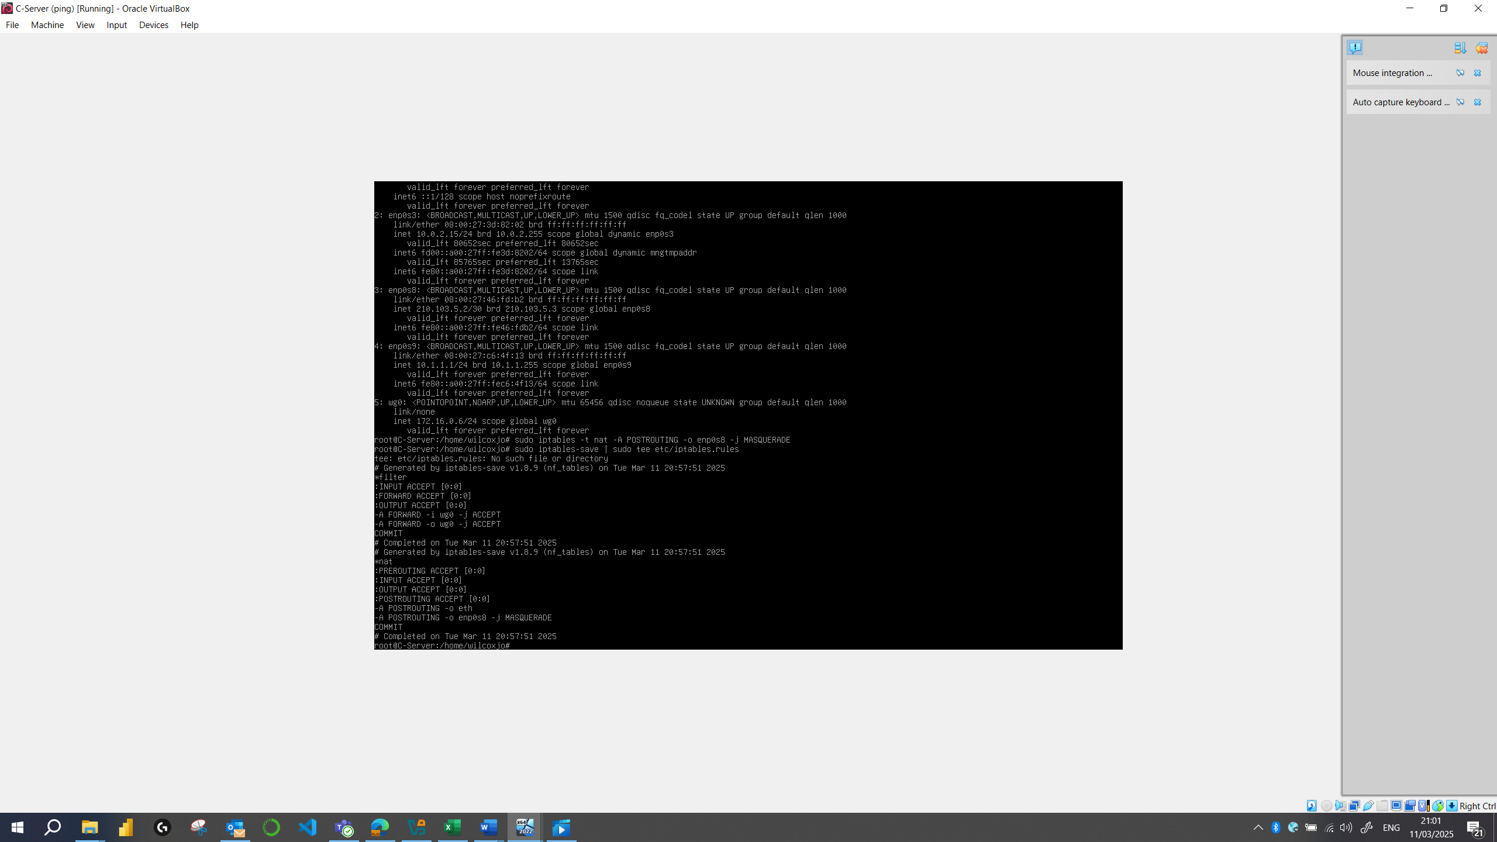

  - Configure Site-to-Site VPN to Swansea Network. Set the connection type to “persistent connection”.
The Figures below shows site to site VPN up and running.
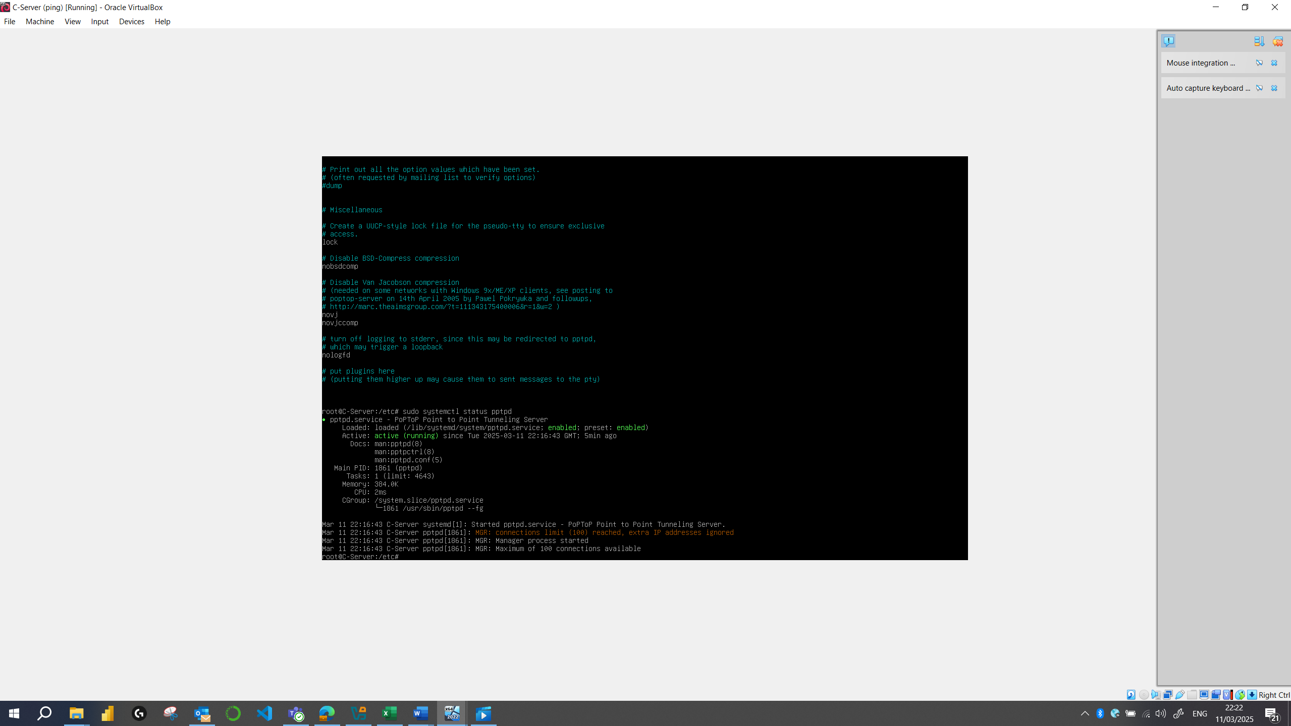

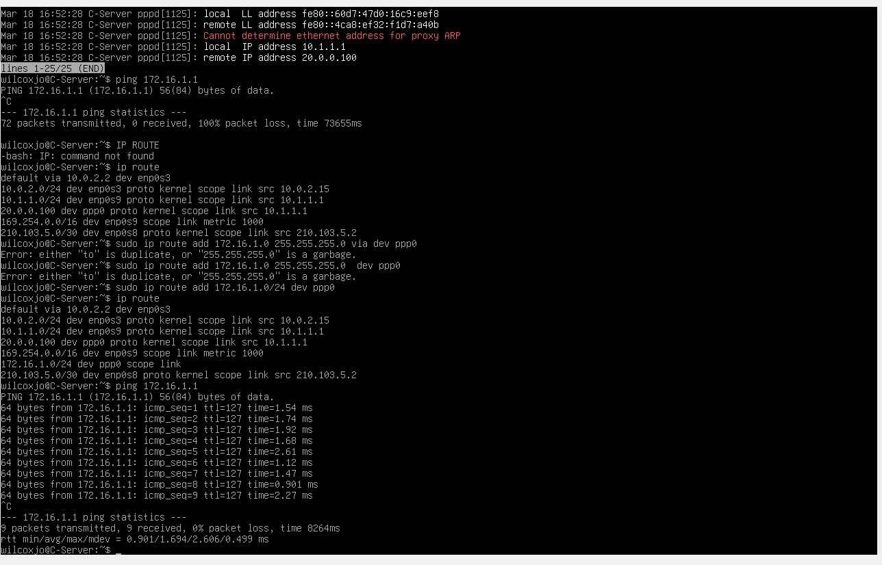

  - Create a child domain named car.yourname.acca in yourname.acca tree (Eg: car.nitheesh.acca) or Join devices in this network to the yourname.acca domain. Justify your action.

  - Configure DHCP Services. The range is 10.1.1.10 – 10.1.1.20. Determine other DHCP options as per the infrastructure.

  - Depending on step no. 2.3, join the ClientC1 to appropriate domain and assign DHCP IP address.

Test the network for Connectivity.

Ping Cardiff Service to Swansea Server and Swansea Client
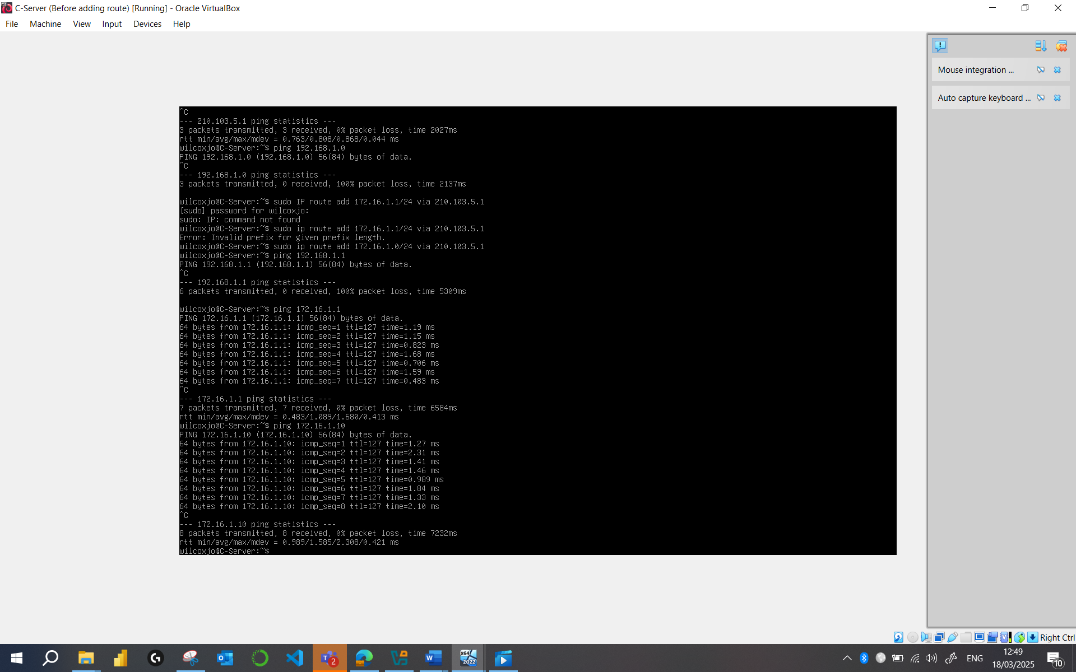
Linux VPN to Windows VPN

Windows VPN to Linux

Sharing Disk Drive:
To the earlier created D:\SwanseaFiles, set access permissions to allow users in the users_list_updated.xlsx has full control permissions and other network users have only read access. Share the drive to both Cardiff and Swansea network.

AD group added of authorised users

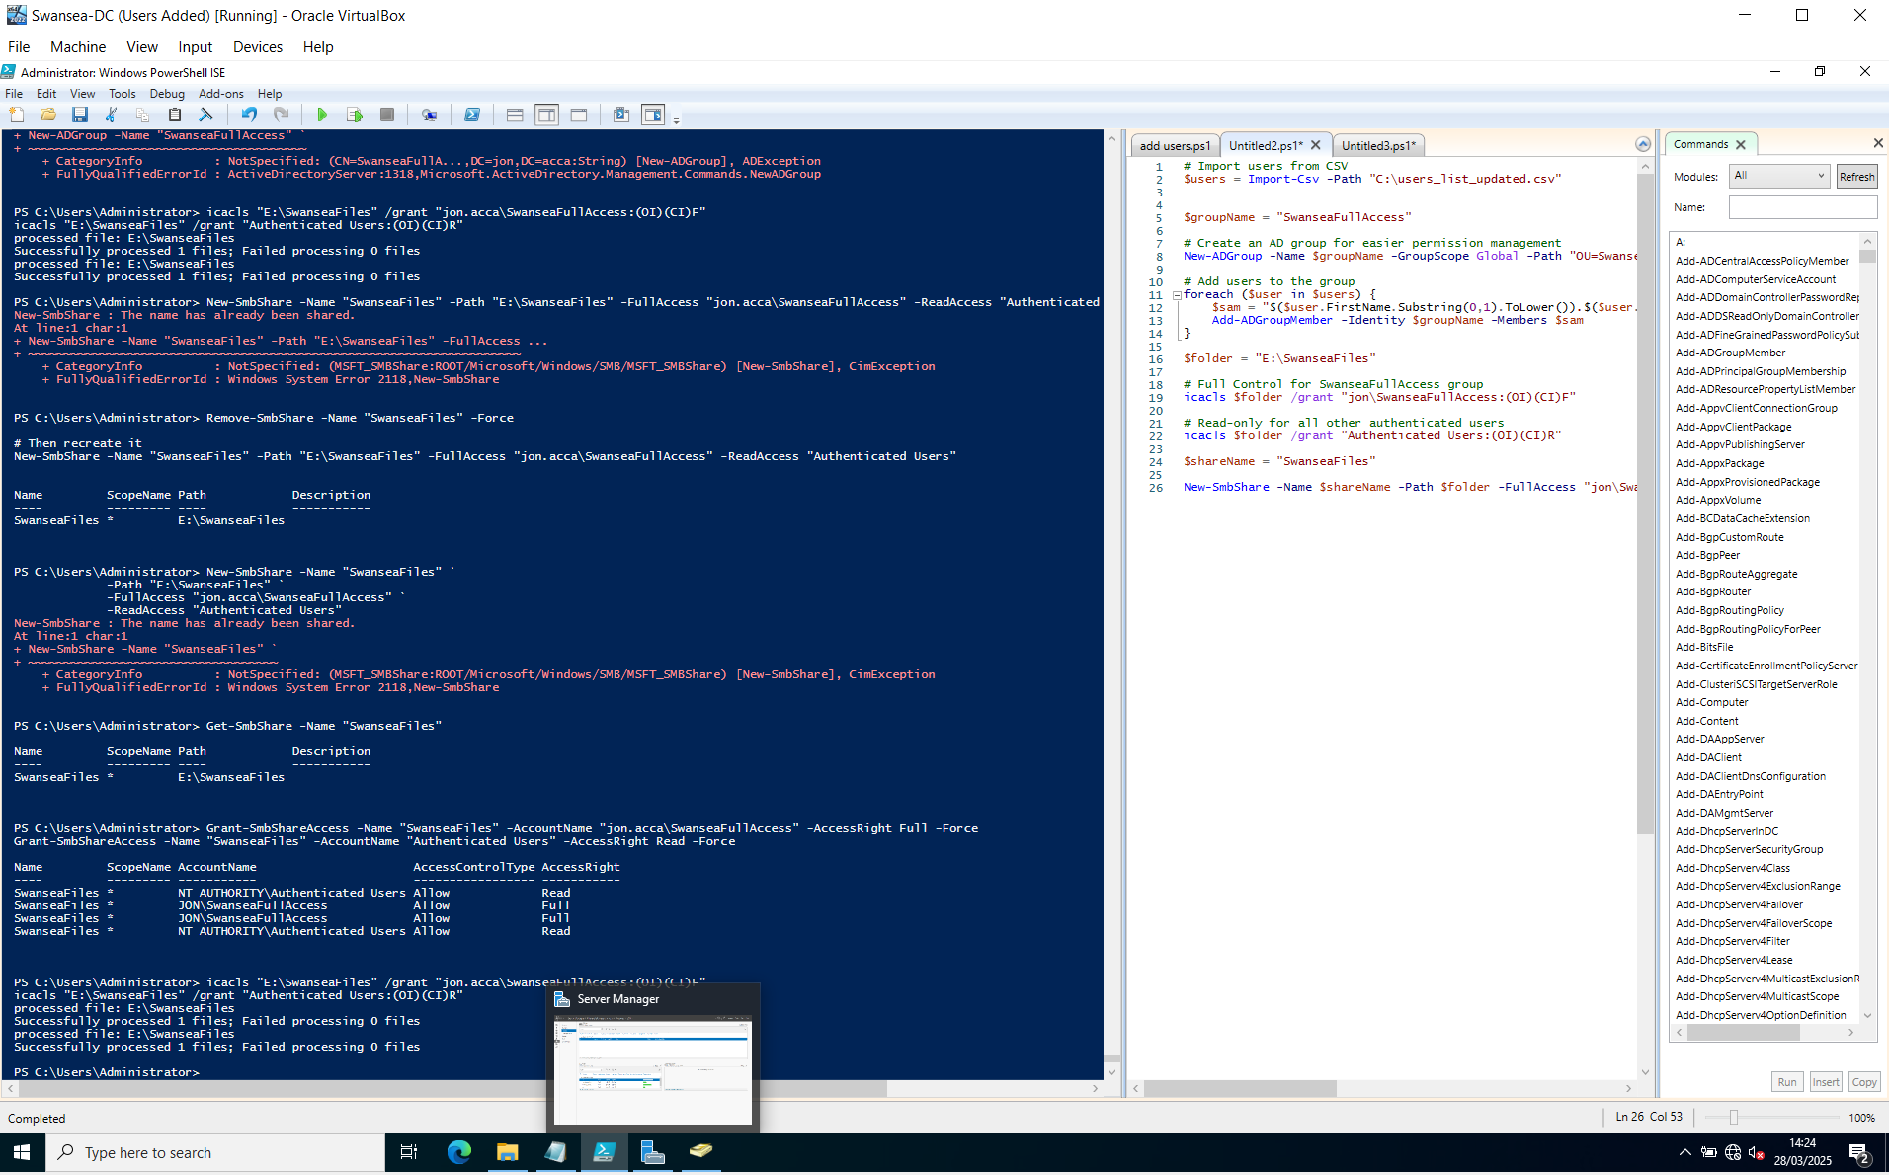
Access to shared drive on Swansea client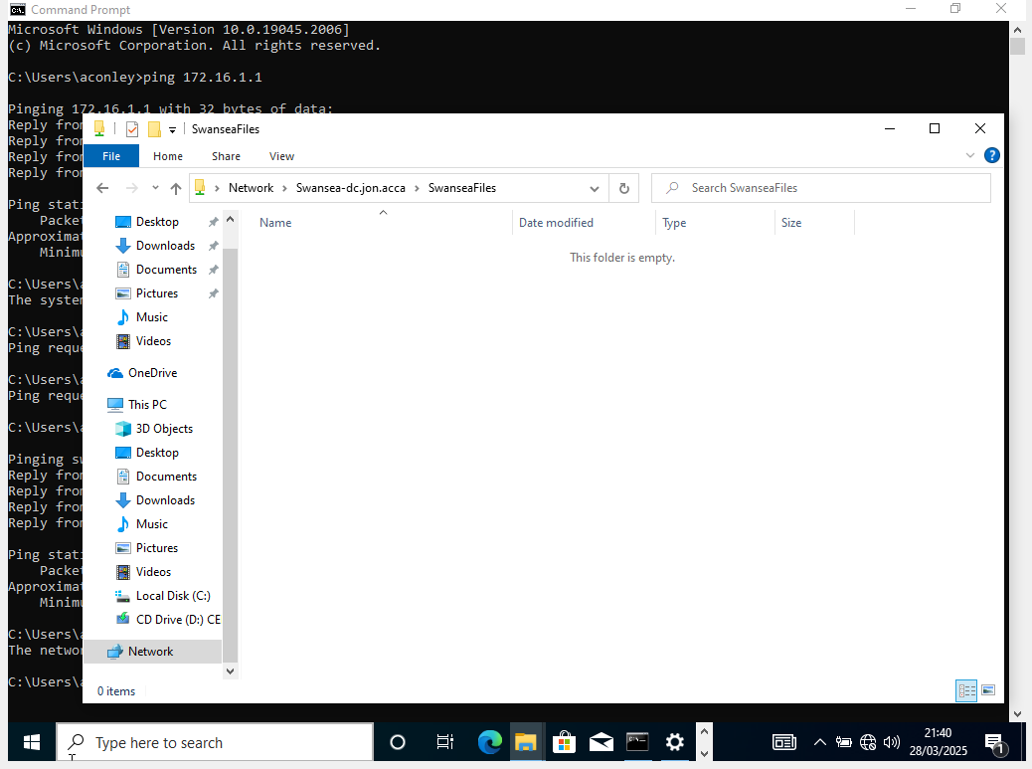

Configure IIS Server
  - Create https://webs. yourname.acca website and enable windows internal authentication.
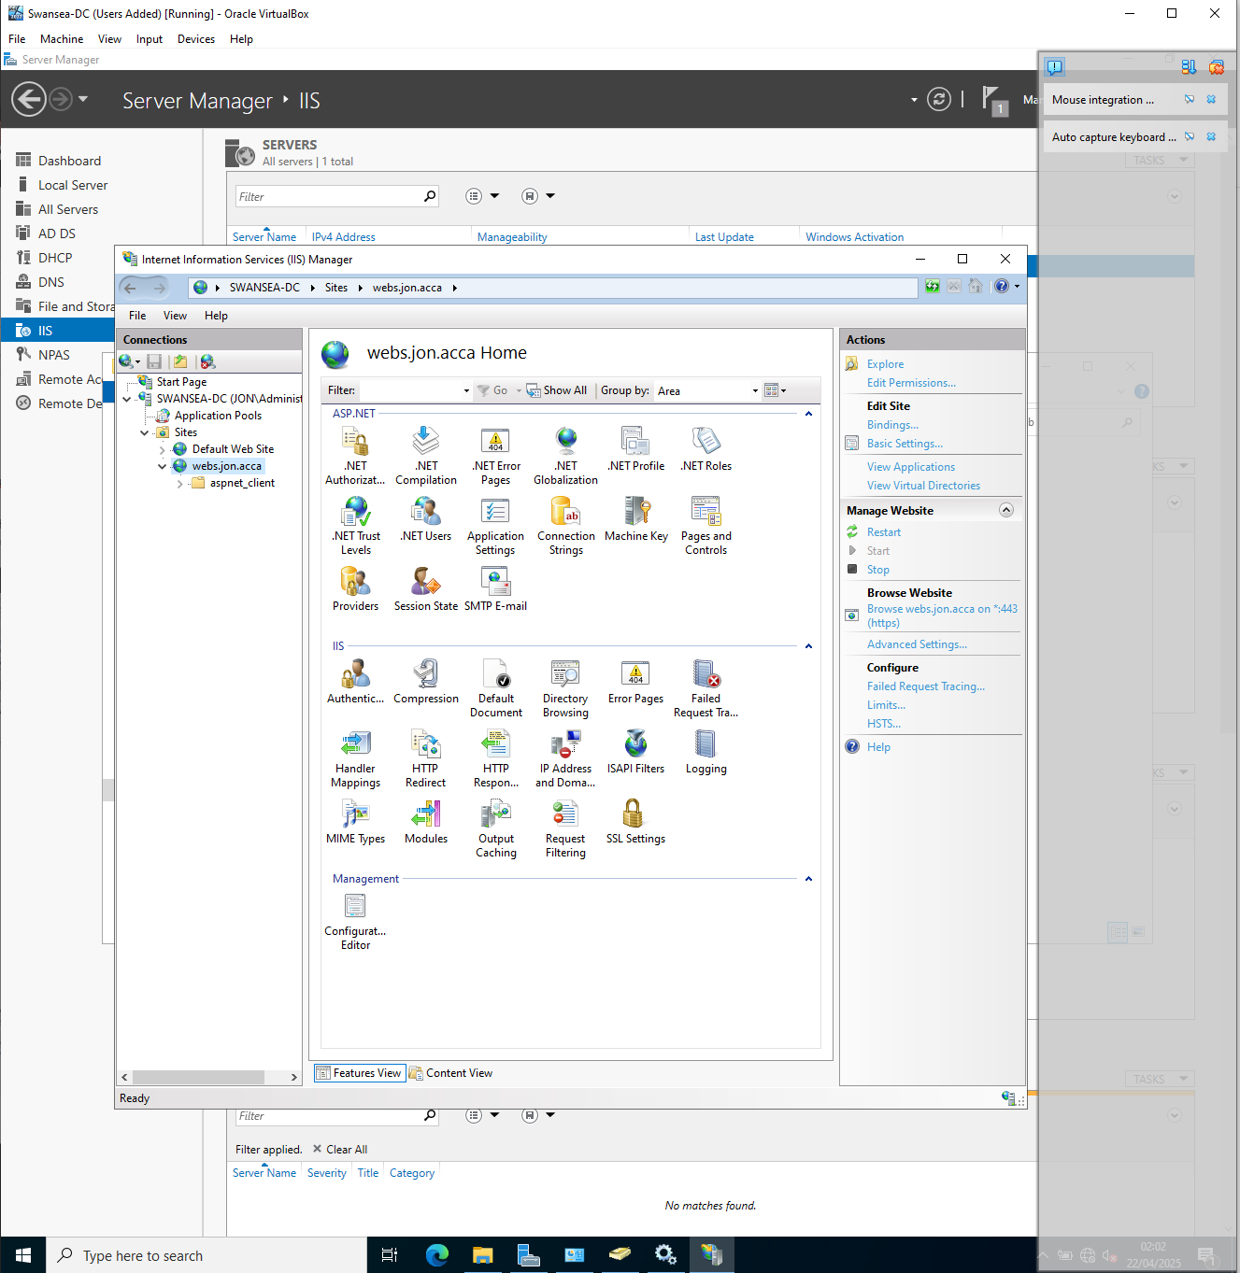

  - All the users can be authenticated.]
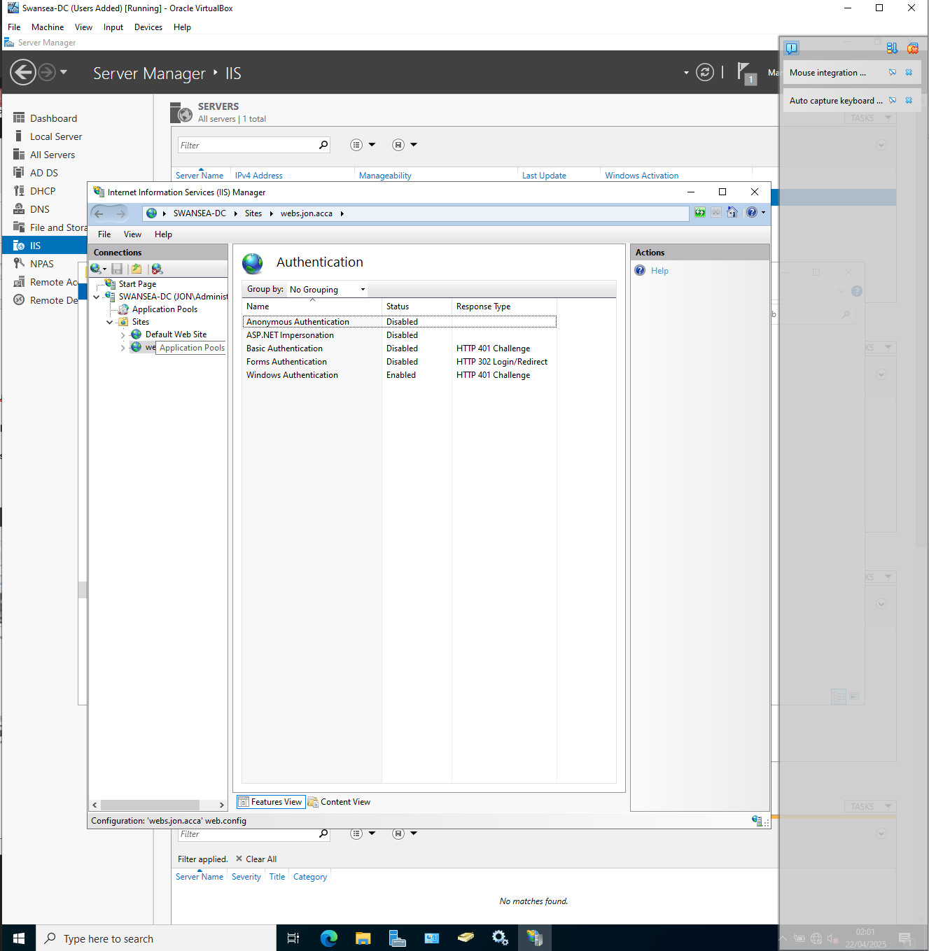

  - All authenticated users should be presented a text “Welcome to Swansea Website”.

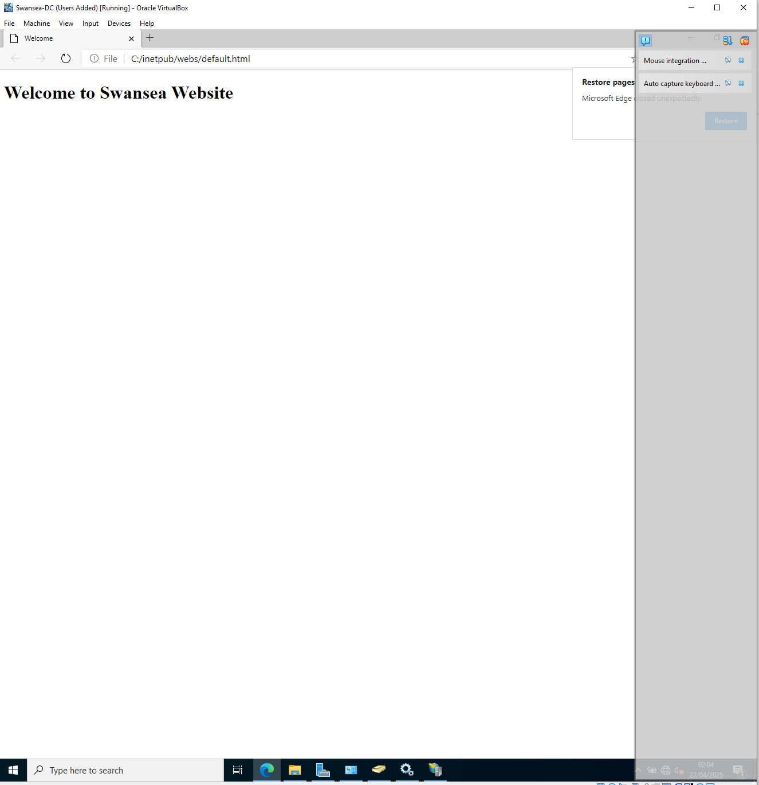
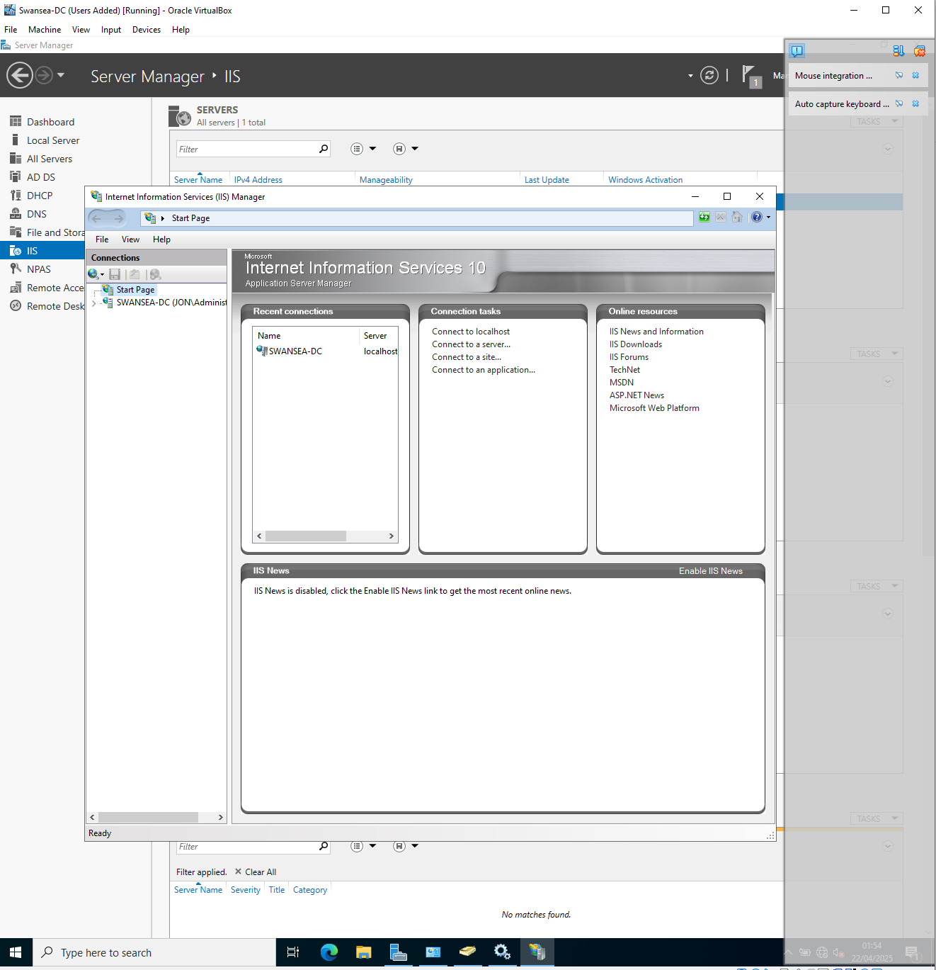

Remote Desktop Services:
Configure remote access for S-DC from any other machines in the network. Make sure that the Remote Desktop Services login page should be accessed via https://rds.yourname.acca and necessary certificates are signed.
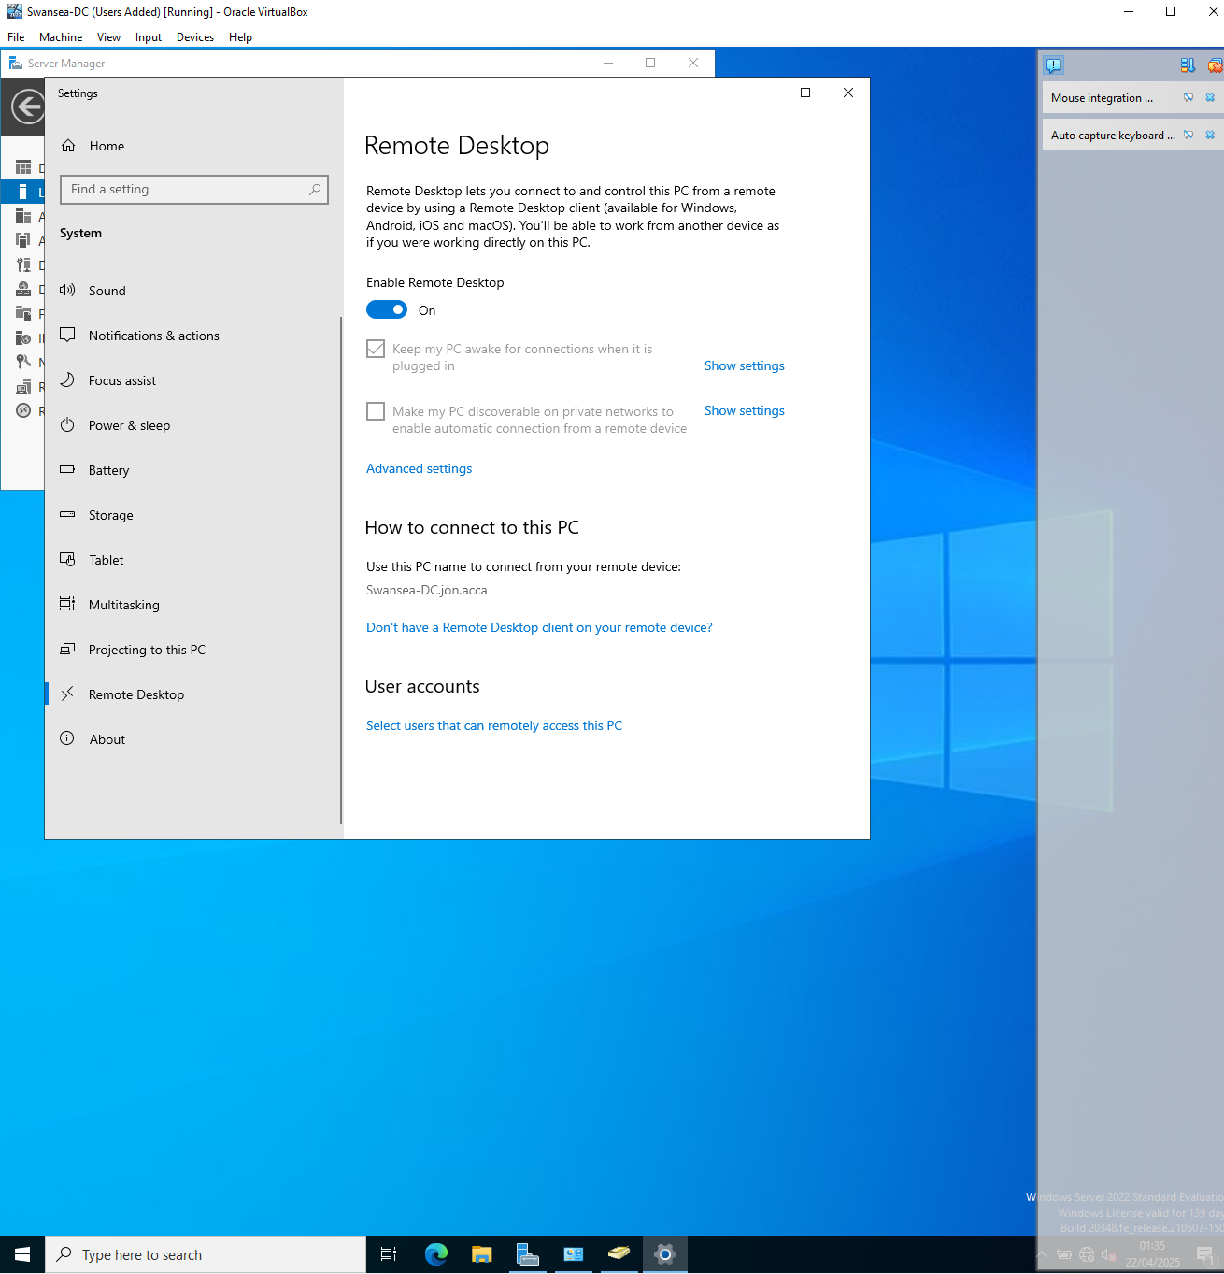

Appendix

Script to add users
# import active directory module
import-module activedirectory

# set default password
$defaultpassword = convertto-securestring "maescynog1986?" -asplaintext -force

# import users from csv
$users = import-csv -path "c:\users_list_updated.csv"

foreach ($user in $users) {
$username = ($user.first_name.substring(0,1) + $user.last_name).tolower()
$name = "$($user.first_name) $($user.last_name)"

# create the user
new-aduser `
-name $name `
-givenname $user.first_name `
-surname $user.last_name `
-userprincipalname "$username@$($user.domain)" `
-samaccountname $username `
-emailaddress $user.email `
-title $user.job `
-city $user.city `
-department $user.department `
-accountpassword $defaultpassword `
-enabled $true `
-path "cn=users,dc=jon,dc=acca"
}
IP addresses and Card Names
Swansea-DC (Swansea Domain Controller Server)
External Card (External)
IP Address 210.103.5.1
Subnet 255.255.255.252

Mac Address 080027F66370

Internal Card (Internal)
IP Address 172.16.1.1
Subnet 255.255.255.0

Preferred DNS 172.16.1.1
Alternate DNS 8.8.8.8

Mac Address 080027BB9F9A

ClientS1 (Swansea Clients)
Internal Card (Internal)
IP Address 172.16.1.10
Subnet 255.255.255.0
Default Gateway 172.16.1.1

Preferred DNS 172.16.1.1
Alternate DNS 8.8.8.8

Mac Address 080027448938

C-Server (Cardiff Server)
Nat Card (ENP0S3)
Mac Address 0800273D8202

External Card (ENP0S8) Named External
IP Address 210.103.5.2
Subnet 255.255.255.252

Mac Address 08002746FDB2

Internal Card (ENP0S9) Named intnet
IP Address 10.0.0.1
Subnet 255.255.255.0

Mac Address 080027C64F13

ClientC1 (Cardiff Client)
Nat Card (ENP0S3)
Mac Address 080027116353
Internal Card (ENP0S8) Named intnet
IP Address 10.1.1.10
Subnet 255.255.255.0

Mac Address 080278d07CA

