Task 1
Link to poster - ..\Task 1 - Poster - Sarah Cosker .pptx

Supplementary notes as follows-

Name: Sarah Cosker
Student number: 1905443
Word count:

Submission Date:

Contents | Page
- Introduction……………………………………………………………....... | 3
- Literature Review………………………………………………………….. | 5
- Methodology……………………………………………………………….. | 9
- Findings…………………………………………………………………….. | 11
- Conclusion…………………………………………………………………. | 17
- Reference………………………………………………………………….. | 19
- Appendix…………………………………………………………………… | 28
Appendix 1 – Survey……………………………………………………... | 28
Appendix 1.1 – Participant Analysis……………………………………. | 32
Appendix 2 – 25 – Survey results……………………………………… | 33
Appendix 26 – Absence data (Aug 2021 – July 2022)………………. | 43
Appendix 27 – Attrition data (Aug 2021 – July 2022)……………….. | 43
Appendix 28 – Exit interview data……………………………………..  Appendix 29 – Survey results…………………………………………. | 43  44
- Introduction

Tai Tarian is one of the largest social housing landlords based in the South Wales Valleys, with responsibility for over 9,000 properties that it is currently developing along with approximately 50 new homes being built which are required to meet standards set by the Welsh government. This falls in line with the organisation’s plan to provide eco-friendly, sustainable homes to contribute to the battle of climate change across the world.
The organisation currently employs 520 staff, comprising of five main directorates, which include, Assets, Housing, Finance, Chief Executive and Deputy Chief Executive.

Tai Tarian currently provides the options for direct upward and direct downward communications. This is via the provision of Staff email groups, Yammer, Microsoft Team channels, an employee-only Facebook group, a newsletter called “the advisor”, and a confidential suggestion forum called “speak in confidence”.

Both new employees and current employees that transfer to new roles within the organisation are required to complete an Action Plan for Success, which is a development plan, requiring managers to meet with their team member on a monthly basis to set goals aligned with their role expectations and raise any issues or concerns if needed, from both parties.

Regardless of the Action Plan for Success process, line managers are encouraged to hold regular 1-2-1’s and team meetings as forms of , and to encourage direct two-way communication. Tai Tarian currently recognises two unions Unison and Unite, as a form of indirect voice.

the aims and objectives of this research are:
Aim:
- To identify and analyse current forms of Employee Voice mechanisms and make suitable recommendations for future development of Employee Voice strategy within Tai Tarian housing association.
Objectives:
- To evaluate current literature on Employee Voice, considering both positives and negatives of EV mechanisms.
- To identify appropriate survey and interview techniques to obtain suitable current data collection for analysis.
- To analyse, present, and highlight the outcome of the research data obtained
- To make recommendations for positive, realistic change and development of future EV mechanisms, and provide a supporting implementation plan for the future.

- Literature Review
To gain background knowledge of ‘best practice’ Employee Voice (EV) and its benefits to an organisation, I researched varies reputable sources for consideration. EV is described as “an essential ingredient for employee engagement and commitment to an organisation” (Bingham,2016).
Supported in the UK by the Information and Consultation of Employees (ICE) Regulations,2004, giving all employees in organisations of 50 or more (ACAS,2022a); a statutory right, to have/request information and be consulted on change (Ellis,2016).
The regulations were implemented with the view to improve communication, but Ellis(2016) highlights that interpretation may not necessarily provide the intent. Employees could therefore be involved in the change but not have a true influence over change.
ACAS (2022b) refers to Information and consultation as the “basic building blocks of every effective organisation”, the CIPD (2020) reiterates this stating that “Organisations with strong information and consultation benefit from improved trust, engagement and productivity, innovative ideas and problem-solving from the workforce, along with improved retention of staff and fewer workplace disputes”.
The Taylor Review (2017) concluded that “workers must have a voice”, but effective EV is not just a voice – it’s within employment where “Employees’ views are sought out; they are listened to and see that their opinions count and make a difference” (MacLeod and Clarke,2009).
Benefits of EV include:
- “Improved employee attitudes, behaviours, loyalty and more co-operative employment relations
- Improved organisational effectiveness, including increases in productivity and individual performance
- Improved systems by tapping into employees’ ideas, knowledge and experience and promoting greater diffusion of information”.
(Wilkinson and Fay,2011)
A workforce with a meaningful voice will in turn be engaged and support an organisation undergoing periods of turbulence, from both internal change and external pressures (Barber,2019).
Dromey (2016) identified, that ‘no matter what job you’re doing if you feel involved, you feel you have autonomy, a role in decision making…you’ll care more about what you’re doing and hence the company will have better results’.
Research indicates that EV can lead to creativity and commitment (Zhou & George, 2001), and improve organizational performance (Batt et al., 2002). In terms of the benefits of EV on organisational development, employers need to build an atmosphere which is receptive to EV.
Just having EV mechanisms is not sufficient, the voice mechanisms must be accompanied by a receptive culture for them to be effective (Gordon et al, 1988; Purcell, 1987; Kowtha et al,2001).
Line Managers play a pivotal role in enabling EV of their teams, promoting constructive dialogue and creating a safe space for team members to voice concerns which can then be raised as needed to the appropriate channels for discussion and implementation of change. Undoubtedly the key to this will be the relationship held between employee and line manager, something that should be nurtured and developed to give all a voice. (Cowly,2014;Wright,2015; Chamberlain,2012)
A varied range of communication tools appears to be the best approach for organisations with key messages driven by line managers and the Senior Management team, which include meaningful dialogue about strategy, organisational goals, culture, change and future plans . Organisation should stay clear of implementing a form of EV as “tick box” exercise – this in turn can create further cynicism to breed – “voice needs to be listened and responded to” (Involvement & Participation Association,2020).
In contrast, the CIPD (2017) claims that there is a large amount of literature that shows individuals are reluctant to voice information, especially negative views to those who have a higher power status, suggesting voice can be restricted due to hierarchy (CIPD,2017)
The organization needs to show that it is safe for employees to speak out, through both formal and informal pathways to improve communication and reduces the likelihood of conflict (Kwon and Farndale,2020; Stone,2005)
Voice has come out as part of the key components that the CIPD identity as one of the seven “Good work” enablers concluding that: “Good work gives people the voice and choice they need to shape their working lives” (CIPD,2022)
When employees feel they are unable to speak out resentment may develop, having a detrimental effect on motivation and performance, causing disengagement and frustration with no means to express views , leading to a range of issues including higher absence and attrition rates. (Perlow and Williams,2003); Investors in people,2022); Barber,2019).
With the increased use of social media, individuals are much more likely to use such platforms to voice their concerns if EV is suppressed within their workplace, this can lead to damaged workplace reputations, effecting a range of points from talent retention figures to company revenue (Brown,2018).
The opposite to EV - identified is employee silence, is where EV mechanisms are provided but ideas are not listened to, so contributing is pointless, representing a high loss of resource (Brown,2018;CIPD,2019a). Senior management are the key to drive effective EV, ideas should not only be listened to but acted upon (Brown,2018;Nolan,2017).
In conclusion, evidence suggests, if adequately natured within an organisations culture, and valued by the senior management team, EV can only benefit to an organisation success.
3. Methodology
To provide background knowledge, I researched the topic of EV from various relevant and credible sources, such as the CIPD. This provided a base to consider what questions I needed to answer from my chosen data collection.
I then considered different ways to compile primary data to make a suitable analysis of the current EV mechanisms within Tai Tarian.
I considered the use of focus groups and interviews, where I would be able to probe into topics discussed to gain richer data (Anderson,2013,p.224), but due to a high workload faced across the organisation and hybrid working this was not feasible at this time.
Further barriers highlighted were linked to the time of year (Summer/school holidays) and many employees on annual leave and also needing to use something cost-effective due to a lack of specific funding to put to the research at this time.
Therefore, the methodology used consisted of a cross-sectional, confidential employee survey, this was used as a cost-effective and quick response option (Taylor and Woodhams,2016.p.??)
Anderson (2013,p.274) identifies that a survey’s success will be dependent on participation. With this in mind, I choose to send my survey through as many communication methods as possible – making use of Tai Tarians communications tools, such as Email, Microsoft Teams, Yammer, and the Employee Facebook group. I also asked employees to complete as I spoke with them to encourage participation. The survey was sent out to all employees to gain useful perspectives from all job level, departments, and work base (Home/Office/Community).
When creating the specific survey questions (Appendix 1), I considered guidelines from the CIPD (2021) including:
- Easy to understand questions
- Clear range of answer options – i.e., Excellent/good/fair/poor/very poor
- Using quantitative questions to provide data that can be easily converted to show results
- Use qualitative questions to gain further insight into specific area
The research data was analysed by considering the previous research of EV and highlighting key themes. When analysis the data I found that there was employee [demographics from across the organisations (Appendix 1.1), which was encouraging to ensure there was a range of viewpoints, which will help to provide increased validity of results (Anderson,2013,p.??).

I included analysis of secondary data from Absence and Attrition data, which included Comparative Research methods (Anderson,2009,p.??) to benchmark Tai Tarian’s data to data provided by the Community Housing Cymru (CHC), (2022) (representative of Housing Associations in Wales).
I also considered the secondary data from Exit interviews to review leaving reasons.
I decided to consider this secondary data due to the concept that there is a link between higher Absence and Attrition rates and lack of / poor EV (Perlow and Williams,2003; Investors in people,2022; Barber,2019).
4. Findings
4.1 Survey results – (All survey questions - Appendix 1)
The overall participation of the survey concluded in 19.81% of the workforce, for across all job levels and work base (Home/Office/Community), providing viewpoint from across the organisation (Appendix 1.1).
There are a variety of communication tools available at Tai Tarian, consisting of a fortnightly and ad hoc “Advisor” newsletter sent via email and “Speak in Confidence” tool. Over the past 18 months there has been the introduction of Yammer, Microsoft Teams channels and a Tai Tarian employee Facebook group. Communications are sent via all methods, with employees encouraged to read all sources of information.
As clearly shown in Appendix 2,3,4 and 5 those that state they “Always” read these communication tools suggest that the organisation is quite a way from reaching the majority of its employees (55% Advisor,19% Yammer, 65% Microsoft Teams channels, 18% Facebook group). What is highlighted is the relatively high number who confirm they “Never” read the communications across each option (14% Advisor,31% yammer, 18% Microsoft teams channels, 55% Facebook group).
This could be the reason that not even half (44%) of employees feel they receive effective communication about changes within the organisation (Appendix 6), and nearly a quarter of participants rating the available communications tools overall as “Poor” or “Very poor” (24%), (Appendix 7) - as they don’t actually use them and therefore miss key messages.
This theme appears to run through the answers to each related question within the survey, with 26% of participants stating that they “Never” feel that the organisation communicates information clearly about work change/ new process (Appendix 8). Furthermore, 22% feel that the organisation “Never” includes them in decision making (Appendix 9).
When asked about teamwork both at an organisational and immediate team level, just 8% feel that there is “Always” a strong feeling of teamwork in the overall organisation (Appendix 10) in comparison to 40% that feel there is “Always” a strong feeling of teamwork within their immediate team (Appendix11). This suggests a disjoint between immediate teams and other departments, and the organisation as a whole, suggesting that outside of immediate teams there is a communication issue which may be causing frustration to breed (Barber,2019).
On further investigation of the results, it appears that the main participants that have answered the results with a negative viewpoint are from the Assets directorate, a high proportion of these would include mainly community workers. Analysis of the comments have highlighted that such workers would only generally have access to an iPad , which appears to be not fit for purpose as these particular employees cannot access all tools on the works iPad (Appendix 12) to access the required communications tools – hence the frustration, lack of use of the tools and could be the reason for feelings that that the organisation does not communicate changes effectively, and do not feel involved in decision making.
Barber(2019) states “A disengaged workforce that lacks a proper mechanism for meaningful dialogue will instead exacerbate those pressures as they look for means to vent the frustrations that they have no legitimate means to express”. This survey may be the means that some employees are expressing their views with no proper access to all communication tools, suggesting disengagement.
Recent research conducted by Gallup highlights that, “three-quarters of UK workers are not engaged” (Engage For Success,2019) it is no surprise that there may be Tai Tarian employees who fall within this demographic. Furthermore, “companies must achieve a 4-to-1 ratio of engaged to disengaged employees in order to counteract the negative effects of disengaged workers” (Riley,2019).
The “Speak in Confidence” tool is a confidential, virtual suggestion box, there have been many suggestions that these are often unproductive (Barber,2019; The Involvement and Participation Association,2020). Deret and Burns (2016) suggest this may even lead to employees thinking it’s not safe to speak up – as why else would a confidential suggestion box be provided if honest and open communication is truly part of the organisations culture.
This is shown with results revealing that only half of the of participants were aware of this tool (Appendix 13), with only 29% confirming they had actually used it (Appendix 14).
Comments from participants relating to why they had not used this tool ranged from “what’s the point – nothing changes”, “ I don’t believe it is confidential” to “ I didn’t even know about it”(Appendix H). This indicates that this may have been developed as a “tick box” exercise and not developed or promoted to the end user, lacking transparency, breeding “cynicism and distrust” (CIPD,2020;The Involvement and Participation Association,2020) in turn placing more of detrimental effect on organisations than those with no EV mechanisms at all (CIPD,2013).
Kashyap (2019) states that “Communication at workplace defines organisational goals and helps co-workers collaborate. This is a step towards a fundamental business practice for a committed and productive workforce” . Upon reflection the results suggest that the organisation may not have a “committed and productive workforce”.
The “Action Plan for Success” process is part of Tai Tarian’s Performance Management system, 48% of the participants confirmed they have completed the process (Appendix 15)., 94% rated it as either excellent, good or fair, giving a positive outlook on the system, although there is a small percentage of 6% that state the system is poor or very poor (Appendix 16). This is important as good performance management is seen as critical for organisational success (CIPD,2019c).
The survey results showed that 48% of the participants state they have 1-2-1’s with their line manager every 3-6 months, 10% every 6-12 months (Appendix 17). This length of time between 1-2-1 could be seen as not suitable, more frequent meetings can provide greater value and purpose to ensure things are discussed within a timely response (Rushmore,2017).
The lack of more frequent 1-2-1’s could be the result of not building positive relationships with managers and in turn the reason for 56% of participants stating that they can only “Sometimes” be open and honest with their manager (Appendix 18), 31% stating they only “Sometimes” and 20% “Never” receive constructive feedback (Appendix 19), and 18% having a “poor or “very poor” relationships with their manager (Appendix 20). Furthermore, over half of participants stated that they only “sometimes” feel their manager communicates information clearly about work changes/ process (Appendix 21). These results potentially show an issue with line manager communication to teams, Solomon (2016) states that “Two-Thirds of Managers Are Uncomfortable Communicating with Employees” which could be a factor to consider. Also, when asked 40% stated that they considered communications have not improved and even seemed to get worse through the Global pandemic of coronavirus restrictions (SOURCE),(Appendix 22), which may be influenced by the instant onset of different communication methods being used such as zoom / teams video calling instead of face-to-face catch ups (Stanley, 2021;Parry,2022,p.47).
The report “building productivity” by ACAS (2015), concluded that out of a varied group employee’s participants across different sectors that “just one in three” (32%) – say that “managers are good or very good at allowing employees to influence decision making”. Dromey (2016) states that “this is a significant cause for concern”. Survey results of Tai Tarian revealed that 42% stated that their managers either “Always” or “Sometimes” included them in decision-making (Appendix 23), showing a slightly positive comparison in relation to the ACAS report.
The questions asked of those that are line managers highlight that 41% do not feel Tai Tarian has provided them with suitable tools/training (Appendix 24), along with 86% stating they would like more training to help support their team (Appendix 25). These results highlight that line managers do need and will welcome more training, to build relationships with their teams which should in turn improve EV.
4.2 Current Tai Tarian Absence, Attrition and Exit interview data
Lack of, or poor EV mechanisms have been linked to both higher Absence and Attrition rates (The Involvement and Participation Association,2020).
Tai Tarian’s rolling 12 month absence figures from Aug 2021 – July 2022 (TaiTarian.co.uk,2022a), including a comparable benchmark against other Social Housing Landlords in Wales (Community Housing Cymru ,2022), (Appendix 26), shows that for 6 out of 12 months, Tai Tarian have been slightly over this average , suggesting a link between rising absence figures and EV (or lack of efficient) and in line with the general theme of the survey results. You could consider that the global pandemic may have influenced this, but these figures do not include covid related absences, so this theory can be discarded.
The Attrition rate for the last 7 months has been above that of the CHC’s (TaiTarian.co.uk,2022b; Community Housing Cymru ,2022), (Appendix 27), again indicating that voice mechanisms are failing somewhere (Forth and Metcalf, 2014). Although, analysis of exit interviews suggests that generally, employees are leaving to pursue different career paths (TaiTarian.co.uk,2022c), which links into the claim of the “great resignation” (Morgan,2021) or “war for talent” (Fallow,2021), which claims that people are generally rethinking their lives after living through the pandemic and choosing to change career paths in search of better work life balance (Mills,2022). A small number of leavers also highlight potential issues with their line managers due to lack of communications and mixed messages of priorities, and frustration with lack of communication between teams (TaiTarian.co.uk,2022c), (Appendix 28).
Suggestions on improvement of EV include improvements of IT, having all communication tools available on the iPad, streamlining the tools as there appears to be too many options , Employee group forums and voting options for all employees on change (Appendix 29), which I will consider within my recommendations.

5. Conclusion
Tai Tarian presents itself to have a range of EV channels and communication tools which is considered to be “best practice” (IPA,2020).
Analysis of survey results, consideration of Absence and Attrition figures, which have been benchmarked against different Social Housing Associations, suggests a disparity between the provision and suggested benefits.
Potentially, this could be through the provision but not actually listening and acting upon suggestions given by employees (MacLeod and Clarke,2009).
This may be through poor communication with line managers, which may be due to or at least in part lack of adequate line management training as highlighted by the responses from line managers. As Line Manager are shown to play a major part in in enabling EV this is a cause for concern (Cowly,2014;Wright,2015; Chamberlain,2012).
There seems to be a percentage of the participants who are clearly disengaged (Barber,2019;Riley,2019) and issues that are breeding cynicism and distrust (CIPD,2020;The Involvement and Participation Association,2020).
As highlighted, within the Assets department in particular, which consists of a high volume of community workers, certain communications tools are not available on their own work devise so vital information is being missed.
There is a clear need to consider the available Employee voice mechanisms and what, if anything, they are achieving at the organisation.

6. Reference
- Advisory, Conciliation and Arbitration Services (2015) “Building Productivity in the UK” [Online] Available via: http://www.acas.org.uk/media/pdf/7/9/Building-productivity-inthe-uk.pdf (Accessed 02/08/2022)
- Advisory, Conciliation and Arbitration Services (2022a) [Online] “Informing and consulting employees (ICE agreements)” [Online] Available via https://www.acas.org.uk/informing-and-consulting-employees (Accessed on: 18 August 2022)
- Advisory, Conciliation and Arbitration Services (2022b) “How your employer should inform and consult you about workplace matters” [Online] Available via https://www.acas.org.uk/how-your-employer-should-inform-and-consult-you-about-workplace-matters (Accessed on: 12 August 2022)
- Anderson,V (2013) Research methods in Human Resource Management; 3rd Edition : London. Chartered Institute of Personnel and Development.
- Anderson,V (2009) Research methods in Human Resource Management; 2nd Edition : London. Chartered Institute of Personnel and Development.
- Barber,B (2019) Building Productivity: ACAS publications and services [Online] Available via: https://archive.acas.org.uk/index.aspx?articleid=5640 (Accessed on: 01 August 2022)
- Batt, R., Colvin, A. J.S., Keefe, J. (2002) Employee voice, human resource practices, and quit rate: Evidence from the telecommunications industry. Industrial and Labor Relations Review, 55(4), 573-594.
- Bingham, C. (2016) Employment Relations, Fairness and Trust in the Workplace. London: SAGE Publications
- Brown (2018) “Employee voice is everywhere – but businesses aren’t listening, experts warn” [Online] Available via: https://www.peoplemanagement.co.uk/article/1744589/employee-voice-everywhere-businesses-not-listening-experts-warn (Accessed on: 01 August 2022)
- Chamberlain,L (2012) “Four key enablers to employee engagement” https://www.personneltoday.com/hr/four-key-enablers-to-employee-engagement/ (Accessed on: 18 August 2022)
- Chartered Institute of Personnel and Development (2019a) Research report – February 2019 - Talking about voice: employees experiences [Online] Available via: https://www.cipd.co.uk/Images/talking-about-voice_employees-experiences_tcm18-54482.pdf (Accessed on: 10 July 2022)
- Chartered Institute of Personnel and Development (2019c) Performance management: an introduction [Online] Available via: https://www.cipd.co.uk/knowledge/fundamentals/people/performance/factsheet (Accessed on: 19 July 2022)
- Chartered Institute of Personnel and Development (2021) Guide to using individual Voice channels: Practical advice for HR professionals [Online] Available via: https://www.cipd.co.uk/Images/guide-to-using-individual-voice-channels-web_tcm18-100114.pdf (Accessed on: 01 July 2022)
- Chartered Institute of Personnel and Development (2022) Survey report - June 2022 - CIPD Good Work UK Working Lives [Online] Available via https://www.cipd.co.uk/Images/good-work-index-survey-report-2022_tcm18-109896.pdf (Accessed on: 18 August 2022)
- Chartered Institute of Personnel Development (2013) Sustainable organisation performance sustainable organisation performance future-fit organisations: Social media and employee voice: the current landscape [Online] Available via: https://www.cipd.co.uk/Images/social-media-and-employee-voice_2013-current-landscape-sop_tcm18-10327.pdf (Accessed on: 03 August 2022)
- Chartered Institute of Personnel Development (2017) Positioning paper - September 2017 - Have your say: alternative forms of workplace voice [Online] Available via: https://www.cipd.co.uk/Images/voice-positioning-report_tcm18-27507.pdf
- Chartered Institute of Personnel Development (2019b) Employee Voice [Online] Available via: https://www.cipd.co.uk/knowledge/fundamentals/relations/communication/voicefactsheet (Accessed 15/08/2020)
- Chartered Institute of Personnel Development (2020) Information and consultation of employees (ice) what, why and how guide- March 2020 [Online] Available via: https://www.cipd.co.uk/Images/ice-guide-full_tcm18-73473.pdf (Accessed on: 10 July 2022)
- Community Housing Cymru (CHC) (2022) [Online] Available via: https://chcymru.org.uk/en/about-us (Accessed: 05 August 2022)
- Cowley,N (2014) “Five ways to get line managers talking” [Online] Available via: https://www.personneltoday.com/hr/five-ways-get-line-managers-talking/ (Accessed: 07 August 2022)
- Dertert,J and Burris,E (2016 ) “Can Your Employees Speak Freely?“ [Online] Available via: https://hbr.org/2016/01/can-your-employees-really-speak-freely (Accessed: 05 July 2022)
- Dromey,J (2016) “Going digital? Harnessing social media for employee voice” [Online] Available via: https://www.ipa-involve.com/harnessing-social-media-for-employee-voice (Accessed: 15 July 2022)
- Engage for Success (2019) “Employee Disengagement – Could Frustration Be to Blame?” [Online]. Available via: https://engageforsuccess.org/employee-disengagement (Accessed: 12 July 2022)
- Fallow,P. (2021) “War for talent set to intensify” [Online] Available via: https://www.thehrdirector.com/business-news/press-release/hrds-say-war-for-talent-set-to-intesify-in-2021-despite-pandemic/?msclkid=32be2001cf9911ec8a1f6d7b31c4ab85 (Accessed: 05 August 2022)
- Forth and Metcalf (2014) “The Business Case for Employee Voice” [Online] Available via: https://www.ipa-involve.com/faqs/the-business-case-for-employee-voice (Accessed: 12 July 2022)
- Gordon, Michael E., & Bowlby, R. (1988) Propositions About Grievance Settlements: Finally, Consultations. Personnel Psychology, 41, 107-123.
- Investors in people (2022) “Employee voice: why is it important to sustainable success?” [Online] Available via: https://www.investorsinpeople.com/knowledge/employee-voice/ (Accessed: 12 July 2022)
- Involvement & Participation Association (2020) Employee Voice [Online] Available via: https://www.ipa-involve.com/employee-voice (Accessed: 17 July 2022)
- Kashyap,V (2019) “Effective Communication in the Workplace: How and Why?” [Online] Available via: https://www.hrtechnologist.com/articles/employee-engagement/effective-communication-in-the-workplace-how-and-why/ (Accessed: 01 July 2022)
- Kowtha, R., Landau, J., and Beng, C. H. (2001) The culture of voice: Exploring the relationship between employee voice and organizational culture. Academy of Management Conference, Washington, DC. [Online] Available via: http://researchgate.net/profile/Rao_kowtha/publication/265524987 (Accessed: 07 July 2022)
- Kwon, B and Farndale, E. (2020) Employee voice viewed through a cross-cultural lens. Human Resource Management Review, vol. 30, no. 1, 100653. [Online] Available via: https://doi.org/10.1016/j.hrmr.2018.06.002 (Accessed: 06 July 2022)
- MacLeod and Clarke (2009) Engaging for Success: Enhancing performance through employee Engagement, Department for Business Innovation and Skills, London.
- Mills,C. (2022) “Great resignation continues – a third of uk workers considering career change in 2022” [Online] Available via: https://www.thehrdirector.com/business-news/employment/the-great-resignation-continues-with-almost-a-third-of-uk-workers-considering-a-career-change-in-2022/ (Accessed: 17 July 2022)
- Morgan,K (2021) “The Great Resignation: How employers drove workers to quit” [Online] Available via: https://www.bbc.com/worklife/article/20210629-the-great-resignation-how-employers-drove-workers-to-quit (Accessed on: 08 July 2022)
- Nolan,D (2017) “Human Resources (HR) has a responsibility to make sure leaders are listening — not just hearing employees” [Online] Available via: https://app.croneri.co.uk/feature-articles/employee-voice-what-employers-can-do-make-it-more-effective (Accessed on: 08 August 2022)
- Parry,E (2022) “In HR, we have a habit of following fashions”. People Management. CIPD, April/May 22, p.47
- Perlow, L Williams,S (2003) “Is Silence Killing Your Company?” [Online] Available via:https://hbr.org/2003/05/is-silence-killing-your-company (Accessed on: 08 August 2022)
- Purcell, J. (1987). Mapping Management Styles in Employee Relations: The Journal of Management Studies; 24:533-548
- Riley,J (2019) How Disengaged Employees Affect Your Organisation [Online] Available via: https://www.guidespark.com/blog/how-disengaged-employees-affect-your-organization/#:~:text=Research%20shows%20that%20disengaged%20employees,for%20new%20jobs%20or%20opportunities (Accessed on: 12 August 2022)
- Rushmore,K (2017) “Annual appraisals – good, bad or just ugly?” [Online] Available via: https://www.personneltoday.com/hr/annual-appraisals-good-bad-just-ugly/ (Accessed: 12 July 2022)
- Stanley,J. (2021) The disadvantages of working from home [Online] Available via: https://realbusiness.co.uk/disadvantages-working-home (Accessed on: 18 August 2022)
- Stone, R (2005) Human Resource Management. John Wiley & Sons, Queensland.
- Tai Tarian (2022a) Rolling 12-month Absence data (Aug 2021 – July 2022). Internal Tai Tarian report. Unpublished
- Tai Tarian (2022b) Rolling 12-month Attrition data (Aug 2021 – July 2022). Internal Tai Tarian report. Unpublished
- Tai Tarian (2022c) Exit interview data. Internal Tai Tarian report. Unpublished
- Taylor,M et al (2017) Good work: the Taylor review of modern working practices. London: Department for Business, Energy and Industrial Strategy [Online] Available via: www.gov.uk/government/publications/good-work-the-taylor-reviewof-modern-working-practices (Accessed: 17 July 2022)
- Taylor,S and Woodhams,C (2016) Human Resource Management: People and Organisations;2ed.London: Chartered Institute of Personnel and Development.
- Wilkinson, A and Fay, R (2014) Handbook of Research on Employee Voice. Cheltenham: Edward Elgar Publishing Ltd.
- Wright,H (2015) “Line manager roles are key to a great workplace” [Online] Available via: https://www.personneltoday.com/hr/line-managers-roles-are-key-to-a-great-workplace/ (Accessed: 17 August 2022)
- Zhou, J., & George, J.M (2001) When job dissatisfaction leads to creativity: Encouraging the expression of voice. The Academy of Management Journal, 44 (4), 682-696.

- Appendix

- Copy of Survey -

Employee voice survey
I would be very grateful if you would take 5 minutes of your time to complete the below survey which is to provide information as part of a research project I am undertaking as part of the study of my masters. All information provided is strictly confidential, the answers should not reveal your identity but if any identifiable information is provided this will be redacted to ensure confidentiality is kept. The recommendations arising from my research will be shared with senior leaders (and wider organisation) but individual responses I receive will not be shared.

- When did you start to work for Tai Tarian ?
- Pre-March 2016
- Post-March 2016

- What Directorate do you work in ?
- Assets
- Housing
- Finance
- Chief Executive
- Deputy Chief Executive

- What is your current job level?
- Senior management team / Head of Service
- Operational Management
- Team leader/ Inspector
- Skilled worker
- Administrator / Groundworker

- Is your current role :
- Office/ home working based
- Community based
- Office/home and community based

- Are you aware of Tai Tarian’s “speak in confidence” communication tool?
- Yes
- No

- Have you used the “speak in confidence” tool?
- Yes
- No

- Do you read the Advisor?
- Always
- Sometimes
- Never

- Do you / have you used Yammer ?
- Always
- Sometimes
- Never

- Do you / have you used the “Teams” channels?
- Always
- Sometimes
- Never

- Do you / have you used the Tai Tarian Facebook group?
- Always
- Sometimes
- Never

- If you have answered No/Never to Q4 – Q9 (about Tai Tarian’s different communications methods)- is there any particular reason why you don’t use them ?

- Do you feel employees receive effective communication about changes within the organisation?
- Always
- Sometimes
- Not sure
- Never

- How do you rate communications within Tai Tarian – this includes the use of “Speak in confidence , the advisor, Yammer, Tai Tarian’s Facebook group and “Teams” channels?
- Excellent
- Good
- Fair
- Poor
- Very poor

- Are you completing/have you completed an Action Plan for Success within your current role?
- Yes
- No

- How would you rate the Action Plan for Success process?
- Excellent
- Good
- Fair
- Poor
- Very poor
- N/A

- How often do you have 1-2-1’s with your line manager?
- Weekly
- Monthly
- Every 3-6 months
- Every 6-12 months
- Never

- Do you feel comfortable being open and honest with your manager?
- Always
- Sometimes
- Not sure
- Never

- Do you receive constructive feedback from your manager?
- Always
- Sometimes
- Not sure
- Never

- How would you describe your relationship with your manager?
- Excellent
- Good
- Fair
- Poor
- Very poor

- Do you feel your Manager includes you in decision making?
- Always
- Sometimes
- Not sure
- Never

- Do you feel the organisation includes you in decision making?
- Always
- Sometimes
- Not sure
- Never

- Do you feel there is a strong feeling of teamwork in your immediate team?
- Always
- Sometimes
- Not sure
- Never

- Do you feel there is a strong feeling of teamwork in the overall organisation?
- Always
- Sometimes
- Not sure
- Never

- Do you feel your manager communicates information clearly about work changes / new process ?
• Always
• Sometimes
• Not sure
• Never

- Do you feel that the organisation communicates information clearly about work changes / new process?
• Always
• Sometimes
• Not sure
• Never

- Do you feel you can contribute to organisational change ?
- Always
- Sometimes
- Not sure
- Never

- Do you think that communications have improved through the pandemic?
- Yes - much better
- Yes – a little but still room for improvement
- No – Not at all
- No – I think communications are worse

- Are there any forms of communication/employee voice that you feel should be considered?

- Please provide any additional feedback about communication in the Organisation you may have:

- If you are a manager:
Do you feel that Tai Tarian has provided you with suitable tools/training to support you as a manager?
Yes
No
N/A

- If you are a manager:
Would you like more management training to help you to support your team?
Yes
No
N/A

- If you answered yes to Q30, please give details of any specific points / issues you would like discussed within future management training

Thank you for taking the time to complete this survey, as confirmed above all information provides is strictly confidential and for the use of a research project in the study of my Masters.

1.1
Participant analysis
Participants: 103 – 19.81% of workforce
Directorate split: | Employee level split: | Work base split:
Assets: 23% | SMT / Head of Service: 4% | Office / Home / Community: 35%
Housing: 18% | Operations Management: 9% | Office / Home: 40%
Finance: 14% | Team Leader / Inspector: 23% | Community: 26%
Chief Executive: 20% | Skilled worker: 28%
Deputy Chief Executive: 14% | Admin / groundworker: 36%

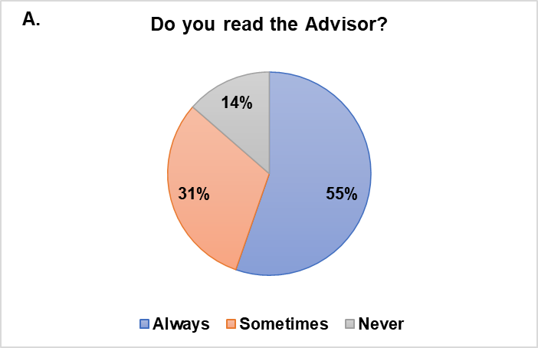
2.
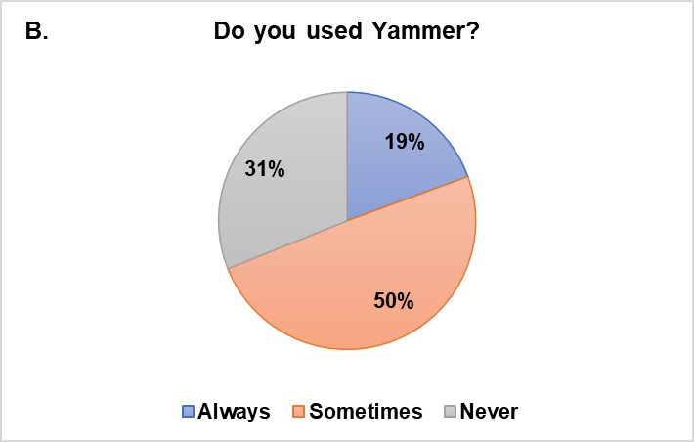
3.
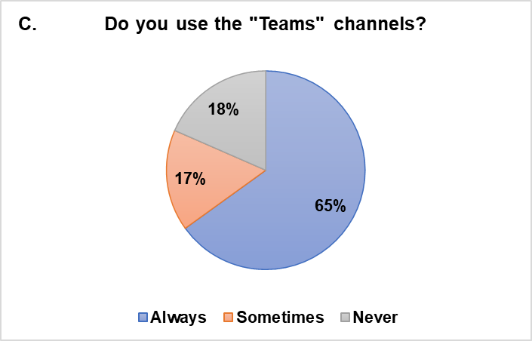
4.

12.
If you have answered No/Never to Q4 – Q9 (about Tai Tarian’s different communications methods)- is there any particular reason why you don’t use them ? –
Related / simular answers have been grouped below:
Comment | Number of Particpants
Never needed to  Will talk to my manager instead  Will just email my suggestions to the team | 22
Not confidential (Speak in confidence tool) | 16
Pointless, nothing changes (Speak in confidence tool) | 6
Didn’t know about it (Speak in confidence tool) | 14
Issues loggin in / not been sent log in details (Speak in confidence tool) | 7
Cannot access on works Ipad (Speak in confidence, Yammer, Facebook group)  (All comments from Asset Directorate - Community based) | 18
No comment provided | 20

19.

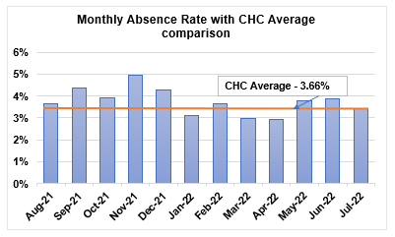
26.
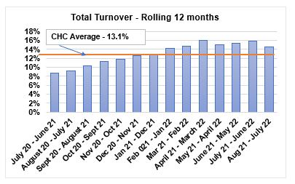
27.

28.
Exit interview Data (Aug 21 – July 22)
Leaving reason / Comments | Total
Career Change (No salary / benefit enhancement) | 14
Career Change (Better salary / Benefits) | 10
Issues with management (Poor communication, lack of clear goals, changing prioritys at last minute, frustrated with lack of communication between teams) | 8
Retirement | 12
End of Fixed term contract | 6
Dismissal | 5
Resignation - No comment provided | 21

29.
Are there any forms of communication/employee voice that you feel should be considered?
- Group forums to discuss change projects

- Voting options on changes that affect the whole organisation

- Having all communications options on the iPad - as this is my own form of communication tool, and I can’t access most things - like yammer etc

- The iPad is not fit for purpose so miss half the messages - really frustrating

- I feel like were the forgotten employees - told to use new things but not given access by our only way of communicating - via the iPad

- You need a laptop to plug in the office now – which we don’t have unless office staff - so I can’t sign into the computer to find out what’s going on anymore and you can’t access all on the iPad !

- The IT is shocking - the iPad is useless

- The IT system is constantly failing - I'm struggling to get my work done let alone look at the communication tools

- There is to many ! Messages are sent from all directions and it’s hard to keep up

- I feel like there is too many options - I can’t keep up and end up missing things

- Can we have one centralised communication tool - there's too many to keep checking

