James Turner (2304088)

Networks and Cyber Security
Assignment 1 - Web
Introduction to Web and Database Concepts (ACCA4023)

Contents
Introduction 1
Requirements 1
Implementation 2
Screen grabs: 2
Validation: 5
Evaluation 5
Website Usability 6
Accessibility 6
Search Engine Optimisation 6
Website Evaluation 7
Usefulness 7
SEO 7
Accessibility 7
References 7
Appendices 8

Introduction

This is my report for Assignment 1 for my Introduction to Web and Database concepts class (ACCA4023). In this report I will cover the requirements for the website, including a bit of background into the website, its purpose as a website, and its designed target audience. I will then talk a little bit about the implementation of the website, in which I would discuss the design of the website, if any errors appeared and how/if they were fixed, and provide an overall validation for the HTML/CSS of the website. Finally, I will give an overall evaluation for the website, and will discuss its usability, accessibility and any search engine optimisations used.

Requirements

For my website, I wanted to provide a space to educate users about specifically Gaming PCs, and to help people understand what each part does, how it interacts with the overall system, and possibly budget advice. The website is designed for people who may already be familiar with gaming or computers, but at a very basic level, so they can understand some of the concepts, but the details need to be explained. This is a wide target audience; however, I feel I made the language approachable enough that the average person would be able to understand what is being discussed.

Implementation

Screen grabs:

Main Page:
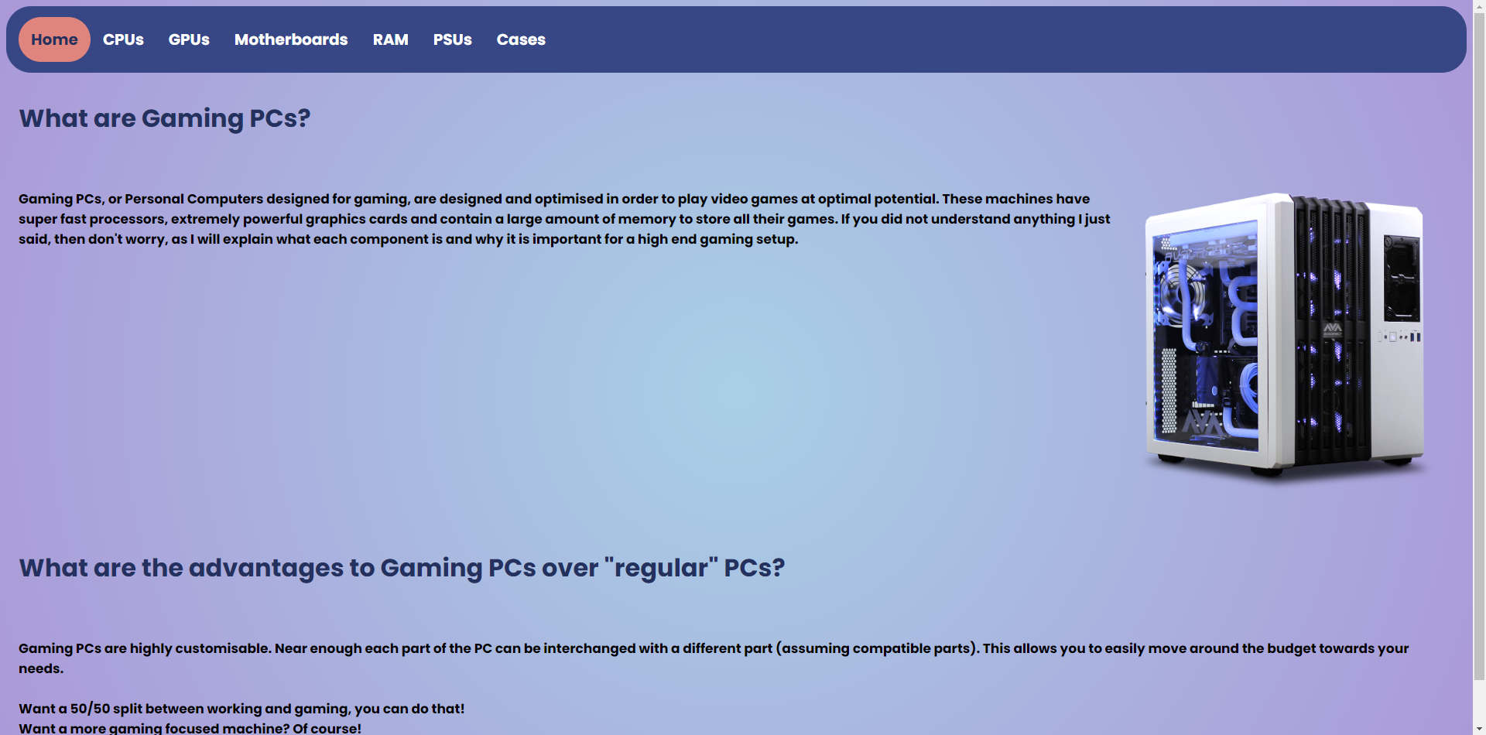
CPU page:
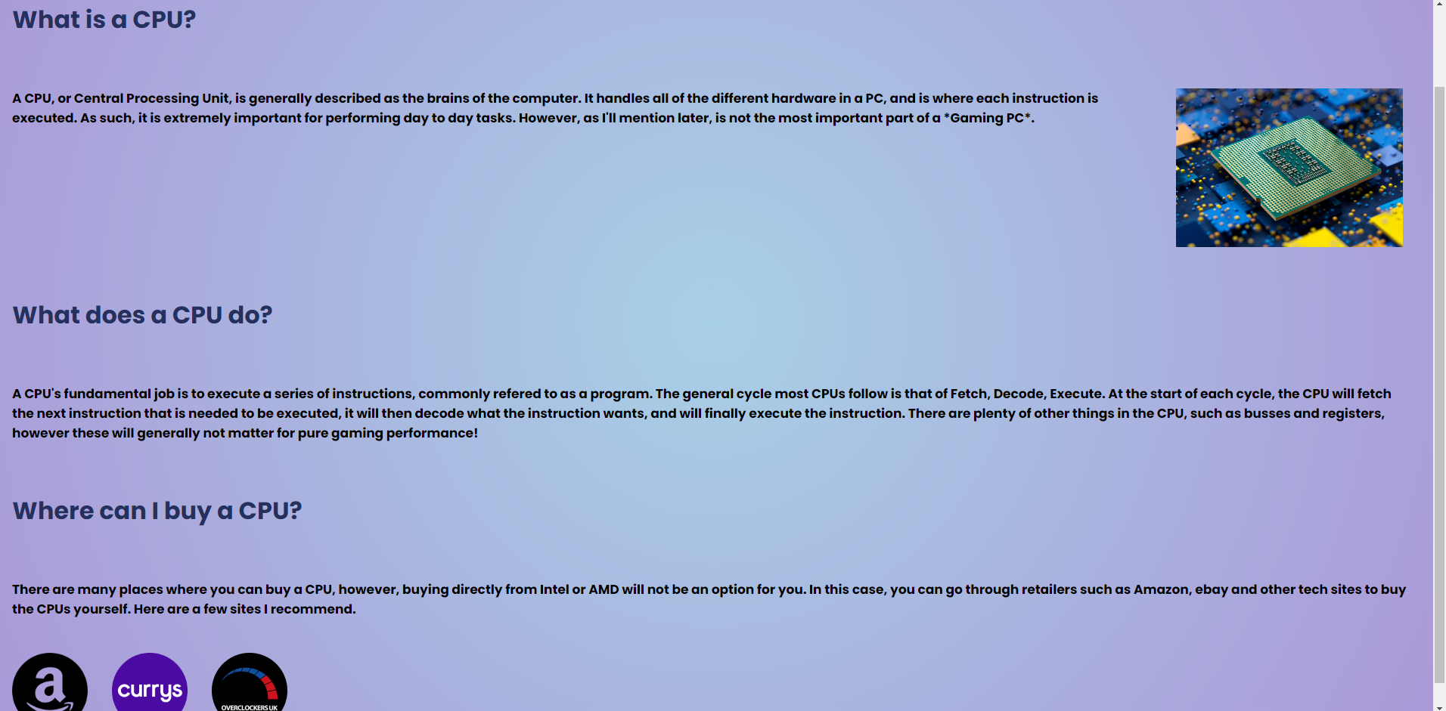
GPU page:
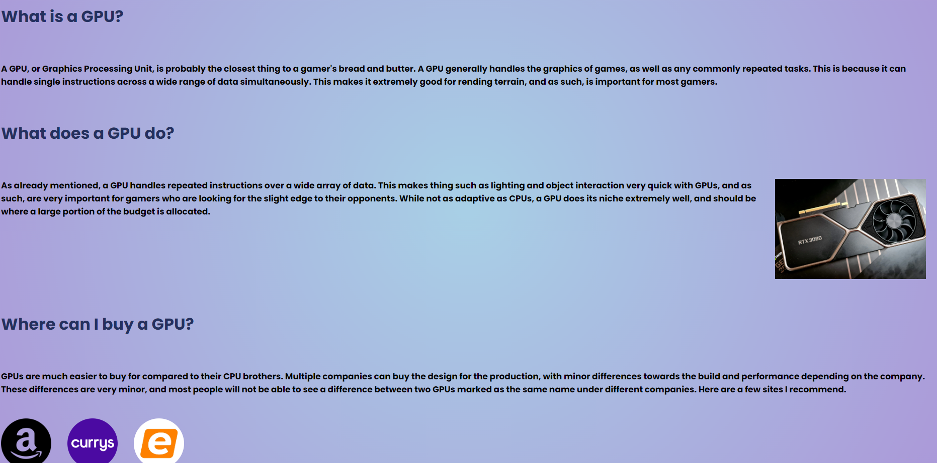
Motherboard page:
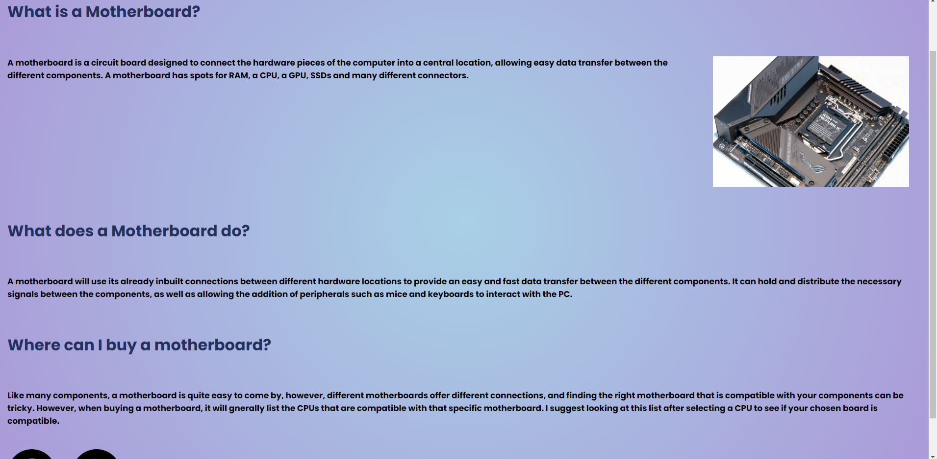
RAM page:
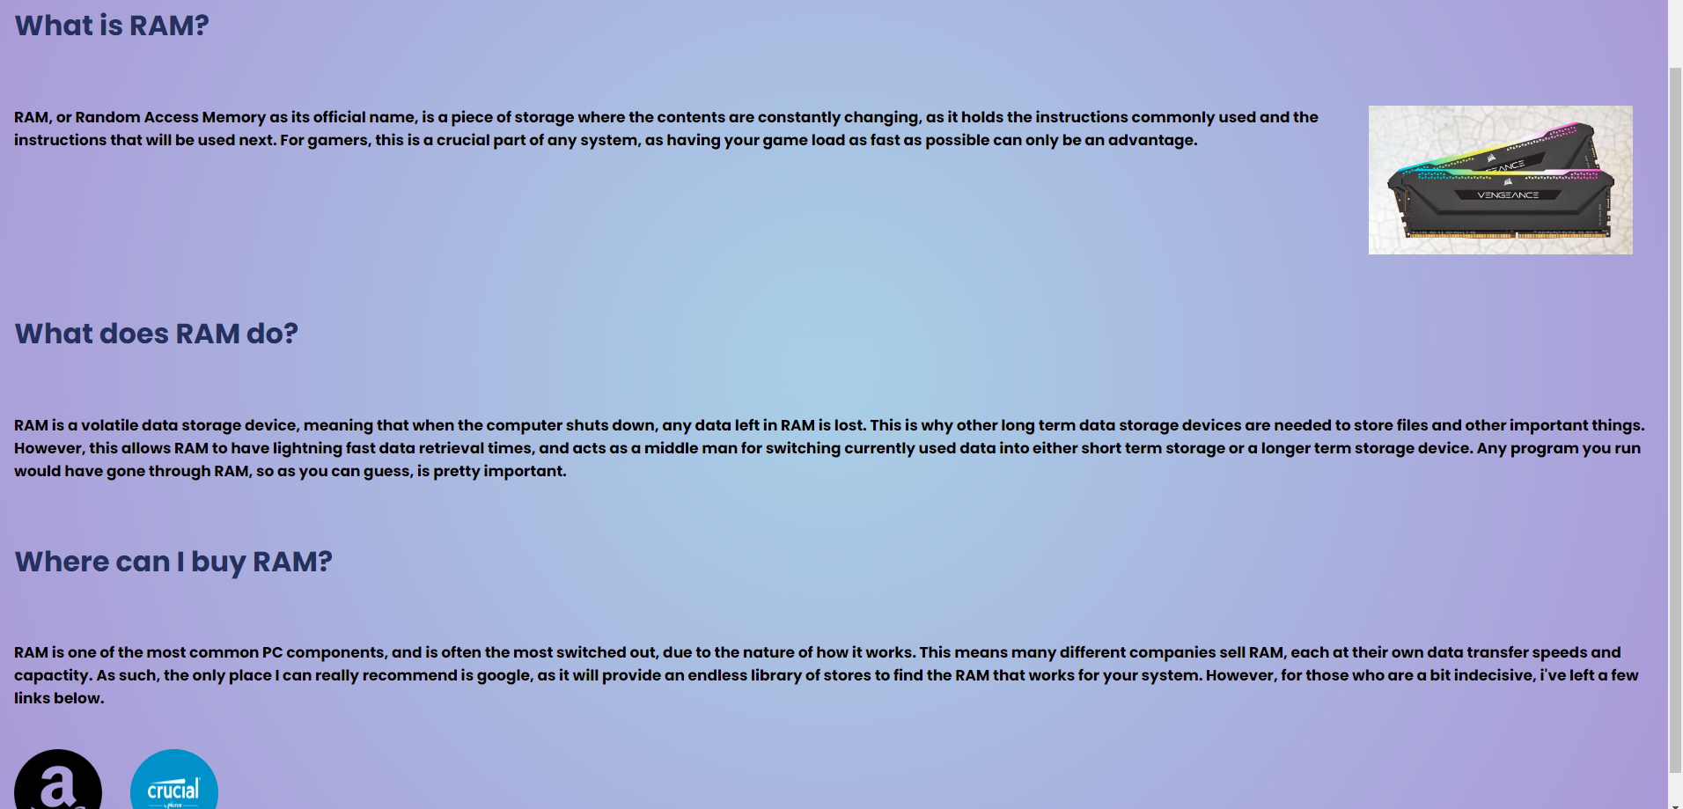
PSU page:
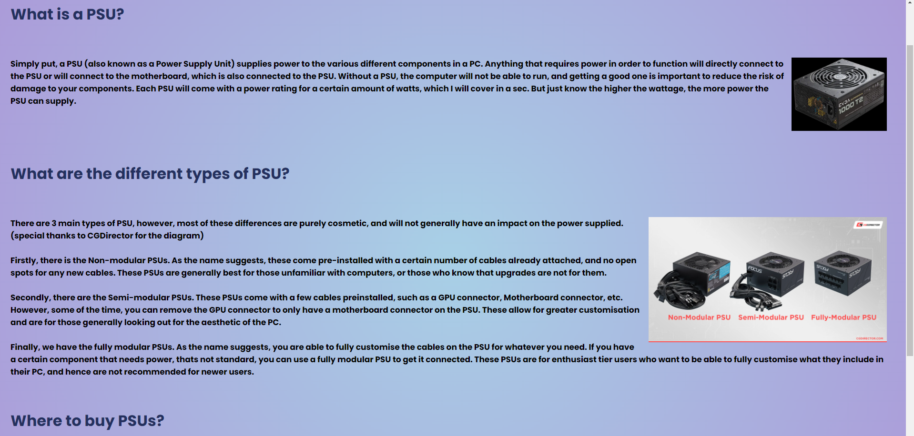
Case page:
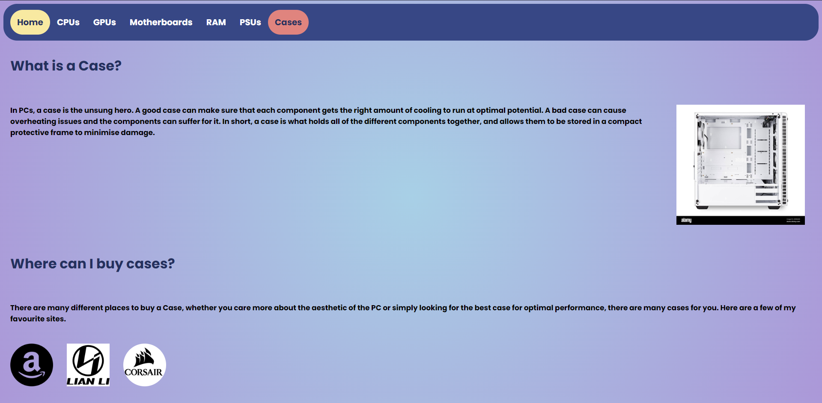

Validation:

Upon using the HTML validator on my main page, I received the following errors.
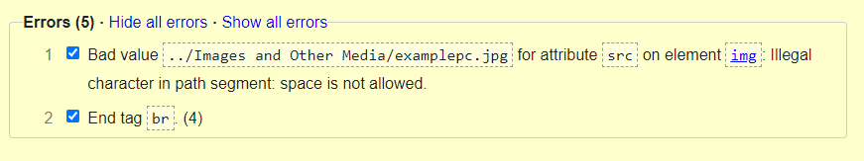
For the first error, it was a simple fix. I had to change the name for my media folder so that there were no spaces. This however did require me to change the file path on all media, however, was a quick fix.
For the second error, I had a </br> , instead of the usual <br> tag. My understanding was that </br> was used instead, however I was wrong.
All errors were cleared after fixing these issues.

Upon using the CSS validator for my stylesheet, I received 0 errors. 

Evaluation

Website Usability

Website usability is generally defined as how easy the user can achieve certain tasks in a quick and efficient manner. Qing-Xing, Guo and Duffy [1] define website usability as “testing measures to the degree to which a website can assist the target user to achieve certain purposes quickly, efficiently and approvingly under a given operational environment”.
For a webpage to achieve quickness, the code must not include any redundant code, and done in an effective manner. To achieve effectiveness, the user must be able to accomplish the desired task without any unnecessary processes or confusion about the process. This can be helped with a streamlined work process with well-organised web pages.
To maintain website usability feedback is often asked for to correct any confusing processes and increasing efficiency of the overall code.

Accessibility

Web accessibility will generally refer to the development of a website and its overall design, so that people with impairments can still access the content in the website effectively. Web accessibility is important for many people, as each person has their own struggles and challenges when it comes to accessing the internet. W3C [2] gives a great example, stating that “The web is fundamentally designed to work for all people, whatever their hardware, software, language, location, or ability.” This means that web accessibility was intended from the very start, and that we should continue to improve our methods to ensure that all people can access the internet and what it provides.
A few ways we can implement web accessibility into web pages is often quite simple, yet very effective. By adding alt text to an image, we can give the same experience to those who may have visual impairments. We can also reduce the amount of flashing/blinking content for those who have sensitive eyes, as well as keyboard navigation options for those with physical impairments. These are just some of the few ways we can increase a websites usability and user experience.

Search Engine Optimisation

Search Engine Optimisation, or more commonly referred to as SEO, is the continuous process of improving a websites ability to be visible on search engines. This process is meant to make a website more likely to appear in search results relating to the website. The process used, as reported by Sharma, Shukla, Kumar Giri and Kumar [3], covers 4 different steps. There is Crawling, where a “spider” crawls the web, visits relevant web pages to gather keywords and other information. Then there is indexing and relevancy. This is where the SEO will create an index from the information gathered on the web pages, and will then use internal algorithms to dictate rankings. Finally, there is the retrieval of the web pages, where the highest “ranks” are displayed in terms of relevance.
Some of the methods used for SEO are as follows: Title tags, where the SEO will use the titles to understand what the website is about; Content, where the content itself and keywords are logged for future reference; URL, where the URL is looked at to see if its self-explanatory/simple, and can be easily linked to.

Website Evaluation

Usefulness

I believe that my website fulfilled its purpose and need, however it was not without its faults. While functional for those who have a base understanding of gaming, it still included terms that many people might not be familiar with, and could hinder their ability to use the website. I believe having a visual representation of each part of the PC on the introduction could help users to find what they are looking for quicker and easier, and not relying on going through each page to find a specific part. I believe I did well on general usability however, as the page was responsive to changes made to screen size, and provided an interactive navigation bar to highlight where the user currently was and where they would be going to. The content is where I did not do so well. I included many terms that may be difficult to understand, and may require additional knowledge to comprehend. I should have used simpler terms and explained in depth what each part did.

SEO

I feel that my website had some uses of on-page SEO techniques, however they could have been more broadly used. A few examples I did use however was Title tags, where I used common questions to improve visibility to the website, as well as optimised URLs, as they were short, were understandable and can be easily linked back to in the future.

Accessibility

For evaluating accessibility, I relied on different tools to help me focus on referencing WCAG 2.1, as during the development I already tried to make the website as accessible to me, and for a different perspective relied on these online tools. My initial thoughts into accessibility was the background and the text, as these play a huge role in accessibility. If people without impairments find the background hard on their eyes, it can cause big problems for those that do. Therefore, I tried to find a background colour/style that was not only stylish, but also easy on the eyes. I used two browser extensions, aXe and WAVE. For aXe I was given 0 errors, but on WAVE I missed out on a few due to missing alt texts for images. I also used Contrastchecker.com to see if my background had enough contrast, and after using both of my background colours, they both passed WCAG 2.0 specification.

References

[1] | F. G. a. V. G. D. Qing-Xing Qu, “Effective use of human physiological metrics to evaluate website usability,” Aslib Journal of Information Management, vol. 69, pp. 370-388, 2017.
[2] | WC3, “Easy Checks - A First Review of Web Accessibility,” W3C, 9 August 2023. [Online]. Available: https://www.w3.org/WAI/test-evaluate/preliminary/. [Accessed 15 January 2024].
[3] | R. S. A. K. G. S. K. Dushyant Sharma, “A Brief Review on Search Engine Optimization,” in IEEE Xplore, 2019.

Appendices

Index.html:
<!DOCTYPE html>
<html lang="en">
<head>
<meta charset="UTF-8">
<meta name="viewport" content="width=device-width, initial-scale=1.0">
<title>Gaming PCs</title>
<link rel="stylesheet" href="styles.css">
<link rel="preconnect" href="https://fonts.googleapis.com">
<link rel="preconnect" href="https://fonts.gstatic.com" crossorigin>
<link href="https://fonts.googleapis.com/css2?family=Permanent+Marker&family=Poppins:wght@700&display=swap" rel="stylesheet">

</head>
<body>
<div class="navbar">
<a href="index.html" class="active">Home</a>
<a href="cpu.html">CPUs</a>
<a href="gpu.html">GPUs</a>
<a href="motherboard.html">Motherboards</a>
<a href="ram.html">RAM</a>
<a href="psu.html">PSUs</a>
<a href="case.html">Cases</a>
</div>

<h1>What are Gaming PCs?</h1>

<p>
<img src="../Media/examplepc.jpg" alt="Example of a gaming pc" style="width:400px">
Gaming PCs, or Personal Computers designed for gaming, are designed and optimised in order to play video games at optimal potential.
These machines have super fast processors, extremely powerful graphics cards and contain a large amount of memory to store all their games.
If you did not understand anything I just said, then don't worry, as I will explain what each component is and why it is important for a high end gaming setup.

</p>

<h1>What are the advantages to Gaming PCs over "regular" PCs?</h1>
<p>
Gaming PCs are highly customisable. Near enough each part of the PC can be interchanged with a different part (assuming compatible parts).
This allows you to easily move around the budget towards your needs.<br><br>

Want a 50/50 split between working and gaming, you can do that!<br>
Want a more gaming focused machine? Of course!<br>
Or do you simply want to play a few games during the office breaks. Absolutely!<br>
</p>

</body>
</html>

Cpu.html:
<!DOCTYPE html>
<html lang="en">
<head>
<meta charset="UTF-8">
<meta name="viewport" content="width=device-width, initial-scale=1.0">
<title>CPUs</title>
<link rel="stylesheet" href="styles.css">
<link rel="preconnect" href="https://fonts.googleapis.com">
<link rel="preconnect" href="https://fonts.gstatic.com" crossorigin>
<link href="https://fonts.googleapis.com/css2?family=Permanent+Marker&family=Poppins:wght@700&display=swap" rel="stylesheet">
</head>
<body>
<div class="navbar">
<a href="index.html">Home</a>
<a href="cpu.html" class="active">CPUs</a>
<a href="gpu.html">GPUs</a>
<a href="motherboard.html">Motherboards</a>
<a href="ram.html">RAM</a>
<a href="psu.html">PSUs</a>
<a href="case.html">Cases</a>
</div>

<h1>What is a CPU?</h1>

<p>

<img src="../Media/examplecpu.webp" width="300px" height="100%" alt="Upside down view of a cpu, surounded by blue and yellow dot like cubes">
A CPU, or Central Processing Unit, is generally described as the brains of the computer.
It handles all of the different hardware in a PC, and is where each instruction is executed.
As such, it is extremely important for performing day to day tasks.
However, as I'll mention later, is not the most important part of a *Gaming PC*.

</p>

<h1>What does a CPU do?</h1>

<p>

A CPU's fundamental job is to execute a series of instructions, commonly refered to as a program.
The general cycle most CPUs follow is that of Fetch, Decode, Execute.
At the start of each cycle, the CPU will fetch the next instruction that is needed to be executed, it will then decode what the instruction wants, and will finally execute the instruction.
There are plenty of other things in the CPU, such as busses and registers, however these will generally not matter for pure gaming performance!

</p>

<h1>Where can I buy a CPU?</h1>
<p>
There are many places where you can buy a CPU, however, buying directly from Intel or AMD will not be an option for you.
In this case, you can go through retailers such as Amazon, ebay and other tech sites to buy the CPUs yourself. Here are a few sites I recommend.
</p>
<a href="https://www.amazon.co.uk/s?k=Gaming+CPU&ref=nb_sb_noss_1"><img class="imgbuy" src="../Media/amazon-circle-icon.png" alt="Amazon circle logo" width="100px" height="100px"</a>
<a href="https://www.currys.co.uk/computing/components-and-upgrades/processors"><img class="imgbuy" src="../Media/Currys_Logo.png" alt="Currys logo" width="100px" height="100px"</a>
<a href="https://www.overclockers.co.uk/pc-components/processors"><img class="imgbuy" src="../Media/overclockers.jpg" style="border-radius: 50%;" alt="overclockers logo" width="100px" height="100px"</a>
</body>
</html>

Gpu.html:
<!DOCTYPE html>
<html lang="en">
<head>
<meta charset="UTF-8">
<meta name="viewport" content="width=device-width, initial-scale=1.0">
<title>GPUs</title>
<link rel="stylesheet" href="styles.css">
<link rel="preconnect" href="https://fonts.googleapis.com">
<link rel="preconnect" href="https://fonts.gstatic.com" crossorigin>
<link href="https://fonts.googleapis.com/css2?family=Permanent+Marker&family=Poppins:wght@700&display=swap" rel="stylesheet">
</head>
<body>
<div class="navbar">
<a href="index.html">Home</a>
<a href="cpu.html">CPUs</a>
<a href="gpu.html" class="active">GPUs</a>
<a href="motherboard.html">Motherboards</a>
<a href="ram.html">RAM</a>
<a href="psu.html">PSUs</a>
<a href="case.html">Cases</a>
</div>

<h1>What is a GPU?</h1>

<p>
A GPU, or Graphics Processing Unit, is probably the closest thing to a gamer's bread and butter.
A GPU generally handles the graphics of games, as well as any commonly repeated tasks. This is because it can handle single instructions across a wide range of data simultaneously.
This makes it extremely good for rending terrain, and as such, is important for most gamers.
</p>

<h1>What does a GPU do?</h1>

<p>
<img src="../Media/examplegpu.webp" height="100%" width="300px">
As already mentioned, a GPU handles repeated instructions over a wide array of data.
This makes thing such as lighting and object interaction very quick with GPUs, and as such, are very important for gamers who are looking for the slight edge to their opponents.
While not as adaptive as CPUs, a GPU does its niche extremely well, and should be where a large portion of the budget is allocated.
</p>

<h1>Where can I buy a GPU?</h1>

<p>
GPUs are much easier to buy for compared to their CPU brothers.
Multiple companies can buy the design for the production, with minor differences towards the build and performance depending on the company.
These differences are very minor, and most people will not be able to see a difference between two GPUs marked as the same name under different companies.
Here are a few sites I recommend.
</p>
<a href="https://www.amazon.co.uk/s?k=GPU&ref=nb_sb_noss_1"><img class="imgbuy" src="../Media/amazon-circle-icon.png" width="100px" height="100px" alt="Amazon link to GPU search term"</a>
<a href="https://www.currys.co.uk/computing/components-and-upgrades/graphics-cards"><img class="imgbuy" src="../Media/Currys_Logo.png" width="100px" height="100px" alt="Currys link to GPU"</a>
<a href="https://www.ebuyer.com/graphics-cards"><img class="imgbuy" src="../Media/ebuyer.png" style="border-radius: 50%;" width="100px" height="100px"</a>
</body>
</html>

Motherboard.html:
<!DOCTYPE html>
<html lang="en">
<head>
<meta charset="UTF-8">
<meta name="viewport" content="width=device-width, initial-scale=1.0">
<title>Motherboards</title>
<link rel="stylesheet" href="styles.css">
<link rel="preconnect" href="https://fonts.googleapis.com">
<link rel="preconnect" href="https://fonts.gstatic.com" crossorigin>
<link href="https://fonts.googleapis.com/css2?family=Permanent+Marker&family=Poppins:wght@700&display=swap" rel="stylesheet">
</head>
<body>
<div class="navbar">
<a href="index.html">Home</a>
<a href="cpu.html">CPUs</a>
<a href="gpu.html">GPUs</a>
<a href="motherboard.html" class="active">Motherboards</a>
<a href="ram.html">RAM</a>
<a href="psu.html">PSUs</a>
<a href="case.html">Cases</a>
</div>

<h1>What is a Motherboard?</h1>
<p>
<img src="../Media/examplemotherboard.jpg" width="400px" height="100%">
A motherboard is a circuit board designed to connect the hardware pieces of the computer into a central location, allowing easy data transfer between the different components.
A motherboard has spots for RAM, a CPU, a GPU, SSDs and many different connectors.
</p>

<h1>What does a Motherboard do?</h1>

<p>
A motherboard will use its already inbuilt connections between different hardware locations to provide an easy and fast data transfer between the different components.
It can hold and distribute the necessary signals between the components, as well as allowing the addition of peripherals such as mice and keyboards to interact with the PC.

</p>

<h1>Where can I buy a motherboard?</h1>
<p>
Like many components, a motherboard is quite easy to come by, however, different motherboards offer different connections, and finding the right motherboard that is compatible with your components can be tricky.
However, when buying a motherboard, it will gnerally list the CPUs that are compatible with that specific motherboard. I suggest looking at this list after selecting a CPU to see if your chosen board is compatible.
</p>
<a href="https://www.amazon.co.uk/s?k=Motherboard&ref=nb_sb_noss_1"><img class="imgbuy" src="../Media/amazon-circle-icon.png" height="100px" width="100px" alt="amazon link to motherboard"></a>
<a href="https://www.overclockers.co.uk/pc-components/motherboards"><img class="imgbuy" src="../Media/overclockers.jpg" style="border-radius: 50%;" height="100px" width="100px"></a>

</body>
</html>

Ram.html:
<!DOCTYPE html>
<html lang="en">
<head>
<meta charset="UTF-8">
<meta name="viewport" content="width=device-width, initial-scale=1.0">
<title>RAM</title>
<link rel="stylesheet" href="styles.css">
<link rel="preconnect" href="https://fonts.googleapis.com">
<link rel="preconnect" href="https://fonts.gstatic.com" crossorigin>
<link href="https://fonts.googleapis.com/css2?family=Permanent+Marker&family=Poppins:wght@700&display=swap" rel="stylesheet">
</head>
<body>
<div class="navbar">
<a href="index.html">Home</a>
<a href="cpu.html">CPUs</a>
<a href="gpu.html">GPUs</a>
<a href="motherboard.html">Motherboards</a>
<a href="ram.html" class="active">RAM</a>
<a href="psu.html">PSUs</a>
<a href="case.html">Cases</a>
</div>

<h1>What is RAM?</h1>

<p>
<img src="../Media/ram.jpg" width="300px" height="100%" alt="picture of RAM">

RAM, or Random Access Memory as its official name, is a piece of storage where the contents are constantly changing, as it holds the instructions commonly used and the instructions that will be used next.
For gamers, this is a crucial part of any system, as having your game load as fast as possible can only be an advantage.
</p>

<h1>What does RAM do?</h1>
<p>
RAM is a volatile data storage device, meaning that when the computer shuts down, any data left in RAM is lost.
This is why other long term data storage devices are needed to store files and other important things.
However, this allows RAM to have lightning fast data retrieval times, and acts as a middle man for switching currently used data into either short term storage or a longer term storage device.
Any program you run would have gone through RAM, so as you can guess, is pretty important.
</p>

<h1>Where can I buy RAM?</h1>
<p>
RAM is one of the most common PC components, and is often the most switched out, due to the nature of how it works. This means many different companies sell RAM, each at their own data transfer speeds and capactity.
As such, the only place I can really recommend is google, as it will provide an endless library of stores to find the RAM that works for your system.
However, for those who are a bit indecisive, i've left a few links below.
</p>
<a href="https://www.amazon.co.uk/s?k=RAM&ref=nb_sb_noss_1"><img class="imgbuy" src="../Media/amazon-circle-icon.png" height="100px" width="100px" alt="amazon link to RAM"></a>
<a href="https://uk.crucial.com/catalog/memory?module-type(-)UDIMM"><img class="imgbuy" src="../Media/crucial.jpg" style="border-radius: 50%;" height="100px" width="100px" alt="link to crucial for RAM"></a>

</body>
</html>

Psu.html:
<!DOCTYPE html>
<html lang="en">
<head>
<meta charset="UTF-8">
<meta name="viewport" content="width=device-width, initial-scale=1.0">
<title>PSUs</title>
<link rel="stylesheet" href="styles.css">
<link rel="preconnect" href="https://fonts.googleapis.com">
<link rel="preconnect" href="https://fonts.gstatic.com" crossorigin>
<link href="https://fonts.googleapis.com/css2?family=Permanent+Marker&family=Poppins:wght@700&display=swap" rel="stylesheet">
</head>
<body>
<div class="navbar">
<a href="index.html">Home</a>
<a href="cpu.html">CPUs</a>
<a href="gpu.html">GPUs</a>
<a href="motherboard.html">Motherboards</a>
<a href="ram.html">RAM</a>
<a href="psu.html" class="active">PSUs</a>
<a href="case.html">Cases</a>
</div>

<h1>What is a PSU?</h1>

<p>
<img src="../Media/psu.webp" width="200px" height="100%" alt="Picture of a psu">
Simply put, a PSU (also known as a Power Supply Unit) supplies power to the various different components in a PC.
Anything that requires power in order to function will directly connect to the PSU or will connect to the motherboard, which is also connected to the PSU.
Without a PSU, the computer will not be able to run, and getting a good one is important to reduce the risk of damage to your components.
Each PSU will come with a power rating for a certain amount of watts, which I will cover in a sec. But just know the higher the wattage, the more power the PSU can supply.
</p>

<h1>What are the different types of PSU?</h1>
<p>
<img src="../Media/Power-Supply-Types.webp" width="500px" height="100%" alt="image showing cable differences in PSU">
There are 3 main types of PSU, however, most of these differences are purely cosmetic, and will not generally have an impact on the power supplied.
(special thanks to CGDirector for the diagram)
</br></br>
Firstly, there is the Non-modular PSUs. As the name suggests, these come pre-installed with a certain number of cables already attached, and no open spots for any new cables.
These PSUs are generally best for those unfamiliar with computers, or those who know that upgrades are not for them.
</br></br>
Secondly, there are the Semi-modular PSUs. These PSUs come with a few cables preinstalled, such as a GPU connector, Motherboard connector, etc. However, some of the time, you can remove the GPU connector to only have a motherboard connector on the PSU.
These allow for greater customisation and are for those generally looking out for the aesthetic of the PC.
</br></br>
Finally, we have the fully modular PSUs. As the name suggests, you are able to fully customise the cables on the PSU for whatever you need. If you have a certain component that needs power, thats not standard, you can use a fully modular PSU to get it connected.
These PSUs are for enthusiast tier users who want to be able to fully customise what they include in their PC, and hence are not recommended for newer users.
</p>

<h1>Where to buy PSUs?</h1>

<p>
PSUs are pretty common, and most tech retailers will sell them. The big thing about a PSU is the wattage. If your PC has a certain wattage requirement, then you need a PSU that at least meets that requirement.
My tip is to buy a PSU last, and look up each components wattage, add them together and find a PSU greater than that number.
This reduces the risk of your components running slower than expected, as they do not have the power needed to run at their full potential.
Here are some recommended sites to buy PSUs
</p>
<a href="https://www.amazon.co.uk/s?k=PSU&ref=nb_sb_noss_1"><img class="imgbuy" src="../Media/amazon-circle-icon.png" height="100px" width="100px" alt="amazon link"></a>
<a href="https://www.corsair.com/uk/en/c/psu"><img class="imgbuy" src="../Media/corsair.avif" style="border-radius: 50%;" height="100px" width="100px" alt="corsair link"></a>

</body>
</html>

Case.html:
<!DOCTYPE html>
<html lang="en">
<head>
<meta charset="UTF-8">
<meta name="viewport" content="width=device-width, initial-scale=1.0">
<title>Cases</title>
<link rel="stylesheet" href="styles.css">
<link rel="preconnect" href="https://fonts.googleapis.com">
<link rel="preconnect" href="https://fonts.gstatic.com" crossorigin>
<link href="https://fonts.googleapis.com/css2?family=Permanent+Marker&family=Poppins:wght@700&display=swap" rel="stylesheet">
</head>
<body>
<div class="navbar">
<a href="index.html">Home</a>
<a href="cpu.html">CPUs</a>
<a href="gpu.html">GPUs</a>
<a href="motherboard.html">Motherboards</a>
<a href="ram.html">RAM</a>
<a href="psu.html">PSUs</a>
<a href="case.html" class="active">Cases</a>
</div>

<h1>What is a Case?</h1>
<p>
<img src="../Media/pccase.jpg" width="300px" height="100%" alt="empty pc case, showing what the case looks like out of the box">
In PCs, a case is the unsung hero. A good case can make sure that each component gets the right amount of cooling to run at optimal potential.
A bad case can cause overheating issues and the components can suffer for it.
In short, a case is what holds all of the different components together, and allows them to be stored in a compact protective frame to minimise damage.
</p>

<h1>Where can I buy cases?</h1>

<p>
There are many different places to buy a Case, whether you care more about the aesthetic of the PC or simply looking for the best case for optimal performance, there are many cases for you.
Here are a few of my favourite sites.
</p>

<a href="https://www.amazon.co.uk/s?k=PC+case&ref=nb_sb_noss_1"><img class="imgbuy" src="../Media/amazon-circle-icon.png" height="100px" width="100px" alt="amazon link"></a>
<a href="https://lian-li.com/product-category/cases/"><img class="imgbuy" src="../Media/lian-li.png" width="100px" height="100px"></a>
<a href="https://www.corsair.com/uk/en/c/pc-cases"><img class="imgbuy" style="border-radius: 50%;" src="../Media/corsair.avif" width="100px" height="100px" alt="corsair link to case"></a>
</body>
</html>

Styles.css:
body{
background-image: radial-gradient(circle,#a8d0e6, #ab98d8);
font-family: 'Poppins', sans-serif;

}

p {
font-size: 17px;
font-family: 'Poppins', sans-serif;
padding: 14px 16px;
float: left;
}

img {
float: right;
padding: 0px 16px;
}

.imgbuy {
float: left;
padding: 14px 16px;
}

h1 {
color: #24305e;
padding: 14px 16px;
font-family: 'Poppins', sans-serif;
text-align: left;
float: left;
}

.navbar {
background-color: #374785;
overflow: hidden;
padding: 14px 16px;
border-radius: 2rem;
}

.navbar a {
float: left;
display: block;
color: white;
text-align: center;
padding: 14px 16px;
text-decoration: none;
font-size: 20px;
border-radius: 2rem;
font-family: 'Poppins', sans-serif
}

.navbar a:hover {
background-color: #f8e9a1;
color: #24305e;
}

.navbar a.active {
background-color: #e0847e;
color: #24305e;
font-family: 'Poppins', sans-serif
}

