

Application of Computer Aided Engineering Processes
BSc Ordnance, Munitions & Explosives
Computer Aided Engineering
ACDB5007
Charlotte McCombe
Student Number: 2411524

Contents
List of Figures 3
List of Tables 3
1. Introduction 4
2. Literature Review 5
2.1 Breakdown of CAE Software 5
2.2 Development of CAE 6
2.3 Finite element analysis 6
2.4 FEA Concepts 7
2.5 Limitations of CAE Software 9
2.6 Assumptions 10
2.7 Mesh Dependency 10
2.8 Boundary Conditions 10
3. Test Case 11
3.1 Materials and material models 11
3.2 ANSYS Simulations 13
3.3 Assumptions 14
3.4 Validation 14
3.4.1 Deformation to penetrated area 14
3.4.2 Deformation on impact of projectile 16
3.4.3 Comparison of different boundary conditions 18
3.5 Stress 20
3.5.1 Comparison of stress in simulation 1 and 2 21
3.6 Shear Strain 22
4 Mesh Independence Study 24
4.1 Meshing 25
4.2 Sphere of Influence 27
4.3 Mesh Refinement 28
5 Conclusion 29
Bibliography 30

List of Figures
Figure 1 - Three Phase Process of Computer Aided Engineering 5
Figure 2 - ANSYS Equation for acceleration to stress tensor in explicit Dynamics [8] 7
Figure 3 - ANSYS Equation for conservation of energy in explicit dynamics [8] 7
Figure 4 - Calculation for nodal acceleration in ANSYS [8] 7
Figure 5 - Calculation for nodal Velocity and Position in ANSYS [8] 8
Figure 7 - Simulation 1 Petaling Pattern 18
Figure 6 - Simulation 2 Petaling Patten 18
Figure 8 - Simulation 2 Plate Deformation 18
Figure 9 - Simulation 3 - Stress wave at time t=6.3195e-005 20
Figure 10 - Stress wave Propagation in Simulation 2 21
Figure 11 - Material Spalling in simulation 3 22
Figure 12 - Simulation 3 Strain Graph 23
Figure 13 - Simulation 1 Strain Graph 23
Figure 14 – Maximum Shear elastic Strain in Simulation 2 at various times. 23
Figure 15 - Simulation 7 Mesh 25
Figure 16 - Simulation 8 deformation following target impact from projectile 27
Figure 17 - Simulation 12 Stress on impact………………………………………………………….28 Figure 18 - Simulation 11 stress on impact 28

List of Tables
Table 1 – Material parameters for Steel S-7 and Aluminium 7039 from ANSYS Library.12
Table 2 – List of Simulations completed in ANSYS Workbench……………………….………13
Table 3 – Comparison of Deformation in Simulation 5 and 6………………………………….15
Table 4 – Comparison of ANSYS Impact Deformation Against Pre-existing Research…16
Table 5 - List of simulation properties used for mesh independence study………….……24
Table 6 – Mesh for simulations 8-12……………………………………………………………………26

Introduction
Computer aided engineering (CAE) plays a vital role throughout many industries including the defence industry. These tools provide an analysis of the behaviours of models under different conditions. Within the defence industry, CAE allows for impact modelling to be completed in a quick and reliable way prior to experimental evaluation.
Within this assignment CAE tools were used to model a defence scenario, and an assessment of the software was completed to determine the modelling reliability. The known limitations and assumptions are discussed in relation to CAE as a whole and scenario specific.

Literature Review

2.1 Breakdown of CAE Software
Computer aided engineering (CAE) is the process of using software and tools to perform activities including engineering analysis and design. The main use of these tools includes structural optimisation, failure detection and process simulation [1]. CAE follows three phases to complete engineering problems [2].

Figure 1 - Three Phase Process of Computer Aided Engineering
In the first phase, preprocessing, geometry and properties are designed and modelled. Computer Aided Design (CAD) tools provide a digital platform for producing both 2D and 3D geometries and can be applied to complex designs. In this phase data including material properties, materials models, design constraints and loads are applied. The aims for the solver are also set out; this includes different types of stress and strain as well as properties such as pressure and deformation.
In the second phase, solving, solvers use numerical methods to solve vast number of equations and produce results. There are many solver methods available on different software depending on what the model is required to achieve.
In the final phase, postprocessing, results are produced in a variety of methods including figures, simulations and graphs. This allows the evaluation and analysis of models. Interpreting these results allows specialists to identify any potential problems or failures of a model and make recommendations and design changes.
CAE tools allow simulations to assess the behaviour of models prior to the manufacture of components or experimental models. These tools are critical in identifying potential failures in models prior to their production so that design changes can be assessed and made. This allows the optimisation of experimental work saving resources and costs. This is important in the delivery of a model to encounter problems and flaws before delivering a final product.

2.2 Development of CAE
CAE tools have been rapidly developed since the 1960’s with the advancement of computing systems and technologies. The introduction on Finite Element Analysis (FEA) allowed for large structures to be simplified into smaller finite elements, allowing numerical methods to be used for analysis of models. The combination of computer aided design (CAD) being transferred to CAE software hugely improved engineering processes. Modern CAE software’s focus on being user friendly and combining newer technologies such as artificial intelligence and machine learning [3]. There are many CAE software’s used in design processes including Abaqus, ANSYS, Siemens NX and Inventor. Each programme provides a tool set for simulation such as structural analysis, fluid dynamics and electrical design increasing the flexibility for use in various industries and applications [4].

2.3 Finite element analysis
Finite element analysis (FEA) method us used to solve differential equations for material behaviours such as stress and strain. It is often used in cases where hand calculations prove difficult and would not provide accurate solutions in complex cases [5]. This method uses regions created by a mesh to define how structures react to different loading conditions and environments. There are many advantages of using Finite element analysis including: generating results and physical response of a model at a given time, producing visual results and calculated results for desired parameters and being applied to models that are dangerous or impractical [6].

2.4 FEA Concepts
ANSYS Explicit Dynamics uses FEA through combining the finite element method with time integration and is the ideal approach for the projectile simulation [7]. For explicit dynamics, the solver uses a time integration scheme to calculate the nodal accelerations further calculating the new nodal positions. This is done through the conservation of momentum and energy using equations in figure 2 and 3 below.
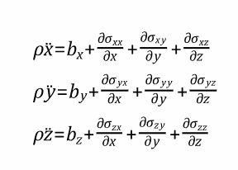

Figure 2 - ANSYS Equation for acceleration to stress tensor in explicit Dynamics [8]
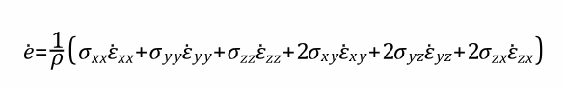
Figure 3 - ANSYS Equation for conservation of energy in explicit dynamics [8]

Throughout the simulation ANSYS works to solve equations at each time step though time integration. This is done by calculating the nodal accelerations using the equation in figure 4 for each individual node.
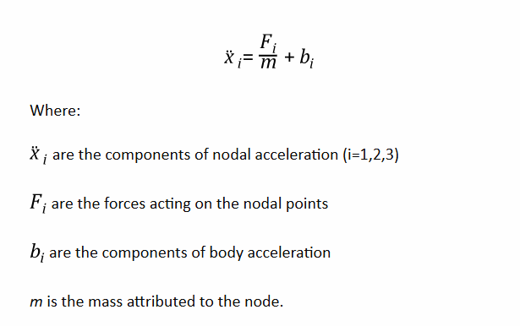
Figure 4 - Calculation for nodal acceleration in ANSYS [8]
The calculated acceleration for each node is then used in the equations in figure 5 to calculate the velocities and positions at a given time in the simulation. The solver uses the new positions and calculated values in the next set of numerical solves.

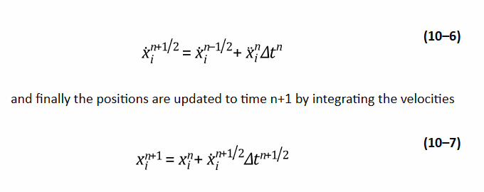
Figure 5 - Calculation for nodal Velocity and Position in ANSYS [8]

CAE tools use a vast range of solvers for each application with many mathematical solvers for different scenarios. Each have their limitations and assumptions that vary in each programme.

2.5 Limitations of CAE Software
The main limitation of CAE is that solutions produced are only approximations and are not exact solutions. Therefore, the results are often required to be validated through existing research or experimental research. Another limitation is the end solution relies deeply on the input from the user. As most tools are used to achieve the optimum output of a scenario, users of the tools and software’s need to be knowledgeable and understand each area in the process.
The use of CAE can have extremely high costs and solving times with the technology still developing and constantly improving. Geometric simplifications are another limitation of these tools, as often models are simplified to ease solving time. This includes the removal of certain features such as corners and bumps [9]
As CAE solvers complete various complex mathematics equations this can result in extremely long solve times. There are many factors influencing the solve times including mesh size, time steps and type of simulation being completed. To reduce the time taken and computational cost for completion of simulations often a model is simplified [10] This can be done in symmetrical models by only modelling a section. Using this method allows for refined meshes on part of a model or reduced solving time. Scenarios for this method aren’t extremely common but can be used for scenarios such as pipes and cogs [11]
High velocity impact models can be difficult to simulate using CAE tools and the finite element due to mesh distortions because of extreme values of stress and strain resulting in extreme deformation and element deletion. Furthermore, these models heavily rely on the quality of the mesh used to gain accurate results [12] .

2.6 Assumptions
There are many known assumptions when using CAE including the assumption that materials are homogenous and isotropic, therefore are a perfect material throughout [13]. By assigning these properties the software has a more efficient and simpler model to solve. This is not an accurate representation of materials in experimental models as they are subject to imperfections such as scratches, dents and voids. However, including each of these imperfections in a model would be timely and increase solver times. It would also not be repeatable for duplicates as each piece of material would have different properties.

2.7 Mesh Dependency
One critical tool used in CAE is the meshing of components as this is a huge contributing factor in the precision and accuracy of a model. The mesh allows a model to be broken down into finite elements which are used in computational calculations for factors such as stress, displacement and stress. CAE solvers use matrix methods to solve calculations in a much quicker time than manual calculations, proving to be a more time efficient modelling method [14].
A prism mesh was used on the target and tetrahedron mesh was used on the projectile. The mesh size of the projectile and the sphere of influence were designated the same size to improve contact between the two objects. Other methods such as adaptive meshing can be applied to a model to improve element distortion in areas where there is material loss. Software including ABAQUS Explicit are suitable for this mesh type [15].

2.8 Boundary Conditions
Within CAE the boundary conditions of a model are often set by the user, which creates an opportunity for human error within a model. Boundary conditions are required to ensure that equilibrium between resultant forces and internal forces are maintained [16]. Various boundary conditions can be applied such as fixed faces, edges or sides depending on the suitability of the model. The boundary conditions are assumed to be perfect.

Test Case
The selected test case was modelled on the ANSYS Workbench programme and consisted of a steel 9mm cylindrical projectile with a round head hitting an aluminium circular target with a defined velocity. The model was designed as 3D objects on the CAD software Autodesk. An explicit dynamic solver was selected for the model which used the finite element method to solve. The test case was repeated using various boundary conditions including velocity and fixed edges or sides. The thickness of the target plate and the geometry of the projectile remained the same throughout all models.
The projectile was set at a very close distance to target with an initial velocity, therefore air resistance in the small time between contact was disregarded. The solvers used for the models were total deformation, maximum shear elastic strain and equivalent stress. These three solutions gave an overall representation of the behaviour of the model and information to analyse.

3.1 Materials and material models
Steel S-7 and Aluminium 7039 were the selected materials assigned to the target and the projectile with Johnson Cook (J-C) parameters. The J-C model is used in ballistic simulations due to material properties being in calculations by the software. The model was used to predict the mechanical behaviour on the materials under impact [17]. This gave an accurate representation to the deformation of the material over a very short time step.
The J-C parameters are essential in FEM of shock wave simulations to relate the stress and strain and to be used in numerical calculations by the software. The Johnson cook model can be used to define the strength behaviour stress and a product of strain and therefore develop a stress strain model for each element within the simulation at a given time. The target underwent extreme deformation when compared to the projectile due the greater yield of the projectile. The steel had a much higher density and shear modulus as shown in table 1.

Table 1 – Material parameters for Steel S-7 and Aluminium 7039 from ANSYS Library
 | Steel S-7 | Aluminium 7039
Density ($kg/m^{2})$ | 7750 | 2770
Specific Heat Constant Pressure ($J/kg∙℃)$ | 477 | 875
Gruneisen Coefficient | 2.17 | 2
Parameter C1$(ms^{-1})$ | 4569 | 5328
Parameter S1 | 1.49 | 1.338
Parameter Quadratic S2 (s/m) | 0 | 0
Strain Rate Correction | First-Order | First Order
Initial Yield Stress (Pa) | 1.539e+09 | 3.37e+008
Hardening Constant (Pa) | 4.77e+08 | 3.43e+08
Hardening Exponent | 0.18 | 0.41
Strain Rate Constant | 0.012 | 0.01
Thermal Softening Exponent | 1 | 1
Melting Temperature $(℃)$ | 1489.9 | 603.85
Reference Strain Rate (Pa) | 1 | 1
Shear Modulus | 8.18e+10 | 2.76e+10

3.2 ANSYS Simulations
The simulations for the analysis are listed below in table 2
Table 2 – List of Simulations completed in ANSYS Workbench
 | Simulation 1 | Simulation 2 | Simulation 3 | Simulation 4 | Simulation 5 | Simulation 6
Global Mesh | $$2{×10}^{-3}$$ | $$2{×10}^{-3}$$ | $$2{×10}^{-3}$$ | $$2{×10}^{-3}$$ | $$2{×10}^{-3}$$ | $$2{×10}^{-3}$$
Sphere of influence size (m) | N/A | N/A | $${1.5×10}^{-2}$$ | $${1.5×10}^{-2}$$ | $${1.5×10}^{-2}$$ | $${1.5×10}^{-2}$$
Sphere of influence mesh size | N/A | N/A | $$8×{10}^{-4}$$ | $$8×{10}^{-4}$$ | $$8×{10}^{-4}$$ | $$8×{10}^{-4}$$
Projectile mesh size | $$2{×10}^{-3}$$ | $$2{×10}^{-3}$$ | $${8 ×10}^{-4}$$ | $$8×{10}^{-4}$$ | $$8×{10}^{-4}$$ | $$8×{10}^{-4}$$
Projectile Velocity (m/s) | 400 | 400 | 400 | 500 | 600 | 300
Boundary Condition | Fixed Sides | Fixed edges (rear) | Fixed sides | Fixed sides | Fixed Sides | Fixed sides
Solutions | Equivalent stress, Max Shear Elastic Strain, Total Deformation | Equivalent stress, Max Shear Elastic Strain, Total Deformation | Equivalent stress, Max Shear Elastic Strain, Total Deformation | Total Deformation | Total Deformation | Total Deformation

3.3 Assumptions
Throughout the test case it was assumed that the projectile hit the target in the normal direction with the centre of the projectile nose hitting the direct centre of the target. This was ensured by using a co-ordinate system in the centre of the target and aligning the centre of the projectile. The co-ordinate system was also used to map the sphere of influence in the central point of the target. It was also assumed that all environmental factors were ignored and the projectile had a straight trajectory. The steel and aluminium were homogenous materials, and the boundary conditions were under perfect conditions. The simulation also used an automatic small-time step.

3.4 Validation

3.4.1 Deformation to penetrated area
The contact zone was assessed when the projectile penetrated the target at various velocities. The mesh used had a sphere of influence of size with radius 0.0015m and an element size of $8×{10}^{-4}$ m. The projectile also had a mesh with element size of $8×{10}^{-4}$ m. The mesh around the sphere of influence was much coarser with a element size of $2×{10}^{-3}$m. The deformations caused within the targets at velocity 300$ms^{-1}$, 400$ms^{-1}$. 500$ms^{-1}$, and 600$ms^{-1}$. The deformation on impact with the target shown in Table 3 is a comparative image of final deformation in simulation 5 and 6.
When comparing simulation 5 and 6 which were high and low velocities, it could be seen that the 600$ms^{-1}$simulation had a greater bending character and a greater deformation around the contact area. There was also with a more detailed petaling pattern in simulation 5.
In a study competed on the impact of a 9mm projectile round hitting a 1.2mm Aluminium 2024-T3 duralumin at 390$ms^{-1}$ the target material and projectile in the ANSYS simulation exhibit the same behaviour [18]. The study used a boundary condition of the fixed outer boundary, similar to that of simulation 2. The results of the study showed deformation in the tip of the bullet which was also seen in all simulations. The study also showed that in a real-world experiment that a higher velocity projectile produced a higher deformation to the hole edges.
Table 3 – Comparison of Deformation in Simulation 5 and 6
Simulation 5 Final Deformation | Simulation 6 Final Deformation
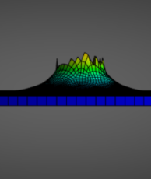 | 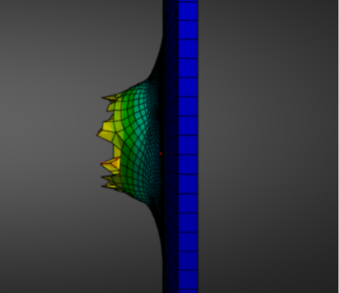

3.4.2 Deformation on impact of projectile
In comparison to a model created by using Al2024 T3 as a target plate, the Al 7039 exhibited the same response to impact [19]. Both materials exhibit similar densities and material properties; therefore, the material behaviours of the models were similar. At the same velocities the deformation around the centre impact was compared.
Table 4 – Comparison of ANSYS Impact Deformation Against Pre-existing Research
 | Al 2024 T3 [19] | Al 7039
300$ms^{-1}$ | 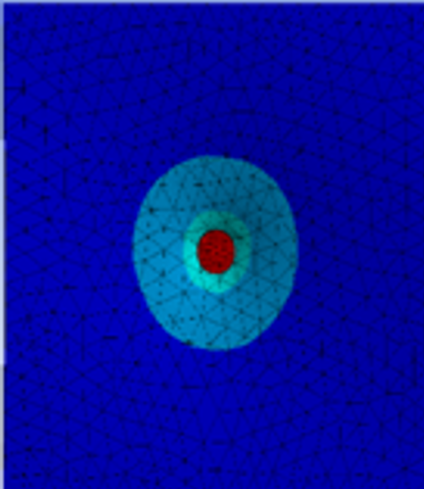 | 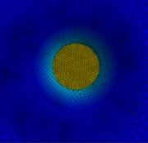
400$ms^{-1}$ | 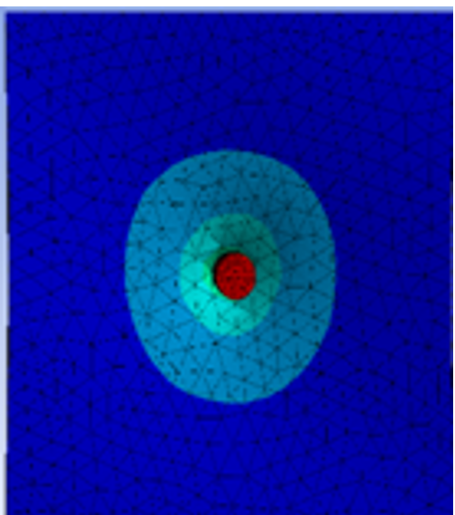 | 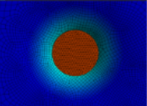
500$ms^{-1}$ | 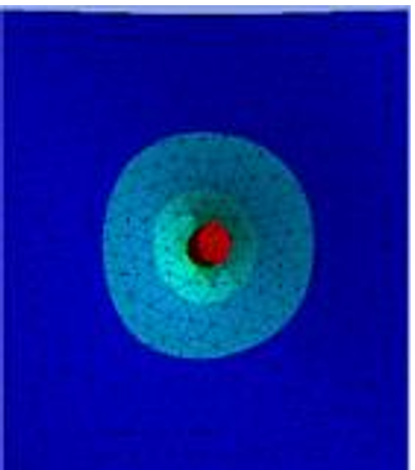 | 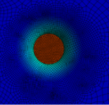
600$ms^{-1}$ | 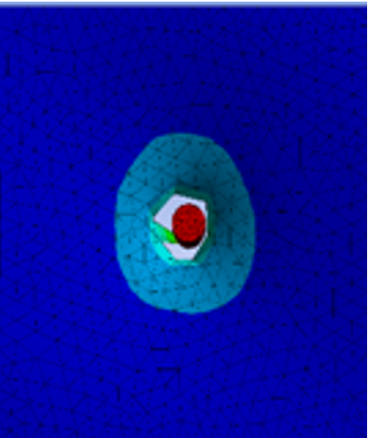 | 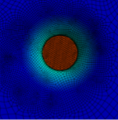
At 300$ms^{-1}$, the deformation around the impact point was less than that at 600$ms^{-1}$ in both cases. This was due to the higher velocity projectile hitting the target with a greater force and transfer of energy. On the objects coming into contact, all deformation took place in the centre of target and propagated to the outer edge of the target.
The AL 2024 T3 had a different response at 600$ms^{-1}$ with the material undergoing a greater deformation and the projectile penetrating through the target material. This could just indicate that a different time step was used for the comparison or that there wasn’t a strong mesh in the AL 2024 T3.
The simulations of projectiles traveling at higher velocities had a greater number of eroded elements due to higher distortion from the energy transfer. This is a known limitation of CAE software’s and in excessive cases can affect the simulation accuracy. However, the erosion of these elements can improve a simulation by increasing the simulation duration.

3.4.3 Comparison of different boundary conditions
Simulation 1 used a boundary condition with the top and bottom sides of the target selected as fixed supports. With fixed sides, the movement of all sides of the target was restricted and did not allow any bending or movement of the edges. Simulation 2 used a boundary condition with the rear top and bottom edges of the target selected as fixed supports. It was expected that the target would bulge in the centre of the target and there would be a greater amount of deformation throughout the target.
The deformation of the target in both simulations produced an identical petaling pattern through the impact hole shown in figures 6 and 7. The maximum deformation was slightly differed with a max of 0.10033 in simulation 1 and 0.10021 in simulation 2.
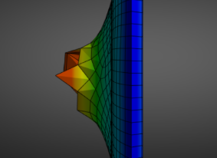
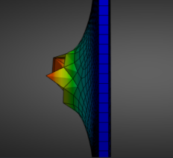
Figure 7 - Simulation 1 Petaling Pattern
Figure 6 - Simulation 2 Petaling Patten
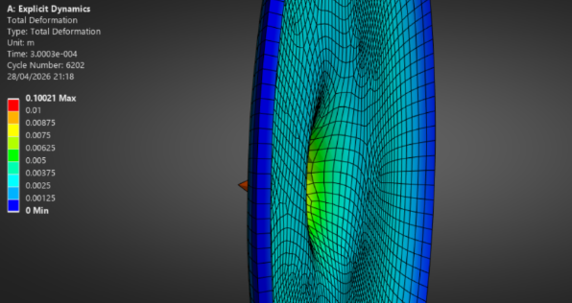
The deformation in simulation 2 was much greater throughout the whole plate with no deformation in the edges. As only one side of the plate was fixed this allowed for deformation in the front face of the target and therefore the damage was more elongated compared to simulation 1. The edges of the target did not have any overall deformation. This was due to the one element thick mesh not allowing for the deformation to occur on a fixed boundary shown in figure 8

Figure 8 - Simulation 2 Plate Deformation
In a previous study, it was proved that the ballistic limit and global deformation of an aluminium target hit by a projectile increased with the decrease of fixed area on the edges of the target. It was also noted that the deformation caused by ogive nosed projectiles is greater than that caused by blunt nose projectiles for various percentages of fixed areas [20]. The boundary conditions also do not influence the failure mode of the target with common failure modes including petaling, fragmentation and deformation [20]. With the fixed edges in simulation 2 it was extremely visible that the target deformation was much greater throughout the whole area which is in line with this theory.

3.5 Stress
As the projectile penetrated the target, elements in both the steel and aluminium underwent temperature increases and changes in stain rate [21]. The aim of the simulation was to see high stresses in the contact zone of the model and for these to then propagate at a calculated velocity through the material in the form of shock waves.

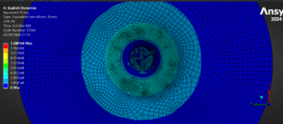
Figure 9 - Simulation 3 - Stress wave at time t=6.3195e-005
Figure 1 shows the contour rings of stress waves produced following the impact to the target. It was seen that the intensity was greater towards the centre of the target and reduced as the wave propagated to the boundary. As the target was a uniform shape it was expected that the stress waves should travel in the same circular pattern through the target however it was seen that some areas had a higher concentration of stress than others in the target.

3.5.1 Comparison of stress in simulation 1 and 2
Following impact in the target, the compressive stress waves propagated at various speeds from the centre to the boundary of the target. However once reaching the boundary, they reflected towards the centre in simulation 1. This affected the overall deformation throughout the target as the reflective waves are tensile and caused further damage to the target. In a real-world scenario, the target would have some freedom of movement, and some stress waves would propagate out of the target and into surrounding objects or atmospheres. ‘
Simulation 2 underwent a huge amount of deformation across the whole face of the target and stress waves propagated from the centre to outer boundary shown in figure 10.
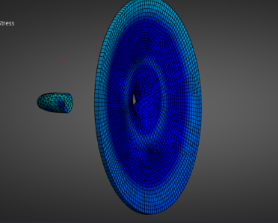
Figure 10 - Stress wave Propagation in Simulation 2
The overall visible deformation was much greater than that of simulation 1 due to the inner edges of the target being unfixed and having a degree of freedom for movement.

3.6 Shear Strain
The strain within the materials was assessed through various simulations to determine how the mesh, velocity and boundary conditions influence the results. The shear elastic strain focused on the angular deformation under load and is used to determine deformation [22]. It was expected that the strain would act in the form of petaling and material spalling.
It was seen in simulation 3 that there was spalling of the target material indicated by the red dots in figure 11. This is target material that had became unattached from the plate due to excessive deformation.
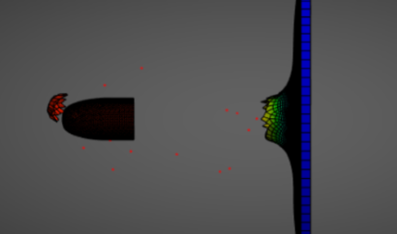
Figure 11 - Material Spalling in simulation 3
Simulations 1 used a course mesh whereas simulation 3 used a refined mesh. The strain graphs against time shown in figures 12 and 13 had very different properties in strain gradients. Figure 13 shows a huge rise in strain at approximately 1.7e-4s which is not present in figure 12. This suggested that refinement of the mesh allowed a smoother transition and greater accuracy, highlighting the importance of mesh quality In gaining accurate results.
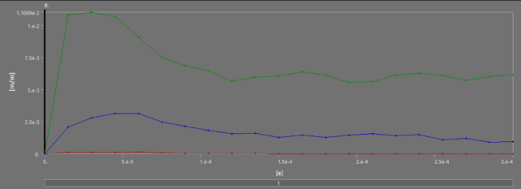
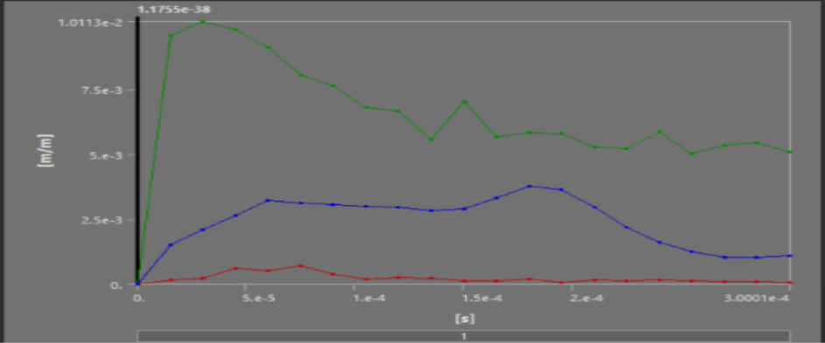
Figure 12 - Simulation 3 Strain Graph

Figure 13 - Simulation 1 Strain Graph

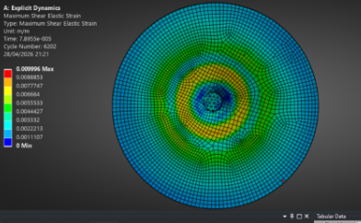
In simulation 2 the strain propagated the boundary of the plate due to the propagation of the stress waves through the material. As the stress waves could not exit the model it remained high on the edges at the end time of the simulation.
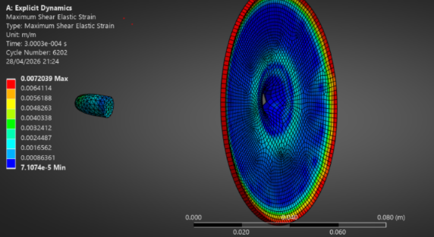
Figure 14 – Maximum Shear elastic Strain in Simulation 2 at various times.
Both simulation 1 and 2 had a similar shear strain at a time of 7.5e-5 as the projectile penetrated the target. The strain was seen throughout the projectile and target and was strongest at a close distance to the impact point as shown in figure 14.

4 Mesh Independence Study
Table 5 - List of simulation properties used for mesh independence study.
 | Simulation 7 | Simulation 8 | Simulation 9 | Simulation 10 | Simulation 11 | Simulation 12
Global Mesh | $$2{×10}^{-3}$$ | $$2{×10}^{-3}$$ | $$2{×10}^{-3}$$ | $$2{×10}^{-3}$$ | $$2{×10}^{-3}$$ | $$2{×10}^{-3}$$
Sphere of influence size (m) | N/A | $${1.5×10}^{-2}$$ | $${1.5×10}^{-2}$$ | $${1.5×10}^{-2}$$ | $${1.5×10}^{-2}$$ | $${1.5×10}^{-2}$$
Sphere of influence mesh size | N/A | $${1×10}^{-3}$$ | $${8 ×10}^{-4}$$ | $${6×10}^{-4}$$ | $${4×10}^{-4}$$ | $${3.5×10}^{-4}$$
Projectile mesh size | $$2{×10}^{-3}$$ | $${1×10}^{-3}$$ | $${8 ×10}^{-4}$$ | $${6×10}^{-4}$$ | $${4×10}^{-4}$$ | $${3.5×10}^{-4}$$
Projectile Velocity (m/s) | 400 | 400 | 400 | 400 | 400 | 400

A mesh independence study was completed on the projectile and target model to ensure that results were accurate. This was completed using simulations 7-12 which all had the same conditions and a changing mesh size within the sphere of influence. The study was also used to determine the point at which the meshing of the model had negligible changes to the solutions and was the most efficient.
For this section only the stress was modelled for analysis. This was selected due to there being extreme high stresses in impact areas and then propagating through the model parts. Determining the point of mesh independence allows for results to be at their most accurate point. Going beyond the mesh independence value would not improve results significantly but would increase the time required to perform calculations therefore increasing resources and cost to complete the model [23].

4.1 Meshing
The mesh used on the target was not ideal due to the switch from the refined elements to the coarse elements on the target. This meant that the transition between the meshes was not fully smooth. The size of the elements around the sphere of influence were not identical geometry’s and there were areas of with a higher number of elements.
The simulations used for the mesh independence study all had a velocity of 400ms-1 and a global size of $2{×10}^{-3}.$ The mesh on the target and the projectile was set to the same value to ensure proper contact between elements so not each node on the projectile hit a node on the target.

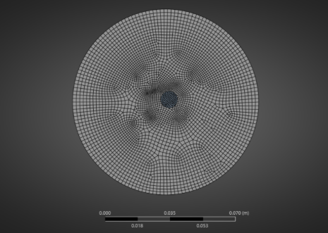
Figure 15 - Simulation 7 Mesh
As shown in figure 15, the mesh in simulation 7 was even around the outer boundary of the target plate, however very misaligned between the sphere of influence and edges. There were more concentrated areas resulting in the solver using more mathematical formulas in those areas, therefore the results in the unconcentrated areas could have been inaccurate. Further refinement of the mesh had the same issues with the meshes show in table 6.

Simulation 8 | Simulation 11
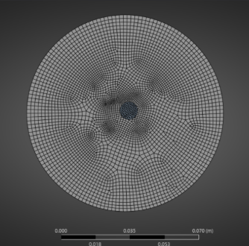 | 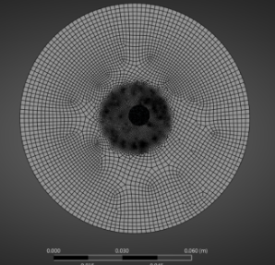
Simulation 9 | Simulation 12
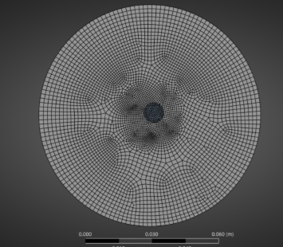 | 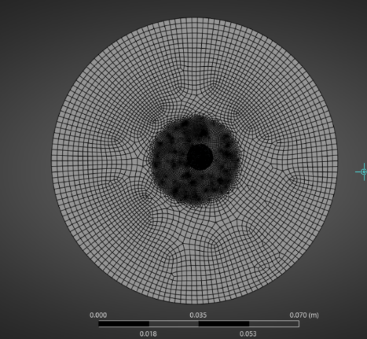
Simulation 10
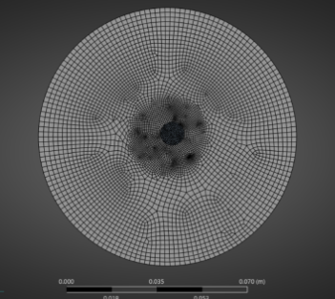
Table 6 – Mesh for simulations 8-12
In simulation 8 it was seen following the impact from the projectile that many elements were deleted. Using a very course mesh with a size of $2{×10}^{-3}m$, the projectile penetrated through the target leaving some petaling around the impact point. There was no fragmentation visible and the petaling pattern was not defined.
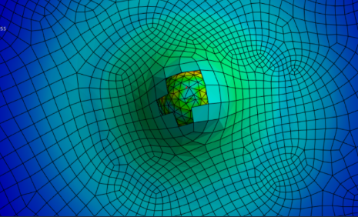
Figure 16 - Simulation 8 deformation following target impact from projectile

4.2 Sphere of Influence
Adding a sphere of influence in the centre of the contact point between the projectile and target allowed for a further refined mesh with a smaller element size shown in table 5. Using the sphere of influence allowed the mesh to be refined in the interest points that are subjected to contact from the high velocity projectile. This was useful as these areas undergo huge amounts of deformation, fragmentation, stresses and strains. Using the sphere of influence also improved the efficiency of the simulations as the refined mesh was only used in the centre impact zone and not throughout the entire model.

4.3 Mesh Refinement
Simulations 11 and 12 show great similarity in the stress of the target plate and the projectile. With the further refined mesh in simulation 12 there was a maximum stress of 1.2444e9 compared to the maximum of 1.2148e9 in simulation 11. The refinement in sim 12 had a significantly longer solve time that sim 11 with results of great similarity. This highlighted that the more efficient was that in simulation 11 with a mesh size of
${4×10}^{-4}$ in the sphere of influence and target.
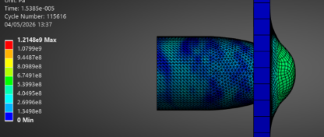
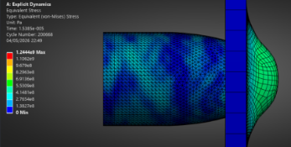
Figure 17 - Simulation 12 Stress on impact Figure 18 - Simulation 11 stress on impact
Through refinement of the mesh the fragment removed from the target became larger suggesting a greater amount of intersection points between both objects and a more accurate result. Simulation 10 shown an anomaly at a time of t=1.5385e-005 the peak stress in the model was 1.5029e9, this was much greater than all simulations in the mesh independence study suggesting that it was not an accurate result.
Decreasing the mesh size increased the time required to complete the simulation due to the solver having a greater number of numerical calculations. The petaling of the target became clearer with the refinement of the mesh The mesh could have been further improved by reducing the global mesh size as the target plate was only one element thick.

5 Conclusion
In summary CAE tools offer a relatively accurate solution to engineering problems, however experimental validation provides an insight that CAE may fail to. Validation and analysis are critical in the design, improvements and implementation of models. CAE is useful on predicting the outcomes however the results depend heavily relies on the quality of the inputted information.
The study completed on the projectile simulation demonstrated how the results are affected by the meshing quality and correct boundary conditions. The explicit dynamic solver in ANSYS gave an accurate representation of the model for the selected solvers. CAE Is very efficient in comparison to using experimental methods and proves to be an essential tool throughout many industries.

Bibliography

[1] | X. Wen Zhao, X. M. Tong, F. W. Ning, M.-L. Cai, F. Han and H.-G. Li, “Review of empowering computer-aided engineering with artificial intelligence,” Advances in Manufacturing, vol. 14, pp. 103-143, 2026.
[2] | F. Iannuzzo and A. S. Bahman, “8 - Computer-aided engineering simulations,” in Wide Bandgap Power Semiconductor Packaging, Cambridge, Woodhead Publishing, 2018, pp. 199-223.
[3] | Novedge, “Design Software History: The Evolution of Computer-Aided Engineering: From Early Innovations to Modern Solutions,” Novedge, 20 December 2024. [Online]. Available: https://novedge.com/blogs/design-news/design-software-history-the-evolution-of-computer-aided-engineering-from-early-innovations-to-modern-solutions?srsltid=AfmBOoqomrpPPeCGu6RfS2jA4bpyPxVLOcvqpRNrMDofU3w6VaiPsLqb. [Accessed 18 April 2026].
[4] | E. Candace, “7 Best Computer-Aided Engineering Software of 2023,” SelfCAD, 17 March 2023. [Online]. Available: https://www.selfcad.com/blog/best-cae-software. [Accessed 28 April 2026].
[5] | V. Plevris, “Educational Challenges in Computer-based Finite Element Analysis and Design of Structures,” Journal of Computer Science, vol. 14, no. 10, pp. 1251-1362, 2018.
[6] | T. Fadiji, C. Coetzee, T. M. Berry, A. Ambaw and U. L. Opara, “The efficacy of finite element analysis (FEA) as a design tool for food packaging: A review,” Biosystems Engineering, vol. 174, pp. 20-40, 2018.
[7] | Ansys, “What is Explicit Dynamics?,” Ansys, [Online]. Available: https://www.ansys.com/en-gb/simulation-topics/what-is-explicit-dynamics. [Accessed 30 April 2026].
[8] | Ansys, “Chapter 10: Explicit Dynamics Theory Guide,” Ansys, [Online]. Available: https://ansyshelp.ansys.com/public/account/secured?returnurl=/Views/Secured/corp/v242/en/exd_ag/exp_dyn_theory.html. [Accessed 28 April 2026].
[9] | L. A. Piegl, “Ten challenges in computer-aided design,” Computer-Aided Design, vol. 37, no. 4, pp. 461-470, 2005.
[10] | M. Žmindák, Z. Pelagic, P. Pastorek, M. Mocilan and M. Vybostok, “Finite element modelling of high velocity impact on plate structures,” Procedia Engineering, vol. 136, pp. 162-168, 2016.
[11] | Xceed, “Using Symmetry To Reduce FEA Runtime,” Xceed, [Online]. Available: https://xceed-eng.com/reducing-fea-runtime-with-symmetry/. [Accessed 28 April 2026].
[12] | F. Ahad, K. Enakoutsa, K. Solanki and D. Bammann, “Nonlocal modeling in high-velocity impact failure of 6061-T6 aluminum,” International Journal of Plasticity, vol. 55, pp. 108-132, 2014.
[13] | W. Tang, C. LIU and K. Zhang, “The Johnson-Cook Constitutive Model of TA19 Titanium,” Journal of Physics: Conference Series, no. 2556, 2023.
[14] | B. A. Haleem, I. El Aghoury, B. S. Tork and H. A. El-Arabaty, “An Overview of Iterative Techniques Used for Solving the Systems of Equations Resulting from the Finite Element Analysis,” IOSR Journal of Mechanical and Civil Engineering, vol. 17, no. 5, pp. 48-57, 2020.
[15] | I. Sadrehaghighi, “Common Industry Practices,” in Adaptive Meshing, Maryland, 2025, pp. 78-97.
[16] | L. Laloui and A. F. Rotta Loria, “Chapter 4 - Deformation in the context of energy geostructures,” in Analysis and Design of Energy Geostructures, London, Academic Press, 2020, pp. 137-205.
[17] | R. Scazzosi, M. Giglio and A. Manes, “Experimental and Numerical Investigation on the Perforation Resistance of Double-Layered Metal Shield under High-Velocity Impact of Armor-Piercing Projectiles,” Materials, vol. 14, no. 3, p. Article 626, 2021.
[18] | J. Hub, J. Komenda and M. Noval, “Ballistic Limit Evaluation for Impact of Pistol,” Advances in Military Technology, vol. 7, no. 1, pp. 21-29, 2012.
[19] | M. N. Ibrahim and M. A. I. Zakaria, “Dynamic responce of Al2024 T3 Aluminium Plate Subjected to Oblique impact of 9mm Bullet Using Single Processor,” Research Progress in Mechanical and Manufacturing Engineering , vol. 1, no. 1, pp. 78-84, 2020.
[20] | G. Tiwari, M. A. Iqbal, P. K. Gupta and N. N. Gupta, “The ballistic resistance of thin aluminium plates with varying degrees,” International Journal of Impact Engineering, vol. 74, pp. 46-56, 2014.
[21] | M. Burley, J. E. Campbell, J. Dean and T. W. Clyne, “Johnson-Cook parameter evaluation from ballistic impact data via,” International Journal of Impact Engineering, vol. 112, pp. 180-192, 2018.
[22] | M. Conniff, “Shear Strain: Definition and Formula,” Xometry, 29 March 2026. [Online]. Available: https://www.xometry.com/resources/materials/shear-strain/. [Accessed 18 April 2026].
[23] | I. Sadrehaghighi, “Mesh Sensitivity & Mesh Independence Study,” CFD Open series, Maryland, 2021.

