Task 1 Mock Interview- Module: Employability and Career Development | Module code: LCLM4005 | Name: Kawsar Miah ID: 2428863

Job Description:

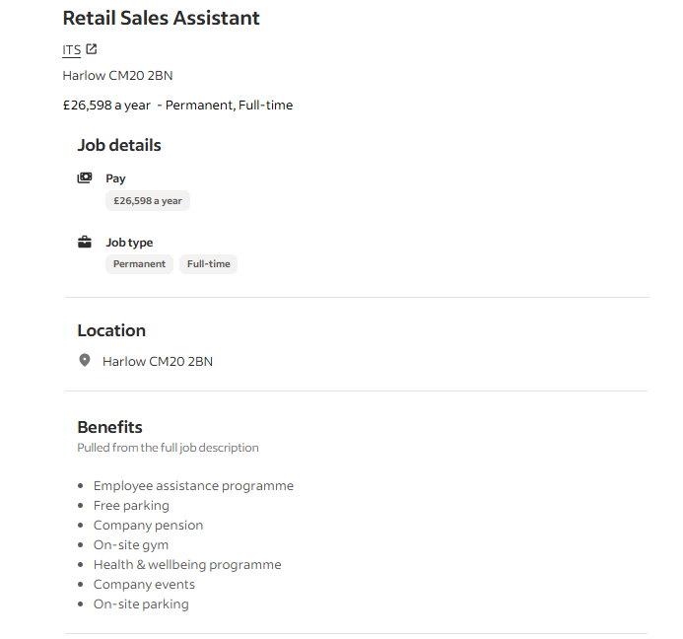

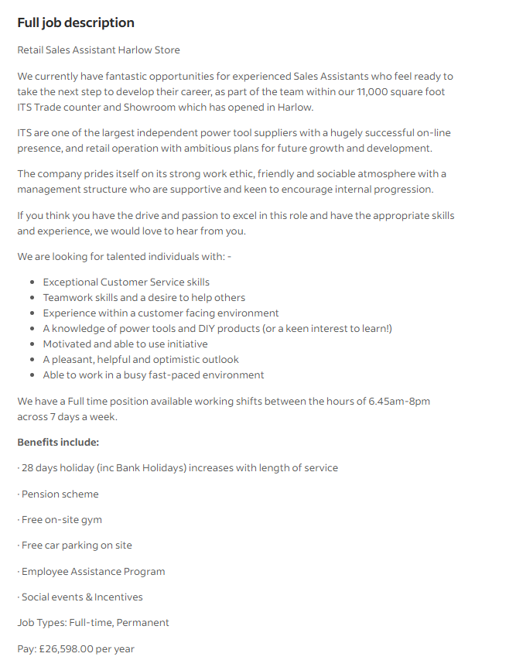

My CV:

Kawsar Miah
London, RM13 8BB
miah34216@gmail.com | 07503 357375

Personal Profile
A hardworking, reliable, and motivated individual with experience in retail, warehouse operations, and customer service. Skilled in till operation, stock management, Shelving and manual handling. Demonstrates excellent communication, teamwork, and problem-solving abilities with a strong commitment to quality work and customer satisfaction.

Key Skills
- Customer service and communication
- Till operation and cash handling
- Stock control and shelving
- Manual handling and lifting (safe practices)
- Teamwork and leadership
- Time management and organization
- Problem-solving and attention to detail

Education
University of Wales Trinity St David
Level 4 – CERTHE Business Skills for the Workplace (Current)
OCR Level 2 – Computer Science-2024 in Barking and Dagenham College.

Work Experience
- Warehouse Operative – Majestic Drinks Ltd, Barking (2025)
- Picking, packing, and loading stock accurately and safely.
- Performing manual handling and lifting duties.
- Supporting stock control and warehouse organization.
- Security Officer – SIA RMSS (July 2024 – 2025)
- Monitoring premises to ensure safety and compliance.
- Providing customer service and help to visitors.
- Maintaining detailed incident reports and communication logs.
- Retail Assistant – RK Convenience Store, Barking (2021 – 2025)
- Helped customers at the till, handling cash, and card payments.
- Restocked shelves and kept product displays.
- Delivered excellent customer service in a fast-paced environment.
- Café Assistant – Caffe Italiano (Temporary (2 Weeks))
- Supported cleaning, organization, and customer interaction.
- Delivery Rider – Uber Eats (Freelance)
- Ensured prompt and professional delivery of food orders.
- Maintained positive communication with customers.

- Waiter- The In and out Naval Military Club (2024-2025)

Languages
English, Bengali, Urdu, Hindi

Hobbies & Interests
I enjoy playing cricket with friends, which helps develop teamwork and coordination. I also enjoy watching comedy films to relax and improve my wellbeing.
Reference
Available on Request.
My Cover Letter:

Kawsar Miah]

MR. Jamie Carter
ITS
DC One, Edinburgh Way
Harlow Essex
CM20 2BN
United Kingdom
Date – 11/16/25

Dear Mr. Carter
I wish to apply for the role of Retail Sales Assistants, currently being advertised on Indeed. Please find enclosed my CV for your consideration.
As you can see from my attached CV, I have over 4 years of experience in the Retail
Industry and I believe with my years of Experience in Customer Service, retail operations and stock Control. I am Confident in my ability to contribute positively to your team and deliver excellent services to your Customers. I feel I will be the perfect candidate for the role.
In my previous role as a Retail Assistant at RK Convenience Store in Barking, I developed strong skills in till operation, cash and card handling, product shelving, and customer service. I consistently ensured that customers received friendly, efficient, and professional support, contributing to a welcoming shopping environment and repeat business. My responsibilities also included maintaining stock displays, monitoring product levels, and assisting with deliveries to ensure smooth store operations.
Alongside my retail experience, I have worked in various roles that strengthened my organizational, communication, and teamwork capabilities. As a Warehouse Operative at Majestic Drinks Ltd, I gained valuable experience in stock picking, packing, and manual handling, ensuring accuracy and safe working practices. My other experience in security and hospitality has further developed my ability to communicate effectively, remain calm under pressure, and support colleagues and customers in a professional manner.

I am currently studying Business Skills for the Workplace (Level 4) at the University of Wales Trinity Saint David, which is enhancing my understanding of customer needs, business operations, and workplace professionalism. I am motivated, reliable, and quick to learn new systems and processes, making me well-equipped to adapt to the high standards of ITS.

I am passionate about the opportunity to join ITS and support the continued success of your retail operations. I welcome the opportunity to discuss my application further and look forward to the possibility of contributing to your team.
I am confident that I can bring this level of success with me to your organisation and help the team to build upon their reputation as a Retail sales assistant.

Thank you for considering my application. I look forward to the possibility of contributing your team.

Yours sincerely
Kawsar Miah

