Evaluate the advantages and disadvantages of the organisation structure in your organisation (or an organisation with which you are familiar) and evaluate the advantages and disadvantages of one other organisation structure. Within the evaluation, you should include the reasons underpinning the structure. (AC 1.1)

Mintzberg stated that ‘structure follows strategy, and both support the organisation. Strategy formation is an integrated system not an arbitrary sequence (Taylor&Woodhams,2022,pg54). Ensuring alignment between the structure and its intended strategy is essential. To achieve this, organisations must meticulously assess their requirements, current circumstances, and future expectations (CIPD,2023).
The Trade Centre Group PLC(TTCG) has a hierarchical structure, characterised by a top-tier role or in their case the board of directors overseeing a descending chain of command. Each level in the hierarchy entails a reduction in both responsibility and authority, giving rise to the recognisable pyramid shape commonly associated with this arrangement (Bottorff,2023). TTCG has implemented a functional-hierarchical structure, each function within the hierarchy is dedicated to fulfilling specific business functions. Significant core functions at TTCG incorporate Sales, Marketing, HR, Recruitment, IT, and Finance (Taylor&Woodhams,2022). This organisational structure ensures that employees have well-defined objectives and goals, due to its existing clear responsibilities. Decision-making authority stems from senior leadership, fostering accountability. The well-defined chain of command facilitates alignment with broader strategic goals (Bottorff,2023). Moreover, the segregation of the workforce based on functions facilitates the clarification of responsibilities and the efficient allocation of tasks (Gleeson,2019). This structure, centred around skill specialisation, empowers employees to master their expertise and fulfil responsibilities with task stability. It enables the development and implementation of efficiency-enhancing processes within their respective functions (Messich,2024).
However, limitations can occur. If a business is slow to adapt and implement change, it may be attributed to knowledge being confined within each function. The structure carries the risk of being overly restrictive, potentially hindering employee development. Moreover, it poses the danger of insufficient communication and collaboration across different departments (Taylor&Woodhams,2022). Additionally, the presence of several layers of management in this type of structure can foster a sense of separation between employees and the organisation's mission and goals. Insufficient communication with employees can exacerbate this feeling of disconnection, potentially resulting in challenges such as job dissatisfaction, increased absenteeism, and higher turnover rates (Taylor&Woodhams,2022).
Tasika operates with a virtual organisational structure. Developments in digital innovations and technology has allowed a new formation of an organisational structure, it is a flexible and dynamic form of working whereby employees collaborate through technology as there is no physical offices/facilities (Taylor&Woodhams,2022). This structure can be distributed locally or globally, face-to-face interactions is not a requirement, they heavily rely on communication via virtual/digital channels (Igbaria&Mahatanankoon,2003). Tasika capitalises on this structure by reducing the overhead costs associated with physical infrastructure and embracing a 24/7 operational capacity facilitated by geographically distributed workers. This continuous availability empowers employees to promptly address client demands at any time, significantly expanding the potential client reach without the constraint of different time zones (Taylor&Woodhams,2022). However, difficulties can occur regarding communication and lack of physical interaction can have an impact on employee’s wellbeing, it’s important for leaders to be very clear regarding communication within this structure. It’s critical that they establish clear goals and foster an environment in which meeting objectives is the aim rather than observing traditional working hours, this will develop a culture of collaboration and create trusted relationships throughout the business (Bhagwat,2020).

Analyse connections between your organisation’s strategy (or an organisation with which you are familiar) and its products or services, and customers. (AC 1.2)

Organisations undergo continuous change and adaptation to stay aligned with external factors, they may transform their strategic goals or purpose to align with external factors and create a new vision for the future (CIPD,2023).
Taylor&Woodhams,2022 outlines three fundamental components of the strategic process. The initial phase involves strategic analysis, where the economic environment is thoroughly examined. The leadership team assesses factors related to customers, competitors, and market trends, additionally, discussions centre around defining the overall mission and purpose of the organisation. A mission statement supports and reinforces the principles and values that a company represents, when an organisation fails to align the desired brand image and culture with their mission, you fail your employees and consumers (Craig,2018). TTCG main purpose is to deliver the highest quality of used cars at the very best value and to provide the most convenient car shopping experience for value driven customers while giving exceptional customer service. Over the past five years, TTCG has experienced substantial growth, expanding its reach by acquiring additional premises to offer services to a broader audience. Plans for expansion are considered within the strategic analysis step, preparation for future growth will include utilising analytical data to identify new market trends, opportunities and advancements in technology will allow agile pivoting in new strategic directions (Taylor&Woodhams,2022).
The next function is, strategy development, this encompasses exploration and evaluation of a variety of strategic options to reach a conclusion on the most appropriate strategy to pursue to maintain sustainable competitive advantage (Taylor&Woodhams,2022). A SWOT analysis can be utilised as a decision-making tool, this can identify an organisations strategic direction and future objectives. It’s an effective planning tool which recognises strengths, weaknesses opportunities and threats (SHRM,2022).
The last function is strategy implementation. This is the process of moving from the organisations well informed conclusions with the goal of achieving effective outcomes and turning them into a reality (Planellas,2019). Future objectives at TTCG are to open new sites further North. There is a heavy connection between this strategic goals and projects that would affect each functional department. It’s critical that this strategy is conveyed throughout the business so all departments can align with it, specifically:
- Reviewing/changing organisational structure
- Aligning people strategy
- Managing financial structure
- Ensuring marketing efforts align with the characteristics, preferences, and behaviours of the new market.
(Taylor&Woodhams,2022)
At TTCG, it’s importance to recognise that this objective would also have a direct connection on the employees and customers, they will need to consider the following impact:
- Opening of a new site; is there a specific number of people employed currently and to train new staff.
- New job opportunities for existing staff to progress and be promoted.
- Achieving a targeted influx of new customers prompts the consideration: In specific locations, is TTCG drawing in existing customers who have previously engaged with other sites?
- Embracing technological advancements and expand online car advertising, it raises a pertinent question: would this potentially decrease the physical foot traffic to our sites, or conversely, could it lead to a surge in online sales revenue, thereby providing the financial means to open additional sites?
(Taylor&Woodhams,2022)

Analyse three external factors or trends currently impacting your organisation (or one with which you are familiar). The impact of these factors or trends could be positive, neutral or negative, some are short-lived whilst others are long-lasting. Identify organisational priorities arising from the factors or trends analysed. (AC 1.3)

PESTLE ANALYSIS
External factors and trends currently impacting or may have a future impact on TTCG:
FACTORS | NOTES | Potential Impact | Implications & Importance
Legal:  Changes in regulation | TTCG are regulated by the Financial Conduct Authority (FCA). On 31st July 2023, the new rules came into force for financial services firms.  The new rules, known as the Consumer Duty, set a higher standard of consumer protection in financial services (FCA,2023). | Medium | This factor would have an ongoing/long timeframe as the organisation would need to comply with the legislation until amended.  This would have a positive/critical impact on external customers knowing they are being treated fairly and not receiving any information that may be misleading.  The impact on the organisation would ensure that they change their processes in line with consumer duty. Additional training for staff would be required.
Economic:  Interest rates | Fluctuations in lending practices and interest rates have the potential to influence consumers' purchasing capabilities, consequently impacting the demand for used vehicles that we sell at TTCG. To stay competitive, used car dealerships must stay informed of financing trends and provide adaptable financing choices.  The current bank rate is at 5.25%, the highest it has been in over 10 years (Bank of England,2023). As interest rates rise, the likelihood of customers opting for vehicle financing decreases, leading to a reduction in the overall number of cars sold and less profitability for TTCG. | High | Timeframe regarding interest rates can change, they ca change up to 8 times per year.  During this current time, interest rates are having a negative impact on consumers as interest rates are currently high, affordability issues may arise.
Environmental:  Carbon Emissions | Governments are striving to achieve net-zero emissions by implementing a plan to prohibit petrol and diesel vehicles by 2035 (GOV,2020). This external shift poses a challenge for TTCG, as the availability of second-hand petrol/diesel vehicles for purchase will diminish. This environmental factor necessitates a significant transformation in the business, requiring a shift towards acquiring electric vehicles and substantial investments in training and development programs for staff to adapt to electric vehicle technologies. | Medium | An ongoing concern that needs to be addresses over the next two years. Despite this being a positive impact on the environment, TTCG are not prepared in term for facilities, or no action has been taken to train employees to gather the expertise they require for electric/hybrid vehicles.

When setting out its view on automation, AI and technology, the CIPD states, ‘Automation, artificial intelligence (AI) and other workplace technologies are bringing major changes to work and employment.’ Assess the scale of technology within organisations and how it impacts work. (AC 1.4)

Current predictions indicate rapid economic growth, it’s highly probable that we will witness a significantly altered composition of jobs that we all currently do. It’s evident that the acceleration of technology and automation are surrounding us in day-to-day life and having a significant impact on work and working life (Chapman,2021).
Advancements in technology has significantly benefited TTCG. Previously training has always been a focus, to continuously educate and develop staff to keep up to date with information that affects them in their day-to-day responsibilities, training provided would include updates regarding General Date Protections Rules, Conduct Rules, Diversity and Inclusion training etc. Due to the current headcount within the organisation, restrains occurred when delivering training as it is a small team. Technological advancements have enabled enhanced communication with stakeholders, reaching a broader audience than ever before, all required staff training is now seamlessly automated, with pertinent modules dispatched annually to existing team members. Additionally, new hires are automatically enrolled in the training program upon joining the organisation.
The current system has a simple reporting structure which eliminated the previous way of recording details manually and has allowed the team to utilise their time more efficiently (RetailTechnology,2023).
Within the retail sector it’s evident that artificial intelligence (AI) and technology is being utilised dramatically in a variety of ways, from developing their online platforms providing a seamless online experience from the comfort of their homes or personalising and improving the customer experience to create a seamless shopping journey (Intel, no date). Within retail we are increasingly seeing AI changing the role of cashiers, AI has allowed certain tasks to be automated, this will inevitably allow cashiers to focus on additional tasks that require more human interaction (Agenda,2023). Both organisations can benefit from utilising chatbots, another automation process to support with the customer service aspect of the business. The process is convenient, interactive, an alternative to the existing processes, chatbots can populate responses can be instant and available 24/7 (Misischia et al.,2022). Additionally, is reduces agent costs and eliminates customer waiting times which will create a positive experience for the customer (rStar Technologies,2023).
Explain Edgar Schein’s model of organisational culture and explain one theory or model which examines human behaviour. (AC 2.1)

Edgar Schein developed a model for comprehending and examining organisational culture. The fundamental components of this model are the implicit beliefs, attitudes, values, and behaviours that individuals express as part of their self-identity and shared among individuals within the organisation (Coghlan,2020). It’s separated into three parts, level 1 consists of artifacts, this includes visible features within an organisation, this can include uniforms/dress code and interior, this level is considered as visible and tangible within the organisation culture (Taylor&Woodhams,2022).
The artifacts are considered easily observable but does not reveal everything entirely, understanding artifacts can be challenging, particularly if the examination of a culture remains superficial and doesn't delve into deeper layers (Burkus,2014). Level 2 encompasses of espoused values; values can represent norms and beliefs that employees express within the organisation as they have an emotional investment. Documentation such as a mission statement or commitment to provide equal opportunities would be considered as part of an organisation’s values. The deepest level is considered as basic assumptions, known as the core, or essence of culture, these are the unconscious assumptions hidden beneath level 1 and 2. It includes individuals views, beliefs and norms which influences their behaviour. This level is considered the most powerful ‘as it works surreptitiously, and shapes decision making processed almost invisibly’ (Clegg et al., 2016, pg209).
Maslow’s (1970) hierarchy of needs examines human behaviour, it establishes human needs in a hierarchical formation. As specific needs within each tier, an individual can move to the next level, these levels are organised from the most basic to the most complicated. As demonstrated below:

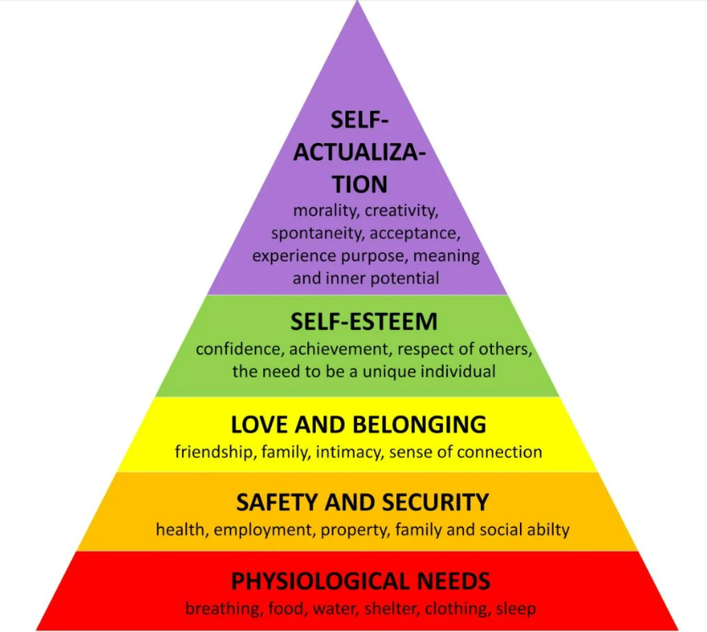

(Mcleod,2023)

The first level begins with physiological needs are biological requirements for human survival, once fulfilled the need for security and safety becomes significant. Safety can be fulfilled by family, emotional/financial security and health and wellbeing. (Mcleod,2023). Level three refers to the social connections we have, the need to feel belonged, to love and be loved. Fourth includes self-esteem, these can be achieved by both professional and other achievements, the sense of feeling appreciated and recognised. The final stage is self-actualisation, this is the need to live the happiest and most fulfilled achieving full potential (Clegg et al.,2016).

Assess how people practices in your organisation (or one with which you are familiar) impact both on organisational culture and behaviour, drawing on examples to support your arguments. (AC 2.2)
Administering the culture of an organisation may at times seem straightforward, but the existing cultures are frequently resistant to management. Culture comprises of the following:
- How are things done within the organisation?
- What is considered as acceptable behaviour?
- What norms were imparted to new members?
- What norms were members expected use to solve problems of external adaptation and internal integration and which ones did they use?
(Clegg et al.,2016, pg211)
Recruitment and selection wield a considerable influence on culture. Upon examining our current recruitment procedures within TTCG, we determined a flaw that necessitated attention. This process serves as the gateway for identifying candidates poised for onboarding success. Our focal point was recalibrating this approach to underscore the importance of core values and cultural fit. This strategic adjustment included a new interview evaluation form that included competency/value-based approach which would enhance our talent and reduce the turnover. As a result of hiring based on shared values are more likely to demonstrate behaviours that are aligned with the desired culture within TTCG. Despite this being a positive change for the business it can be difficult when there is a limited applicant pool, the pressure to fill roles within TTCG can be concerning as there is a growing risk of between quality and best fit, it’s important to not give into the pressure when stakeholders are pressuring to employee when there’s a shortfall on their matrix (Cancialosi,2016).
Yielding to pressure can result in hiring an employee whose goals do not align with TTCG, fostering low morale among existing staff, and incurring additional costs and time for finding a replacement. (Robert Half,2022). Its critical to continuously educate individuals, both internally and externally about the brand and culture. Those exhibiting a high level of proficiency in providing clear insights into their organisational dynamics to potential candidates are likely to enhance their competitive edge in attracting top talent as they expand (Cancialosi,2016).
Additionally, training programmes, robust induction and effective leadership training can lead to an enhanced culture and improved performance. Comprehensive leadership training can strengthen the drive for achievement, integrity, and honesty. It also equips individuals with the capability to effectively inspire and motivate others, fostering a collective commitment to achieving shared goals. There are many characteristics that are critical to be a successful leader which are evident through social norms and culture (Clegg et al.,2016). Within TTCG, the people practice team have implemented a leadership programme, that focuses on desired attributes and competencies and reiterates what the core value and purpose is. It’s recognised that an effective leadership programme that provides existing and future leaders with the right competencies and skills can create a positive culture and boost employee morale. Providing extensive training supports the continuous improvement for self-development and it ensures individuals gain the skills and knowledge to contribute positively to the desired culture (The Economic Times,2023).
Peter Cheese, current CEO of CIPD asserts, ‘People professionals are a vital function in supporting businesses to adapt to rapidly changing circumstances’. Explain two different models or theories to managing change. (AC 2.3)

A model that is widely used for change is Kurt Lewin’s three step process. The stages involve, unfreeze, change, and refreeze. Organisational change may be planned, or they have recognised the need for change, and this requires the system/process to be unfreeze (Hussain et al.,2018). It’s important for individuals in the organisation to acknowledge the imperative for change, this will involve breaking down barriers with those who are sceptical of the new way of operating (Mind Tools, no date, a).

Knotters eight stage process is a widely recognised process for change management, the process is represented in a linear sequence of steps that an organisation will experience (Pollack&Pollack,2014). Kotter, 2022 model outlines eight stages for effectively managing change within an organisation, the steps are as follows:

- Establishing a sense of urgency
  - A potential opportunity is identified, and discussions take place to key stake holders to persuade the change is necessary and crucial.
- Form a guiding coalition:
  - Influential individuals group together to support the transformation.
- Create a vision and strategy.
  - An effective strategy is developed to support the desired change.
- Communicating the change vision:
  - Communicate the change/new strategy effectively and encouraging the wider audience to be positive.
- Empowering broad-based change:
  - Avoid barriers of any obstruction, at this stage the group will encourage risk taking, and nontraditional ideas may take place.
- Generating short-term wins:
  - Create improvements and celebrate small developments and wins to maintain momentum and motivation throughout the team. Recognise and reward individuals who supported the improvements.
- Consolidating gains and producing more change:
  - Identify individuals who can join the team to support the new project.
  - Underpin the changes by focusing on continuous improvements, this can be embedded into the organisational culture.
  - A selection process occurs, identify those who can support the desired vision.
- Securing new approaches in the culture
  - Embed modifications that occurred within culture, articulation the connections from the new behaviours and companies’ success.

A variety of models have been developed to explain how change is experienced. Discuss one model that explains how change is experienced. (AC 2.4)
Change management is recognised as a systematic strategy that assists an organisation in transitioning from its existing state to a desired state. Its focus often lies in providing support to employees to effectively facilitate the process of change (CIPD,2023b). One famous model that describes how change is experienced is Kubler-ross change model, this model concentrates on the way individuals respond change to grief. The model is divided into 5 stages which include, denial, anger, bargaining, depression, and acceptance (Shoolin,2010). Change is inevitable for any successful business that needs to adapt to the external factors that occur, managers need to maintain positive language, emotional intelligence and offer support through the transition state of change (Taylor&Woodhams,2022).

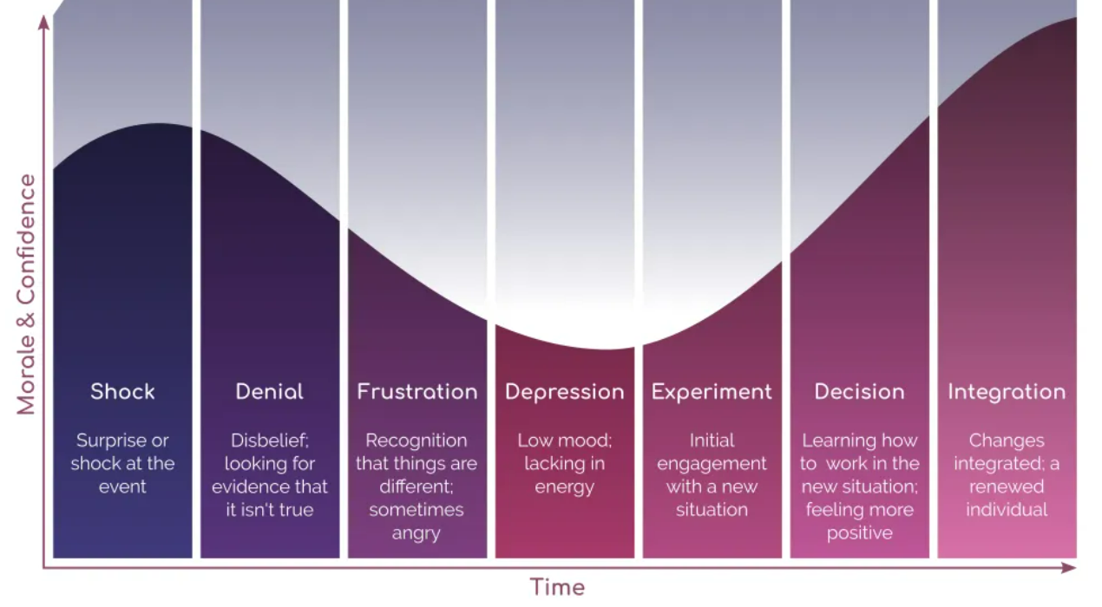
(EKR Foundation, 2023)
Firstly is shock/denial, this is the initial reaction when a change is announced, within organisations the employees may feel reluctant and resist change, traits of shock and unwillingness may occur. CIPD,2023b). The second stage is when an individual expresses anger when reality of the change hits (CIPD,2023b). Thirdly, individuals try to use bargaining power to attempt to minimise change and reduce the impact that may occur, these implications may seem unrealistic, denial is still apparent within this stage (Belbin, no date). Prior to embracing the change, individuals may withdraw and experience a phase of despondency, this is referred to the depression stage in Kubler-Ross model. The final stage is acceptance. Reality has finally started to settle in at this point and they have come to terms of the situation, and they will start to embrace the change (CIPD,2023b). It's crucial to emphasise that each stage is not necessarily sequential, individuals may not always go through them in a strictly step-by-step manner; rather, they represent a common path that people may follow (EKR Foundation,2023).
The CIPD’s Health and wellbeing at work survey 2022 found, ‘There is less management focus on health and wellbeing compared with the first year of the pandemic’, and goes on to remark that this is disappointing. Assess the importance of wellbeing at work and factors which impact wellbeing. (AC 2.5)
Prioritising employee wellbeing is paramount for organisations, as it significantly enhances overall performance and contributes directly to sustained success. In the past, the concept of wellbeing often centred around the physical health and safety of employees, not only is this a fundamental right but it’s likely to minimise the conflict within an organisation improve staff retention, efficiency, and performance (WHO,2022). Additionally, it’s crucial to broaden our perspective to encompass mental health and overall wellbeing with equal importance (Taylor&Woodhams,2022).
There are a considerable number of factors that can have an influence on wellbeing on individuals, the CIPD has considered seven domains which can affect wellbeing, key considerations that organisations should reflect on when creating a wellbeing strategy:

Domains: | Considerations:
Health | Physical Safety:  - Implement safe working practices and policies.  - Provide correct personal protection equipment (PPE).  - Ensure training is provided so there are adequate number of staff training in first aid and fire safety.  Mental/Physical Health:  - Implement an employee assistant programme (EAP)  - Partner with an occupational health provider.  - Offer a health care cash plan.  - Have a capability policy.  - Provide training to line managers to deal with situations relating to physical/mental health.  - Encourage individuals to focus on their health
Good Work | Environment:  - Promote an inclusive work environment that is not limiting, ensuring that equality is evident across all aspects of the workplace.  Management:  - Establish a leadership team that communicates efficiently, adheres to policies, advocates for work-life balance, and can effectively guide the team to meet the demands of the business.  - Ensure that management training is undertaken to firmly embed the desired organisational culture.
Values/Principles | Leadership:  - Ensure leaders are promoting the organisations values and working towards the mission and objectives, this can be fostered through efficient training.  - Guarantee that individuals promote the need for diversity and inclusion by valuing differences, ideas and social characteristics, which will contribute to the culture and success of the business.
Collective/Social | Participation:  - Facilitate transparent communication across all organisational levels, granting employees a voice in decision-making or, at the very least, the opportunity to provide feedback.
Personal Growth | Development:  - Encourage senior leaders to mentor and coach, ensuring that their skills derivative to the team, fostering the organic development of positive working relationships and clear succession plans are established and promote open and collaborative culture.
Good lifestyle Choices | - Provide internal communication posters to encourage employees to focus of their physical health, such as walking clubs or new health recipes to try.
Financial Wellbeing | - Partner with an external company to provide financial wellbeing support to employees.  - Signpost staff to free external sources  - Within reason, pay employees above the statutory national living wage.
(CIPD,2023c)
Introducing initiatives suggested above and prioritising wellbeing for employees can foster and impact the culture positively as employees feel valued as companies are invested from a health perspective, this provides positive working environments, heighted job satisfaction and morale which inevitably will lead to increased productivity and engagement (CIPD,2023c). Additionally, this will support an organisation people’s practices strategy as it will help to attract and retain individuals by offering additional benefits while reducing absenteeism and costs (Kindlon,2023).

The CIPD Profession Map states ‘People practices are the processes and approaches that we use across the employee lifecycle’. Discuss the links between the employee lifecycle and different people practice roles. (AC 3.1)

An employee lifecycle refers to various stages in which an employee experiences during their employment, these stages can be broken down into six stages according to Waite et al (2021). The lifecycle is made up of the following:
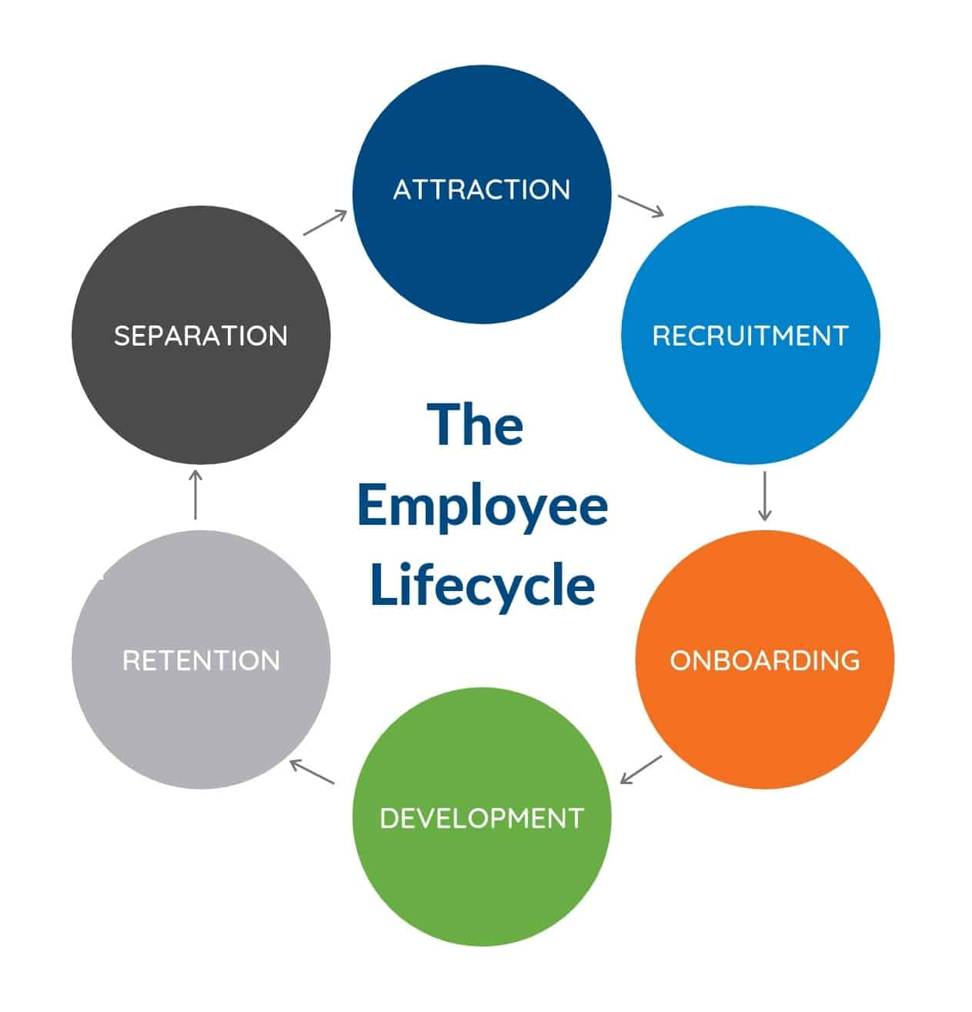
It’s a multilayered process that involves and relies on various business functions, each plays a fundamental role in achieving a common objective. Attraction refers to being an appealing inclusive employer to recruit top talent, a strong brand and effective recruitment strategies can attract the best candidates which can contribute to the existing positive culture within the organisation (Srivastava,2023). At TTCG they have implemented a policy whereby they are committed to provide equal opportunities, TTCG are committed to not treating any candidate less favourably based on any characteristic that is stated on the equality Act 2010, a policy drafted by the HR team to support the recruitment and talent acquisition function to ensure they recruit individuals who demonstrates the necessary skills, attitudes and experience to align with the business culture and objectives (Taylor,2014).
TTCG onboarding stage is heavily linked to HR, this is where the transition starts between the new employee joining and them becoming settled within their new role. During this stage the HR function will guide the new starter through an effective induction process, while guaranteeing they have a full understanding of the companies’ values, culture and polices. Employees can evaluate how their beliefs and behaviours align not only with the company's values but also how they contribute to the overall purpose of the organisation, this also can reduce attrition and increase employee engagement (Newhouse,2020).
Employee development is the purpose of continuous growth for individuals, during this stage there is a strong bond between people management professionals and those involved in employee and organisational development (Taylor&Woodhams,2022,pg98). HR can support line management with setting performance expectations or address any existing issues, additionally the learning and development function can create training opportunities and courses to support the continuous development stage to upskill and achieve business objectives. By completing the previous stages effectively, it would suggest that an organisation would have a high retention rate. It’s critical for HR to determine the right protocols to retain skilful talent and can continue to utilise their knowledge, expertise, and positive attitudes (Taylor&Woodhams,2022).
Finally, separation is the process of transitioning the employees out of the organisation, HR can carry out exit interviews and ensure a smooth departure and delve into the reasons on why the employee leaving, to prevent future talent leaving (Taylor&Woodhams,2022). In addition, it’s important to maintain a positive relationship with former employees as they can still be customers or brand ambassadors (Crail&Watts,2022).

Analyse how people practice connects with other areas of an organisation and supports wider people and organisational strategies. (AC 3.2)
The People Practice team carries out several functions that wield a substantial impact on the broader team and contribute significantly to achieving strategic objectives. The desired strategy at TTCG involves adopting a more flexible approach for employees, fostering greater engagement across the team. This initiative is aimed at enhancing and revitalising the organisational culture. This became apparent when TTCG conducted a comprehensive review of its existing reward system to address the challenges posed by the prevailing labour shortage. Presently, employees at TTCG adhere to a demanding six-day workweek schedule along with poor benefits to compensate for the unsociable hours. This unique shift pattern has notably affected the individuals in the People Practice team, making it challenging to attract, retain, motivate, and engage with team members. The repercussions of this scheduling approach have resulted in an apparent negative impact on overall team dynamics and effectiveness. Having identified this, TTCG utilised analytical methods to recognise the existing issues, surveys and focus groups allowed us to gain a deeper understanding from the wider organisation and allowed greater statical power for the organisation to act and make a substantial impact on what existing employees wanted (Jones et al.,2013).
Rewarding employees within the organisation for exceptional work can create a sense of value, this can be a compelling motivator that can improve performance throughout all teams. Kessler, 2005 states that employee reward is one of the central pillars of supporting the employee relationship (as cited in Perkins et al.,2016). A reward management strategy can come in a variety of forms, such as salary, pay incentives and benefits or non-cash forms such as company cars or paid holidays (Perkins et al.,2016).
The People Strategy at TTCG is to attract and retain the best talent while enhancing skills and capabilities to sustain a competitive advantage. This strategic shift in the organisation’s strategy connects and aligns with the people practice initiatives, it’s allowed us to meet the desired strategy/purpose, enhance a positive culture and performance and met employees’ requirements that were evident within the surveys (HR Team,2021).
While these approaches are great incentives careful consideration needs to be reflected with an eye on the labour market to ensure that organisations are competing with others but ensuring that salaries remain reasonable, stakeholder interests are met, and, ultimately, that strategic goals and objectives are attained all while maintaining a fair and equitable reward system for all (Taylor&Woodhams,2022,b).
Discuss processes you have, or could use, for consulting and engaging with internal customers of the people function in order to understand their needs. (AC 3.3)

People practices that implement strategies, policies and plans affect all internal customers within the organisation, this can be directly or indirectly. TTCG have a small people function, it’s important that a stakeholder analysis is conducted as we need to identify and heavily engage with senior management to support with identifying the needs of all stakeholders. Once the process of a stakeholder analysis is completed, it’s critical to evaluate their knowledge, information, authority, and influence within the organisation and how they can support to further understand the needs of the wider team (Taylor&Woodhams,2022). It represents an implicit understanding of power, whereby certain interests are afforded a more legitimate status than others (Clegg et al.,2016). There are several analysis tools to engage with internal customers to support the people function which can seek opportunities and identify issues, this can include conducting staff surveys, interviews and focus groups.

Surveys are utilised as a quick analysis tool as opposed to interviews, depending on what data the people function obtains, they can utilise questions to understand the needs and expectations of the organisation as a whole or target each department or team separately. Due to their cost-effectiveness, organisations may favour surveys as they are often free and quicker to administer. However, it's essential to acknowledge certain limitations, such as the inability to guide individuals for additional insights on a specific topic or pose more intricate questions, given that surveys are distributed to a diverse audience (Taylor&Woodhams,2022).
Additionally, focus groups are utilised to engage with stakeholders when there is a topic in which people practices are interested in, they will engage in open discussions to gather qualitative insights and gauge reactions on a specific topic. However, it can be difficult to arrange this process and gather the relevant stakeholders, furthermore, some individuals can be overly dominant within the discussion (Taylor&Woodhams,2022). It’s also subject to group think whereby group consensus overrides critical evaluation and common sense (Mind Tools,No Date,b). This procedure can be impacted by external pressure, self-restraint, and authoritative leadership(CFI,2023).
As discussed previously, it’s critical to understand the needs of internal customers and acknowledge that they all have different needs, having a deep understanding can allow the people function to make a positive impact to add value to the organisation, stakeholders including shareholders. It establishes lines of communication and ensures the organisations goals are aligned with specific requirements across different departments. The benefits of these analysis methods are that these activities can be used and revisited later in the future, to identify any continuous trends or evaluate if any changes that were implemented have made a positive impact. In addition, it can allow an evaluation of how successful the stakeholders feel in achieving their needs (Taylor&Woodhams,2022).

References
Agenda, D. (2023) Here’s how artificial intelligence can benefit the retail sector, World Economic Forum. Available at: https://www.weforum.org/agenda/2023/01/here-s-how-artificial-intelligence-benefit-retail-sector-davos2023/ (Accessed: 03 February 2024).
Bank of England (2023) What are interest rates?, Bank of England. Available at: https://www.bankofengland.co.uk/explainers/what-are-interest-rates#:~:text=Bank%20Rate%20is%20currently%205.25%25. (Accessed: 14 January 2024).
Belbin (no date) Coaching people through the change curve with Belbin, Belbin. Available at: https://www.belbin.com/resources/articles-directory/the-change-curve (Accessed: 21 January 2024).
Bhagwat, T. (2020) 10 critical factors in creating an effective virtual organization, LinkedIn. Available at: https://www.linkedin.com/pulse/10-critical-factors-creating-effective-virtual-tawana/ (Accessed: 04 February 2024).
Bottorff, C. (2023) 7 organizational structure types (with examples), Forbes. Edited by C. Organ. Available at: https://www.forbes.com/advisor/business/organizational-structure/ (Accessed: 13 January 2024).
Burkus, D. (2014) How to tell if your company has a creative culture, Harvard Business Review. Available at: https://hbr.org/2014/12/how-to-tell-if-your-company-has-a-creative-culture (Accessed: 14 January 2024).
Cancialosi, C. (2016a) Why you can’t ignore culture in your recruiting process, Forbes. Available at: https://www.forbes.com/sites/chriscancialosi/2016/07/18/how-important-is-your-recruiting-process-to-your-culture/ (Accessed: 21 January 2024).
CFI (2023) Groupthink, Corporate Finance Institute. Available at: https://corporatefinanceinstitute.com/resources/management/groupthink-decisions/ (Accessed: 01 February 2024).
Chapman, C. (2021) What the future world of work might look like, Acas. Available at: https://www.acas.org.uk/what-the-future-world-of-work-might-look-like (Accessed: 03 February 2024).
CIPD (2023) Organisation design: Factsheets, CIPD. Available at: https://www.cipd.org/uk/knowledge/factsheets/organisational-development-design-factsheet/ (Accessed: 13 January 2024).
CIPD (2023a) SWOT analysis: Factsheets, CIPD. Available at: https://www.cipd.org/uk/knowledge/factsheets/swot-analysis-factsheet/ (Accessed: 21 November 2023).
CIPD (2023b) Change management: A guide for people professionals, CIPD. Available at: https://www.cipd.org/uk/knowledge/guides/change-management/ (Accessed: 16 January 2024).
CIPD (2023c) Wellbeing at work, CIPD. Available at: https://www.cipd.org/uk/knowledge/factsheets/well-being-factsheet/#:~:text=This%20means%20creating%20an%20environment,and%20higher%20performance%20and%20productivity. (Accessed: 27 January 2024).
Clegg, S.R., Pitsis, T. and Kornberger, M. (2016) Managing and organizations: An introduction to theort and practice. Los Angeles: Sage.
Coghlan, D. (2020) ‘Edgar Schein on change: Insights into the creation of a model’, The Journal of Applied Behavioral Science, 57(1), pp. 11–19. doi:10.1177/0021886320924029.
Craig, W. (2018) The importance of having a mission-driven company, Forbes. Available at: https://www.forbes.com/sites/williamcraig/2018/05/15/the-importance-of-having-a-mission-driven-company/ (Accessed: 14 January 2024).
Crail, C. (2022) Offboarding: Definition & best practices (2024 guide), Forbes. Edited by R. Watts. Available at: https://www.forbes.com/advisor/business/offboarding/#why_offboarding_is_crucial_section (Accessed: 28 January 2024).
EKR Foundation (2023) Kübler-Ross Change Curve, EKR Foundation. Available at: https://www.ekrfoundation.org/5-stages-of-grief/change-curve/ (Accessed: 21 January 2024).
FCA (2023) Consumer Duty Sets Higher Standards for financial services customers, FCA. Available at: https://www.fca.org.uk/news/news-stories/consumer-duty-higher-standards-financial-services#:~:text=On%2031%20July%2C%20new%20rules,need%2C%20when%20you%20need%20it (Accessed: 14 January 2024).
Gleeson, P. (2019) Benefits & disadvantages of a functional organizational structure, Small Business - Chron.com. Available at: https://smallbusiness.chron.com/benefits-disadvantages-functional-organizational-structure-11944.html (Accessed: 13 January 2024).
GOV (2020) Government takes historic step towards net-zero with end of sale of new petrol and diesel cars by 2030, GOV.UK. Available at: https://www.gov.uk/government/news/government-takes-historic-step-towards-net-zero-with-end-of-sale-of-new-petrol-and-diesel-cars-by-2030 (Accessed: 14 January 2024).
HR Team. (2021) Reward management: Best practice guide, Davidson Morris. Available at: https://www.davidsonmorris.com/reward-management/ (Accessed: 03 February 2024).
Hussain, S.T. et al. (2018) ‘Kurt Lewin’s change model: A critical review of the role of leadership and employee involvement in organizational change’, Journal of Innovation &amp; Knowledge, 3(3), pp. 123–127. doi:10.1016/j.jik.2016.07.002.
Igbaria, M. and Mahatanankoon, P. (2003) ‘Virtual organizations’, Encyclopedia of Information Systems, pp. 573–587. doi:10.1016/b0-12-227240-4/00193-3.
Intel (no date) Artificial Intelligence (AI) in retail, Intel. Available at: https://www.intel.com/content/www/us/en/retail/solutions/ai-in-retail.html#:~:text=AI%20helps%20retailers%20enhance%20customer,shelves%2C%20and%20automated%20inventory%20management. (Accessed: 03 February 2024).
Jones, T.L., Baxter, M.A. and Khanduja, V. (2013) ‘A quick guide to survey research’, The Annals of The Royal College of Surgeons of England, 95(1), pp. 5–7. doi:10.1308/003588413x13511609956372.
Kindlon, D. (2023) Supporting the workforce and boosting mental and physical health through employee benefits: TheHRD, the HR DIRECTOR. Available at: https://www.thehrdirector.com/features/employee-benefits-reward/supporting-workforce-boosting-mental-physical-health-employee-benefits/ (Accessed: 27 January 2024).
Kotter, J. (2022) Leading change: Why transformation efforts fail, Harvard Business Review. Available at: https://hbr.org/1995/05/leading-change-why-transformation-efforts-fail-2 (Accessed: 27 January 2024).
Mcleod, S. (2023) Maslow’s hierarchy of needs, Simply Psychology. Available at: https://www.simplypsychology.org/maslow.html (Accessed: 14 January 2024).
Messich, B. (2024) Organizational Structure Analysis: A Guide to 7 common models and their impacts, People Managing People. Available at: https://peoplemanagingpeople.com/culture/organizational-structure/#h-departmentalization (Accessed: 13 January 2024).
Mind Tools (no date) The Change Curve, MindTools. Available at: https://www.mindtools.com/au03rgg/the-change-curve (Accessed: 16 January 2024).
Mind Tools (no date,a) Lewin’s Change Management Model, MindTools. Available at: https://www.mindtools.com/ajm9l1e/lewins-change-management-model (Accessed: 21 January 2024).
Mind Tools (no date,b) Avoiding Groupthink, MindTools. Available at: https://www.mindtools.com/awb7i63/avoiding-groupthink (Accessed: 01 February 2024).
Misischia, C.V., Poecze, F. and Strauss, C. (2022) ‘Chatbots in customer service: Their relevance and impact on service quality’, Procedia Computer Science, 201, pp. 421–428. doi:10.1016/j.procs.2022.03.055.
Newhouse, M. (2020) Why effective onboarding is more important than ever, Forbes. Available at: https://www.forbes.com/sites/forbeshumanresourcescouncil/2020/12/02/why-effective-onboarding-is-more-important-than-ever/ (Accessed: 28 January 2024).
Perkins, S., Jones, S. and White, G. (2016) Reward management - alternatives, consequences and contexts. Chartered Institute Of Personn.
Planellas, M. (2019) The 3-stage process for making strategic decisions, Do Better. Available at: https://dobetter.esade.edu/en/making-strategic-decisions (Accessed: 14 January 2024).
Pollack, J. and Pollack, R. (2014) ‘Using Kotter’s eight stage process to manage an organisational change program: Presentation and practice’, Systemic Practice and Action Research, 28(1), pp. 51–66. doi:10.1007/s11213-014-9317-0.
Retail Technology (2023) 16 examples of how technology has changed the Business World, Retail Technology Innovation Hub. Available at: https://retailtechinnovationhub.com/home/2022/9/22/16-examples-of-how-technology-has-changed-the-business-world (Accessed: 03 February 2024).
Robert Half. (2022) 3 serious consequences of a bad hire, Robert Half . Available at: https://www.roberthalf.com/gb/en/insights/hiring-tips/3-serious-consequences-bad-hire (Accessed: 21 January 2024).
rSTAR Technologies (2023) Save costs and boost revenue with Ai Chatbots, LinkedIn. Available at: https://www.linkedin.com/pulse/save-costs-boost-revenue-ai-chatbots-rstartec-mxcde/ (Accessed: 03 February 2024).
Shoolin, J.S. (2010) ‘Change management – recommendations for successful electronic medical records implementation’, Applied Clinical Informatics, 01(03), pp. 286–292. doi:10.4338/aci-2010-01-r-0001.
SHRM (2022) What is a SWOT analysis? - SHRM. Available at: https://www.shrm.org/resourcesandtools/tools-and-samples/hr-qa/pages/what-is-a-swot-analysis.aspx (Accessed: 21 November 2023).
Srivastava, A. (2023) Talent attraction vs talent management, LinkedIn. Available at: https://www.linkedin.com/pulse/talent-attraction-vs-management-anupam-srivastava/ (Accessed: 28 January 2024).
Taylor, S. (2014) Resourcing and talent management. 6th edn. London: Chartered Institute of Personnel and Development.
Taylor, S. and Woodhams, C. (2022) Human Resource Management People and Organisations. S.l.: KOGAN PAGE.
Taylor, S. and Woodhams, C. (2022) Studying Human Resource Management: A guide to the study, context and practice of HR. 3rd edn. London, United Kingdom: Kogan Page.
The Economic Times (2023) Impact of leadership training on organisational culture, The Economic Times. Available at: https://economictimes.indiatimes.com/jobs/c-suite/impact-of-leadership-training-on-organisational-culture/articleshow/103308997.cms?from=mdr (Accessed: 21 January 2024).
Waite, K. et al. (2021) People practice: A complete guide. London, United Kingdom: Kogan Page.
WHO (2022) Mental health at work, World Health Organization. Available at: https://www.who.int//news-room/fact-sheets/detail/mental-health-at-work/?gad_source=1&gclid=EAIaIQobChMIwJyxpIH-gwMVxJRQBh1X6wvuEAAYBCAAEgI5PfD_BwE (Accessed: 27 January 2024).

