University of Wales trinity saint David
Wales institute of science and art



Engine Performance Characteristics
Motorcycle/Motorsport/Vehicle Technology
ACHA4003/4004/4012

Cameron Andrews
2300898
15/03/2024
Contents
1 Introduction 2
3 Chapter 1 - Describing the testing equipment and method used. 3
4 Chapter 2 – Raw Data 5
5 Chapter 3 – Plotted graphs and relevant questions 6
6 Chapter 5 – Test Results conclusion 9
7 Chapter 6 – Evaluation 11
8 References 12

Introduction
During this assignment I have carried out a series of tests on the dynamometer with Mark Fall. The aim of the test was to be able to control the dynamometer to increase load and rpm through step or sweep tests so we can gain an accurate reading of the engine and gather data. The data will allow me to work out engine torque, engine power, SFC, BMEP and thermal efficiency. I will then be talking about my results.

Chapter 1 - Describing the testing equipment and method used.
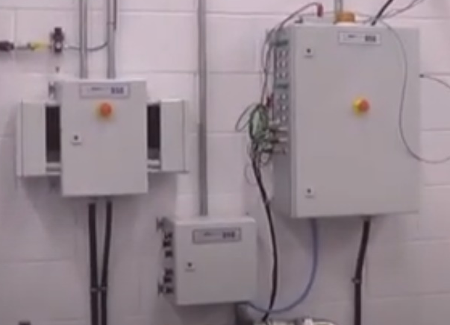
To begin the test you have to have the require equipment, For example, You will need a Dynamometer that will be attached to the engines crank using a drive shaft, a sensor recorder module so you can send data back to the computers. You will need a exhaust extraction system and a fuel supply board.
(image of Sensor recorder module) (Workshop, 2021)
Figure 1

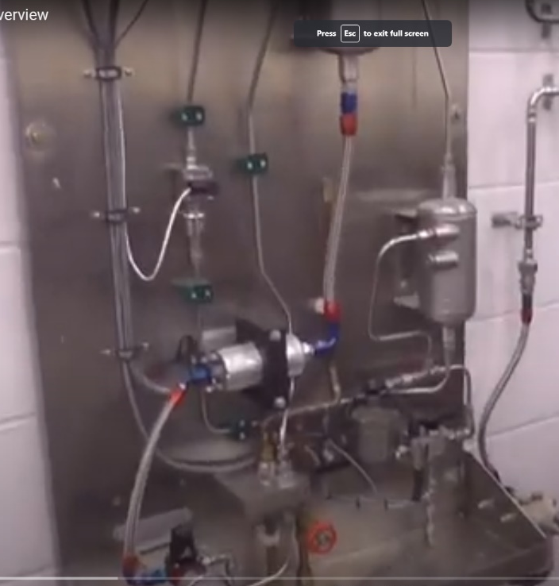
The fuel supply board will use a lift pump to extract the fuel from the main fuel tank located in the fuel safe. The fuel then gets sent through a fuel filter and then pumped using a fuel flow meter and sent to the engine using a fuel regulator. The throttle is controlled by the computer and the throttle actuator box. The dynamometer will have many different sensors in it to help monitor the engine, The dynamometer is a eddy current dyno meaning the inner core spins freely when powered by the engine and the outer casing is fed by current creating an electromagnetic field, this electromagnetic field will then put a load onto the engine trying to slow it down. It does this by trying to turn but by using a strain gauge you prevent this from turning. The dynameter also has 2 calibration arms that will be designed to a specific length. These arms will help in working out the torque of the engine. Finally on the engine side there is a coolant tank and an inlet and outlet hoses.
Figure 2 Image of the fuel supply board
On the computer side you will have a control unit set up to receive the inputs from the sensor recorder module. From the varies sensors you can then control the engine rpm and load by using two dials. One of the dials is labelled engine and will be used to increase the RPM by opening the throttle and the other will be called dynameter and will increase the electromagnetic filed that is used to slow the engine down.
The method used for my test was a sweep test, during this sweep test we set the ramp time meaning the time it takes to start, we held it for 1 second and started at 1250 rpm, and finished at 5500rpm and logged it every 50rpm. To start the test, I increased the throttle to 100% and then the computer than the car to 5500 rpm and took measurements every 50 rpm

Chapter 2 – Raw Data
(refer to excel spreadsheet)

Chapter 3 – Plotted graphs and relevant questions

Suggest reasons why the SFC varies as it does with engine speed.
By looking at the graph you can see there is an overall steady increase in SFC as the engine rpm increase, it does have moments of decreasing especially at top end performance. Some reasons for the increase in SFC will be -
Increased frictional loses means that when the engine speed increases the piston speed will also increase and in turn increases mechanical stresses on components which can affect fuel consumption.
Throttle position is also another factor in the increase of SFC. As higher engine speeds are achieved it will require the throttle position to be more open to increase air flow into the combustion chamber, this will lead to increases pumping loses and result in a higher SFC especially if the engine isn’t at full load.
A third reason for this increase in SFC can be Excessive Heat Losses, due to the higher engine speeds there is less time for heat to be transferred effectively, in turn leading to an increase in heat loss through the exhaust system and cooling system. Due to the need for additional fuel consumption to compensate for lost energy and maintain proper operating conditions.
Suggest reasons why Torque varies as it does with engine speed.
The intake and exhaust valves can affect torque. As engine speed increases, the valves can open and close quicker, allowing for better intake and exhaust flow, which increases torque.
Combustion Efficiency- When engine speed increases the combustion efficiency becomes more complete leading to a steady increase in torque over time until the combustion efficiency goes beyond the peak point and then it will start to become incomplete and lose torque.
Piston Speed: With a low engine speed piston speed will be slow, meaning less force being applied to the crankshaft per rotation, the opposite happens when the engine speed in increases and more for in applied at a faster rate resulting in a greater torque output.
Suggest reasons why Brake Power varies as it does with engine speed.
Combustion Efficiency, depending on engine speed brake power will get effect for example. At lower engine speeds the combustion efficiency is incomplete This can result in lower brake power output. On the other hand, at higher engine speed complete combustion will occur more often resulting in an increase in brake output.
Intake and Exhaust Dynamics- Engine speed is a major factor in timing and duration when it comes to inlet and exhaust valves, when engine speed is lower the valves open and close at a slower rate resulting in a restricted exhaust flow and inlet flow restricting air in the chamber and scavenging which can affect brake power. As engine speed increases, the valves open and close more rapidly, allowing for better airflow and exhaust flow, which can increase brake power output.
Engine Load: At lower engine loads the engine won’t be producing as much power so brake power will also be affected. As engine speed increases or load increases, brake power output typically increases to meet the demand for power.

Chapter 5 – Test Results conclusion
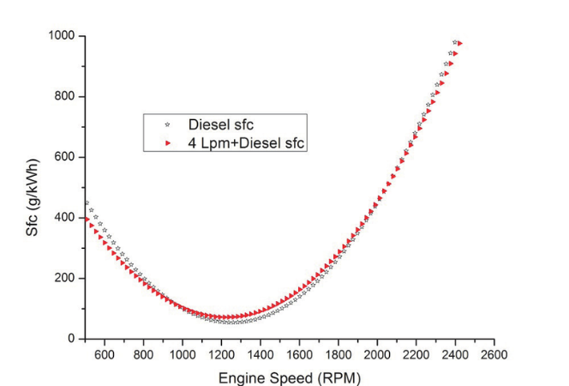
To conclude my test results I produced 3 graphs ( see chapter 3). My first graph was SFC against engine speed. As you can see by my results, I found that SFC increases as the rpm increased leading to a higher fuel consumption rate. You can also see at the end that the SFC almost stays the same and decreases slightly before increasing again. This could be down to fuel injector timing being slightly off causing this odd scenario. n (Hadi, 2020)

According to this graph I found online this is another SFC against engine speed graph. This one shows a steady decrease in SFC as engine speed increases and then a rapid increase towards higher rpm. This is different from mine so in the future I would make sure my working out are correct and my data is 100% right by potentially running the test again and getting another set of data allowing me to compare.
My second graph is engine speed against torque. In this graph you can see a varied increase and decrease in torque over the rev range showing where peak torque is for that engine depending on the load. You can see an overall increase at the start before it slowly drops off and then comes right down in the higher rpm suggesting peak torque is early on in the rev range and you are actually losing torque with higher rpm.
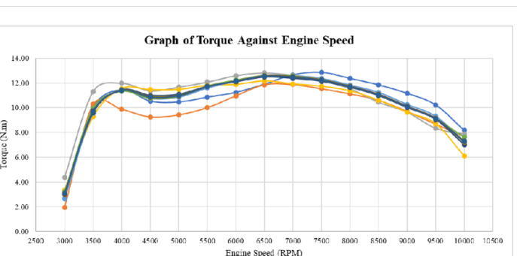
(Warju, 2021)This is a graph I found online that shows a typical engine speed versus torque graph. As you can see the graphs are similar in the early stage increase and then higher rpm torque drop off, meaning that my data is most likely accurate, and I can use it as key information.
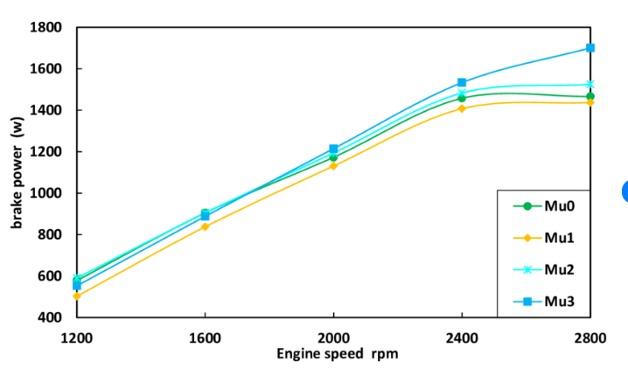
My third graph is Brake power against engine speed. With this graph I compared to another one I found, and I found that both were similar with mine having a clear increase over time meaning the engine was being forced to produce more power to meet the higher demand. (Baltacioglu, 2014)

Chapter 6 – Evaluation
Overall, I think I understood and completed the test well and gathered a good set of data from the test. I would next time like to do the test another time just to get an extra set of data to help compare my results together to find any errors, in doing so will help prevent question like my first graph and how it doesn’t look like most SFC against engine speed graphs. For the future I would also improve the way in which we gather the data from the computers and use a more detailed sweep test so we can gain more data and work out more information.

References
Baltacioglu, M. K., 2014. Reserch Gate. [Online]
Available at: https://www.researchgate.net/figure/Specific-fuel-consumption-versus-engine-speed_fig4_299514960
[Accessed 15th march 2024].
Hadi, A. S., 2020. Research Gate. [Online]
Available at: https://www.researchgate.net/figure/Specific-fuel-consumption-versus-engine-speed_fig4_299514960
[Accessed 15th march 2024].
Warju, W., 2021. Reserch Gate. [Online]
Available at: https://www.researchgate.net/figure/Graph-of-torque-against-engine-speed_fig5_349434997
[Accessed 15th march 2024].
Workshop, U. W., 2021. Youtube. [Online]
Available at: https://www.youtube.com/watch?v=-WajOAp2LUE
[Accessed 15th march 2024].

