Poppy Morrissey (2501786)

Chris Wilkin
12/12/2025
Word Count: 1507
Marketing Report for swansea arena house party 2026.
Niche Marketing and Social Media BMTP4014

AI Statement
I confirm that I have not used any AI tools in the research and creation of this assignment. I confirm that I have not presented any AI generated materials as my own work. I confirm I have copies of my drafts, notes, and other resources I used, which I may be asked to provide in evidence.

Introduction
The marketing plan is being prepared to efficiently promote and support the Swansea Building Society’s House Party in February 2026. The house party is an annual event with live music that supports the Music Venue Trust and small bands across South Wales. The marketing plan is being prepared for local bands, Swansea Arena and partnerships. The marketing plan uses frameworks like SOSTAC, 5Cs, 4Ps, PESTLE and Ansoff’s Matrix to focus on factors like strategic marketing, market segmentation and niche marketing. This ensures the marketing plan is sufficient and affective to help attract target markets to attend the event (ATG, 2025a).

Situation Analysis

5 'C's analysis model
The 5 C’s analysis model analyses key areas of a marketing plan, consisting of the company, customers, competitors, collaborators and climate. Each factor contributes to a successful marketing plan (Bhasin, 2025).
In appendix 1 there is a SWOT analysis table discussing strengths, weaknesses, opportunities and threats on the Swansea Arena House Party, discussing how the event supports local bands and charities, transportation issues and leverage technologies.
Swansea Arena has different customer types shown in Appendix 3. The images shown in Appendix 4 are different charts and graphs to show how this information has been gathered.
In Appendix 6 there is a perceptual positioning map for each 3 customer profiles. This shows the competitors for the House Part for the specific market.
This event is delivered in collaboration with other venues and the University of Wales Trinity St David. In collaboration with the event, Swansea Arena works with the Bunkhouse, Elysium, and other music venues for after parties and promotion (ATG, 2025a).
Appendix 2 shows a PESTLE analysis of Swansea Arena and the House Party. The table oversees Swansea’s regeneration project, the music of local bands, and sustainability, showing the climate of the house party.

4 P’s
The 4 Ps of marketing showcase factors businesses use to sell products through a marketing mix. This includes what they offer, what they charge, where its available and how they decide to promote the product. The 4 Ps are Product, Price, Place and Promotion (Twin, 2025).
The House Party is a multi-genre live music event with different performers and a lively atmosphere. Food and drink are available to purchase during the event. The event supports the Music Venue Trust charity, which is a unique selling point, it is likely that customers will attend making it very likely to be successful (ATG, 2025a).
Swansea Arena value the perception of the event to keep the tickets at an affordable reasonable price and make profit for the Music Venue Trust. Compared to other events the House Party a cheaper event.
The House Party is in a newly built arena which is highly accessible and located in the centre of Swansea, meaning it is in an ideal place where all types of visitors can go to the event. Swansea Arena has its own carpark and bus bay with an accessible lift and a foot-bridge overlooking the busiest roads in Swansea.
Promotion is used to encourage ticket sales, through social media campaigns on Instagram and Facebook. These campaigns include highlighting performers and lead-up posts.

Objectives
The SMART target is to target 300 new customers who have not yet attended the event to go to the House Party event by the 15th of February 2026, this will be measured by tracking ticket purchase data and post-event surveys. To do this there will be social media campaigns, new artists and targeted ads to reach the new audience. The marketing campaigns will run for 6 weeks leading up to the event.

Strategy

Ansoff Matrix
Ansoff’s Matrix is a marketing strategy used to identify growth factors in correlation with an events target or goal. An example of Ansoff’s Matrix linked with the House Party is shown in Appendix 5. Concluding the matrix, the product of the event will change but the market will be kept the same.
In adaption to the previous 4 P’s, the Swansea Arena House Party will change their product to encourage existing customers to re-attend the event. Indie-rock bands like the Manic Street Preachers will be performing along with other smaller indie-rock bands and individual artists. However, this means that there will be an increase in price per ticket. This is to cover the cost of hosting a larger band. The increase in price maybe a problem as the main customer is younger females, they may only go to cheaper and affordable events. Although there is this possibility there is also the opportunity to have a well-known band which would entice more customers to attend. Hopefully, with more people attending this will allow the smaller artists to gain recognition.

Tactics
The most popular social media’s that are used by the new target market are youtube and Facebook, this is shown in the customer profiles. The overall strategy is to get more followers for a new product. This will be done through the RACE strategy. RACE stands for Reach, Act, Convert and Encourage.
Swansea Arena have already reached their customers as they are existing customers. They will continue to reach their audience through posting and creating campaigns at specific times in the day to ensure it reaches as many people as possible. The best times to post on Facebook is 10am and the best times for Instagram is between 8am and 9am. The tables of the best times of day to post are shown in Appendix 7. For Swansea Arena to improve on reaching their customers they should create YouTube videos to post online too, this is something they do not already do. Online active engagement like polls, questionnaires, or prompts are a great way for Swansea Arena to engage with existing customers, this also allows for feedback and recommendations (SmartGuide, 2025). These campaigns and posts will work towards the objective and SMART target. These communications will hopefully reach more customers within the target market and convert non-customers into customers. To encourage the customers to attend the event again there will be emails sent out with deals if tickets are purchased by a certain date. Swansea Arena will also change the led band every year which creates an excited atmosphere for customers to find out who its going to be.
To improve Swansea Arena will reach out and create more engaging content for customers to be a part of, including workshops into the events will allow customers to feel included, this could include volunteers helping to set up, giving them the opportunity to create their own music or learn how to play and instrument.

Action
The chosen marketing channels Swansea Arena will choose are Instagram, Facebook and YouTube with a 6 week campaign leading up to the event. YouTube videos be posted weekly from week 2 on Wednesday at 4pm. This time and day is chosen based off the chart in Appendix 9. Furthermore, photos of the event and engaging content like polls and quizzes will be posted on Instagram and Facebook at 10am on Monday, 10am on Wednesday and 11am on Friday weekly. During the week 6 there will be a final promotional push with email reminders about the event and to get tickets if they haven’t already, during this week their will be daily posts. This will hopefully make those last sales and encourage people to attend.

Control
To measure the success of the House Party and marketing plan, Swansea Arena will use Key Performance Indicators (KPIs) and metrics from a Gannt chart. These Key Performance Indicators are new customers, social media interactions, website traffic and profits. The number of sales made will also be an indication as to how successful the event was. The SMART Target will be tracked through new ticketing emails that haven’t already been signed up for the event previously, they can also be tracked through polls asking if the customer has attended the event before. A USP is an unique selling point, the USP for the House Party is that it is a charitable event, raising money for the Music Venue Trust. When events are for charity people tend to be more inclined to attend as its giving back to others in need.
A gantt chart is a graph showcasing the timeline of a campaign. It shows what tasks are done on what dates and how long they will take. A gantt chart of the 6 week marketing campaign can be seen in Appendix 8.

Conclusion
In conclusion, the marketing plan for the Swansea Arena House Party includes many different strategies and frameworks. The overall strategy is SOSTAC with other frameworks like the 4 P’s, 5 C’s, Ansoff’s Matrix and PESTLE, SWOT and perceptual positioning maps. Having a larger well-known band playing will increase the likelihood of raising funds for the Music Venue Trust and making profit on the event. However, one of the challenges that may rise is some customer not re-attending due to the price increase. As stated before pre-existing customers can have a deal if purchasing tickets before a certain date, this would keep the price lower than new customers.

References
SmartGuide (2025) Best practice visitor experience in an attraction. Available at: Best practice visitor experience in an attraction (Accessed: 15 December 2025)
ATG (2025a) House Party 2026. Available at: Swansea Arena | House Party 2026 (Accessed: 10 December 2025)
ATG (2025b) Safety and Security. Available at: Safety & Security | Your Visit | Swansea Arena (Accessed: 10 December 2025)
Bhasin, H (2025) 5 C’s of Marketing. Available at: 5 C's of Marketing - Definition, Analysis and Examples | Marketing91(Accessed: 11 December 2025)
Music Venue Trust (2023) The Swansea Arena House Party: Uniting For Music With Music Venue Trust. Available at: The Swansea Arena House Party: Uniting For Music With Music Venue Trust (Accessed: 12 December 2025)
Nation Cymru (2024) Artists confirmed for Swansea Arenas 2025 House Party. Available at: Artists confirmed for Swansea Arena's 2025 House Party (Accessed: 11 December 2025)
Ridge and Partners LLP (2025) Swansea Arena. Available at: Swansea Arena - Ridge and Partners LLP (Accessed: 10 December 2025)
SFG Productions (2024) How to Make a Big Impact with a Small Event. Available at: How to Make a Big Impact with a Small Event | sfgproductions.com (Accessed: 11 December 2025)
Solarsense (no date) Swansea Arena Solar Panels. Available at: Swansea Arena Solar Panels - Solarsense (Accessed: 10 December 2025)
Sundae Communications (2024) Swansea Arena House Party: The Fight to Save Grassroots Venues. Available at: Swansea Arena House Party: The Fight to Save Grassroots Venues - Sundae Communications (Accessed: 12 December 2025)
Swansea (2025) Figures show arena success since opening. Available at: Figures show arena success since opening - Swansea (Accessed: 11 December 2025)
Twin, A (2025) 4 Ps of Marketing: What they are and how to use them successfully. Available at: The 4 Ps of Marketing: What They Are and How to Use Them Successfully (Accessed: 10 December 2025)

Appendices

Appendix 1
SWOT analysis on the Swansea Arena House Party event.
Strengths  Swansea Arena House Party has strengths in many areas. The event supports Grassroots Music Venues by raising funds for the Music Venue Trust which aims to support grassroot music venues into the region.  This event also collaborates with local venues like the Bunkhouse, Hanger 18 Music Venues, Hippos and so many more.  Swansea Arenas House Party supports local talent as it provides a significant platform for local artists to engage and perform which helps them be recognizes and build their carer (Music Venue Trust, 2023). | Opportunities  Swansea Arena offers various opportunities for the House Party to expand through leverage technologies. This would allow for other attendees from livestreams to pay and tune in to watch the event, this hopefully would encourage them to participate in person the following year (SFG Productions, 2024).
Weakness  The House Party event has previously faced challenges with fundraising due to the Music Venue Trust warning that 10% of grassroot music venues are at risk of closing.  Transport is also a weakness of the venue and event as there is limited late night transport coming in and out of Swansea (Sundae Communications, 2024) | Threats  The Swansea Arena House Party aims to raise £20,000 for the Music Venue Trust, this money gives other smaller venues in Swansea the ability to stay open and provide other events for locals. These funds are vital as there is has already been a loss of venues at a fats rate.

Appendix 2
A PESTLE analysis of Swansea Arena and the House Party.
Political | Swansea Arena interlinks with Swansea Council as part of Swansea’s regeneration project which has shares of the profits the arena makes (Ridge and Partners LLP, 2025). Since opening the arena has brought in 750,000 people into Swansea, this shows that the regeneration project with Swansea Council is working the way they hoped (Swansea, 2025).
Economic | The House Party is an affordable event with tickets being £12.50, meaning guests would be more inclined to come to the event and purchase drinks and food which increases visitor spending, creating more profit and charitable funds.
Social | Socially, the event brings communities together from all over South Wales to enjoy the music of local bands and artists whilst allowing the artists to grow and advance whilst also providing and enjoyable experience for guests.
Technological | Swansea Arena has a strong position with social media when it comes to marketing for events. Previously, the House Party has had campaigns leading up to the event. Also, the purchase of tickets is on the ticketing platform and staff members use technology scanners to scan the tickets.
Legal | Swansea Arena House Party complies with health and safety regulations to ensure there is a safe environment for everyone at any event. These safety measures include, searching bags, scanning tickets, cloakrooms for larger objects, CCTV and security (ATG, 2025b).
Environmental | Swansea Arena is continuously reducing its environmental impact through different initiatives. The arena has solar PV systems that generates 73,512kWh of clean energy each year which reduces the carbon emissions by 20,360kg. This linked with the arenas commitment to being sustainable (Solarsense, no date).

Appendix 3
This shows the target markets and different customer profiles Swansea Arena has for their House Party.
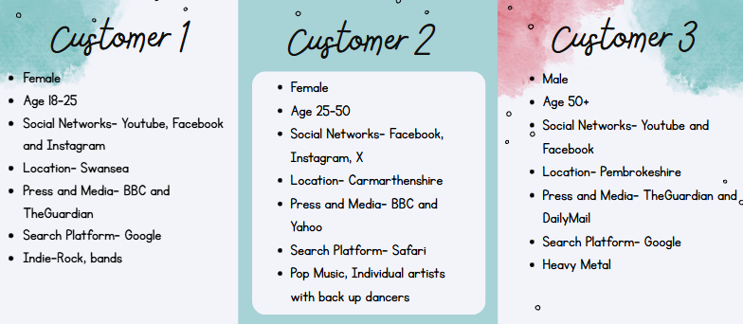

Appendix 4
Here are some graphs and charts from SimilarWeb.
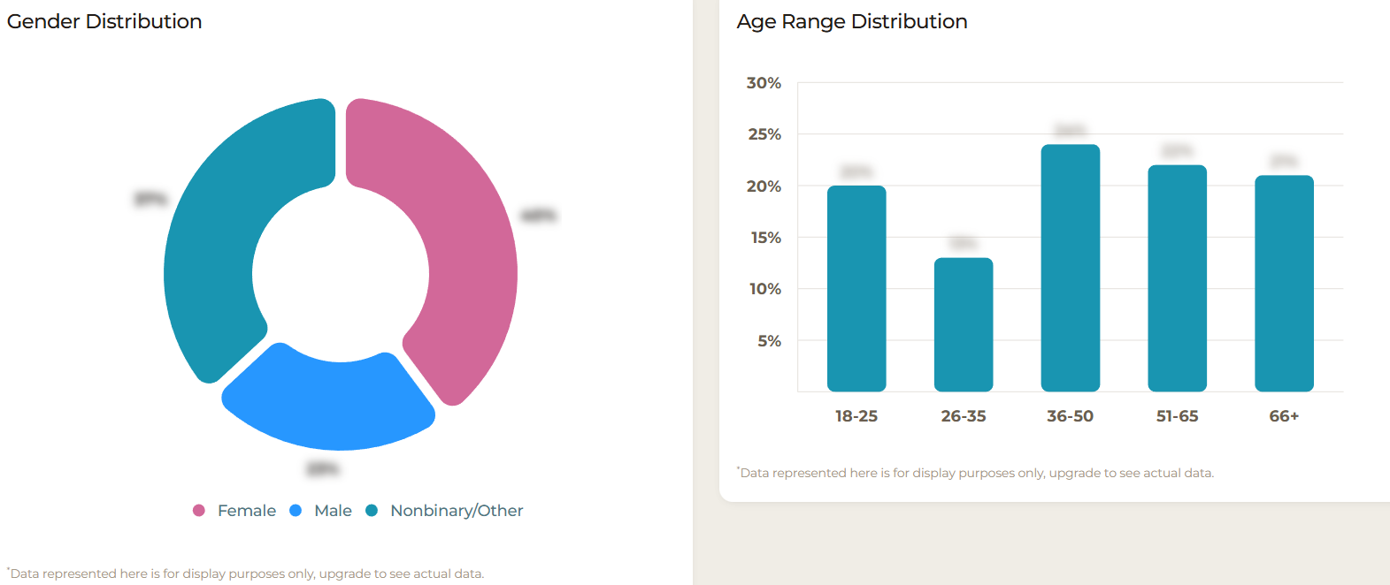
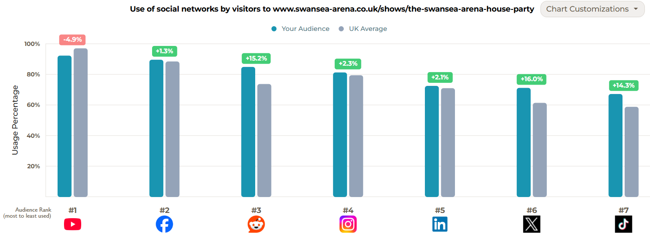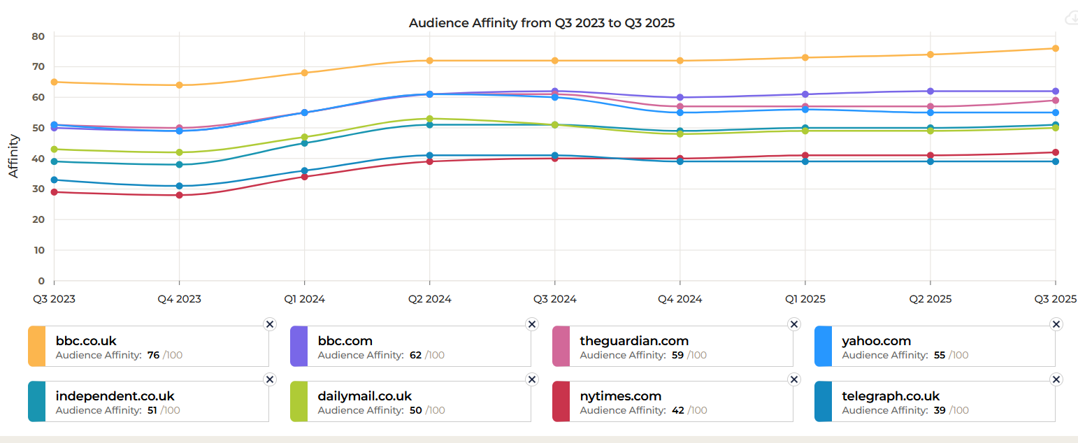

Appendix 5
 | Existing Markets | New Markets
Existing Products | - More social media campaigns posted on Instagram and Facebook to reach more people within the audience  - Create a YouTube video of previous events to promote the House Party | - Hold the event with pop music artists to gather a wider audience
New Products | - Have a larger indie-rock band like Manic Street Preachers to perform, this makes the event more exciting and encourages existing markets to attend again. | - No strategy

Appendix 6

Customer 1
High Price
Big Country  Far away location | Madness  Close location
Rocket | All Time Low  Public Image LTD
Low price

Customer 2
Likely music type
Low price | Jessie J Lilly Allen  Stereophonics  High price
Trousdale

Chuckie and Tazers RNB and Slow Jams
Unlikely music type

Customer 3
Close location
K Pop Superstars  Flowers and friendship bracelets  Unlikely event | Rhythm of the 90’s  Likely event
Luminsence | Heaven Shall Burn
Far away location

Appendix 7
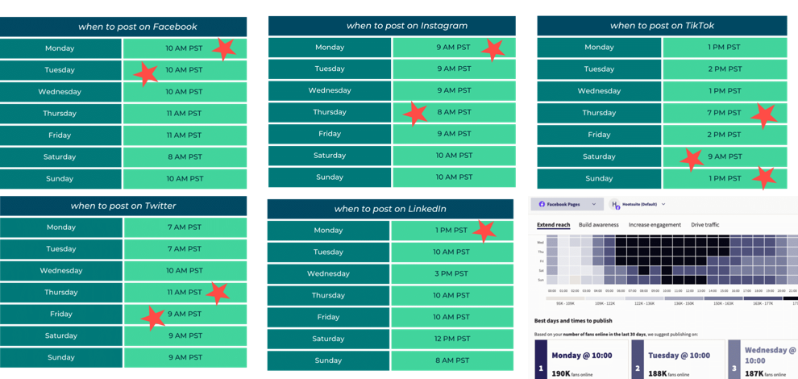

Appendix 8
Here is a Gannt Chart showing the KPI’s and metrics of Swansea Aren’s House Party.
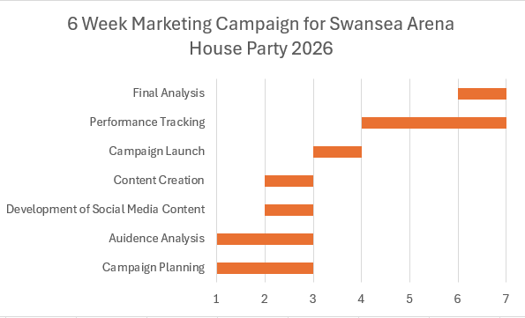

Appendix 9
This table shows the best times to post on YouTube for the Action section of the plan.


