1903588 Paula Smith Module 3007 20-12-2020
Discuss the unique and diverse Islamic responses to mortality, such as ideas of martyrdom and the rituals surrounding death. Illustrate your answer with examples drawn from your own reading.
Introduction.
This essay will discuss some common themes within Islam, and the rituals regarding death and burial. It will conclude that there is a strong identity across the communities of Islam, but also significant differences about important issues.
Discussion.
The Quran is the Word of God revealed to the Prophet Muhammad, shown to him over 23 years of his prophetic mission. It is the fundamental source of Islamic law and ethics, and led to the foundation of a great civilization, becoming one of the major scientific, philosophical, and artistic traditions in world history. It is about a way of living, and is practical, legal and moral, and has instruction regarding everyday problems as well as spiritual and intellectual life. (Nasr,2015).
Awareness of mortality pervades the Islamic faith, with followers directed towards conducting their lives in obedience to God. Life is considered to be a stage on the way to the afterlife, a journey that requires constant awareness of the straight path, and the temptations to fall. With prayer and following the advice in the teachings, reward follows death. For those who fall, unending punishment follows. Paradise, or Jannah, is a place of beauty and blissful immortality, and Hell, or Jahannam, is presided over by the Jinn Malik and a place of unending torture. Angels observe one throughout life, and on death, a believer is interrogated by two Angels, Munkar and Nakir, and a decision is made regarding their fate. The daily prayers are a constant reminder of the requirements of a good life, ensuring this is in the fore of one’s mind, and even after death relatives will give advice at the grave about what to say (Rheinhart, 2009).
The Quran talks about death and its meanings, but does not address funeral rites, so this instruction comes from the interpretations made after Muhammad’s death and from the witnesses of his sayings about those who died during his lifetime. The interpretation of the Quran followed the death of the Prophet and it is at this point that divergence in the teachings occurred, and different branches of Islam started to be formed. Over time, these different interpretations have led to the development of distinct identities within Islam, and these different communities are now spread across the globe (Kusserow, Pawlak, Ferguson. 2015).

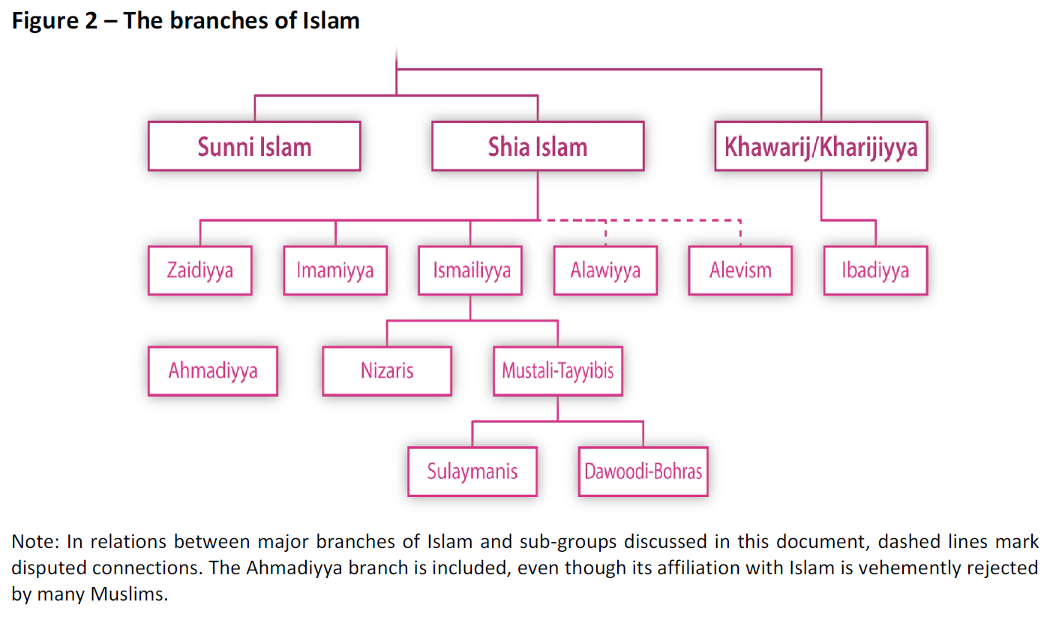European Parliamentary Research Service Blog. 2015.

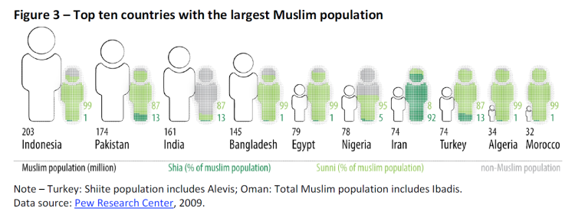
European Parliamentary Research Service Blog. 2015.

World Muslim Population
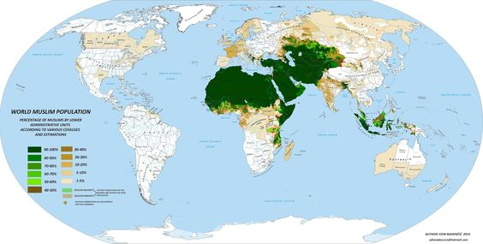
Vividmaps.com.

The divergence between Sunni and Shia is the most significant development. The dispute centred on who should lead the community, and whether the leader should be directly descended from Muhammad, and if he is considered infallible (Kusserow, 2016).

Sunni Islam is the largest branch, making up to 90% of the global Muslim population. The Sunni branch deny that Ali, Muhammad’s cousin and son-in-law, was chosen as Muhammad's only legitimate successor. Sunni Islam avoided fundamental divisions, allowing instead for 'pluralism within a unitary system'. There is no central religious authority and the unifying factor is Sharia Law, derived from the Quran. Sunni scholars agreed on a set of historical accounts (Hadith) of the sayings and actions of the Prophet. This was consolidated in several legal schools, four of which prevailed. They differ in the interpretation of the Quran, but accept each other.
Salafism is a puritanical movement within Sunni Islam. They take a fundamentalist approach, trying to restore faith and practice back to the days of Muhammad, and date back to the 14th Century. They are again divided into three groups, Purist (who must not rebel against the leader), Activist (involved with politics and shaping society) and Jihadist (militarist, where violent opposition to a non-Muslim leader is permitted). To Sunni Islam the most holy places are Mecca, Medina and Jerusalem, and the shrines associated with Shiia Islam are not revered (Immenkamp, 2016).

Shiia Islam does believe that Ali and his decendants are the only legitimate successors to the Prophet Muhammad. There have been disputes over leadership within Shiia Islam, which have resulted in the development of many sub-divisions. Shiite Muslims derive their name from Shiat Ali, which means the party of Ali. Shiite Muslims have differentiated themselves into sub groups according to their belief regarding which route of decadency from Muhammad their leaders have come.
The Imamiyya is the largest of the Shiite branches with up to 2 million followers. They are also known as’ The Twelvers’ as they can trace their line back through twelve Imams, the tombs of which have become important pilgrimage sites.
Ismaili Shiites form the second largest sub-division, and are also known as the ‘Severners’ as they view a different family member to be the rightful successor. The religious teachings also differ. This group of Ismaliyya is also split, the largest sub-group is the Nizaris (Kusserow, 2016).

Although the many branches of Islam differ in details regarding authority and some aspects of belief, there is shared approach to death and the associated rituals. The variations are related to the type of death that has occurred, and the definition of that death. Some deaths are considered to be un-natural, and result in particular responses. Suicide is seen as a sin, with the person being compelled to live the act over and over again in the grave, and martyrdom bestows unhindered access to Paradise (Reinhart, Denny, 2020).
A natural death includes the need for the dying to be aware of their impending demise, giving the opportunity for personal preparation. The Surah is recited, preferably the Ya Sin. This is known as the heart of the Quran, and contains the three principles of monotheism, prophet hood and resurrection (Jafari,2020). The Shahadah , the Muslim profession of faith, is recited into the ear of the dying. The preparation of the body follows- when cool, the relatives wash the body thoroughly, before it is wrapped in cloth. There are three pieces of cloth for males, and five for females (Dar-alifta.org, 2020). They are then covered by a tightly tied covering- a coffin is not required. The body is laid in a deep grave and the face is turned towards Mecca (Rose, 1992).The burial should take place as soon as possible, ideally before nightfall of the day of death. This is seen as emulating the way the Prophet attended burials in his lifetime, his actions and instructions becoming the template for his followers. When the death is in a hospital or hospice, there can be anxieties about the orientation of the body and rituals of washing as well as the delay caused by a post mortem (Gatrad, 1994).
To die as a martyr is to die in the service of the religion. This death is of the highest service to God, and promises reward. Martyrs do not go through the interrogation by the two angels in the grave, and can ascend to the highest level of Paradise, close to the throne of God.
In Sunni Islam, the deliberate pursuit of martyrdom is discouraged, being seen as close to suicide, and living a life as close to the teachings, making war on one’s own desires, is the form of martyrdom to pursue.
However, in Shiia Islam, martyrs are very important. There is worship at the shrines of martyrs with annual pilgrimages, weeping and experiencing thirst and hunger in recognition of the suffering of the martyr. The gravesites, or Mashhad, of the martyrs have become towns and centres of learning with colleges of higher learning- Madrasahs.
All struggles in the defence of Islam are known as Jihad- or striving- from the defence from persecution experienced during the life of the Prophet when Islam was becoming established, to current conflict today. There are different forms of Jihad-The Prophet said “We are finished with the lesser jihad; now we are starting the greater jihad" when returning from battle. Fighting the outer enemy is lesser than the one waged internally, so the Greater Jihad is the striving to live a good Muslim life, following the five pillars of Islam (BBC Religions, 2009).
Lesser Jihad is military death in the cause of Islam. It requires leaders to sanction the action, and not all leaders will do this. Lesser Jihad can also be religious missions, and persuasion. The group known as Islamic State (I.S.) has gained a lot of publicity for their use of Jihad as a weapon. I.S. have become known for acts of Jihad in the form of suicide bombers against civilian targets, which has produced much condemnation and debate. Most Muslim leaders condemn this practice as terrorism and the death a suicide, but others see it as a necessary defence against oppression, for example in Palestine today many support this tactic against Israeli occupation of the Gaza Strip and West Bank (The Islamic World Past and Present, 2020).The use of the internet as a way of recruiting people to this cause is hard to control, and the use of media to promote the actions in a theatrical way has a profound effect in terms of radicalisation and recruitment (Bunt,2018). The promise of Paradise is used to recruit potential bombers as the action is sanctioned as an act of Jihad.
A Jihad death requires a different ritual for the preparation of the body and burial. Those who die as a result of Lesser Jihad are to be buried where they fall, without washing or preparation, in the clothes they died in. Those who die on pilgrimage have a shroud with no sewn seams, and women have their faces uncovered (Rheinhart , 2009).
Greater Jihad is the ongoing striving to live a good life, following the teachings of Islam. This is a constant effort, and some Sunni leaders recognise this as martyrdom in itself, and so has a guaranteed place in the highest level of Paradise. It does not consist of one action but a constant awareness of the temptations of life and the effort it takes to stay on the straight path.
Conclusion.
Although Muslims have shared beliefs, there is diversity within their community. The diverging branches have differences of both their understanding of the history and authority of their Imams. They also differ in the worshiping of shrines, validation of martyrs and views of Jihad, and in what category a death might fall. There is ongoing exploration of the teachings, with active websites for followers to consult, and as such, Islam remains an evolving religion responding to modern life in a fluid way, as can be seen in the adaptations due to Coronavirus this year (Arab News, 2020).
Word count 1735.
Reference list.
Arab News. 2020.UK cemetery adopts new way of burying Muslims amid rising Coronavirus deaths. Available at: https://www.arabnews.com/node/1661091/world Accessed on 15-12-2020.
BBC Religions. 2009. Jihad. Available at: https://www.bbc.co.uk/religion/religions/islam/beliefs/jihad_1.shtml. Accessed on 15-12-2020.
Bunt,G.R.2018. E-Jihad and Gen-ISIS. Hashtag Islam. University of North Carolina Press, 2018. Available at: https://r2.vlereader.com/Reader?ean=9781469643175 . Accessed on 15-12-2020 )

Dar-alifta.org. 2020. The manner of shrouding men and women. Available at:

https://www.dar-alifta.org/Foreign/ViewFatwa.aspx?ID=8102 Accessed on 17-12-2020.
Gatrad,A. (1994). Muslim customs surrounding death, bereavement, postmortem examinations, and organ transplants. BMJ (Clinical research ed.). 309. 521-3. 10.1136/bmj.309.6953.521. Available at: https://www.researchgate.net/publication/15351645_Muslim_customs_surrounding_death_bereavement_postmortem_examinations_and_organ_transplants Accessed on 13-12-2020.
Immenkamp,B. 2016. Understanding the branches of Islam: Sunni Islam. Briefing. European Parliament. Available at: https://www.europarl.europa.eu/RegData/etudes/BRIE/2016/577963/EPRS_BRI(2016)577963_EN.pdf Accessed on 13-12-2020.
Jafari,M. 2020. Religious Times. Why is Surah Yasin called the heart of the Quran. Available at: https://article.tebyan.net Accessed on 13-12-2020.
Kusserow, S, 2016. Understanding the branches of Islam: Shia Islam. Briefing. European Parliament. Available at: https://www.europarl.europa.eu/RegData/etudes/BRIE/2016/573914/EPRS_BRI(2016)573914_EN.pdf Accessed on 13-12-2020.
Kusserow,S. Pawlak, P and Ferguson, C. 2015. Understanding The Branches Of Islam. European Parliamentary Research Service Blog. Available at: https://epthinktank.eu/2015/09/24/understanding-the-branches-of-islam/ Accessed on 13-12-2020.
Nasr,S.H. 2015. The Study Quran. A New Translation with Notes and Commentary.Available at: http://enterprise.supadu.com/images/ckfinder/553/images/Study-Quran/StudyQuran_ExcerptFinal_updated.pdf Accessed on 12-12-2020.
Reinhart, A. K. 2009. "Funerary Rites." The Oxford Encyclopaedia of the Islamic World. Oxford Islamic Studies Online. Available at: Funerary%20Rites%20-%20Oxford%20Islamic%20Studies%20Online.html . Accessed on 10-12-2020.
Rose, H.J. 1992. Celestial and Terrestrial Orientation of the Dead. The Journal of the Royal Anthropological Institute of Great Britain and Ireland Vol. 52 (Jan. - Jun., 1922), pp. 127-140. Available at: https://www.jstor.org/stable/2843774?seq=1 Accessed on 13-12-2020.
Vividmaps.com. Available at: https://www.pinterest.co.uk/pin/657947826781626810/ Accessed on 13-12-2020.

Bibliography.
Bunt,G.R.2018. E-Jihad and Gen-ISIS. Hashtag Islam. University of North Carolina Press, 2018. Available at: https://r2.vlereader.com/Reader?ean=9781469643175 . Accessed on 15-12-2020 )

Cook, B.J. (2017) Pre-mortality in mystical Islam and the cosmic journey of the soul. Available at: https://search-proquest-com.ezproxy.uwtsd.ac.uk/docview/1927525259?accountid=130472&pq-origsite=primo. Accessed on 14-12-2020.

Der-alifta.org. 2020.The manner of shrouding men and women. Available at: https://www.dar-alifta.org/Foreign/ViewFatwa.aspx?ID=8102 ccessed on 17-12-2020.
Esposito, J.L. 2020. "Martyrdom." In The Islamic World: Past and Present. Oxford Islamic Studies Online. Available at: http://www.oxfordislamicstudies.com/article/opr/t243/e209. Accessed on 10-12-2020.
Immenkamp,B. 2016. Understanding the branches of Islam: Sunni Islam. Briefing. European Parliament.
Islam question and answer. Some of the rulings on Jihad: degrees of martyrdom and the life of martyrs after death. Available at: https://islamqa.info/en/answers/71284/some-of-the-rulings-on-jihad-degrees-of-martyrdom-and-the-life-of-the-martyrs-after-death Accessed on 14-12-2020.

Jafari, M. Religious Times. ? Why is the Surah Yasin called the heart of the Quran.

Khadija Kadrouch-Outmany . 2017. Speaking of the dead. Cambridge Core. Available at: https://www.cambridge.org/core/books/women-and-social-change-in-north-africa/speaking-of-the-dead Accessed on 14-12-2020
Loddon Mallee. An outline of different cultural beliefs at the time of death. Regional palliative care consortium. Available at: https://lmrpcc.org.au/admin/wp-content/uploads/2011/07/Customs-Beliefs-Death-Dying.pdf Accessed on 14-12-2020
Miskinzoda,G. 2017 Sira Available at: https://www.oxfordbibliographies.com/view/document/obo-9780195390155/obo-9780195390155-0149.xml Accessed on 12-12-2020
Reinhart, A. Kevin and Frederick Mathewson Denny. "Funerary Rites." In The Oxford Encyclopedia of the Islamic World. Oxford Islamic Studies Online.

Seyyed Hossein Nasr. The Study Quran. 2015.

Shoemaker,SJ. 2011. The Death of a Prophet: The End of Muhammad's Life and the Beginnings of Islam. Available at:https://books.google.co.uk/books?hl=en&lr=&id=qcfHxDSbdT0C&oi=fnd&pg=PP2&dq=muhammad+islam+prophet&ots=RwPIMYyQ-5&sig=LTKy56skQTPiyHbjNsTHBrhXOF4&redir_esc=y#v=onepage&q=muhammad%20islam%20prophet&f=false Accessed on 12-12-2020
Sira. Miskinzoda. Oxford Bibliographies.2017
The World’s Muslims: Unity and Diversity. Pew research centre. Available at: https://www.pewforum.org/2012/08/09/the-worlds-muslims-unity-and diversity-executive-summary/ Accessed on 14-12-2020.

