Stuart Sumner Smith 1919831

Networks and Cyber Security Essentials

ACCA4024

Synthesize a solution to a potential real-life scenario

Contents
- Cover Page
- Contents
- Abstract
- Introduction
- Overview and definition
- Analysis of Chi Se Network
- Penetration Test of Chi Se Network
  - Wire Shark Identifies a Network
  - Wireshark sniffs and then captures the HTTP packets
  - Username Capture
  - Password Capture
10. Cyber Security Policy Recommendations
11. Cyber Security Policy Recommendations Continued
12. Cyber Security Policy Recommendations Continued
13. Conclusion
14. Bibliography

Abstract

This assignment will explore the basics of networks with a special emphasis on network security. Exploring how networks provide vital services for business and how networks, in particular remote access to networks, function for users. With a focus on security risks posed by remote access and the use of personal devices.
It will attempt to introduce universal standards of cyber security and then apply those standards to a hypothetical company Chi Se. An examination of Chi Se’s failings regarding cyber security will be highlighted, and this will include a penetration test to capture password information on an unsecured network. Finally, it will put forward a new cyber security policy for Chi Se to remedy the previous failings in this area.

Networks are what make communication possible.
However, if a network is compromised by bad actors, we risk our communications falling into the wrong hands. At the very worst a cyber-attack on our system disrupting or even destroying the whole network and confidential data loss, by way of such tools and exploits such as: spyware, ransom ware, virus, backdoors, Doss attacks, and numerous other ways of stealing data and disrupting networks.
In terms of computers, a network means two or more devices that communicate with each other. These can be any size ranging from a small peer to peer network with two computers, to a large company network that involves hundreds of computers as well as mobile access.
Digital networks allow us to communicate information fast, securely, and efficient. This is a massive benefit to business and allows commerce and social interactions to be flexible, timely, global and above all develop freedom and creativity.

Computers communicate using data sent in small packets. This means a for example content on an internet page is gradually build up using different portions of data.
Each computer has a logical IP address and a hard coded MAC address (which cannot be changed). Computers send messages using IP address to send messages to other computers with the matching IP and MAC address.

A computer network can communicate with another network using, the internet “a worldwide collection of interconnected networks (internetworks or internet for short), cooperating with each other to exchange information using common standards. Through telephone wires, fibre-optic cables, wireless transmissions, and satellite links, Internet users can exchange information in a variety of forms.” [1]

The internet allows us to communicate with computers in any location. The simplicity and speed of the digital process means, that we can communicate with computers in virtually any place using only matching IP and MAC address. The ease and speed of this communication creates problems for the security of that network if we do not have the controls in place to keep then network secure.
Herein lies the problem for Chi Se’s network. Since the network in question, can be joined at a remote location, with an even greater prevalence, as digital technology advances, this means we cannot guarantee who is joining our network, unless our network is secure and free from major security risks.

The large computer network used by Chi – Se, consists of many servers, switches, and routers at different locations. They distribute and send the data in an organised way to provide communication between devices and mobile devices. Using wired and wireless data transfer. This allows network users to enter the network at a remote location, not just where the physical networks are present. A large multinational construction company like Chi Si, uses its network 24 hours a day 7 days a week, to store information in cloud storage, for video conferencing, chat, and other message applications, to make their operation flexible, fast and efficient. However, the size of the network, and the fact that many of its legitimate users are allowed access to all Chi Se’s data in its network from personal external devices, puts the entire security of the network at risk and leaves it prone to cyber-attack.

Chi Se’s current statement is out of date, inadequate and not fit for purpose:
Chi Se Cybersecurity Statement
“Employees are expected to follow standard guidelines and practices with regards to security of data and systems. It is the responsibility of the employer and employee to make sure these guidelines are followed daily with regards to protecting systems and data.” Garry Smith Chi Se CEO 1999.
While this might have been relevant when written in 1999, the world has moved on in terms of digital technology development, and because of the upsurge especially of personal mobile technology and remote connection to networks in the last 10 years or so, this creates more risk in terms of cyber security threats. The above statement also does not include any reference to implementation of the procedure or daily practice. Such as guidance on basic areas such as passwords, access levels, remote access, or the IT security principles of Confidentiality, Integrity and Availability. The security of Chi Se’s network is left up to the common sense of the employee or visitor and because threats can come from inside and outside the organisation the Chi Se cybersecurity statement is not fit for purpose.
“IEEE C37. 240-2014 - IEEE Standard Cybersecurity Requirements for Substation Automation, Protection, and Control Systems. Cybersecurity measures require that a balance be achieved between technical feasibility and economic feasibility and that this balance addresses the risks expected to be present at a substation” [2]
The NIST computer security handbook defines security as “The protection afforded to an automated information systemin order to attain the applicable objectives of preserving the integrity, availability, and confidentiality of information system resources (includes hardware, software, firmware, information/data, and telecommunications.” [3]

The NCSC (National Cyber Security Centre UK.) suggest 10 areas which if address can protect a network and mitigate a possible cyber-attack These are”
- Network security. 2 User Education. 3 Malware Prevention 4. Removable Media Controls. 5. Security Configuration. 6. User privileges. 7. Incident Management. 8. Monitoring 9. Mobile working. 10. Define risks “[3]

Considering a “balance be achieved between technical feasibility and economic feasibility” [3] for Che Si’s protection we will consider the main areas that are applicable and unique to the company. We must keep in mind, that each situation is unique, and Chi-Se’s network, will need both a bespoke set of controls for cyber-attack prevention as well as more common ways to mitigate risk.
Currently Chi Se’s systems can be accessed remotely by any personal device that obtains a password and has an internet connection. There is no filtering of devices on the main network. This creates numerous risks due to the presence of weak security on personal devices at home. Risks include, data loss from transferring data from personal devices; leaking data to unauthorised users; malware spreading through phishing attacks on personal devices; to name but a few critical instances.
For example, it is common practice in Chi Se, that passwords tend to be reused on personal devices we have discovered. This means, the same password is used by a person on their personal device network, as well as on Chi Se’s company networks This causes considerable risk as you can imagine.
To demonstrate this risk, I have used a Packet Sniffer tool Wireshark, to capture packets of data that was sent by an employee’s mobile device using plain text on a vulnerable protocol. In this case the protocol was HTTP. The packet sniffer tool was easily able to capture a password and username. In this case both username and password on the personal network are the same as used on Chi Shi’s network. I have tested and verified this. Below is a description of the process I used, Illustrated with screen shots of the evidence.
  - Wireshark Identifies the Wi-Fi Network at Che – Si.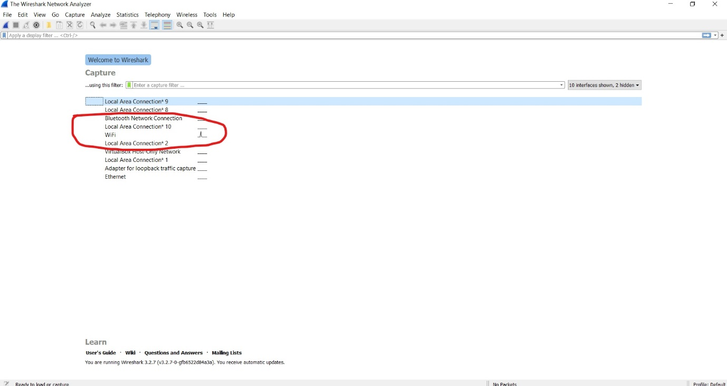

  - Below Wireshark sniffs and then captures the HTTP packets from the webpage.
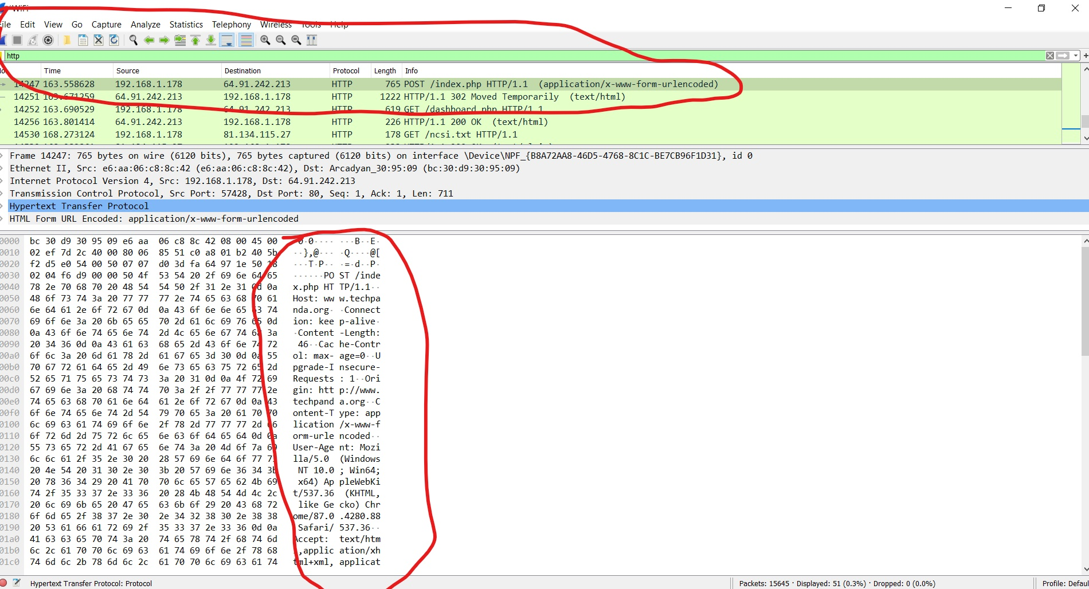

  - In this image you can clearly see then username captured: chise@admin.com
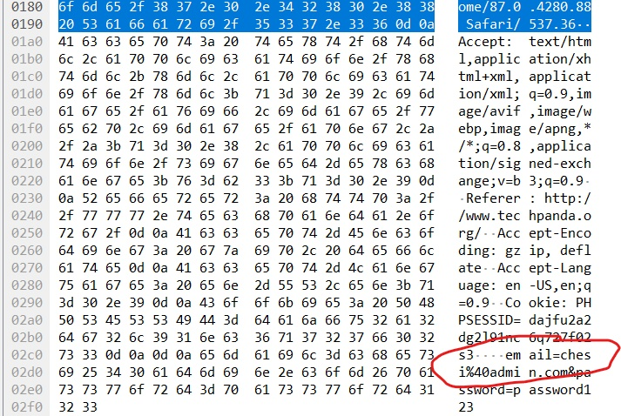

  - Finally in the below image the password of the user: password2020
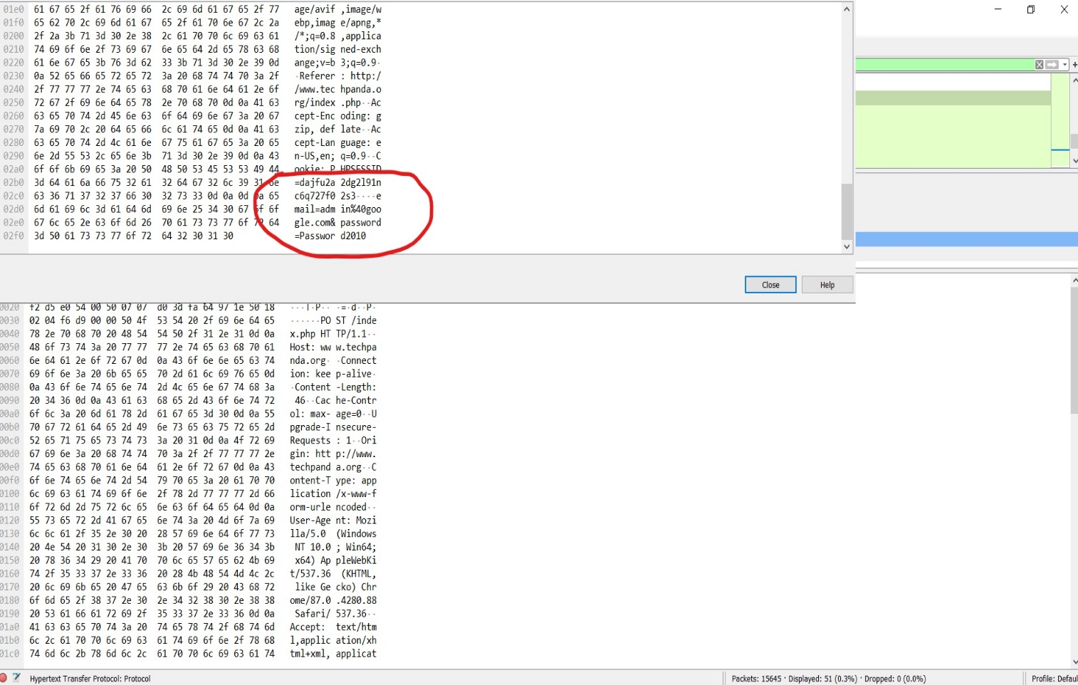

The identified vulnerabilities still exist within Chi Se’s networks at this very moment. Therefore, I recommend an urged review of cyber security within Chi Se and the immediate adoption of the below cyber security policy at a minimum.

Cyber Security Policy Chi Se
- Mission
At Che Si it is our daily mission to protect our systems and data as we recognise these are important assets and the framework our business operates on. We have therefore committed to this mission by developing a robust policy with will be revived by our CEO and board of directors on an annual basis.
- Scope
This policy shall cover but not be limited to:
- All customers of our business and every employee
- All end devices such as computers (private and personal), mobile devices (private and personal), all networks that engage with our main network ( private and personal)
- Homeworking and mobile working environments

- Needs analysis
A needs analysis has been carried out by our consultants with regards to cybersecurity in Che Si.
Key areas that cybersecurity deficiencies were found in both infrastructure, policy, and procedure.
To minimise the risk. We recommend the following for all mobile network access:

1a. MAC Address filtering.
All legitimate safe external devices have their MAC address added to a white list to gain access to Chi Se network. A MAC address is hard coded onto a device and cannot be changed. Those not on the list are blacklisted and blocked from the network.
2a. Two factor identification.
2FA, shall be enforced when users log onto the network. This means users will be prompted for 2 different types of ID to verify themselves such as their password and a number code, obtained from a different device such as a mobile phone. [3]

3a. User privilege access controls.
“User access: Access to processes, assets, and data should be provided strictly
based on the role and function.” [4]
Users will only be given access to the parts of the network they require for work; users will be blocked from accessing data that is not involved in their daily tasks. E.G the HR Department, will only be able to access HR documents, and the Billing Department, will be allowed customer accounts as well as billing, but not HR documents.
4a. Enforce strong passwords.
“In any organization, a strong password policy should prevail and check for Authentication, Authorization, and Accounting (AAA).” [5]
Strong passwords will be enforced across the network. Users will then only be able to create a strong password at least 16 characters and a mixture of numbers upper and lowercase and special characters. Users will be forced to change passwords monthly. WPA 2 password encryption shall also be enforced on any personal routers attempting to access the Chi Se network.
5a. VPN usage (virtual private network).
All external mobile connections should be routed through a VPN. A VPN provides an encrypted connection to a network and ensures all data in transit is encrypted and then decrypted at source. If any bad actor were to intercept data in transit in would show as a scrambled encrypted communication and would be unable to make sense of this. This is opposed to plan text communications which are unencrypted and form the basis of many data transfers on Chi Se’s network.
6a. Phishing and Vishing (types of social engineering attacks).
Phishing attack, which exploits social engineering to
leverage user’s trust by masquerading as communications from a trusted source” [4]
And a “Vishing (attack which) is the equivalent of phishing when conducted over the phone.” [5] We recommend that all staff attend quarterly training and awareness raising sessions on the latest social engineering attacks such as:
- Phishing
- Vishing
These attacks are changing in sophistication on a weekly basis and staff and users of the network need to be constantly updated. So, users may take the necessary precautions to prevent these attacks.

Other recommendations include:
- Robust anti malware software installed and implemented on the network
- Removable media controls: flash drives and other removable media should be blocked from computers in the main building unless a business case can be made for their use
- Software patches and updates to be updated on a regular basis.

- KPIs

Daily actions
- 2FA login to be used daily on all devices with new logins and all devices after 7 days of usage
- Access levels restricted
- Device filtering
- Encryption
- Complex passwords to be used

Monthly actions
- Passwords to be changed for 100% of employees

Quarterly actions
- Phishing and Vishing education and awareness training sessions for all employees.

In conclusion: the ability of networks to be accessed remotely creates a greater risk of cyber-attacks. Robust cyber security aims to reduce that risk. Less risks will manifest itself in less cyber-attacks against Chi Se. Considering the low standard of Cyber security currently it is fortunate not to have already suffered an attack. Cyber security risks can be highlighted by penetration testing. Seeking a qualified individual to conduct a mock attack on a network. Risks can be minimised by adoption and daily implementation of a cyber security plan Any policy needs to be updated constantly with regards to the ever-increasing growth and innovation of digital technology, which conversely carries with it ever increasing cyber security threats.
To keep up with this digital revolution, cyber security cannot stand still and must move on a regular basis to keep up with digital technology developments.

Bibliography

[1] Cisco Network Academy. Introduction to Networks Companion Guide (CCNAv7): (Companion Guide). Pearson Education (US). 2013.

[2] IEEE Standard Cybersecurity Requirements for Substation Automation, Protection, and Control Systems," in IEEE Std C37.240-2014 , vol., no., pp.1-38, 30 Jan. 2015, doi: 10.1109/IEEESTD.2015.7024885.

[3] B Guttman, E Roback. An Introduction to Computer Security: the NIST Handbook, Published October 2, 1995.

[4] Anonymous, NCSC. UK Government. 10 steps to cyber security. PUBLISHED17 November 2018, Version 1.0 https://www.ncsc.gov.uk/collection/10-steps-to-cyber-security/the-10-steps 04/01/2021

[5] Gold, S. Social engineering today: psychology, strategies, and tricks. Network Security, Volume 2010, Issue 11, 2010,Pages 11-14.

[6] A.Mukherjee, Network security strategies Continuous and Effective Threat Management. Published by Packt Publishing Ltd. First published: October 2020.

[7] N M Kaliyamurthy, Network and Cybersecurity Essentials Network Essentials: Building and Managing Networks, UWTSD 2020.

