Rental Car App – Group Project – Individual Report
By Justin Hendy
Software Design Evaluation
Before setting out to complete any functionality we decided upon our program design and layout. Having recently worked with repositories, models and service layers we decided the best course of action would be to continue working with this design methodology. The benefits were mainly surrounding the ability to work in parallel without having to deal with frequent merge conflicts as well as maintaining a clear structure over the various aspects of our code. Being an inexperienced software engineer I had some reservations about this implementation due to its heavy reliance on Object Oriented Programming concepts, of which I have little, to no experience of using and certainly have no more than a basic theoretical understanding, however, I was confident that I would be able to overcome these obstacles with the help from other team members and through the repurposing of existing code to complete any assigned features. I will now explain and evaluate our design in greater depth.
Using a layered design provided our software with a clear and concise structure whilst also abstracting away functionality or methods that would be repeatedly required or implemented throughout our software. All layer classes were grouped under four separate packages:
- Repositories
- Models
- Services
- Seams
Our Repositories layer manages the interactivity between any functionality or feature and the underlying data required to complete any tasks associated with said functionality or feature. Here we implement methods that define specific SQL commands that query the database depending on the need of the method being called. Whilst working in this layer I created several methods for our “VehicleRepository” including creating or adding a vehicle and deleting a vehicle. In each instance I would define a SQL command, extract any necessary variables from passed method parameters and then pass these variables into the SQL command and post the command to the database.
Our Models layer defines the data structures of our program and allows us to model and store data relating to the entities within our database, it essentially acts as a link between our underlying data and the rest of our program. I created two Model layers, “Vehicle” and “VehicleType”. Within the vehicle model I defined the instance variables in line with the column headings of our vehicle entity. These instance variables would then be called when implementing the “addVehicle” method within the VehicleRepository and are updated via inputted user values. Each Model layer would also contain specific methods to be used in conjunction with the object defined by the layer, most commonly this involved overriding the “toString” method so that, in the case of the Vehicle Model, we could display all the relevant data associated with a particular instance of that object on the console.
Typically, Service layers are used to contain any business logic or business rules associated with the application however in reality this didn’t happen. For the most part we just added methods to our service layer that then return values to our repositories with all the business logic being contained within our Seams layer. Using our structure, it would’ve been possible to pass a new vehicle to our “createVehicle” service layer method without a location being set, however this was not how we defined the business rules associated with creating a new vehicle. As stated previously this was accommodated within our Seams layer but this is not good practice.

Our Seams layer is where we added all methods for carrying out tasks within the app and would deal with user inputs and any associated outputs. I contributed to several seams specifically, “VehicleUserInput” and “UserInterface”. I added several methods to “VehicleUserInput” involving the creation/deletion of vehicles and the ability to search and display specific vehicles. To do this, several different service layers would be injected along with other Seams such as “Input” and “Output”. When creating a vehicle, a few instructions would need to be displayed or output to the console. These instructions would also need to call methods relating to location and vehicle type as these options are defined within other tables of the database. There would also be several user inputs collected relating to make, model and registration, these inputs would then be used to define a new vehicle object which could be passed back through our service and repository layers to our database. Search methods would typically ask for a specific search criterion and then display all returned instances of that particular entity. The “UserInterface” Seam contains all methods relating to the displaying of menus and ultimately allows for interaction with the app. It was at this point that the flow and shape of our app was implemented. Menu options would be output to the console, user inputs would then be passed to a switch statement and from there all relevant feature methods would be called. To improve useability we also added 1000ms sleep methods after each method call and before returning the user to the previous menu.
Overall, I found this design allowed for a great number of features and functionality to be added to our app in a very short space of time and as previously stated, kept merge conflicts to a minimum. I did feel that each new feature I added involved having to pick apart some existing code or at least discuss the issue with other team members before it could be implemented however this barrier did not prevent me from being able to contribute to the completion of this project.

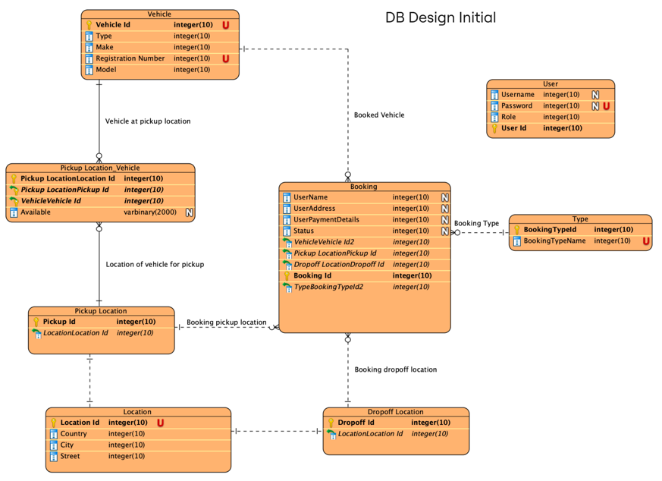
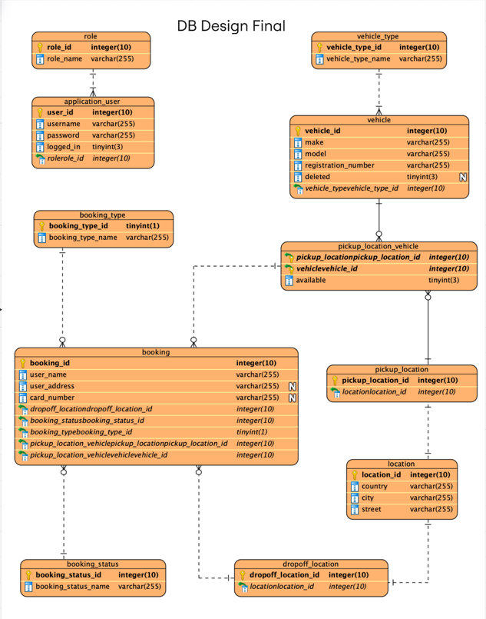
Database Design and Evaluation

The ERDs above demonstrate our initial database design and a revised final database design. The initial design was helpful as it allowed us to create SQL queries for table creation and begin connecting our Java program to our database. As we developed our app it became clear that we had moved away from our initial design and therefore produced an updated ERD on Wednesday.
I initially designed the vehicle table, I defined the unique vehicle ID as the primary key and then included all relevant fields taken from the spec – type, make, model and registration number plate. I later decided that vehicle type should be a predetermined list set by the business and as a result the vehicle type table was created with a one-to-many relationship between vehicle type and vehicle with a minimum cardinality of 1 as each vehicle must have a defined type. The vehicle type would then be included as a foreign key in the vehicles table. The initial SQL query also defined the primary key as a serial and therefore each new entity would be given a sequentially increasing ID number. All fields were also defined as not nullable apart from the later added “deleted” field. A vehicle would need to be added to a specific pickup location and therefore we had many-to-one relationship between vehicles and pickup locations. We used a pickup location vehicle table that would contain a vehicle ID and a location ID and an additional field to set availability of that vehicle. The availability would be determined by any bookings being placed with that vehicle or if the vehicle has been sold. Our location entity table is linked to the pickup location vehicle table via a pickup location table as not all locations have to be pickup locations. We also had a drop off location table that is links our location entities to our booking table. The booking table links to the following fields contained within a other entities - booking type, booking status, pickup location, drop off location and vehicle Id. Each booking generates a unique booking ID and this is set as its primary key, we also enter user name, user address and card number. We also have a table for setting user roles and creating users. Ideally these roles would then define specific user views but we were unable to implement this feature within the timeframe.
Overall, the design is relatively robust, allowed us to incorporate all features requested as part of the spec and the relationships make sense in terms of the needs of the database. We were unable to add any database tests and as previously mentioned we didn’t control which features certain users could access. Our data validation is also non-existent and, in most cases, where any validation is implemented the user is just returned to the home page upon entering incorrect values.

Individual Contribution & Reflection
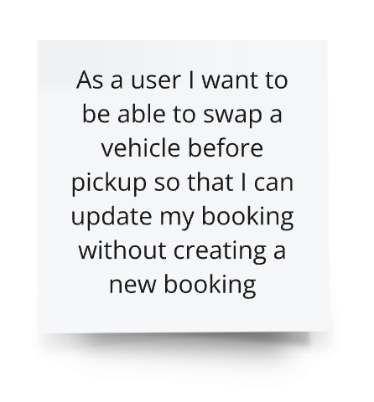
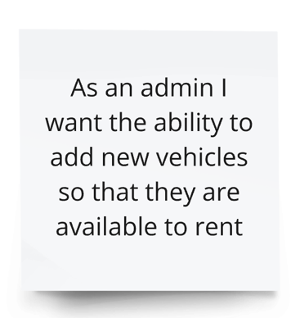
Below are the three user stories I’d like to discuss:
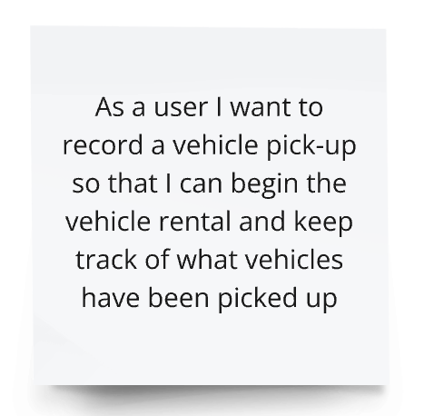

The main aim of recording a vehicle pickup is to change the booking type from a booking to a rental as the vehicle is now being used as an active rental. Within the booking repository is a method called “changeVehicleBookingType” which requires a booking and a booking type Id. In order to pass these values I added a method called “RecordAPickUp” to the “UserBooking” seam, this in turn displayed a list of all active bookings using the booking service method “getInProgressBookings”. From there the user is prompted to select a booking, this value is stored as a Booking variable called selected and is passed to the booking repository. The user is then prompted with a confirmation that they have selected the right booking, if they select “y” for yes then the selected booking ID variable and the integer 1 is sent to the booking repository so that the database can update the booking type from a booking (value 4) to a rental (value 1). The booking repository uses an SQL update query to set the booking type ID.
To add new vehicles I created a method within the vehicle repository called “addVehicle” which uses a SQL insert into query and pass a vehicle type ID, make, model and registration. These values are taken from the “VehicleUserInput” seam where the user is initially given a list of available locations. They are prompted to set the location first and then they’re prompted with a selection of vehicle types. After these two choices are set the user can enter the vehicle make, model and registration number. This method then passes the location to the location service method “createPickUpLocationVehicle” which requires a vehicle object and a selected pickup location. Finally the vehicle object created is also passed to the method “createVehicle” on the Vehicle Service layer which in turn passes the values to the vehicle table via the Vehicle Repository.
To swap a vehicle on a booking before a pickup has been initialised I used the “updateVehicleBooking” method on the Booking Repository which passes a pickup location vehicle Id to the database as well as a booking Id. To switch the availability of the car no longer being used as well as the newly selected car, two methods within the vehicle repository were also needed, “markAvailable” and “markUnavailable”. These two methods use SQL update queries to set the availability to true or false accordingly. All of these values are taken from the “ChangeBookingVehicle” method within the “UserBooking” seam. This method allows the user to see a list of active bookings, select the booking where they wish to amend the vehicle, confirm that they have selected the right booking, display a list of available vehicles at that location and then select the new vehicle. The method also tells the user if no vehicles are available at that location or if there are no active bookings.
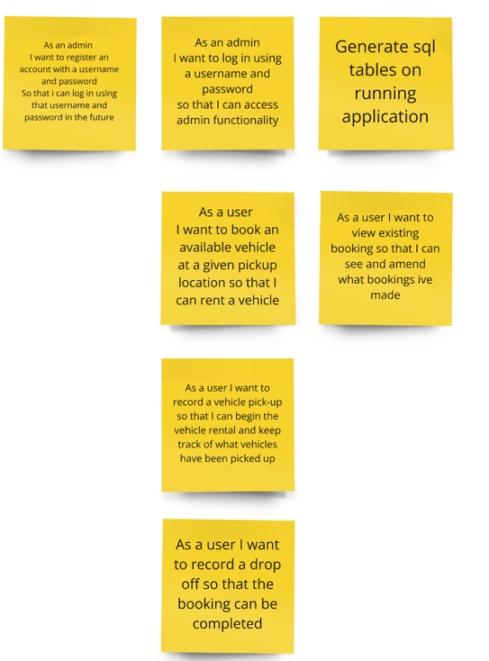
In order to complete this project we have implemented and used agile principles. This included daily standups, a sprint planning session, sprint retrospective and refinement of user stories.

Initially we set out a minimum viable product as above and we completed all necessary stories by midweek. The benefits of the agile sprint process are that each team member had clear features to complete and could take ownership of their user stories. User stories could easily be broken down into subtasks and the daily standups allowed for clear communication lines between team members. Given the timeframe, Waterfall may have been better implemented as a week does not allow for a great deal of iteration, I also felt the user points were generally moot as this type of work is new to many of us and we found it hard to gauge the level of difficulty for each ticket.

