

George Butcher

Principles of OME

UWTSD
OME

BEng
Academic Year: 2025 - 2029

Supervisor: Gareth Collett
Associate Supervisor: Dave Holley
Dec 2025

Academic integrity declaration
I declare that:
- the thesis submitted has been written by me alone.
- the thesis submitted has not been previously submitted to this university or any other.
- that all content, including primary and/or secondary data, is true to the best of my knowledge.
- that all quotations and references have been duly acknowledged according to the requirements of academic research.
I understand that to knowingly submit work in violation of the above statement will be considered by examiners as academic misconduct.

Abstract.
This assignment examines the importance of critical diameter and critical density in achieving reliable detonation within an explosive train. These parameters define the minimum geometric and material conditions required for a self-sustaining detonation. The performance characteristics of Lead Styphnate as a primary explosive and RDX as a secondary explosive are reviewed, with particular focus on their sensitivity, density, and detonation behaviour. The role of confinement in reducing critical diameter and improving detonation reliability is discussed, highlighting its practical benefits. The effect of density on detonation velocity is analysed, demonstrating that RDX exhibits increasing detonation velocity as density approaches maximum values, while Lead Styphnate operates within a narrow optimal density range. The assignment demonstrates how these principles effect an explosive train and reviews conditions for safe, reliable initiation.
Table of Contents
Academic integrity declaration 2
Abstract. 3
List of Figures 5
List of Tables 5
List of Abbreviations. 6
1 Introduction. 7
2 Explosive Types. 7
2.1 Primary Explosives – Lead Styphnate. 7
2.2 Secondary Explosives - RDX. 8
3 Critical Diameter and Critical Density. 8
3.1 Definitions. 8
3.2 Lead Styphnate – Critical Diameter and Density. 9
3.3 RDX - Critical Diameter and Density. 9
4 Explosive Train. 9
4.1 Diagram of the Fusehead Igniter. 10
4.2 Diagram of Full Explosive Train. 10
5 Effect of Confinement. 11
5.1 General Effect of Confinement. 11
5.2 Lead Styphnate. 11
5.3 RDX. 11
5.4 Importance of Confinement. 11
6 Density Effect of Detonation Velocity. 11
6.1 Lead Styphnate. 11
6.2 RDX. 12
7 Conclusion. 13
8 References. 15

List of Figures
Figure | Description | Page
1 | Diagram of the Fusehead Igniter | 10
2 | Diagram of Full Explosive Train | 10
3 | Graph Showing Effect of Density on Detonation Velocity for Lead Styphnate | 12
4 | Graph Showing Effect of Density on Detonation Velocity for RDX | 13

List of Tables
Figure | Description | Page
1 | Density to Detonation Velocity for Lead Styphnate. | 12
2 | Density to Detonation Velocity for RDX. | 13

List of Abbreviations.
ESD | Electrostatic Discharge
OME | Ordnance, Munitions and Explosives
RDX | Research Department Explosive

Introduction.
This assignment will explain why critical diameter and critical density are important for achieving successful detonation in explosives. Critical diameter and critical density determine whether an explosive can form a stable detonation, rather than simply burning or failing to react properly. Understanding these concepts is essential in Ordnance, Munitions and Explosives (OME), because they directly influence how explosive trains are designed and how reliably they function [1].
For this, one primary explosive (Lead Styphnate) and one secondary explosive (RDX), will be used. Lead Styphnate is commonly used in detonators because it is very sensitive and can be initiated by flame, friction, spark or electrostatic discharge. RDX is used as a secondary explosive, it is a lot more powerful, however it is less sensitive, meaning it needs a lot more energy to detonate [2], [3].
This assignment will compare the performance characteristics of both explosives, discuss their critical diameters and densities, and explain how the detonation transfers from the primary to the secondary explosive. These factors are important to an explosive train design, as failure to meet them can result in misfire, low-order detonation, or deflagration rather than detonation. It will also look at how confinement can change these values and why this is helpful in an OME environment. Finally, it will show the effects on detonation velocity by changing the density [1].

Explosive Types.
Explosives used in initiation systems are commonly categorised as primary or secondary explosives based on their sensitivity and role within an explosive train. Primary explosives are very sensitive and can be easily initiated by heat, friction, impact or a small electrical spark. Secondary explosives are much less sensitive and can’t be initiated very easily, but they are a lot more powerful and produce a stronger detonation. For this reason, a primary explosive is used to provide the initial shock, and a secondary explosive is used to provide the main explosion. Using both types together ensures that an explosive device is safe to handle but still detonates reliably when required [2], [3].

Primary Explosives – Lead Styphnate.
Lead Styphnate, also known as lead trinitroresorcinate, is one of the most common primary explosives used in military and commercial applications. It is used in percussion caps, small arms ammunition and detonators. Lead Styphnate is used because it is sensitive enough to be initiated by heat, impact or spark, however its stable enough for manufacture and storage [2], [5].
At the industry standard density (1.5-1.6g/cm³) Lead Styphnate has a detonation velocity of around 5.2 km/s. Its detonation velocity is lower than that of secondary explosives, however the rapid pressure rise and high sensitivity make it ideal for initiating less sensitive materials. It is particularly sensitive to heat, friction and electrostatic discharge (ESD), which means that even a small stimulus can initiate it, leading to detonation. Because it is often used in very small quantities, it has little gas output, but the pressure pulse it generates is sharp and strong, which is ideal for initiating secondary explosives [5], [13].
Lead Styphnate can also be affected by its crystal size and manufacturing conditions, which can change its sensitivity and performance slightly, but it remains a reliable choice for the first stage of an explosive train.

Secondary Explosives - RDX.
RDX is one of the most widely used secondary explosives in both military and commercial applications. It is a nitramine explosive with a high nitrogen and oxygen content, which gives it a large amount of stored chemical energy. RDX is classified as a secondary explosive because it is a lot less sensitive and requires a detonator or booster to initiate [1], [4].
At high density (about 1.80 g/cm³), RDX has a detonation velocity of around 8.75km/s. RDX has a high detonation pressure, which is why it is commonly used in warheads, demolition charges and plastic-bonded explosives [6].
RDX is relatively stable under normal storage conditions and doesn’t detonate when exposed to fire or small-arms fire; instead, it tends to burn unless it receives a strong shock. This makes it safer to handle, but it also means that reliable initiation requires a properly designed explosive train and sufficient energy from the primary explosive.

Critical Diameter and Critical Density.

Definitions.
Critical diameter is the smallest diameter of an explosive charge that will allow a detonation to keep going once it has started. If the diameter of the explosive is below the critical diameter, the shockwave loses energy out of the sides faster than the chemical reaction can replace it. When this happens, the detonation dies out and the explosive may only burn or partially react instead of fully detonating [7], [10].
Critical density is the minimum density an explosive needs to be to before it can detonate properly. If an explosive is too loosely packed or full of air gaps, the detonation wave cannot pass smoothly through it. These empty spaces interrupt the reaction, causing the detonation wave to weaken and possibly fail [12].
Both properties depend on the explosive used, its grain size, its microstructure and the conditions under which it is being used. Studies on high explosives show that grain size and structure can have a strong effect on critical diameter and detonation behaviour. Critical diameter and critical density are both parameters that describe threshold conditions for detonation and are therefore design constraints rather than performance optimisation variables [7], [8].

Lead Styphnate – Critical Diameter and Density.
As a primary explosive, Lead Styphnate has a very small critical diameter, often less than 1 mm, because of its high sensitivity and fast reaction rate. This allows it to detonate reliably in the very small diameters, like the ones found in primer cups and detonators. It is normally pressed to a density of around 1.5–1.6 g/cm³, which ensures that its performance is consistent and that it produces the required shock wave [2], [11].

RDX - Critical Diameter and Density.
RDX has a significantly larger critical diameter. For pressed RDX, unconfined critical diameters are typically in the range of 3–5 mm, depending on density and grain size. Its effective critical density is around 1.40 g/cm³. Anything below this value, the detonation becomes less reliable as voids and air gaps will be produced [7], [8].
For RDX, the detonation velocity and the critical diameter are linked to the internal structure of the explosive. Finer, more uniform grains and higher densities lead to more reliable detonation and give higher detonation velocities. The effect of density on detonation velocity can be seen in Table 1 and Figure 3 below. This is useful because it places constraints on munition design. In practice, RDX charges that fall below this diameter and density present a high risk of low-order detonation, which is unacceptable in military and commercial environments.

Explosive Train.
In an explosive train, a small stimulus (for example, a firing pin strike, an electrical signal or heat) is used to detonate the sensitive primary explosive. This will then produce enough energy to detonate of secondary explosive. For this example, an electrically initiated fuse head igniter with the priming charge of Lead Styphnate and a base charge or RDX will be used.
To initiate the detonator an electrical fusehead igniter will be used. A fusehead igniter is a small electrical starter used in detonators. It has two lead wires and a tiny bridgewire mounted on an insulated strip. When electricity passes through the bridgewire, it heats up and ignites the ignition coating which then ignites the flash coating (Lead Styphnate in this example). These coatings act like a miniature match-head and produce a hot flash that ignites the priming charge (Lead Styphnate). As shown in Figure 1.
Once the priming charge detonates, it creates a high-pressure shock wave. This shock wave travels into the RDX pellet and compresses it. Under sufficient pressure, small hot spots form in the RDX due to local heating, plastic deformation and friction. If these hot spots are strong and numerous enough, they grow into a fully developed detonation wave in the secondary explosive [10], [11]. As shown in Figure 2.
For this transition to occur reliably, three conditions must be met. The RDX must be at or above its critical density (1.40 g/cm³ or higher), the RDX charge must be larger than its critical diameter and the shock pressure from the Lead Styphnate must exceed the critical threshold for detonation in RDX. If any of these requirements are not met, the RDX may only burn, partially react, or fail to detonate. This makes the pellet size, density and confinement essential when designing a munition [10], [11].

Diagram of the Fusehead Igniter.
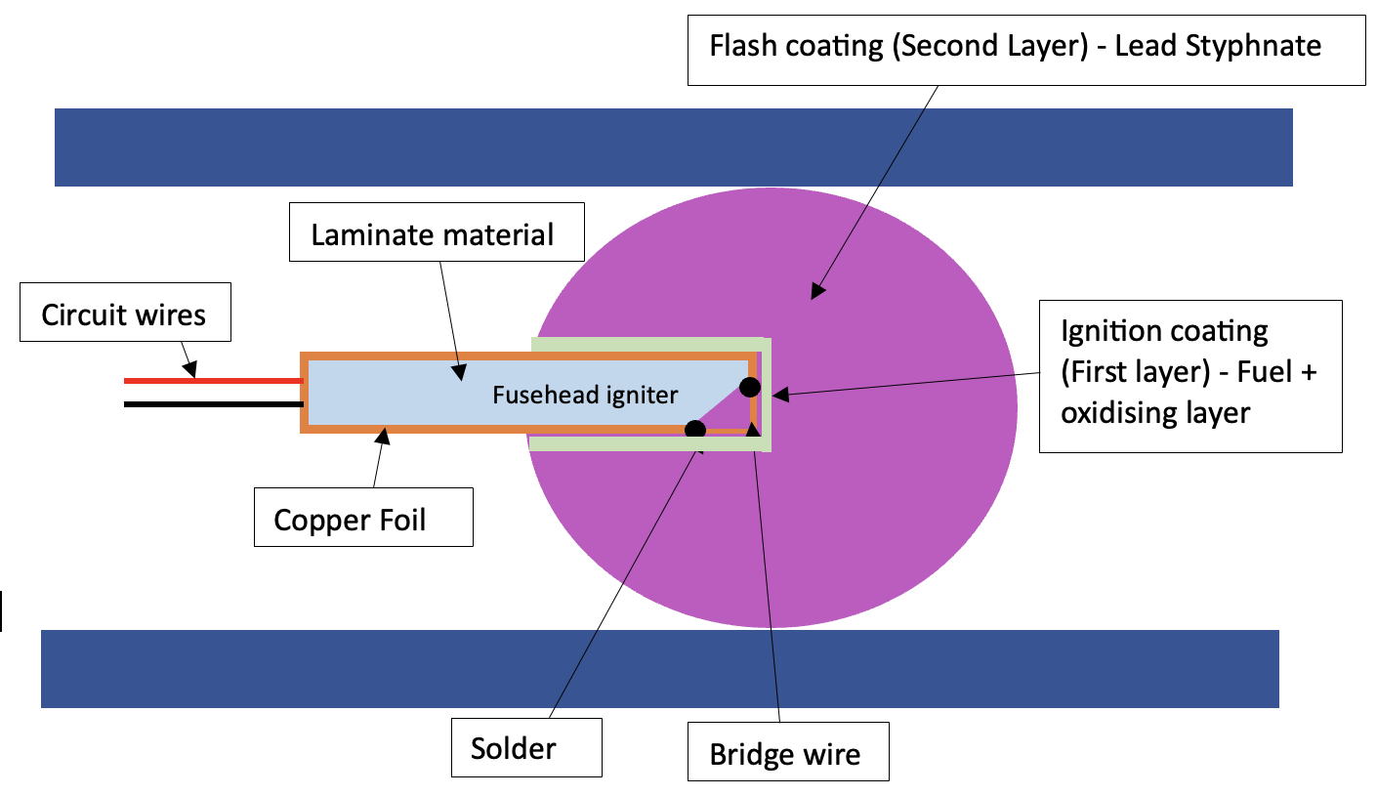Figure 1 - Diagram of the Fusehead Igniter.

Diagram of Full Explosive Train.
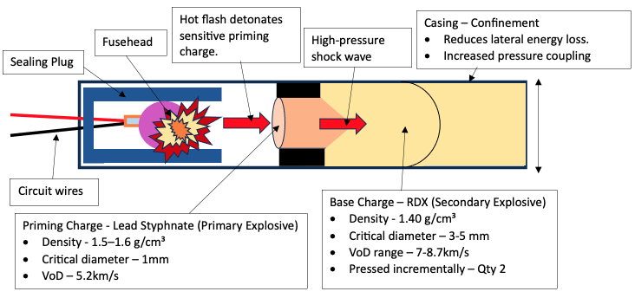
Figure 2 – Diagram of Full Explosive Train.

Effect of Confinement.

General Effect of Confinement.
Confinement is how tightly an explosive is held or enclosed by a container, casing, or surrounding material. Increasing confinement of an explosive reduces lateral energy loss and increases the pressure in the reaction area. As a result, confinement usually lowers the critical diameter and can improve the reliability of detonation. By confining an explosive, it can allow detonation at diameters that would fail in an unconfined state [1], [4], [10].

Lead Styphnate.
Unconfined Lead Styphnate may sometimes burn or give an incomplete reaction if it is not confined. However, when pressed into a primer cup or detonator, it detonates much more reliably. This give Lead Styphnate a confined critical diameter of <1mm. The confinement keeps the pressure high and channels the output energy into the secondary explosive [11], [13].

RDX.
RDX benefits greatly from confinement. With strong confinement, the critical diameter can be reduced well below its unconfined value. This gives RDX a confined critical diameter of around 1-3mm. This allows designers to use relatively small pellets of RDX, while still achieving reliable detonation [1], [2], [7], [8].

Importance of Confinement.
For OME environments, understanding confinement is important for several reasons. It helps in designing reliable explosive trains, where each stage behaves as expected. It supports safety assessments, as accidental detonation is a lot less likely in unconfined or low-density situations, but more likely under tight confinement. It also informs decisions about storage, transport, disposal and operational use, where confinement conditions may change.

Density Effect of Detonation Velocity.

Lead Styphnate.
The density of Lead Styphnate influences how it behaves during initiation. For Lead Styphnate, density mainly affects reliability and sensitivity. At low densities (below 1.40 g/cm³) the material contains air gaps, which prevents a stable detonation wave from forming. This can result in the Lead Styphnate burning or giving a weak reaction rather than detonating. At normal operating densities of around 1.50–1.60 g/cm³, Lead Styphnate produces a reliable, consistent shock wave and reaches its typical detonation velocity of around 5.2–5.6 km/s. If it is pressed too tightly (1.65–1.70 g/cm³), the material can become desensitised and may fail to initiate. This shows that, there is an optimal density range for reliable performance rather than a performance increase with higher density [5], [13].

Density (g/cm³) | Detonation Velocity (m/s)
1.20 | 4700
1.30 | 5000
1.40 | 5200
1.50 | 5400
1.60 | 5600
1.70 | 5300
Table 1 - Density to Detonation Velocity for Lead Styphnate.
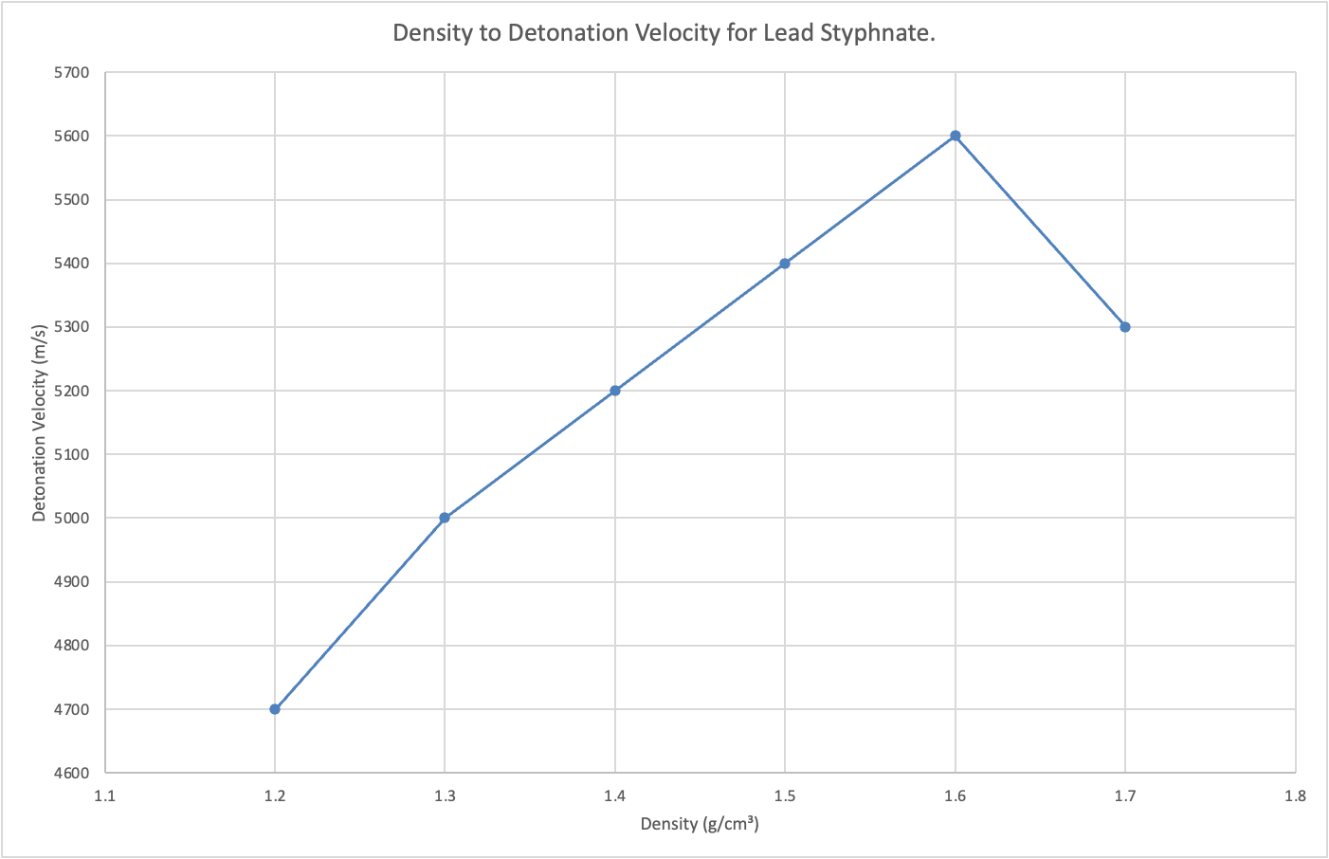
Figure 3 - Graph Showing Effect of Density on Detonation Velocity for Lead Styphnate.

RDX.
The detonation velocity of RDX is strongly affected by its density. Data from open literature and technical reports show that as density increases toward the theoretical maximum, detonation velocity increases significantly [4], [6], [9]. Typical values are:
Density (g/cm³) | Detonation Velocity (m/s)
1.10 | 5000 - 6000
1.30 | 6500
1.40 | 7000
1.60 | 7800
1.75 | 8500
1.80 – 1.82 | 8700 - 8750
Table 2 – Density to Detonation Velocity for RDX.
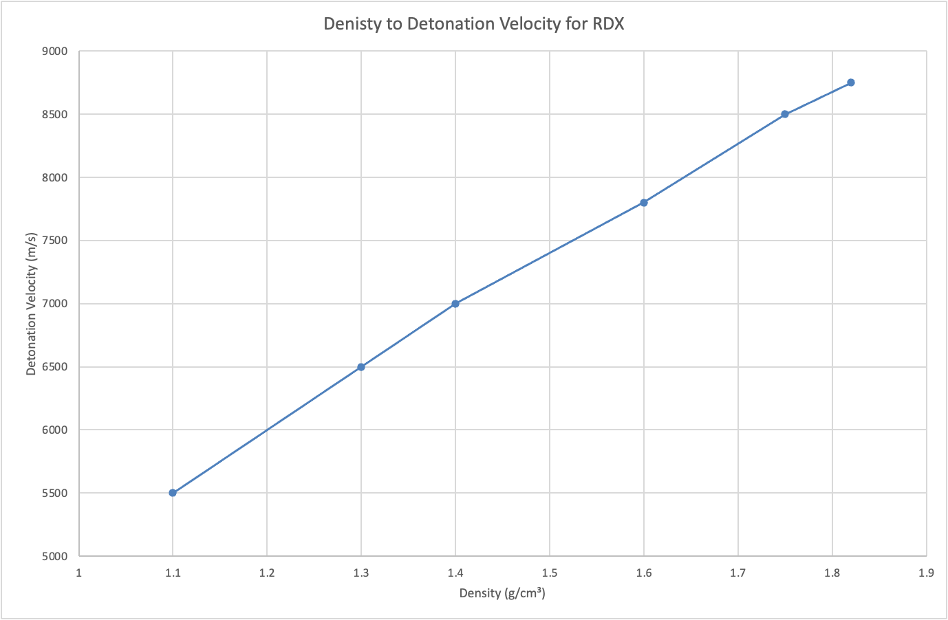
Figure 4 – Graph Showing Effect of Density on Detonation Velocity for RDX.
When RDX is at higher densities, there are fewer voids inside the explosive, which improves how the shock wave couples into the material and how the reaction area develops. Both density and grain size influence detonation velocity for RDX, with denser and more uniform grain size leading to faster and more stable detonation. However, very high densities can make RDX pellets more brittle and difficult to manufacture, so in practice a compromise density is often chosen that balances performance, safety and manufacturability.

Conclusion.
In conclusion, critical diameter and critical density are important characteristics in understanding whether an explosive will detonate successfully. Lead Styphnate, as a primary explosive, has a very small critical diameter and high sensitivity, making it ideal for the first stage of an explosive train. RDX, as a secondary explosive, has a larger critical diameter and requires higher density and a strong input shock, but provides much greater explosive power.
The transition from Lead Styphnate to RDX in an explosive train depends on the shock pressure, the density of the RDX and the charge diameter. Confinement plays a major role by reducing critical diameter and improving detonation stability. For OME professionals, understanding these relationships is important for designing safe, reliable explosive trains and for managing explosives during storage, transport and operational use [2].

References.
[1] P. W. Cooper, Explosives Engineering. New York, NY, USA: Wiley-VCH, 1996.
[2] UK Ministry of Defence, JSP 333: Service Textbook of Explosives, Issue 5. United Kingdom: MOD, 2020.
[3] A. Bailey and S. Murray, Explosives, Propellants and Pyrotechnics, 2nd ed. London, UK: Brassey’s, 1989.
[4] S. Fordham, High Explosives and Propellants, 2nd ed. Oxford, UK: Pergamon Press, 1980.
[5] J. J. Sabatini, A. K. Kettner, and J. C. Owens, “Recent advances in the synthesis of high explosive primary explosives,” Crystals, vol. 6, no. 1, p. 5, 2016.
[6] E. Bearzi, “Properties of Selected High Explosives,” Los Alamos National Laboratory, NM, USA, Tech. Rep., 1995.
[7] S. G. Khasainov, “Influence of the grain size of high explosives on critical diameter,” Combustion, Explosion, and Shock Waves, vol. 33, no. 1, pp. 84–91, 1997.
[8] N. P. Satonkina et al., “Influence of the grain size of high explosives on critical diameter,” Scientific Reports, vol. 9, no. 1, p. 13492, 2019.
[9] V. Bellitto et al., “Influence of microstructure on detonation velocity,” Propellants, Explosives, Pyrotechnics, vol. 43, no. 2, pp. 153–162, 2018.
[10] N. K. Bourne, Shock and Detonation Physics. Cambridge, UK: Cambridge University Press, 2022.
[11] U.S. Army Materiel Command, AMCP 706-179: Explosive Trains. Washington, DC, USA, 1965.
[12] J. H. S. Lee, The Detonation Phenomenon. Cambridge, UK: Cambridge University Press, 2008.
[13] National Oceanic and Atmospheric Administration, “Lead Styphnate,” CAMEO Chemicals. [Online]. Available: https://cameochemicals.noaa.gov/chemical/11739

