SOFTWARE AND HARDWARE DISASTER RECOVERY PROJECT CONTROL

Assignment 3: Final Project report

Name: Said Ahmed
ID Number: P150856
Programme: BSc Computing Portfolio
Lecturer: Sue Maw
Module: Project Management
Submission date: 25/1/2019

Contents

1 INTRODUCTION 4
2 RISK MANAGEMENT 4
2.1 Risk identification 5
2.1.1 Schedule Risk 5
2.1.2 Cost Risk 5
2.1.3 Performance Risk 5
2.2 Risk analysis 6
2.2.1 Risk assessment Matrix 6
3 SUSTAINABILITY ISSUES 7
3.1 Sustainably designed for the DVLA backup system 7
3.2 Using Network system to reach sustainability goals 7
3.3 Creating a sustainable for Project environment 7
4 ETHICAL AND LEGAL ISSUES 7
4.1 Security Liability 8
4.2 Privacy 8
4.3 Data Gathering 8
4.4 Access Costs 9
4.5 Digital Ownership 9
4.6 For the Brexit 9
5 QUALITY ASSURANCE ISSUES 10
5.1 Safety 10
5.2 Satisfaction 10
5.3 Productivity 10
6 CONCLUTION 10
7 APPENDICES 11
7.1 Demo: Packet tracer for testing 11
7.2 PID table Update 12
8 REFERENCES 15

INTRODUCTION
This final project explained how to progress the perfect concept of quality and quality management, and explains in details the role quality plays in project development. Also explained the risk management for the Third Sector project with sustainability issues and Ethical and Legal issues for Driver and Vehicle Licencing Agency (DVLA).
The DVLA offer an online services for the United Kingdom drivers and vehicles as a part of the duties to make sure keep decent records for the driver in medical situations, vehicles registration certificate, help police department for any crime from the drivers, also issuing driving licences ID card from the central office in Swansea. [1]
However, the whole system will go down or broken when the natural disaster occurred, so that will cause for the failure of software, hardware and all network system in general. So, without a good backup strategies nothing will work as normal.
In order to avoid any natural disaster must come and think the best and decent alternative means for the all network system to function as normal and restore data without any failure or interruption, the high speed Local Area Network (LAN) and Wireless Local Area Network (WLAN) communications such as data, voice and video to run as normal like nothing happen.

RISK MANAGEMENT
The main point to consider when doing any project should look for the risk management, so this is the method of analysing, identifying and then take an action of any risk that appears over the cycle life of the project to make stand firmly on path and focus achieved on its goal. This part is playing a huge role in a project management; it should include in a project plan in order to find out any risk happen and the best ways to control them.
So, Risk are category in two part either negative or positive. Where negative risk involves to damage the main aspect of the project while positive risks are the big chances to lead the project in to benefit and best achievement. [2]

Risk identification
The risk should identify first and then resolve, can’t solve any risk without knowing what it is, the collecting data is very important and then follows through the steps to finalise it. Risk in a project comes in to different categories, just as explained below:

Schedule Risk
If the project takes longer to complete out of the plan scheduled so that make the schedule risk. This sometimes can cause to happen for cost risks, because normally the longer of the project takes, the cost increase will be. If the project fail to complete on time that makes the entire system to be change. Is caused of either equipment delays, information delays, or management pushes too much, also sometimes by not enough workforce as delayed to finish this project on time for the lack of the group member participated, that makes to postponed for this DVLA disaster recovery project.
One of the technique used to analysis schedule risk is Gantt chart, that used for the purpose of plan the DVLA project activity and showing the time period of work scheduled to be finish also with the current status. [3]

Cost Risk
Is a risk when the project cost more than actually budgeted. It can cause to happen for a performance risk, if cost spread over cause to decreases in quality or scope. For DVLA project, the cost expected to change than planned before because of the new idea raised for building good infrastructure for the main purpose of overcome any natural disaster occur.
Cost risk can sometime make happen for schedule risk, this because when not enough money available to finish the project that can lead to extended the all project. [3]

Performance Risk
This happen when finalised the project either in testing or project performance in general, fails to function or fail to meet the standard requirement for the business project such as using packet tracer software for testing for the DVLA hardware and software disaster recovery project. The devices system failed to ping and communicated each other, that made to check each device IP address if assign in logical order and at the same time problem of technical issues happened that lead to the cost and schedule risk, so the cost and duration increased. [3]

Risk analysis
According for the project this included different of natural disasters risk that can happen anytime without knowing, all of these disaster are serious. Below is the main natural disasters risk and the strategies on how to manage them:
Risks | Strategies used to manage these risks
Earthquake | A remote server is applied on the iCloud.
Flooding | Server room is on upper floor and a backup remote server in Bristol.
Heavy snowfall | Automatic connection to the Bristol server for the normal function
Hurricane | A quick iCloud internet for the purpose of the clients to access the services as normal
Severe rains | Notification technology designed to contact with the Bristol backup remote server.

Risk assessment Matrix
Below is the table explained on how the probability of the risks for this project:
RISK LIKELIHOOD | RISK LEVEL | RISK IDENTIFICATION CATEGORY
IMPROBABLE | LOW | COST RISK
POSSIBLE | MEDIUM | PERFORMANCE RISK
PROBABLE | HIGH | SCHEDULE RISK

SUSTAINABILITY ISSUES
When term sustainability means balance the level or maintain it, for this project should focus more on how the use of IT facilities for the economic and environment issues. The points explained below on how the sustainable for the DVLA:

Sustainably designed for the DVLA backup system
Should focus more on where the new backup server can be build and make sure the system design cannot effect environment in any ways. The environment and social risk related through the life cycle during the construction for the new backup server in Bristol. When selecting machines such as computers, router, switch, firewall and servers that made sure choose the high standards product for the reduced [4] environmental impact.

Using Network system to reach sustainability goals
Network systems can contribute to progress the performance of sustainability of the DVLA Company. The energy used in an implementing process for the entire system should be low to reduce the cost and even the pollution for the environment impact.
The network system used is for the communication in daily routine of the any disaster happen within the system. [4]

Creating a sustainable for Project environment
DVLA new backup project will benefit the company by making entire Project more sustainable. The low of energy used in a project, good strategies for recycling the wasted materials after the project all for the one focus of lowering energy consumption, recycling for guaranteeing usable inside system are one of the several benefits. [4]

ETHICAL AND LEGAL ISSUES
As Information technology become powerful these part is similarly related to many thing within this sector, below is the five most ethical and legal issues for the DVLA project:

Security Liability
Security systems for network system are through electronics for the aim to keep safe important assets and vital information. Though, this helped to maintain a good security for the DVLA system for the new project backup because for the best design and technology used for the any disasters happen in a main office. All systems security got essential risks, which means it is a question of what risks are suitable and what choices can be lost. Initially, at the same time for the creation of a good security system and ethical to active that need to balance the risk. [5]

Privacy
The data of most of people now days spread all over in digital platform world. Even known to be secure but at the same time the fraud people can have access of them such as hacker can go direct to the private account for the stole of personal data and even sometime money. Most of employers usually check their employees’ computer for daily task performed. So for this project focused more for the client personal identification information records, to make sure even in any disasters happen all the customer privacy is secured to the backup server and can have access any time needed. Also implemented a better firewall to manage and control and stop any threat comes in a network. For the United Kingdom the data protection comes into force by 25 of May 2018, after a two years of transition period [5]

Data Gathering
For DVLA the United Kingdom government has the authority to monitor all customer for making a better security, if the customer passed all the test for driving should have the identification card license or if any the UK driver make accident or drive roughly straight the police will have access for any driver break the law. This project designed good system for collecting data without lost them by implement a backup ISP provider for making sure no internet connection lost for the data monitoring in different area.
The entire communication aspect either by voice, data or video will be collect and stored in a special backup servers in Bristol for the future and continuously service provided by DVLA. [5]

Access Costs
For the DVAL customer to have access with UK licence should pay and apply and pass theory test and practical test. But as long already hold a licence can access online service at any time. The customer aware for the cost applied for the licensing conditions with the application process of the United Kingdom driving licence.
These matters are important for everyone needed for a full licence because can actually help describe a legal and ethical code for the coming generation. [5]

Digital Ownership
The digital ownership will continue to be belong for the DVLA and that will remain stored securely to the system for the purpose of any future references but the customer will have a right for the information ownership of their identification card. For this project the main point implemented is in electronic technology to make sure all right remain for the company for generates and stores information through any system failure.
To finalise this point, all copyright remains for the driving vehicle licence agency (DVLA). [5]

For the Brexit
In Europe, they are building a Digital Single Market. Is planned to provide the assurance wanted for the General data protection regulation (GDPR). For the good long term relationship have with Europe the deadline for partnerships deals will be on 29 March 2019.
For this project hopefully the data protection regulation will not change that for the main benefit of the citizen who have a UK driving licence and live in Europe and for Europe citizen who live here because each countries will have their own company authorities for the data protection but will be in one general data protection regulation. And that will make a good digital society. [6]

QUALITY ASSURANCE ISSUES
This is for the DVLA to achieve the standard service of the backup required, should done by a high standard for the point of provide good quality to the company and customer as well.
This confirms that the methods, systems, techniques and procedures are planned for project are applied correctly. Quality assurance confirms the processes of create and manage tasks is delivered and function well.

Safety
This undertake the level risk of harm environment, system, and people surrounding. So the project plan should follow the proper ways of not causing any effect and for the all system safety till completed the project in a testing area.

Satisfaction
At the end of the project the main point is the satisfaction for the DVLA Company and also to meet the standard of user requirement, so all part should be happy.

Productivity
To avoid using unnecessary components or tools and use the main one such as firewall for the best security on entire system, that can lead in to achievable project goals with the good security implementation.

CONCLUTION
This report has explained about the software and hardware disaster recovery control project with the research for the risk management, risk evaluation matrix for the risk identification and strategies on how to manage those risk. Also it explained the most ethical and legal issues included the possible outcome for the brexit for the general data protection regulation, sustainability issues and quality assurance issues.
The recommendation on this report are on two points, the ethical and legal issues is the important part to look more on it, will help to identify the right for the customer and DVLA copyright and to implement more for the privacy because that the main thing to consider for the data protection. Also to understand risk management in general because that needs time to identify risk and analyse it, this will make the entire system project to finish in a good order without delay.

APPENDICES
Below is other screenshots for this module for the demo and update plan performed during lectures.

Demo: Packet tracer for testing
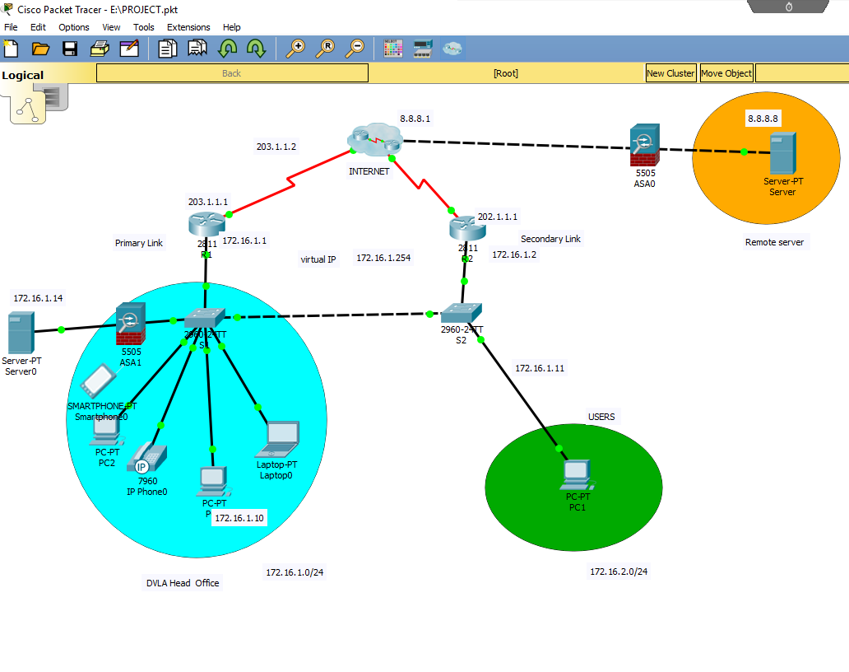

PID table Update
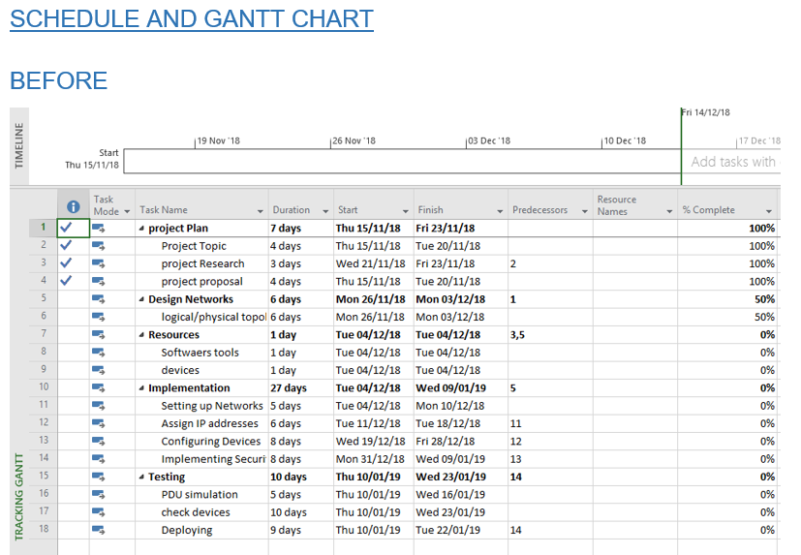
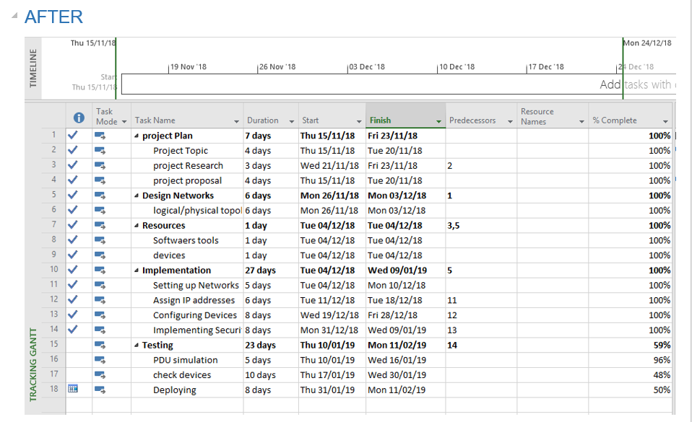
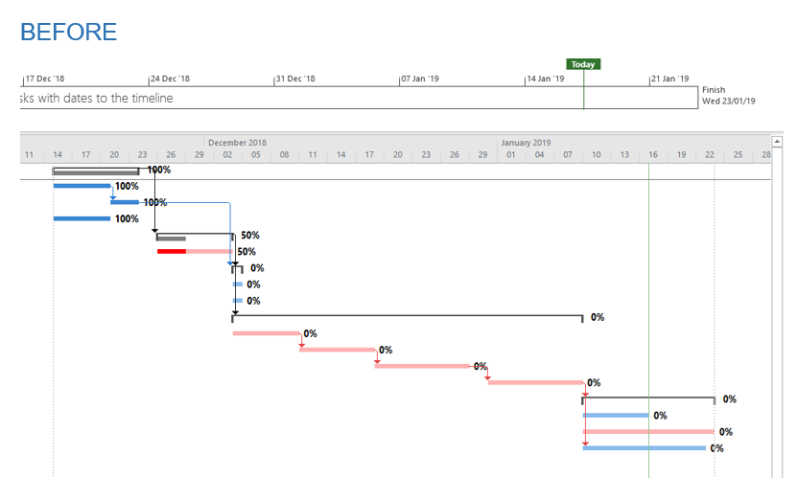
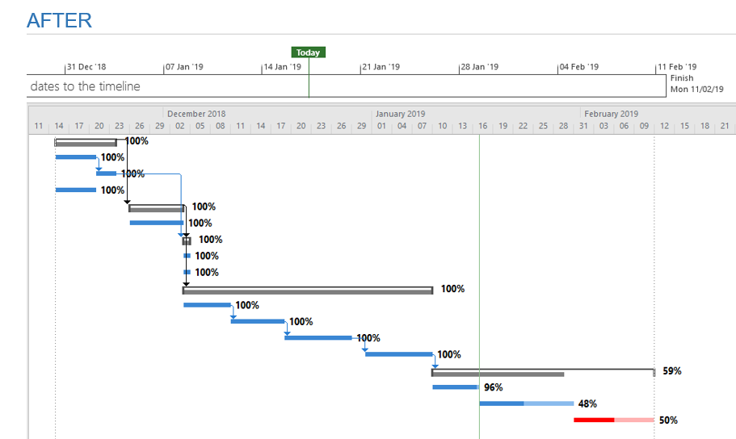
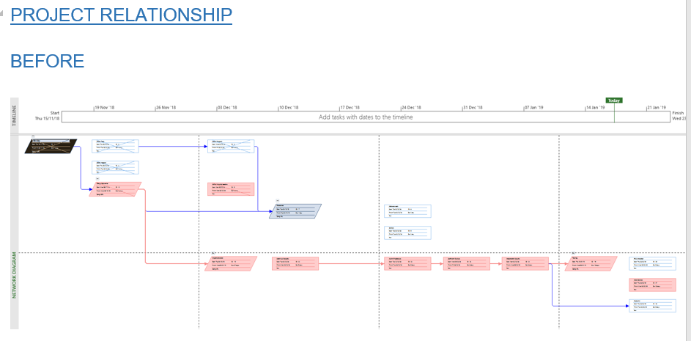
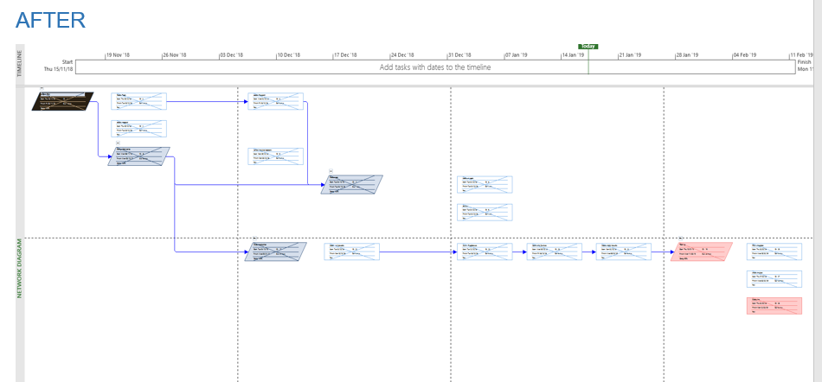

REFERENCES

[1] | “Department of Transport,” [Online]. Available: https://www.gov.uk/government/organisations/department-for-transport/about.
[2] | S. Ray, “The Risk Management Process in Project Management,” 19 October 2017. [Online]. Available: https://www.projectmanager.com/blog/risk-management-process-steps.
[3] | “Outcome 1: Project Management Principles,” [Online]. Available: https://www.sqa.org.uk/e-learning/ProjMan01CD/page_09.htm.
[4] | “About Sustainable IT,” [Online]. Available: https://tcocertified.com/sustainable-it/.
[5] | “5 Legal and Ethical Issues in IT,” [Online]. Available: https://www.bestcomputersciencedegrees.com/lists/5-legal-and-ethical-issues-in-it/.
[6] | “Navigating Brexit and GDPR,” 6th October 2016. [Online]. Available: https://www.bcs.org/content/conBlogPost/2612?utm_source=British%20Computer%20Society&utm_medium=email&utm_campaign=7611269_Brexit%20Bulletin.

