Electronics Assessment – Fundamentals of Electrical and Electronic Systems

Author: Joseph S. Rula (2317963)
University of Wales Trinity Saint David
Course Code: ACDA 4018
Instructor: Mr. Stalin Jacobs
Due: 22nd July 2024 1500hrs

Electronics Report – Fundamentals of Electrical and Electronic Systems
Contents
1.0 Introduction: 3
2.0 - Explicit Circuit Description and Explanation 3
2.1 - Astable Multivibrator 3
2.2 - 555 Timer Integrated Chip 4
2.3 – Calculations needed for the realisation of this circuit 5
3.0 - Creating the circuit in simulation software ‘Proteus’ 6
3.1 – Digital Simulation of the Circuit using an Oscilloscope 6
4.0 - How the Circuit was made and tested on a Breadboard 9
4.1 – Visual breadboard testing 10
4.2 – Oscilloscope breadboard testing 11
5.0 - Conclusion 12
Bibliography 13
Table of Figures: 13

Introduction:
This 555 timing circuit is a regenerative switching circuit, more specifically an Astable Multivibrator, which automatically and autonomously switches output without any additional input. These are used in this particular circuit to flash LED’s in sequence, though they can be used for any purpose where an alternating signal is required, such as a two tone siren.
In this circuit there is usage of this Integrated Circuit (IC), being the 555 Astable Multivibrator Chip, alongside other simple components in order flash LEDs. The circuit was first designed in a software called “Proteus”, once an understanding of the circuit was achieved it would then be constructed using a breadboard and simple components; such as resistors, capacitors, and LEDs. This circuit will then be tested using an oscilloscope whilst being powered by a table top power supply emanating a Vcc of 9V, Vcc meaning a positive supply of Voltage [1]. The waveform will then be recorded an analysed.

2.0 - Explicit Circuit Description and Explanation

2.1 - Astable Multivibrator
An Astable Multivibrator is an Integrated Circuit (IC) that when provided with power continuously and autonomously generates a square wave output.
A Multivibrator can be either Monostable, Bistable or Astable. [2]
Monostable is defined as having only one stable state, either HI or LOW, and can be temporarily changed to the other state upon receiving stimulation, once it is no longer stimulated it will return to its default state. An example would be a red “STOP” button on a bus.
Bistable is defined as a having two stable states, HI and LOW, and can be changed to either state and will hold its position there until stimulated into changing state. An example would be a light switch.
Astable is defined as having no stable state, and continuously switches between the HI and the LOW state at a regular interval, creating a square waveform. It does this without any input and is entirely caused by internal components in the Integrated Circuit (IC) provided it is being supplied with continuous power. An example would be a siren.
A Multivibrator can be defined as any circuit that produces a non-sinusoidal waveform as an output [2].

2.2 - 555 Timer Integrated Chip
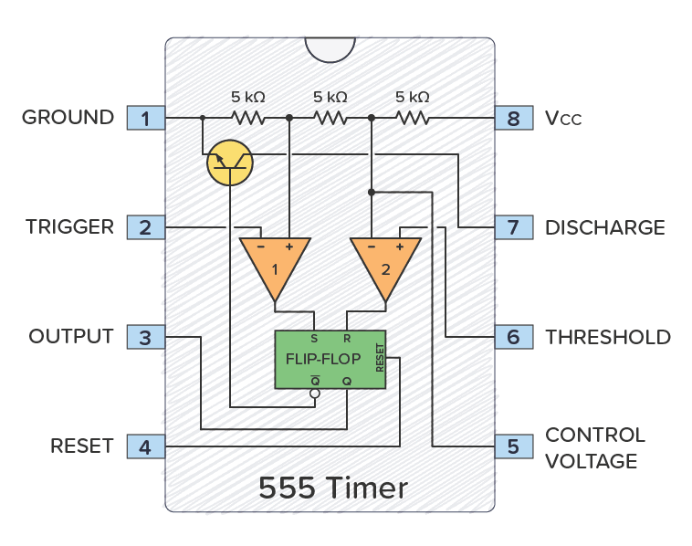
An Integrated Chip (IC), also known as a microchip, is a smaller circuit etched onto silicon and encapsulated in plastic that is used within a larger circuit. The main purpose for the usage of an Integrated Chip is the size and cost savings. Microchips, when ordered in large number, have a lower cost per part than assembling the same circuit at the larger scale with discrete components [3]. Creating the circuit at this larger scale requires a larger surface area of the board, limiting the scale of the circuit.
Figure 1 - Diagram of the internal schematics of a 555 Timer Integrated Chip [4]
The 555 timer Integrated Circuit’s works by using internal capacitors and resistors to create a cyclic effect resulting in the ‘flip flop’ behaviour.

2.3 – Calculations needed for the realisation of this circuit
The schematic provided to replicate the circuit lacks the values for the Ohms (Ω) of resistors, R3 and R4, in order to construct this circuit in a manner that is suitable for efficient usage these values must be calculated.
To calculate the resistance of R3 and R4 this equation will be used;
$$R3=\frac{Vcc-Vf}{If}$$
$$R4=\frac{Vcc-Vf}{If}$$
In this equation the values being used are;
- Vcc (Supply Voltage) = 9V
- Vf (Voltage Former) = 2.2V
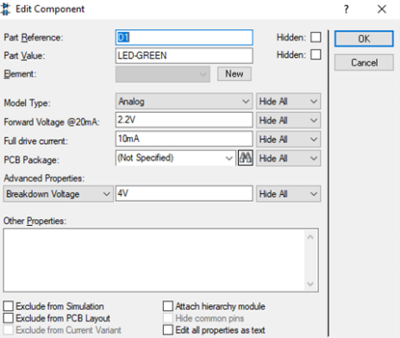
- If (Current Former) = 20mA
Figure 2 - Properties Screen of Resistor R3 and R4
The result of these formula is that R3 and R4 need a resistance of 340Ω (ohms). These values were sourced from the simulation software ‘Proteus’ as viewing the properties of the resistors whilst the simulation is running details the required resistance.
Other equations include;
Frequency (Hz) $f=\frac{1.44}{\left(R1+2*R2\right)*C}$ = 685.7Hz
Period (s) s = $\frac{1}{f}$ = 0.001458seconds = 1.458 milliseconds
On time (ms) $s=0.694 \left(R1+R2\right)C$ = 0.763 milliseconds
Off time (ms) $s=0.694 \left(R2\right)C$ = 0.694 milliseconds

3.0 - Creating the circuit in simulation software ‘Proteus’
The creation of the circuit in the simulation software was done by replicating a schematic for the circuit provided by the lecturer. All values were provided minus the resistance values for resistors R3 and R4, these would have to be calculated. Once these resistance values have been correctly calculated, they will be used to create the circuit on the breadboard in the real world.
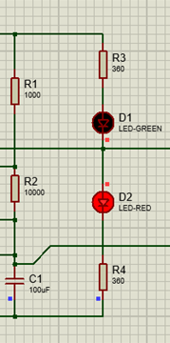
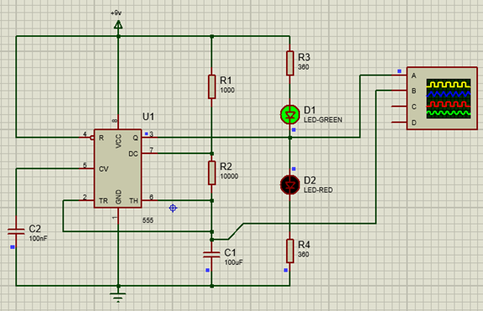
Figure 3 - Red LED pictured
Figure 4 - Finished Proteus Simulation (Green LED pictured)
Upon entering in the resistance values calculated earlier the circuit created in ‘Proteus’ began to work, and the Astable] nature showed itself in the ‘flip flopping’ of the LEDs changing.

3.1 – Digital Simulation of the Circuit using an Oscilloscope
Within the ‘Proteus’ simulation software an oscilloscope can be used to monitor the voltage running through the circuit in a specific location by connecting the oscilloscope to that location with a wire, with this oscilloscope a waveform is generated, this will be compared to the waveform generated when this circuit is replicated on a breadboard.
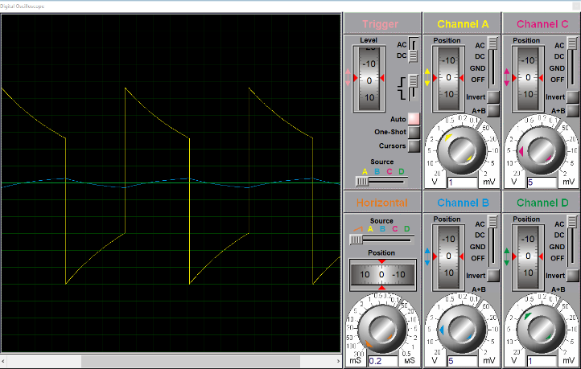
This (Figure 5) is a screenshot of the digital oscilloscope it shows the waveform of the voltage passing through capacitor C1, the curved line shows the voltage as the capacitor C1, is charging and discharging.
Figure 5 - Raw Screenshot of the Waveform first shown by the Digital Oscilloscope
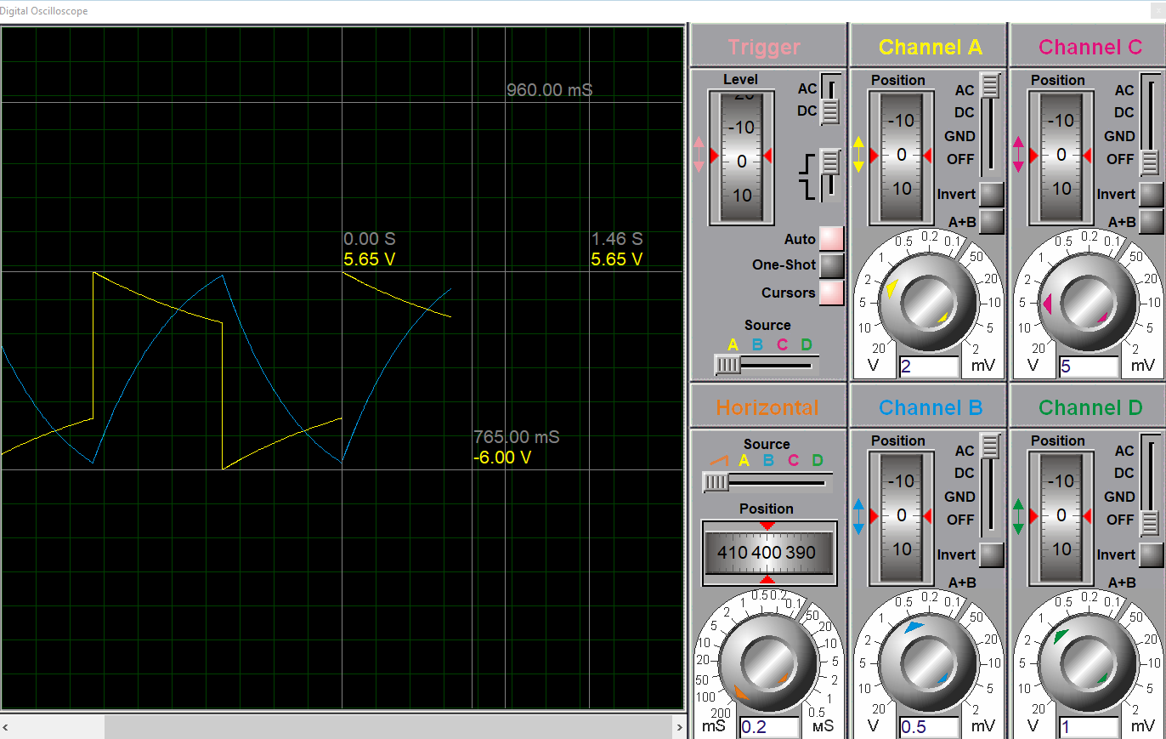
Figure 6 - Oscilloscope Graph of Capacitor C1, with times and Voltages Labelled using the built-in cursor for the Digital Oscilloscope.
Using the timings and the voltages from the labelled oscilloscope, a comparison can be made to the calculations made earlier.
 | Calculated | Simulated | Accurate?
Frequency | 685.7 Hz | 684.9 Hz | Close
Period | 1.458 seconds | 1.46 seconds | Yes
On Time | 0.763 seconds | 0.765 seconds | Yes
Off Time | 0.694 seconds | 0.695 seconds | Yes

As evident from the comparison, the calculations were accurate to <0.002 of a second.
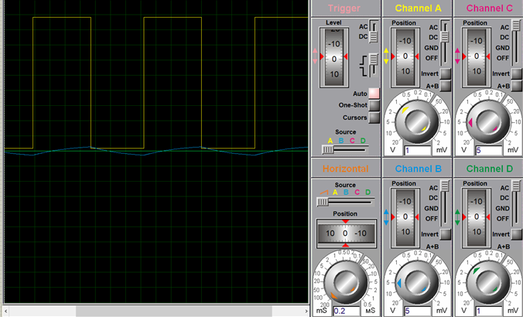
Figure 7 - Adjusted Waveform to show the true nature of the Voltage signal, a square/rectangular waveform, indicative of an Astable Circuit.

The blue line on the oscilloscope screenshots is the waveform of Output 3, it has a distinctive saw tooth shape. Output 3’s voltage is slightly lower than the voltage passing through Capacitor C1. But as Output 3 is the main output of the circuit it controls the ‘flip flopping’ nature of this astable circuit.

4.0 - How the Circuit was made and tested on a Breadboard
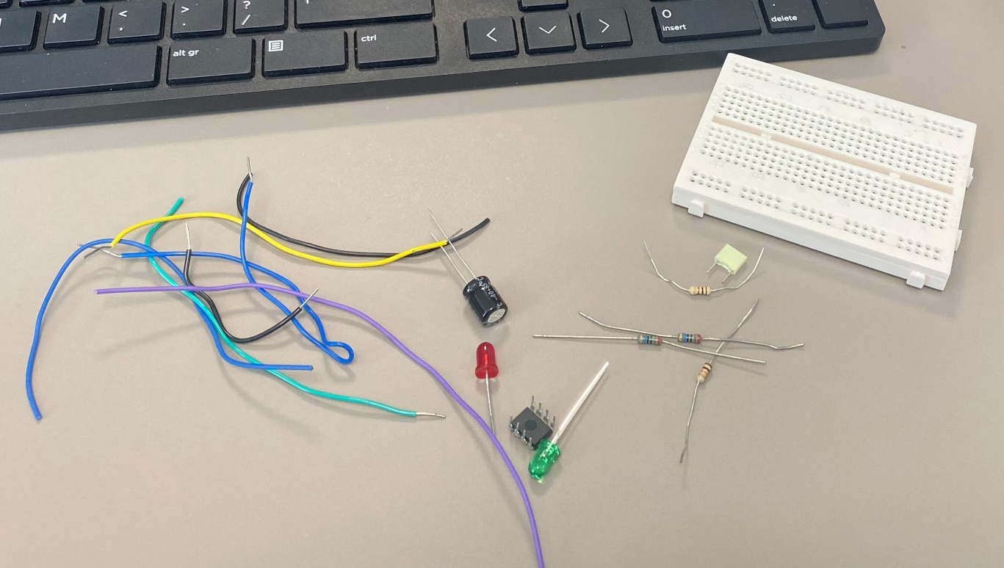
Figure 8 - 555 Astable Multivibrator Unassembled, components include; coloured wires, coloured LEDs, Capacitors, Resistors and the Integrated Circuit (IC) Chip.
A breadboard is a series of fifty eight metal plates that are not connected to any other plate, isolated inside a plastic shell each of these plates are exclusively accessible via five separate connection points. There are also four running plates that stretch the length of the board with twenty five connection points each, useful for assigning one to maximum voltage and zero voltage. Each breadboard has connecting lugs to attach other breadboards if a larger area is required, for this 555 Astable Multivibrator only one breadboard is required.
Since eight inputs are needed for the Integrated Circuit, it is placed in a way that straddles the centre of the board so that all pins have a separate and unique input. Then by using the design created in Proteus as a reference, replicating the design of the 555 Astable Multivibrator on the breadboard becomes easier, though due to the constraints of the linear pattern of the metal strips in the breadboard, an exact translation can’t be made.
Some components are directional, whilst others are not, they are; the LEDs, the Integrated Circuit 555 Chip and one of the Capacitors. The other capacitor is polarised whilst the other is non-polarised.
Short standoff wires with stripped ends are inserted into the breadboard in the voltage max and voltage zero locations as well as two further standoff wires are inserted as probe connection points for the breadboard.

4.1 – Visual breadboard testing
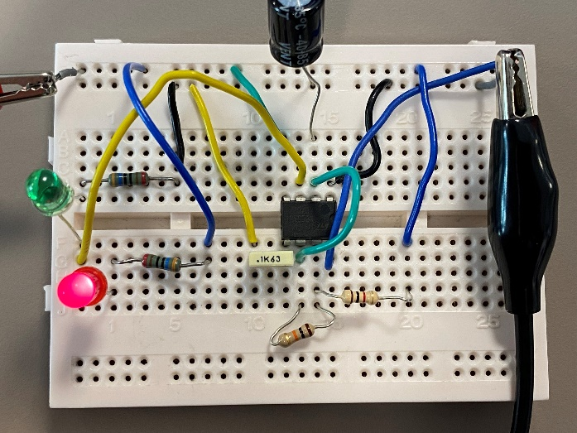
The breadboard was tested first by connecting the 555 Astable Multivibrator Timing Circuit to power and observing the circuit to confirm if the coloured LEDs are alternating which LED is turned on, approximately every second. If the breadboard fails this test, confirming all connections are secure is the point of call before re-arranging the board.
Figure 10 - 555 Timing Circuit (Red LED illuminated)
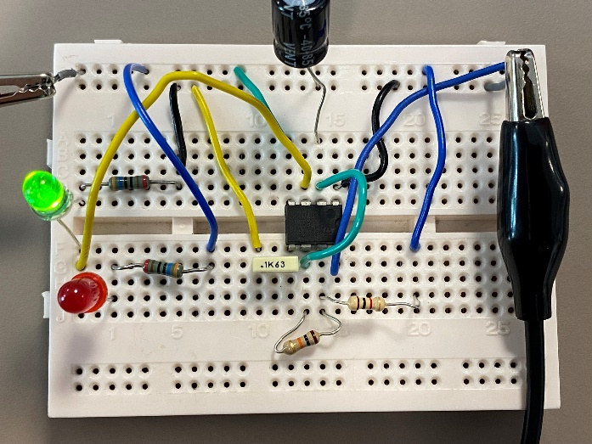
Figure 9 - 555 Timing Circuit (Green LED illuminated)

4.2 – Oscilloscope breadboard testing
To connect the breadboard to the oscilloscope the usage of standoff wire and probes is required. Standoff wires are used to allow probes to connect to the breadboard as they allow for a new point of contact for the hook probes or crocodile clips to attach to where the clips would not previously been able to connect due to the breadboards design.
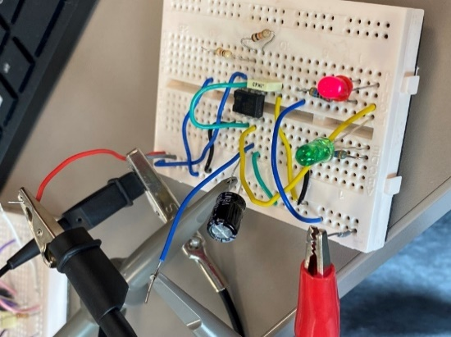
Figure 11 - 555 Timing Circuit with Power connected via Crocodile Clips and Oscilloscope Probes attached via Hook Probes connected to Standoff Wires.
The oscilloscope is a tool to show Voltage as a waveform in the same manner as a graph, Voltage on the Y-axis and Time on the X-axis. For this circuit the oscilloscope probes were placed at the C1 capacitor and Output 3, the reason for this is to measure the signal released by the capacitor as it releases charge and the lack of charge beyond the capacitor whilst it is charging, this action of taking in energy and releasing it rhythmically is the source of timing for the circuit.
The oscilloscope has an adjustable crosshair, this is used as a cursor to be moved around the graphing screen using this crosshair, using this adjustable crosshair and its corresponding coordinates, the waveform generated from the charge measured by the probes can be mapped and its peaks and troughs values recorded into a table.

Location on Square Waveform | Time | Voltage
Left Top | 68.00ms | ~7.5V
Middle Top | 812.0ms | ~7.5V
Middle Bottom | 812.0ms | 0V
Right Bottom | 1.500s | 0V
Right Top | 1.500s | ~7.5V
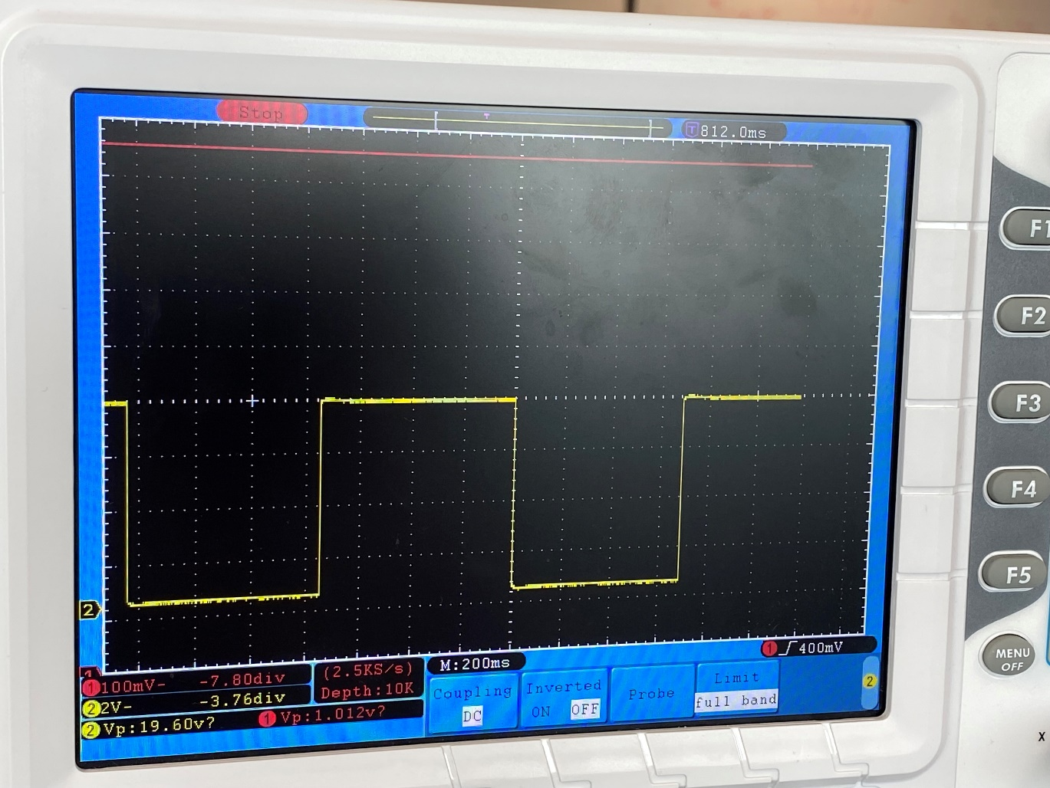
Figure 12 - Photo of Oscilloscope Connected to 555 Timing Circuit, Square Yellow Waveform is visible as well as its values.
The measurements recorded from the breadboard and dissimilar to the ones calculated and simulated, leading me to the conclusion that an error was made during the setup of the breadboard, likely it was supplied with too much power, not enough to pop a resistor but enough to affect the cyclical rate of the astable circuit and the max voltage recorded.

5.0 - Conclusion
Overall this Assignment has demonstrated the way that circuits are designed and prototyped on breadboards before ultimately being manufactured into printed circuit boards. The calculations used to mock-up the circuit were effective as they were accurate to the simulation software though they were not accurate to the replication on the breadboard and that is likely due to the error described.

Bibliography

[1] | khi5, “What is Vcc, Vss, Vdd, Vee in Electronics?,” WOOPCB, [Online]. Available: https://woopcb.com/blog/what-is-vcc-vss-vdd-vee-in-electronics. [Accessed 16 07 2024].
[2] | ElectronicsTutorials, “Multivibrators,” ElectronicsTutorials, [Online]. Available: https://www.electronics-tutorials.ws/sequential/seq_3.html. [Accessed 16 07 2024].
[3] | PCMag, “Definition of a Discrete Component,” PCMag, [Online]. Available: https://www.pcmag.com/encyclopedia/term/discrete-component. [Accessed 18 07 2024].
[4] | Cloudistro, “How does a 555 Timer work?,” Cloudistro, [Online]. Available: https://cloudistro.com/how-does-a-555-timer-work/. [Accessed 18 07 2024].

Figure Number: | Brief Description | Page Number:
Figure 1 | Diagram of 555 timer Integrated Chip | 4
Figure 2 | Properties of digital LED | 5
Figure 3 | Red LED simulation | 6
Figure 4 | Green LED simulation | 6
Figure 5 | Raw Waveform Digital Oscilloscope | 7
Figure 6 | Labelled Waveform Digital Oscilloscope | 7
Figure 7 | Square Waveform Digital Oscilloscope | 8
Figure 8 | Components and Breadboard, Unassembled | 9
Figure 9 | Green LED breadboard | 10
Figure 10 | Red LED Breadboard | 10
Figure 11 | Assembled Breadboard | 11
Figure 12 | Square Waveform Oscilloscope | 12

Table of Figures:

