Patient Path: Initial Research Documentation
Industrial Based Research
ACCA6029

Univeristy of wales Trinity St David | Velindre University NHS Trust
Healthcare TRANSFORMED; Patient Informed
Samuel Jackson 1802975
2023
Table of Contents
1. Introduction 3
1.1 Justification 3
1.2 Aims and Objectives 4
2. Literature Review 5
3. Methodology 7
3.1 Research Methodology 7
3.1.1 Philosophy 7
3.1.2 Approach 7
3.1.3 Strategies 7
3.1.3.1 Literature Review 7
3.1.3.2 Survey 7
3.1.3.3 Case Study 7
3.1.4 Risks & Limitations 7
3.1.5 Ethical Issues 8
3.1.6 Validity, Reliability & Generalisability 8
3.1.6.1 Validity 8
3.1.6.2 Reliability 8
3.1.6.3 Generalisability 8
3.1.7 Data Evaluation Method 8
3.1.7.1 Data Collection 8
3.1.7.2 Data Evaluation 8
3.2 Development Methodology 9
3.2.1 Software Development Methodology 9
3.3 Resources 9
3.3.1 Hardware Resources 9
3.3.2 Software Resources 9
3.3.3 Information Resources 9
3.3.4 Human Resources 9
3.3.5 Project Plan 10
4. Predicted Outcomes 11
4.1 Enhanced Efficiency in Handovers 11
4.2. Improved Accuracy and Reduction in Errors 11
4.3. Enhanced Patient Experience 11
4.4. Scalability and Adaptability 11
4.5. Cost-Efficiency 11
4.6. Strengthened Inter-professional Collaboration 12
4.7. Data-Driven Decisions and Insights 12
Conclusion 12
5. References 13

Figure 1 Potential Patient Path 9
Figure 2 Gantt Chart 10

Introduction
This research explores the development and implementation of an innovative solution, "Patient Path," aimed at digitising patient progress timelines in hospital settings. The objective is to enhance the efficiency of healthcare workflows, reduce the time spent on nurse handovers, and minimise patient anxiety by providing transparency about their care journey. The project utilises the Microsoft Power platform, leveraging Power Automate, PowerApps, and SharePoint to create an interactive, real-time display of patient care activities and the next steps in their care plan at the patient’s bedside companied by a master view that displays all occupied beds at the nurse station allows a holistic view of all patient timelines on the ward. The project aims to integrate with existing systems like the Welsh Nursing Care Record (WNCR) and Welsh Clinical Portal (WCP) in future phases, extending the application's utility beyond hospital premises. A key factor for success will be ensuring data governance and security, maintaining strict adherence to healthcare regulations.
This paper describes the project's design, development, and evaluation stages, including feedback collection from primary users, namely doctors, nurses, and healthcare support workers, via a comprehensive questionnaire. The study signifies a crucial step towards modernising healthcare management, with Patient Path's success potentially paving the way for further digital transformation in healthcare.

Justification
To provide a more efficient and effective digital solution for healthcare staff to manage and monitor patient progress, reducing errors, streamlining workflows, and saving time.

Aims and Objectives
Aims | Objectives
Design a Digital Transformation: To transition from traditional, paper-based patient management to a digital cloud-based solution that enhances efficiency and reliability in healthcare delivery. | Digital Transformation and Efficiency:  Develop a digital timeline system to replace the current paper-based notes, aiming to reduce nurse handover time by 20% and streamline patient progress flow.  Ensure compatibility with existing hospital systems, like the WNCR, for seamless 'live data' updates.  Patient-Centric Design:  Design the platform for potential scalability, allowing for future usage in additional wards.  Data Governance and Security:  Guarantee that the system aligns with Information Governance regulations and NHS Wales's data governance guidelines, targeting a zero breach or non-compliance record throughout its implementation and usage.  Implementation and Adoption:  Evaluate change management strategies to ensure a high adoption rate among healthcare workers.  Adhere to project milestones, completing the research phase by September 2023 and the planning/design phase by May 2024.

Literature Review

The increased digitisation of healthcare processes has emerged as a major trend in recent years, contributing to the improved delivery of patient care and the enhancement of hospital operations, this trend is showing no signs of slowing down as outlines in NHS England’s long term Digital Strategy Plan [1]. This literature review aims to discuss the digitisation of patient care timelines, examining its relevance, effectiveness, challenges, and opportunities in healthcare.
Healthcare organisations globally have begun recognising the benefits of moving from paper-based systems to digital platforms for patient management [2]. Such transition enhances efficiency, reduces errors, and streamlines workflows [3], all of which are key aims for the proposed project.
Patient timeline and interactive patient systems have been explored extensively in literature. They offer a complete view of a patient's medical history, and when utilised effectively, can significantly improve patient care [4]. In line with the project's objectives, they can potentially reduce nurses' handover time and improve overall hospital efficiency.
Increasing patient engagement is another crucial aspect of modern healthcare. Several studies emphasise the role of technology in reducing patient anxiety and improving their engagement with their own care [5]. By providing patients with a clear and accessible timeline of their treatments, they feel more involved in their care, which aligns with the proposed project's aims.
However, this literature also highlights several challenges associated with implementing digital healthcare solutions and with effective integration to existing hospital systems, such as the WNCR in this case. Developing a system compatible with these can ensure seamless data synchronisation and 'live' updates. In order to achieve this RPA (Robotic Processes Automation) tools and techniques will be used. RPA is the process of using a specialist software that can overlay onto legacy systems that do not have an existing application programming interface (API) to act as a user to read, write and complete commands on any existing system [6], RPA is commonly used to complete repetitive manual tasks and integration of still in use legacy systems, the type often used throughout the NHS.
Data privacy and compliance are additional concerns. Healthcare data is highly sensitive, and its security is paramount [7]. Compliance with Information Governance regulations and NHS Wales's data governance guidelines, therefore, is critical for the project. Recognising the profound significance of safeguarding healthcare data, the decision to host the project within NHS Wales's Microsoft environment was taken with considerable foresight. Microsoft's secure cloud infrastructure, renowned for its robust security features offers an advanced protection mechanism that aligns with the rigorous standards of healthcare [8]. In conjunction with Microsoft's security measures, the NHS Wales environment is tailored to address the unique challenges and needs of the healthcare sector in Wales. By combining the strengths of these two entities, the project ensures an optimal combination of security, compliance, and accessibility. In this dynamic and secure environment, data breaches and unauthorised access are significantly minimized, assuring stakeholders of the safety of the sensitive patient data being managed. Moreover, as digital health landscapes continue to evolve, positioning the project within such a future-ready environment ensures that the system can adapt and respond to emerging threats and regulations in line with the NHS Wales Digital Strategy, guaranteeing the long-term viability and security of the project [9].

Change management emerges as another significant theme in literature. Digital transformation initiatives can often meet resistance from staff due to lack of training as “Learning new systems can be challenging for nurses and healthcare workers who aren't familiar with technology” [10] or fear of change A proactive approach towards addressing these issues can ensure the successful adoption of the new system [11].
Looking towards the future, literature indicates the trend of 'patient-centric' healthcare, monitoring and telemedicine [12]. This presents an opportunity for the proposed project, as it aims to expand its services outside the hospital environment, potentially integrating into patient entertainment systems and home use.
To summarise, the literature strongly supports the need and benefits of digital transformation in healthcare. By understanding the opportunities and challenges discussed in existing research, this project can be designed and implemented effectively. The key is to ensure it enhances care delivery, supports data privacy, promotes user adoption, and is future-proof.

Methodology

This chapter outlines the methodological approach employed in the Patient Pathway project. It delves into the research and development methodologies, the resources used, and pertinent ethical considerations.

3.1 Research Methodology

3.1.1 Philosophy
The project subscribes to a pragmatism philosophy. This is primarily because the research endeavours to provide practical solutions for real-world problems, like improving the efficiency of patient management in healthcare settings. The advantages, such as flexibility in method selection and data source variety, will be leveraged to create a holistic understanding. While pragmatism can be seen as lacking a firm theoretical grounding, this will be addressed by consistently grounding decisions in existing research and tangible outcomes.

3.1.2 Approach
A deductive approach is adopted, where hypotheses derived from existing literature will guide the research. This top-down strategy ensures that the research aligns with established knowledge while exploring specific areas of interest. The structured nature of this approach ensures clarity, but its strict adherence can be restrictive. Therefore, iterative feedback during data collection will ensure flexibility.

3.1.3 Strategies

3.1.3.1 Literature Review
Existing literature on healthcare process efficiency, patient-anxiety mitigation, and digital transformation in healthcare will be examined to ground the project in current understanding.

3.1.3.2 Survey
Surveys will be employed to gather frontline insights from healthcare professionals. This will assist in understanding the challenges faced in current handover systems and expectations from a digital solution.

3.1.3.3 Mapping Analysis
A mapping analysis will be conducted, focusing on a specific hospital ward, to get an in-depth understanding of the practicalities and nuances of the problem area.

3.1.4 Risks & Limitations
Potential risks include resistance to change from the end-users and data security concerns. Regular feedback, user training, and strict data compliance will be employed to mitigate these. A limitation is the project’s initial focus on a specific ward, which might limit generalisability.

3.1.5 Ethical Issues
Research Data Collection: Ensuring the privacy and anonymity of survey respondents is crucial. All data will be anonymised, and informed consent will be sought before the collection.
Privacy and Confidentiality: Patient Path involves collecting and managing patient-related data, which is highly sensitive. Ensuring the privacy and confidentiality of this data is highly important. Healthcare data is subject to strict regulatory frameworks, including General Data Protection Regulation (GDPR).
Stake Holders: Ensure that all stakeholders, including healthcare workers, are onboard with the project's goals and understand its implications. Resistance to change can be a significant ethical concern.

3.1.6 Validity, Reliability & Generalisability

3.1.6.1 Validity
By aligning the research with the existing literature and collecting data from the ground, the research remains relevant and apt for addressing the problem.

3.1.6.2 Reliability
Standardised surveys and a structured approach to the case study will ensure that another researcher could replicate the research and achieve similar results.

3.1.6.3 Generalisability
While the project starts with a specific ward, insights could be applied to similar wards or healthcare settings with minor adjustments.

3.1.7 Data Evaluation Method

3.1.7.1 Data Collection
Data will be collected through surveys, interviews during the case study, and existing literature. Surveys will target at least 50 healthcare professionals from the chosen ward. Each participant will have an identical brief of the proposed project to ensure their understanding and expectations aligned with the desired outcome of the project.

3.1.7.2 Data Evaluation
Data will be evaluated using descriptive and inferential statistics. Themes from qualitative data will be extracted using content analysis.

3.2 Development Methodology
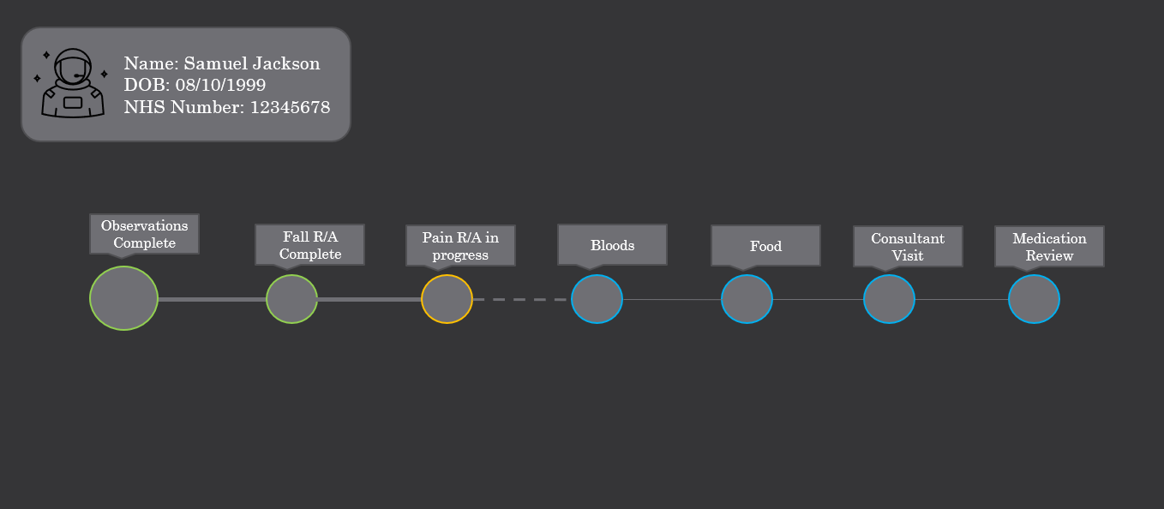
Figure 1 Potential Patient Path
First draft visualisation of what Patient Path will be developed to look like as shown in Figure 1. This visualisation will assist with brief during the data collection interview stage.

3.2.1 Software Development Methodology
The Agile methodology will be adopted for its iterative and feedback-rich nature, ensuring the developed solution remains aligned with user needs. The Agile methodology allows an enhanced collaboration during the development stages as the continual feedback from the end users will help with moulding Patient Path into the most for purpose solution.

3.3 Resources

3.3.1 Hardware Resources
Standard networked PCs will be used for data analysis and software development. Mobile devices will be used to deployed Patient Path.

3.3.2 Software Resources
Microsoft Power Platform, including Power Automate, Power Apps, Dataverse and SharePoint, will be utilised. All software is sourced from licensed platforms.

3.3.3 Information Resources
Existing datasets on patient handovers, if available, will be sourced from the hospital’s administration.

3.3.4 Human Resources
Besides the developer and supervisor, input will be sought from healthcare professionals, especially nurses, from the chosen ward for surveys and interviews along with Current Digital Services staff for incite on requirements to fit with existing infrastructure.

3.3.5 Project Plan
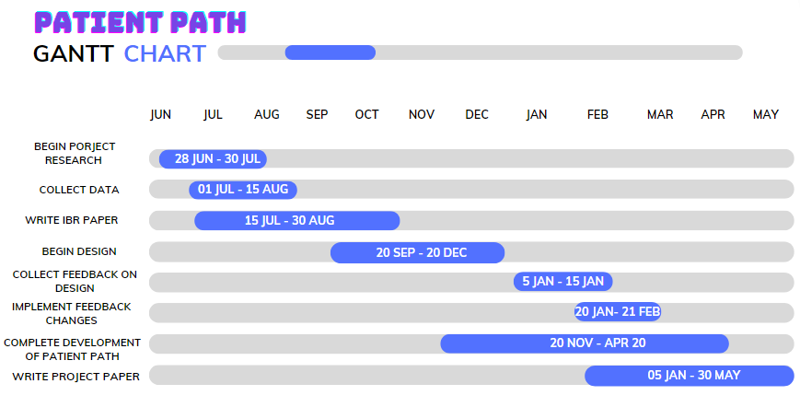
Figure 2 Gantt Chart
The success this project hinges on effective planning and management. Both a project plan and a Gantt chart as seen in Figure 2 offer critical benefits to ensure the successful execution of the Patient Path project, especially as it integrates complex healthcare systems.

Predicted Outcomes
The 'Patient Path' initiative, underpinned by a solid research foundation and the incorporation of digital technology, is envisioned to revolutionise the way patient handovers are conducted in healthcare settings. As with any project of this nature, predicting exact outcomes can be challenging; however, based on the current literature, direct feedback from healthcare professionals, and preliminary analyses, several anticipated results can be predicted.

4.1 Enhanced Efficiency in Handovers
One of the primary outcomes expected from the 'Patient Path' project is the streamlining of handover processes. By integrating digital solutions and eliminating manual and often redundant tasks, healthcare professionals will be able to pass on vital patient information more swiftly. The immediate advantage of this would be a reduction in the time taken for shift handovers, thereby granting medical staff more time for direct patient care.

4.2. Improved Accuracy and Reduction in Errors
By digitising the handover process, the potential for human error, often caused due to fatigue, rushed handwriting, or miscommunication, is likely to diminish significantly. The system's capability to alert nurses or doctors about missing information or discrepancies ensures that the data passed from one shift to the next is both accurate and complete. This could directly result in improved patient outcomes, as there will be less likelihood of repeated tasks and mistreatment based on incorrect information.

4.3. Enhanced Patient Experience
An indirect but significant predicted outcome is the enhanced patient experience. With a smoother handover process and more consistent data, patients will experience fewer disruptions. They won't need to repeatedly provide the same information to different staff and vice versa, thus alleviating some of the anxieties associated with hospital stays. Further, by keeping patients informed through the 'Patient Path' platform, they gain a sense of autonomy and understanding of their care journey, leading to increased satisfaction.

4.4. Scalability and Adaptability
While the initial focus of the 'Patient Path' project is on a specific ward, the digital solution's modular nature is designed for scalability. Once the effectiveness is proven in the target ward, the system has the potential be adapted and scaled to other wards, specialties, or even across different hospitals. This not only ensures the longevity of the project but also positions it as a game-changer in healthcare management across various settings.

4.5. Cost-Efficiency
In the long run, the adoption of the 'Patient Path' system can lead to significant cost savings for healthcare organisations. With reduced time spent on handovers, there's a direct saving in terms of man-hours. Moreover, the project is to be built using already purchased tool’s that are included in the current Microsoft Licences in use through NHS Wales, this will increase the utilisation of the licences, resulting in achieving a better return on the existing investment, ensuring that NHS Wales capitalise fully on the resources already committed. further bolsters the project's economic viability. While there's an initial investment in setting up the system, the returns, both in terms of monetary value and intangible benefits like patient satisfaction and staff morale, are predicted to be substantial.

4.6. Strengthened Inter-professional Collaboration
The 'Patient Path' system's collaborative design ensures that not just nurses, but all healthcare professionals involved in a patient's care, have access to the latest and most accurate information. This fosters a spirit of collaboration between different departments and specialties. By having a single, unified platform for patient data, silos that often exist in healthcare settings can be broken down, leading to more holistic patient care.

4.7. Data-Driven Decisions and Insights
By digitising the handover process, a wealth of data is generated. This data, when analysed, can offer valuable insights into areas of improvement, bottlenecks, or patterns that might not be evident otherwise. For instance, if a particular type of error or omission becomes recurrent, it can be addressed proactively. Further, this data can be utilised for research, providing a foundation for future innovations in healthcare management.

Conclusion
The 'Patient Path' project, with its integration of research and technology, stands at the forefront of addressing a critical challenge in healthcare settings: efficient and accurate patient handovers. The predicted outcomes, ranging from enhanced operational efficiency to improved patient experiences, underline the transformative potential of this initiative. As with any project, continuous monitoring, feedback, and iterative improvements will be key to realising these outcomes. Yet, based on the solid foundation it's built upon, 'Patient Path' promises to set a new standard in patient care and management.

References

[1] NHS England, "Digitally Enabled Care Will Go Mainstream Across the NHS." [Online]. Available: https://www.longtermplan.nhs.uk/online-version/chapter-5-digitally-enabled-care-will-go-mainstream-across-the-nhs/
[2]NHS England, “Cutting Reliance on Paper." [Online]. Available: https://www.england.nhs.uk/2015/09/cutting-reliance-on-paper/
[3] NHS Shared Business Services, "Moving from Paper-Based to Systems-Led." [Online]. Available: https://www.sbs.nhs.uk/article/15370/Moving-from-paper-based-to-systems-led
[4] M. de Ridder, L. Bi, L. Constantinescu, J. Kim and D. D. Feng, "Data processing and presentation for a personalised, image-driven medical graphical avatar," [Online]. Available Data processing and presentation for a personalised, image-driven medical graphical avatar | IEEE Conference Publication | IEEE Xplore (uwtsd.ac.uk)
[5] A. H. Krist, S. T. Tong, R. A. Aycock, and D. R. Longo, "Engaging Patients in Decision-Making and Behavior Change to Promote Prevention," Stud. Health Technol. Inform. [Online]. Available: Engaging patients in decision-making and behavior change to promote prevention - PMC (nih.gov)
[6] Y. Ketkar and S. Gawade, "Effectiveness of Robotic Process Automation for data mining using UiPath," 2021 International Conference on Artificial Intelligence and Smart Systems (ICAIS), [Online]. Available: Effectiveness of Robotic Process Automation for data mining using UiPath | IEEE Conference Publication | IEEE Xplore (uwtsd.ac.uk)
[7] NHS Wales, “Keeping patient information safe,” Digital Health and Care Wales. [Online]. Available: https://dhcw.nhs.wales/about-us/keeping-patient-information-safe/
[8] Microsoft, "Forrester names Microsoft a Leader in 2023 Infrastructure as a Service (IaaS) Platform Native Security Report," Microsoft Security Blog, 03-May-2023. [Online]. Available: https://www.microsoft.com/en-us/security/blog/2023/05/03/forrester-names-microsoft-a-leader-in-2023-infrastructure-as-a-service-platform-native-security-report/?culture=en-gb&country=gb.
[9] Welsh Government, "Digital and Data Strategy for Health and Social Care in Wales," Gov.Wales, [Online]. Available: https://www.gov.wales/digital-and-data-strategy-health-and-social-care-wales-html
[10] Nurses Group UK, "Current Issues in Nursing," NursesGroup.co.uk, [Online]. Available: https://nursesgroup.co.uk/current-issues-in-nursing
[11] N. Zaman, D. M. Goldberg, S. Kelly, R. S. Russell, and S. L. Drye, "The Relationship between Nurses' Training and Perceptions of Electronic Documentation Systems, [Online]. Available: The Relationship between Nurses’ Training and Perceptions of Electronic Documentation Systems - PMC (nih.gov)
[12] V. Kadambi et al., "Review of an electronic health record model to facilitate remote patient management in metabolic and lifestyle diseases," 2018 10th International Conference on Communication Systems & Networks (COMSNETS), Bengaluru, [Online]. Available: Review of an electronic health record model to facilitate remote patient management in metabolic and lifestyle diseases | IEEE Conference Publication | IEEE Xplore (uwtsd.ac.uk)

