LDE Assignment1 E-Por2olio
LEARNING IN THE DIGITAL ERA

LEARNING IN THE DIGITAL ERA
MODULE CODE: ACCA 4025S

STUDENT NAME: DANIELA ESTRADA
STUDENT ID: 2440640
GROUP: 1

LECTURER’S NAME: KOUSHIK MODAK
24/July/2026

The University of Wales Trinity Saint David.
E-Porfolio Link: https://24406403.wixsite.com/daniela-learning-i-1

Table of Contents
Introduction 2
Task 1: Essential Academic and Employment Skills for the future career Path 3
Task 1(b): Evaluation Based on Similarity Report 4
Task 2: Collaborative Mind Map and Individual Poster 4
Poster (Individual) 6
Task 3: Virtual Collaboration and RefWorks 7
Task 4: E-Portfolio Creation and Evaluation 12
Task 4 (a): E-Portfolio Creation 12
Task 4 (b): Illustrative Review of E-Portfolio tool Selection 12
EVIDENCE 13
Conclusion 22
References Error! Bookmark not defined.
References Task 1 Error! Bookmark not defined.
References Task 3 Error! Bookmark not defined.

Introduction
This report explores a range of software solutions that support modern business operations. It examines essential academic and employability skills for a future career as a Software Developer, e-commerce platforms, mind mapping, Microsoft Office applications, and communication and collaboration tools. Practical examples and evidence are included to demonstrate how these technologies can improve productivity and support business activities.

Task 1: Essential Academic and Employment Skills for the future career Path
As a student preparing for a future career as a Software Developer, I believe that academic and employability skills are essential for success in both higher education and the workplace. These skills will help me solve technical problems, communicate effectively with colleagues, and continue learning throughout my professional career [1].
One of the most important skills I have developed is research. Research allows me to find reliable information, evaluate different sources, and make informed decisions. As a Software Developer, I will need to analyse user requirements, solve technical problems, develop software solutions, and work with development teams to create reliable applications.
Another essential skill is communication. Throughout this module, I have improved my written and verbal communication through reports, presentations, and collaborative activities Software Developers communicate regularly with project managers, designers, testers, clients and other developers [2].
Research skills
As a student of the Certificate of Higher Education in Computing Skills for the Workplace, I believe research skills are essential for finding reliable information, evaluating evidence and solving technical problems learning new digital tools, and solving workplace problems. Developing this skill will help me adapt to new technologies and continue learning throughout my career
Communication Skills
I believe communication is an essential skill for working in a digital workplace. During my studies, I have improved my written communication through assignments and my communication skills when working with colleagues, managers and clients when using digital technologies.

Teamwork Skills
Teamwork has helped me understand how to collaborate with others when completing academic activities. As someone preparing for a career in the digital workplace, I know that working effectively in a team will help me contribute to projects, share ideas and achieve common goals [3] .
Time Management Skills
Time management has become one of the most valuable skills I have developed during my studies. Organising my assignments and meeting deadlines has improved my productivity. I believe this skill will help me manage multiple tasks efficiently in a modern workplace where digital projects often have strict deadlines [4] .
In conclusion, developing academic and employability skills during my studies will prepare me for a successful career as a Software Developer. Skills such as research, communication, teamwork, time management will help me develop effective software solutions, collaborate with others and adapt to new technologies throughout my professional career.
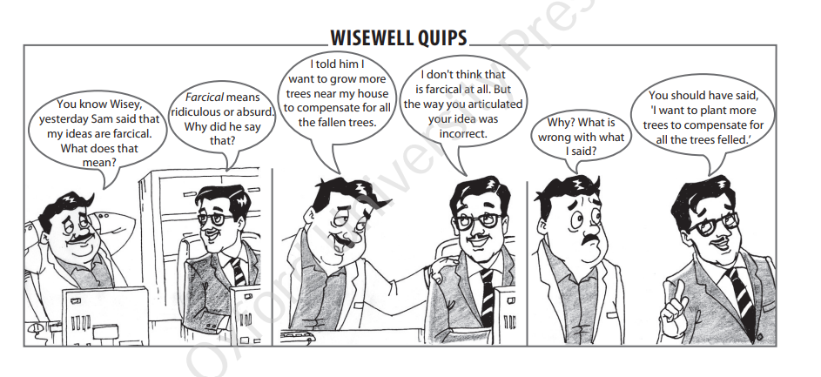
Figure 1: The comic illustrates the importance of effective communication and correct word choice. Although the speaker's intention was to express the idea of planting more trees to replace those that were cut down, the sentence was poorly phrased, making it sound incorrect. This highlights that communication is not only about having the right idea but also about expressing it clearly and accurately so that the intended message is understood by others [1].

Task 1(b): Evaluation Based on Similarity Report
My Turnitin similarity score was 38%. This shows that some parts of my work matched published sources because I used academic references, standard terminology, and correct IEEE citations. After reviewing the similarity report and reflecting on my work, I realised that I need to express more ideas in my own words and include more personal reflection. In future assignments, I will improve my paraphrasing skills by writing more independently while continuing to use accurate academic referencing.
Based on the Generic Assessment Criteria, I would award myself 65%. I believe I demonstrated a good understanding of the topic and included appropriate IEEE references to support my discussion. However, I recognise that I could strengthen the connection between the academic skills discussed and my future career as a Software Developer. I also need to provide more critical reflection and develop my own ideas in greater depth to achieve a higher mark in future assignments.

Task 2: Collaborative Mind Map and Individual Poster
Link of Mind Map (Collaborative): https://mm.tt/map/4037194957?t=NnIikFIrEa
Mind Map Image:
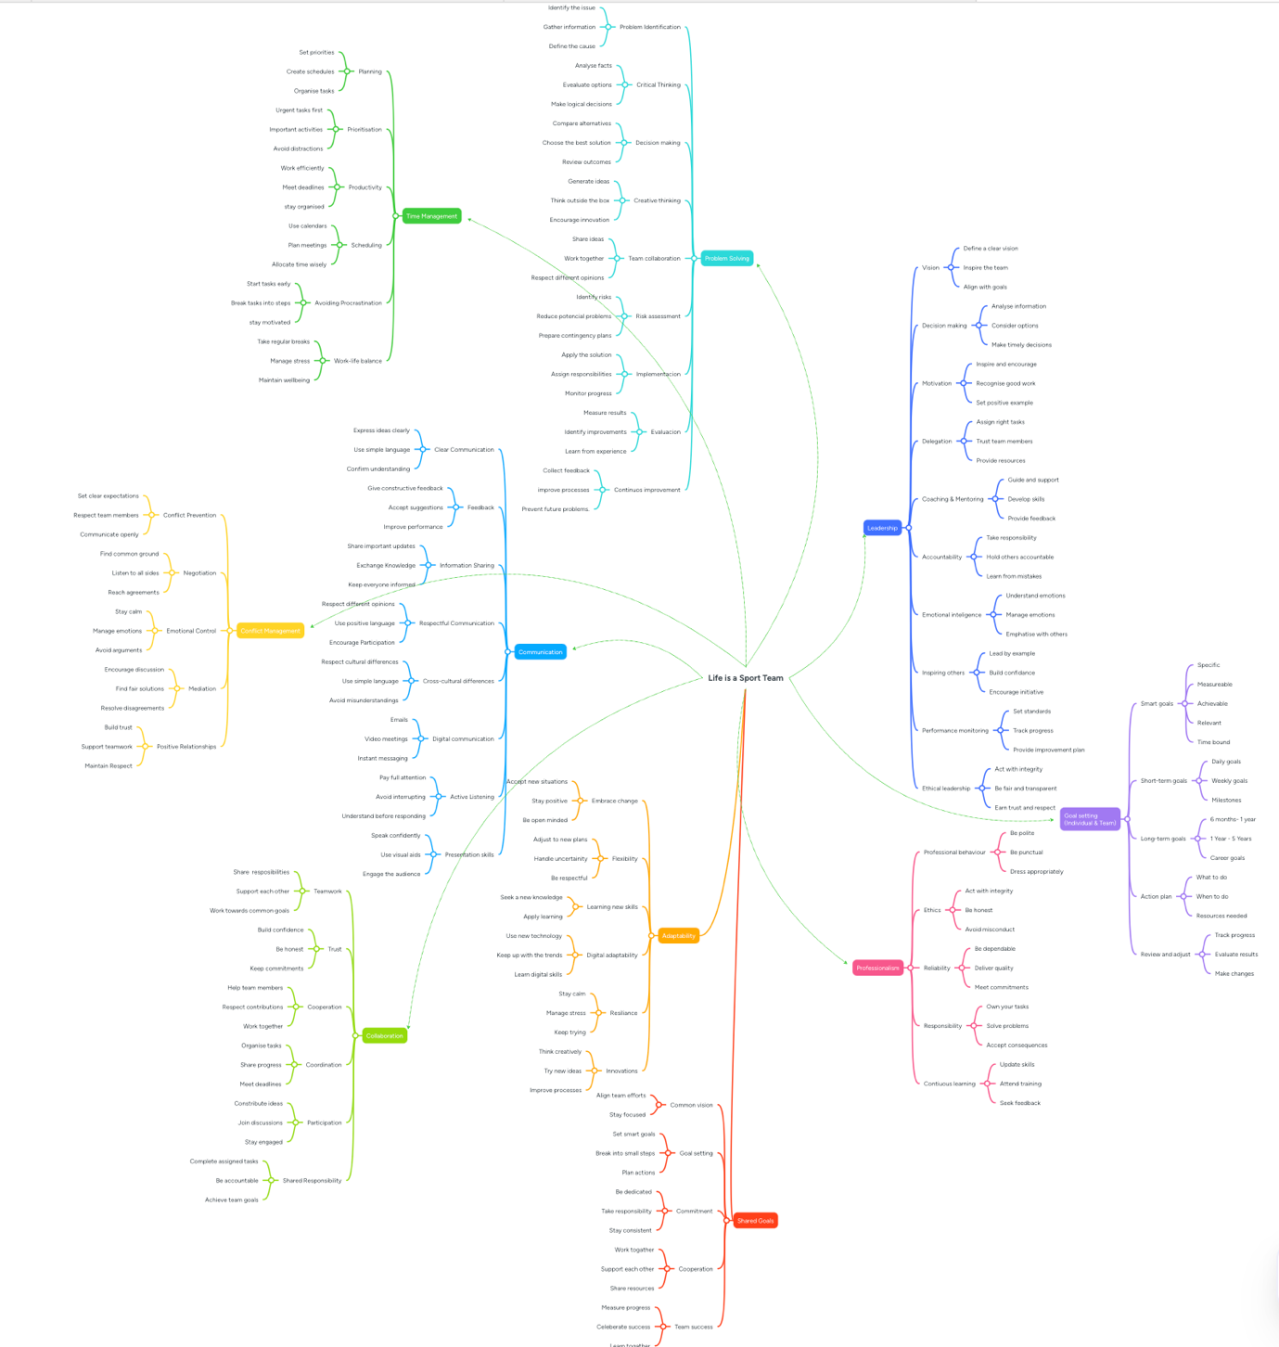

Poster (Individual). Link: https://canva.link/0zfy8hzvw9f4bk9
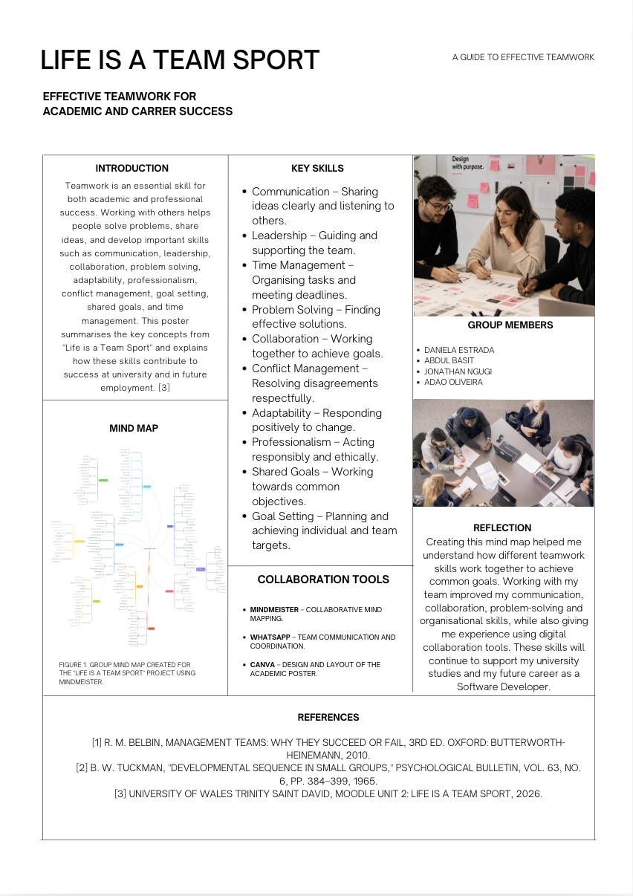

Task 3: Virtual Collaboration and RefWorks
Report on Virtual Collaboration
Virtual collaboration has become an essential skill in both higher education and modern workplaces. During this module, I learned that successful teamwork is not only about completing tasks but also about communicating effectively, giving constructive feedback, and supporting other team members throughout the project. These skills are especially important in my Certificate of Higher Education in Computing Skills for the Workplace, where many future projects will involve working with others using digital technologies [2].
One of the most valuable ideas I learned from Topic 3 – The New Norming was the importance of constructive feedback. I realised that feedback should help team members improve rather than criticise them. During our group activity, we shared ideas respectfully and discussed how to improve our mind map before creating the final version. This experience showed me that listening carefully to different opinions leads to better decisions and stronger teamwork [3].
Another important lesson from this topic was understanding the Norming stage of teamwork, where team members begin to trust one another, accept different strengths and work towards shared goals. I also learned that commitment and accountability are essential because every member is responsible for completing their tasks and supporting the success of the whole team. Recognising and valuing each person's contribution created a more positive working environment and helped our group collaborate more effectively throughout the project.
During the group project, my team used WhatsApp to communicate and coordinate tasks, while Mind Meister was used to create and organise the collaborative mind map. Using these digital tools allowed us to organise our work, share responsibilities, and complete tasks efficiently, even when we were not together in the same place
This activity also helped me develop personal skills that will benefit my future career in computing. I improved my communication, organisation, time management, and ability to work with people from different backgrounds. I also became more confident when sharing my own ideas while respecting the opinions of others. These employability skills are highly valued in today's technology industry because many organisations use remote or hybrid working environments [1] .
Overall, this topic helped me understand that virtual collaboration is much more than using technology. It requires mutual respect, clear communication, constructive feedback, and shared responsibility. I believe the knowledge and experience I gained from this activity will help me become a more effective student and prepare me for working successfully in the computing and technology sector after completing my studies

STEP-BY-STEP PROCESS OF USING REFWORKS WITH VISUALS
To manage the references for this assignment, I used RefWorks to organise academic sources and generate IEEE citations. First, I searched for reliable academic sources through the university library and imported the selected references into my RefWorks account. Next, I organised my references into a project folder for this assignment. I then used the Write-N-Cite/RefWorks Citation Manager to insert in-text citations directly into my Word document. Finally, I generated the reference list automatically in IEEE format and checked that all citations matched the sources used. Using RefWorks helped me save time, improve the accuracy of my referencing, and reduce formatting errors.

Step 1 – Create a RefWorks Account
Visit the RefWorks website and create a free account using your university email address and Sign in to your RefWorks account with your email address and password.
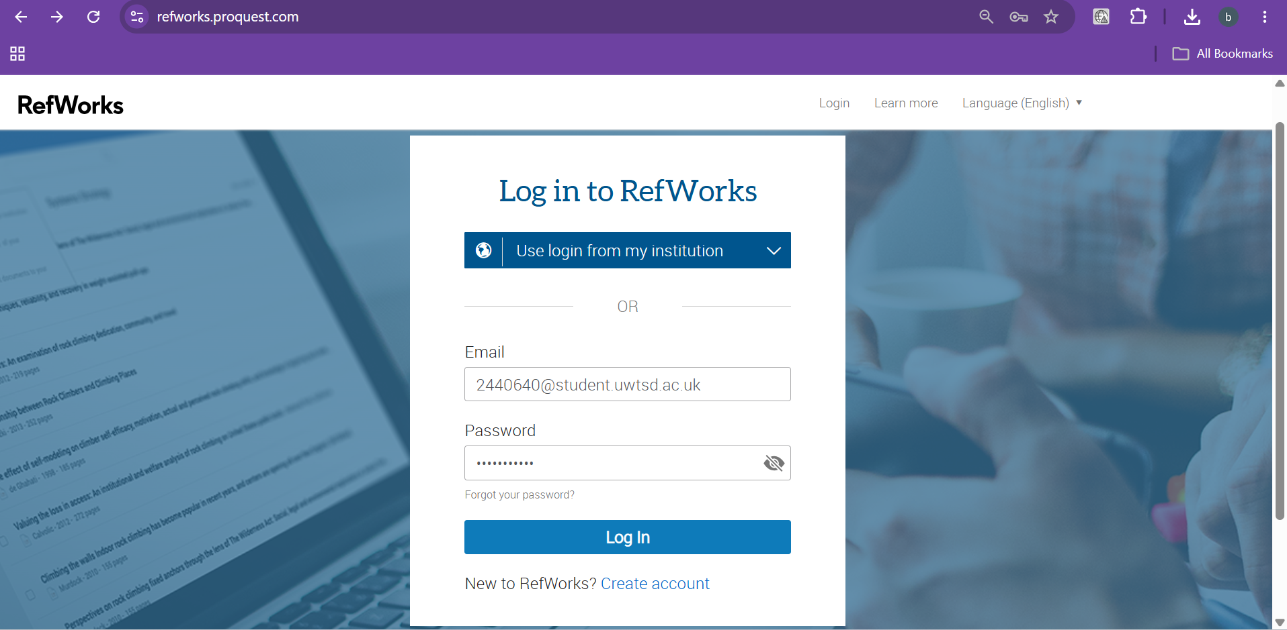

Step-2: Organize References by adding folder
Create folders to organise your references by module, assignment, or research topic.
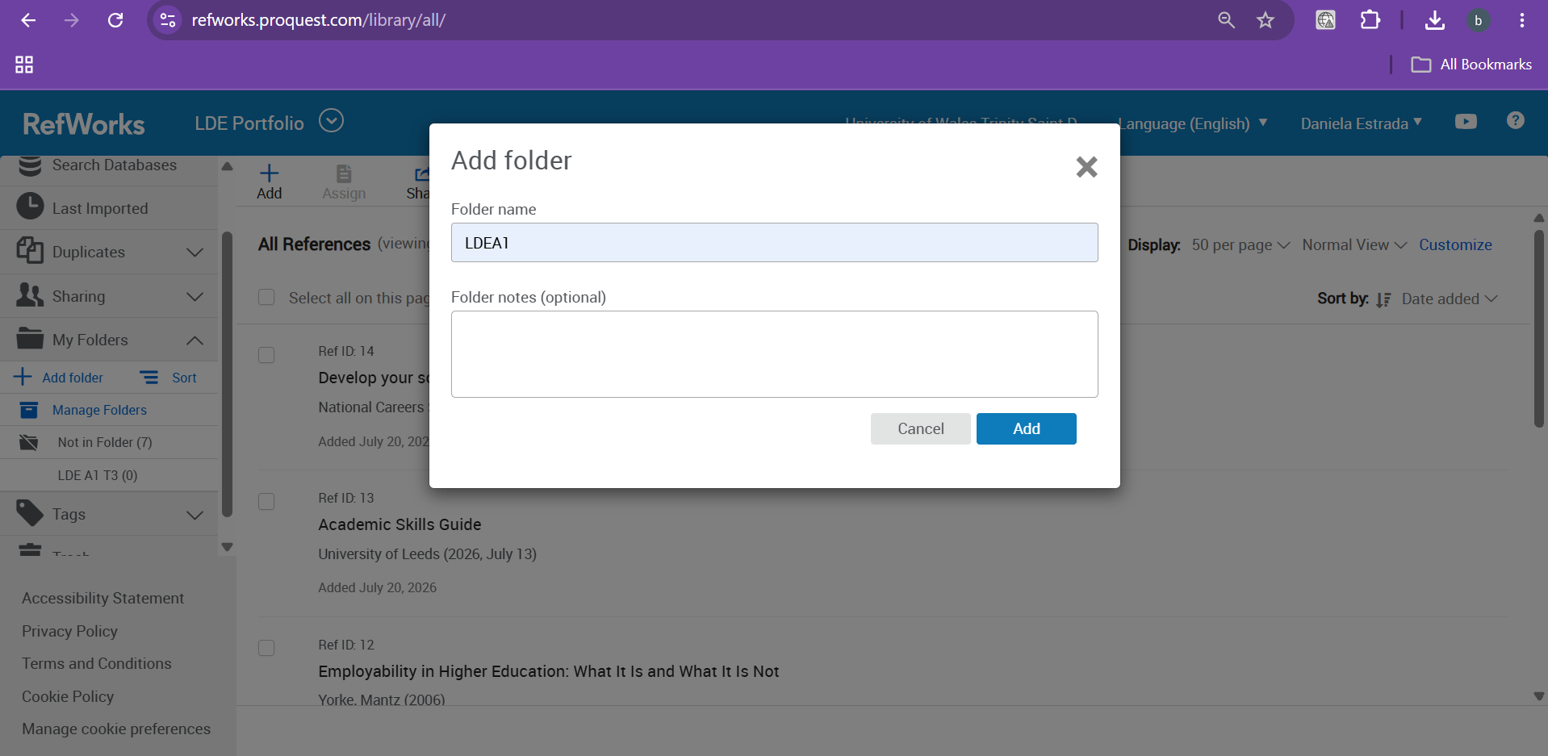

Step 3 – Search for referencing
Search academic references from Google Scholar.
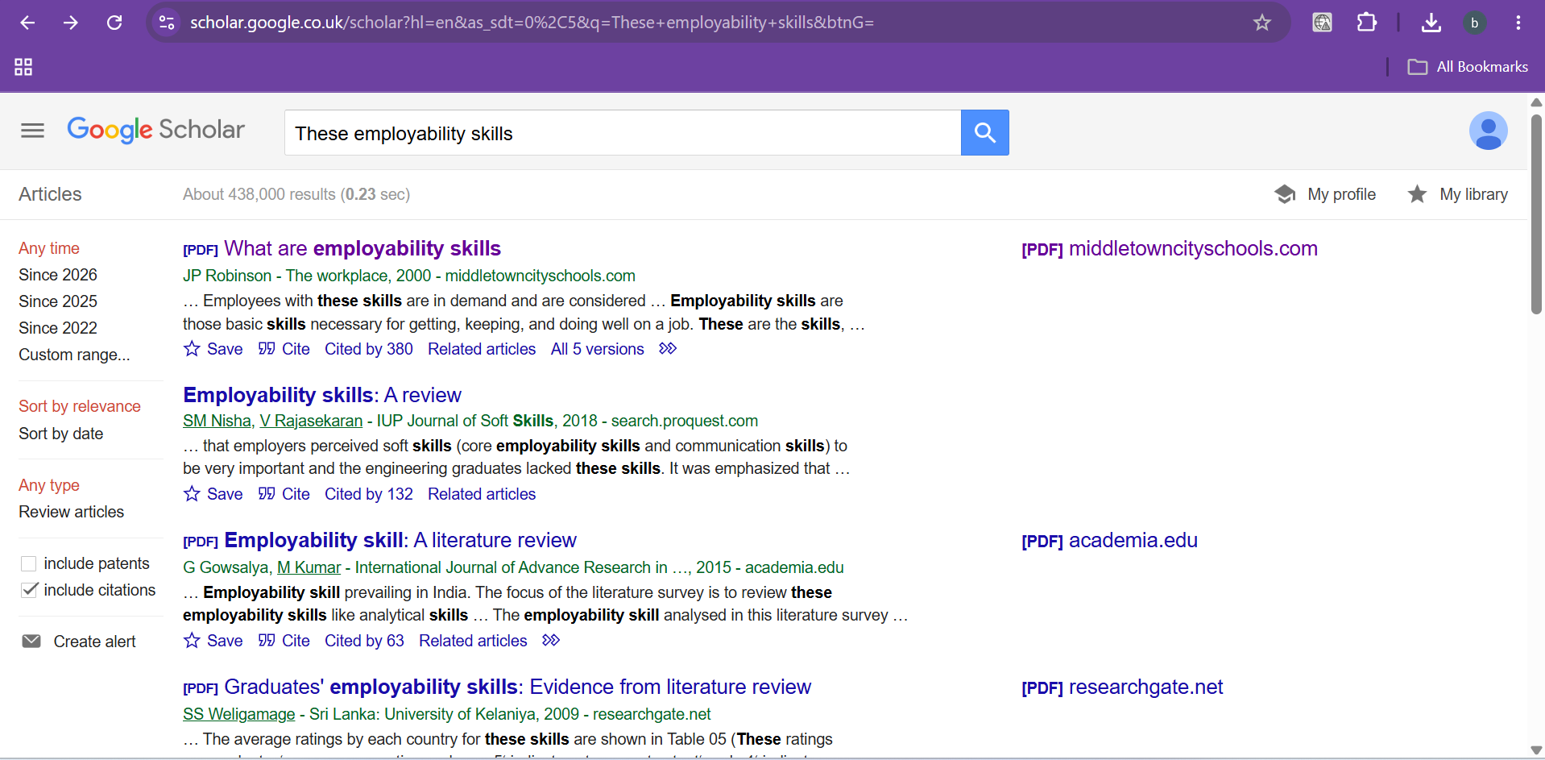

Step 4 – Citation to RefWorks
Click on Cite than a window popup we click on RefWorks to get us into RefWorks tool.
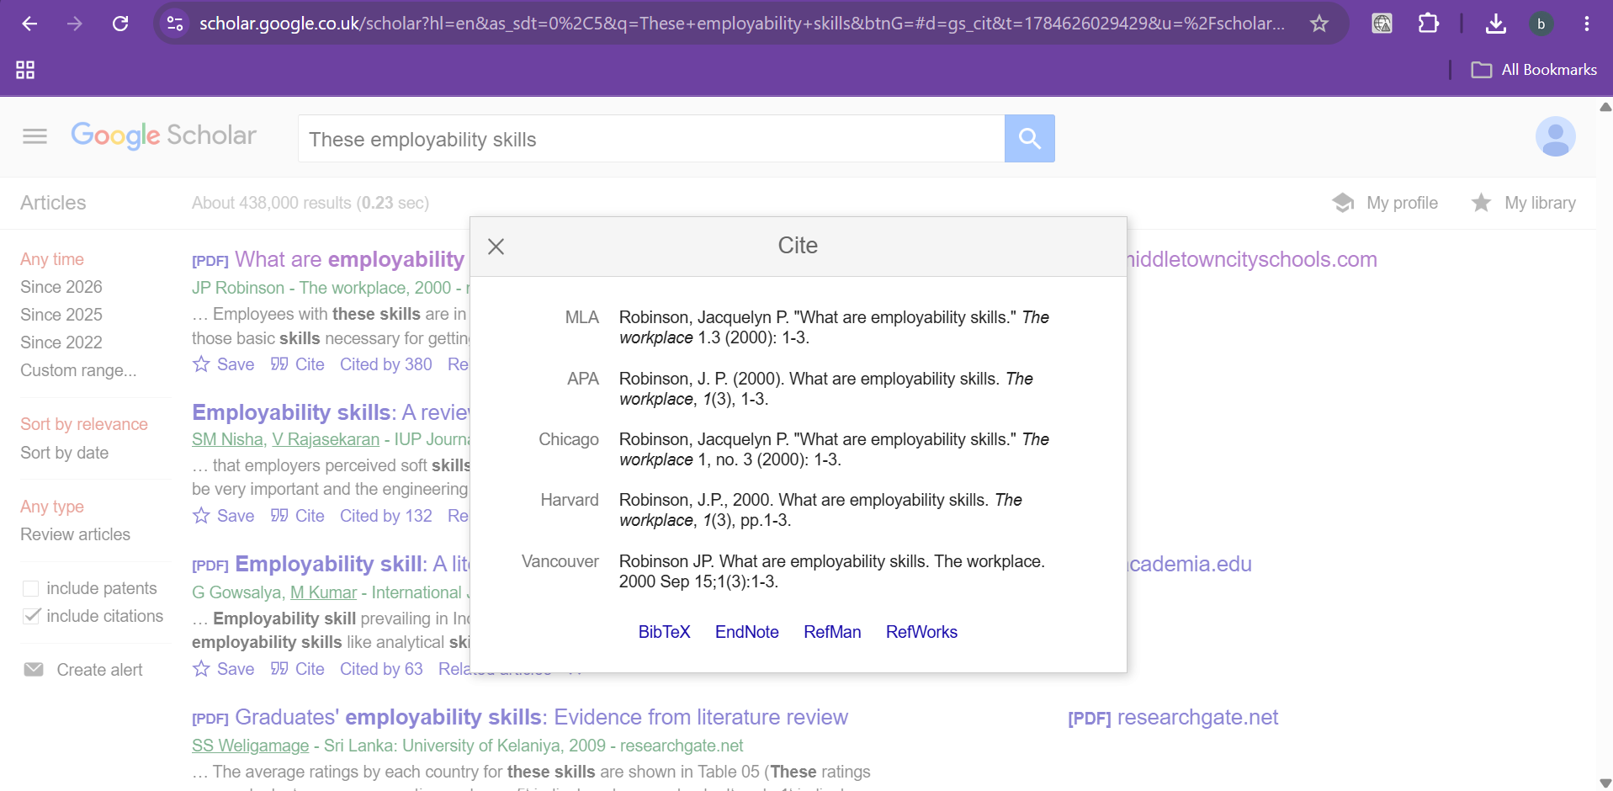

Step 5 – Import References
Import selected references into your RefWorks library for easy access and management.
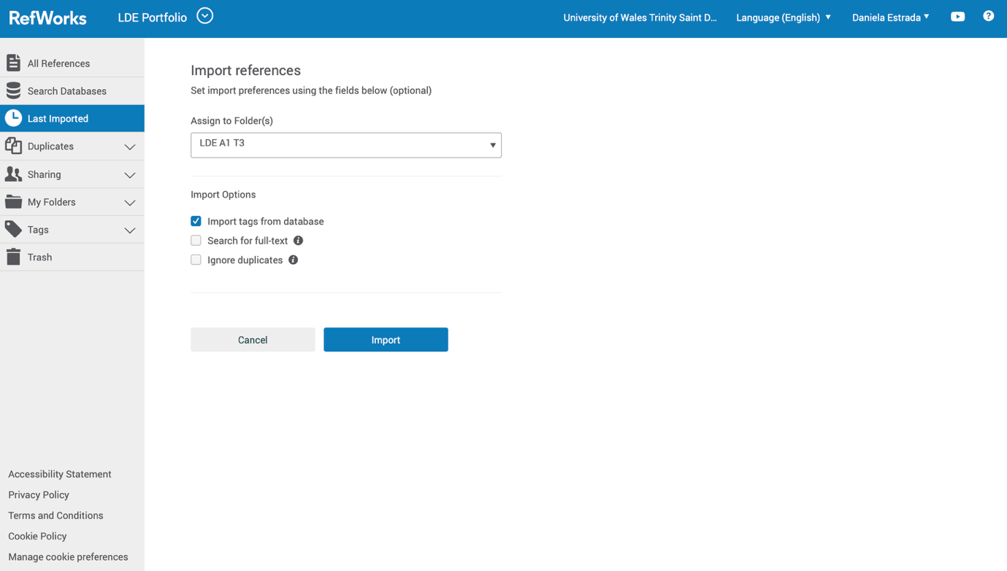

Step 6 – Generate a Bibliography
Automatically create a reference list in your chosen referencing style, such as IEEE UWTSD.

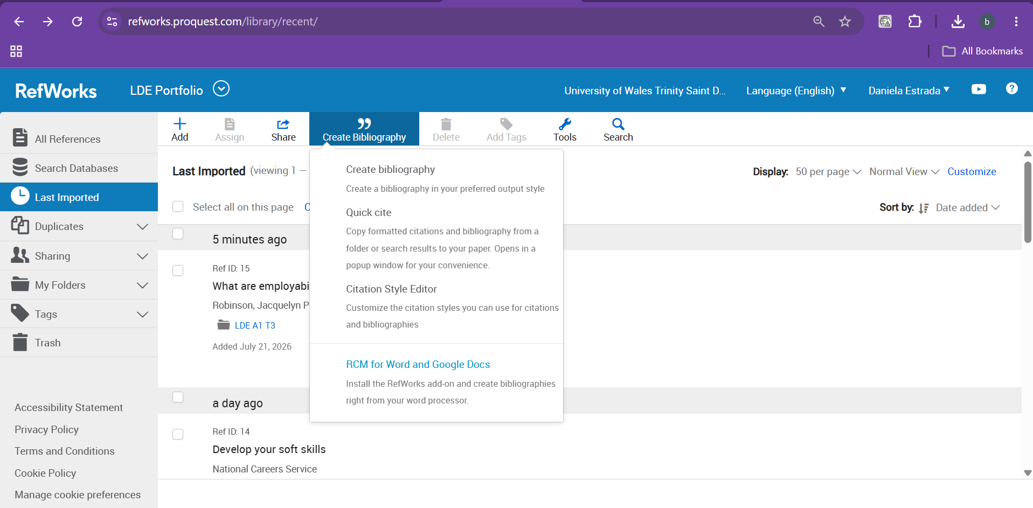

Step 7 – Save and Share
Save your reference library securely online and share folders with classmates or collaborators if needed.
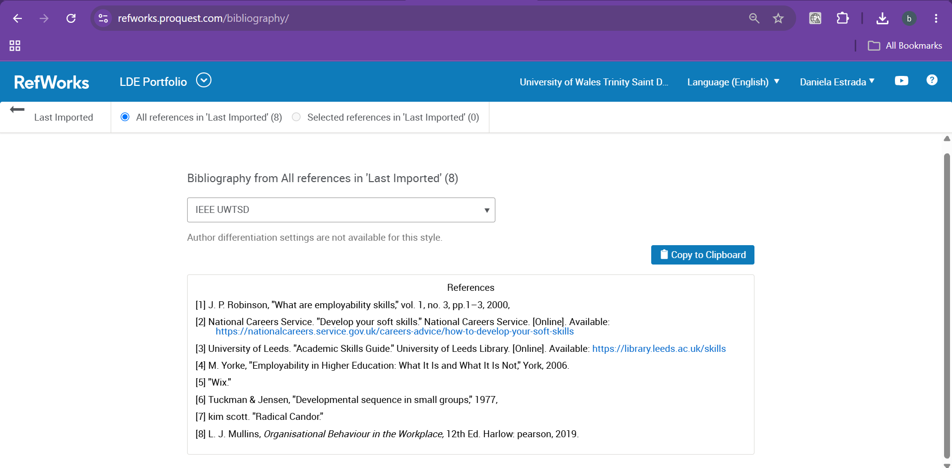

Step 8: The final step is to show how to insert a citation using the RefWorks Citation Manager add-ins.
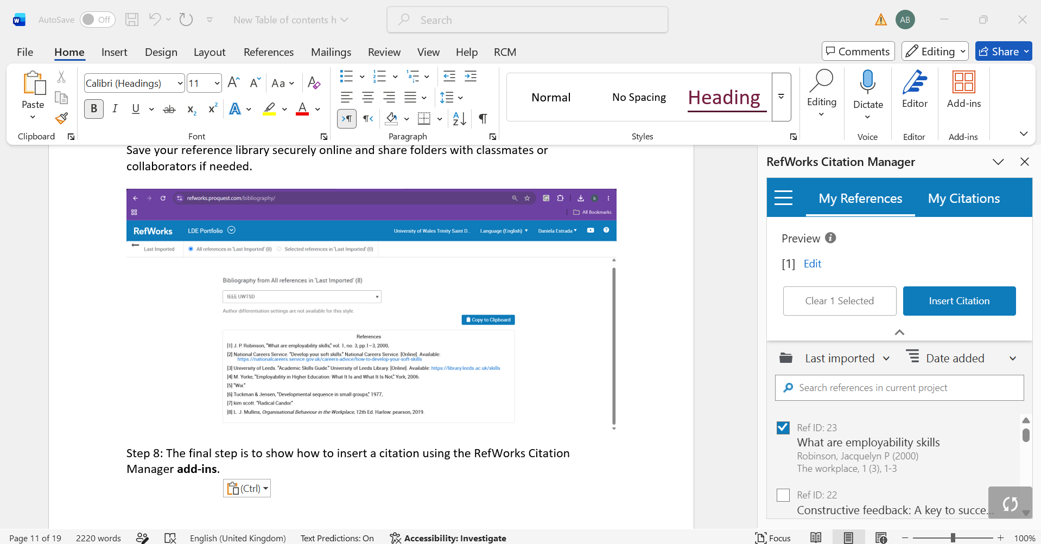

Task 4: E-Portfolio Creation and Evaluation

Task 4 (a): E-Portfolio Creation
As part of this assignment, I created my e-portfolio using Wix, an online website builder that enables users to design professional and visually appealing websites without requiring advanced programming knowledge. I selected Wix because it offers a wide range of templates, flexible design options, and an intuitive drag-and-drop interface that made it easy to organise my work.

Task 4 (b): Illustrative Review of E-Portfolio tool Selection
I selected Wix because it provides an effective balance between flexibility, ease of use, and professional design. The platform offers a large collection of templates and customisation options, allowing users to create attractive and responsive websites without requiring web development experience. Its drag-and-drop editor made it easy to personalise the layout and present my work in a clear and professional way.

Other e-portfolio platforms, such as Google Sites, WordPress, and Canva, also provide useful features. Google Sites is simple to use and integrates well with Google Workspace, but it offers fewer design options than Wix. WordPress offers greater customisation but requires more technical knowledge. Canva is excellent for creating visually attractive presentations; however, it is not as suitable as Wix for developing a complete website-based e-portfolio.

Overall, I believe Wix was the most appropriate platform for this assignment because it allowed me to create a professional-looking e-portfolio while developing valuable web design, digital communication, and organisational skills.

EVIDENCE
The following screenshots provide evidence of the e-portfolio that I created using Wix. They illustrate the main sections of the website, including the home page, personal profile, portfolio pages, and contact page.

Figure 1. Home page of the Wix e-portfolio.

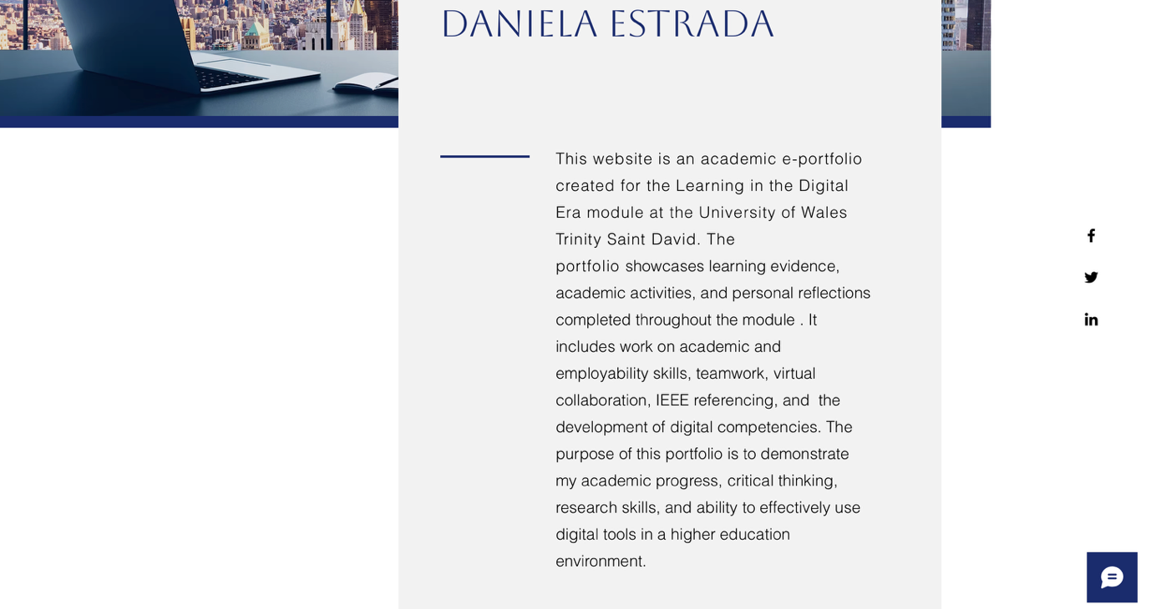

Figure 2. Portfolio page showing Task 1.

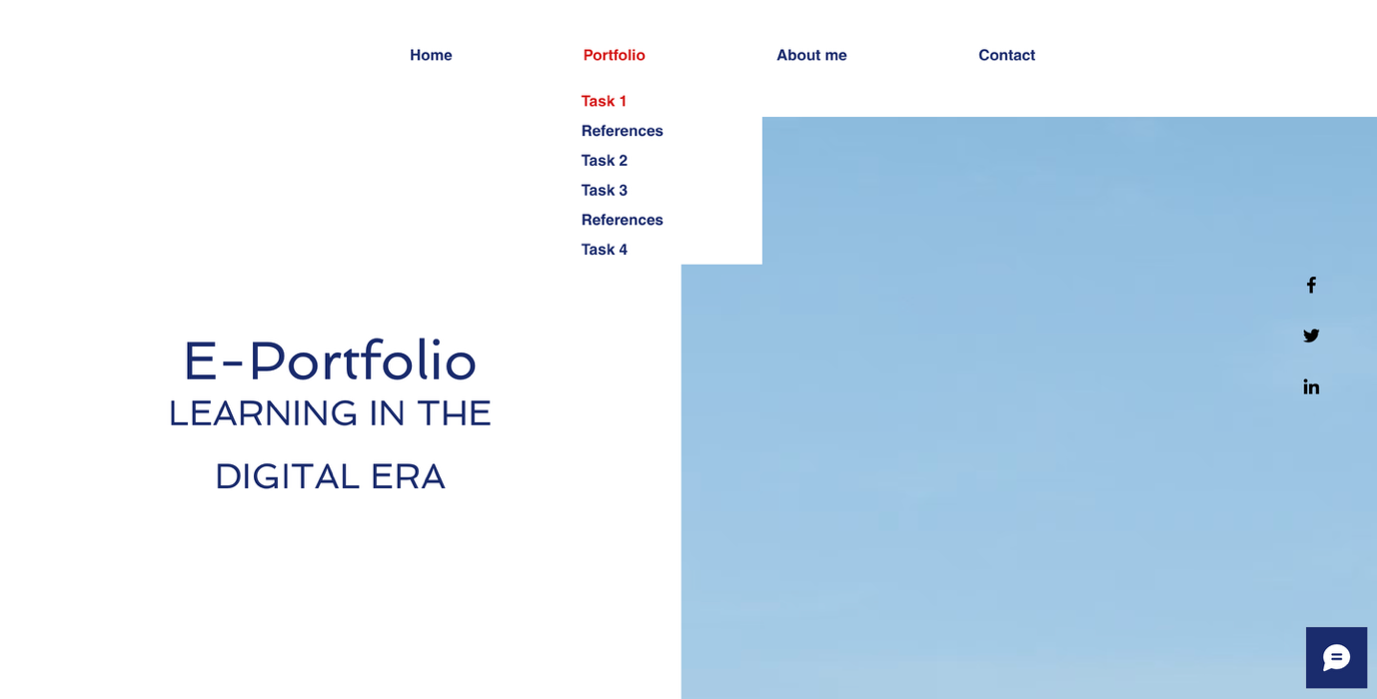

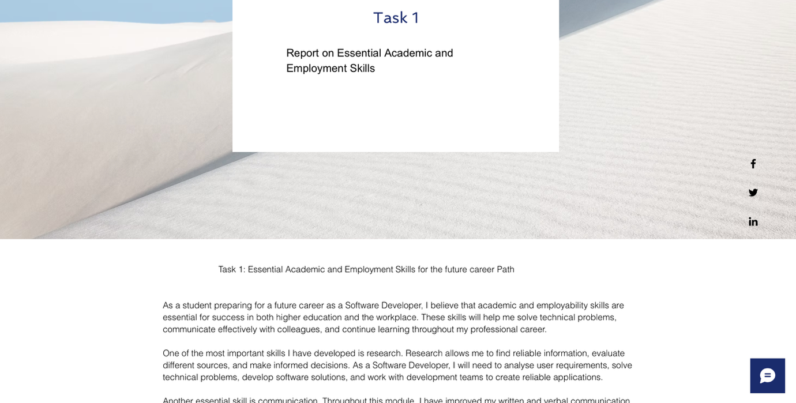

Figure 3. Portfolio page showing References Task 1.

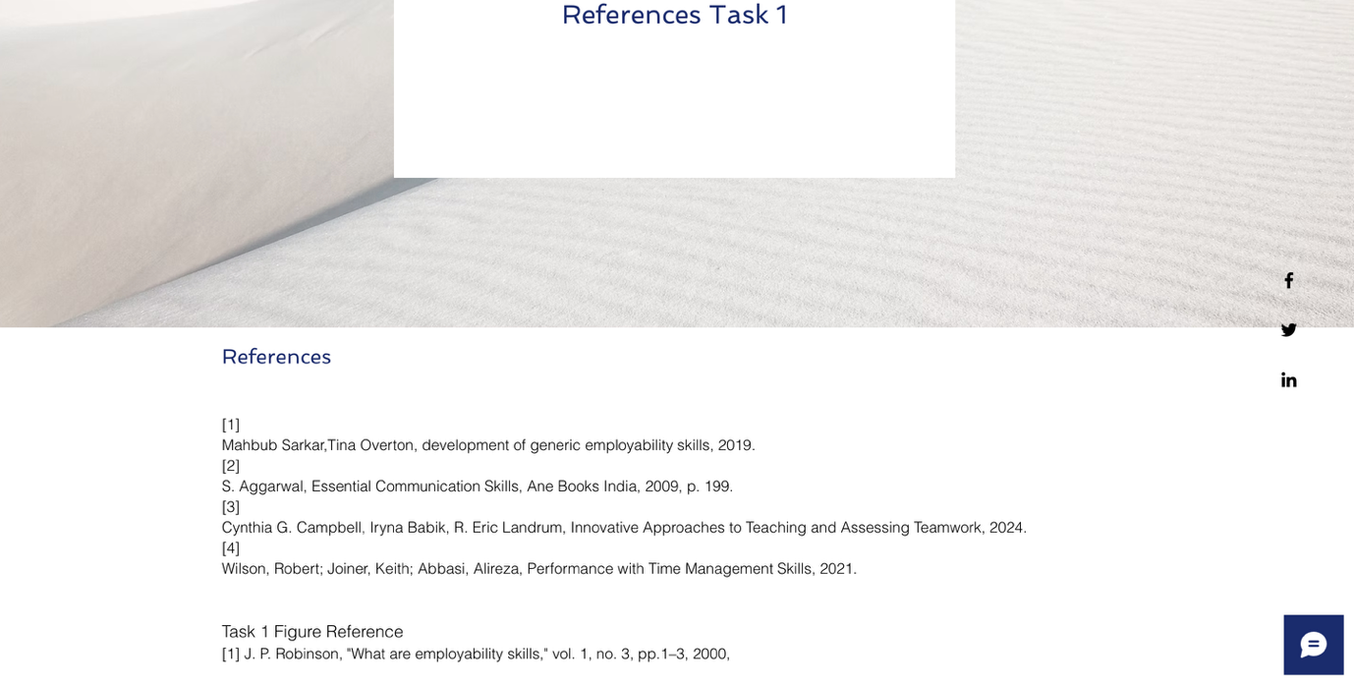

Figure 4. Portfolio page showing Task 2
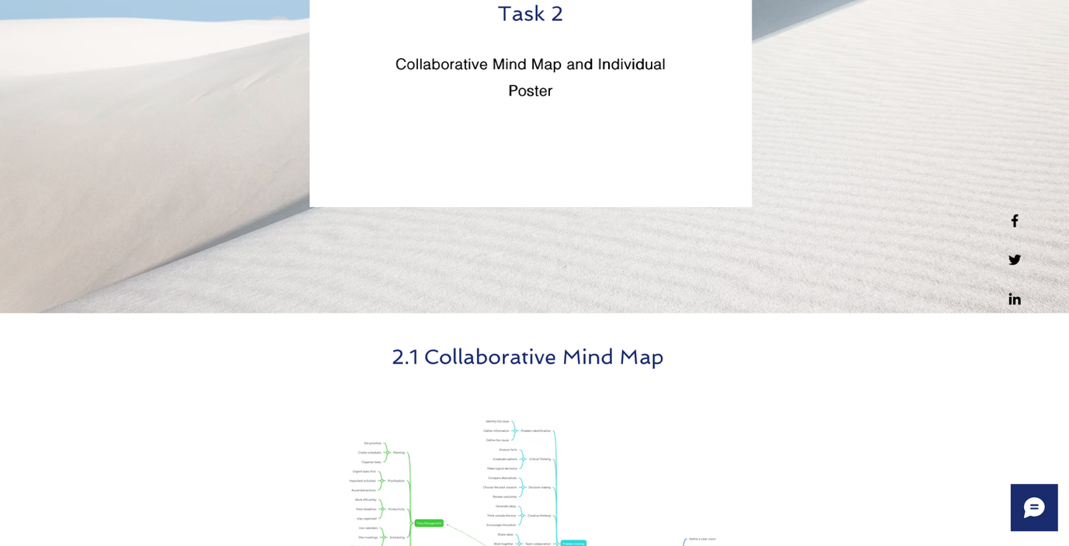
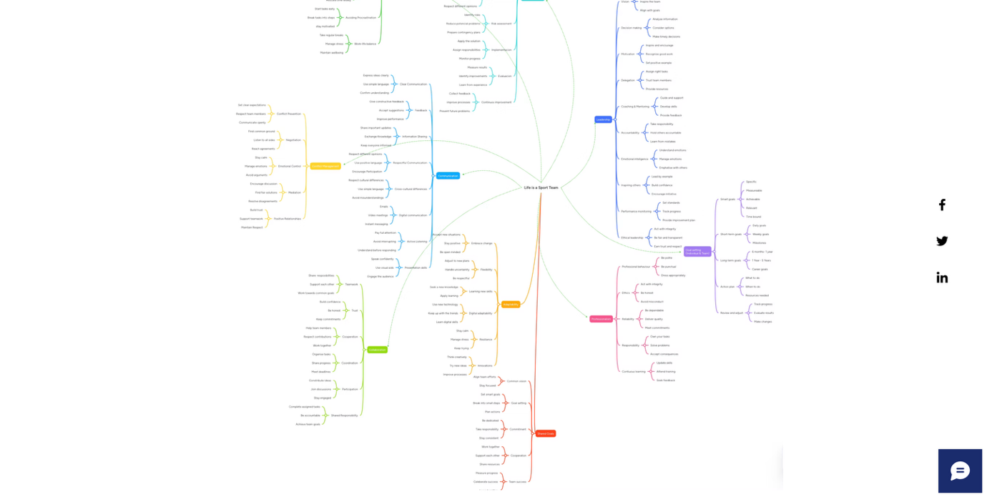
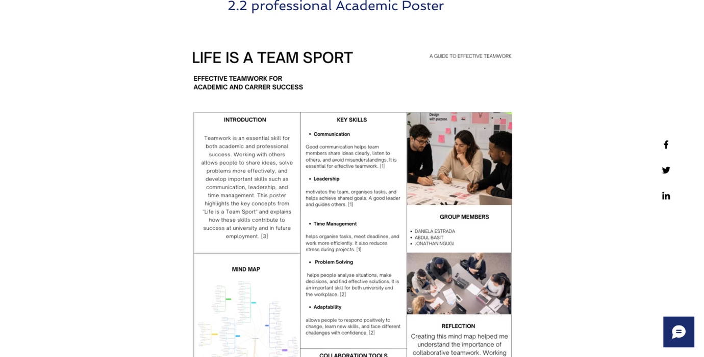

Figure 5. Portfolio page showing Task 3

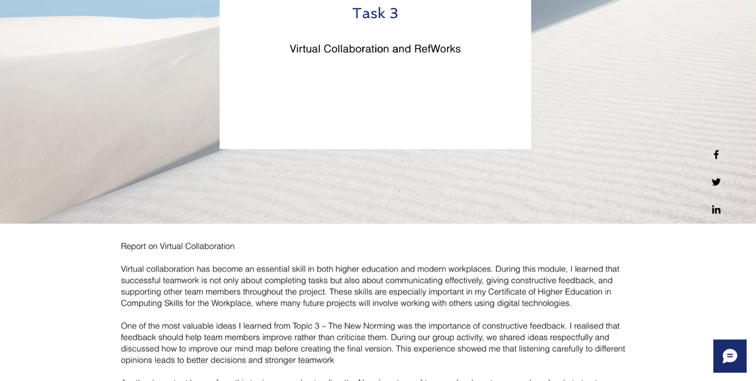
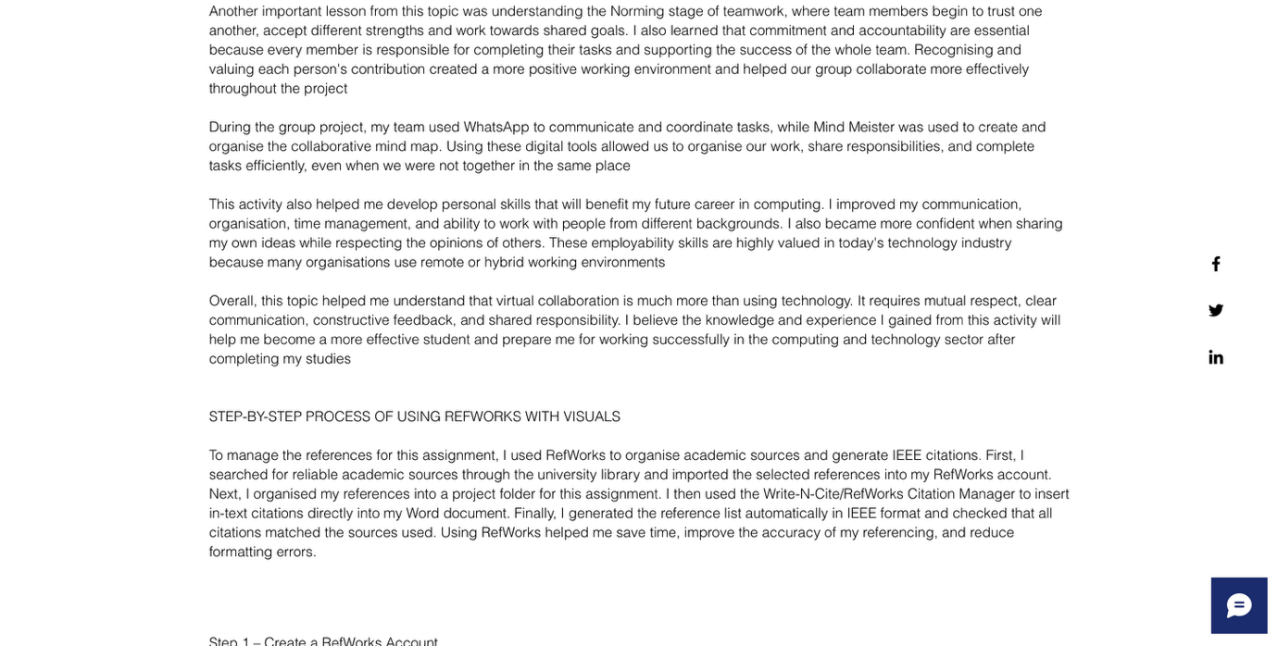
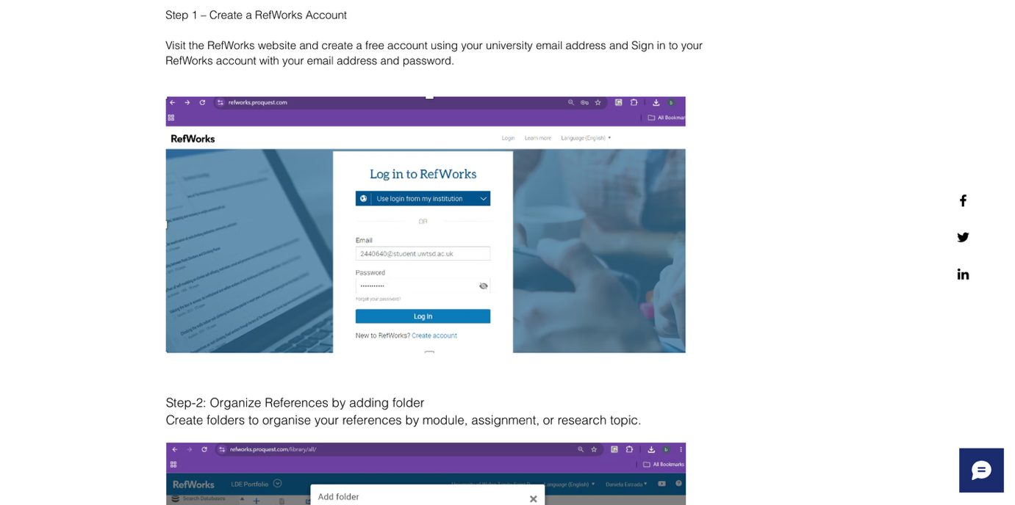

`

Figure 6. Portfolio page showing Task 3 References.

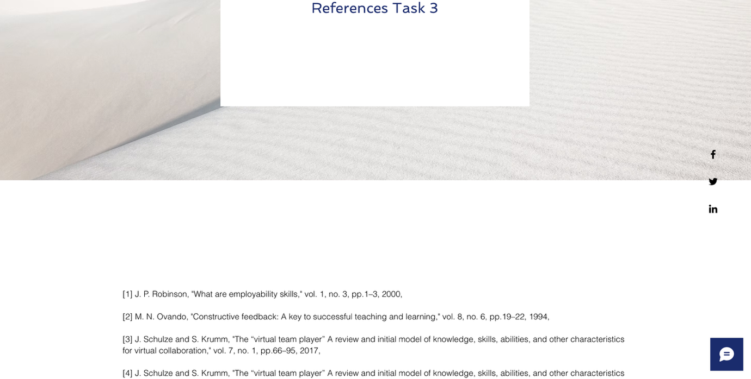

Figure 7. Portfolio page showing Task 4.

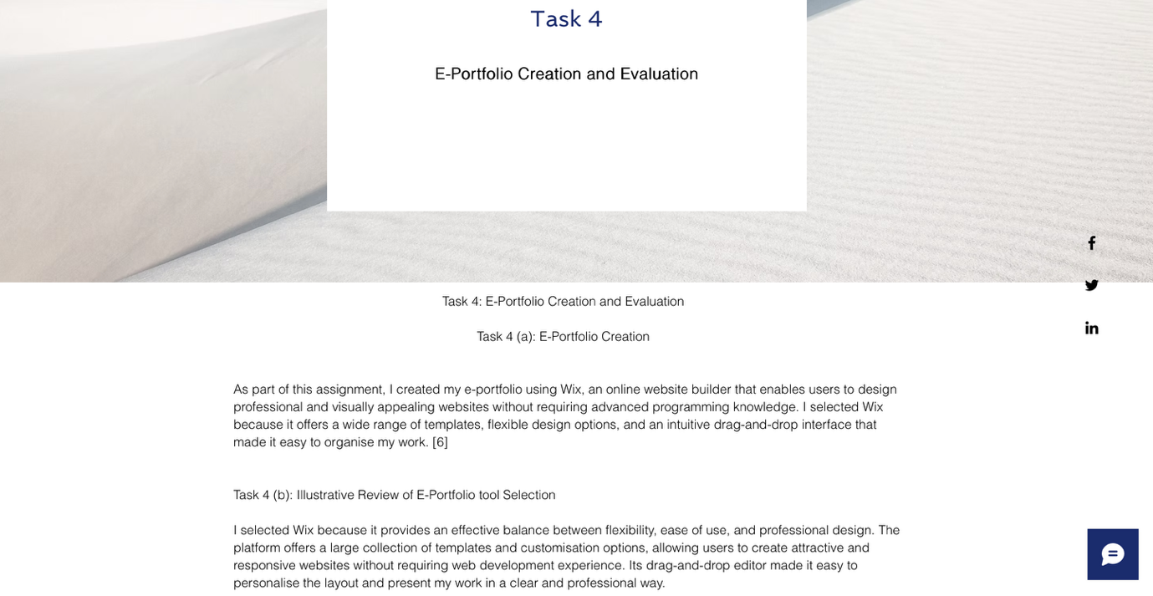
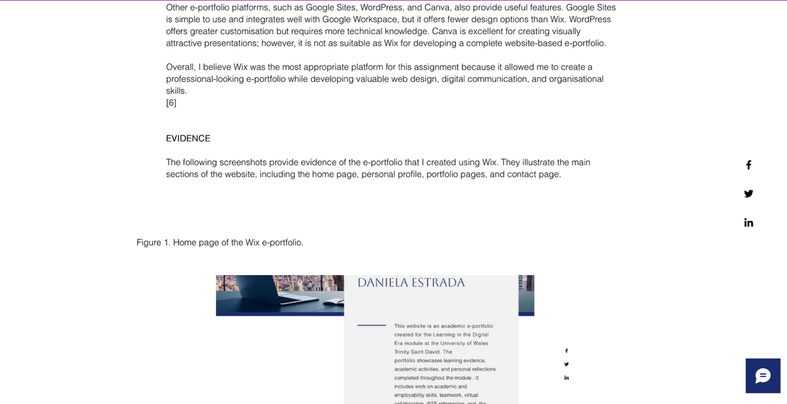

Figure 8. About me page.

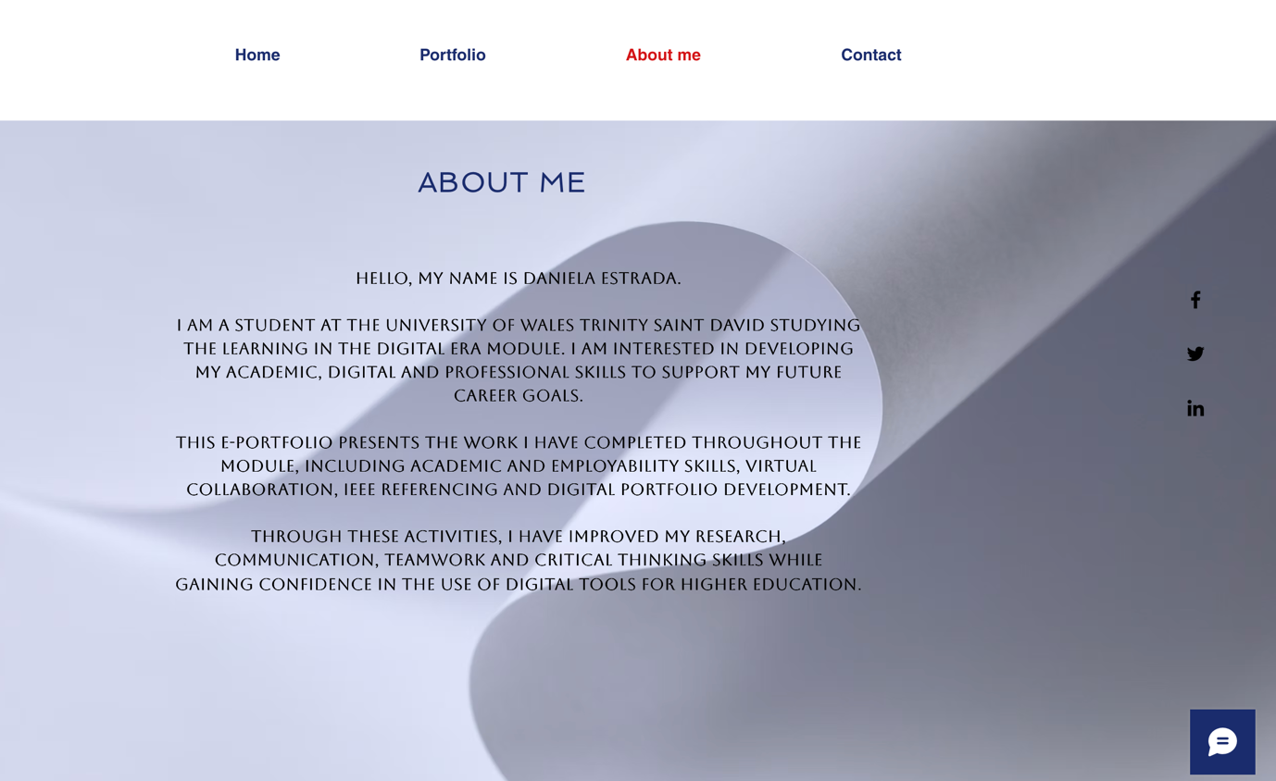

Figure 9. Contact page of the e-portfolio.

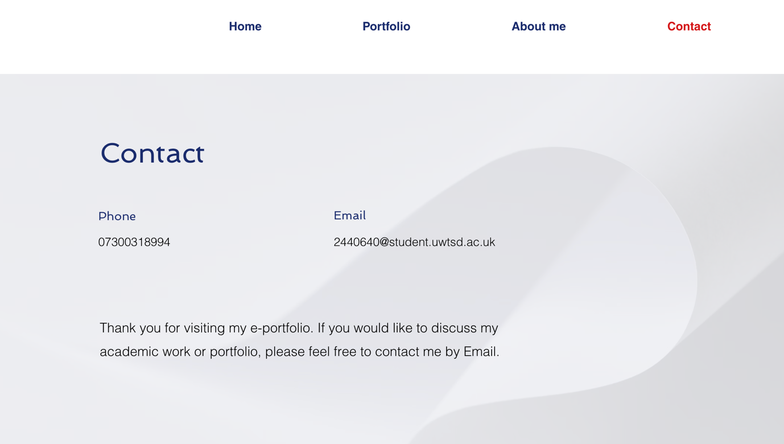

The completed e-portfolio successfully brings together all the module activities within a single website. Creating the portfolio helped me improve my digital literacy, organisation, website design, and communication skills while providing a professional way to present my academic work.

Conclusion

Throughout this module, I developed a range of academic, digital, and employability skills. Completing the written report, collaborative activities, IEEE referencing using RefWorks, and the Wix e-portfolio improved my research, communication, teamwork, organisation, and digital literacy skills. These experiences have increased my confidence in using digital technologies within higher education and have prepared me for future academic study and employment in the computing industry.

References:

Task 1 References

[1] | Mahbub Sarkar,Tina Overton, development of generic employability skills, 2019.
[2] | S. Aggarwal, Essential Communication Skills, Ane Books India, 2009, p. 199.
[3] | Cynthia G. Campbell, ‎Iryna Babik, ‎R. Eric Landrum, Innovative Approaches to Teaching and Assessing Teamwork, 2024.
[4] | Wilson, Robert; Joiner, Keith; Abbasi, Alireza, Performance with Time Management Skills, 2021.

Task 1 Figure Reference
[1] J. P. Robinson, "What are employability skills," vol. 1, no. 3, pp.1–3, 2000,

Task 3 References:
[1] J. P. Robinson, "What are employability skills," vol. 1, no. 3, pp.1–3, 2000,
[2] M. N. Ovando, "Constructive feedback: A key to successful teaching and learning," vol. 8, no. 6, pp.19–22, 1994,
[3] J. Schulze and S. Krumm, "The “virtual team player” A review and initial model of knowledge, skills, abilities, and other characteristics for virtual collaboration," vol. 7, no. 1, pp.66–95, 2017,
[4] J. Schulze and S. Krumm, "The “virtual team player” A review and initial model of knowledge, skills, abilities, and other characteristics for virtual collaboration," vol. 7, no. 1, pp.66–95, 2017,

