Zara Khan
Student Number- 2404947
BA Course Title- Product and Furniture Design
Module- Ways of thinking
Tutors Name- Julia Lockheart

Task 1- Manifesto Writing (502)
Task 2- Observational Writing ( )

Task 1- Manifesto
- Design is boring
- Design should be felt
- Design with mass production is ugly
- Design should push boundaries
- Design should be innovative
- Design shouldn’t over-optimise
- Design should be treasured
- Design shouldn’t drown in imitation

- Design is boring
Design is boring. Design has lost its depth. Design has conformed to a world full of minimalism and innovation is fading. A stool has now become a circle with legs, a sofa is now a fluffy box, a table is a wooden square. Its time to bring back exciting creations that are full of life. “designers should focus on function first, form second. The descriptive interpretation means that beauty arises from purity of function.” (Lidwell, Holden and Butler, 2023,120). Aesthetics is important to the composition of a product, but the functionality is also important. Having elements of design where it can be interacted with in a unique way adds to the experience of the product and can show that aesthetics and functionality can work hand in hand to make a coherent, interesting product. Alongside this, we should pull inspiration from diversity in product designing. The uniformity of basic shapes with basic fixtures has little distinctiveness. Diversity in design is important to foster creativity and inclusivity that can be pulled from the real world and represent those of diverse cultures, identities, and lifestyles. People don’t want products that just look good and have basic functions, they want products that can intrigue them.
- Design should be felt
Humans are design consumers. Feeling design means to transcend practicality and instead impact the experiences and connections. This then fosters deeper bonds between humans and the product. Being surprised or challenged by a design makes the user feel something towards it. We should design with the intention to not only solve a problem but add to the experience. “Usable designs are not necessarily enjoyable to use.” (Norman, 2003, pg.8) A simple design with little character lacks the novelty or emotional resonance which make products engaging. Mundane tasks could be made fun by having thoughtfully designed products, like a simple coffee mug can be designed special and uplift the user. Design can also connect people to their personal identity or culture. Using traditional aesthetics, using native materials and historical design can evoke pride and uplift. I will make design human again. Design should reflect the world and diversity, not flatten it.

- Design should be innovative
Theres no denying that the simple designs are consumed very easily. Starting with a quick, cheap, and easy manufacturing process to being sold by the thousands, there’s no doubt that minimalism sells well. But, why does it have to be minimalistic? Why can’t we have intricate products that sell to be treasured? We can combine these two dynamics to produce thoughtful products to be sold on a larger scale “Divergent thinking is the route, not the obstacle, to innovation.” (Brown, 2009, pg.59) Embracing imperfections, playing with unconventional scopes and exploring new breadths of design is what’s needed to bring back what we once had, thoughtful design full of character and personality.

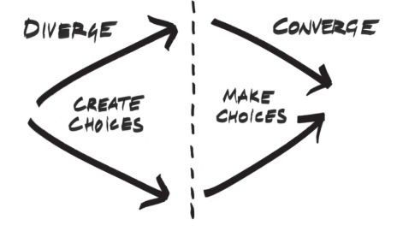
(Brown, 2009, pg.58)
There is a process within designing and innovation which designers within companies tend to miss. Instead of coming up with unique solutions, the design will be a rip off from another design. There’s a major focus on trends and aesthetics which takes away the much needed innovation. I will commit to experimentation, taking inspiration from historical designs to create innovative and unique future products with functionality and purpose.

Manifesto Bibliography-
Emotional Design: Why We Love (or Hate) Everyday Things, 2003, Norman, D.A.N, (99+) Emotional Design, Donald Norman.pdf | Franco Olivetti - Academia.edu
Change By Design, 2009, Brown, T.B, https://ebookcentral.proquest.com/lib/trinity/reader.action?docID=6931612&ppg=1
Universal Principles of Design, 2023, Lidwell, Holden, Butler, W.L, K.H, J.B The Pocket Universal Principles of Design : 150 Essential Tools for Architects, Artists, Designers, Developers, Engineers, Inventors, and Makers

Task 2- Observational Writing


