Module: | Certificate of Higher Education in Employability Skills
Student name | Gabriel Vandame Mihalecea
Student id | 2324149

1. Analysing Questionnaire Data
- Local Sourcing: 57% of respondents rated sourcing local ingredients as highly important. This insight supports emphasizing the use of fresh, locally sourced ingredients on the website and in marketing materials.
- Multicultural Menu: 57% of participants were very interested in multicultural options such as Welsh, halal, and vegetarian dishes. This highlights the demand for cultural inclusivity in dining, which can be a central theme for promotional content.
- Dining Preferences: 71% of respondents prefer dine-in services, suggesting that the website should promote the ambiance and dining experience of the restaurant.
- Health Focus: 86% selected health and nutrition as their primary reason for choosing homestyle meals, reinforcing the need to highlight nutritious, fresh, and balanced options in the design.
- Loyalty Programs: 86% rated loyalty programs as highly attractive, indicating the need to prominently showcase Gaby’s Good Eats Club.
- Digital Discovery: 57% of respondents use online reviews and websites to discover new restaurants, suggesting the importance of a user-friendly, well-optimized website.
- Time Preferences: Most respondents indicated dinner as their preferred time for dining, which can inform marketing campaigns and website call-to-actions, such as "Perfect for Dinner Plans."
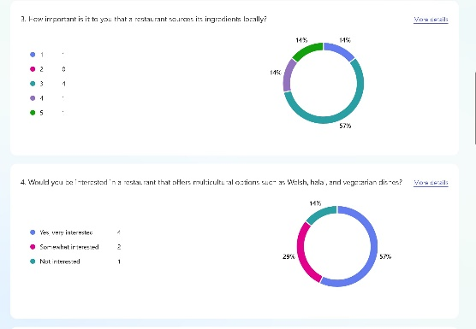 | 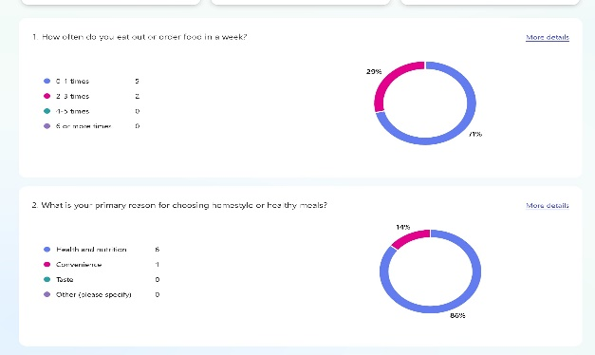
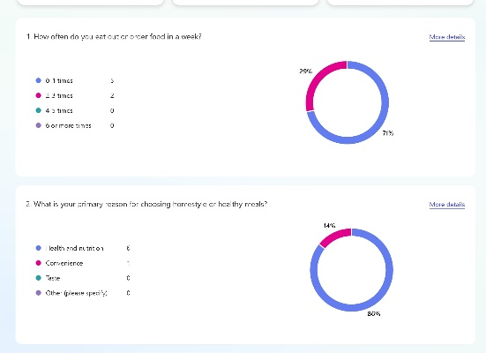 | 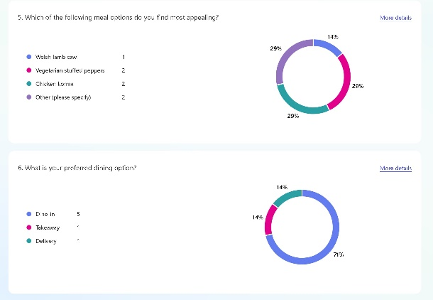
2. Website Design
Approach Using Weebly
- Page 1: Homepage
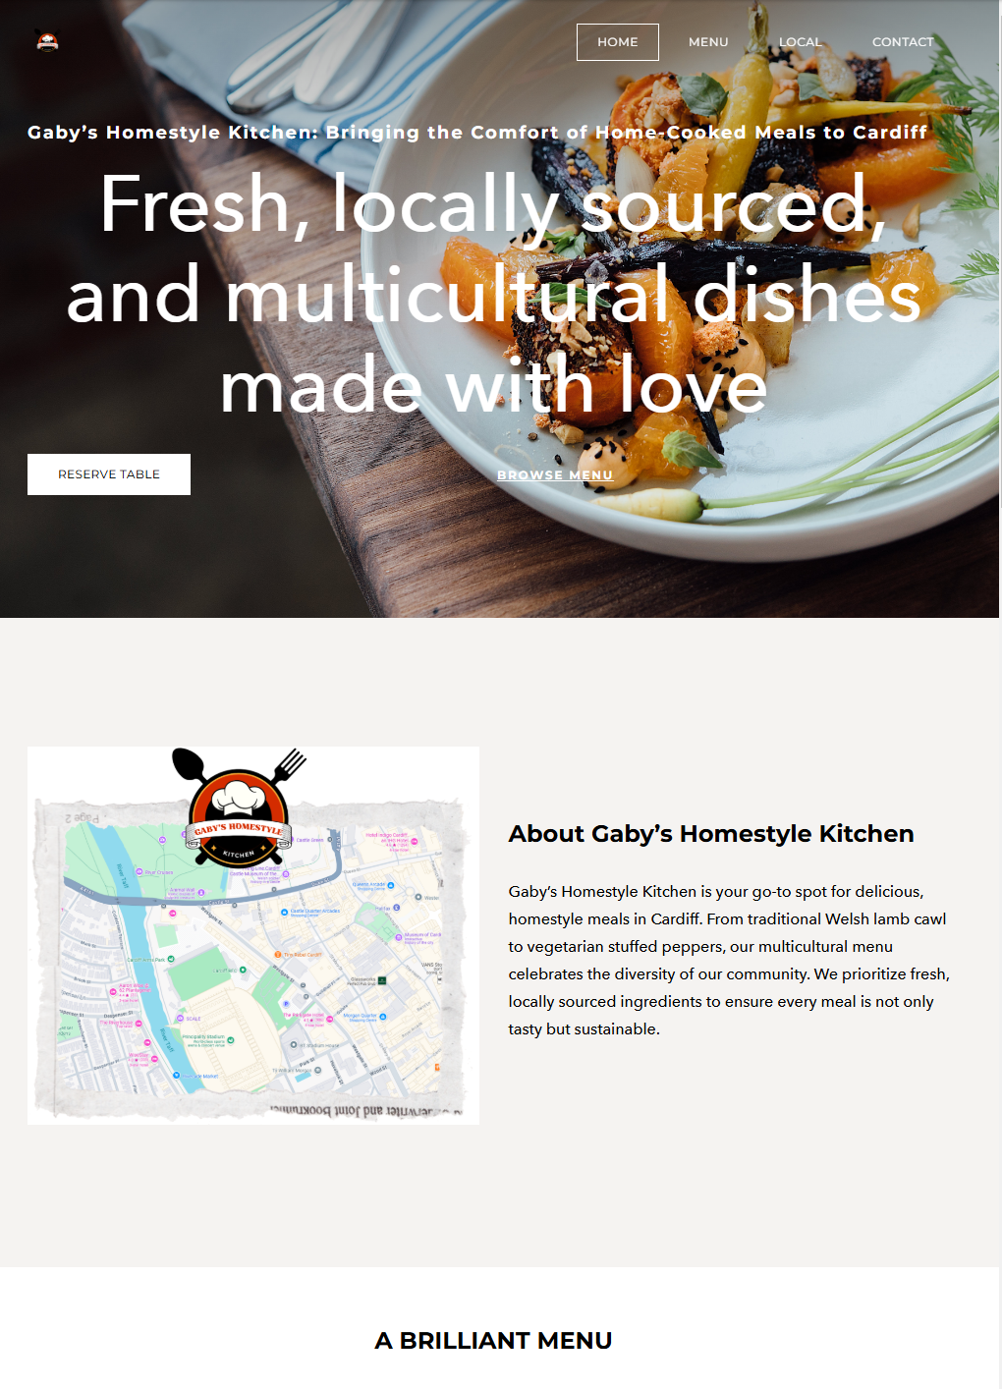

- Page 2: Menu and Contact Page
- 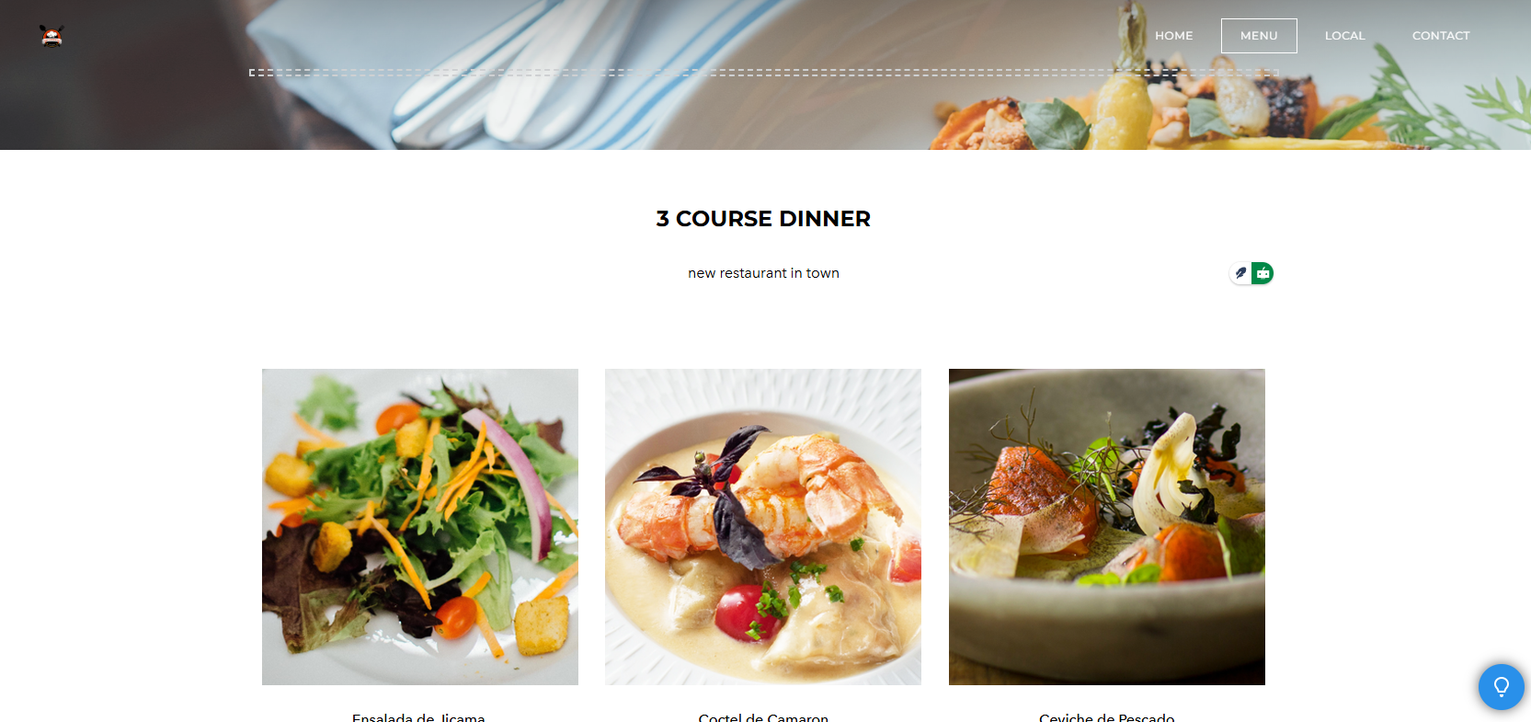

SEO Considerations:
    - Keyword optimization for "healthy dining Cardiff" and "Cardiff halal food options."
    - Alt-text for all images to enhance search engine visibility.

3. Marketing Materials
Approach Using Canva
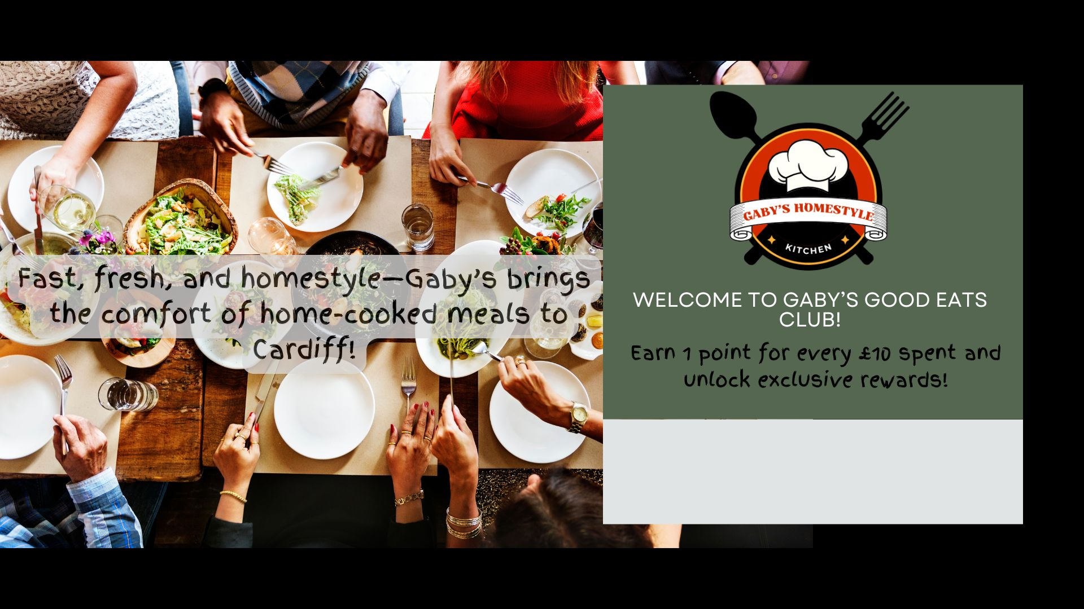
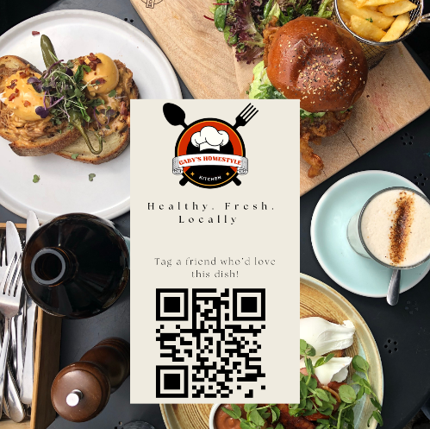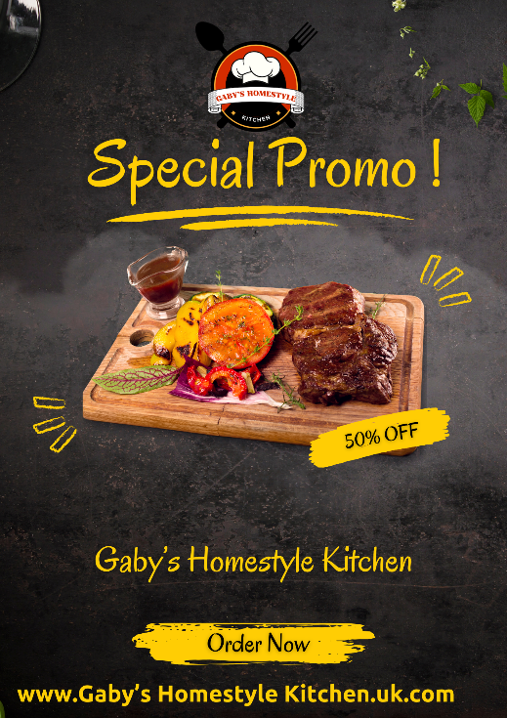

4. Incorporating Questionnaire Data into Design
Segmentation
- Identified customer segments include:
  - Health-Conscious Diners: Prioritize nutritional transparency and health benefits.
  - Cultural Food Enthusiasts: Attracted by multicultural options like halal and vegetarian dishes.
  - Loyalty Seekers: Interested in incentives such as discounts and rewards.
  - Evening Diners: Prefer dining during dinner hours, guiding targeted promotional campaigns.
Implementation in Website and Marketing Materials
- Homepage and flyer focus on health, local sourcing, and multicultural diversity to attract health-conscious and cultural food enthusiasts.
- Highlighted loyalty program prominently on all materials to appeal to loyalty seekers.
- Targeted dinner promotions on social media to attract evening diners.

5. SEO Optimization
- Website:
  - Used relevant keywords like “healthy meals Cardiff” and “multicultural dining.”
  - Optimized meta tags and descriptions to include health, locality, and multicultural focus.
  - Alt-text for images: "Welsh Lamb Cawl," "Vegetarian Stuffed Peppers."
- Social Media:
  - Hashtags: #LocalIngredients, #HealthyEats, #CardiffFoodies.
  - Engaging posts designed to drive traffic back to the website.

6.Reflective Summary: Using Questionnaire Data to Design a Website and Marketing Materials
- Creating the website and marketing materials for Gaby’s Homestyle Kitchen was an exciting and insightful process. It was my first experience designing promotional tools for a business idea, and I quickly realized how crucial the questionnaire results would be in shaping the content. The questionnaire provided valuable insights into what potential customers value most, and this data guided every decision I made while working on the website and marketing materials. From identifying specific target audiences to ensuring that the content was optimized for search engines, the process felt like solving a puzzle—each piece informed the next step.
- The first task was analyzing the questionnaire responses. It wasn’t just about looking at numbers but about understanding the story they told. One of the clearest takeaways was how much people prioritize health and nutrition when choosing meals. An overwhelming 86% of respondents indicated this as their primary reason for opting for homestyle or healthy meals. This made me think about how we could position Gaby’s Homestyle Kitchen as a health-focused brand. The concept of "fresh, healthy, and locally sourced ingredients" became central to both the website and the marketing materials. It was clear that this aspect would resonate with a large portion of the audience, so I made it a key focus in the promotional materials.
- Another interesting insight was the interest in multicultural menu options, such as Welsh, halal, and vegetarian dishes. More than half of the respondents (57%) were very interested in this, which reinforced the idea that Gaby’s should emphasize its diverse offerings. I realized that highlighting these options wouldn’t just attract a wider audience but also help position the business as inclusive and culturally aware. This became a theme across the website and materials. For example, the homepage of the website prominently features the tagline, “A Multicultural Taste for Every Plate,” and showcases dishes like Welsh Lamb Cawl and vegetarian stuffed peppers. On social media, I planned posts that celebrate these dishes with hashtags like #MulticulturalDining and #LocalIngredients.
- Another important aspect of the questionnaire was understanding how people discover new restaurants. I was surprised to see that 57% relied on online reviews and websites, with only 14% using social media. This insight helped me prioritize the website’s design and functionality. I realized that the website needed to be not only visually appealing but also easy to navigate and optimized for search engines so that it could appear in search results. I used this data to guide the SEO strategy for the website, focusing on keywords like "healthy meals Cardiff" and "multicultural dining Cardiff." This meant carefully crafting titles, meta descriptions, and even the alt text for images to reflect these keywords.
- The questionnaire also revealed that a significant number of respondents valued loyalty programs, with 86% rating them as highly important. This insight felt like an opportunity to create a unique selling point for Gaby’s. I designed a loyalty program called “Gaby’s Good Eats Club,” which rewards customers with points for every purchase. The program is highlighted on the website’s homepage with a call-to-action: “Join Now and Start Earning Rewards!” I also created a flyer using Canva to promote the program, featuring bold text like “Good Food, Great Rewards” to attract attention. These materials made me realize how important it is to create something that customers can feel connected to—something that gives them a reason to come back.
- As I worked on the website design, I kept reflecting on how to make it align with what the audience wanted. The homepage became a space to showcase the restaurant’s values: health, local sourcing, and cultural inclusivity. I used images of fresh ingredients and beautifully plated dishes to make the page visually engaging, but I also included clear calls-to-action, like “Reserve Your Table” and “Explore Our Menu.” For the second page, which focused on the menu and contact information, I added details about each dish, including nutritional benefits, to appeal to health-conscious diners. I also made sure the page included a Google Maps widget and simple buttons for reservations and inquiries, as the questionnaire showed that people valued convenience.
- Social media was another area where the questionnaire insights guided my decisions. Although social media wasn’t the primary way people discovered restaurants, I knew it was still important for building brand awareness and engagement. I created posts for platforms like Instagram and Facebook, focusing on visuals of the food and the loyalty program. One post features a close-up of the Welsh Lamb Cawl with the caption: “Fresh, healthy, and locally sourced – Taste the difference at Gaby’s!” Another post highlights the loyalty program, saying, “Join Gaby’s Good Eats Club and enjoy rewards with every meal!” These posts were designed to reflect the brand’s core values while also encouraging interaction and engagement.
- While creating these materials, I also had to think about SEO. I wanted the website to rank well in search engine results, so I focused on integrating keywords based on the questionnaire data. For example, I used phrases like “healthy homestyle meals in Cardiff” and “multicultural dining options” in headings and meta descriptions. I also added alt text to all the images, describing each dish or feature in a way that would help with search engine visibility. Writing blog content for the website was another step in this process. I included articles like “The Benefits of Eating Locally Sourced Food” to target common search queries and bring more traffic to the site.
- Reflecting on the process, I can see how valuable the questionnaire data was in making informed decisions. It provided a roadmap for creating materials that would genuinely appeal to the audience. However, it wasn’t without challenges. One of the biggest hurdles was balancing the different needs of the audience segments. For example, health-conscious diners might prioritize nutrition, while cultural enthusiasts might care more about the diversity of the menu. I had to make sure that the website and materials addressed all these priorities without overwhelming the overall message.
- Another challenge was ensuring that the materials maintained a consistent tone and brand identity. It was tempting to include too much information because of how much we learned from the questionnaire, but I realized that simplicity and clarity were key. This was especially important for the website, where too much text or cluttered design could drive users away. I learned to focus on the most important insights and let those guide the design.
- In conclusion, the questionnaire data was the foundation for everything I created for Gaby’s Homestyle Kitchen. From segmenting the audience to optimizing the website for SEO, every decision was guided by what the data revealed. The process showed me how powerful customer insights can be in shaping a brand and ensuring that it resonates with its audience. I’m excited to see how these materials could help bring Gaby’s Homestyle Kitchen to life and connect with the people it’s meant to serve

References
- Barrow, C., Barrow, P., & Brown, R., 2021. The Business Plan Workbook: A Step-by-Step Guide to Creating and Developing a Successful Business. 10th ed. London: Kogan Page.
- Green, P., & Brown, T., 2020. Sustainable Sourcing in the UK Food Industry. Cambridge: Cambridge University Press.
- Harris, J., 2020. Building Brand Loyalty in the Food Service Industry. Journal of Marketing & Management, 35(3), pp. 86-101.
- Mintel, 2022. The UK Food Service Market Report. Available at: https://www.mintel.com.
- Statista, 2022. Food Delivery Market in the UK. Available at: https://www.statista.com.
- Young, P., n.d. Business Plan. Global Media Publications.

7. a/ Spreadsheet using Microsoft Excel to project the finances of a small business over a three-month period

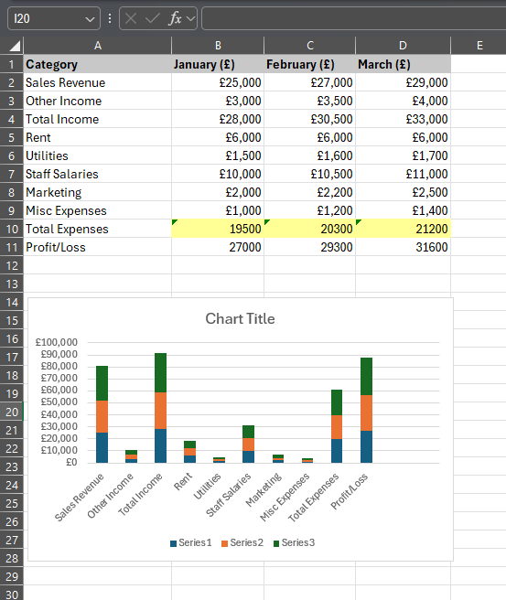
b/ The Importance of Excel in the Digital Era
Microsoft Excel has evolved into an indispensable tool in the digital age, assisting individuals and organisations in data organisation, analysis, and interpretation. Its simplicity, versatility, and sophisticated features make it a popular choice in a variety of sectors. This article examines why Excel is so important in today's society, how it helps users manage data, make choices, and automate processes, and how it affects skill development and professional life.
Managing and Analyzing Data
Excel is extensively used to manage and analyse data, making it a valuable tool for both organisations and individuals. Its grid-like style enables users to effortlessly store and organise information. Sorting, filtering, and conditional formatting allow people to make sense of data without the need for significant technical expertise. Businesses, for example, can keep organised records of their spending, revenues, and staff information. Similarly, students utilise Excel to arrange study plans and analyse results.
Excel has strong data analysis features as well. Calculations may be completed quickly with the help of functions like SUM, AVERAGE, and VLOOKUP. Large datasets may be easily summarised and analysed by users with the use of more sophisticated tools like pivot tables. For example, financial analysts may use Excel to anticipate and predict trends, while marketers can utilise pivot tables to monitor consumer purchasing habits. One of the reasons Excel is still so popular is its capacity to manage little and medium-sized data well (Barrow et al., 2021).
Facilitating Decision-Making
Decision-making in the digital era is frequently based on data, and Excel is essential to this process. Excel helps users make decisions by organising and analysing data to provide them clear insights. Excel, for instance, may be used by businesses to assess sales data, compare budgets, and find development prospects.
Excel's scenario analysis features, such as Goal Seek and Solver, assist users in making predictions and selecting the most effective course of action. For example, a company may utilise Solver to distribute resources in a manner that optimises earnings while adhering to financial limitations. In a similar vein, households may successfully manage their money and evaluate spending possibilities by using Excel (Young, n.d.).
Visualizations, such as charts and graphs, also make Excel valuable for decision-making. A simple bar chart can make it easier to identify trends in sales data or compare expenses over time. This visual representation of information helps users communicate findings clearly, whether in business meetings or school presentations (Harris, 2020).
Automation and Efficiency
Excel's capacity to automate processes is among its most beneficial capabilities, since it reduces mistakes and saves time. Spreadsheets may be configured to update automatically as new data is added by users using formulae. A retail establishment, for instance, can design a sales monitoring sheet that computes daily, weekly, and monthly totals automatically.
Visual Basic for Applications (VBA) and macros go beyond automation by letting users write unique scripts for repeated operations. By using macros to create reports or send emails automatically, a company may free up staff members' time to concentrate on key tasks. VBA is a useful tool in businesses where productivity is crucial, despite the fact that it necessitates considerable technical expertise (Green & Brown, 2020).
Skill Development and Career Opportunities
Learning Excel fosters the development of critical thinking and problem-solving abilities in addition to data management. Spreadsheet creation calls for logical thinking and meticulousness, which are useful in practically any line of work. For instance, creating a budget spreadsheet requires accuracy, trend analysis, and numerical analysis.
Another well-known essential business ability is Excel. Excel competence is required for many jobs, ranging from entry-level to managerial positions. Candidates who are proficient in data analysis, reporting, and automation using Excel are highly valued by employers. Because they show a deeper understanding of the program, Excel certifications can significantly improve professional prospects (Williams, 2022).
Adapting to Modern Technology
Excel has changed to accommodate the demands of contemporary users as technology develops. Multiple users can now collaborate on the same spreadsheet in real time thanks to Excel's interface with cloud services like Microsoft 365. This is especially crucial in remote work settings where team collaboration is crucial.
Excel's functionality is increased via its interface with other programs, such Google Sheets and Power BI. By integrating Excel with these platforms, users can now analyse larger datasets and produce sophisticated visualisations. Moreover, Excel's artificial intelligence (AI) tools, like as Ideas, give users automated insights derived from their data. Excel's continued relevance in the digital age is guaranteed by these advancements (Statista, 2022).
Challenges and Limitations
Excel has many drawbacks despite its great advantages. Because too much data can slow down its speed, it might not be the greatest option for processing really huge datasets. More sophisticated tools, such as Python or SQL databases, are recommended in these situations. Furthermore, even though Excel is easy to use, incorrect use might result in math errors or data mismanagement.
These difficulties do, however, also offer opportunity. Gaining knowledge on how to integrate Excel with other programs, such Python or Power Query, will help you handle complicated jobs with a strong workflow. Furthermore, some of these restrictions are still being addressed by Microsoft's regular upgrades, which gradually increase Excel's stability and effectiveness (Mintel, 2022).
Conclusion
Excel is a vital tool for data management, decision-making, and efficiency enhancement in the digital age. Students and professionals alike can utilise it because of its adaptability and user-friendly interface. Excel continues to satisfy the demands of contemporary users by embracing new technologies and providing robust automation tools. Excel is essential to digital literacy in today's world because it enables users to analyse data and solve problems efficiently, whether they are used for personal finances, corporate operations, or professional advancement.
References
- Barrow, C., Barrow, P. & Brown, R., 2021. The Business Plan Workbook: A Step-by-Step Guide to Creating and Developing a Successful Business. 10th ed. London: Kogan Page.
- Young, P., n.d. Business Plan. Global Media Publications.
- Harris, J., 2020. Building Brand Loyalty in the Food Service Industry. Journal of Marketing & Management, 35(3), pp. 86-101.
- Green, P. & Brown, T., 2020. Sustainable Sourcing in the UK Food Industry. Cambridge: Cambridge University Press.
- Williams, S., 2022. The Financial Times Guide to Business Start-Up 2021/2023: The Most Comprehensive Guide for Entrepreneurs. 32nd ed. Harlow: Pearson.
- Mintel, 2022. The UK Food Service Market Report. Available at: https://www.mintel.com.
- Statista, 2022. Digital Tools in Business. Available at: https://www.statista.com.

Task 04
200-Word Reflection on Storytelling Techniques
The video for Gaby’s Homestyle Kitchen uses key storytelling techniques to create an emotional connection with viewers while highlighting the brand’s unique value proposition. The narrative begins with a personal introduction by Gaby, the founder, to establish trust and authenticity. By sharing the story behind the business and emphasizing the values of love, freshness, and community, the video appeals to the audience’s emotions and fosters a sense of belonging.Visual storytelling plays a significant role, showcasing the vibrant kitchen, fresh ingredients, and joyful customer experiences. These visuals create a sensory connection, helping viewers imagine the taste and quality of the meals. Testimonials from satisfied customers further enhance credibility, presenting real-life endorsements that reinforce the brand’s trustworthiness.The hero’s journey technique positions the customer as the central figure, with Gaby’s Homestyle Kitchen acting as the solution to their needs for healthy, convenient, and comforting food. The use of uplifting music and a warm tone throughout the video keeps the narrative engaging and relatable.Finally, the call-to-action invites viewers to visit the restaurant or order online, ensuring a clear and actionable message. By blending emotion, visuals, and strategic messaging, the video effectively communicates the heart and soul of Gaby’s Homestyle Kitchen.

The YouTube video link :
https://youtu.be/lNvv0pzmxRA

