
The significance of Global Navigation Satellite Systems (GNSS) spoofing to OME.

Author: Joshua Ede
Student Number: 2023302
Word count: 2,636

Contents

1. Introduction 2
2. The science and technology of GNSS, with special reference to GPS 3
2.1 What is GNSS? 3
2.2 The Global Positioning System (GPS): Structure and operation 4
2.2.1 The Space Segment 5
2.2.2 The Control Segment 5
2.3 Signals, codes and modulation 6
3. The use of GNSS in OME 7
4. Jamming and spoofing 7
4.1 Jamming 7
4.2 Spoofing 9
4.2.1 Case Study: The RQ-170 incident 9
5. Significance to OME 10
References 11

Figure 1: R1 is the range the vessel may be from foghorn 1, R2 is the range the vessel may be from foghorn 2. The vessel must be at either intersection point A or B. [6, p. 22] 3
Figure 2: The satellites are the foghorns and the two points are where all three spheres intersect in three-dimensional space are shown [6, p. 27]. 4
Figure 3: Control antennas consist of the Ground Antenna (green) and Air Force Satellite Control Network (AFSCN) (yellow), and the monitoring sites include both the Air Force monitor stations (blue) and the National Geospatial Intelligence Agency (NGA) stations (purple) [9]. 5
Figure 4: The signal broken down into its component parts. [7, p. 125] 6
Figure 5:The shape of GPS signals with M code shown in dark grey [11, p. 145]. 8
Figure 6:The shape of GPS signal frequencies illustrating that a M-Code lies to the edge of the signal distribution therefore is receivable even during wide band jamming. 9

Introduction

Global Navigation Satellite Systems (GNSS) have revolutionised the modern world, becoming a ubiquitous technology that is in many of today’s common appliances [1]. GNSS and more specifically the American Global Positioning System (GPS), began as a military project in the 1970s, but it is now the case that 90% GNSS receivers are in mobile phones [2]. In the ordinance munitions and explosives (OME) context, GNSS has been used on large, long-distance ballistic missiles [3], through to small, light, unmanned aerial vehicles (UAVs) [4]. In order to evaluate the usefulness and vulnerabilities of GNSS, in the context of UK OME, it is necessary to illustrate and describe the underpinning science and technology of the system. Therefore, this report requires a discussion of the engineering of GNSS, with special reference to GPS, before looking at some specific examples of GNSS enabled systems. The report will then examine the terms ‘jamming’ and ‘spoofing’, what they are and their effects on military systems and the actions being taken to limit them. Via this discussion the aim will be to provide the reader with a measured examination of the significance of GNSS spoofing to OME.

The science and technology of GNSS, with special reference to GPS

2.1 What is GNSS?

GNSS: “is a general term describing any satellite constellation that provides positioning, navigation and timing (PNT) services on a global or regional basis” [5]
GNSS utilises time of arrival (ToA) ranging, which measures the time taken for a signal to leave a known location and arrive to a user at an unknown location [6]. To begin with it is easiest to conceptualise trying to determine position using this method in 2 dimensions (2D). The example often used is of a mariner aboard a ship listening for a foghorn coming from a known location [6].For explanation, the following assumptions are useful:
1) The mariner’s clock is perfectly accurate.
2) The foghorn sounds at an exact time known by the mariner.
3) The mariner’s clock is perfectly synchronised to the foghorn clock.
4) The mariner is roughly aware of the position of the vessel.
[6]
If the mariner hears one foghorn under the above conditions, then a distance between the foghorn and vessel may be determined by multiplying the time taken to hear the foghorn, the propagation time, by the speed of sound [6]. Taking two foghorns, the overlapping radii would intersect at two points and so long as condition (4) is met the erroneous position can be discarded and the vessel can be accurately located [6].
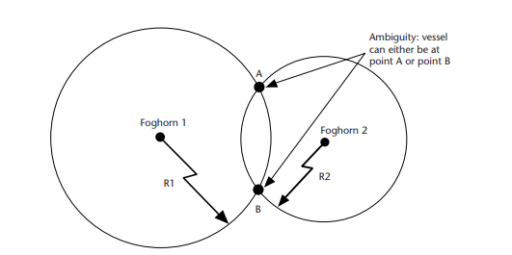
Figure 1: R1 is the range the vessel may be from foghorn 1, R2 is the range the vessel may be from foghorn 2. The vessel must be at either intersection point A or B. [6, p. 22]
Moving to a 3 dimensional (3D) environment, but with all (4) assumptions it would be possible to locate a position using only three ToA measurements. The ambiguous pair of positions would still be created, but assuming a user is on the surface of the earth one position could be discounted [6].

.

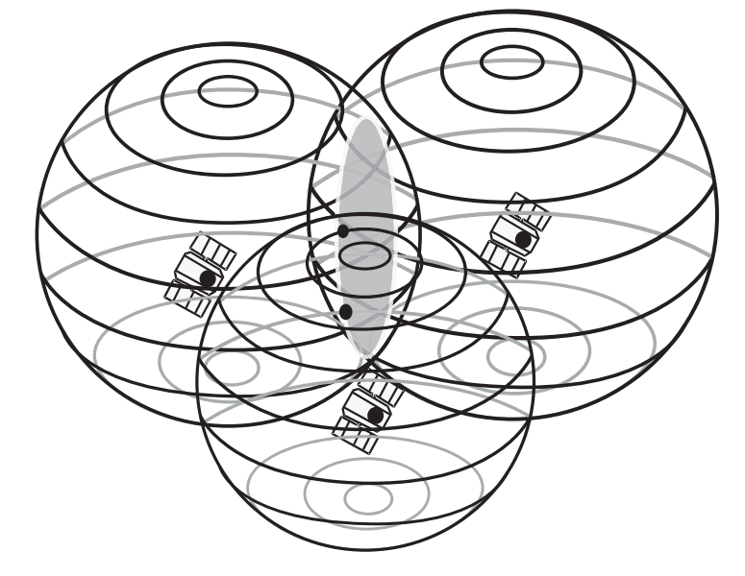
Figure 2: The satellites are the foghorns and the two points are where all three spheres intersect in three-dimensional space are shown [6, p. 27].
Unfortunately for the GNSS user in todays world, assumptions (1) and (3) do not hold true and this necessitates the use of a fourth measurement to correct for inaccuracies in the user’s clock and the offset from the source time. However, it has the added advantage of removing ambiguity, thereby enabling users to determine their position even when they are far above the earth’s surface [6] [7]. Even from this overview the significance of accurate locating can be related to OME, where such technology allowed the American Air Force to precisely target the first floor of a hotel during the first gulf war [8].

2.2 The Global Positioning System (GPS): Structure and operation

GPS specifically refers to the American system of satellites that provide position, navigation and timing solutions (PNT), others including BeiDou, GLONASS and Galileo also exist, as well as, two regional systems Indian Regional National Satellite System (IRNSS later renamed NavIC [2]) and Quasi-Zenith Satellite System (QZSS) [5]. The architecture of these systems is broadly similar and designed to be interoperable, therefore although it is GPS that will be explained many of its features are common to all GNSS systems with any significant differences highlighted [2]. GPS has three segments and each will be looked at in turn and then a more detailed discussion will centre on the signal used in GPS.

The Space Segment

The space segment of the GPS is a constellation of satellites in Middle Earth Orbit (MEO), around 20,200km that broadcast radio wave signals across the earth. There are 32 satellites in the constellation, of which 24 are operative 95% of the time [7]. The angle, spacing and distribution of the satellites is designed to ensure coverage across the surface of the globe and this is one way in which GPS differs from other systems [6]. The Chinese BeiDou constellation, for example, has satellites that are geostationary and in Middle Earth Orbit and is designed to be more visible to users in East Asia [2].

The Control Segment

The control segment of GPS consists of a Master Control Station (MCS), an alternate master control, 11 control antennas and 16 monitoring sites [7]. The figure below shows their distribution across the globe.
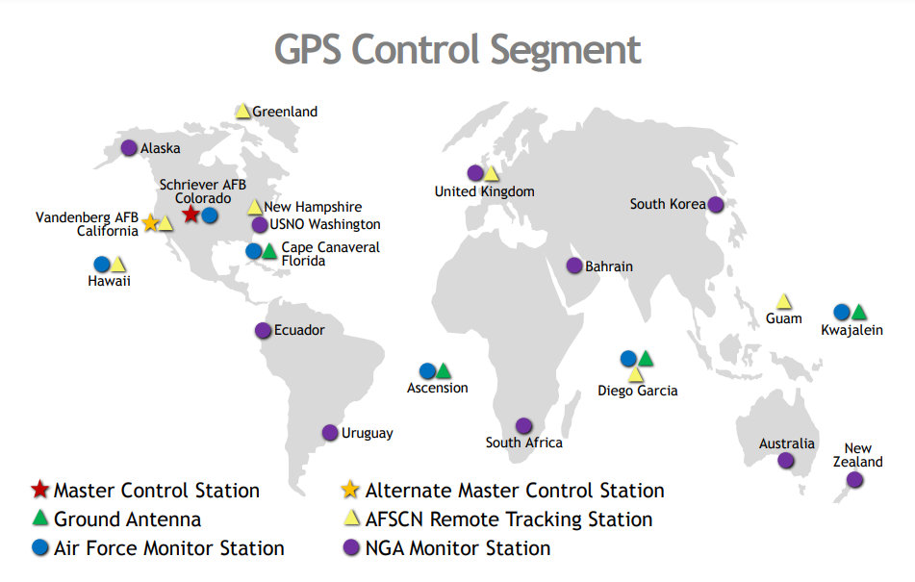
Figure 3: Control antennas consist of the Ground Antenna (green) and Air Force Satellite Control Network (AFSCN) (yellow), and the monitoring sites include both the Air Force monitor stations (blue) and the National Geospatial Intelligence Agency (NGA) stations (purple) [9].
The control segment is the way in which the constellation is monitored and analysed, this includes the maintenance of the satellites through to the checking of clock and auxiliary data and updating the constellation of abnormalities or issues [10] [7]. It is also responsible for the data encryption and protecting GPS from attacks [10], this is particularly important to remember when discussing GNSS’s role in OME.

    - The User Segment
The user segment is essentially the GPS receiver that is able to decode the signals sent from the space segment of the system [10]. There are a wide range of receivers, but all are designed to provide the user with a positional, velocity/navigation and timing solution [7].

Signals, codes and modulation

In section 2.1 the concept of ToA ranging was introduced. GPS uses the exact same principle, however the signals are now radio waves transmitted at 1575.42MHz (L1), 1227.60MHz (L2) and more recently 1176.4MHz (L5) and a pseudorange is obtained by multiplying the time interval between receiver and transmitter and the speed of light [10]. The L numbers refer to the internationally agreed frequency bandwidths [10]. In order to provide an accurate location however, each satellite in the constellation generates a unique pseudorandom noise (PRN) code, which is broadcast along with the carrier signal as well as any data such as space vehicle position, clock bias and satellite health [7] [6]. Binary phase shift keying (BPSK) is used to modulate differences between the PRN and navigation data and the carrier [7]. This form of uniquely coded modulation is referred to as Code Division Multiple Access (CDMA), allowing the same frequency to be used by multiple signals [2].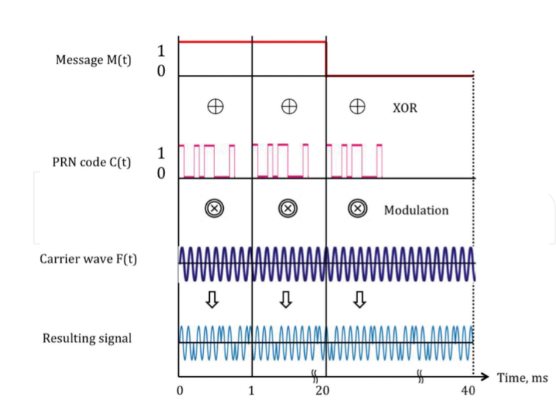
Figure 4: The signal broken down into its component parts. [7, p. 125]
The chipping rate is the amount of PRN transmitted over for each value of either 1 or 0 in the message signal [11]. There are two PRN codes modulated on the L1 band: coarse acquisition code (C/A) and precise code (P) [6]. The differences between them are the code rates and durations. A C/A code chip is around 1ms in duration and has a code rate of 1.023MHz,, whereas the P code has a duration of a week and a code rate of 10.23MHz, making it ten times faster, so it can carry more data and is therefore more precise [7] [11]. The P code, can also carry an encrypted element and when these are combined it is referred to as the P(Y) code, where the Y stands for the encryption key and is for the exclusive use of military operators [11]. Furthermore, the P code is transmitted on both the L1 and L2 frequencies, which will be discussed further when examining jamming [2].
As a final word on GNSS signals the Russian GLONASS should be mentioned. Up until recently, GLONASS used a slightly different technique to CDMA, called frequency dimension multiple access where each satellite has a slightly different broadcast frequency [11]. However, with the latest updates to the GLONASS constellation the Russians have begun using CDMA similar to the other GNSS constellations [11].

The use of GNSS in OME

In section 2.1 the example of the smart bomb as used in the first gulf war highlighted the role of GNSS in the development of OME [8]. In fact, the Gulf war proved a pivotal moment for the use of GNSS by the military with 1000 GPS receivers being issued at the start of the war and more than 9000 being in use by the end [3]. This fact aside, this section concentrates on the role of GNSS not just by the military as a technology for planning and mapping, but specifically regarding OME design and function.
The first GNSS guided weapons were submarine launched ballistic missiles (SLBMs), developed by the United States in the 1970s. These systems allowed the ballistic missile to make small adjustments in its flight path and therefore much more accurate over long distances [2] [3]. Taken forward to today and the advancement of GNSS and supporting inertial navigation systems mean that cruise missiles can be designed with huge stand-off distances, making platforms safer and less vulnerable to attack [3]. However, the munitions themselves have also been modernised by GNSS and a 2004 test showed 155mm artillery shell was accurate within 3m when guided by GPS [12]. Today the importance of GNSS and precision guidance in munitions design to the United Kingdom is illustrated by the BAE systems manufacture of long-range precision-guidance kits, which can be fitted to existing artillery shells in order to improve accuracy and reduce the amount of ordinance required for the combat mission [13].
Another major development in modern warfare that relies heavily on GNSS are unmanned aerial vehicles (UAVs) or drones [4]. It should be remembered that UAVs are not OME, but a delivery platform similar to a plane. When considering the significance of jamming or spoofing on OME however, it is really the platform that could be considered vulnerable. The OME device itself has an inherent advantage in that they generally travel at speeds that mean a jammer or spoofer would have to be very powerful to divert or disrupt the device for long enough for it to miss a target altogether. Furthermore, both the platform and device contain inertial measurement devices, such as gyroscopes in the form of mini electromechanical sensors (MEMs), to provide comparative data and thus detect and correct against anomalies and that may come from jamming or spoofing [8] [2].

Jamming and spoofing

Jamming

Jamming may be defined as the denial of signal to a user or device [14], this may broadly be put under the category of electronic warfare and it is well known that hostile states use these techniques for denial of GNSS along with other radio signals [15]. Jamming is relatively simple and involves creating a large amount of ‘noise’ in the bandwidth of the receiver, thereby disabling the receiver from being able to lock onto the GNSS signal and give a clear position [14]. This noise can be concentrated in a narrow area or across the bandwidth, the latter is more effective than the former as it eliminates more of the signals that may be used for GNSS [14]. However, it should be noted that military applications have long been aware of the threat of jamming and have been developing a counter called M-code since the 1990s [11].
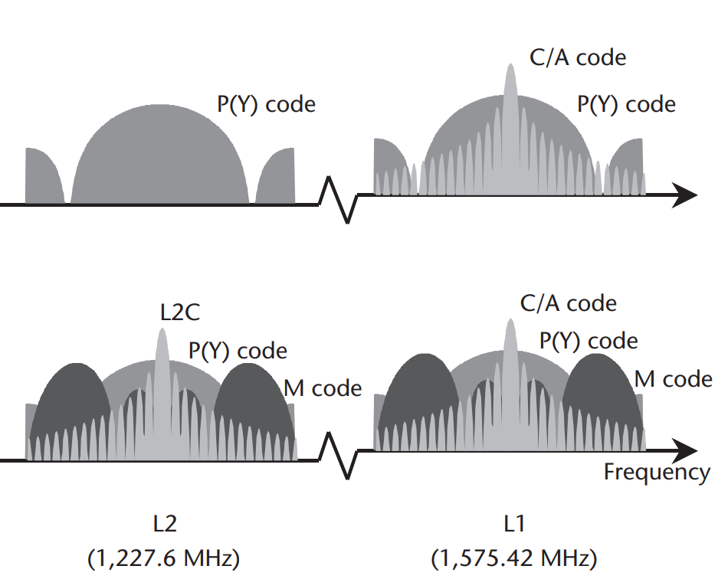
Figure 5:The shape of GPS signals with M code shown in dark grey [11, p. 145].
A wide band jammer would create interference across the bandwidth as shown in the diagram below. However, the strongest part of the M code signals actually lie towards the edge of the signal distribution meaning more of the signal gets through and it is not effectively blocked even by the wide band jamming [14] [11]. Modern military GPS receivers are referred to as YMCA receivers as they can use P(Y) code, M code and C/A code in order to provide a solution [11].
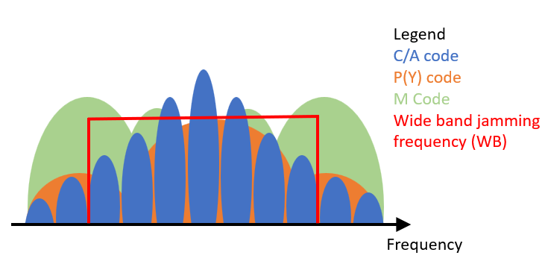
Figure 6: The shape of GPS signal frequencies illustrating that a M-Code lies to the edge of the signal distribution therefore is receivable even during wide band jamming (adapted from [11, p. 145]).
.

Spoofing

Spoofing is the use of false signals to make a user or device believe it is in a different location [4]. If used effectively spoofing can be used to ‘drag’ moving targets off course [16]. There are different forms of spoofing, such as through software where an application sends false data to the same devices’ GNSS receiver, right through to a receiver attack where the attacker uses their GNSS receiver to overlay a false signal to ‘fool’ the victim [16]. Aside from the software attack, which requires no broadcasting and is instead an ‘interruption’ within one device, spoofing is in fact very difficult to achieve [16]. Looking at the example of dragging a victim off course, an attacker would have to create a spoofed signal that not only mimicked the legitimate one, but also be positioned in such a way as to not alert the victims device that the signal was coming from another location as modern GNSS devices are built to include other auxiliary data to account for spoofed signals [16]. This does not mean that it is impossible, but it should be remembered when considering the following case.

Case Study: The RQ-170 incident

In December 2011, a US drone was successful recovered by Iran [4]. In an interview, one of the Iranian engineers that purportedly worked on the project claimed that initially the drone, designated RQ-170, had its GPS jammed, forcing it to go onto autopilot. Following this the signal was spoofed diverting the device into the desert [17]. The US has always denied that the drone was spoofed [4] and despite this example being well publicised, experts from a number of US academic institutions have questioned the voracity of the claim [18]. One of the key components to consider is that a military device should be using the encrypted P(Y) GPS code, therefore to spoof the signal the encryption key would also have to be deciphered. Aside from the difficulty this poses, another key question would be, why target a drone? If US military encryptions had been deciphered this information could be used damage numerous systems, including global financial markets, thus suggesting that spoofing a drone would be a relatively benign use of such information [18]. It is suggested that the lack of clear evidence of spoofing and the choice of target both imply that whilst Iran did recover a US drone, it is unlikely spoofing was the method used.

Significance to OME

Through the literature review of this report the author was not able to find conclusive evidence that a military device had been spoofed, though jamming systems are certainly being used [15]. However, the growth of research in spoofing [14] should influence future OME design with systems being made more robust to anticipate the threat. There could be concerns about whether the reliance on one system of guidance, and one that requires an ally’s acquiescence, is a weakness and this has prompted the UK government to look for alternatives [19]. Current developments in OME systems do highlight the increased use of inertial measurement devices, as highlighted earlier, however these are not a total replacement for GNSS and instead are an augmentation. These same systems also add to the resilience of GNSS as a method of navigation for OME by providing more corroborating data. It is therefore the case that as they become more powerful, spoofing and jamming become less significant.
Overall, whilst spoofing and jamming are an issue for the GNSS used in UK OME, the current defence, still works. This is the use of encryption on the P(Y) and M codes as part of the GPS system. Current developments suggest that exploring alternatives is prudent as over reliance on one system is a vulnerability that can be exploited. Presently however, the UK government should not consider GNSS spoofing as a significant risk to the reliability of existing or near future OME systems.

References

[1] | S. Ross, “How GPS has revolutionized our lives,” 09 11 2018. [Online]. Available: https://www.geospatialworld.net/blogs/how-gps-has-revolutionized-technology-today/. [Accessed 02 12 2022].
[2] | B. W. Parkinson, Y. J. Marton, F. v. Diggelen and J. J. S. Jnr., “Introduction, Early History, and Assuring PNT (PTA),” in Position, Navigation, and Timing Technologies in the 21st Century: Integrated Satellite Navigation, Sensor Systems, and Civil Applications, vol. I, F. v. D. J. J. S. J. a. B. W. P. Y. T. Jade Morton, Ed., New York, y John Wiley & Sons, Inc, 2021, pp. 1- 42.
[3] | S. Sultana, T. Reza, M. Tahsin and M. Hossam-E-Haider, “An Overview of GNSS Applications,” Military Institute of Science and Technology, vol. 3, no. 1, pp. 30 - 35, 2015.
[4] | L. Meng, L. Yang, W. Yang and L. Zhang, “A Survey of GNSS Spoofing and Anti-Spoofing Technology,” Remote Sensing, vol. 14, no. 19, pp. 1 - 24, 2022.
[5] | National Coordination Office for Space-Based Positioning, Navigation, and Timing, “Other Global Navigation Satellite Systems (GNSS),” US Government , 19 10 2021. [Online]. Available: https://www.gps.gov/systems/gnss/. [Accessed 15 11 2022].
[6] | E. D. Kaplan, J. L. Leva, D. Milbert and M. S. Pavloff, “Fundementals of Satellite Navigation,” in Undersanding GPS Principles and Applications, Boston, Artech House, 2006, pp. 21 - 63.
[7] | M. Tamazin, M. Karaim and A. Noureldin, “GNSSs, Signals, and Receivers,” in Multifunctional Operation and Application of GPS, London, IntechOpen, 2018, pp. 119 - 140.
[8] | J. Wilson, “Breakthroughs in inertial sensors to augment GPS will guide future of precision-guided munitions,” Military Aerospace Electronics, 14 Nov 2009. [Online]. Available: https://www.militaryaerospace.com/power/article/16721067/breakthroughs-in-inertial-sensors-to-augment-gps-will-guide-future-of-precisionguided-munitions. [Accessed 30 November 2022].
[9] | National Coordination Office for Space-Based Positioning, Navigation, and Timing, “Control Segment,” US Government, 09 August 2021. [Online]. Available: https://www.gps.gov/systems/gps/control/. [Accessed 03 12 2022].
[10] | S. Dawoud, GNSS principles and comparison, Potsdam: Potsdam University, 2012.
[11] | P. W. Ward, J. W. Betz and C. J. Hegarty, “GPS Satellite Signal Characteristics,” in Understanding GPS Principles and Applications, 2nd ed., E. D. Kaplan and C. J. Hegarty, Eds., Boston, Artech House, 2006, pp. 113 - 150.
[12] | L. Jacobsen, “GNSS Markets and Applications,” in Understanding GPS Principles and Applications, 2nd ed., E. D. Kaplan and C. J. Hegarty, Eds., Boston, Artech House, 2006, pp. 635 - 661.
[13] | BAE Systems, “Long Range Precision Guidance Kit (LR-PGK),” BAE Systems, 2022. [Online]. Available: https://www.baesystems.com/en/product/long-range-precision-guidance-kit. [Accessed 30 11 2022].
[14] | K.-S. Ko, “A Basic Study on the Jamming Mechanisms and Characteristics against GPS/GNSS Based on Navigation Warfare,” Journal of Navigation and Port Research, vol. 34, no. 2, pp. 97 - 103 , 2010.
[15] | S. Cranny-Evans, Fields of silence and broken cycles: Russia’s electronic warfare, 2022.
[16] | M. Psiaki and T. Humphreys, “Civilian GNSS Spoofing, Detection, and Recovery,” in Position, Navigation, and Timing Technologies in the 21st Century: Integrated Satellite Navigation, Sensor Systems, and Civil Applications, 1st ed., vol. I, J. Y. Morton, F. v. Diggelen, J. J. S. Jnr. and B. W. Parkinson, Eds., New York, John Wiley & Sons Inc, 2021, pp. 655 - 680.
[17] | S. Peterson and P. Faramarzi, “Exclusive: Iran hijacked US drone, says Iranian engineer,” Christian Science Monitor, 15 12 2011. [Online]. Available: https://www.csmonitor.com/World/Middle-East/2011/1215/Exclusive-Iran-hijacked-US-drone-says-Iranian-engineer. [Accessed 02 12 2022].
[18] | A. Rawnsley, “Iran's Alleged Drone Hack: Tough, but Possible,” Wired, 16 12 2011. [Online]. Available: https://www.wired.com/2011/12/iran-drone-hack-gps/. [Accessed 03 12 2022].
[19] | Defence and Security Accelerator, “Exploring GNSS alternatives for weapon systems,” Uk Government , 10 February 2022. [Online]. Available: https://www.gov.uk/government/news/exploring-gnss-alternatives-for-weapon-systems. [Accessed 30 11 2022].

