NAME: Josephine H. Mantey

MOODLE: Digital Skills & Research Methods

LECTURER: Joy Botu

PROGRAMME : Certificate for Higher Education ( Health & Social Care) Level 4

STUDENT ID:1908217

Student’s Virtual learning Environment in University of Wales Trinity Saint David London Campus using MOODLE (2020 users)

Introduction
Virtual Learning Environment (VLE) is a unified university environment where one can apply for admission at the university, enrolled in programmes offered by VLE after applying, access a complete programme, take a test and interact with lectures as well as course mates (Kumar et al ,1998).

We are in an era where the traditional way of learning ( face - face) way of learning is blended with technological learning to prepare students for the future.

Blending strategies enhances student engagement and learning through online activities to the course curriculum, and improves effectiveness and efficiency by reducing lecture time.
Blended learning, combining the best elements of online and face-to-face education, is likely to emerge as the predominant teaching model of the future ( Siirak. V, 2012). According to Siirak, Moodle has increased students' interpersonal contact learning from with each other and has also increased students' motivation in their own activities in the learning process.

An implemented kind of learning is one of the useful ways of learning among others. Effective use of VLE may be a smart space that helps students to learn and rein- force subject content. It allows learners to have instant access to learning; to build and reinforce knowledge by means of teamwork activities; taking tests, and quizzes, posting of recorded videos and multimedia materials, among other tasks both from Lectures or students( Luján-García. C& García-Sánchez. S, 2015).

Why Moodle
At the University of Wales Trinity Saint David- London, the VLE used is Moolde and this is where the information of the programme being offered to each student is seen and accessed. Students are given assignments at specific times and the answers to the assignments are transmitted to the lecturers automatically.Students are able to access course work, recorded videos, course materials etc at this platform.

Moodle is an acronym for Modular Object Oriented term Development Learning Environment. It’s a free web application that educators use to create effective online learning sites. One of the advantages of moodle is it is an open source which allows any user with programming knowledge to modify and according to their own needs adapt to the environment (Lopes,A. P. 2011)

Moodle was developed by Martin Dougiamas- an Australian Computer Scientist and it is an open source learning management system ( LMS) used for blended learning, distance education, flipped classroom and other online learning projects in schools, university, workplaces and other sectors.

Aim
The aim of this report is to know the impact of Virtual Learning Environment (Moodle) on students' learning experience at University of Wales Trinity Saint David London Campus.

Objectives
The objectives of this report is:

- To identify students' experiences with the use of moodle.
- To undergo primary source of data collection.
- To investigate using secondary sources of data.
- To evaluate using questionnaires .

Methodology
Quantitative data( Primary data)
Using online questionnaires obtained from students. These questionnaires were designed using Microsoft Word, and were administered 25 students through their emails and 10 out of these students (eight females and 2 males ) responded to the email sent to them.

Secondary data.
The three secondary data were obtained from google scholar .
- A Survey of University of Edinburgh- WebCT users 2004 explained that a good digital service available is of reduced value if students cannot access information effectively and efficiently from on and off campus.
- An article by Luján-García. C& García-Sánchez. S, 2015 explains students at a University in Spain sees and values the usefulness of Moodle and also thinks its still not obsolete using Moodle.
- Moodle as a tool that boosts participation and performance (Wood.S.L,2010).

Questionnaires
Well designed online questionnaires were emailed to students from 10th April, 2020 to 20th April, 2020. Participants were informed about the reason for the data collection. This covered the following areas:
- About you
- Technology used
- Years of using internet
- The use of internet
- Hours spent on the internet on average per day.
This included the use of closed end questions, Date to return questions were stated on the questionnaires and it was given to students randomly.

Results- In this section of the report, questionnaires given to students.
Demographics
10 students, 8 females and 2 males.

Question 1.
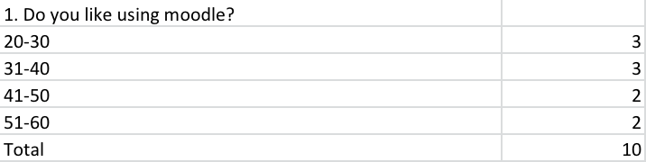

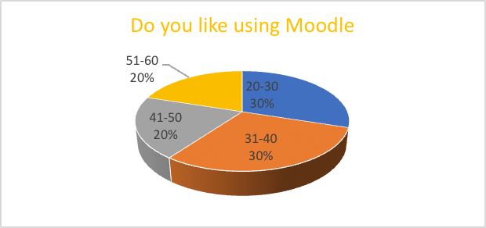
Figure 1. If students like using moodle
With the total number of students who received an online questionnaire, ages range were; 20-30: 30%, 31-40 :30%, 31- 40 : 20% and 41-50 were also 20%.

Question 2.
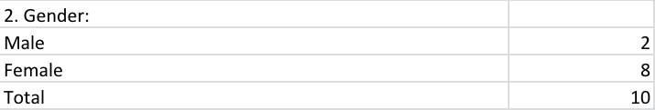

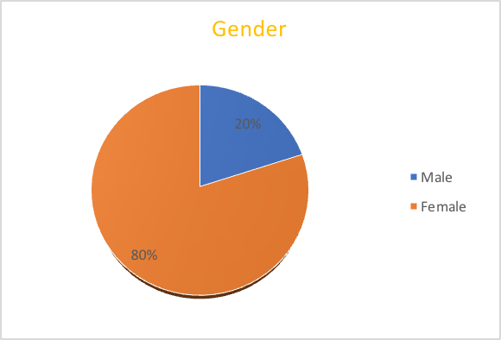
Figure 2. Gender
8 females and 2males replied to the email and answered the questions.

Question 4
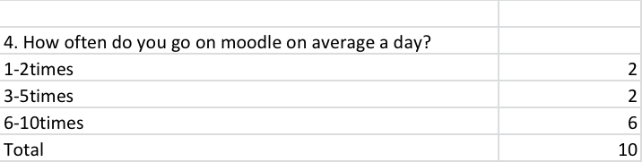

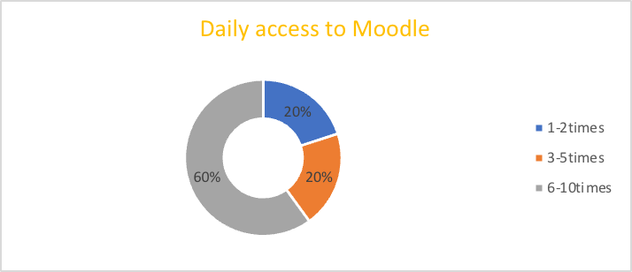
Figure 3. Daily access to moodle
These were the number of times students felt comfortable as they accessed moodle.

Question 5
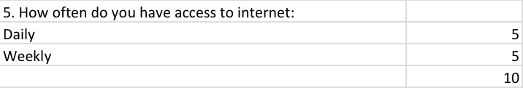
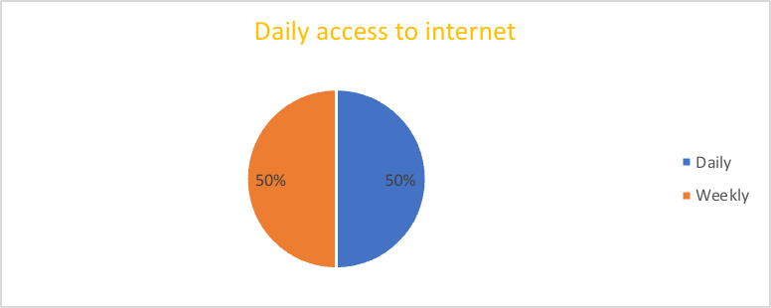
Figure 4. Daily access to the internet .
These were students who had constant access to the internet in their houses and on their phones.

Question 6
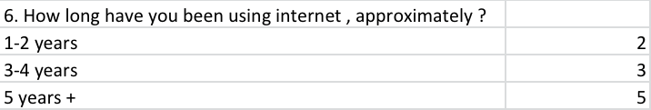

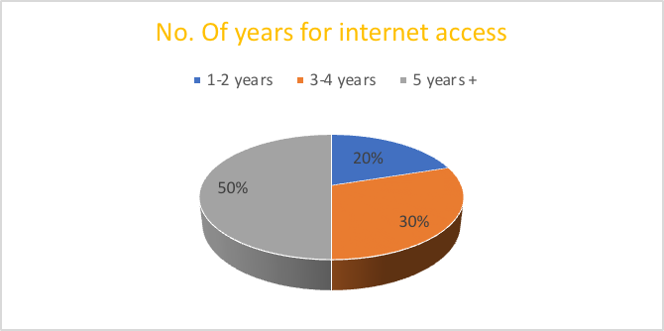
Figure 5. Years of using internet
Students inform me of the number of years they have been using the internet.

Question 7
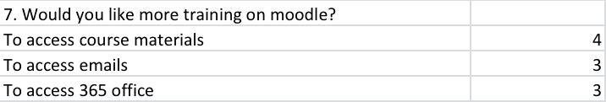

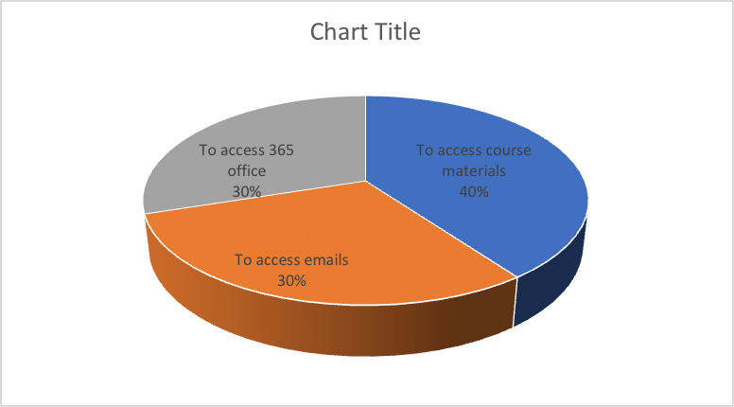

Figure6. Further training on how to use the moodle.
Students who have been accessing the moodle to check their emails, course materials and Microsoft office 365 and still need more training on the use of the above areas.

Findings
The first findings give students perception about the use of moodle and how impactful it has on their studies through primary data collection. The second part is the Secondary data findings which explains the perception of other students from other universities or institutions.

Students of UWTSD and Moodle(Primary source of Data)
After having the feedback from the students in question 1 states of 60% students between the ages of 20- 40 years of age sees Moodle as a useful and comfortable to use whiles 20% of students aged between 41- 50 years sees it useful but do not feel comfortable using it alone, 20% aged 51-60 years of the students thinks its not useful nor comfortable using moodle and would prefer only face to face learning as a result of their age ( figure 1 shows the results of students feedback).

In question 2, questionnaires were given to 8 female constituents of 80% of the students and 2 male constituents 20% of the students ( figure 2 show’s results of such information).

Question 4 explains Six - 60% of students who understood the use of Moodle were accessing it more and frequently going to moodle 6- 10 daily to check assignments, emails, students forums etc. However, 20% found it useful when helped by colleagues and so their daily was 3-5times. The other 20% accessed moodle 1-2times a day due to lack of interest using the moodle (figure 3 show’s results)

In question 5, 50% of the students have full daily internet access because they have unlimited internet on their phone while the other 50% who do not have unlimited internet on their phone have weekly accessed their internet home (This can be seen in figure 4).

Question 6, shows the number of years the respondents have used the internet. 20% of the respondents have used the internet between 1-2 years, 30% used the internet between 3-4years and 50% of respondents have used the internet for 5 years and over.( shown in figure 5 )

Question 7 was about further training on the use of moodle and 40% were more interested in them being trained on how to access the course materials on each particular subject being thought on, 30% wanted more training on how to use Microsoft 365, for instance training on Microsoft Teams, excel etc and the other 30% of the respondents wanted more training on how to access their emails and use them on moodle. Most of the communication from the lecturers, academic board among others are communicated to students through their emails ( figure 6 displays this information).

Secondary data
The young students like to explore and find it more fun using moodle while some of the middle age students find it difficult learning on the moodle. Looking at how they responded to the questionnaires, you could see for the middle aged alone, they would prefer the traditional way of learning- face to face. According to an Article in Engineering Education which was published in 2012, stated that students with age range between 20-21 were ranked with high excellent IT skills as compared with students age range 31+ (Sheriff. R, 2012).
Other students who embrace change see this as an amazing way of learning and see the use of moodle as a hard skill acquired through learning at the university.

Wood, 2010 in an article explains the different perception both students and teachers have when it comes to using Moodle as a tool in higher education. According to this article not all students aged from 11- 31 years were digital native. Another findings from the research explains that Moodle allows professors to use a course at the same time developing,reuse and improve it each year. A student posted once said Technology makes learning more time efficient and less frustrating but technology has made him lazy (Wood.S.L,2010).

According to Haywood et al, 2014, a good digital service (ICT) is of no importance if students are not able to access it effectively and efficiently wherever they are, be it on or off campus. Which means any obstacles must be removed as soon as possible to help students feel safe to use the moodle. In order words, if students do not have the ownership of using the internet for their assignments, research work etc, then the use of moodle will not be of great value to them.

A research in Spain which was conducted with European students and in that report, one of the basic principles of the European Higher Education Area (EHEA) was to promote a lifelong learning process among professionals working in any field. Each European citizen is encouraged to enhance (Luján-García. C& García-Sánchez. S, 2015 ) and to be up-to-date with the innovations that emerge in his/her area of specialism because the use of Moodle will be ineffective among students.
The Internet has opened the doors to knowledge and the construction of a collective intelligence outside the traditional academic structures and it is also a platform which has more LMS that offers this combination between learning inside and outside the classroom. Students and lecturers feel comfortable and have a good perception when it comes to Moodle usage in higher education as a result of it being improved more often ( Luján-García. C& García-Sánchez. S, 2015).

Conclusion
As times are changing, technology has become part of our journey in this life.Moodle is a great tool when students really understand how it is used. Though not all students are the same but if training is organised more often, the problem of some students not having the confidence to learn through using Moodle will be resolved.

Appendix

Questionnaires

This question is about the impact of moodle learning experience at the campus. Could you kindly answer below questionnaires and return it by 15/04/2020. It will take about 5- 10minutes of your time.

1. Do you like using moodle? Yes No Sometimes

2. Gender: Male Female Other

3. Age range: 20-30 31-40. 41-50. 51- 60

4. How often do you go on moodle on average a day? 1-2times 3- 5times 6-10times

5. How often do you have access to internet:
Daily. Weekly Monthly Never
from phone
from home

6. How long have you been using the internet , approximately ?
Less than a year
1-2 years
3-4years
5years or more

7. Would you like more training on moodle?
To access course materials
To access online library
To access emails
To access Hub Chat
To access 365 office
To access OneDrive
All of the above

Thank you for your cooperation.👏🏻👏🏻👏🏻👏🏻

Reference

- Haywood,J. et al (2004) Student Views of E- Learning. Available at http://www.flp.ed.ac.uk/ALTC2004/studentviews.pdf ( Accessed: 8 April 2020)
- Kumar, A.et al(1998 ) The Virtual Learning Environment Systems. Available athttps://ieeexplore.ieee.org/abstract/document/738777/references#reference (Accessed: 8 April 2020).
- Lopes,A. P. (2011) Teaching with Moodle in Higher Education. Available at http://hdl.handle.net/10400.22/622 (Accessed: 1 May 2020).
- Luján-García. C& García-Sánchez. S.(2015) Moodle as a useful pervasive learning environment. Available at https://accedacris.ulpgc.es/bitstream/10553/45598/1/Moodle_como_um_ambiente_de_aprendizagem_amplo_e_ut.pdf ( Accessed: 1 May 2020).
- Siirak. V, (2012) Moodle E- Learning Environment as an Effective Tool in University Education. Available at https://www.jitae.org
- Sheriff. R, (2012) An evaluation of students’ and lecturers’ use of technologies: An engineering case study. Available at https://www.researchgate.net/publication230725768 ( Accessed: 20 April 2020).
- Wood, S. L( 2010) Technology for Teaching and Learning: Moodle as a Tool for Higher Education. Available at http://www.isetl.org/ijtlhe

