Module: Psychology for Health and Social Care
Module code: BMHP4003

Lecturer: Rebecca Kavanagh
Assignment Title: Case Study Report

Submitted By: Saima Faser
Student ID: 2108665

Table of Contents
Introduction 3
Aggression 3
Case Study 3
Frustration Aggression Hypothesis 4
Social Learning Theory 4
Biological Behaviour 5
Relevant Data 5
Conclusion 8
Recommendation 8
References 9

Case Study Report

Introduction
The report looks at the case study of Norma who was 56 years old and diagnosed with breast cancer. The report focuses on the different theories of aggression such as frustrations, hypothesis, biology theory and social learning theories. In the case study it is mentioned that Norma’s two children and her husband were quite rude with staff, and they were using abusive language and behaving unethically with the management team.

Aggression
Aggression is one of the types of social interaction, for example when a person interacts with each other in a polite way, while when a person is being aggressive with each other in louder way (Averill, 1983). When a person is showing aggression, they will speak loudly as well as they will shout with each other, they will use harsh word or harsh language. Most of the people used the word “aggressive” for e.g., Ali behaved very aggressively etc. According to Sipes this word comes from aggression it means when a person trying to hurt someone or destroy someone deliberately or consciously, through words or physical behaviour e.g.,
Sr No | Words | Physical Behaviour
1. | Shouting | Pushing
2. | Swearing | Hitting
3. | Harsh language | Kicking
4. | Abusive language | Slapping

Aggression takes place in a normal routine life of every person as you can see in many families mostly fights occurred because of aggression (Anderson et al., 2002).
Apart from this, aggression’s examples are clearly shown in sports such as if we talk about, in football the player hits on the knee, elbow, ankle etc. of another play just to show their aggression (Stone, 2006).

Case Study
As in Norma’s case study who was suffering from Breast cancer the following sentences showed the aggression of her husband and the two children.
- You are leaving her in pain, give her more morphine.
- You bunch of idiots do not know what you are doing.
- Staff being physically pushed by Norma’s husband.

Frustration Aggression Hypothesis
According to different research, one of the common causes of aggression is Frustration, which means when any person is prevented from attainment some goal (Bjorkly, 2006) This concept of aggression as a reaction to frustration is called frustration aggression hypothesis.
Aggression
Frustration

The behaviour of Norma’s Husband and children come’s under frustration aggression hypothesis. You get frustrated because of the situation, circumstances and you cannot even handle them, or sort out them (Ferns, 2007)
If we talk about the case study which is given for research, we can analyse the frustration aggression hypotheses as Norma’s family is showing to the staff for them to get the right treatment to help Norma in her recovery as soon as possible. Norma’s family want to get better treatment as they feel that the staff are not giving enough right level of treatment to Norma. On the other hand, the hospital staff feel they are providing the best treatment they can give her. Norma’s family is showing aggressiveness and frustration on these circumstances.

Social Learning Theory
Social learning theory was given by Albert Bandura. He thinks aggressive behaviours are also learnt by looking at each other (Ellis, 1989). All social learning theories try to explain that aggressive behaviours are learnt through observation as well as by watching aggressive models, in particular social role models lead to aggressive behaviour for example an engineer must maintain all the building work to make sure all the work is carried correctly and on time if not done this can lead to them taking it out on the staff. (Eron, 1994).
Another example of this is when a child is 3 to 4 years old, they learn a lot of things such as if you say to them that the water is hot do not touch it the child will not touch it (Yeager et al., 2013). The children will follow what they see or are told to do.
As in our case study you can see that the father is showing unethically behaviour in front of the children, by doing this it sets a bad example for the children as they will also behave rudely, aggressively, and violently with hospital staff or even with any staff of any institution because they will see that as being ok. The Husband in this situation needs to be patient they have understand that the hospital management are doing their best to save the life of Norma. It is important that the father takes the responsibility to look after the children and make them understand the situation and not behave rudely with anyone.

Biological Behaviour
According to Sigmund Freud “Aggression was a basic human instinct, and All humans have aggressive tendency.” (Karahe, 2020). It means that we are born with aggressive tendency, innate tendency of aggression and we gain that tendency through our genes. According to research aggression if we talk about test of siren which is male sex hormone it has been linked with higher level of aggression and that is the reason males are more aggressive than females and genetically it transferred in children too. Moreover, alcohol also have severe impact on aggressive behaviour, more the people are consuming alcohol more will be the tendency to behave aggressively and violently (Mann et al., 1982)
For example, an experiment was conducted on twins both the children had upbringing in two separate places just to check out the aggression of them after the test it showed that even though they were put in separate places they still had the same aggressive behaviour and same violent tempers (Graham et al., 2000)
We see that Norma’s husband and her two children are also behaving rudely, violently, aggressively with the staff. So, we can infer that genetically aggression has been transferred into the children while in Norma’s case she is quite polite and cooperative with staff. This case study shows that woman is naturally or biologically more patience even though she is facing difficulties, while her husband and her children are behaving rudely. This case study shows how it links to biologically aggression and other members of Norma’s family.

Relevant Data
In the diagram below you can see that the first step is to drive to goal which is to make sure the recovery Norma is achieved as soon as possible. The next step is obstacle, or you may say the hurdles that the family of Norma’s thinks that the staff is not doing their work accurately to help Norma recover, this leads to the next step which is the frustration which leads into them showing their anger and then they show aggression by using harsh language to the management team of hospital.
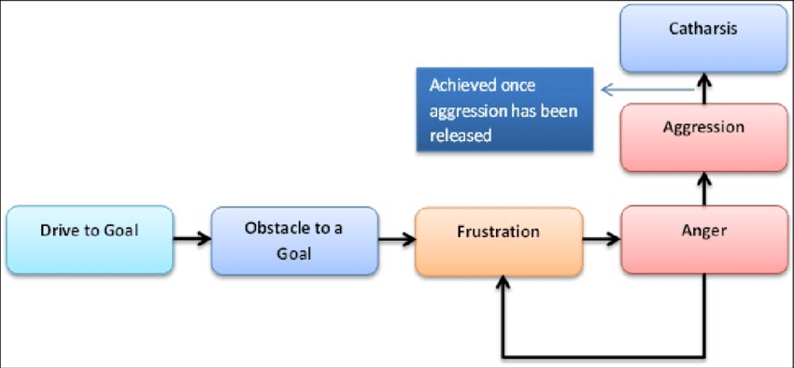
In the second picture, it can be clearly seen that genetically male have a hormone through which gets transferred onto the children genetically furthermore It is an innate instinct. When a child born, they have the tendency of getting aggressive (Geen et al., 1998)

The third picture, you can see that how child is observing his father is polishing their shoes and they are copying what the father is doing with his father, this is how social learning theory works.
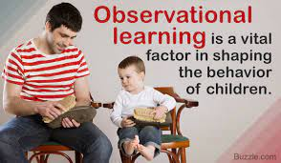

Conclusion
My research revealed that people should behave nicely with each other and in this case with the staff of any institution such as factory, hospital, market etc. Nothing is more precious than talking with others in a polite manner. Regarding the case study of Norma’s husband, they should not talk rudely and use abusive language with the staff member as they are trying their best to do what they can in the situation they are in. The management team stayed calm when cooperating with him. Looking at the three theories of aggression such as social learning theory, biological theory, and frustration aggression hypothesis. All these theories lie in our case study and the case study.

Recommendation
You should not show aggression to anyone. People go through different situations in life. People deal with situations differently. Staff who have higher authority should show more understanding of the aggression that Norma’s husband is showing as they were paying money to hospital and they feel they were not getting the level of treatment they should have received, that is why he was showing anger.
By calming the family members down and explaining the situation to them and keeping them informed via meetings and care logs so the family can see what treatment is being supplied will lead to them feeling more relaxed and have a better understanding of the situation and show less aggression to the staff.

References
- Averill, J.R., 1983. Studies on anger and aggression: Implications for theories of emotion. American psychologist, 38(11), p.1145.
- Anderson, C.A., and Bushman, B.J., 2002. Human aggression. Annual review of psychology, 53(1), pp.27-51.
- Bjørkly, S., 2006. Psychological theories of aggression: principles and application to practice. Violence in mental health settings, pp.27-46.
- DeWall, C.N. and Anderson, C.A., 2011. The general aggression models.
- Ellis, L., 1989. Theories of rape: Inquiries into the causes of sexual aggression. Taylor & Francis.
- Eron, L.D., 1994. Theories of aggression. In Aggressive behaviour (pp. 3-11). Springer, Boston, MA.
- Ferns, T., 2007. Considering theories of aggression in an emergency department context. Accident and emergency nursing, 15(4), pp.193-200.
- Geen, R.G. and Donnerstein, E.D. eds., 1998. Human aggression: Theories, research, and implications for social policy.
- Graham, K., 1980. Theories of intoxicated aggression. Canadian Journal of Behavioural Science/Revue canadienne des sciences du comportement, 12(2), p.141.
- Graham, K., West, P. and Wells, S., 2000. Evaluating theories of alcohol‐related aggression using observations of young adults in bars. Addiction, 95(6), pp.847-863.
- Krahé, B., 2020. The social psychology of aggression. Routledge.
- Mann, L., Newton, J.W. and Innes, J.M., 1982. A test between deindividuation and emergent norm theories of crowd aggression. Journal of Personality and Social Psychology, 42(2), p.260.
- Stone, J., 2006. Aggression and world order: a critique of United Nations theories of aggression. The Lawbook Exchange, Ltd.
- Sipes, R.G., 1973. War, Sports, and Aggression: An Empirical Test of Two Rival Theories 1. American anthropologist, 75(1), pp.64-86.
- Yeager, D.S., Trzesniewski, K.H. and Dweck, C.S., 2013. An implicit theories of personality intervention reduces adolescent aggression in response to victimization and exclusion. Child development, 84(3), pp.970-988.

