Student Name: Grzegorz Zalewski
Number:1809948
Programme of Study: Graphic Design
Module: ADAD4018

Tasks in the order I received them:
Task One. (Jon Task) Reflective Writing: Do you know what you think? =
523 words
In this essey I will try to explain or describe my reflection as well as show the differences
about pretending, acting and the performance of everyday life as all human activity could be
considered as a “Performance “Bertolt Brecht wanted to make audience think, and
often said that theatre audiences “hang up their brains with their hats in the cloakroom”.
emphasizing the perspective of the viewer in “Epic theatre” on stage, in the cinema or in
everyday life everyone is performing and creating an act some of them are shocking and some
no one even noticing in the theater tricks and techniques are used to manipulate understandi
ng and emotional state in the cinema is limited by a uniform narrative without the possibility
of interacting with the audience but in everyday life we ​​have the ability to use the interaction
fully from the image through the smell, touch a small gesture or story that is associated with a
given person or his origin or material status or religious believes
for me the truest kind of interaction is contact with the nature I can translate what I see
smell, feel, hear in my own way by my own experiences and experience my self being as one
with the nature if there are tricks, there are there because, I have understood what I am
experiencing deeper and therefor defriend level of experience can be archived and can
“acquired a new kind of impressiveness” (Berger, 1972)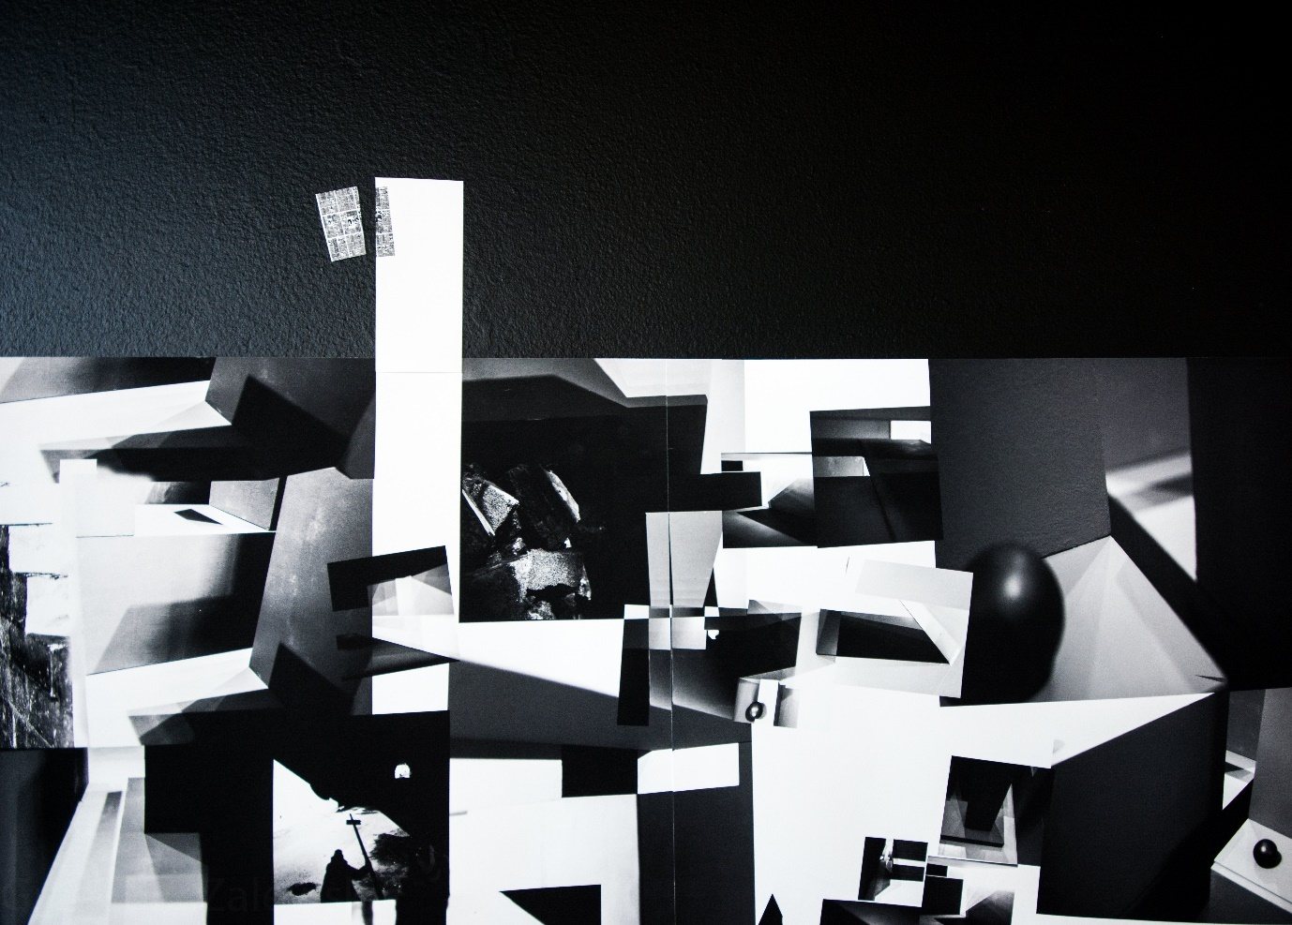
Picture by Zalewski
Using Experimental Learning Cycle, I have created an abstract image which in some sense
created itself as I was driven by passion for exploring and experimenting with light and
shadow looking for a shape that will construct a bigger picture, I didn’t have idea what it will
become or the finale picture will look like it appears to be a blend of light and shade fighting
for a space. And also using a quote that describes this representation of an image “it may be
objected that everyday life already pushes us all into a multiplicity
of overlapping and often conflicting roles: our different areas of activity” (Fontcuberta,2014)
I explored places I like and places I don’t but there was bigger puzzle to solve what am I will
point this camera at pick a path direct, narrow my vision work on a specific subject something
that full fill and energise me to keep shooting photographs will never match up to the real
experience walking on the rocks walk in to the gallery breathing the smell of library hear the
waves crushing or cold wind when you at the pick of a mountain hears how the stream of
water go down from the top how water interact with dry sand and feeds the plants with toxic
rain those experiences push me to be creative Something that has become meaningless
without a story and at the same time it is a story of progress but there is no surprise here.just going forward with passion like in cinema actors taking dive into method acting
(Marlon Brando Godfather, Adrien Brody in Pianist, Jim Carrey in Man on The Moon
, Nicolas Cage Birdy, Christian Bale Mechanist And many more went beyond normal acting
as if the passion took control of the personality or the decision of the act began to be
fulfilled regardless of the consequences, it looked to me like the categories they use to
understand the subject but they are not examined as a way of
thinking leads to mad acting process as Donald
Schon was exploring those ideas in “invention and the Evolution of Ideas” D Schon (1967)
Bibliography
Berger, J (1972) Ways of Seeing. London, Penguin.
Joan Fontcuberta.(2014) Pandora’s camera Mack (1 July 2014)
Donald Schon (1967) Invention and the Evolution of Ideas
David McCandless (2009)Information is Beautiful Inprint of Harper Colins Publishers
Articles
Donald Schon-learning, reflection, and change
Alexander Rodchenko Dance .An objectless Composition (1915)
https://www.theartstory.org/artist/rodchenko-alexander/
Kazimir Malevich Black square (1915) https://www.theartstory.org/artist/malevich-kasimir/
Research videos
Gustav Metzger- Auto-Destructive Art

Task Two: Semiotic Analysis Observational Writing:
Identify an image and write a semiotic analysis =511 words

Situation that we are living appearances traveling to our eyes, leading to always
Changing perception of a world. Uniqueness of an image seen by the individual have
defriend meaning depending on a surrounding, culture, place you live in, history of the
region, live experience knowledge and so on. Pictures, graphics, paintings come to you
with a piece of information, or a message to persuade us give hope inspire, arouse compassion
Roland Barthes seminal publication, Image, Music, Text (1977), Barthes shows distinctions
between the ‘denoted’, literal and connoted’, its implied meaning
Berger (1972) The meaning of painting is no longer attached to them:
their meaning is transmittable reviling hidden message, I will introduce 2007 Campaign
Two confronted worlds that question the values ​​of what is necessary and what is banal
I will examine a poster created by Cordaid
for me this campaign evokes emotional conflict on one hand it feels offensive to this tribe in
the sense that in their eyes those items came from the world “sold to devil “n another hand it
could be exotic for people from Kenya like they are to us in front we can see two
of the posters created for the Campaign called “Small Change Big diffidence
“men and women from the Samburu Kenya were posing in various positions acting as a
model, holding an item, expensive accessory. Standing in their natural everyday surrounding
where there is shortage of fresh water, food and basic stuff, where life is hard. Holding an
“commodity fetish “Guy Debord (1994) items Showing the contrast between the state of
being extremely poor and luxury life and how much those two worlds are different.
Looking at “The altered mode of representation “(Walter Benjamin 2008) of a digital picture
(which is always edited) also it’s a “product of an economy” (J. Fontcuberta 2014) taken in
Samburu Kenya I can see a woman with dark skin laying on a dry ground lighted by the
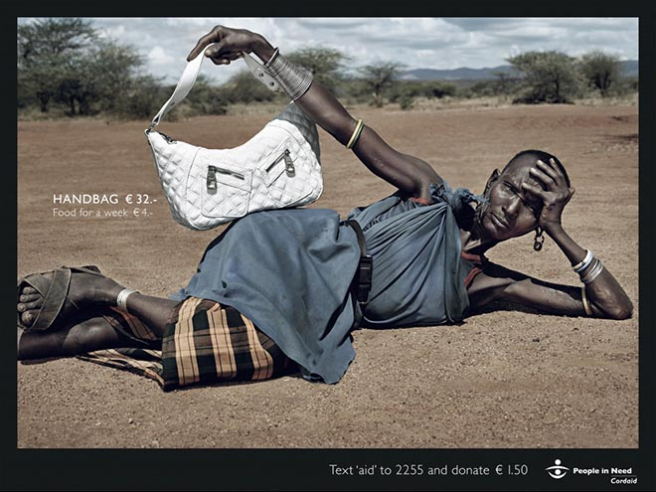
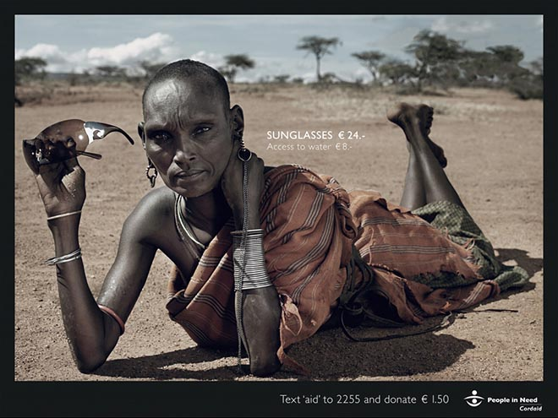
midday sun she have short hair, supporting her head with one hand and in her other arm
she is holding a handbag made of white material reminiscent of skin leaning on her hip
her legs are bent at the knees and sandals on her feet she have a dress looks like its handmade
in a faded dark blue colour
girded with a leather belt, everything looks practical and thoughtful. Symbolic meaning of the
picture reviling the narrative of a story where text on a picture reviling the value of an object
accessories in this case and comparing them with necessity like food for a week which is 6
times less than a handbag. This shows absurdity of a western habits of consumption and
shows two worlds separating further apart people in Samburu Kenya living the “real life” and
people from civilized world living as “Decline of being, in to having and having in to merely
appearing “Guy Debord (1967)
money we spent every day so easily, can make big change in a way of living in this area in my
opinion civilization exerts pressure to be a member of it through social media showing
examples of being elegant being relaxed how to be cool, it also shows symbols/icons
of celebrities Forgetting about the basic needs we are guided to forget and live in
an automatic scheme created by people striving for success based on the exploitation of
people who are unaware or indifferent to the fate of others

Bibliography

Barthes Roland. (1981), “Camera Lucida: Reflections on Photography ,Hill and Wang: New York
Barthes, R. (1977) Image, Music, Text. London, Fontana Press.
Berger, J. (1972) Ways of Seeing. London, Penguin.
Guy Debord. (1967) Society of Spectacle Rebel Press, London; New edition (1 Sept. 1994)
Joan Fontcuberta.(2014) Pandora’s camera Mack (1 July 2014)
Walter Benjamin. (2008) The Work of Art in the Age of Mechanical Reproduction
Penguin; 01 edition (7 Aug. 2008)
Raymond Wiliams (1976) “Avocabulary of culture and society “fontana press
Articles
Steven Bradley Article onMarch 29,( 2016) found on Vanseodesign.com An Introduction To Semiotics — Signifier And Signified

The Key to PR Success: The Semiotic Theory by Jaclyn Stumm's PR Blog

Article about Campaign Cordaid Small Change Big Difference Revisited
http://theinspirationroom.com/daily/2016/cordaid-revisited/

Task Three: Manifesto “What do I believe in?” 501= words

I am for meaningful relationships, direct interactions, hugs

I am against commodity consumptions

I am against commodity fetish

I am for reviling the thru nature of things

I am standing for logic against commodity

I am for authentic experience valuing things by how much contribution to my believe
ideology they have the” real good “my personal growth and contribution to society

I am for being spectacular

I am for being active, stop being passive

Stop imitate and innovate

1“Don’t imitate innovate”
In this statement “I am aim to offer up a challenge the foundation of human evolution in

communication and backdrop of environmental and social breakdown.
(Img.source) http://www.ancientdigger.com/2009/06/evolution-of-petrograph
“No longerare the powers of myth invincible “(Walter Benjamin the work of Art in the Ag
e of Mechanical Reproduction p-60)
One of the Technic of communication is using a technology available at the specific time
development of a language is owed to written information, copying and translation from the
beginning of the existence of humanity from drawing on clay thru paper to digital realm of
information shrinking the size of reality and expanding the meaning containers holding the
information, developing smarter, more efficient ways of passing the memory, thoughts
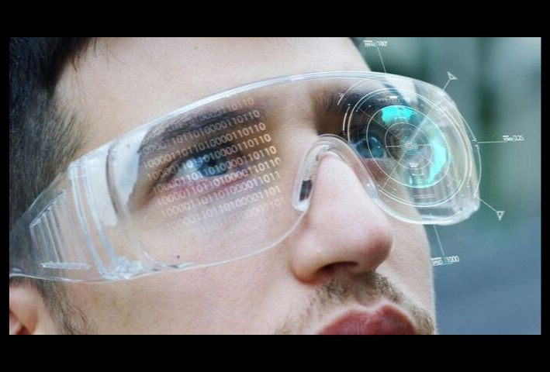
(Image sourced from shutterstock.com)
statements, laws technological development
is inevitable until people want to improve
their existence we have all the technics of
communication from beginning
until now It’s a pattern after which you can guess the next move a new means of
communication needed tool to develop new ideas pass on the knowledge. In my opinion
the development of communication is necessary for order harmony peace in the world
copying other things is necessary only to learn from and develop on the way for bright future.
But there is a risk of loosing all human qualities .as going into digital binary ways of
perceiving “Enrichment of human sensory perception through information, generally
manipulated and conveyed electronically, not perceptible with the 5 senses”.

2“Logic Against Commodity fetishism”
Pic by Barbara Kruger
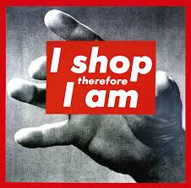
Kruger is showing open statement related to material
consumption to help any viewer too
think about deeper meaning of this statement.
According to Jean Baudrillard (1967 ) consumption is a
proper phenomenon for
post-industrial Culture that emerged during the centuries-old process
of exchanging goods. he stated that “consumption is a myth around which
organizes a consumer society”. The Consumer Society (1998)

Barbara Kruger, Be Here Now “we became isolated and lose touch with our own reality and desires” Guy Deborg
As more and more media adverts emerge and
“such information might distract from the points
being made “(Berger ways of seeing page 43) common people can’t distinguished what’s
worth buying or not or ever what they need or not because to feel on trend gain sense of unity
and a sense of social satisfaction and acceptance, it is more important than what is logically
good purchase, but in my humble opinion if you have a passion for what you do
you don’t look at the others and only use what you really need to develop your skill and grow
your freedom, and just buy what you need not what you want because this hype, trend is only
temporary and does not last long .I have notice some people can’t even open
the new item or were the shoes they bought because as soon as they back home they don’t
like it anymore.

3“Valuing things by how much they contributed to my believe ideology personal growth and contribute to society”

For me it is the most important to understand and know how to find value in things usually
it is buried deep under layers of ‘fake news’ (Carson, 2018) fake identity behind masks, people
put on, to blend into society or to gain something they don’t even need, but when I stop and
ask myself what I really want, the answer is in front. Every culture has it is own valuables,
believes from a whole country thru small group to a single person “our inventions are wont to
be pretty toys which distract our attention from serious things “(Henry David Thoreau,
walden,1854) Words like” thank you”, you welcome” etc Actions like stepping down the
elderly person's places in the queue or charity activity including giving your own time,
emotional support, kindness positivity sharing knowledge has value to me.
Mind map 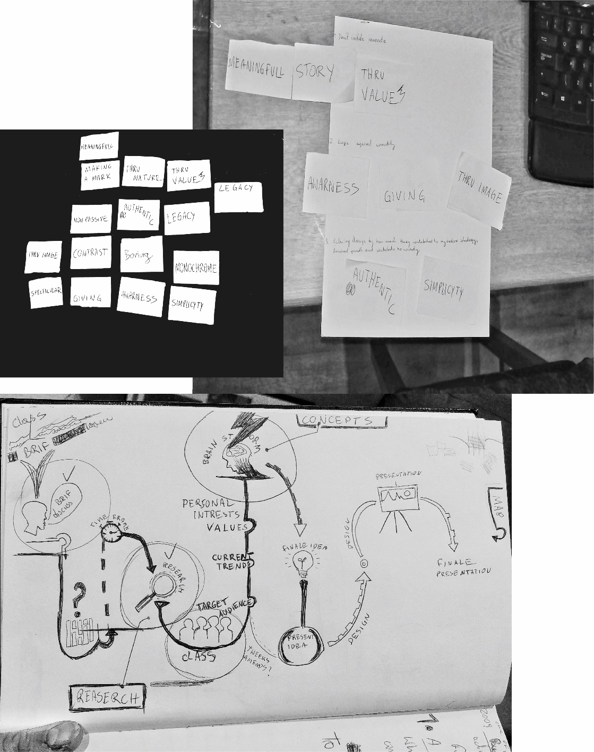
Key words: consumption, ideology, myth, structure, arbitrariness, code, authentic
contrast, non-passive, meaningful

Bibliography
Jean Baudrillard. “The Consumer Society: Myths and Structures Sage Publications Ltd; First edition (14 Mar. 1998)
Berger, J. (1972) Ways of Seeing. London, Penguin.
Walter Benjamin (2008) the work of Art in the Age of Mechanical Reproduction. London Penuin
John Berger / Ways of Seeing , Episode 1,2,3,4 (1972) You Tube
www.artnet.com/artists/barbara-kruger
www.thebroad.org/art/barbara-kruger
www.pinterest.co.uk/pin/748019819343670687
Slavoj Žižek: Don't Act. Just Think. https://www.youtube.com/watch?v=IgR6uaVqWsQ
Don’t try -The Philosophy of Charles Bukowski
www.poetryfoundation.org/poets/charles-bukowski
Article www.poetryfoundation.org/poets/charles-bukowski
Articles
History of Information Technology found on (openbookproject.net)
‘Paula Scher: Works’ Publications — May 18, 2017 https://www.pentagram.com/news/paula-scher-works, www.behance.net/PaulaScher
wikipedia.org/wiki/Commodity_fetishism

