

Annabel Harries
(Student Number: 144892)

School Improvement Report

How do scaffolded, guided reading interventions impact the attainment and attitudes of disadvantaged students in Wales?

Submitted to the University of Wales in partial fulfilment of the requirements for the Degree of Master of Arts (MA) Education (Teach First)

University of Wales Trinity Saint David

2019

Word Count: 16473 (15000 ± 10%)

Abstract
This school improvement report explores the issues surrounding low reading levels of disadvantaged students in Wales, and identifies the consequences of poor attainment. The report also evaluates the literacy provision of a school improvement plan and identifies areas for development within the document. Research conducted in this report focuses on the reading levels of secondary school students and analyses the impact of a reading intervention programme on these pupils. The intervention uses scaffolded silent reading and guided repeated oral reading in a whole-class setting. During the intervention, several strategies are applied, which include group discussion, repeated reading, teacher modelling and silent reading. Data is collected through a mixture of quantitative and qualitative approaches, including pre-intervention and post-intervention testing, questionnaires and interviews. The results from the intervention programme show positive outcomes for the majority of students. Not only do levels of attainment increase, but attitudes towards reading also improve. These positive outcomes are evident for all subpopulations, including those who have special educational needs, and those who are eligible for free school meals. The reading approaches are therefore considered successful, and as a result, recommendations for the inclusion of the intervention programme in the school improvement plan are made.

Declarations and Statements

DECLARATION
This work has not previously been accepted in substance for any degree and is not being concurrently submitted in candidature for any degree.

Signed:………Annabel Harries………......... (candidate)
Date: ……………05/04/2019…………….

STATEMENT 1
This School Improvement Report is being submitted in partial fulfilment of the requirements for the degree of Master of Arts (MA) Education (Teach First).

Signed: ………Annabel Harries……......... (candidate)
Date: …………05/04/2019………………..

STATEMENT 2
This School Improvement Report is the result of my own independent work / investigation, except where otherwise stated.
Other sources are acknowledged by footnotes giving explicit references. A reference list is appended.

Signed: ………Annabel Harries……......... (candidate)
Date: …………05/04/2019……………….

STATEMENT 3
I hereby give consent for my School Improvement Report, if accepted, to be available for photocopying and for inter-library loan, and for the title and summary to be made available to outside organisations.

Signed: ………Annabel Harries…......... (candidate)
Date: ………05/04/2019……………………

Table of Contents
Abstract 1
Declarations and Statements 2
Table of Contents 4
Table of Abbreviations 6
List of Figures, Tables, Charts and Graphs 7
1. Introduction 8
1.1. National Context 8
1.2. School Context 9
1.3. Rationale 12
1.4. Aims and Objectives 12
2. Literature Review 14
2.1. School Improvement Planning and Self-Evaluation 14
2.2. Educational Research 17
2.3. Literacy and Numeracy 18
2.4. Literacy and Disadvantage 21
2.5. Reading Levels 22
2.6. Successful Reading Instruction in Schools 26
- 2.6.1. Teacher Expertise 27
- 2.6.2. Accessible Reading 27
- 2.6.3. Sustained Silent Reading 28
- 2.6.4. Scaffolded Silent Reading and Guided Repeated Oral Reading 29
- 2.6.5. Limitations 32
- 2.6.6. Conclusions 32
2.7. Proposed Research Question 33
3. Methodology 34
3.1. Research Design Rationale 34
3.2. Ethical Consideration 35
3.3. Participant Information 37
3.4. Methodological Approach 39
- 3.4.1. Testing 39
- 3.4.2. Groups 39
- 3.4.3. Timings 40
- 3.4.4. Books 41
- 3.4.5. ScSR and GROR Activities 42
- 3.4.6. Resources 45
3.5. Data Collection and Research Techniques 46
- 3.5.1. Testing 46
- 3.5.2. Questionnaires 47
- 3.5.3. Focus Group 48
- 3.5.4. Interviews 49
4. Results and Analysis of Data 52
4.1. Student Attainment in Pre-intervention & Post-intervention Tests 52
- 4.1.1. Percentage Points 52
- 4.1.2. Progress Measures 55
- 4.1.3. Age-standardised Scores 57
- 4.1.4. Anomalies in the Test Data 60
- 4.1.5. Demographic Patterns 61
4.2. Student Attitudes Following the Programme 70
- 4.2.1. Enjoyment and Appreciation of the Reading Programme 70
- 4.2.2. Impact and Self-perception 72
- 4.2.3. Post-intervention Reading 73
4.3 Implementation of the Intervention 75
- 4.3.1. GROR and ScSR Activities 75
- 4.3.2. Books 78
- 4.3.3. Groups 80
- 4.3.4. Behaviour of Students 80
4.4. Staff Perceptions of the Intervention Programme 81
- 4.4.1. Impact on Students 81
- 4.4.2. Reading in the School Improvement Plan 82
5. Conclusions 87
5.1. Conclusions from Pre-intervention and Post-intervention Tests 87
5.2. Conclusions from Student Attitudes Following the Programme 87
5.3. Conclusions from Implementation of the Intervention 88
5.4. Conclusions from Staff Perceptions of the Reading Programme 89
5.5. Strengths of the Reading Programme 90
5.6. Weaknesses of the Reading Programme 91
5.7 Recommendations for Reading in the School Improvement Plan 93
6. Bibliography 97
7. Appendices 108

Table of Abbreviations

Abbreviation | Explanation
BBC | British Broadcasting Corporation
BERA | British Education Research Association
EAL | English as an Additional Language
EEF | Education Endowment Foundation
eFSM | eligible for Free School Meals
GCSE | General Certificate of Secondary Education
GROR | Guided Repeated Oral Reading
LNF | Literacy and Numeracy Framework
Ofsted | The Office for Standards in Education, Children's Services and Skills
PISA | Programme for International Student Assessment
ScSR | Scaffolded Silent Reading
SDP | School Development Plan
SEN | Special Educational Need
SER | Self-Evaluation Report
SIP | School Improvement Plan
SSR | Sustained Silent Reading
UK | United Kingdom
UWTSD | University of Wales Trinity Saint David

List of Figures, Tables, Charts and Graphs

Name | Description | Page
Figure 1 | school development planning cycle | 15
Figure 2 | self-evaluation cycle | 16
Figure 3 | country performance in Pisa - Wales | 24
Figure 4 | Pisa reading results in the UK | 25
Table 1 | week 1; session 1 of intervention | 43
Table 2 | week 1; session 2 of intervention | 43
Table 3 | week 1; session 3 of intervention | 44
Graph 1 | percentage points | 53
Graph 2 | percentage point change | 53
Graph 3 | progress measures | 55
Graph 4 | progress measure change | 56
Graph 5 | age-standardised scores | 58
Graph 6 | age-standardised score change | 59
Graph 7 | eFSM and non-eFSM data | 62
Graph 8 | MAT and non-MAT data | 63
Table 4 | male and female data | 64
Graph 9 | SEN and non-SEN data | 67
Graph 10 | EAL and non-EAL data | 69
Pie Chart 1 | enjoyment of the reading programme | 70
Graph 11 | perceptions of programme benefits | 71
Pie Chart 2 | perceived progress during programme | 72
Pie Chart 3 | attitudes to continued reading | 74
Pie Chart 4 | enjoyment of activities - most preferred | 76
Pie Chart 5 | enjoyment of activities - least preferred | 77
Pie Chart 6 | suitability of books | 79
Graph 12 | views on raising literacy standards | 83
Pie Chart 7 | current emphasis on literacy in School X | 83
Graph 13 | year groups requiring literacy support | 84
Graph 14 | types of student requiring literacy support | 85
Pie Chart 8 | implementation of programme on whole-school level | 86

1. Introduction

1.1. National Context

In his speech ‘Teaching Makes a Difference’ in 2011, the Minister for Children, Education and Lifelong Learning - Leighton Andrews, addressed the prominent issues surrounding education in Wales. Andrews set out his three priorities for the future: “literacy; numeracy; and tackling the link between poverty and poor attainment” (Andrews, in Institute of Welsh Affairs, 2011a). On becoming the Minister for Education and Skills, Andrews once again reiterated these priorities, by announcing his plan for a new Literacy and Numeracy Framework (LNF) and detailing this educational reform (Andrews, in Institute of Welsh Affairs, 2011b; Welsh Government, 2012). Andrews’ proposal has remained at the forefront of teaching and learning since this time, as schools must work in line with these national priorities, and carefully follow the guidelines to improve outcomes for students (Welsh Government, 2008; 2013; 2016a). The importance of literacy and numeracy is reaffirmed in multiple documents that outline plans for improved education in Wales. These documents include Qualified for Life (Welsh Government, 2015a) and Successful Futures (Donaldson, 2015).

As well as working in line with national priorities, schools in Wales are required to consider their own priorities, in line with school context and personal circumstances. New regulations for these priorities were implemented by The Education (School Development Plans) (Wales) Regulations (The Education Regulations) in 2014, stipulating that all schools in Wales "must prepare a school development plan" (SDP) (2014:5), or School Improvement Plan (SIP). The main purpose of a School Development Plan is "to improve learner outcomes" (Welsh Government, 2014:3) across each school. This is done by reflecting on current strategies, and implementing necessary actions to elicit change.

There are six areas of development to be observed when planning for improvement, including priorities, targets, and strategies (Appendix A). Reflecting on each of the areas is important, so that schools and governing bodies can identify how to effectively improve learner outcomes. This helps schools to plan for new strategies and interventions, and work towards a unified goal. Each plan should be personal to the context of the school, and reflective of its individual needs. To guarantee this bespoke nature, it is advised that School Development Plans should only span three years, and should be updated annually. This allows the school and the governing body to "monitor and review the progress made by the school during each year" (The Education (School Development Plans) (Wales) Regulations, 2014:6).

1.2. School Context

To better understand the impact and efficiency of an SDP/SIP, this report will analyse the SIP of School X, an English medium secondary school situated in Wales (My Local School, 2018). The school suffers from severe disadvantage, with 37.6% of all students eligible for Free School Meals (eFSM) and 41.6% of students with a Special Educational Need (SEN) (My Local School, 2018; Appendix B). These figures demonstrate the struggles that both the school and its students face, as the numbers are considerably higher than both local and national averages (My Local School, 2018; Appendix C; Appendix D).

The Improvement Plan of School X features five key focus areas (School X, 2018a; Appendix E). Several procedures and strategies are outlined within each area, with the intention of providing detailed guidance on how to improve student outcomes. Despite its comprehensive SIP, in its most recent full inspection Estyn declared School X to require "significant improvement" (2015a:3). Estyn also emphasised that "self-evaluation and planning for improvement are not robust enough and are not managed effectively" (2015a:2). This observation correlates directly to the appropriate preparation and use of the SIP, and demonstrates that the document had not been successfully implemented at the time of the inspection.

In line with Estyn protocol, several recommendations were made after the inspection in School X. The principal recommendation was that School X "raise standards, particularly in English and mathematics" (Estyn, 2015a:3). The recommendation came after Estyn discovered low levels of literacy and numeracy across the school. The issue of poor literacy and English attainment was especially prevalent. For example, Estyn noted that only "half of teachers [...] place a strong emphasis on developing pupils’ literacy skills" (2015a:7). Although this comment identifies the good work of many teachers in School X, it also suggests that approximately 50% of teachers had not been effective in developing pupils’ literacy skills.

These negative comments, however, do not reflect the prevalence of literacy in the SIP. As part of the SIP, literacy provision is made compulsory across a variety of curriculum areas in the school. Literacy features in three of the school’s SIP priority areas, demonstrating its importance across the school, and its recognition as a key priority in Wales (School X, 2018a). Furthermore, a significant amount of funding is reserved for the development of literacy provision in School X. This is used to support staff and students with accessing the LNF, as well as to improve standards across the school. The funding is allocated across a range of different areas, including allowances for a literacy coordinator, training for staff, and resources to use within the classroom (School X, 2018b).

Estyn’s comments therefore contradict the efforts made towards literacy development in School X. This suggests that there are significant issues with implementation and provision of literacy in the school. These issues may be attributed to a number of factors. For example, a lack of proper training and support from qualified experts or a lack of confidence in teaching the skills. Such problems are experienced by many teachers in Wales (Welsh Government 2015b), and are discussed in more detail later in this report. The evidence therefore shows that School X is ineffective in its ability to implement certain aspects of the SIP, in particular, its ability to provide appropriate literacy support for students.

1.3. Rationale

The rationale for this investigation derives from the low levels of literacy both within School X and across the country. Literacy levels prove to be significantly lower than numeracy levels, and are a cause for great concern, as they directly contradict the national priorities set out by the Minister for Education and Skills (Andrews, in Institute of Welsh Affairs, 2011a; 2011b). This considerable literacy deficit must be addressed, so that students in Wales may succeed, and meet the required expectations in literacy attainment. This area of focus will therefore be investigated and evaluated throughout the report.

School X has been chosen as the location for the research due to the problematic findings by Estyn (2015a), the apparent struggles with literacy development, and the considerable levels of disadvantage within the school.

1.4. Aims and Objectives

This report aims to improve literacy provision within the SIP of School X. Research is conducted in order to ascertain new literacy strategies that incite progress across the school and improve learner outcomes. The strategies are then evaluated for their impact on students. The results of the research in this report will be communicated with the governing body at School X, and suggestions will be made for the inclusion of the research within the SIP.

The principal aims of this report are therefore as follows: firstly, to identify and solve an educational issue by carrying out research , and implementing appropriate literacy strategies within School X. Secondly, to successfully apply this to the SIP of School X, so that the research may be implemented on a whole school level.

During the report, reference is made to key priorities of both the school and the Welsh Government in a national context. The report also acknowledges recommendations made by Estyn in the 2015 inspection on School X (Estyn, 2015a).

2. Literature Review

2.1. School Improvement Planning and Self-Evaluation

To prepare an effective SIP, the Welsh Government advises that governors and headteachers must first establish a clear, strategic vision for the school. The vision should relate to national priorities, as well as the needs and context of the school. This vision, along with the objective of improving learner outcomes, should serve as the foundation for the SIP, and should underpin all subsequent decisions in the planning process (Welsh Government, 2014). The SIP of School X identifies the school vision and core values, and uses these to guide the contents of the document (School X, 2018a).

The Welsh Government (2014) advises a cyclical approach to an SIP, so as to ensure continuity and consistency. The steps of the cycle are outlined below.

Figure 1: school development planning cycle
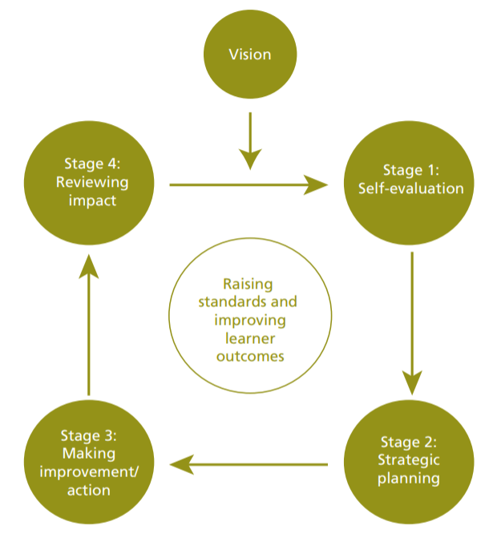

(Welsh Government, 2014:7)

An integral part of this planning cycle is self-evaluation. In an educational setting, self-evaluation allows teachers, leaders and governors to analyse strengths and weaknesses in their current performance, and set goals for improving learner outcomes (Welsh Government, 2014). Estyn advises that self-evaluation should "involve staff at all levels" (2017a:5), and that it should include the views of "a wide range of stakeholders, including teachers, governors, parents/carers, employers and the community" (2017a:5). In this way, self-evaluation is an all-encompassing tool.
Hord (1997) and Estyn (2017a) advise that self-evaluation should be a continual process, and that it should be carried out on a regular basis. By adhering to this recommendation of regular and continuous self-evaluation, schools are able to observe which techniques and strategies work well. They can also ensure their development by revising and adapting unsuccessful strategies as necessary.

As well as advocating a regular process of self-evaluation, Estyn (2017a) recognises a strong correlation between self-evaluation and school development planning (Figure 2). Estyn also notes that the Self-Evaluation Report (SER) of a school should aim to "drive forward improvement or to maintain high standards" (2017b:1). For Estyn, the link between self-evaluation and improvement planning is key for schools in establishing a clear and coherent vision, as well as ensuring progress for all students.

Figure 2: self-evaluation cycle
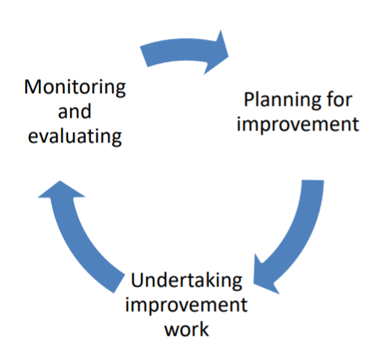

(Estyn, 2017a:3)

Recommendations of self-evaluation may even be included within a school’s SIP. For example, the SIP of School X advises that self-evaluation, along with educational research and improvement planning, be further developed and embedded within the school (School X, 2018a; Appendix F; Appendix G) This shows the strong link between planning and evaluation, and supports the idea that regular evaluation can improve standards and outcomes across the school.

2.2. Educational Research

To effectively self-evaluate and begin to plan for improvement, providers may use educational research to analyse existing strategies and implement new ideas (Welsh Government, 2015c). Educational research is a strategic method of asking and answering important questions surrounding learning and teaching. It helps to improve practice, influence policies, and support growth within education (Cohen, Manion & Morrison, 2017).

Educational research is integral to supporting the progress and improvement of schools. By conducting research, educators are often able to identify solutions to significant issues within the profession. This research enables reflection and evaluation of individual and school practice, and it motivates educators to determine the best pedagogical systems (Burton and Bartlett, 2009). Moreover, educational research promotes pioneering and deeper reasoning. This in turn, allows for a more practical approach to teaching, and enables significant development within the profession (Opie, 2004). The SIP of School X makes reference to this idea, and advocates teachers having the opportunity to undertake research-based enquiry to impact their professional development (School X, 2018a).

Educational research may also be used as an exemplar to improve standards and outcomes in other educational settings (Opie, 2004). For example, a strategy implemented in one class may be adapted for use across a school. It is for this reason that the research in this project will focus on a small-scale intervention, and will then attempt to embed any successful strategies on a whole-school level.

It is therefore widely accepted that educational research has significant value in school settings. If educational research were abandoned, practitioners would become stagnant in their approaches and students would suffer from antiquated and obsolete practices. This, in turn, would cause outcomes to diminish (Burton and Bartlett, 2009; Welsh Government, 2015c). For this reason, both self-evaluation and educational research are considered integral aspects of this report.

2.3. Literacy and Numeracy

Since the introduction of the LNF, literacy and numeracy attainment has been a main priority for schools in Wales (Welsh Government, 2013). The focus on these skills is extremely important, as it comes after research into literacy and numeracy attainment, where findings showed that students in Wales were consistently performing well below the average, and that levels of attainment were significantly lower than other countries (British Broadcasting Corporation (BBC), 2016; Organisation for Economic Co-operation and Development (OECD), 2016).

The Framework was designed for the benefit of schools and students alike, and provides schools with the foundations and guidance from which to teach students about important aspects of literacy and numeracy. A cross-curricular approach to the Framework is advised as it allows students to understand a greater range of concepts, and apply them to real-life situations (Welsh Government, 2013). Following initial implementation of the Framework, the Welsh Government (2016a) published a report detailing a strategic action plan for literacy and numeracy. The document advocates implementing skills across the curriculum, and mentions that in the most successful cases, teachers have already been able to embed skills within their regular lessons. In his review of curriculum and assessment arrangements, Donaldson (2015) also recommends that literacy and numeracy be cross-curricular responsibilities for all teachers. Outside of Wales, several other academics also advocate teaching these skills across the curriculum to improve outcomes (Alexander et al., 2008:23-35; Walker-Dalhouse and Risko, 2008:422-424).

Nevertheless, recommendations of cross-curricular teaching should be followed tentatively. For example, although the Welsh Government (2016) recommends a cross-curricular approach to literacy and numeracy, it also stipulates that literacy skills be explicitly taught in the ‘Language, Literacy and Communication’ subject area prior to application across the curriculum. It is argued that this initial implementation helps to embed skills and encourage students to become more independent before applying their knowledge in other areas.

Outside of Wales, there are others who also treat cross-curricular literacy learning with caution. For example, the Office for Standards in Education, Children's Services and Skills (Ofsted) notes that it "should not [be] assume[d] that all teachers will welcome and embrace cross-curricular literacy initiatives" (2013:39). This recommendation demonstrates the aversion that some teachers feel towards literacy teaching, and echoes the views of May and Wright, who note that "implementing literacy across the curriculum policies often seems like an uphill, sometimes overwhelming, battle" (2007:370). They describe that operational difficulties often arise and that teacher attitude can have a negative impact on implementation. They also comment that "the traditional organisation of secondary schools often militates against whole school, cross-curricular initiatives" (ibid). It could therefore be suggested that students should be given separate literacy and numeracy centred lessons, in order to provide more focused learning experiences and allow for more manageable strategies to be implemented.

Evidence also shows that many teachers take issue with the LNF in Wales, and struggle with the notion of implementing it across the curriculum. A recent evaluative study conducted by the Welsh Government (2015b) for example, found that many teachers and leaders experienced significant problems with the Framework. These problems included: lack of confidence in delivering the Framework, lack of support given to education professionals, and difficulty embedding the Framework in lessons and across the curriculum.

These weaknesses are also noted by Estyn (2015b), who finds that implementation of the Framework is still flawed, and that attainment data shows little improvement over recent years. Research shows that many students still lack the opportunities needed to improve their literacy skills in particular. Estyn also comments that provision for the development of literacy in Wales is only "adequate" (2015b:3). Furthermore, it is noted that progress tracking is underdeveloped, and many teachers are not clear about expected standards (Estyn, 2015b).

2.4. Literacy and Disadvantage

Although the Framework encompasses strands of both literacy and numeracy, there is a clear disparity in attainment between the two. Literacy levels are considerably lower than numeracy levels across Wales, a pattern that has been consistent for many years (Estyn, 2015b; OECD, 2016; 2018). Historically, low literacy levels have been linked with severe poverty and disadvantage (National Literacy Trust, 2011). Several studies have been conducted into the connection between literacy levels and disadvantage, and results show that the two variables are directly connected. For example, low levels of literacy have been linked to deprivation in later life, with reports referring to poor health prospects, low earnings and decreased motivation (Bynner and Parsons, 2006; Jenkins et al., 2011; Bostock and Steptoe, 2012), Dugdale and Clark (2008) also linked poor literacy attainment to several areas of deprivation (Appendix H). Although the authors indicate that disadvantage is not a direct result of low literacy levels, they do maintain that there is a link between the two, and that low literacy levels are certainly a contributing factor in the cycle of poverty (2008:48). In a second report, the National Literacy Trust explains that poverty is currently "resting on low achievement, low aspiration and lack of employment [and that] literacy has a vital role to play in addressing all of these" (2011:1).

In Wales, Estyn highlights literacy as one of the most crucial areas of focus for closing the gap in education (2010; 2012b; 2014a; 2017). In 2010, Estyn noted that children from parents with a lower income were "falling behind in literacy at an early age, which has a knock‐on effect future progress and attainment" (2010:12). This demonstrates that the issue of literacy attainment and disadvantage is still a serious concern across Wales. Although some progress has been made, there is still a significant body of work to do in this area. As recently as 2017, Estyn has confirmed that "raising standards in literacy remains a priority for most schools” (2017c:19).

2.5. Reading Levels

The research shows an overwhelming demand for more literacy in schools, to combat the rising levels of disadvantage across the country, and secure the necessary skills for students. In particular, the reading ability of pupils in schools is of serious concern, as it has been highlighted as an area of weakness for most students (Estyn, 2012a:2). After a two year inspection period that focused on literacy within schools, Estyn found that around 40% of children were entering secondary school in year 7 with a reading age at least six months below their chronological age (2012a:2). Estyn therefore recommended more guidance, support and training for teachers. It also recommended that more monitoring and evaluation take place within schools (2012a:4).

The problem of poor reading levels has been apparent for many years, and the recent introduction of national testing from 2013 has further highlighted the underachievement across the country (Welsh Government, 2013). In 2017, national tests showed that 13.6% of all students in Wales had a below-average reading score for their age (Welsh Government, 2017). In particular, year 3 and year 9 students demonstrated the most significant underachievement, with 16% of all students in these year groups falling below the average (ibid).

Results from PISA are also a concern. PISA tests are used to measure pupil attainment in Mathematics, Science and Reading on an international scale (OECD, 2018). Results from Wales are consistently poor across all three strands, and are most troubling in reading, where the gap in attainment is substantial (Jerrim and Shure, 2016). Results from the 2015 PISA tests show that students in Wales performed below the international average in all three areas of testing, and scored very poorly in reading (OECD, 2016; 2018; Figure 3).

Figure 3: country performance in Pisa - Wales
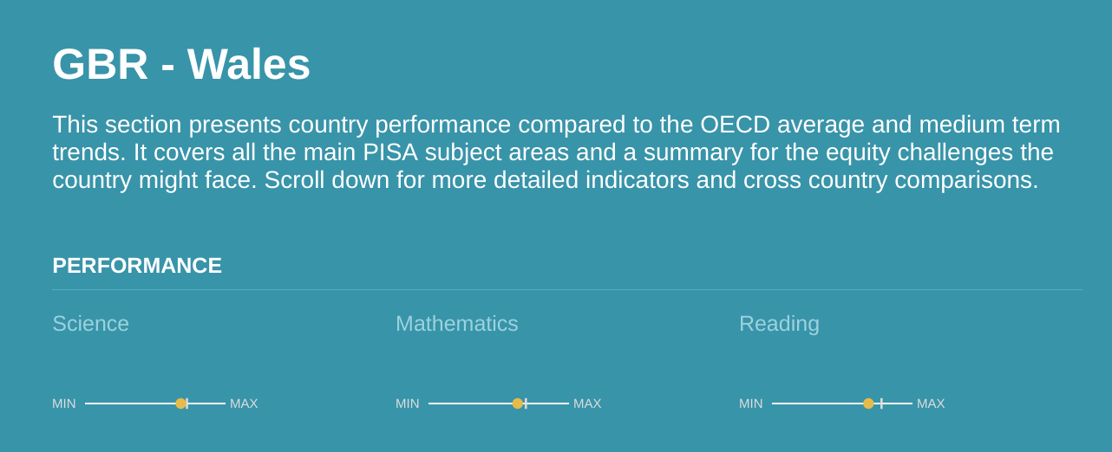
(Compare Your Country, 2018)

Furthermore, results for reading in Wales were significantly lower than in England, Ireland and Scotland (Figure 4). Wales was the only country in the UK where students had a below-average score in reading, a statistic that has remained the same for several years. The average PISA score for reading in 2015 was 493; whereas in Wales, the average reading score was only 477 (Figure 6; BBC, 2016).

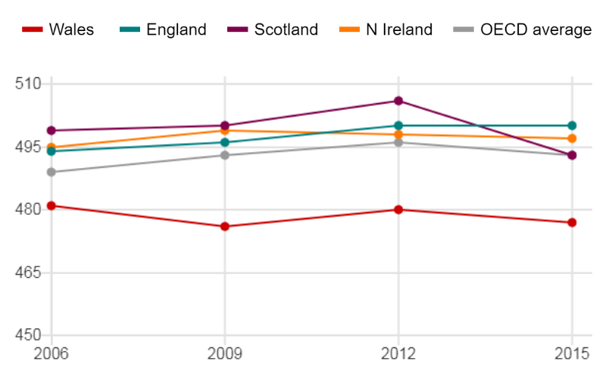
Figure 4: Pisa reading results in the UK

(BBC, 2016)

In the most recent annual report, Estyn notes that only "a few pupils have well-developed higher-order reading skills" (2018:38). This signifies that a large majority of pupils do not have the required skills, and struggle to successfully access the curriculum as a result. The need to improve reading levels in Wales is therefore extremely clear. The responsibility of this task falls on the key stakeholders in the education sector: governors, staff members, local authorities and the Welsh Government (Estyn, 2015b:2). It is the task of these stakeholders to consider the most effective route forward with regards to students’ reading levels. Specific development plans and interventions must therefore be implemented so that outcomes and attainment levels improve significantly.

The SIP of School X includes several references to the development of literacy, and advocates certain strategies to improve student attainment in this area. For example, in the ‘Standards’ section of the SIP, under the heading ‘Continue to improve standards and progress in skills’, reference is made to a handwriting programme, specialist tutors of English, a ‘book in a bag’ programme for year 7, literacy assessments and tracking, speaking frames, and the teaching of inference skills (School X, 2018a; Appendix I). The majority of these strategies are recommended for whole-school implementation. Some are targeted at specific students or year groups, however, there are none that are specifically tailored for year 9 students. This is a concern, as year 9 students have already been identified as having the lowest reading levels of secondary students in Wales (Welsh Government, 2017). They are a key year group, as students get ready to start their General Certificate of Secondary Education (GCSE) courses, and prepare for an increased workload in more specialised areas. The school would therefore benefit from considering a specific intervention for year 9 students that aims to improve attainment and prepare students for the critical years ahead.

2.6. Successful Reading Instruction in Schools

Despite the importance of reading in Wales, there is a lack of research surrounding reading strategies in Welsh secondary schools. Much of the research discussed below is outdated, has been conducted outside of Wales, or has instead focused on strategies within primary schools. Despite this, several studies will be considered for their relevance. This will help to inform strategies used for this research project.

2.6.1. Teacher Expertise

The theme of teacher competence and expertise in literacy appears frequently in discussions of reading instruction in schools. Academics agree that teachers must have excellent knowledge surrounding language structure and specific linguistic systems in order to successfully support students’ reading skills (Brozo and Simpson, 2003). Reid Lyon and Weiser (2009) cite multiple examples of students’ success in reading as a cause of teachers’ literacy expertise and knowledge. They note that the most successful teachers have a highly comprehensive understanding of linguistic systems, and are able to apply components correctly and expertly. Snow, Griffin and Burns discuss that teachers’ linguistic knowledge is often inadequate, perhaps because the information is seen as "too complex and technical" (2005:10). It is, however, this understanding that is required for successfully teaching students about the intricacies of literacy and reading in schools.

2.6.2. Accessible Reading

Many researchers maintain that students need more access to reading time and reading materials in secondary schools; it is agreed that literacy strategies are currently not a predominant feature in secondary schools, and that policymakers have all but abandoned attention on reading with older pupils (Peterson et al., 2001; Sturtevant, 2003). It is suggested that this is because secondary students are presumed to have sufficient reading skills by this age (Peterson et al., 2001). However, as evidenced in the literature, many secondary students do not have satisfactory reading levels, and this must be addressed by promoting reading in schools. This should include more time spent on reading and a greater amount of relevant resources. In a recent study, Siah (2008) found that children who were exposed to more reading time displayed higher levels of understanding and improved attitudes towards reading. There is also debate surrounding the type of resources used for reading in schools; some argue that students should be able to choose their own books (Guth in Sturtevant, 2003; Stahl in Siah, 2008), whilst others maintain that teachers should choose the material, and provide appropriate, levelled books for students (Stallings, 1979; Al Otaiba and Rivera, 2006).

2.6.3. Sustained Silent Reading

Sustained Silent Reading (SSR) is an approach to reading that allows students increased access to books, and more time to read them individually. This strategy is a very popular method for building reading skills, and is used extensively across many schools (Pilgreen, 2000; Garan and DeVoogd, 2008; Gardiner, 2005; Siah and Kwok, 2010). Not only has SSR been shown to improve pupil attainment, but studies also show that it leads to improvements in students’ habits and attitudes towards reading (Siah, 2008; Siah and Kwok, 2010).

There are, however, reports that disfavour the SSR approach. For example, Stallings (1979) attributes lack of progress in reading attainment to too much silent reading and not enough structure. Furthermore, in a report by the National Reading Panel, no evidence was found to support the effectiveness of independent silent reading in improving reading achievement (2000:34). It has also been argued that students simply do not engage with SSR in the classroom because there is no active learning (Bryan, Fawson and Reutzel, 2003). The studies show that SSR provides few tangible results, as students do not engage with the teacher, and the teacher has little opportunity to check progress or provide feedback. For these reasons, it is claimed that many schools have discontinued their use of SSR (ibid).

2.6.4. Scaffolded Silent Reading and Guided Repeated Oral Reading

Although SSR is presented as a rather ineffective approach to reading, it should not be disregarded completely as a tool for improving student attainment. Several researchers note that SSR may be implemented in schools when used alongside additional methods of reading instruction. These methods include modelling, discussion, encouraging students to read aloud in small groups and giving supportive feedback (Stallings, 1979; Peterson et al., 2001; Al Otaiba and Rivera, 2006). Two methods are often implemented to complement SSR, and are known as Scaffolded Silent Reading (ScSR) and Guided Repeated Oral Reading (GROR) (Reutzel, Fawson and Smith, 2008; Reutzel et al., 2008).

ScSR focuses on monitoring, discussion and comprehension of texts (Appendix J). It usually consists of students reading a text, answering questions and having discussions in groups. Small groups or a "group of around four or six students" are recommended for this approach (Didau, 2012:104). During the sessions, the teacher facilitates the questioning, and supports students when they encounter difficulties (Collins and Smith, 1980). Questions should be open-ended to allow for greater discussion (Hsui, 2000). Whilst small groups are discussing the book, the rest of the students in the class should be reading silently and independently (Didau, 2012).

Many academics encourage this method of reading, noting that the strategies act as supports and scaffolds for students (Peterson et al., 2001). The approach is used to engage students in reading, and provide them with the opportunity to consolidate their learning. Research has shown that even non-engaged readers can benefit from this approach to reading, as it involves all students and allows them to express their ideas (Bryan, Fawson and Reutzel, 2003). Significantly, research also shows that these strategies can lead to success in a secondary setting (Boling and Evans, 2008).

GROR on the other hand, focuses on modelling, repetition and fluency as ways to improve student outcomes (Appendix K). In GROR, students listen to the teacher modelling a passage, practise the reading by themselves, and use writing to support their learning (Peterson et al., 2001). These reading sessions usually last between 15/20-30 minutes (Hsui, 2000; Siah, 2008; Didau, 2012).

The method of guided reading is recommended by a number of academics, and studies using the approach show extremely positive outcomes (Rasinski, 1990; Widdowson, Dixon and Moore, 1996; Al Otaiba and Rivera, 2006; Rasinski et al., 2011). Reports of increased motivation and attention, as well as rate and accuracy of reading demonstrate the significant impact this approach can have (Guth in Sturtevant, 2003; Al Otaiba and Rivera, 2006; Widdowson, Dixon and Moore, 1996) Rasinski et al. also note that this approach to reading instruction is very inclusive, as findings from their research were "positive for all subpopulations studied, including special education and regular education students" (2011:75).

Both ScSR and GROR have proven to be successful in many schools, and are often used side by side for a more dynamic approach (Collins and Smith, 1980; Peterson et al., 2001; Al Otaiba and Rivera, 2006; Reutzel, Fawson and Smith, 2008; Fountas and Pinnell, 2012a). Research has shown that by using ScSR, GROR or both approaches together, students make significant "improvements in accuracy, reading rate, expression, and comprehension" (Reutzel et al., 2008:205). In fact, Reutzel, Fawson and Smith (2008) advise that exclusive use of just one of these strategies tends toward tedium and reduces enjoyment and motivation for students. Estyn (2011:9; 2014b:39; 2014c:14) also recommends a mixed approach for schools in Wales. It notes that both shared and guided reading can be used to promote higher-order skills and improve reading comprehension.

These methods, therefore, suggest a more effective approach to reading instruction than SSR. They engage students and allow them to interact with their books on a deeper level. They also allow teachers to monitor and check progress more effectively.

2.6.5. Limitations

Despite the successes of ScSR and GROR, there are several limitations to consider. Firstly, large class sizes are cited as a significant flaw in these approaches. Large classes present two issues: (i) they allow for misbehaviour and negative interactions when the teacher is working with only one group, and the rest of the class is completing silent reading. This means that the majority of pupils are not being supervised, and without teaching assistants, students are likely to become disruptive (Stallings, 1979); (ii) as there are usually multiple groups in large classes, the teacher is not physically able to work with every group during one session. This means that students do not benefit from teacher interaction as often as recommended (Sturtevant, 2003). A second limitation is that research into these methods has mainly been conducted within primary schools, and the impact of these strategies in secondary schools has not yet been widely explored. It is therefore suggested that any application of these methods into secondary schools is implemented with caution, and that the strategies are appropriately adapted to suit the needs of older pupils.

2.6.6. Conclusions

The evidence shows that ScSR and GROR are successful reading interventions currently implemented in many schools. They work together as companions to improve reading outcomes for a large number of students (Reutzel, Fawson and Smith, 2008) Nevertheless, similar reading approaches in Welsh secondary schools are not yet widespread, and are not embedded effectively for the greatest outcomes. This demonstrates an opportunity for implementing such methods in order to achieve the key priorities set out for Welsh education.

2.7. Proposed Research Question

After empirical observations and consideration of the literature, it was decided that the reading ability of year 9 students should be investigated for this research project. ScSR and GROR are also chosen as the approaches for the investigation. The investigation takes the style of an intervention, the reasons for which are discussed in the methodology section of this paper below. The proposed research question therefore asks ‘how do scaffolded, guided reading interventions impact the attainment and attitudes of disadvantaged students in Wales?’. In implementing this intervention programme, the researcher hopes to narrow the gap for pupils in School X, and improve learner outcomes. The researcher also hopes to contribute to the field, and improve the future prospects for reading in Wales.

3. Methodology

3.1. Research Design Rationale

When considering the research design of this project, factors such as type of data and different variables were taken into account. As the research required new strategies to be implemented within School X, a pragmatic approach was chosen. An intervention was subsequently designed and conducted so that GROR and ScSR could be appropriately introduced and executed. By designing the intervention, the researcher also had substantial control over the variables (Anderson and Arsenault, 2005).

Implementing an intervention programme meant that action research was carried out in the classroom. Action research allowed the researcher to collect and analyse both qualitative and quantitative data using mixed-methodology. These different types of data are often analysed separately, however, it can also be beneficial to use them together, as a mixed-methods approach helps to "bridge the schism between qualitative and quantitative research" (Johnson and Onwuegbuzie, 2004:15), and this outlook reflects the way in which this research project was conducted. The research was also explorative and inductive, so that several theories and data patterns could be examined, and conclusions drawn from the results.

3.2. Ethical Consideration

To fully comply with the high standards of ethical conduct as outlined in the British Education Research Association (BERA) (2011) and the University of Wales Trinity Saint David (UWTSD) (2017), full ethical approval was sought prior to the start of this research project. After designing the research, an ethics form was completed by the researcher, and was reviewed and approved by the UWTSD ethics board. The form outlined important ethical considerations, and acknowledged issues that could have arisen during the intervention programme (Harries, 2018). As well as being discussed in the form, potential issues and appropriate methods of mitigation are outlined below.

At the start of the project, participants were provided with consent letters, and were given information packs outlining the processes involved in the research. Parental consent was also sought via letter before beginning any research.

The researcher followed the school safeguarding policy and made sure to respond to any matters of distress or wellbeing in line with this (School X, 2017). This ensured that no physical or psychological harm came to any child. Participants were notified of their right to stop or leave proceedings at any point, and received a debriefing session at the end of the data collection. Furthermore, students were given the right to withdraw their involvement at any point after data collection if they decided they did not want to participate. The safeguarding policy also helped to protect the researcher, as any risk of accusation was mitigated by following the policy assiduously (ibid).
The researcher handled sensitive and confidential information during the research process, including personal data, such as students’ eFSM and SEN status. This ensured the researcher adhered to BERA (2011) guidelines on confidentiality and anonymity. The researcher notified all participants of their rights regarding confidentiality and anonymity, as well as how their data would be stored, and what to do if they believed that there had been any kind of breach. The researcher also informed participants that confidentiality and anonymity would have to be broken in line with the school safeguarding policy, if for example, the researcher believed that a participant were at risk (School X, 2017; UWTSD, 2017). In order to maintain confidentiality, the researcher ensured that all computerised data was password protected, and that physical data was stored securely in a locked drawer. In order to maintain anonymity, all participants were given pseudonyms, and no other identifiable characteristics were revealed. Participants were also asked to maintain a level of confidentiality towards each other and the project. The researcher was the only person with access to the data, and all evidence was kept in line with new government legislation (Data Protection Act 2018). Furthermore data was destroyed upon completion of the project.

For both the focus group and interviews the researcher obtained consent from the participants to observe and audio record the sessions. The researcher also made notes during the focus group and interviews, so that non-verbal communication could be recorded. Again, all data was securely stored for analysis in line with new government legislation (Data Protection Act 2018).

The ethical considerations outlined here ensured that the researcher and all participants were safe from harm throughout the research project. Further, more detailed information surrounding the ethics of data collection are discussed later on in this report.

3.3. Participant Information

Qualitative and quantitative data was gathered from 26 pupils who took part in the intervention programme in School X. Pupils were chosen for the intervention programme based on a number of factors:

(i) Year Group
Students from year 9 were targeted for the intervention, after the Welsh Government identified this year group as one of the lowest achieving year groups in the 2017 national tests (Welsh Government, 2017). Year 9 were also chosen for the intervention programme to support them in preparation for their upcoming GCSE courses.

(ii) Form Group
Students from a single registration (form) group were chosen, so that they could easily access the intervention programme during the daily registration period.

(iii) Demographic
The particular year 9 form group (Form Y) was chosen as it covers an exceptionally large demographic, and this spread is necessary to reflect a variety of data (Opie, 2004). Form Y includes students who are male, female, eFSM, MAT and who have SEN and English as an Additional Language (EAL) (Appendix L).

Key members of staff were also chosen to take part in the research project. The three staff in School X who have contributed to the project are: the literacy coordinator, the head of year 9, and the headteacher. Staff were selected based on their involvement with the students, the intervention programme, and their knowledge of the SDP.

The participants were therefore chosen through a mixture of purposive and convenience sampling (Dhivyadeepa, 2015). The sample size of approximately 30 participants is of sufficient size to elicit a variety of opinions on the reading intervention. However, it is not so large that the research and subsequent data sets become unmanageable, or that results are adversely affected (ibid).

3.4. Methodological Approach

3.4.1. Testing

Prior to commencing the reading intervention programme, all students in Form Y were provided with a pre-intervention reading test. This test was a direct reflection of the content in the Welsh national tests, as it was used as the reading paper for year 9 students in 2015 (Welsh Government, 2015d). The test was therefore relevant and age-appropriate. Students in Form Y had no previous access to the test, and had no prior knowledge of its content.

Once the intervention programme had finished, all students in Form Y were given a post-intervention test to measure their progress. This test was once again taken from the Welsh Government archives, as the paper was used in the 2016 national reading tests (Welsh Government, 2016b). The similar nature of the pre-intervention and post-intervention tests meant that students’ progress could be measured accurately and effectively.

3.4.2. Groups

After completing the tests, Form Y were split into small groups, comprising 4-5 students. Groups of this size were chosen based on recommendations from Didau (2012:104). The groups were based on the reading levels from the pre-intervention test. Students were grouped with others who had achieved similar reading levels to themselves, so that the ability of each group was similar. Reading levels were established by calculating age-standardised scores for each student (Appendix M). Students were not made aware of the reasons for the grouping, so as not to affect their attitude or interpretation of the intervention programme (BERA, 2011).

Once students were grouped, the head of year 9 and the literacy coordinator were advised of the procedures that would occur over the next few weeks. The researcher requested that the two members of staff visit Form Y on regular occasions throughout the intervention programme. This allowed the two members of staff to gain an insight into the methods used, and observe any academic impact or change in students’ attitude throughout the process.

3.4.3. Timings

Over the next 6 weeks, students in Form Y were exposed to regular, focused reading sessions during the morning registration period. These sessions took place three times a week, on a Monday, Wednesday and Friday, and followed recommendations from Chard, Vaughn, and Tyler (2002) in Al Otaiba and Rivera, who advise that students should practise these reading strategies “three to five times per week” (2006:145). This consistency allowed students to regularly practise their reading skills. The sessions were each 30 minutes long, which ensured that students had enough time to develop their skills, but that they did not disengage with the material. These timings are based on the recommendations of Hsui (2000), Siah (2008) and Didau (2012).
The decision was made to conduct the intervention programme solely within the registration period, as cross-curricular implementation was considered too problematic without linguistic experts and a suitable level of support across the school (May and Wright, 2007). However, a linguistic expert was used for this intervention programme, as the sessions were led by an experienced practitioner of literacy. This ensured that teacher knowledge was excellent, and that students benefited from a high level of support (Brozo and Simpson, 2003; Reid Lyon and Weiser, 2009).

3.4.4. Books

During the reading sessions, students were provided with books that matched their reading levels, based on their pre-intervention tests (Al Otaiba and Rivera, 2006). These books were chosen by the practitioner, and corresponded with the Fountas and Pinnell gradient (2012b). The books chosen were age-appropriate, relevant and interesting for the students, so that the class remained engaged and motivated throughout the sessions (Al Otaiba and Rivera, 2006; Appendix N). The length and difficulty of the books also corresponded to students’ levels. It was decided that students should not be allowed to choose their own books, as they would not be able to identify appropriate material for their reading level. This follows advice given by Stallings (1979) and Al Otaiba and Rivera (2006), and satisfies the needs of this reading programme, which required all students in one group to have the same book. By accessing the same books, students within the same group could benefit from discussion, modelling and support.
3.4.5. ScSR and GROR Activities

The style of the intervention mimicked the successful methods of ScSR and GROR. Both of these strategies were used together in order to maximise attainment and outcomes for the students. This reflects guidance from Jones, Fawson and Smith (2008). During the lessons, each group of students carried out particular activities:

- GROR: Students use headphones to listen to the teacher modelling a pre-recorded passage of their group book;
- ScSR/GROR: Teacher to monitor students as, one at a time, they read from the book;
- ScSR: Teacher to incite discussion with students based on the passage read, and direct oral comprehension questions to individual students;
- GROR: Students to read the text, quietly on their own, several times;
- ScSR: Students to complete pre-prepared comprehension questions on a worksheet.

The fifth activity was not assigned its own period, as students were instructed to complete the comprehension questions over the weeks, as and when they felt that answers could be provided. The worksheets were not collected, nor marked by the teacher; they were used purely as a tool for students to express their ideas, consolidate their learning, and aid in group discussions (Peterson et al., 2001). The process and timings of the activities can be found in tables 1, 2 and 3 below.

Table 1: week 1; session 1 of intervention
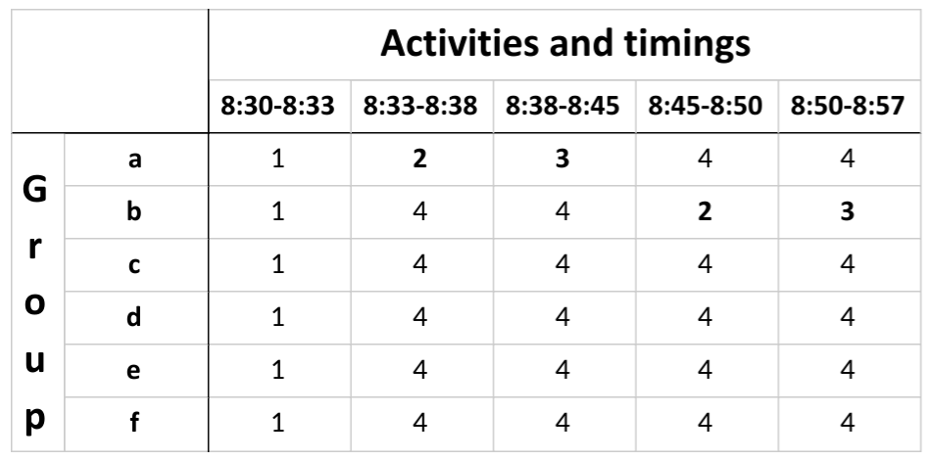

Table 2: week 1; session 2 of intervention
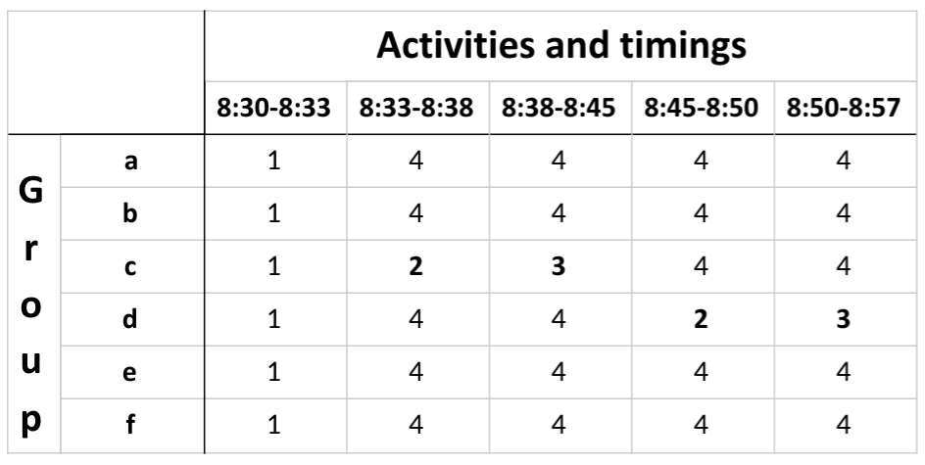

Table 3: week 1; session 3 of intervention
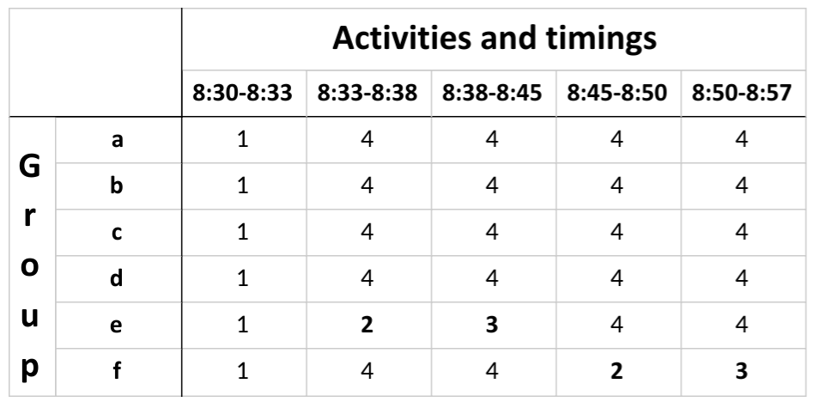

The tables show that every week, each group of students received 3 periods of modelled reading, 1 period of reading out loud with teacher monitoring, 1 period of discussion and questioning with the teacher, and 10 periods of quiet reading. Numbers in bold represent direct teacher monitoring and support in each group. 3 additional minutes (8:57-9:00) were left at the end of each registration period to allow for resources to be collected. Activities were repeated in this manner for a total of 6 weeks. Each week, the order of activities 2 and 3 for each group were rotated. This meant that the groups benefited from teacher interaction at a different point every week (Appendix O).

The 6 week time frame was chosen as it allowed for full group rotation and sufficient reading time for students. Confirming a set period of time also was also in line with ScSR procedure, which recommends that goals are set for completing the reading of books within a specific time frame (Appendix J; Reutzel, Fawson and Smith, 2008). Per week, each student had 60 minutes of silent reading (activity 4). It was anticipated, however, that, for some students, this time would be insufficient to complete the reading. As such, the teacher instructed each group to read up to a certain page by the end of the week. This meant that students could complete unfinished reading over the weekend, and that on the following Monday, students in each group would be on the same page. Teacher-modelled recordings and comprehension worksheets were therefore relevant and appropriate for each week of sessions.

3.4.6. Resources

The activities required several resources, meaning that a significant amount of planning and preparation was conducted prior to the intervention programme. The teacher produced 36 recordings (1 per group per week), as well as 36 worksheets (1 per group per week). The recordings and worksheets were all created to correspond with the content of the books, and to align with the same pages of the books each week.

Following the end of the reading intervention programme, and the collection of post-intervention tests, research was conducted into the attainment and attitudes of the students involved. Key members of staff were also involved in data collection, and provided their professional opinions on a range of issues surrounding the reading intervention.

3.5. Data Collection and Research Techniques

The researcher collated findings using a mixed-methods approach and collected a variety of qualitative and quantitative data from the intervention programme (Johnson and Onwuegbuzie, 2004). Data was then triangulated to ensure the reliability of results (Mertler, 2008). This enabled the researcher to form an accurate understanding of the impact of the intervention.

3.5.1. Testing

During the reading intervention, the researcher administered quantitative tests to all students in Form Y. Students had two tests to complete; one pre-intervention and one post-intervention (Welsh Government, 2015d, 2016b). Analysing the data from these tests allowed the researcher to measure attainment in reading at the start and end of the programme. The method of testing was chosen as it provided accurate, quantitative results. It also allowed for fair and efficient data collection (Phelps, 2005; Cangelosi, 1990).

There are, however, limitations to testing, the principal issue being the wellbeing of students (McDonald, 2001). If a student arrives at school feeling tired, or stressed about the test, for example, they may not perform very well. On the other hand, if a student arrives at school feeling motivated and alert, they may perform exceptionally well (Gronlund, 1993). These issues may lead to inaccurate and unreliable data. The researcher attempted to mitigate these issues by monitoring students’ wellbeing prior to, and throughout the tests. Furthermore, anomalous data from the tests was carefully considered during the analysis stage.

3.5.2. Questionnaires

The researcher administered questionnaires for all students and staff involved in the programme (Appendix P; Appendix Q). The questionnaires elicited data surrounding attitudes to, and effectiveness of the reading intervention. This method was chosen for several reasons. Firstly, questionnaires are not time-bound, and do not require participants to adjust their schedules. There is also no requirement for researcher and participant to organise a protracted meeting for data collection to take place (Saris and Gallhofer, 2014); some questionnaires can even be administered online. Furthermore, questionnaires allow for intramethod mixing (Johnson and Turner, 2003:298). Open-ended questions, for example, will produce qualitative data, whereas likert-type scales and multiple choice questions will elicit quantitative data (Likert, 1932; Mellenbergh, 2008). Questionnaires used in this research project were administered online, and made use of both quantitative and qualitative style questions for comprehensive triangulation of data.

Nevertheless, there are limitations to using questionnaires. Firstly, participants may exhibit demand characteristics, and therefore cause bias and unreliability in the data (Weber and Cook, 1972). Participants exhibit demand characteristics when they develop an interpretation of the research goals, and alter their responses as a result. This, in turn, damages the credibility of the project (ibid). To mitigate this situation, the researcher reminded participants that they must be honest and open when providing their views, and that their views would not be shared outside of the project.

Secondly, participants often find questionnaires difficult to answer for certain reasons:
(1) respondent fatigue, which occurs when participants become disinterested or tired. This causes the quality of responses to decrease, and leads to unreliability in the data (Ben-Nun, 2008). To mitigate this unreliability, the researcher administered short, simple questionnaires to participants.
(2) lack of human connection, which often leads to misunderstanding and misinterpretation of questions. Without an explanation of questions, participants may avoid parts of the questionnaire, answer randomly, or respond inappropriately when they have misunderstood a question. These issues may cause results to be skewed (Foddy, 1993). To mitigate this issue, clear and simple language was used throughout the questionnaires.

3.5.3. Focus Group

The researcher used a focus group with students to gain qualitative data from unstructured and open-ended questions. Participants for the focus group were selected using stratified sampling, where factors such as SEN, eFSM and EAL status were considered. The focus group method was chosen as it allowed the group to discuss their thoughts freely and openly. It also allowed the researcher to observe paralanguage and subtleties (Cohen, Manion and Morrison, 2017).

One limitation of a focus group is that some participants may dominate the conversation, whilst others may not have the opportunity to talk. For example, participants may feel reluctant to offer their opinions if they feel that they are insignificant (Greenbaum, 2000). The researcher mitigated this scenario by targeting questions to pupils, and ensuring that volatile situations were diffused. The second limitation concerns social desirability bias, which causes participants to alter their behaviour to match what they believe others want to see and hear (Edwards, 1953; 1957). In a student-centred focus group, this phenomenon usually manifests itself as students trying to impress their peers. To mitigate this issue, the researcher reminded participants that they should respect others, and be honest with their opinions.

3.5.4. Interviews

The researcher interviewed 3 key staff in School X who were involved with the reading intervention programme. The researcher also chose several students to interview using purposive sampling (Dhivyadeepa, 2015). Participants were chosen following results from the focus group and students questionnaires. Those who provided anomalous responses, or responses with the potential for further development, were targeted. This ensured the effective triangulation of data. This method was chosen as it used open-ended questions to elicit qualitative data and allowed for a personable approach. The interview format also allowed for real time feedback and discussion (Hennink, Hutter and Bailey, 2011). The researcher prepared questions prior to the interviews to ensure that relevant ideas were discussed. The researcher also adapted questions as necessary, and followed deviations from questions when appropriate.

Despite the strengths of interviews, there are several limitations to consider. Firstly, the issue of personal boundaries between interviewer and interviewee. These boundaries may be crossed due to the nature of comprehensive questioning in interviews. If questions become too invasive, for example, interviewees may experience discomfort and unease (Seidman, 2006). To mitigate these issues, the researcher prepared semi-structured questions and adapted questions as necessary during the interview. The researcher also monitored interviewees’ paralanguage and emotional states, so that questioning could be stopped if participants exhibited distress. Researchers may also risk crossing personal boundaries by inadvertently offering their personal views on the research project. If these views are shared, there is a risk of the interviewee adopting and repeating this information (Weiss, 1994). This causes bias, which could lead to inaccuracy and unreliability in the data. To mitigate these issues, the researcher remained professional and objective throughout, and used pre-prepared questions to guide the interviews.

As with the focus group, demand characteristics and social desirability bias are also issues here. This means that responses may be skewed, and therefore unreliable. As such, participants were reminded of the need to be honest with their responses. Participants were also advised that their opinions would not be judged, nor shared outside of the research project.

The breadth of research techniques used in this project ensured that data could be triangulated effectively, and that the accuracy and reliability of results could be improved as a result (Mertler, 2008).

4. Results and Analysis of Data

Analysis of data is used to identify the strengths and weaknesses of the programme, and to support self-evaluation. This analysis and evidence can then be used to support recommendations for contributions to the SIP (School X, 2018a). The researcher has chosen to use thematic data analysis methods to collate and produce results. The researcher will demonstrate triangulated findings through a variety of qualitative and quantitative data from both pupils and staff. Finally, the researcher will refer to the literature to aid with results and analysis of data.

4.1. Student Attainment in Pre-intervention & Post-intervention Tests

Progress in attainment was measured using two national reading test papers from the Welsh Government (2015d; 2016b). Three categories were analysed after results had been collected: percentage points, progress measures and age-standardised scores (Welsh Government 2015e; 2016c).

4.1.1. Percentage Points

Results from the pre-intervention and post-intervention tests were converted into percentages to allow for clear and simple analysis. The graphs below demonstrate the change in attainment throughout the intervention programme.

Graph 1: percentage points
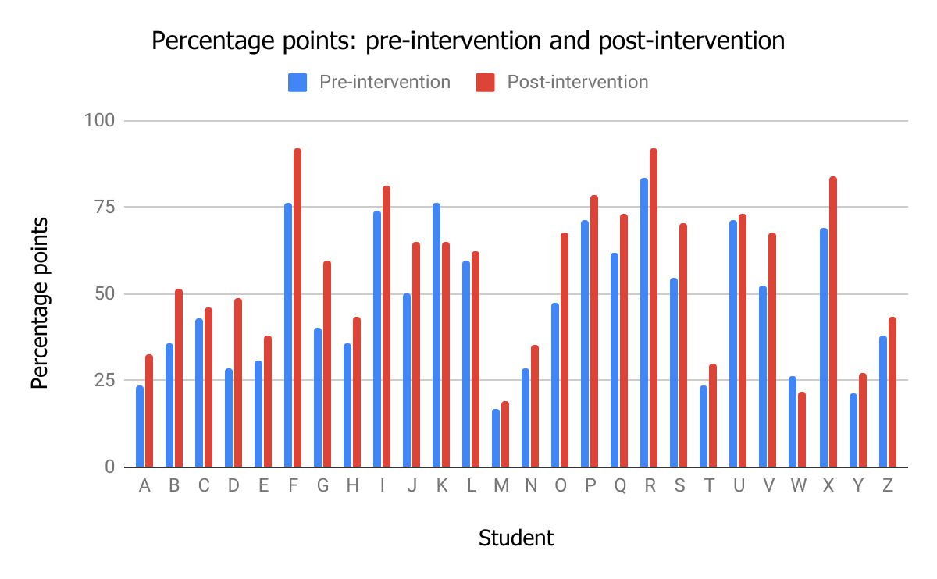

Graph 2: percentage point change
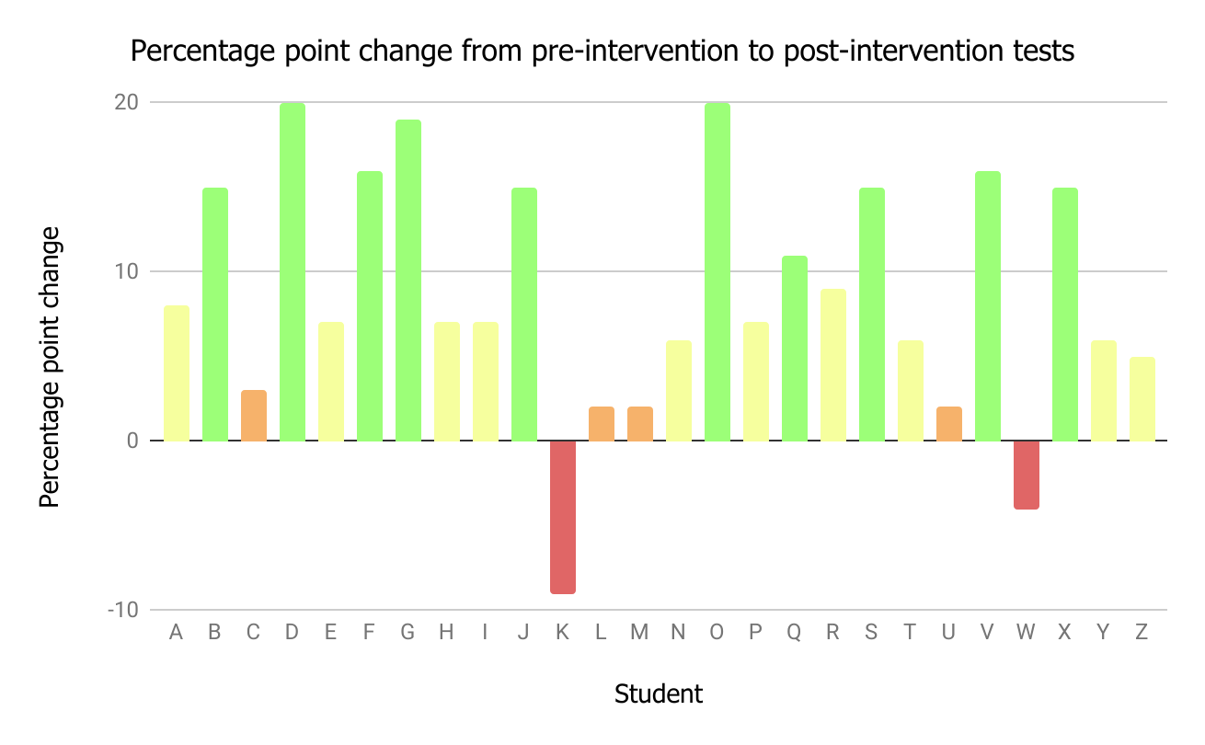

Graph 1 shows the percentage score of each student in their pre-intervention and post-intervention tests. The graph shows that 92% of students improved their post-intervention score, regardless of what they achieved in their pre-intervention test. This suggests that the methods were successful for the large majority of students, and not just for a certain demographic. This aligns with the research of Rasinski et al. who found that this type of reading instruction is "positive for all subpopulations studied" (2011:75).

Graph 2 shows the percentage point change for each student from the pre-intervention to the post-intervention test. The bars are colour coded to demonstrate the change for each student. Where x equals percentage point change, green shows x>10%, yellow: 5%<x<10%, orange: 0%<x<5%, and red: x<0%. Although the majority of scores are positive, there were 2 students who failed to make any progress. These negative scores may be attributed to students’ wellbeing on the day of the post-intervention test; for example, the students may have been tired, nervous or experiencing other issues at the time of testing (McDonald, 2001). The two students (K and W) who failed to make any progress are therefore considered anomalous results, and will be discussed in more detail throughout the analysis section.

Despite these negative scores, most students managed to increase their attainment by at least 5 percentage points, which shows that considerable progress was made across all subpopulations. Again, this research aligns with that of Rasinski et al. (2011), who suggest that these methods are effective for all student demographics.
4.1.2. Progress Measures

The Welsh Government have produced detailed documents advising how to interpret national test data. As part of this guidance, progress measures are recommended, as they show "how well an individual learner has done in a given test compared with all other learners in the same national curriculum year group" (Welsh Government 2015e:20; 2016c:20). The graphs below demonstrate the change in progress measures of students in Form Y.

Graph 3: progress measures
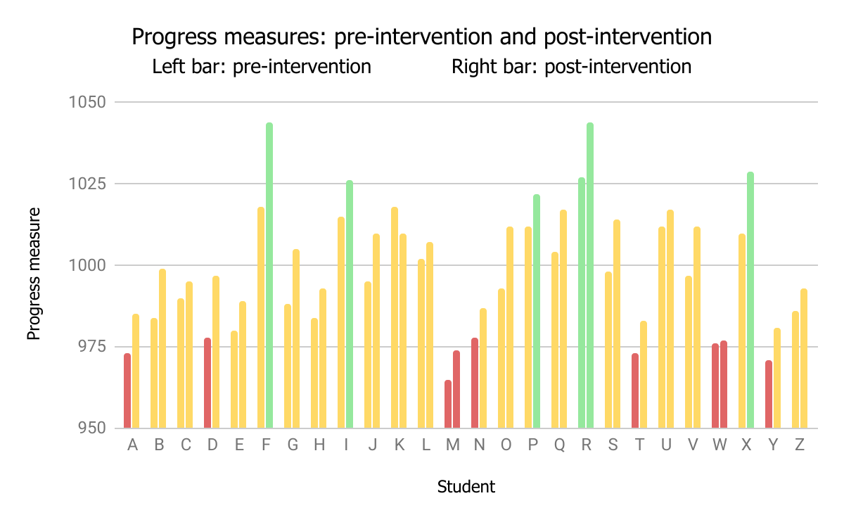

Graph 4: progress measure change
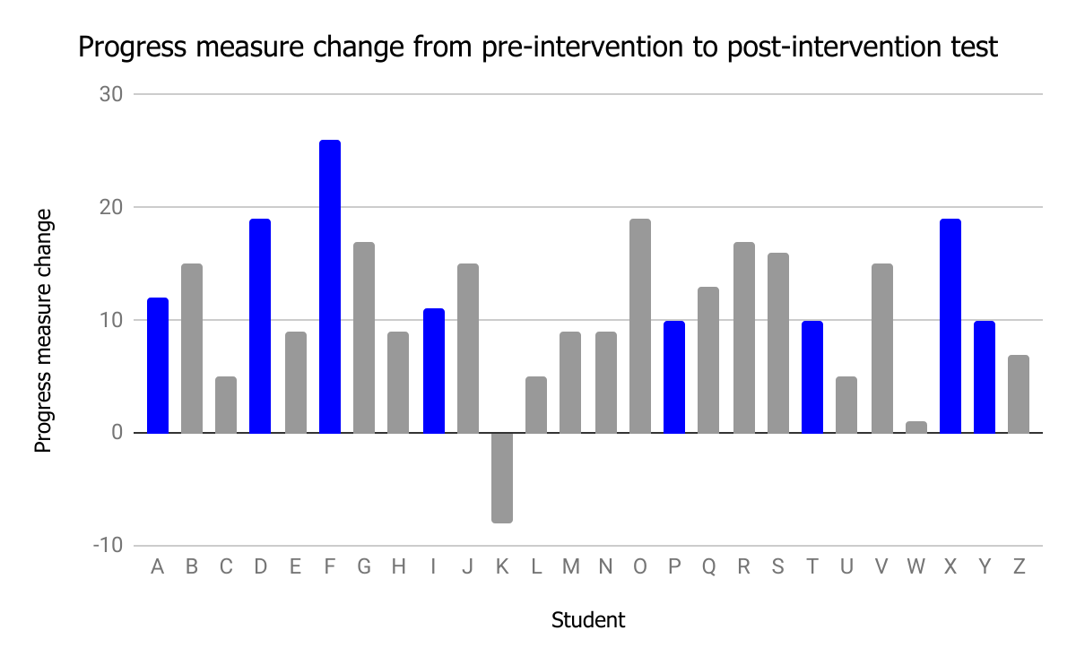

Graph 3 demonstrates the progress measures in the pre-intervention test and the post-intervention test. Bars are colour coded according to the Welsh Government (2015e; 2016c.), whose guidance document suggests that all students who score a progress measure between 980 and 1020 are working at a level in line with learners in the same year group (coloured orange). Progress measures below 980 (coloured red) or above 1020 (coloured green) suggest the student is working below or above other learners in year 9 respectively.

The graph therefore shows that at pre-intervention testing, 7 students were working below expected level, 18 were working at expected level, and 1 was working above expected level. The 7 students working below expected level are of serious concern here. At 27%, the number of students in Form Y who scored a below-average mark in the test far exceeds the Welsh Government’s national statistics, which were calculated at 16% for year 9 students (Welsh Government, 2017). The data demonstrates the significant needs of students in Form Y and suggests that an intervention of this type is highly appropriate.

By the end of the intervention, only 2 students (8% of Form Y) were working below the expected level and 24 were working at, or above, the expected level. In particular, students A, D, N, T and Y managed to increase their progress measure from below-average at the start of the intervention, to meet the levels of other learners in the same year group by the end of the intervention. This is a significant achievement for these students, as all of them have at least one additional learning need (ALN), and face several difficulties that often hinder their learning (Appendix L). This reflects research from Al Otaiba and Rivera (2006), who found that students with learning difficulties made significant progress in reading rate, accuracy and comprehension when taking part in a similar programme.

Graph 4 shows the progress measure change for each student in Form Y. All students apart from one managed to elevate their progress measure by the end of the intervention. Highlighted in blue are the students who managed to move up into a different band. Student K, however, appears once more as an anomaly in the data set. This anomalous data will be discussed in further detail later.

4.1.3. Age-standardised Scores

The Welsh Government has produced detailed instruction on how to calculate learners’ age-standardised scores. These calculations provide a more detailed analysis of progress, as they can be used to compare attainment of students "with the performance of all other learners of the same age, in years and completed months" (Welsh Government, 2015e; 2016c). Below are the graphs demonstrating age-standardised scores for all students in Form Y.

Graph 5: age-standardised scores
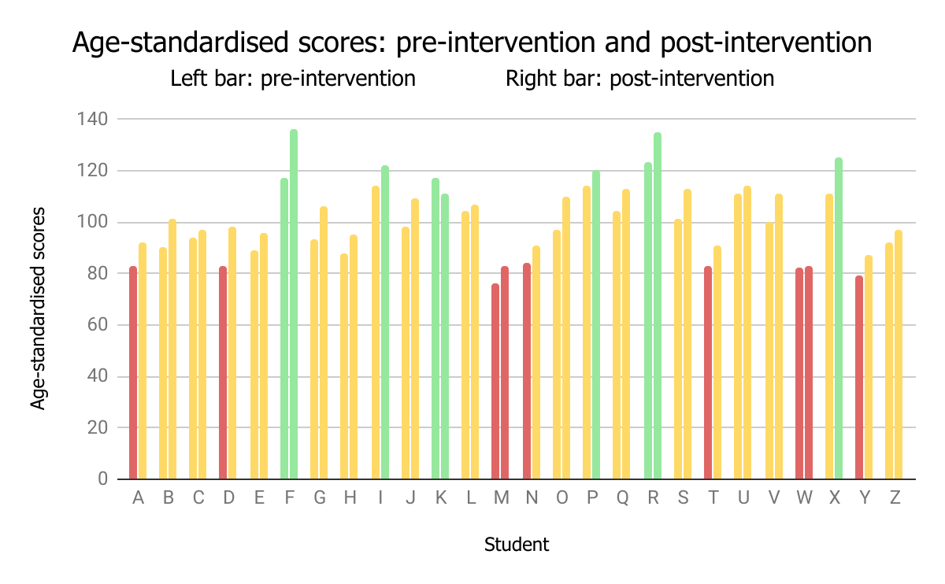

Graph 6: age-standardised score change
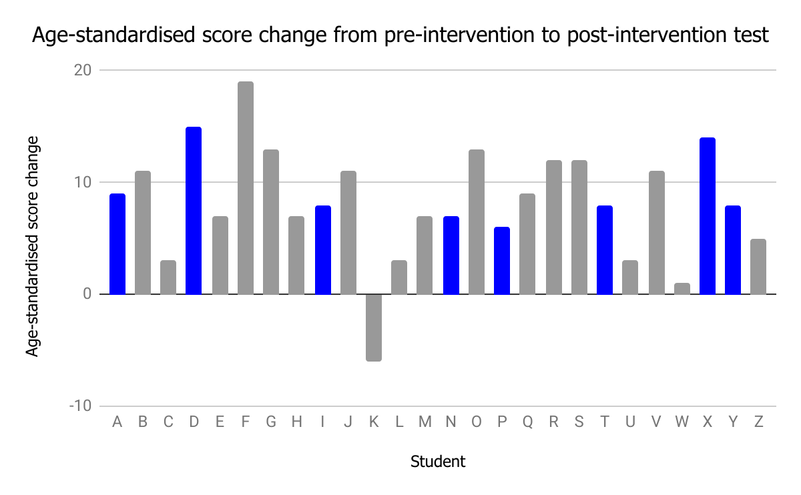
Graph 5 demonstrates the age-standardised scores in the pre-intervention and post-intervention test. Again, the bars are colour coded to reflect guidance from the Welsh Government (2015e; 2016c). The guidance states that the majority of students are expected to score between 85-115 points (coloured orange). Less than 85 points suggests difficulty with reading (coloured red), and above 115 suggests above-average reading ability (coloured green).

The graph therefore demonstrates the success of the programme in the number of students who managed to elevate their score from pre-intervention to post-intervention testing. With 27% of Form Y falling below reading age expectations pre-intervention, data once again exceeded statistics from the Welsh Government (2017) suggesting that only 16% of year 9 students are working below the average. Post-intervention data, however, demonstrates a clear change in these numbers, with only 8% remaining below this mark post-intervention. A significant number of students also managed to increase their level to above the expected reading age, with almost 20% of students accessing this higher band in the post-intervention test.

Graph 6 represents the change in age-standardised scores for students in Form Y. Once again, all bar one student (Student K) managed to secure an increased reading level in the post-intervention test. In blue are the students who successfully managed to move into a higher band. These coloured bars represent almost a third of students in Form Y, and are a clear demonstration of the success of the programme. Student K will be discussed in further detail below.

4.1.4. Anomalies in the Test Data

Despite the significant progress from pre-intervention to post-intervention tests, the issue of anomalies must be discussed. Primarily, student K, who, in every data set above, presents a negative change from pre-intervention testing to post-intervention testing. These changes are anomalous and can be considered outliers when compared to the rest of the data. Student K has a challenging profile and results from the testing may be attributed to these factors. Student K is eFSM, has an SEN (Autistic Spectrum Disorder), and is also MAT. All of these elements suggest that student K was unable to sufficiently adapt to the intervention programme and its methods. For these reasons, data from student K will be omitted from further quantitative analysis regarding attainment. This will ensure that results are not skewed, and that calculations of average scores are not affected.
4.1.5. Demographic Patterns

As a whole, Form Y made substantial progress throughout the intervention programme, as evidenced in the 3 categories above. However, it is important to discuss students in terms of individuals and groups, as analysis shows various patterns across the different demographics.

4.1.5.1. eFSM and non-FSM

Of the 7 pupils in Form Y who were classified as ‘below-average’ based on their pre-intervention age-standardised scores and progress measures, 5 of these pupils were eFSM. Not only does this demonstrate the worrying link between poor attainment and disadvantage, but it also highlights the issue of eFSM students performing well below the level of their classmates, and falling ever further behind in school (Estyn, 2010; 2014a).

On completion of the reading intervention programme, the number of eFSM students performing below the expected level dropped to just 2. The increase in progress by eFSM students means that 80% of students achieved the expected level in line with other students of their age. One student even managed to secure an ‘above-average’ classification, based on their post-intervention age-standardised scores and progress measures.

Despite these successes, the group performed poorly in comparison with other groups in Form Y. In all 3 categories (percentage points, age-standardised scores, and progress measures), eFSM students presented some of the lowest average increases in points (7.2, 7.6 and 10.2 respectively), second only to students with SEN.

When compared with non-eFSM students, the difference is very apparent. Non-eFSM students scored highly in all three areas, with an average percentage point change of 10.9, an average age-standardised score change of 9.7, and an average progress measure change of 13.4. The gap in attainment is therefore extremely clear, and despite the intervention, the issues of disadvantage are still prevalent (Graph 7).

Graph 7: eFSM and non-eFSM data
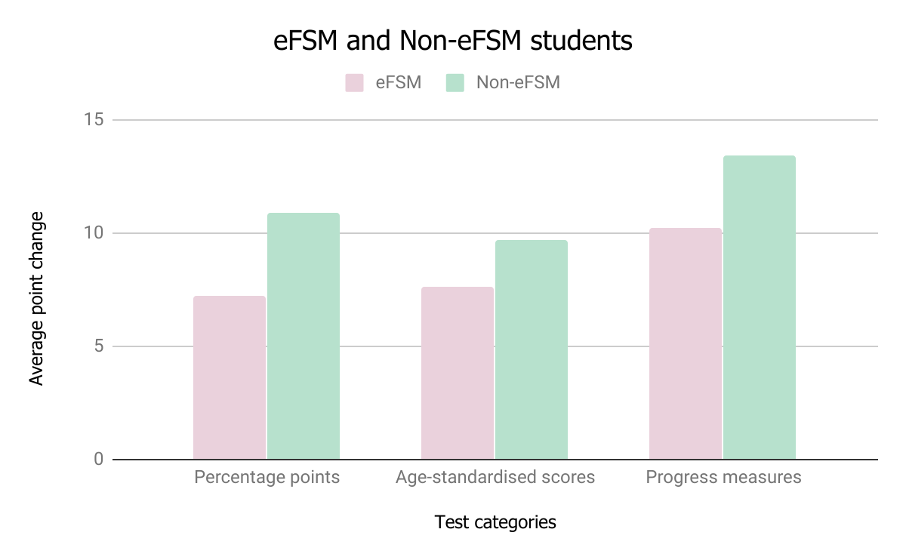

4.1.5.2. MAT and non-MAT

MAT students did not make significant levels of progress throughout the intervention programme when compared to other sets of students. Their average score increases were similar to other demographic groups within Form Y, and in some cases, non-MAT students even outperformed MAT students, as evidenced in graph 8. Reasons for this average test data may be attributed to students finding the work boring, demotivating and frustrating due to the repetition and ease of the tasks (Welsh Government, 2016a; Estyn, 2018).

Graph 8: MAT and non-MAT data

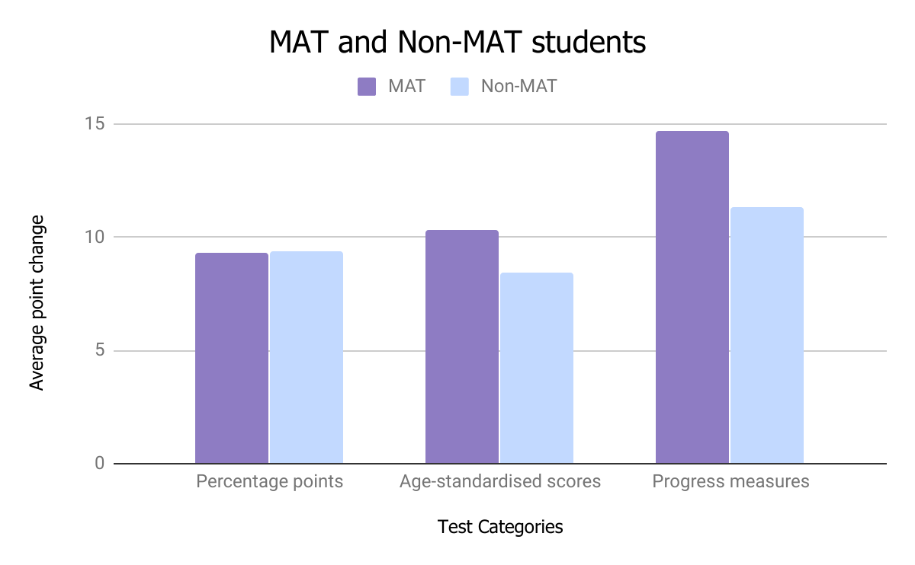

Despite this seemingly average group data, there are some individual cases that should be highlighted. For example, in pre-intervention testing, only 1 MAT student (student R) achieved above-average status in their age-standardised score and their progress measure. By the end of the intervention programme, however, 5 MAT students had achieved this status. These students also increased their percentage points by at least 5% in the tests.

The results, therefore, are mixed for MAT students. Group scores appear similar to others in Form Y, but individual post-intervention scores, show greater levels of progress.

4.1.5.3. Males and Females

Males and females showed little difference in their pre-intervention and post-intervention results. Average scores in each of the 3 reporting areas show less than a 1 point difference, as demonstrated in table 4 below.

Table 4: male and female data
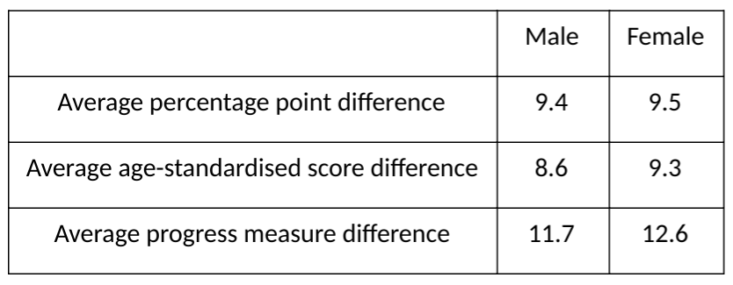

Although the average results from table 4 show minor differences in attainment, it does show that girls marginally outperformed boys.

However, girls presented a larger spread of data across all three categories, meaning that their results were rather sporadic. Boys’ results, on the other hand, were much more consistent. This means that the intervention programme had varied effects on the girls in Form Y, whereas the programme ensured similar, dependable results across the group of boys. This could therefore suggest that the reading programme was more successful for male students.

The results for males and females contradict the well-established patterns of girls significantly outperforming boys in reading attainment (Estyn, 2008; Chudowsky and Chudowsky, 2010). Although girls still outperformed boys in this reading intervention, there is little difference in post-intervention test scores. Estyn suggests that boys often perform poorly due to a number of factors, including sitting in silence for long periods of time in lessons (2008:16). As this intervention implemented strategies such as group discussion and reading aloud, it is suggested that boys were more engaged throughout the programme. This engagement, therefore, may be the reason as to why boys exhibited such positive results, and were almost able to match the performance of girls in this intervention.

4.1.5.4. SEN and non-SEN

Students with SEN were the lowest performing group in the intervention programme. On average, these students ranked at the bottom of each of the 3 test categories in terms of their progress. Their pre-intervention and post-intervention scores were also considerably below other demographics in Form Y.

60% of SEN students scored below-average age-standardised scores and progress measures at the start of the intervention. Although the remaining 40% secured the expected levels in these categories, their results were towards the lower end of the scale. This may suggest that the reading abilities of SEN students were significantly lower than non-SEN students at the time of testing, however, it may also suggest that students had trouble accessing and understanding the material itself (Wearmouth, 2017).

Despite the low pre-intervention scores, all bar two of the SEN students managed to secure average age-standardised scores and progress measures in the post-intervention tests. Although the data shows once more that these results were towards the lower end of the scale, progress was clearly made in these areas. One individual in particular (student O) demonstrated particularly high levels of progress. Student O made 20 percentage points of progress in the post-intervention test, and was the only SEN student to achieve above 110 points in the post-intervention age-standardisation scores (Appendix M).

Graph 9: SEN and non-SEN data
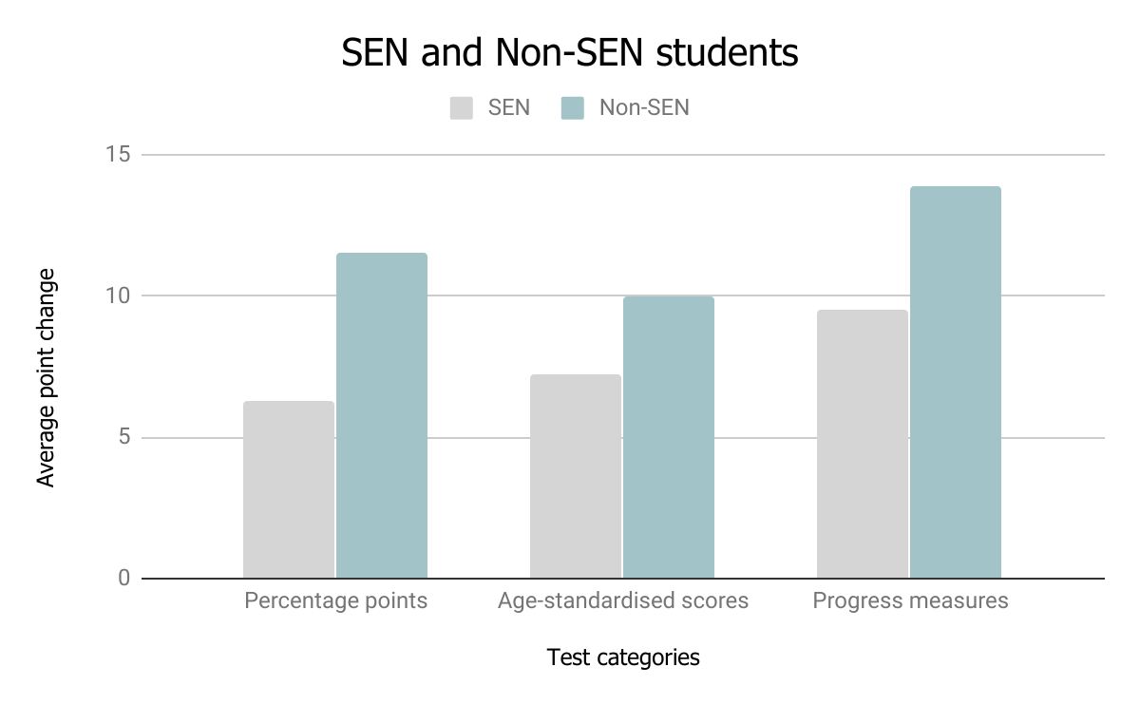
Graph 9 shows a clear difference between the attainment of SEN and non-SEN students, with non-SEN students securing higher progress scores across all 3 areas of testing. Despite this disparity, graph 9 does show that SEN students made progress in all 3 areas over the course of the intervention. It can therefore be seen, that although SEN students made limited progress when compared to other demographic groups in Form Y, they successfully made progress as individuals. This improvement by SEN students reflects research from Rasinski et al., who found that SEN students taking part in a reading intervention “demonstrated significantly and substantially greater gains in measures of reading achievement" than students who did not take part in the intervention (2011:95).

4.1.5.5. EAL and non-EAL

Students with EAL demonstrated the greatest amount of progress across any demographic group in Form Y. From pre-intervention to post-intervention testing, the average percentage point change was 17.5; the average age-standardised score change was 13; and the average progress measure change was 17. This data suggests that the reading programme was extremely effective for students with EAL. This echoes research from Suits (2003) who found that EAL students benefited from guided, scaffolded reading strategies in primary school.

In comparison with EAL students, non-EAL students scored significantly lower in each category (Graph 10). With an average percentage point change of 8.7; an average age-standardised score change of 8.5; and an average progress measure change of 11.7, data from non-EAL students is at least 4 points lower in each category when compared with data from students with EAL.

Graph 10: EAL and non-EAL data
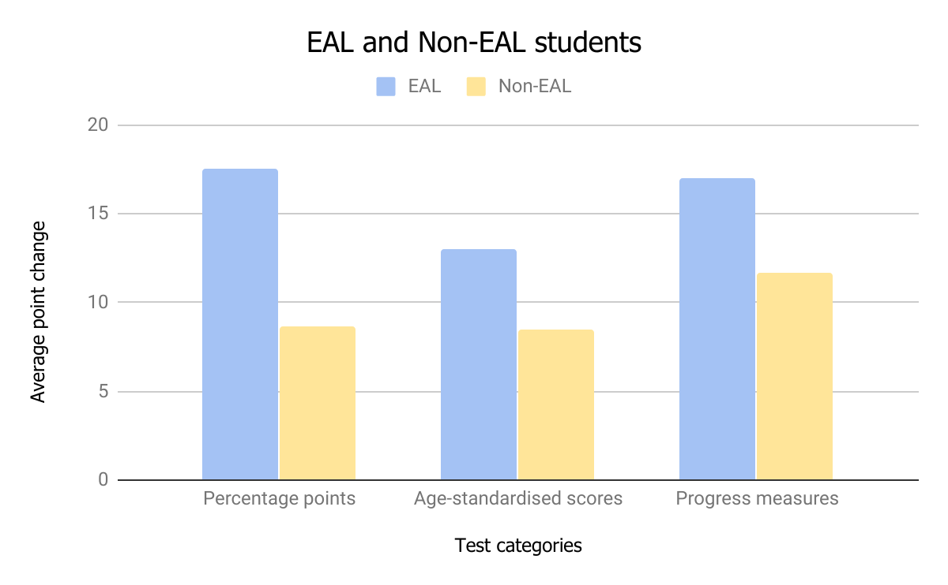

Despite the apparent successes for students with EAL, it is important to note that there are only 2 students who meet this criteria in Form Y. With only 2 EAL students, data is insufficient, as the sample size of these students is too low to make direct comparisons or draw such significant conclusions. Therefore, although the data is promising, it is unreliable and cannot be used as an accurate measure of progress. To increase the reliability of the data, the sample size of students with EAL would need to be increased.

4.2. Student Attitudes Following the Programme

4.2.1. Enjoyment and Appreciation of the Reading Programme

Results from student questionnaires showed an overall positive attitude and enthusiasm for the reading intervention. When asked if students enjoyed the programme, almost 60% agreed or strongly agreed (Pie Chart 1).

Pie Chart 1: enjoyment of the reading programme
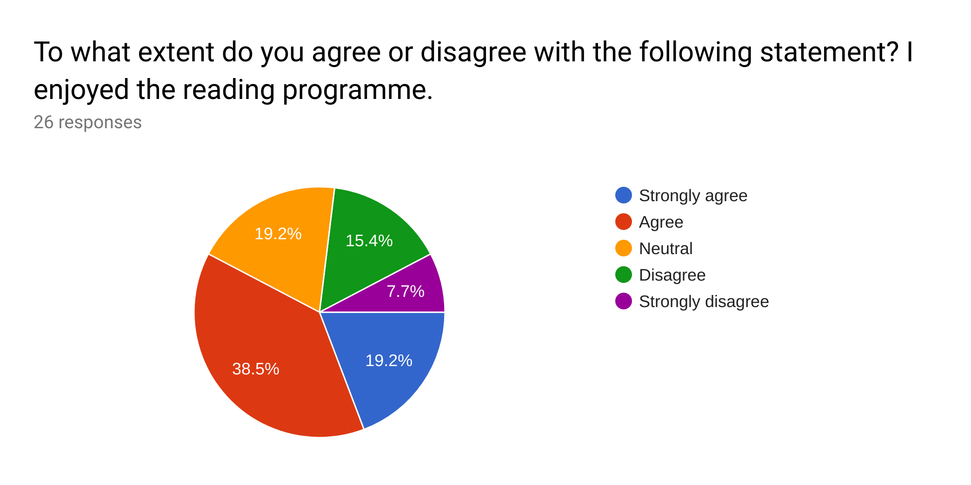
Data also shows that the majority of students found the intervention programme worthwhile and beneficial, with more than 50% of students scoring the programme an 8 or above on the scale below.

Graph 11: perceptions of programme benefits
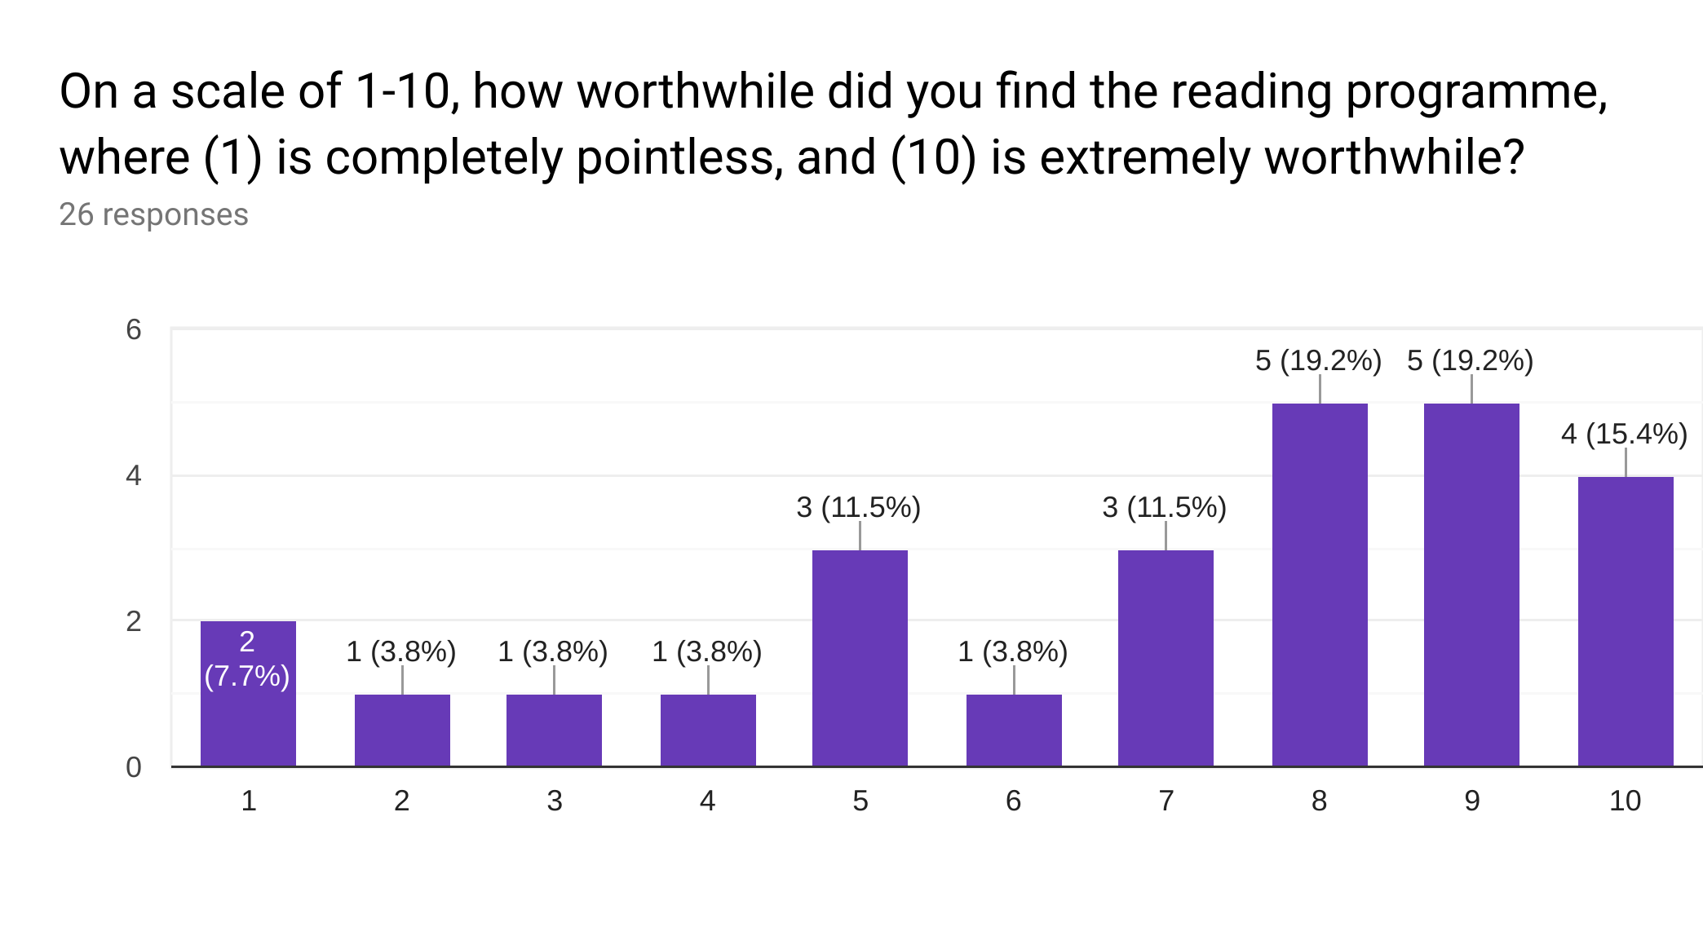
This demonstrates the positive impact that the intervention had on the students in Form Y, and shows that the majority of students enjoyed the programme and understood the benefits. This reflects the findings of Siah and Kwok (2010), who found that many student attitudes increased during their sustained reading programme.

Discussions from the focus group and student interviews help to triangulate these attitudes. A large number of positive comments confirms findings from Siah (2008), who conducted research into student’s attitudes towards reading for leisure, and found that attitudes improved after extended periods of time spent reading.

The weight of evidence therefore suggests that the majority of students enjoyed the programme and felt that it was a worthwhile experience. Although some negative comments were made about the programme, the positive remarks greatly outweighed these.

4.2.2. Impact and Self-perception

Following the programme, questionnaires asked students about the impact they felt the reading intervention had. Over 60% of pupils stated that they felt they had made progress throughout the reading intervention, with less than 20% disagreeing that they had improved (Pie Chart 2).

Pie Chart 2: perceived progress during programme
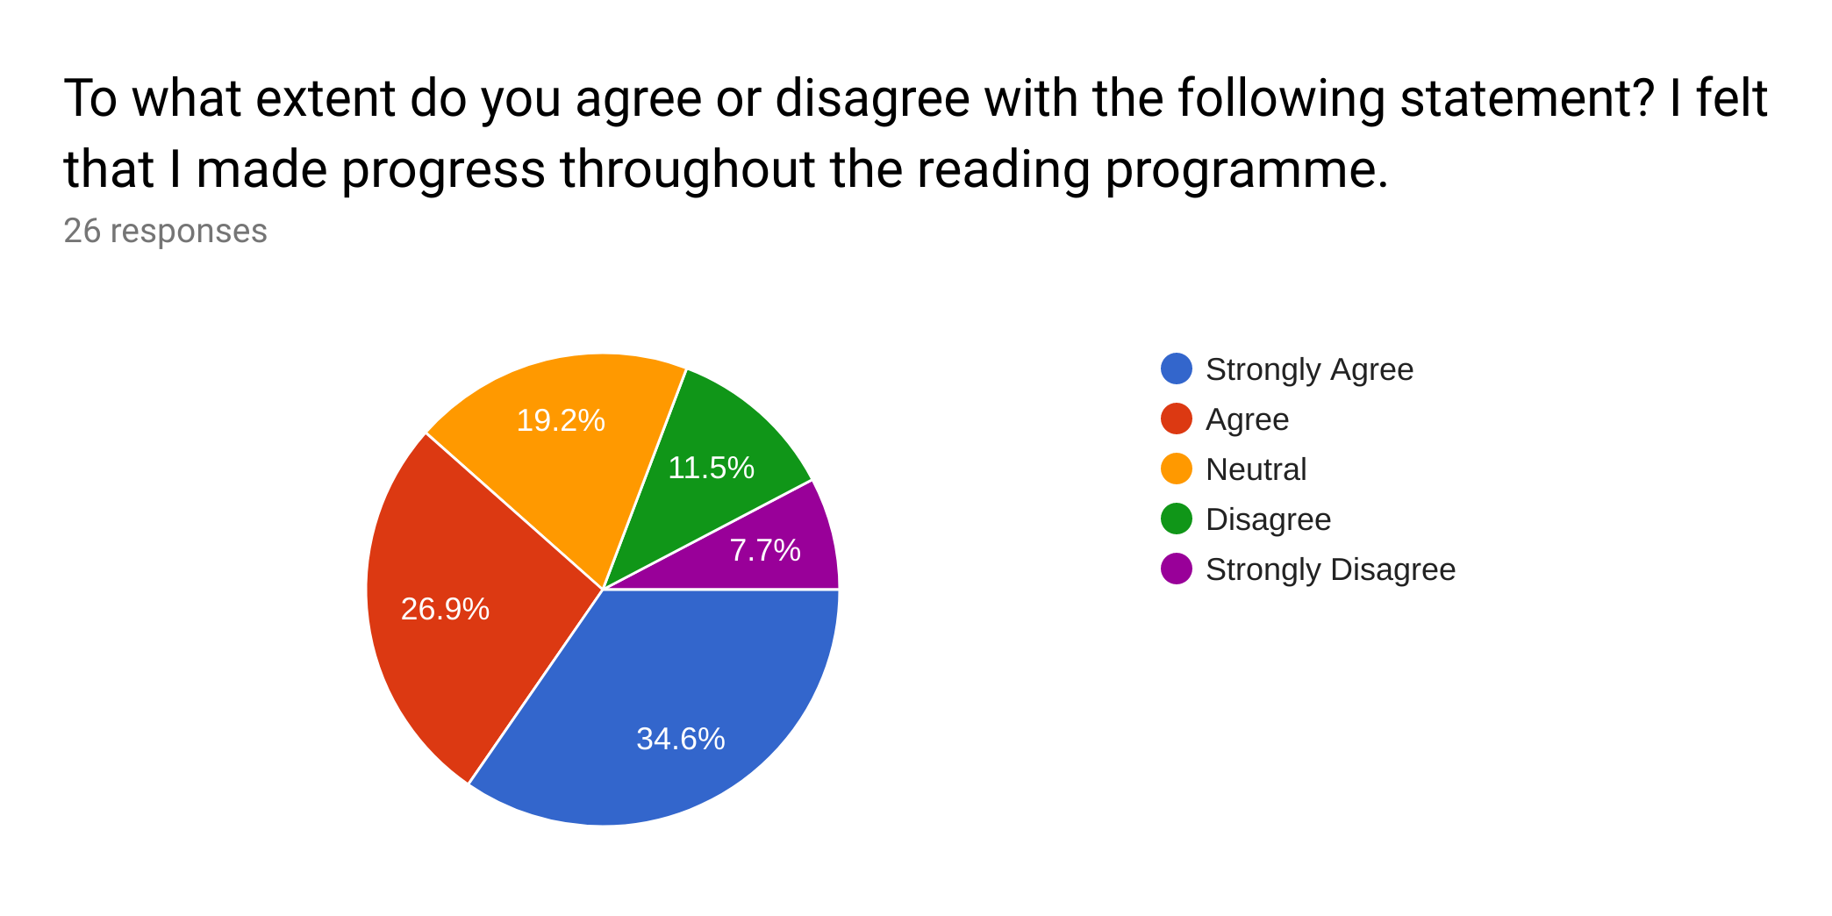

Qualitative results from questionnaires also showed that students felt an improvement in their reading ability. Students attributed having praise from the teacher, repeating the reading for clarification, and managing to read a whole book as reasons for this improvement. This aligns with research on student progress and attitudes from Stallings (1979) and Al Otaiba and Rivera (2006). Furthermore, only a small minority of students explicitly stated that they had a negative view of their progress made, or of their reading skills at the end of the programme.

Triangulated data from the focus group also suggests that the majority of students saw an improvement in their progress following the intervention programme. The reading intervention, therefore, appears to have been highly successful in improving students’ self-belief and attitudes towards their reading ability.

4.2.3. Post-intervention Reading

When asked if students would continue reading at home after the programme had finished, 46.2% of Form Y responded positively in the questionnaires and only 15.4% responded negatively (Pie Chart 3).

Pie Chart 3: attitudes to continued reading
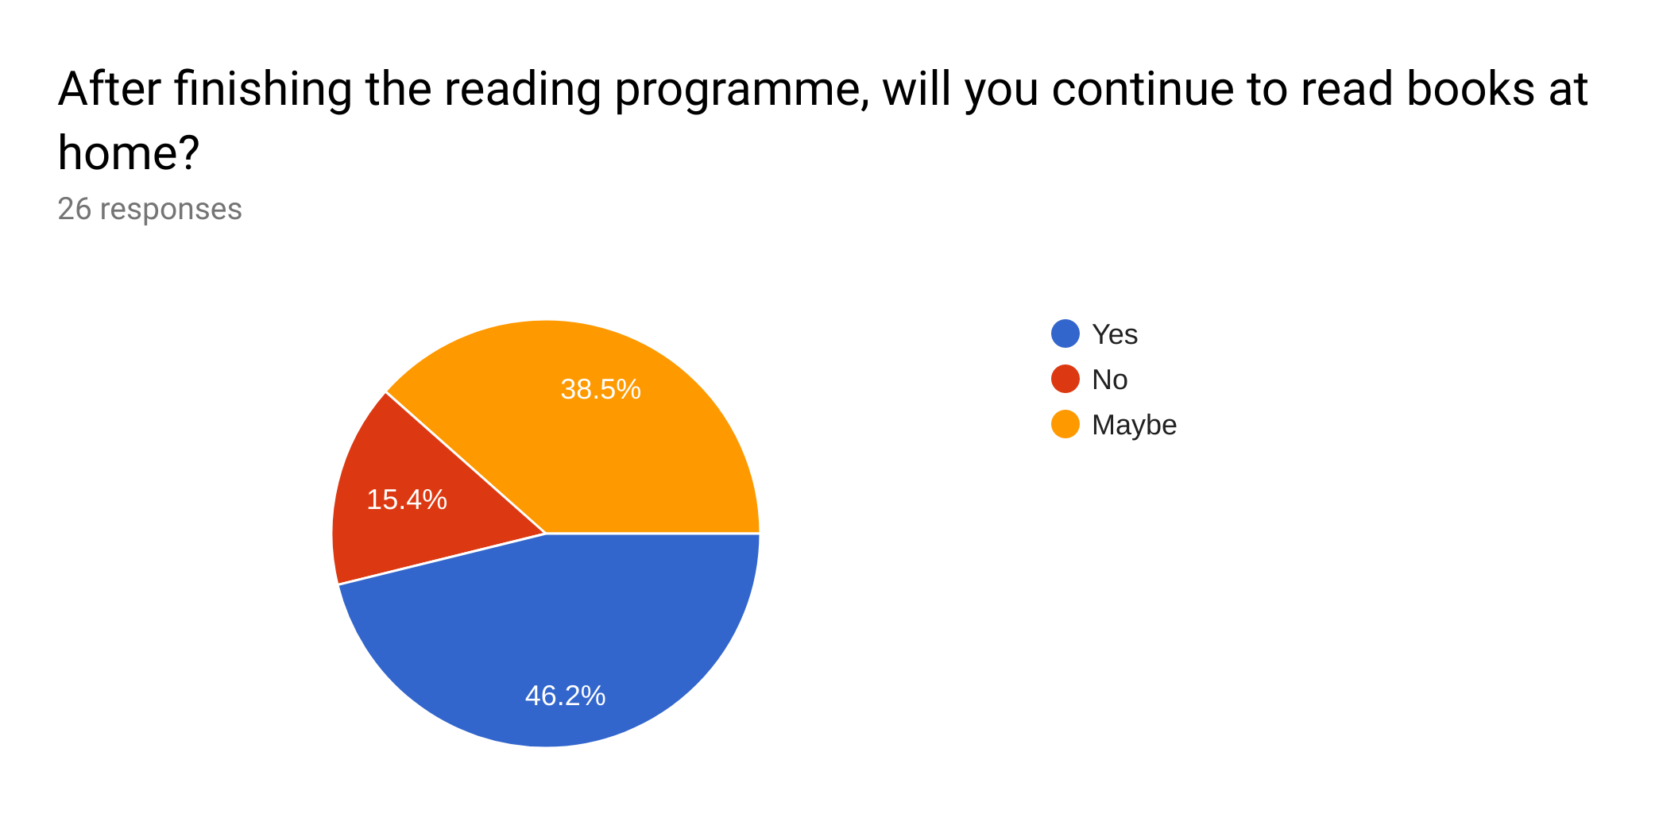
Focus group responses indicated that several students had never read at home prior to the intervention, but that they would look to begin after finishing the reading programme. Student interviews also corroborated this, with two thirds of those interviewed stating that they wanted to access more books as a result of the intervention programme. These themes reflect research conducted by Siah (2008), which found that the number of students reading books for leisure increased following a similar reading intervention programme.

Furthermore, when asked for suggestions on how to improve the intervention programme, several students commented that they would appreciate more books to read. Students suggested that the teacher could provide books for students to take home and show students where and how to access more books. In her research into guided independent reading, Hsui (2000) advocates students taking books home, and encouraging them to continue reading, so that attainment and attitude to reading may improve. This may therefore be an interesting aspect to explore in a future research project, especially as students in Form Y already appear open to the idea.

Despite the fact that not all students displayed the intention to continue reading following the intervention, the large majority of students made positive comments about continuing their reading. The data therefore demonstrates that the intervention was a success in improving most students’ relationships with reading and increasing students’ contact with books.

4.3 Implementation of the Intervention

An analysis of the strategies, resources and logistics of the intervention helps to demonstrate the strengths and weaknesses of the programme. This analysis will focus on the opinions of both researcher and students following the data collection.

4.3.1. GROR and ScSR Activities

As the intervention programme combined two different reading methods (GROR and ScSR), students were asked for their opinions on each activity undertaken in the programme. Data from the questionnaires shows a preference for GROR activities, with over 60% of students responding that the activities they enjoyed the most were: individual, silent reading and teacher modelling (Pie Chart 4). Less than 30% of Form Y agreed that they enjoyed ScSR activities the most (group discussion and worksheet questions). The data therefore shows a preference for GROR activities, in particular, the silent reading activity. The results also show that students preferred the receptive activities to the productive activities.

Pie Chart 4: enjoyment of activities - most preferred
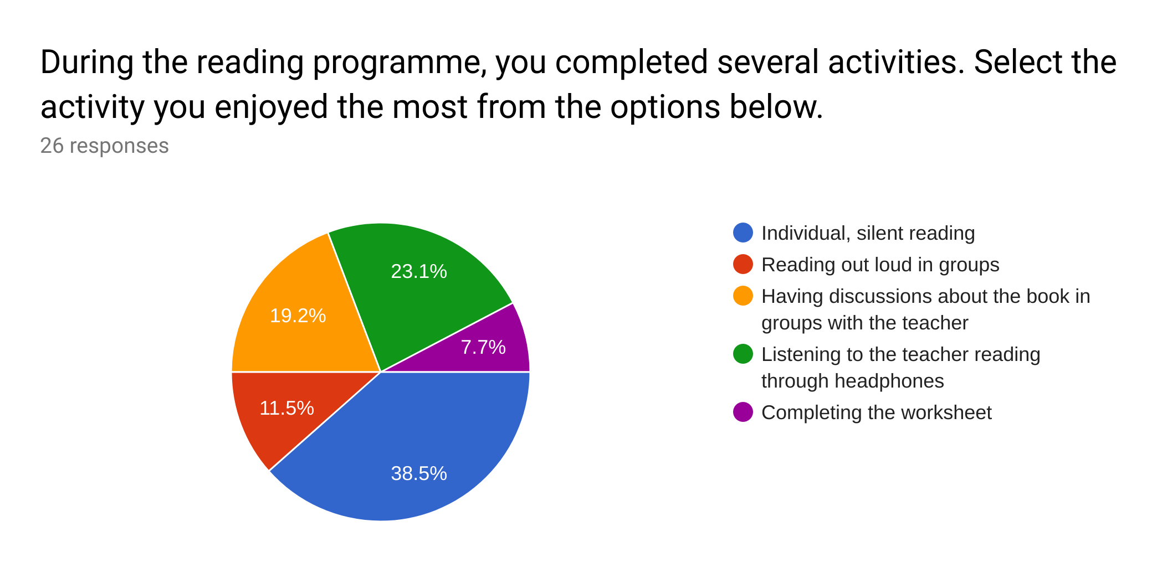
When asked which activities students enjoyed the least, 50% of students chose completing the worksheet and group discussions, both of which are ScSR activities. Less than 30% of students chose individual, silent reading and teacher modelling; both of which are GROR activities. The activity that students collectively enjoyed the least was reading out loud, which is both a GROR and ScSR activity. Again, this shows that more students enjoyed the receptive activities than the productive activities.

Pie chart 5: enjoyment of activities - least preferred
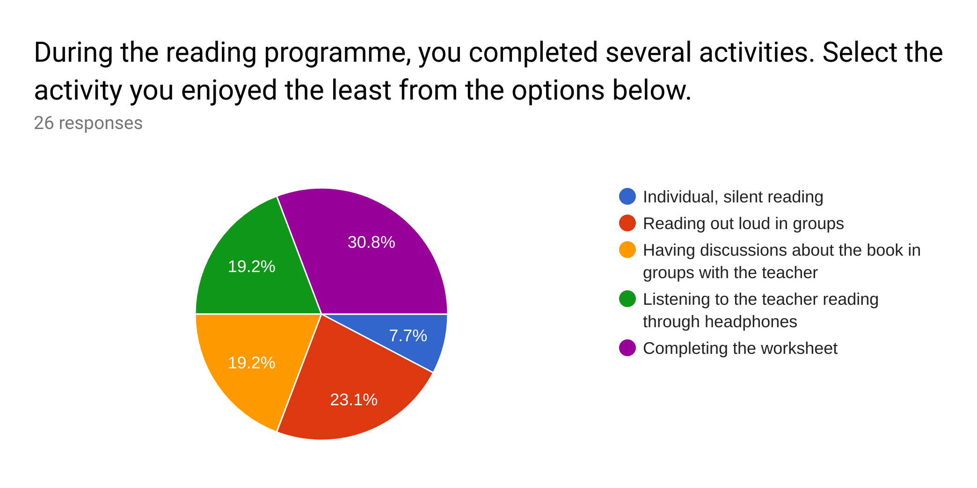

Qualitative data from questionnaires, interviews and the focus group helps to triangulate this data, as students’ comments demonstrated a preference for completing GROR activities over ScSR activities. In particular, individual reading was mentioned frequently as a favourite activity, whereas reading out loud and completing the worksheet were repeatedly noted as being unenjoyable. Responses from the data collection elicit several themes that explain these attitudes. Reasons for not enjoying reading out loud included: embarrassment, low self-esteem and not having the opportunity to voice their opinions. These problems are similar to those experienced by participants in focus groups (Greenbaum, 2000). This may therefore be an issue for ethical consideration in the future.

Students described the worksheets as: too long, boring and as being an interruption of their reading time. Reasons for increased appreciation of silent reading included: working individually, making a lot of progress through the book and using it as a way to relax.
Despite the findings which suggest that GROR activities were preferable to ScSR activities, it is important to note that the two approaches are proven to be very successful when used together, and that when used individually, student enjoyment and motivation decrease (Reutzel, Fawson and Smith, 2008). Unfortunately, this data does not indicate the activities which aided the most in improving attainment. This research project is unable to analyse data regarding the individual approaches, as GROR and ScSR were combined during the intervention, however, an analysis between the two different approaches may be a consideration for future research.

4.3.2. Books

Throughout the programme, students were provided with books that matched their reading levels (Fountas and Pinnell, 2012b). Over 50% of the students agreed that their book was suitable for them, with only a small minority stating that they did not think their book was appropriate.

Pie Chart 6: suitability of books
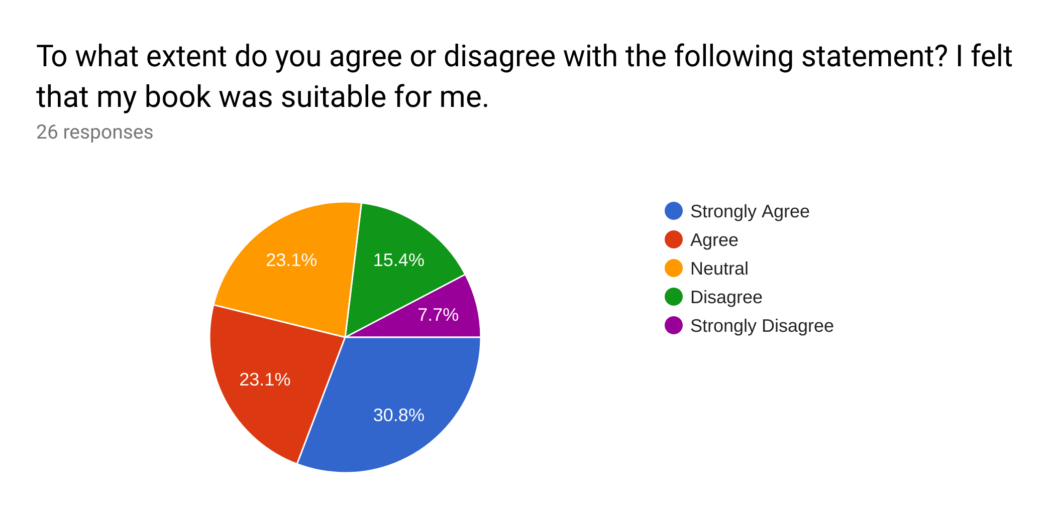

Despite the large amount of positive feedback, certain discussions from the focus group and interviews suggest that the books were often too hard or irrelevant. Qualitative data from the questionnaires also suggests that students would have preferred to choose their own book or to swap books with other students. This may have increased engagement and outcomes as a result. Although many researchers recommend against students choosing their own books (Guth in Sturtevant, 2003; Stahl in Siah, 2008), there are those who advise that students make their own decision regarding reading material (Stallings, 1979; Al Otaiba and Rivera, 2006). This is perhaps a consideration for a future intervention programme.

4.3.3. Groups

Qualitative data from questionnaires shows a significant aversion to the groupings during the intervention programme. Several comments from students suggest that they were unhappy with either having to work with other people in general or with having to work with specific people in the group. Comments from questionnaires suggested that students found it embarrassing to speak in front of the other people in their group, found certain members of the group irritating, or described other students talking for too long so that they were unable to participate fully in the discussions.

These negative comments identify several issues with the programme. Typically, ScSR is conducted using individual reading conferences with teacher and student (Stahl, in Reutzel et al., 2008), however, time constraints meant that this level of personalisation was impractical for the intervention. For this reason, students were grouped, and asked to conduct discussions together. The issues arising from the groupings may indicate inappropriate matching of students, or lack of teacher management when in group discussions. This suggests a limitation to the intervention, and may point to low levels of progress from certain students.

4.3.4. Behaviour of Students

Although most students followed instructions assiduously during the reading intervention, several behaviour issues arose during the programme as a result of student disengagement and lack of teacher monitoring. Comments from the focus group described that some students were disinterested in the work, and caused distractions for other students as a result. Students also commented that there were those who took the opportunity to misbehave when the teacher was consulting with other groups. Data from student questionnaires and interviews corroborates these observations. Students who distracted others, as well as those who were distracted by these students, suffered from a lack of focus and engagement. These observations suggest that many students may not have been able to make as much progress as expected. These findings directly contradict research from Al Otaiba and Rivera (2006) and Widdowson, Dixon and Moore (1996), who suggest that these types of reading programme actually increase motivation and attention. The behaviour is therefore a concern, and is considered a limitation in this research.

4.4. Staff Perceptions of the Intervention Programme

4.4.1. Impact on Students

Questionnaires and interviews with staff helped to triangulated student data surrounding the impact of the programme. All staff who have regular contact with students in Form Y stated that they had seen progress following the intervention programme. In terms of behaviour, staff commented that students displayed more willingness, increased levels of participation and more energy and engagement during and following the intervention. This is inconsistent with student behaviour during the intervention, but is a successful result nonetheless. With regards to attainment, staff commented that several students achieved higher than usual marks in a recent class test, showed a marked improvement in classwork, and demonstrated a substantial increase in their attainment. These comments show that students made significant progress not only in their reading, but in other areas of the curriculum as well. This suggests that they have been able to apply their newly acquired skills in different situations and subjects across the school.

Staff interviews also elicited discussion surrounding post-intervention reading, with teachers stating that believed students had been inspired to read by the programme, that students had gone to members of staff asking how they could check books out of the library and that some had asked if they could read their books in a lesson upon finishing classwork. This supports research from Siah (2008), who notes an increase in students’ willingness to read following a similar research intervention.

Staff therefore suggest that certain students not only improved their attainment, but that students also displayed more positive behaviours as a result of the programme.

4.4.2. Reading in the School Improvement Plan

After the intervention programme had finished, teachers were asked about their opinions on literacy and reading within School X. Responses from teacher questionnaires and interviews showed a preference for raising literacy standards throughout the school (Graph 12; Pie Chart 7).
Graph 12: views on raising literacy standards
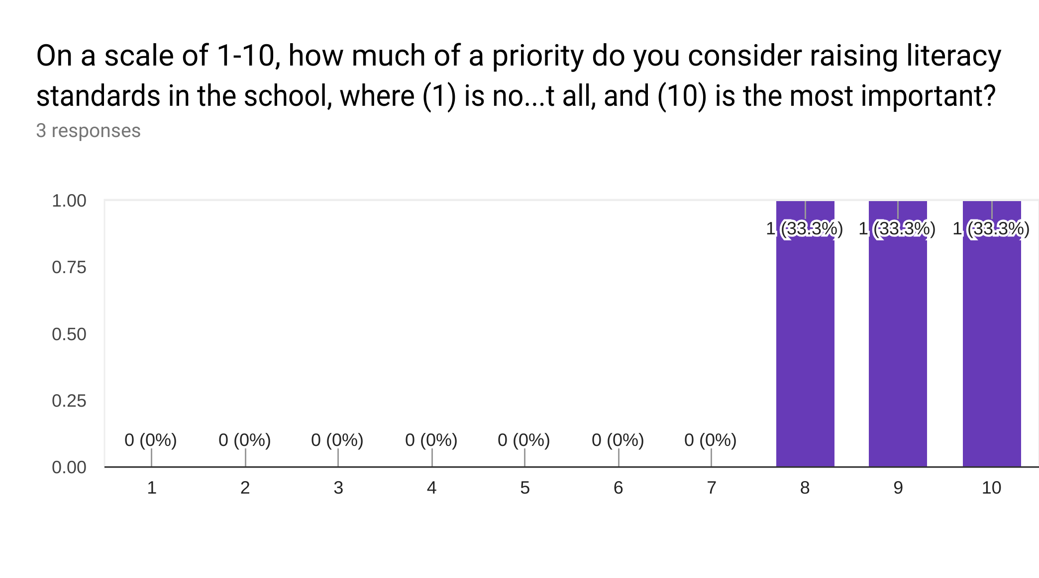

Pie Chart 7: current emphasis on literacy in School X
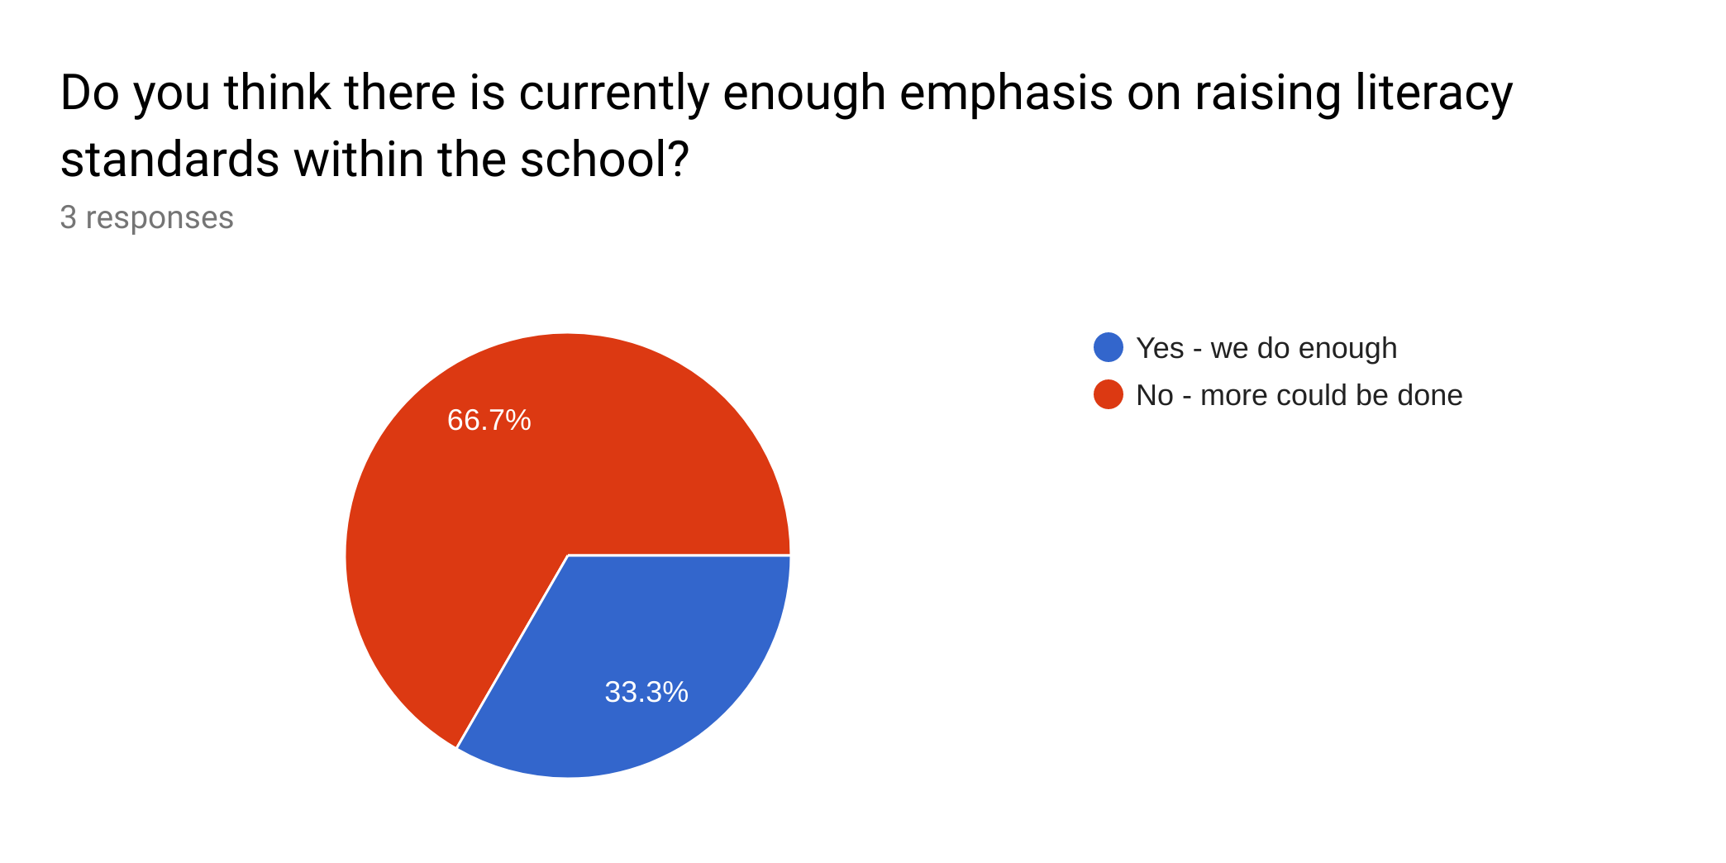

The majority of teachers agreed that students from year 7 to year 11 require the most literacy support, and in particular, that year 9 students are the group in most significant need (Graph 13) . When interviewed about the reasons for their choices, the teachers explained that intervention should occur prior to students starting their GCSE exams, as their literacy skills need to be fully developed before this time. One staff member noted that. The targeted year 9 intervention therefore appropriately reflects the needs of School X, and is well-placed to support students through their upcoming GCSE’s. It also reflects data from the Welsh Government (2013), which states that year 9 students have some of the lowest levels of literacy across all students in Wales.

Graph 13: year groups requiring literacy support
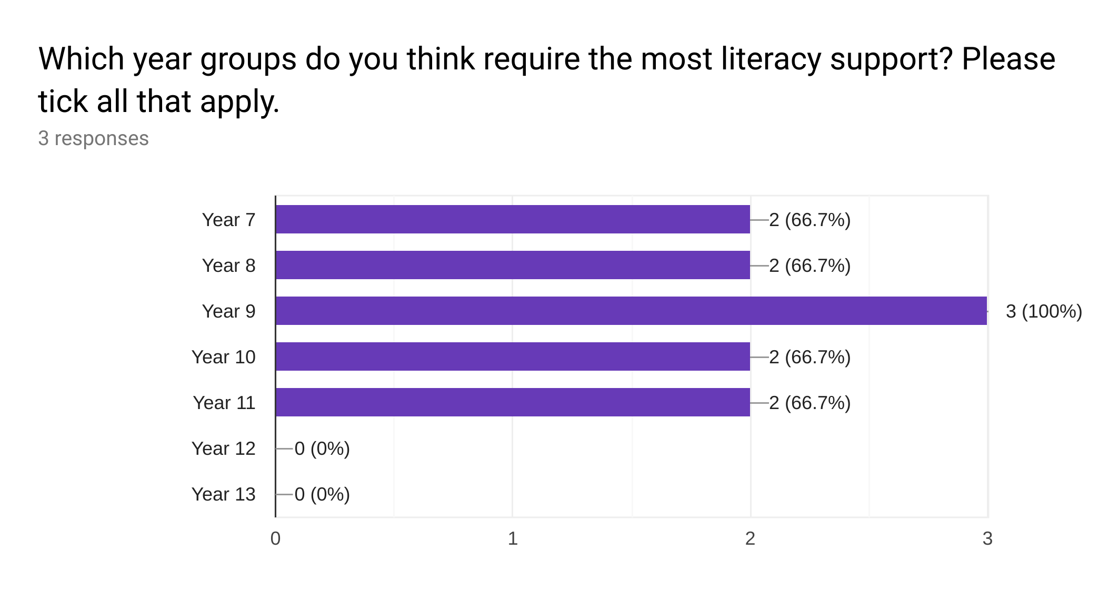

When asked which particular students would benefit from further support with their reading, all teachers agreed that students with an ALN would be the most suitable for a reading intervention programme (Graph 14). Reasons for these choices were discussed in the interviews, with teachers explaining that the reading programme would help eFSM, SEN and EAL students to meet the expected standards, and would help MAT students to achieve their full potential in reading. The programme, as well as research from Rasinski et al. (2011) shows that these goals are achievable.

Graph 14: types of student requiring literacy support
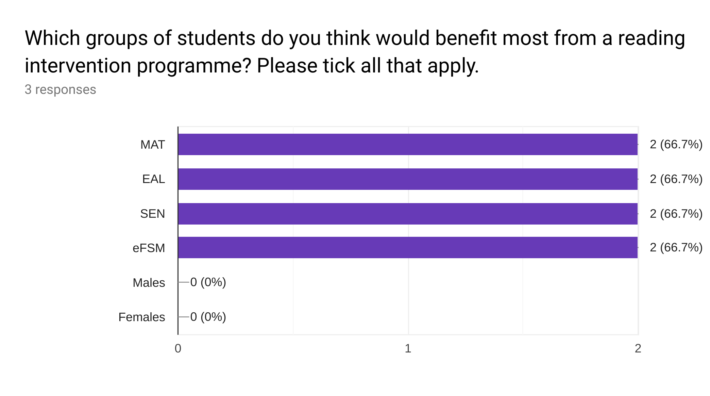
Finally, teachers were asked whether such a reading intervention programme would be successful on a whole-school level (Pie Chart 8). All teachers responded positively in the questionnaires, and explained that as the results from this intervention programme were so positive, it would be beneficial to implement the programme school-wide. This reflects research from Rasinski et al. (2011), who found that teachers who participated in a reading programme were very supportive of its implementation.

Pie Chart 8: implementation of programme on whole-school level
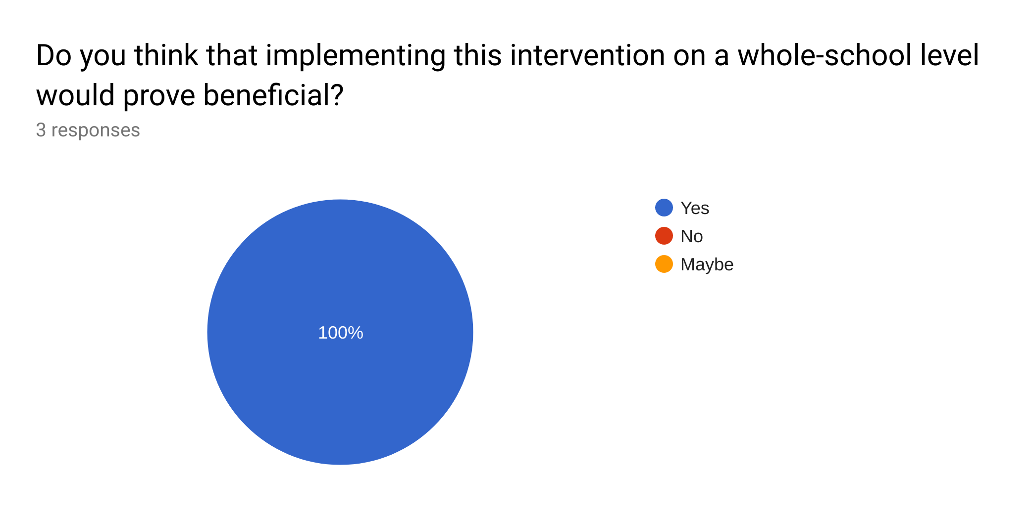

5. Conclusions

5.1. Conclusions from Pre-intervention and Post-intervention Tests

Although EAL students appear to have made the most progress throughout the intervention, their data is considered unreliable due to the insufficient sample size. MAT students could therefore be considered as the group who made the most progress throughout the programme. Although this group demonstrated similar changes in their average points scores to other groups of students in Form Y, individual improvement shows that several MAT students managed to score above-average reading levels in the post-intervention tests. It could be argued, however, that data does not point to exceptional achievement for one particular group in Form Y. Instead, results from the quantitative tests demonstrate considerable increases in reading ability for almost all students in Form Y. This widespread progress may be attributed to the inclusive and engaging strategies implemented throughout the intervention programme. The progress made by the large majority of students therefore shows that GROR and ScSR techniques are successful for many different types of student.

5.2. Conclusions from Student Attitudes Following the Programme

Evidence from data collection suggests that the intervention programme had a substantial impact on students’ attitudes towards reading. Not only did most students believe that the programme had a positive impact on their reading ability, but the majority of students also enjoyed the programme and noted the benefits that it had. Many students also displayed the intention to extend their relationship with reading by commenting that they would continue to read at home once the programme had finished. However, it is noted that several students displayed negative attitudes towards the programme, and although the positive attitudes outweighed these minorities, their views are still taken into account. Neutral and negative responses in questionnaires for example, represented a significant number of students in Form Y. It is clear then, that the programme is not without its flaws, and that alterations would have to be made to improve student enjoyment and attitude if the programme were to be implemented again.

5.3. Conclusions from Implementation of the Intervention

Although students made clear progress in attainment and attitude throughout the programme, observations of certain intervention strategies suggest several areas for development. Firstly, preferences for certain activities in the programme suggest that students preferred GROR (receptive) activities to ScSR (productive) activities. Although the responses may show a genuine preference for the more receptive activities, they could also suggest a lack of engagement and enthusiasm for the programme. Students who chose the receptive activities as their favourites, for example, may have done so because they found that these activities required the least amount of effort. This lack of effort may have hindered progress as a result. Secondly, many students voiced their criticism of the groupings and the books chosen for the intervention. This demonstrates a negative attitude towards the resources and strategies implemented, and suggests that students may have made less progress as a result of their lack of engagement. Finally, the researcher observed several troubling patterns of behaviour throughout the programme, an issue that could once again suggest that students were bored or disengaged by the intervention activities. It can therefore be concluded, that despite the successes of improved student attainment and attitudes, there are issues that suggest that the programme was not entirely successful in its implementation. Student disengagement and aversion to certain strategies suggest that progress may have been hindered or compromised. These concepts could be explored further if the intervention were to be repeated.

5.4. Conclusions from Staff Perceptions of the Reading Programme

Staff questionnaires and interviews helped to triangulate students’ responses during data collection. Staff corroborated that many students had shown an improvement in attitude and attainment following the reading intervention, and that these improvements were apparent in different subjects across the curriculum. Staff also discussed their views on literacy and reading across the school, and agreed that literacy remains a high priority for students. Staff noted that targeting ALN students for such an intervention would likely be the most effective route forward, as this would improve standards in key areas. The consensus from staff that the reading intervention would be successful on a whole-school level shows that staff believe the programme to be effective and worthwhile. This therefore suggests possible inclusion in the Improvement Plan of School X.
5.5. Strengths of the Reading Programme

The weight of evidence shows the intervention programme to have had a positive impact on the students in Form Y. Both qualitative and quantitative data demonstrate improvement in outcomes, as well as in attitude to reading. These successes may be attributed to the approaches of GROR and ScSR, as well as teacher knowledge and expertise in the field.

Analysis of data shows positive impact for students across all subpopulations, and this is a significant success of the programme. Not only a certain demographic of students, but students who are MAT, eFSM, SEN and EAL all benefited from the strategies used in the intervention. This reflects comments from Rasinski et al. (2011) and shows that GROR and ScSR are inclusive strategies for the majority of students. Positive changes were seen in both attainment and attitude, with both quantitative data and students’ qualitative comments supporting these findings. The effect on attainment is likely to be a large deciding factor for governors when deciding whether to implement the intervention in the SIP.

School X staff also expressed their content with the programme, and noted on the positive change in both attainment and attitude of the students involved. Securing the backing from other members of staff is considered a great strength, as it shows that the value and impact of the programme is recognised by other educational leaders. This support ensures that the research is recognised, and gives the researcher the opportunity to recommend the programme for a place in the school’s improvement plan, knowing that several members of staff already recognise its positive impact.

Continued reading is also identified as a key strength, as so many students commented that they would sustain the practice of reading at home upon terminating the programme. This shows a positive change in attitude from the majority of students, and indicates that they will be continuing to develop their skills effectively. Reading at home will also help students to consolidate the reading strategies learnt in class, and will help to extend their literary knowledge and awareness (Hsui, 2000).

5.6. Weaknesses of the Reading Programme

Despite the many successes of the research project, and the positive impact that the programme had on the students, there are several weaknesses and limitations that must be considered.

Firstly, the large class size caused an issue throughout the programme. This had an impact both on behaviour of the students, and on the amount of teacher-student interaction time. The number of pupils in the class meant that the teacher could not effectively monitor behaviour whilst working with individual groups. For this reason, student conduct started to become a problem, and many participants commented on the distractions that this poor behaviour caused. The large amount of students also meant that the teacher could not spend time with each group of students in every session. This meant that students were often reading silently for extended periods of time, and not benefiting from teacher support, guidance or discussion.

A second weakness discovered in data analysis was the selection of books used in the intervention. Several students expressed their dissatisfaction with the reading material, noting that the books were irrelevant or inappropriate for them. Students commented that this had a negative impact on them throughout the programme. If the programme were to be repeated, it is suggested that students have the opportunity to choose their book from a selection of pre-prepared materials (Sturtevant, 2003).

Another limitation was the number of students that did not appreciate the programme. Despite the majority of students agreeing that they enjoyed the intervention, several students commented that they either found the programme boring, ineffective or a waste of time. These comments suggest that some students did not understand the benefits of the programme, despite securing higher results in the post-intervention tests. A modified version of the intervention programme could aim to address these issues.

Finally, the issue of sample size is discussed in relation to the reliability and accuracy of data. In the analysis section of this report, EAL students were found to have made the most progress in attainment from all demographic groups in Form Y. However, it was noted that due to the small sample size of only two EAL students, these findings were perhaps unreliable.
5.7 Recommendations for Reading in the School Improvement Plan

School X currently struggles with literacy attainment, and despite measures outlined in the current SIP, progress in this area is insufficient (Estyn, 2015a). Therefore, after analysis of the data and consideration of the methods used throughout the intervention, a case will be put forward to include the reading programme within the SIP of School X. The following recommendations and guidelines will subsequently be taken to governors of School X.

- The intervention should use both GROR and ScSR approaches to reading instruction. Despite aversion by many of the students in Form Y to GROR methods, quantitative and qualitative results show both approaches to be successful. The combination of these methods is also recommended by academics in the field (Peterson et al., 2001; Al Otaiba and Rivera, 2006; Reutzel, Fawson and Smith, 2008). These complementary methods have not only improved literacy attainment, but have also helped to develop positive attitudes towards reading. Progress in attainment has been noted in other subjects as a result of the programme, and improved attitudes have meant that students are now accessing reading material outside of the classroom.

- The intervention should be aimed at year 9 students, due to the considerably low reading levels of this year group, as identified by the Welsh Government (2017). Comments from staff members in School X also identify year 9 as a key year group for such an intervention, due to their upcoming GCSE exams and PISA tests to be sat the following year. With this in mind, it is also recommended that teachers of year 9 students receive the relevant training so members of staff are working to the same high standards, and implementing the same strategies within each group. Staff should continue to collect pre-intervention and post-intervention test data to evidence progress and attainment throughout the programme. This would also help to support self-evaluation and promote tracking, which Estyn noted as being underdeveloped in previous inspections (2015b). Implementing the programme with a larger number of students would also increase accuracy and reliability of data. For example, it would help to determine the impact of the intervention on students with EAL.

- Despite recommendations of cross-curricular literacy approaches from several academics (Welsh Government, 2013, Donaldson, 2015), it is recommended that on initial implementation, this intervention only takes place within the registration period, and not in other subjects across the school. The reasons for this decision are numerous. Firstly, the intervention was successful in the registration period, and the recommended 30 minutes proved to be an appropriate length of time for each session. Secondly, the school is not yet prepared for such a widespread intervention of this nature; there are not enough trained literacy experts who would be able to support students in this type of reading instruction, nor are there sufficient numbers of teaching assistants to deploy into all classrooms for managing the behaviour of students. Finally, implementing the intervention on a whole-school scale would involve creating thousands of recordings and worksheets for the sessions. These materials would take a considerable amount of time and effort to complete, and could not be created without first testing students, analysing data, and sourcing appropriately levelled books for each pupil. These conclusions suggest that in the short term, the intervention is only upscaled to include other year 9 form groups in School X. However, expansion always remains possible, and in subsequent years, there may be scope to implement the programme across the curriculum.

- After analysis of existing literature and qualitative data from this research project, it is recommended that the intervention is not implemented in a whole-class setting. The poor behaviour from students and the lack of engagement in the silent reading tasks suggests that the intervention may be more successful if implemented with small groups away from the classroom environment. These sessions could involve removing selected groups of students from their form classes and working with them on a more personalised level. It would avoid distractions and would make students feel more comfortable. The teacher could also give their full attention to the group. Another member of staff could then be used to monitor the remaining students left in the main classroom whilst they complete separate activities (Stallings, 1979).

- Students should have more access to books and resources both during and after the intervention. During the programme, students should make informed choices about the books they would like to read. Although they cannot be given complete freedom when deciding on these books, they should be able to choose from a small selection of relevant, appropriately levelled materials. This may also promote enjoyment, as students could choose books that were more accessible and interesting. Upon completing the programme, students should receive teacher recommendations and advice on where and how to access appropriate reading material that they may take home. This would encourage reading outside of school, and would support students with their continued development and learning.

With these recommendations and guidelines in mind, it is suggested that a revised version of the intervention programme be implemented for year 9 students in the future, and that subsequently, this strategy be included in the SIP of school X. The strategy would be best placed in the ‘Standards’ section of the SIP, under the current heading ‘Continue to improve standards and progress in skills’. Not only will this addition to the SIP therefore support the needs of the school, but it will also reflect the national priorities for education. If successful across the year group, the intervention may be considered for implementation on a whole-school level, or even further afield. This would support schools in improving student outcomes, and would also help to tackle the issue of low literacy skills across Wales.

6. Bibliography

Al Otaiba, S. and Rivera, M. (2006) ‘Individualizing Guided Oral Reading Fluency Instruction for Students With Emotional and Behavioral Disorders’, Intervention in School and Clinic, 41(3), pp.144-149. Available at: https://doi.org/10.1177/10534512060410030301 (Accessed 12 January 2019).

Alexander, J., Jarman, R., McClune, B. and Walsh, P. (2008) ‘From Rhetoric to Reality: Advancing Literacy by Cross-curricular Means’, The Curriculum Journal, 19(1), pp.23-35, doi: 10.1080/09585170801903225 (Accessed 07 August 2018).

Anderson, G. and Arsenault, N. (2005) Fundamentals of Educational Research. Second ed. London: The Falmer Press.

BBC (2016) Pisa: Wales Still Worst in UK in World Education Tests [online] Available at: https://www.bbc.com/news/uk-wales-38208738 (Accessed 24 September 2018).

Ben-Nun, P. (2008) ‘Respondent Fatigue’, Encyclopedia of Survey Research Methods, 2, pp.742-743.

BERA (2011) Ethical Guidelines for Educational Research [pdf] Available at: http://dysgu.ydds.ac.uk/pluginfile.php/262282/mod_resource/content/1/BERA-Ethical-Guidelines-2011.pdf (Accessed 17 June 2018).

Boling, C. J. and Evans, W. H. (2008) ‘Reading Success in the Secondary Classroom’, Preventing School Failure: Alternative Education for Children and Youth, 52(2), pp.59-66, doi: 10.3200/PSFL.52.2.59-66 (Accessed 21 August 2018).

Bostock, S. and Steptoe, A. (2012) ‘Association between low functional health literacy and mortality in older adults: longitudinal cohort study’, British Medical Journal, 344: e1602 doi:10.1136/bmj.e1602 (Accessed 20 February 2019).

Boyne, J. (2014) The Boy in the Striped Pyjamas: a Fable. London: Definitions

Brozo, W. and Simpson, M. (2003) Readers, Teachers, Learners: Expanding Literacy Across the Content Areas. Michigan: Merrill Prentice Hall.

Bryan, G., Fawson, P. C. and Reutzel, D. R. (2003) ‘Sustained Silent Reading: Exploring the Value of Literature Discussion with Three Non‐engaged Readers’, Reading Research and Instruction, 43(1), pp.47-73, doi: 10.1080/19388070309558400 (Accessed 16 February 2019).

Burton, D. and Bartlett, S. (2009) Key Issues for Education Researchers. London: Sage.

Bynner, J. and Parsons, S. (2006) New Light on Literacy and Numeracy: Summary Report [pdf] Available at: https://dera.ioe.ac.uk/22309/1/doc_3186.pdf (Accessed 12 August 2018).

Cangelosi, J. (1990) Designing Tests for Evaluating Student Achievement. New York: Addison-Wesley.

Chudowsky, N. and Chudowsky, V. (2010) State Test Score Trends Through 2007-08, Part 5 Are There Differences in Achievement Between Boys and Girls? Washington D.C.: Center on Education Policy [pdf] Available at: https://www.cbsnews.com/htdocs/pdf/GenderReportMarch2010.pdf (Accessed 12 December 2018).

Cohen, L., Manion, L. and Morrison, K. (2017) Research Methods in Education. Eighth Edition ed. Abingdon: Routledge.

Collins, A. and Smith, E. (1980) Teaching the Process of Reading Comprehension. Massachusetts: Bolt Beranek and Newman Inc.

Compare Your Country (2018) Country Overview: GBR - Wales [online] Available at: https://www.compareyourcountry.org/pisa/country/gbr4?lg=en (Accessed 26 October 2018).

Data Protection Act 2018, c. 12. Available at: http://www.legislation.gov.uk/ukpga/2018/12/pdfs/ukpga_20180012_en.pdf (Accessed 13 September 2018).

Dhivyadeepa, E. (2015) Sampling Techniques in Educational Research. New Delhi: Laxmi Book Publication.

Didau, D (2012) The Perfect Ofsted English Lesson. Carmarthen: Independent Thinking Press.

Donaldson, G. (2015) Successful Futures (Donaldson Report) [pdf] Available at: https://hwbplus.wales.gov.uk/schools/6714052/Documents/Donaldson%20Report.pdf (Accessed 18 June 2018).

Dugdale, G. and Clark, C. (2008) Literacy Changes Lives: An Advocacy Resource. London: National Literacy Trust.

Edwards, A. (1953) ‘The Relationship Between the Judged Desirability of a Trait and the Probability that the Trait will be Endorsed’, Journal of Applied Psychology, 37, pp. 90-93.

Edwards, A. (1957) The Social Desirability Variable in Personality Assessment and Research. New York: The Dryden Press.

Estyn (2008) Closing the Gap Between Boys’ and Girls’ Attainment in Schools [pdf] Available at: https://dera.ioe.ac.uk/7498/1/Gender_Gap_Report_March_2008.pdf (Accessed 12 March 2019).

Estyn (2010) Tackling Child Poverty and Disadvantage in Schools [pdf] Available at: https://dera.ioe.ac.uk/904/1/Tackling_child_poverty_and_disadvantage_in_schools_January_2010.pdf (Accessed 29 September 2018).

Estyn (2011) Literacy and the Foundation Phase: An Evaluation of the Implementation of the Foundation Phase for Five to Six-Year-Olds in Primary Schools, with Special Reference to Literacy [pdf] Available at: https://www.estyn.gov.wales/sites/default/files/documents/Literacy%20and%20the%20Foundation%20Phase%20%20-%20September%202011.pdf (Accessed 14 September 2018).

Estyn (2012a) Literacy in Key Stage 3 [pdf] Available at: https://www.estyn.gov.wales/sites/default/files/documents/Literacy%20in%20key%20stage%203%20-%20June%202012.pdf (Accessed 17 June 2018).

Estyn (2012b) Effective Practice in Tackling Poverty and Disadvantage in Schools [pdf] Available at: https://learning.gov.wales/docs/learningwales/publications/140211-effective-practice-in-tackling-poverty-and-disadvantage-in-schools-en.pdf (Accessed 28 June 2018).

Estyn (2014a) Pupil Deprivation [online] Available at: https://www.estyn.gov.wales/thematic-reports/pupil-deprivation-may-2014 (Accessed 21 August 2018).

Estyn (2014b) Supplementary guidance: Literacy and Numeracy in Primary Schools [pdf] Available at: https://www.estyn.gov.wales/sites/default/files/documents/Literacy%20and%20numeracy%20-%20primary.pdf (Accessed 21 September 2018).

Estyn (2014c) English in Key Stages 2 and 3 [pdf] Available at: https://www.estyn.gov.wales/sites/default/files/documents/English%20in%20key%20stages%202%20and%203%20-%20June%202014.pdf (Accessed 19 February 2019).

Estyn (2015a) Inspection Report School X [online] Available at: http://www.estyn.gov.uk (Accessed 09 September 2018).

Estyn (2015b) Literacy in Key Stage 3: An Interim Report [pdf] Available at: https://www.estyn.gov.wales/sites/default/files/documents/Literacy_in_key_stage_3_An_interim_report_-_January_2015.pdf (Accessed 17 February 2019).

Estyn (2017a) Supplementary Guidance: Self-Evaluation [pdf] Available at: https://dera.ioe.ac.uk/30951/1/NIA%20Supplementary%20guidance%20-%20self-evaluation_0.pdf (Accessed 20 September 2018).

Estyn (2017b) Self-Evaluation Report Template: From September 2017 (doc) Available at: https://www.estyn.gov.wales/document/self-evaluation-template-september-2017 (Accessed 17 August 2018).

Estyn (2017c) The Annual Report of Her Majesty's Chief Inspector of Education and Training in Wales 2016-2017 [online] Available at: https://www.estyn.gov.wales/document/annual-report-2016-2017 (Accessed 28 August 2018).

Estyn (2018) The Annual Report of Her Majesty's Chief Inspector of Education and Training in Wales 2017-2018 [online] Available at: https://www.estyn.gov.wales/document/annual-report-2017-2018 (Accessed 06 January 2019).

Foddy, W. (1993) Constructing Questions for Interviews and Questionnaires: Theory and Practice in Social Research. Cambridge: Cambridge University Press.

Fountas, I. C. and Pinnell, G. S. (2012a). ‘Guided Reading: The Romance and the Reality’, The Reading Teacher, 66(4), pp.268–284. doi: 10.1002/TRTR.01123 (Accessed 28 August 2018).

Fountas, I. C. and Pinnell, G. S. (2012b) Text Level Ladder of Progress. Portsmouth NH: Heinemann.

Gardiner, S. (2005) Building Student Literacy Through Sustained Silent Reading. Virginia: ASCD.

Garan, E., and DeVoogd, G. (2008) ‘The Benefits of Sustained Silent Reading: Scientific Research and Common Sense Converge’, The Reading Teacher, 62(4), pp.336-344. Available at: http://www.jstor.org/stable/27699697 (Accessed 17 January 2019).

Greenbaum, T. (2000) Moderating Focus Groups. California: Sage.

Gronlund, N. (1993) How to Make Achievement Tests and Assessments. Fifth ed. New York: Allyn and Bacon.

Haddon, M. (2014) The Curious Incident of the Dog in the Night-Time. London: Red Fox.

Harries, A (2018) Application for Ethical Approval. Internal Document - UWTSD. Unpublished.

Hennink, M., Hutter, I. & Bailey, A. (2011) Qualitative Research Methods. London: Sage.

Hord, S. (1997) Professional Learning Communities - Communities of Continuous Inquiry and Improvement [pdf] Available at: http://www.sedl.org/pubs/change34/plc-cha34.pdf (Accessed 10 August 2018).

Horowitz, A. (2004) Stormbreaker. London: Walker.

Hsui, V. (2000) ‘Guided Independent Reading (GIR): A Programme to Nurture Lifelong Readers’, Teaching and Learning, 20(2), pp.31-39. Available at: https://repository.nie.edu.sg/bitstream/10497/364/1/TL-20-2-31.pdf (Accessed 02 November 2018).

Institute of Welsh Affairs (2011a) Teaching Makes a Difference [online] Available at: http://www.iwa.wales/click/2011/02/teaching-makes-a-difference/ (Accessed 04 August 2018).

Institute of Welsh Affairs (2011b) Raising School Standards [pdf] Available at: http://dera.ioe.ac.uk/4250/1/raising-standards-29-06-11-eng.pdf (Accessed 05 August 2018).

Jenkins, A., Ackerman, R., Frumki, L., Salter, E. and Vorhaus, J. (2011) Literacy, Numeracy and Disadvantage Among Older Adults in England [pdf] Available at: http://discovery.ucl.ac.uk/10021320/1/Literacy_numeracy_and_disadvantage_among_older_adults_in_England.pdf (Accessed 29 August 2018).

Jerrim, J. and Shure, N. (2016) Achievement of 15-Year-Olds in Wales: PISA 2015 National Report [pdf] Available at: https://dera.ioe.ac.uk/27969/1/161206-pisa-2015-en.pdf (Accessed 20 August 2018).

Johnson, B. and Turner, L. A. (2003) ‘Data Collection Strategies in Mixed Methods Research’, in: Tashakkori, A. and Teddlie, C. (eds.), Handbook of Mixed Methods in Social & Behavioral Research. pp.297-319. California: Sage.

Johnson, R. B. and Onwuegbuzie, A. J. (2004) ‘Mixed Methods Research: A Research Paradigm Whose Time Has Come’, Educational Researcher, 33(7), pp.14–26, doi: 10.3102/0013189X033007014 (Accessed 08 October 2018).

Likert, R. (1932) ‘A Technique for the Measurement of Attitudes’, Archives of Psychology, 22(140), pp.1-55.

May, S. and Wright, N. (2007) ‘Secondary Literacy Across the Curriculum: Challenges and Possibilities’, Language and Education, 21(5), pp.370-376, doi: 10.2167/le797.0 (Accessed 26 February 2018).

McCaughrean, G. (2002) The Kite Rider. Oxford: Oxford University Press.

McDonald, A. S. (2001) ‘The Prevalence and Effects of Test Anxiety in School Children’, Educational Psychology, 21(1), pp.89-101, doi: 10.1080/01443410020019867 (Accessed 02 November 2018).

Mellenbergh, G. J. (2008) ‘Chapter 10: Tests and Questionnaires: Construction and Administration’, in: Adèr, H. J. and Mellenbergh, G. J. (eds.) (with contributions by D.J. Hand), Advising on Research Methods: A Consultant’s Companion. pp. 211-236. Huizen: Johannes van Kessel Publishing.

Mertler, C. (2008) Action Research: Teachers as Researchers in the Classroom. London: Sage.

My Local School (2018) School X [online] Available at: http://mylocalschool.wales.gov.uk/SchoolX/ (Accessed 04 October 2018).

National Literacy Trust (2011) Literacy: A Route to Addressing Child Poverty? [pdf] Available at: https://files.eric.ed.gov/fulltext/ED541406.pdf (Accessed 29 August 2018).

National Reading Panel (2000) Teaching Children to Read: An Evidence-Based Assessment of the Scientific Research Literature on Reading and Its Implications for Reading Instruction [pdf] Available at: https://www.nichd.nih.gov/sites/default/files/publications/pubs/nrp/Documents/report.pdf (Accessed 12 January 2019).

OECD (2016) Programme for International Student Assessment (PISA) Results from PISA 2015: United Kingdom [pdf] Available at: https://www.oecd.org/pisa/pisa-2015-United-Kingdom.pdf (Accessed 04 August 2018).

OECD (2018) Pisa 2015 Results in Focus [pdf] Available at: https://www.oecd.org/pisa/pisa-2015-results-in-focus.pdf (Accessed 04 October 2018).

Ofsted (2013) Improving Literacy in Secondary Schools: a Shared Responsibility [pdf] Available at: https://assets.publishing.service.gov.uk/government/uploads/system/uploads/attachment_data/file/413182/Improving_literacy_in_secondary_schools.pdf (Accessed 24 August 2018).

Opie, C. (2004) Doing Educational Research: A Guide to First-Time Researchers. London: Sage.

Partnership for Reading (2019) ‘What is Guided Oral Reading?’, Reading Rockets [article] Available at: http://www.readingrockets.org/article/what-guided-oral-reading (Accessed 03 February 2019).

Peterson, C. L., Caverly, D. C., Nicholson, S. A., O'Neal, S. and Cusenbary, S. (2001) Building Reading Proficiency at the Secondary Level: A Guide to Resources. Introduction [pdf] Available at: https://files.eric.ed.gov/fulltext/ED458562.pdf (Accessed 04 November 2018).

Phelps, R. (2005) Defending Standardized Testing. London: Psychology Press.

Pilgreen, J. (2000) The SSR Handbook: How to Organize and Manage a Sustained Silent Reading Program. Portsmouth, NH: Heinemann.

Rasinski, T. (1990) ‘Effects of Repeated Reading and Listening-While-Reading on Reading Fluency’, The Journal of Educational Research, 83(3), pp.147-151, doi: 10.1080/00220671.1990.10885946 (Accessed 07 February 2019).

Rasinski, T., Samuels, S. J., Hiebert, E., Petscher, Y. and Feller, K. (2011) ‘The Relationship Between a Silent Reading Fluency Instructional Protocol on Students’, Reading Comprehension and Achievement in an Urban School Setting’ Reading Psychology, 32(1), pp.75-97, doi: 10.1080/02702710903346873 (Accessed 20 August 2018).

Reid Lyon, G. and Weiser, B. (2009) ‘Teacher Knowledge, Instructional Expertise, and the Development of Reading Proficiency’, Journal of Learning Disabilities, 42(5), pp.475-480, doi: 10.1177/0022219409338741 (Accessed 02 November 2018).

Reutzel, D., Fawson, P. and Smith, J. A. (2008) ‘Reconsidering Silent Sustained Reading: An Exploratory Study of Scaffolded Silent Reading (ScSR)’ Journal of Educational Research, 102, pp.37-50. Available at: http://dx.doi.org/10.3200/JOER.102.1.37-50 (Accessed 19 September 2018).

Reutzel, D., Jones, C., Fawson, P., and Smith, J. (2008) ‘Scaffolded Silent Reading: A Complement to Guided Repeated Oral Reading That Works!’, The Reading Teacher, 62(3), pp.194-207. Available at: http://www.jstor.org/stable/20143931 (Accessed 20 October 2018).

Rosoff, M. (2013) How I Live Now. London: Penguin Books.

Saris, W. E. and Gallhofer, I. N. (2014) Design, Evaluation, and Analysis of Questionnaires for Survey Research. Second ed. New Jersey: John Wiley and Sons.

[School X] (2017) School Policy on Safeguarding. South Wales: School X.

[School X] (2018a) School Improvement Plan 2018-19. South Wales: School X.

[School X] (2018b) Allocation of Funding 2018-19. South Wales: School X.

Sedgwick, M. (2016) Revolver. London: Orion Children’s Books.

Seidman, I. (2006) Interviewing as Qualitative Research: A Guide for Researchers in Education and the Social Sciences. Third ed. New York: Teachers College Press.

Siah, P. C. (2008) ‘The Effects of the Sustained Silent Reading Program on Cultivating Students' Habits and Attitudes in Reading Books for Leisure’, The Clearing House: A Journal of Educational Strategies, Issues and Ideas, 81(4), pp.180-184, doi: 10.3200/TCHS.81.4.180-184 (Accessed 06 March 2019).

Siah, P. C. and Kwok, W. L. (2010) ‘The Value of Reading and the Effectiveness of Sustained Silent Reading’, The Clearing House: A Journal of Educational Strategies, Issues and Ideas, 83(5), pp.168-174, doi: 10.1080/00098650903505340.

Snow, ‎C., Griffin, ‎P. and Burns, S. (2005) Knowledge to Support the Teaching of Reading: Preparing Teachers for a Changing World. California: Jossey-Bass.

Stallings, J. (1979) ‘How to Change the Process of Teaching Reading in Secondary Schools’, Educational Horizons, 57(4), pp.196-201. Available at: http://www.jstor.org/stable/42924344 (Accessed 19 September 2018).

Sturtevant, E. (2003) The Literacy Coach: A Key to Improving Teaching and Learning in Secondary Schools [pdf] Available at: http://citeseerx.ist.psu.edu/viewdoc/download?doi=10.1.1.170.9156&rep=rep1&type=pdf (Accessed 03 September 2018).

Suits, B. (2003) ‘Guided Reading and Second-Language Learners’, Multicultural Education, 11(2), pp.27–34.

The Education (School Development Plans) (Wales) Regulations 2014 Welsh Statutory Instrument 2014/2677 (W.265). [pdf] Available at: http://www.legislation.gov.uk/wsi/2014/2677/pdfs/wsi_20142677_mi.pdf (Accessed 18 September 2018).

UWTSD (2017) Research Ethics & Integrity Code of Practice [pdf] Available at: https://www.uwtsd.ac.uk/media/uwtsd-website/content-assets/documents/research/research-ethics-integrity-code-practice.pdf (Accessed 17 July 2018).

Walker-Dalhouse, D. and Risko, V. (2008) ‘Learning From Literacy Successes in High-Achieving Urban Schools’, The Reading Teacher, 61(5), pp.422-424. Available at: https://ila.onlinelibrary.wiley.com/doi/pdf/10.1598/RT.61.5.7 (Accessed 20 August 2018).

Wearmouth, J. (2017) Special Educational Needs and Disabilities in Schools
A Critical Introduction. London: Bloomsbury.

Weber, S. J. and Cook, T. D. (1972) ‘Subject Effects in Laboratory Research - Examination of Subject Roles, Demand Characteristics, and Valid Inference’, Psychological Bulletin, 77(4), pp. 273-275. Available at: https://doi.org/10.1037/h0032351 (Accessed 05 November 2018).

Weiss, R. (1994) Learning from Strangers: The Art and Method of Qualitative Interview Studies. New York: The Free Press.

Welsh Government (2008) School Effectiveness Framework [pdf] Available at: https://gov.wales/docs/dcells/publications/091020frameworken.pdf (Accessed 11 September 2018).

Welsh Government (2012) National Literacy Programme [pdf] Available at: https://dera.ioe.ac.uk/14643/7/160512nlprogrammeen_Redacted.pdf (Accessed 10 August 2018).

Welsh Government (2013) National Literacy and Numeracy Framework [pdf] Available at: http://learning.gov.wales/docs/learningwales/publications/130415-lnf-guidance-en.pdf (Accessed 10 September 2018).

Welsh Government (2014) School Development Plans [pdf] Available at: https://gov.wales/sites/default/files/publications/2018-03/school-development-plans.pdf (Accessed 12 September 2018).

Welsh Government (2015a) Qualified for Life: A Curriculum for Wales - A Curriculum for Life [pdf] Available at: https://dera.ioe.ac.uk/24680/1/151021-a-curriculum-for-wales-a-curriculum-for-life-en_Redacted.pdf (Accessed 07 December 2018).

Welsh Government (2015b) Evaluation of the National Literacy and Numeracy Programmes - Interim Report [pdf] Available at: https://dera.ioe.ac.uk/24930/1/151210-evaluation-national-literacy-numeracy-programmes-interim-en.pdf (Accessed 12 August 2018).

Welsh Government (2015c) Effective Use of Data and Research Evidence [pdf] Available at: https://learning.gov.wales/docs/learningwales/publications/150814-effective-use-of-data-en.pdf (Accessed 03 November 2018).

Welsh Government (2015d) National Reading Tests: Reading ED3 [pdf] Available at: https://pentrehafod.school/wp-content/uploads/2017/04/ED3.pdf (Accessed 07 January 2019).

Welsh Government (2015e) Calculating Learners’ Scores English Reading Tests Years 2-9 [pdf] Available at: https://learning.gov.wales/docs/learningwales/publications/150703-calculating-learners-scores-reading-english-e.pdf (Accessed 13 February 2019).

Welsh Government (2016a) National Literacy and Numeracy Programme – A Strategic Action Plan [pdf] Available at: http://learning.gov.wales/docs/learningwales/publications/160316-national-literacy-and-numeracy-programmes-en.pdf (Accessed 10 September 2018).

Welsh Government (2016b) National Reading Tests: Reading ED4 [pdf] Available at: https://pentrehafod.school/wp-content/uploads/2017/04/ED4.pdf (Accessed 07 January 2019).

Welsh Government (2016c) Calculating Learners’ Scores English Reading Tests Years 7-9 [pdf] Available at: https://learning.gov.wales/docs/learningwales/publications/160707-2016-english-reading-calculating-learners-scores-years-7-9-en.pdf (Accessed 13 February 2019).

Welsh Government (2017) National Reading and Numeracy Test Results [online] Available at: https://gweddill.gov.wales/statistics-and-research/national-reading-numeracy-test-results/?tab=previous&lang=en (Accessed 17 June 2018).

Welsh Government (2018) My Local School [online] Available at: http://mylocalschool.wales.gov.uk (Accessed 19 September 2018).

Widdowson, D., Dixon, R. and Moore, D. (1996) ‘The Effects of Teacher Modelling of Silent Reading on Students’ Engagement During Sustained Silent Reading’, Educational Psychology, 16(2), pp.171-180, doi: 10.1080/0144341960160206 (Accessed 03 September 2018).

7. Appendices

Appendix A:
The areas of focus for a School Development Plan

- school improvement priorities;
- school improvement targets, expected outcomes and strategy;
- professional development strategy;
- working with the community;
- school staff and school resources;
- previous targets.

Adapted from Welsh Government (2014)

Appendix B:
School X profile
Please note that the most recent data available is from 2018
Percentage of pupils eligible for Free School Meals (eFSM) | 37.6%
Percentage of pupils with a Special Educational Need (SEN)  - School Action  - School Action Plus  - Statemented | 41.6%  16.9%  16.6%  8.1%

Adapted from My Local School (2018)

Appendix C:
Local Authority profile
Please note that the most recent data available is from 2018
Percentage of pupils eligible for Free School Meals (eFSM) | 19.9%
Percentage of pupils with a Special Educational Need (SEN)  - School Action  - School Action Plus  - Statemented | 24%  13.6%  7.5%  2.9%

Adapted from My Local School (2018)

Appendix D:
National (Wales) profile
Please note that the most recent data available is from 2018
Percentage of pupils eligible for Free School Meals (eFSM) | 16.6%
Percentage of pupils with a Special Educational Need (SEN)  - School Action  - School Action Plus  - Statemented | 25%  14.4%  8.3%  2.3%

Adapted from My Local School (2018)

Appendix E:
School X improvement plan priorities
- Standards
- Wellbeing & Attitudes to Learning
- Learning & Teaching Experiences
- Care, Support & Guidance
- Leadership & Management

Adapted from School X (2018a)

Appendix F:
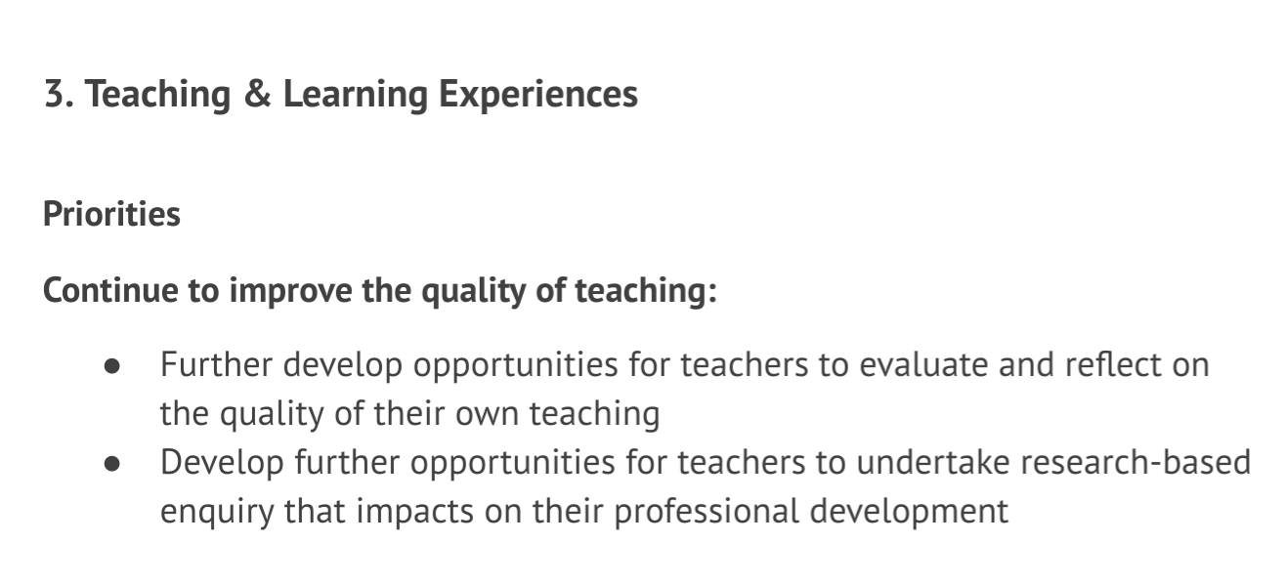
Section of School X SIP promoting self-evaluation and research-based enquiry

Adapted from School X (2018a)

Appendix G:
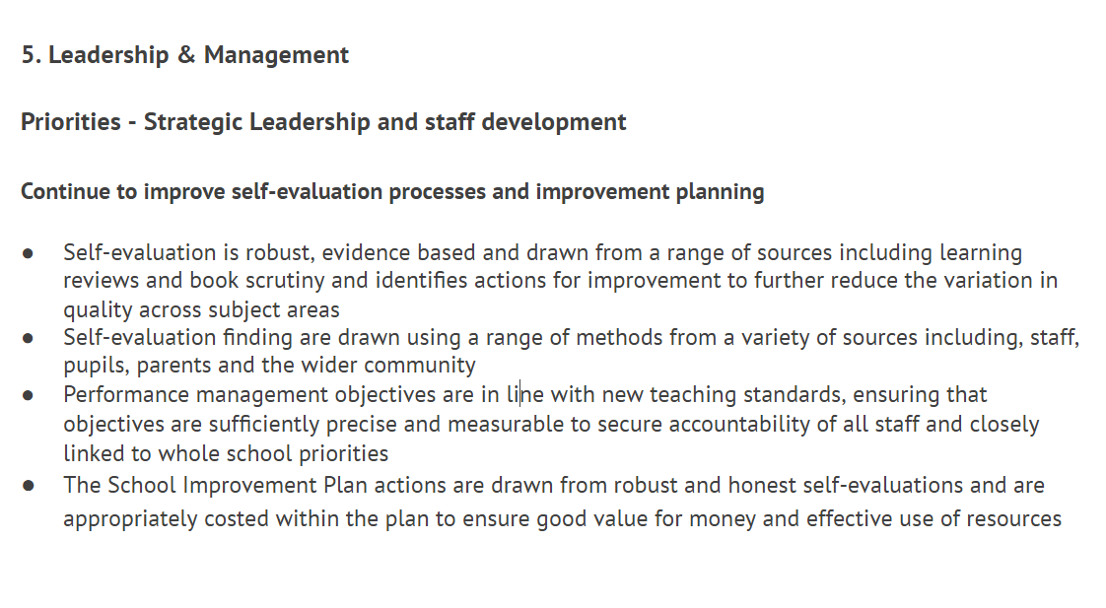
Section of School X SIP promoting self-evaluation and improvement planning
Adapted from School X (2018a)
Appendix H:
Profiles of (i) a person with poor literacy and (ii) a person with improved literacy
Profile of a person with poor literacy | Profile of a person with improved literacy
More likely to live in a non-working household | Becomes less likely to be on state benefits
22% of men and 30% of women with literacy below entry level 2 live in nonworking households. | Men who improve their literacy rates see their likelihood of being on state benefits reduced from 19% to 6%.
Less likely to have children | Becomes more likely to own their own home
Individuals with low levels of literacy are more likely to lead solitary lives without any children. | A modest rise in literacy level sees the likelihood of a man owning their own house rise from 40% to 78%.
More likely to live in overcrowded housing | Becomes more likely to use a PC at work
Individuals with low literacy levels are more likely to live in overcrowded housing with reduced access to technology. | Increased literacy rates improve the chances of using a PC at work from 48% to 65%.
Less likely to vote | Becomes more involved in democratic processes
Men and women with the poorest literacy or numeracy skills were the least likely to have voted in the 1987 and 1997 general elections. | 16% of men who improved their literacy between the ages of 21 and 34 had contact with government, compared to 0% of those whose literacy remained poor.

Adapted from Dugdale and Clark (2008)

Appendix I:
Section of School X SIP - Continue to improve standards and progress in skills

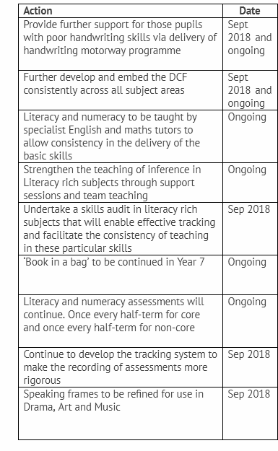
Adapted from School X (2018a)

Appendix J:
Description of Scaffolded Silent Reading (SSR)
‘teachers monitor students during practice through individual reading conferences in which students read aloud, discuss the book, answer questions, and set goals for completing the reading of the book within a specific time.’

Adapted from Reutzel, Fawson and Smith (2008)

Appendix K:
Description of Guided Repeated Oral Reading (GROR)
‘a teacher [...] reads a passage aloud, modeling fluent reading. Then students reread the text quietly, on their own, sometimes several times. The text should be at the student's independent reading level. Next, the students read aloud and then reread the same passage.’

Adapted from Partnership for Reading, in Reading Rockets (2019)

Appendix L:
Classification of students in Form Y

Key: SOI: Start of Intervention
EOI: End of Intervention

Student | D.O.B | Age (SOI) | Age (EOI) | M/F | eFSM | SEN | EAL | MAT
A | 23/5/05 | 13.03 | 13.05 | M | ✓ | ✓
B | 28/1/05 | 13.07 | 13.08 | M |  |  | ✓
C | 20/11/04 | 13.09 | 13.11 | F | ✓
D | 12/9/04 | 14.00 | 14.01 | F |  |  | ✓
E | 24/8/05 | 13.00 | 13.02 | M |  | ✓
F | 19/6/05 | 13.02 | 13.04 | F |  |  |  | ✓
G | 27/2/05 | 13.06 | 13.07 | F | ✓
H | 15/9/04 | 14.00 | 14.01 | F |  | ✓
I | 29/3/05 | 13.05 | 13.06 | M |  |  |  | ✓
J | 9/3/05 | 13.06 | 13.07 | M | ✓
K | 10/7/05 | 13.02 | 13.03 | F | ✓ | ✓ |  | ✓
L | 8/2/05 | 13.07 | 13.08 | F
M | 19/4/05 | 13.04 | 13.06 | M | ✓ | ✓
N | 14/11/04 | 13.10 | 13.11 | M | ✓ | ✓
O | 11/1/05 | 13.08 | 13.09 | M |  | ✓
P | 25/7/05 | 13.01 | 13.03 | M |  |  |  | ✓
Q | 22/10/04 | 13.10 | 14.00 | M
R | 28/2/05 | 13.06 | 13.07 | F |  |  |  | ✓
S | 30/1/05 | 13.07 | 13.08 | F
T | 2/7/05 | 13.02 | 13.03 | M |  | ✓
U | 20/12/04 | 13.08 | 13.10 | F | ✓ |  |  | ✓
V | 15/3/05 | 13.06 | 13.07 | M
W | 27/9/04 | 13.11 | 14.00 | F | ✓ | ✓
X | 4/6/05 | 13.03 | 13.04 | F | ✓ |  |  | ✓
Y | 1/11/04 | 13.10 | 13.11 | M | ✓ | ✓
Z | 15/4/05 | 13.05 | 13.06 | M |  | ✓

Appendix M:
Full data comparison from pre-intervention test to post-intervention test

Student | Start raw data (out of 42) | Start % | Start age-standardised score | Start progress measure | End raw data (of of 37) | End % | End age-standardised score | End progress measure
A | 10 | 24 | 83 | 973 | 12 | 32 | 92 | 985
B | 15 | 36 | 90 | 984 | 19 | 51 | 101 | 999
C | 18 | 43 | 94 | 990 | 17 | 46 | 97 | 995
D | 12 | 29 | 83 | 978 | 18 | 49 | 98 | 997
E | 13 | 31 | 89 | 980 | 14 | 38 | 96 | 989
F | 32 | 76 | 117 | 1018 | 34 | 92 | 136 | 1044
G | 17 | 40 | 93 | 988 | 22 | 59 | 106 | 1005
H | 15 | 36 | 88 | 984 | 16 | 43 | 95 | 993
I | 31 | 74 | 114 | 1015 | 30 | 81 | 122 | 1026
J | 21 | 50 | 98 | 995 | 24 | 65 | 109 | 1010
K | 32 | 76 | 117 | 1018 | 24 | 65 | 111 | 1010
L | 25 | 60 | 104 | 1002 | 23 | 62 | 107 | 1007
M | 7 | 17 | 76 | 965 | 7 | 19 | 83 | 974
N | 12 | 29 | 84 | 978 | 13 | 35 | 91 | 987
O | 20 | 48 | 97 | 993 | 25 | 68 | 110 | 1012
P | 30 | 71 | 114 | 1012 | 29 | 78 | 120 | 1022
Q | 26 | 62 | 104 | 1004 | 27 | 73 | 113 | 1017
R | 35 | 83 | 123 | 1027 | 34 | 92 | 135 | 1044
S | 23 | 55 | 101 | 998 | 26 | 70 | 113 | 1014
T | 10 | 24 | 83 | 973 | 11 | 30 | 91 | 983
U | 30 | 71 | 111 | 1012 | 27 | 73 | 114 | 1017
V | 22 | 52 | 100 | 997 | 25 | 68 | 111 | 1012
W | 11 | 26 | 82 | 976 | 8 | 22 | 83 | 977
X | 29 | 69 | 111 | 1010 | 31 | 84 | 125 | 1029
Y | 9 | 21 | 79 | 971 | 10 | 27 | 87 | 981
Z | 16 | 38 | 92 | 986 | 16 | 43 | 97 | 993

Appendix N:
Books used in reading programme with students in Form Y

- How I live Now (Rosoff, 2013)
- The Curious Incident of the Dog in the Night-Time (Haddon, 2014)
- Revolver (Sedgwick, 2016)
- The Boy in the Striped Pyjamas (Boyne, 2014)
- Stormbreaker (Horowitz, 2004)
- Kite Rider (McCaughrean, 2002)

Appendix O:
Order of group rotation for weekly intervention
 | Week 1 | Week 2 | Week 3 | Week 4 | Week 5 | Week 6
1 | a | f | e | d | c | b
2 | b | a | f | e | d | c
3 | c | b | a | f | e | d
4 | d | c | b | a | f | e
5 | e | d | c | b | a | f
6 | f | e | d | c | b | a

Appendix P:
Student questionnaire distributed after the reading programme
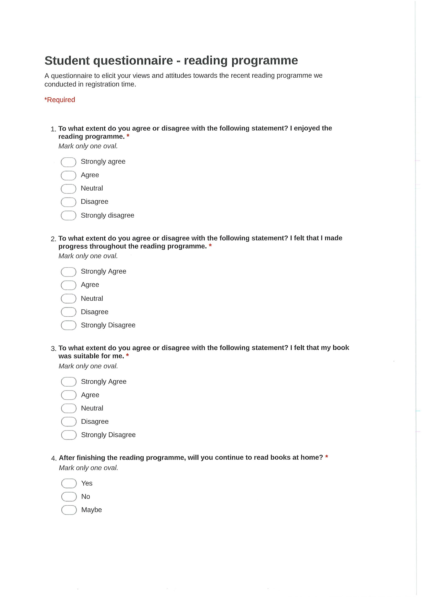




Appendix Q:
Staff questionnaire distributed after the reading programme

