University of Wales Trinity Saint David

Wales Institute of Science & Art



Low Pass & High Pass Filter Experiment & Analysis
Electrical & Electronic Principles (ACDB4002)



James Levi
2416761
June 2025

Abstract
The experiment investigates and compares simulations and practical circuits designed to represent the functionality of high pass and low pass filters. This was completed using a breadboard and simulation software called Proteus. The main objective of the experiment was to validate the results by comparing the simulation to the practical experiment, from these results values such at the attenuation and cut off frequencies were to be calculated.

For the high pass filter, attenuation was high at low frequencies and decreased as the frequency increased, with the $-3dB$ point at approximately $1000Hz$.

As expected, the low pass filter showed low attenuation at low frequencies, with attenuation increasing to $-3dB$ at approximately $28,000Hz$.

The experiment was successful, both filters behaved as expected, and the data supports the validity of the circuits design. However if it were to be conducted again some minor improvements could be made to eliminate and variance in results.

Table of Contents

1 Abstract 1
2 Introduction 3
2.1 Intentions 3
3 Circuit Descriptions 4
3.1 Low Pass Filter 4
3.2 High Pass filter 5
3.3 Circuit Simulations 5
4 Results 7
4.1 Low Pass Filter Results 7
4.2 High Pass Filter Results 9
5 Discussion 12
6 Conclusion 12
7 References 13

Table 1 - Low Pass Filter Results 6
Table 2 - High Pass Filter Results 8

Figure 1 - Low Pass Filter Circuit Diagram 4
Figure 2 - Low Pass Fiter Breadboard Circuit 4
Figure 3 - High Pass Filter Circuit Diagram 5
Figure 4 - High Pass Filter Breadboard Circuit 5
Figure 5 - Proteus High Pass Filter Circuit Diagram 5
Figure 6 - Proteus Low Pass Filter Circuit Diagram 6
Figure 7 - Low Pass Filter Graph 8
Figure 8 - Low Pass Filter Graph (to -3dB) 8
Figure 9 - High Pass Filter Graph 10
Figure 10 - High Pass Filter Graph (to -3dB) 10

Introduction
High pass and low pass filters are electronic filters that only allow signals with a frequency higher or lower than a certain cutoff frequency to pass through. This cutoff frequency can be calculated using the following equation:

$$f_{c}= \frac{1}{2πRC}$$

Equation 1 - Cutoff frequency equation

At this frequency, $f_{c}$, the attenuation (measured in dB) will be $-3dB$, which, at this point the output voltage is less than 70.7% of the input voltage. Anything outside of this frequency will be attenuated. An everyday example where low pass and high pass filters are used is a stereo system, such as one in your car. A tweeter (treble) speaker blocks low frequency sound the same way a high pass filter works, “a treble speaker connected in series with a capacitor will serve as a high pass filter”. Using the same example, a woofer (bass) speaker is used to produce low frequency sound, blocking out high frequencies, “an inductor connected in series with a bass speaker will serve as a low-pass filter for low frequencies.”

A band-pass filter is another use of high and low pass filters. A band-pass filter consists of both a low and high-pass filter, which work together to allow a desired ‘band’ of frequencies to pass through. They’re seen in everyday life within telecommunications for example, since they work to allow receivers to only hear a selected range of frequencies, also known as having a bandwidth. Since a band-pass filter works to only allow a range of frequencies, rather than any frequency above or below a cutoff frequency, it has two cutoff frequencies, a $f_{cL}$ (lower cutoff) and a $f_{cH}$ (higher cutoff). The bandwidth can be calculated by subtracting the two values, seen below:

$$BW= f_{cH}-f_{cL}$$

Equation 2 - Bandwidth Formula

Intentions
The aim of this report is to analyze the findings from a laboratory exercise, in which both a low pass and high pass filter will be created using a breadboard and in a simulation software, proteus. These filters will be given an input voltage with varying frequency at a constant of 5V peak-peak from a signal generator. Then, using an oscilloscope the output voltage ($V_{out}$) will be measured and recorded across the range of frequencies, $100Hz$ to a maximum of $300kHz$. Using the $V_{out}$ results attenuation can be calculated using the following formula:

$$A=20×\log_{10}{\frac{V_{out}}{V_{in}}}$$

Equation 3 - Attenuation equation
The output voltage results are recorded in an excel spreadsheet for analysis, where they are used to calculate attenuation and then plot scatter graphs, which can be used determine the -3dB cut off frequencies. From the graphs it’s easy to visualize the effect frequencies have on output voltage and therefore attenuation.

Circuit Descriptions

Low Pass Filter

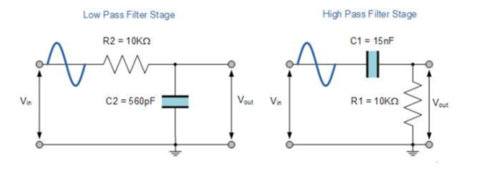
Figure 1 - Low Pass Filter Circuit Diagram
Using the above circuit diagram (figure 1), a low pass filter circuit was created by using a breadboard in conjunction with a signal generator and then an oscilloscope all in series. The signal generator is used to generate a constant $5V$ pk-pk input voltage with variable frequency, between $100Hz$ and $300kHz$. The measurements are taken using an oscilloscope by connecting it to the breadboard between the $10kΩ$ resistor and $560pF$ capacitor (see figure 2), this measurement will be the output voltage, $V_{out}$, which will then be used to calculate attenuation using the attenuation equation (Equation 2) in the excel spreadsheet. The $V_{out}$ will be measured at specific intervals of frequency, starting from $100Hz$ up to $300kHz$.

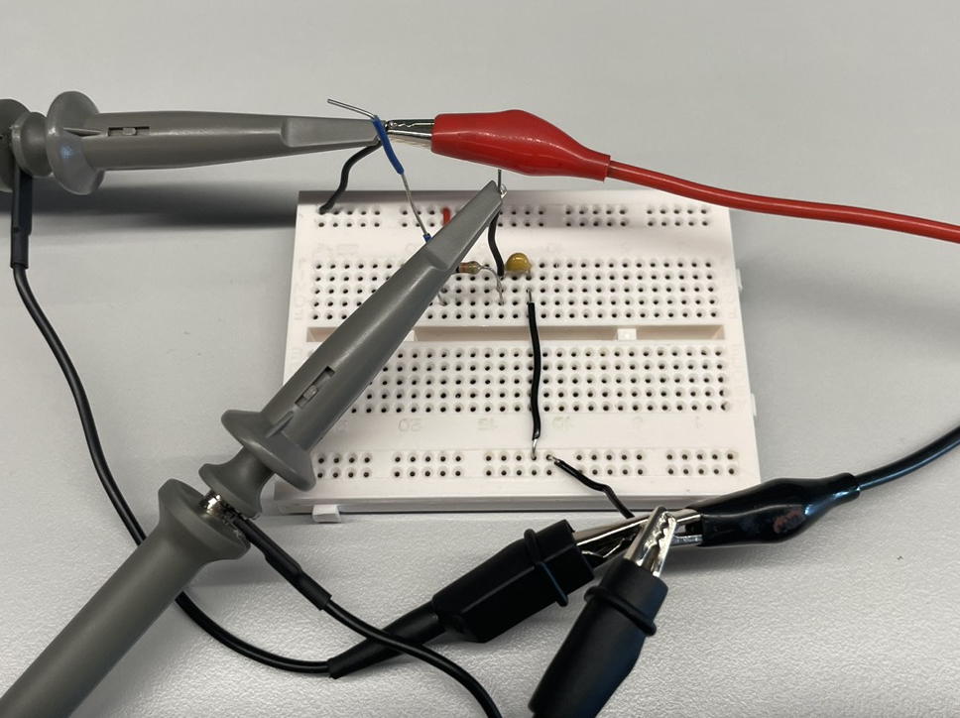
Figure 2 - Low Pass Fiter Breadboard Circuit

High Pass filter
Figure 3 - High Pass Filter Circuit Diagram
To imitate a high pass filter a similar circuit to the low pass filter seen in section 3.1 is set up, using a breadboard, signal generator and oscilloscope. As seen in figure 3 however, the position of the resistor and capacitor are swapped, and the capacitors capacitance is increased to $15nF$. This means that the. The $V_{out}$ is still measured at specific intervals of frequency, starting from $100Hz$ up to $300kHz$, and the $V_{in}$ is still $5V$ pk-pk.

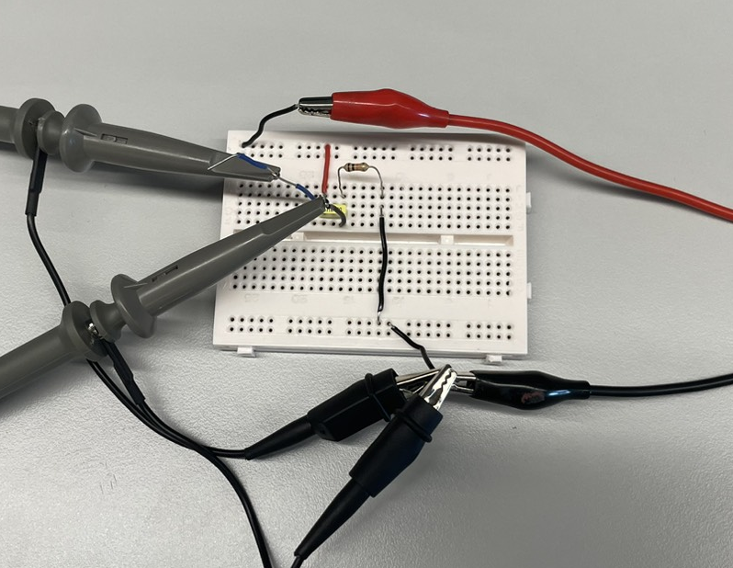
Figure 4 - High Pass Filter Breadboard Circuit

Circuit Simulations
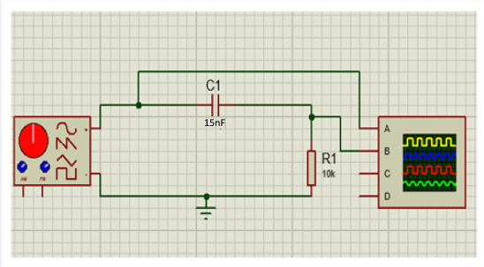
Figure 5 - Proteus High Pass Filter Circuit Diagram
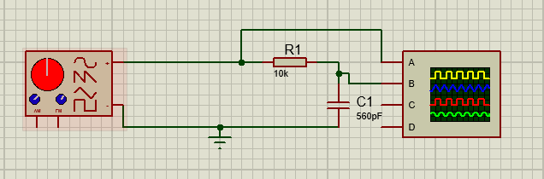
Figure 6 - Proteus Low Pass Filter Circuit Diagram
A simulation of each circuit was created and carried out using proteus, which is a software tool used for electronic design. Using the simulation function within the software, results could be recorded and analyzed using the same method as the laboratory exercise. The circuits contain all the same elements, consisting of a signal generator, resistor, capacitor and oscilloscope (see figures 5,6).

Results

Low Pass Filter Results

Table 1 - Low Pass Filter Results
Low pass Filter
 |  | Simulation |  | Measured
F (Hz) | Vin(V) | Vout(V) | Simulation Attenuation(dB) | Vout(V) | Measured Attenuation(dB)
100 | 5 | 5 | 0 | 5 | 0
500 | 5 | 5 | 0 | 5 | 0
1000 | 5 | 5 | 0 | 4.96 | -0.069766557
5000 | 5 | 5 | 0 | 4.4 | -1.110346557
10000 | 5 | 4.9 | -0.175478486 | 4.1 | -1.723722952
20000 | 5 | 4.7 | -0.537442928 | 3.94 | -2.06947565
25000 | 5 | 4.1 | -1.723722952 | 3.8 | -2.383728154
26000 | 5 | 3.7 | -2.615365605 | 3.6 | -2.853350071
27000 | 5 | 3.6 | -2.853350071 | 3.6 | -2.853350071
28000 | 5 | 3.54 | -2.999334846 | 3.54 | -2.999334846
29000 | 5 | 3.5 | -3.0980392 | 3.4 | -3.349821746
30000 | 5 | 3.46 | -3.197878111 | 3.2 | -3.87640052
50000 | 5 | 2.46 | -6.160697945 | 2.4 | -6.375175252
100000 | 5 | 1.35 | -11.37272472 | 1.4 | -11.05683937
200000 | 5 | 0.7 | -17.07743929 | 0.8 | -15.91760035
300000 | 5 | 0.45 | -20.91514981 | 0.6 | -18.41637508

Figure 7 - Low Pass Filter Graph

Figure 8 - Low Pass Filter Graph (to -3dB)
Table 1 above shows the results from both the practical and simulation investigations. The frequencies highlighted in yellow are of close interest, since at these frequencies the attenuation is closing into its $-3dB$ point, its cutoff frequency. Looking at the results on the table, both the simulation and practical reached its cutoff frequency by $2900Hz$. Therefore, it can be observed that $f_{c}$ must lie between $28000Hz$ and $29000Hz$, and the $V_{out}$ value at this frequency is approximately $3.5V$.

The graphs in figures 7 and 8 help to visualize the recorded results more clearly. We can deduct from these that the attenuation generally follows the same trend, however quite a disparity between the frequency values $1000Hz$ to $20000Hz$ becomes quite noticeable. This could be due to the intervals at which readings were taken, since over this $19000Hz$ range there was only four readings. Regardless, the graph does support the analysis made from Table 1, since the disparity lessens when more frequent readings are taken, and towards $-3dB$ the results are very close, suggesting that $f_{C}$ is at approximately $28000Hz$.

High Pass Filter Results
Table 2 - High Pass Filter Results
High Pass Filter
F (Hz) | Vin | Vout | Simulation Attenuation | Vout | Practical Attenuation
100 | 5 | 0.45 | -20.91514981 | 0.6 | -18.41637508
200 | 5 | 0.95 | -14.42492798 | 1 | -13.97940009
300 | 5 | 1.35 | -11.37272472 | 1.6 | -9.897000434
400 | 5 | 1.75 | -9.118639113 | 2 | -7.958800173
500 | 5 | 2.16 | -7.290325064 | 2.4 | -6.375175252
600 | 5 | 2.46 | -6.160697945 | 2.6 | -5.679933127
700 | 5 | 2.76 | -5.161218445 | 2.8 | -5.03623946
800 | 5 | 3 | -4.436974992 | 3.2 | -3.87640052
850 | 5 | 3.16 | -3.985658434 | 3.2 | -3.87640052
900 | 5 | 3.26 | -3.715048085 | 3.4 | -3.349821746
950 | 5 | 3.36 | -3.452614539 | 3.6 | -2.853350071
1000 | 5 | 3.46 | -3.197878111 | 3.6 | -2.853350071
1050 | 5 | 3.5 | -3.0980392 | 3.6 | -2.853350071
1100 | 5 | 3.6 | -2.853350071 | 3.8 | -2.383728154
1150 | 5 | 3.7 | -2.615365605 | 3.8 | -2.383728154
1200 | 5 | 3.76 | -2.475643188 | 4 | -1.93820026
1500 | 5 | 4.1 | -1.723722952 | 4.2 | -1.514414279
2000 | 5 | 4.4 | -1.110346557 | 4.6 | -0.724243453
3000 | 5 | 4.7 | -0.537442928 | 4.7 | -0.537442928
5000 | 5 | 4.9 | -0.175478486 | 4.8 | -0.354575339
10000 | 5 | 4.96 | -0.069766557 | 5 | 0
50000 | 5 | 5 | 0 | 5 | 0
100000 | 5 | 5 | 0 | 5 | 0
200000 | 5 | 5 | 0 | 5 | 0
300000 | 5 | 5 | 0 | 5 | 0

Figure 9 - High Pass Filter Graph

Figure 10 - High Pass Filter Graph (to -3dB)
Table 2 above shows the results from the investigations into the low pass filter. Again, the frequencies of interest that are near the $-3dB$ point, the cutoff frequency, are highlighted yellow. Looking at the results recorded in table 2, the simulation appears to reach the $-3dB$ point at $1050Hz$, where the practical reached its $-3dB$ point at $900Hz$. This means that the cutoff frequency lies somewhere between those two frequencies, and by taking the median $f_{C}=1000Hz$ it can be observed that the $V_{out}$ value at $-3dB$ must be lay between $3.46V$ (Simulation $f_{C}=1000Hz$) and $3.6V$ (Practical $f_{C}=1000Hz$).

The graphs in figures 9 and 10 help to visualize the recorded results more clearly. From these graphs it’s clear that the recorded results are comparable and are both accurate since there’s no notable disparity. The graphs also support the analysis made from Table 2, since the $-3dB$ points lie between $900Hz$ and $1050Hz$.

Discussion
From the experiments results it’s clear that both the filters operated as expected, and the disparities observed earlier on can be determined to be caused imperfections in the real-world components used combined with variations in measurements collected. In the high pass filter the attenuation is significant at low frequencies, and as the frequency increases the attenuation decreases until it reaches $0$, meaning that the signal is passed through without any attenuation. From the median taken in section 4.2 for $f_{C}=1000Hz$ it can be observed that the $V_{out}$ value at $-3dB$ must be lay between $3.46V$ (Simulation $f_{C}=1000Hz$) and $3.6V$ (Practical $f_{C}=1000Hz$), this is clear that the data is consistent with the simulation. There are a few small variations in the results, such as at $100Hz$ there’s a difference between attenuations of around $2.5dB$. Since the overall trend of the results are consistent, seen in the graphs (figures 9 and 10), this variation can be disregarded and as previously mentioned it is likely due to factors in the real circuit such as noise (disturbances that interfere with signals) and resistor tolerances (resistors allowable deviation from its actual resistance values).

The low pass filters result also demonstrates the expected behavior of a low pass filter. At low frequencies ($100Hz$ up to $20000Hz$) the output voltages are close to the input voltage; therefore the attenuation is low, and the signal is allowed to pass with little disturbance. As the frequency increases the attenuation begins to increase also, it can be observed that $f_{c}$ must lie between $28000Hz$ and $29000Hz$, and the $V_{out}$ value at this frequency is approximately $3.5V$. The $V_{out}$ also correlates with the $-3.5dB$ , since $5×0.707=3.535V$ a value very close to the results, further proving that they’re accurate and any discrepancies can be determined to be caused by factors such as noise or component tolerances.

If this experiment was to be completed again there are some improvements to be made. The variations in the data can be easily explained by the inconsistent intervals at which the readings were taken and the likelihood of components having imperfections. The readings were taken at inconsistent frequency intervals primarily as a time saving measure, since taking the closer reading intervals required near the expected cutoff frequencies for the whole experiment would be impractical. However, there could still be readings taken with smaller intervals between a frequency range smaller than $100Hz$ to $300kHz$ to improve accuracy. The practical experiments were also completed on different days. This leaves a vulnerability of environmental factors to more likely affect results, as its possible for different components such as a different $10kΩ$ resistor with different tolerances to be used unintentionally.

Conclusion
Overall, the experiment was successful. Despite having some anomalous results, the data presented is consistent and has no major discrepancies to suggest it’s unreliable. The high pass filter in this experiment exhibited expected behaviors and had a cutoff frequency of around $1000Hz$. The low pass filter also behaved expectedly and had a cutoff frequency of approximately $28000Hz$. These cutoff frequencies both corresponded to the $V_{out}$ values expected, being close to if not equal to 70.7% of $V_{in}$. To conclude, the experiment was successful since both filters suppressed signals at unwanted frequencies and the data supports the validity of the circuits design, however if it were to be conducted again some minor improvements could be made.

References
All about Circuits, Textbook summary of filters [online]
Available at: https://www.allaboutcircuits.com/textbook/alternating-current
[Accessed 04 June 2025]

