Module code: LCLM 5005
Lecturer: Rameses Manalang

Organisational Culture
Individual Report


Student: Andreea Gabriela Bacus
Student Number:2331305
Group1-Term3-Level 5
21 April 2026
University of wales TRINITY SAINT DAVID
London Campus



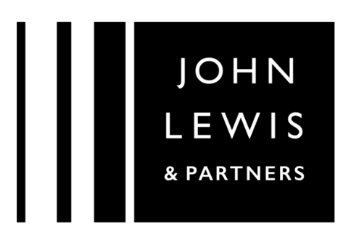

Table of Contents
1. Introduction 2
2. Organisational Culture of The John Lewis Partnership 2
3. Evaluating Organisational Culture as an Enabler or Barrier to Effectiveness 4
4. The Influence of Organisational Culture on Structure and Decision-Making at John Lewis Partnership 5
5. The Psychological Foundations of Organisational Culture 7
6. Evaluating External Influences on John Lewis Partnership through PESTLE 9
7. The partnership model of leadership fosters strong employee engagement by creating a sense of ownership. 9
8. Conclusion 12
9.References 12

1. Introduction

John Lewis Partnership stands out in the UK retail industry for its still unusual employee ownership model and dedication to collaborative governance (John Lewis Partnership, 2026; UK Parliament, 2016). Founded on the principle of partnership, the organisation promotes an ethos centred on collective responsibility, democratic participation, fairness, and long-term sustainability (Storey and Salaman, 2017). Employees, referred to as Partners, are meant to have both a financial stake in the business and a meaningful voice in its direction, reinforcing a formal identity built around mutual respect and accountability (Storey and Salaman, 2017; Basterretxea and Storey, 2017 ).
While this ethos provides a clear corporate framework, the lived culture within individual stores and operational sites may vary. In major organisations, everyday values are often shaped by the leadership approaches in each area, the composition of employees, the social and psychological influences specific to various locations, resulting in unique subcultures throughout the organisation and JLP makes no exception. (Democratic Audit, 2013; Hall,1990). As a result, informal norms and behaviours can sometimes diverge from the Partnership’s stated principles interplaying between declared ethos and locally shaped values and may lead to occasional misalignment, highlighting the complexity of sustaining a unified organisational culture across diverse premises (Storey and Salaman, 2017).

2. Organisational Culture of The John Lewis Partnership

The organisational culture at JLP is strongly shaped by its identity as an employee-owned business. Unlike many large retail organisations, John Lewis refers to its employees as “partners,” reflecting the fact that they collectively own the company. This ownership model sits at the heart of its culture and influences attitudes, behaviours, and everyday working practices.
A key feature of the culture is shared responsibility. Partners are encouraged to see themselves not just as staff members completing tasks, but as co-owners contributing to the long-term success of the business. This creates a sense of accountability and collective interest. Profits are distributed through an annual bonus (when performance allows), reinforcing the idea that everyone’s effort contributes to shared outcomes. As a result, there is traditionally a strong emphasis on teamwork, commitment, and pride in the organisation.
Another important aspect of the culture is democratic participation. John Lewis has formal governance structures such as the Partnership Council, which gives partners a voice in how the business is run. This reflects a culture of openness and dialogue. Communication is often described as transparent, with leadership expected to explain major decisions and performance outcomes. The idea is that information should not be restricted to senior management but shared across the organisation, promoting trust.
Customer service excellence is also central to the organisational culture. John Lewis has built its reputation on quality, reliability, and strong service standards. Partners are encouraged to take personal responsibility for customer satisfaction rather than rigidly following scripts or policies. This creates a culture where initiative and problem-solving are valued. The expectation is that partners act in the best interest of both the customer and the business.
Ethical responsibility and long-term thinking form another cultural pillar. As an employee-owned partnership rather than a publicly traded company driven by external shareholders, the organisation traditionally places importance on sustainability, fair treatment, and responsible sourcing. Decisions are often framed around long-term stability rather than short-term financial gain. This contributes to a culture that values prudence and careful planning.
The working environment is also shaped by mutual respect. Because everyone is considered a partner, there is an underlying principle of equality. Although hierarchical roles still exist, the cultural language reduces the sense of distance between management and frontline staff. Leaders are expected to act as stewards of the partnership rather than distant authority figures.
The organisational culture at John Lewis can be described as collaborative, participative, customer-focused, and ethically driven. Its employee-owned structure fosters a sense of belonging and shared purpose, while its democratic mechanisms promote openness and engagement. These cultural characteristics combine to create a distinctive identity within the UK retail sector, one that emphasises responsibility, fairness, and long-term collective success.

3. Evaluating Organisational Culture as an Enabler or Barrier to Effectiveness

Organisational culture at John Lewis Partnership plays a mixed role in how effectively the business operates, but overall, it tends to act more as an enabler than a barrier.
A key strength is the sense of involvement it creates. Referring to employees as “partners” encourages a stronger connection to the organisation’s performance, which can improve motivation and maintain high service standards. The culture also supports open communication and trust, making collaboration across teams more effective (Schein, 2016). In addition, its focus on long-term stability rather than short-term gains helps the organisation remain resilient, reflecting a broader stakeholder approach (Freeman, 1984) and long-time sustainability through cultivating integrity.
However, there are some limitations such as not all partners engage equally, which can weaken the idea of shared responsibility in practice.
Another issue comes from how the idea of “democracy” is sometimes misunderstood within the organisation. While the partnership model is designed to give employees a voice, it does not mean that every decision is made collectively or that all opinions carry equal strategic weight. In some cases, partners may expect to be involved in decisions beyond their role or resist management decisions on the basis that they feel entitled to direct influence. For example, during periods of restructuring or change, some employees may challenge decisions not through formal channels, but through informal resistance, slowing implementation. This can create tension between participation and managerial authority, making it harder to act decisively when needed.
Overall, the main challenge lies in how consistently the principles of ownership and participation are understood and applied in practice.

Table1: JLP Employee Attitude Scores Compared Table2: JLP Employee Attitude Scores Compared with
with Benchmark Firms (Positive Comparisons) Benchmark Firms (Negative Comparisons)
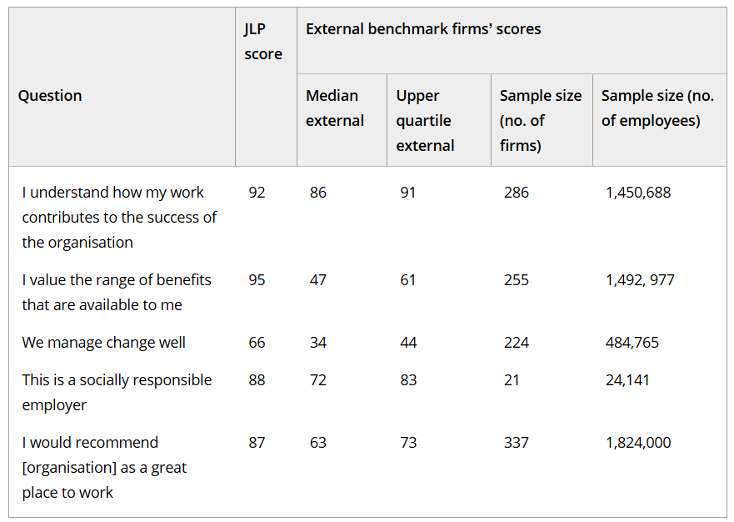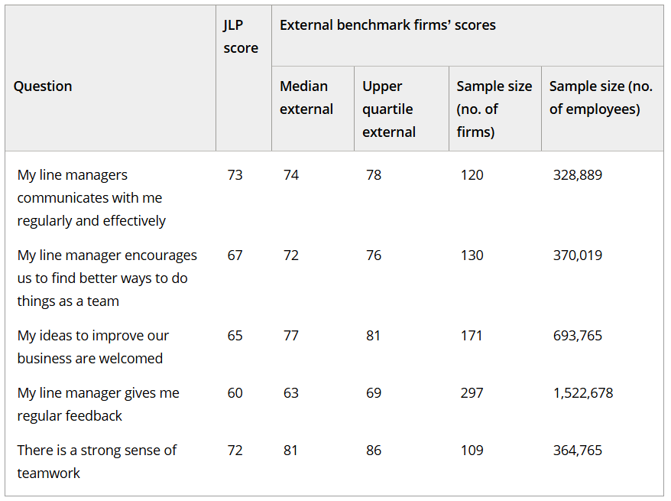

4. The Influence of Organisational Culture on Structure and Decision-Making at John Lewis Partnership

When you look at John Lewis Partnership, the first thing to understand is that its organisational culture isn’t just a background feature, it genuinely drives the structure and the way decisions are made. Staff are called “partners,” and that word isn’t just clever branding. It reflects a culture built around shared responsibility, collective reward, and mutual accountability (John Lewis Partnership, 2025) that leads to both ways continuous improvement.
John Lewis Partnership (JLP) has a hybrid organisational structure (Diagram2) that combines elements of democratic/participative governance with traditional hierarchical management creating a unique workplace where both culture and structure shape everyday life.
At JLP, culture and structure are closely linked and constantly influence each other. The company’s culture of partnership and employee ownership, where staff are treated as “partners,” (Diagram 1) shapes the way the organisation is set up, with democratic mechanisms like the Partnership Council giving employees a real voice in decisions. Shared values like collaboration, responsibility, and ethics guide how teams work together and how responsibilities are shared, while the focus on long-term thinking helps the business prioritise sustainability over short-term profit. At the same time, the structure affects culture: leaders still hold authority in urgent or sensitive situations, and how temporary or external staff are integrated influences how well partnership values are adopted. Formal communication channels also help reinforce transparency and involvement. Culture and structure work together, but they rely on active participation, if partners don’t engage, democratic systems can feel like formalities rather than real collaboration. Some employees may underestimate the long-term impact of their performance or involvement, assuming that a large and well-resourced organisation is resilient enough to absorb individual disengagement. This can weaken the very democratic structure the culture depends on. If participation is uneven, decision-making becomes influenced by a smaller, more vocal group rather than the collective. In that sense, the culture relies heavily on maturity, awareness, and active contribution from partners, and when that’s missing, the structure becomes less representative in practice.
The Chairman and executive team still retain strong authority, so in commercially sensitive or urgent situations, hierarchy takes precedence. This type of culturally collaborative but operationally pragmatic culture reflects what Schein (2016) argues that organisational culture shapes behaviour, but external pressures still demand structured leadership.
Another cultural influence is the focus on long-term sustainability rather than short-term profit. Because partners share profits and job security, decisions are framed around reputation, stability, and ethical practice. Investment in training and service quality becomes structurally embedded and while this long-term mindset can slow radical change, it promotes and conserves quality.
An additional structural challenge comes from third parties such as recruitment agencies. When temporary or agency workers are brought in who are not fully aligned with partnership values, it can create a cultural disconnect. These workers may not feel the same ownership mindset, and permanent partners may treat them differently, consciously or unconsciously, or when the agency structure itself is not aligned with that of JLP resulting in paradoxical messages (Julmi,2022; Gibson,2024) can create informal hierarchies within teams, subtly undermining the inclusive culture. It also complicates decision-making, as leaders must balance cost-efficiency with cultural integrity.
The organisational culture of John Lewis deeply shapes its governance, accountability systems, and leadership style, but the effectiveness of this model depends on consistent partner engagement and alignment, both internally and with external workforce providers. The culture is powerful, but it is also fragile if not actively lived by everyone involved.

Diagram 1 Diagram 2

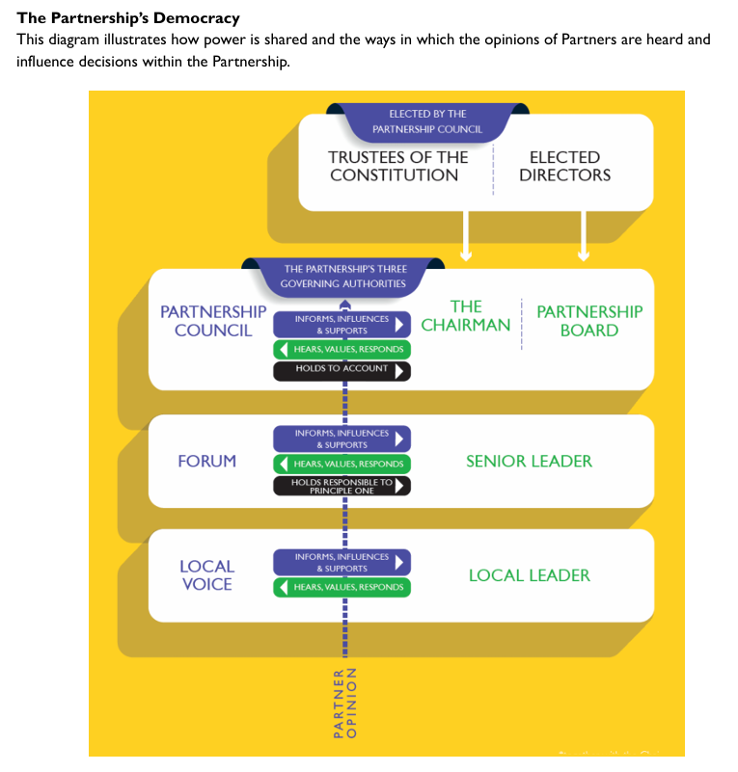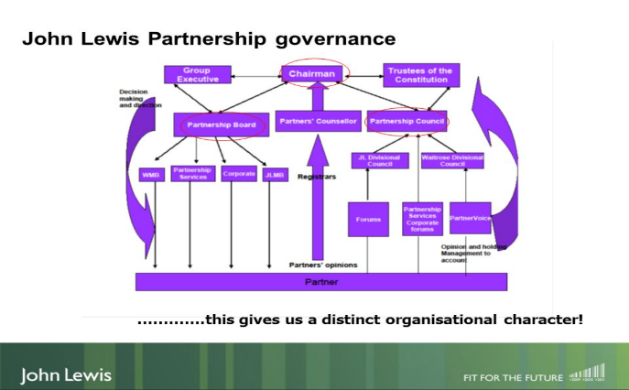

5. The Psychological Foundations of Organisational Culture

Understanding the organisational culture of John Lewis Partnership can be explored effectively through established cultural frameworks such as Schein’s Model of Organisational Culture and Hofstede’s Cultural Dimensions Theory. These models help identify visible cultural elements, deeper values, and behavioural patterns within the organisation.
According to Edgar Schein, organisational culture operates at three levels: artefacts, espoused values, and underlying assumptions (Schein, 2016). At the surface level, artefacts are the visible expressions of culture, such as language, structures, and practices. In John Lewis Partnership (JLP), one of the most obvious artefacts is the term “partners” used for employees. This language reflects the employee-owned structure of the business and signals a culture built on participation and shared responsibility. Other visible artefacts include governance bodies like the Partnership Council and the practice of sharing company performance information with partners. These structures symbolise transparency and democratic participation.
The second level of Schein’s model is espoused values, which represent the principles and strategies the organisation claims to follow. At JLP, these values include fairness, partnership, customer service excellence, and long-term sustainability. The organisation emphasises that partners contribute to decision-making and share in financial success through bonuses when the business performs well (John Lewis Partnership, 2025). These values encourage collaboration, responsibility, and commitment to delivering high-quality service. The emphasis on customer trust and ethical trading also reinforces the organisation’s identity as a responsible retailer within the UK market.
The deepest level of Schein’s model involves underlying assumptions, unconscious beliefs that guide behaviour. Within JLP, a key assumption is that employees who feel valued and involved will be more committed and motivated to contribute to organisational success. This assumption supports the employee-owned structure and the belief that collective ownership leads to better engagement and stronger performance (Schein, 2016). This deeper layer of culture can also be understood through an analogy with the psychological theories of Carl Jung. Jung argued that human behaviour is influenced not only by conscious attitudes but also by unconscious patterns and archetypes that shape how individuals interpret the world (Jung, 1964). In a similar way, Schein suggests that organisations operate based on hidden assumptions that strongly influence behaviour without always being explicitly recognised. Within JLP, the belief that partners are more committed when they feel respected, informed, and involved acts almost like a collective psychological assumption. Even when partners do not consciously reflect on it, this belief influences everyday collaboration, communication, and attitudes toward responsibility. In this sense, Schein’s model helps explain how organisational culture operates at both visible and unconscious levels, much like Jung’s concept of deeper psychological structures shaping human behaviour.
Another useful way to analyse organisational culture at JLP is through Geert Hofstede’s Cultural Dimensions Theory (Hofstede, 1980). One relevant dimension is power distance, which refers to how power is distributed within organisations. JLP demonstrates relatively low power distance because partners are encouraged to question leadership and participate in governance processes through structures such as the Partnership Council. Although management hierarchy still exists, the culture attempts to reduce excessive authority gaps.
Another dimension is individualism versus collectivism. JLP reflects a more collectivist organisational culture compared with many Western corporations. The emphasis on teamwork, shared ownership, and profit-sharing promotes collective responsibility rather than purely individual achievement.
The long-term orientation dimension is also visible. JLP traditionally focuses on sustainability, ethical sourcing, and long-term reputation rather than short-term profits (John Lewis Partnership, 2025). This strategic mindset supports stability and responsible decision-making within the organisation.
Schein’s and Hofstede’s models show that John Lewis Partnership encourages participation, teamwork, and strong values. The employee-owned structure encourages engagement and shared responsibility, while governance systems reinforce openness and accountability. Although the organisation still operates with formal leadership structures, its culture attempts to balance managerial authority with democratic participation. These cultural characteristics contribute to JLP’s distinctive identity within the retail industry and help sustain a powerful sense of belonging among partners.

6. Evaluating External Influences on John Lewis Partnership through PESTLE Analyses

To understand how John Lewis Partnership responds to external pressures, a PESTLE analysis is useful, as reflected in table 1, but it becomes more meaningful when you consider how the organisation’s culture shapes those responses in practice.

Table 3.
Political | Strong alignment with employee rights and governance regulations due to partner-based culture; but consultation processes can slow decision-making.
Economical | Focus on long-term stability and job security; financial pressures are shared (e.g., reduced bonuses), which builds resilience but may limit rapid cost-cutting.
Social | Values of trust, fairness, and sustainability align well with consumer expectations; strong customer service culture supports adaptability.
Technological | Careful, consultative culture can slow innovation, but high employee engagement leads to effective implementation once decisions are made.
Environmental | Sustainability is embedded in values, enabling proactive responses to environmental pressures.
Legal | Transparency and fairness support compliance with employment laws; complex governance can make decisions more time-consuming.

7. Enhancing Performance Through Partnership Leadership: Challenges and Solution

According to Bromberg-Martin, E.S., et al (2011), when employees feel ownership and autonomy, the brain’s reward system is being activated boosting dopamine responsible for motivation, focus and persistence, culture of trust and fairness increases oxytocin release, which promotes social bonding, cooperation, and prosocial behaviours. Employees are more likely to support one another, share knowledge, and work collaboratively, reducing conflict and increasing efficiency. Fair, transparent, and supportive leadership reduces chronic stress, lowering cortisol levels. Lower stress improves cognitive flexibility, creativity, and overall workplace well-being, which in turn supports sustained productivity. (TJ Power, 2025; Kosfeld2, 2007).

Diagram 3: Dopamine control of positive and negative motivation in the dorsal striatum.

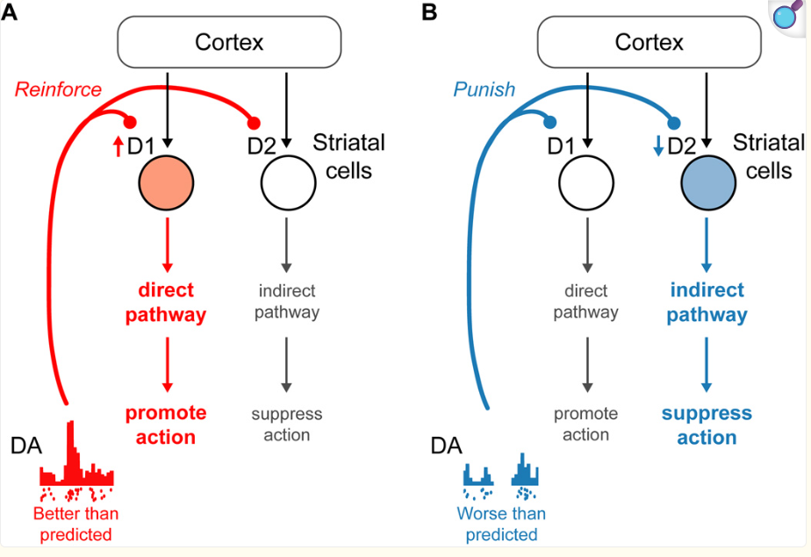

At first glance, the emphasis on consultation and inclusion in partnership-oriented leadership may appear to slow decision-making, creating the impression that productivity will suffer. However, this is largely an illusory expectation. Productivity is maintained because employees’ engagement triggers beneficial neurohormonal responses. Increased dopamine from autonomy and ownership enhances motivation and task persistence, oxytocin from trust and collaboration improves cooperation and information sharing, and regulated cortisol reduces stress and protects cognitive flexibility (McEwen, 2017). Together, these neuronal and hormonal balances ensure that teams remain focused, resilient, and effective, compensating for any time lost to consultation and inclusive decision-making. The brain’s reward and social systems, therefore, sustain performance despite slower procedural steps, making the perceived productivity loss largely illusory.
To improve performance, a few targeted adjustments could be made without losing the core strengths of the culture. First, clearer communication around what “partnership” and participation actually mean in practice would help manage expectations and reduce confusion. This could involve structured training or internal communication that reinforces the difference between having a voice and having decision-making authority.
Second, the organisation could streamline decision-making in specific areas by defining when consultation is necessary and when faster, top-down decisions are more appropriate. This would improve agility while still respecting the culture of inclusion. Research highlights that balancing participation with clear leadership improves organisational effectiveness (Schein, 2016).
Better integration of temporary or external staff into the organisational culture would help maintain consistency. Ensuring that all workers, including those hired through agencies, understand and align with core values could reduce variations in service quality and team cohesion.
The emphasis on a democratic approach sometimes highlights gaps in management training, leading to inconsistent leadership and a lack of clear direction in certain settings.
To improve performance, several practical steps could be taken. First, managers should receive more structured training on delivering feedback in a balanced and respectful way, focusing on improvement rather than criticism. Second, there should be clearer guidance on how performance is assessed, ensuring that factors such as task type, system delays, or operational context are considered before conclusions are made. Third, encouraging appropriate team interaction during quieter periods could help strengthen relationships and reduce misunderstandings, ultimately supporting a more cohesive and productive working environment.

Table 4: JLP: Six-Year Performance Summary (£m)
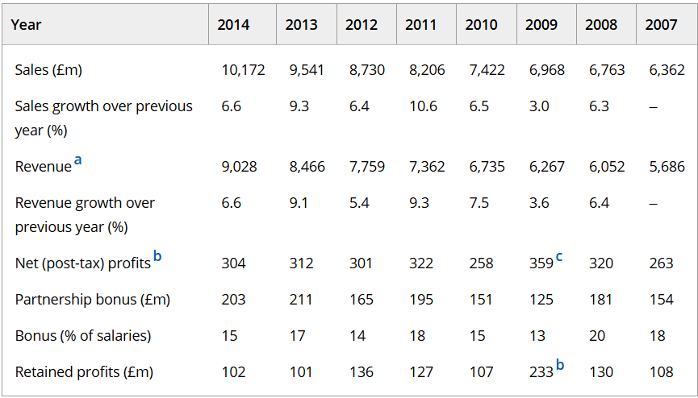

8. Conclusion

In short, John Lewis Partnership’s culture of employee ownership and partnership encourages collaboration, trust, and long-term thinking, helping the organisation work effectively. While involving everyone in decisions can look like sometimes things slow down, the benefits, motivation, engagement, and shared responsibility, more than make up for it.
Clearer communication and better integration of temporary staff could make the business even more agile without losing the values that make JLP unique.

9.References

1.Basterretxea, I. and Storey, J. (2017) 'Do Employee-Owned Firms Produce More Positive Employee Behavioural Outcomes? If Not Why Not? A British-Spanish Comparative Analysis', BJIR, Volume 56, Issue2, Page292-319 . Available at: Do Employee‐Owned Firms Produce More Positive Employee Behavioural Outcomes? If Not Why Not? A British‐Spanish Comparative Analysis - Basterretxea - 2018 - British Journal of Industrial Relations - Wiley Online Library (Accessed: 27/02/2026).
2.Bromberg-Martin, E.S., et al (2011) 'Dopamine in motivational control: rewarding, aversive, and alerting', PubMed Central, .Available at: Dopamine in motivational control: rewarding, aversive, and alerting - PMC (Accessed:02/04/2026).
3.Democratic Audit (2013) researchonline.lse.ac.uk. Available at: The John Lewis model reveals the tensions and paradoxes at the heart of workplace democracy (Accessed: 20/02/2026).
4.Gibson, P., 2024. Speak your mind, but not like that: The double bind theory. Psychology Today. Available at: https://www.psychologytoday.com/gb/blog/escaping-our-mental-traps/202402/speak-your-mind-but-not-like-that-the-double-bind-theory. (Acessed:14/03/2026)
5.Hall, E.T. (1990) The hidden dimension. Reprint of 1966 edition. New York: Anchor Books.
6.Hofstede, G. (1980) Culture's consequences: international differences in work-related values. California: Sage Publications;
7.John Lewis Partnership plc, 2025. Annual report and accounts 2024/25. Available at: https://www.johnlewispartnership.co.uk/~/media/Files/J/john-lewis/corp/documents/jlp-plc-ara-2024-25.pdf
8.John Lewis Partnership (2026) Our Partnership Model. Available at: Partnership Model – John Lewis Partnership (Accessed: 23/02/2026).
9.Julmi, C., 2022. More than just a special case: The value of double bind theory for bringing light into the dark side of organizational paradoxes. Scandinavian Journal of Management, Available at: More than just a special case: The value of double bind theory for bringing light into the dark side of organizational paradoxes - ScienceDirect (Accessed:13/03/2026).
10.Kosfeld, M., 2007. Trust in the brain: Neurobiological determinants of human social behaviour. EMBO Reports, . Available at https://pmc.ncbi.nlm.nih.gov/articles/PMC3327534/ (Accessed:27/03/2026)
11.McEwen B.S. (2017) 'Neurobiological and Systemic Effects of Chronic Stress.', Sage Journal, Available at: Neurobiological and Systemic Effects of Chronic Stress - Bruce S. McEwen, 2017 (Accessed 04/04/2026)
12.Power, T.J. (2025) The DOSE Effect: Optimize Your Brain and Body by Boosting Your Dopamine, Oxytocin, Serotonin, and Endorphins. New York: Dey St., an imprint of William Morrow.
13.Schein, E.H, (2016) Organizational Culture and Leadership, 5th edition (The Jossey-Bass Business & Management Series). USA: Wiley.

14.Storey, J. and Salaman, G. (2017) 'Employee ownership and the drive to do business responsibly: a study of the John Lewis Partnership', Oxford Review of Economic Policy, Volume 33, Issue 2 Pages 339–354. Available at: Employee ownership and the drive to do business responsibly: a study of the John Lewis Partnership | Oxford Review of Economic Policy | Oxford Academic (Accessed:25/2/2026)
15.UK Parliament (2016) Written evidence submitted by the John Lewis Partnership. Available at: CGV0099 - Evidence on Corporate Governance (Accessed: 27/02/2026).

