

Strategic Management

Assignment: Task-2

Strategic Analysis of Rightmove plc

Student name: Bikash Roy
Student Number: 2010168
Module Code: LCMB7003_LON
Lecturer: Dr Hoang Nguyen
Submission Date: 23/08/2024


Executive Summary: We are asked to submit a personal coursework assignment that will "critically evaluate the emergence of "Virtual Organisations" and how the concept of virtual management is practiced within an organisation."
In the context of planning, designing, and leading companies in a highly competitive global business world, I will talk about the opportunities and problems associated with implementing virtual management.
Contents
Executive Summary: 2
1.Introduction: 3
2.Overview of Organisation: 3
2a. Analysation of Rightmove: 3
3. Planning, Designing and Leading of Rightmove: 4
3a. Planning: 4
3b. Designing: 5
3c. Leading: 6
4.Conclusion: 7
5.References: 8
Appendix :1 9
Slides: 9
Precis: 12
Appendix :2 13
Assignment: Second Part 14
Of 14
Task-1 14
1. Introduction and Author's Argument of ERP Research: 14
2.Explanetion of Necessity of ERP and Motive of Research: 15
3. Sum of the Research: 16
4. Conclusion: 16
5. References: 17

1.Introduction: A virtual organisation is a transient network of stand-alone establishments, companies, or highly skilled individuals that collaborate ad hoc using information and communication technologies to maintain a competitive advantage. They work as a single organisation, integrate vertically, and combine their key capabilities (or organisational unit). (Fuehrer, Votalk, 1997)
E-collaboration encourages communication between individuals via the Internet and is essential in virtual work environments where employees collaborate without regard to time or place. The book E-Collaborations and Virtual Organisations addresses a wide range of subjects, including basic mechanisms and underlying technological structures that are pertinent to e-Collaboration and virtual organisations.
2.Overview of Organisation: Rightmove is the leading digital property advertising and information portal in the UK, accounting for 86% of all indexed property portals. People visit Rightmove when they are ready to move. Property professionals, including estate agents, lettings agents, and new home builders, list their properties on Rightmove for a membership fee as part of their regular business. This covers digital marketing tools and goods to boost their profiles and set themselves apart from their rivals and obtain our exclusive market profiles data. A tiny percentage of clients publicise properties abroad. They, as for lettings agents, provide comprehensive tenancy services from mentioning and providing coverage for broadband.
Small retail stores to major fund managers, commercial brokers, developers, and landlords all pay a subscription fee to advertise commercial real estate and space. Because they own an 86% market share in terms of consumer time, their enormous property market data is unmatched and exclusive to Rightmove. A variety of clients are served by this: brokers, local government agencies, insurers, agents, landlords, surveyors, and mortgage lenders. In addition, they offer valuation services and market their extensive and distinctive property data. They offer mortgage in principle (MiP) and broker services to customers who wish to assess their affordability through their partners, which results in commissions for them once the mortgage is paid off. Many companies who wish to quickly and effectively reach a big audience also purchase advertising banners to place on the Rightmove platform. Schools and relocation businesses are among these clients. (Rightmove plc | Annual Report 2023)
2a. Analysation of Rightmove: Rightmove plc, a UK-based company, primarily uses its digital platform to conduct business virtually. Connecting buyers, sellers, renters, and real estate professionals, it is one of the top online real estate websites in the UK. Rightmove operates as a virtual organisation in the following ways:
Rightmove mainly uses its mobile applications and website to deliver its services. Without the necessity for actual offices, consumers can interact with real estate agents, browse property listings, and read details online. On Rightmove, homeowners and real estate brokers can offer their properties for sale or rental. These postings can be found by users by using different filters such as price, location, and kind of property. A lot of real estate listings come with virtual tours, pictures, and videos so that prospective tenants and purchasers may see the homes from a distance. Rightmove offers real estate professionals and consumers useful market data and analytics. This covers area statistics, market demand, and pricing trends. By utilising in-depth analytics to precisely target their campaigns, real estate brokers and property developers can expand their reach by Rightmove's advertising tools. Chatbots, FAQs, and online help centres all ensure that users may receive information and address problems without going through physical support centres.
Rightmove provides real estate agents with a range of virtual professional services, such as marketing assistance and training. Rightmove has a scattered workforce, with many employees operating remotely. This configuration facilitates the organization's virtual structure and permits adaptable work schedules. Working Together with Real Estate Agents: Rightmove serves as a digital middleman that streamlines property transactions by working with thousands of real estate agents and developers throughout the United Kingdom. This eliminates the necessity for in-person interactions. Rightmove plc uses digital technology to offer full-service real estate, keeping a robust online presence that reduces the need for physical infrastructure and increases consumer convenience and accessibility.
3. Planning, Designing and Leading of Rightmove: Their strong and durable position is maintained through all market cycles and industry events because to their leading brand, platform, and the potent network effect of their consumers and customers. Most importantly, one Rightmove Platform having many linked nodes.
3a. Planning: Their goal is to empower everyone to believe they can make the shift, and to realise that goal, our purpose is still to simplify and ease the relocation process for everyone by providing access to the greatest resources—tools, knowledge, and data—to enable it. Their goal is to provide both with extraordinary value clients and clients on the back of the widest array of property data in the United Kingdom, driven by unparalleled digital scale, which will ultimately result in growth and remarkable worth for every one of their stakeholders. Simultaneously, Rightmove is persisting in its efforts to enhance its operational emissions and aims. We accomplished our three-year environmental goal to close their office by 2023, power tonnes of CO2 by ten percent, and they’ve surpassed their aim to have 75% ultra-low emission fleet cars by 2025 and all 100 percent by 2028. Additionally, they finished rebasing 2020, computation techniques and data sets, to guarantee conforms to their most recent carbon footprint estimate.
Obstacles in the Market Competition:
Rightmove is up against property websites like Zoopla and On The Market, who provide comparable services and are coming up with new ideas to draw in customers.
Since there are little barriers to entry in the digital industry, it's possible that new rivals with innovative business ideas or disruptive technology will surface. Persistent doubts over the outcome of Brexit may have an impact on property values, investor confidence, and consumer behaviour in the real estate industry. The property market may see a decline in activity during economic downturns, such as those brought on by worldwide pandemics or financial crises, which could have an impact on Rightmove's earnings from listings and adverts. Rapid Changes: To maintain a smooth and cutting-edge user experience, IT infrastructure and innovation must be continuously invested in to keep up with technological advancements. Due to the increasing risk of cyber threats and data breaches brought on by rising digitalisation, robust security measures are necessary. It can be challenging and costly to comply with regulatory requirements and data protection laws, including the GDPR. By altering the real estate market's dynamics, changes to housing laws and regulations may have an impact on Rightmove's business strategies and operations.

Opportunities for Innovation in Technology: AI & Machine Learning: Making use of AI to deliver tailored real estate recommendations, trend-spotting analytics, and improved user experience. Using VR to create virtual property tours can increase platform traffic and improve user engagement. Diversification is the process of growing into allied services to provide extra revenue sources, such as insurance, property management, and mortgage comparisons. Looking into ways to diversify and lessen reliance on the UK market by investigating potential in other markets. Big Data analytics is the process of using the enormous quantity of data that has been gathered to understand consumer behaviour, market trends, and preferences to provide more specialised and efficient services. Creating alliances with other businesses to combine complementary services (like moving and financial services) can improve the value offer. Constantly enhancing the user interface and user experience to guarantee usability and boost consumer happiness and loyalty. Improving the functionality of mobile apps to meet the needs of the increasing number of customers who use tablets and smartphones to access services. Green Technologies: Highlighting and utilising sustainable and green technologies in real estate listings to draw in eco-aware buyers and fit in with larger cultural shifts towards sustainability.
3b. Designing: Leading UK-based online real estate marketplace Rightmove PLC competes in a fast-paced sector. To sustain and expand its business, it must deal with several obstacles and seize new chances as it works to keep its leading position.
Rightmove is under pressure from competitors like Zoopla and OnTheMarket in the fiercely competitive UK online real estate market. Slower growth could result from saturation. Constant innovation is needed to meet the growing demand from consumers for augmented reality (AR), virtual viewings, and personalised services. The home market may be impacted by Brexit and other economic upheavals, which could cause variations in the amount of real estate transactions. Investing in augmented reality, virtual reality tours, and AI-driven property recommendations could improve user experience and engagement. By using user data to provide individualised services and targeted advertising, new revenue streams can be generated. Rightmove may consider providing allied services like international listings, property management, or mortgage broking.
Challenges in Technological Development and Integration:
Being a well-known online retailer, Rightmove is frequently the target of cyberattacks. Data security must be guaranteed. It's critical to make sure the platform is stable and scalable considering the increasing volume of users and data. The explosive expansion of Prop-Tech companies offers opportunities and challenges for the integration of new technology.
Gaining a competitive edge might come from applying AI to improve search algorithms, anticipate property values, and do predictive analytics. With more people browsing on mobile devices, more features for mobile apps could lead to more user engagement.
Blockchain for Transactions: Rightmove may be able to establish itself as a leader in this field by investigating blockchain technology for safe, transparent real estate transactions. It might be difficult to continuously provide users with a seamless, quick, and personalised experience. It's a difficult endeavour to maintain great connections with estate agents while juggling the demands of consumers. In a cutthroat industry, preserving brand loyalty calls for constant innovation and top-notch customer support.
By using machine learning and advanced data analytics to personalise the user journey, engagement can be increased. Creating a community on social media, blogs, and forums helps improve brand affinity and consumer loyalty. Offering special discounts to regular users or premium members through loyalty programs may help increase retention. Since Rightmove gathers a significant amount of personal data, adherence to the GDPR and other data protection laws is essential. To stay out of legal trouble, it is imperative that all real estate listings and adverts adhere to UK advertising rules. Stakeholders are putting more and more pressure on businesses to implement sustainable practices and operational transparency. Rightmove can improve its brand reputation and draw more eco-aware customers by implementing and advocating sustainable practices. Increasing pricing transparency, providing property details, and managing user data can all help to foster trust among partners and customers. Taking part in CSR programs that support affordable housing or community development can enhance a company's reputation and brand value.
Strategic Alliances and Development Obstacles:
If relationships break down or partners experience problems, an excessive reliance on some partners (such as mortgage lenders or tech vendors) may be dangerous.
Entering foreign markets necessitates adjusting to various regulatory frameworks and consumer trends. Rivals may be a threat if they get together to innovate more quickly.
Bringing new ideas and technologies to Rightmove's platform through partnerships with up-and-coming Prop Tech companies could be beneficial. Rightmove plc UK may investigate bringing its platform to other nations, especially those in emerging markets or Europe. You can develop new services and income streams by collaborating with tech companies, insurance providers, or financial institutions.
3c. Leading: Guiding Rightmove plc, the biggest online real estate marketplace in the UK, into a bright future requires negotiating a changing environment that is full of possibilities and obstacles. Here is a breakdown of the important elements:
Difficulties Market Oversaturation:
Rightmove has fierce competition from Zoopla, On The Market, and other platforms, as well as from more recent entrants who are delivering cutting-edge technologies, in the UK property market. Rightmove must continuously improve its user experience and provide distinctive value propositions to real estate agents and consumers to stay ahead of the competition. Uncertainties in the economy, shifts in governmental regulations, and international events (like Brexit and COVID-19) can all cause volatility in the UK property market. These may influence the number of real estate listings and, in turn, Rightmove's earnings. PropTech Innovation: A possible danger is the growth of PropTech (property technology) companies that use big data, blockchain, and artificial intelligence to provide more individualised and effective real estate services. For Rightmove to remain competitive, it must incorporate cutting-edge technologies. Rightmove, an online platform that handles a lot of user data, needs to keep investing in cybersecurity to keep consumers safe and build confidence.
Regulatory Obstacles:
Rightmove is subject to more obligations for the management of user data due to stricter data protection laws, such as the GDPR. To avoid significant fines and harm to one's reputation, compliance is essential. Rightmove's business model may be impacted by government actions in the housing market, such as adjustments to taxes or housing rules, which can alter market dynamics.
Possibilities:
In addition to property listings, Rightmove may consider providing additional value-added services including mortgage broking, house insurance, and relocation assistance. This might improve client retention and open new revenue streams. By utilising its extensive user and property data, Rightmove may be able to provide real estate agents with data analytics services that provide insights into consumer behaviour, pricing tactics, and market trends. By offering chatbot support, virtual tours, and personalised property recommendations, investing in AI-driven personalisation can increase customer engagement. Users and agents may find the platform more appealing as a result.
As more people use mobile devices to access services, making the mobile experience more user-friendly with faster load times and intuitive designs could improve user happiness and enhance conversions. Acquiring Property Portals Abroad: Although Rightmove is presently concentrated on the UK market, it may investigate prospects for global growth by introducing its platform in other nations or purchasing pre-existing property portals overseas. This diversification may create new revenue streams and lessen reliance on the UK market. Given the increased focus on sustainability, Rightmove may choose to promote environmentally friendly homes and collaborate with green building projects. Encouraging eco-friendly residential properties may draw eco-aware purchasers and financiers. Investing in affordable housing developments and other CSR initiatives can help Rightmove's brand image and align with investors' increasing attention to Environmental, Social, and Governance (ESG) aspects. investing in and promoting technological innovation. To stay ahead of the competition, Rightmove would be prudent to invest in cutting-edge technologies like big data analytics, virtual reality, and artificial intelligence (VR). Retaining and expanding the user base will depend on improving the user experience via personalisation, mobile optimisation, and smooth integration of other services. To take advantage of new opportunities and reduce risks, Rightmove needs to be adaptable and sensitive to changes in the real estate industry. By highlighting environmentally friendly processes and homes, Rightmove may be able to attract an increasing number of eco-aware investors and customers while also keeping pace with larger social trends.
4.Conclusion: Rightmove PLC enjoys a strong market position as the top real estate web in the UK, but it also faces formidable obstacles from rivalry, technical advancements, and regulatory requirements. Proper focus on technology innovation, improved customer involvement, and new revenue streams will allow Rightmove to develop and stay at the top of the market. Its reputation and commercial sustainability will be further enhanced via strategic alliances and a dedication to ESG principles. Rightmove plc has the potential to maintain its position as the market leader in the UK property industry and grow its impact in the digital real estate sector by tackling these obstacles and seizing possibilities.

5.References:
- Rightmove plc | Annual Report 2023
- Innovation in an Academic Setting: Designing and Leading a Business Through Market-Focused, Interdisciplinary Teams, A. BONILAURIE R. WEINGARTSHELLEY EVENSON, 2009
- Strategic Management and Competitive Advantage: Concepts and Cases, Global Edition. J Barney and W Hesterly. Aug 2018
- Business Planning and Market Strategy. E K Valentin, Mar 2020
- Principles of Strategic Management. Mr Tony, Nov 2007

Appendix :1

Slides:

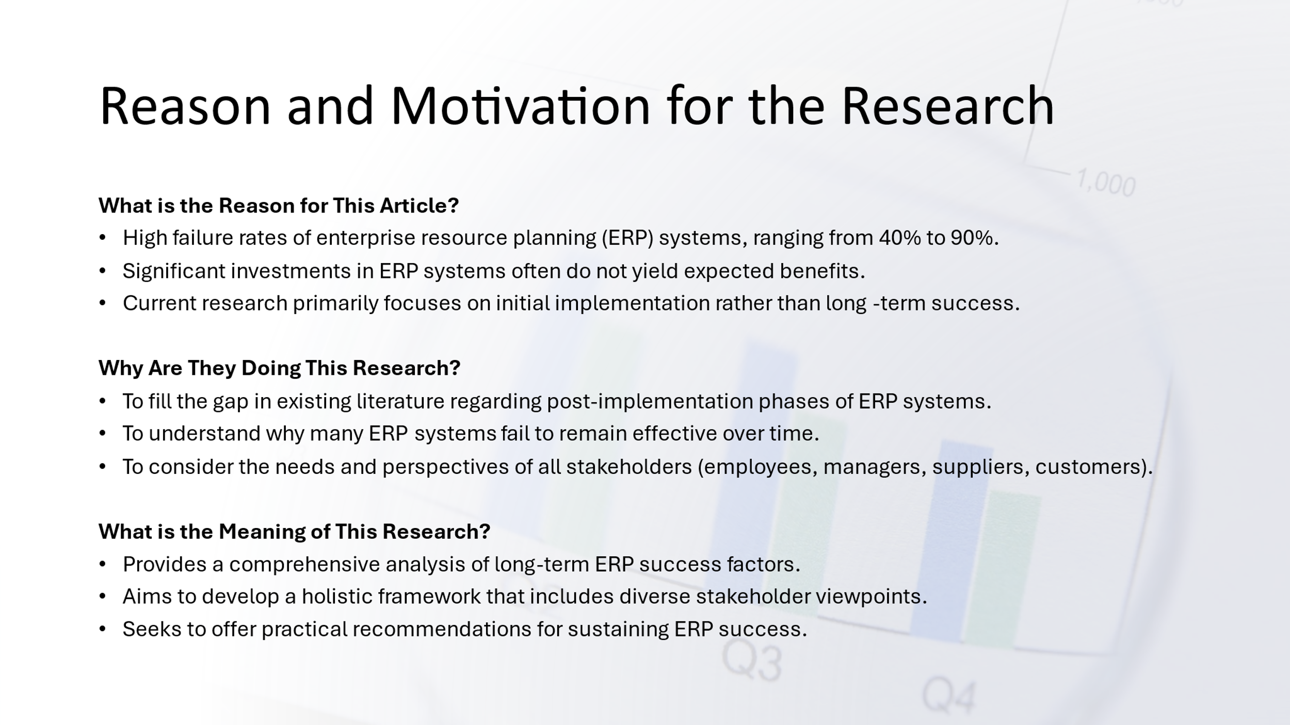

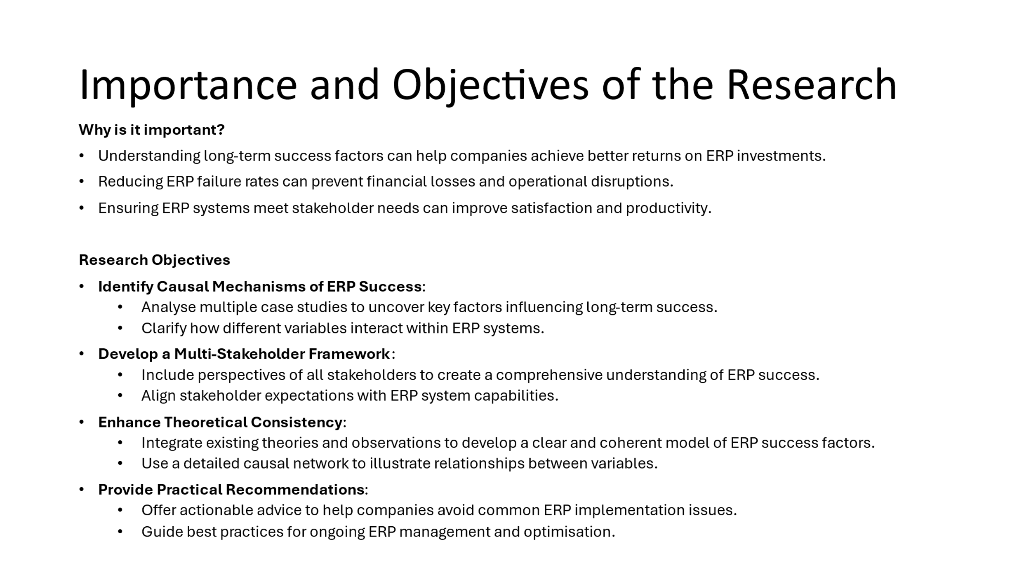

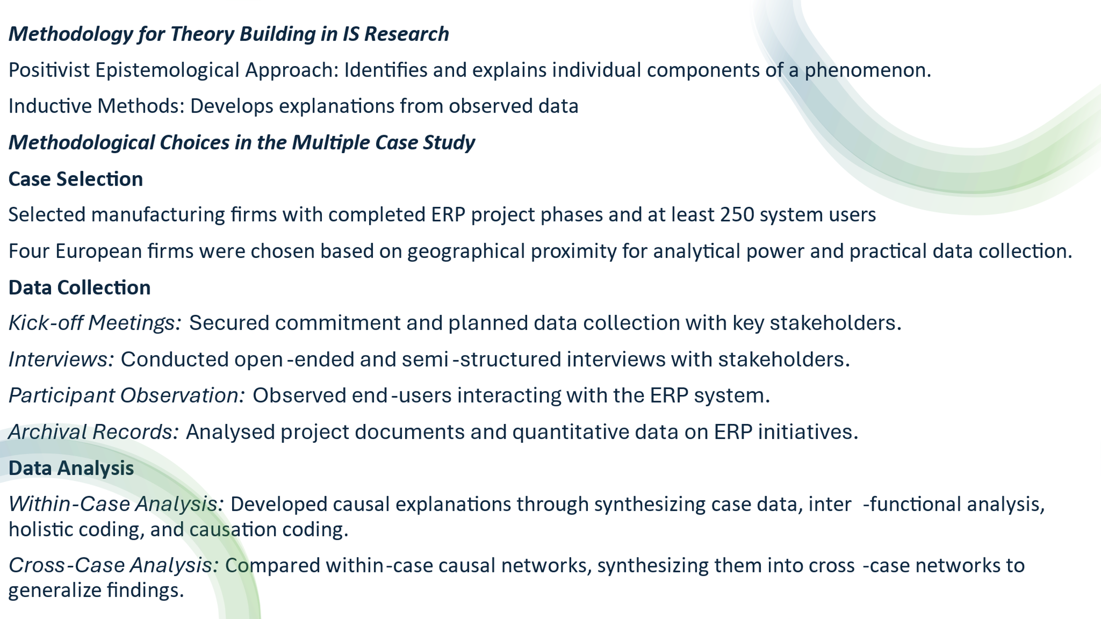

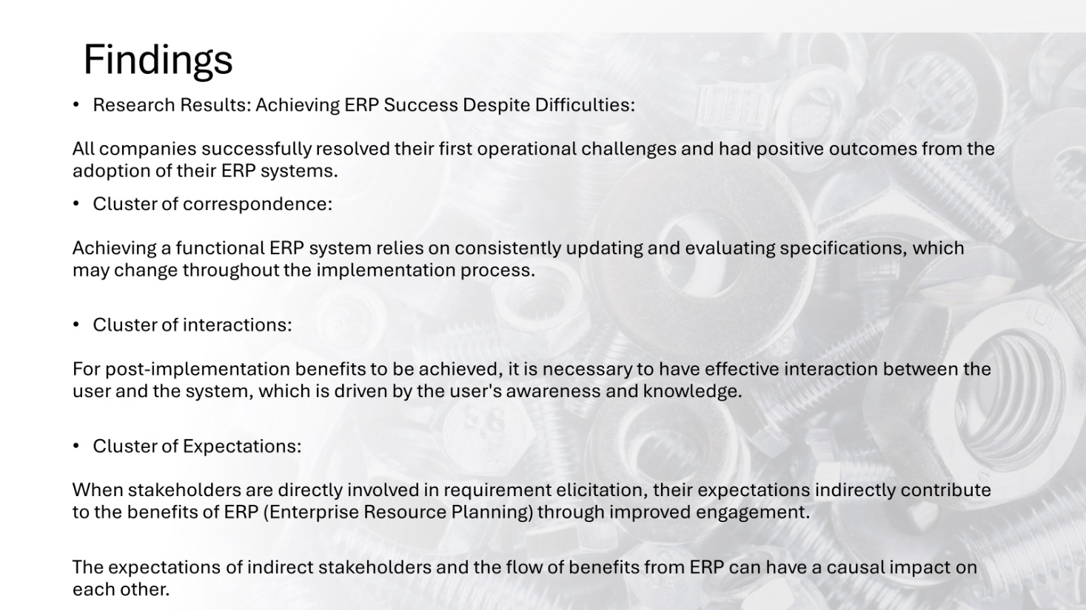
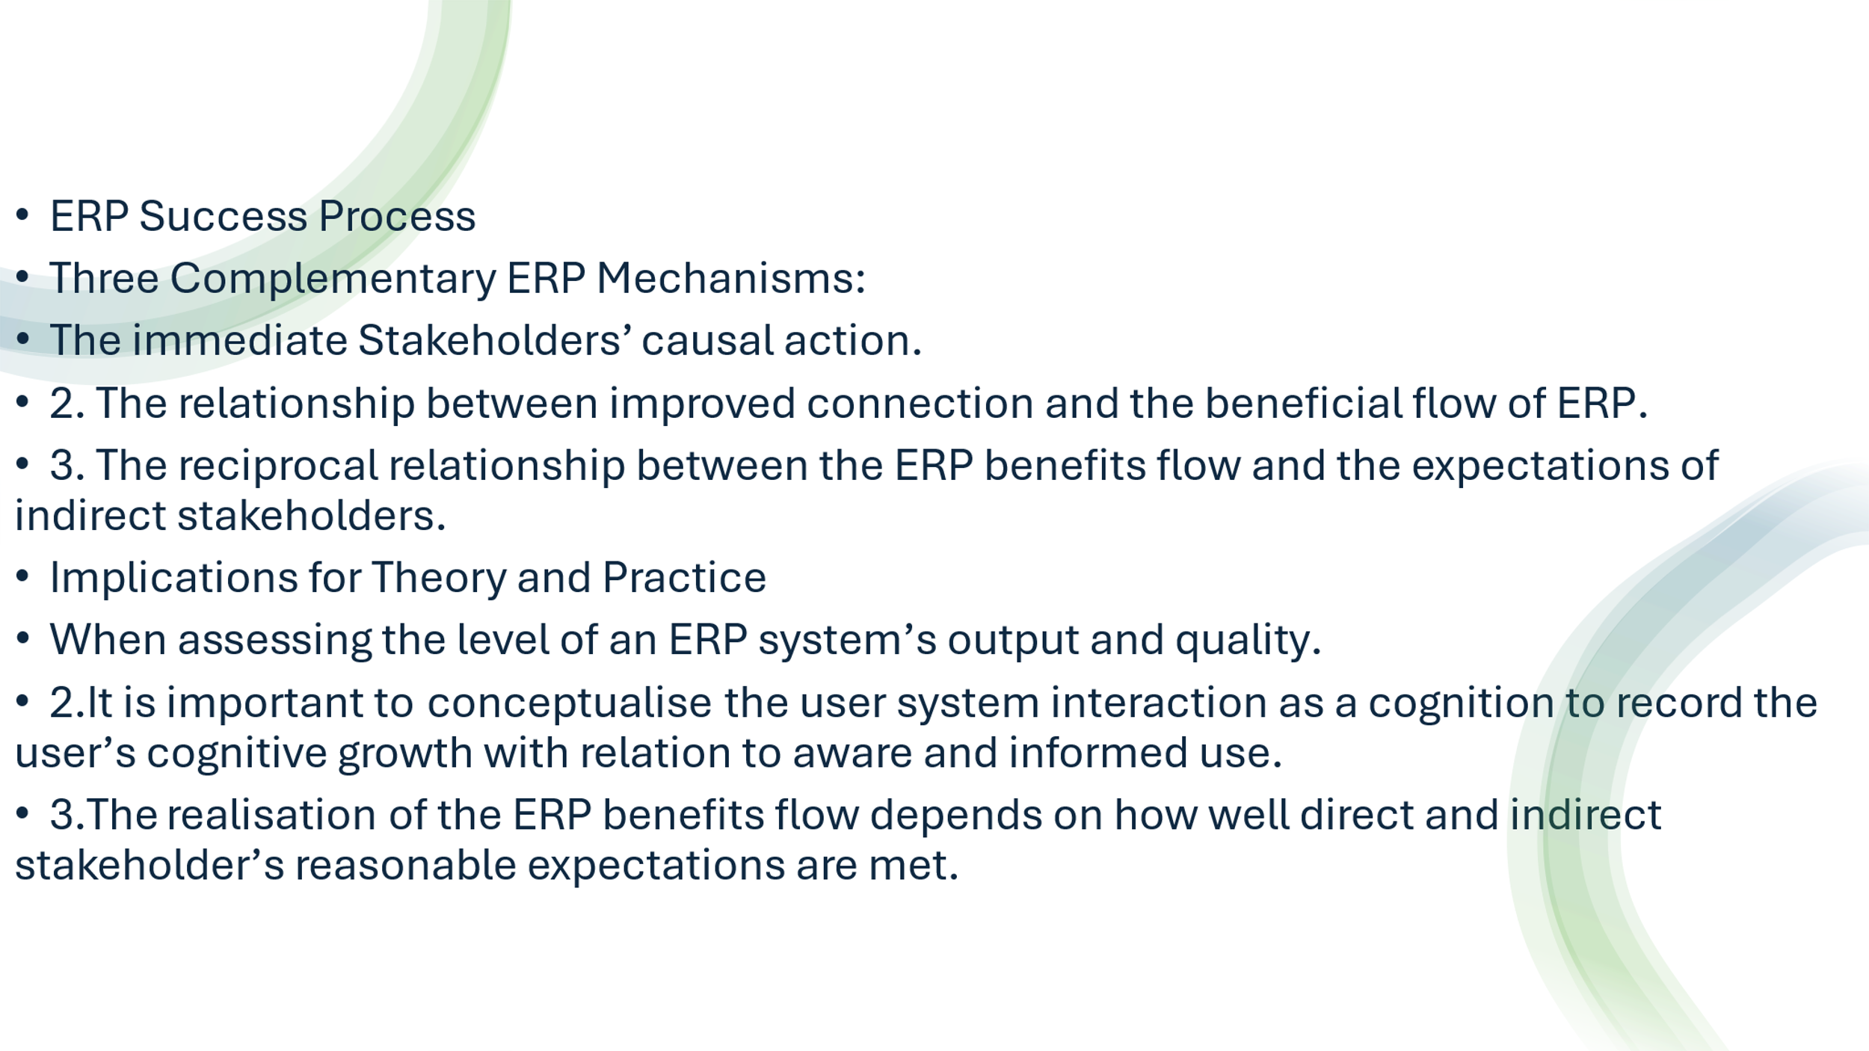
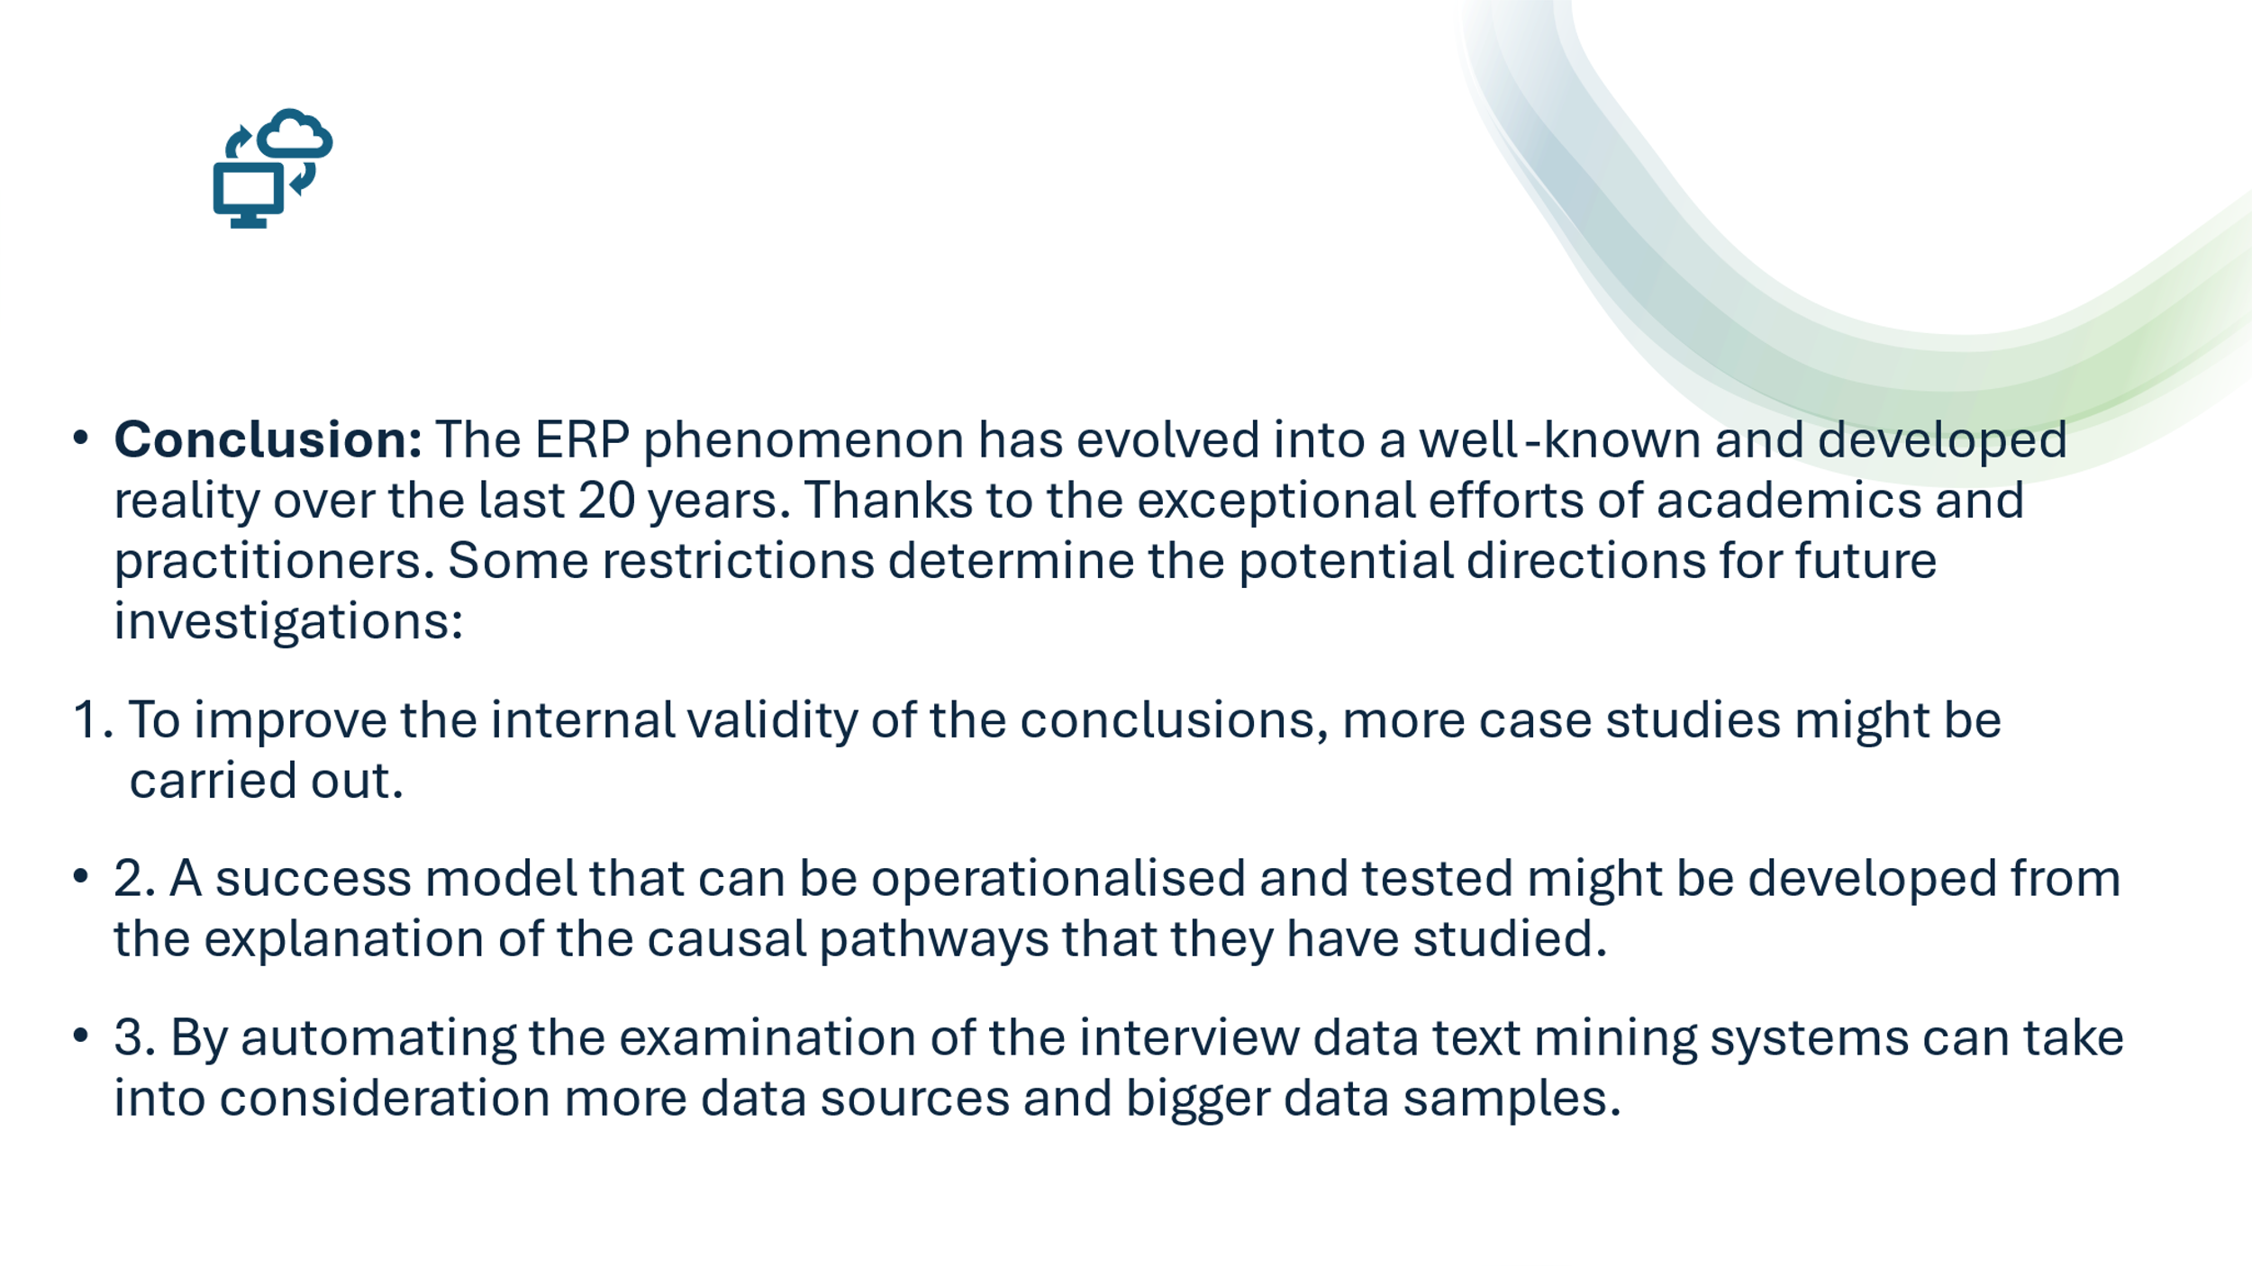


Precis:
Conclusion: Over the past 20 years, the exceptional work of scholars and professionals has made the ERP phenomenon a well-known and developed reality. However, the ERP acronym continues to be linked to both enduring overall advantages and instances of recurring setbacks, a financial collapse, and well-known legal actions. Despite a few noteworthy additions.
Long-term success of ERP initiatives is mainly neglected. The absence of the context-specific "multi-stakeholder perspective" boundary condition in addressing ERP success may be one of the primary causes of this gap. This may indicate theoretical inconsistency and deepens the gap between any theoretical explanation of ERP success and the empirical occurrence of such a phenomenon. Utilise AI to anticipate maintenance requirements, optimise inventory, and forecast demand. Automate repetitive activities with machine learning algorithms to increase productivity and accuracy.
To explain why ERP success may occur, in this article they used several qualitative data analysis methodologies in conjunction with the inductive case-based theory-building methodology. As a result, they created an ERP success causal network that incorporates the boundary condition that many stakeholders overlook. Subsequent research endeavours ought to investigate ERP performance in a variety of situations and industries, scrutinising the impact of cultural and organisational disparities on the discerned causal mechanisms.

Reference: RESEARCH ARTICLE Why enterprise resource planning initiatives do succeed in the long run: A case-based causal network. Pierluigi ZerbinoID*, Davide Aloini, Riccardo Dulmin, Valeria Mininno

Appendix :2

Strategic Management

Assignment: Second Part

Of

Task-1

Student’s Name: Bikash Roy
Student ID: 2010168
Module Code: LCMB7003_LON
Term: 2
Lecturer’s Name: Dr Hoang Nguyen

RESEARCH ARTICLE: PLOS ONE
Executive Summary: As for we asked to choose an article to do our group presentation with slides & Precis and summarise the article without our own opinion. Our chosen article was ‘PLOS ONE’ and effect of ERP research.
1. Introduction and Author's Argument of ERP Research: The study by Pierluigi Zerbino, Davide Aloini, Riccardo Dulmin, and Valeria Mininno explores the reasons for the long-term success of Enterprise Resource Planning (ERP) programs, even in the face of the difficulties and complexities that are frequently related to them. The multi-stakeholder perspective is a crucial internal boundary condition that has not been sufficiently addressed by conventional ways to researching ERP performance, according to the authors. This neglect has led to discrepancies in comprehending the primary causes of success by generating a gap between theoretical expectations of ERP performance and the reality of its implementation.
To solve this, the authors create a causal network that explains the mechanisms underlying ERP success using a case-based, inductive methodology. When assessing ERP success which they define as the efficient use of the ERP system and the data it produces to accomplish desired results over time—they stress the significance of considering the viewpoints of all pertinent stakeholders. This definition places more emphasis on the long-term operational and strategic benefits of ERP systems than it does on the technical installation success alone.
The study makes a distinction between ERP systems' present and future benefits. Savings on labour, inventory, and quality are examples of immediate gains that are operational and have a direct impact on profitability. Conversely, future benefits pertain to the intermediate and extended periods of consolidating ERP-enabled business practices. These benefits encompass managerial, strategic, and organisational aspects that have an indirect impact on profitability. In summary, this research contributes to a better understanding of the causal factors underlying ERP performance and gives insightful managerial advice to assist steer ERP programs towards sustained success.
2.Explanetion of Necessity of ERP and Motive of Research: Packages for enterprise resource planning (ERP) have a wide range of applications for both internal and external business activities. Thus, the effective implementation and utilisation of ERP systems are essential to the existence and performance of organisations. The examination of ERP project outcomes and issues that was carried out with the support of an ERP systems vendor is presented in this paper. There were two main research questions answered. First, how successful are businesses with ERP at various stages of their endeavours, and what is the relationship between various performance metrics? (That is, is it possible for failure to come after early success and vice versa?) Secondly, what are the issues that ERP adopters face during the implementation and deployment process, and how do these issues connect to the results? The results demonstrated that the effectiveness of ERP systems varies depending on when it is measured and that there may be only a tenuous relationship between success at one moment and success at another. Businesses encounter issues throughout the whole ERP system life cycle, and many issues that arise later had their roots earlier but were overlooked or left unfixed. These results imply that scholars and businesses might benefit from adopting inclusive definitions and a variety of success metrics, as well as paying close attention to the early detection and resolution of issues. (Learning from adopters’ experiences with ERP problems encountered and success achieved, M Markus, S Axline, D Petrie, SC Tanis. Journal of information technology, 2000 Taylor & Francis)
Establishing an enterprise resource planning (ERP) system successfully is not difficult, despite the enormous amount of work required. Before implementing ERP to its fullest extent, your organisation must develop a success plan. nevertheless, "be ready for your staff to be disrupted, your organisation to be reengineered, and your productivity to decline before the payoff is realised." ERP implementation is a new business endeavour that needs cooperation to be successful; it's not just installing software. Companies must involve every employee and completely, absolutely sell the idea to them for ERP to be successful. A successful implementation requires involving, supervising, rewarding, and retaining staff members who have worked or will work closely with the system. If everyone isn't on the same page and supports the ERP deployment completely, it won't go as intended. This was the situation of a soft drink bottler who tried to cut expenses but didn't recognise the importance of the people who depended on them so much. (Erp Implementation Failure: A Case Study, T Barker & M N Frolick, Dec 2006)
To address these problems, the research topic "Why does ERP success occur?" is addressed in this work.
There is a significant issue when ERP projects fall short of user expectations. Using causal elements present during an implementation as predictors, some research creates an Adaptive Neuro Fuzzy Inference System (ANFIS) model to predict the crucial ERP outcome, "User Satisfaction." The models were trained and tested using data from a variety of businesses that had adopted ERPs. ANFIS is contrasted with ANN and MLRA, two other prediction methods. The findings demonstrate that ANFIS surpasses ANN and MLRA, which have errors of 0.85 and 0.86, respectively, in outcome prediction, with an error (RMSE) of 0.277. It is anticipated that this study will give managers and academics standards for predicting ERP outcomes ex ante, allowing corrective efforts to reroute failing projects. (Predicting ERP User Satisfaction-an Adaptive Neuro Fuzzy Inference System ‘ANFIS’ Approach, C Venugopal, S P Devi, K S Rao. Intelligent Information Management, July 2022)
3. Sum of the Research: ERP post-implementation success is defined here as the efficient use of the ERP system and the data it produces to realise the anticipated benefits flow over time from the viewpoint of all relevant stakeholders. This does not include the technical installation success or any associated data (such as time estimates, cost overruns, or project management KPIs). From now on, to save space, they refer to "ERP success" instead of “ERP post-implementation success”. Regarding the benefits, they distinguish as follows:
Benefits resulting from early ERP-enabled business practice adoption, system improvements, and/or information generated by the system are referred to as immediate benefits. They are operational and have a direct impact on profitability, such as lowering labour, inventory, and quality expenses.
Future benefits: advantages related to the adoption of ERP-enabled business practices in the medium and long terms, as well as advantages from changes made to the system and/or the data it produces. They comprise most advantages that have an indirect impact on profitability, advantages for managers (such better decision-making), strategic advantages (like assistance to expansion strategies), organisational advantages (like enhanced organisational learning), and potential advantages (like upcoming ERP-enabled investment opportunities).
4. Conclusion: Based on the results, we used the Theory of Effective Use and the Expectation-Confirmation Theory to support the existence of the primary Causal Chains. We contend that the conjoint and synergistic effects of ERP installation may lead to post-implementation success. causal mechanisms at play in relation to ERP specifications, user and stakeholder cognitions anticipations. Thus, this publication advances our comprehension of the rationale behind theoretical provides some implications for the ERP post-implementation success theorisation based on the ERP success criterion.
These constraints provide the basis of potential directions for future investigation. Initially, further case studies might be carried out to improve the conclusions' internal validity. Second, a success model that can be operationalised and evaluated might be developed from the explanation of the causal pathways we examined. This could pave the path for a verified model to be applied empirically. Third, to account for more data sources and larger data samples, the interview data analysis can be automated with the use of text mining technologies.

5. References:
- RESEARCH ARTICLE Why enterprise resource planning initiatives do succeed in the long run: A case-based causal network. Pi Zerbino, D Aloini, Ri Dulmin, V Mininno, Dec 2021
- Learning from adopters’ experiences with ERP problems encountered and success achieved, M Markus, S Axline, D Petrie, SC Tanis. Journal of information technology, 2000 Taylor & Francis
- Erp Implementation Failure: A Case Study, T Barker & M N Frolick, Dec 2006
- Predicting ERP User Satisfaction-an Adaptive Neuro Fuzzy Inference System ‘ANFIS’ Approach, C Venugopal, S P Devi, K S Rao. Intelligent Information Management, July 2022

