
Group Project
Joseff Samuel Davies

May 13, 2024
University of Wales Trinity Saint David

Executive Summary

With more than 200 employees, the Energybuild Coal Mine in Glynneath, South Wales, is one of the last deep coal mines remaining in the United Kingdom. Facing challenges with ageing machinery, frequent breakdowns, and missed production targets, the mine experienced low worker morale. To address these issues, Energybuild introduced a new maintenance shift schedule aimed at improving equipment uptime, workplace safety, and asset longevity.
Introduction to maintenance shifts
The new maintenance shifts meant assigning detailed tasks to a group of employees to carry out the maintenance. The Tasks to be performed were things like changing oil filters, greasing all points on machine, checking for leaks, and testing functions across various machines like the JCM, Bolter 1 and 2, Shuttle Car, and Stamler.
The main 3 aims of the project were to Maximize Equipment Uptime as proactive maintenance minimizes unplanned downtime, enhancing production efficiency. Enhance Workplace Safety: Regular checks prevent equipment failures, reducing the risk of workplace accidents. The 3rd aim was to Prolong Asset Lifespan: Systematic maintenance extends equipment life, lowering repair and replacement costs.
2 Change management approaches were used:
Lewin’s Force Field Analysis: Identified driving and restraining forces, emphasizing the need for improved employee satisfaction, extended asset lifespan, and enhanced safety.
Kotter’s 8-Step Change Model: A structured framework guided the change implementation, from creating urgency to embedding the change in the company culture.
The strategies used when implementing this was:
- Establishing Urgency and Building Coalitions: Emphasized the need for change due to low morale and frequent machine breakdowns.
- Strategic Vision and Effective Communication: Developed and communicated a clear vision to reduce downtime through posters and meetings.
- Removing Barriers: Addressed resistance by involving employees in decision-making and providing necessary training.
- Achieving Short-term Wins and Sustaining Momentum: Adjusted bonus targets and incentives to motivate employees and maintain momentum.
- Embedding the Change: Ensured maintenance shifts became routine through consistent scheduling and adherence.
The results shown from this project was that Energybuild overcame initial resistance by involving employees and addressing their concerns, as well as conducted training sessions to equip employees with necessary maintenance skills. The data showed a gradual decrease in downtime, validating the effectiveness of the maintenance shift strategy
To conclude, the implementation of maintenance shifts at Energybuild Coal Mine has improved operational efficiency, safety, and profitability. Despite initial challenges, the project has shown positive results, including reduced downtime and increased employee morale. Following structured change management frameworks, Energybuild achieved its goals and ensured sustainable operations in the competitive energy sector.

Table of Contents
Executive Summary 1
Introduction 4
List of figures 5
Main Findings 7
Gantt Chart 7
3 Main Aims of implementing these maintenance shifts. 9
Lewin’s force field analysis 9
Kotter’s 8 step change model 11
Step 1 – Creating a sense of urgency. 12
Step 2 – Forming a guiding coalition. 12
Step 3 – Create a strategic vision. 12
Step 4 – Communicate the change vision. 13
Step 5 – Remove barriers to change. 13
Step 6 – Generating short term wins. 13
Step 7 – Sustaining change as a continuous process. 14
Step 8 – Incorporating change into organisational culture. 14
Reflection 14
Conclusion 16
Bibliography 17

Introduction
Glynneath, the South Wales town of the Neath valley, is home to the centuries old Energybuild Coal Mine. The largest and one of the last deep coal mines in the United Kingdom is this one. There are over 200 workers at the firm, ages 17 to 72. Teams of knowledgeable miners, fitters, electricians and deputy managers run the mine five days a week, working 24-hour shifts to guarantee maximum coal production. Premium anthracite coal, valued for its purity and high carbon content, is produced by Energybuild. Additionally, the washery at Energybuild guarantees that the coal may be cleaned, divided, and sized to meet client specifications. With a history based on adaptability and creativity, Energybuild is a key player in the provision of energy resources while upholding the customs and legacy of the Welsh mining community.
The ageing machinery and 24-hour manufacturing meant that frequent repairs were necessary, which had an adverse effect on output goals and numbers. The fact that production bonus objectives were not being met was also having a detrimental effect on workers' enthusiasm to work. In an attempt to recover the lost downtime and increase output, this would likewise result in "quick fixes," but in the long term, this would just cause additional issues and lengthier downtime. In order to perform general maintenance on all of the machines and to ensure that all of the oils were checked and that all of the machines were greased throughout the week, management decided to implement roster shifts that would allow for weekend maintenance as well as corrective maintenance on the weekends. Throughout the week, between the hours of 10 and 12 am, these maintenance shifts would take place. The benefits of this project extend beyond the immediate improvements in equipment uptime and productivity. A well-maintained fleet of mining equipment will reduce the overall operational costs associated with repairs and replacements. Also, a focus on maintenance will enhance the safety of the mining environment, reducing the risk of accidents caused by equipment failures. In the long term, this project will contribute to the sustainable and profitable operation of the coal mine, ensuring that it remains competitive in a challenging and dying industry.

List of figures
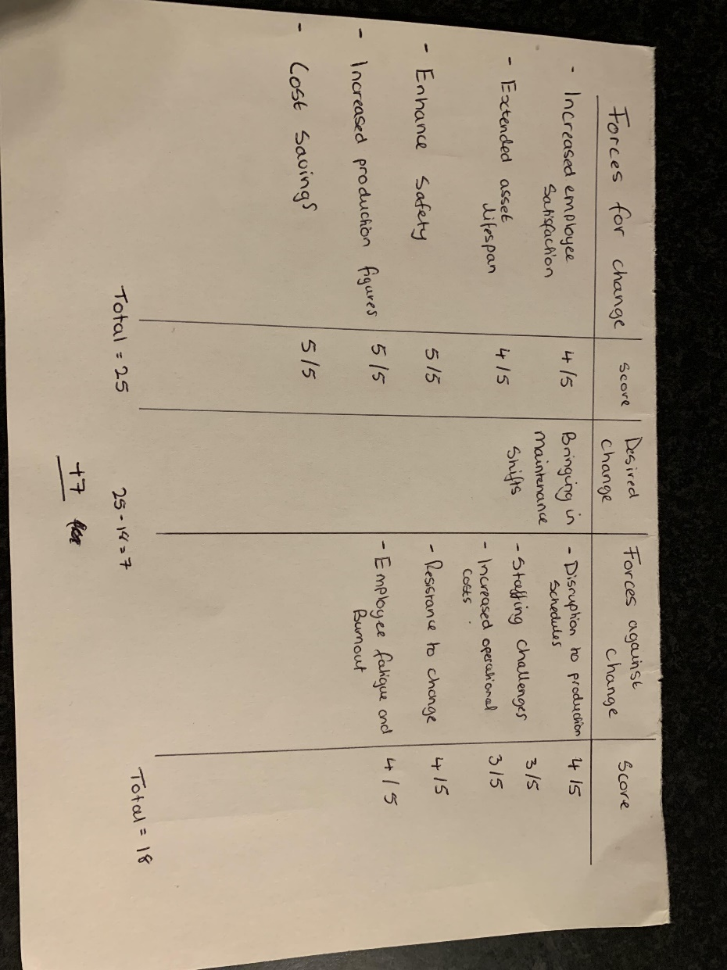
Figure 1
(Teaching guide: Lewin's force field analysis)
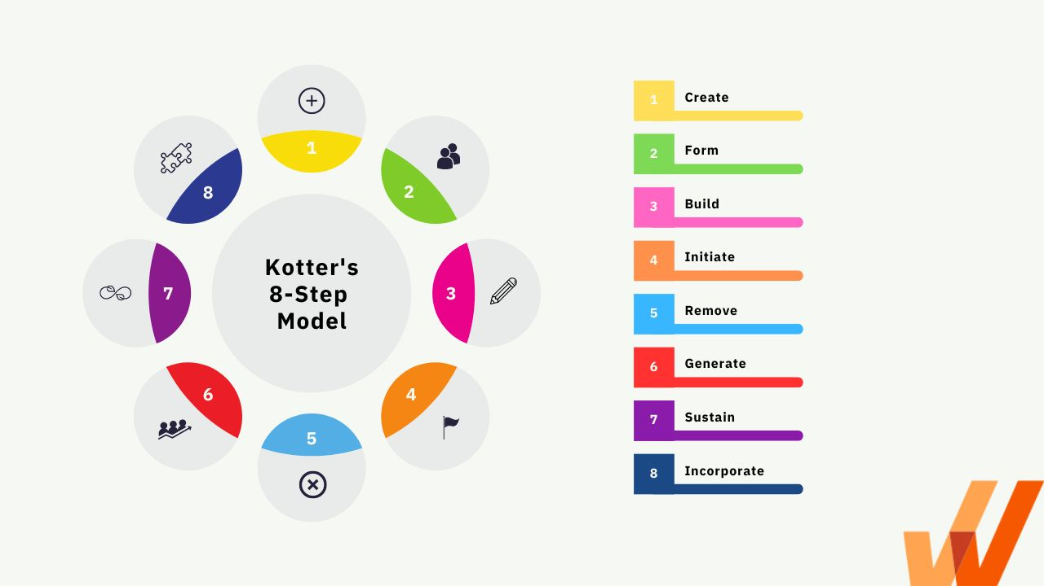
Figure 2
(Jain,2023)

Figure 3 – Data collected from recording all downtime throughout the month against the targeted downtime

Figure 3- Data collected from 4 months after the original 6-month period to ensure that these maintenance shifts kept happening and progress was still being made.

Figure 5- Gantt chart showing how these maintenance shifts will be implemented through the week.

Main Findings

Gantt Chart

Figure 5

Task 1 – Maintenance on the JCM
Maintenance to be done within this 2-hour slot:
- Change all 5 oil filters.
- Grease all greasing manifolds and pins on machine.
- Check all picks and change if worn.
- Correct any leaks on machines.
- Check machine for any damage.
- Test all functions on machine.
- Check oil levels for different gearboxes and fill if required.
- Ensure centre chain is tensioned correctly if not adjust.

Task 2 – Maintenance on Bolter 1
Maintenance to be done within this 2-hour slot:
- Change all 4 oil filters.
- Grease all points on machine.
- Check machine for any leaks and repair if necessary.
- Test pressures on all 4 rigs and adjust if incorrect.
- Check machines oil levels and fill if necessary.
- Check machine for damage.
Task 3- Maintenance on Bolter 2
Maintenance to be done within this 2-hour slot:
- Change all 4 oil filters.
- Grease all points on machine.
- Check machine for any leaks and repair if necessary.
- Test pressures on all 4 rigs and adjust if incorrect.
- Check machines oil levels and fill if necessary.
- Check machine for damage.
Task 4- Maintenance on shuttle car
Maintenance to be done within this 2-hour slot:
- Check oil levels and fill if necessary.
- Perform a brake test.
- Grease all points on machine.
- Ensure all wheels are in good condition.
- Check machine for any leaks and repair if necessary.
- Check machine for any damage.
- Change all 4 oil filters.
Task 5- Maintenace on Stamler
Maintenance to be done within this 2-hour slot:
- Test charge pressure on pump.
- Change all 5 filters.
- Check oil levels and fill if necessary.
- Grease all points on machine.
- Check all picks on crusher are not worn and change if needed.
- Ensure chain is tensioned correctly if not adjust.
These are the tasks to be performed in the 2-hour slot given during the maintenance shifts, This amount of work is feasible to do within that 2 hour time slot as there would be a team of at least 4 craftsmen working on each machine. This process will be repeated every week and downtime will be monitored to ensure that this plan would work.

3 Main Aims of implementing these maintenance shifts.

- Maximising equipment uptime
The main goal of this is to ensure machinery and equipment are operational as much as possible outside of these maintenance shifts to maintain high production levels. Regular maintenance shifts allow for proactive identification and resolution of potential issues before they cause unplanned downtime. This keeps production lines running smoothly and efficiently.
- Enhancing workplace safety
The main goal for this aim is to ensure the workplace is as safe as it can be by systematically addressing maintenance needs. Scheduled maintenance helps prevent equipment failures that could lead to accidents or hazardous conditions. By maintaining machinery in optimal condition, the risk of injuries and safety incidents is significantly reduced.
- Prolonging asset lifespan
The main goal for this aim is to extend the lifespan of equipment and infrastructure through regular and systematic maintenance. Consistent maintenance prevents wear and tear from escalating into major issues, thus preserving the functionality and performance of assets over time. This reduces the frequency and cost of replacements and major repairs, and as all equipment and parts have a long waiting time in this industry its important equipment and machinery are maintained properly.
These aims collectively contribute to the overall efficiency, safety, and cost-effectiveness of operations within an organization, highlighting the importance of implementing well-structured maintenance shifts.

Lewin’s force field analysis
A structured framework for comprehending the dynamics of organisational change or projects is provided by Lewin's force field analysis. It creates two opposing forces out of the causes causing the change. One is a driving force that accelerates change, while the other is a restraining factor that impedes it. Employing this approach simplifies the process for businesses to pinpoint important factors and challenges when executing a transformation. This facilitates planning and helps you get past any initial difficulties. Additionally, because it is a straightforward method of analysis, it will be simpler for everyone in the business to comprehend the benefits and drawbacks of the change. This analysis approach may sometimes lead to division within the organisation and arguments about whether a project should be launched, or a change should be made. This would be problematic since, in order to successfully implement an organisational change, management and all leaders must work together to steer and lead the initiative and inspire other staff members to follow suit.
Figure 1
(Teaching guide: Lewin's force field analysis)

Forces for change
Increased employee satisfaction was used as employers can improve employee morale and job satisfaction by demonstrating to their workforce that they are committed to maintaining top-notch facilities and equipment by introducing maintenance shifts. When they work in a clean, safe atmosphere that encourages productivity, employees feel appreciated. This was rated a 4/5 as improving moral was a major factor that needed to be looked at withing this project due to lack of motivation in employees to work before starting this project. Extended asset lifespan was also a key factor when implementing this project as any spares for all the machines always have a lengthy waiting list as these machines are not used much in the UK and need to abide to mining regulations e.g all electrical equipment to be FLP. This means you could be waiting up to months for certain parts. Scheduled maintenance would help prolong the lifespan of equipment and infrastructure, maximizing the return on investment and reducing the need for costly repairs or replacements in the long run. Enhancing safety is also a positive due to the environment being quite unsafe usually any aspects of improving safety is a must and this is why it was rated 5/5. Although maintenance shifts require upfront investment in personnel and resources, they can result in significant cost savings over time. By preventing unplanned downtime, minimizing repair costs, and extending the lifespan of assets, organizations can achieve greater efficiency and profitability in their operations. Increasing production figures is also rated 5/5 as this was one of the main reasons this project needed to happen. Unfortunately, as a privately owned mine, as there are no major investors. The production of coal is what keeps the place open, and if production is down constantly and not hitting targets, this is when the mine is in danger of closing due to not being profitable and being able to fund the costly outgoings.
Forces against change
There were also some forces against this project. Disruption to production was the first one that come up as maintenance schedules would mean less time for production. This force against is a bit of a ‘bittersweet’ as even though at the start of this project there would be the same number of delays and maintenance shifts on top causing delays, you have to look further down the line and hopefully by doing these maintenance shifts, general downtime would decrease gradually. This is the reason this was rated 4/5. Staffing challenges are another problem as finding people to work these corrective maintenance shifts on the weekend would be hard due to lack of qualified people in the workforce. By making these employees work weekends as well it would also cause fatigue and burnout through the week which could possibly mean more people taking time off. Another problem could be resistance to change as nobody likes change as it breaks routine and for this project to work everybody must be on board.

These were the findings obtained by application of Lewin's force field analysis. The fact that the final score was positive from looking at figure 1 indicates that this project/change was necessary because the positives outweighed the negatives. Should the score be negative, it indicates that altering the current course would result in the negatives outweighing the advantages. If so, you would need to address the drawbacks before proceeding with the project’s implementation.

Kotter’s 8 step change model
When doing a project to do with a change in the workplace there are many different approaches to doing it. (Jain,2023) “Kotter’s 8-Step Change Model is a popular change management model that empowers organizations to tackle organizational change and digital innovation by mobilizing their employees to rapidly adopt and implement new processes, technology, and other organizational changes.” Energybuild followed Kotter’s 8 step model when doing this project.
Figure 2
(Jain,2023)

Step 1 – Creating a sense of urgency.
(Fishbane, 2017) “Urgency creates a sense of priority and motivates individuals to act quickly and decisively. It helps to build momentum and ensures that the change process moves forward smoothly. The longer it takes to implement changes, the more difficult it becomes to achieve the desired outcomes.” One of the most crucial elements in Kotter's eight-step change model is this one related to energy build. Employees were not motivated because of the outdated and frequently malfunctioning equipment, which left them with a lot of downtime during shifts. This caused low morale and motivation among the staff since they were not receiving bonuses as they did when the machine was newer. Maintenance shifts provided a glimpse of the future, where machines would be better maintained and experience less downtime.

Step 2 – Forming a guiding coalition.
(Truell, 2023) “A Guiding Coalition is a group of key individuals who come together to lead and drive change within an organization.” Step 2 involves selecting individuals who were born leaders and role models within the organisation, not necessarily managers. Four people were appointed, one each for the electrical, mechanical, and mining shifts. The 12 people selected from throughout the organisation had very various pay scales and other characteristics, which is beneficial to have because it encouraged people in different positions to join and contribute to this change.

Step 3 – Create a strategic vision.
(Tanner, 2023) “A successful change vision and strategy will identify the areas of change, provide clear and realistic targets for measuring success, and appeal to the long-term interests of organizational stakeholders.” This organisational adjustment had a straightforward change area: all machines would undergo preventative maintenance during the week and corrective maintenance on the weekends to reduce the likelihood of breakdowns during the workweek and restore output targets to their proper levels. Due to the poor condition of the machinery and the protracted—sometimes up to two months—waiting times for components in the coal mining business, the goal they set for results was to resume reaching targets within six months. The adjustment would be implemented promptly during the six months, so there would be a progressive decrease of downtime before then. The aim would be to reduce this downtime by 3 hours per month by performing maintenance every day. The average downtime for all 6 machines was between 20 and 30 hours every 120-hour week.

Step 4 – Communicate the change vision.
(Tanner, 2023) “This occurs when senior leadership and the guiding coalition (change management oversight team) create a sensible and appealing vision of the future that can be used for organizational decision making.” The twelve members of this "oversight team" met in the office to talk about this change with other members of management. Following a series of two-way talks, they concluded that the best course of action for informing the other employees about this change was to present a clear and concise picture in order to capture their interest and win them over. As a result, numerous posters detailing the hours of the maintenance shifts were up on the wall, and a roster comprising the names of the employees was created for the weekends. This list also included the rationale for the move, which was to increase output and by doing those employees would receive bonuses.

Step 5 – Remove barriers to change.
(Smith, 2020) “Many organisational change initiatives fail because of lack of attention to removing the barriers to change that exist within the organisation. The existing infrastructure, policies and procedures bind the organisation and its employees to the current state. They are part of the fabric of the organisation, developed and embedded over many years. The organisation must make adjustments to enable change to happen.” The managers and oversight team examined any possible obstacles inside the company throughout this phase. The first thing examined was employee’s attitudes withing the workplace. Any changes would be met with resistance from the older generation of miners, who have a tendency to be obstinate and set in their ways. The only way to change the mindset of the older generation would be to give them a voice in every aspect of the setup, such as choosing the personnel for their rostered weekend shift and the time maintenance should take place. Lack of training and skills in the workplace was found to be another impediment to transformation. Because the company operates the last remaining coal mine in Wales, it is far more difficult to teach employees how to operate and maintain the equipment. One of the main issues energybuild face is that there aren't many courses available for apprentices to go on because courses nowadays are only general fitting and not in detail for the machines that Energybuild own. Due to a lack of personnel in every department of the workplace, inexperienced miners, electricians, and fitters occasionally have to mentor apprentices. In certain situations, this results in operator error, and in other situations, improperly fixed machinery, which causes longer downtime and lower production.

Step 6 – Generating short term wins.
(Barlow, 2019) “A win is any measurable, unambiguous performance improvement that helps the organization move toward the overall change goal”. The productivity bonus was reduced from 80 metres of yardage per week to 60 metres per week in order to guarantee that workers are inspired to continue working on the change and perform comprehensive maintenance on the machines. Given that maintenance and breakdown repairs would take two hours each day, employees would have a higher possibility of receiving bonuses because downtime would be at its highest at the beginning of the transition. Because workers must forfeit one weekend per month for corrective maintenance on the roster, Sunday overtime changed to two times your hourly rate instead of 1.5 times, for all workers.

Step 7 – Sustaining change as a continuous process.
(Haggerty, 2024) “Sustained changes provide a stable foundation for future improvements and innovations, allowing the organization to build on the change rather than backtrack. Each successful change imparts valuable knowledge, skills, attitudes and new behaviours that equip your people for ongoing success.” It’s a must to set progressive targets throughout a change. The reason for this is because you can compare the changes' advancement over time, this also aids in determining how successful the change is. These goals were monthly objectives that the managers had set. The management had set a goal of reducing the monthly average downtime by three hours. The downtime would be reevaluated after six months to determine whether this time frame may still be shortened. The daily maintenance and roster shifts would continue in the hopes of minimising downtime, but the weekly meterage incentive for metres cut would rise back up to a manageable amount (approximately 85–100m) in order to motivate staff and keep them from growing complacent.

Step 8 – Incorporating change into organisational culture.
(Deng & Murph, 2024) “Effective change management is key to fostering a culture of trust, collaboration, and adaptability.” Following the implementation of this change, it was crucial that employees adhered to it and did not revert to their previous practices. It was essential that maintenance times be consistent both during and after the procedure to foster the concept of forming the change into a habit. This meant that all departmental managers had to accommodate the specified timeframes. Also, it meant that maintenance work on the weekends would continue without any pressure from management to cut coal in order to boost output statistics.

Reflection
After reflecting on the first step when management made this adjustment, the majority of workers felt empowered to follow suit because it would benefit management (meeting goals and turning a profit) as well as provide opportunity for workers to meet their goals and receive bonuses. This meant that it provided another great reason to implement the change.
The second step to Kotter’s 8 step change model was also successful upon reflection because the individuals selected were excited about the maintenance shift as they could see both the business and personal rewards which helped motivate everyone to join and drive the change. Gaining motivation from employees during this project is a huge aspect of making the project successful and from individual’s responses and reactions it showed that they were interested in making this change.
Before this project underwent, the vision to lessen downtime was clear and lowering the amount of downtime was a must, but after reflecting, reducing the average downtime 3 hours per month was a bit too much as seen in figure 3.
After communicating the change barriers, it was clear to see that this part of the project was successful as everybody understood the weekend roster and weekday maintenance. Upon positive reflection everyone was happy to do the maintenance throughout the week, but some were unhappy to do weekend overtime. There were many reasons for this as the older generation said that as they were getting paid from their pension it would mean that all overtime work done on the weekend would not be worth it as when it come to the end of the month, it would put them in a higher tax bracket overall. Some of the younger generations were also unhappy to do this overtime as they had hobbies like rugby and football on Saturdays. To solve this problem a meeting occurred with these employees that were unhappy to try and find ways around this problem. It was set that if you worked a Saturday or Sunday, it would mean that you could get a holiday back for either day which meant they would not go over the tax threshold. Another solution was making these weekend shifts shorter therefore instead of doing 9 hours shifts on the weekend, you would have to do 7-hour shifts which meant that the younger generation would be able to go to work and get back in time for their hobbies. This shift was from 5am-12. Also offering x1.5 for Saturday shifts and x2 for Sunday shift was another solution during these short-term wins, as everyone was more eager to work on Sundays. Additionally, it increased the likelihood of hitting the production bonus during the week as bigger jobs were getting done on the weekends. All employees were also given a week course from Joy mining employees, which took the fitters and electricians through all the hydraulic and electrical drawings for the machines and also gave maintenance sheets, so employees had something to follow if they were unsure of things like greasing points and oil levels on the machines. Miners also had a course on how to operate the machines correctly, this meant there was no excuse for operators’ error as they had been shown the correct way to do things.
Figure 3 shows that at the start of the project more preventative maintenance had to be done to ensure that the project was started off on the right step. When doing this maintenance as people were less inclined to work weekends before the short-term wins were suggested it meant that some of this maintenance had to be done during the week which increased downtime. But as solutions were made to this the decrease of downtime throughout the week was evident as shown from figure 3. April’s result from figure 3 was due to a major breakdown which nothing could have been done about it until it happened as the whole front of the Continuous miner had to be changed. This Breakdown took 10 hours to change therefore from looking at the graph, if this unusual occurrence didn’t happen, then the average downtime for the month would have been decreasing from march’s average downtime.
Upon reflection of step 7, even though these targets were not being reached every month, there was a continuous gradual decrease in downtime every month (apart from Aprils anomalous result) which as a collective, management were happy about therefore there was no need to change any of the targets set. Also, everybody after 3 months was happy to work their rostered shifts on the weekend as they could see that this project was not only decreasing downtime which made everybody less frustrated, but also giving them a better chance of getting their productivity bonus.
Figure 4 shows that step 8 was successful as maintenance shifts in Energybuild became a habit and as the results showed the average downtime throughout the next 4 months which were monitored showed that the downtime was at a stage where all management were happy. Due to old machinery, 12 hours downtime was a stage where management were satisfied. The bonus gradually increased back up to 95m of cutting per week and due to the decrease of downtime this figure of 95m was reasonable to hit.

Conclusion
Implementing maintenance shifts at Energybuild Coal Mine has been a strategic decision aimed at improving overall operational efficiency, safety, and profitability. This Project addresses three primary objectives: maximizing equipment uptime, enhancing workplace safety, and prolonging asset lifespan. These goals support the sustainable operation of the mine, which is critical in an industry characterized by high operational costs and lengthy lead times for equipment and parts replacements. Energybuild attempts to prevent unscheduled downtime by proactively addressing equipment concerns through the implementation of regular maintenance shifts. By being proactive, they can sustain high output levels by keeping machinery in good condition. By enabling the early identification and repair of possible issues, scheduled maintenance lowers the risk of equipment breakdowns that might interfere with operations. This improves the mine's overall efficiency in addition to facilitating the smooth operation of the production process. Enhancing workplace safety is another important goal of the maintenance shift plan. The mining environment is dangerous by nature, and equipment malfunctions can raise the chance of mishap considerably. Frequent maintenance lowers the chance of accidents caused by malfunctioning equipment by ensuring that all machinery is operating as intended. By addressing maintenance needs, Energybuild can create a safer working environment for its employees, which is paramount in an industry with strict safety regulations. Prolonging asset lifespan is also a key goal. Regular and systematic maintenance prevents minor issues from escalating into major problems that require expensive repairs or replacements. Given the long lead times for parts in the coal mining industry, this is particularly important. By extending the lifespan of its equipment, Energybuild can reduce the frequency and cost of major repairs and replacements, thereby achieving greater cost-effectiveness in its operations. But this transition did come with some difficulties as the initial resistance to change was a significant barrier. Many employees, particularly the older generation, were set in their ways and resistant to altering their routines. To overcome these difficulties, management had to negotiate with the employees and explain the benefits of the new maintenance schedule and to demonstrate how it would ultimately make their work easier and safer. Another challenge was the need for adequate training. The specialized nature of the mining equipment meant that employees required specific training to carry out maintenance tasks effectively. Energybuild addressed this by organizing training sessions with the company that owns all of the mine’s machine, ensuring that all employees were equipped with the necessary skills to perform maintenance correctly. Despite these initial challenges, the gradual decrease in downtime, as shown in the data gathered, suggests that the maintenance shift strategy has given positive results. Short-term wins, such as adjusting bonus targets and enhancing weekend shift incentives, have been critical in motivating employees and demonstrating the benefits of the new maintenance schedule. These short-term successes have helped build momentum and support for the change initiative. Energybuild saw some disruptions and an adjustment period when maintenance shifts were implemented, but the long-term advantages are starting to show. By adhering to structured change management frameworks, such as Lewin's Force Field Analysis and Kotter's 8-Step Change Model, and addressing both the technical and human aspects of the transition, Energybuild is set to achieve its goals of increased productivity, enhanced safety, and prolonged equipment lifespan.
The project shows the value of perseverance, patience, and strategic planning in an organisational change. As Energybuild continues to continue its maintenance processes, the mine is expected to operate more efficiently, safely, and sustainably, securing its place in the competitive energy resource sector.

Bibliography

Teaching guide: Lewin’s force field analysis (no date a) AQA. Available at: AQA | Teaching guide: Lewin's force field analysis (Accessed: 15 May 2024). Image made by myself but idea taken from reference.
Jain, M. (2023) Kotter’s 8-step change model (+advantages & disadvantages), The Whatfix Blog | Drive Digital Adoption. Available at: Kotter’s 8-Step Change Model (+Advantages & Disadvantages) (whatfix.com) (Accessed: 15 May 2024).
Fishbane, M.D. (2017) Why change is so hard: The power of habit in the human brain, GoodTherapy.org Therapy Blog. Available at: GoodTherapy | Why Change Is So Hard: The Power of Habit i... (Accessed: 16 May 2024).
Truell, P. (2023) Creating a guiding coalition: A key element in change management models, businesschangestrategies.com. Available at: Creating a Guiding Coalition: A Key Element in Change Management Models (businesschangestrategies.com) (Accessed: 11 May 2024).
Tanner, R. (2023) Leading change (step 3) – develop a change vision and strategy, Management is a Journey® – Helping you with the people side of the businessTM. Available at:Leading Change (Step 3) – Develop a Change Vision and Strategy – Management is a Journey® (Accessed: 16 May 2024).
Tanner, R. (2023b) Leading change (step 4) – communicate the Change Vision, Management is a Journey® – Helping you with the people side of the businessTM. Available at: Leading Change (Step 4) – Communicate the Change Vision – Management is a Journey® (Accessed: 16 May 2024).
Smith, C. (2020) Eliminating the barriers to change, The Big Picture People. Available at: Eliminating the barriers to change (thebigpicturepeople.co.uk) (Accessed: 16 May 2024).
Barlow, C. (2019) Generating short-term wins, Generating Short-term Wins. Available at: Generating Short-term Wins (synergetics.com) (Accessed: 16 May 2024).
Haggerty, M. (2024) The strategic imperative of sustainment in change management, Prosci. Available at: The Strategic Imperative of Sustainment in Change Management (prosci.com) (Accessed: 16 May 2024).
Deng, C. and Murph, M. (2024) Building a strong organizational culture through effective change management, The Jabian Journal. Available at : Building a Strong Organizational Culture Through Effective Change Management | The Jabian Journal (Accessed: 16 May 2024).

