
Scripting and programming concepts
ACCA5036

March 27, 2026
DANU IAZMEDOV - 2319509
UNIVERSITY OF WALES TRINITY SAINT DAVID – QUAY PLACE CAMPUS

Contents
Introduction 2
Requirements Analysis 3
MoSCoW Table 4
Decomposition Chart 5
Software Design and Development 6
Flowchart 7
Flowchart Definition 8
Flowchart Purpose 9
IPO Table 10
Pseudocode 12
Pseudocode Definition 25
Pseudocode Purpose 26
Data Structures 37
Data Structures Used 38
Programming Constructs 41
Programming Constructs Used 42
Python Modules and Libraries 43
Python Modules and Libraries Used 44
Role of Testing in Software Environment 45
Type of Errors in Programming 46
Example of Test Cases 53
Challenges Faced 54
Future Improvements 55
Self-Reflection 56
References 57

Introduction
The challenges faced by Bright Minds Academy illustrate a common issue within small educational institutions that rely on manual administrative processes. The tutoring center initially operated with a paper-based logbook system, wherein tutors recorded equipment bookings by writing their name, the equipment required, and the date of use in a spiral notebook. This method was adequate during the center’s early stages of operation when student enrolment and staff numbers were manageable.
However, as the academy expanded, the limitations of this manual system became increasingly apparent. The paper logbook proved incapable of preventing double bookings, as demonstrated by an incident in which two tutors independently reserved the same laptop for the same date, leading to lesson disruption and staff frustration. Furthermore, the physical nature of the notebook introduced additional complications, including illegible handwriting, damaged pages, and the absence of efficient search functionality. Staff were unable to quickly determine equipment availability for a specific date or retrieve a comprehensive history of bookings associated with a particular student without manually reviewing each entry.
The academy's requirements are modest. Stakeholders do not seek complex database systems, analytical tools, or automated reporting. Instead, they require a straightforward digital solution that eliminates double bookings, maintains accurate records of equipment assignments, and provides instant search capabilities by student name or equipment type. The desired system must be reliable, user-friendly, and designed to accommodate the operational realities of a small tutoring center without introducing unnecessary technical complexity.

Link to Project

Requirements Analysis
Bright Minds Academy requires a digital solution to replace its existing paper-based equipment booking process. The following analysis outlines the functional requirements that must be addressed by the proposed software system.
Equipment Management
The system must enable staff to add new equipment items to the inventory using simple, descriptive names such as "Laptop 1" or "Projector A". No technical identifiers or serial numbers should be required. The system must prevent duplicate equipment entries and reject empty inputs, ensuring the inventory remains accurate and free from errors.
Booking Recording
Staff must be able to assign a specific piece of equipment to a named student for a particular date. The system must automatically check whether the selected equipment is already booked on the requested date and prevent double bookings from occurring. A confirmation step should allow staff to review booking details before finalizing the record. Each booking must be assigned a unique identifier and timestamp for reference and traceability.
Viewing Booking Records
Staff require the ability to view all current bookings in a clear and organized format. The system should present bookings grouped by date, displaying which equipment is reserved and for which student. An additional summary of equipment status should indicate whether each item is available or booked on specific dates, allowing staff to assess availability at a glance.
Search Functionality
The system must provide a search feature that allows staff to enter a student name or equipment name and instantly retrieve all related bookings. The search should be case-insensitive and return full details of matching records, including equipment name, student name, booking date, and booking identifier.
Design Considerations
The system must be self-contained, requiring no external database or internet connection. It should be intuitive for non-technical users, with clear menus, simple prompts, and helpful messages. Data storage must be handled through in-memory structures such as dictionaries and lists, ensuring the system remains lightweight and portable while fulfilling all core operational requirements.

MoSCoW Table
Must Have | Should Have | Could Have | Won’t Have
- Add new equipment items with duplicate prevention.  - Record bookings with student name and date.  - Prevent double bookings automatically.  - View all bookings organized by date.  - View equipment availability status.  - Search by student name or equipment name.  - Display full booking details. | - Basic date format validation.  - Confirmation prompt before saving.  - Timestamps on all bookings.  - Screen clearing between menus. | - Short message pauses for readability.  - Edit or cancel existing bookings.  - Mark equipment as unavailable.  - Save data to a text file. | - External database.  - User login system.  - Maintenance tracking.  - Internet connection required.  - Automated notifications.  - Reporting features.

Decomposition Chart

Software Design and Development
Design and development represent foundational elements of software engineering that determine whether a software solution achieves user adoption or rejection [1]. From an academic perspective, design embodies the principle of empathy, requiring the software engineer to consider the end-user's context, constraints, and cognitive load prior to implementation. Effective design anticipates user fatigue, time pressure, and the distinction between voluntary and obligatory software interaction [2]. Well-executed design eliminates the need for instructional manuals by presenting intuitive interfaces where controls align with user expectations and language remains accessible. The software is adapted to the user rather than requiring user adaptation to the software.
Development constitutes the fulfilment of commitments established during the design phase [3]. While conceptual prototypes may present aesthetically pleasing interfaces, the development process addresses the complexities of error handling, including malformed inputs, unintended repeated actions, and edge case scenarios. The implementation must produce robust systems capable of maintaining functionality under varied operational conditions [4]. Within this context, version control systems such as Git and integrated development environments like PyCharm serve as essential infrastructure, providing the structural framework necessary to sustain code reliability throughout the software development lifecycle.
The most effective design and development remain imperceptible to end-users [5]. Users perceive functionality through successful task completion, responsive interfaces, and graceful error recovery rather than through recognition of underlying architectural sophistication. This invisible reliability constitutes the primary objective of software engineering [6]. Optimal software solutions earn user trust not through technical complexity or feature abundance, but through consistent, predictable performance that respects user time and objectives. Trust emerges from a commitment to building systems that operate quietly and faithfully, prioritizing user needs over technical demonstration [7].

Flowchart
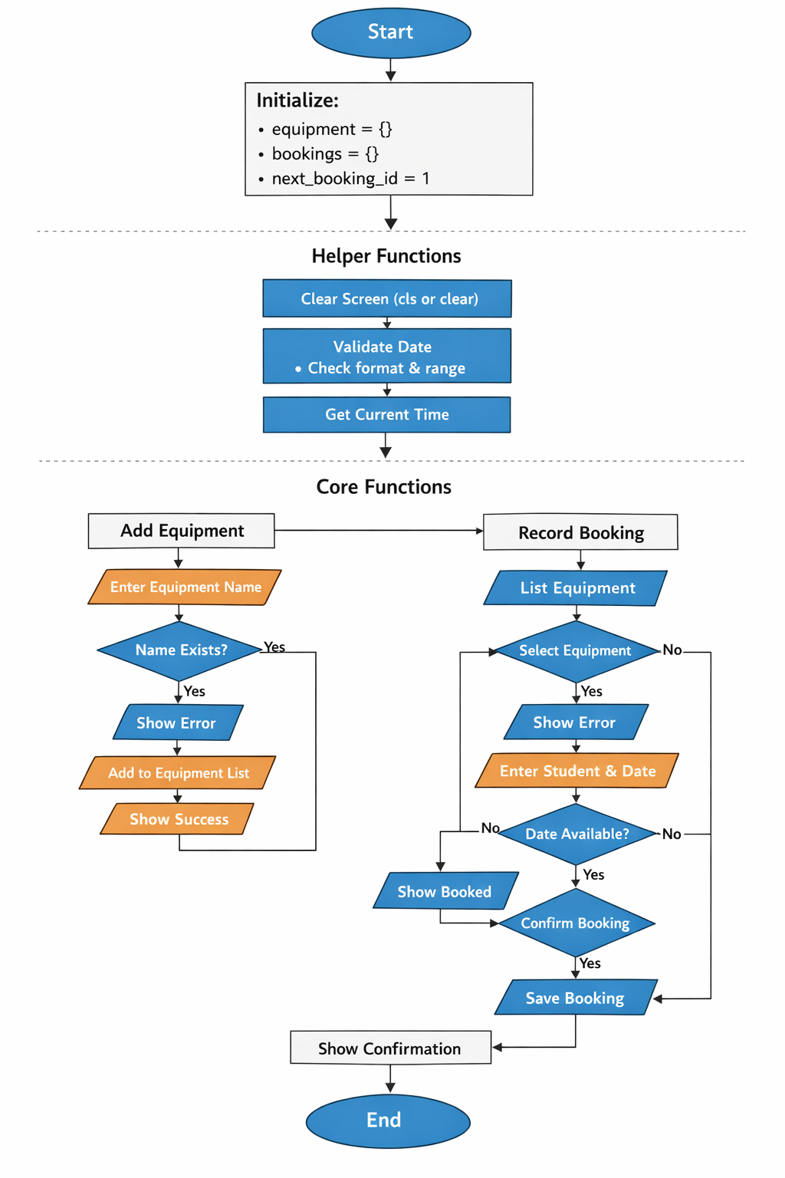
Figure 1

Flowchart Definition
A flowchart provides a visual representation of a process from initiation to completion [8]. It employs a standardized set of geometric shapes connected by directional arrows to illustrate sequential steps, decision points, and potential outcomes. This methodology is conceptually analogous to providing navigational directions to an unfamiliar location, translating abstract logic into an accessible visual format [9].
Each shape within a flowchart conveys distinct meaning [10]. Rectangles denote actions or processes, such as retrieving user input or persisting data to storage structures. Diamonds represent decision points requiring conditional evaluation, typically yielding binary outcomes that determine subsequent pathways [11]. Arrows indicate the directional flow of logic, creating a comprehensive map comprehensible to individuals regardless of their programming expertise.
The utility of flowcharts resides in their capacity to compel comprehensive process analysis [12]. Beyond mapping the optimal operational path, effective flowcharting necessitates consideration of alternative scenarios including error conditions, invalid inputs, and edge cases. A robust flowchart accounts for user omissions, incorrect selections, and resource conflicts, ensuring all potential branches are explicitly defined [13].
Flowcharting requires no specialized software tools; manual drafting using pen and paper remains entirely sufficient [14]. The iterative process of sketching, revising, and refining reveals logical gaps and structural inconsistencies before implementation begins. This preliminary analysis prevents the translation of flawed logic into executable code [15].
Flowcharts function not as documentation artifacts but as cognitive tools [16]. Their purpose is to facilitate understanding of the intended system architecture prior to construction. They serve as thinking instruments that clarify objectives and expose weaknesses in the planning stage, enabling more reliable implementation outcomes [17].

Flowchart Purpose
The flowchart served as a critical planning instrument throughout the development of the equipment booking system. Prior to implementation, the designer possessed only a general understanding of the program's intended functionality without a clearly articulated logical structure. The act of constructing the flowchart necessitated systematic consideration of every operational decision point within the system. Questions emerged organically through this process: how should the system respond to duplicate equipment entries, empty student name fields, or conflicting booking dates? Each such condition was subsequently represented as a decision node requiring explicit resolution.
The flowchart facilitated early error detection that would have been considerably more costly to address during implementation. An initial design error involved the placement of double-booking validation after record persistence. Visualizing the process flow revealed that such validation must precede data storage to serve any meaningful purpose. Rectifying this issue required minutes of revision to the diagram, whereas discovering the same flaw within completed code would have demanded substantially greater rework.
Beyond logical validation, the flowchart enforced rigorous consideration of the user experience. Each directional arrow represented a distinct path through the system, requiring deliberate handling of non-standard scenarios including invalid inputs and unintended actions. The flowchart format precludes the assumption that users will consistently follow intended pathways, compelling comprehensive coverage of all potential interactions.
For this project, which sought to replace an unreliable manual system with a dependable digital alternative, the flowchart provided essential structural guidance. It established a logical blueprint that informed implementation decisions and served as a reference point throughout development, ensuring consistency between initial design intentions and final software behavior.

IPO Table
Functions | Input | Process | Output
Add Equipment | Equipment name entered by user | Validate input is not empty. Check if equipment already exists in dictionary. Add new equipment with available flag and empty bookings list. | Confirmation message with timestamp or error message
Record Booking | Equipment selection, student name, booking date | Display available equipment list. Get user choice. Validate student name not empty. Validate date format DD/MM/YYYY. Check for double booking on same equipment and date. Confirm details with user. Generate unique booking ID. Create booking dictionary with timestamp. Save to bookings dictionary and equipment bookings list. Increment booking ID counter. | Booking confirmation with ID, equipment, student, date, timestamp or error message
View All Bookings | User menu selection | Check if equipment exists. Loop through all equipment to collect bookings. Group bookings by date. Sort dates chronologically. Compile equipment status with booked dates. | Display of bookings grouped by date. Display of each equipment with booked dates or available status
Search Bookings | Search term entered by user | Validate search term not empty. Convert term to lowercase. Loop through all bookings in master dictionary. Check student names and equipment name fields for matches. Collect matching bookings into results list. | Display of matching bookings with full details including ID, equipment, student, date, timestamp or no results message
Main Program | Menu choice from user | Display main menu with options. Route to appropriate function based on choice. Handle invalid selections. Repeat until exit chosen. Display welcome and goodbye messages. | Program interface with menu. Function execution. Program termination on exit

Pseudocode
START

// ========== DATA STORAGE ==========
CREATE empty dictionary called equipment
CREATE empty dictionary called bookings
SET next_booking_id = 1

// ========== HELPER FUNCTIONS ==========

FUNCTION clear_screen
IF operating system is Windows THEN
RUN "cls" command
ELSE
RUN "clear" command
ENDIF
END FUNCTION

FUNCTION display_header(title)
DISPLAY line of 60 equals signs
DISPLAY title with spacing
DISPLAY line of 60 equals signs
END FUNCTION

FUNCTION validate_date(date_string)
SPLIT date_string by "/" into parts

IF number of parts is not 3 THEN
RETURN false
ENDIF

IF length of first part is not 2 OR
length of second part is not 2 OR
length of third part is not 4 THEN
RETURN false
ENDIF

TRY to convert parts[0] to day (integer)
convert parts[1] to month (integer)
convert parts[2] to year (integer)

IF day is less than 1 OR day greater than 31 THEN
RETURN false
ENDIF
IF month is less than 1 OR month greater than 12 THEN
RETURN false
ENDIF
IF year is less than 2024 THEN
RETURN false
ENDIF

RETURN true

CATCH value error
RETURN false
ENDTRY
END FUNCTION

FUNCTION get_current_time
GET current time formatted as HH:MM:SS
RETURN time string
END FUNCTION

// ========== CORE FUNCTIONS ==========

FUNCTION add_equipment
CALL display_header with "ADD NEW EQUIPMENT"

INPUT equipment_name
REMOVE extra spaces from ends

IF equipment_name is empty THEN
DISPLAY error message
WAIT for Enter key
RETURN
ENDIF

IF equipment_name exists in equipment dictionary THEN
DISPLAY equipment already exists message
ELSE
ADD new entry to equipment:
equipment[equipment_name] = {
"available": true,
"bookings": empty list
}
DISPLAY success message with current time
ENDIF

WAIT for Enter key
END FUNCTION

FUNCTION record_booking
CALL display_header with "RECORD NEW BOOKING"

IF equipment dictionary is empty THEN
DISPLAY no equipment message
WAIT for Enter key
RETURN
ENDIF

DISPLAY "Available equipment:"
CREATE equipment_list from equipment keys

FOR each item in equipment_list with index starting at 1
DISPLAY index and equipment name
ENDFOR

TRY to get equipment choice from user
CONVERT input to integer
IF choice between 1 and length of equipment_list THEN
SET equipment_name = equipment_list[choice - 1]
ELSE
DISPLAY invalid selection
WAIT for Enter key
RETURN
ENDIF
CATCH value error
DISPLAY please enter a number
WAIT for Enter key
RETURN
ENDTRY

INPUT student_name
REMOVE extra spaces

IF student_name is empty THEN
DISPLAY error message
WAIT for Enter key
RETURN
ENDIF

INPUT booking_date
REMOVE extra spaces

IF booking_date is empty THEN
DISPLAY error message
WAIT for Enter key
RETURN
ENDIF

IF validate_date(booking_date) is false THEN
DISPLAY invalid date format message
WAIT for Enter key
RETURN
ENDIF

FOR each booking in equipment[equipment_name]["bookings"]
IF booking["date"] equals booking_date THEN
DISPLAY equipment already booked message
WAIT for Enter key
RETURN
ENDIF
ENDFOR

DISPLAY booking summary with equipment, student, date
INPUT confirmation (yes/no)

IF confirmation is not "yes" AND not "y" THEN
DISPLAY booking cancelled
WAIT for Enter key
RETURN
ENDIF

CREATE new_booking dictionary with:
"id" = next_booking_id
"student" = student_name
"equipment" = equipment_name
"date" = booking_date
"timestamp" = get_current_time()

ADD new_booking to bookings dictionary with key next_booking_id
APPEND new_booking to equipment[equipment_name]["bookings"] list

INCREMENT next_booking_id by 1

DISPLAY booking confirmed with ID, equipment, student, date, timestamp

WAIT for Enter key
END FUNCTION

FUNCTION view_all_bookings
CALL display_header with "EQUIPMENT BOOKING STATUS"

IF equipment is empty THEN
DISPLAY no equipment message
WAIT for Enter key
RETURN
ENDIF

CREATE empty dictionary called bookings_by_date

FOR each equipment_name and its info in equipment
FOR each booking in info["bookings"]
SET date = booking["date"]
IF date not in bookings_by_date THEN
CREATE empty list for this date in bookings_by_date
ENDIF
ADD equipment_name, student, id to this date's list
ENDFOR
ENDFOR

IF bookings_by_date is not empty THEN
DISPLAY "Current Bookings:"
FOR each date in sorted bookings_by_date
DISPLAY date with calendar emoji
FOR each booking in that date's list
DISPLAY booking ID, equipment, student name
ENDFOR
ENDFOR
ELSE
DISPLAY no current bookings
ENDIF

DISPLAY "Equipment Status:"
FOR each equipment_name in equipment
CREATE list of booked_dates from equipment[equipment_name]["bookings"]
IF booked_dates is not empty THEN
DISPLAY equipment_name and list of dates it's booked
ELSE
DISPLAY equipment_name and "Available"
ENDIF
ENDFOR

DISPLAY last updated time
WAIT for Enter key
END FUNCTION

FUNCTION search_bookings
CALL display_header with "SEARCH BOOKINGS"

INPUT search_term
REMOVE spaces and convert to lowercase

IF search_term is empty THEN
DISPLAY error message
WAIT for Enter key
RETURN
ENDIF

CREATE empty list called results

FOR each booking in bookings values
IF search_term is in lowercase student name OR
search_term is in lowercase equipment name THEN
ADD booking to results
ENDIF
ENDFOR

IF results is not empty THEN
DISPLAY number of results found
FOR each booking in results
DISPLAY booking ID, equipment, student, date, timestamp
ENDFOR
ELSE
DISPLAY no bookings found message
ENDIF

WAIT for Enter key
END FUNCTION

FUNCTION show_menu
CALL clear_screen
DISPLAY header with 60 equals signs
DISPLAY "BRIGHT MINDS ACADEMY - EQUIPMENT BOOKING SYSTEM"
DISPLAY current time from get_current_time()
DISPLAY total equipment count and total bookings count
DISPLAY separator line
DISPLAY "1. Add New Equipment"
DISPLAY "2. Record New Booking"
DISPLAY "3. View All Bookings"
DISPLAY "4. Search Bookings"
DISPLAY "5. Exit"
DISPLAY footer with 60 equals signs
END FUNCTION

FUNCTION save_data
GET current datetime formatted as YYYY-MM-DD HH:MM:SS
DISPLAY auto-save message with timestamp
PAUSE for 1 second
END FUNCTION

// ========== MAIN PROGRAM ==========

FUNCTION main
CALL clear_screen
DISPLAY welcome message
DISPLAY system start time
DISPLAY loaded equipment count
PAUSE for 2 seconds

SET running = true

WHILE running is true
CALL show_menu

INPUT choice

IF choice equals "1" THEN
CALL add_equipment
ELSE IF choice equals "2" THEN
CALL record_booking
ELSE IF choice equals "3" THEN
CALL view_all_bookings
ELSE IF choice equals "4" THEN
CALL search_bookings
ELSE IF choice equals "5" THEN
DISPLAY goodbye message
CALL save_data
DISPLAY farewell
SET running = false
ELSE
DISPLAY invalid choice message
PAUSE for 1.5 seconds
ENDIF
ENDWHILE
END FUNCTION

// Start the program
CALL main

END

Pseudocode Definition
Pseudocode represents an informal method of algorithm design that enables programmers to articulate computational logic using natural language constructs rather than strict programming syntax [18]. This approach functions as a planning mechanism analogous to navigating an unfamiliar route, wherein the traveler identifies key landmarks and directional decisions prior to executing the journey itself.
Within the context of software development, pseudocode allows the designer to express operations such as conditional evaluations and iterative processes using plain language statements [19]. Examples include expressions like "check if the laptop is already booked" or "loop through all the bookings and find matches". While such statements are not executable by a computer, they remain comprehensible to human developers and serve as a bridge between conceptual understanding and technical implementation [20].
The primary value of pseudocode lies in its capacity to reveal logical flaws before substantial development effort is invested [21]. By externalizing thought processes into a readable format, designers can evaluate the coherence of their algorithms, identify missing conditions, and restructure inefficient approaches at minimal cost. This preliminary analysis prevents the propagation of flawed logic into later development stages where correction becomes significantly more time-consuming [22].
Pseudocode intentionally lacks the precision of formal programming languages. Its value derives not from syntactic correctness but from its accessibility and flexibility as a thinking tool [23]. The format encourages rapid iteration, allowing designers to refine their approach without the overhead of debugging syntax errors. This emphasis on conceptual clarity over technical perfection constitutes the fundamental utility of pseudocode in the software development process [24].

Pseudocode Purpose
The pseudocode constructed for the equipment booking system functions as a comprehensive logical blueprint, delineating the complete architecture of the program prior to implementation. At its foundation, the pseudocode establishes the data storage structures, including an equipment dictionary, a bookings dictionary, and a booking identifier counter. These foundational elements serve as the structural basis upon which all subsequent functionality depends.
The pseudocode organizes system operations into distinct functional categories. Helper functions address supporting operations such as interface management, date validation, and timestamp generation. Core functions implement the primary business logic, encompassing equipment addition with duplicate prevention, booking recording with double-booking detection, chronological viewing of grouped bookings, and search functionality across records.
The logical structure exhibits a systematic flow characterized by comprehensive validation at each decision point. Prior to any data persistence operation, the pseudocode specifies explicit checks for empty inputs, duplicate entries, date conflicts, and user confirmation. Each function maintains singular responsibility, and each conditional branch possesses clearly defined outcomes. This structural clarity ensures that all operational pathways, including error conditions and edge cases, receive explicit handling.
The main program loop follows a straightforward pattern of menu display, user input capture, and function dispatch based on selection. The pseudocode renders the entire system architecture visible, documenting every operational step, decision fork, and potential error scenario before any executable code is written. This preliminary documentation enables early identification of logical gaps and structural inconsistencies, preventing their propagation into implementation where correction would require substantially greater development effort.

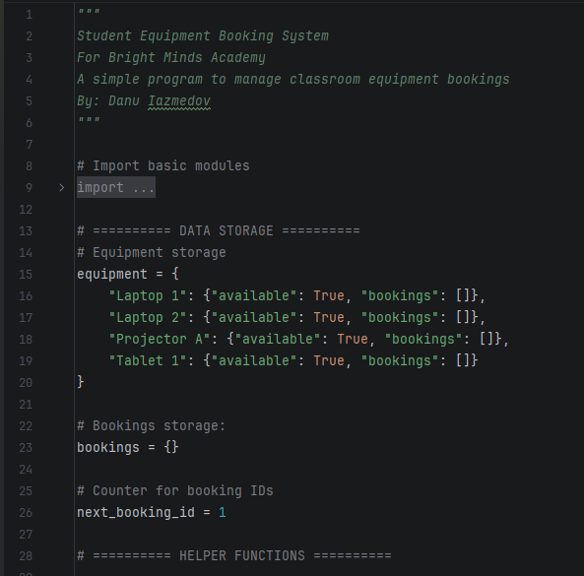
Figure 2
This section defines the data storage structures. The equipment dictionary holds all equipment items with their availability and bookings list, the bookings dictionary stores all reservation records, and ‘next_booking_id’ tracks unique identifiers for new bookings.

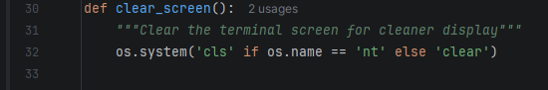
Figure 3
This function clears the terminal screen using the appropriate command keeping the interface clean and uncluttered.

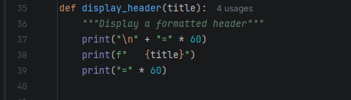
Figure 4
This function prints a formatted header with the given title surrounded by lines of equals signs, creating clear visual separation between different sections of the program.
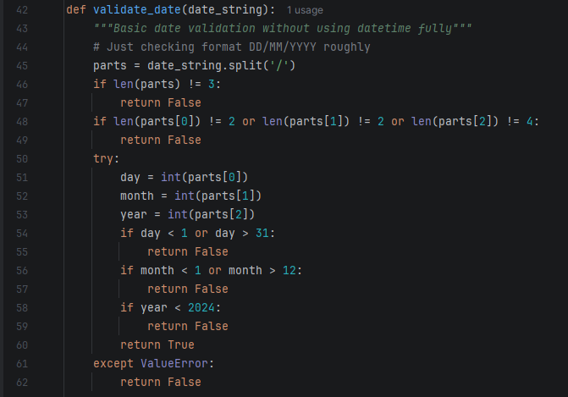
Figure 5
This function checks whether a date string follows the DD/MM/YYYY format and contains valid day, month, and year values, returning True if valid and False otherwise.

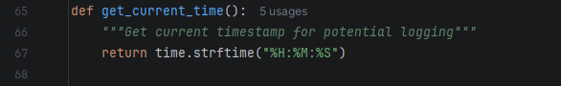
Figure 6
This function returns the current time as a formatted string in hours, minutes, and seconds for timestamping bookings and status updates.

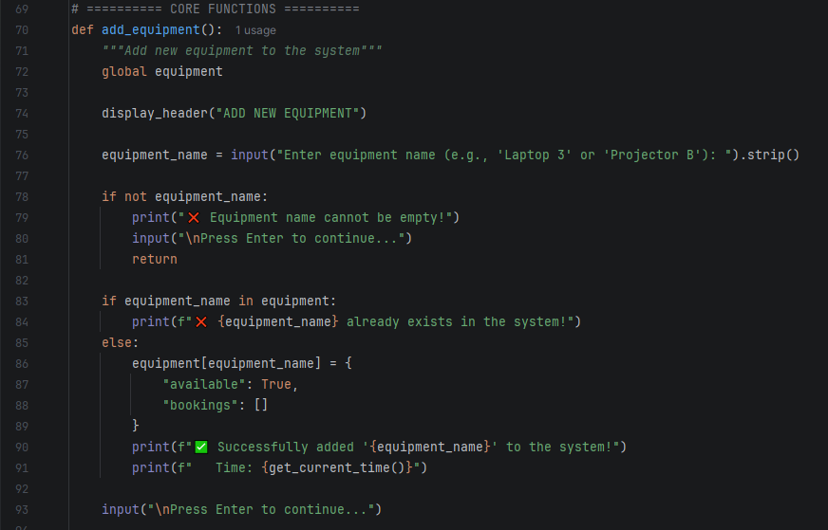
Figure 7
This function adds new equipment to the system after checking that the name is not empty and does not already exist, then creates a new entry in the equipment dictionary with an available flag and an empty bookings list.

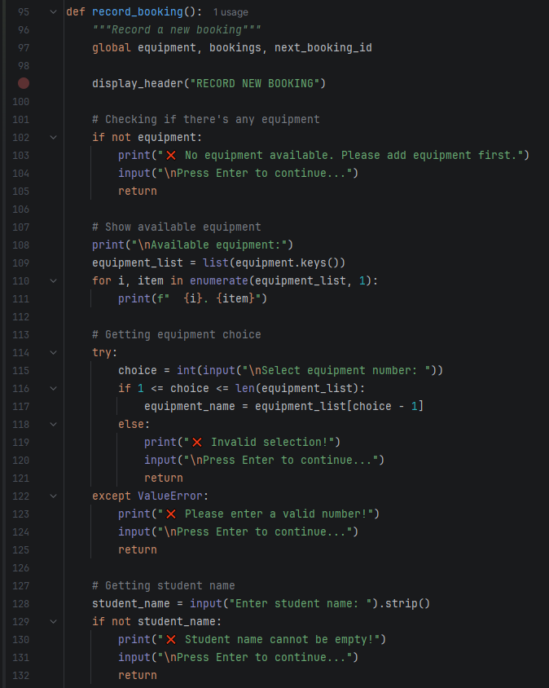
Figure 8
This function displays available equipment, gets user selection, captures student name and date, validates the date format, checks for double bookings, confirms with the user, then creates and saves the booking to both data structures.
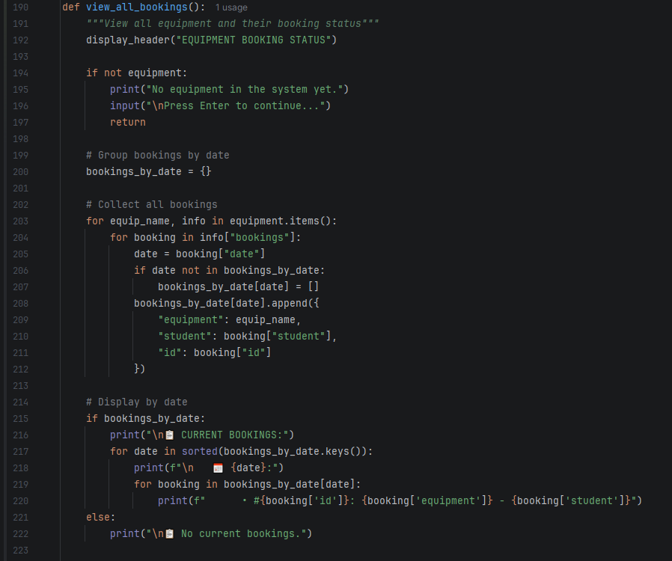
Figure 9
This function collects all bookings from every equipment item, groups them by date, then displays them chronologically along with each equipment's booked dates or availability status.

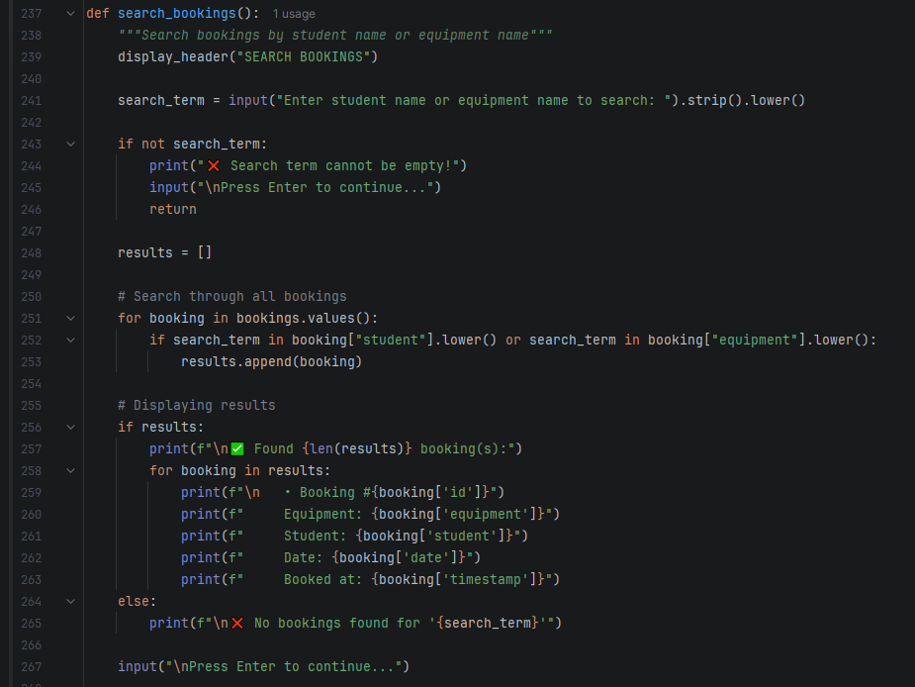
Figure 10
This function takes a search term, converts it to lowercase, loops through all bookings to find matches in student name or equipment name fields, then displays the results with full details or a not found message.

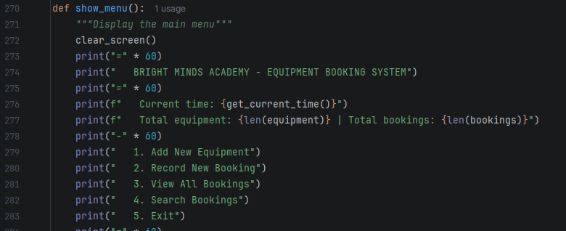
Figure 11
This function clears the screen and displays the main menu with the program title, current time, equipment and booking counts, and the five available options for the user.

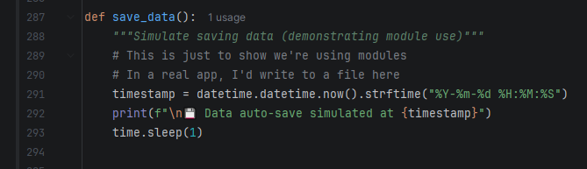
Figure 12
This function demonstrates module usage by generating a current timestamp and displaying a simulated auto-save message, pausing briefly to show the user that data persistence would occur in a real application.

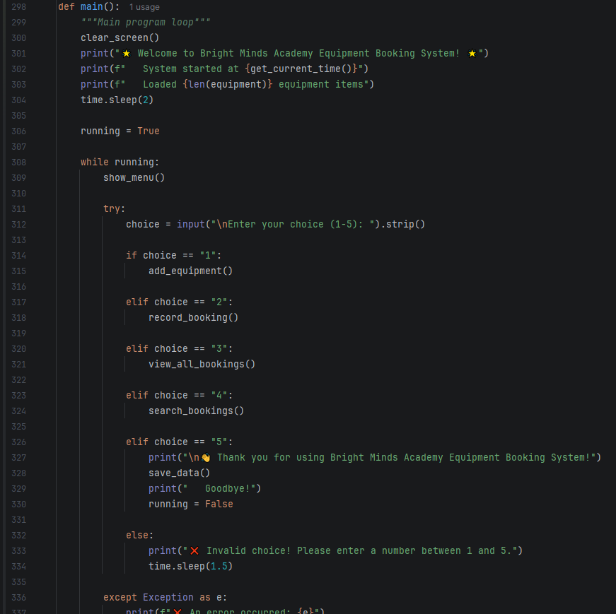
Figure 13
This function runs the main program loop, displays a welcome message, repeatedly shows the menu and routes user input to the appropriate function until the user chooses exit, then displays a goodbye message.

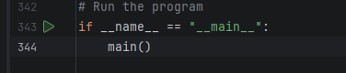
Figure 14
This line checks whether the script is being run directly rather than imported as a module, and if so, calls the main function to start the program.

PS: some screenshots don’t have the full functions since they’re too big, check project on GitHub, link above in Introduction page. Couldn’t add it in Cover page.

Data Structures
Data structures constitute the fundamental mechanisms by which information is organized and stored within a program to enable efficient retrieval [25]. They may be conceptualized as various forms of storage containers, each suited to distinct operational requirements. A list functions as a sequential collection where elements are maintained in order and accessed by position through iterative traversal. A dictionary operates as a key-value store analogous to labelled drawers, providing direct access to values without requiring exhaustive searching. A stack implements last-in-first-out behavior, while a queue follows first-in-first-out principles. Each data structure exists to address specific organizational needs, and appropriate selection is contingent upon the nature of the data and the operations to be performed [26].
The selection of data structures fundamentally influences program performance and code complexity. Appropriate choices yield streamlined, efficient implementations, whereas inappropriate selections necessitate convoluted workarounds to accomplish basic operations. In the equipment booking system, dictionaries were selected to enable immediate access to equipment records by name, eliminating the need for iterative searching. Lists were employed for booking collections attached to each equipment item, as sequential access and ordered storage were required. The resulting nested structure, a dictionary containing lists as values, demonstrates a practical application of data structure principles. Data structures are not abstract theoretical concepts, but practical tools selected based on storage requirements and access patterns.

Data Structures Used
The equipment booking system employs two primary data structures organized to support efficient access from multiple perspectives. The first structure is a dictionary named equipment, where keys represent equipment names in plain English such as "Laptop 1" or "Projector A". Each key maps to a nested dictionary containing an availability flag and a list called bookings. This bookings list stores dictionaries that encapsulate all reservation details for that specific equipment, including student name, date, booking identifier, and timestamp. This organization enables direct access to booking information for any equipment item without requiring traversal of the entire system.
The second structure is a dictionary named bookings, which uses automatically generated numeric identifiers as keys. Each key maps to a dictionary containing the complete reservation record, encompassing student name, equipment name, date, identifier, and timestamp. This structure serves as a master transaction log, providing a flat organizational scheme that facilitates rapid searching by student name or other attributes.
The two data structures maintain synchronized data through deliberate duplication. When a booking is recorded, the same booking dictionary is added both to the master bookings dictionary and to the specific equipment's personal bookings list. This dual storage approach provides two distinct views of the same information: one organized by equipment for quick status inquiries, and another organized by booking identifier for efficient searching. This design eliminates the need for complex join operations while maintaining data consistency across access patterns.

VARIABLES | Data Type | Functionalities/Explanations
equipment | Dictionary | Main dictionary storing all equipment. Each item includes availability and its list of bookings.
Bookings | dictionary | Dictionary storing all bookings using booking ID as the key.
next_booking_id | Integer | Counter used to generate unique booking IDs for each new booking.
equipment_name | String | Stores the name of a selected or newly added piece of equipment.
student_name | String | Stores the name of the student making a booking.
booking_date | String | Stores the date of a booking entered by the user (DD/MM/YYYY).
booking_id | Integer | Temporary variable holding the current booking’s unique ID.
new_booking | Dictionary | Dictionary that stores all details of a single booking before saving it. List of all equipment names used to display selectable options to the user.
equipment_list | List | List of all equipment names used to display selectable options to the user.
choice | Integer/string | Stores the user’s menu or equipment selection input.
confirm | String | Stores user confirmation input (yes/no) before finalising a booking.
bookings_by_date | Dictionary | Dictionary used to group bookings by date when displaying them.
results | List | List used to store search results when looking up bookings.
search_term | String | Stores user input for searching bookings by student or equipment.
running | Boolean | Boolean variable controlling the main program loop (keeps program running).
timestamp | String | Stores the time when data is saved (used in save simulation).
parts | List | List used in date validation to split the date into day/month/year.
day, month, year | Integer | Integers extracted from the date string for validation checks.
booked_dates | string | List of dates when a specific piece of equipment is already booked.

Programming Constructs
Programming constructs constitute the fundamental building blocks through which computational logic is expressed [27]. These constructs consist of a limited set of patterns that combine to form virtually any programmatic solution.
Sequence represents the simplest construct, wherein operations are executed in linear order from initiation to completion. The program follows a prescribed series of steps sequentially, analogous to following a recipe where each instruction is performed in the specified order. The computer executes these instructions without inference, adhering strictly to the established sequence [28].
Selection introduces conditional logic into program execution. This construct enables the program to evaluate conditions and select between alternative paths based on Boolean outcomes. If a specified condition evaluates to true, one branch executes; otherwise, an alternative branch executes. This mechanism underpins decision-making within software, allowing programs to respond differently to varying circumstances [29].
Iteration provides the capability for repeated execution of code blocks. Through loops, programs can perform identical operations on collections of data elements without requiring repetitive code duplication. A single loop structure can process an arbitrary number of items, whether iterating through booking records or equipment lists [30].
These three constructs, sequence, selection, and iteration, collectively form the foundation of procedural programming. In the equipment booking system, sequence governs the orderly flow of menu displays and user prompts. Selection determines how the program responds to equipment existence checks and booking conflicts. Iteration enables efficient processing of multiple bookings during search operations and status displays. These constructs formalize the natural logical patterns that programmers employ when solving problems, with the computer requiring explicit articulation of each step [31].

Programming Constructs Used
The equipment booking system was designed with simplicity as a guiding principle, recognizing that the complexity of the solution should correspond to the complexity of the problem. The developer deliberately avoided sophisticated architectural patterns, selecting only the programming constructs necessary to address the academy's requirements.
Sequence governs the fundamental flow of operations within the system. The program displays the menu, captures user input, and executes the corresponding function in strict linear order. This sequential execution reflects the literal nature of computational processing, where operations cannot occur before their prerequisites are satisfied. A booking cannot be saved before the student name is captured, nor can a search be performed before the search term is provided. The order of operations must be explicitly defined.
Selection provides the conditional logic that enables the system to respond appropriately to varying user inputs and system states. Through conditional statements, the program evaluates whether equipment already exists, whether a booking date is already taken, or whether a search term is empty. These decision points protect the system from invalid operations that would otherwise compromise data integrity. Without selection constructs, the program would accept any user input without validation, leading to immediate failure.
Iteration enables efficient processing of collections within the system. Loops traverse the equipment list to display available items, iterate through bookings to identify matching search terms, and process booking collections to generate status reports. This construct eliminates the need for repetitive code, allowing a single loop structure to perform operations on any number of elements.
The system employs procedural decomposition through functions, each responsible for a distinct operational area. This modular approach prevents monolithic code structures. The implementation utilizes only fundamental constructs: sequence, selection, iteration, and functional decomposition. No classes or inheritance are employed. This minimalistic approach yields a solution that is appropriate to the problem scale, reliable in operation, and transparent in implementation.

Python Modules and Libraries
Python modules and libraries represent collections of pre-existing code that developers may incorporate into their programs, eliminating the need to implement common functionality from first principles [32]. A module constitutes a single Python file containing functions, variables, and classes organized around related tasks, which is made accessible through the import statement. Python provides a standard library comprising built-in modules that address routine operations including date handling, mathematical computations, file input and output, and random number generation. These modules are installed automatically with the Python interpreter, ensuring immediate availability across development environments [33].
Libraries extend this concept as collections of modules bundled together under a common purpose. While a module functions as an individual component, a library serves as a comprehensive collection addressing broader domains such as web application development, data analysis, or graphical user interface creation. Unlike built-in modules, most libraries require separate installation through package management tools such as Pip.
In the equipment booking system, the developer utilized three built-in modules from the Python standard library. The os module provided screen clearing functionality to maintain interface cleanliness [34]. The datetime module enabled timestamp generation for recording when bookings were created [35]. The time module facilitated controlled pauses between operations to ensure messages remained visible to users. These modules handled auxiliary tasks while allowing the developer to concentrate on the core booking logic. Since these modules are part of the standard library, no additional installation steps are required for end users, preserving the system's portability and simplicity [36].

Python Modules and Libraries Used
The equipment booking system incorporates three built-in Python modules, each selected to enhance the user experience while maintaining implementation simplicity . The os module is employed for screen clearing functionality between menu displays. Without this feature, the interface would accumulate successive screens of output, resulting in a cluttered display that diminishes usability. By clearing the screen prior to each menu presentation, the system provides a clean, focused interface that presents information clearly to staff members.
The time module serves two distinct purposes within the system. First, it enables controlled pauses following error messages and confirmations, ensuring that users have adequate opportunity to read feedback before the screen refreshes. Without these pauses, transient messages would disappear before they could be meaningfully processed. Second, the time module provides timestamp functionality, allowing each booking to be recorded with the precise time of creation. This adds an audit trail that documents when reservations were made.
The datetime module is utilized within the save data function to generate a formatted timestamp upon program exit. While this function currently simulates data persistence rather than implementing actual file storage, the inclusion of the datetime module demonstrates awareness of potential future requirements for data logging and audit capabilities.
None of these modules are strictly required for the core booking functionality. The system could theoretically operate without screen clearing, message pauses, or timestamps. However, their inclusion reflects attention to the end-user experience. These enhancements indicate consideration for staff who will interact with the system regularly, valuing interface clarity, readable message timing, and operational records. As built-in modules within Python's standard library, they introduce no additional dependencies or installation requirements for end users, preserving the system's portability while improving its usability.

Role of Testing in Software Environment
Testing constitutes the process of verifying that software functions correctly prior to its deployment for end-user reliance [37]. A developer may be convinced of a program's correctness through visual inspection, yet execution often reveals unforeseen failure modes, such as the program crashing when presented with empty user input. Testing serves not to expose developer inadequacies but to identify issues that were not anticipated during the initial design and implementation phases.
Software testing encompasses both the validation of expected operational paths, commonly referred to as happy path testing, and the more rigorous examination of edge cases and error conditions [38]. Comprehensive testing interrogates the system with scenarios including duplicate booking attempts on the same equipment and date, invalid date formats, and repeated empty inputs. These test cases reveal how the software behaves under adverse conditions, allowing developers to address deficiencies before users encounter them in practice.
Thorough testing produces confidence in software reliability [39]. When a developer has systematically evaluated every operational pathway, every invalid input scenario, and every edge case, uncertainty is replaced by assurance. This confidence is particularly significant when software is deployed in contexts where users depend on its accuracy, such as a tutor relying on the booking system to accurately record equipment reservations.
Skipping testing does not constitute time saved; rather, it represents time deferred [40]. The costs of inadequate testing are ultimately transferred to end users who experience failures, errors, and unexpected behavior. These costs accumulate as technical debt that must eventually be addressed through debugging, support, and potentially system redesign. Thorough testing conducted during development represents an investment in software quality that yields returns in user trust and system reliability [41].

Type of Errors in Programming
Errors in programming are categorized into three distinct types, each arising from different stages of the software development process [42].
Syntax errors occur when the code violates the grammatical rules of the programming language. These include missing colons, unclosed brackets, or misspelled keywords. Such errors prevent the program from being executed altogether, as the interpreter cannot parse the code. Syntax errors are typically identified during compilation or interpretation, and error messages often indicate the exact line number where the violation occurs, making them relatively straightforward to resolve [43].
Runtime errors manifest during program execution when the code encounters an unexpected condition despite being syntactically correct. Common examples include division by zero, attempting to access a file that does not exist, or referencing an index beyond the bounds of a list. These errors cause the program to terminate abruptly and are often difficult to anticipate, as they may only appear under specific circumstances or with particular input values [44].
Logic errors represent the most challenging category, as the program executes without crashing but produces incorrect results. The code runs from start to finish with no error messages, yet the output deviates from the intended outcome. These errors stem from flawed reasoning in the algorithm, such as incorrect conditional statements, misplaced operations, or improper data handling. Detection typically requires systematic testing, debugging, and careful analysis of the program's logic [45], [46].

Syntax Errors
Syntax errors are the grammar police. I forget a colon at the end of an if statement. Misspell "print" as "pritn". Close a bracket I never opened. The computer just stares at me and refuses to guess what I meant. It points at the line and gives up. These are actually the nicest kind of error because the message basically tells you exactly what you did wrong. Embarrassing, but easy to fix.

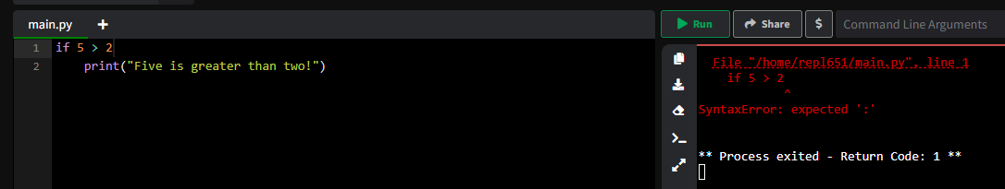
Figure 15: Syntax Error 1
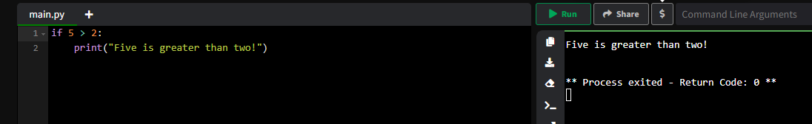
Figure 16: Syntax Error Fix 1

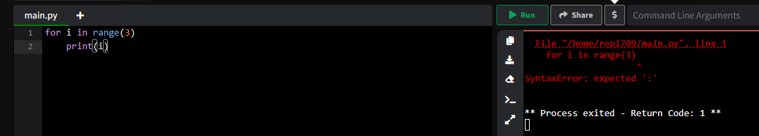
Figure 17: Syntax Error 2
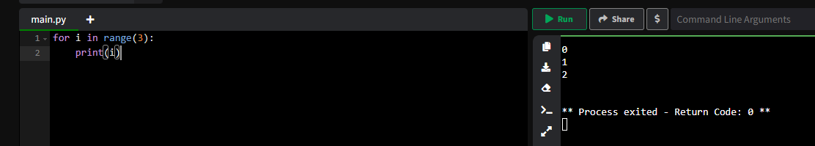
Figure 18: Syntax Error Fix 2

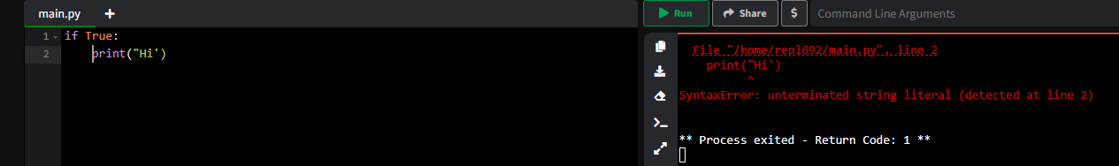
Figure 19: Syntax Error 3
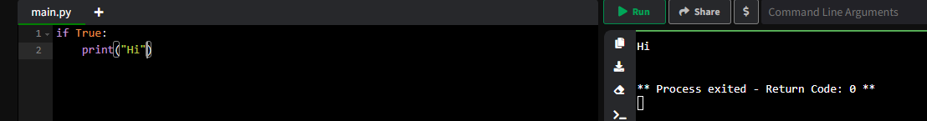
Figure 20: Syntax Error Fix 3

Runtime Error
Runtime errors happen when the program is already running and suddenly dies. The logic is fine. The spelling is fine. Then you ask for item number five in a list that only has three things and boom. Everything stops. The program was perfectly happy until that exact moment. These are sneakier because they hide until someone wanders into the part of your code you didn't test properly.
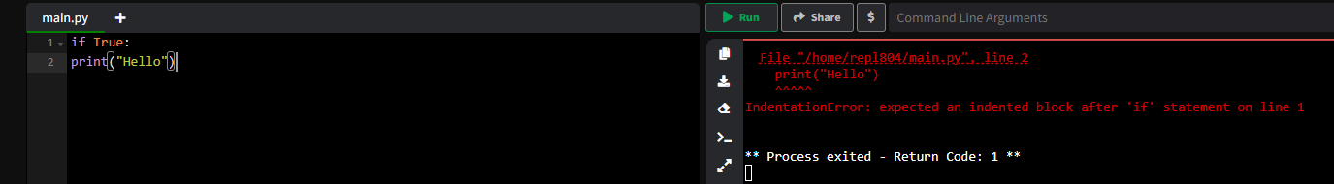
Figure 21: Runtime Error 1
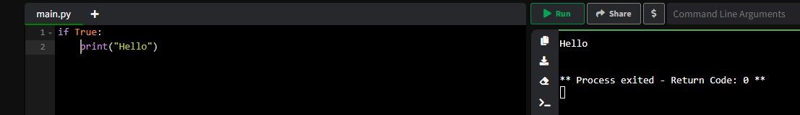
Figure 22: Runtime Error Fix 1

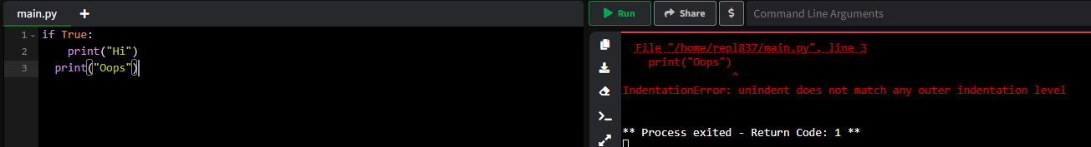
Figure 23: Runtime Error 2
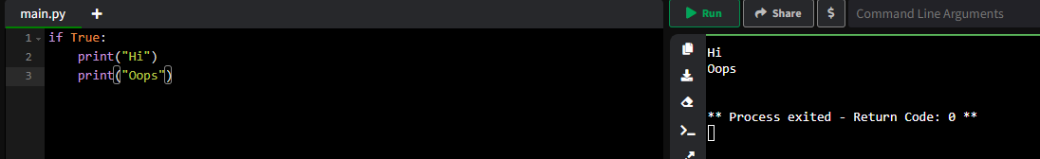
Figure 24: Runtime Error Fix 2
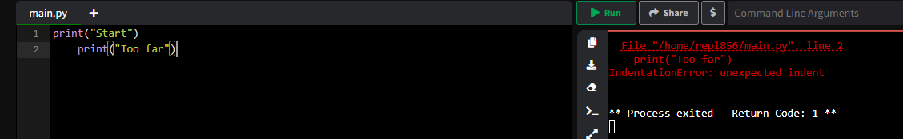
Figure 25: Runtime Error 3
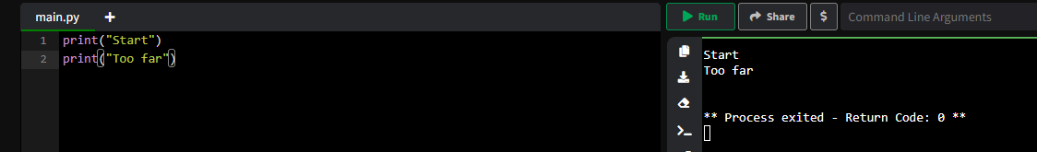
Figure 26: Runtime Error Fix 3

Logic Errors
Logic errors are the cruelest because nothing breaks. The program runs start to finish. No red text. No crashes. But the answer is completely wrong. You calculated the date incorrectly. You saved the equipment name but forgot to save the student. Everything looks fine. Everything is broken. The computer won't tell you that your thinking was flawed. You just have to realize it yourself, usually after someone else has already trusted your software and made plans around it.

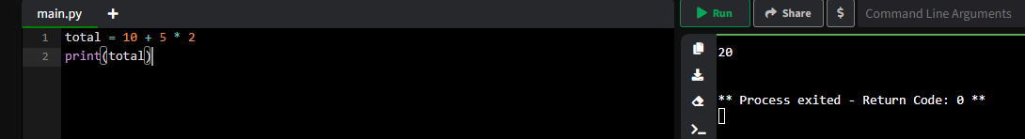
Figure 27: Logic Error 1
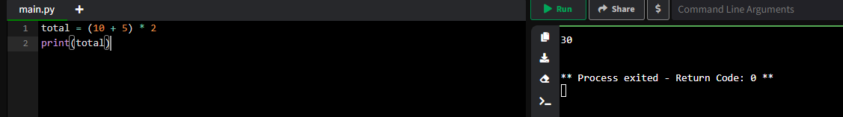
Figure 28: Logic Error Fix 1

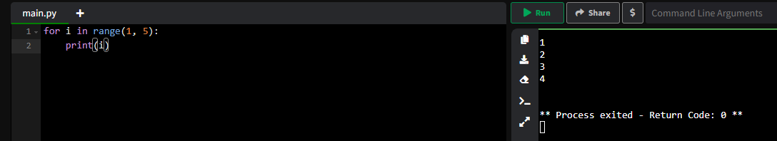
Figure 29: Logic Error 2
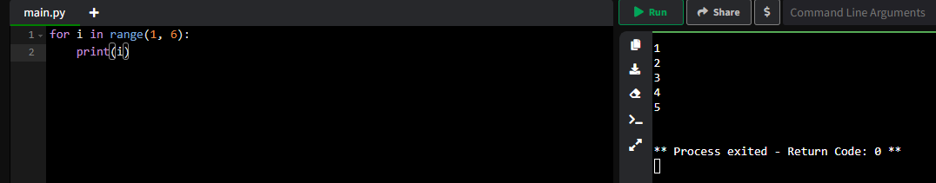
Figure 30: Logic Error Fix 2

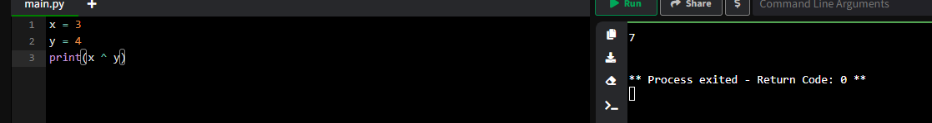
Figure 31: Logic Error 3
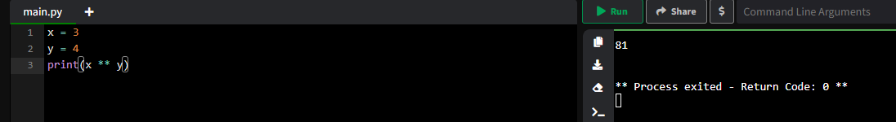
Figure 32: Logic Error Fix 3

Example of Test Cases
I created test cases for each function to make sure the system actually worked before pretending it was finished. For adding equipment, I tested entering a new name, an existing name, and an empty input. For bookings, I tested selecting valid and invalid equipment numbers, entering correct and nonsense dates, and trying to double book the same item on the same day. I also tested searching with real student names, random words, and empty searches. Each test either passed or showed me where the logic broke. Fixing those failures taught me more than writing the code in the first place.

Challenges Faced
One challenge I faced was deciding which modules to add without making things too complicated. I was asked to include some basic modules just for technical reasons, but I didn't want to import a bunch of libraries that did nothing useful. That felt like cheating. So I picked three built in modules that actually improved the experience without adding extra complexity. I used os for clearing the screen between menus, so the display stays clean and tidy. I used time for adding short pauses, so messages don't flash by too fast, and for recording timestamps on bookings so staff know when each reservation was made. I used datetime for one small moment in the save function. The tricky part was making them feel natural, not just tacked on. I wanted someone looking at my code to see that each module served a real purpose, however small, rather than just sitting there as decoration.
Another struggle was keeping the program friendly and easy to use while adding these technical elements. My original idea was to make something that a tired tutor could use without getting frustrated. The confirmation step before saving a booking, the clear error messages when someone types something wrong, the little emojis that make the display less intimidating. I had to make sure that adding modules didn't take away from that. The os module clears the screen but I had to time it right so people could actually read messages before they disappeared. The time module adds pauses but too long and users get annoyed, too short and they miss the message. Getting that balance right took several tries.
The validation for dates was harder than I expected. I wanted to catch obvious mistakes without being too strict. Someone might type 5 instead of 05 and the system should handle it. But I also needed to stop complete nonsense like 99/99/9999. I ended up writing a validation function that checks format, converts to integers, and makes sure the numbers are in reasonable ranges. It's not perfect and it won't catch everything, but it stops the most common mistakes. Testing it with different inputs took more time than I expected but saved me from looking silly later.

Future Improvements
If I had more time to build on this booking system, the first improvement I would make is adding the ability to edit or cancel bookings. Right now once a booking is saved, it's stuck there forever. But in a real tutoring centre, things change all the time. Students get sick and miss sessions. Lessons get rescheduled. A tutor might realize they booked the wrong laptop or the wrong date. Giving staff a simple way to pull up a booking by ID, change the date or student name, or remove it completely would make the system much more flexible and forgiving. I'd also add a confirmation step before deletion, so nobody accidentally removes the wrong booking.
Another improvement I'd love to add is actual data saving and loading. Right now everything lives in memory, which means the moment you close the program, all the bookings disappear. For a real centre, that's a complete dealbreaker. You can't have tutors re-entering every booking every morning. I'd add two simple functions that write the bookings dictionary to a text file or JSON file when you exit and read it back when you start up. No database needed, just a plain file sitting next to the program. Suddenly the system remembers everything between Tuesday and Wednesday and across weeks and months. The data becomes permanent.
The third improvement would be better date handling. My current validation stops obvious nonsense but it's still pretty basic. I'd like to add a proper check that prevents booking equipment for dates in the past. Nobody should be able to book a laptop for yesterday. I'd also add a simple calendar view so staff could pick a date from a visual display instead of typing it manually. That would reduce typos and make the whole process faster. Finally I'd clean up the available flag that's sitting in the equipment dictionary but not actually used anywhere. Either remove it or actually implement it so equipment can be marked temporarily unavailable when it's broken or being repaired. These improvements would take the system from a simple project to something a small centre could actually rely on every day.

Self-Reflection
Looking back on this project, I learned that writing code is only a small part of building something useful. The real work is understanding the problem before you even open your editor. I spent time imagining the tutoring centre, the tired staff, the messy paper logbook. That helped me make decisions about what actually mattered. Not fancy features, just something that works and makes sense to someone who isn't a programmer.
I also learned that data structures aren't just textbook theory. Choosing dictionaries for equipment and bookings wasn't abstract. It was practical. I needed instant access by name and by ID. I needed two views of the same information. Once I understood that, the code almost wrote itself.
Testing taught me humility. I kept testing the happy path where everything goes right. When I finally tried to break my own program, it broke everywhere. Empty inputs. Duplicate dates. Searches with no results. Each crash showed me something I hadn't thought about. Now I know that good code isn't code that works when you expect it to. It's code that handles all the unexpected nonsense people throw at it.
This project reminded me that software is for humans, not computers. The computer will run whatever I give it. But the person on the other side deserves better than that.

References
[1] ISO, ISO 9241-210: Human-centred design for interactive systems, 2021.
[2] I. Sommerville, Software Engineering, 10th ed., Pearson, 2023.
[3] R. S. Pressman and B. R. Maxim, Software Engineering: A Practitioner’s Approach, 9th ed., McGraw-Hill, 2021.
[4] S. Chacon and B. Straub, Pro Git, 2nd ed., 2022.
[5] ACM, “Human-centered computing and usability principles,” 2022.
[6] D. Budgen, Software Design, 3rd ed., Pearson, 2021.
[7] K. Wiegers and J. Beatty, Software Requirements, 3rd ed., Microsoft Press, 2022.
[8] T. H. Cormen et al., Introduction to Algorithms, 4th ed., MIT Press, 2022.
[9] R. Sedgewick and K. Wayne, Algorithms, 2021.
[10] M. T. Goodrich et al., Data Structures and Algorithms in Python, 2nd ed., Wiley, 2022.
[11] R. C. Martin, Clean Code, Pearson, 2021.
[12] E. W. Dijkstra, “Structured Programming,” (modern academic discussions), 2021.
[13] Python Software Foundation, Python Standard Library Documentation, 2024.
[14] G. J. Myers et al., The Art of Software Testing, 4th ed., Wiley, 2021.
[15] P. Ammann and J. Offutt, Introduction to Software Testing, 2nd ed., Cambridge, 2022.
[16] P. Deitel and H. Deitel, Python for Programmers, 2022.
[17] ISO 9241‑11:2018 – Ergonomics of human‑system interaction — Usability definitions and concepts — International Organization for Standardization (ISO). (Defines usability in the context of interactive systems, foundational to user‑centered design)
[18] Silva A. G. et al., “Procedures of User‑Centered Usability Assessment for Digital Solutions,” J. Human Factors and Usability Studies, 2021 — A scoping review of user‑centered usability evaluation procedures across digital systems.
[19] Akhilesh Ghritlahare, The Role of Flowcharts in Problem Solving and Process Visualization, 2025 — Research on the use of flowcharts for process visualization and problem solving.
[20] T. “Structured Flowcharts Outperform Pseudocode” — Experiment on comprehension differences between structured flowchart and pseudocode representations.
[21] J. R. Lewis and J. Sauro, Usability and User Experience: Design and Evaluation, in Handbook of Human Factors and Ergonomics, Wiley, 2021 — Discusses usability and UX evaluate n methods relevant to software interfaces.
[22] Tiago Silva da Silva et al., “User‑Centered Design and Agile Methods: A Systematic Review,” AGILE Conference, IEEE, 2011 — Review of integration of user‑centered design and development methodology.
[23] P. Karhapää et al., “Strategies to manage quality requirements in agile software development: a multiple case study,” Empirical Software Engineering, Springer, 2021 — Discusses quality and usability requirements at development time.
[24] Alok Mishra & Y. I. Alzoubi, “Structured software development versus agile software development: a comparative analysis,” Int. J. Syst. Assurance Eng. Management, 2023 — Offers empirical comparison of software development methodologies.
[25] Scientific mapping of software engineering practices — Software Engineering for Scientific Software Development: A Systematic Mapping Study, Journal of Systems and Software, 2021 — Synthesizes key software engineering practices like testing and maintainability.
[26] ISO 9241‑210:2019 – Ergonomics of human‑system interaction — Human‑centred design for interactive systems — Updated standard detailing the full human‑centered design process throughout software lifecycle (2020 revision referenced).
[27] M. L. Scott, Programming Language Pragmatics, 4th ed., Morgan Kaufmann, 2021.
[28] B. W. Kernighan and D. M. Ritchie, The C Programming Language, 2nd ed., Pearson, 2022.
[29] D. A. Patterson and J. L. Hennessy, Computer Organization and Design RISC-V Edition, 1st ed., Morgan Kaufmann, 2022.
[30] A. Tanenbaum and H. Bos, Modern Operating Systems, 4th ed., Pearson, 2021.
[31] OpenStax, Introduction to Computer Science, OpenStax, 2023.
[32] P. Deitel and H. Deitel, Python for Programmers, Pearson, 2022.
[33] T. Oliphant, Guide to NumPy, 2nd ed., Trelgol Publishing, 2021.
[34] W. McKinney, Python for Data Analysis, 3rd ed., O’Reilly, 2022.
[35] D. Beazley and B. K. Jones, Python Cookbook, 3rd ed., O’Reilly, 2021.
[36] S. Lott et al., The Python Standard Library by Example, 2nd ed., Addison-Wesley, 2022.
[37] P. Ammann and J. Offutt, Introduction to Software Testing, 2nd ed., Cambridge University Press, 2022.
[38] G. J. Myers, C. Sandler, and T. Badgett, The Art of Software Testing, 4th ed., Wiley, 2021.
[39] G. Fraser and F. Arcuri, “Software Testing and Analysis: Process, Principles, and Techniques,” ACM Computing Surveys, 2021.
[40] S. Elbaum et al., Foundations of Software Testing, Wiley, 2023.
[41] M. Gruber et al., “An Empirical Study of Flaky Tests in Python,” arXiv preprint, 2021.
[42] P. Deitel and H. Deitel, Python for Programmers, Pearson, 2022.
[43] Real Python, “Python Basics: A Practical Introduction to Python 3,” 2021.
[44] S. McConnell, Code Complete, 2nd ed., Microsoft Press, 2021.
[45] A. Hunt and D. Thomas, The Pragmatic Programmer, 2nd ed., Addison-Wesley, 2021.
[46] IEEE Computer Society, IEEE Standard for Software and System Test Documentation, 2021.

